WANTED: PEOPLE WHO LOVE TO SING & RING!
The 2015 NE District Convention will begin with the celebration Opening Service on Friday, June 12, 1:30pm at the Younes Center in Kearney NE. We are looking for singers and handbell ringers to join us in the Zion/Holy Cross combined handbell choir and mass vocal choir for this worship service. Handbell rehearsals will be at Holy Cross, Kearney on Thursday, May 21, May 28 and June 4 at 6:00pm. Rehearsals for the mass choir will be at Holy Cross on the same Thursdays at 7:00pm. Please call the Holy Cross church office (308-237-2944) by Monday, May 18 with your name and contact information so we can have the music ready by our 1st rehearsals. Thank you for your prayerful consideration. We look forward to singing & ringing with you!

Thank You
The family of Max Ehrlich would like to thank Pastor DeLoach and the congregation of Zion for all their prayers, cards, and phone calls we received during this difficult time. Your thoughts and prayers are greatly appreciated. Vera Ehrlich & Family

Summer Office Hours
During the summer months, the office will be open Monday – Friday from 9:00 am to 1:00 pm. Victoria Crow will work in the office Monday through Thursday and Shirley will be in on Fridays.

Men’s Softball
Our Zion Men’s Softball season has started. Games are played on Tuesday’s at Harvey Park. We will try to include their games times in the church calendar for any who wish to go and cheer them on.
VBS
There are registration forms for VBS available in the Narthex. Please pick some up and invite your grandchildren, neighbors, co-workers children etc. Our bible school will be June 21-25, with classes for 4 year olds through completed 6th grade.

Stewardship Note
1 John 5:12 “Whoever has the Son has life; whoever does not have the Son of God does not have life.” Jesus is the foundation, the bedrock, the beginning and the end. To have Him is to have it all. In Him we have life. And we are called to live in Him, to live this new life He has given us, to grow up into His image. This is a struggle in this sinful world! But His grace is sufficient as He refreshes us through Word and Sacrament.
Announcements – May 17, 2015
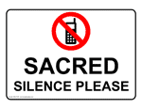
Please remember...to silence your cell phone upon entering the sanctuary.

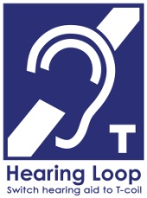
Hearing Loop Zion’s sanctuary is equipped with a hearing loop. Please switch hearing aids to T-coil mode.
We have 2 headsets and receivers that persons without hearing aids can use. Ask an usher for assistance.

Graduate Reception - Today
This morning during the bible study hour, the Youth Board will host a reception for our high school graduate Holly Smith in the fellowship hall. All are welcome to come and congratulate Holly.

Gideon’s
Following our service today, a representative from the Gideon’s will give a brief presentation.

Senior Citizens
Tomorrow, May 18 our Senior Citizens will meet at 12 noon for their monthly potluck. All are welcome to join us.

Stewardship
Envelopes have been placed in your mailbox to continue our focus on the Debt Reduction. To God be the Glory!

Mr. Jagels Moving Schedule - Can You Help?
On new 2nd grade teacher, Mr. Jagels and his family are tentatively planning to arrive in Kearney on June 9th. It would be a great help if we could get some of our members to assist with unpacking their trailer. If you can help, please speak with Tony Splittgerber.

Saturday Worship
Due to scheduling conflicts, there will also be no Saturday services during the month of May.

Armed Forces Sunday
Next Sunday in addition to Pentecost, we will observe Armed Forces Sunday.

Volleyball Coach
We are in need of a person to serve as volleyball coach for our Zion team next fall. If anyone is interested please speak with Mr. Splittgerber.

VBS!

ZION LUTHERAN CHURCH

AGES FOUR THROUGH COMPLETED GRADE SIX

JUNE 21-25, 6-8 PM

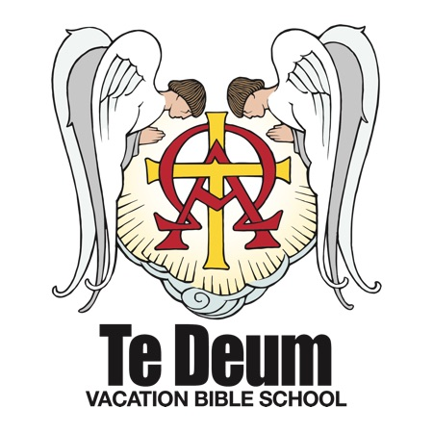
VBS is in the planning stages! Mark your calendars for June 21-25 from 6-8. Please consider donating your time and talents to help the week run smoothly. Volunteers are needed for registration, snacks, teaching and assisting, music and crafts.
The Higher Things "Te Deum" 2015 VBS focuses on the true worship of God in receiving His gifts and in coming to Him in prayer. The "Te Deum" is the ancient hymn of the Christian church, "We praise You, O God!" The Higher Things VBS strengthens our children in the faith of Christ that we confess in the Te Deum and teaches them to call upon that True God for all our needs of body and soul.

If you are willing to help, or if you have any questions, please contact Nathan or Liz Gaunt at 308-293-5689 or ekgaunt@gmail.com.

