Custodian
We are now taking applications for a part time custodian for the school. This could include summertime hours as well as afternoon work when the next school year begins. Ed DeLaet plans to continue to work with us, but would like to cut back on hours. Applications are available at the office.

Morning Aide Wanted
Mr. Splittgerber needs someone who loves working with young children to aide in the morning prekindergarten class on Tuesdays and Thursdays. Please call 234-3410 if you are interested.

Thank You
Thank you to Pastor DeLoach and the congregation of Zion for all their prayers, cards, and memorials we received during this difficult time. Your thoughts and prayers are greatly appreciated. Rachel Strong & Family

Summer Office Hours
During the summer months, the office will be open Monday – Friday from 9:00 am to 1:00 pm. Victoria Crow will work in the office Monday through Thursday and Shirley will be in on Fridays.

Armed Forces Sunday
Today in addition to Pentecost, we will observe Armed Forces Sunday.

Hafermann Retirement
Zion’s former Pastor, John Hafermann will retire from the ministry on June 6. If anyone wishes to send Pastor and Gay Lea a card, they can be mailed to their daughter Rachel. Rachel Smith 488 Fox Trail Dr., Lake Saint Louis, MO 63367-2254.

Stewardship Note
Acts 2:1 “When the day of Pentecost arrived, they were all together in one place.” Pentecost was the Old Testament harvest festival: a time of thanksgiving, bounty, and the giving of gifts. How appropriate that in the New Testament it takes on the meaning of harvest the ripe fields of the nations, bringing in the elect of every tribe and tongue to sing the Lord’s praise. Every farmer knows that it is God who gives the increase, that harvest calls for thanksgiving.
Announcements – May 24, 2015
Please remember...to silence your cell phone upon entering the sanctuary.

Hearing Loop Zion’s sanctuary is equipped with a hearing loop. Please switch hearing aids to T-coil mode.
We have 2 headsets and receivers that persons without hearing aids can use. Ask an usher for assistance.

Mr. Jagels Moving Schedule - Can You Help?
On new 2nd grade teacher, Mr. Jagels and his family are tentatively planning to arrive in Kearney on June 9th. It would be a great help if we could get some of our members to assist with unpacking their trailer. If you can help, please speak with Tony Splittgerber.

Ordination
Dear friends at Zion,
On April 28th, I have received a call to be Associate Pastor of Crown of Life Lutheran Church in San Antonio, Texas.
I have scheduled my Ordination for Sunday, June 14th, here at Zion. It will be held at 4:00pm, with a meal to follow. I look forward to seeing you there, and celebrating this tradition and blessing together.
It will be a great opportunity for me to thank you all for your support over the last several years—and of course over all my years before that. In advance: thank you.
I will be installed at Crown of Life in San Antonio two weeks later, on Sunday the 28th of June, and then begin my service in that place.
Thank you,
Chris

VBS
There are registration forms for VBS available in the Narthex. Please pick some up and invite your grandchildren, neighbors, co-workers children etc. Our bible school will be June 21-25, with classes for 4 year olds through completed 6th grade.

Camp Comeca
Eight of our youth will attend catechism camp this week at Camp Comeca. Lisa Splittgerber will be the adult chaperone. We pray that God will keep them safe.

Volleyball Coach
We are in need of a person to serve as volleyball coach for our Zion team next fall. If anyone is interested please speak with Mr. Splittgerber.

VBS!

ZION LUTHERAN CHURCH

AGES FOUR THROUGH COMPLETED GRADE SIX

JUNE 21-25, 6-8 PM

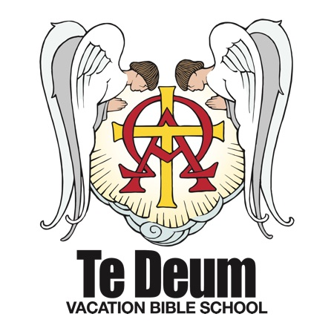
VBS is in the planning stages! Mark your calendars for June 21-25 from 6-8. Please consider donating your time and talents to help the week run smoothly. Volunteers are needed for registration, snacks, teaching and assisting, music and crafts.
The Higher Things "Te Deum" 2015 VBS focuses on the true worship of God in receiving His gifts and in coming to Him in prayer. The "Te Deum" is the ancient hymn of the Christian church, "We praise You, O God!" The Higher Things VBS strengthens our children in the faith of Christ that we confess in the Te Deum and teaches them to call upon that True God for all our needs of body and soul.

If you are willing to help, or if you have any questions, please contact Nathan or Liz Gaunt at 308-293-5689 or ekgaunt@gmail.com.

Office Closed Tomorrow
The Church Office will be closed tomorrow for Memorial Day.

Thank You
The family of Ileene Wenzlick wish to thank everyone for all expressions of sympathy shown to the family at her passing. Thank you to Pastor DeLoach for his comforting words, Kay Banner, organist, the school children for their special music, and all who helped and served lunch.
Thank you

