CPH Bible Sale
CPH is offering many of their bibles at a discount. There is a chart in the hallway listing what is available and the cost. If you wish to place an order please add you name and what you wish to purchase to the chart or you may pick up an individual order form in the narthex and turn it in to Shirley in the office. All orders need to be in before September 30. You may pay for your items when they arrive.
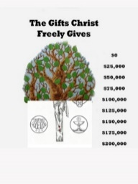
The Gifts Christ Freely Gives
Our treasurer was able to make a principal only payment in July in the amount of $1,000. After this and our regular July payment, our current balance is $ 85,586.41.

Jean Ahrens
We have received word that our member Jean Ahrens died in Kerrville, Texas. Graveside services will be held Friday, August 21 at Hendley Cemetery in Hendley, Nebraska.

Sleeping Mats
Everyone’s been having so much fun making the sleeping mats that we will now meet every Tuesday! It is at 1:30 in the fellowship hall, and you can cut plastic grocery bags or crochet the strips. Children, men and women are all welcome. Come and enjoy the fellowship and do some mission work.

Stewardship Note
Ephesians 5:6-7 “Let no one deceive you with empty words, for because of these things the wrath of God comes upon the sons of disobedience. ⁷ Therefore do not associate with them.” The wrath of a God is a real thing and we do well to reflect on this. As the Small Catechism states: God threatens to punish all who break these commandments. Therefore, we should fear His wrath and not do anything against them. But He promises grace and every blessing to all who keep these commandments. Therefore, we should also love and trust in Him and gladly do what He commands.
Announcements – August 16, 2015
Please remember...to silence your cell phone upon entering the sanctuary.

Hearing Loop Zion’s sanctuary is equipped with a hearing loop. Please switch hearing aids to T-coil mode.
We have 2 headsets and receivers that persons without hearing aids can use. Ask an usher for assistance.

Senior Citizens
The Senior Citizens will meet tomorrow, August 17 at 12 noon for their monthly potluck. All welcome to join us for an afternoon of good food and fellowship.

Colorado Peaches & Pears – August 21 & 22
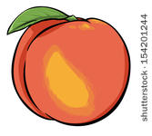
Mary Martha will be selling Delicious Colorado Peaches and Pears August 21 & 22.
Mary Martha ladies plan to sell the fruit Friday the 21st from 1:00 pm-5:00 pm and Saturday from 8:00 am to 12:00 pm.
Our youth group will have peaches for sale the following weekend.

Saturday Evening Services
Please note that there will not be a Worship Service next Saturday, August 22.

Midweek Class Orientation
Midweek class orientation for students and parents is scheduled for August 26 at 5:45 PM. This class is for all youth (4th grade and older).
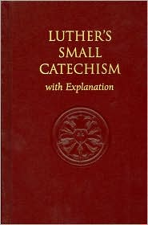
Over a 4 year span students will study Old Testament and New Testament Bible Stories, along with the teachings of the Christian Faith as taught by the Small Catechism. At orientation the students will receive materials for the class and an assignment sheet for the coming school year.

School Notes

- We began our 85th year this past Wednesday with our Kindergarten – 8th grade children. The early childhood classes will join us this Monday & Tuesday.

- The bathroom remodeling project is completed. Please take a look, we are very happy with the way they turned out.

A big thank you to all who helped with this project. Todd Koopman who headed up the whole project, the trustees for their assistance, Ed DeLaet for keeping everything as tidy as possible during the construction, and all others who helped in any way.

- Thank you to Victoria Crow who has been our Summer Office Assistant. We thank you for all of the work you did this summer in getting things ready for this school year. God’s Blessings to you as you return to college.

- The first game for our girls’ volleyball team is scheduled Sept. 10 in Hastings. Our first home game is Sept. 22.

- We had a wonderful turn out for our back to school night. The Bd. of Ed. grilled hamburgers & hot dogs, and the teachers meet with the children and parents in their classrooms. We also had a large bouncy slide on the playground for the children to play on.

- Zion Golf Tournament – September 27
The Zion Golf Tournament will be Sunday, September 27 at 1:00 pm. Be watching for details on how to register and donate to this fundraiser.

