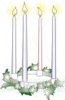**Advent Services**

Special Wednesday evening Advent services will be held at 7 pm on Dec. 2, 9, & 16. Each service will be preceded by a meal in the fellowship hall beginning at 5:30.

**Automatic Giving**

If anyone is interested in signing up for automatic giving for the 2016 giving year, please contact the church office to fill out the proper forms. Please complete by December 1st. Thank You

**GIVE WHERE YOU LIVE**

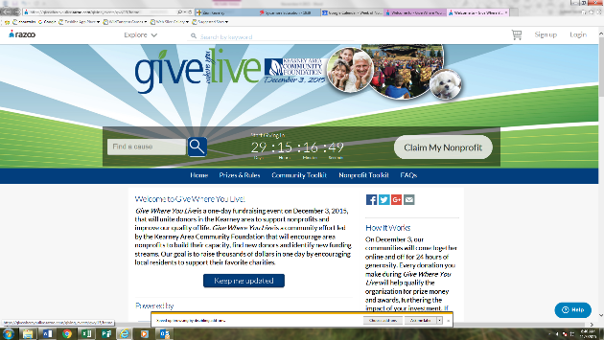This year Zion Lutheran School will be participating in the Give Where You Live Campaign. It is now until December. To participate/contribute online go to: <https://www.razoo.com/story/Zion-Lutheran-School-9> If you would rather donate in person feel free to stop by the office. Please share this with your family and friends. Thank you for your support of this great school!

**Food Collection**

Zion will collect food items during the month of November to help supply Kearney agencies who assist the needy. There are grocery carts in the narthex and school area to gather these items.

**Sleeping Mats**

The sleeping mat group will not meet this Tuesday, November 24th.

**Radio Broadcast & Flower Charts**

The congregation is invited to sign up to sponsor altar flowers or radio broadcasts on the 2016 charts hanging on the bulletin board. Cost to sponsor a radio broadcast is $150 per Sunday. Families are welcome to share the cost of the broadcast if they wish.

**Stewardship**

Last Sunday of the Church Year

Isaiah 51:6: “For the heavens vanish like smoke, the earth will wear out like a garment.” The things of this earth that hold our attention, that cause us worry, that tempt us away from the Lord: they are all passing away. They will vanish like a garment. They are not for us to worry over, but rather to use for the Lord's purposes. The things of this world are not ends in and of themselves, but only means to be used wisely by the children of the Kingdom that has no end.

**Announcements – November 22, 2015**

Please remember...to silence your cell phone upon entering the sanctuary.

Zion’s sanctuary is equipped with a **HEARING LOOP**. Please switch hearing aids to T-coil mode.We have 2 headsets and receivers that persons without hearing aids can use. Ask an usher for assistance.

**Our Weekly Memory Work**

Thanksgiving Break

**Voters Meeting Today**

The November Voters Meeting will be today at 10:15 a.m. Business will include election of officers and board members for 2016.

**Thanksgiving Eve**

We extend a very special invitation to you and your family to come and worship with us on Wednesday, November 25, at 7:00 p.m. For those who have guests visiting, we also invite them to come and worship with us. As Thanksgiving approaches, we ask that you pause and remember the many blessings the Lord has given you. What a gracious God we have!

**No Choir or Bell Rehearsal this Wednesday**

**Office Closed**

The church/school office will be closed Thursday and Friday, November 26 & 27, to observe Thanksgiving.

**Sunday School Choir**

The Sunday School Children will sing at our service next Sunday, November 29. Children are asked to meet 15 minutes before the service in the Fellowship Hall.

**Christmas Eve Service Rehearsal**

Sunday School children will rehearse hymns and speaking parts for our Christmas Eve Service on Saturday mornings from 9-10:30. The first practice is December 5.

**Holiday Pies**

There are several pies remaining from the pie sales. The flavors are pumpkin, pecan, fruits of the forest, caramel apple nut, strawberry rhubarb, apple, cherry, peach. This would be great for your thanksgiving meal or a treat for anytime.

**Sower and Bulletin Announcements**

The December Sower and next Sunday’s bulletin will be printed on Tuesday of this week. If you have anything to include, please have it in to the office by 9:00 Tuesday morning.

**Decorating the Church for Christmas**

Come one come all to join in the festivities of decorating the Church for Christmas. Have fun and fellowship while decorating on December 5th beginning at 11:00 am. Stay for as long as you can, bring the entire family and start a new tradition. We would appreciate some men to help with the tree assembly. Hope to see you on December 5th.

**Christmas Poinsettias**

C:\Users\school\AppData\Local\Microsoft\Windows\Temporary Internet Files\Content.IE5\5XUAILOU\MC900030653[1].wmfWe will be using poinsettias decorate our Church this Christmas season.  If you wish to provide a poinsettia, the cost will be $12.  To avoid confusion, please place your money in an envelope and turn in to the church office.

**Higher Things**

Youth who have been confirmed are encouraged to consider attending the Higher Things conference this summer. All youth who are interested are asked to pick up a registration form from the office and return it with your preferred dates circled. The youth will then decide as a group which conference we will attend.

**School News**

* There are a few t-shirts with this year’s theme “Armored in Christ” available for sale at the office.
* Thank you to all who purchased pies from our children. It was a very successful fundraiser. We do have a few pies left. Check with the office if you are interested in purchasing any.
* Thanksgiving break will be November 25-27
* We will open enrollment for the 2015-2016 school year to our church families and our returning school families the first week of December. Please stop by or call the office for registration forms. Our early childhood classes fill quickly.
* The school Christmas program is December 13 at 4:00 p.m.