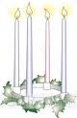**Advent Services**

Special Wednesday evening Advent services will be held at 7 pm on Dec. 2, 9, & 16. Each service will be preceded by a meal in the fellowship hall beginning at 5:30.

**GIVE WHERE YOU LIVE**

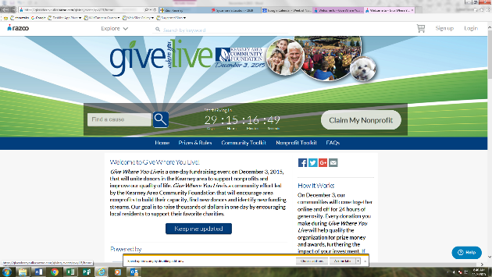This year Zion Lutheran School will be participating in the Give Where You Live Campaign. It is now until December. To participate/contribute online go to: <https://www.razoo.com/story/Zion-Lutheran-School-9> If you would rather donate in person feel free to stop by the office. Please share this with your family and friends. Thank you for your support of this great school!

**Food Collection**

Zion will collect food items during the month of November to help supply Kearney agencies who assist the needy. There are grocery carts in the narthex and school area to gather these items.

**Radio Broadcast & Flower Charts**

The congregation is invited to sign up to sponsor altar flowers or radio broadcasts on the 2016 charts hanging on the bulletin board. Cost to sponsor a radio broadcast is $150 per Sunday. Families are welcome to share the cost of the broadcast if they wish.

**Stewardship**

Advent I

Luke 19:31: “If anyone asks you, ‘Why are you untying it?’ you shall say this: ‘The Lord has need of it.’”

Consider the faithfulness of that man who owned the donkey and colt. All he needed to hear was, “The Lord has need of it” - and he willingly gave. The Lord has given each of us various callings in life (in our homes, in the Church, and in the communities we live in). In each calling we have good work to do which comes from the Lord's hand. The Lord has need of us in each calling. How is He calling you to generous giving in each of your vocations?

**Announcements – November 29, 2015**

Please remember...to silence your cell phone upon entering the sanctuary.

Zion’s sanctuary is equipped with a **HEARING LOOP**. Please switch hearing aids to T-coil mode.We have 2 headsets and receivers that persons without hearing aids can use. Ask an usher for assistance.

**Our Weekly Memory Work**

Lord’s Prayer: Introduction & 1st Petition

**Meetings this Week**

Board of Stewardship meets Tuesday, 12/1 at 7:00 p.m.

Concordia meets Thursday, 12/3 at 2:00 p.m.

Board of Education meets Thursday, 12/3 at 7:00 p.m.

**Saturday Divine Service**

There will be **NO** Saturday services in the month of December.

**Christmas Eve Service Rehearsal**

Sunday School children will rehearse hymns and speaking parts for our Christmas Eve Service on Saturday mornings from 9-10:30. The first practice is December 5.

**Holiday Pies**

There are several pies remaining from the pie sales. The flavors are pumpkin, pecan, fruits of the forest, caramel apple nut, strawberry rhubarb, peach. This would be great for your thanksgiving meal or a treat for anytime.

**Decorating the Church for Christmas**

Come one come all to join in the festivities of decorating the Church for Christmas. Have fun and fellowship while decorating on December 5th beginning at 11:00 am. Stay for as long as you can, bring the entire family and start a new tradition. We would appreciate some men to help with the tree assembly. Hope to see you on December 5th.

**Christmas Poinsettias**

C:\Users\school\AppData\Local\Microsoft\Windows\Temporary Internet Files\Content.IE5\5XUAILOU\MC900030653[1].wmfWe will be using poinsettias decorate our Church this Christmas season.  If you wish to provide a poinsettia, the cost will be $12.  To avoid confusion, please place your money in an envelope and turn in to the church office.

**Sleeping Mats**

The sleeping mat group will not be meeting until January. They are still accepting bags. Have a wonderful holiday season!

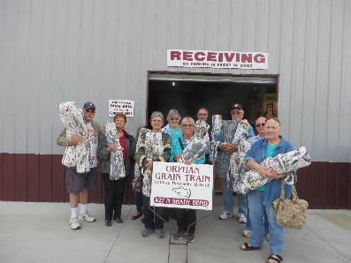The group delivered 13 mats to the orphan grain train in Grand Island in October. It takes about 500-700 bags per mat, so all of the bag donations are appreciated.

**Higher Things**

Youth who have been confirmed are encouraged to consider attending the Higher Things conference this summer. All youth who are interested are asked to pick up a registration form from the office and return it with your preferred dates circled. The youth will then decide as a group which conference we will attend.

**School News**

* There are a few t-shirts with this year’s theme “Armored in Christ” available for sale at the office.
* Thank you to all who purchased pies from our children. It was a very successful fundraiser. We do have a few pies left. Check with the office if you are interested in purchasing any.
* Thanksgiving break will be November 25-27
* We will open enrollment for the 2015-2016 school year to our church families and our returning school families the first week of December. Please stop by or call the office for registration forms. Our early childhood classes fill quickly.
* The school Christmas program is December 13th at 4:00 p.m.

