Amazon.com Purchases
If you use Amazon support Zion by shopping at smile.amazon.com. Amazon donates 0.5% of the price of your eligible AmazonSmile purchases to those who have enrolled. Call the office with questions.

Your 2017 Church Envelopes
Are available in the narthex. There was a shortage of envelopes, so families from W-Z will receive them in a few weeks. We apologize for the inconvenience.
Please note that the envelopes that were missing have now arrived and are ready for pick up.

Radio Broadcast & Flower Charts
The Altar Flower and Radio charts for 2017 are on the bulletin board across from the mailboxes. The cost to sponsor a radio broadcast is $161.50 per week. Families are welcome to go together to sponsor a broadcast.

School News
School will be dismissed for Christmas break this Wednesday, December 21st. School will resume on Wednesday, January 4, 2017.

Enrollment for the 2016-2017 school year is open to our church families and our returning school families. Our early childhood classes fill quickly and registration will open to the public on January 4th.

Stewardship

John 1:5 “The light shines in the darkness, and the darkness has not overcome it.” Through all of our hardships, all of our sorrows, all of our pains and loneliness: Jesus' light shines in the darkness, and we are not overcome. In the face of our sin, in the midst of our pettiness, against all our pride: Jesus' light shines and illuminates our hearts, and changes us, day by day, into a greater reflection of His likeness.

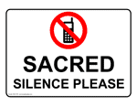
Announcements – December 25, 2016
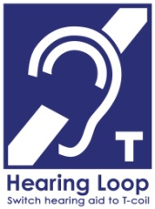
Please remember...to silence your cell phone upon entering the sanctuary.

Zion’s sanctuary is equipped with a HEARING LOOP. Please switch hearing aids to T-coil mode. We have 2 headsets and receivers that persons without hearing aids can use. Ask an usher for assistance.
Forgot your offering? Don’t have your checkbook or cash? Today or any day you can give in a new way! Visit our website at zionkearney.com and click on the “giving” tab. Or, text “zionkearney” (one word) to 77977. You’ll receive a text back with instructions to start giving.

Saturday Worship
This year since New Year’s Eve is on Saturday, we will combine our New Year’s Eve service with the Saturday Service. There will be one service at 5:00 pm.

Church Office Will Be Closed
Thursday, December 22 to Tuesday, January 3rd, 2017. For Pastoral emergencies please call Pastor DeLoach (308-627-5260) or Pastor Gaunt (308-455-0552).

If you wish to purchase scrip over the break, please go to the book nook on Sunday mornings.

Heating & Air for Fellowship
We will be replacing the heating and air conditioning systems for the fellowship hall. If you would like to help with this project, please mark your contribution “building improvements”

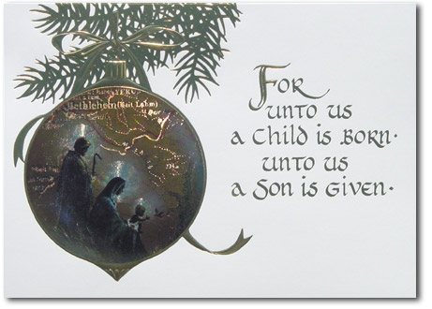

Amazon.com Purchases
If you use Amazon support Zion by shopping at smile.amazon.com. Amazon donates 0.5% of the price of your eligible AmazonSmile purchases to those who have enrolled. Call the office with questions.

Your 2017 Church Envelopes
Are available in the narthex. There was a shortage of envelopes, so families from W-Z will receive them in a few weeks. We apologize for the inconvenience.
Please note that the envelopes that were missing have now arrived and are ready for pick up.

Radio Broadcast & Flower Charts
The Altar Flower and Radio charts for 2017 are on the bulletin board across from the mailboxes. The cost to sponsor a radio broadcast is $161.50 per week. Families are welcome to go together to sponsor a broadcast.

School News
School will be dismissed for Christmas break this Wednesday, December 21st. School will resume on Wednesday, January 4, 2017.

Enrollment for the 2016-2017 school year is open to our church families and our returning school families. Our early childhood classes fill quickly and registration will open to the public on January 4th.

Stewardship

John 1:5 “The light shines in the darkness, and the darkness has not overcome it.” Through all of our hardships, all of our sorrows, all of our pains and loneliness: Jesus' light shines in the darkness, and we are not overcome. In the face of our sin, in the midst of our pettiness, against all our pride: Jesus' light shines and illuminates our hearts, and changes us, day by day, into a greater reflection of His likeness.

Announcements – December 25, 2016
Please remember...to silence your cell phone upon entering the sanctuary.

Zion’s sanctuary is equipped with a HEARING LOOP. Please switch hearing aids to T-coil mode. We have 2 headsets and receivers that persons without hearing aids can use. Ask an usher for assistance.
Forgot your offering? Don’t have your checkbook or cash? Today or any day you can give in a new way! Visit our website at zionkearney.com and click on the “giving” tab. Or, text “zionkearney” (one word) to 77977. You’ll receive a text back with instructions to start giving.

Saturday Worship
This year since New Year’s Eve is on Saturday, we will combine our New Year’s Eve service with the Saturday Service. There will be one service at 5:00 pm.

Church Office Will Be Closed
Thursday, December 22 to Tuesday, January 3rd, 2017. For Pastoral emergencies please call Pastor DeLoach (308-627-5260) or Pastor Gaunt (308-455-0552).

If you wish to purchase scrip over the break, please go to the book nook on Sunday mornings.

Heating & Air for Fellowship
We will be replacing the heating and air conditioning systems for the fellowship hall. If you would like to help with this project, please mark your contribution “building improvements”

