VBS

VBS 2017 is a victory celebration! In Mighty Fortress VBS, your children learn that in Jesus, the victory is won! They’ll look into the Bible, God’s Holy Word, and explore five Bible accounts about God, our Mighty Fortress, and the victory Jesus has won for us.

Registration is open for ages 4yrs-6th grade who will attend VBS from July 16-20, from 6:00-8:00 pm. Come along with us as we sing fun songs, do crazy crafts, eat yummy snacks, play awesome games, and more. Plus, you’ll learn in Jesus, the victory is won! Can’t wait to see you there! Register online at www.vbsmate.com/zionkearney. Or fill out the blue registration form in the narthex and on the table in the school hallway and turn into the office.
Register now for Mighty Fortress Vacation Bible School! Can’t wait to see you there!!

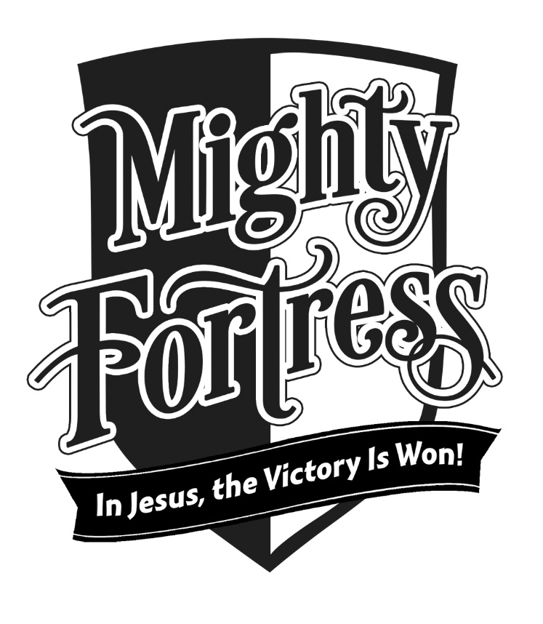

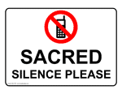
Announcements – June 25, 2017
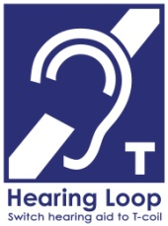
Please remember...to silence your cell phone upon entering the sanctuary.

Zion’s sanctuary is equipped with a HEARING LOOP. Please switch hearing aids to T-coil mode. We have 2 headsets and receivers that persons without hearing aids can use. Ask an usher for assistance.
Forgot your offering? Don’t have your checkbook or cash? Today or any day you can give in a new way! Visit our website at zionkearney.com and click on the “giving” tab. Or, text “zionkearney” (one word) to 77977. You’ll receive a text back with instructions to start giving.

Fabric Kits
Mary Martha Love Circle is collecting fabric kits for Lutheran World Relief. From LWR: "You’ve maybe heard the analogy about teaching someone to fish… well you can help teach a person to sew and provide the tools to earn an income and break out of poverty. Project Promise Fabric Kits are used in vocational training programs to teach young men and women useful, marketable skills. Cover them with love!" Specific supplies will be collected through Sunday, July 9. For more information, please pick up a flyer from the hallway near the collection box.

Pre-School Aide Needed
Our school has an opening for an aide in the preschool for the coming school year. This position is for Monday-Friday from 8:00- 11:30 am. If you are interested please pick up an application from the office or speak with Mr. Splittgerber. anthony.splittgerber@zionkearney.org

Stewardship Note
Romans 6:13 “Present yourselves to God as those who have been brought from death to life, and your members to God as instruments for righteousness.” Everything we have – even our own existence, our very selves – is a gift from God to be used for His purposes. God has called you to be His own and has given you tasks to perform in home, church, and society. How will you serve Him today?

VBS

VBS 2017 is a victory celebration! In Mighty Fortress VBS, your children learn that in Jesus, the victory is won! They’ll look into the Bible, God’s Holy Word, and explore five Bible accounts about God, our Mighty Fortress, and the victory Jesus has won for us.

Registration is open for ages 4yrs-6th grade who will attend VBS from July 16-20, from 6:00-8:00 pm. Come along with us as we sing fun songs, do crazy crafts, eat yummy snacks, play awesome games, and more. Plus, you’ll learn in Jesus, the victory is won! Can’t wait to see you there! Register online at www.vbsmate.com/zionkearney. Or fill out the blue registration form in the narthex and on the table in the school hallway and turn into the office.
Register now for Mighty Fortress Vacation Bible School! Can’t wait to see you there!!

Announcements – June 25, 2017
Please remember...to silence your cell phone upon entering the sanctuary.

Zion’s sanctuary is equipped with a HEARING LOOP. Please switch hearing aids to T-coil mode. We have 2 headsets and receivers that persons without hearing aids can use. Ask an usher for assistance.
Forgot your offering? Don’t have your checkbook or cash? Today or any day you can give in a new way! Visit our website at zionkearney.com and click on the “giving” tab. Or, text “zionkearney” (one word) to 77977. You’ll receive a text back with instructions to start giving.

Fabric Kits
Mary Martha Love Circle is collecting fabric kits for Lutheran World Relief. From LWR: "You’ve maybe heard the analogy about teaching someone to fish… well you can help teach a person to sew and provide the tools to earn an income and break out of poverty. Project Promise Fabric Kits are used in vocational training programs to teach young men and women useful, marketable skills. Cover them with love!" Specific supplies will be collected through Sunday, July 9. For more information, please pick up a flyer from the hallway near the collection box.

Pre-School Aide Needed
Our school has an opening for an aide in the preschool for the coming school year. This position is for Monday-Friday from 8:00- 11:30 am. If you are interested please pick up an application from the office or speak with Mr. Splittgerber. anthony.splittgerber@zionkearney.org

Stewardship Note
Romans 6:13 “Present yourselves to God as those who have been brought from death to life, and your members to God as instruments for righteousness.” Everything we have – even our own existence, our very selves – is a gift from God to be used for His purposes. God has called you to be His own and has given you tasks to perform in home, church, and society. How will you serve Him today?

