VBS

VBS 2017 is a victory celebration! In Mighty Fortress VBS, your children learn that in Jesus, the victory is won! They’ll look into the Bible, God’s Holy Word, and explore five Bible accounts about God, our Mighty Fortress, and the victory Jesus has won for us.

Registration is open for ages 4yrs-6th grade who will attend VBS from July 16-20, from 6:00-8:00 pm. Come along with us as we sing fun songs, do crazy crafts, eat yummy snacks, play awesome games, and more. Plus, you’ll learn in Jesus, the victory is won! Can’t wait to see you there! Register online at www.vbsmate.com/zionkearney. Or fill out the blue registration form in the narthex and on the table in the school hallway and turn into the office.
Register now for Mighty Fortress Vacation Bible School! Can’t wait to see you there!!
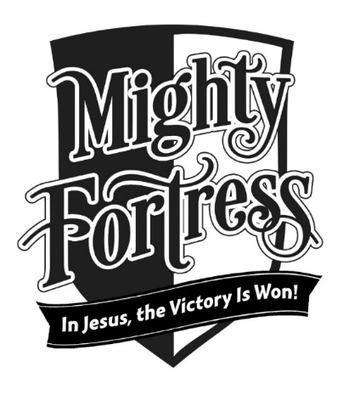

Stewardship Note
Romans 8:12 “So then, brothers, we are debtors, not to the flesh, to live according to the flesh.” We owe the flesh, the world, and the devil nothing at all. We are not debtors to these enemies: we are freed by the blood of Christ. We are joyful servants in Christ’s kingdom – servants that He calls friends. We share our Lord’s plans and purposes – and this gives direction and purpose to our lives.

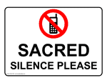
Announcements – July 16, 2017
Please remember...to silence your cell phone upon entering the sanctuary.

Zion’s sanctuary is equipped with a HEARING LOOP. Please switch hearing aids to T-coil mode. We have 2 headsets and receivers that persons without hearing aids can use. Ask an usher for assistance.
Forgot your offering? Don’t have your checkbook or cash? Today or any day you can give in a new way! Visit our website at zionkearney.com and click on the “giving” tab. Or, text “zionkearney” (one word) to 77977. You’ll receive a text back with instructions to start giving.

VBS

VBS Snacks
Thank you to all who offered to bring snack for VBS. You may drop them off in the Fellowship Hall kitchen.

VBS
VBS parents and drivers, you are invited to come in and join your children for our “Mighty Fortress Closing” at 7:40 each night. And then you can enjoy a snack with children and staff after. Both are in the Fellowship Hall.

Voter’s Meeting
The quarterly Voter’s meeting will take place on July 23, at 10:30 in the Fellowship Hall.

