MC900030653[1]**Poinsettia**

We will be using poinsettias decorate our Church this Christmas season.  If you wish to provide a poinsettia, the cost will be $12.  To avoid confusion, please place your money in an envelope and turn in to the church office. Checks should be made out to Mary Martha.

**Food Collection**

Zion will collect food items during the month of November to help supply Kearney agencies who assist the needy. There are grocery carts in the narthex and school area to gather these items. Non-perishable items only please. **Please note that the Jubilee Center could especially use Peanut Butter, Cereal, and diapers size 3 & 4.**

**School News**

* The date for the school Christmas Program has been set for Sunday, December 10 at 4:30 pm.
* Scrip cards for the new Raising Cane’s restaurant are available in the Booknook.
* We have received word that the Labels for Education (Campbell’s Soup labels) Program is coming to an end. Please turn in any labels that you have collected for us as soon as possible. Our last day to submit these is January 2, 2018.

**Give Where You Live**

This year Zion Lutheran School will be participating in the Give Where You Live Campaign. It will be December 7 (giving day), but donations will be accepted beginning November 1st. To participate/contribute online go to: <https://www.givewhereyoulive.net/ZionLutheranSchool>

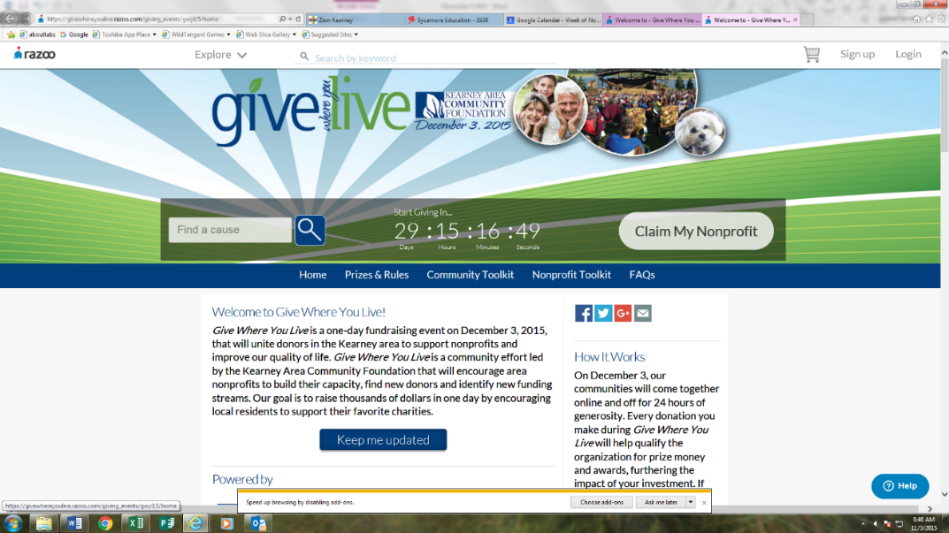if you would rather in person feel free to stop by the office. Please share this with your family and friends.

**Announcements – November 26, 2017**

Please remember...to silence your cell phone upon entering the sanctuary.

Zion’s sanctuary is equipped with a **HEARING LOOP**. Please switch hearing aids to T-coil mode.We have 2 headsets and receivers that persons without hearing aids can use. Ask an usher for assistance.



**Forgot your offering? Don’t have your checkbook or cash? Today or any day you can give in a new way! Visit our website at zionkearney.com and click on the “giving” tab. Or, text “zionkearney” (one word) to 77977. You’ll receive a text back with instructions to start giving.**

**Voters Meeting – Today**

A Voters meeting is scheduled for Sunday, November 26 at 10:30 in the Fellowship Hall. Business will include election of officers and board members for 2018.

**Decorating the Church for Christmas**

Come one come all to join in the festivities of decorating the Church for Christmas. Have fun and fellowship while decorating on Saturday, December 2nd beginning at 9:00 am. Stay for as long as you can, bring the entire family and start a new tradition. **We would really appreciate some men to help with the tree assembly.** Hope to see you on December 2nd.

**Advent**

Next Sunday is the first Sunday in Advent. We will have special Advent Services Dec. 6, Dec. 13 & Dec. 20 at 7:00 pm each evening. We are also planning to serve a meal before each Advent Service beginning at 5:30.

**Christmas Caroling – Next Sunday**

Please join us in singing Christmas carols to the shut-ins December 3 at 2:00 p.m. They really appreciate and enjoy the beautiful music. No special music knowledge is needed, just the enjoyment of singing traditional Christmas carols. The time commitment is about 1 ½ - 2 hours max. Please meet at the church.

**Christmas Eve Program Practice**

The rehearsal dates for the Children’s Christmas Eve program will be 12/9, 12/16, and 12/23. The rehearsals will be 9:30-11:00.

After the rehearsal on Dec. 23 the children will go Christmas Caroling, return to Zion for pizza and then go ice skating. Please note that our Sunday School children who are not participating in the Christmas Eve service are welcome to join us. Please meet us at the church at 11:00.

**Holiday Pies**

Thank you to all who purchased holiday pies from our school children. Because we have to purchase pies in full cases, we have some of each variety left. If you are interested in purchasing any of these for your holiday celebrations, please speak with Lisa or Shirley after the service today.

**Lifetouch Pictures**

An additional group of 8 x 10 directory photographs were received at the office this week. If you have not received yours yet, please check with Shirley after the service today.

**Mission Sunday**

Over $500 was collected for Issues, Etc. If you still wish to contribute to this, you may do so until the end of November.

**Raising Cane’s Fundraiser**

**Zion will be having an in-store fundraiser at Raising Cane’s on Thursday, December 14th from 6:00-9:00 p.m.** Purchase anything from Raising Cane’s mention Zion Lutheran and we will earn 20% of sales. Treat yourself out this night, make cooking easier during the busy time of December and earn money for the school. Don’t forget to mention Zion Lutheran School!

**Devotional Books**

Are you looking for a special gift for yourself or for some other special person? The Book nook has copies of Pastor Allwardt’s 3 devotional books available. They would be great “reading.” Pastor would be happy to sign one for you.

Stop in and check them out!

**Thank You**

Thank you all for the thoughts and prayers while I’ve been recovering from my broken ankle. I’m healing and will be more mobile soon. Thank goodness.

Marion Richmond

**THANK YOU** for the celebration on Sunday of the 25th anniversary of my ordination. I am humbled and grateful for all your gifts, cards, prayers, and kind words. Carol and I were overwhelmed with the evening and your generosity! It is an honor to be the Lord’s servant at Zion, and to work with you in service to Him. To God be the glory! Pastor and Carol DeLoach

**Stewardship Note**

**Matthew 25:44** “Then they also will answer, saying, 'Lord, when did we see you hungry or thirsty or a stranger or naked or sick or in prison, and did not minister to you?'” With this parable Jesus once again emphasizes that our good works come from who we are, not the other way around. Sheep do sheep works, and goats do goat works. So first things first: if we want to live more faithfully, let us come to Jesus, receive His gifts, and ask him to increase our faith!

