**Devotional Books**

Are you looking for a special gift for yourself or for some other special person? The Book nook has copies of Pastor Allwardt’s 3 devotional books available. They would be great “reading.” Pastor would be happy to sign one for you.

Stop in and check them out!

**School News**

* The date for the school Christmas Program has been set for Sunday, December 10 at 4:30 pm.
* Scrip cards for the new Raising Cane’s restaurant are available in the Booknook.
* We have received word that the Labels for Education (Campbell’s Soup labels) Program is coming to an end. Please turn in any labels that you have collected for us as soon as possible. Our last day to submit these is January 2, 2018.

**Thank You**

I want to thank everyone for all that they have done for me while I have been in the hospital and recovering. Thank you to the Pastors and friends for prayers, the many goodies, cards, visits, and phone calls. I appreciate everything and all that the Zion Church & School family have done.

Many blessing to everyone!

Evelyn Heiden

**Stewardship Note**

**Jeremiah 23:6** “And this is the name by which he will be called: 'The LORD is our righteousness.'” Jesus is our righteousness, our justification, our all. In Jesus we are forgiven and receive every blessing from the Father. This knowledge sets us free to live as children of the Heavenly Father without fear. Freed from the supposed need to justify ourselves, good works can be done by us for the *right* reason: to thank God and to serve our neighbor.



**Announcements – December 3, 2017**

Please remember...to silence your cell phone upon entering the sanctuary.

Zion’s sanctuary is equipped with a **HEARING LOOP**. Please switch hearing aids to T-coil mode.We have 2 headsets and receivers that persons without hearing aids can use. Ask an usher for assistance.

**Forgot your offering? Don’t have your checkbook or cash? Today or any day you can give in a new way! Visit our website at zionkearney.com and click on the “giving” tab. Or, text “zionkearney” (one word) to 77977. You’ll receive a text back with instructions to start giving.**

**Christmas Caroling – Today**

Please join us in singing Christmas carols to the shut-ins today at 2:00 p.m. They really appreciate and enjoy the beautiful music. No special music knowledge is needed, just the enjoyment of singing traditional Christmas carols. The time commitment is about 1 ½ - 2 hours max. Please meet at the church.

**Advent**

Today is the first Sunday in Advent. We will have special mid-week Services Dec. 6, Dec. 13 & Dec. 20 at 7:00 pm each evening. We are also planning to serve a meal before each Advent Service beginning at 5:30.

Wednesday, December 6 The Board of Education will be serving Egg casseroles, rolls and fruit in our fellowship hall. There will be a freewill offering.

**Church Christmas Decorating**

Thank you to all who helped decorate the church for the Christmas season!

**Christmas Eve Program Practice**

The rehearsal dates for the Children’s Christmas Eve program will be 12/9, 12/16, and 12/23. The rehearsals will be 9:00-10:30.

After the rehearsal on Dec. 23 the children will go Christmas Caroling, return to Zion for pizza and then go ice skating. Please note that our Sunday School children who are not participating in the Christmas Eve service are welcome to join us. Please meet us at the church at 11:00.

**Give Where You Live**

This year Zion Lutheran School will be participating in the Give Where You Live Campaign. It will be December 7 (giving day), but donations will be accepted beginning November 1st. To participate/contribute online go to: <https://www.givewhereyoulive.net/ZionLutheranSchool>

if you would rather in person feel free to stop by the office. Please share this with your family and friends.

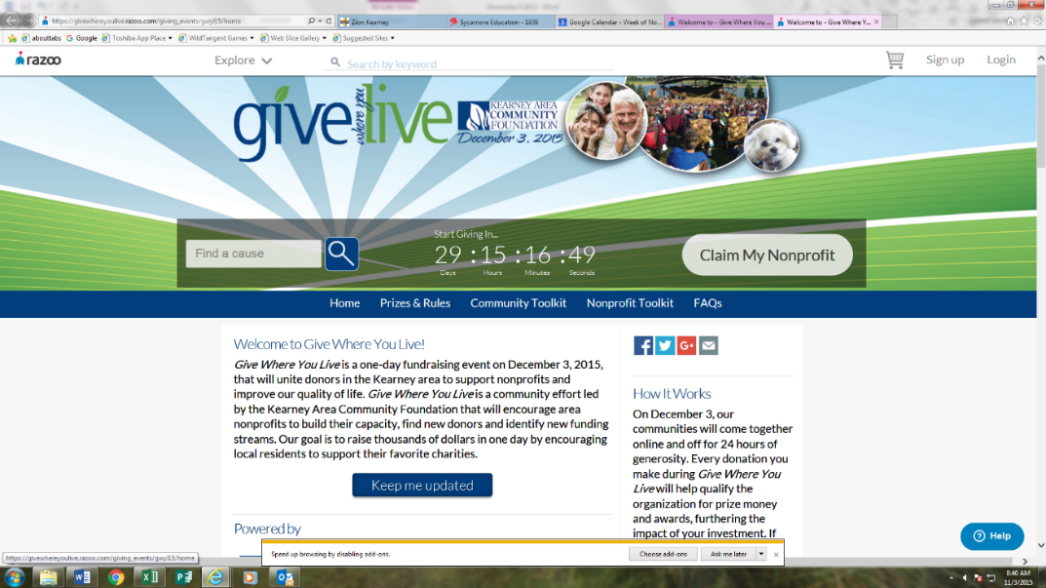

**Raising Cane’s Fundraiser**

**Zion will be having an in-store fundraiser at Raising Cane’s on Thursday, December 14th from 6:00-9:00 p.m.** Purchase anything from Raising Cane’s mention Zion Lutheran and we will earn 20% of sales. Treat yourself out this night, make cooking easier during the busy time of December and earn money for the school. Don’t forget to mention Zion Lutheran School!

**Saturday Worship**

Please note that we will have 5:00 pm Saturday worship services December 3, 10 & 17. On Saturday, Dec. 24 we will have the 7:00 pm Christmas Eve service only and on Saturday, December 31 we will have a 5:00 pm New Year’s Eve service only.

**Zion Youth Group**

Save the Date:

Youth Christmas Celebration

December 17th, 10:30 a.m.

Details to Follow!

Keep an eye out for details about a Storm hockey game in January!

MC900030653[1]**Poinsettia**

We will be using poinsettias decorate our Church this Christmas season.  If you wish to provide a poinsettia, the cost will be $12.  To avoid confusion, please place your money in an envelope and turn in to the church office. Checks should be made out to Mary Martha.

**Year End Reports**

The Chairman of each board and organization is asked to turn in a Year End Report to the Church office. The most convenient way to receive these is by email [school@zionkearney.org](mailto:school@zionkearney.org)

**Zion Christmas Cards**

For those of you needing Christmas greeting cards, we do have a supply of cards that feature pictures of our sanctuary decorated for Christmas available in the book nook.

**Radio Broadcast & Flower Charts**

The Altar Flower and Radio charts for 2017 are on the bulletin board across from the mailboxes. The cost to sponsor a radio broadcast is $161.50 per week. Families are welcome to go together to sponsor a broadcast.

**Holiday Pies**

Thank you to all who purchased holiday pies from our school children. We have some remaining to sell. If you are interested in purchasing any of these for your holiday celebrations stop by or call the office.

**Lifetouch Pictures**

8 x 10 directory photographs are at the office. Please stop by and pick yours up.

