P.E.A.C.E 2018
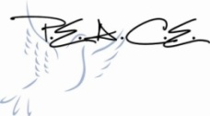
One of the major fundraisers for the Zion Parent-Teacher League is our annual dinner and auction. Our 2018 P.E.A.C.E. (People Excited About Christian Education) Auction and Dinner will be held on March 17th. Alumni guest speakers this year are Stephanie Glanzer and Leslie (Glanzer) Suffredini. These women are daughters of Bob and Wanda Glanzer.
Please remember that there is a $5 per ticket discount if you purchase by February 26th. Tickets may be purchased at the office.
Organizers are also asking for suggestions of items you would like to see on the auction. If you have ideas please let us know at the office.

School News
- Enrollment for the 2018-2019 school year is underway. The 2 morning pre-kindergarten classes are full. We have openings in the afternoon pre-kindergarten class and both pre-school classes as well and kindergarten.
- Our boys and girls basketball teams are wrapping up their seasons this weekend at the c-club tournaments in Seward.
- Are you or someone you know looking for a top-notch kindergarten? We would love to have you join our Zion school family. Please speak with Mr. Splittgerber or the office staff about enrolling.
- Apple Market receipts are due to the office March 1st.

Pancake Feed –
There will be a pancake feed Saturday, March 10, at the Zion School Gym. Pancakes and sausages will be available for a freewill donation from 7:30 am to 12:00 pm. The donations will go the Zion Lutheran School Foundation.

Announcements – February 25, 2018
Thou shalt silence your cell phone during worship.
Our sanctuary has a HEARING LOOP. Please switch hearing aids to T-coil mode. We have 2 headsets and receivers for use by those without hearing aids. Ask an usher for assistance.

Forgot your offering? Don’t have your checkbook or cash? Today or any day you can visit our website at zionkearney.com and click on the “giving” tab. Or, text “zionkearney” (one word) to 77977. You’ll receive a text back with instructions to start giving.

For Your Safety and Security … all exterior doors are locked 15 minutes after the church service begins. If you are running late please go to the west door for access to the sanctuary.

Our Lenten “A Season for Sacrifice” series on Biblical stewardship continues today. Last week we talked about how Lent is a time to focus on the many sacrifices our Savior made for us throughout His ministry. All that leads up to the final sacrifice He made when He suffered and died on the cross for our salvation. That’s the Good News that inspires us to be good stewards of God’s gifts. Today we remember that being sacrificial first fruits percentage givers (Biblical stewardship) begins with “Sacramental Worship.” The Holy Spirit works through the Word and Sacraments to keep our minds on the “things of God” rather than “the things of man” through worship and Bible study, Bible reading, and personal devotion. The purpose of today’s survey cards is to encourage mindful use of God’s means of grace.

Join us for Lenten Vespers… each Wednesday throughout this season. We will be studying the Six Chief Parts of the Small Catechism under the theme "Dying and Rising with Christ." This week we will consider the The Lord’s Prayer
Preceding the service the stewardship/evangelical boards will be serving Brats and a variety of desserts. The meal is in Fellowship Hall beginning at 5:30.There is a freewill donation.

Opportunities to Worship during Lent
DATE | Service Time | LENTEN MEALS AT 5:30 -SERVED BY
February 28 | 7:00pm | Evangelism/Stewardship
March 7 | 7:00pm | Youth
March 14 | 7:00pm | Board of Education
March 21 | 7:00pm | Elders /Trustees
March25 | 9:00am | Palm Sunday Meal @ 11:30
March 29  Maundy Thursday | 7:00pm
March 30  Good Friday Service | 2:00pm | Fellowship Hour Following
March 30  Tenebrae Service | 7:00pm
March 31  Easter Vigil Service | 7:00pm
April 1  Easter Sunrise Service | 7:00am | Easter Breakfast served  8:00-8:45
April 1  Easter Festival Service | 9:00am

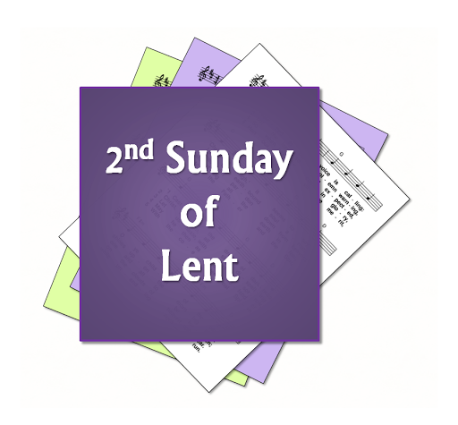

Zion Youth Group
The Zion youth will be having a game night on
March 4th at 5:30 pm in the Zion Fellowship Hall a light supper will be provided.

Youth please be prepared for March 7th. This is the Wednesday that the youth will be serving the Lent meal.

Raising Cane’s Fundraiser
Please join Zion on March 8th from 5:00-8:00 at Raising Cane’s for another fundraiser. Mention Zion when ordering please. Don’t forget your scrip gift cards! Enjoy a night out and support Zion.

The Sower
March will be the last month that the Sower will be placed in your mailbox. The Sower will either be emailed to you or if you would like a paper copy there will be ones available in the narthex. Please provide the office with your most current email address to stay up-to-date on Zion happenings.

Stewardship Note

Mark 8:32 – “And he said this plainly. And Peter took him aside and began to rebuke him.” Anytime we sin we are acting like Peter: thinking we know better than the Lord. But as Jesus says, such acts stem from Satan. So let us repent: let us trust our Lord Jesus and follow Him. For certainly He has earned our trust with His gracious sacrifice for us.

Thank You
Thank you to all who attended the Ash Wednesday meal hosted by Mary Martha. Thanks to your generous donations $474 has been added to the Roof Replacement Fund. Thank you also to the Thrivent Action Team who provided much of the food.

