**Sleeping Mats**

The Sleeping Mat group has been meeting for 3 years this past August. We have sent 158 sleeping mats through the Grand Island Orphan Gran Train mainly for international aid. (Recycling about 95,000 bags) Special thanks to Kay & Dave Banner, Pat & Jim Catterson, Linda & Craig Nuttelman, Nancy & Mark Dissmeyer, Carolyn & Lewis Westman and Blance Horst (from Ravenna) for all their hard work of flattening, cutting and knotting. Also huge thanks to Pat & Kay for crocheting most of those 158.

Margaret & Norbert Smith

**Stewardship Note**

**James 2:2 – “For if a man wearing a gold ring and fine clothing comes into your assembly, and a poor man in shabby clothing also comes in.”** God shows no partiality: rich and poor alike are called into the Kingdom. And both rich and poor alike have something to contribute to the Kingdom in accordance with the callings God has given them in their lives. This is why both the Old and New Testaments talk about proportional giving – that is, giving a proportion of our income to the Lord’s work. This makes it possible for rich and poor alike to have the honor of supporting God’s work.

**Ways to Help our School**

**Big G Boxtops**

Found on many General Mills products. We receive 10c for each one.

**Family Fresh Register Receipts**

When we get $150,000 worth, we’ll receive $1,000.

**UPCs** from Our Family products available at Family Fresh

We receive $25 for every 500 UPCs.

**Apple Mart Register Receipts**

Save receipts dated Sept. 1, 2018 through March 2, 2019



**Announcements – September 9, 2018**

**Please silence your cell phone during worship**.

Our sanctuary has a **HEARING LOOP.** Pleaseswitch hearing aids to T-coil mode. We have 2 headsets and receivers for use by those without hearing aids. Ask an usher for help.

**Forgot your offering**? Don’t have your checkbook or cash? Today or any day you can visit our website at zionkearney.com and click on the “giving” tab. Or, text “zionkearney” (one word) to 77977. You’ll receive a text back with instructions to start giving**.**

**For Your Safety and Security …** all exterior doors are locked 15 minutes after the church service begins. If you are running late please go to the west door for access to the sanctuary.

**Mission Sunday- Today**

Today is Mission Sunday. This month we will support our college and seminary students who are studing for full time church work.

Mission gifts will be given to support Matthias Wollberg who is in his fourth year of study at Concordia Seminary, Ft. Wayne and Abigail DeLoach who is in her first year of study at Concordia, Seward,to become a Lutheran school teacher. There are special Mission Envelopes in the Narthex that may be used. All gifts should be clearly marked and placed in the offering plate. If you are not prepared today, gifts will be received for the rest of this month.

**Youth Planning Meeting Today**

Following the service today, all 7th -12th grade youth and their parents are asked to stay for a brief meeting. We will be planning youth activities for the coming months. The board has some ideas and welcomes input from the youth familes.

**Golf Scramble Today**

Zion Lutheran is hosting its Annual 2 Person Golf Scramble. The golf tournament will take place at the Elks Country Golf. Cost is $60 per team (two divisions: 2 adults or 1 adult/1child) which includes 18 holes of golf and dinner. If interested in participating or sponsoring a hole for $50, Registration forms are available in the office area. Good golf skills not required.

**Special Music…**

ADULT CHOIR AND HANDBELLS will both begin Wednesday, September 12.  Handbells meet at 6:00 pm in the balcony, with adult choir following at 7:00 p.m.

**Adult Instruction Class**

A new adult instruction class began last week. It was decided that meeting on Thursday works better for the group so the class time has changed to Thursdays at 7:00. It is not too late to join this class.

**Midweek Class**

Midweek classes began Wednesday, September 6. Classes are from 5:45 to 7:00 pm. This class is for all Zion public school youth, who are in the 4th grade or older. Students need to bring a 3 ring binder (one inch or more), their bible, and their catechism. First year students will receive a catechism.

A class schedule and assignment sheet will be distributed at the first class. Call Pr. DeLoach (308-627-5860) with any questions.

**Congratulations…** to Leif and Keri Hansen at the birth of their daughter, Ella Rose Hansen, who was born on Saturday, Sept. 1,2018!

**Help Needed next Saturday**

The Trustees will be recoating the school roof on Saturday, Sept 15 at 1:00 pm.  If they do not finish on Saturday, they plan to do so on Sunday afternoon. They need and would appreciate, help from the congregation.  Please call the church office if you can help.

234-3410

Mary Martha Guild

Mary Martha circles will meet Monday, September 10th at 7:00 at the following places:

Peace Circle (Margaret’s) will meet at Carol Gaunt’s home 4705 10th Ave. Pl.

Love Circle (Bev’s) will meet at Carol DeLoach’s home -3510 14th Ave.

ZYG

**Fall Youth Activities**

September

**Sept.9: Youth in 7th -12th grade and their parents meet after Church at 10:15 in the sanctuary to plan fall activities**



Sept.23: Fall Kick Off - outdoor activities at the Wilkens Farm

October

Oct.7: Game Night, make your own pizza

Oct.28: Pumpkin Patch, Pumpkin Carving Competition

November

Nov.11: Rake and Run, Followed by Something Warm



December

Bible Hour Gift Exchange?

Dec. 22: Caroling, Ice Skating

Looking Ahead:

Higher Things at Concordia Seward

June 24-27, 2019

Register by November 1 before it fills!

**Bryceton Herrera Silent Auction and Luncheon Benefit**

Sunday, September 30th from 11:30 to 3:00 at Zion Lutheran Church

**Raffle Tickets:**Thanks to donations from Builder’s Warehouse and Kearney Moving, we will have 3 raffle items.  First Prize: Weber 2 Burner Grill (purchased at a discounted price at True Value). Second Prize: Yeti Hopper Flip 18 Cooler. Third Prize: $100 Hy-Vee Gift Card.  Tickets are 1 ticket for $5 or 5 tickets for $20. Winners will not need to be present to win. Tickets can be purchased at the Zion office or through Michelle Millsap, Lisa Splittgerber, Amy Woodman, or Darcy Willers.

**Window Decals:**Another way to support Bryceton is

to purchase window decals.  Decals are $5 per decal and are available at the Zion office or through Amy Woodman today after church.

Auction items are currently being gathered.  We are asking that items be turned in no later than September 15th.  Volunteers are also needed. People are needed to help before, during, and after the benefit.  Zion members are asked to bring cookies and bars for the dessert. Please contact Michelle Millsap at 308-233-7398 to sign up to donate items, volunteer to work, and/or to bring desserts or with any questions.

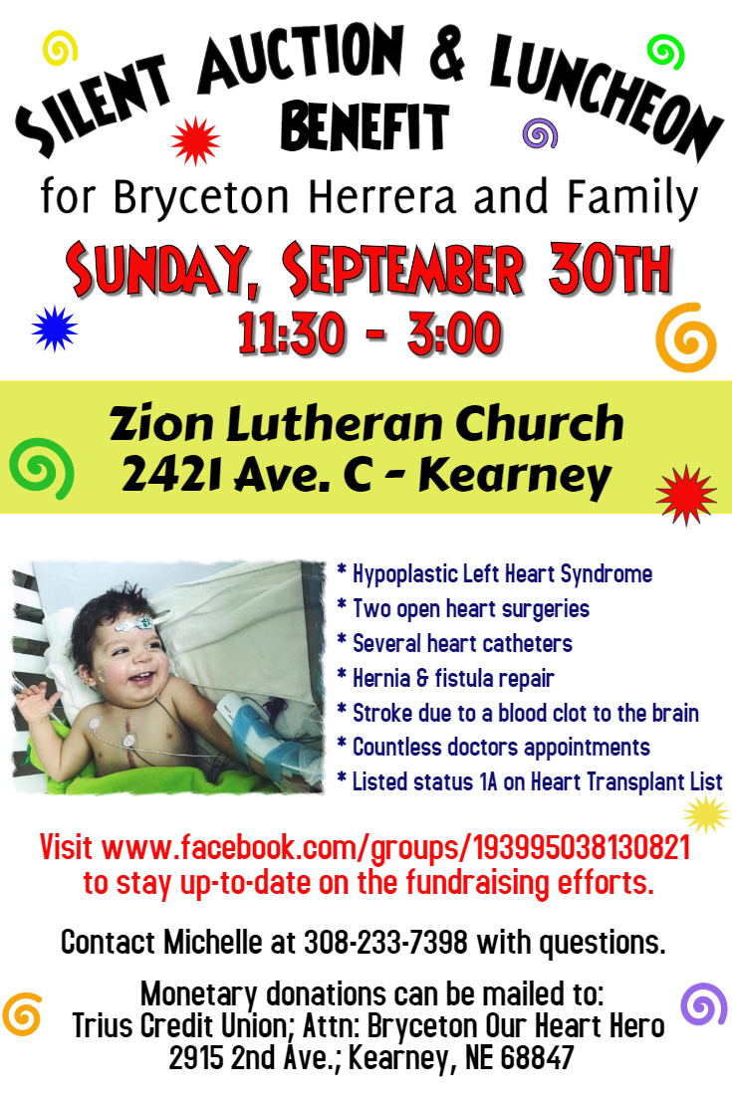

**Bryceton Herrera Silent Auction and Luncheon Benefit**

Sunday, September 30th from 11:30 to 3:00 at Zion Lutheran Church

**Raffle Tickets:**Thanks to donations from Builder’s Warehouse and Kearney Moving, we will have 3 raffle items.  First Prize: Weber 2 Burner Grill (purchased at a discounted price at True Value). Second Prize: Yeti Hopper Flip 18 Cooler. Third Prize: $100 Hy-Vee Gift Card.  Tickets are 1 ticket for $5 or 5 tickets for $20. Winners will not need to be present to win. Tickets can be purchased at the Zion office or through Michelle Millsap, Lisa Splittgerber, Amy Woodman, or Darcy Willers.

**Window Decals:**Another way to support Bryceton is to purchase window decals.  Decals are $5 per decal and are available at the Zion office or through Amy Woodman today after church.

Auction items are currently being gathered.  We are asking that items be turned in no later than September 15th.  Volunteers are also needed. People are needed to help before, during, and after the benefit.  Zion members are asked to bring cookies and bars for the dessert. Please contact Michelle Millsap at 308-233-7398 to sign up to donate items, volunteer to work, and/or to bring desserts or with any questions.

