School News
- Save your Apple Market receipts dated September 1, 2019 – March 2, 2020 and turn them into the office for the school to earn FREE rewards.

- The school is saving Family Fresh receipts. If you shop at Family Fresh save your receipts and turn them into the office.
- Pies will be available on Wednesday, November 20th from 3:30-6:00 pm.

- The Zion school students in grades 3rd-8th will sing at Zion on November 24th during service.

- Give Where You Live will be held December 5, 2019. Zion will participate again this year. Online giving day will be December 5th from midnight to midnight. If you wish to donate other than online you may drop your donation off during regular office hours at the church/school office.

- Mark your calendars. The Zion School Christmas program will be Sunday, December 15th at 4:00 p.m. This is for students in Kindergarten-8th grade.

- Basketball practices for boys and girls will begin soon for 5th-8th grade. Since this is a club team, all Zion members in grades 5-8 who attend public school are welcome to be on the team. Please contact Mr. Splittgerber for more information.

- 2020-2021 Enrollment will begin soon for returning families and for Zion members only. Enrollment will be open to the public on January 6, 2020.

- The office will be closed Wednesday-Friday, November 27-29. If you will need into the office during those times please make arrangements before.

- Do you like science? Zion Lutheran School is adopting a new science text and program to replace the current text which is about 18 years old. The purchase of the classroom kits is costly, nearly $2,000 per class. If you would like to help the school with a donation to offset this cost, please make out a check to Zion Lutheran and note SCIENCE on the memo line. If you would like more information, please see Mr. Splittgerber. Thank you!

Announcements – November 17, 2019
Thou shalt silence your cell phone during worship.
Our sanctuary has a HEARING LOOP. Please switch hearing aids to T-coil mode. We have 2 headsets and receivers for use by those without hearing aids. Ask an usher for assistance.

Forgot your offering? Don’t have your checkbook or cash? Today or any day you can visit our website at zionkearney.com and click on the “giving” tab. Or, text “zionkearney” (one word) to 77977. You’ll receive a text back with instructions to start giving.

Thank you – Grace Burger for the beautiful music you provided for us this morning!

Zion Family Thanksgiving Dinner – TODAY - The Mary Martha Guild invites all members of Zion to join them as we give thanks to God for all that He has done. Make plans to join us for the Family Thanksgiving Dinner TODAY, at 11:30am in the gym. Mary Martha will provide the turkey, dressing, potatoes, gravy, green bean casserole, dinner rolls, salads, desserts, drinks, and table service. Come join us as we give thanks. A free will offering will be taken with the proceeds going to support Abigail DeLoach and Taylor Zehendner who are studying for full time church work.

Senior Citizens – will meet for their monthly potluck and fellowship on Monday, November 18th at 12:00 pm. Everyone is invited!

Men’s Bible Study - Our Men’s Bible Study will meet Thursday, November 21st at 7:00 pm.

Voters’ Meeting – The quarterly voters’ meeting will be held on Sunday, November 24th at 10:30am in the fellowship hall.

Office Closed – the office will be closed Wednesday-Friday, November 27-29. If you will need into the office during those times please make arrangements before.
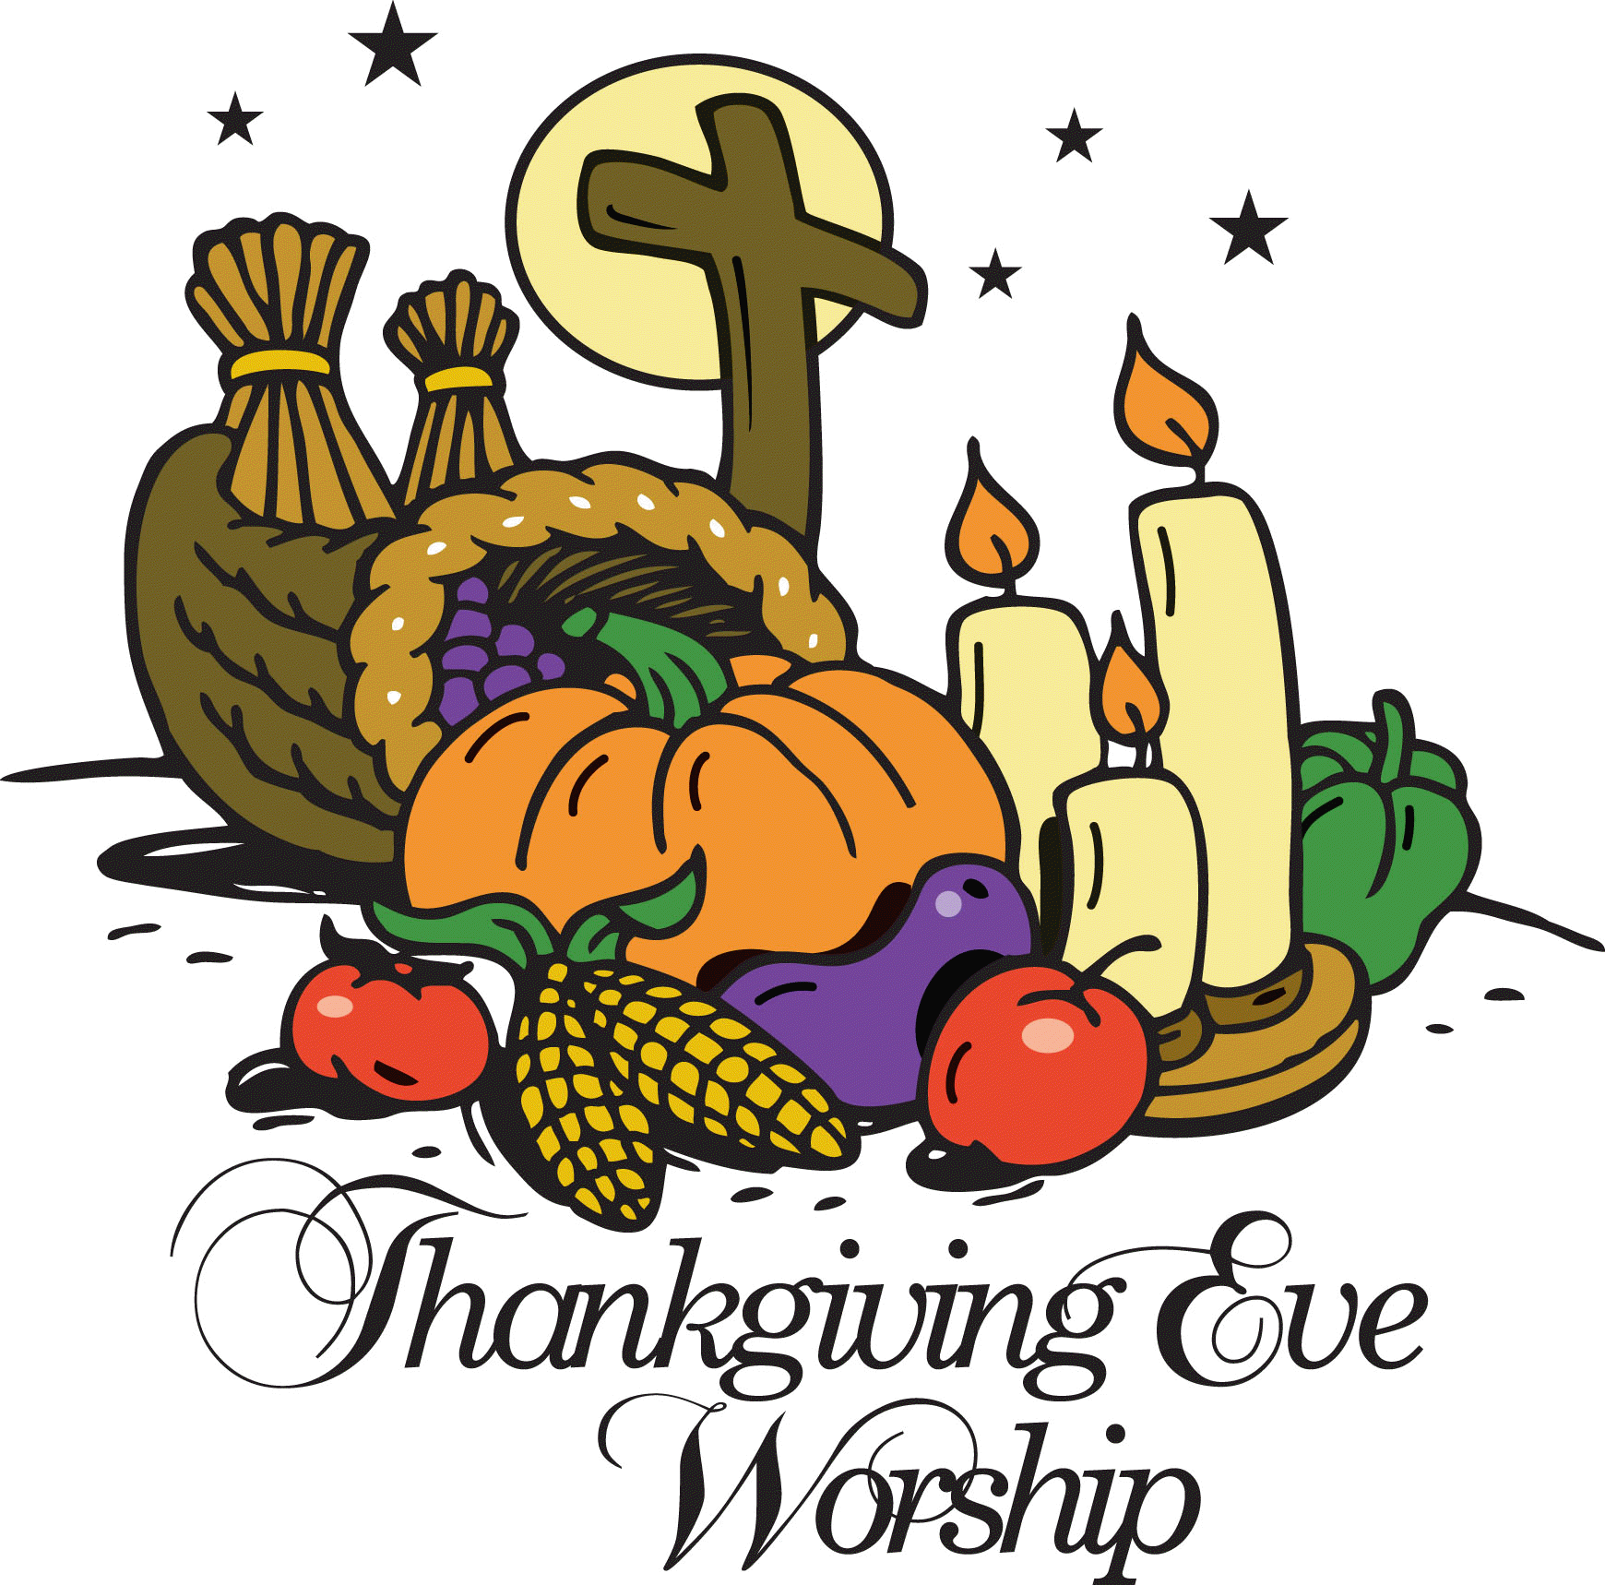
Thanksgiving Eve Worship - We extend a very special invitation to you and your family to come and worship with us on Wednesday, November 27, at 7:00 p.m. For those who have guests visiting, we also invite them to come and worship with us.

Zion Youth – December 1st the youth group is planning an ice skating party. Plan to attend this fun event and bring a friend! More details to come in the coming weeks.

Radio Broadcast and Flowers – Zion is in need of radio broadcast sponsors. Please consider sponsoring a radio broadcast, several families can sponsor together, or providing altar flowers to beautify the sanctuary. The sign up sheet is on the board across from the mailboxes. There are several open dates. Sign up today! The 2020 sheets are up, so sign up early to get your date!

Poinsettia - We will be using poinsettias to decorate our Church this Christmas season. If you wish to provide a poinsettia, the cost will be $13. Orders are due into the office by Monday, December 2. To avoid confusion, please place your money in an envelope and turn in to the church office. Checks should be made out to Mary Martha.

Book Nook – The book nook has Zion Lutheran Church Christmas cards for sale. They are priced at $2.00 for a package of 12 cards and envelopes. The book nook also offers an assortment of all occasion greeting cards. A box is $4.50 and individual cards are $0.50. Stop by today for all of your card needs. Scrip is also available for purchase in the book nook on Sunday mornings or at the office during office hours. Scrip cards work great for gifts or for yourself. Support Zion and purchase a scrip gift card today!

A CHRISTMAS GIFT TO LAST ALL YEAR - -The Book Nook has copies of the daily devotional books written by Pastor Allward: Rainbows and Rattlesnakes" and "More Rainbows Than Rattlesnakes", for sale @ $12 each. These sales also support local missions as well as the Ysleta Hispanic Mission in El Paso, TX. His third book, Messages from the Coast", has a longer meditation for each week of the year - also costs $12. Discounts are available for purchasing a number of copies at the same time (see Pastor Allwardt for details).

Food Collection - Zion will collect food items during the month of November to help supply Kearney agencies who assist the needy. There are grocery carts in the narthex and school area to gather these items. Non-perishable items only please.

Adult Handbells – The adult handbell practice schedule has changed. The dates for handbell practice will be November 20, December 4, and December 18.

Thank You – I would like to thank all members and friends of Zion who helped me celebrate my 90th birthday and for the cards and gifts. Thanks for making it special.
Blessings, Rose Ann Braden

Zion’s Mission Projects - The 4th Quarter missions are being collected for church work student support. Current church work students are Abigail DeLoach and Taylor Zehendner both at CUNE. Please use a special mission envelope located in the narthax and clearly mark your envelope number and place in the offering plate. Thank you for your supporting this project.

Church Christmas Decorating – Mark your calendar to help ring in the Christmas spirit and decorate the Church for Christmas. The date for decorating will be Saturday, December 7th at 11:30 am. Stay as long as you like. We would really appreciate some men to help with the heavy items.

HLHS Blood Drive – On Tuesday, November 19th from 8:30a-2:30p the Heartland Lutheran National Honor Society Students will be hosting a blood drive for the Red Cross. The students have set a goal of 30 units to be donated. Please consider donating!

“Christmas Blessings Tour” – The Merryman Performing Arts Center will be presenting Sandi Patty’s “Christmas Blessings Tour” on Friday, December 6th at 7:00pm. Ticket prices are $35/$39/$44. Tickets on sale now at pickmytickets.com or at the Merryman box office at 308-698-8297. A group of 10 or more will receive a 10% discount.

Luke 21:6 – “As for these things that you see, the days will come when there will not be left here one stone upon another that will not be thrown down.” Everything in this world is headed for the graveyard, but some things are also destined to rise from the grave. On that Day of Resurrection, as we look back on our earthly life, what will we see? What will have really mattered? This is a good question to ask ourselves in this season of the Church Year that focuses on the Last Things.

