Divine Service
Reformation Day
(Observed)
October 25, 2020
Zion Lutheran Church
Kearney, Nebraska

Welcome to Zion!
All worshippers please fill out an attendance card in the pew rack and let us know how we might be of service to you.

Holy Communion at Zion

The Lord’s Supper is celebrated at this congregation as Jesus has given it. As he says, our Lord gives into our mouths not only bread and wine but his very body and blood to eat and to drink for the forgiveness of sins and to strengthen our union with him and with one another. Our Lord invites to his table those who trust his words, repent of all sin, and set aside any refusal to forgive and love as he forgives and loves us, that they may show forth his death until he comes. All communicants need to register in the narthex prior to the service.

Because those who eat and drink our Lord’s body and blood unworthily do great harm and because Holy Communion is a confession of the faith which is confessed at this altar, any who are not yet instructed, in doubt, or who hold a confession differing from that of this congregation and The Lutheran Church—Missouri Synod, are asked not to commune until they are able to speak with our pastor first. He is happy to visit with you about the Christian faith and how to receive the Lord’s Supper for your good and for the good of others. Those not communing are invited to come to the altar, cross your arms in front of you, and bow your head to receive a pastoral blessing.

The Son of God Has Set Us Free from Sin and Death by His Grace

“Wisdom is justified by her deeds” (Matt. 11:19), and the true wisdom of God, Christ Jesus, the incarnate Son, justifies us by His deeds. He prepares His way by the preaching of repentance, but He has suffered the violence of the Law and voluntarily handed Himself over to violent men, in order that we may eat and drink with Him in His Kingdom and “remain in the house forever” (John 8:35). He is “a friend of tax collectors and sinners” (Matt. 11:18–19), and He has rescued us by His grace from the slavery of sin and death. By the proclamation of His eternal Gospel “to those who dwell on earth, to every nation and tribe and language and people” (Rev. 14:6), “the righteousness of God has been manifested apart from the law” (Rom. 3:21), “that he might be just and the justifier of the one who has faith in Jesus” (Rom. 3:26). And by the hearing of that Gospel of Christ Jesus, “whom God put forward as a propitiation by his blood, to be received by faith” (Rom. 3:25), “you will know the truth, and the truth will set you free” (John 8:31–32).
Confession and Absolution

655 Lord, Keep Us Steadfast in Your Word
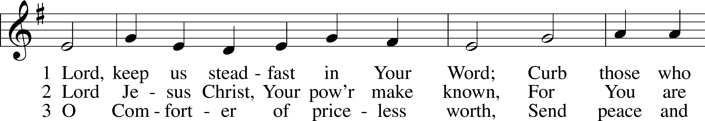
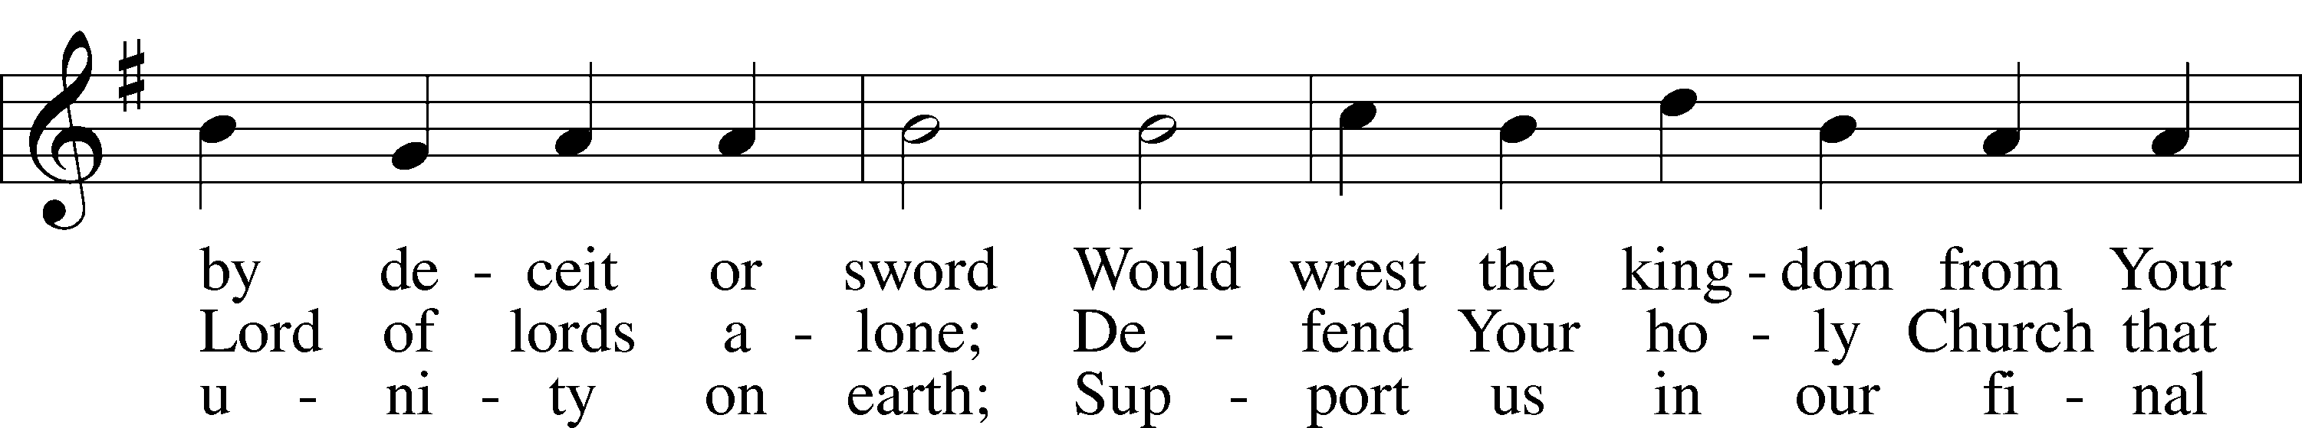
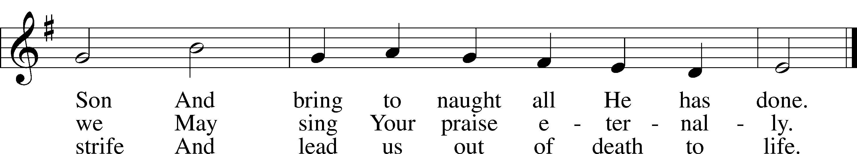
Text and tune: Public domain

Stand

The sign of the cross may be made by all in remembrance of their Baptism.

P In the name of the Father and of the T Son and of the Holy Spirit.
C Amen.

P If we say we have no sin, we deceive ourselves, and the truth is not in us.
C But if we confess our sins, God, who is faithful and just, will forgive our sins and cleanse us from all unrighteousness.

Kneel/Stand

Silence for reflection on God’s Word and for self-examination.

P Let us then confess our sins to God our Father.
C Most merciful God, we confess that we are by nature sinful and unclean. We have sinned against You in thought, word, and deed, by what we have done and by what we have left undone. We have not loved You with our whole heart; we have not loved our neighbors as ourselves. We justly deserve Your present and eternal punishment. For the sake of Your Son, Jesus Christ, have mercy on us. Forgive us, renew us, and lead us, so that we may delight in Your will and walk in Your ways to the glory of Your holy name. Amen.

P Almighty God in His mercy has given His Son to die for you and for His sake forgives you all your sins. As a called and ordained servant of Christ, and by His authority, I therefore forgive you all your sins in the name of the Father and of the T Son and of the Holy Spirit.
C Amen.

Stand

Service of the Word

Psalm Psalm 46; antiphon: v. 7
¹God is our ref- | uge and strength,*
a very present help in | trouble.
²Therefore we will not fear though the | earth gives way,*
though the mountains be moved into the heart | of the sea,
³though its waters | roar and foam,*
though the mountains tremble at its | swelling.
⁴There is a river whose streams make glad the cit- | y of God,*
the holy habitation of the | Most High.
⁵God is in the midst of her; she shall | not be moved;*
God will help her when | morning dawns.
⁶The nations rage, the kingdoms | totter;*
he utters his voice, the | earth melts.
⁷The Lord of hosts is | with us;*
the God of Jacob is our | fortress.
⁸Come, behold the works | of the Lord,*
how he has brought desolations | on the earth.
⁹He makes wars cease to the end | of the earth;*
he breaks the bow and shatters the spear;
he burns the chariots | with fire.
¹⁰“Be still, and know that | I am God.*
I will be exalted among the nations,
I will be exalted | in the earth!”
¹¹The Lord of hosts is | with us;*
the God of Jacob is our | fortress.

Glory be to the Father and | to the Son*
and to the Holy | Spirit;
as it was in the be- | ginning,*
is now, and will be forever. | Amen.

Kyrie LSB 152
A In peace let us pray to the Lord.
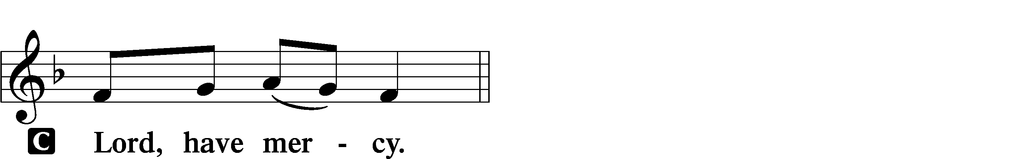

A For the peace from above and for our salvation let us pray to the Lord.
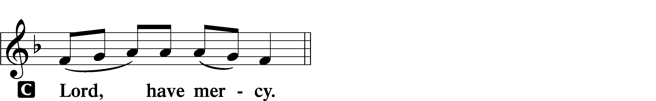

A For the peace of the whole world, for the well-being of the Church of God, and for the unity of all let us pray to the Lord.
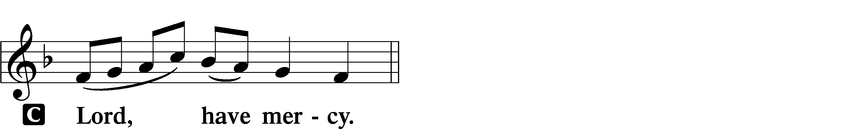

A For this holy house and for all who offer here their worship and praise let us pray to the Lord.
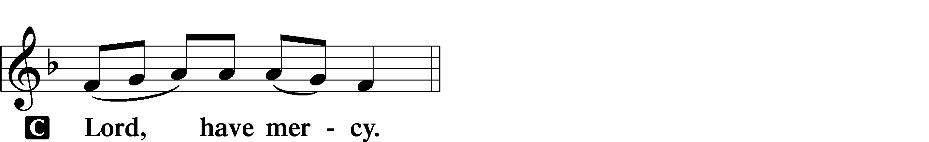

A Help, save, comfort, and defend us, gracious Lord.

Gloria in Excelsis LSB 154
A Glory to God in the highest, and peace to His people on earth.
C Lord God, heavenly king, almighty God and Father:
We worship You, we give You thanks, we praise You for Your glory.
Lord Jesus Christ, only Son of the Father, Lord God, Lamb of God:
You take away the sin of the world; have mercy on us.
You are seated at the right hand of the Father; receive our prayer.
For You alone are the Holy One, You alone are the Lord,
You alone are the Most High, Jesus Christ, with the Holy Spirit,
in the glory of God the Father. Amen.

Salutation and Collect of the Day
P The Lord be with you.
C And also with you.

P Let us pray.
Almighty and gracious Lord, pour out Your Holy Spirit on Your faithful people. Keep us steadfast in Your grace and truth, protect and deliver us in times of temptation, defend us against all enemies, and grant to Your Church Your saving peace; through Jesus Christ, Your Son, our Lord, who lives and reigns with You and the Holy Spirit, one God, now and forever.

C Amen.

Sit
First Reading Revelation 14:6–7
6Then I saw another angel flying directly overhead, with an eternal gospel to proclaim to those who dwell on earth, to every nation and tribe and language and people. 7And he said with a loud voice, “Fear God and give him glory, because the hour of his judgment has come, and worship him who made heaven and earth, the sea and the springs of water.”

A This is the Word of the Lord.
C Thanks be to God.

Gradual Psalm 48:1a, 12–14a
Great is the Lord and greatly | to be praised*
in the city | of our God!
Walk about Zion, go around her, number her | towers,*
consider well her ramparts, go through her | citadels,
that you may tell the next gener- | ation*
that this is God, our God forever and | ever.

Epistle Romans 3:19–28
19Now we know that whatever the law says it speaks to those who are under the law, so that every mouth may be stopped, and the whole world may be held accountable to God. 20For by works of the law no human being will be justified in his sight, since through the law comes knowledge of sin.
21But now the righteousness of God has been manifested apart from the law, although the Law and the Prophets bear witness to it— 22the righteousness of God through faith in Jesus Christ for all who believe. For there is no distinction: 23for all have sinned and fall short of the glory of God, 24and are justified by his grace as a gift, through the redemption that is in Christ Jesus, 25whom God put forward as a propitiation by his blood, to be received by faith. This was to show God’s righteousness, because in his divine forbearance he had passed over former sins. 26It was to show his righteousness at the present time, so that he might be just and the justifier of the one who has faith in Jesus.
27Then what becomes of our boasting? It is excluded. By what kind of law? By a law of works? No, but by the law of faith. 28For we hold that one is justified by faith apart from works of the law.

A This is the Word of the Lord.
C Thanks be to God.

Stand

Alleluia and Verse LSB 156
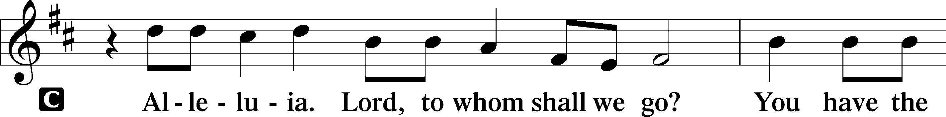
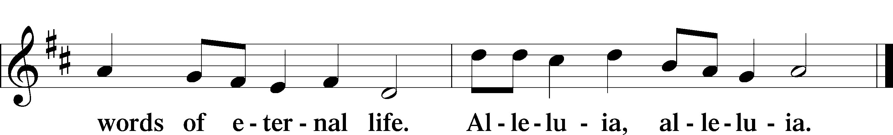

Holy Gospel Matthew 11:12–19
P The Holy Gospel according to St. Matthew, the eleventh chapter.
C Glory to You, O Lord.

12[Jesus said:] “From the days of John the Baptist until now the kingdom of heaven has suffered violence, and the violent take it by force. 13For all the Prophets and the Law prophesied until John, 14and if you are willing to accept it, he is Elijah who is to come. 15He who has ears to hear, let him hear.
16“But to what shall I compare this generation? It is like children sitting in the marketplaces and calling to their playmates,
17“‘We played the flute for you, and you did not dance;
we sang a dirge, and you did not mourn.’
18For John came neither eating nor drinking, and they say, ‘He has a demon.’ 19The Son of Man came eating and drinking, and they say, ‘Look at him! A glutton and a drunkard, a friend of tax collectors and sinners!’ Yet wisdom is justified by her deeds.”

P This is the Gospel of the Lord.
C Praise to You, O Christ.

Sit

657 A Mighty Fortress Is Our God sts. 1–4
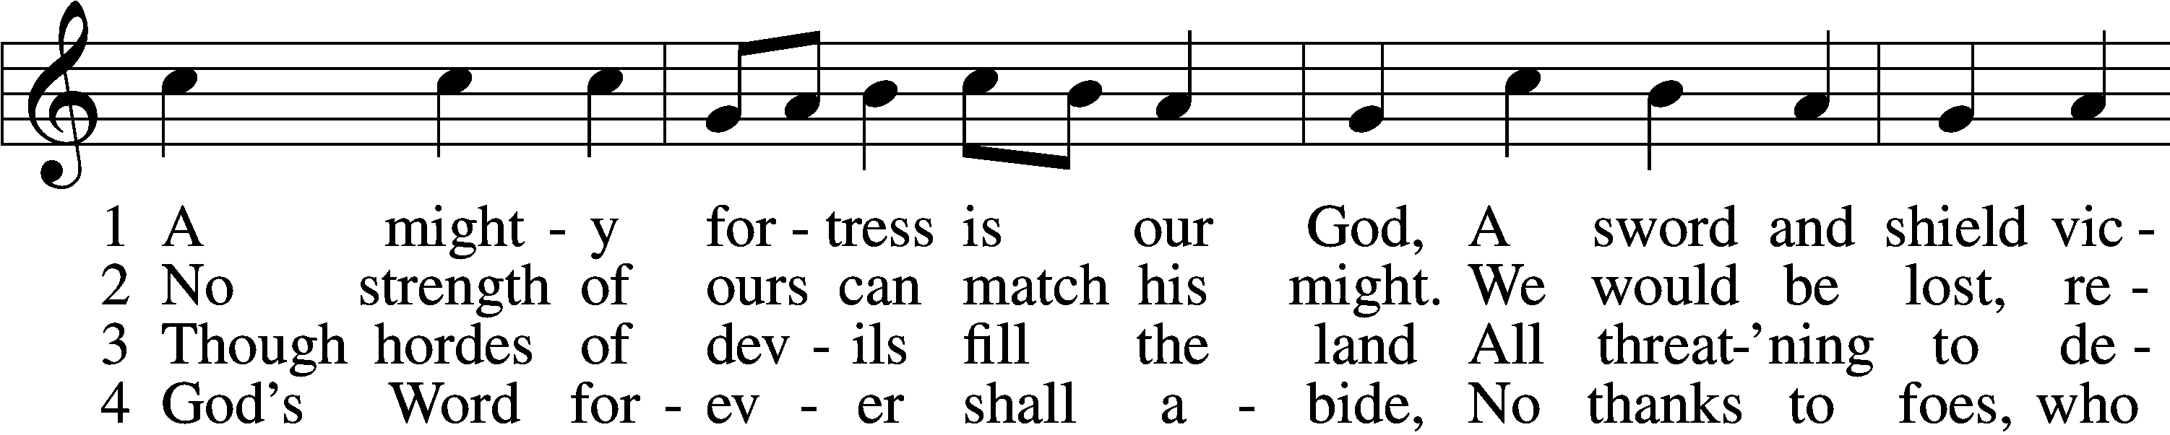
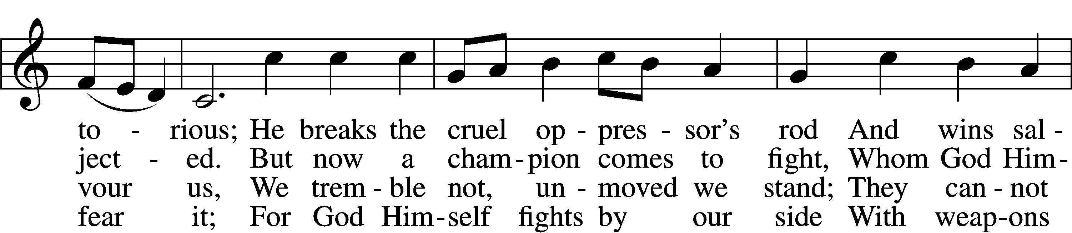
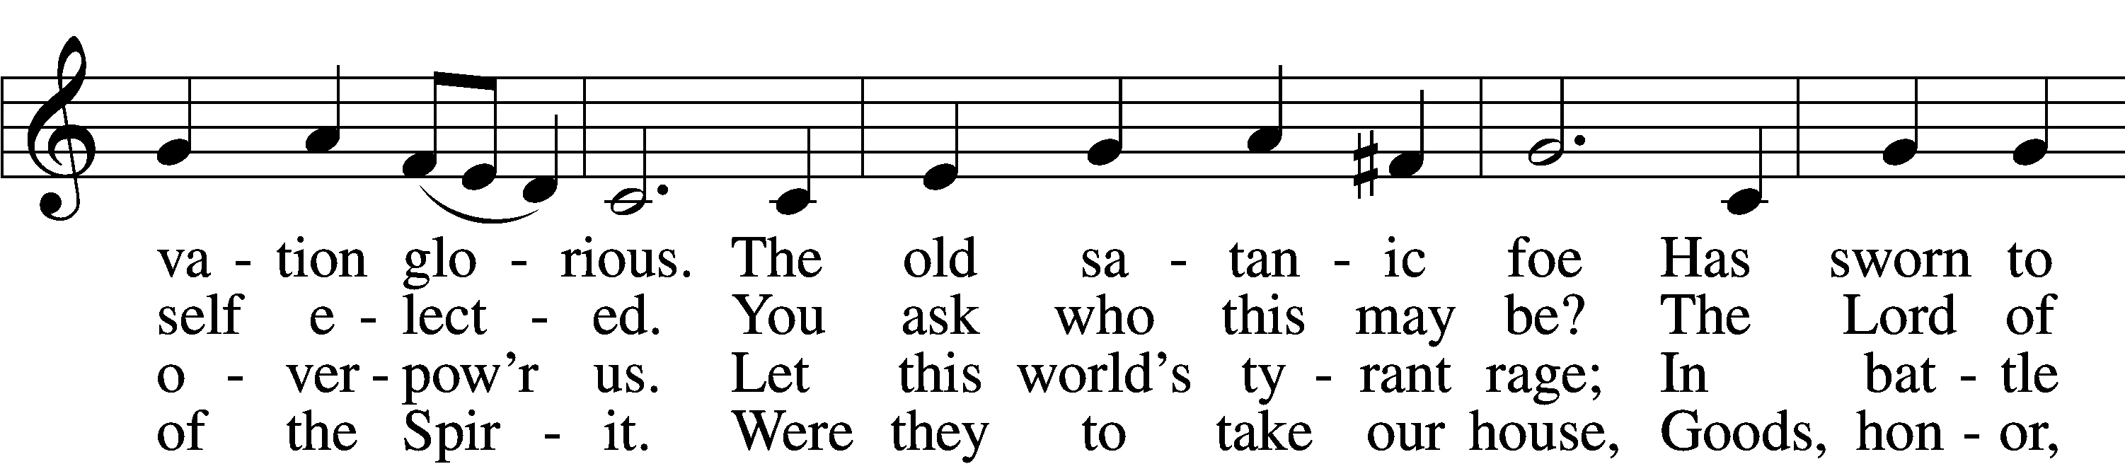
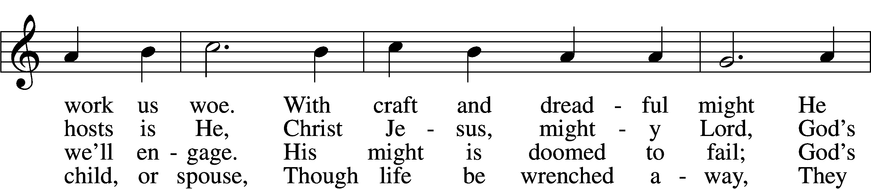
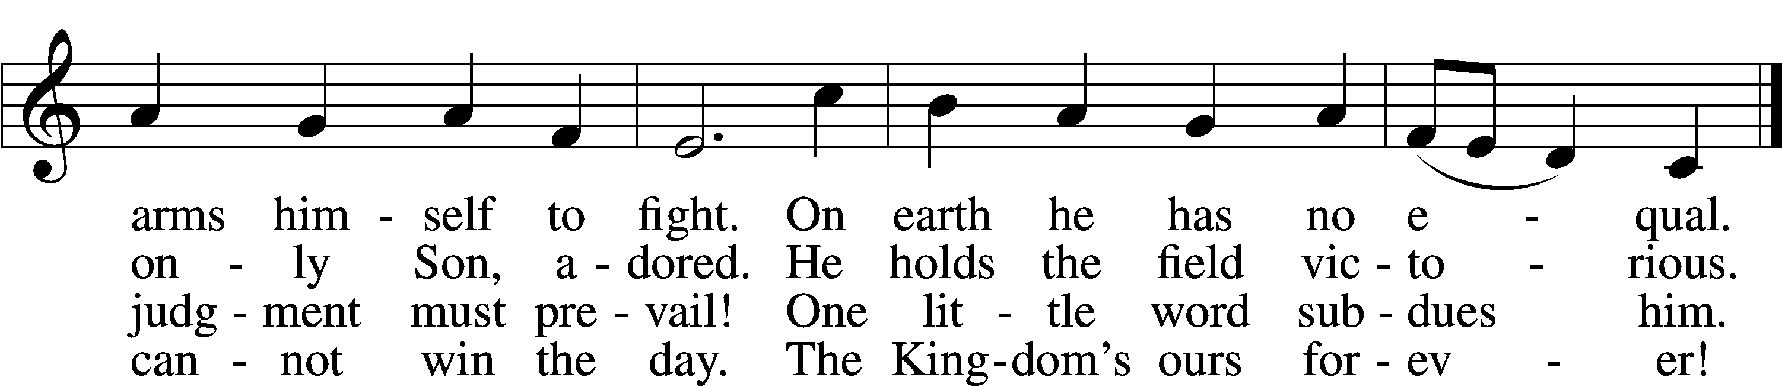
Text: © 1978 Lutheran Book of Worship. Used by permission: LSB Hymn License no. 110003744

Sermon – Reformation Restoration

Stand

Apostles’ Creed
C I believe in God, the Father Almighty,
maker of heaven and earth.

And in Jesus Christ, His only Son, our Lord,
who was conceived by the Holy Spirit,
born of the virgin Mary,
suffered under Pontius Pilate,
was crucified, died and was buried.
He descended into hell.
The third day He rose again from the dead.
He ascended into heaven
and sits at the right hand of God the Father Almighty.
From thence He will come to judge the living and the dead.

I believe in the Holy Spirit,
the holy Christian Church,
the communion of saints,
the forgiveness of sins,
the resurrection of the body,
and the life T everlasting. Amen.

Prayer of the Church

Sit

Choir Anthem “Reformation Hymn”

Offertory LSB 159
C What shall I render to the Lord for all His benefits to me?
I will offer the sacrifice of thanksgiving and will call on the name of the Lord.
I will take the cup of salvation and will call on the name of the Lord.
I will pay my vows to the Lord now in the presence of all His people,
in the courts of the Lord’s house, in the midst of you, O Jerusalem.

Service of the Sacrament

Preface LSB 160
P The Lord be with you.
C And also with you.

P Lift up your hearts.
C We lift them to the Lord.

P Let us give thanks to the Lord our God.
C It is right to give Him thanks and praise.

P It is truly good, right, and salutary that we should at all times and in all places give thanks to You, holy Lord, almighty Father, everlasting God, through Jesus Christ, our Lord, who on this day overcame death and the grave and by His glorious resurrection opened to us the way of everlasting life. Therefore with angels and archangels and with all the company of heaven we laud and magnify Your glorious name, evermore praising You and saying:

Sanctus LSB 161
C Holy, holy, holy Lord God of pow’r and might:
Heaven and earth are full of Your glory.
Hosanna. Hosanna.
Hosanna in the highest.
Blessed is He who comes in the name of the Lord.
Hosanna in the highest.

Lord’s Prayer
C Our Father who art in heaven,
hallowed be Thy name,
Thy kingdom come,
Thy will be done on earth
as it is in heaven;
give us this day our daily bread;
and forgive us our trespasses
as we forgive those
who trespass against us;
and lead us not into temptation,
but deliver us from evil.
For Thine is the kingdom
and the power and the glory
forever and ever. Amen.

The Words of Our Lord
P Our Lord Jesus Christ, on the night when He was betrayed, took bread, and when He had given thanks, He broke it and gave it to the disciples and said: “Take, eat; this is My T body, which is given for you. This do in remembrance of Me.”

In the same way also He took the cup after supper, and when He had given thanks, He gave it to them, saying: “Drink of it, all of you; this cup is the new testament in My T blood, which is shed for you for the forgiveness of sins. This do, as often as you drink it, in remembrance of Me.”
Pax Domini LSB 163
P The peace of the Lord be with you always.
C Amen.

Agnus Dei LSB 163
C Lamb of God, You take away the sin of the world; have mercy on us.
Lamb of God, You take away the sin of the world; have mercy on us.
Lamb of God, You take away the sin of the world; grant us peace.
Sit

Distribution

627 Jesus Christ, Our Blessed Savior
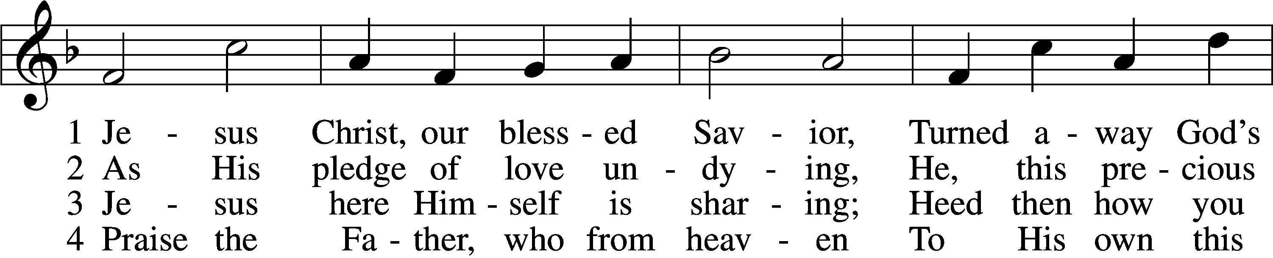
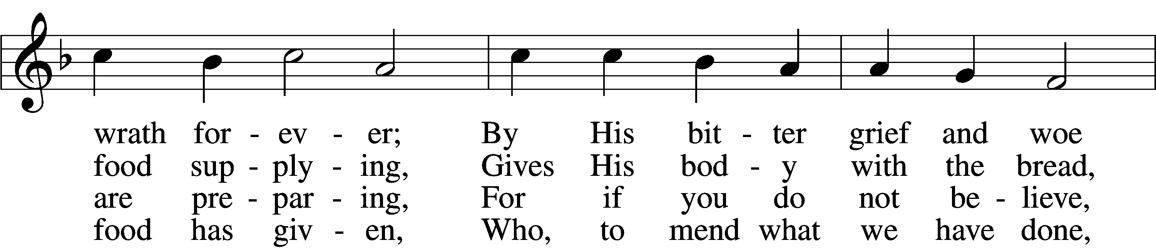
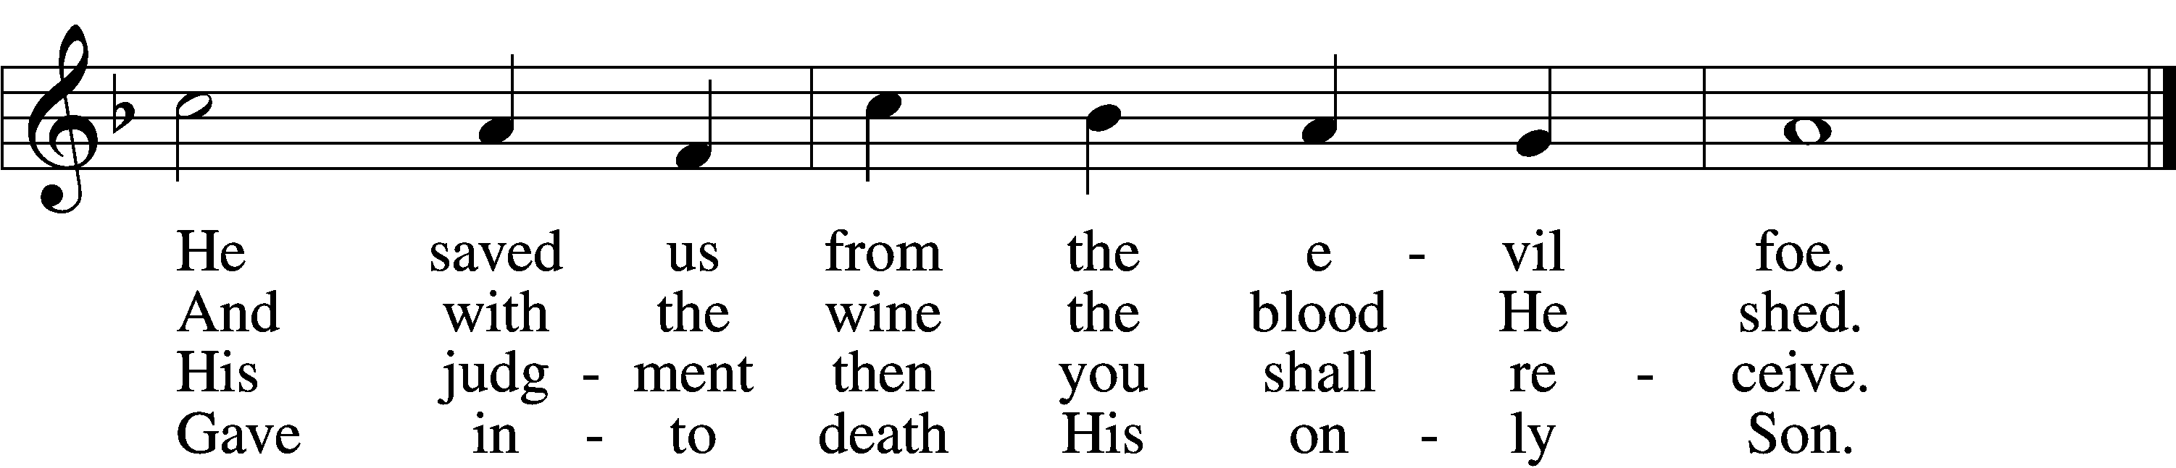

5 Firmly hold with faith unshaken
That this food is to be taken
By the sick who are distressed,
By hearts that long for peace and rest.

6 Agony and bitter labor
Were the cost of God’s high favor;
Do not come if you suppose
You need not Him who died and rose.

7 Christ says: “Come, all you that labor,
And receive My grace and favor:
Those who feel no pain or ill
Need no physician’s help or skill.

8 “For what purpose was My dying
If not for your justifying?
And what use this precious food
If you yourself were pure and good?”

9 If your heart this truth professes
And your mouth your sin confesses,
You will be your Savior’s guest,
Be at His banquet truly blest.

10 Let this food your faith so nourish
That its fruit of love may flourish
And your neighbor learn from you
How much God’s wondrous love can do.
Text (sts. 1–2, 4–5, 7, 9) and tune: Public domain
Text (sts. 3, 6, 8, 10): © 1980 and 2006 Concordia Publishing House. Used by permission: LSB Hymn License no. 110003744

555 Salvation unto Us Has Come
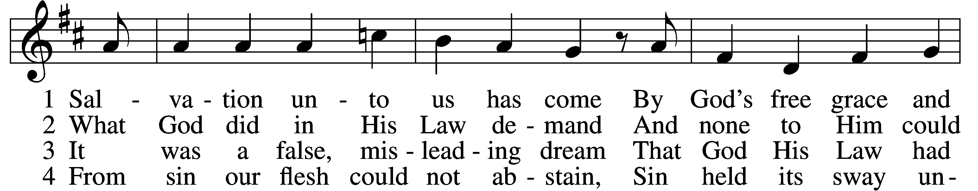
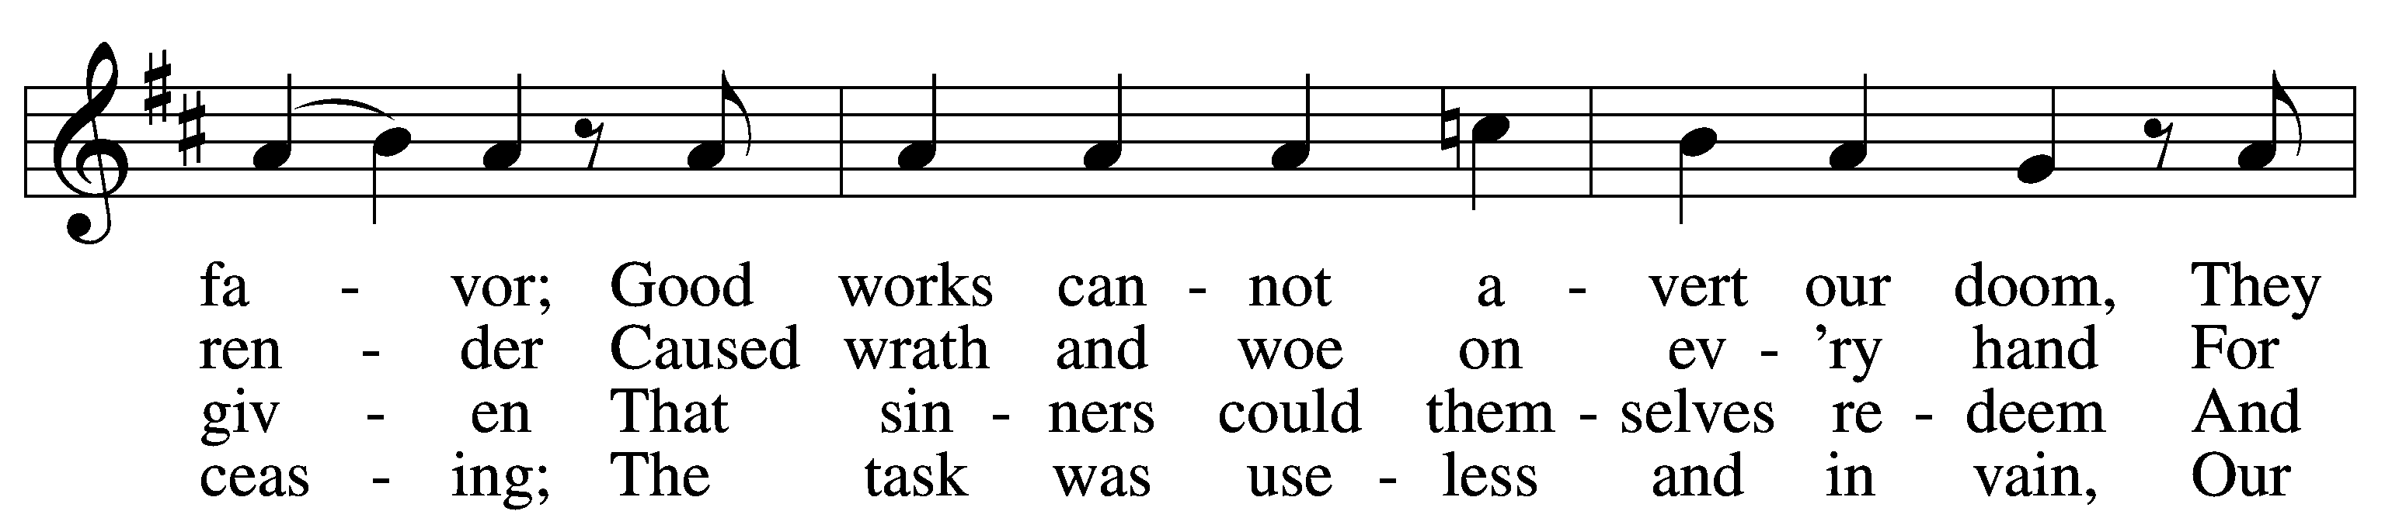
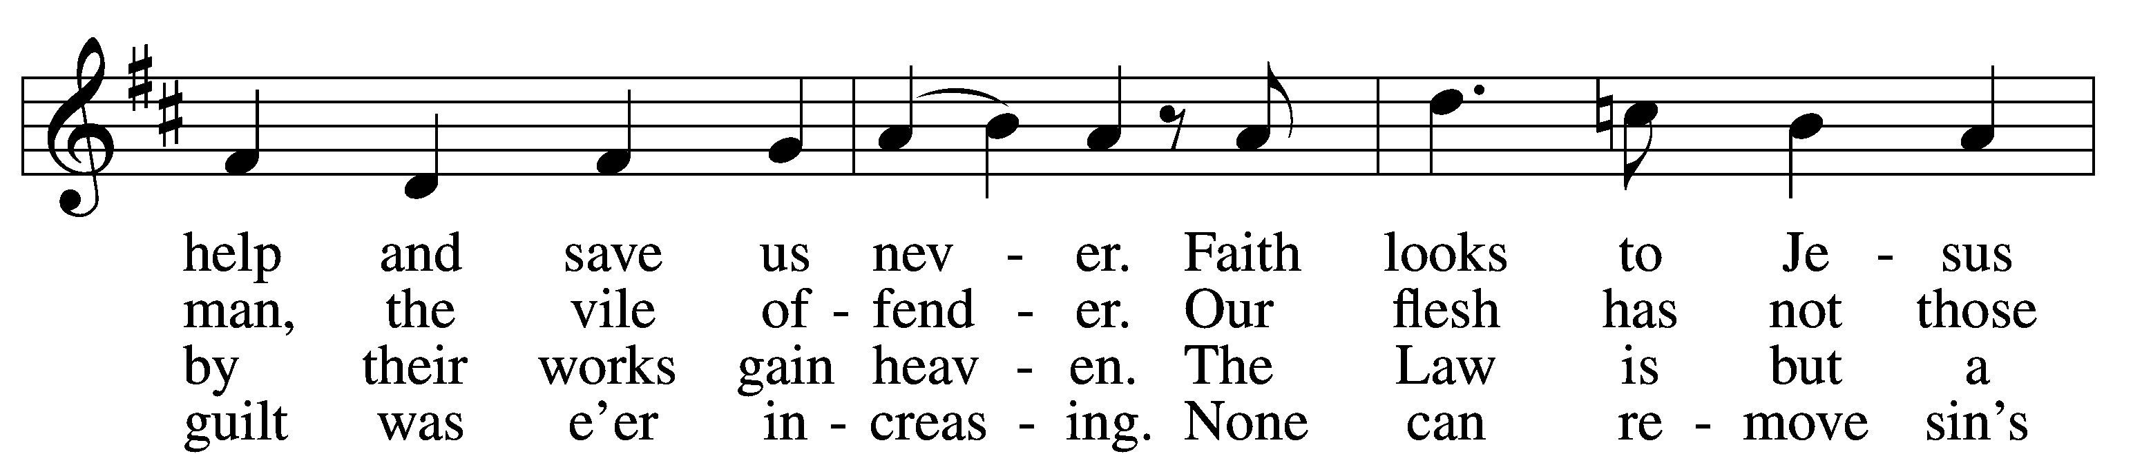
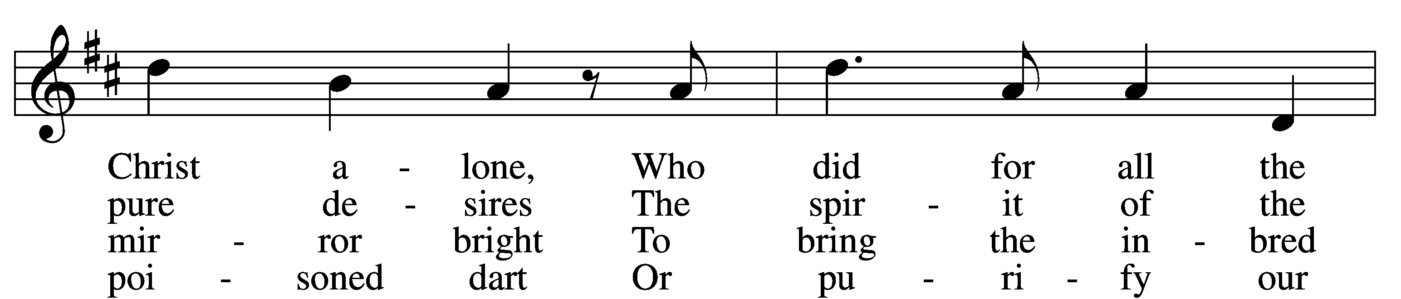
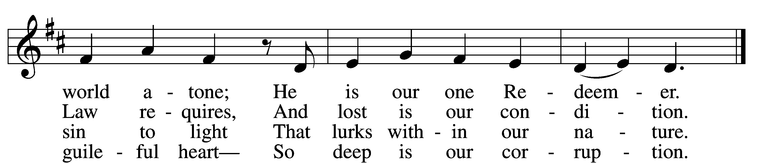

5 Yet as the Law must be fulfilled
Or we must die despairing,
Christ came and has God’s anger stilled,
Our human nature sharing.
He has for us the Law obeyed
And thus the Father’s vengeance stayed
Which over us impended.

6 Since Christ has full atonement made
And brought to us salvation,
Each Christian therefore may be glad
And build on this foundation.
Your grace alone, dear Lord, I plead,
Your death is now my life indeed,
For You have paid my ransom.

7 Let me not doubt, but truly see
Your Word cannot be broken;
Your call rings out, “Come unto Me!”
No falsehood have You spoken.
Baptized into Your precious name,
My faith cannot be put to shame,
And I shall never perish.

8 The Law reveals the guilt of sin
And makes us conscience-stricken;
But then the Gospel enters in
The sinful soul to quicken.
Come to the cross, trust Christ, and live;
The Law no peace can ever give,
No comfort and no blessing.

9 Faith clings to Jesus’ cross alone
And rests in Him unceasing;
And by its fruits true faith is known,
With love and hope increasing.
For faith alone can justify;
Works serve our neighbor and supply
The proof that faith is living.

D 10 All blessing, honor, thanks, and praise
To Father, Son, and Spirit,
The God who saved us by His grace;
All glory to His merit.
O triune God in heav’n above,
You have revealed Your saving love;
Your blessèd name we hallow.
Tune and text: Public domain

566 By Grace I’m Saved
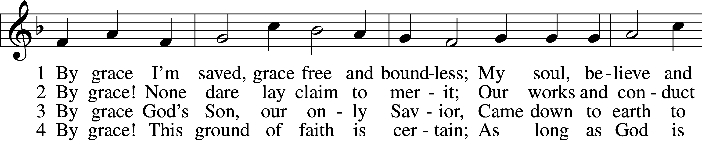
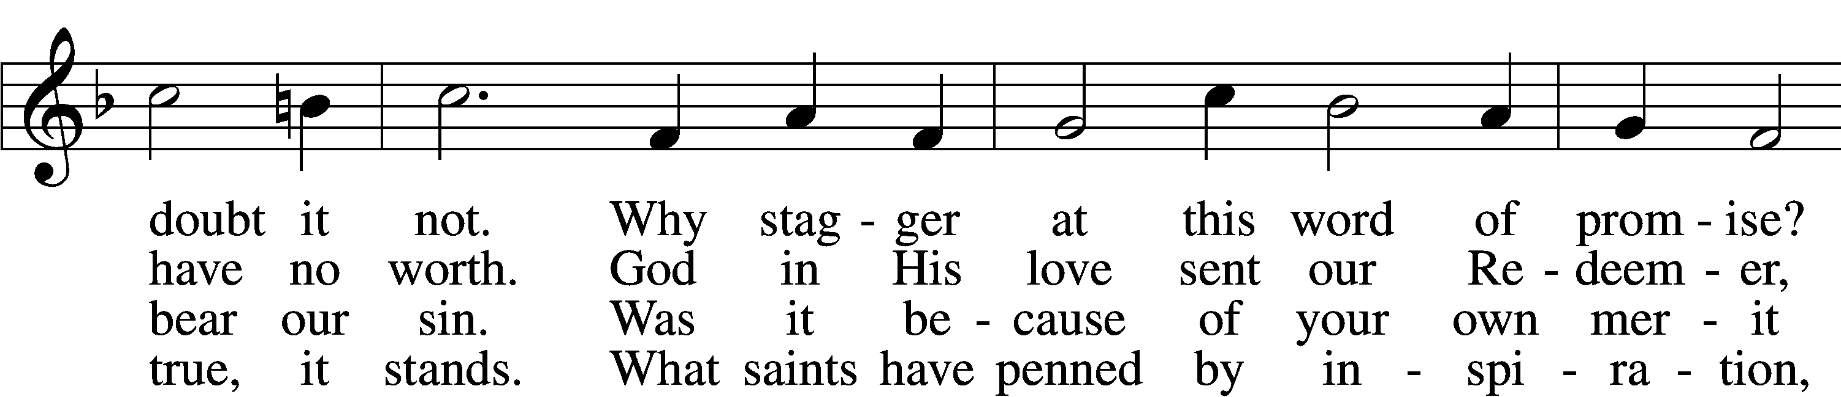
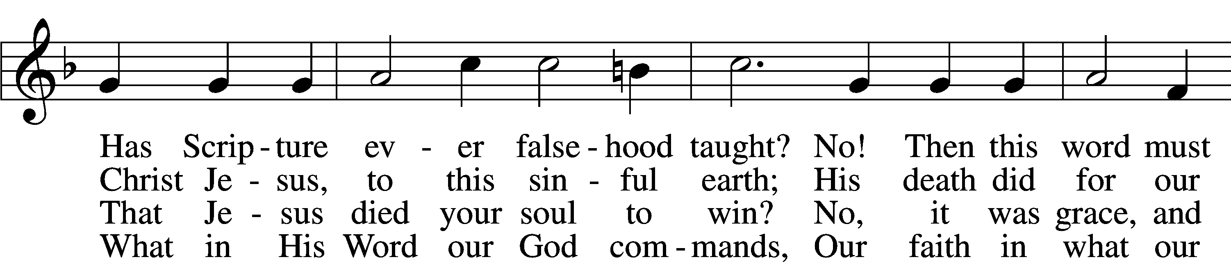
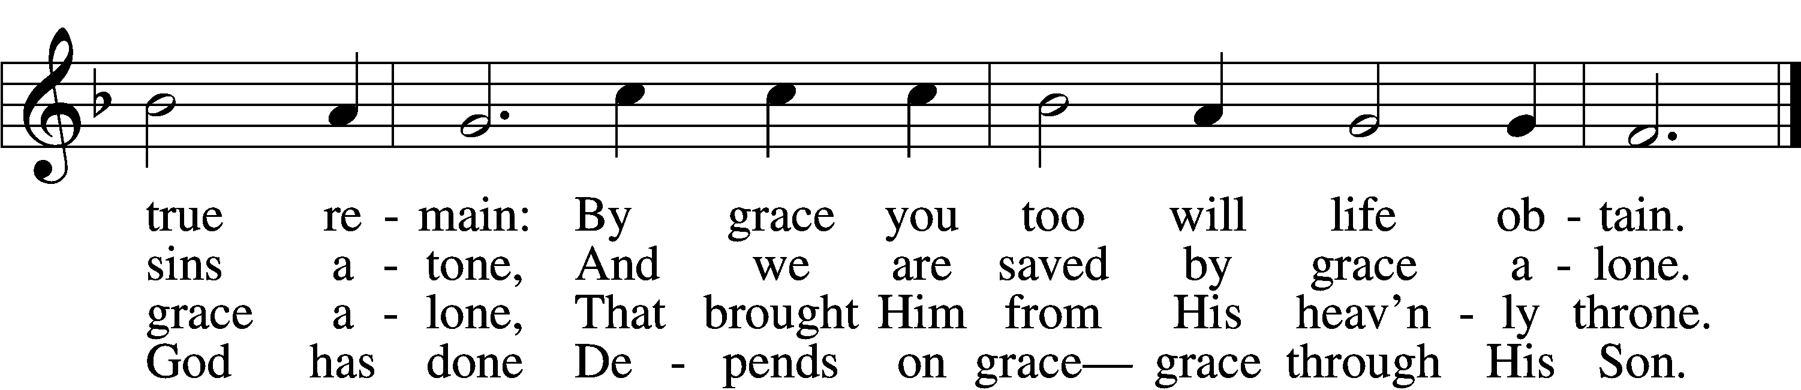

5 By grace to timid hearts that tremble,
In tribulation’s furnace tried,
By grace, in spite of fear and trouble,
The Father’s heart is open wide.
Where could I help and strength secure
If grace were not my anchor sure?

6 By grace! On this I’ll rest when dying;
In Jesus’ promise I rejoice;
For though I know my heart’s condition,
I also know my Savior’s voice.
My heart is glad, all grief has flown
Since I am saved by grace alone.
Tune and text: Public domain

Stand

In dismissing the communicants, the following is said:

P The body and blood of our Lord Jesus Christ strengthen and preserve you in body and soul to life everlasting. Depart T in peace.
C Amen.

Thank the Lord LSB 164
C Thank the Lord and sing His praise; tell ev’ryone what He has done.
Let all who seek the Lord rejoice and proudly bear His name.
He recalls His promises and leads His people forth in joy
with shouts of thanksgiving. Alleluia, alleluia.

Post-Communion Collect
A Let us pray.
We give thanks to You, almighty God, that You have refreshed us through this salutary gift, and we implore You that of Your mercy You would strengthen us through the same in faith toward You and in fervent love toward one another; through Jesus Christ, Your Son, our Lord, who lives and reigns with You and the Holy Spirit, one God, now and forever.
C Amen.

Benediction LSB 166
P The Lord bless you and keep you.
The Lord make His face shine on you and be gracious to you.
The Lord look upon you with favor and T give you peace.
C Amen.

582 God’s Word Is Our Great Heritage
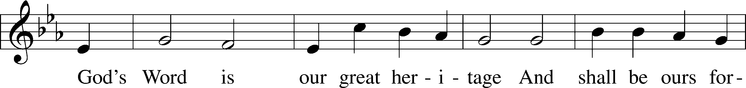
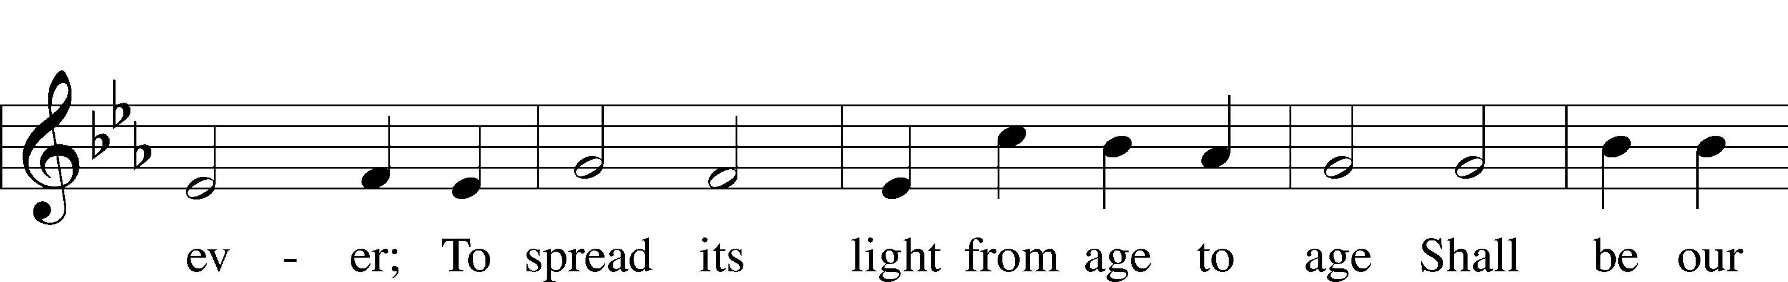
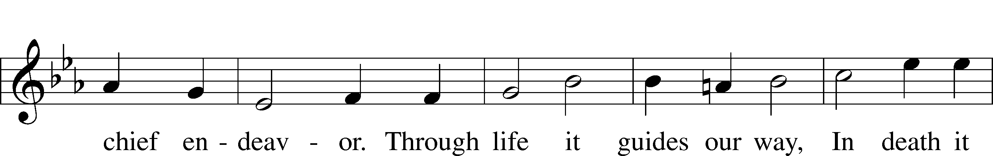
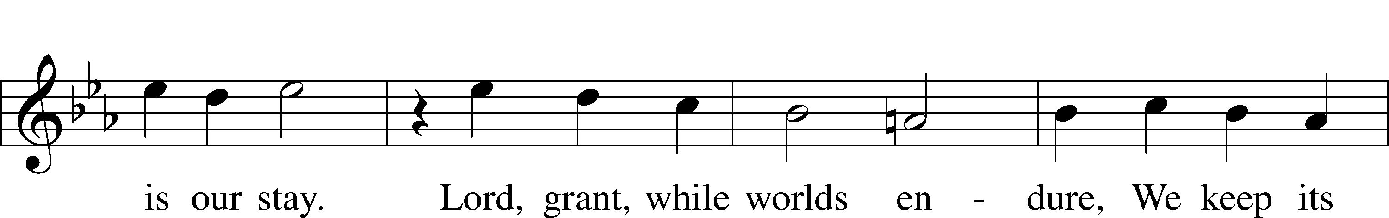
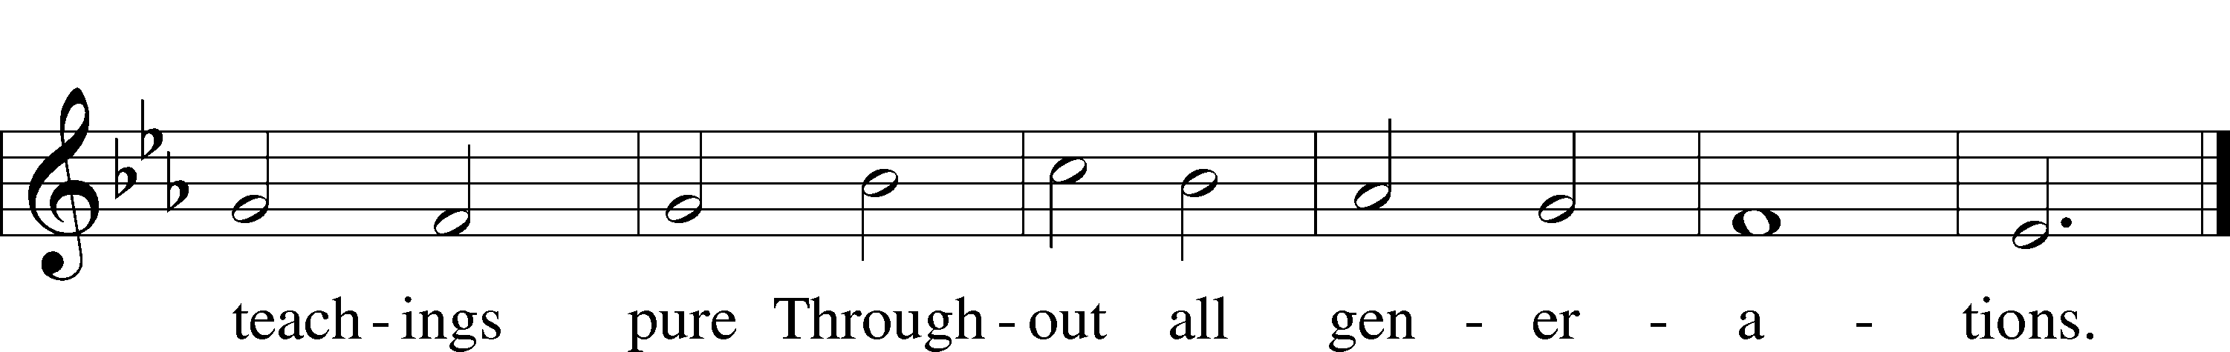
Text and tune: Public domain

Acknowledgments
Divine Service, Setting One from Lutheran Service Book
Unless otherwise indicated, Scripture quotations are from the ESV® Bible (The Holy Bible, English Standard Version®), copyright © 2001 by Crossway, a publishing ministry of Good News Publishers. Used by permission. All rights reserved.
Created by Lutheran Service Builder © 2018 Concordia Publishing House.

Prayers for Our Members
Robin Baker, Bailey Hockemeier, Leah Vogel | Expectant Mothers
Norman Abels (Brookestone Meadows – Elkhorn) | Healing
Judy Ahrens (St. Luke’s) | Healing
Vaughn Albrecht (Northridge) | Healing
Tom & DyAnn Altwine | Healing
David Banner | Healing
Lyle Colsden (Mother Hull) | Healing
Pat Flodine (Cambridge Court) | Healing
Vi Fox (Prairie View) | Healing
Verleen Gentry | Healing
Ruby Hatfield | Healing
Sandy Heiden | Healing
Chelsea Herrera | Healing
Carol Kreutzer | Healing
Janel Lange | Healing
Michelle Millsap | Healing
Betty Mustard | Healing
Roger Riekenberg | Healing
Marion Richmond | Healing
Geraldine Roeder | Healing
Lavern Stuehm | Healing
Fran Junge | Cancer
Bev Nuttelman | Cancer
Kim Vos | Cancer

Prayers for Our Members’ Family & Friends
Brandon & Shannon Howell (Quentin & Janel Lange’s friends) | Family
Will Brennemann (Jami Helmbrecht’s father) | Healing
Reg Duke (Westman’s brother-in-law) | Healing
James Gentry (Verleen Gentry’s son) | Healing
Roger Hoffman (Marc’s father) | Healing
Sharon Kreutzer (former member) | Healing
Lyra Mais (Zion student) | Healing
Randy Solomon (Beth Rosenthal’s father) | Healing
Mary Ann Mertz (Pam’s Uhlir’s friend) | Healing
Roy Reynolds (Verleen Gentry’s son-in-law) | Healing
Janet Stalder (Carol Florang’s sister) | Healing
D.D. Dugger (Sue Kaiser’s brother) | Cancer
Ron Halvorsen (Jeff’s dad) | Cancer
Carol Haubold (Don Helmbrecht’s sister) | Cancer
Tyler Holland (Quentin & Janel Lange’s brother-in-law) | Cancer
Randy Jochum (Ken Hockemeier’s brother-in-law) | Cancer
Fred Koch (Pam Uhlir’s cousin) | Cancer
Lynda Kreutzer (Rich & Carol’s sister-in-law) | Cancer
Sharon Mulhair (Pam Uhlir’s cousin) | Cancer
Becky Rathkie (former Zion teacher) | Cancer
Jeannie Schmidt (Lisa Splittgerber’s sister-in-law) | Cancer
Tyrone Uhlir (Pam’s nephew) | Cancer

Today’s Radio Broadcast is given to the Glory of the Lord by Merna Oertwig in memory of husband Fred

Serving in Worship

Sunday, October 25~ 9:00am  Elder: Eric Rosenthal  Usher: Mike Wilkens &  Robert Glanzer  Engineer: Shawn Starkey  Announcer: Lonna Gronewoller  Altar Guild: Jami Helmbrecht &  Shirley Helmbrecht | Sunday, November 1~ 9:00am  Elder: Dan Oertwig  Usher: Fred Flessner &  Lennis Hodgson  Engineer: Jamie Nikodym  Announcer: Carol Kreutzer  Altar Guild: Brooke Fisher &  Tracy Schake

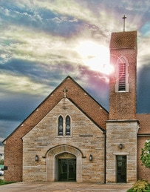

Our Response to the Gospel

Date: 10/18/2020

Offering: $4,626.00
Weekly Need: $7,542.37

Attendance:

ZION LUTHERAN CHURCH AND SCHOOL

Pr. James DeLoach, Pastor + (308) 627-5260
james.deloach@zionkearney.org
Pr. Doug Gaunt, Pastor + (308) 455-0552
doug.gaunt@zionkearney.org
Tony Splittgerber, Principal + (308) 293-0168
anthony.splittgerber@zionkearney.org

Church Office
Administrative Assistant: Jessica Shiers
Email: school@zionkearney.org
Phone: (308)-234-3410 Fax: (308) 236-8100
Office Hours: Monday-Friday 8:00am-4:00pm
Radio Broadcast: Sunday @ 10:30 a.m. on 1460 AM
Website: www.zionkearney.com

Where our Triune God strengthens us through His mercy in faith toward Him and in fervent love toward one another.

This Week at Zion

Sun  10/25 | 9:00a  10:30a | Divine Service  Radio Broadcast 1460am
Mon  10/26 | Birthdays  Anniversaries | ---  ---
Tues  10/27 | 1:30p  Birthdays  Anniversaries | Sleeping Mats  Eleanor Baker  ---
Wed  10/28 | 8:25a  9:00a  5:45p  7:00p  Birthdays  Anniversaries | K-8th Chapel  ECE Chapel  Midweek Class  Adult Choir  Angela Jorgensen  Ken & Ellen Hockemeier
Thurs  10/29 | Birthdays  Anniversaries | Allen Mitchel  ---
Fri  10/30 | Birthdays  Anniversaries | Pie Orders Due to the office  Marla Hartman  ---
Sat  10/31 | 5:00p  Birthdays  Anniversaries | Divine Service  ---  ---
Sun  11/01 | 9:00a  10:30a  Birthdays  Anniversaries | Divine Service  Radio Broadcast 1460am  Daylight Savings Time Ends  ---  ---
ANNOUNCEMENTS

Thank You – Thank you to the choir for sharing your talents with us during the Supper preparation. Thank you!

Pastor Appreciation – October is Pastor Appreciation month. Our pastors at Zion work very hard, are very kind, and always ready to help. We want to thank them for ALL that they do for all of God’s children and the church. Zion is very blessed to have the pastors that we do and appreciate all that they do! You are welcome and encouraged to show your appreciation to our pastors in your very own special way.

Pie Sales - The school children are taking orders for delicious Holiday Pies. Any of our school children would be happy to take your order or stop by the office. New this year is the option to order online. Visit www.zionkearney.org to place your order online. Pass this information along to anyone who would appreciate a delicious pie while supporting a great school! Orders need to be placed by October 30. Thank you for your support!

Volunteering Opportunites – Zion needs volunteers to help with the audio, video, and ushers for our worship service. Training will be provided. Please contact the office or Pr. DeLoach if interested or with questions.

A Bible Study – is prerecorded and available each Sunday, along with a study guide you can use to follow along. We are studying the three lessons for the day—the Old Testament, the Epistle, and the Gospel. Go to Zion’s website www.zionkearney.com to access the video and study guide.

Offering during this time. If you are not able to attend live Church Services, you may: drop your offering in the mail slot by the south doors, mail it to the church, or use online giving option at zionkearney.com. If you have any questions or need assistance please contact the office at 308-234-3410 or school@zionkearney.org. Thank you for supporting of your church!

The Lord’s Prayer Booklet – There is a Lord’s Prayer Booklet, to assist with your devotions, on the counter in the narthex. Feel free to take one. These are compliments of Pastor & Carol Gaunt.

Radio Broadcast & Altar Flowers - Please help Zion spread the Gospel! There are several open dates. This is a great need during this time, many people are listening to our broadcast during this time. There are also many openings for altar flowers. Please help beautify the sanctuary.

Mission Offerings - The fourth quarter missions, October through December, will support those preparing for fulltime church work (Peter Kreutzer and Taylor Zehendner, both at CUNE). If you would like to donate to this mission please use the mission envelopes located in the narthex. Thank you for your support.

Apple Market Receipts – Apple Market receipts will be accepted from register dates September 1, 2020 – March 1, 2021. Please turn in your receipts to the office to earn free things for the school!

Family Fresh Receipts –Don’t forget that Zion collects Family Fresh receipts any date. Please turn them into the office.

Boxtops –Boxtops has discontinued the labels on the packages. They now have an app for your smartphone to redeem qualifying products. If you do not have a smartphone or don’t want to install the app turn your grocery receipts with qualifying boxtop products into the office and they will get scanned to continue to earn money for Zion.

2021 Radio & Flower Charts – The 2021 radio and flower charts are posted in the hallway by the mailboxes. If there is a special day make sure you sign up early. You are welcome to call the office to sign up for your spot.

2021 Lutheran Annual – If you would like to order at 2021 Lutheran Annual please notify the church office at 308-234-3410 or school@zionkearney.org. They will be about $29.14 per book.

Employment Opportunities at Zion

2020 has been a real year of change and through it all Zion has been blessed with a remarkably steady and stable staff. Recently however, personal events have led to some upcoming staff changes and we praying that the Lord will bless these individuals as they move on and also that the Lord will continue to provide Zion with stellar replacements. If you or someone you know may be interested in the following positions, please pass this information along to them and let Mr. Splittgerber know. Thank you!

1) Preschool Teacher’s Aide: We are looking for someone to aide in our preschool class. The class runs from 8 a.m. to 11:45 a.m. on Tuesday and Thursday. Candidates should love children and be able to assist the teacher in a variety of tasks that help the morning run smoothly. This position will become available on November 3.
2) Part-time Cook: We are looking for someone who has some experience/interest in food service. Task include meal prep, serving, and cleaning. Candidate strengths should include time management, kitchen experience, and a positive disposition. This position is for 3 days a week.
3) Elementary School Teacher: Mr. Vogel and family will be moving at the conclusion of this school year so the search for another high quality Lutheran teacher has begun. Full time teachers in our school must be members of the LCMS (or willing to become so). The grade level will most probably be for the 3rd/4th grade.

