Divine Service
All Saints’ Day
November 1, 2020
Zion Lutheran Church
Kearney, Nebraska

Welcome to Zion!
All worshippers please fill out an attendance card in the pew rack and let us know how we might be of service to you.

Holy Communion at Zion

The Lord’s Supper is celebrated at this congregation as Jesus has given it. As he says, our Lord gives into our mouths not only bread and wine but his very body and blood to eat and to drink for the forgiveness of sins and to strengthen our union with him and with one another. Our Lord invites to his table those who trust his words, repent of all sin, and set aside any refusal to forgive and love as he forgives and loves us, that they may show forth his death until he comes. All communicants need to register in the narthex prior to the service.

Because those who eat and drink our Lord’s body and blood unworthily do great harm and because Holy Communion is a confession of the faith which is confessed at this altar, any who are not yet instructed, in doubt, or who hold a confession differing from that of this congregation and The Lutheran Church—Missouri Synod, are asked not to commune until they are able to speak with our pastor first. He is happy to visit with you about the Christian faith and how to receive the Lord’s Supper for your good and for the good of others. Those not communing are invited to come to the altar, cross your arms in front of you, and bow your head to receive a pastoral blessing.

Saints Are Blessed in the Eternal Presence of Christ

“A great multitude … from all tribes and peoples and languages” cry out, “Salvation belongs to our God who sits on the throne” (Rev. 7:9–10). Faith-filled saints from every place and time with unified voices eternally magnify the Lamb of God. As His beloved children, we, too, “shall see him as he is” (1 John 3:2). Joined with the throng of angels and myriad saints, we shall “serve him day and night in his temple” (Rev. 7:15). In our earthly tension vacillating between saint and sinner, faith and doubt, sacred and profane, we earnestly seek Jesus to calm our fears, comfort our spirits and forgive our sins. The Holy Spirit, through faith in Christ, propels us forward to our eternal home, fortifying us in Word and Sacrament. In the midst of our constant struggle as believers, we need to be blessed. And so we are. The poor in spirit, the meek, the hungry, the thirsty, the merciful, the pure and the persecuted are all blessed, and we will most certainly inherit the kingdom of heaven (Matt. 5:1–12).

Confession and Absolution

904 Blessed Jesus, at Your Word
1 Blessèd Jesus, at Your Word
We are gathered all to hear You.
Let our hearts and souls be stirred
Now to seek and love and fear You,
By Your teachings, sweet and holy,
Drawn from earth to love You solely.

2 All our knowledge, sense, and sight
Lie in deepest darkness shrouded
Till Your Spirit breaks our night
With the beams of truth unclouded.
You alone to God can win us;
You must work all good within us.

3 Gracious Savior, good and kind,
Light of Light, from God proceeding,
Open now our heart and mind;
Help us by Your Spirit’s pleading.
Hear the cry Your Church now raises;
Hear and bless our prayers and praises.

D 4 Father, Son, and Spirit, Lord,
Praise to You and adoration!
Grant that we may trust Your Word,
Confident of our salvation,
While we here below must wander,
Till we sing Your praises yonder.
Text: Public domain

Stand

The sign of the cross may be made by all in remembrance of their Baptism.

Invocation
P In the name of the Father and of the T Son and of the Holy Spirit.
C Amen.

Exhortation LSB 151
P If we say we have no sin, we deceive ourselves, and the truth is not in us.
C But if we confess our sins, God, who is faithful and just, will forgive our sins and cleanse us from all unrighteousness.

Silence for reflection on God’s Word and for self-examination.

Confession of Sins LSB 151
P Let us then confess our sins to God our Father.
C Most merciful God, we confess that we are by nature sinful and unclean. We have sinned against You in thought, word, and deed, by what we have done and by what we have left undone. We have not loved You with our whole heart; we have not loved our neighbors as ourselves. We justly deserve Your present and eternal punishment. For the sake of Your Son, Jesus Christ, have mercy on us. Forgive us, renew us, and lead us, so that we may delight in Your will and walk in Your ways to the glory of Your holy name. Amen.

Absolution LSB 151
P Almighty God in His mercy has given His Son to die for you and for His sake forgives you all your sins. As a called and ordained servant of Christ, and by His authority, I therefore forgive you all your sins in the name of the Father and of the T Son and of the Holy Spirit.
C Amen.

Service of the Word

Introit Psalm 31:1, 3, 5; antiphon: Revelation 7:14b
These are the ones coming out of the great tribu- | lation.*
They have washed their robes and made them white in the blood | of the Lamb.
In you, O Lord, do I take refuge; let me never be | put to shame;*
in your righteousness de- | liver me.
For you are my rock and my | fortress;*
and for your name’s sake you lead me and | guide me.
Into your hand I commit my | spirit;*
you have redeemed me, O Lord, | faithful God.
Glory be to the Father and | to the Son*
and to the Holy | Spirit;
as it was in the be- | ginning,*
is now, and will be forever. | Amen.
These are the ones coming out of the great tribu- | lation.*
They have washed their robes and made them white in the blood | of the Lamb.

Kyrie LSB 152
A In peace let us pray to the Lord.

A For the peace from above and for our salvation let us pray to the Lord.

A For the peace of the whole world, for the well-being of the Church of God, and for the unity of all let us pray to the Lord.

A For this holy house and for all who offer here their worship and praise let us pray to the Lord.

A Help, save, comfort, and defend us, gracious Lord.

This Is the Feast LSB 155
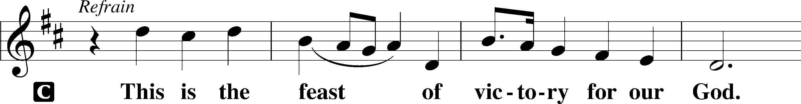
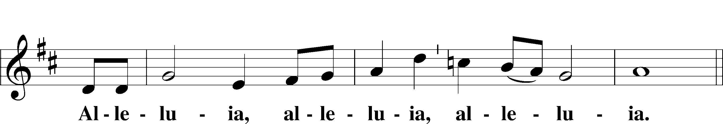
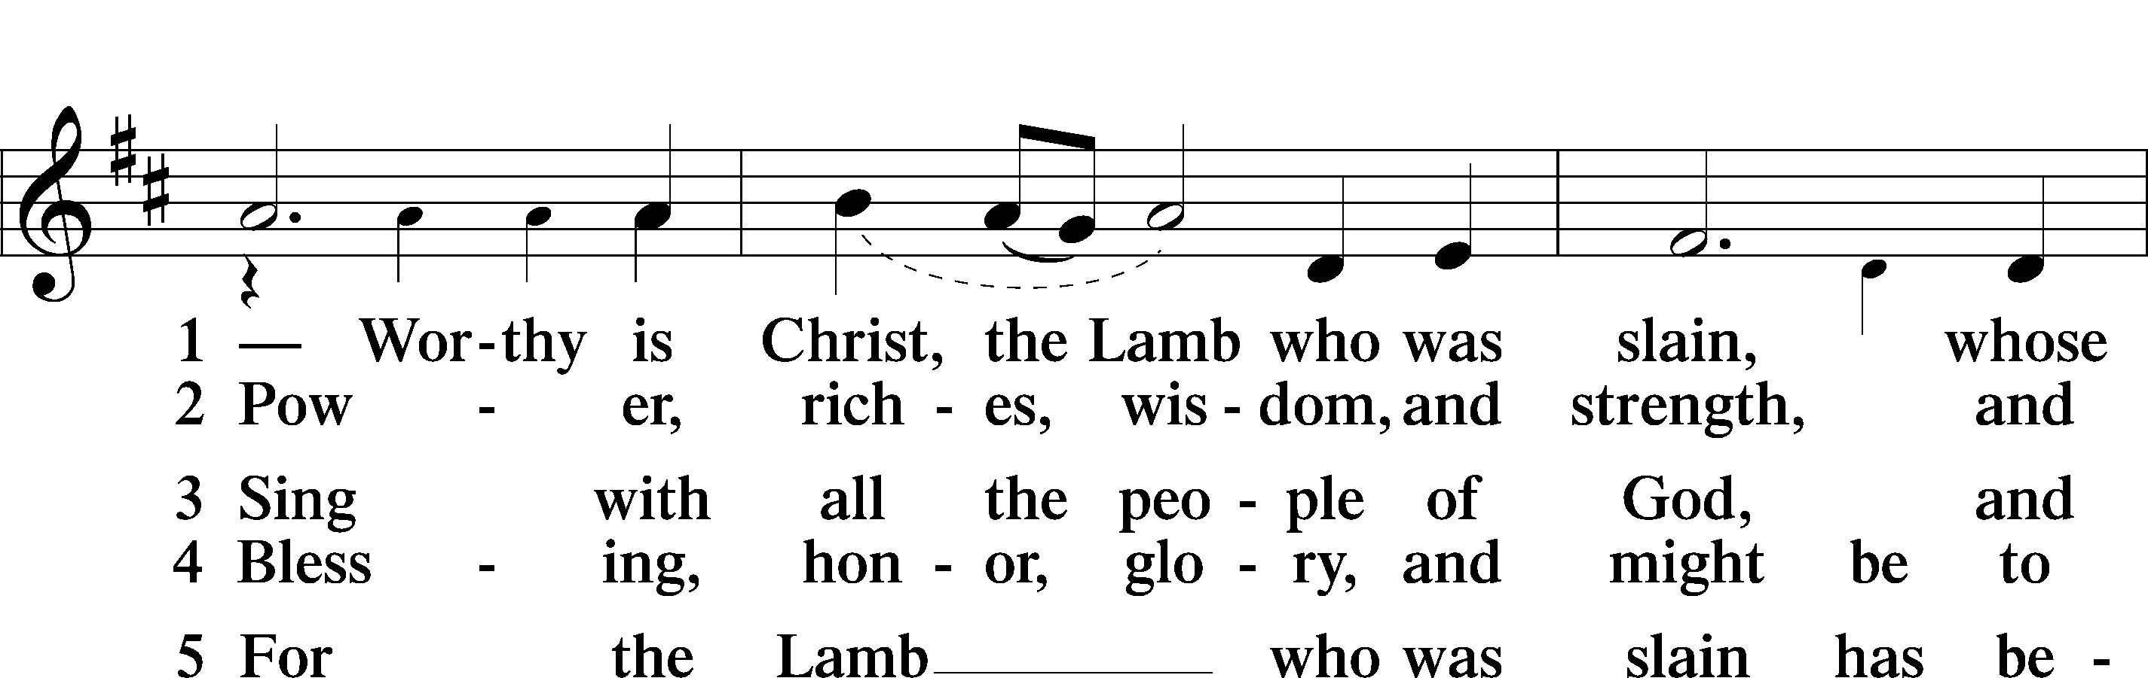
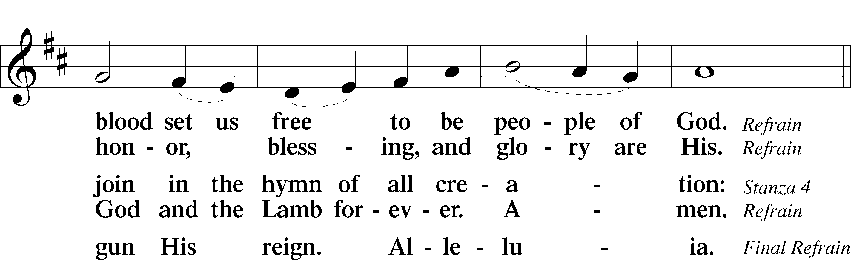
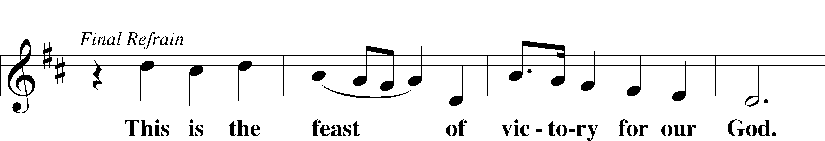
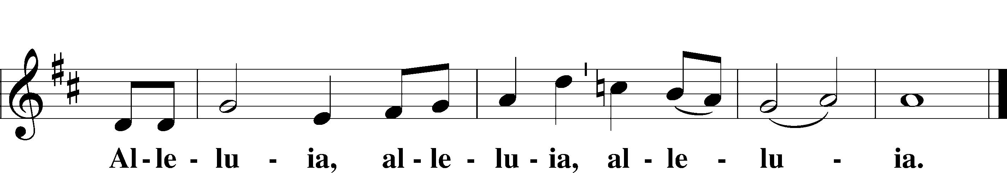

Salutation and Collect of the Day
P The Lord be with you.
C And also with you.

P Let us pray.
Almighty and everlasting God, You knit together Your faithful people of all times and places into one holy communion, the mystical body of Your Son, Jesus Christ. Grant us so to follow Your blessed saints in all virtuous and godly living that, together with them, we may come to the unspeakable joys You have prepared for those who love You; through Jesus Christ, our Lord, who lives and reigns with You and the Holy Spirit, one God, now and forever.

C Amen.

Sit

First Reading Revelation 7:9–17
⁹After this I looked, and behold, a great multitude that no one could number, from every nation, from all tribes and peoples and languages, standing before the throne and before the Lamb, clothed in white robes, with palm branches in their hands, ¹⁰and crying out with a loud voice, “Salvation belongs to our God who sits on the throne, and to the Lamb!” ¹¹And all the angels were standing around the throne and around the elders and the four living creatures, and they fell on their faces before the throne and worshiped God, ¹²saying, “Amen! Blessing and glory and wisdom and thanksgiving and honor and power and might be to our God forever and ever! Amen.”
¹³Then one of the elders addressed me, saying, “Who are these, clothed in white robes, and from where have they come?” ¹⁴I said to him, “Sir, you know.” And he said to me, “These are the ones coming out of the great tribulation. They have washed their robes and made them white in the blood of the Lamb.
¹⁵“Therefore they are before the throne of God,
and serve him day and night in his temple;
and he who sits on the throne will shelter them with his presence.
¹⁶They shall hunger no more, neither thirst anymore;
the sun shall not strike them,
nor any scorching heat.
¹⁷For the Lamb in the midst of the throne will be their shepherd,
and he will guide them to springs of living water,
and God will wipe away every tear from their eyes.”

A This is the Word of the Lord.
C Thanks be to God.
Gradual Revelation 7:14b; Psalm 84:5
These are the ones coming out of the great tribu- | lation.*
They have washed their robes and made them white in the blood | of the Lamb.
Blessèd are those whose strength is | in you,*
in whose heart are the highways to | Zion.

Epistle 1 John 3:1–3
¹See what kind of love the Father has given to us, that we should be called children of God; and so we are. The reason why the world does not know us is that it did not know him. ²Beloved, we are God’s children now, and what we will be has not yet appeared; but we know that when he appears we shall be like him, because we shall see him as he is. ³And everyone who thus hopes in him purifies himself as he is pure.

A This is the Word of the Lord.
C Thanks be to God.

Stand

Alleluia and Verse LSB 156
C Alleluia.
Lord, to whom shall we go?
You have the words of eternal life.
Alleluia, alleluia.

Holy Gospel Matthew 5:1–12
P The Holy Gospel according to St. Matthew, the fifth chapter.
C Glory to You, O Lord.

¹Seeing the crowds, [Jesus] went up on the mountain, and when he sat down, his disciples came to him.
²And he opened his mouth and taught them, saying:
³“Blessed are the poor in spirit, for theirs is the kingdom of heaven.
⁴“Blessed are those who mourn, for they shall be comforted.
⁵“Blessed are the meek, for they shall inherit the earth.
⁶“Blessed are those who hunger and thirst for righteousness, for they shall be satisfied.
⁷“Blessed are the merciful, for they shall receive mercy.
⁸“Blessed are the pure in heart, for they shall see God.
⁹“Blessed are the peacemakers, for they shall be called sons of God.
¹⁰“Blessed are those who are persecuted for righteousness’ sake, for theirs is the kingdom of heaven.
¹¹“Blessed are you when others revile you and persecute you and utter all kinds of evil against you falsely on my account. ¹²Rejoice and be glad, for your reward is great in heaven, for so they persecuted the prophets who were before you.”
P This is the Gospel of the Lord.
C Praise to You, O Christ.

Sit

677 For All the Saints
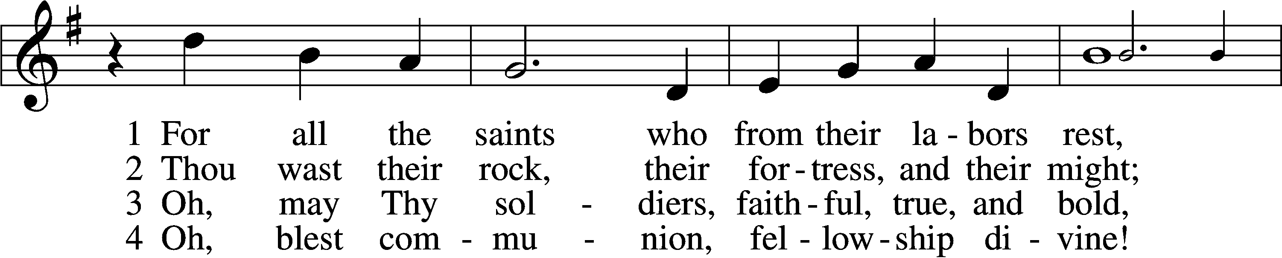
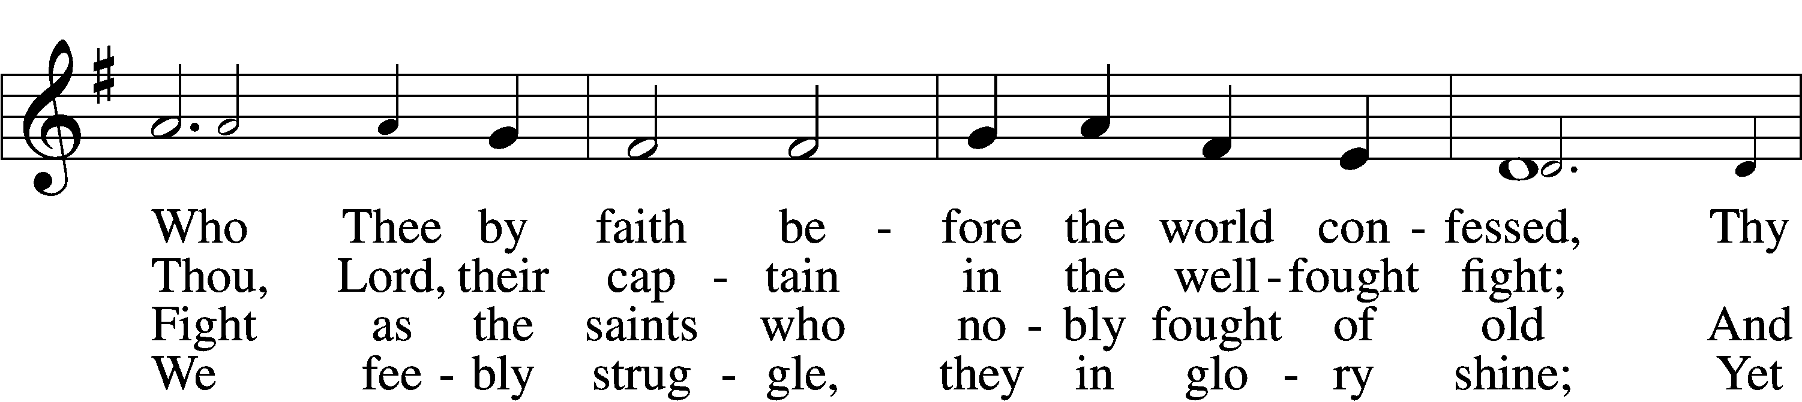
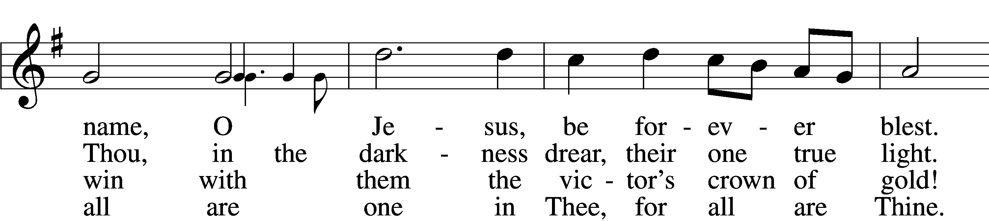
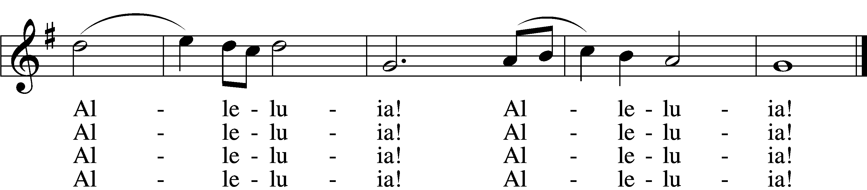

5 And when the fight is fierce, the warfare long,
Steals on the ear the distant triumph song,
And hearts are brave again, and arms are strong.
Alleluia! Alleluia!

6 The golden evening brightens in the west;
Soon, soon to faithful warriors cometh rest;
Sweet is the calm of paradise the blest.
Alleluia! Alleluia!

7 But, lo, there breaks a yet more glorious day:
The saints triumphant rise in bright array;
The King of Glory passes on His way.
Alleluia! Alleluia!

D 8 From earth’s wide bounds, from ocean’s farthest coast,
Through gates of pearl streams in the countless host,
Singing to Father, Son, and Holy Ghost:
Alleluia! Alleluia!

Sermon

Stand

Nicene Creed
C I believe in one God,
the Father Almighty,
maker of heaven and earth
and of all things visible and invisible.

And in one Lord Jesus Christ,
the only-begotten Son of God,
begotten of His Father before all worlds,
God of God, Light of Light,
very God of very God,
begotten, not made,
being of one substance with the Father,
by whom all things were made;
who for us men and for our salvation came down from heaven
and was incarnate by the Holy Spirit of the virgin Mary
and was made man;
and was crucified also for us under Pontius Pilate.
He suffered and was buried.
And the third day He rose again according to the Scriptures
and ascended into heaven
and sits at the right hand of the Father.
And He will come again with glory to judge both the living and the dead,
whose kingdom will have no end.

And I believe in the Holy Spirit,
the Lord and giver of life,
who proceeds from the Father and the Son,
who with the Father and the Son together is worshiped and glorified,
who spoke by the prophets.
And I believe in one holy Christian and apostolic Church,
I acknowledge one Baptism for the remission of sins,
and I look for the resurrection of the dead
and the life T of the world to come. Amen.

Remembrance of the Faithful Departed +

All Saints’ Day 2020

P: The Apostle John wrote: “I heard a voice from heaven saying, ‘Write this: Blessed are the dead who die in the Lord henceforth.’”
C: “Blessed indeed,” says the Spirit, “that they may rest from their labors.”
P: We remember with thanksgiving those who have gone before us in the faith, for they were created by God to offer Him praise and thanksgiving forever.
C: He gave them new life through His Son in Holy Baptism.
P: He fed them in the company of His saints at Holy Communion.
C: And in His mercy He has taken them to His side that they may joyfully serve Him forever.
P: In joyful expectation of the resurrection to life, we remember before You, O Lord, all our departed kin and friends who have preceded us in the faith,

+ Theodore Allwardt +  01 December 2019  + Elaine Buss +  08 December 2019  + Vivian Axmann +  01 May 2020  + Craig Nuttelman +  9 May 2020 | + Lillian Johnson +  30 June 2020  + Ramona Gaunt +  10 July 2020  + Merle Wuehler +  15 July 2020  + Dorothy Sikes +  23 August 2020
…and all who are in our hearts and minds this day.

C: We give thanks for the faith You gave them and we cling to Your promise of salvation.

P: O Lord, remember Your church throughout the world; help us grow in love for You and each other. As You have received our brothers and sisters who rest in You to the day of the resurrection, bring us at the last into the glory of your presence, that reunited with all Your saints we may praise you forever, through Your Son, Jesus Christ our Lord.
C: Amen.

The Prayer of the Church
All Saints’ Day

P: O Holy God, You have made us Your holy people, uniting us with the communion of saints in heaven and on earth. For Your holy church; for the congregations and pastors that faithfully teach your Word and administer your sacraments according to your command.
C: With the glorious company of apostles we praise You.
P: For all good and faithful gifts from your creation;
C: With the noble fellowship of prophets we praise You.
P: For those slandered and persecuted for confessing Your holy name; for those endangered and dying for speaking Your Word.
C: With the white-robed army of martyrs we praise You.
P: For the good works you do through us in Your name;
for the saints serving day and night before Your throne.
C: With the Church throughout the world we praise You.
P: As Your saints, we intercede for the whole world: all nations, all people, and all godly vocations.
C: Come, O Lord, and help Your people.
P: For our nation: give wisdom and godliness to those serving; for those in the military, especially ___.
C: Come, O Lord, and help Your people.
P: For our families, that you would enable us to reflect your abiding love by living holy lives for each other.
For all pregnant, especially ____, protect both mother and child.
C: Come, O Lord, and help Your people.
P: For all the sick, grant healing, especially to ____ and all whom we name in our hearts this day.
C: Come, O Lord, and help Your people.
P: With all Your saints, of heaven and earth, of today and ages past, we pray:
C: “Blessing and glory and wisdom and thanksgiving and honor and power and might be to our God for ever and ever! Amen." [Rev. 7:12]

Offertory LSB 159
C What shall I render to the Lord for all His benefits to me?
I will offer the sacrifice of thanksgiving and will call on the name of the Lord.
I will take the cup of salvation and will call on the name of the Lord.
I will pay my vows to the Lord now in the presence of all His people,
in the courts of the Lord’s house, in the midst of you, O Jerusalem.

Service of the Sacrament

Preface LSB 160
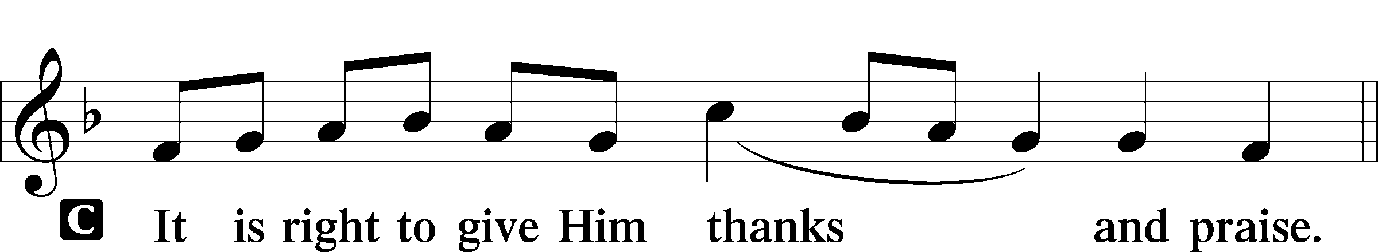

Proper Preface
P It is truly good, right, and salutary that we should at all times and in all places give thanks to You, holy Lord, almighty Father, everlasting God. In the communion of all Your saints gathered into the one body of Your Son, You have surrounded us with so great a cloud of witnesses that we, encouraged by their faith and strengthened by their fellowship, may run with perseverance the race that is set before us and, together with them, receive the crown of glory that does not fade away. Therefore with angels and archangels and with all the company of heaven we laud and magnify Your glorious name, evermore praising You and saying:

Sanctus LSB 161
C Holy, holy, holy Lord God of pow’r and might:
Heaven and earth are full of Your glory.
Hosanna. Hosanna.
Hosanna in the highest.
Blessed is He who comes in the name of the Lord.
Hosanna in the highest.

Lord’s Prayer
C Our Father who art in heaven,
hallowed be Thy name,
Thy kingdom come,
Thy will be done on earth
as it is in heaven;
give us this day our daily bread;
and forgive us our trespasses
as we forgive those
who trespass against us;
and lead us not into temptation,
but deliver us from evil.
For Thine is the kingdom
and the power and the glory
forever and ever. Amen.

The Words of Our Lord
P Our Lord Jesus Christ, on the night when He was betrayed, took bread, and when He had given thanks, He broke it and gave it to the disciples and said: “Take, eat; this is My T body, which is given for you. This do in remembrance of Me.”

In the same way also He took the cup after supper, and when He had given thanks, He gave it to them, saying: “Drink of it, all of you; this cup is the new testament in My T blood, which is shed for you for the forgiveness of sins. This do, as often as you drink it, in remembrance of Me.”
Pax Domini LSB 163
P The peace of the Lord be with you always.
C Amen.

Agnus Dei LSB 163
C Lamb of God, You take away the sin of the world; have mercy on us.
Lamb of God, You take away the sin of the world; have mercy on us.
Lamb of God, You take away the sin of the world; grant us peace.

Sit

Distribution

678 We Sing for All the Unsung Saints
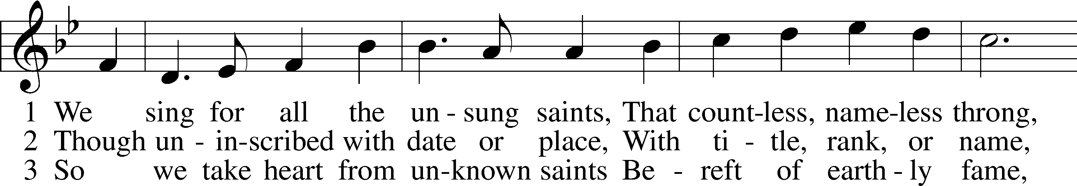
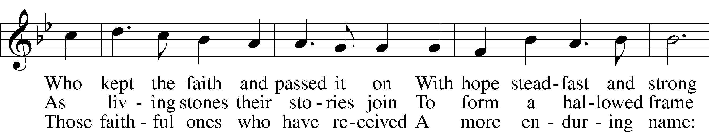
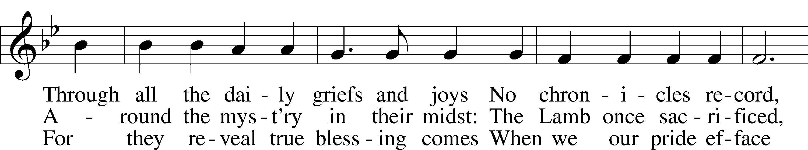
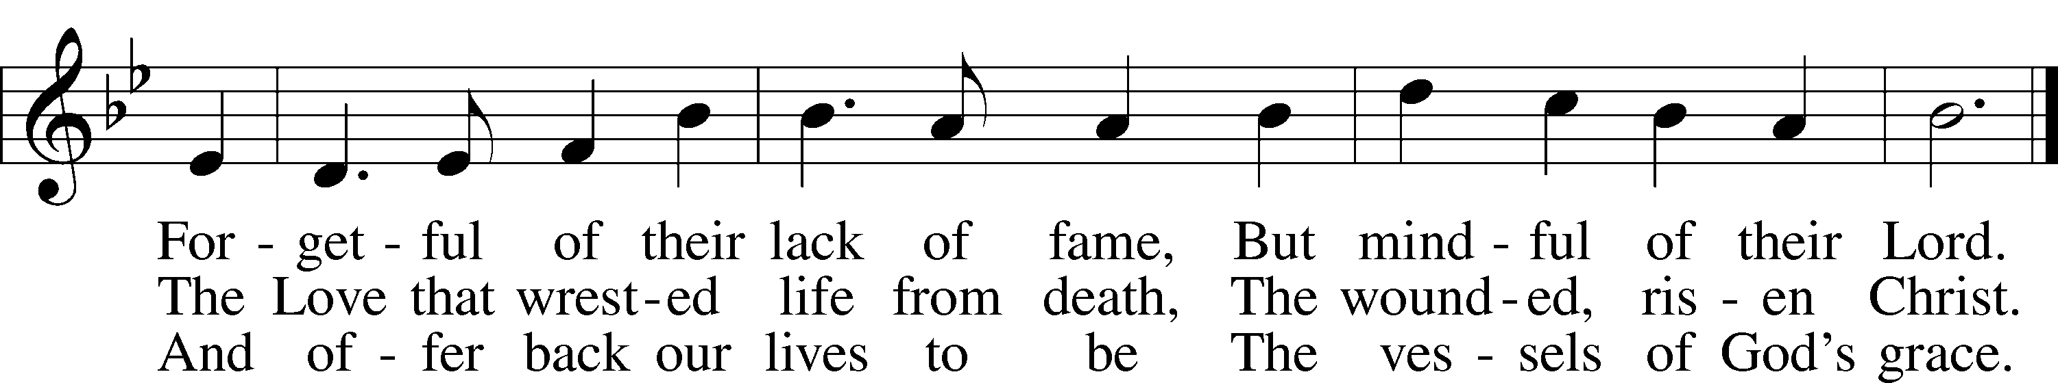
Text: © 1996 Hope Publishing Co. Used by permission: LSB Hymn License no. 110003744
Tune: Public domain

667 Saints, See the Cloud of Witnesses
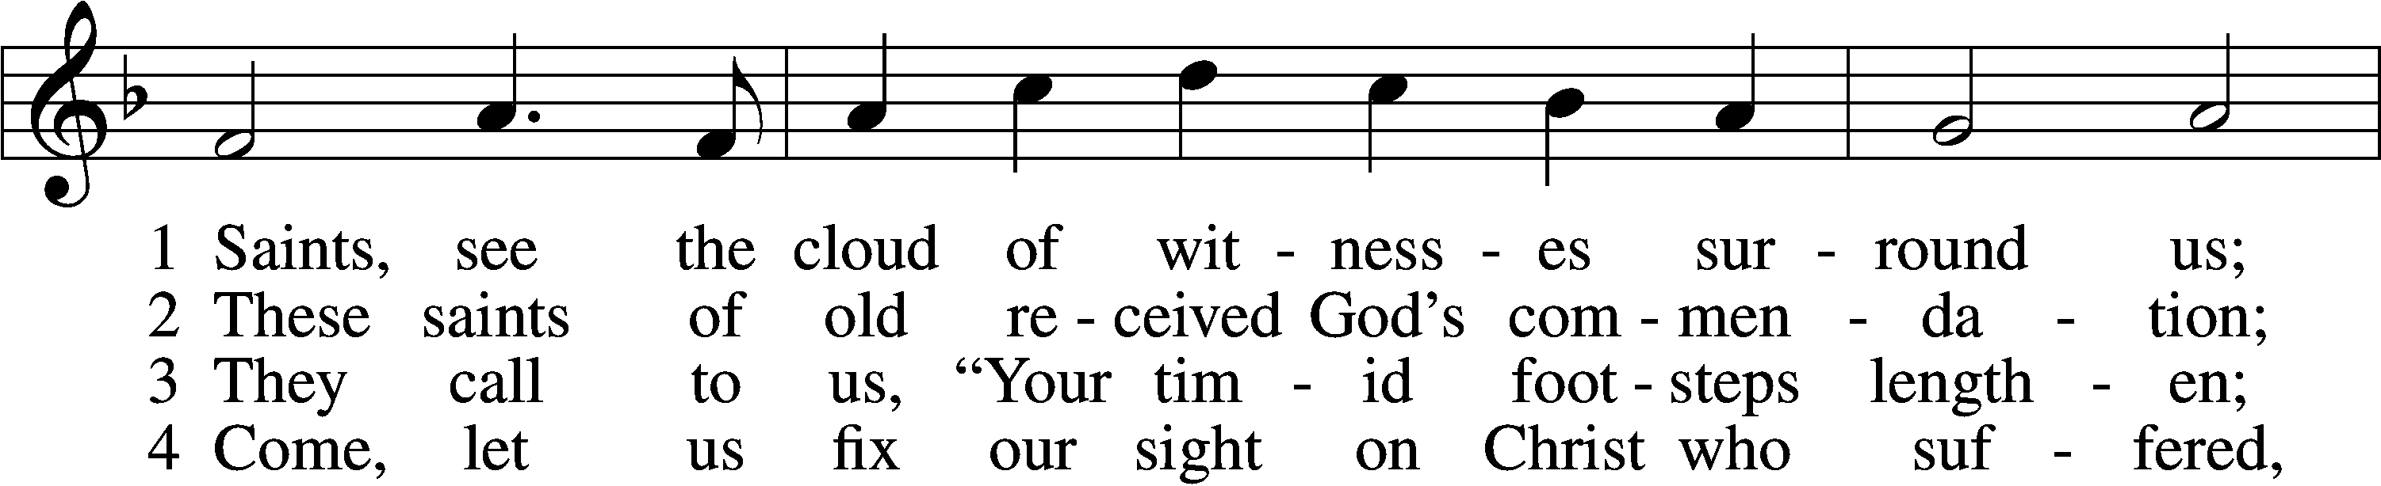
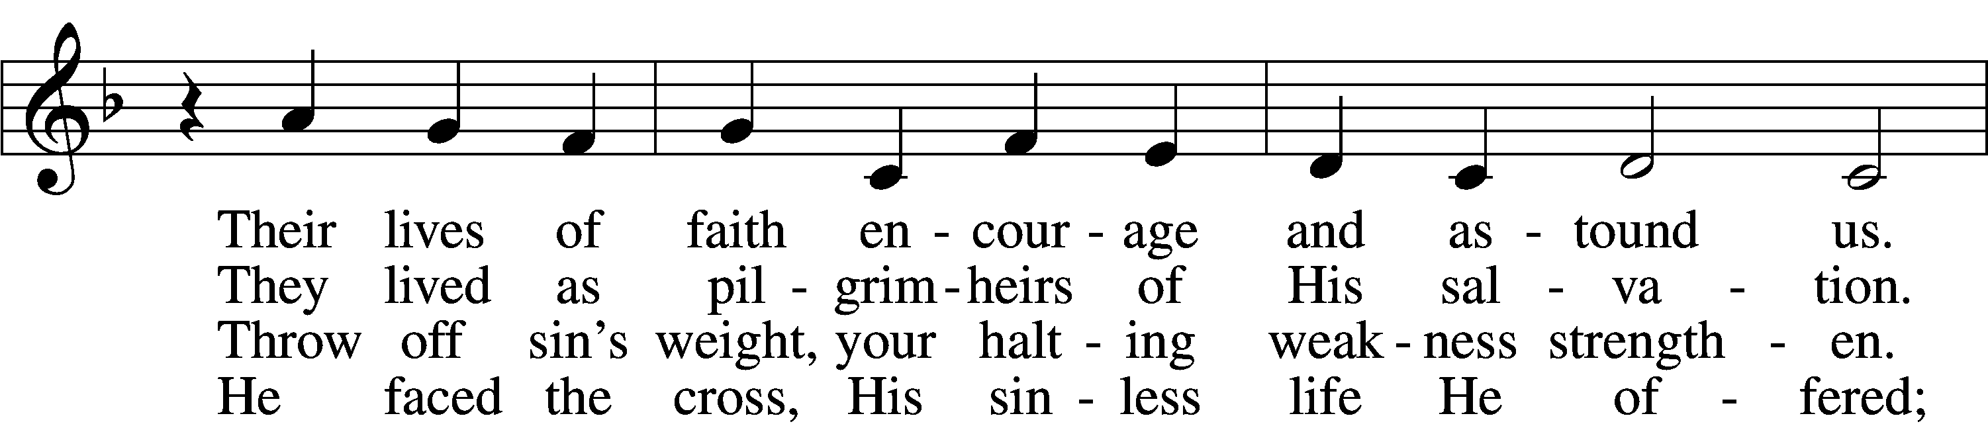
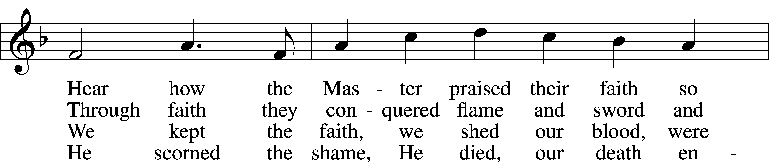
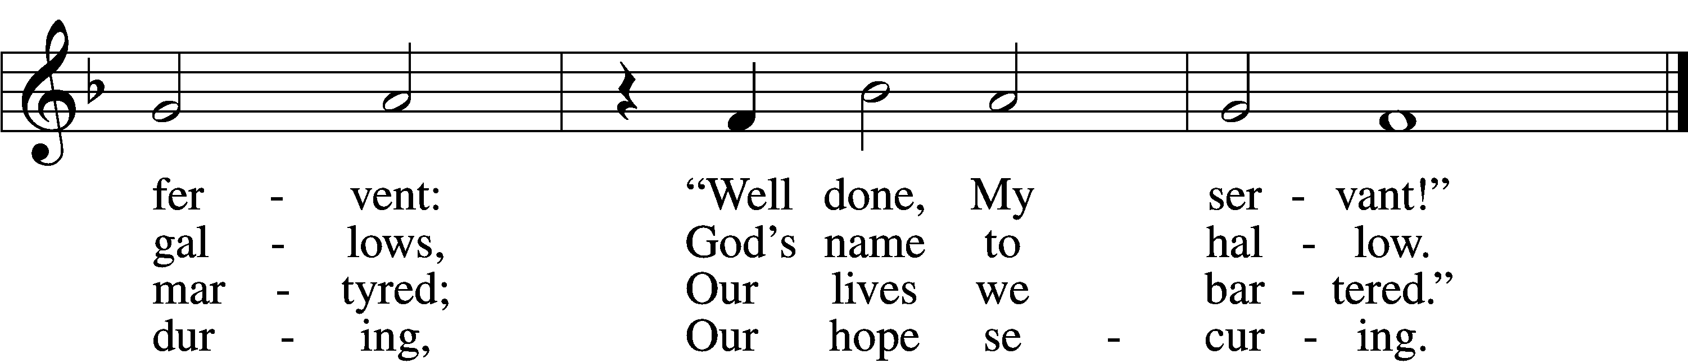

5 Lord, give us faith to walk where You are sending,
On paths unmarked, eyes blind as to their ending;
Not knowing where we go, but that You lead us—
With grace precede us.

6 You, Jesus, You alone deserve all glory!
Our lives unfold, embraced within Your story;
Past, present, future—You, the same forever—
You fail us never!
Tune: © 1974 Augsburg Publishing House, admin. Augsburg Fortress. Used by permission: LSB Hymn License no. 110003744
Text: © 1997 Stephen P. Starke, admin. Concordia Publishing House. Used by permission: LSB Hymn License no. 110003744

720 We Walk by Faith and Not by Sight
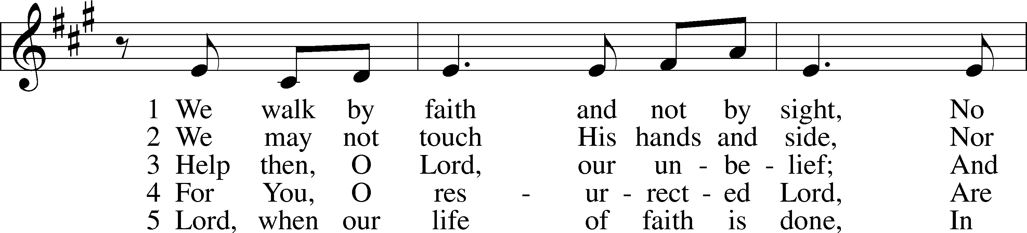
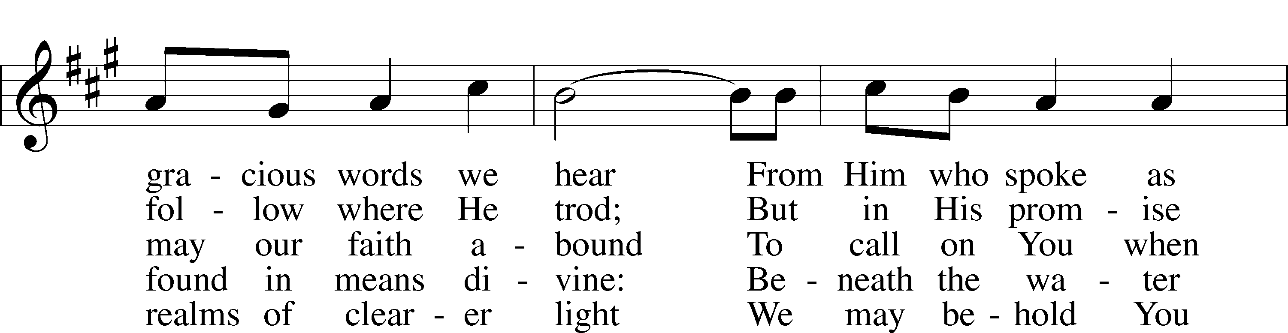
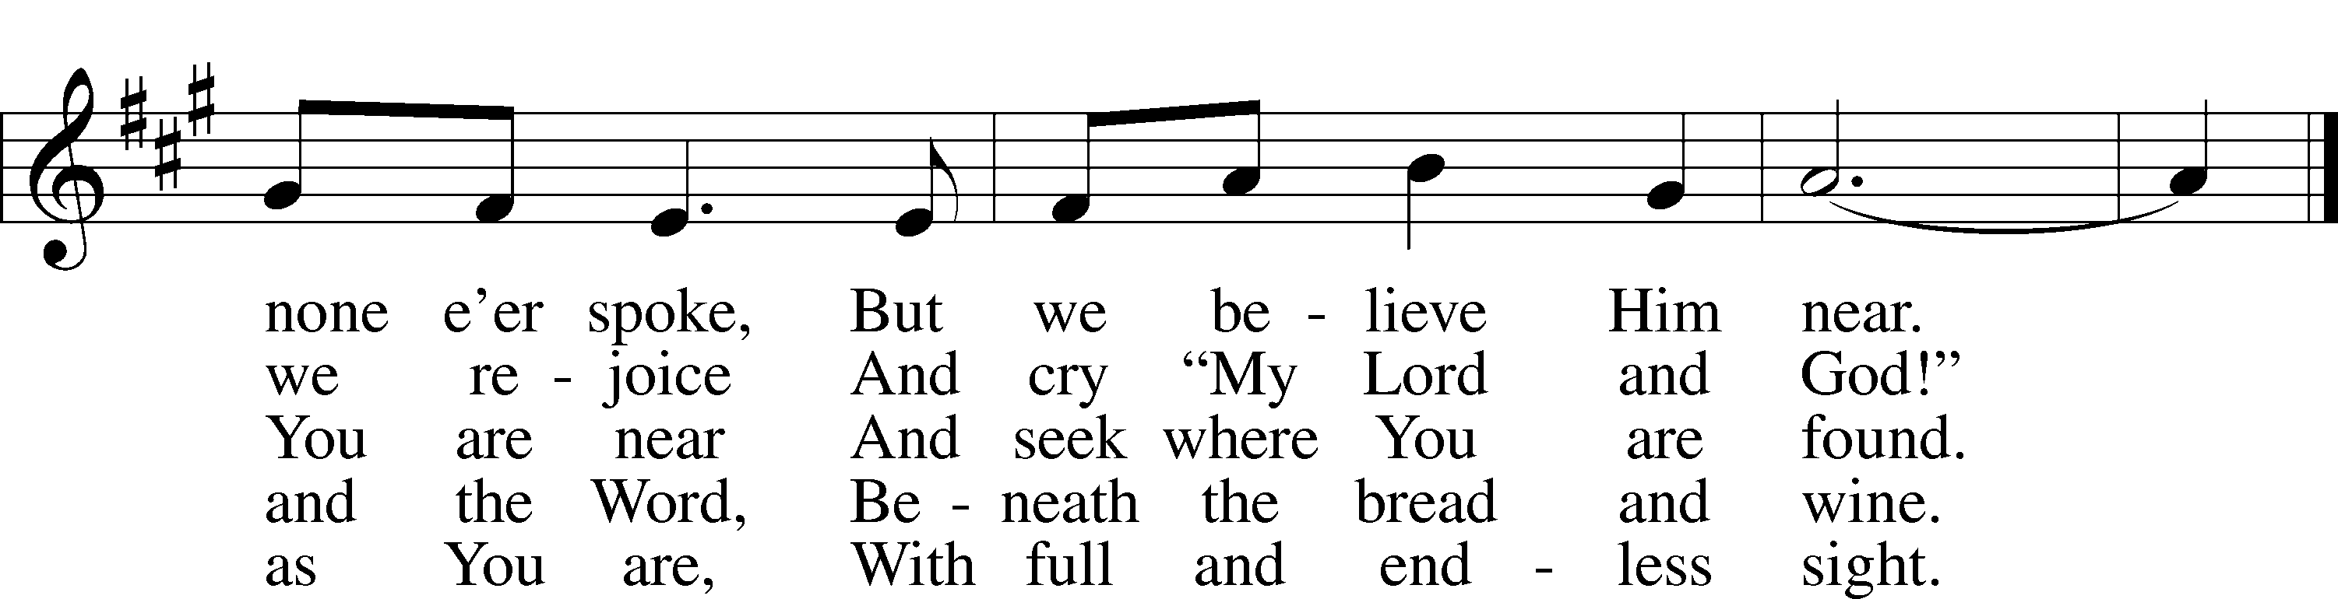
Tune: © 1984 GIA Publications, Inc. Used by permission: LSB Hymn License no. 110003744
Text: Public domain

Stand

The Dismissal
P The body and blood of our Lord Jesus Christ strengthen and preserve you in body and soul to life everlasting. Depart T in peace.
C Amen.

Thank the Lord LSB 164
C Thank the Lord and sing His praise; tell ev’ryone what He has done.
Let all who seek the Lord rejoice and proudly bear His name.
He recalls His promises and leads His people forth in joy
with shouts of thanksgiving. Alleluia, alleluia.

Post-Communion Collect
A Let us pray.
Gracious God, our heavenly Father, You have given us a foretaste of the feast to come in the Holy Supper of Your Son’s body and blood. Keep us firm in the true faith throughout our days of pilgrimage that, on the day of His coming, we may, together with all Your saints, celebrate the marriage feast of the Lamb in His kingdom which has no end; through Jesus Christ, Your Son, our Lord, who lives and reigns with You and the Holy Spirit, one God, now and forever.
C Amen.

Benediction LSB 166
P The Lord bless you and keep you.
The Lord make His face shine on you and be gracious to you.
The Lord look upon you with favor and T give you peace.
C Amen.

671 Sing with All the Saints in Glory
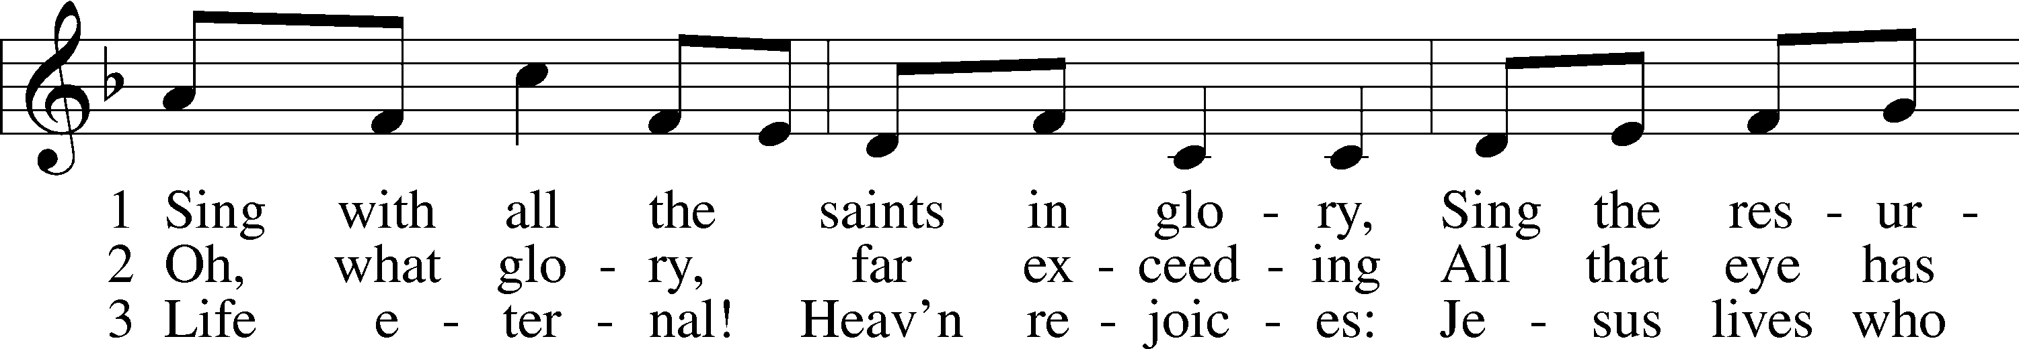
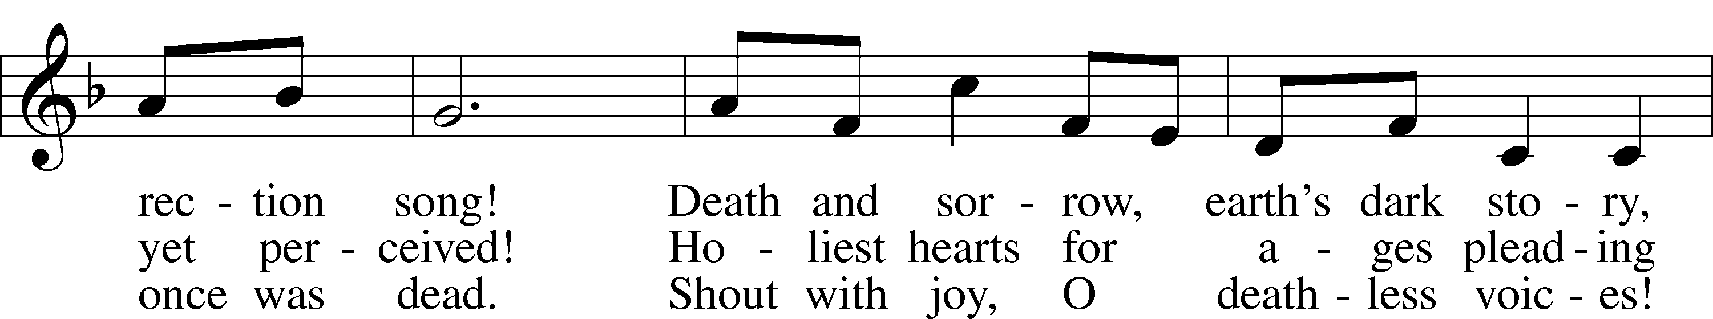
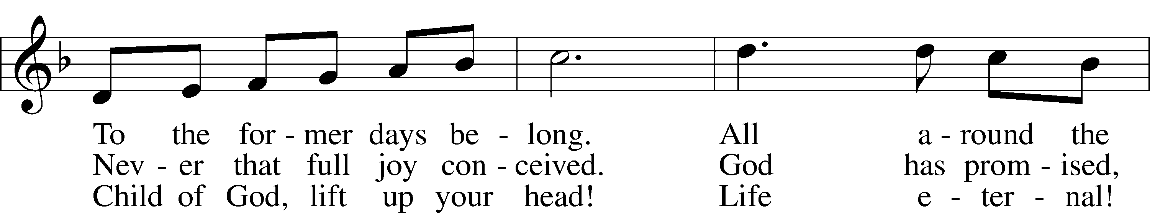
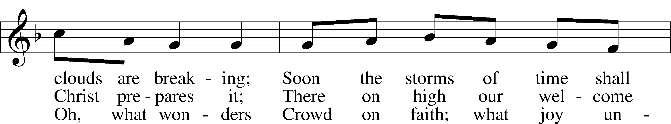
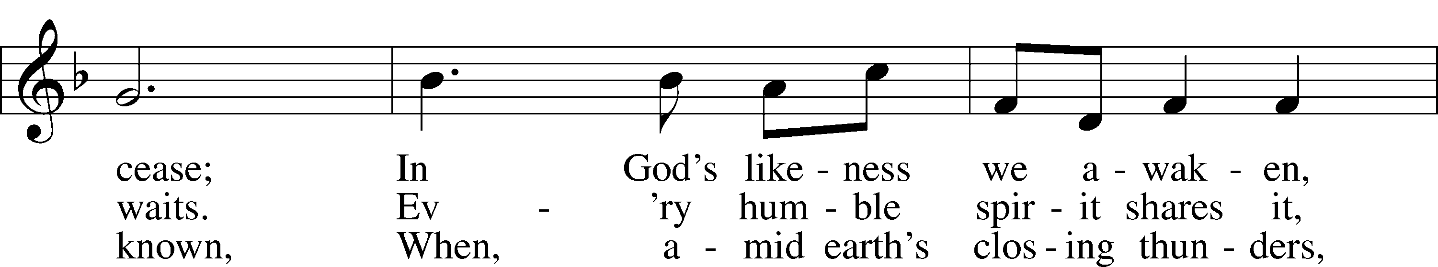
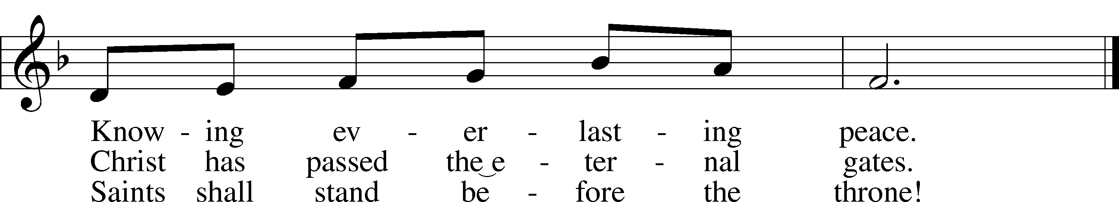
Text: Public domain
Tune: © 1995 Augsburg Fortress. Used by permission: LSB Hymn License no. 110003744

Acknowledgments
Unless otherwise indicated, Scripture quotations are from the ESV® Bible (The Holy Bible, English Standard Version®), copyright © 2001 by Crossway, a publishing ministry of Good News Publishers. Used by permission. All rights reserved.
Created by Lutheran Service Builder © 2020 Concordia Publishing House.
Prayers for Our Members
Robin Baker, Bailey Hockemeier, Leah Vogel | Expectant Mothers
Norman Abels (Brookestone Meadows – Elkhorn) | Healing
Judy Ahrens (St. Luke’s) | Healing
Vaughn Albrecht (Northridge) | Healing
Tom & DyAnn Altwine | Healing
David Banner | Healing
Lyle Colsden (Mother Hull) | Healing
Pat Flodine (Cambridge Court) | Healing
Vi Fox (Prairie View) | Healing
Verleen Gentry | Healing
Ruby Hatfield | Healing
Michelle Millsap | Healing
Betty Mustard | Healing
Roger Riekenberg | Healing
Marion Richmond | Healing
Geraldine Roeder | Healing
Lavern Stuehm | Healing
Fran Junge | Cancer
Bev Nuttelman | Cancer
Kim Vos | Cancer
Bob Glanzer | Thanksgiving

Prayers for Our Members’ Family & Friends
Brandon & Shannon Howell (Quentin & Janel Lange’s friends) | Family
Will Brennemann (Jami Helmbrecht’s father) | Healing
Reg Duke (Westman’s brother-in-law) | Healing
James Gentry (Verleen Gentry’s son) | Healing
Roger Hoffman (Marc’s father) | Healing
Sharon Kreutzer (former member) | Healing
Lyra Mais (Zion student) | Healing
Randy Solomon (Beth Rosenthal’s father) | Healing
Mary Ann Mertz (Pam’s Uhlir’s friend) | Healing
Roy Reynolds (Verleen Gentry’s son-in-law) | Healing
Janet Stalder (Carol Florang’s sister) | Healing
D.D. Dugger (Sue Kaiser’s brother) | Cancer
Ron Halvorsen (Jeff’s dad) | Cancer
Carol Haubold (Don Helmbrecht’s sister) | Cancer
Tyler Holland (Quentin & Janel Lange’s brother-in-law) | Cancer
Randy Jochum (Ken Hockemeier’s brother-in-law) | Cancer
Fred Koch (Pam Uhlir’s cousin) | Cancer
Lynda Kreutzer (Rich & Carol’s sister-in-law) | Cancer
Sharon Mulhair (Pam Uhlir’s cousin) | Cancer
Becky Rathkie (former Zion teacher) | Cancer
Jeannie Schmidt (Lisa Splittgerber’s sister-in-law) | Cancer
Tyrone Uhlir (Pam’s nephew) | Cancer

Today’s Radio Broadcast is given to the Glory of the Lord by Quentin & Janel Lange

Serving in Worship

Sunday, November 1~ 9:00am  Elder: Dan Oertwig  Usher: Fred Flessner &  Lennis Hodgson  Engineer: Jamie Nikodym  Announcer: Carol Kreutzer  Altar Guild: Brooke Fisher &  Tracy Schake | Sunday, November 8~ 9:00am  Elder: Ken Hockemeier  Usher: Marc Hoffman &  Steve Junge  Engineer: Zach DeLoach  Announcer: Brooke Fisher  Altar Guild: Brooke Fisher &  Tracy Schake

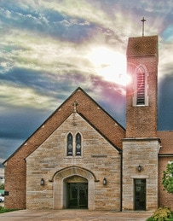

Our Response to the Gospel

Date: 10/25/2020

Offering: $7,343.88
Weekly Need: $7,542.37

ZION LUTHERAN CHURCH AND SCHOOL

Pr. James DeLoach, Pastor + (308) 627-5260
james.deloach@zionkearney.org
Pr. Doug Gaunt, Pastor + (308) 455-0552
doug.gaunt@zionkearney.org
Tony Splittgerber, Principal + (308) 293-0168
anthony.splittgerber@zionkearney.org

Church Office
Administrative Assistant: Jessica Shiers
Email: school@zionkearney.org
Phone: (308)-234-3410 Fax: (308) 236-8100
Office Hours: Monday-Friday 8:00am-4:00pm
Radio Broadcast: Sunday @ 10:30 a.m. on 1460 AM
Website: www.zionkearney.com

Where our Triune God strengthens us through His mercy in faith toward Him and in fervent love toward one another.

This Week at Zion

Sun  11/01 | 9:00a  10:30a | Divine Service  Radio Broadcast 1460am
Mon  11/02 | Birthdays  Anniversaries | School Foundation  Lynette Johnson  ---
Tues  11/03 | 1:30p  Birthdays  Anniversaries | Election Day  Sleeping Mats  ---  ---
Wed  11/04 | 8:25a  9:00a  5:45p  7:00p  Birthdays  Anniversaries | K-8th Chapel  ECE Chapel  Midweek Class  Adult Choir  Abigail Burger  ---
Thurs  11/05 | Birthdays  Anniversaries | ---  Quentin & Janel Lange
Fri  11/06 | Birthdays  Anniversaries | Kelly Eckhoff  Elizabeth Gaunt  Camden Vogel  Shane & Kelly Eckhoff
Sat  11/07 | 5:00p  Birthdays  Anniversaries | Divine Service  ---  ---
Sun  11/08 | 9:00a  10:30a  Birthdays  Anniversaries | Divine Service  Radio Broadcast 1460am  ---  ---
ANNOUNCEMENTS

Poinsettias – Zion will be taking poinsettia orders to adorn the Church Sanctuary during Christmas time. They will be $14.00 per plant. To order please place your money in an envelope with your name in the offering plate or the mail slot on the south side of the building or drop it off during office hours. Please make checks out to Mary Martha.

Volunteering Opportunities – Zion needs volunteers to help with the audio, video, and ushers for our worship service. Training will be provided. Please contact the office or Pr. DeLoach if interested or with questions.

A Bible Study – is prerecorded and available each Sunday, along with a study guide you can use to follow along. We are studying the three lessons for the day—the Old Testament, the Epistle, and the Gospel. Go to Zion’s website www.zionkearney.com to access the video and study guide.

Offering during this time. If you are not able to attend live Church Services, you may: drop your offering in the mail slot by the south doors, mail it to the church, or use online giving option at zionkearney.com. If you have any questions or need assistance please contact the office at 308-234-3410 or school@zionkearney.org. Thank you for supporting of your church!

Mary Martha – Mary Martha will meet in the fellowship hall on November 9th at 7:00p.m. Both circles will meet together.

Thanksgiving Meal Cancelled – The Mary Martha Guild has made the decision to NOT have our Thanksgiving meal this year because of Covid-19 concerns. We plan to make every effort to bring it back next year.

Food Collection – Zion will collect food items during the month of November to help supply Kearney agencies who assists the needy. There will be grocery carts in the narthex and school are to gather these items. Non-perishable items only please.

Radio Broadcast & Altar Flowers - Please help Zion spread the Gospel! There are several open dates. This is a great need during this time, many people are listening to our broadcast during this time. There are also many openings for altar flowers. Please help beautify the sanctuary.

2021 Lutheran Annual – If you would like to order at 2021 Lutheran Annual please notify the church office at 308-234-3410 or school@zionkearney.org. They will be about $29.14 per book.
Mission Offerings - The fourth quarter missions, October through December, will support those preparing for fulltime church work (Peter Kreutzer and Taylor Zehendner, both at CUNE). If you would like to donate to this mission please use the mission envelopes located in the narthex. Thank you for your support.

Apple Market Receipts – Apple Market receipts will be accepted from register dates September 1, 2020 – March 1, 2021. Please turn in your receipts to the office to earn free things for the school!

Family Fresh Receipts –Don’t forget that Zion collects Family Fresh receipts any date. Please turn them into the office.

Boxtops –Boxtops has discontinued the labels on the packages. They now have an app for your smartphone to redeem qualifying products. If you do not have a smartphone or don’t want to install the app turn your grocery receipts with qualifying boxtop products into the office and they will get scanned to continue to earn money for Zion.

2021 Radio & Flower Charts – The 2021 radio and flower charts are posted in the hallway by the mailboxes. If there is a special day make sure you sign up early. You are welcome to call the office to sign up for your spot.

The Lord’s Prayer Booklet – There is a Lord’s Prayer Booklet, to assist with your devotions, on the counter in the narthex. Feel free to take one. These are compliments of Pastor & Carol Gaunt.

Give Where You Live - This year Zion will be participating in Give Where You Live Campaign. It will be December 3rd (giving day), but donations will be accepted beginning November 5th. To contribute online go to: https://www.givewhereyoulive.net//zionlutheranschool. If you would rather give in person feel free to stop by the office. Please share this with family and friends.

Heartland Lutheran Blood Drive – On Friday, November 13 from 8:30am-2:30pm Heartland Lutheran will be holding a blood drive. Please call Mrs. Zehendner at 308-385-3900 to schedule an appointment time.

Organ Available – I am moving and must part with my 2-manual, full-pedal Rodgers organ. I am a former organ teacher and church organist, so parting with the organ isn't easy. I'm hoping a congregation, school, or individual can provide it continued use. I may be reached at Enidhansen11@gmail.com or by calling 308.440.8087. Thank you,

Employment Opportunities at Zion

2020 has been a real year of change and through it all Zion has been blessed with a remarkably steady and stable staff. Recently however, personal events have led to some upcoming staff changes and we praying that the Lord will bless these individuals as they move on and also that the Lord will continue to provide Zion with stellar replacements. If you or someone you know may be interested in the following positions, please pass this information along to them and let Mr. Splittgerber know. Thank you!

1) Part-time Cook: We are looking for someone who has some experience/interest in food service. Task include meal prep, serving, and cleaning. Candidate strengths should include time management, kitchen experience, and a positive disposition. This position is for 3 days a week.
2) Elementary School Teacher: Mr. Vogel and family will be moving at the conclusion of this school year so the search for another high quality Lutheran teacher has begun. Full time teachers in our school must be members of the LCMS (or willing to become so). The grade level will most probably be for the 3rd/4th grade.

