Divine Service
Twenty-fourth Sunday after Pentecost
November 15, 2020
Zion Lutheran Church
Kearney, Nebraska

Welcome to Zion!
All worshippers please fill out an attendance card in the pew rack and let us know how we might be of service to you.

Holy Communion at Zion

The Lord’s Supper is celebrated at this congregation as Jesus has given it. As he says, our Lord gives into our mouths not only bread and wine but his very body and blood to eat and to drink for the forgiveness of sins and to strengthen our union with him and with one another. Our Lord invites to his table those who trust his words, repent of all sin, and set aside any refusal to forgive and love as he forgives and loves us, that they may show forth his death until he comes. All communicants need to register in the narthex prior to the service.

Because those who eat and drink our Lord’s body and blood unworthily do great harm and because Holy Communion is a confession of the faith which is confessed at this altar, any who are not yet instructed, in doubt, or who hold a confession differing from that of this congregation and The Lutheran Church—Missouri Synod, are asked not to commune until they are able to speak with our pastor first. He is happy to visit with you about the Christian faith and how to receive the Lord’s Supper for your good and for the good of others. Those not communing are invited to come to the altar, cross your arms in front of you, and bow your head to receive a pastoral blessing.

God’s Gift of Forgiveness Engenders Our Forgiveness of Others

The Day of the Lord is “near and hastening fast,” and it will be “a day of distress and anguish, a day of ruin and devastation” (Zeph. 1:14, 15). The Lord will search out and punish “the men who are complacent” concerning His Word, “who fill their master’s house with violence and fraud” (Zeph. 1:9, 12). Then all their works and efforts will be for nothing: “Though they build houses, they shall not inhabit them; though they plant vineyards, they shall not drink wine from them” (Zeph. 1:13). But those who fear, love and trust in the Lord are “good and faithful” stewards of His property (Matt. 25:21). They live by faith in His free gift of forgiveness, and they multiply His goods in the loving forgiveness of their neighbor, and “the master of those servants” settles His accounts with them by the gracious reckoning of His Gospel (Matt. 25:19). Likewise, “God has not destined us for wrath, but to obtain salvation through our Lord Jesus Christ” (1 Thess. 5:9). Therefore, let us also “put on the breastplate of faith and love” in our dealings with one another (1 Thess. 5:8).
Confession and Absolution

508 The Day Is Surely Drawing Near
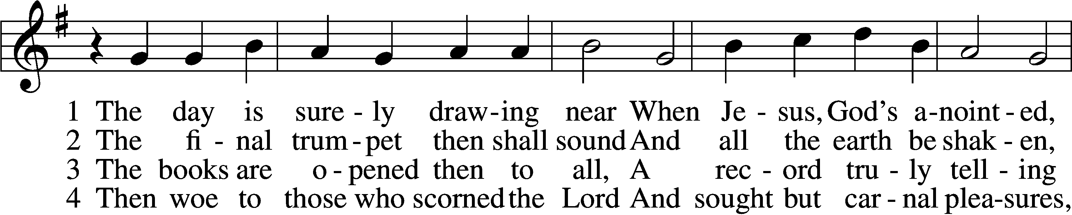
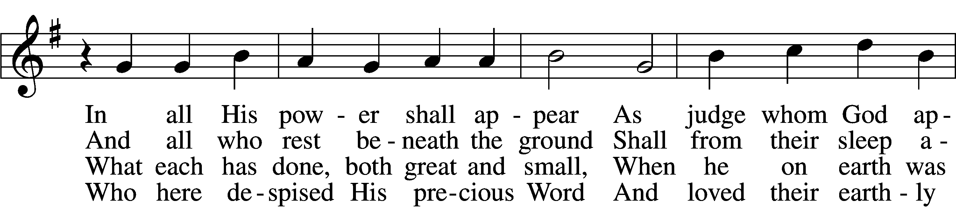
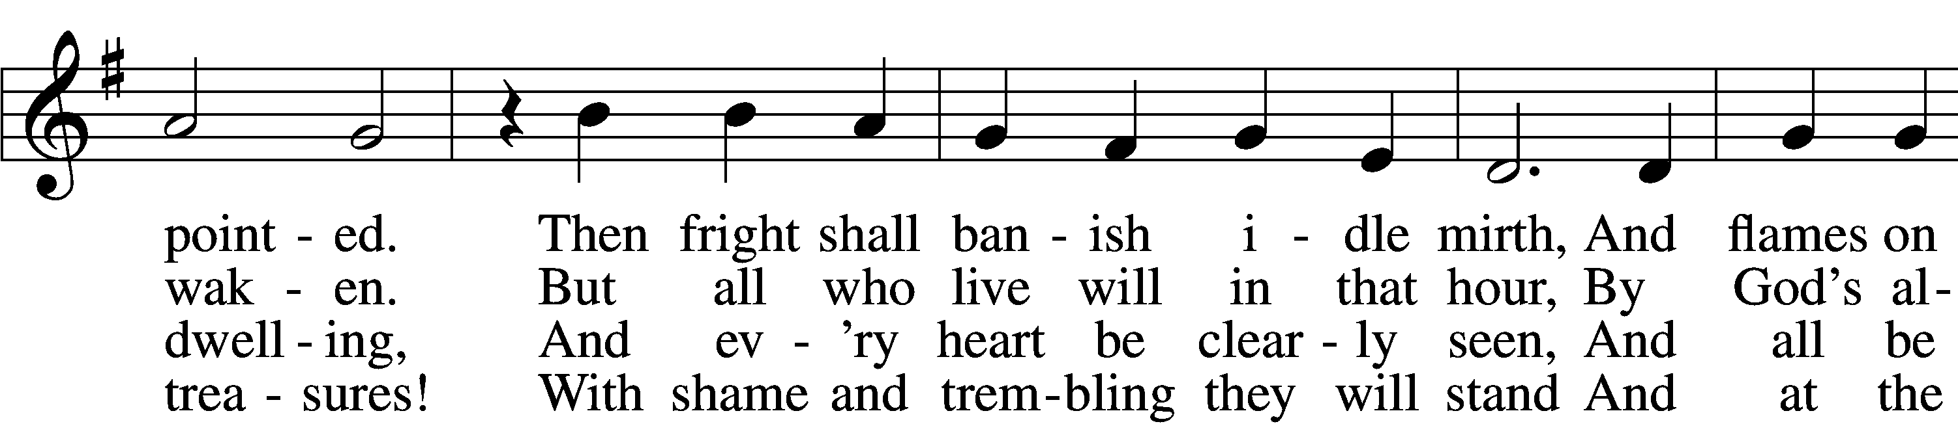
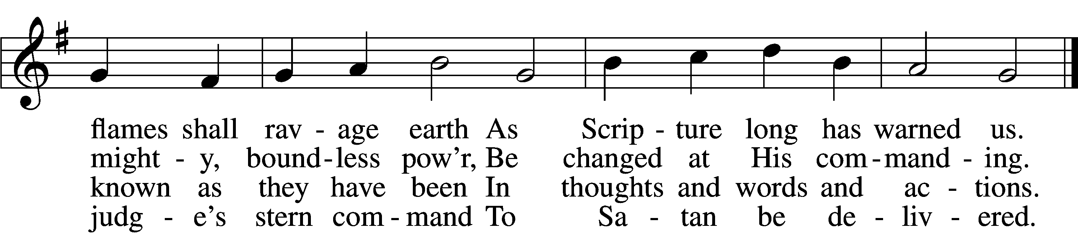

5 My Savior paid the debt I owe
And for my sin was smitten;
Within the Book of Life I know
My name has now been written.
I will not doubt, for I am free,
And Satan cannot threaten me;
There is no condemnation!

6 May Christ our intercessor be
And through His blood and merit
Read from His book that we are free
With all who life inherit.

Then we shall see Him face to face,
With all His saints in that blest place
Which He has purchased for us.

7 O Jesus Christ, do not delay,
But hasten our salvation;
We often tremble on our way
In fear and tribulation.
O hear and grant our fervent plea:
Come, mighty judge, and set us free
From death and ev’ry evil.
Text and tune: Public domain

Stand

The sign of the cross may be made by all in remembrance of their Baptism.
P In the name of the Father and of the T Son and of the Holy Spirit.
C Amen.

P If we say we have no sin, we deceive ourselves, and the truth is not in us.
C But if we confess our sins, God, who is faithful and just, will forgive our sins and cleanse us from all unrighteousness.

Silence for reflection on God’s Word and for self-examination.

P Let us then confess our sins to God our Father.
C Most merciful God, we confess that we are by nature sinful and unclean. We have sinned against You in thought, word, and deed, by what we have done and by what we have left undone. We have not loved You with our whole heart; we have not loved our neighbors as ourselves. We justly deserve Your present and eternal punishment. For the sake of Your Son, Jesus Christ, have mercy on us. Forgive us, renew us, and lead us, so that we may delight in Your will and walk in Your ways to the glory of Your holy name. Amen.

P Almighty God in His mercy has given His Son to die for you and for His sake forgives you all your sins. As a called and ordained servant of Christ, and by His authority, I therefore forgive you all your sins in the name of the Father and of the T Son and of the Holy Spirit.
C Amen.

Stand

Service of the Word

Introit Psalm 143:2, 5–6, 10–11; antiphon: v. 1
Hear my prayer, O Lord; give ear to my pleas for | mercy!*
In your faithfulness answer me, in your | righteousness!
Enter not into judgment with your | servant,*
for no one living is righteous be- | fore you.
I remember the days of old; I meditate on all that | you have done;*
I ponder the work | of your hands.
I stretch out my | hands to you;*
my soul thirsts for you like a | parched land.
Teach me to do your will, for you | are my God!*
Let your good Spirit lead me on | level ground!
For your name’s sake, O Lord, pre- | serve my life!*
In your righteousness bring my soul out of | trouble!
Glory be to the Father and | to the Son*
and to the Holy | Spirit;
as it was in the be- | ginning,*
is now, and will be forever. | Amen.
Hear my prayer, O Lord; give ear to my pleas for | mercy!*
In your faithfulness answer me, in your | righteousness!

Kyrie LSB 152
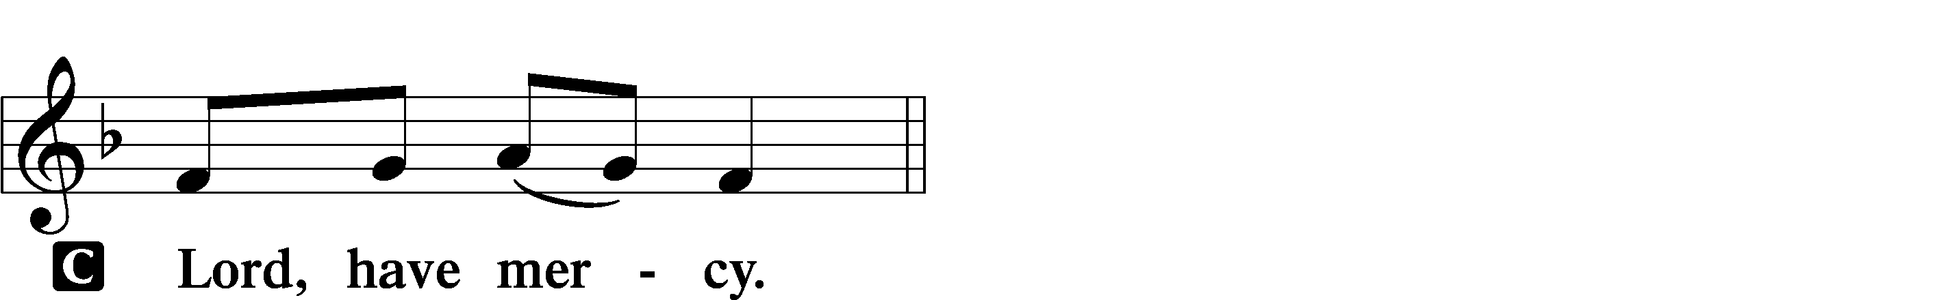

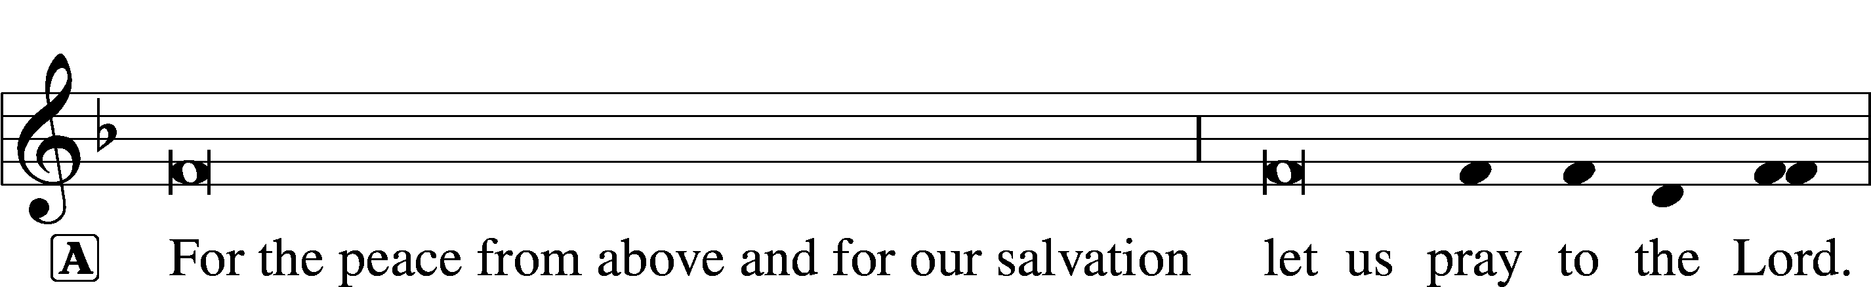

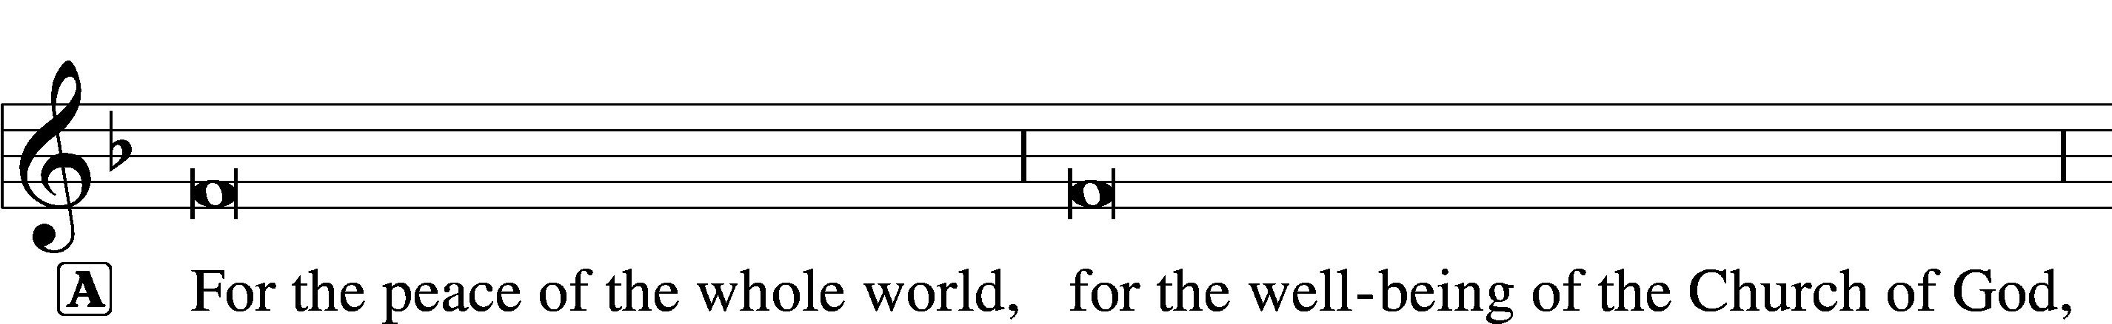

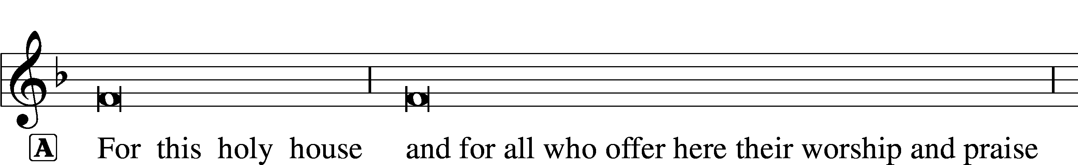
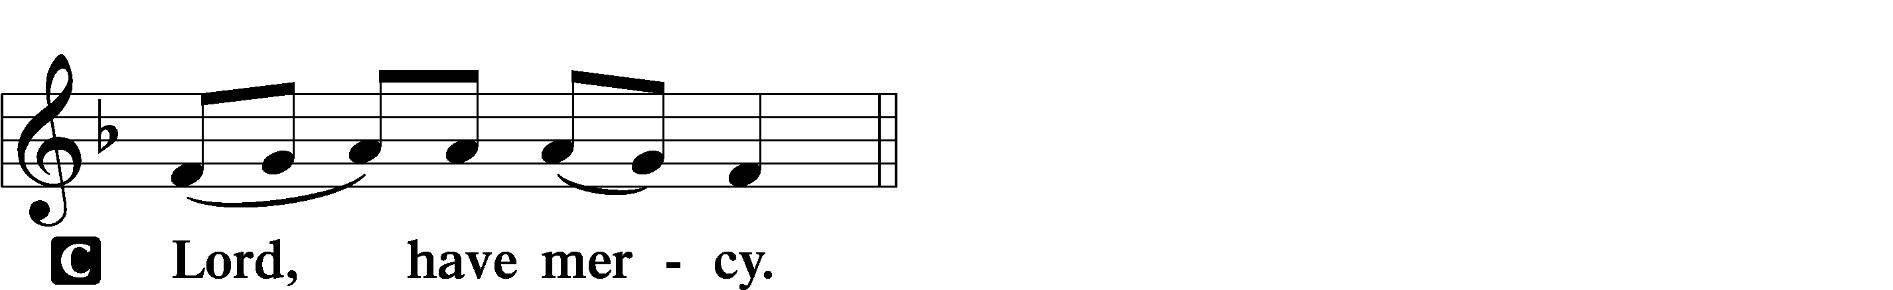

Gloria in Excelsis LSB 154
A Glory to God in the highest, and peace to His people on earth.
C Lord God, heavenly king, almighty God and Father:
We worship You, we give You thanks, we praise You for Your glory.
Lord Jesus Christ, only Son of the Father, Lord God, Lamb of God:
You take away the sin of the world; have mercy on us.
You are seated at the right hand of the Father; receive our prayer.
For You alone are the Holy One, You alone are the Lord,
You alone are the Most High, Jesus Christ, with the Holy Spirit,
in the glory of God the Father. Amen.

Salutation and Collect of the Day
P The Lord be with you.
C And also with you.

P Let us pray.
Almighty and ever-living God, You have given exceedingly great and precious promises to those who trust in You. Dispel from us the works of darkness and grant us to live in the light of Your Son, Jesus Christ, that our faith may never be found wanting; through the same Jesus Christ, our Lord, who lives and reigns with You and the Holy Spirit, one God, now and forever.

C Amen.

Sit

Old Testament Reading Zephaniah 1:7–16
⁷Be silent before the Lord God!
For the day of the Lord is near;
the Lord has prepared a sacrifice
and consecrated his guests.
⁸And on the day of the Lord’s sacrifice—
“I will punish the officials and the king’s sons
and all who array themselves in foreign attire.
⁹On that day I will punish
everyone who leaps over the threshold,
and those who fill their master’s house
with violence and fraud.
¹⁰“On that day,” declares the Lord,
“a cry will be heard from the Fish Gate,
a wail from the Second Quarter,
a loud crash from the hills.
¹¹Wail, O inhabitants of the Mortar!
For all the traders are no more;
all who weigh out silver are cut off.
¹²At that time I will search Jerusalem with lamps,
and I will punish the men
who are complacent,
those who say in their hearts,
‘The Lord will not do good,
nor will he do ill.’
¹³Their goods shall be plundered,
and their houses laid waste.
Though they build houses,
they shall not inhabit them;
though they plant vineyards,
they shall not drink wine from them.”
¹⁴The great day of the Lord is near,
near and hastening fast;
the sound of the day of the Lord is bitter;
the mighty man cries aloud there.
¹⁵A day of wrath is that day,
a day of distress and anguish,
a day of ruin and devastation,
a day of darkness and gloom,
a day of clouds and thick darkness,
¹⁶a day of trumpet blast and battle cry
against the fortified cities
and against the lofty battlements.

A This is the Word of the Lord.
C Thanks be to God.

Gradual Revelation 7:14b; Psalm 84:5
These are the ones coming out of the great tribu- | lation.*
They have washed their robes and made them white in the blood | of the Lamb.
Blessèd are those whose strength is | in you,*
in whose heart are the highways to | Zion.

Epistle 1 Thessalonians 5:1–11
¹Now concerning the times and the seasons, brothers, you have no need to have anything written to you. ²For you yourselves are fully aware that the day of the Lord will come like a thief in the night. ³While people are saying, “There is peace and security,” then sudden destruction will come upon them as labor pains come upon a pregnant woman, and they will not escape. ⁴But you are not in darkness, brothers, for that day to surprise you like a thief. ⁵For you are all children of light, children of the day. We are not of the night or of the darkness. ⁶So then let us not sleep, as others do, but let us keep awake and be sober. ⁷For those who sleep, sleep at night, and those who get drunk, are drunk at night. ⁸But since we belong to the day, let us be sober, having put on the breastplate of faith and love, and for a helmet the hope of salvation. ⁹For God has not destined us for wrath, but to obtain salvation through our Lord Jesus Christ, ¹⁰who died for us so that whether we are awake or asleep we might live with him. ¹¹Therefore encourage one another and build one another up, just as you are doing.

A This is the Word of the Lord.
C Thanks be to God.

Stand

Alleluia and Verse LSB 156
C Alleluia.
Lord, to whom shall we go?
You have the words of eternal life.
Alleluia, alleluia.

Holy Gospel Matthew 25:14–30
P The Holy Gospel according to St. Matthew, the twenty-fifth chapter.
C Glory to You, O Lord.

¹⁴[Jesus said:] “For it will be like a man going on a journey, who called his servants and entrusted to them his property. ¹⁵To one he gave five talents, to another two, to another one, to each according to his ability. Then he went away. ¹⁶He who had received the five talents went at once and traded with them, and he made five talents more. ¹⁷So also he who had the two talents made two talents more. ¹⁸But he who had received the one talent went and dug in the ground and hid his master’s money. ¹⁹Now after a long time the master of those servants came and settled accounts with them. ²⁰And he who had received the five talents came forward, bringing five talents more, saying, ‘Master, you delivered to me five talents; here I have made five talents more.’ ²¹His master said to him, ‘Well done, good and faithful servant. You have been faithful over a little; I will set you over much. Enter into the joy of your master.’ ²²And he also who had the two talents came forward, saying, ‘Master, you delivered to me two talents; here I have made two talents more.’ ²³His master said to him, ‘Well done, good and faithful servant. You have been faithful over a little; I will set you over much. Enter into the joy of your master.’ ²⁴He also who had received the one talent came forward, saying, ‘Master, I knew you to be a hard man, reaping where you did not sow, and gathering where you scattered no seed, ²⁵so I was afraid, and I went and hid your talent in the ground. Here you have what is yours.’ ²⁶But his master answered him, ‘You wicked and slothful servant! You knew that I reap where I have not sowed and gather where I scattered no seed? ²⁷Then you ought to have invested my money with the bankers, and at my coming I should have received what was my own with interest. ²⁸So take the talent from him and give it to him who has the ten talents. ²⁹For to everyone who has will more be given, and he will have an abundance. But from the one who has not, even what he has will be taken away. ³⁰And cast the worthless servant into the outer darkness. In that place there will be weeping and gnashing of teeth.’”

P This is the Gospel of the Lord.
C Praise to You, O Christ.

Sit

513 The Clouds of Judgment Gather
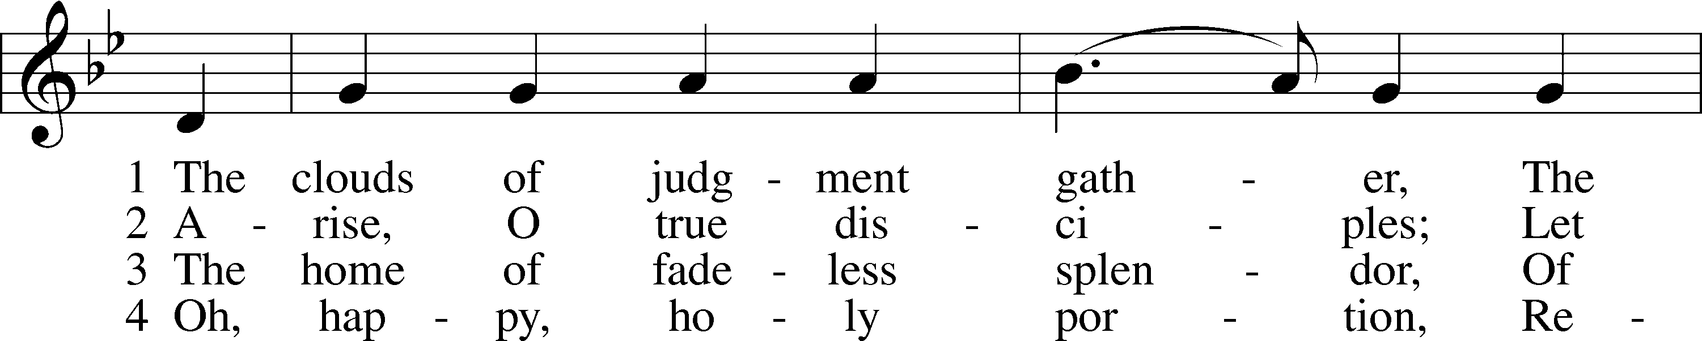
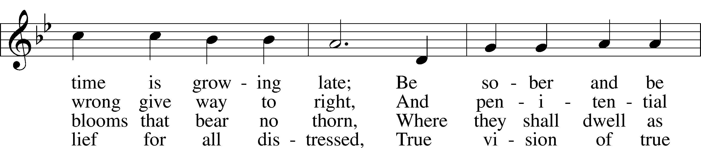
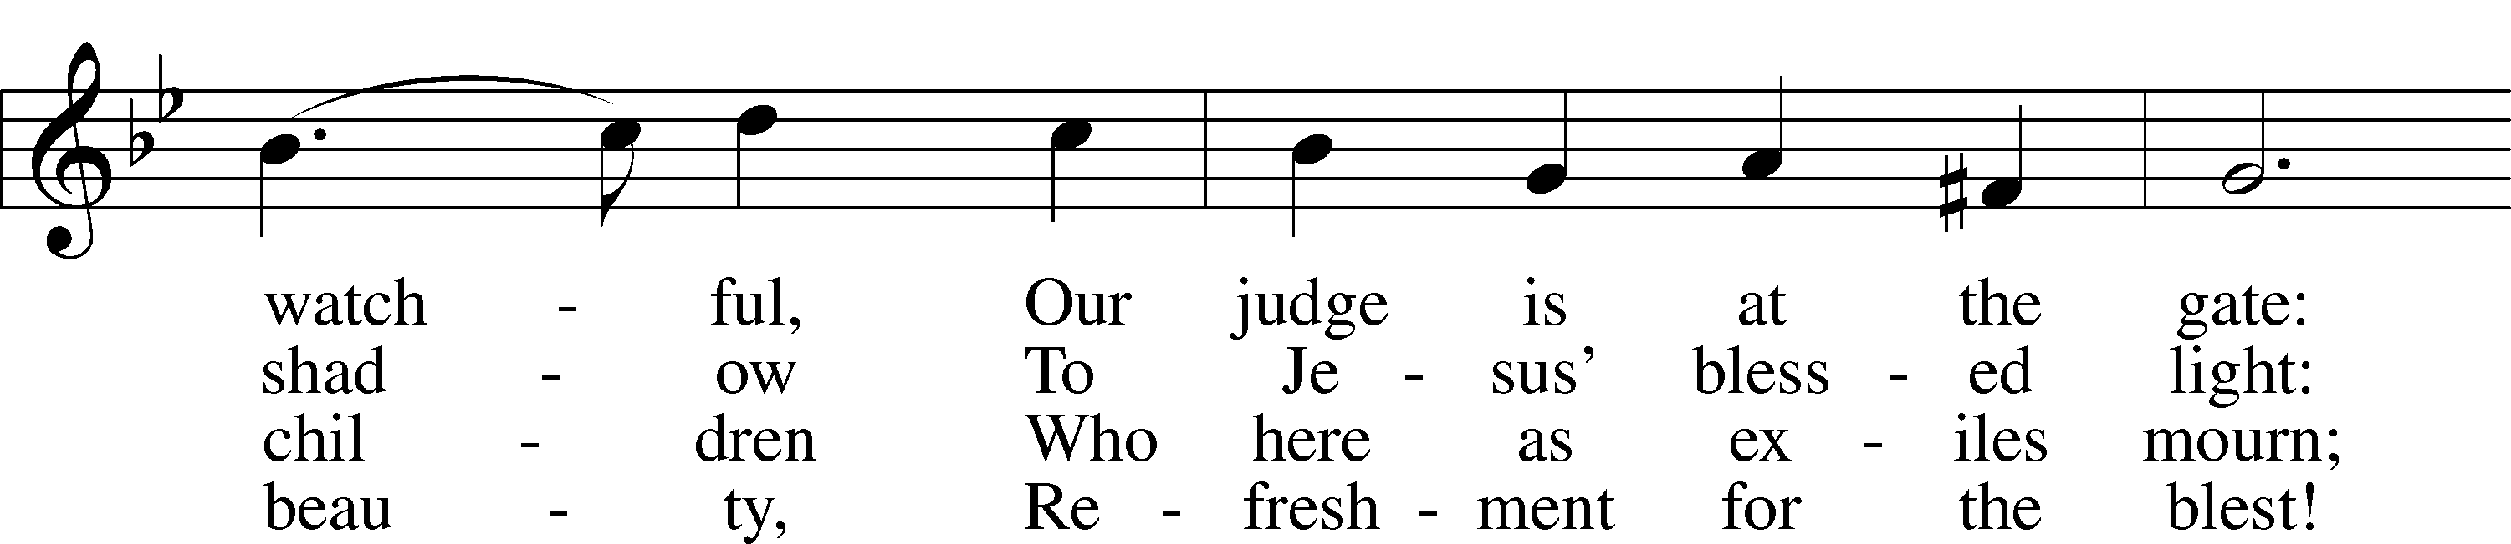
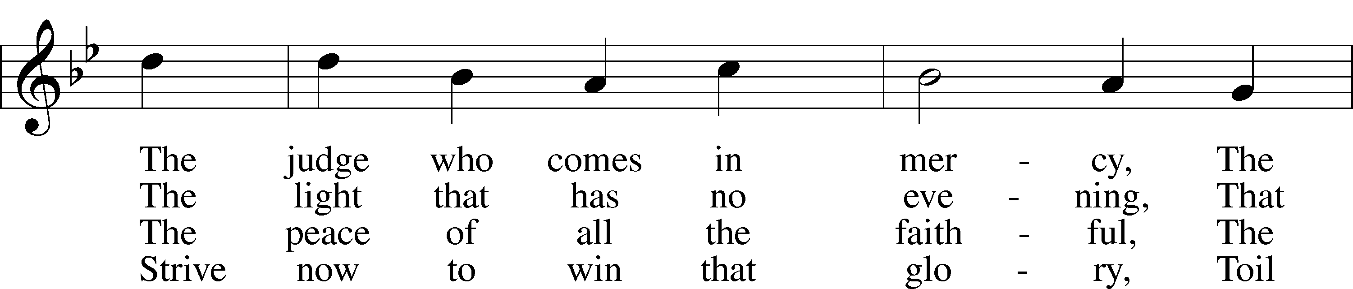
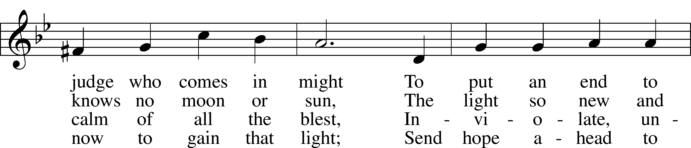
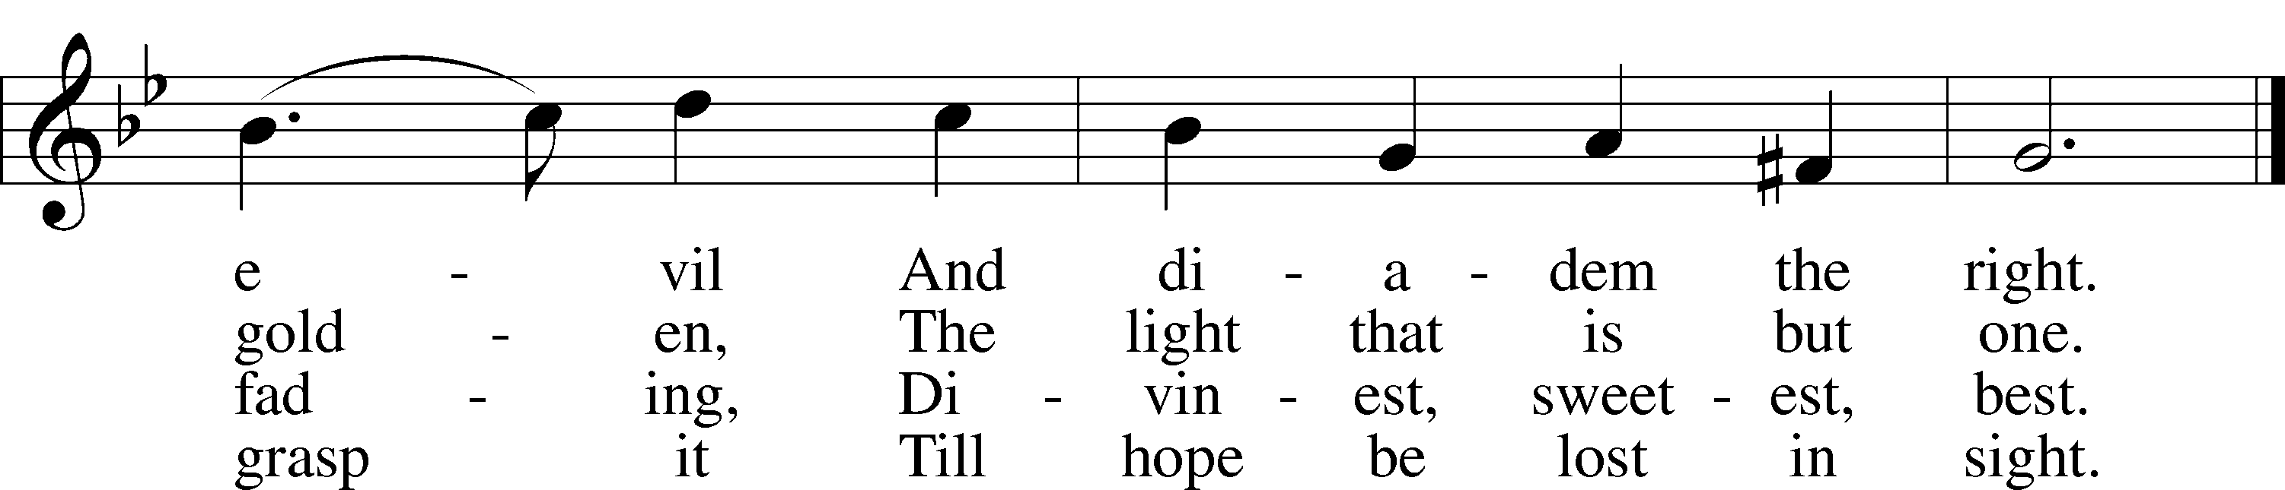
Tune: Public domain
Text: © 1978 Lutheran Book of Worship. Used by permission: LSB Hymn License no. 110003744

Sermon – No Place For Complacency

Stand

Nicene Creed
C I believe in one God,
the Father Almighty,
maker of heaven and earth
and of all things visible and invisible.

And in one Lord Jesus Christ,
the only-begotten Son of God,
begotten of His Father before all worlds,
God of God, Light of Light,
very God of very God,
begotten, not made,
being of one substance with the Father,
by whom all things were made;
who for us men and for our salvation came down from heaven
and was incarnate by the Holy Spirit of the virgin Mary
and was made man;
and was crucified also for us under Pontius Pilate.
He suffered and was buried.
And the third day He rose again according to the Scriptures
and ascended into heaven
and sits at the right hand of the Father.
And He will come again with glory to judge both the living and the dead,
whose kingdom will have no end.

And I believe in the Holy Spirit,
the Lord and giver of life,
who proceeds from the Father and the Son,
who with the Father and the Son together is worshiped and glorified,
who spoke by the prophets.
And I believe in one holy Christian and apostolic Church,
I acknowledge one Baptism for the remission of sins,
and I look for the resurrection of the dead
and the life T of the world to come. Amen.

Prayer of the Church

Offertory LSB 159
C What shall I render to the Lord for all His benefits to me?
I will offer the sacrifice of thanksgiving and will call on the name of the Lord.
I will take the cup of salvation and will call on the name of the Lord.
I will pay my vows to the Lord now in the presence of all His people,
in the courts of the Lord’s house, in the midst of you, O Jerusalem.

Service of the Sacrament

Preface LSB 160
P The Lord be with you.
C And also with you.

P Lift up your hearts.
C We lift them to the Lord.

P Let us give thanks to the Lord our God.
C It is right to give Him thanks and praise.

P It is truly good, right, and salutary that we should at all times and in all places give thanks to You, holy Lord, almighty Father, everlasting God, through Jesus Christ, our Lord, who, having created all things, took on human flesh and was born of the virgin Mary. For our sake He died on the cross and rose from the dead to put an end to death, thus fulfilling Your will and gaining for You a holy people. Therefore with angels and archangels and with all the company of heaven we laud and magnify Your glorious name, evermore praising You and saying:

Sanctus LSB 161
C Holy, holy, holy Lord God of pow’r and might:
Heaven and earth are full of Your glory.
Hosanna. Hosanna.
Hosanna in the highest.
Blessed is He who comes in the name of the Lord.
Hosanna in the highest.

Lord’s Prayer
C Our Father who art in heaven,
hallowed be Thy name,
Thy kingdom come,
Thy will be done on earth
as it is in heaven;
give us this day our daily bread;
and forgive us our trespasses
as we forgive those
who trespass against us;
and lead us not into temptation,
but deliver us from evil.
For Thine is the kingdom
and the power and the glory
forever and ever. Amen.

The Words of Our Lord
P Our Lord Jesus Christ, on the night when He was betrayed, took bread, and when He had given thanks, He broke it and gave it to the disciples and said: “Take, eat; this is My T body, which is given for you. This do in remembrance of Me.”

In the same way also He took the cup after supper, and when He had given thanks, He gave it to them, saying: “Drink of it, all of you; this cup is the new testament in My T blood, which is shed for you for the forgiveness of sins. This do, as often as you drink it, in remembrance of Me.”

Pax Domini LSB 163
P The peace of the Lord be with you always.
C Amen.

Agnus Dei LSB 163
C Lamb of God, You take away the sin of the world; have mercy on us.
Lamb of God, You take away the sin of the world; have mercy on us.
Lamb of God, You take away the sin of the world; grant us peace.

Sit

Distribution

663 Rise, My Soul, to Watch and Pray
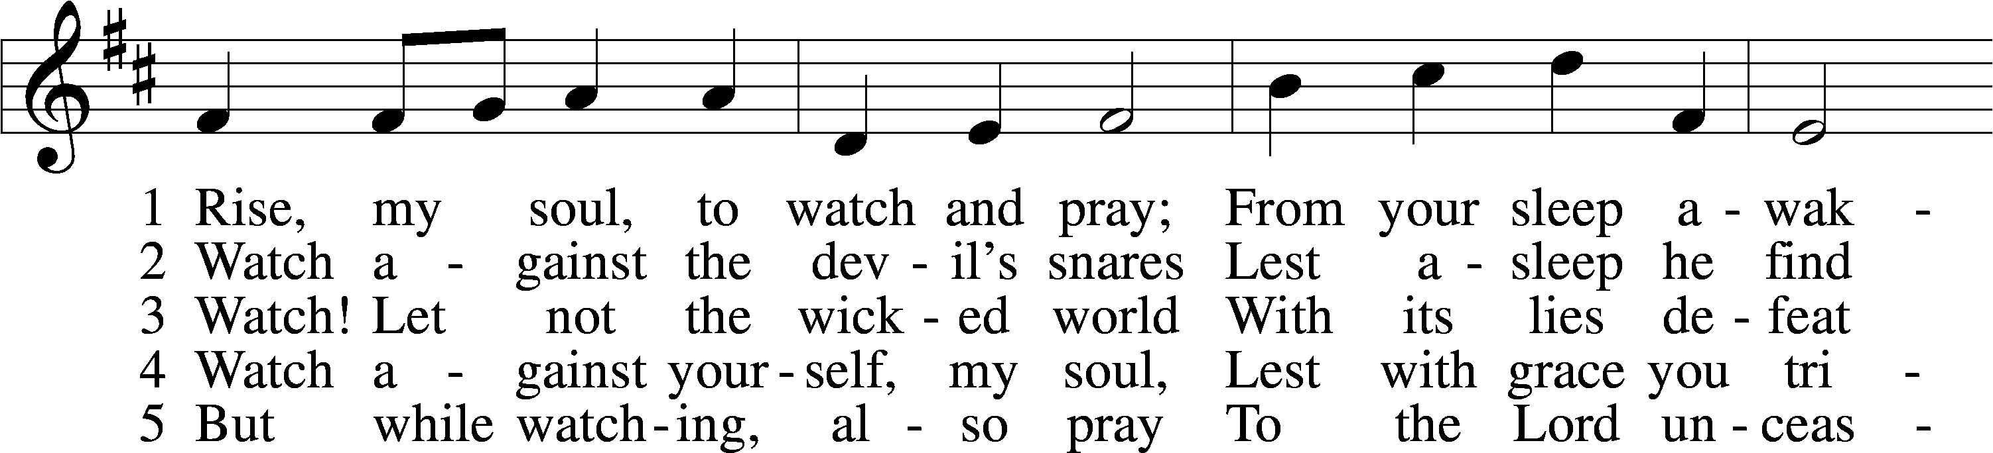
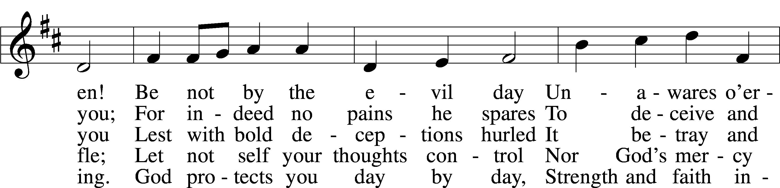
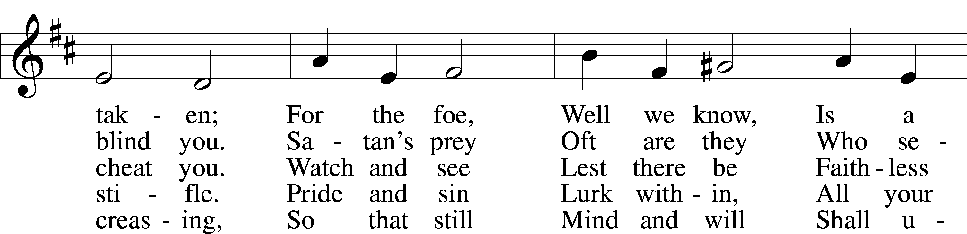
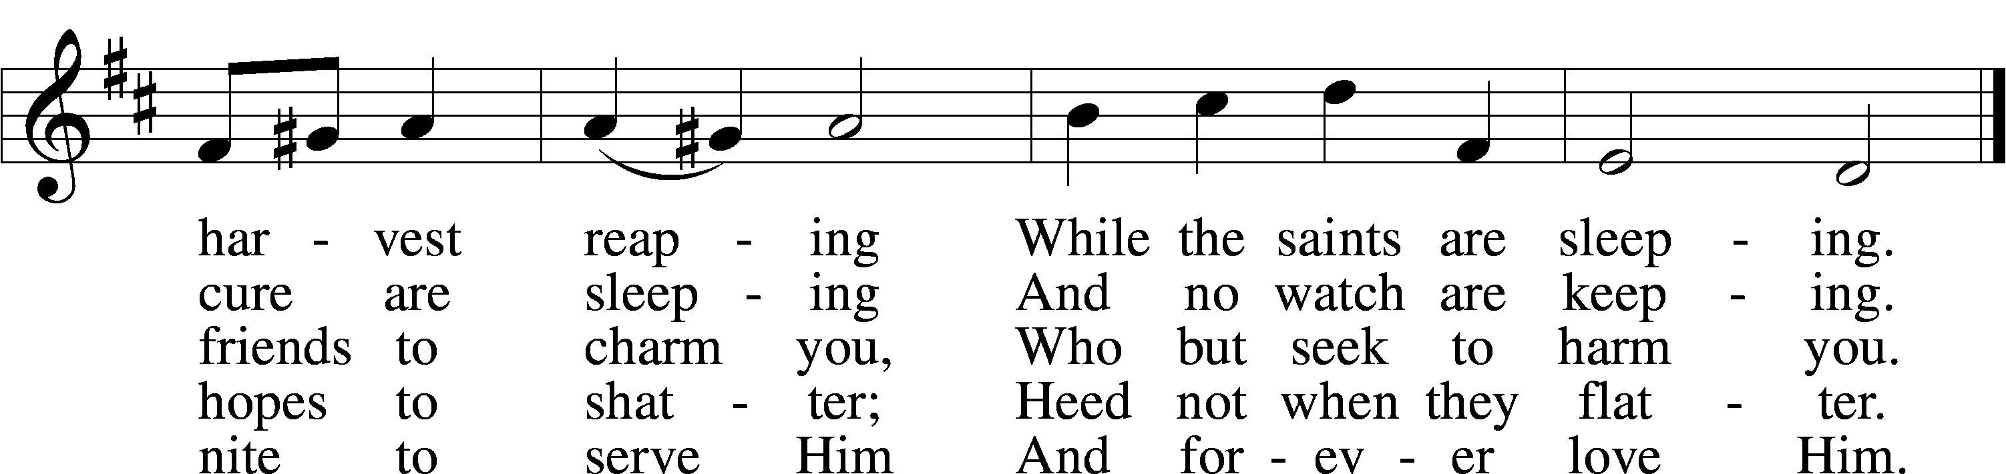
Tune and text: Public domain

621 Let All Mortal Flesh Keep Silence
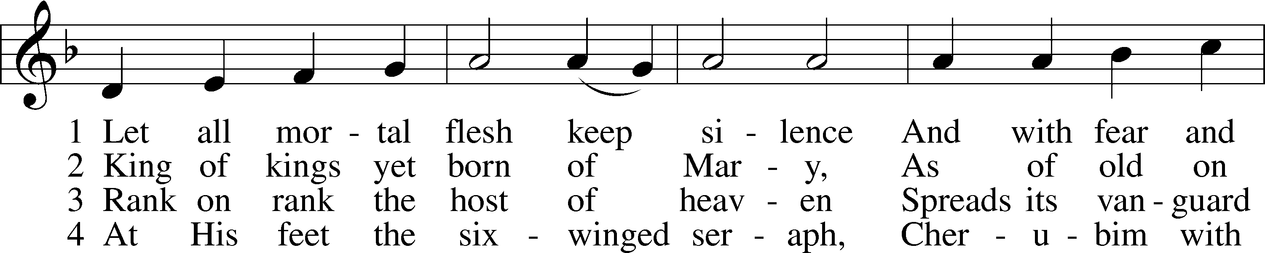
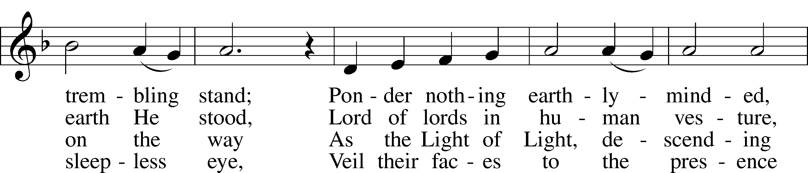
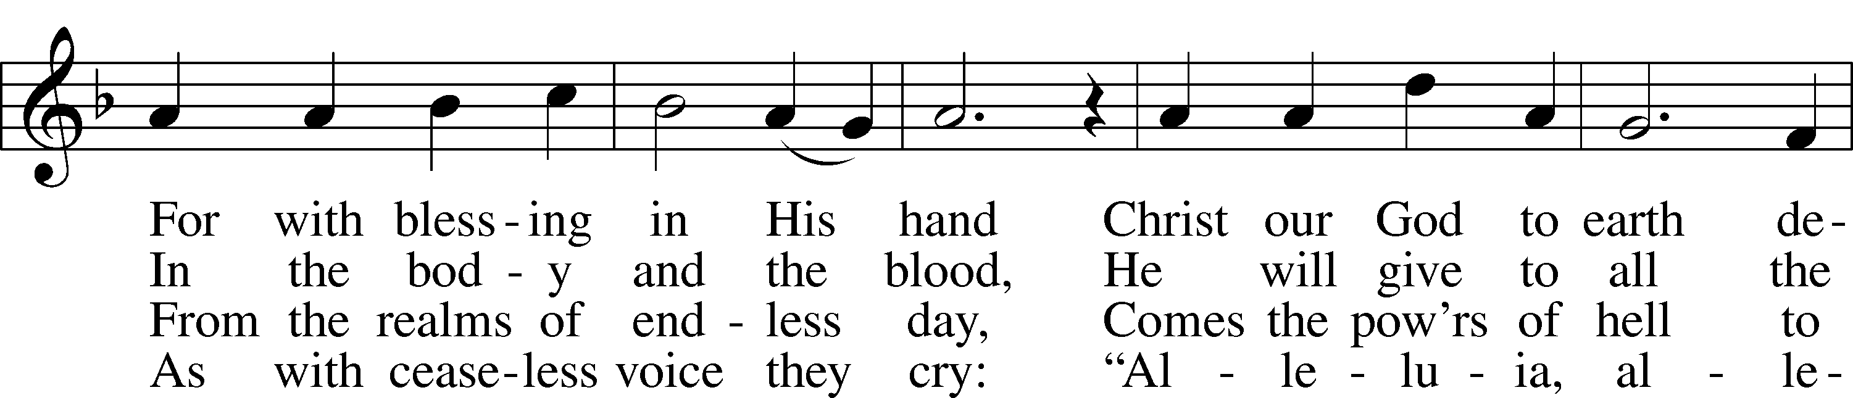
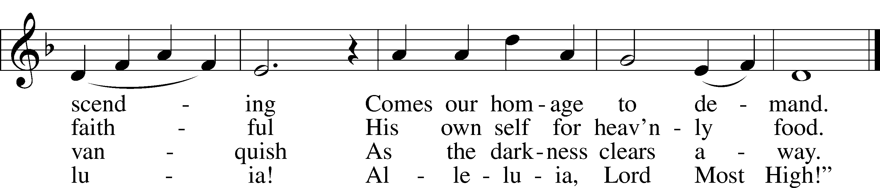
Text and tune: Public domain

627 Jesus Christ, Our Blessed Savior
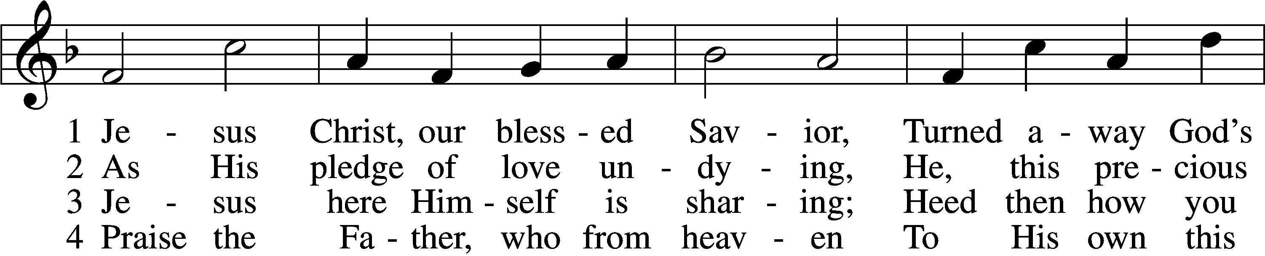
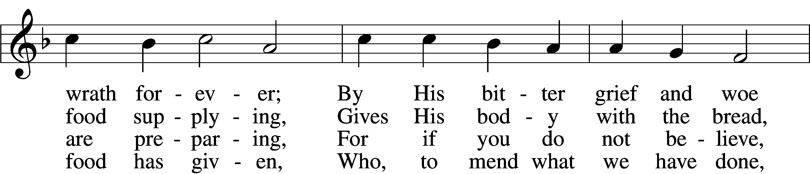
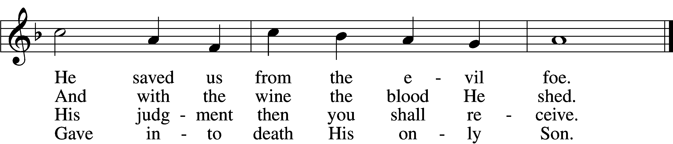

5 Firmly hold with faith unshaken
That this food is to be taken
By the sick who are distressed,
By hearts that long for peace and rest.

6 Agony and bitter labor
Were the cost of God’s high favor;
Do not come if you suppose
You need not Him who died and rose.

7 Christ says: “Come, all you that labor,
And receive My grace and favor:
Those who feel no pain or ill
Need no physician’s help or skill.

8 “For what purpose was My dying
If not for your justifying?
And what use this precious food
If you yourself were pure and good?”

9 If your heart this truth professes
And your mouth your sin confesses,
You will be your Savior’s guest,
Be at His banquet truly blest.

10 Let this food your faith so nourish
That its fruit of love may flourish
And your neighbor learn from you
How much God’s wondrous love can do.
Text (sts. 1–2, 4–5, 7, 9) and tune: Public domain
Text (sts. 3, 6, 8, 10): © 1980 and 2006 Concordia Publishing House. Used by permission: LSB Hymn License no. 110003744

Stand

The Dismissal

P The body and blood of our Lord Jesus Christ strengthen and preserve you in body and soul to life everlasting. Depart T in peace.
C Amen.

Thank the Lord LSB 164
C Thank the Lord and sing His praise; tell ev’ryone what He has done.
Let all who seek the Lord rejoice and proudly bear His name.
He recalls His promises and leads His people forth in joy
with shouts of thanksgiving. Alleluia, alleluia.

Post-Communion Collect
A Let us pray.
We give thanks to You, almighty God, that You have refreshed us through this salutary gift, and we implore You that of Your mercy You would strengthen us through the same in faith toward You and in fervent love toward one another; through Jesus Christ, Your Son, our Lord, who lives and reigns with You and the Holy Spirit, one God, now and forever.
C Amen.

Benediction LSB 166
P The Lord bless you and keep you.
The Lord make His face shine on you and be gracious to you.
The Lord look upon you with favor and T give you peace.
C Amen.

659 Lord of Our Life
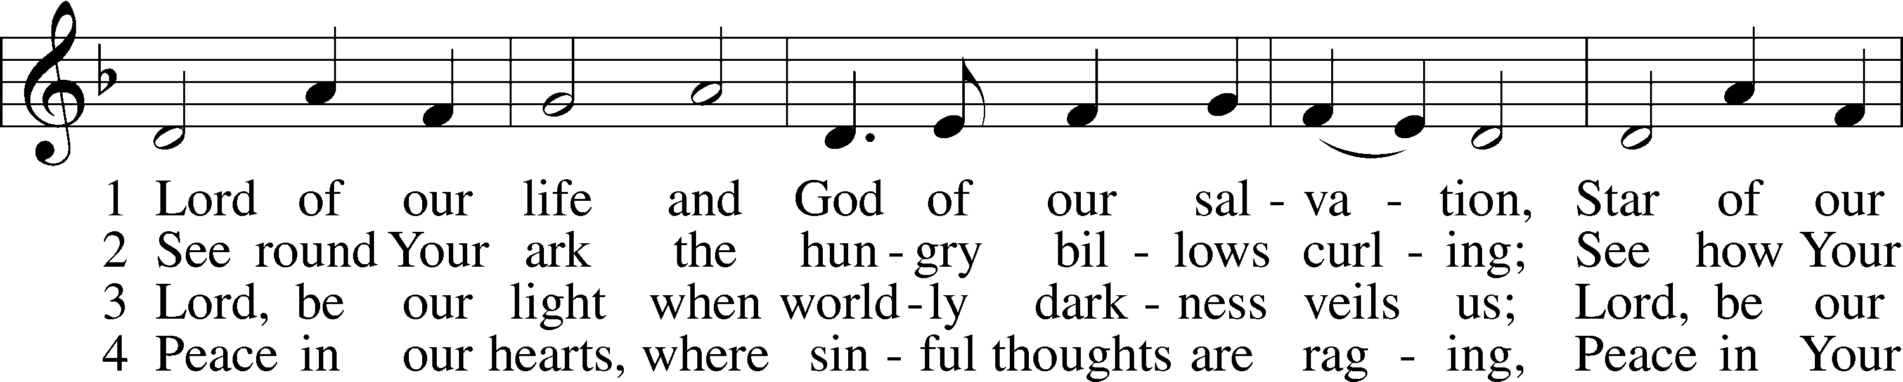
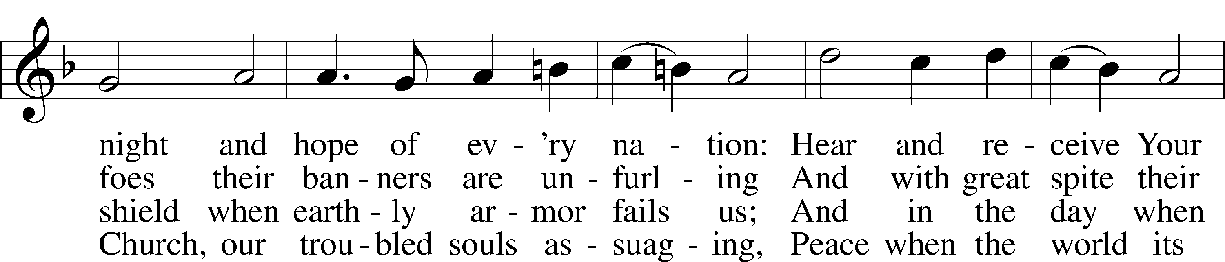
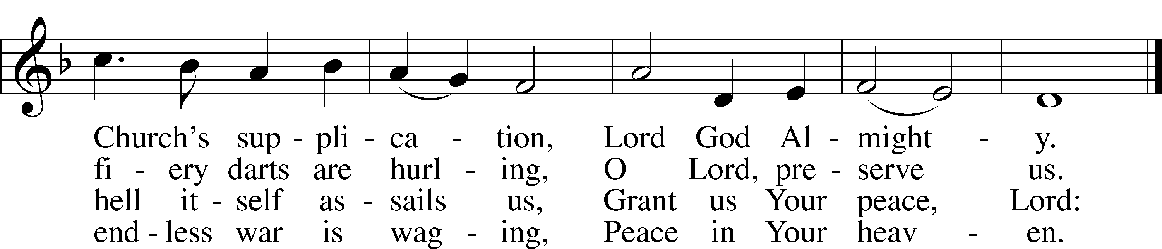
Text and tune: Public domain

Acknowledgments
Divine Service, Setting One from Lutheran Service Book
Unless otherwise indicated, Scripture quotations are from the ESV® Bible (The Holy Bible, English Standard Version®), copyright © 2001 by Crossway, a publishing ministry of Good News Publishers. Used by permission. All rights reserved.
Created by Lutheran Service Builder © 2020 Concordia Publishing House.

Prayers for Our Members
Robin Baker, Bailey Hockemeier, Leah Vogel | Expectant Mothers
Family and Friends of Geraldine Roeder | Grief
Norman Abels (Brookestone Meadows – Elkhorn) | Healing
Judy Ahrens (St. Luke’s) | Healing
Vaughn Albrecht (Northridge) | Healing
Tom & DyAnn Altwine | Healing
David Banner | Healing
Lyle Colsden (Mother Hull) | Healing
Pat Flodine (Cambridge Court) | Healing
Vi Fox (Prairie View) | Healing
Verleen Gentry | Healing
Ruby Hatfield | Healing
Michelle Millsap | Healing
Roger Riekenberg | Healing
Marion Richmond | Healing
Lavern Stuehm | Healing
Fran Junge | Cancer
Bev Nuttelman | Cancer
Kim Vos | Cancer

Prayers for Our Members’ Family & Friends
Brandon & Shannon Howell (Quentin & Janel Lange’s friends) | Family
Will Brennemann (Jami Helmbrecht’s father) | Healing
Reg Duke (Westman’s brother-in-law) | Healing
James Gentry (Verleen Gentry’s son) | Healing
Roger Hoffman (Marc’s father) | Healing
Sharon Kreutzer (former member) | Healing
Lyra Mais (Zion student) | Healing
Randy Solomon (Beth Rosenthal’s father) | Healing
Mary Ann Mertz (Pam’s Uhlir’s friend) | Healing
Roy Reynolds (Verleen Gentry’s son-in-law) | Healing
Janet Stalder (Carol Florang’s sister) | Healing
Bill Zehendner (Chuck’s dad) | Healing
D.D. Dugger (Sue Kaiser’s brother) | Cancer
Ron Halvorsen (Jeff’s dad) | Cancer
Carol Haubold (Don Helmbrecht’s sister) | Cancer
Tyler Holland (Quentin & Janel Lange’s brother-in-law) | Cancer
Randy Jochum (Ken Hockemeier’s brother-in-law) | Cancer
Fred Koch (Pam Uhlir’s cousin) | Cancer
Lynda Kreutzer (Rich & Carol’s sister-in-law) | Cancer
Sharon Mulhair (Pam Uhlir’s cousin) | Cancer
Becky Rathkie (former Zion teacher) | Cancer
Jeannie Schmidt (Lisa Splittgerber’s sister-in-law) | Cancer
Tyrone Uhlir (Pam’s nephew) | Cancer

Today’s Radio Broadcast is given to the Glory of the Lord by Wes & Mary Fiddelke in memory of mothers; Irene Fiddelke and Melvina Fletcher.

Today’s altar flowers is given to the Glory of the Lord by
Lonna Gronewaller in memory of Harry Fuqua

Serving in Worship

Sunday, November 15~ 9:00am  Elder: Nathan Gaunt  Usher: Robert Glanzer  Engineer: Jared Nuttelman  Announcer: Jesse Florang  Altar Guild: Brooke Fisher &  Tracy Schake | Sunday, November 22~ 9:00am  Elder: Rich Kreutzer  Usher: Mike Wilkens  Engineer: Shawn Starkey  Announcer: Lonna Gronewoller  Altar Guild: Brooke Fisher &  Tracy Schake

Our Response to the Gospel

Date: 11/08/2020

Offering: $5,608.33
Weekly Need: $7,542.37

ZION LUTHERAN CHURCH AND SCHOOL

Pr. James DeLoach, Pastor + (308) 627-5260
james.deloach@zionkearney.org
Pr. Doug Gaunt, Pastor + (308) 455-0552
doug.gaunt@zionkearney.org
Tony Splittgerber, Principal + (308) 293-0168
anthony.splittgerber@zionkearney.org

Church Office
Administrative Assistant: Jessica Shiers
Email: school@zionkearney.org
Phone: (308)-234-3410 Fax: (308) 236-8100
Office Hours: Monday-Friday 8:00am-4:00pm
Radio Broadcast: Sunday @ 10:30 a.m. on 1460 AM
Website: www.zionkearney.com

Where our Triune God strengthens us through His mercy in faith toward Him and in fervent love toward one another.

This Week at Zion

Sun  11/15 | 9:00a  10:30a | Divine Service  Radio Broadcast 1460am
Mon  11/16 | 7:00p  Birthdays  Anniversaries | Sanctuary Update Committee  Edward DeLaet  Keith & Beverly Nuttelman
Tues  11/17 | 1:30p  7:00p  Birthdays  Anniversaries | Sleeping Mats  Church Council  Wanda Glanzer  ---
Wed  11/18 | 8:25a  9:00a  3:30p  5:45p  7:00p  Birthdays  Anniversaries | K-8th Chapel  ECE Chapel  Pie Pickup - gym  Midweek Class  Adult Choir  Sandra Heiden  ---
Thurs  11/19 | 7:00p  Birthdays  Anniversaries | Men’s Bible Study  ---  ---
Fri  11/20 | Birthdays  Anniversaries | Rachael Burger  ---
Sat  11/21 | 5:00p  Birthdays  Anniversaries | Divine Service  ---  ---
Sun  11/22 | 9:00a  10:30a  Birthdays  Anniversaries | Divine Service  Radio Broadcast 1460am  Richard Crow  ---
ANNOUNCEMENTS

Men’s Bible Study – The Men’s Bible Study will be on Thursday, November 19th at 7:00pm.

Voter’s Meeting – Zion will have a voter’s meeting directly after the service on Sunday, November 29th.

Thanksgiving Meal Cancelled – The Mary Martha Guild has made the decision to NOT have our Thanksgiving meal this year because of Covid-19 concerns. We plan to make every effort to bring it back next year.

Food Collection – Zion will collect food items during the month of November to help supply Kearney agencies who assists the needy. There will be grocery carts in the narthex and school are to gather these items. Non-perishable items only please.

Poinsettias – Zion will be taking poinsettia orders to adorn the Church Sanctuary during Christmas time. They will be $14.00 per plant. To order there is an envelope in the narthex, place your money in the envelope with your name, place the envelope in the offering plate or the mail slot on the south side of the building or drop it off during office hours. Please make checks out to Mary Martha.

Give Where You Live - This year Zion will be participating in Give Where You Live Campaign. It will be December 3rd (giving day), but donations will be accepted beginning November 5th. To contribute online go to: https://www.givewhereyoulive.net//zionlutheranschool. If you would rather give in person feel free to stop by the office. Please share this with family and friends.

Offering Envelopes – If you no longer wish to receive offering envelopes please contact Darcy Willers or the office.

Volunteering Opportunities – Zion needs volunteers to help with the audio, video, and ushers for our worship service. Training will be provided. Please contact the office or Pr. DeLoach if interested or with questions.

A Bible Study – is prerecorded and available each Sunday, along with a study guide you can use to follow along. We are studying the three lessons for the day—the Old Testament, the Epistle, and the Gospel. Go to Zion’s website www.zionkearney.com to access the video and study guide.

Offering during this time. If you are not able to attend live Church Services, you may: drop your offering in the mail slot by the south doors, mail it to the church, or use online giving option at zionkearney.com. If you have any questions or need assistance please contact the office at 308-234-3410 or school@zionkearney.org. Thank you for supporting of your church!

Radio Broadcast & Altar Flowers - Please help Zion spread the Gospel! There are several open dates. This is a great need during this time, many people are listening to our broadcast during this time. There are also many openings for altar flowers. Please help beautify the sanctuary.

Mission Offerings - The fourth quarter missions, October through December, will support those preparing for fulltime church work (Peter Kreutzer and Taylor Zehendner, both at CUNE). If you would like to donate to this mission please use the mission envelopes located in the narthex. Thank you for your support.

Apple Market Receipts – Apple Market receipts will be accepted from register dates September 1, 2020 – March 1, 2021. Please turn in your receipts to the office to earn free things for the school!

Family Fresh Receipts –Don’t forget that Zion collects Family Fresh receipts any date. Please turn them into the office.

Boxtops –Boxtops has discontinued the labels on the packages. They now have an app for your smartphone to redeem qualifying products. If you do not have a smartphone or don’t want to install the app turn your grocery receipts with qualifying boxtop products into the office and they will get scanned to continue to earn money for Zion.

2021 Radio & Flower Charts – The 2021 radio and flower charts are posted in the hallway by the mailboxes. If there is a special day make sure you sign up early. You are welcome to call the office to sign up for your spot.

The Lord’s Prayer Booklet – There is a Lord’s Prayer Booklet, to assist with your devotions, on the counter in the narthex. Feel free to take one. These are compliments of Pastor & Carol Gaunt.

Organ Available – I am moving and must part with my 2-manual, full-pedal Rodgers organ. I am a former organ teacher and church organist, so parting with the organ isn't easy. I'm hoping a congregation, school, or individual can provide it continued use. I may be reached at Enidhansen11@gmail.com or by calling 308.440.8087. Thank you,

Employment Opportunities at Zion

2020 has been a real year of change and through it all Zion has been blessed with a remarkably steady and stable staff. Recently however, personal events have led to some upcoming staff changes and we praying that the Lord will bless these individuals as they move on and also that the Lord will continue to provide Zion with stellar replacements. If you or someone you know may be interested in the following positions, please pass this information along to them and let Mr. Splittgerber know. Thank you!

1) Part-time Cook: We are looking for someone who has some experience/interest in food service. Task include meal prep, serving, and cleaning. Candidate strengths should include time management, kitchen experience, and a positive disposition. This position is for 3 days a week.
2) Elementary School Teacher: Mr. Vogel and family will be moving at the conclusion of this school year so the search for another high quality Lutheran teacher has begun. Full time teachers in our school must be members of the LCMS (or willing to become so). The grade level will most probably be for the 3rd/4th grade.

3) Prekindergarten Teacher’s Aide: Friday morning only. We are looking for someone to aide in our prekindergarten class. The class runs from 8 a.m. to 11:45 a.m. every Friday. Candidates should love children and be able to assist the teacher in a variety of tasks that help the morning run smoothly. This position is available now.

