Divine Service

Third Sunday in Advent
December 13, 2020
Zion Lutheran Church
Kearney, Nebraska

Welcome to Zion!
All worshippers please fill out an attendance card in the pew rack and let us know how we might be of service to you.

Holy Communion at Zion

The Lord’s Supper is celebrated at this congregation as Jesus has given it. As he says, our Lord gives into our mouths not only bread and wine but his very body and blood to eat and to drink for the forgiveness of sins and to strengthen our union with him and with one another. Our Lord invites to his table those who trust his words, repent of all sin, and set aside any refusal to forgive and love as he forgives and loves us, that they may show forth his death until he comes. All communicants need to register in the narthex prior to the service.

Because those who eat and drink our Lord’s body and blood unworthily do great harm and because Holy Communion is a confession of the faith which is confessed at this altar, any who are not yet instructed, in doubt, or who hold a confession differing from that of this congregation and The Lutheran Church—Missouri Synod, are asked not to commune until they are able to speak with our pastor first. He is happy to visit with you about the Christian faith and how to receive the Lord’s Supper for your good and for the good of others. Those not communing are invited to come to the altar, cross your arms in front of you, and bow your head to receive a pastoral blessing.

The Coming of the Christ Brings True Rejoicing in His Forgiveness

When he preaches repentance, John the Baptist points us to Christ Jesus. John was sent by God “as a witness, to bear witness about the light, that all might believe through him” (John 1:7). He baptizes with water in order to “make straight the way of the Lord,” who shall redeem His people from their sins (John 1:23). That Lord Jesus “who comes after” John now stands among us and makes Himself known to us (John 1:26–27). He has been anointed by the Holy Spirit “to bring good news to the poor” and “to bind up the brokenhearted” (Is. 61:1). By the washing of the water with His Word and Spirit, He clothes His Church with “the garments of salvation” and adorns her with His own righteousness “as a bride adorns herself with her jewels” (Is. 61:10). Therefore, we “rejoice always” in the Lord, “pray without ceasing” and “give thanks in all circumstances” (1 Thess. 5:16–18). For “the God of peace,” who has called you by the Gospel, will surely “sanctify you completely,” so that “your whole spirit and soul and body” will “be kept blameless at the coming of our Lord Jesus Christ” (1 Thess. 5:23–24).
Confession and Absolution

354 Arise, O Christian People
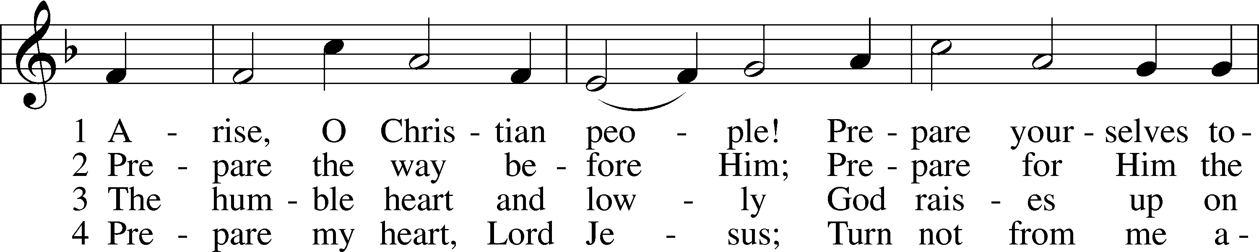
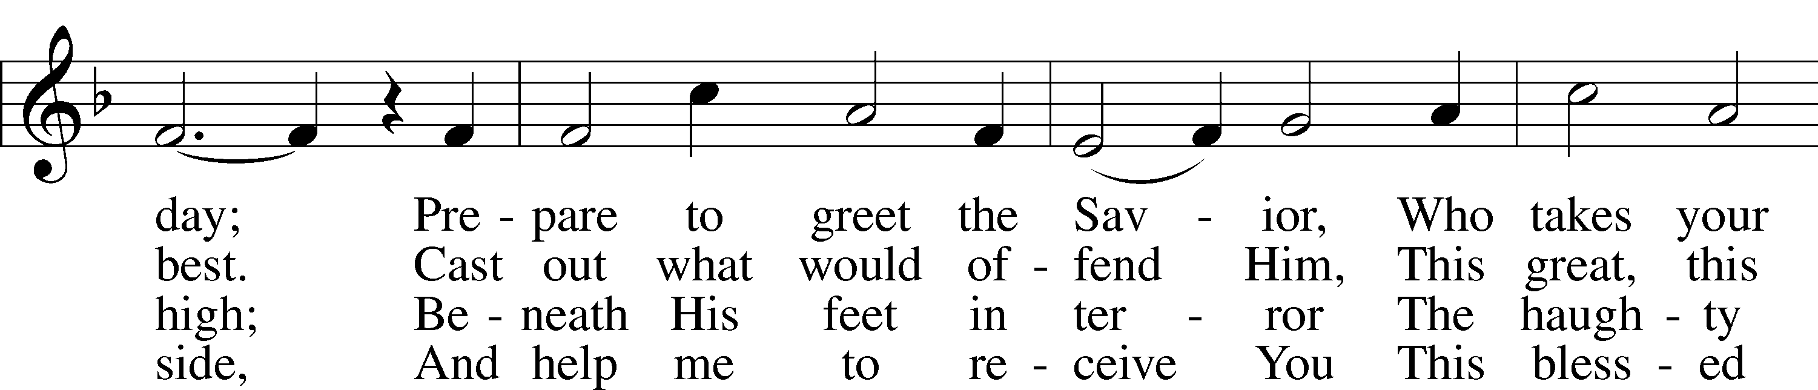
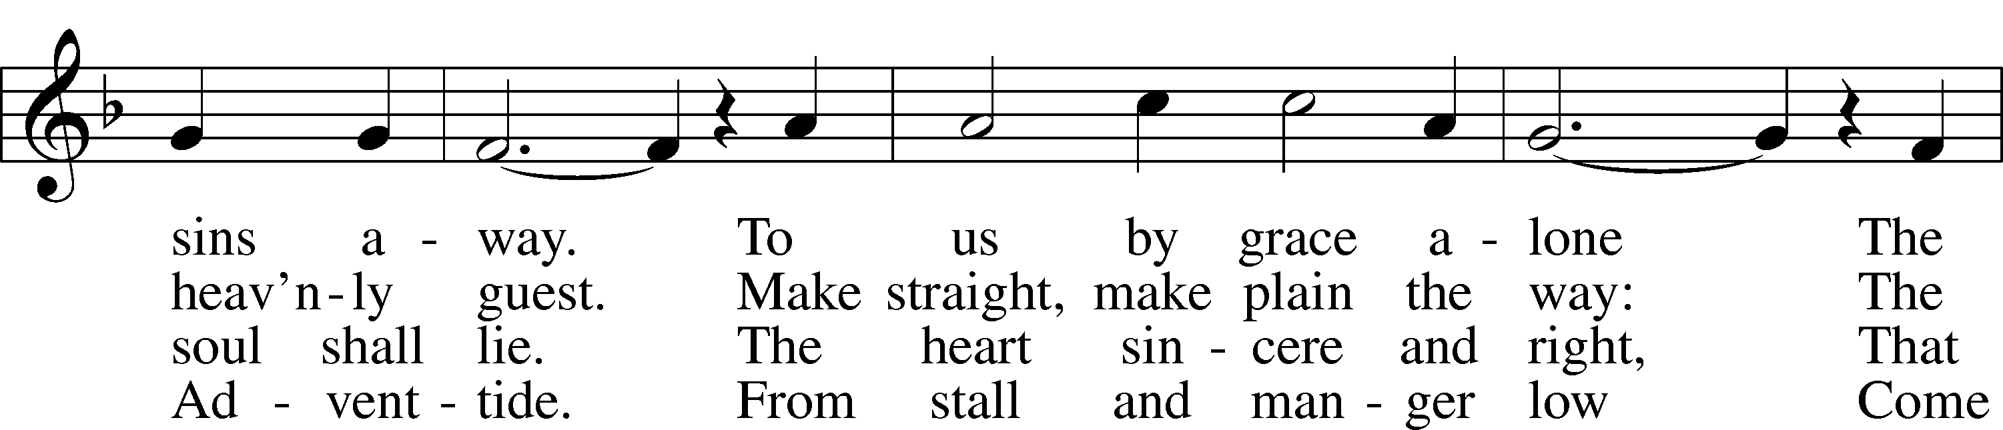
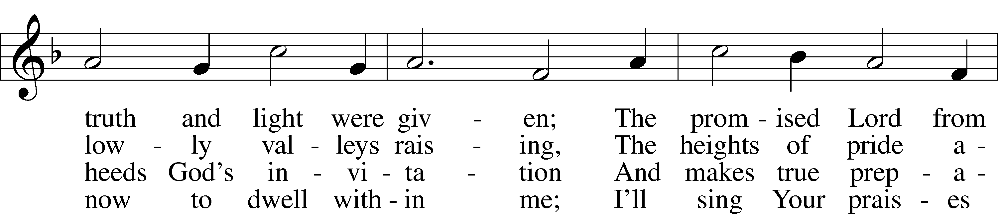
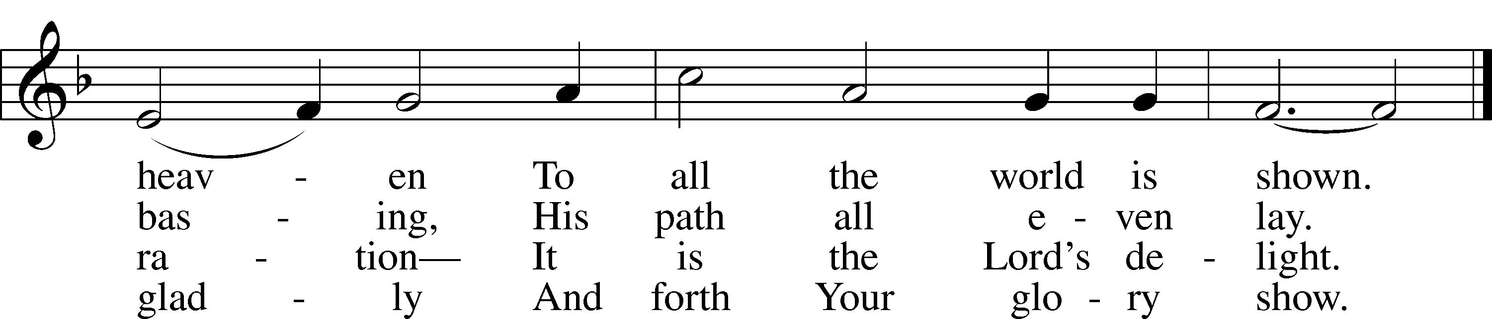
Text and tune: Public domain

Stand

The sign of the cross may be made by all in remembrance of their Baptism.

Invocation
P In the name of the Father and of the T Son and of the Holy Spirit.
C Amen.

Exhortation LSB 184
P Beloved in the Lord! Let us draw near with a true heart and confess our sins unto God our Father, beseeching Him in the name of our Lord Jesus Christ to grant us forgiveness.

P Our help is in the name of the Lord,
C who made heaven and earth.
P I said, I will confess my transgressions unto the Lord,
C and You forgave the iniquity of my sin.

Silence for reflection on God’s Word and for self-examination.

Confession of Sins LSB 184
P O almighty God, merciful Father,
C I, a poor, miserable sinner, confess unto You all my sins and iniquities with which I have ever offended You and justly deserved Your temporal and eternal punishment. But I am heartily sorry for them and sincerely repent of them, and I pray You of Your boundless mercy and for the sake of the holy, innocent, bitter sufferings and death of Your beloved Son, Jesus Christ, to be gracious and merciful to me, a poor, sinful being.

Absolution LSB 185
P Upon this your confession, I, by virtue of my office, as a called and ordained servant of the Word, announce the grace of God unto all of you, and in the stead and by the command of my Lord Jesus Christ I forgive you all your sins in the name of the Father and of the T Son and of the Holy Spirit.
C Amen.

Stand

Service of the Word
Introit
But we will | bless the Lord*
from this time forth and forevermore. | Praise the Lord!
As for me, I have | set my King*
on Zion, my | holy hill.
I will tell of | the decree:*
The Lord said to me, “You are my Son; today I have be- | gotten you.”
Praise the Lord, all | nations!*
Extol him, all | peoples!
For great is his steadfast | love toward us,*
and the faithfulness of the Lord endures forever. | Praise the Lord!
Gloria Patri LSB 186
C Glory be to the Father and to the Son and to the Holy Ghost;
as it was in the beginning, is now, and ever shall be, world without end. Amen.

Kyrie LSB 186
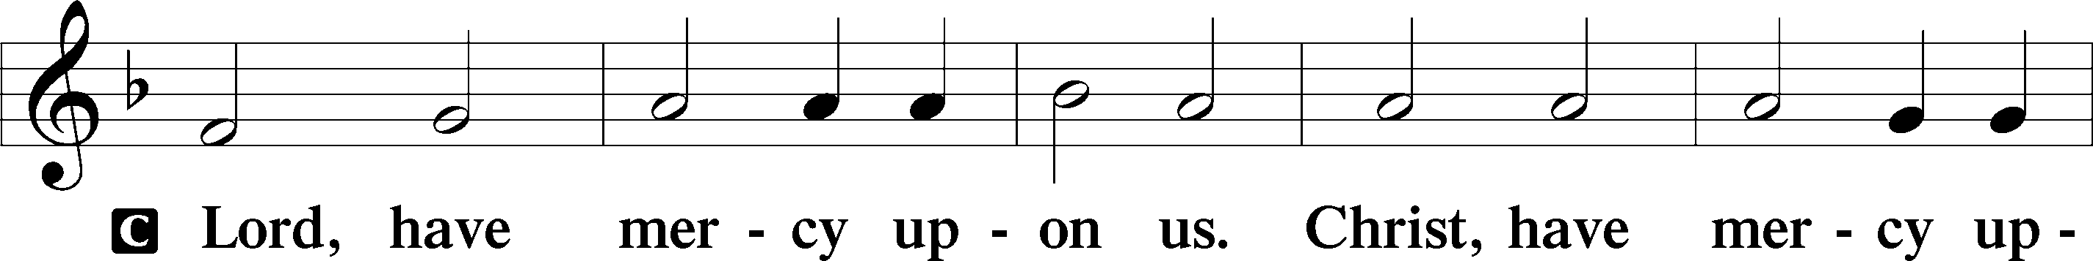
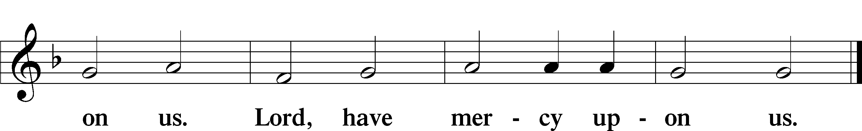

357 O Come, O Come, Emmanuel sts. ref, 4
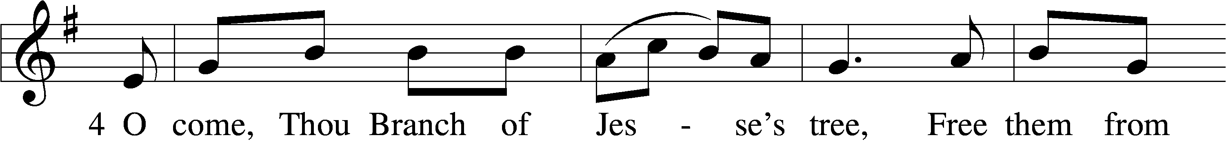
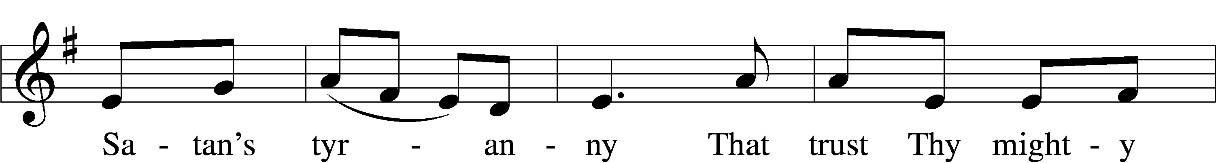
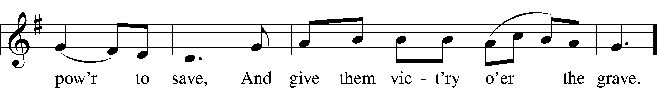
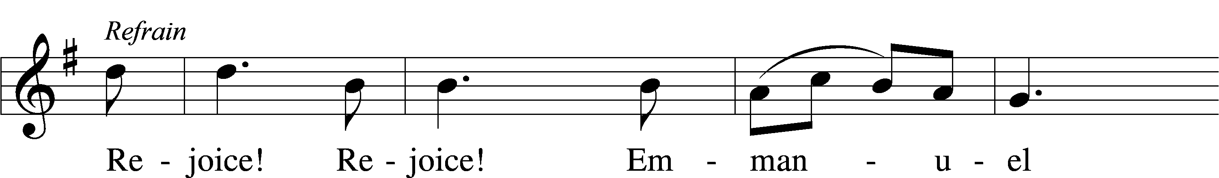
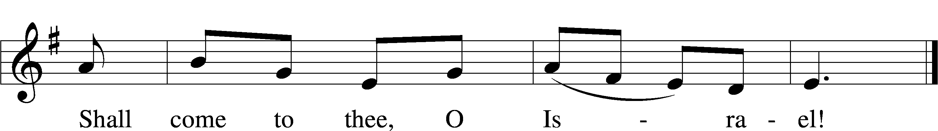
Tune and text: Public domain

Salutation and Collect of the Day
P The Lord be with you.
C And with thy spirit.

P Let us pray.
Lord Jesus Christ, we implore You to hear our prayers and to lighten the darkness of our hearts by Your gracious visitation; for You live and reign with the Father and the Holy Spirit, one God, now and forever.
C Amen.

Sit

Old Testament Reading Isaiah 61:1–4, 8–11
The Year of the Lord’s Favor
¹The Spirit of the Lord God is upon me,
because the Lord has anointed me
to bring good news to the poor;
he has sent me to bind up the brokenhearted,
to proclaim liberty to the captives,
and the opening of the prison to those who are bound;
²to proclaim the year of the Lord’s favor,
and the day of vengeance of our God;
to comfort all who mourn;
³to grant to those who mourn in Zion—
to give them a beautiful headdress instead of ashes,
the oil of gladness instead of mourning,
the garment of praise instead of a faint spirit;
that they may be called oaks of righteousness,
the planting of the Lord, that he may be glorified.
⁴They shall build up the ancient ruins;
they shall raise up the former devastations;
they shall repair the ruined cities,
the devastations of many generations. . . .
⁸For I the Lord love justice;
I hate robbery and wrong;
I will faithfully give them their recompense,
and I will make an everlasting covenant with them.
⁹Their offspring shall be known among the nations,
and their descendants in the midst of the peoples;
all who see them shall acknowledge them,
that they are an offspring the Lord has blessed.
¹⁰I will greatly rejoice in the Lord;
my soul shall exult in my God,
for he has clothed me with the garments of salvation;
he has covered me with the robe of righteousness,
as a bridegroom decks himself like a priest with a beautiful headdress,
and as a bride adorns herself with her jewels.
¹¹For as the earth brings forth its sprouts,
and as a garden causes what is sown in it to sprout up,
so the Lord God will cause righteousness and praise
to sprout up before all the nations.

A This is the Word of the Lord.
C Thanks be to God.

Gradual Zechariah 9:9; Psalm 118:26, alt.
Rejoice greatly, O daughter of | Zion.*
Shout aloud, O daughter of Je- | rusalem.
Behold, your king is com- | ing to you;*
righteous and having sal- | vation.
Blessèd is he who comes in the name | of the Lord.*
From the house of the Lord we | bless you.

Epistle 1 Thessalonians 5:16–24
¹⁶Rejoice always, ¹⁷pray without ceasing, ¹⁸give thanks in all circumstances; for this is the will of God in Christ Jesus for you. ¹⁹Do not quench the Spirit. ²⁰Do not despise prophecies, ²¹but test everything; hold fast what is good. ²²Abstain from every form of evil.
²³Now may the God of peace himself sanctify you completely, and may your whole spirit and soul and body be kept blameless at the coming of our Lord Jesus Christ. ²⁴He who calls you is faithful; he will surely do it.

A This is the Word of the Lord.
C Thanks be to God.

Stand

Alleluia LSB 190
C Alleluia. Alleluia. Alleluia.

Holy Gospel John 1:6–8, 19–28
P The Holy Gospel according to St. John, the first chapter.
C Glory be to Thee, O Lord.

⁶There was a man sent from God, whose name was John. ⁷He came as a witness, to bear witness about the light, that all might believe through him. ⁸He was not the light, but came to bear witness about the light. . . .
The Testimony of John the Baptist
¹⁹This is the testimony of John, when the Jews sent priests and Levites from Jerusalem to ask him, “Who are you?” ²⁰He confessed, and did not deny, but confessed, “I am not the Christ.” ²¹And they asked him, “What then? Are you Elijah?” He said, “I am not.” “Are you the Prophet?” And he answered, “No.” ²²So they said to him, “Who are you? We need to give an answer to those who sent us. What do you say about yourself?” ²³He said, “I am the voice of one crying out in the wilderness, ‘Make straight the way of the Lord,’ as the prophet Isaiah said.”
²⁴(Now they had been sent from the Pharisees.) ²⁵They asked him, “Then why are you baptizing, if you are neither the Christ, nor Elijah, nor the Prophet?” ²⁶John answered them, “I baptize with water, but among you stands one you do not know, ²⁷even he who comes after me, the strap of whose sandal I am not worthy to untie.” ²⁸These things took place in Bethany across the Jordan, where John was baptizing.

P This is the Gospel of the Lord.
C Praise be to Thee, O Christ.

Nicene Creed
C I believe in one God,
the Father Almighty,
maker of heaven and earth
and of all things visible and invisible.

And in one Lord Jesus Christ,
the only-begotten Son of God,
begotten of His Father before all worlds,
God of God, Light of Light,
very God of very God,
begotten, not made,
being of one substance with the Father,
by whom all things were made;
who for us men and for our salvation came down from heaven
and was incarnate by the Holy Spirit of the virgin Mary
and was made man;
and was crucified also for us under Pontius Pilate.
He suffered and was buried.
And the third day He rose again according to the Scriptures
and ascended into heaven
and sits at the right hand of the Father.
And He will come again with glory to judge both the living and the dead,
whose kingdom will have no end.

And I believe in the Holy Spirit,
the Lord and giver of life,
who proceeds from the Father and the Son,
who with the Father and the Son together is worshiped and glorified,
who spoke by the prophets.
And I believe in one holy Christian and apostolic Church,
I acknowledge one Baptism for the remission of sins,
and I look for the resurrection of the dead
and the life T of the world to come. Amen.
Sit

345 Hark! A Thrilling Voice Is Sounding
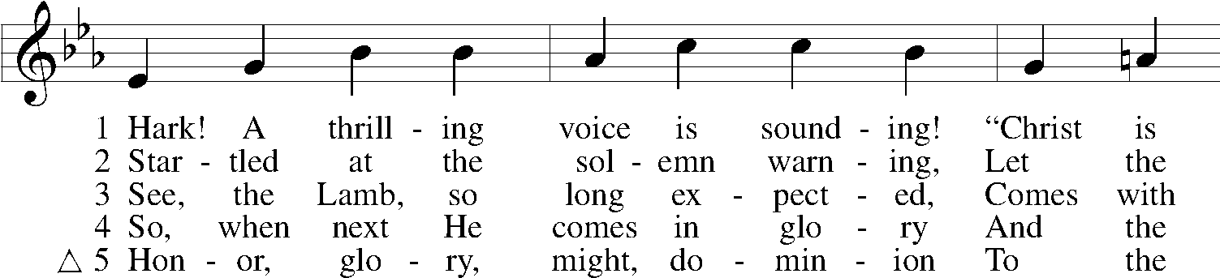
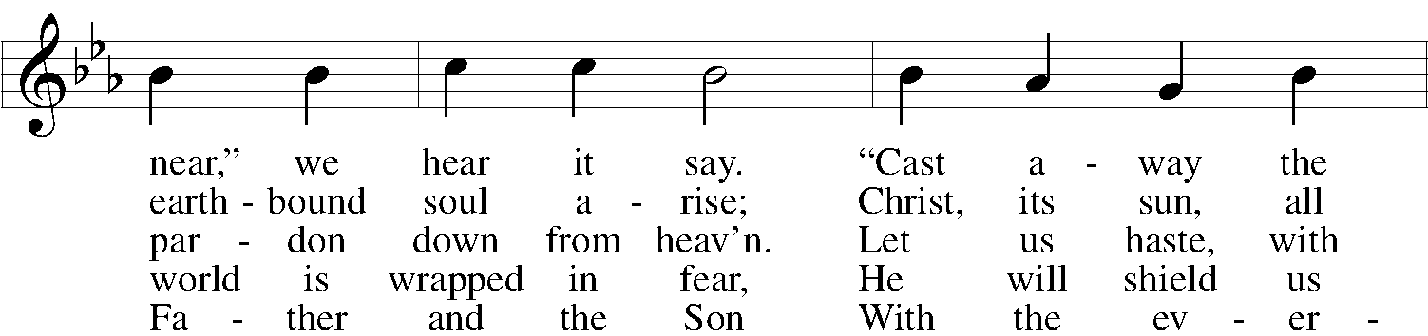
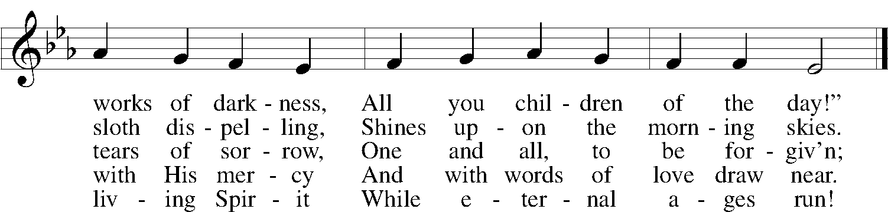
Tune and text: Public domain

Sermon

Stand

Offertory LSB 192
C Create in me a clean heart, O God, and renew a right spirit within me.
Cast me not away from Thy presence, and take not Thy Holy Spirit from me.
Restore unto me the joy of Thy salvation, and uphold me with Thy free spirit. Amen.

Prayer of the Church
Service of the Sacrament

Preface LSB 194
P The Lord be with you.
C And with thy spirit.
P Lift up your hearts.
C We lift them up unto the Lord.

P Let us give thanks unto the Lord, our God.
C It is meet and right so to do.

Proper Preface
P It is truly meet, right, and salutary that we should at all times and in all places give thanks to You, holy Lord, almighty Father, everlasting God, through Jesus Christ, our Lord, whose way John the Baptist prepared, proclaiming Him the promised Messiah, the very Lamb of God who takes away the sin of the world, and calling sinners to repentance that they might escape from the wrath to be revealed when He comes again in glory. Therefore with angels and archangels and with all the company of heaven we laud and magnify Your glorious name, evermore praising You and saying:

Sanctus LSB 195
C Holy, holy, holy Lord God of Sabaoth;
heav’n and earth are full of Thy glory.
Hosanna, hosanna, hosanna in the highest.
Blessed is He, blessed is He, blessed is He that cometh in the name of the Lord.
Hosanna, hosanna, hosanna in the highest.

Lord’s Prayer LSB 196
Our Father who art in heaven,
hallowed be Thy name,
Thy kingdom come,
Thy will be done on earth as it is in heaven;
give us this day our daily bread;
and forgive us our trespasses as we forgive those who trespass against us;
and lead us not into temptation,
but deliver us from evil.
For Thine is the kingdom and the power and the glory forever and ever. Amen.

The Words of Our Lord LSB 197
P Our Lord Jesus Christ, on the night when He was betrayed, took bread, and when He had given thanks, He broke it and gave it to the disciples and said: “Take, eat; this is My T body, which is given for you. This do in remembrance of Me.”

In the same way also He took the cup after supper, and when He had given thanks, He gave it to them, saying: “Drink of it, all of you; this cup is the new testament in My T blood, which is shed for you for the forgiveness of sins. This do, as often as you drink it, in remembrance of Me.”

Pax Domini LSB 197
P The peace of the Lord be with you always.
C Amen.

Agnus Dei LSB 198
C O Christ, Thou Lamb of God, that takest away the sin of the world, have mercy upon us.
O Christ, Thou Lamb of God, that takest away the sin of the world, have mercy upon us.
O Christ, Thou Lamb of God, that takest away the sin of the world, grant us Thy peace. Amen.

Sit

The Distibution

349 Hark the Glad Sound
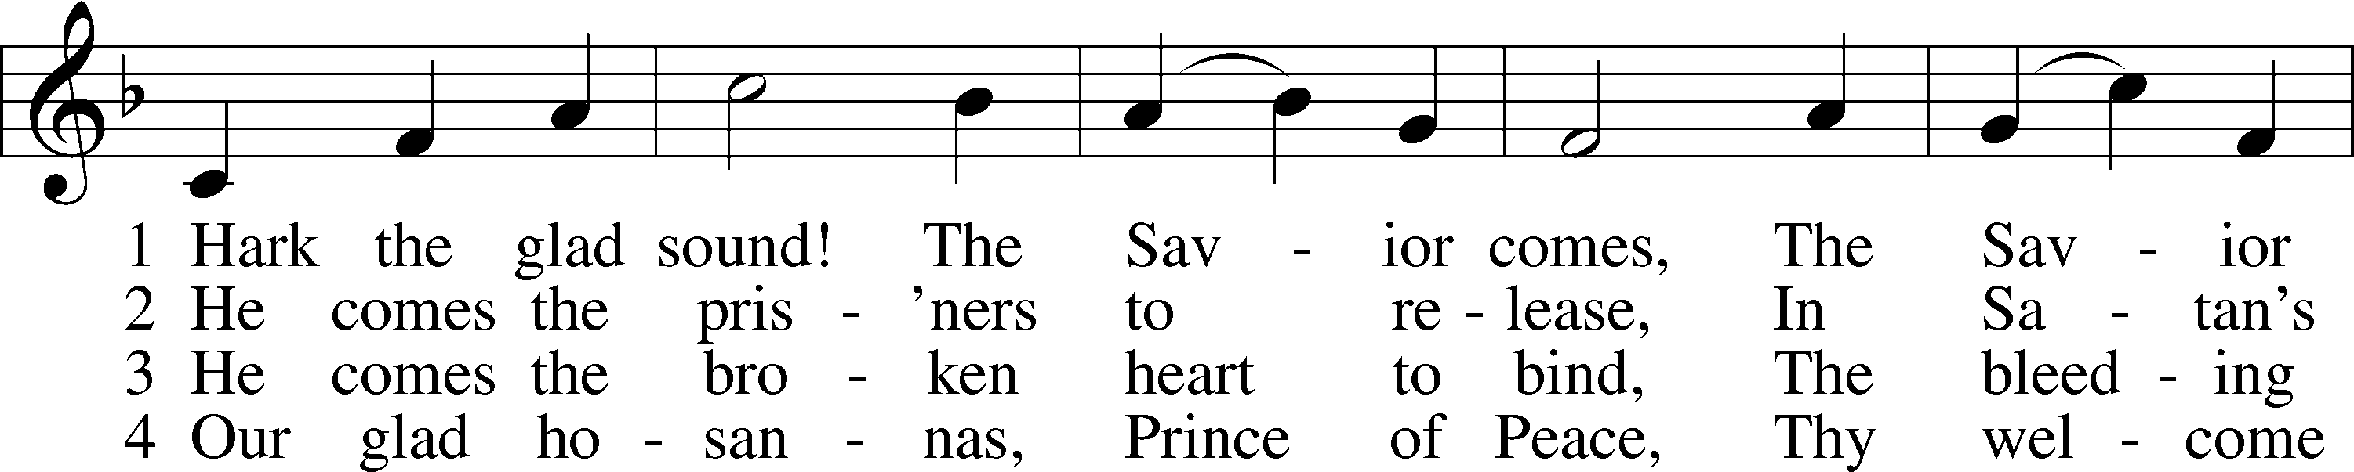
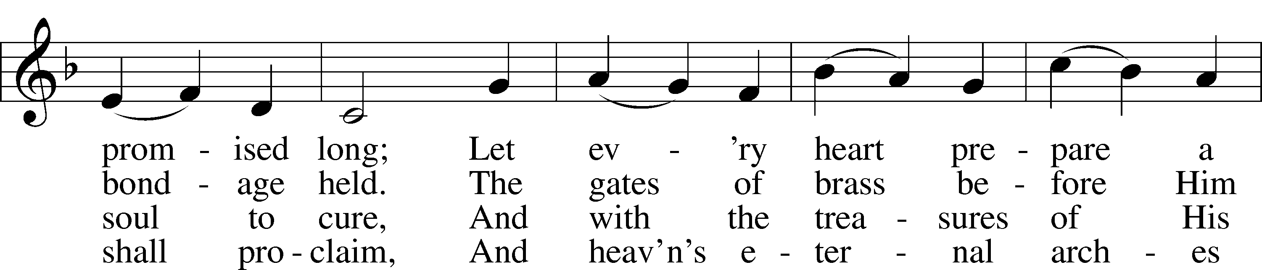
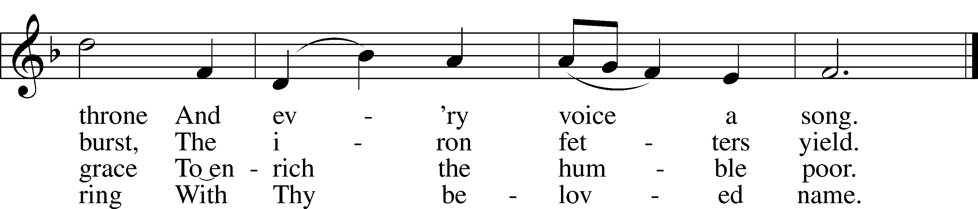
Tune and text: Public domain

618 I Come, O Savior, to Thy Table
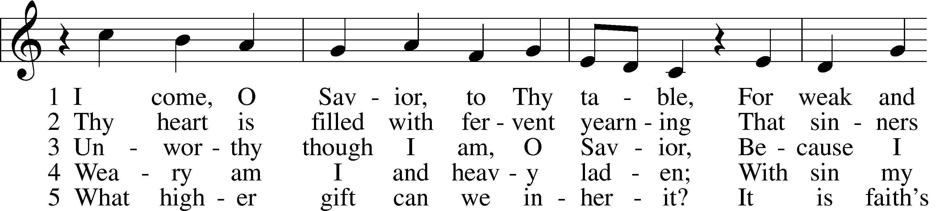
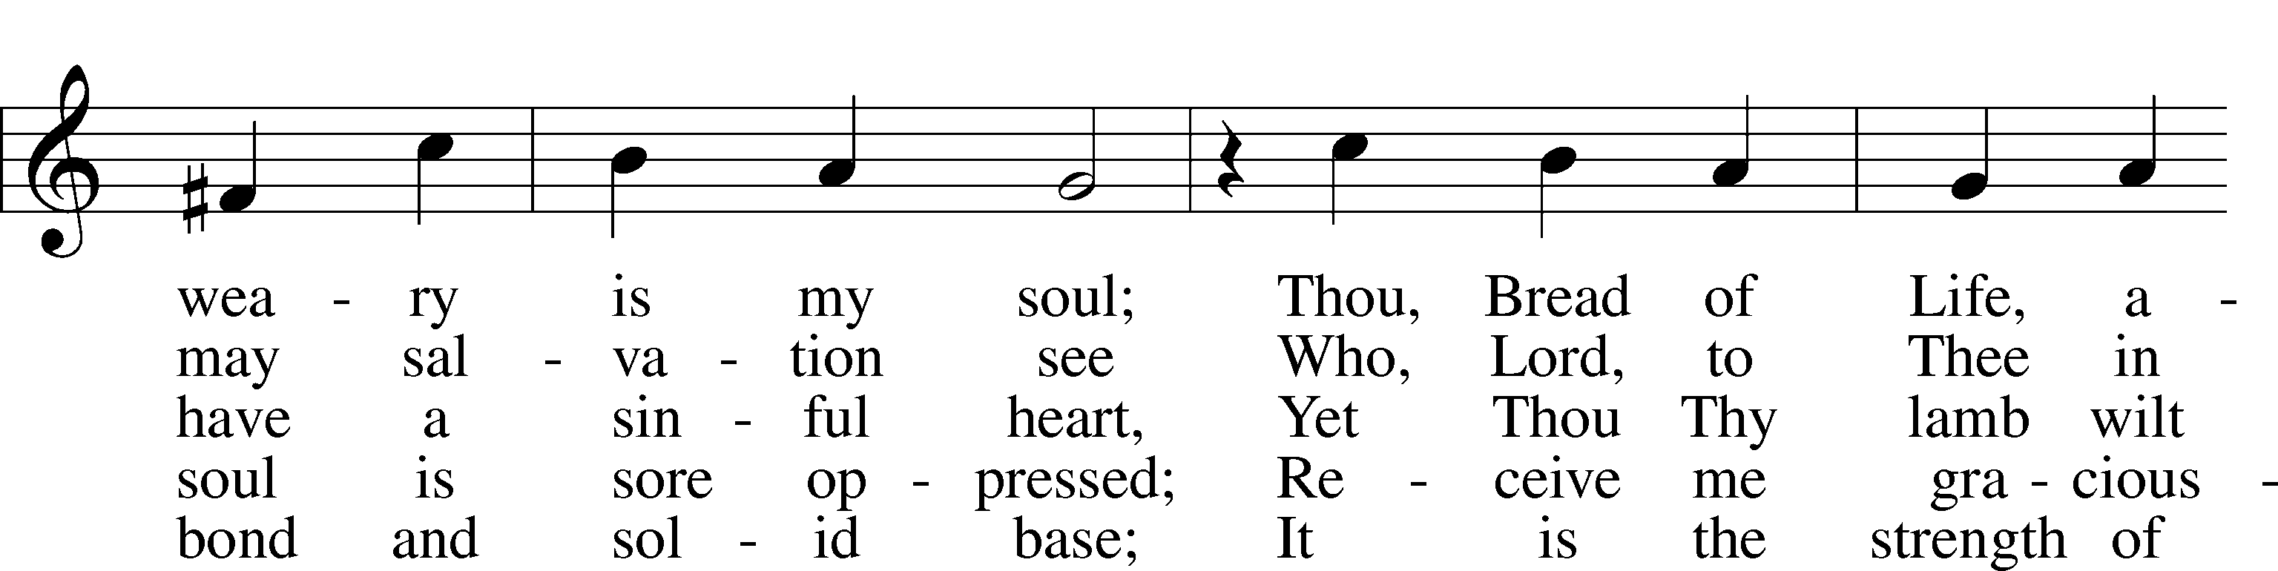
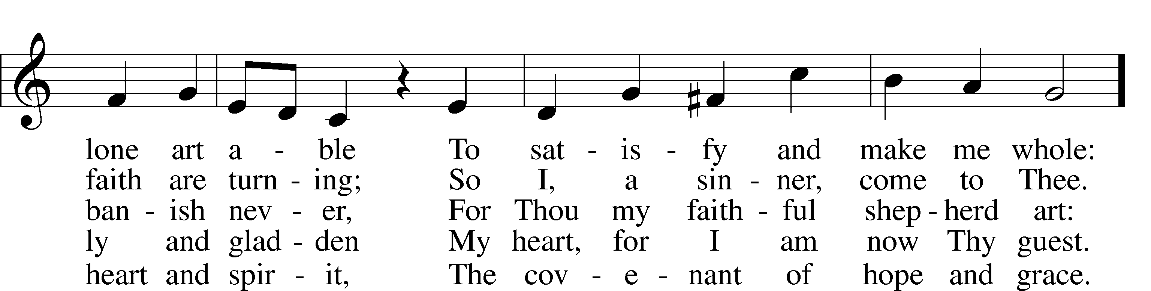
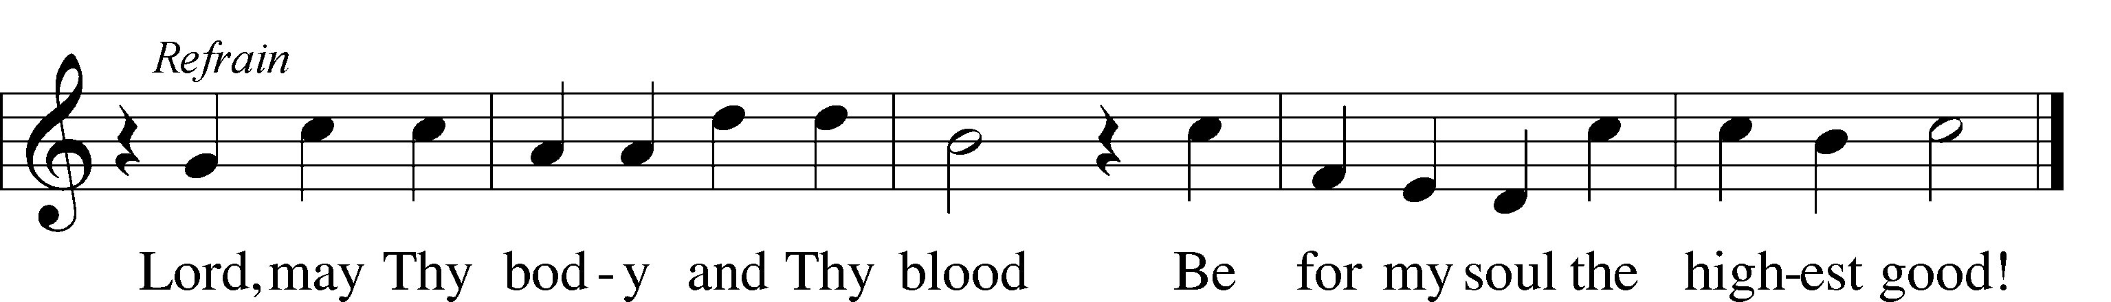
Tune: Public domain
Text: © 1941 Concordia Publishing House. Used by permission: LSB Hymn License no. 110003744

398 Hail to the Lord’s Anointed
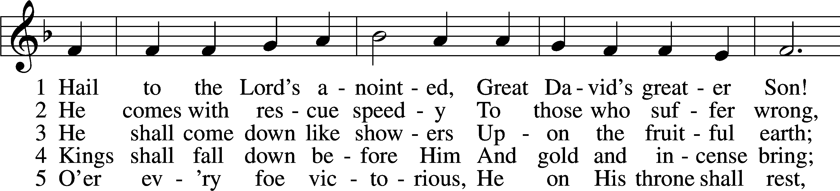
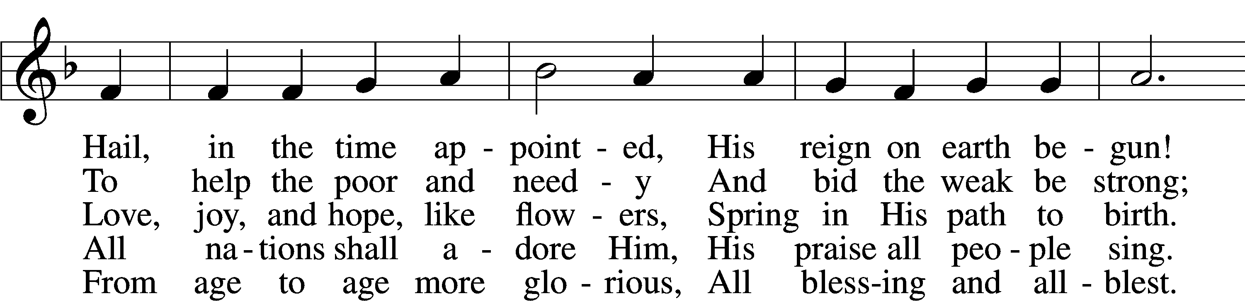
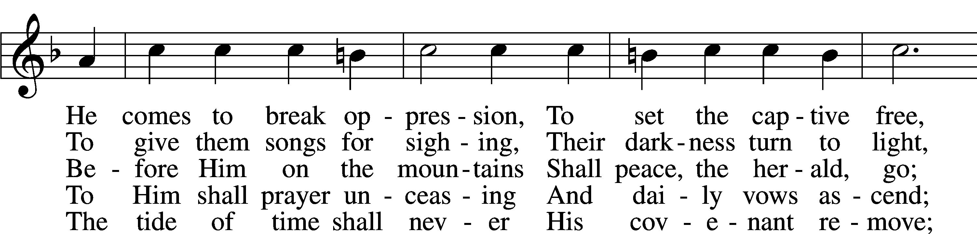
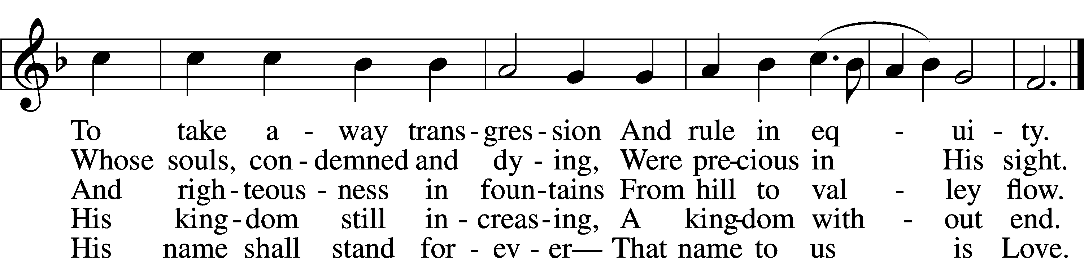
Tune and text: Public domain

Stand

The Dismissal LSB 199
P The body and blood of our Lord Jesus Christ strengthen and preserve you in body and soul to life everlasting. Depart T in peace.
C Amen.

Nunc Dimittis LSB 199
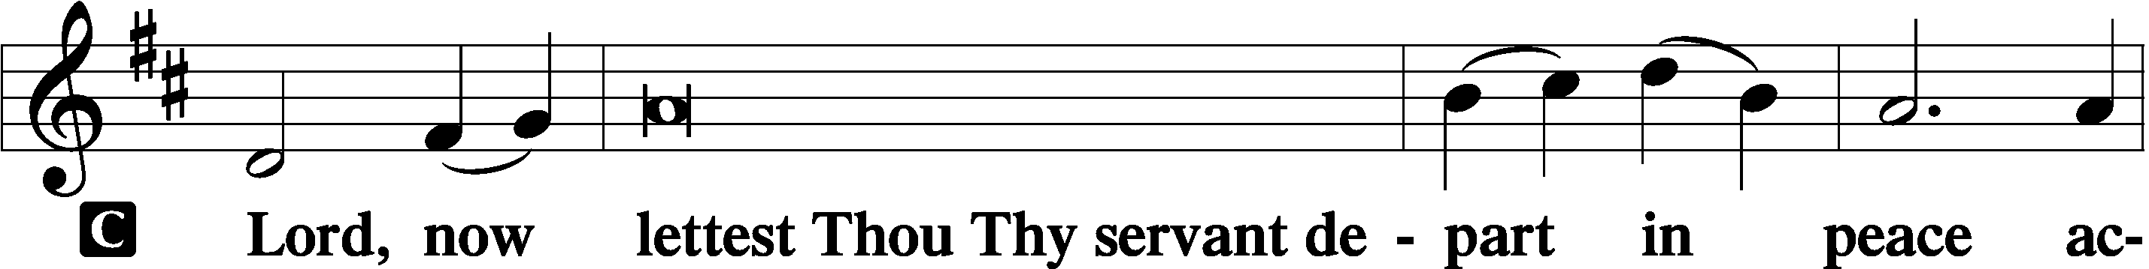

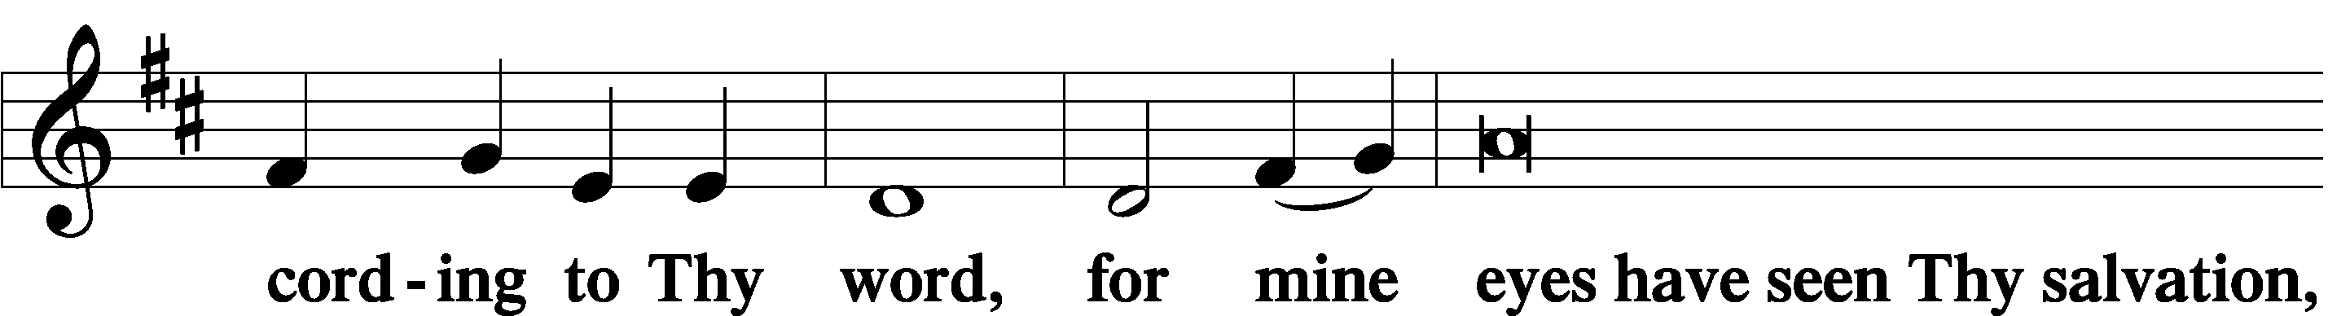

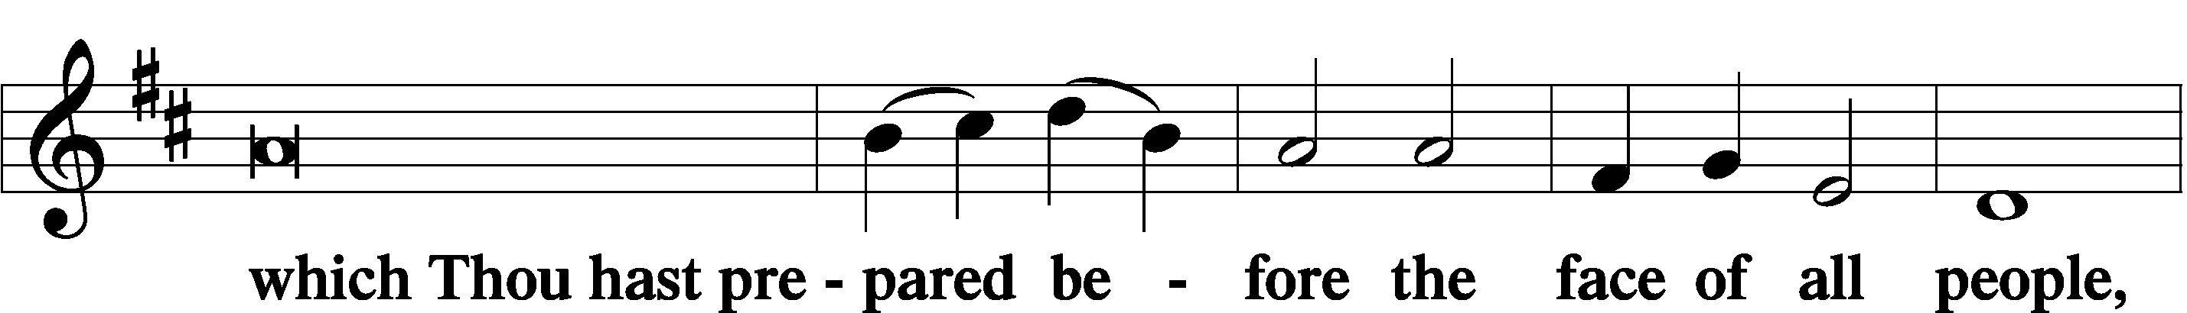

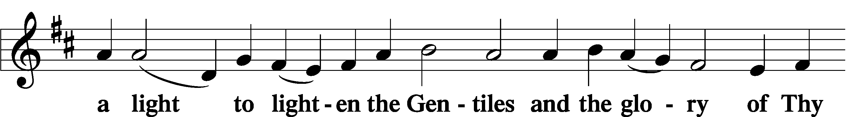

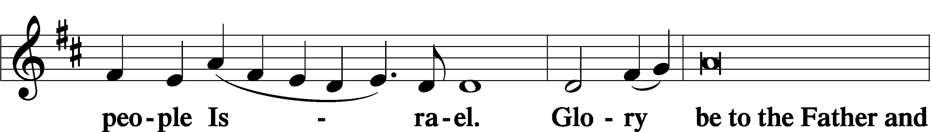

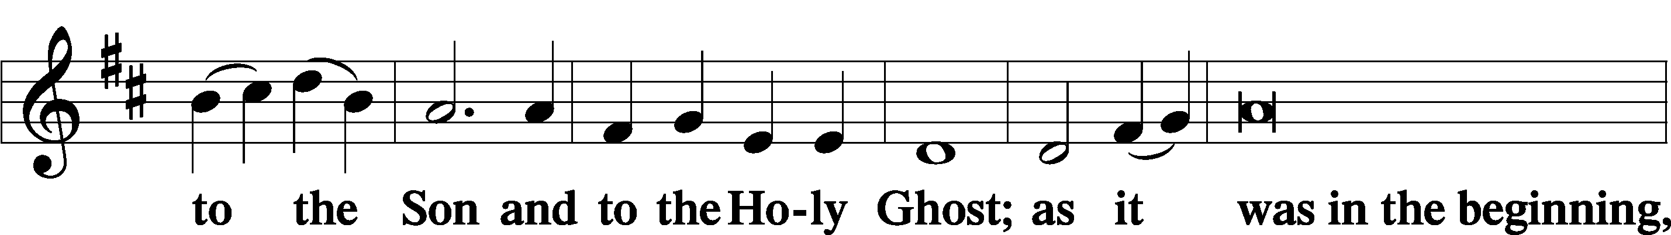

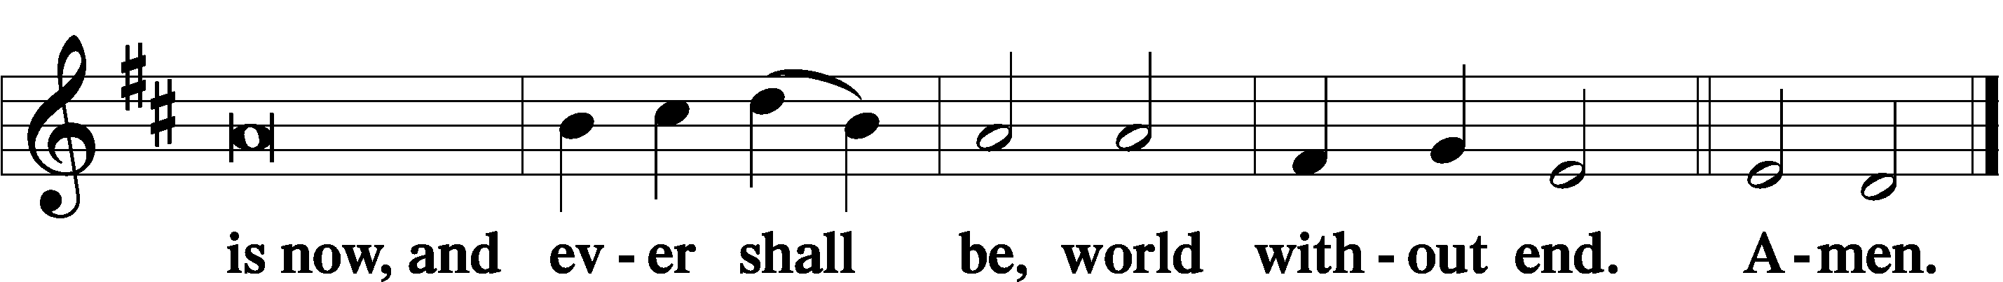

Thanksgiving LSB 200
A O give thanks unto the Lord, for He is good,
C and His mercy endureth forever.

Post-Communion Collect
A Let us pray.
We give thanks to You, almighty God, that You have refreshed us through this salutary gift, and we implore You that of Your mercy You would strengthen us through the same in faith toward You and in fervent love toward one another; through Jesus Christ, Your Son, our Lord, who lives and reigns with You and the Holy Spirit, one God, now and forever.
C Amen.

Salutation LSB 201
P The Lord be with you.
C And with thy spirit.

Benedicamus LSB 202
A Bless we the Lord.
C Thanks be to God.

Benediction LSB 202
P The Lord bless you and keep you.
The Lord make His face shine upon you and be gracious unto you.
The Lord lift up His countenance upon you and T give you peace.
C Amen, amen, amen.

515 Rejoice, Rejoice, Believers
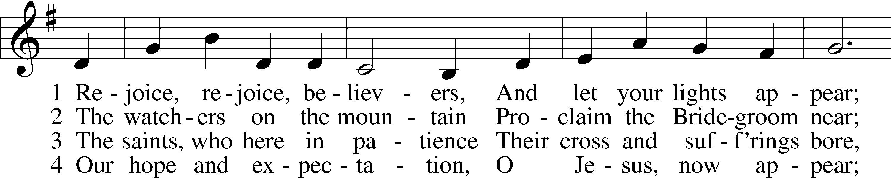
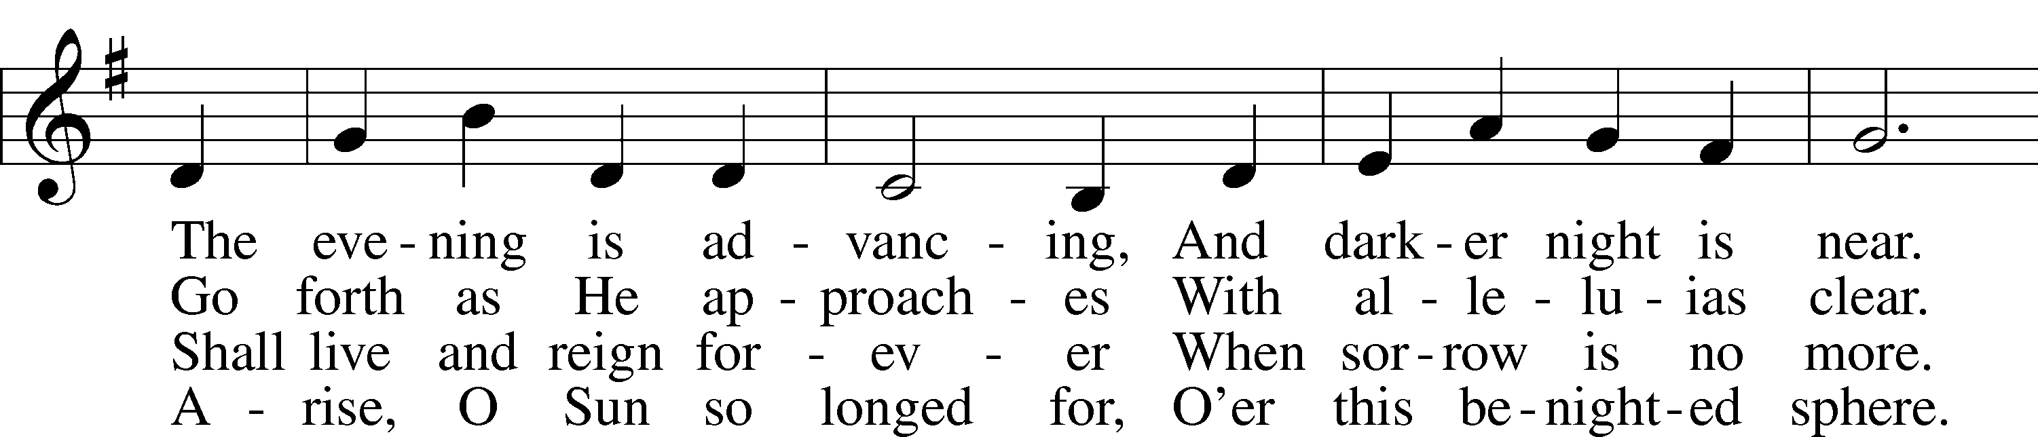
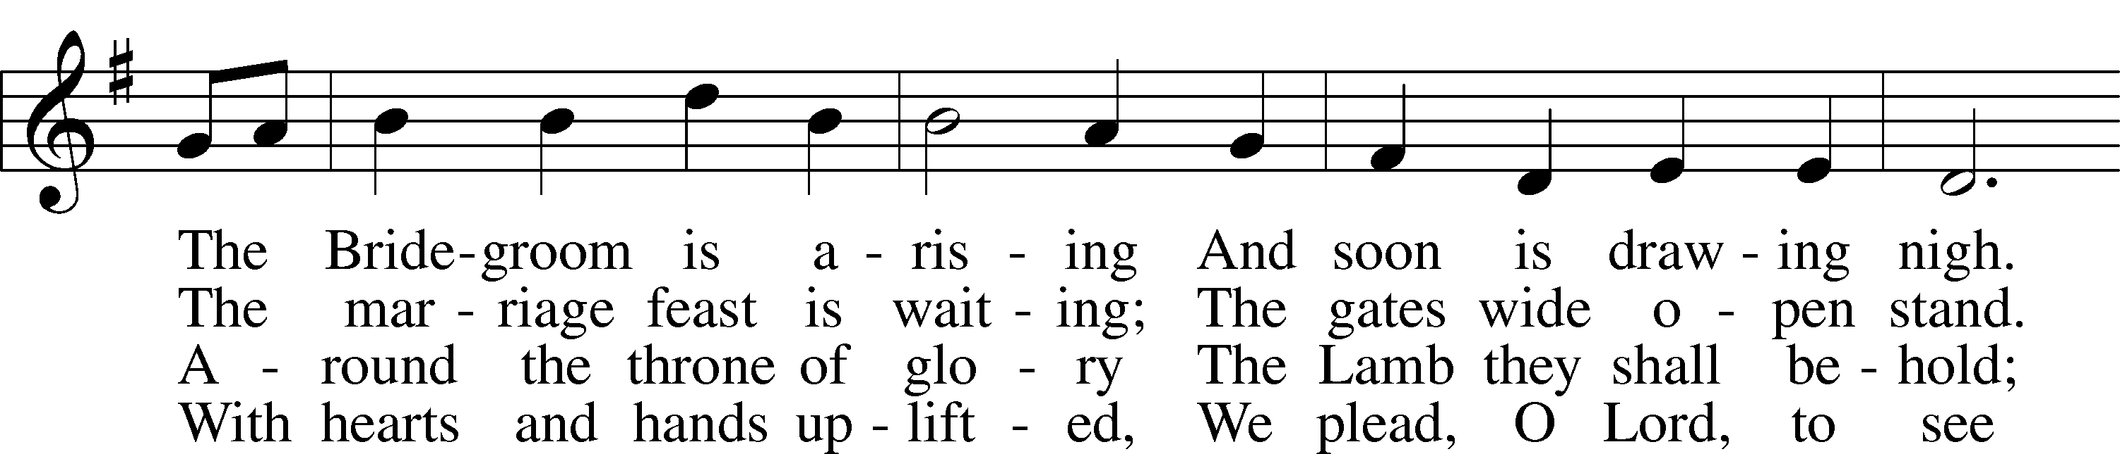
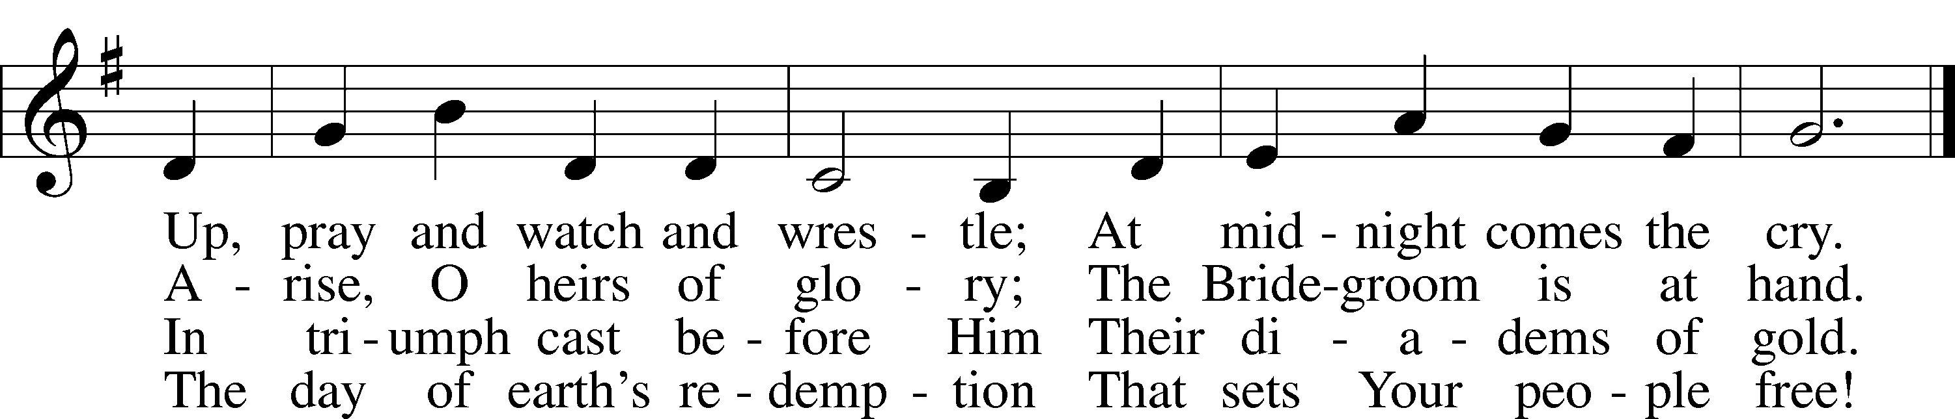
Text and tune: Public domain

Acknowledgments
Unless otherwise indicated, Scripture quotations are from the ESV® Bible (The Holy Bible, English Standard Version®), copyright © 2001 by Crossway, a publishing ministry of Good News Publishers. Used by permission. All rights reserved.
Created by Lutheran Service Builder © 2020 Concordia Publishing House.

Prayers for Our Members
Bailey Hockemeier, Leah Vogel | Expectant Mothers
Norman Abels (Brookestone Meadows – Elkhorn) | Healing
Judy Ahrens | Healing
Vaughn Albrecht (Northridge) | Healing
Tom & DyAnn Altwine | Healing
David Banner | Healing
Lyle Colsden (Mother Hull) | Healing
Pat Flodine (Cambridge Court) | Healing
Vi Fox (Prairie View) | Healing
Verleen Gentry | Healing
Ruby Hatfield | Healing
Michelle Millsap | Healing
Roger Riekenberg | Healing
Marion Richmond | Healing
Fran Junge | Cancer
Bev Nuttelman | Cancer
Kim Vos | Cancer

Prayers for Our Members’ Family & Friends
Dawn Gaunt (Pr. & Carol Gaunt’s daughter-in-law) | Expectant Mother
Brandon & Shannon Howell (Quentin & Janel Lange’s friends) | Expecting
Will Brennemann (Jami Helmbrecht’s father) | Healing
Reg Duke (Westman’s brother-in-law) | Healing
James Gentry (Verleen Gentry’s son) | Healing
Roger Hoffman (Marc’s father) | Healing
Sharon Kreutzer (former member) | Healing
Lyra Mais (Zion student) | Healing
Randy Solomon (Beth Rosenthal’s father) | Healing
Mary Ann Mertz (Pam’s Uhlir’s friend) | Healing
Roy Reynolds (Verleen Gentry’s son-in-law) | Healing
Janet Stalder (Carol Florang’s sister) | Healing
D.D. Dugger (Sue Kaiser’s brother) | Cancer
Ron Halvorsen (Jeff’s dad) | Cancer
Carol Haubold (Don Helmbrecht’s sister) | Cancer
Tyler Holland (Quentin & Janel Lange’s brother-in-law) | Cancer
Randy Jochum (Ken Hockemeier’s brother-in-law) | Cancer
Fred Koch (Pam Uhlir’s cousin) | Cancer
Lynda Kreutzer (Rich & Carol’s sister-in-law) | Cancer
John Moore (family of Susan Tonniges) | Cancer
Sharon Mulhair (Pam Uhlir’s cousin) | Cancer
Becky Rathkie (former Zion teacher) | Cancer
Jeannie Schmidt (Lisa Splittgerber’s sister-in-law) | Cancer
Tyrone Uhlir (Pam’s nephew) | Cancer

Today’s Radio Broadcast is given to the Glory of the Lord by David & Kay Banner

Serving in Worship

Sunday, December 13~ 9:00am
Elder: Ken Hockemeier
Usher: Marc Hoffman & Steve Junge
Engineer: Zach DeLoach
Announcer: Jesse Florang
Altar Guild: Beth Rosenthal
Wednesday, December 16~ 7:00pm
Elder: Ken Hockemeier
Usher: Marc Hoffman & Steve Junge
Engineer: Zach DeLoach

Sunday, December 20~ 9:00am
Elder: Nathan Gaunt
Usher: Roger Riekenberg & Bob Glanzer
Engineer: Jared Nuttelman
Announcer: Lonna Gronewoller
Altar Guild: Beth Rosenthal
Altar Guild: Beth Rosenthal

OPPORTUNITIES FOR WORSHIP DURING ADVENT
Dec 16 | 7:00 pm | Advent Service
Dec 19/20 | 5:00p/9:00a | Sunday Worship
Dec 24 | 7:00 pm | Christmas Eve Candlelight Service
Dec 25 | 10:00 am | Christmas Day Worship

Our Response to the Gospel

Date: 12/06/2020

Offering: $7,802.11
Weekly Need: $7,542.37

ZION LUTHERAN CHURCH AND SCHOOL

Pr. James DeLoach, Pastor + (308) 627-5260
james.deloach@zionkearney.org
Pr. Doug Gaunt, Pastor + (308) 455-0552
doug.gaunt@zionkearney.org
Tony Splittgerber, Principal + (308) 293-0168
anthony.splittgerber@zionkearney.org

Church Office
Administrative Assistant: Jessica Shiers
Email: school@zionkearney.org
Phone: (308)-234-3410 Fax: (308) 236-8100
Office Hours: Monday-Friday 8:00am-4:00pm
Radio Broadcast: Sunday @ 10:30 a.m. on 1460 AM
Website: www.zionkearney.com

Where our Triune God strengthens us through His mercy in faith toward Him and in fervent love toward one another.

This Week at Zion

Sun  12/13 | 9:00a  10:30a | Divine Service  Radio Broadcast 1460am
Mon  12/14 | 7:00p  Birthdays  Anniversaries | Mary Martha - FH  Vaughn Albrecht  ---
Tues  12/15 | 1:30p  Birthdays  Anniversaries | Sleeping Mats  Church Council - CANCELLED  ---  ---
Wed  12/16 | 8:30a  5:45p  6:15p  7:00p  Birthdays  Anniversaries | Chapel  Midweek  Adult Choir  Advent Service  ---  ---
Thurs  12/17 | 7:00p  Birthdays  Anniversaries | Men’s Bible Study  Lillian Podany  Marion Richmond  Judy Tadlock  ---
Fri  12/18 | Birthdays  Anniversaries | Anthony Ahrens  Eric & Beth Rosenthal
Sat  12/19 | 5:00p  Birthdays  Anniversaries | Divine Service  ---  ---
Sun  12/20 | 9:00a  10:30a  Birthdays  Anniversaries | Divine Service  Radio Broadcast 1460am  Cameron Junge  ---
ANNOUNCEMENTS

Masks – According to Kearney City Ordinance No. 8457 masks are required “at a location that is open to the general public and where they cannot maintain six foot of distance.”

Mary Martha – Mary Martha will meet tomorrow Monday, December 14th at 7:00pm in the fellowship hall

Men’s Bible Study – The Men’s Bible Study will meet on Thursday, December 17th in the fellowship hall at 7:00pm. The prime rib dinner is postponed to a later date, due to COVID.

Year-End Reports - The Chairman of each board and organization is asked to turn in a Year End Report to the Church office. The most convenient way to receive these is by email. school@zionkearney.org

Office Closed – The church office will be closed Monday, December 21-Wednesday, January 6th. For Pastoral emergencies please call Pastor DeLoach (308-627-5260) or Pastor Gaunt (308-455-0552).

POINSETTIAS - Thank you to the following families who provided poinsettias for use in our sanctuary this Christmas season: Patrick & Patrice Brost, Paul & Rachael Burger, Waunita DeLaet, Wes & Mary Fiddelke, Bob & Wanda Glanzer, Lonna Gronewoller, Don & Shirley Helmbrecht, Matt & Amy Hodgson, Chris & Sarah Hoehner, Todd & Ellen Koopman, Doreen Lemburg, Dan & Shirley Oertwig, Don & Marion Richmond, Jane Schmid, Becky Thornton, Cinda Ward.

2020 Contributions - Just a reminder that the 2020 contributions must be dated December 31, 2020 and put in the plate by December 31 to be counted as 2020 contributions.

A Bible Study – is prerecorded and available each Sunday, along with a study guide you can use to follow along. We are studying the three lessons for the day—the Old Testament, the Epistle, and the Gospel. Go to Zion’s website www.zionkearney.com to access the video and study guide.

Offering Envelopes – 2021 offering envelopes are in your church mailbox.

Offering during this time. If you are not able to attend live Church Services, you may: drop your offering in the mail slot by the south doors, mail it to the church, or use online giving option at zionkearney.com. If you have any questions or need assistance please contact the office at 308-234-3410 or school@zionkearney.org. Thank you for supporting of your church!

Radio Broadcast & Altar Flowers - Please help Zion spread the Gospel! There are several open dates. This is a great need during this time, many people are listening to our broadcast during this time. There are also many openings for altar flowers. Please help beautify the sanctuary.
Scrip cards - are still available during this time. Visit the office during normal hours to purchase your gift cards.

Mission Offerings - The fourth quarter missions, October through December, will support those preparing for fulltime church work (Peter Kreutzer and Taylor Zehendner, both at CUNE). If you would like to donate to this mission please use the mission envelopes located in the narthex. Thank you for your support.

Registration Open-
Registration is now open for the 2021-2022 school year for current school families and Zion church members. Registration will open to the public on Wednesday, January 6th. New this year is and all-day prekindergarten! If you have any questions please feel free to contact the office. Please tell your family and friends about Zion. Enroll early to make sure you have a spot. We invited everyone to reenroll. Zion is a wonderful school family, we would love to see everyone back!

Zion Basketball - Basketball practices for the girls and boys has begun. Since this is a club team, all Zion members in grades 5th-8th who attend public school are welcome to be on the team. Please contact Mr. Splittgerber for more information.

New Teacher Search - Mr. Vogel and family will be moving at the conclusion of this school year so the search for another high quality Lutheran teacher has begun. Full time teachers in our school must be members of the LCMS (or willing to become so). The grade level will most probably be for the 3rd/4th grade. If you or someone you know might be interested in this position please contact Mr. Splittgerber

Give Where You Live – Thank you to all of those that participated in Give Where You Live. We couldn’t be the great school we are without your support this day and every day!

Important Calendar Change - The Board of Education, on its December 8th meeting, voted to add two days to the school Christmas break. Zion will now return from break on Wednesday, January 6.

This change was made in part to recognize the Herculean efforts that Zion’s teachers have made to keep the school running during a pandemic. This change will also align Zion’s calendar with that of other Kearney schools.

School Christmas Program - The students have been working hard to prepare for our annual Christmas program! This year will be different as we will not be able to host it in the traditional live format. This year we will be recording the program in its entirety on the morning of Monday, December 14th. The recording will be distributed and/or posted before Christmas break.

