Divine Service

Fourth Sunday in Advent
December 20 2020
Zion Lutheran Church
Kearney, Nebraska

Welcome to Zion!
All worshippers please fill out an attendance card in the pew rack and let us know how we might be of service to you.

Holy Communion at Zion

The Lord’s Supper is celebrated at this congregation as Jesus has given it. As he says, our Lord gives into our mouths not only bread and wine but his very body and blood to eat and to drink for the forgiveness of sins and to strengthen our union with him and with one another. Our Lord invites to his table those who trust his words, repent of all sin, and set aside any refusal to forgive and love as he forgives and loves us, that they may show forth his death until he comes. All communicants need to register in the narthex prior to the service.

Because those who eat and drink our Lord’s body and blood unworthily do great harm and because Holy Communion is a confession of the faith which is confessed at this altar, any who are not yet instructed, in doubt, or who hold a confession differing from that of this congregation and The Lutheran Church—Missouri Synod, are asked not to commune until they are able to speak with our pastor first. He is happy to visit with you about the Christian faith and how to receive the Lord’s Supper for your good and for the good of others. Those not communing are invited to come to the altar, cross your arms in front of you, and bow your head to receive a pastoral blessing.

The Lord Builds a House for David: Jesus Christ Who Comes in the Flesh

When King David “lived in his house and the Lord had given him rest from all his surrounding enemies,” he piously supposed that he would build a house for God (2 Sam. 7:1–2). But the Lord would turn it around: He would establish a house for David and an everlasting throne. This He has done not only for David, but also for all His people, in the Son of David, Jesus Christ, “conceived by the Holy Spirit, born of the Virgin Mary” (Apostles’ Creed). That holy child, the incarnate “Son of the Most High,” receives “the throne of his father David” and begins to reign “over the house of Jacob forever” (Luke 1:32–33). Having given Himself as a sacrifice for the sins of the world, His body is the true and eternal temple of God in which His people have their own place of peace and rest. That is “the mystery that was kept secret for long ages” but is now “made known to all nations, according to the command of the eternal God” in order that we may have faith and life in Christ (Rom. 16:25–26).
Confession and Absolution

357 O Come, O Come, Emmanuel sts. 1, ref, 3–4, 6–7
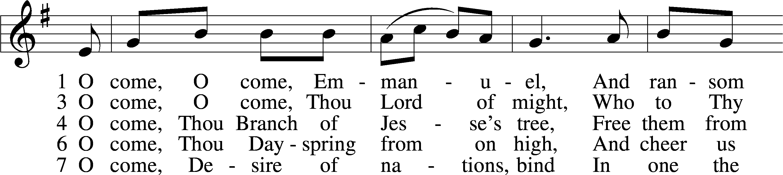
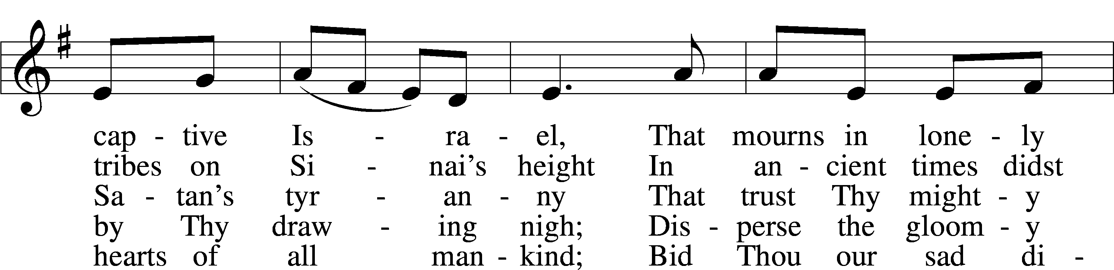
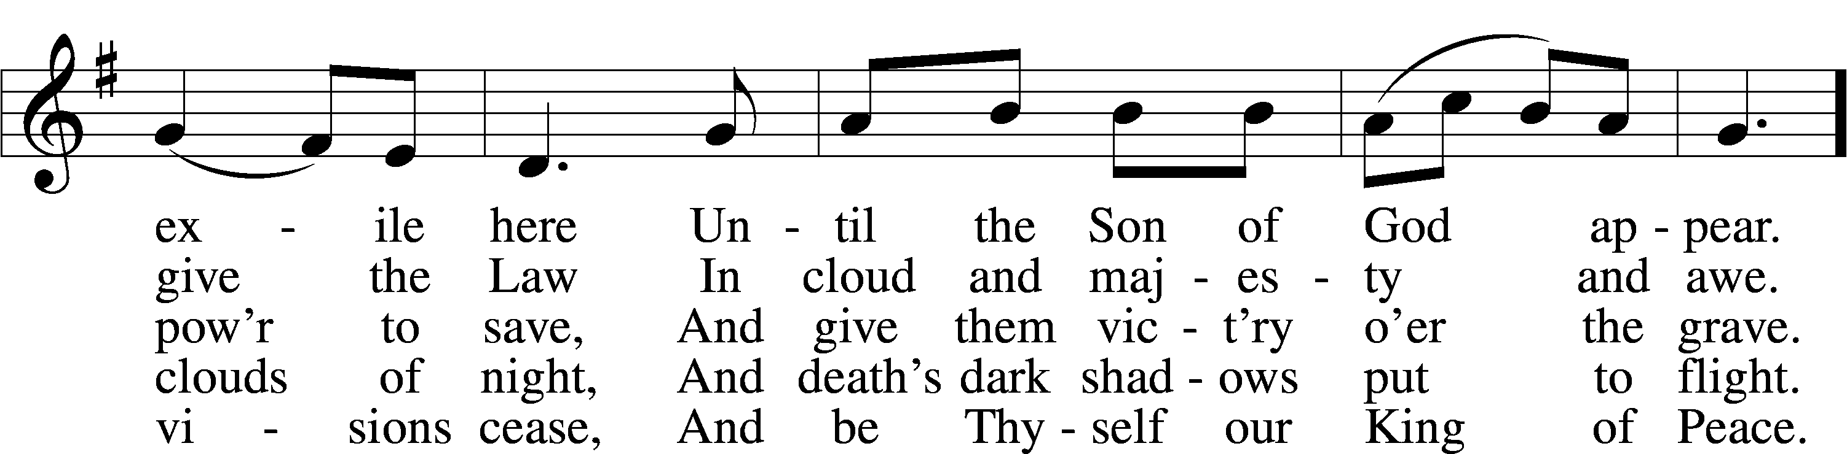
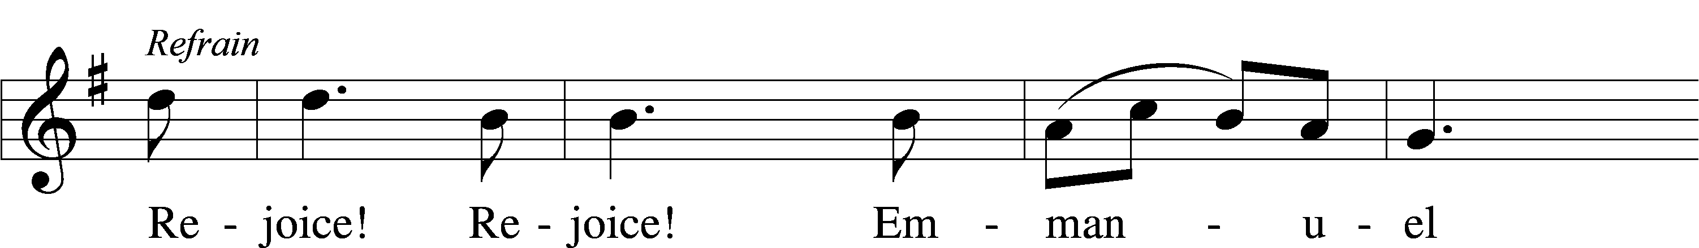
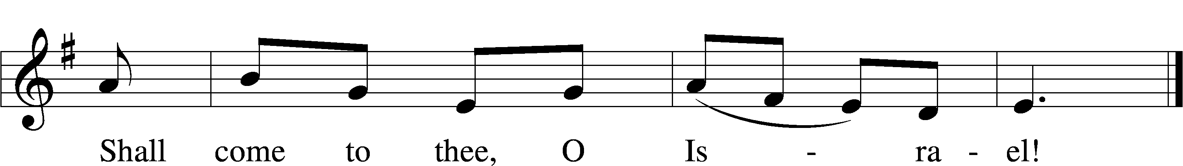
Tune and text: Public domain

Stand
The sign of the cross may be made by all in remembrance of their Baptism.

Invocation
P In the name of the Father and of the T Son and of the Holy Spirit.
C Amen.
Exhortation LSB 184
P Beloved in the Lord! Let us draw near with a true heart and confess our sins unto God our Father, beseeching Him in the name of our Lord Jesus Christ to grant us forgiveness.
P Our help is in the name of the Lord,
C who made heaven and earth.
P I said, I will confess my transgressions unto the Lord,
C and You forgave the iniquity of my sin.

Silence for reflection on God’s Word and for self-examination.

Confession of Sins LSB 184
P O almighty God, merciful Father,
C I, a poor, miserable sinner, confess unto You all my sins and iniquities with which I have ever offended You and justly deserved Your temporal and eternal punishment. But I am heartily sorry for them and sincerely repent of them, and I pray You of Your boundless mercy and for the sake of the holy, innocent, bitter sufferings and death of Your beloved Son, Jesus Christ, to be gracious and merciful to me, a poor, sinful being.

Absolution LSB 185
P Upon this your confession, I, by virtue of my office, as a called and ordained servant of the Word, announce the grace of God unto all of you, and in the stead and by the command of my Lord Jesus Christ I forgive you all your sins in the name of the Father and of the T Son and of the Holy Spirit.
C Amen.

Stand
Service of the Word
Introit
But we will | bless the Lord*
from this time forth and forevermore. | Praise the Lord!
As for me, I have | set my King*
on Zion, my | holy hill.
I will tell of | the decree:*
The Lord said to me, “You are my Son; today I have be- | gotten you.”
Praise the Lord, all | nations!*
Extol him, all | peoples!
For great is his steadfast | love toward us,*
and the faithfulness of the Lord endures forever. | Praise the Lord!
Gloria Patri LSB 186
C Glory be to the Father and to the Son and to the Holy Ghost;
as it was in the beginning, is now, and ever shall be, world without end. Amen.

Kyrie LSB 186
C Lord, have mercy upon us.
Christ, have mercy upon us.
Lord, have mercy upon us.

357 O Come, O Come, Emmanuel sts. ref, 5
ref Rejoice! Rejoice! Emmanuel
Shall come to thee, O Israel!

5 O come, Thou Key of David, come,
And open wide our heav’nly home;
Make safe the way that leads on high,
And close the path to misery. Refrain
Text: Public domain

Salutation and Collect of the Day
P The Lord be with you.
C And with thy spirit.

P Let us pray.
Stir up Your power, O Lord, and come and help us by Your might, that the sins which weigh us down may be quickly lifted by Your grace and mercy; for You live and reign with the Father and the Holy Spirit, one God, now and forever.

C Amen.

Sit

Old Testament Reading 2 Samuel 7:1–11, 16
God’s Covenant with David
¹Now when the king lived in his house and the Lord had given him rest from all his surrounding enemies, ²the king said to Nathan the prophet, “See now, I dwell in a house of cedar, but the ark of God dwells in a tent.” ³And Nathan said to the king, “Go, do all that is in your heart, for the Lord is with you.”
⁴But that same night the word of the Lord came to Nathan, ⁵“Go and tell my servant David, ‘Thus says the Lord: Would you build me a house to dwell in? ⁶I have not lived in a house since the day I brought up the people of Israel from Egypt to this day, but I have been moving about in a tent for my dwelling. ⁷In all places where I have moved with all the people of Israel, did I speak a word with any of the judges of Israel, whom I commanded to shepherd my people Israel, saying, “Why have you not built me a house of cedar?”’ ⁸Now, therefore, thus you shall say to my servant David, ‘Thus says the Lord of hosts, I took you from the pasture, from following the sheep, that you should be prince over my people Israel. ⁹And I have been with you wherever you went and have cut off all your enemies from before you. And I will make for you a great name, like the name of the great ones of the earth. ¹⁰And I will appoint a place for my people Israel and will plant them, so that they may dwell in their own place and be disturbed no more. And violent men shall afflict them no more, as formerly, ¹¹from the time that I appointed judges over my people Israel. And I will give you rest from all your enemies. Moreover, the Lord declares to you that the Lord will make you a house. . . .
¹⁶And your house and your kingdom shall be made sure forever before me. Your throne shall be established forever.’”

A This is the Word of the Lord.
C Thanks be to God.

Gradual Zechariah 9:9; Psalm 118:26, alt.
Rejoice greatly, O daughter of | Zion.*
Shout aloud, O daughter of Je- | rusalem.
Behold, your king is com- | ing to you;*
righteous and having sal- | vation.
Blessèd is he who comes in the name | of the Lord.*
From the house of the Lord we | bless you.

Epistle Romans 16:25–27
Doxology
²⁵Now to him who is able to strengthen you according to my gospel and the preaching of Jesus Christ, according to the revelation of the mystery that was kept secret for long ages ²⁶but has now been disclosed and through the prophetic writings has been made known to all nations, according to the command of the eternal God, to bring about the obedience of faith— ²⁷to the only wise God be glory forevermore through Jesus Christ! Amen.

A This is the Word of the Lord.
C Thanks be to God.

Stand

Alleluia LSB 190
C Alleluia. Alleluia. Alleluia.

Holy Gospel Luke 1:26–38
P The Holy Gospel according to St. Luke, the first chapter.
C Glory be to Thee, O Lord.

Birth of Jesus Foretold
²⁶In the sixth month the angel Gabriel was sent from God to a city of Galilee named Nazareth, ²⁷to a virgin betrothed to a man whose name was Joseph, of the house of David. And the virgin’s name was Mary. ²⁸And he came to her and said, “Greetings, O favored one, the Lord is with you!” ²⁹But she was greatly troubled at the saying, and tried to discern what sort of greeting this might be. ³⁰And the angel said to her, “Do not be afraid, Mary, for you have found favor with God. ³¹And behold, you will conceive in your womb and bear a son, and you shall call his name Jesus. ³²He will be great and will be called the Son of the Most High. And the Lord God will give to him the throne of his father David, ³³and he will reign over the house of Jacob forever, and of his kingdom there will be no end.”
³⁴And Mary said to the angel, “How will this be, since I am a virgin?”
³⁵And the angel answered her, “The Holy Spirit will come upon you, and the power of the Most High will overshadow you; therefore the child to be born will be called holy—the Son of God. ³⁶And behold, your relative Elizabeth in her old age has also conceived a son, and this is the sixth month with her who was called barren. ³⁷For nothing will be impossible with God.” ³⁸And Mary said, “Behold, I am the servant of the Lord; let it be to me according to your word.” And the angel departed from her.

P This is the Gospel of the Lord.
C Praise be to Thee, O Christ.

Apostles’ Creed
C I believe in God, the Father Almighty, maker of heaven and earth.

And in Jesus Christ, His only Son, our Lord, who was conceived by the Holy Spirit, born of the virgin Mary, suffered under Pontius Pilate, was crucified, died and was buried. He descended into hell. The third day He rose again from the dead. He ascended into heaven and sits at the right hand of God the Father Almighty. From thence He will come to judge the living and the dead.

I believe in the Holy Spirit, the holy Christian Church, the communion of saints, the forgiveness of sins, the resurrection of the body, and the life T everlasting. Amen.

Sit

356 The Angel Gabriel from Heaven Came
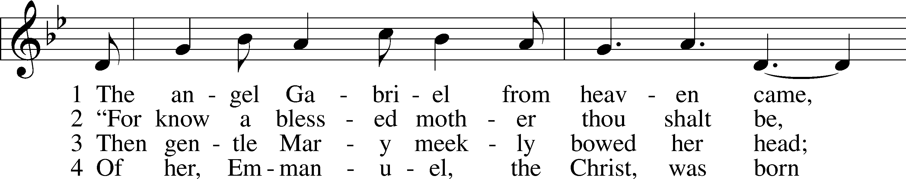
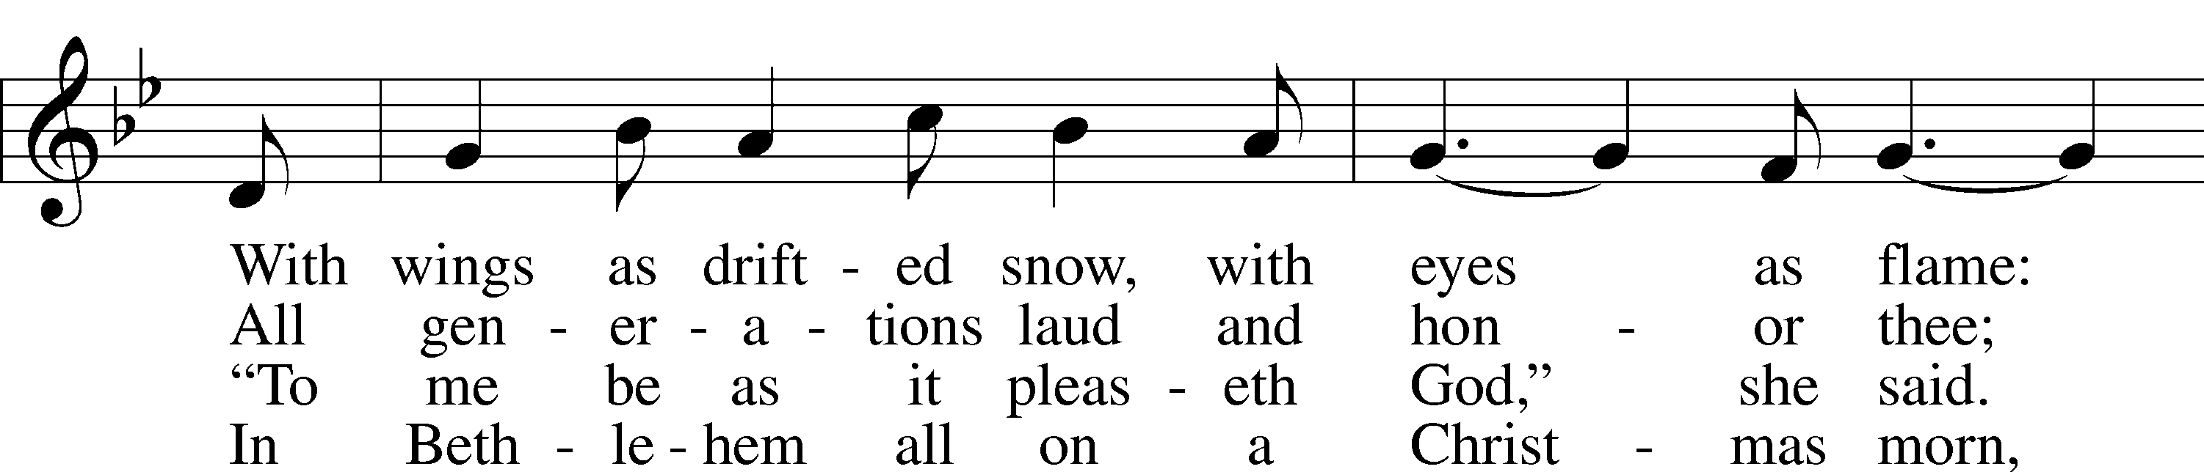
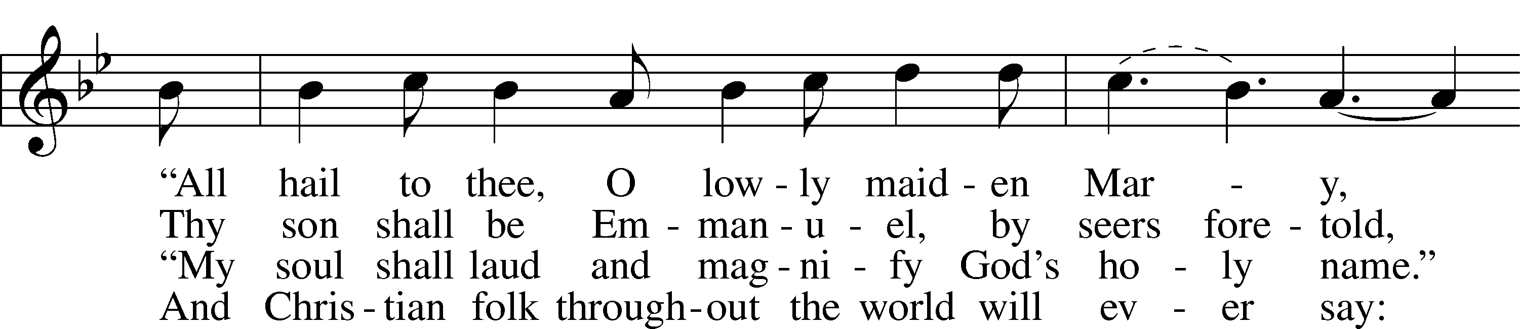
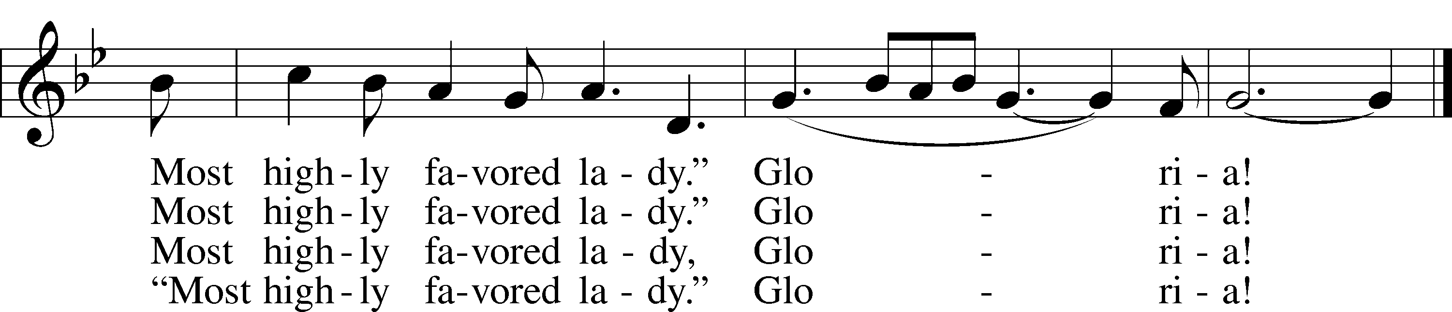
Tune and text: Public domain

Sermon ~ Baby King Jesus

Stand

Offertory LSB 192
C Create in me a clean heart, O God, and renew a right spirit within me.
Cast me not away from Thy presence, and take not Thy Holy Spirit from me.
Restore unto me the joy of Thy salvation, and uphold me with Thy free spirit. Amen.
Prayer of the Church

Piano Solo
Service of the Sacrament

Preface LSB 194
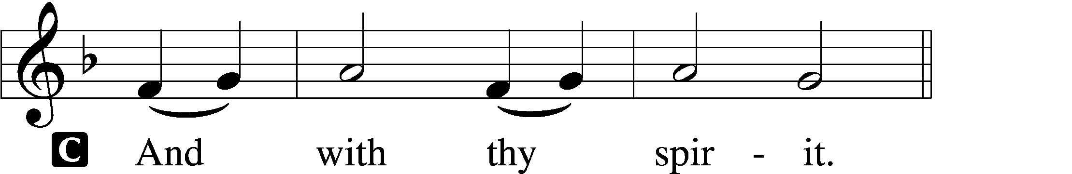

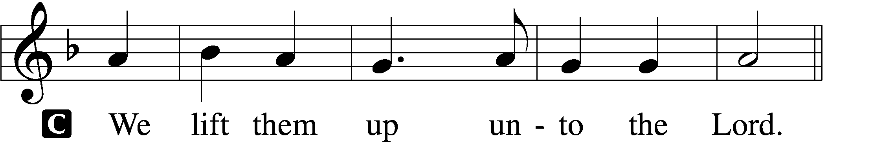

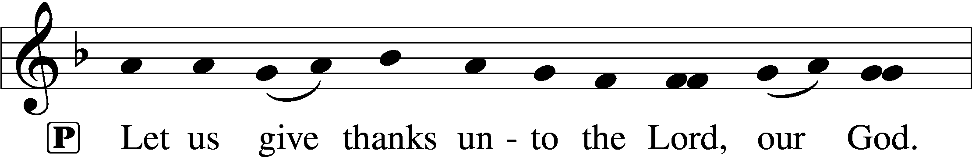
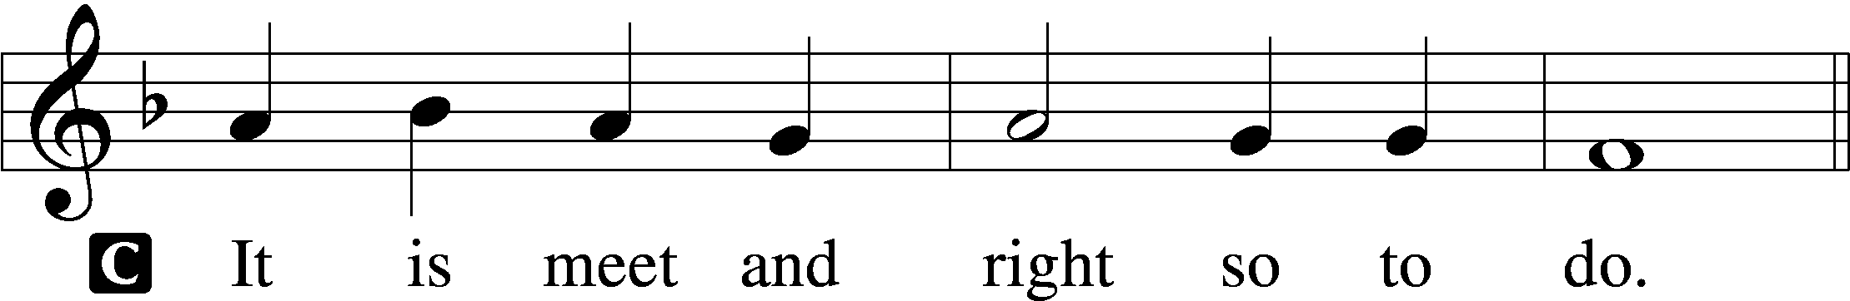

Proper Preface (Full)
P It is truly meet, right, and salutary that we should at all times and in all places give thanks to You, holy Lord, almighty Father, everlasting God, through Jesus Christ, our Lord, whose way John the Baptist prepared, proclaiming Him the promised Messiah, the very Lamb of God who takes away the sin of the world, and calling sinners to repentance that they might escape from the wrath to be revealed when He comes again in glory. Therefore with angels and archangels and with all the company of heaven we laud and magnify Your glorious name, evermore praising You and saying:

Sanctus LSB 195
C Holy, holy, holy Lord God of Sabaoth;
heav’n and earth are full of Thy glory.
Hosanna, hosanna, hosanna in the highest.
Blessed is He, blessed is He, blessed is He that cometh in the name of the Lord.
Hosanna, hosanna, hosanna in the highest.

Lord’s Prayer LSB 196
P Our Father who art in heaven,
hallowed be Thy name,
Thy kingdom come,
Thy will be done on earth as it is in heaven;
give us this day our daily bread;
and forgive us our trespasses as we forgive those who trespass against us;
and lead us not into temptation,
but deliver us from evil.
C For Thine is the kingdom and the power and the glory forever and ever. Amen.

The Words of Our Lord LSB 197
P Our Lord Jesus Christ, on the night when He was betrayed, took bread, and when He had given thanks, He broke it and gave it to the disciples and said: “Take, eat; this is My T body, which is given for you. This do in remembrance of Me.”

In the same way also He took the cup after supper, and when He had given thanks, He gave it to them, saying: “Drink of it, all of you; this cup is the new testament in My T blood, which is shed for you for the forgiveness of sins. This do, as often as you drink it, in remembrance of Me.”

Pax Domini LSB 197
P The peace of the Lord be with you always.
C Amen.

Agnus Dei LSB 198
C O Christ, Thou Lamb of God, that takest away the sin of the world, have mercy upon us.
O Christ, Thou Lamb of God, that takest away the sin of the world, have mercy upon us.
O Christ, Thou Lamb of God, that takest away the sin of the world, grant us Thy peace. Amen.

Sit

Distribution

370 What Child Is This
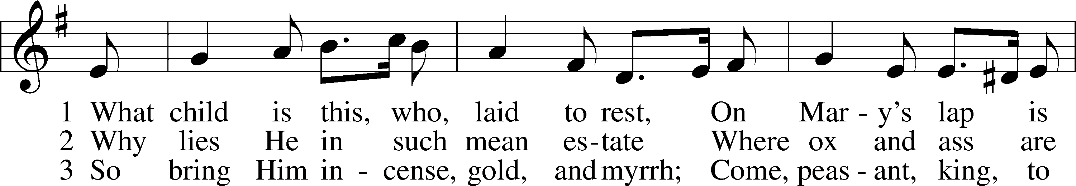
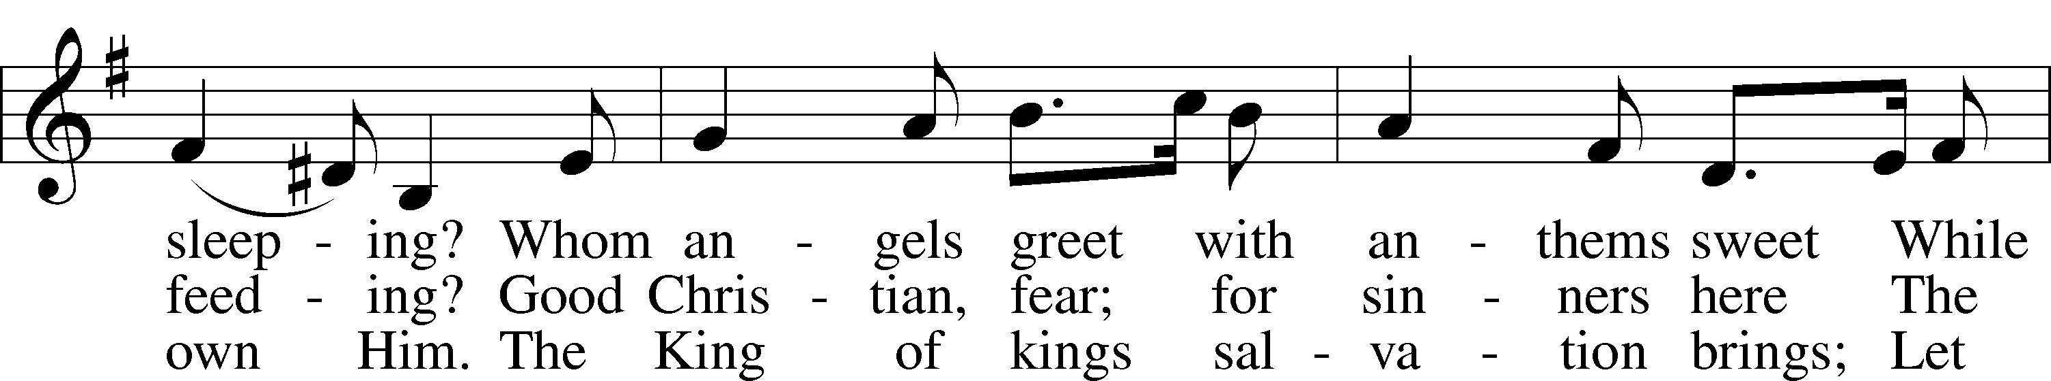
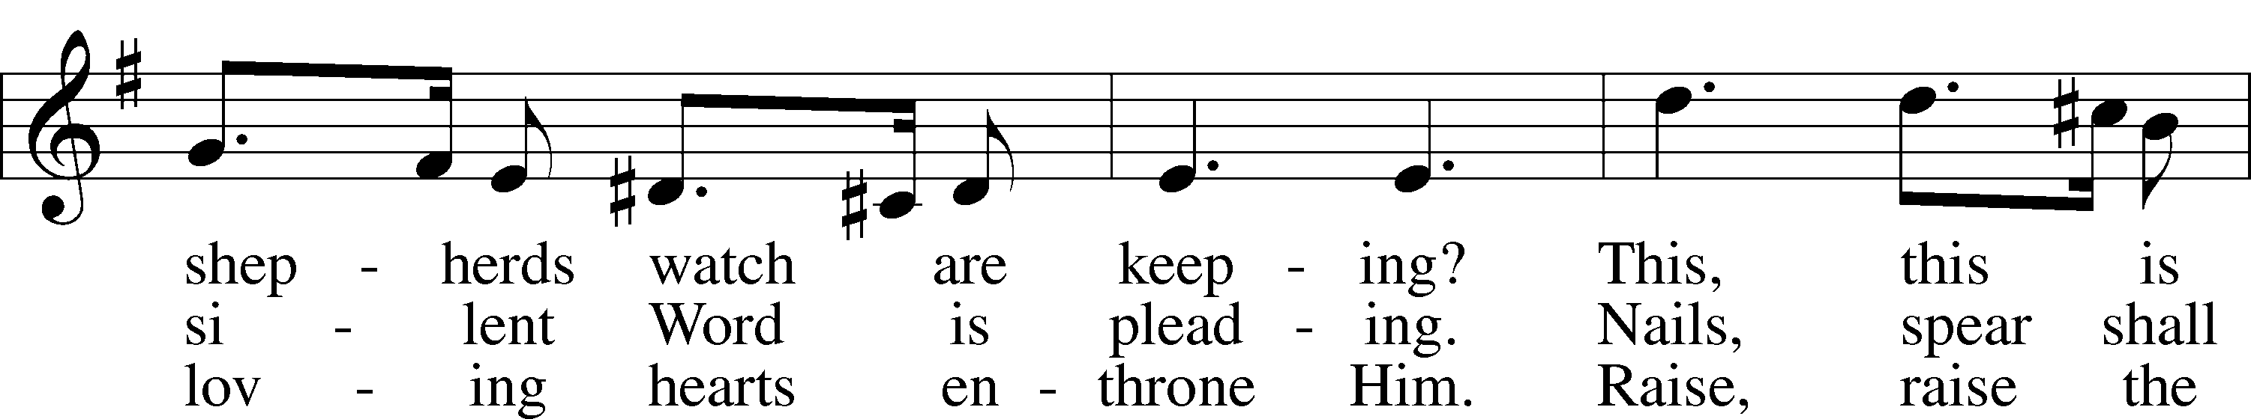
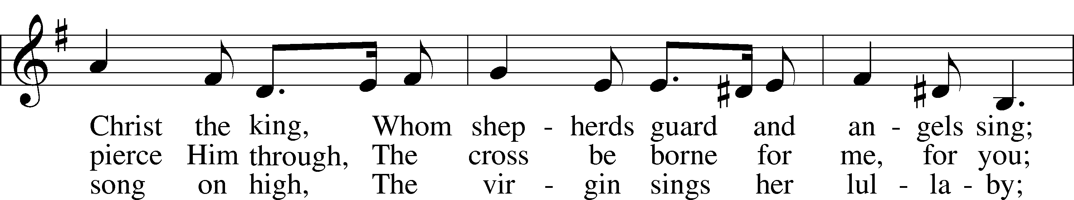
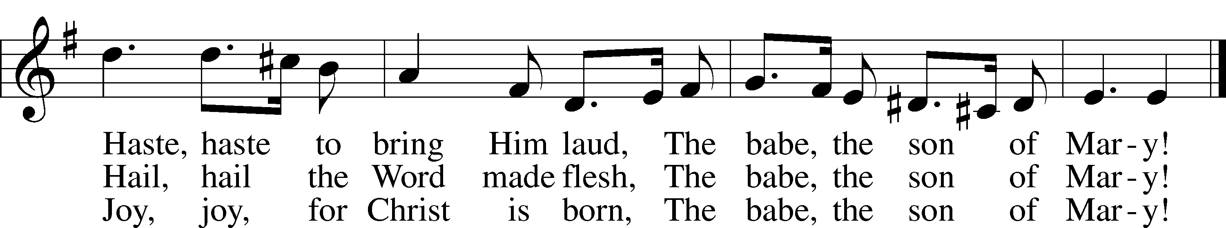
Text and tune: Public domain

621 Let All Mortal Flesh Keep Silence
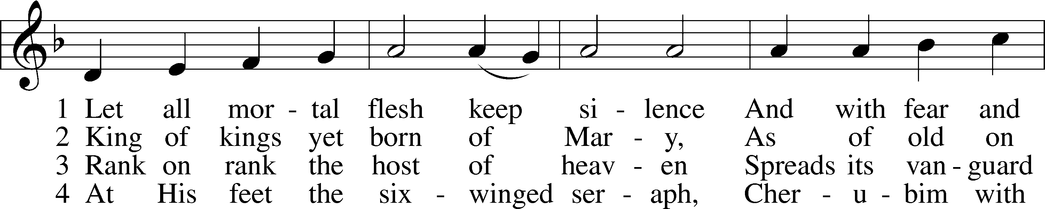
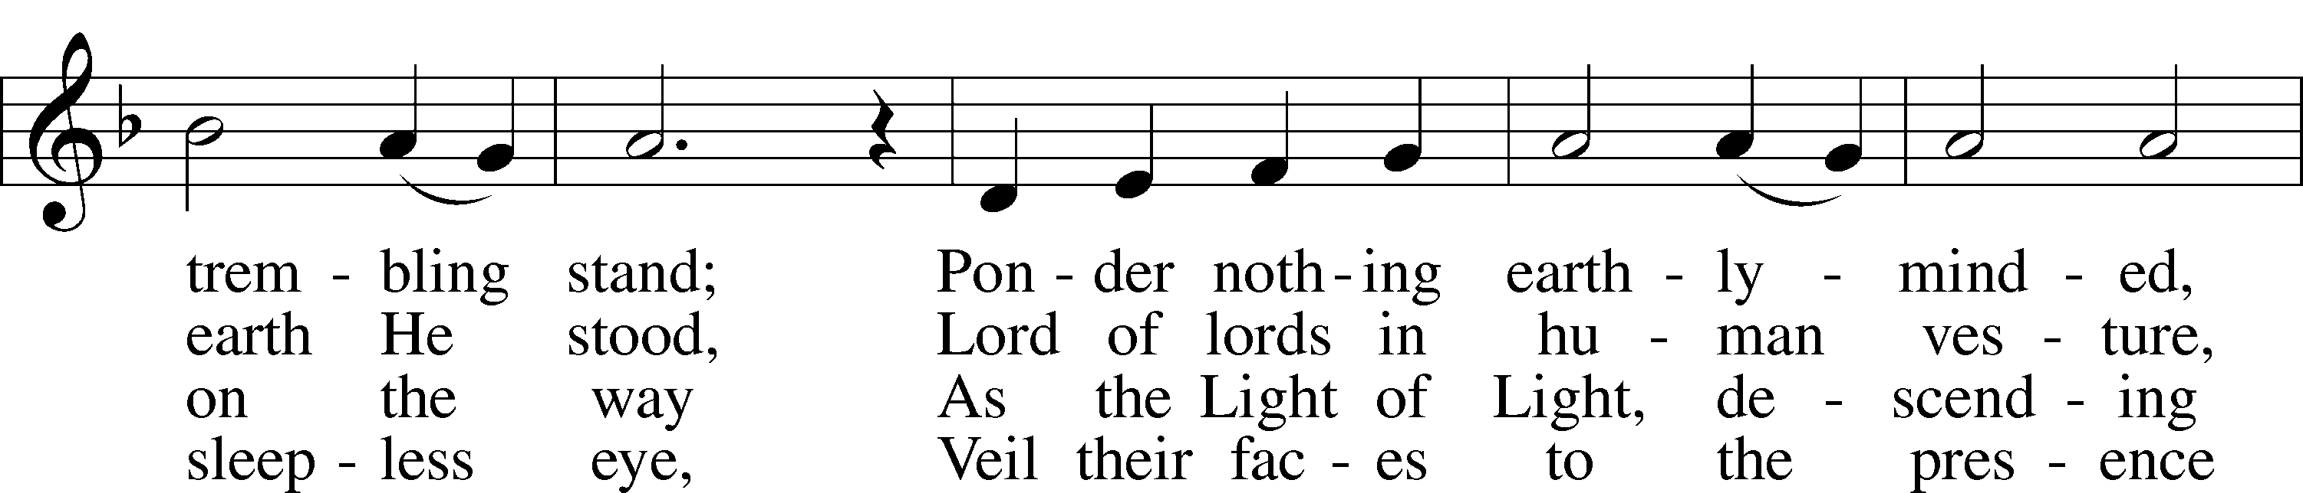
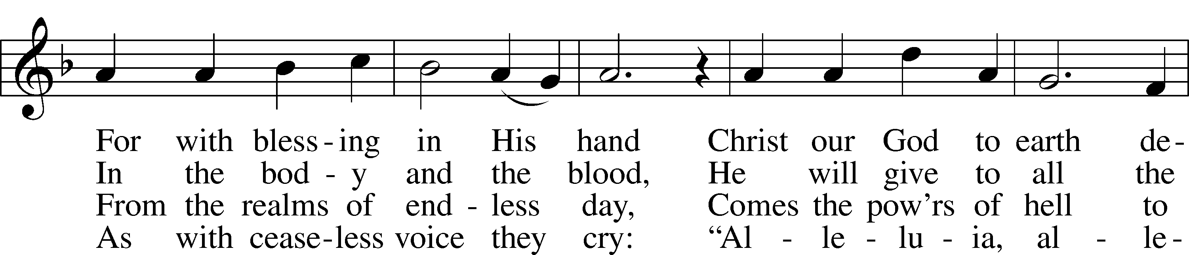
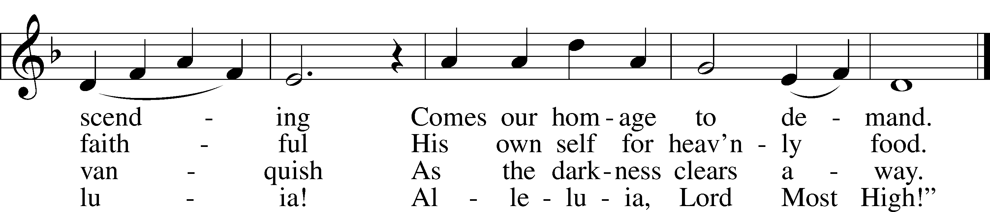
Text and tune: Public domain

383 A Great and Mighty Wonder
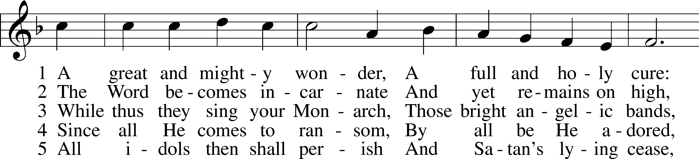
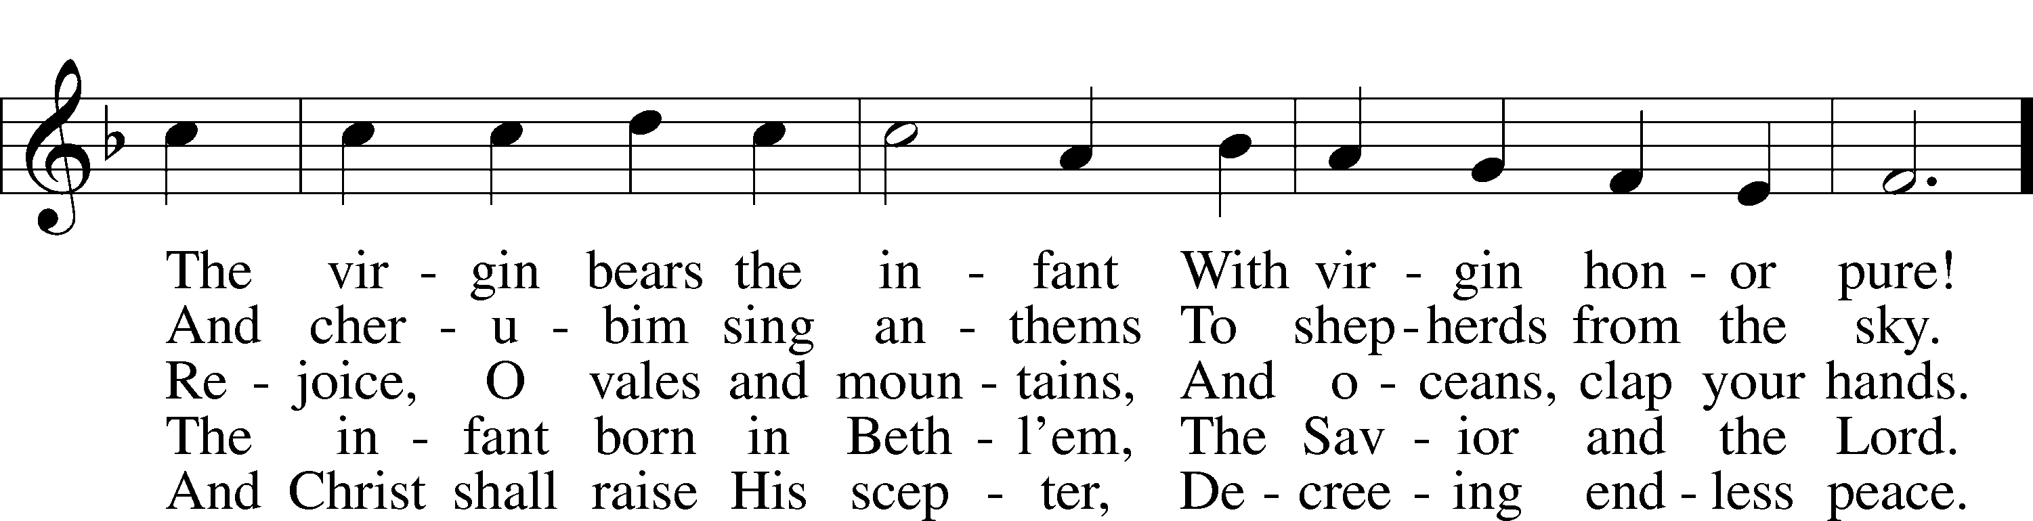
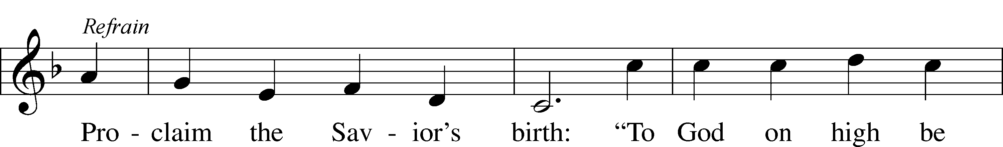
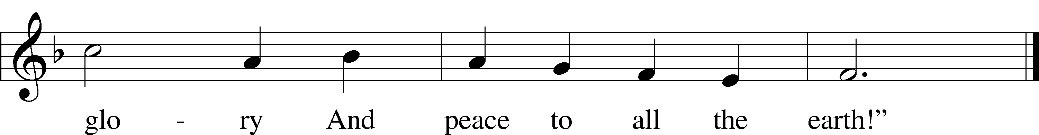
Text and tune: Public domain

Stand

In dismissing the communicants, the following is said:

The Dismissal LSB 199
P The body and blood of our Lord Jesus Christ strengthen and preserve you in body and soul to life everlasting. Depart T in peace.
C Amen.

Nunc Dimittis LSB 199
C Lord, now lettest Thou Thy servant depart in peace according to Thy word,
for mine eyes have seen Thy salvation, which Thou hast prepared before the face of all people,
a light to lighten the Gentiles and the glory of Thy people Israel.
Glory be to the Father and to the Son and to the Holy Ghost;
as it was in the beginning, is now, and ever shall be, world without end. Amen.

Thanksgiving LSB 200
A O give thanks unto the Lord, for He is good,

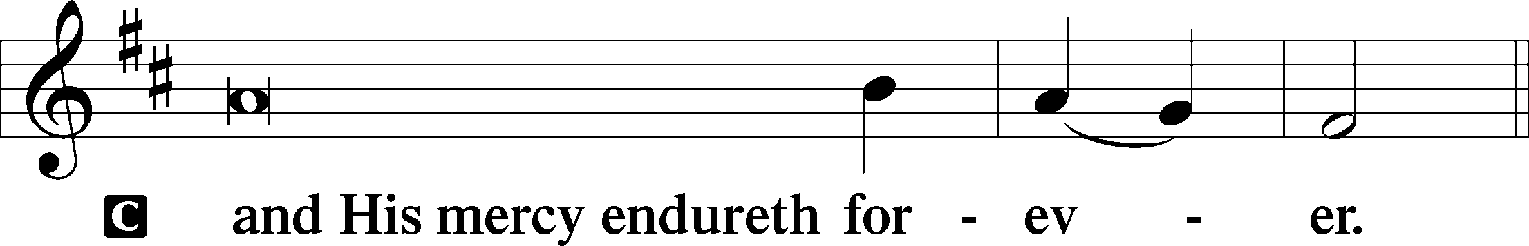

Post-Communion Collect
A Let us pray.
We give thanks to You, almighty God, that You have refreshed us through this salutary gift, and we implore You that of Your mercy You would strengthen us through the same in faith toward You and in fervent love toward one another; through Jesus Christ, Your Son, our Lord, who lives and reigns with You and the Holy Spirit, one God, now and forever.
C Amen.

Salutation LSB 201
P The Lord be with you.

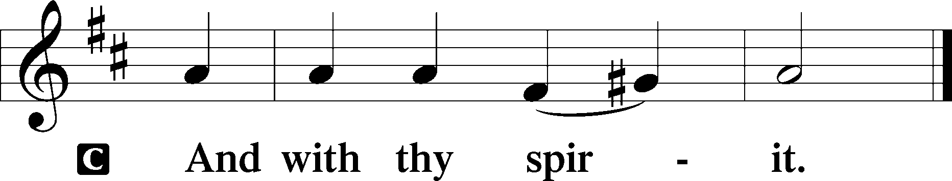

Benedicamus LSB 202
A Bless we the Lord.

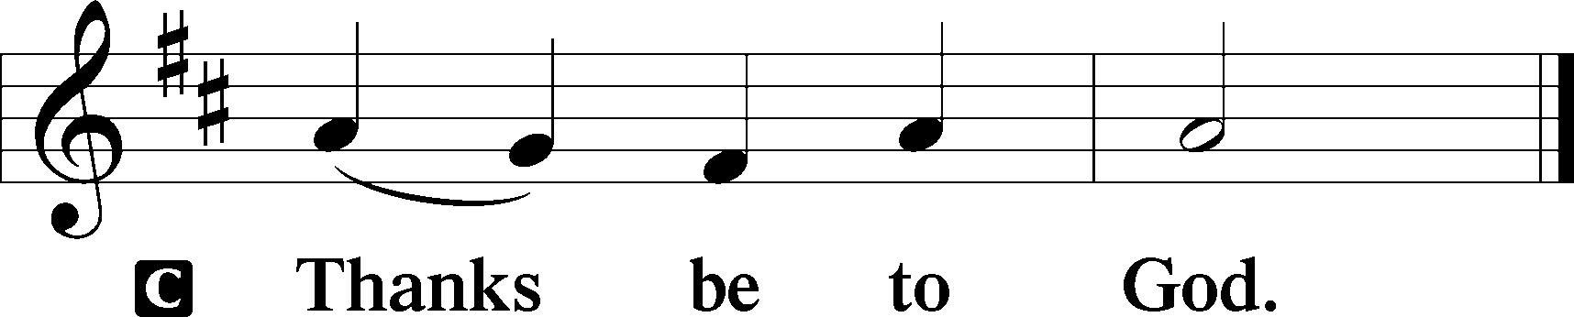

Benediction LSB 202
P The Lord bless you and keep you.
The Lord make His face shine upon you and be gracious unto you.
The Lord lift up His countenance upon you and T give you peace.
C Amen, amen, amen.

900 Jesus! Name of Wondrous Love
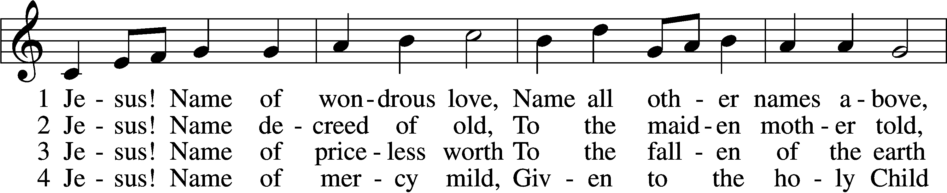
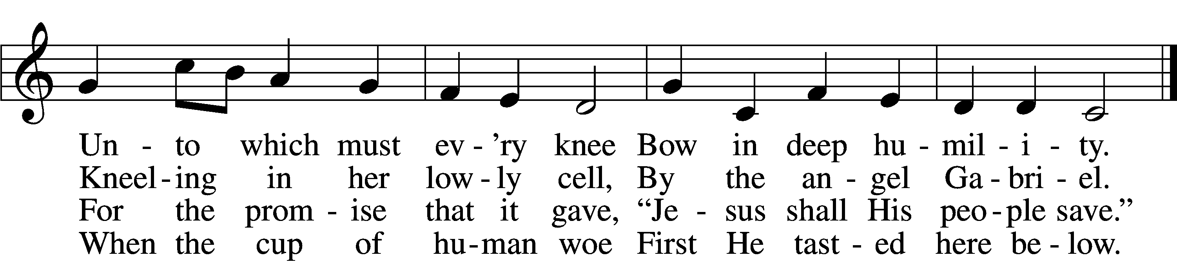

5 Jesus! Only name that’s giv’n
Under all the mighty heav’n
Whereby those to sin enslaved
Burst their fetters and are saved.

6 Jesus! Name of wondrous love,
Human name of God above;
Pleading only this, we flee
Helpless, O our God, to Thee.
Tune and text: Public domain

Acknowledgments
Unless otherwise indicated, Scripture quotations are from the ESV® Bible (The Holy Bible, English Standard Version®), copyright © 2001 by Crossway, a publishing ministry of Good News Publishers. Used by permission. All rights reserved.
Created by Lutheran Service Builder © 2020 Concordia Publishing House.

Prayers for Our Members
Bailey Hockemeier, Leah Vogel | Expectant Mothers
Norman Abels (Brookestone Meadows – Elkhorn) | Healing
Judy Ahrens | Healing
Vaughn Albrecht (Northridge) | Healing
Tom & DyAnn Altwine | Healing
David Banner | Healing
Lyle Colsden (Mother Hull) | Healing
Pat Flodine (Cambridge Court) | Healing
Vi Fox (Prairie View) | Healing
Verleen Gentry | Healing
Ruby Hatfield | Healing
Michelle Millsap | Healing
Merna Oertwig | Healing
Roger Riekenberg | Healing
Marion Richmond | Healing
Fran Junge | Cancer
Bev Nuttelman | Cancer
Kim Vos | Cancer

Prayers for Our Members’ Family & Friends
Dawn Gaunt (Pr. & Carol Gaunt’s daughter-in-law) | Expectant Mother
Brandon & Shannon Howell (Quentin & Janel Lange’s friends) | Expecting
Will Brennemann (Jami Helmbrecht’s father) | Healing
Reg Duke (Westman’s brother-in-law) | Healing
James Gentry (Verleen Gentry’s son) | Healing
Roger Hoffman (Marc’s father) | Healing
Sharon Kreutzer (former member) | Healing
Lyra Mais (Zion student) | Healing
Randy Solomon (Beth Rosenthal’s father) | Healing
Mary Ann Mertz (Pam’s Uhlir’s friend) | Healing
Roy Reynolds (Verleen Gentry’s son-in-law) | Healing
Janet Stalder (Carol Florang’s sister) | Healing
D.D. Dugger (Sue Kaiser’s brother) | Cancer
Ron Halvorsen (Jeff’s dad) | Cancer
Carol Haubold (Don Helmbrecht’s sister) | Cancer
Tyler Holland (Quentin & Janel Lange’s brother-in-law) | Cancer
Randy Jochum (Ken Hockemeier’s brother-in-law) | Cancer
Fred Koch (Pam Uhlir’s cousin) | Cancer
Lynda Kreutzer (Rich & Carol’s sister-in-law) | Cancer
John Moore (family of Susan Tonniges) | Cancer
Sharon Mulhair (Pam Uhlir’s cousin) | Cancer
Becky Rathkie (former Zion teacher) | Cancer
Jeannie Schmidt (Lisa Splittgerber’s sister-in-law) | Cancer
Tyrone Uhlir (Pam’s nephew) | Cancer

Today’s Radio Broadcast is given to the Glory of the Lord by Marian Allwardt for thanksgiving for Rev. James and Zach DeLoach’s birthdays

Serving in Worship

Sunday, December 20~ 9:00am
Elder: Nathan Gaunt
Usher: Roger Riekenberg & Bob Glanzer
Engineer: Jared Nuttelman
Announcer: Lonna Gronewoller
Altar Guild: Beth Rosenthal
Thursday, December 24~ 5:00 & 7:00pm Christmas Eve
Elder: Nathan Gaunt
Usher: All Captains
Engineer: Jared Nuttelman

Friday, December 25~ 10:00am Christmas Day
Elder: Nathan Gaunt
Usher: Roger Riekenberg & Bob Glanzer
Engineer: Jared Nuttelman
Altar Guild: Beth Rosenthal
Altar Guild: Beth Rosenthal

Sunday, December 27~ 9:00am
Elder: Rich Kreutzer
Usher: Mike Wilkens
Engineer: Shawn Starkey
Announcer: Carol Kreutzer
Altar Guild: Beth Rosenthal

OPPORTUNITIES FOR WORSHIP DURING ADVENT
Dec 24 | 5:00 pm &  7:00 pm | Christmas Eve Candlelight Service
Dec 25 | 10:00 am | Christmas Day Worship

Our Response to the Gospel

Date: 12/13/2020

Offering: $8,740.70
Weekly Need: $7,542.37

ZION LUTHERAN CHURCH AND SCHOOL

Pr. James DeLoach, Pastor + (308) 627-5260
james.deloach@zionkearney.org
Pr. Doug Gaunt, Pastor + (308) 455-0552
doug.gaunt@zionkearney.org
Tony Splittgerber, Principal + (308) 293-0168
anthony.splittgerber@zionkearney.org

Church Office
Administrative Assistant: Jessica Shiers
Email: school@zionkearney.org
Phone: (308)-234-3410 Fax: (308) 236-8100
Office Hours: Monday-Friday 8:00am-4:00pm
Radio Broadcast: Sunday @ 10:30 a.m. on 1460 AM
Website: www.zionkearney.com

Where our Triune God strengthens us through His mercy in faith toward Him and in fervent love toward one another.

This Week at Zion

Sun  12/20 | 9:00a  10:30a | Divine Service  Radio Broadcast 1460am
Mon  12/21 | Birthdays  Anniversaries | Josh Jorgensen  Reese Jade Florang  Dale & Lynette Johnson
Tues  12/22 | Birthdays  Anniversaries | Rev. James DeLoach  ---
Wed  12/23 | Birthdays  Anniversaries | ---  ---
Thurs  12/24 | 5:00p  7:00p  Birthdays  Anniversaries | Christmas Eve Service  Christmas Eve Service  Alan Altwine  Eric Hansen  ---
Fri  12/25 | 10:00a  Birthdays  Anniversaries | Christmas Day Service  Brandon Fletcher  Kaitlyn Kaufman  ---
Sat  12/26 | 5:00p  Birthdays  Anniversaries | Divine Service  Jana Flessner  Lyn Hoffman  ---
Sun  12/27 | 9:00a  10:30a  Birthdays  Anniversaries | Divine Service  Radio Broadcast 1460am  DyAnn Altwine  Allison Wilkens  ---
ANNOUNCEMENTS

Masks – According to Kearney City Ordinance No. 8457 masks are required “at a location that is open to the general public and where they cannot maintain six foot of distance.”

Year-End Reports - The Chairman of each board and organization is asked to turn in a Year End Report to the Church office. The most convenient way to receive these is by email. school@zionkearney.org

Office Closed – The church office will be closed Monday, December 21-Tuesday, January 5th. For Pastoral emergencies please call Pastor DeLoach (308-627-5260) or Pastor Gaunt (308-455-0552).

Thank You to Grace Burger for playing piano for our service today.

POINSETTIAS - Thank you to the following families who provided poinsettias for use in our sanctuary this Christmas season: Patrick & Patrice Brost, Paul & Rachael Burger, Waunita DeLaet, Wes & Mary Fiddelke, Bob & Wanda Glanzer, Lonna Gronewoller, Don & Shirley Helmbrecht, Matt & Amy Hodgson, Chris & Sarah Hoehner, Todd & Ellen Koopman, Doreen Lemburg, Dan & Shirley Oertwig, Don & Marion Richmond, Jane Schmid, Becky Thornton, Cinda Ward.

2020 Contributions - Just a reminder that the 2020 contributions must be dated December 31, 2020 and put in the plate by December 31 to be counted as 2020 contributions.

A Bible Study – is prerecorded and available each Sunday, along with a study guide you can use to follow along. We are studying the three lessons for the day—the Old Testament, the Epistle, and the Gospel. Go to Zion’s website www.zionkearney.com to access the video and study guide.

Offering Envelopes – 2021 offering envelopes are in your church mailbox.

Offering during this time. If you are not able to attend live Church Services, you may: drop your offering in the mail slot by the south doors, mail it to the church, or use online giving option at zionkearney.com. If you have any questions or need assistance please contact the office at 308-234-3410 or school@zionkearney.org. Thank you for supporting of your church!

Radio Broadcast & Altar Flowers - Please help Zion spread the Gospel! There are several open dates. This is a great need during this time, many people are listening to our broadcast during this time. There are also many openings for altar flowers. Please help beautify the sanctuary.

Mission Offerings - The fourth quarter missions, October through December, will support those preparing for fulltime church work (Peter Kreutzer and Taylor Zehendner, both at CUNE). If you would like to donate to this mission please use the mission envelopes located in the narthex. Thank you for your support.

Registration Open- Registration is now open for the 2021-2022 school year for current school families and Zion church members. Registration will open to the public on Wednesday, January 6th. New this year is and all-day prekindergarten! If you have any questions please feel free to contact the office. Please tell your family and friends about Zion. Enroll early to make sure you have a spot. We invited everyone to reenroll. Zion is a wonderful school family, we would love to see everyone back!

New Teacher Search - Mr. Vogel and family will be moving at the conclusion of this school year so the search for another high quality Lutheran teacher has begun. Full time teachers in our school must be members of the LCMS (or willing to become so). The grade level will most probably be for the 3rd/4th grade. If you or someone you know might be interested in this position please contact Mr. Splittgerber

Important Calendar Change - The Board of Education, on its December 8th meeting, voted to add two days to the school Christmas break. Zion will now return from break on Wednesday, January 6.

This change was made in part to recognize the Herculean efforts that Zion’s teachers have made to keep the school running during a pandemic. This change will also align Zion’s calendar with that of other Kearney schools.

