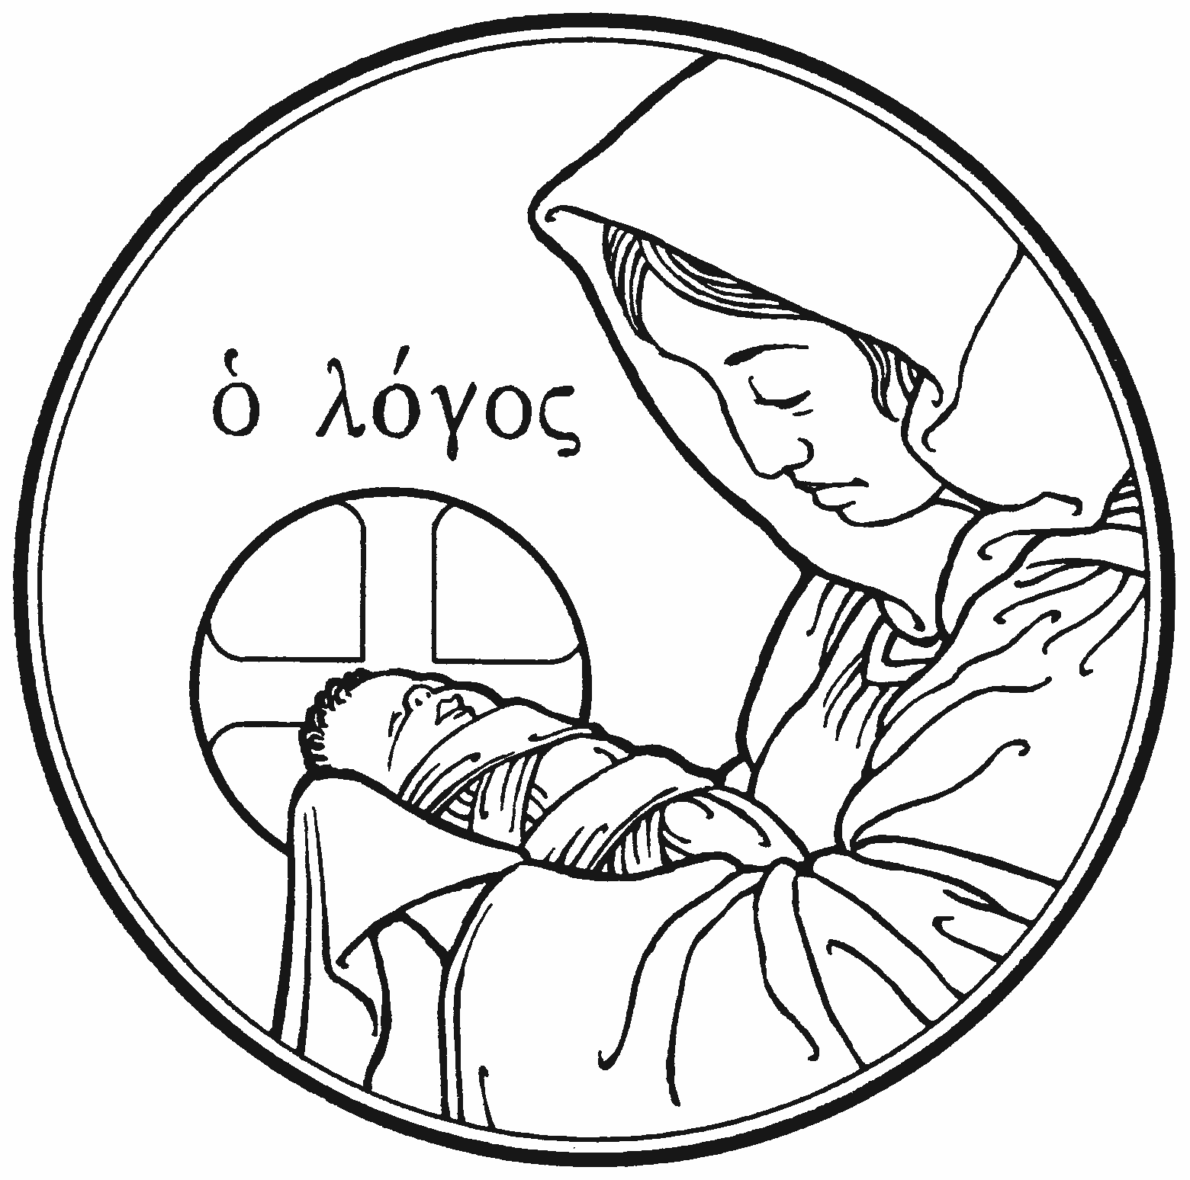

Christmas Day
25 December 2020 ~ 10:00 a.m.

Zion Lutheran Church & School

Kearney, NE + (308) 234-3410

Rev. James DeLoach, Pastor + (308) 627-5260
Rev. Doug Gaunt, Pastor + (308) 455-0552
Tony Splittgerber, Principal + (308) 293-0168
A WARM WELCOME TO OUR GUESTS

Please sign our guest book in the narthex and let us know how we can be of service to you. If you are a member in good standing of a sister LC-MS congregation, we invite you to commune with us. Members of other church bodies with whom we are not in confessional fellowship are asked to please refrain from communing. Our pastor will be happy to visit with you about our desire for true unity in Christ and how that is connected to our communion practice. All communicants need to register in the narthex prior to the service.

✤ ✤ ✤
Serving Zion Today

Preacher: Pr. James DeLoach Liturgist: Pr. Doug Gaunt
Organist: Teresa Leising Elder: Nathan Gaunt
Crucifer: Isaiah Gaunt Altar Guild: Beth Rosenthal
Pianist: Miriam Gaunt Violinist: Jamie Wilkens
✤ ✤ ✤
379 O Come, All Ye Faithful
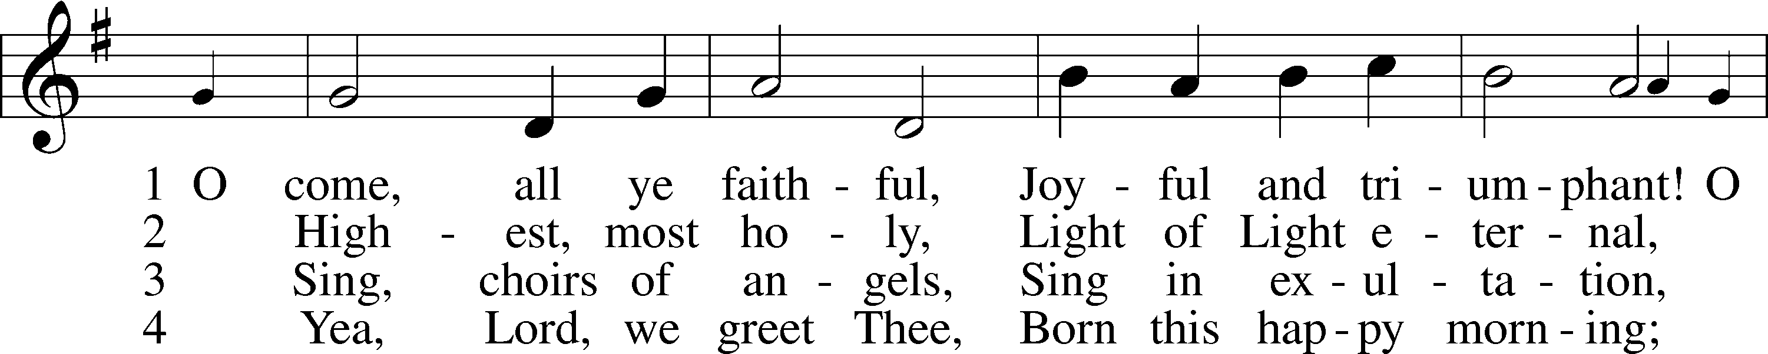
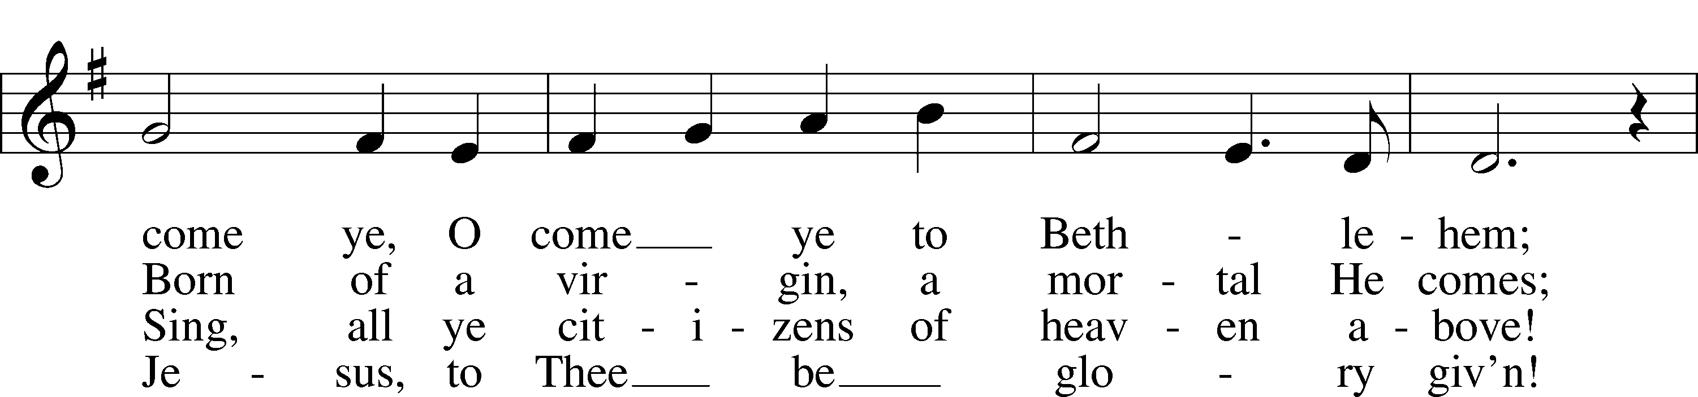
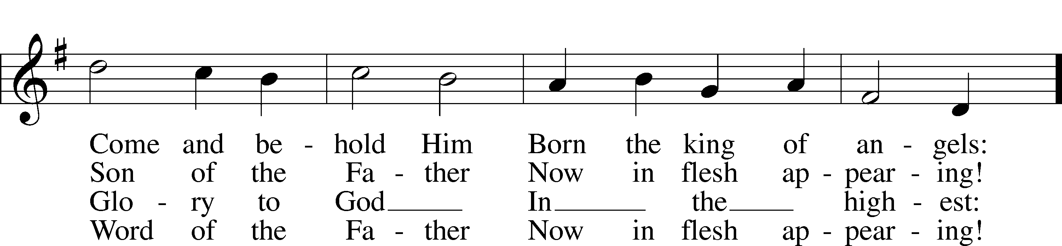
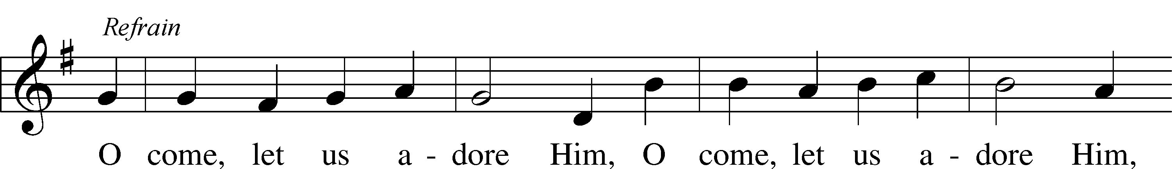
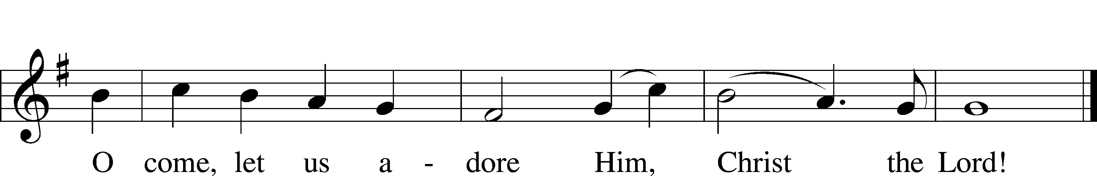
Text and tune: Public domain

Stand

The sign of the cross may be made by all in remembrance of their Baptism.

Invocation
P In the name of the Father and of the + Son and of the Holy Spirit.
C Amen.

Exhortation LSB 184
P Beloved in the Lord! Let us draw near with a true heart and confess our sins unto God our Father, beseeching Him in the name of our Lord Jesus Christ to grant us forgiveness.

P Our help is in the name of the Lord,
C who made heaven and earth.
P I said, I will confess my transgressions unto the Lord,
C and You forgave the iniquity of my sin.

Silence for reflection on God’s Word and for self-examination.

Confession of Sins LSB 184
P O almighty God, merciful Father,
C I, a poor, miserable sinner, confess unto You all my sins and iniquities with which I have ever offended You and justly deserved Your temporal and eternal punishment. But I am heartily sorry for them and sincerely repent of them, and I pray You of Your boundless mercy and for the sake of the holy, innocent, bitter sufferings and death of Your beloved Son, Jesus Christ, to be gracious and merciful to me, a poor, sinful being.

Absolution LSB 185
P Upon this your confession, I, by virtue of my office, as a called and ordained servant of the Word, announce the grace of God unto all of you, and in the stead and by the command of my Lord Jesus Christ I forgive you all your sins in the name of the Father and of the T Son and of the Holy Spirit.
C Amen.

Service of the Word

Introit
But we will | bless the Lord*
from this time forth and forevermore. | Praise the Lord!
As for me, I have | set my King*
on Zion, my | holy hill.
I will tell of | the decree:*
The Lord said to me, “You are my Son; today I have be- | gotten you.”
Praise the Lord, all | nations!*
Extol him, all | peoples!
For great is his steadfast | love toward us,*
and the faithfulness of the Lord endures forever. | Praise the Lord!

Gloria Patri LSB 186
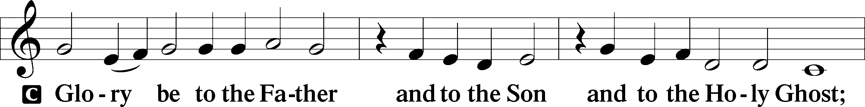
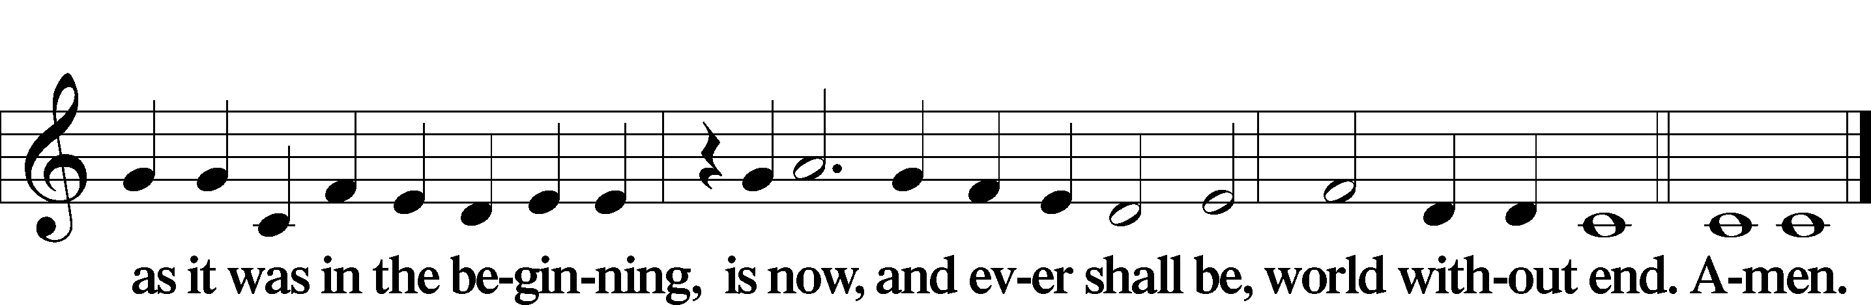

Kyrie LSB 186
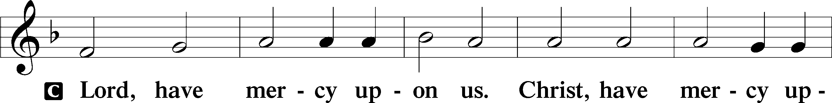
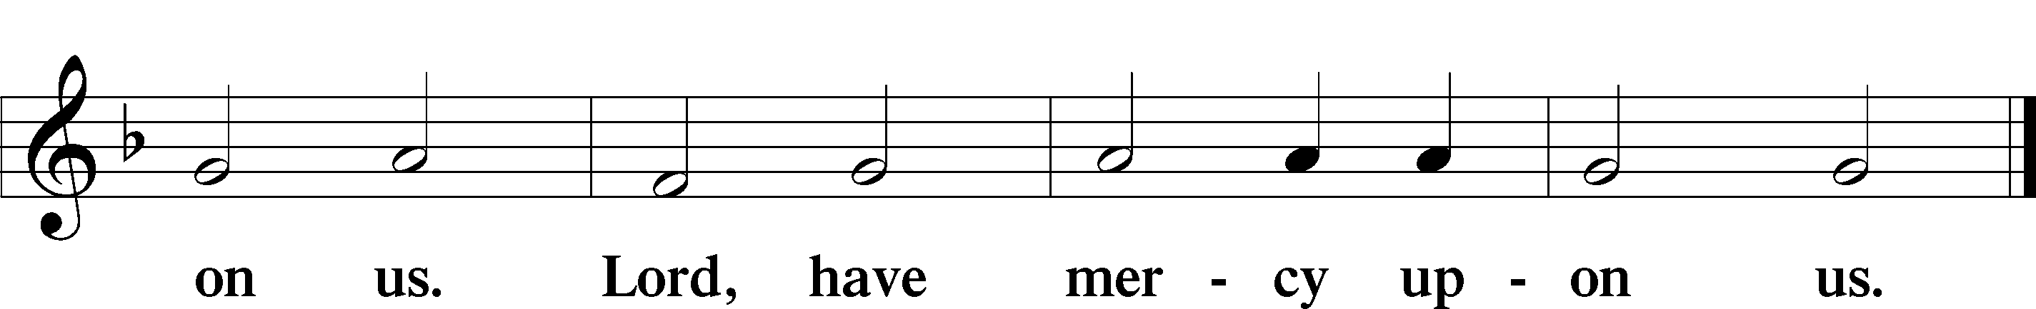

Gloria in Excelsis LSB 187
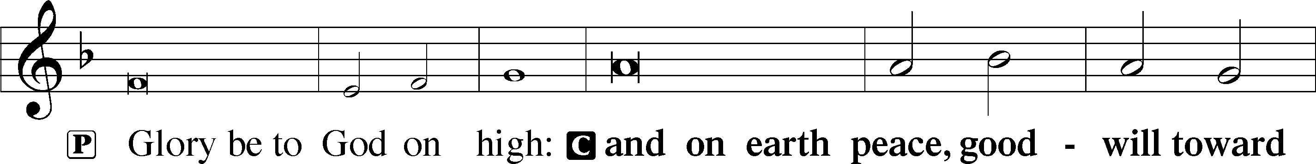
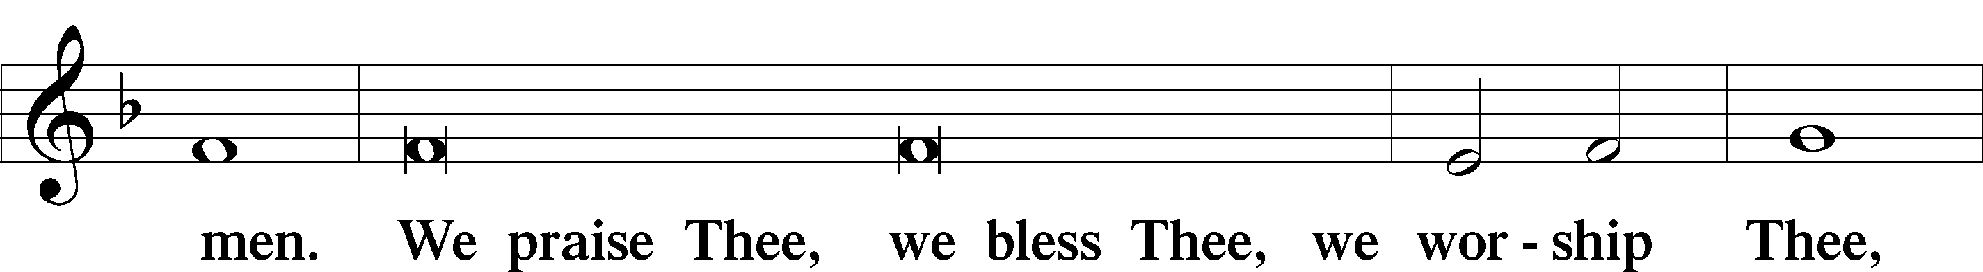
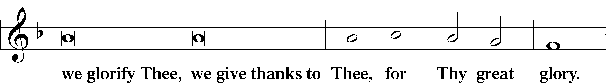
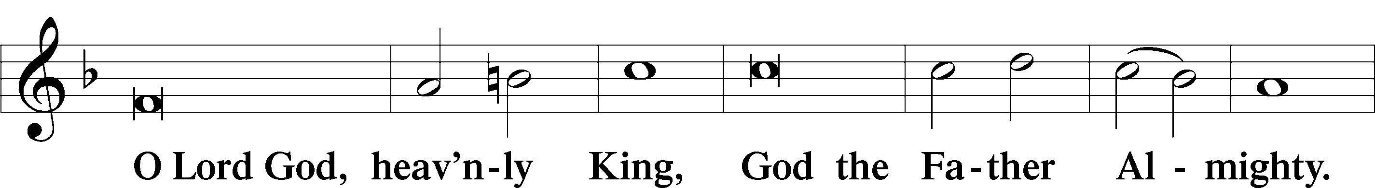
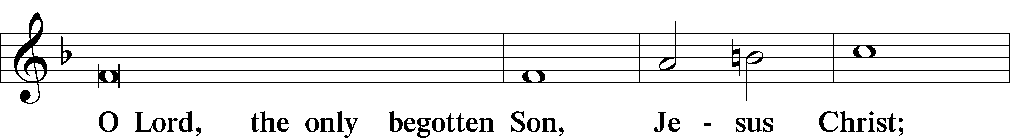
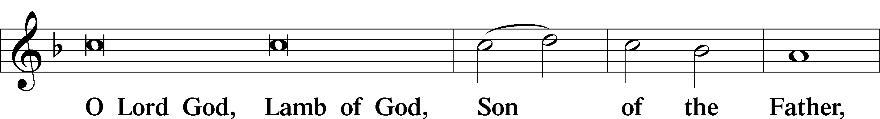
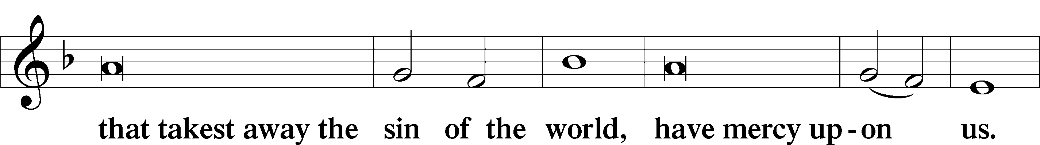
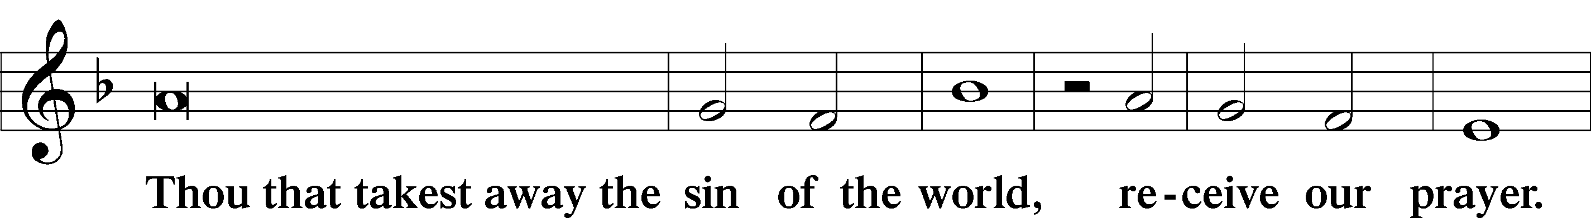
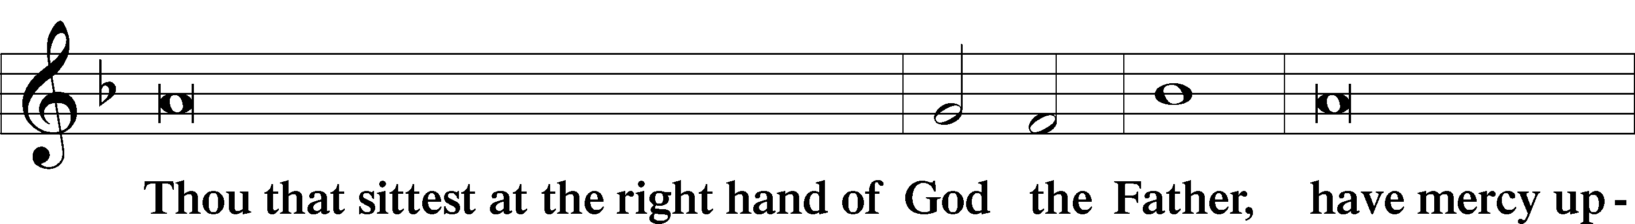
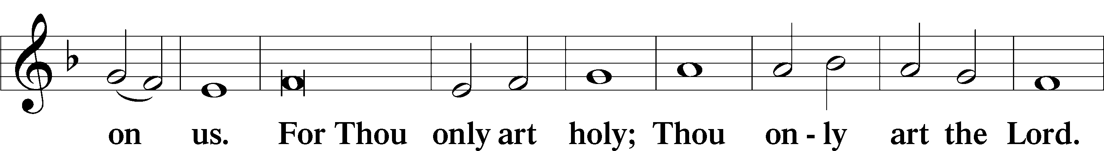
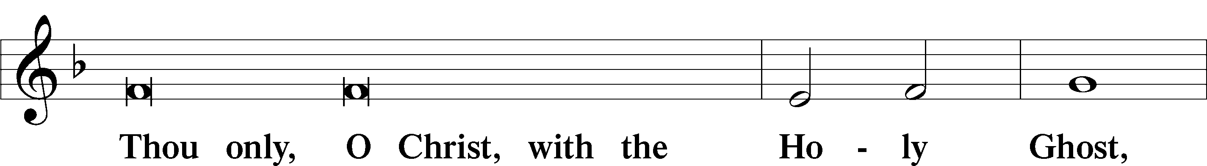
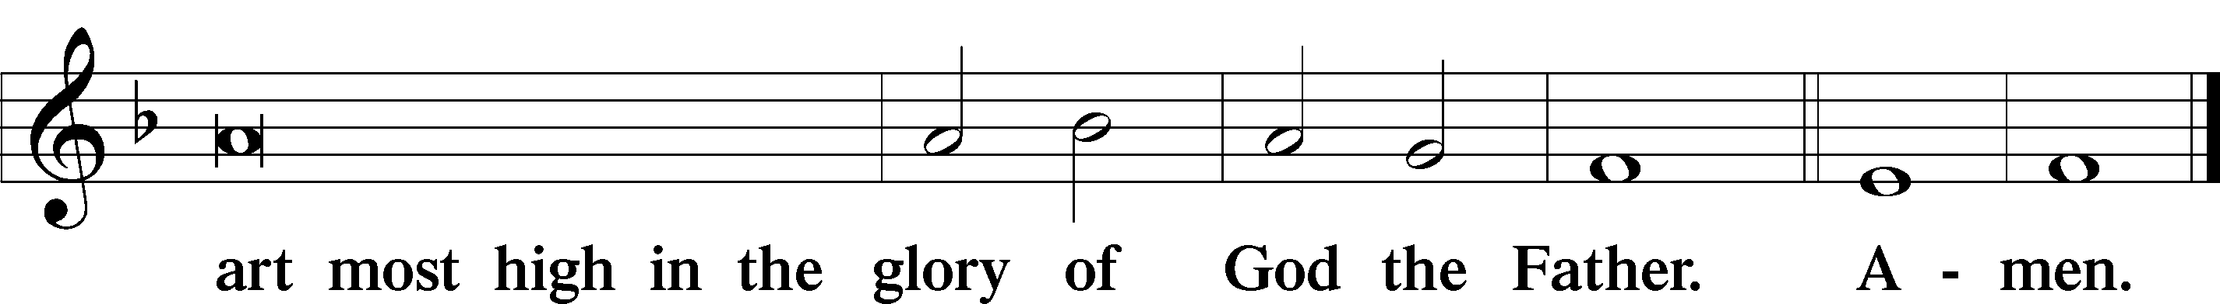

Salutation and Collect of the Day
P The Lord be with you.
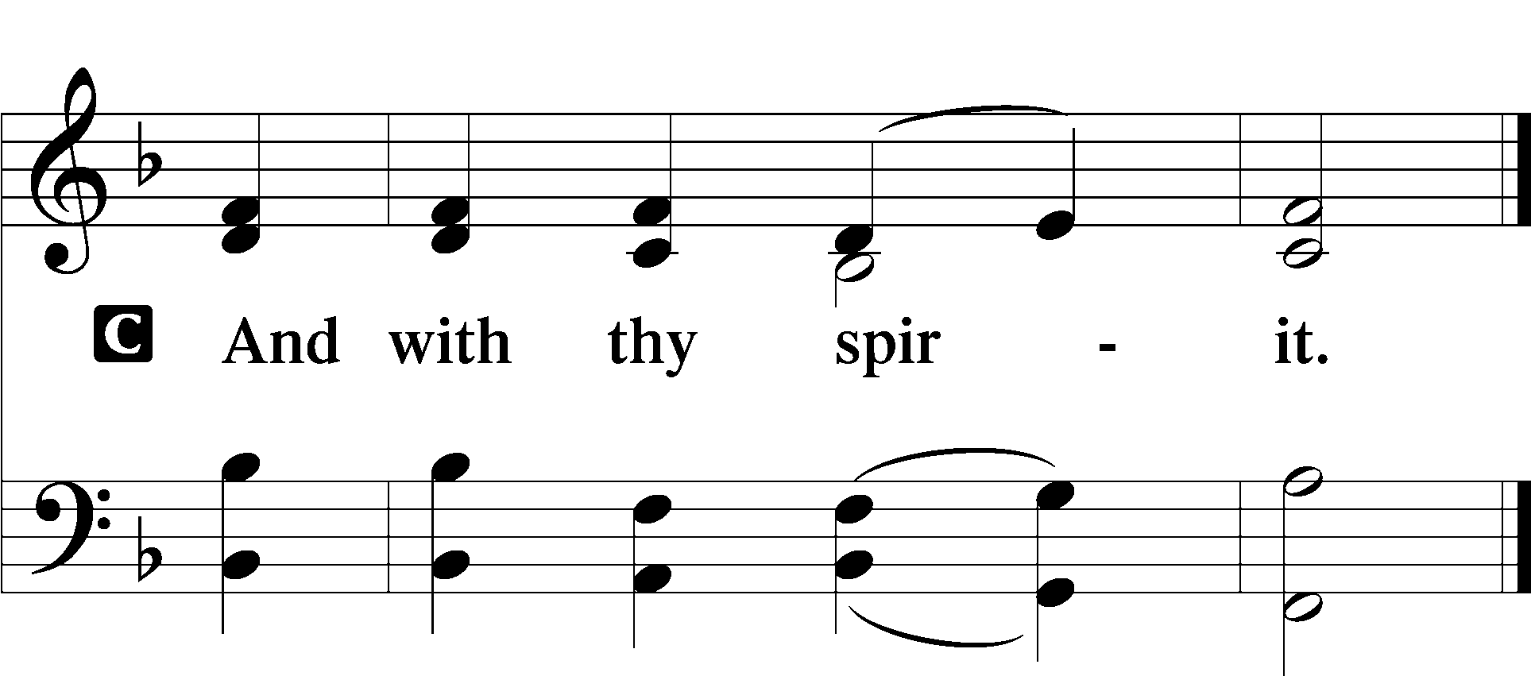
P Let us pray.
Almighty God, grant that the birth of Your only-begotten Son in the flesh may set us free from the bondage of sin; through Jesus Christ, Your Son, our Lord, who lives and reigns with You and the Holy Spirit, one God, now and forever.

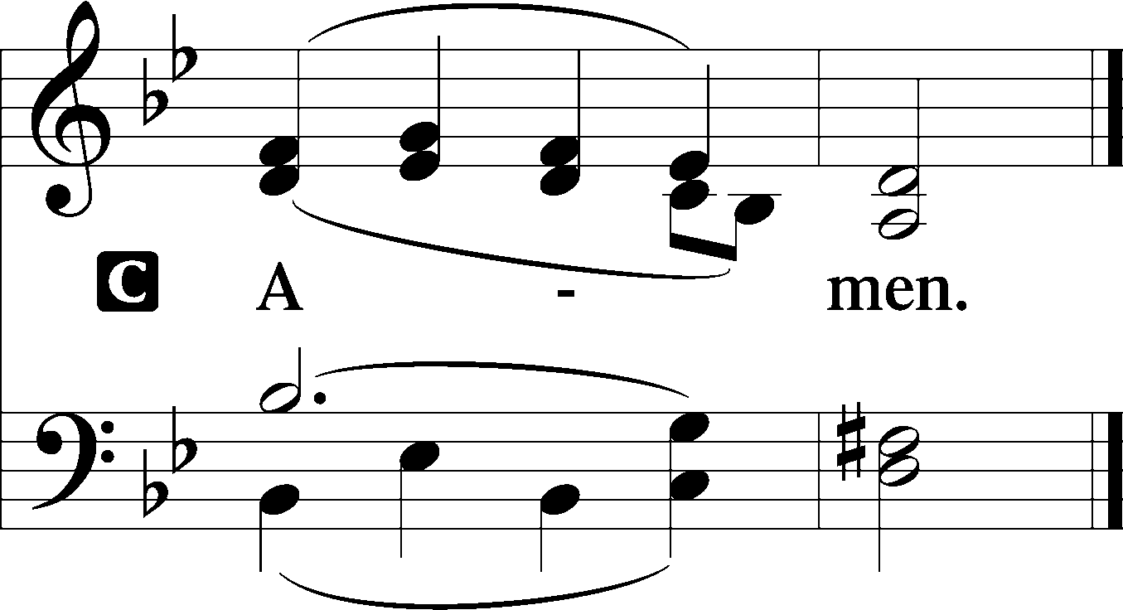

Sit

Old Testament Reading ~ Exodus 40:17–21, 34–38
¹⁷In the first month in the second year, on the first day of the month, the tabernacle was erected. ¹⁸Moses erected the tabernacle. He laid its bases, and set up its frames, and put in its poles, and raised up its pillars. ¹⁹And he spread the tent over the tabernacle and put the covering of the tent over it, as the Lord had commanded Moses. ²⁰He took the testimony and put it into the ark, and put the poles on the ark and set the mercy seat above on the ark. ²¹And he brought the ark into the tabernacle and set up the veil of the screen, and screened the ark of the testimony, as the Lord had commanded Moses…
³⁴Then the cloud covered the tent of meeting, and the glory of the Lord filled the tabernacle. ³⁵And Moses was not able to enter the tent of meeting because the cloud settled on it, and the glory of the Lord filled the tabernacle. ³⁶Throughout all their journeys, whenever the cloud was taken up from over the tabernacle, the people of Israel would set out. ³⁷But if the cloud was not taken up, then they did not set out till the day that it was taken up. ³⁸For the cloud of the Lord was on the tabernacle by day, and fire was in it by night, in the sight of all the house of Israel throughout all their journeys.

A This is the Word of the Lord.
C Thanks be to God.

Gradual Isaiah 9:6; Psalm 98:1a
To us a child is born, to us a son is | given;*
and the government shall be upon his | shoulder.
And his name shall be called Wonderful Counselor, | Mighty God,*
Everlasting Father, | Prince of Peace.
Sing to the Lord a | new song,*
for he has done | marvelous things!

Epistle ~ Hebrews 1:1–6
¹Long ago, at many times and in many ways, God spoke to our fathers by the prophets, ²but in these last days he has spoken to us by his Son, whom he appointed the heir of all things, through whom also he created the world. ³He is the radiance of the glory of God and the exact imprint of his nature, and he upholds the universe by the word of his power. After making purification for sins, he sat down at the right hand of the Majesty on high, ⁴having become as much superior to angels as the name he has inherited is more excellent than theirs.
⁵For to which of the angels did God ever say,
“You are my Son,
today I have begotten you”?
Or again,
“I will be to him a father,
and he shall be to me a son”?
⁶And again, when he brings the firstborn into the world, he says,
“Let all God’s angels worship him.”

A This is the Word of the Lord.
C Thanks be to God.

Stand

Alleluia Verse with Gospel Processional (Please stand)
The congregation will echo the Alleluias after Pastor

Alle-luia. Alle-luia. Alle-luia.

The Word became flesh and dwelt among us,
and we beheld His | glory,*
the glory as of the only begotten of the Father,
full of grace and | truth.

Alle-luia. Alle-luia. Alle-luia.

Holy Gospel John 1:1–18
P The Holy Gospel according to St. John, the first chapter.

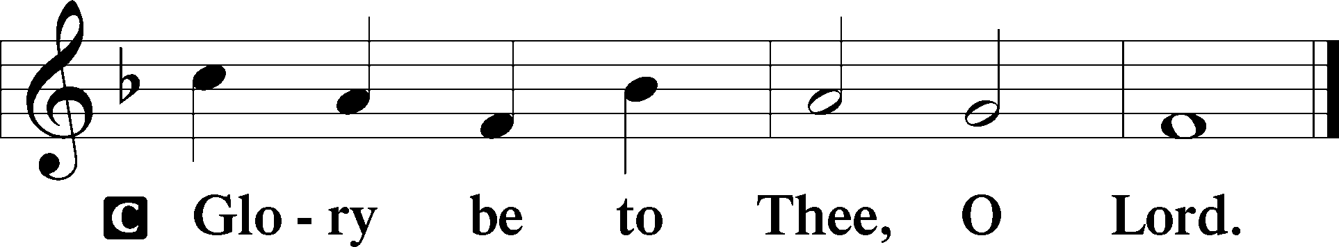

The Word Became Flesh
¹In the beginning was the Word, and the Word was with God, and the Word was God. ²He was in the beginning with God. ³All things were made through him, and without him was not any thing made that was made. ⁴In him was life, and the life was the light of men. ⁵The light shines in the darkness, and the darkness has not overcome it.
⁶There was a man sent from God, whose name was John. ⁷He came as a witness, to bear witness about the light, that all might believe through him. ⁸He was not the light, but came to bear witness about the light.
⁹The true light, which enlightens everyone, was coming into the world. ¹⁰He was in the world, and the world was made through him, yet the world did not know him. ¹¹He came to his own, and his own people did not receive him. ¹²But to all who did receive him, who believed in his name, he gave the right to become children of God, ¹³who were born, not of blood nor of the will of the flesh nor of the will of man, but of God.
¹⁴And the Word became flesh and dwelt among us, and we have seen his glory, glory as of the only Son from the Father, full of grace and truth. ¹⁵(John bore witness about him, and cried out, “This was he of whom I said, ‘He who comes after me ranks before me, because he was before me.’”) ¹⁶And from his fullness we have all received, grace upon grace. ¹⁷For the law was given through Moses; grace and truth came through Jesus Christ. ¹⁸No one has ever seen God; the only God, who is at the Father’s side, he has made him known.

P This is the Gospel of the Lord.

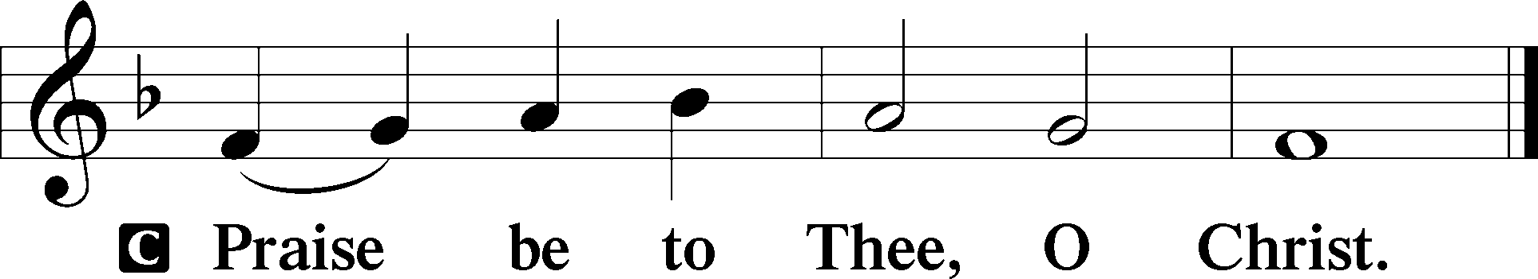

Nicene Creed
C I believe in one God,
the Father Almighty,
maker of heaven and earth
and of all things visible and invisible.

And in one Lord Jesus Christ,
the only-begotten Son of God,
begotten of His Father before all worlds,
God of God, Light of Light,
very God of very God,
begotten, not made,
being of one substance with the Father,
by whom all things were made;
who for us men and for our salvation came down from heaven
and was incarnate by the Holy Spirit of the virgin Mary
and was made man;
and was crucified also for us under Pontius Pilate.
He suffered and was buried.
And the third day He rose again according to the Scriptures
and ascended into heaven
and sits at the right hand of the Father.
And He will come again with glory to judge both the living and the dead,
whose kingdom will have no end.

And I believe in the Holy Spirit,
the Lord and giver of life,
who proceeds from the Father and the Son,
who with the Father and the Son together is worshiped and glorified,
who spoke by the prophets.
And I believe in one holy Christian and apostolic Church,
I acknowledge one Baptism for the remission of sins,
and I look for the resurrection of the dead
and the life + of the world to come. Amen.

Sit

382 We Praise You, Jesus, at Your Birth
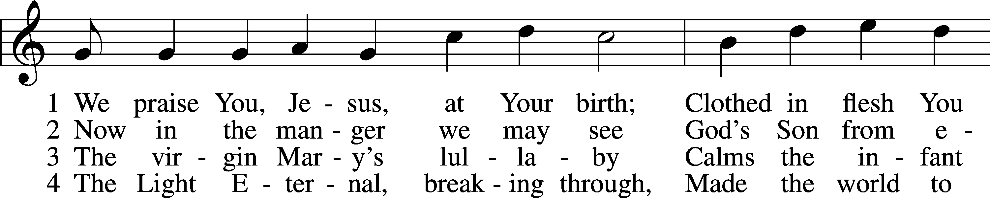
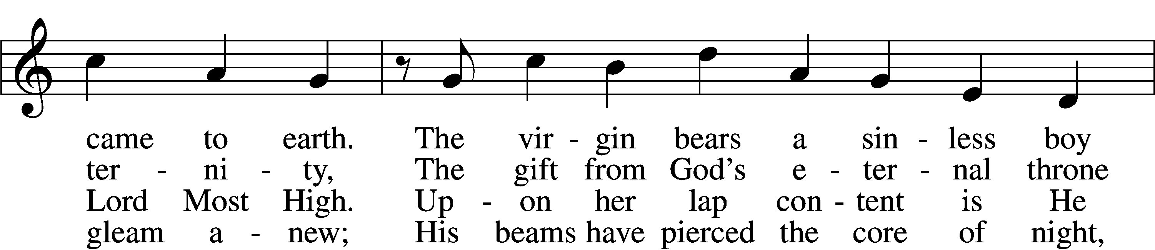
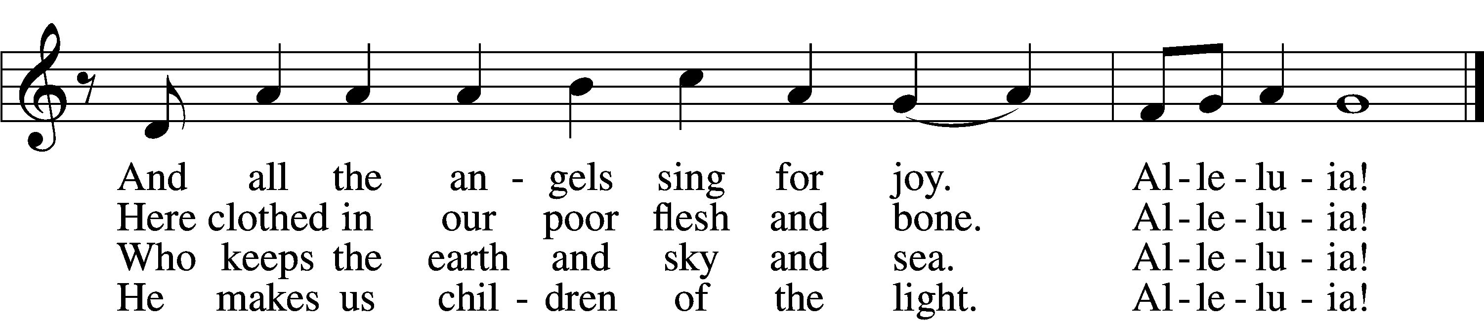

5 The very Son of God sublime
Entered into earthly time
To lead us from this world of cares
To heaven’s courts as blessèd heirs.
Alleluia!

6 In poverty He came to earth
Showing mercy by His birth;
He makes us rich in heav’nly ways
As we, like angels, sing His praise.
Alleluia!

7 All this for us our God has done
Granting love through His own Son.
Therefore, all Christendom, rejoice
And sing His praise with endless voice.
Alleluia!
Tune: Public domain
Text (sts. 1, 3, 5–7): © 2006 Concordia Publishing House; (sts. 2, 4): © 1978 Concordia Publishing House. Used by permission: LSB Hymn License no. 110003744

Sermon

Stand

Offertory LSB 192
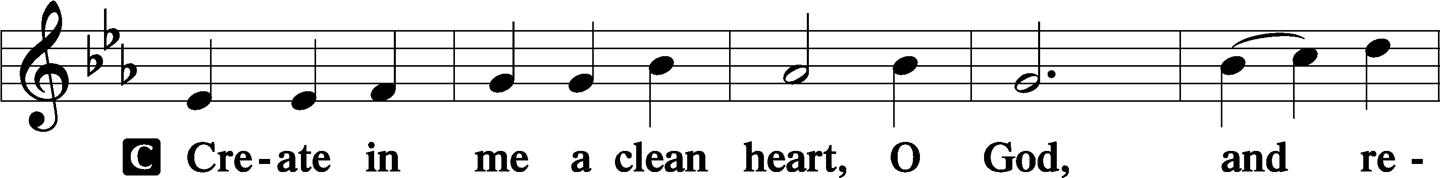
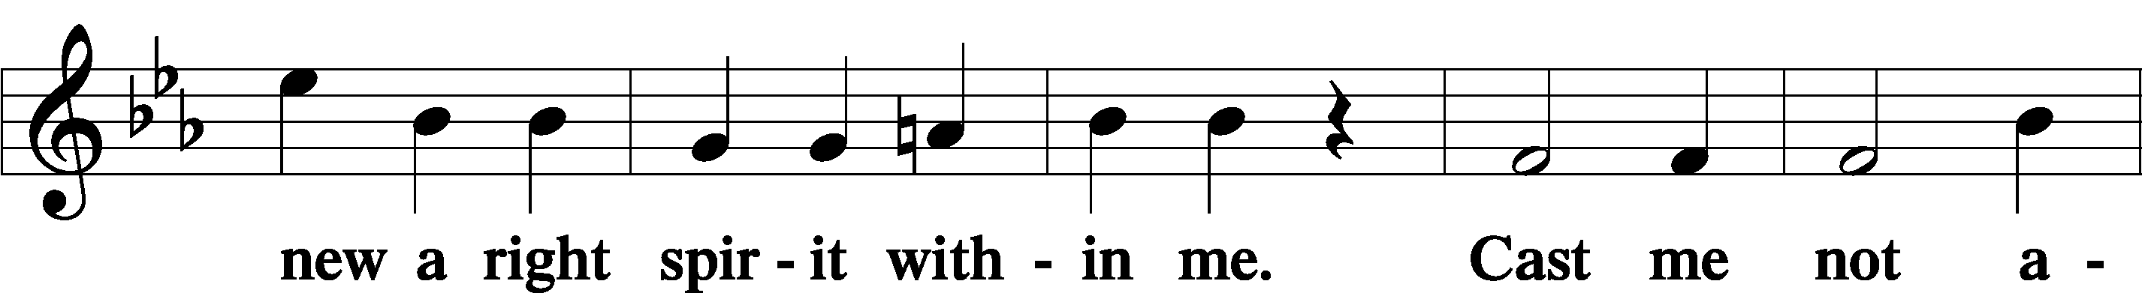
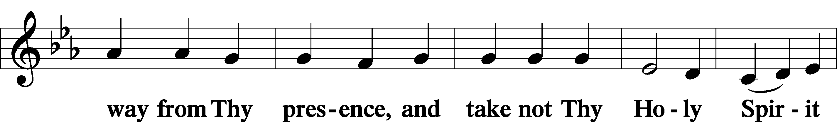
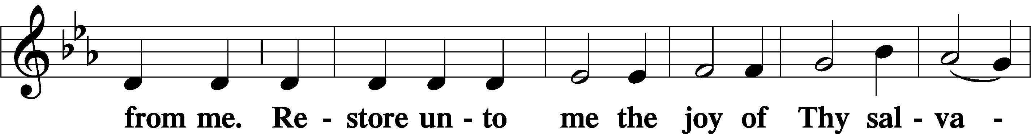
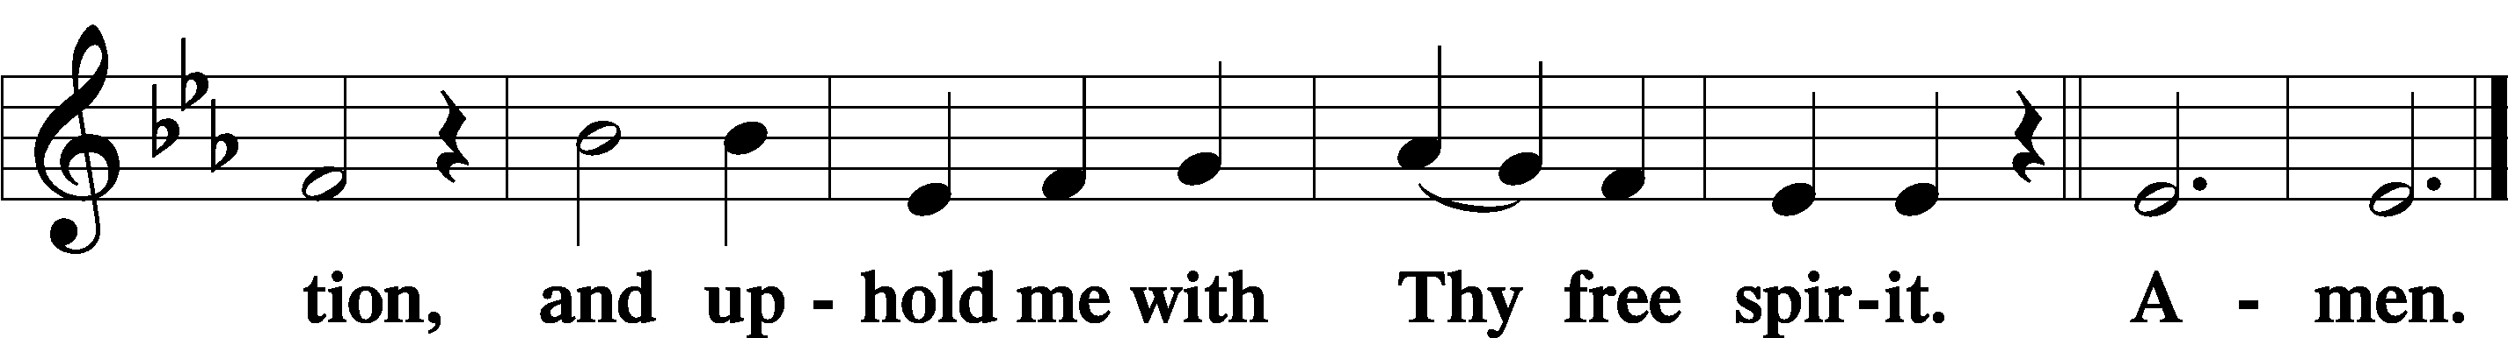

Prayer of the Church

Piano Solo: "O Little Town of Bethlehem" Miriam Gaunt

Service of the Sacrament

Preface LSB 194
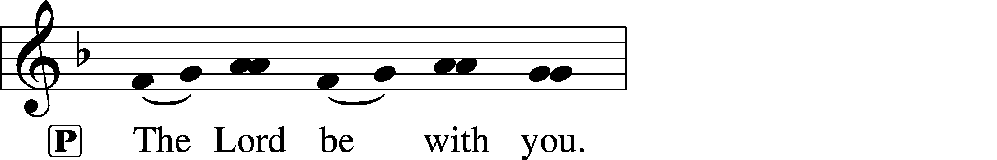
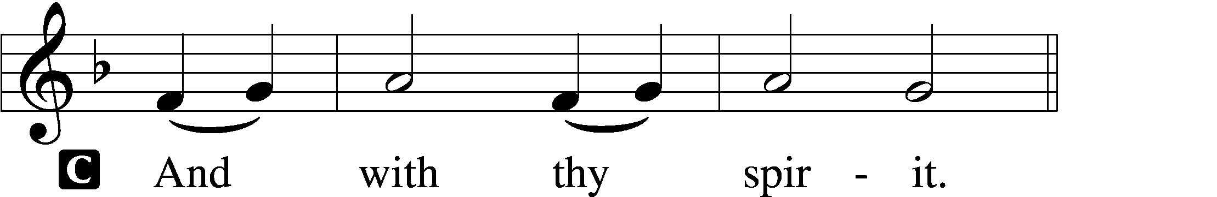

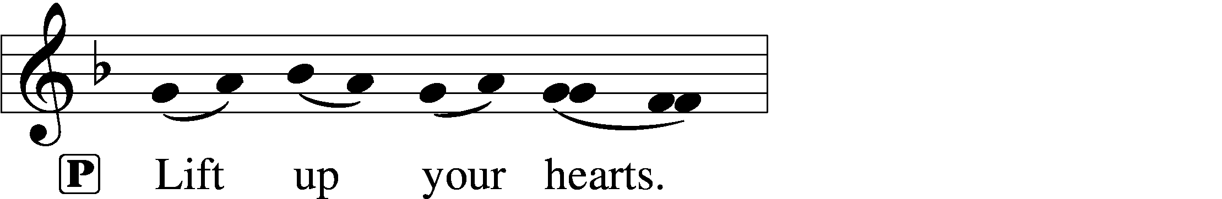
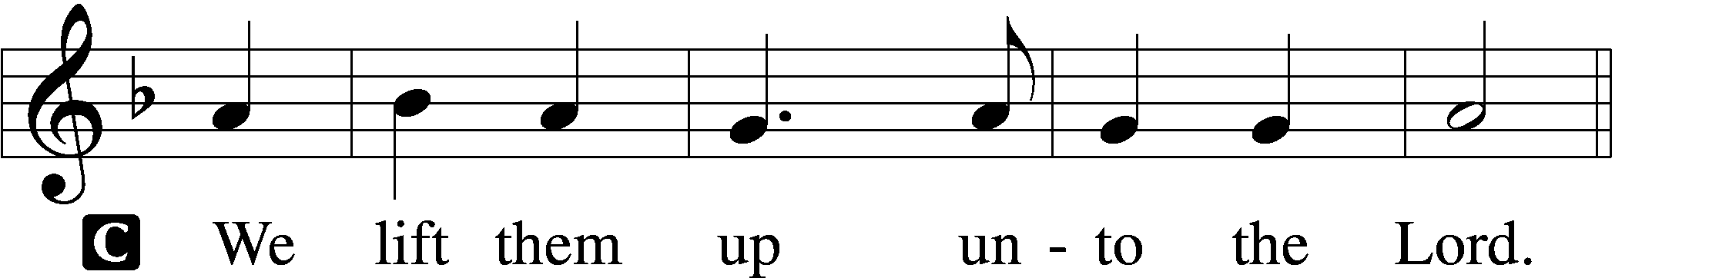

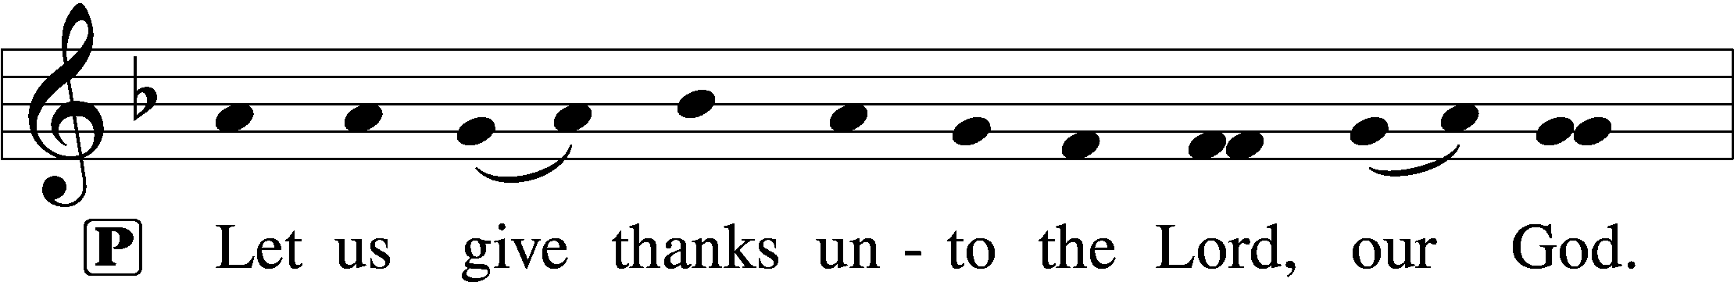
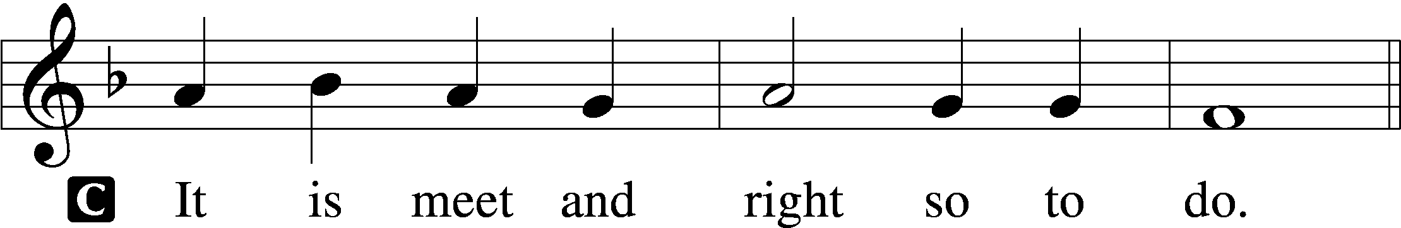

Proper Preface (Full)
P It is truly meet, right, and salutary that we should at all times and in all places give thanks to You, holy Lord, almighty Father, everlasting God, through Jesus Christ, our Lord; for in the mystery of the Word made flesh You have given us a new revelation of Your glory that, seeing You in the person of Your Son, we may know and love those things which are not seen. Therefore with angels and archangels and with all the company of heaven we laud and magnify Your glorious name, evermore praising You and saying:
Sanctus LSB 195
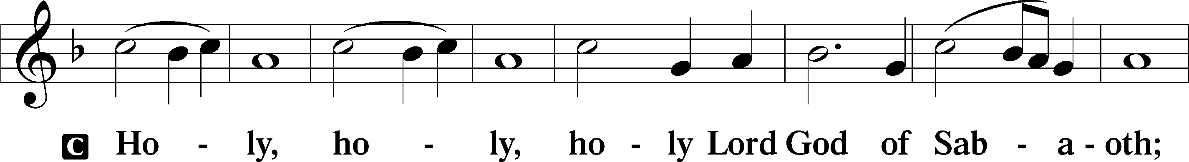
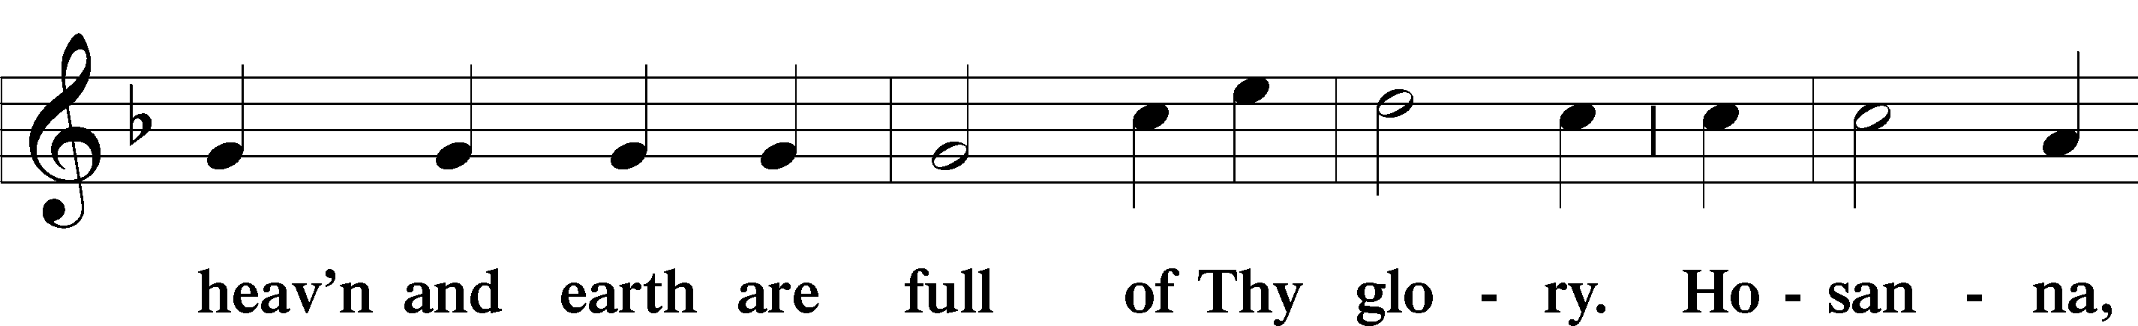
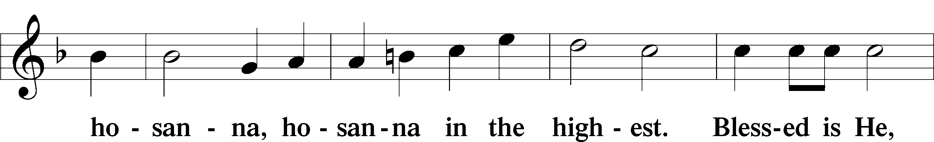
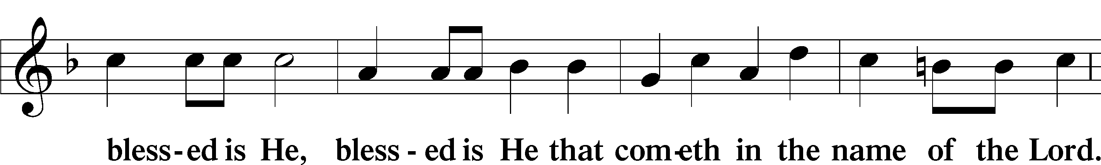
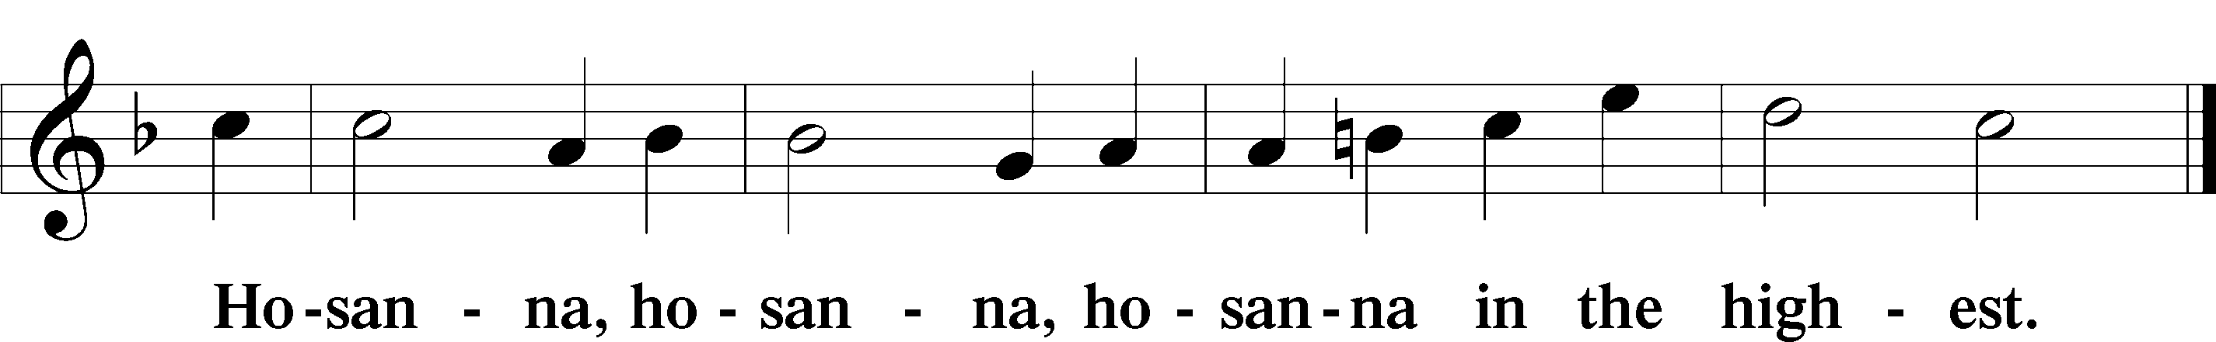
Lord’s Prayer LSB 196
Our Father who art in heaven
hallowed be Thy name,
Thy kingdom come,
Thy will be done on earth as it is in heaven;
give us this day our daily bread;
and forgive us our trespasses as we forgive those who trespass against us;
and lead us not into temptation,
but deliver us from evil.
For Thine is the kingdom and the power and the glory forever and ever. Amen.

The Words of Our Lord LSB 197
P Our Lord Jesus Christ, on the night when He was betrayed, took bread, and when He had given thanks, He broke it and gave it to the disciples and said: “Take, eat; this is My+ body, which is given for you. This do in remembrance of Me.”

In the same way also He took the cup after supper, and when He had given thanks, He gave it to them, saying: “Drink of it, all of you; this cup is the new testament in My + blood, which is shed for you for the forgiveness of sins. This do, as often as you drink it, in remembrance of Me.”

Pax Domini LSB 197
P The peace of the Lord be with you always.
C Amen.

Agnus Dei LSB 198
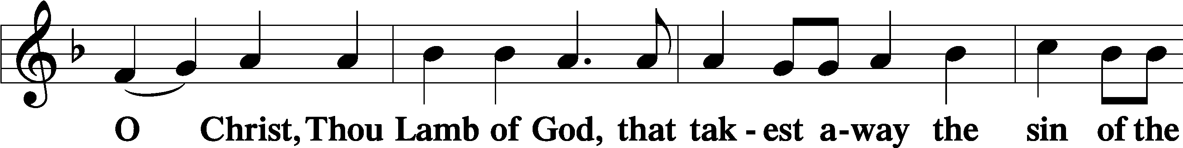
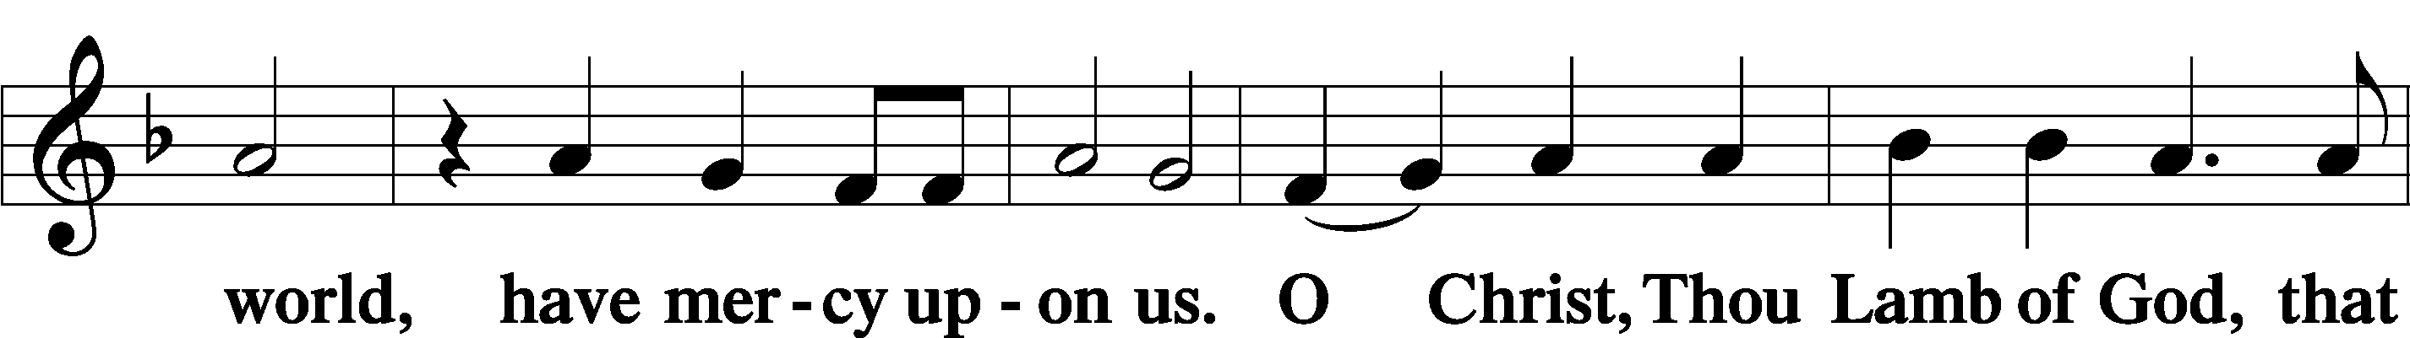
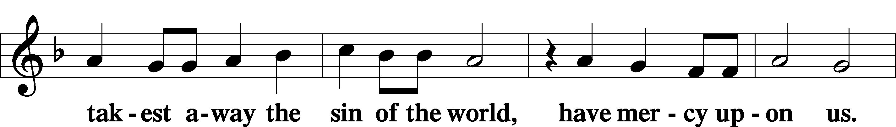
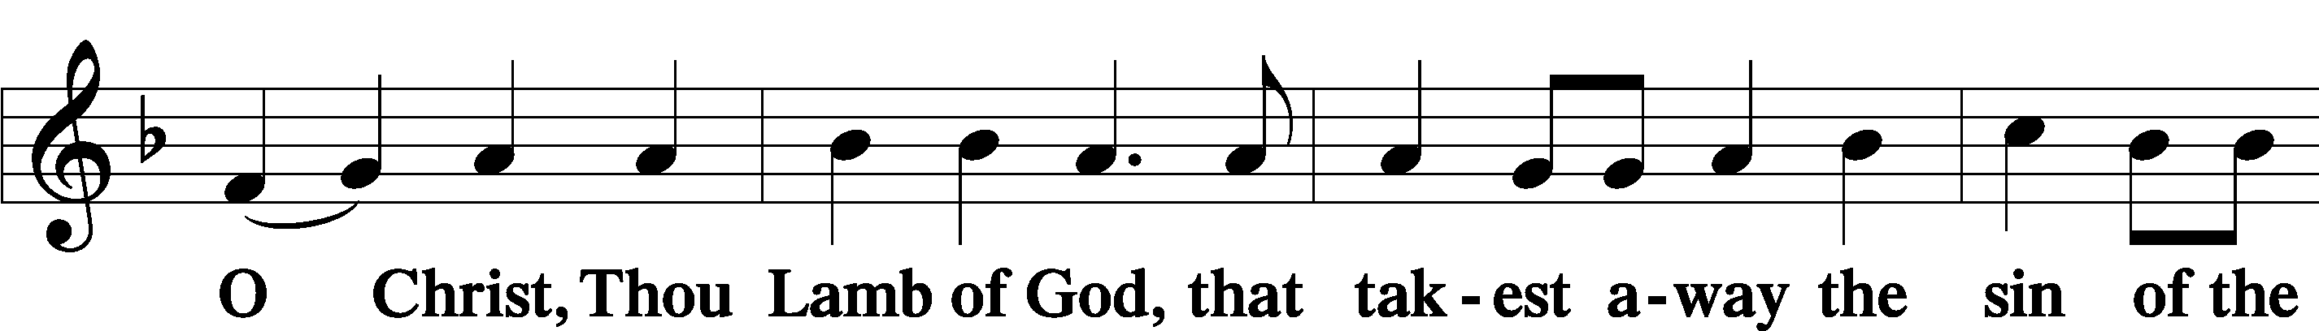
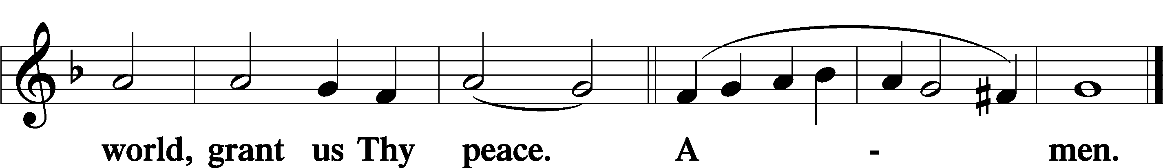

Sit

THE DISTRIBUTION

Violin Solo: "Silent Night," Jamie Wilkens
"O Come, All Ye Faithful,"
"Joy to the World,"
"God Rest Ye Merry Gentlemen"

380 Hark! The Herald Angels Sing
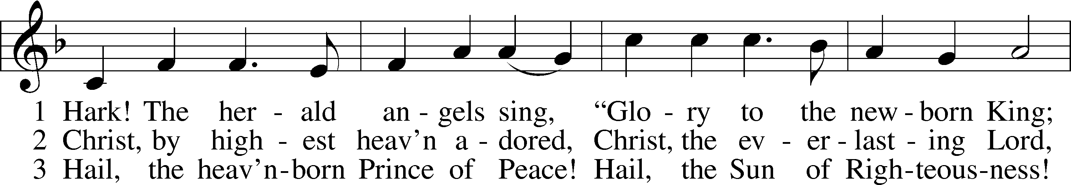
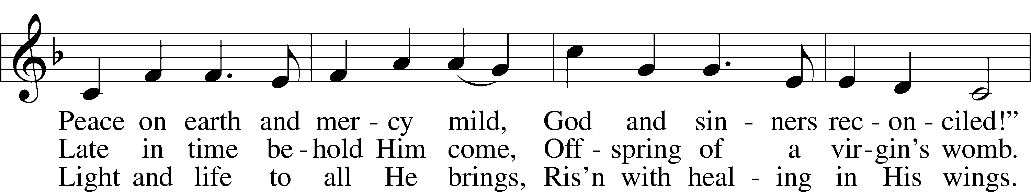
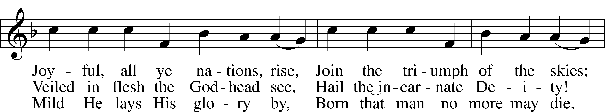
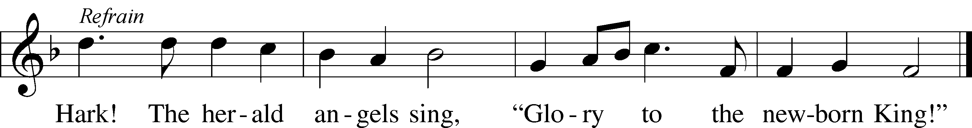
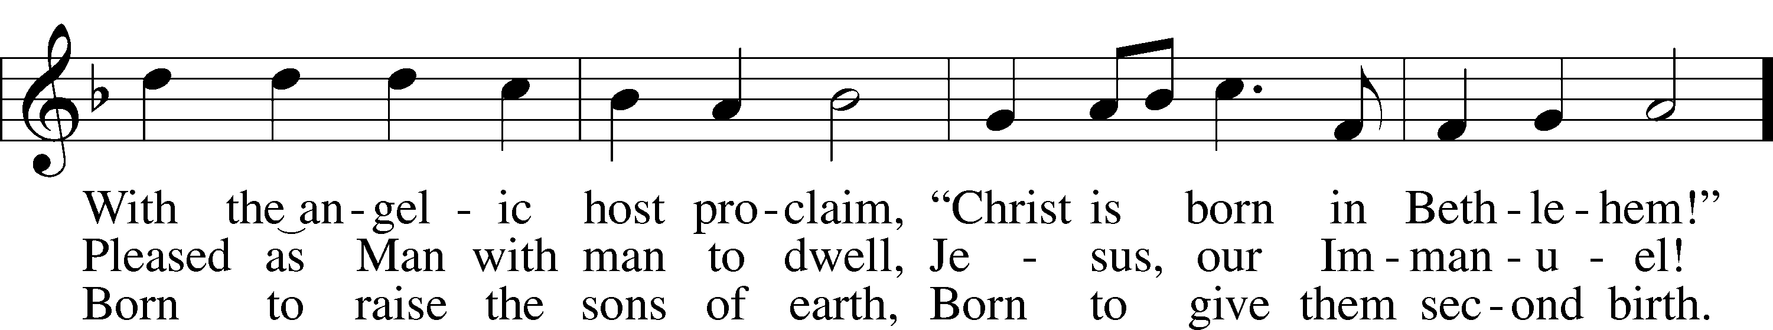

Tune and text: Public domain

386 Now Sing We, Now Rejoice
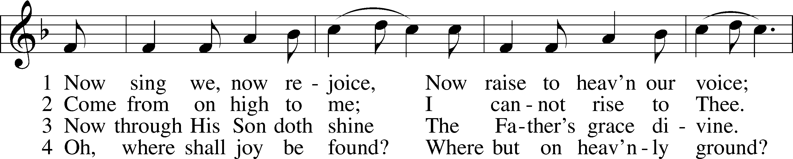
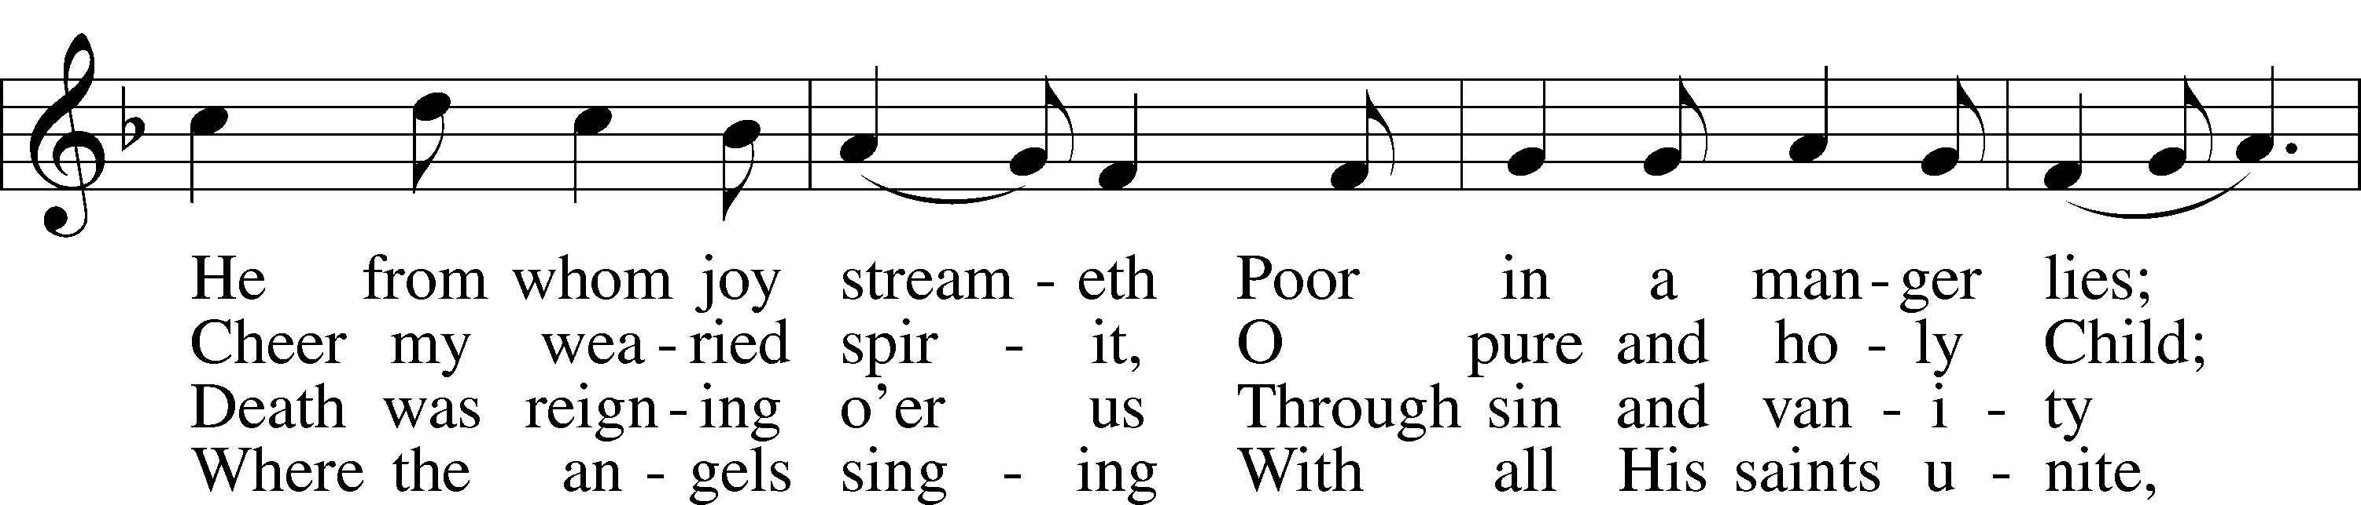
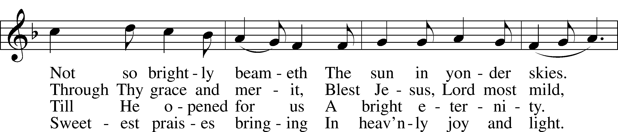
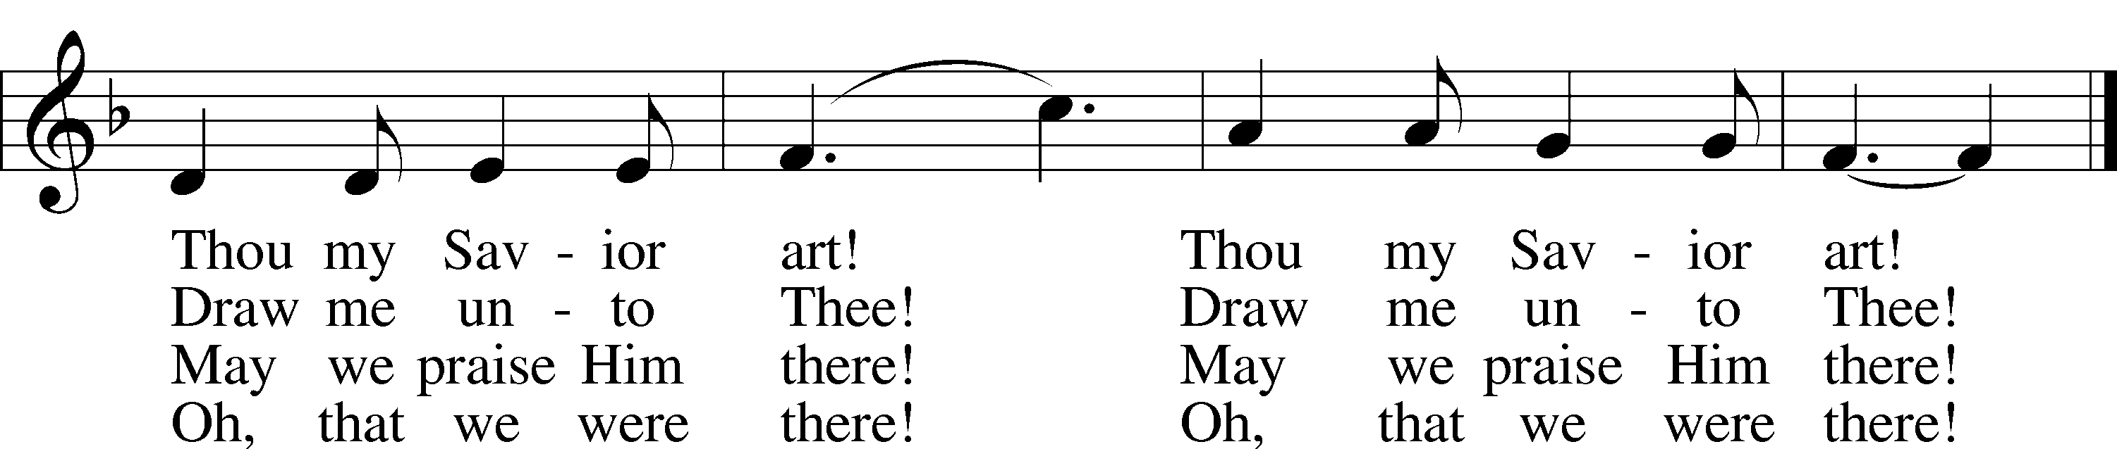
Text and tune: Public domain

388 Go Tell It on the Mountain
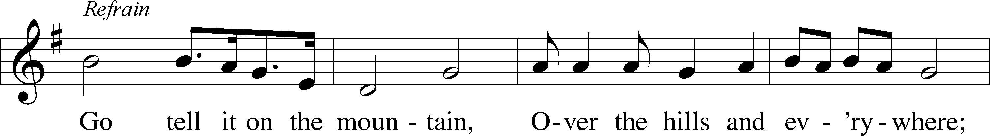
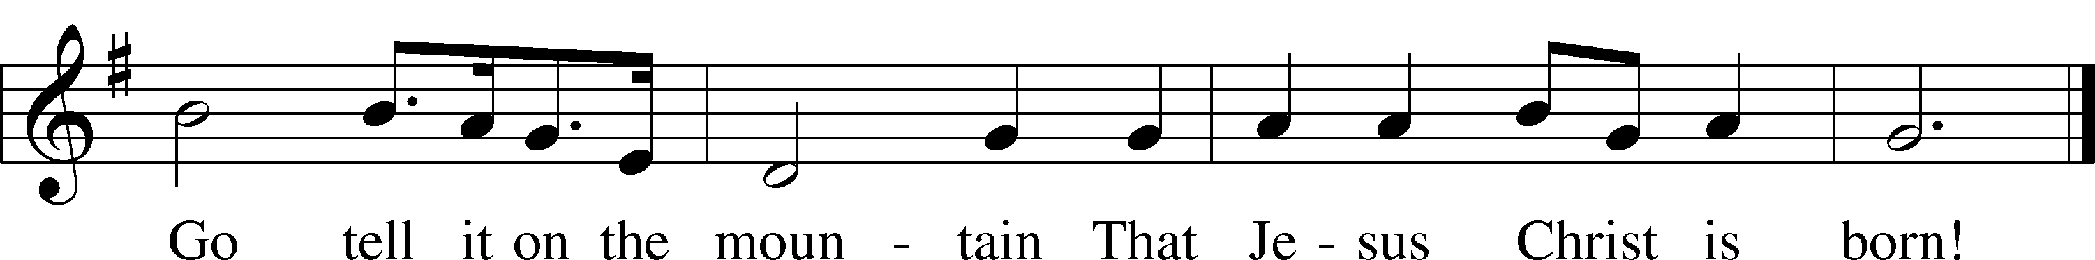
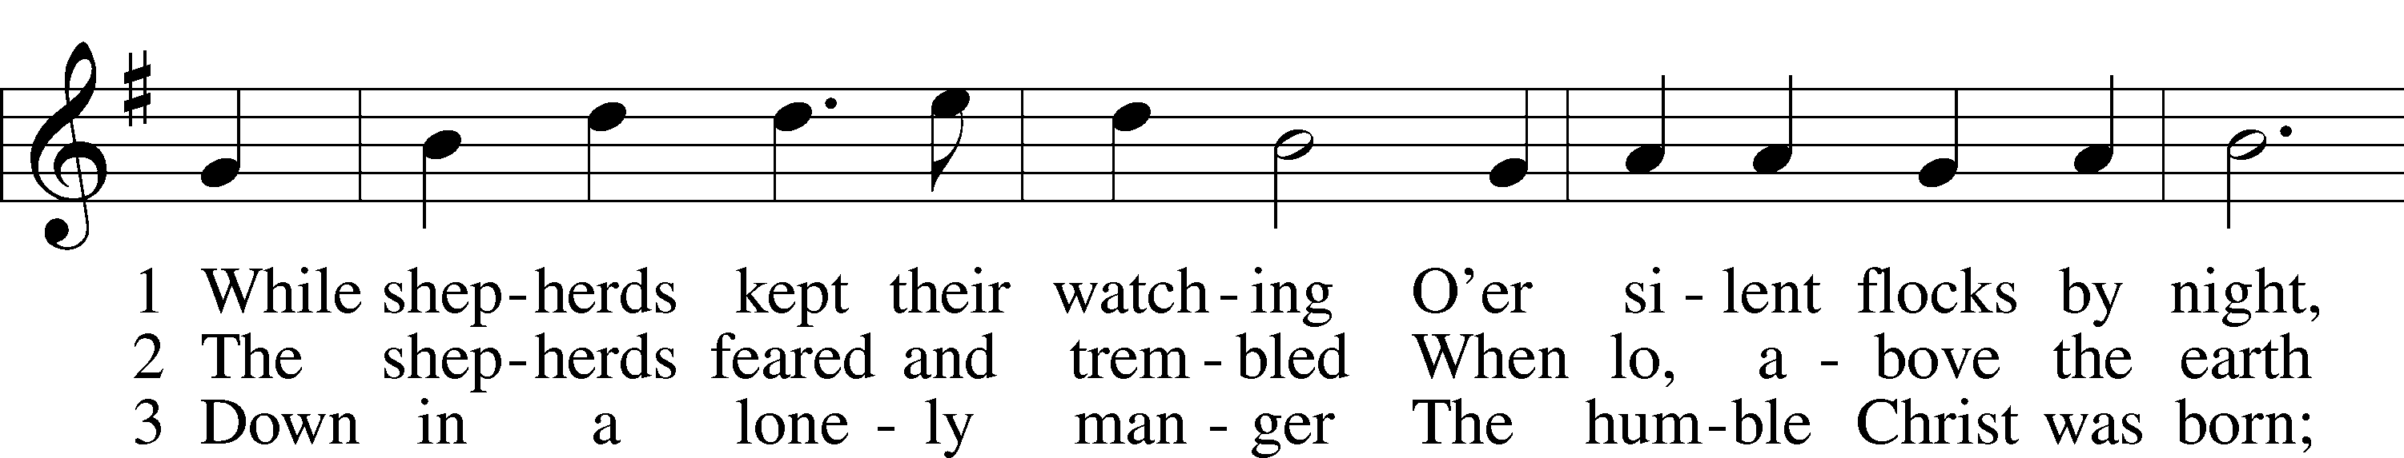
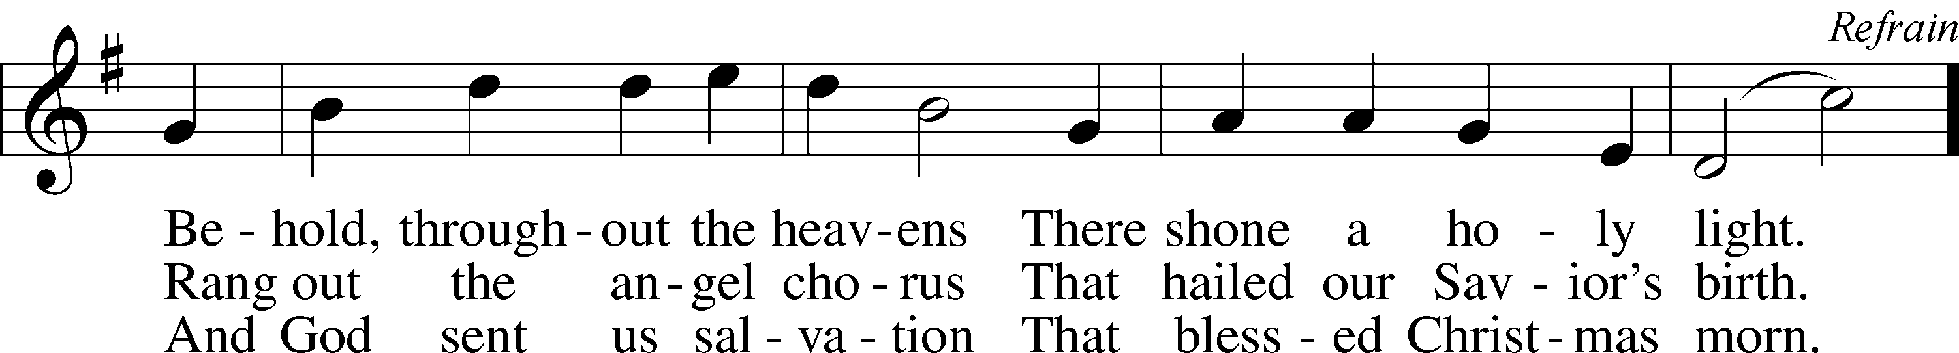
Tune and text: Public domain

Stand

In dismissing the communicants, the following is said:

The Dismissal LSB 199
P The body and blood of our Lord Jesus Christ strengthen and preserve you in body and soul to life everlasting. Depart T in peace.
C Amen.

Nunc Dimittis LSB 199
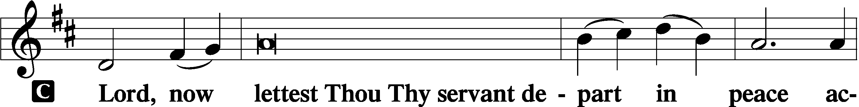

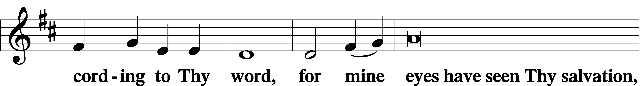

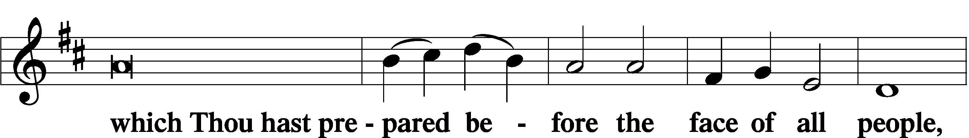

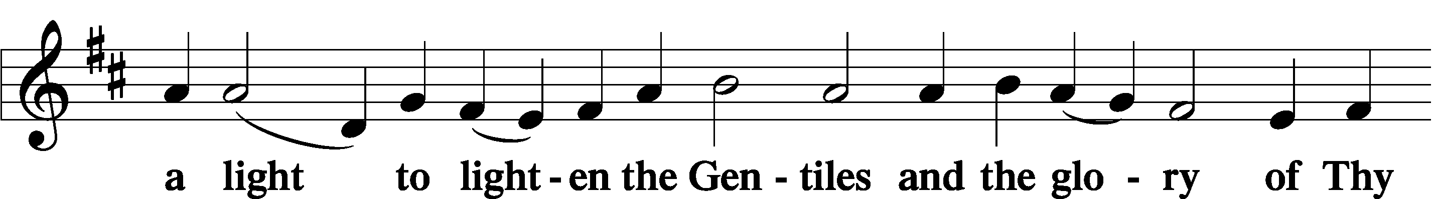

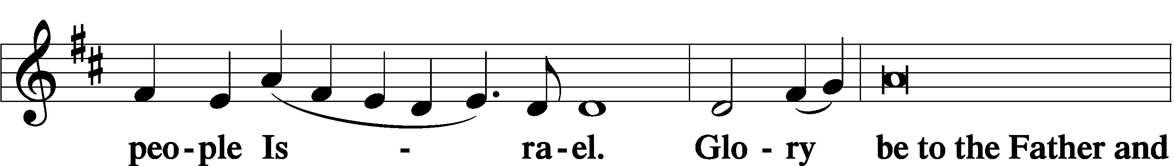

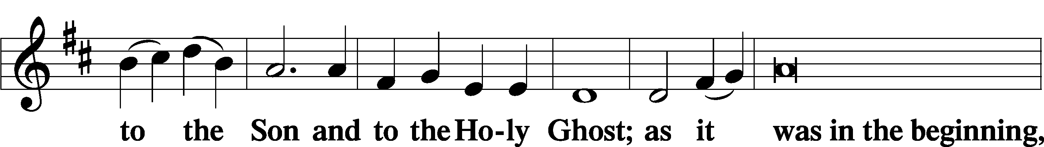

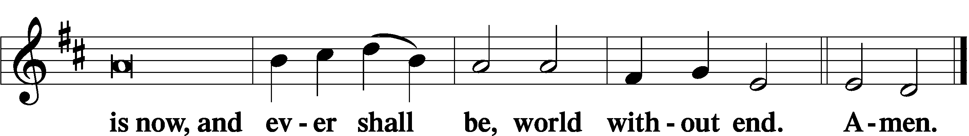

Thanksgiving LSB 200
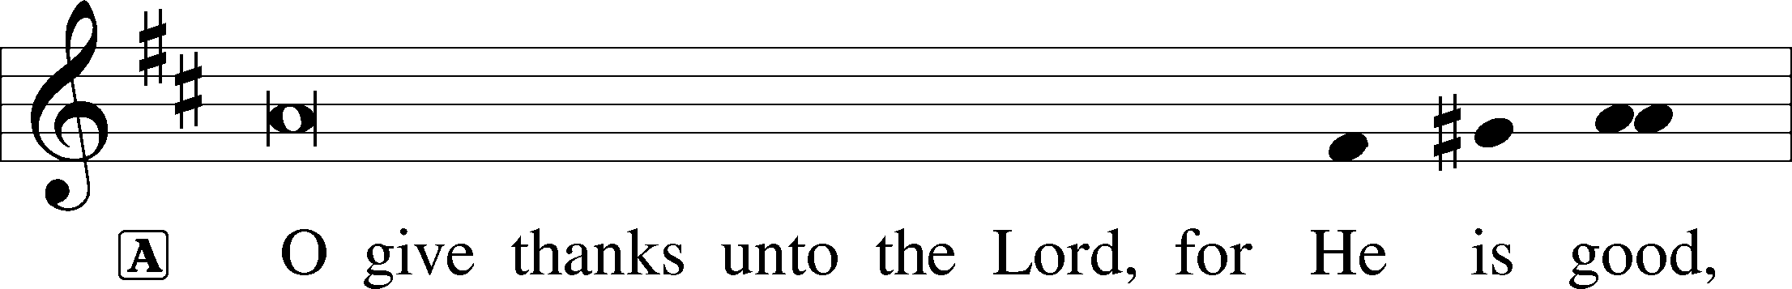

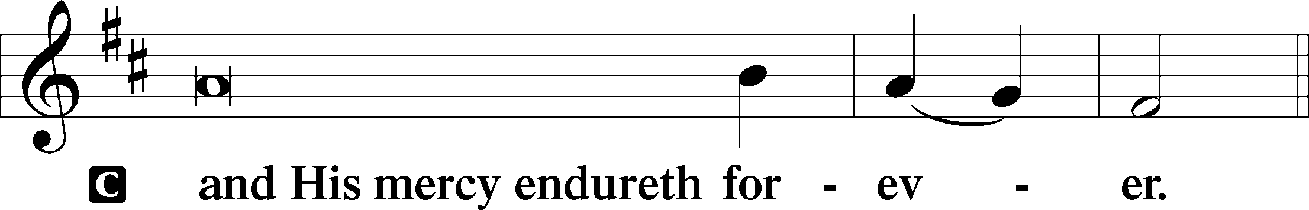

Post-Communion Collect
A Let us pray.
We give thanks to You, almighty God, that You have refreshed us through this salutary gift, and we implore You that of Your mercy You would strengthen us through the same in faith toward You and in fervent love toward one another; through Jesus Christ, Your Son, our Lord, who lives and reigns with You and the Holy Spirit, one God, now and forever.
C Amen.

Salutation LSB 201
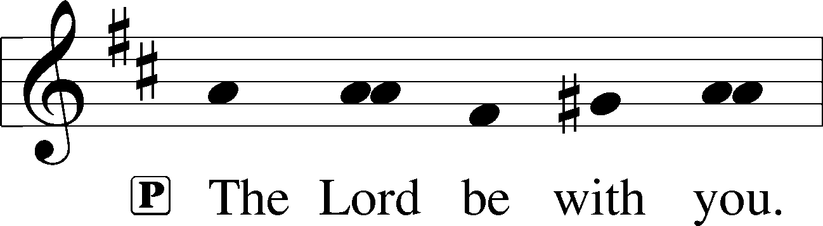

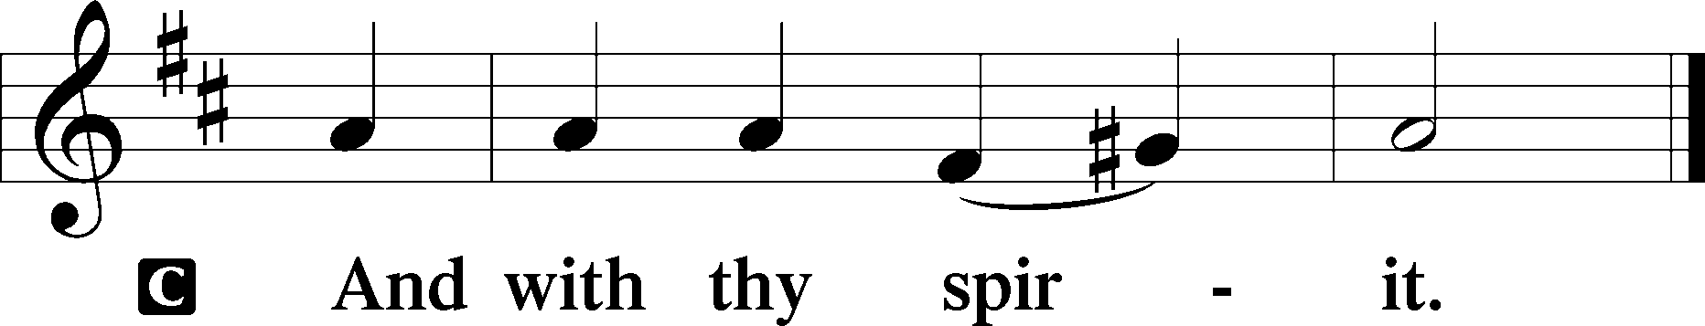

Benedicamus LSB 202
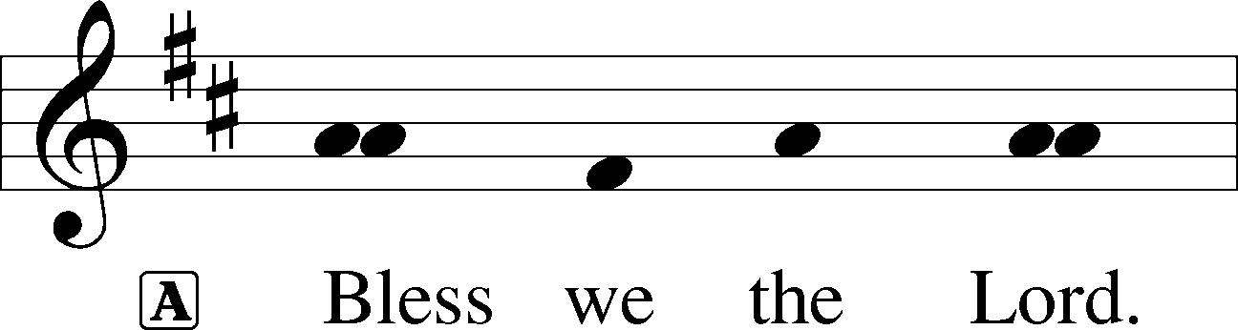

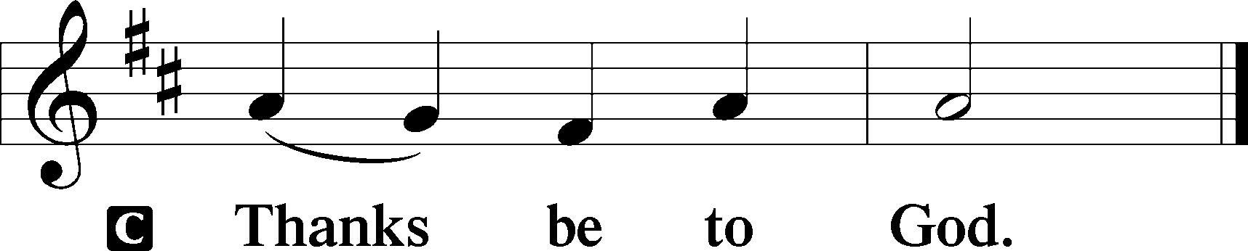

Benediction LSB 202
P The Lord bless you and keep you.
The Lord make His face shine upon you and be gracious unto you.
The Lord lift up His countenance upon you and + give you peace.
C Amen, amen, amen.

387 Joy to the World
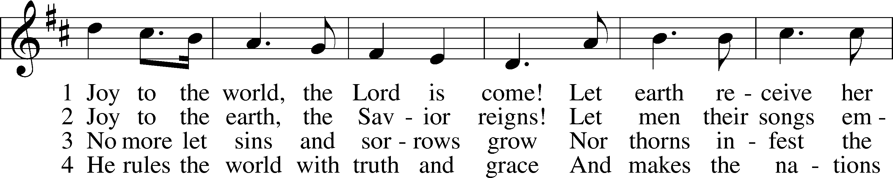
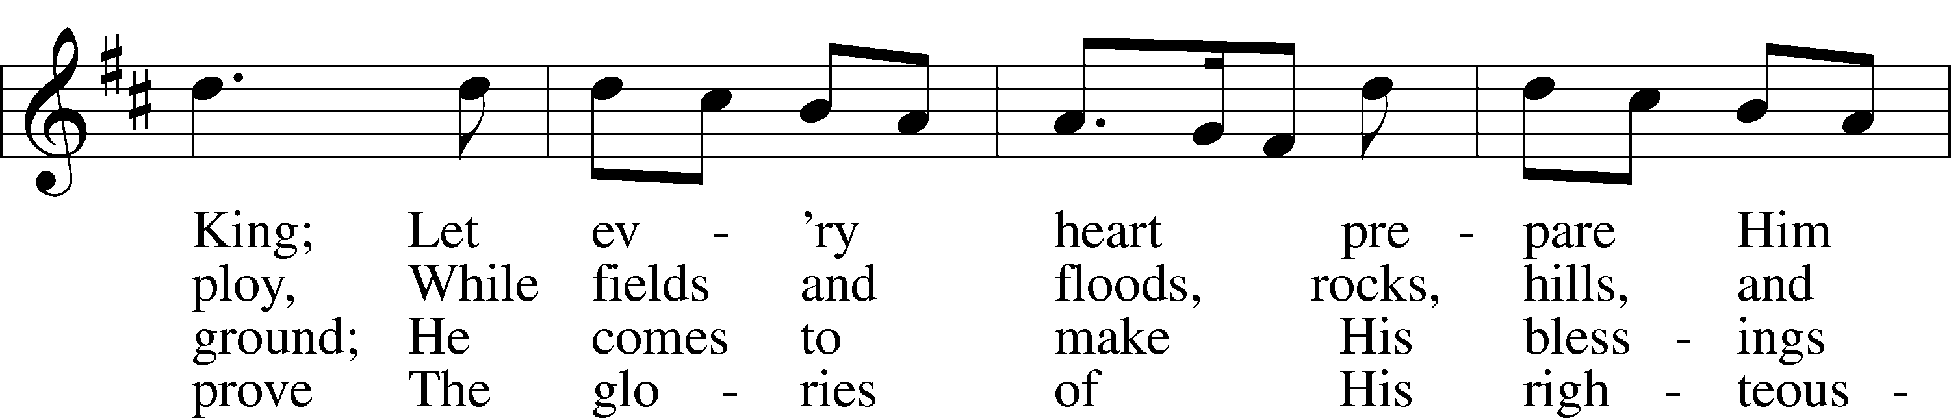
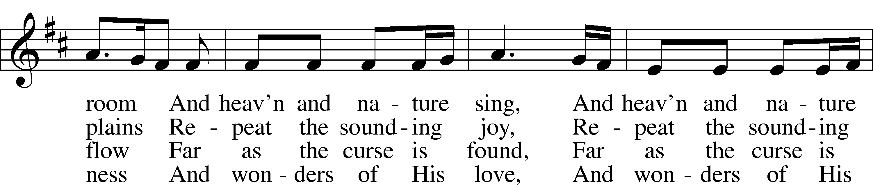
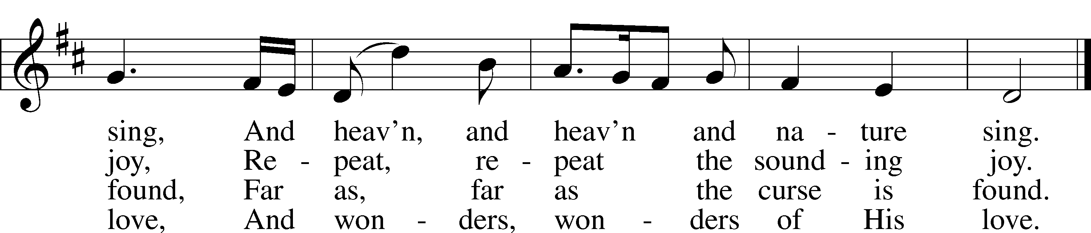
Text and tune: Public domain

Acknowledgments
Unless otherwise indicated, Scripture quotations are from the ESV® Bible (The Holy Bible, English Standard Version®), copyright © 2001 by Crossway, a publishing ministry of Good News Publishers. Used by permission. All rights reserved.
Created by Lutheran Service Builder © 2020 Concordia Publishing House.

