Divine Service
First Sunday After Christmas
December 27, 2020
Zion Lutheran Church
Kearney, Nebraska

Welcome to Zion!
All worshippers please fill out an attendance card in the pew rack and let us know how we might be of service to you.

Holy Communion at Zion

The Lord’s Supper is celebrated at this congregation as Jesus has given it. As he says, our Lord gives into our mouths not only bread and wine but his very body and blood to eat and to drink for the forgiveness of sins and to strengthen our union with him and with one another. Our Lord invites to his table those who trust his words, repent of all sin, and set aside any refusal to forgive and love as he forgives and loves us, that they may show forth his death until he comes. All communicants need to register in the narthex prior to the service.

Because those who eat and drink our Lord’s body and blood unworthily do great harm and because Holy Communion is a confession of the faith which is confessed at this altar, any who are not yet instructed, in doubt, or who hold a confession differing from that of this congregation and The Lutheran Church—Missouri Synod, are asked not to commune until they are able to speak with our pastor first. He is happy to visit with you about the Christian faith and how to receive the Lord’s Supper for your good and for the good of others. Those not communing are invited to come to the altar, cross your arms in front of you, and bow your head to receive a pastoral blessing.

The Time Has Fully Come for Redemption and Purification through Jesus Christ, Our Lord

“When the fullness of time had come, God sent forth his Son,” born of the woman, “to redeem those who were under the law” (Gal. 4:4–5). Therefore, “according to the Law of Moses,” Mary and Joseph “brought him up to Jerusalem to present him to the Lord” (Luke 2:22). There He was received and taken up into the arms of Simeon, who was righteous and devout, “waiting for the consolation of Israel” (Luke 2:25). Simeon praised God and blessed the parents by confessing the cross for which this child was appointed. “At that very hour,” old and faithful Anna, who had watched, prayed and worshiped in the temple for so long, came up and “began to give thanks to God and to speak of him to all who were waiting for the redemption of Jerusalem” (Luke 2:38). The Lord causes “righteousness and praise to sprout up before all the nations” (Is. 61:11). We also “greatly rejoice in the Lord,” because this child has clothed us “with the garments of salvation,” covered us “with the robe of righteousness” and called us “by a new name” (Is. 61:10; 62:2).
Tune and text: Public domain

Confession and Absolution

367 Angels from the Realms of Glory
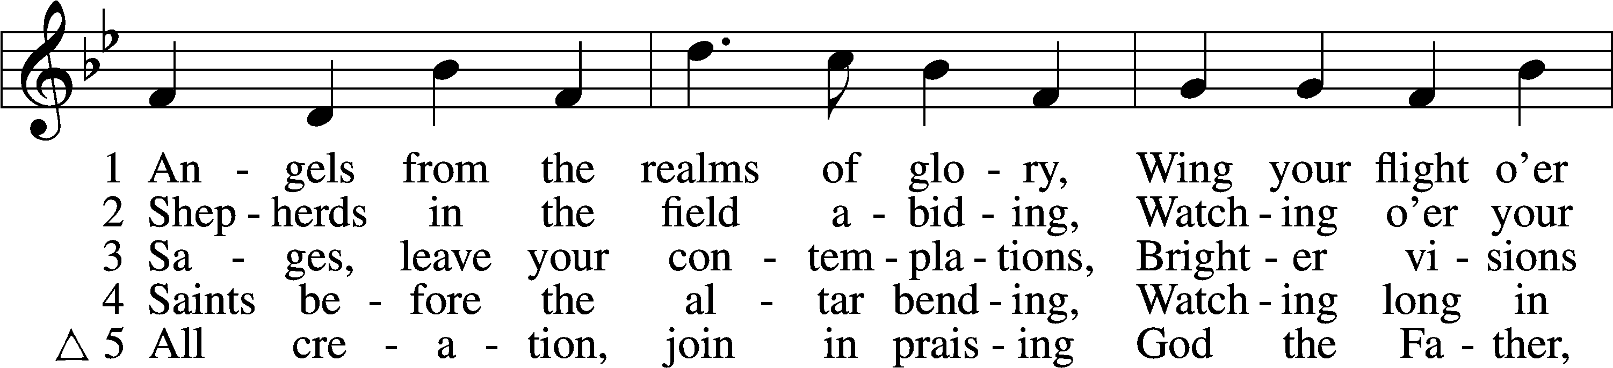
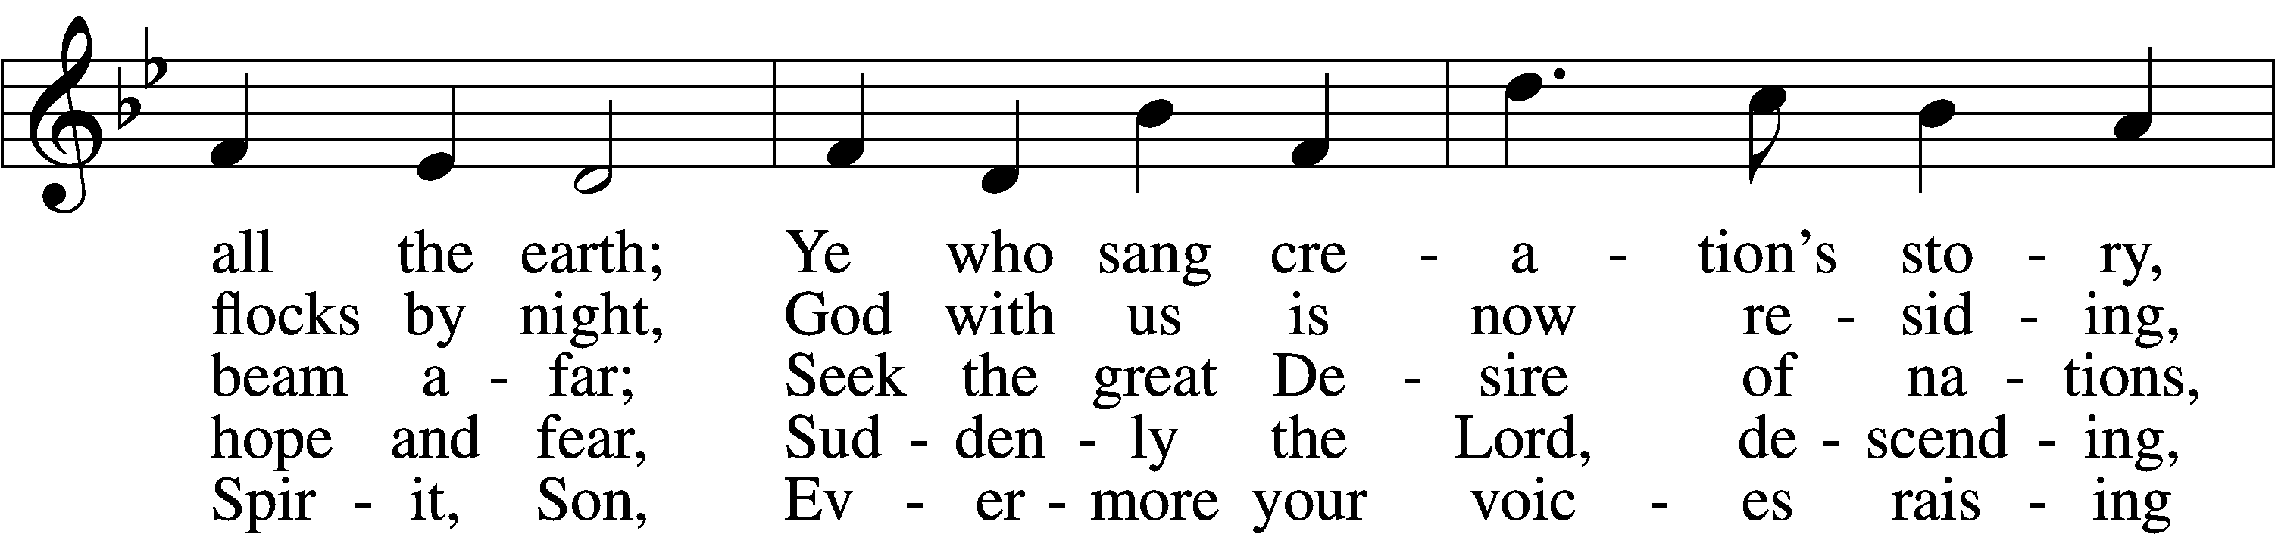
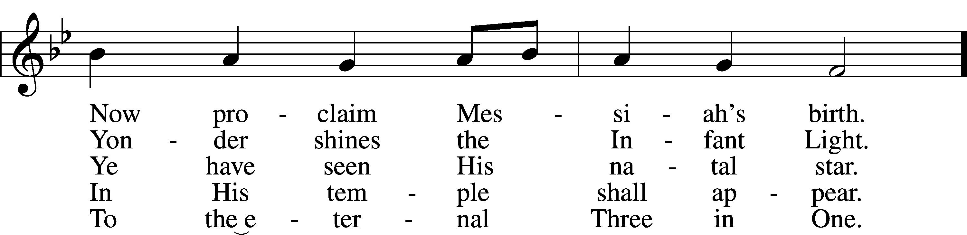
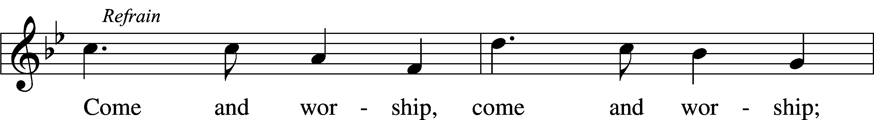
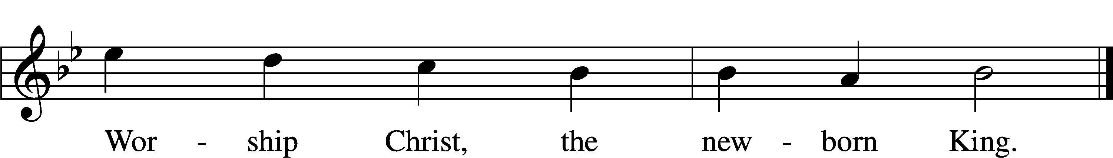
Text and tune: Public domain

Stand

The sign of the cross may be made by all in remembrance of their Baptism.

Invocation
P In the name of the Father and of the T Son and of the Holy Spirit.
C Amen.

Exhortation LSB 184
P Beloved in the Lord! Let us draw near with a true heart and confess our sins unto God our Father, beseeching Him in the name of our Lord Jesus Christ to grant us forgiveness.

P Our help is in the name of the Lord,
C who made heaven and earth.
P I said, I will confess my transgressions unto the Lord,
C and You forgave the iniquity of my sin.

Kneel/Stand

Silence for reflection on God’s Word and for self-examination.

Confession of Sins LSB 184
P O almighty God, merciful Father,
C I, a poor, miserable sinner, confess unto You all my sins and iniquities with which I have ever offended You and justly deserved Your temporal and eternal punishment. But I am heartily sorry for them and sincerely repent of them, and I pray You of Your boundless mercy and for the sake of the holy, innocent, bitter sufferings and death of Your beloved Son, Jesus Christ, to be gracious and merciful to me, a poor, sinful being.

Absolution LSB 185
P Upon this your confession, I, by virtue of my office, as a called and ordained servant of the Word, announce the grace of God unto all of you, and in the stead and by the command of my Lord Jesus Christ I forgive you all your sins in the name of the Father and of the T Son and of the Holy Spirit.
C Amen.

Stand

Service of the Word

Introit
The Lord has bared his holy arm before the eyes of all the | nations,*
and all the ends of the earth shall see the salvation | of our God.
Oh sing to the Lord a new song, for he has done | marvelous things!*
His right hand and his holy arm have worked salva- | tion for him.
The Lord has made known his sal- | vation;*
he has revealed his righteousness in the sight of the | nations.
He has remembered his steadfast love and faithfulness to the house of | Israel.*
All the ends of the earth have seen the salvation | of our God.
Make a joyful noise to the Lord, | all the earth;*
break forth into joyous song and sing | praises!

Gloria Patri LSB 186
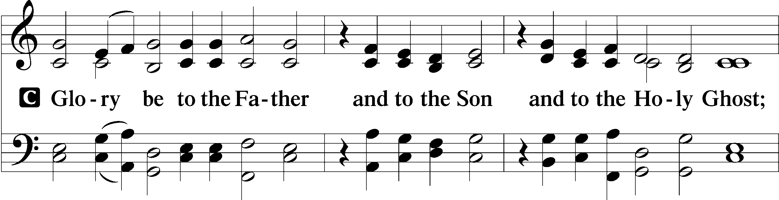
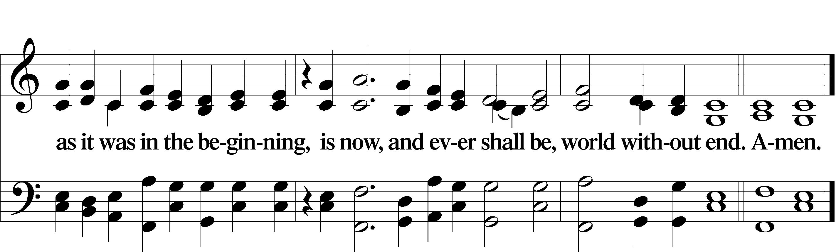

Kyrie LSB 186
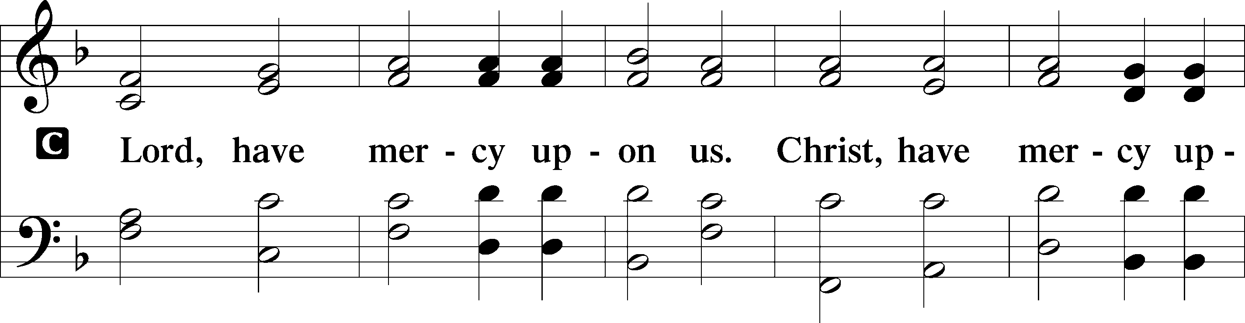
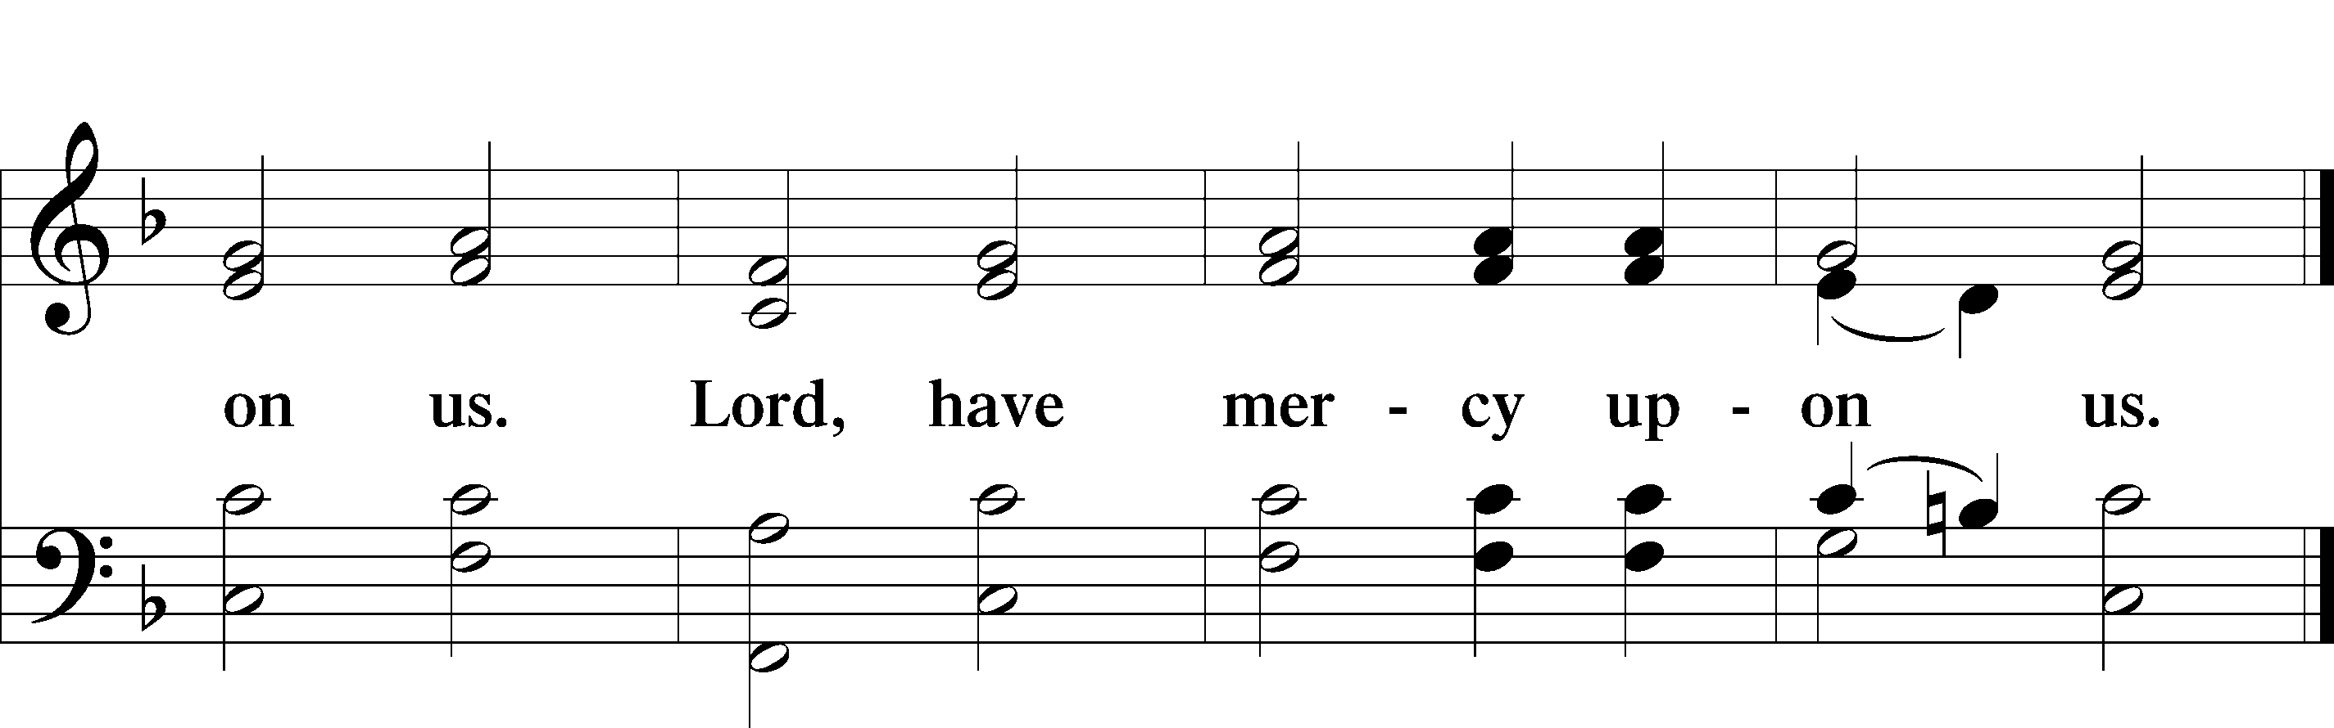

Gloria in Excelsis LSB 187
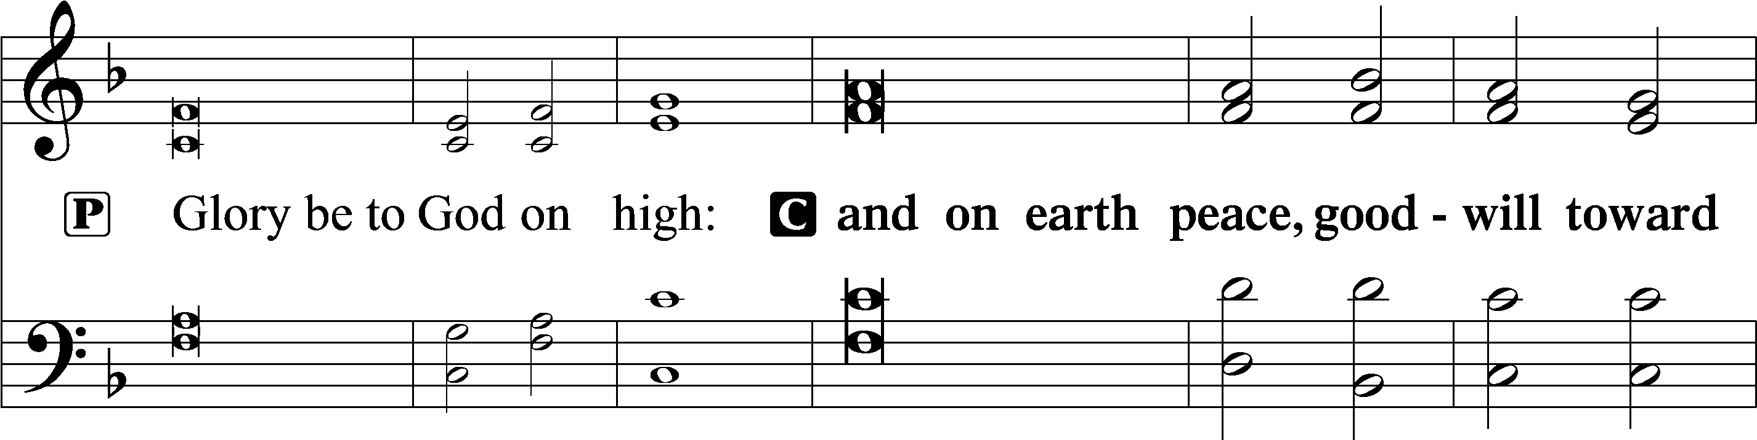
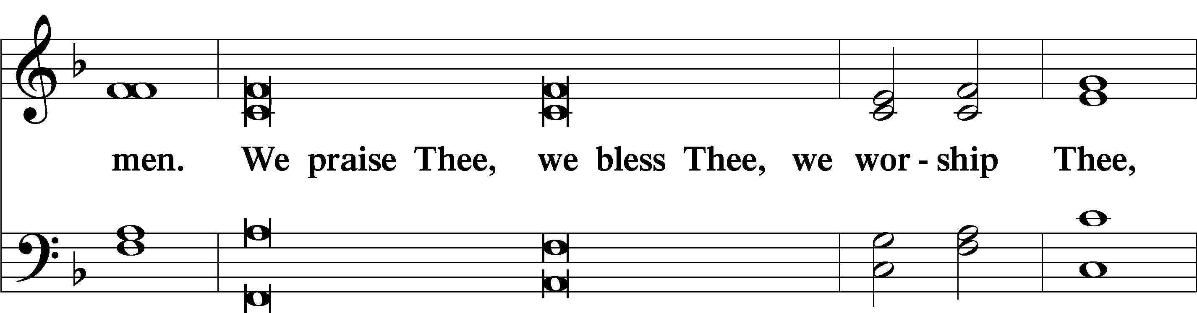
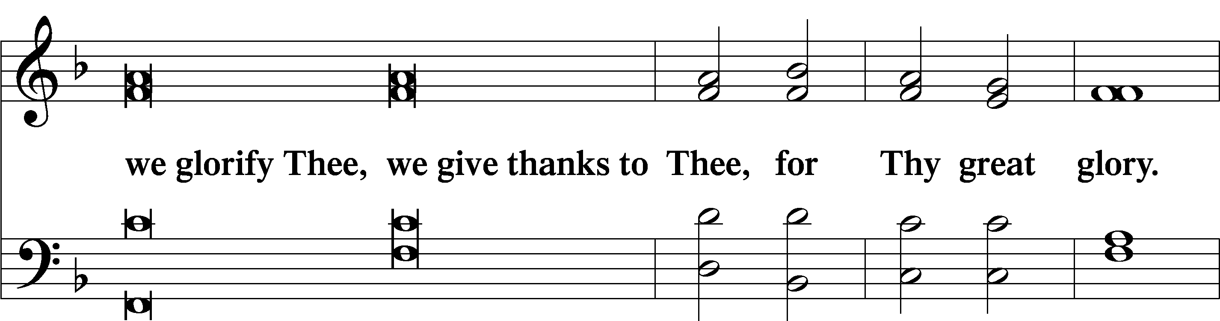
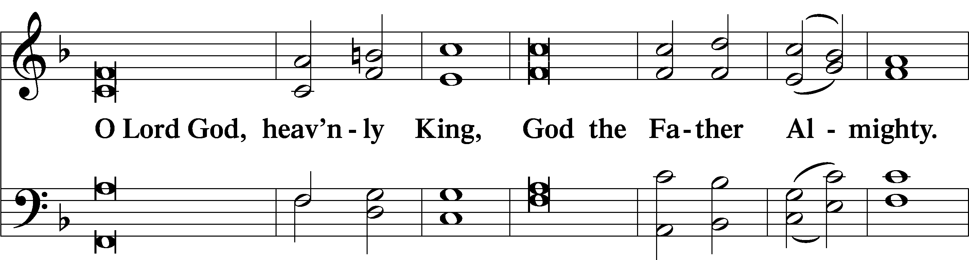
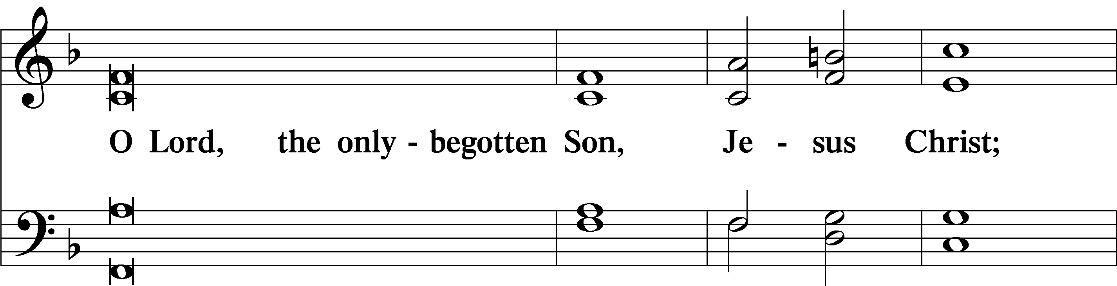
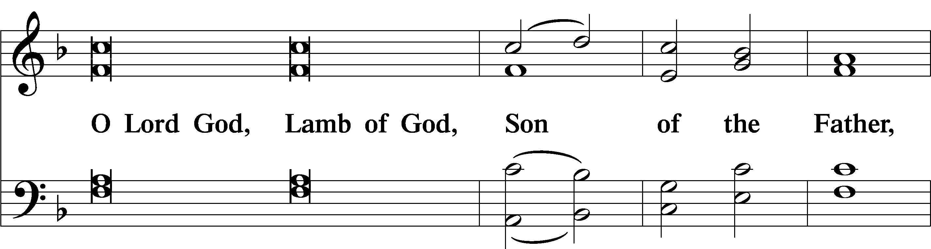
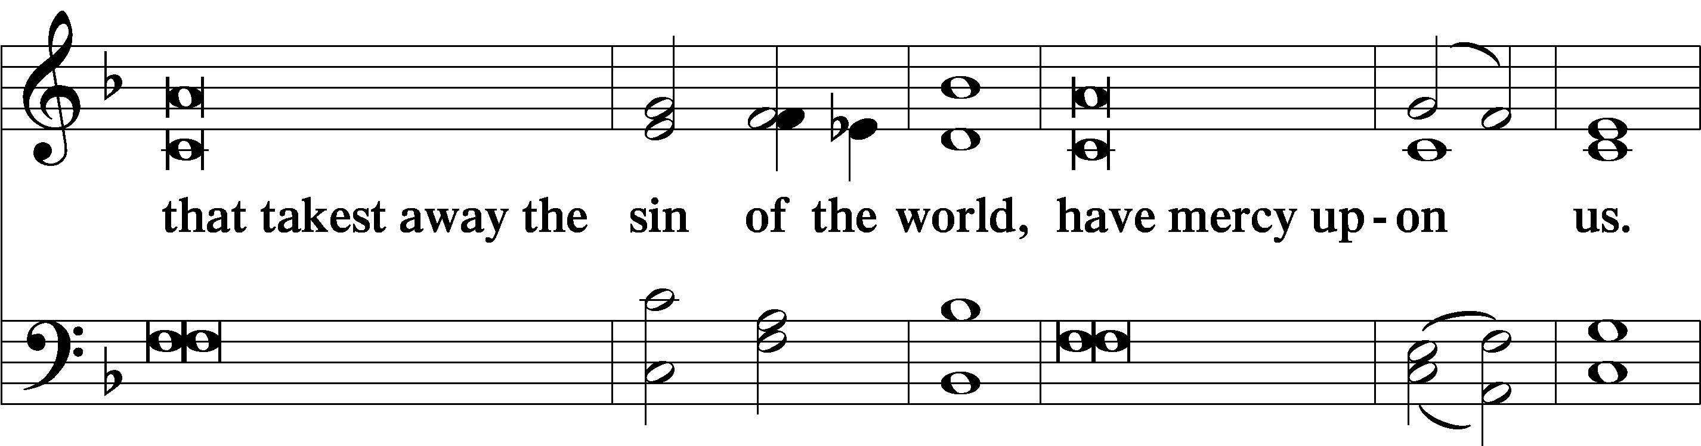
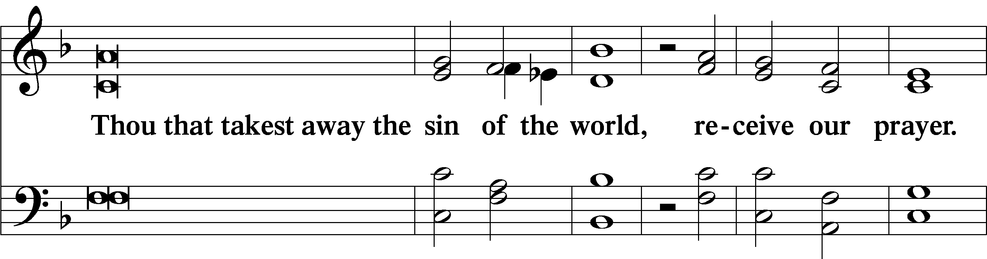
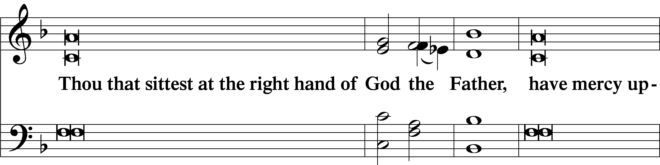
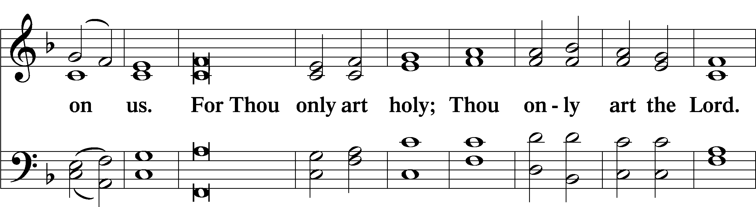
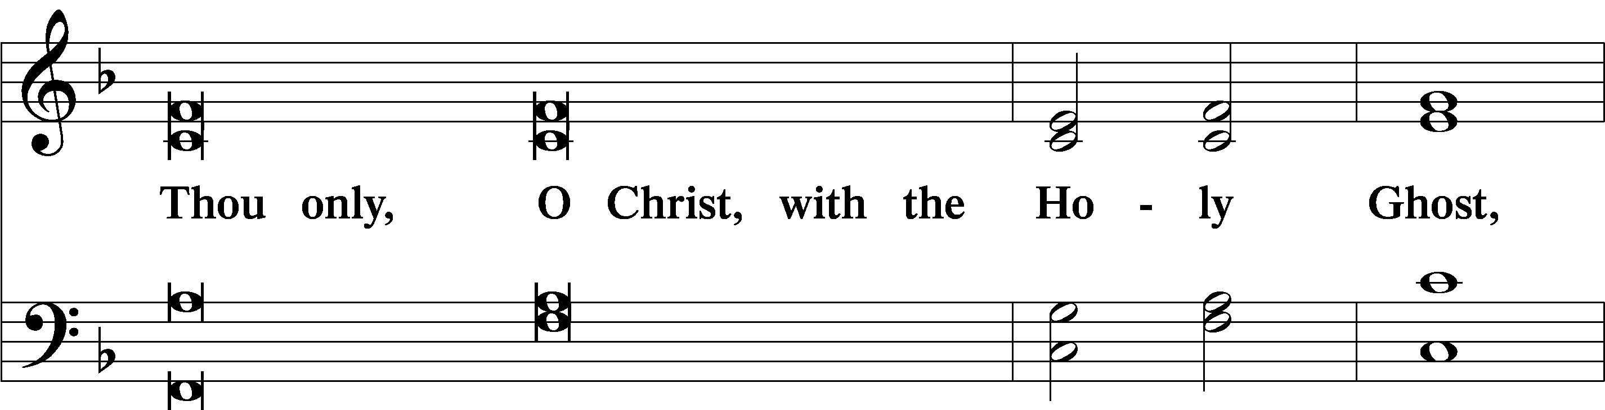
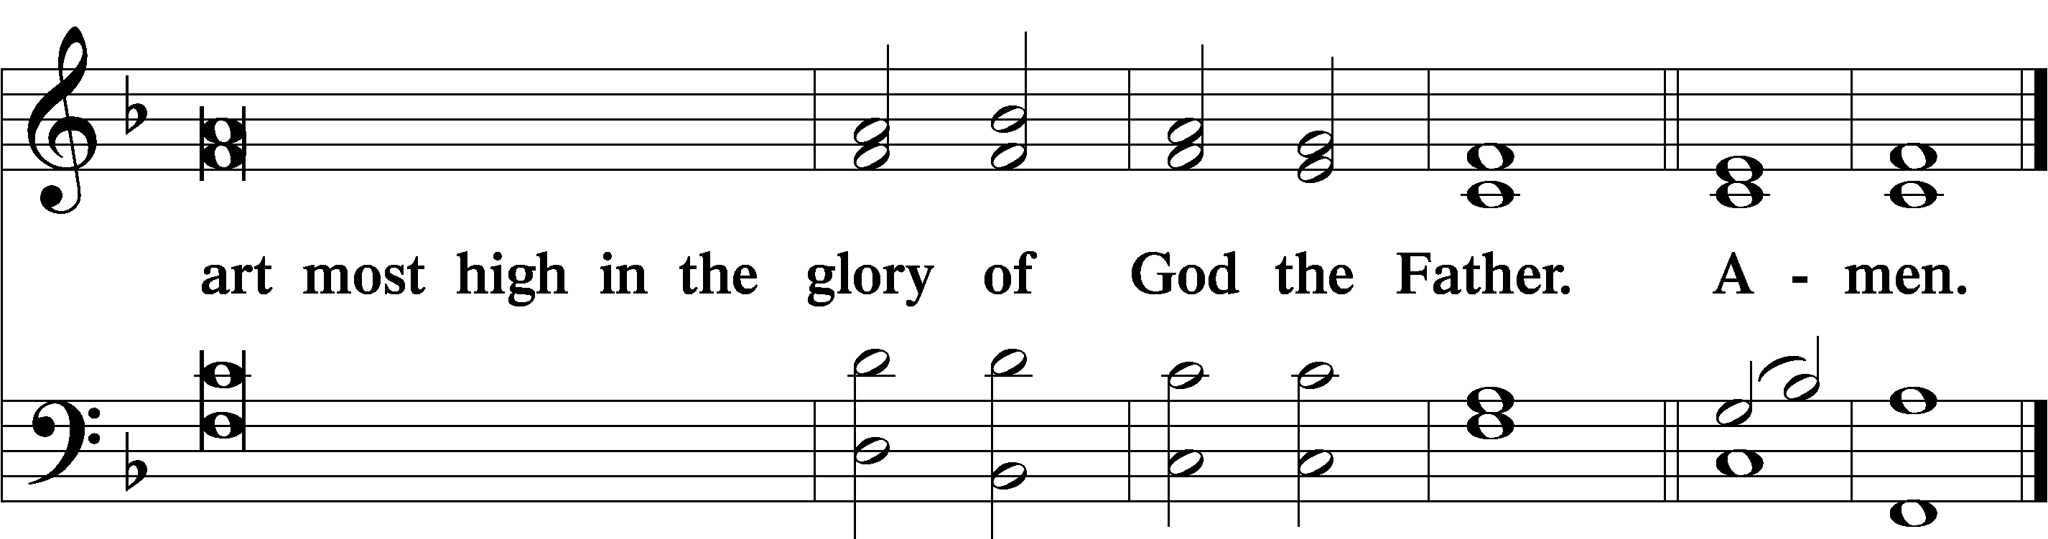

Salutation and Collect of the Day
P The Lord be with you.
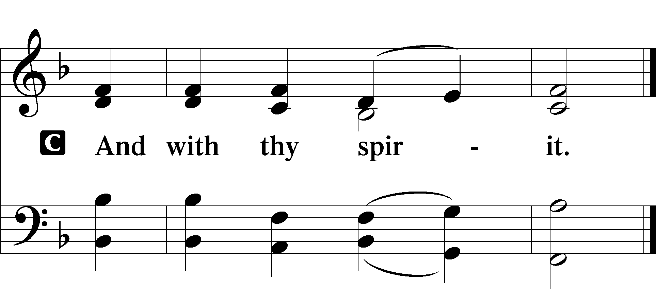
P Let us pray.
O God, our Maker and Redeemer, You wonderfully created us and in the incarnation of Your Son yet more wondrously restored our human nature. Grant that we may ever be alive in Him who made Himself to be like us; through Jesus Christ, our Lord, who lives and reigns with You and the Holy Spirit, one God, now and forever.

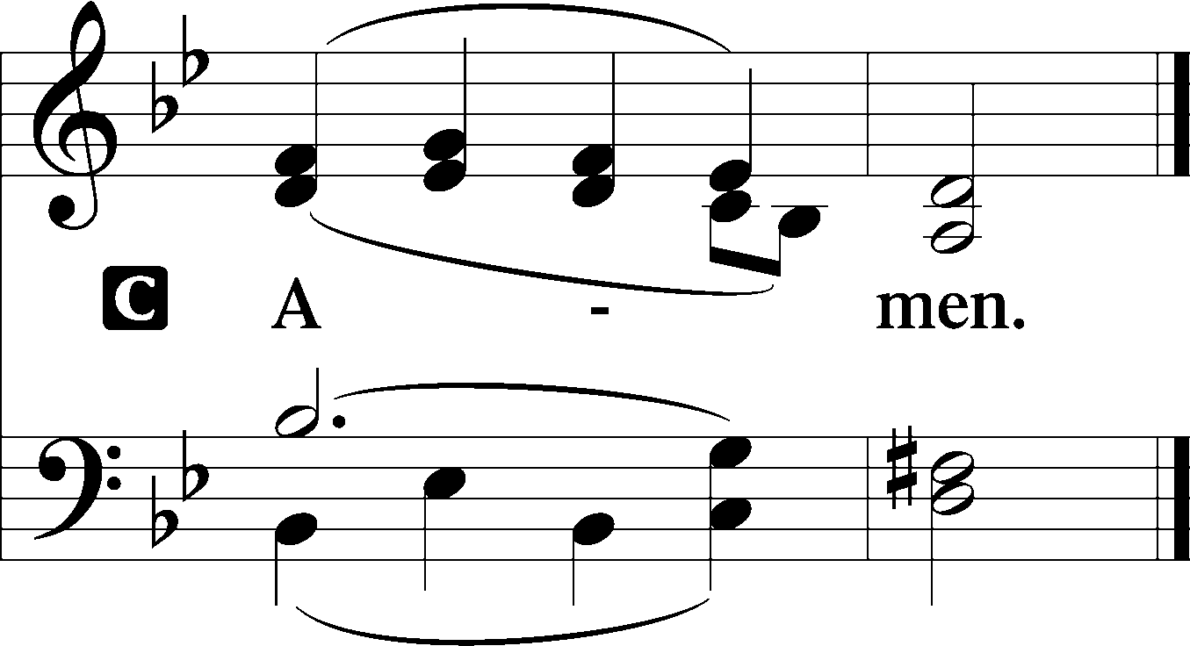

Sit

Old Testament Reading Isaiah 61:10—62:3
¹⁰I will greatly rejoice in the Lord;
my soul shall exult in my God,
for he has clothed me with the garments of salvation;
he has covered me with the robe of righteousness,
as a bridegroom decks himself like a priest with a beautiful headdress,
and as a bride adorns herself with her jewels.
¹¹For as the earth brings forth its sprouts,
and as a garden causes what is sown in it to sprout up,
so the Lord God will cause righteousness and praise
to sprout up before all the nations.
Zion’s Coming Salvation
¹For Zion’s sake I will not keep silent,
and for Jerusalem’s sake I will not be quiet,
until her righteousness goes forth as brightness,
and her salvation as a burning torch.
²The nations shall see your righteousness,
and all the kings your glory,
and you shall be called by a new name
that the mouth of the Lord will give.
³You shall be a crown of beauty in the hand of the Lord,
and a royal diadem in the hand of your God.

A This is the Word of the Lord.
C Thanks be to God.

Gradual Isaiah 9:6; Psalm 98:1a
To us a child is born, to us a son is | given;*
and the government shall be upon his | shoulder.
And his name shall be called Wonderful Counselor, | Mighty God,*
Everlasting Father, | Prince of Peace.
Sing to the Lord a | new song,*
for he has done | marvelous things!

Epistle Galatians 4:4–7
⁴When the fullness of time had come, God sent forth his Son, born of woman, born under the law, ⁵to redeem those who were under the law, so that we might receive adoption as sons. ⁶And because you are sons, God has sent the Spirit of his Son into our hearts, crying, “Abba! Father!” ⁷So you are no longer a slave, but a son, and if a son, then an heir through God.

A This is the Word of the Lord.
C Thanks be to God.

Stand

Alleluia LSB 190
C Alleluia. Alleluia. Alleluia.

Holy Gospel Luke 2:22–40
P The Holy Gospel according to St. Luke, the second chapter.

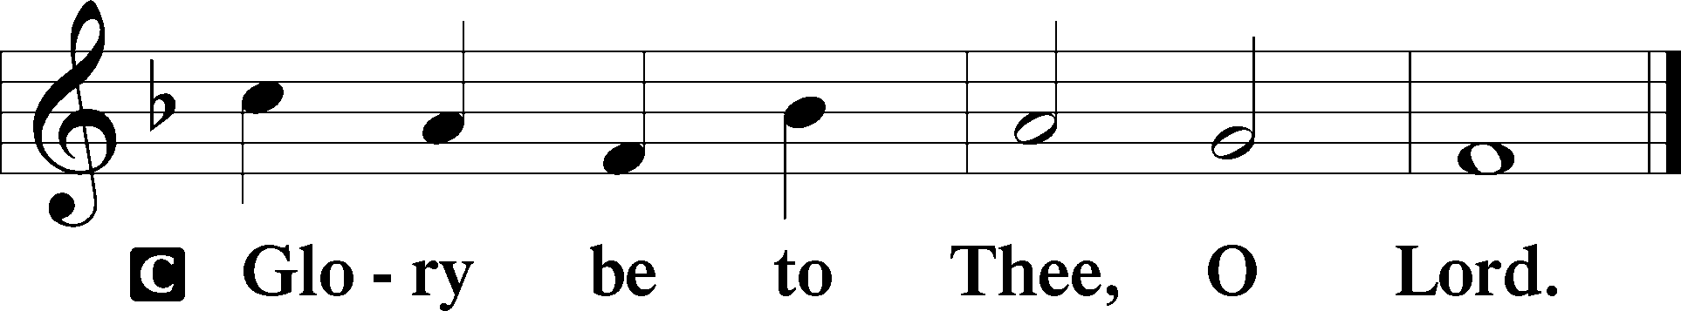

Jesus Presented at the Temple
²²When the time came for their purification according to the Law of Moses, [Mary and Joseph] brought [Jesus] up to Jerusalem to present him to the Lord ²³(as it is written in the Law of the Lord, “Every male who first opens the womb shall be called holy to the Lord”) ²⁴and to offer a sacrifice according to what is said in the Law of the Lord, “a pair of turtledoves, or two young pigeons.” ²⁵Now there was a man in Jerusalem, whose name was Simeon, and this man was righteous and devout, waiting for the consolation of Israel, and the Holy Spirit was upon him. ²⁶And it had been revealed to him by the Holy Spirit that he would not see death before he had seen the Lord’s Christ. ²⁷And he came in the Spirit into the temple, and when the parents brought in the child Jesus, to do for him according to the custom of the Law, ²⁸he took him up in his arms and blessed God and said,
²⁹“Lord, now you are letting your servant depart in peace,
according to your word;
³⁰for my eyes have seen your salvation
³¹that you have prepared in the presence of all peoples,
³²a light for revelation to the Gentiles,
and for glory to your people Israel.”
³³And his father and his mother marveled at what was said about him. ³⁴And Simeon blessed them and said to Mary his mother, “Behold, this child is appointed for the fall and rising of many in Israel, and for a sign that is opposed ³⁵(and a sword will pierce through your own soul also), so that thoughts from many hearts may be revealed.”
³⁶And there was a prophetess, Anna, the daughter of Phanuel, of the tribe of Asher. She was advanced in years, having lived with her husband seven years from when she was a virgin, ³⁷and then as a widow until she was eighty-four. She did not depart from the temple, worshiping with fasting and prayer night and day. ³⁸And coming up at that very hour she began to give thanks to God and to speak of him to all who were waiting for the redemption of Jerusalem.
The Return to Nazareth
³⁹And when they had performed everything according to the Law of the Lord, they returned into Galilee, to their own town of Nazareth. ⁴⁰And the child grew and became strong, filled with wisdom. And the favor of God was upon him.

P This is the Gospel of the Lord.

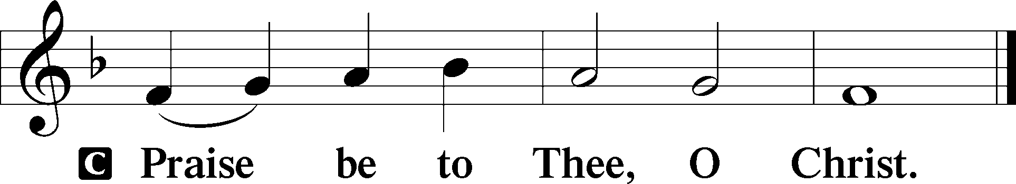

Apostles’ Creed
C I believe in God, the Father Almighty,
maker of heaven and earth.

And in Jesus Christ, His only Son, our Lord,
who was conceived by the Holy Spirit,
born of the virgin Mary,
suffered under Pontius Pilate,
was crucified, died and was buried.
He descended into hell.
The third day He rose again from the dead.
He ascended into heaven
and sits at the right hand of God the Father Almighty.
From thence He will come to judge the living and the dead.

I believe in the Holy Spirit,
the holy Christian Church,
the communion of saints,
the forgiveness of sins,
the resurrection of the body,
and the life T everlasting. Amen.

Sit

389 Let All Together Praise Our God Congregation = vs. 1-2, 7; women = vs. 3, 5; men = 4, 6
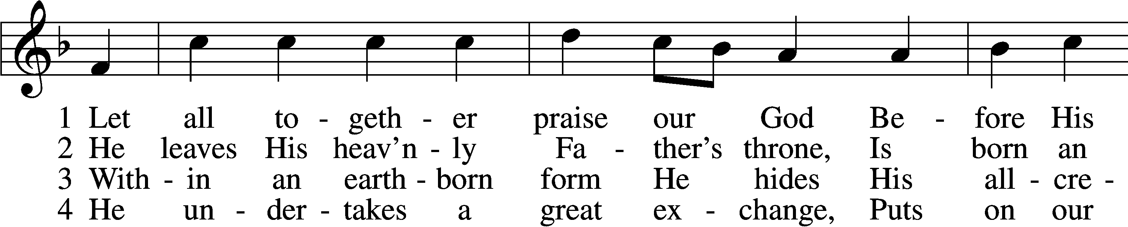
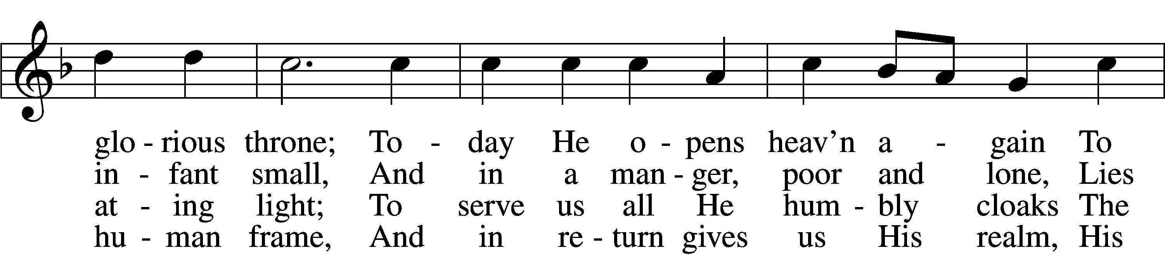
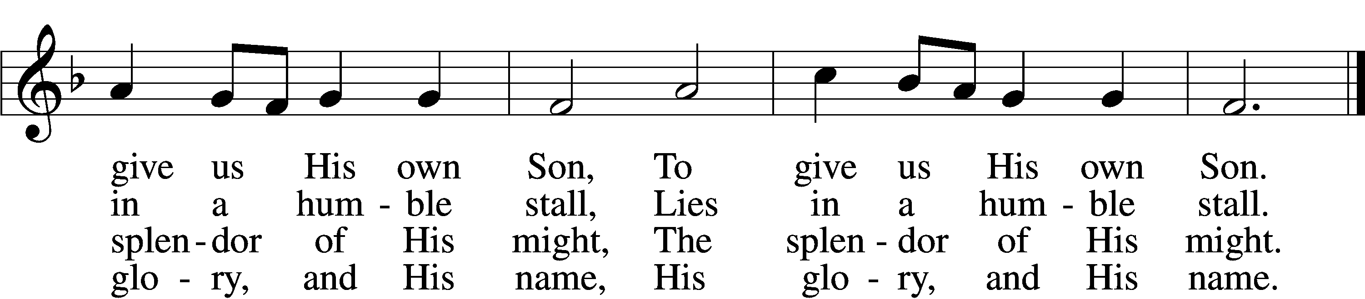

5 He is a servant, I a lord:
How great a mystery!
How strong the tender Christ Child’s love!
No truer friend than He,
No truer friend than He.

6 He is the key and He the door
To blessèd paradise;
The angel bars the way no more.
To God our praises rise,
To God our praises rise.

D 7 Your grace in lowliness revealed,
Lord Jesus, we adore
And praise to God the Father yield
And Spirit evermore;
We praise You evermore.
Text (st. 2) and tune: Public domain
Text (sts. 1, 3–7): © 1969 Concordia Publishing House. Used by permission: LSB Hymn License no. 110003744

Sermon

Stand

Offertory LSB 192
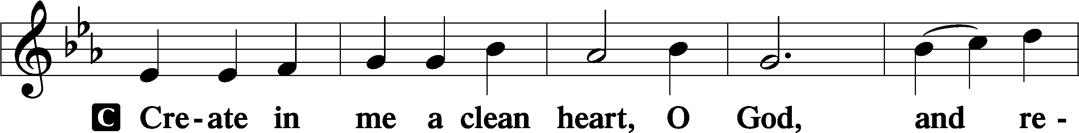
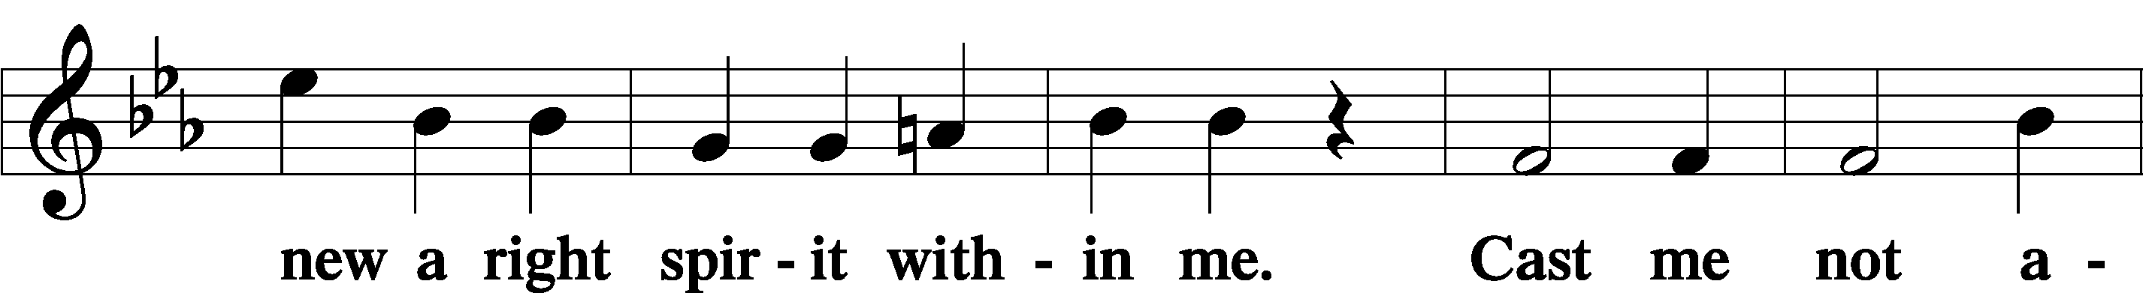
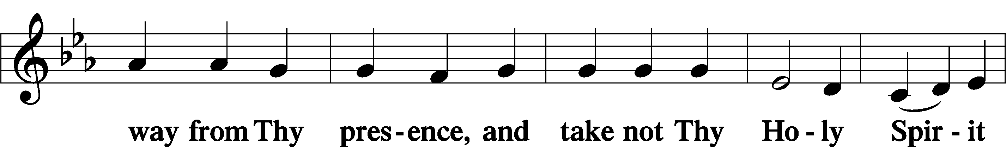
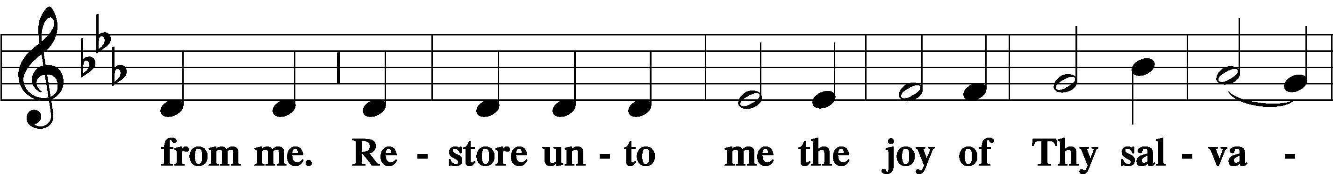
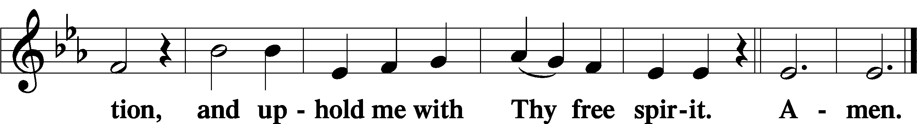

Prayer of the Church

Service of the Sacrament

Preface LSB 194

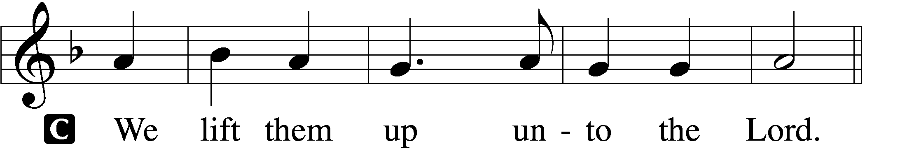

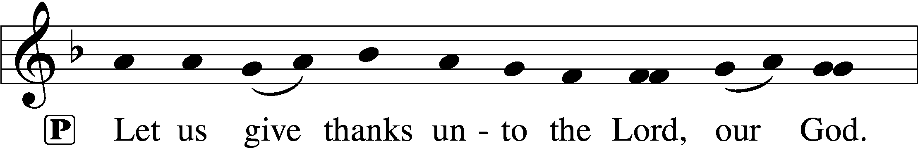
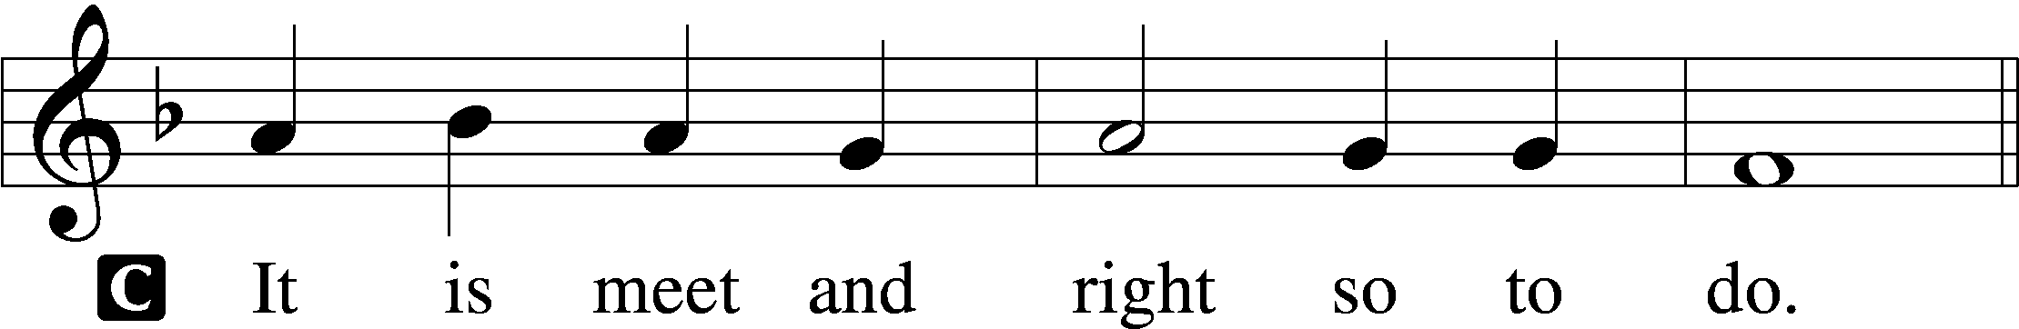

Proper Preface (Full)
P It is truly meet, right, and salutary that we should at all times and in all places give thanks to You, holy Lord, almighty Father, everlasting God, through Jesus Christ, our Lord; for in the mystery of the Word made flesh You have given us a new revelation of Your glory that, seeing You in the person of Your Son, we may know and love those things which are not seen. Therefore with angels and archangels and with all the company of heaven we laud and magnify Your glorious name, evermore praising You and saying:

Sanctus LSB 195
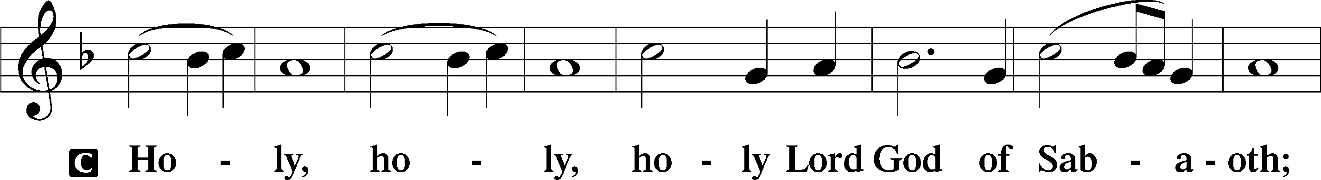
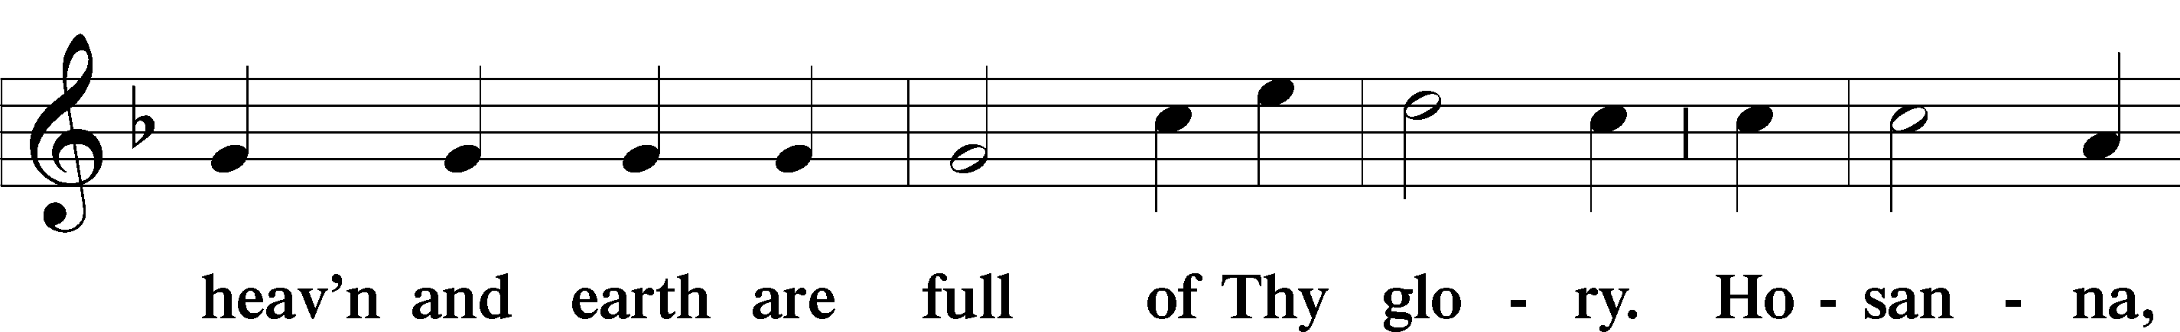
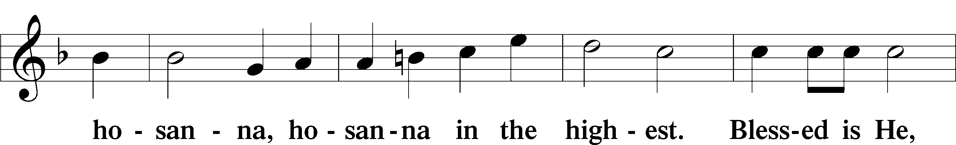
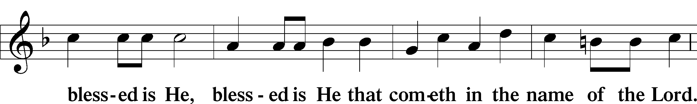
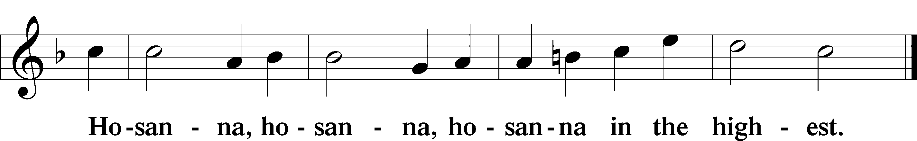

Lord’s Prayer LSB 196
P Our Father who art in heaven,
hallowed be Thy name,
Thy kingdom come,
Thy will be done on earth as it is in heaven;
give us this day our daily bread;
and forgive us our trespasses as we forgive those who trespass against us;
and lead us not into temptation,
but deliver us from evil.
C For Thine is the kingdom and the power and the glory forever and ever. Amen.

The Words of Our Lord LSB 197
P Our Lord Jesus Christ, on the night when He was betrayed, took bread, and when He had given thanks, He broke it and gave it to the disciples and said: “Take, eat; this is My T body, which is given for you. This do in remembrance of Me.”

In the same way also He took the cup after supper, and when He had given thanks, He gave it to them, saying: “Drink of it, all of you; this cup is the new testament in My T blood, which is shed for you for the forgiveness of sins. This do, as often as you drink it, in remembrance of Me.”
Pax Domini LSB 197
P The peace of the Lord be with you always.
C Amen.

Agnus Dei LSB 198
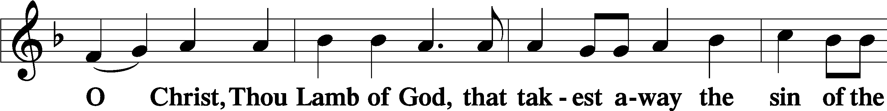
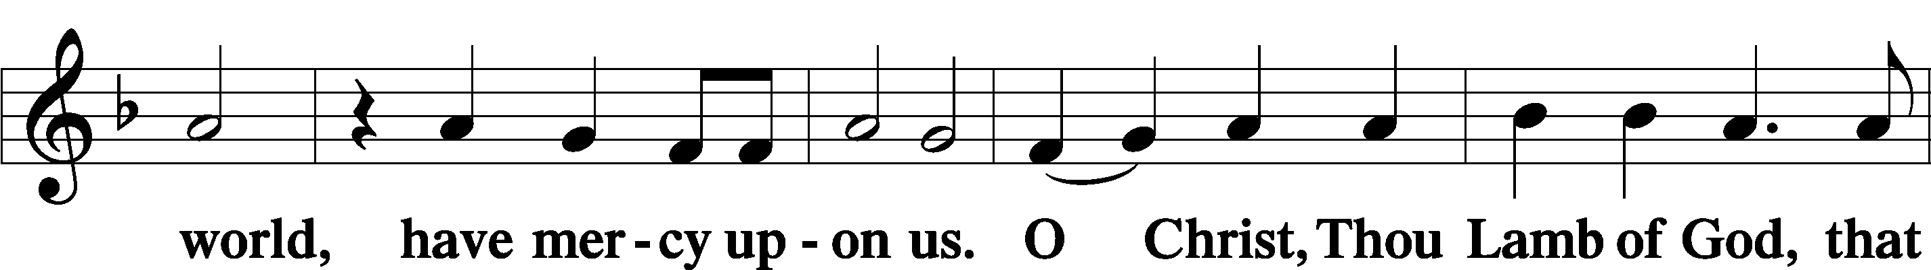
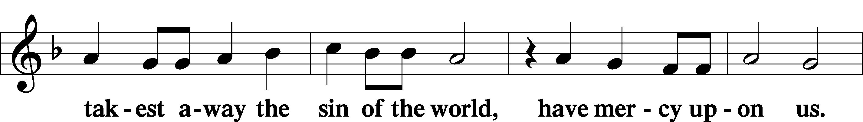
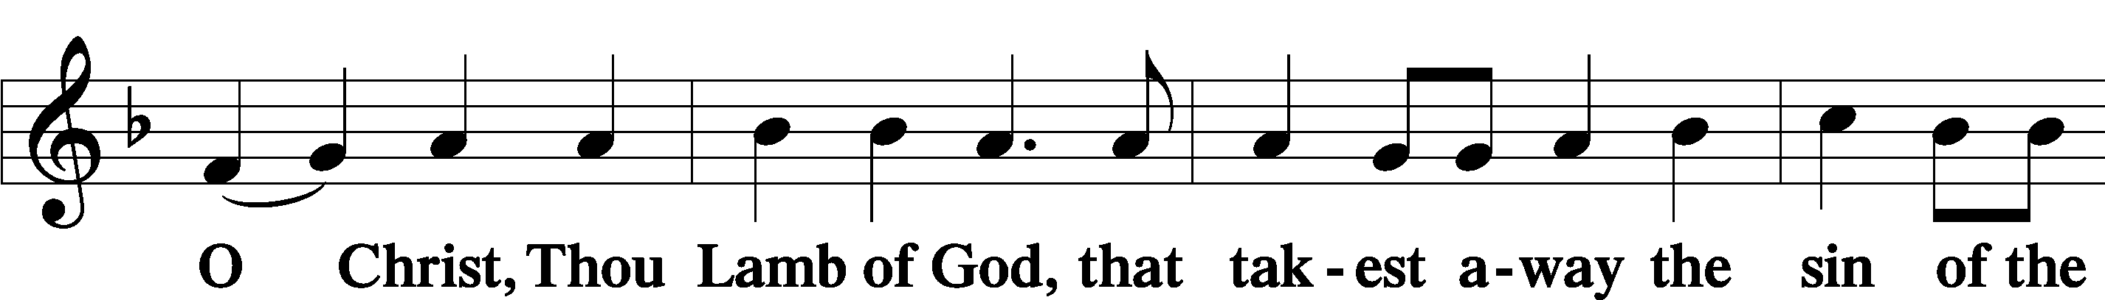
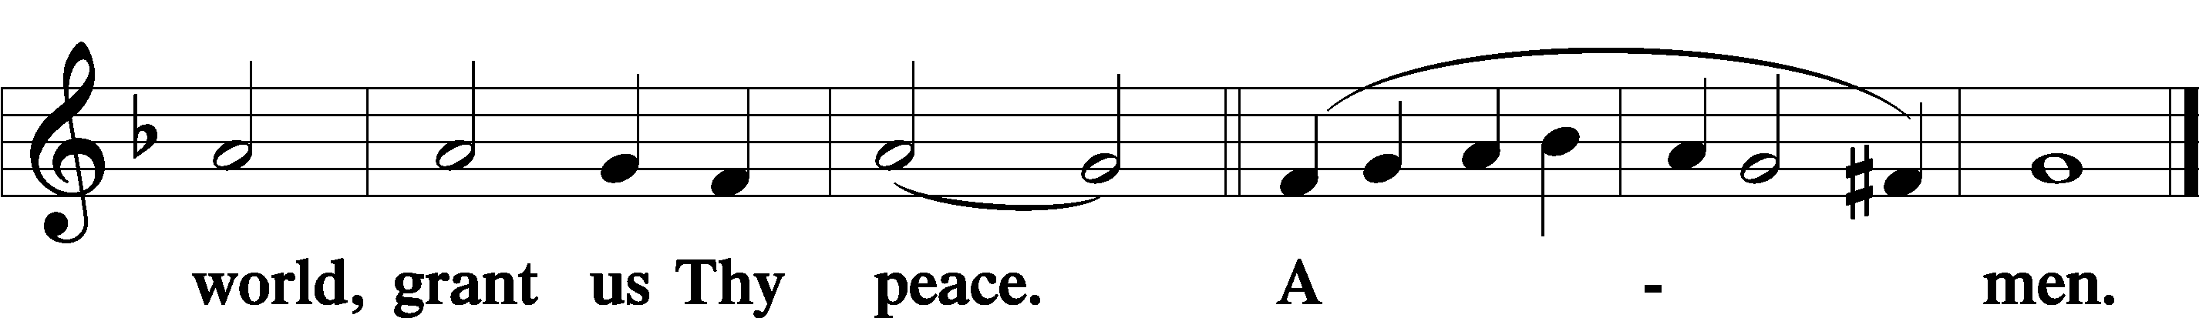

Sit

624 The Infant Priest Was Holy Born
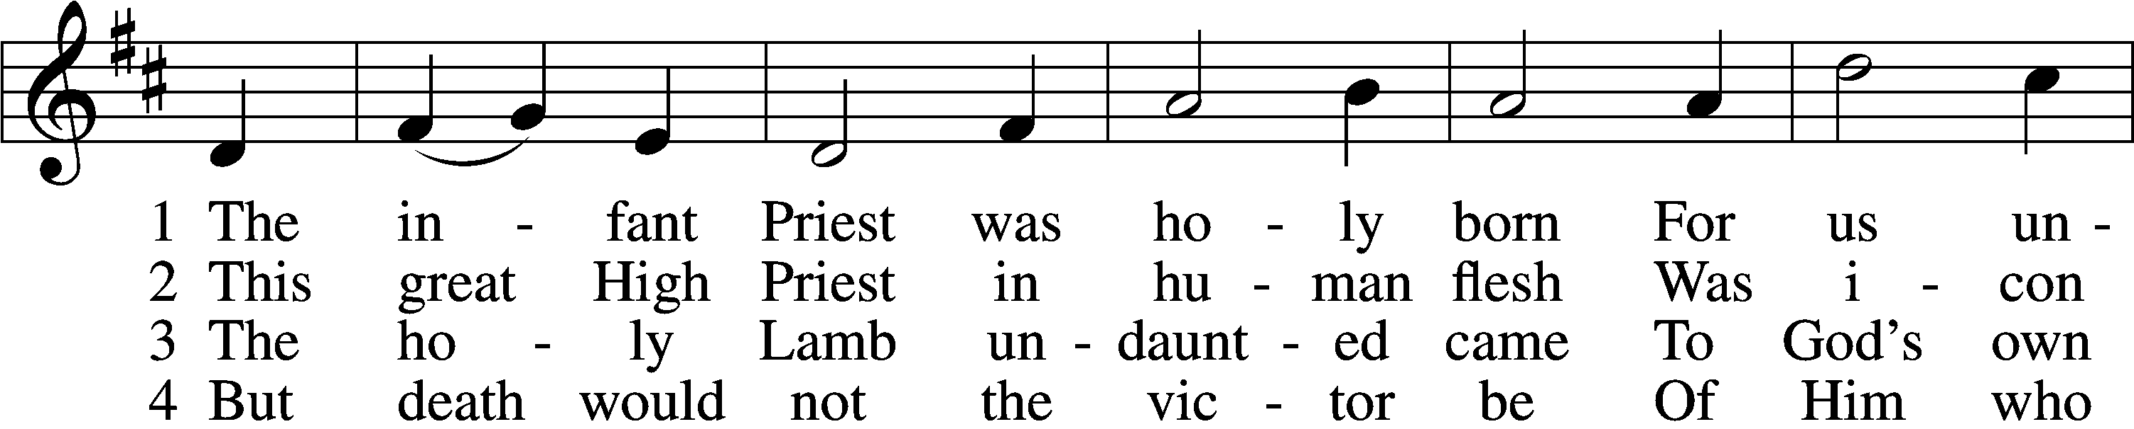
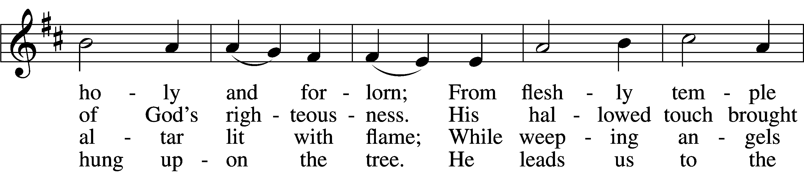
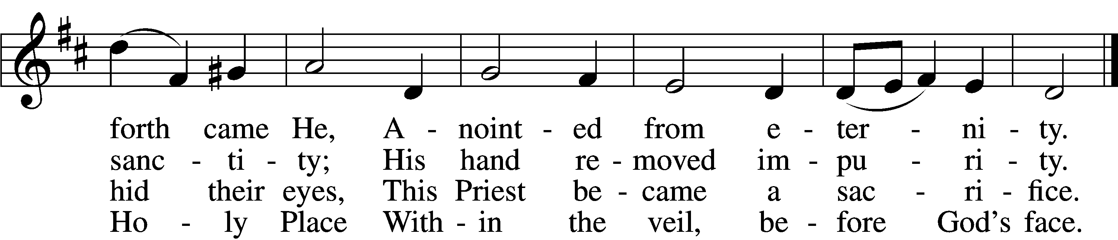

5 The veil is torn, our Priest we see,
As at the rail on bended knee
Our hungry mouths from Him receive
The bread of immortality.

6 The body of God’s Lamb we eat,
A priestly food and priestly meat;
On sin-parched lips the chalice pours
His quenching blood that life restores.

7 With cherubim and seraphim
Our voices join the endless hymn,
And “Holy, holy, holy” sing
To Christ, God’s Lamb, our Priest and King.
Text: © 1997, 2003 Chad L. Bird. Used by permission: LSB Hymn License no. 110003744
Tune: Public domain

375 Come, Your Hearts and Voices Raising
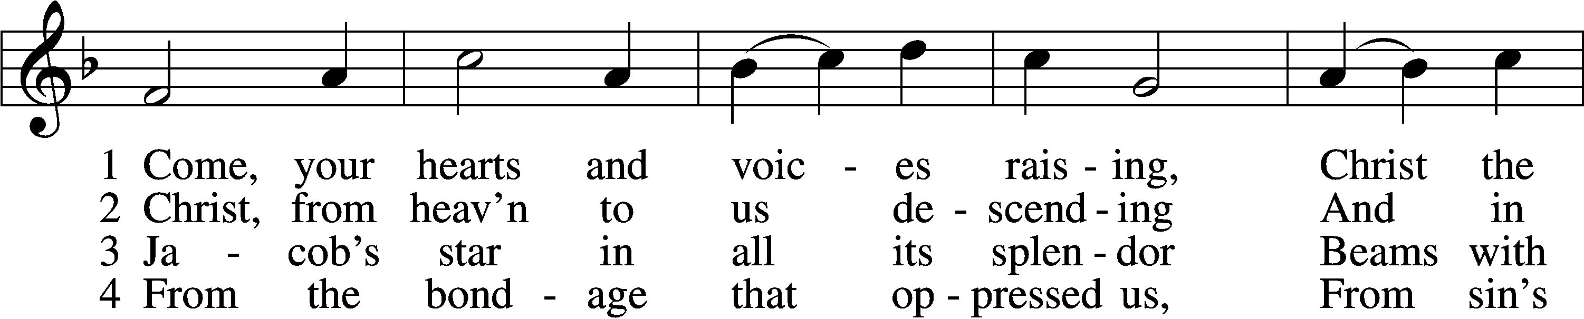
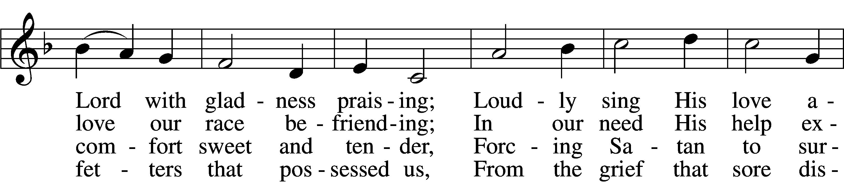
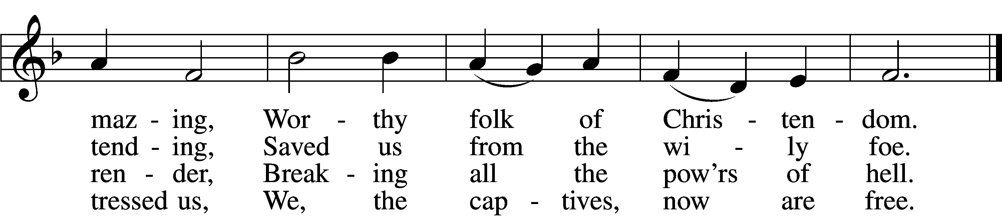

5 Oh, the joy beyond expressing
When by faith we grasp this blessing,
And to You we come confessing
That Your love has set us free.

6 Gracious Child, we pray, O hear us,
From Your lowly manger cheer us,
Gently lead us and be near us
Till we join Your choir above.
Text: © 1941 Concordia Publishing House. Used by permission: LSB Hymn License no. 110003744
Tune: Public domain

386 Now Sing We, Now Rejoice
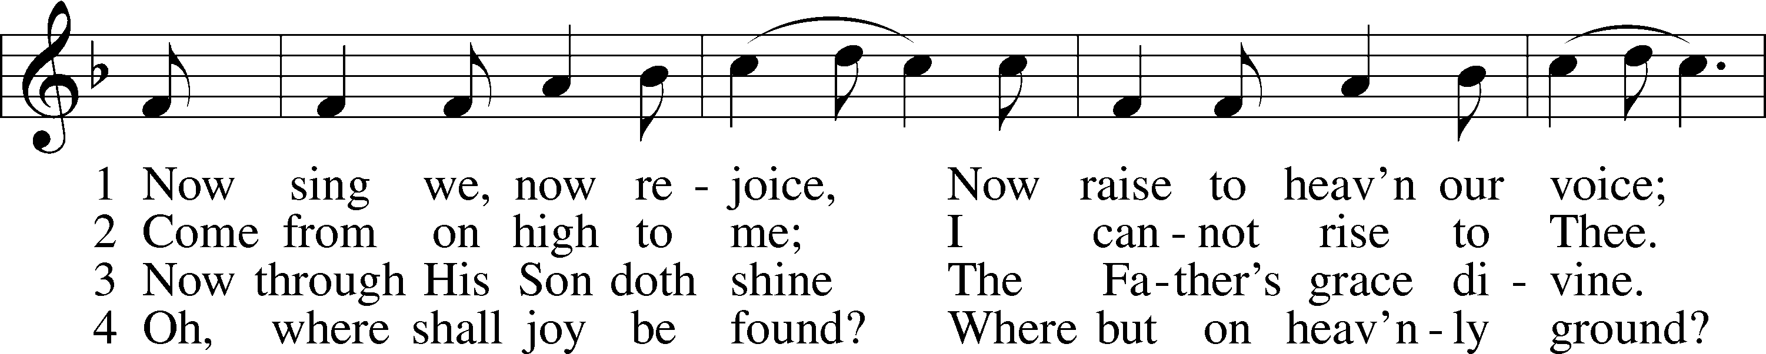
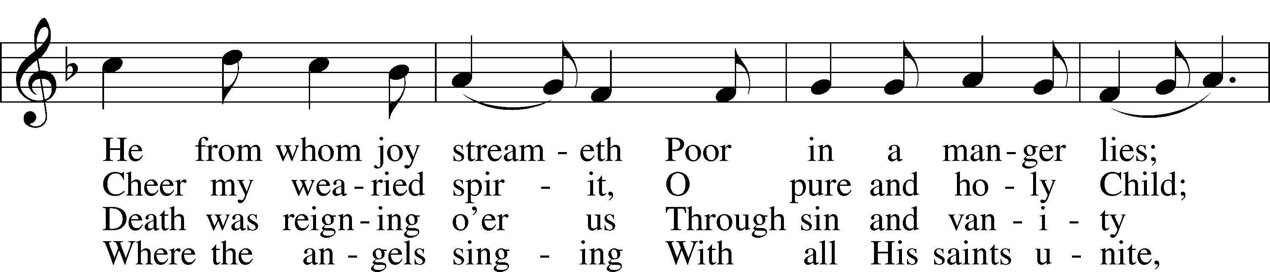
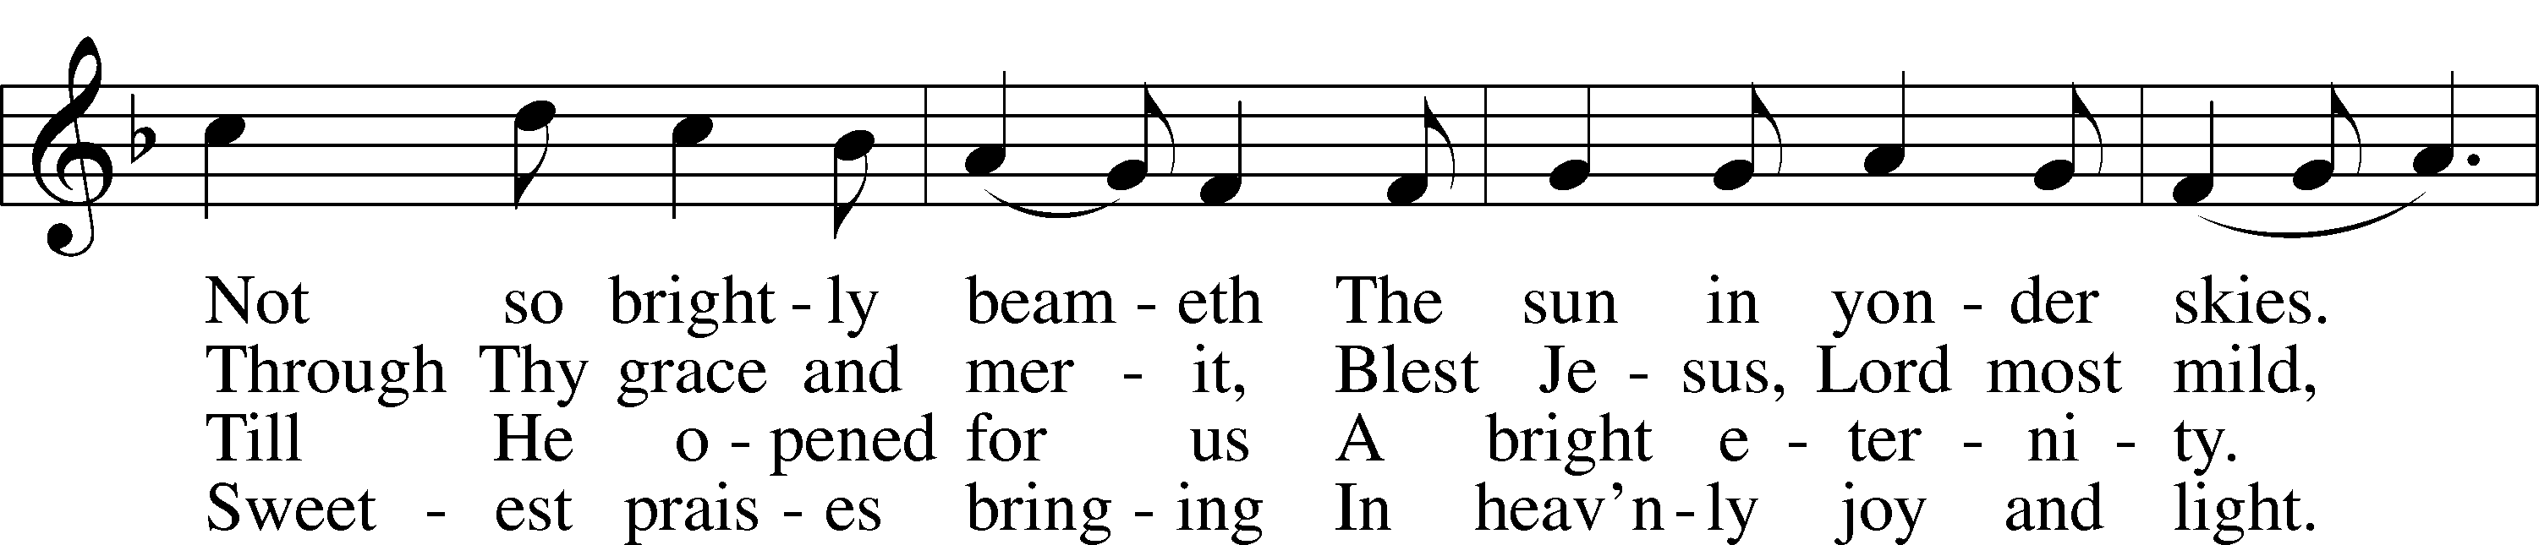
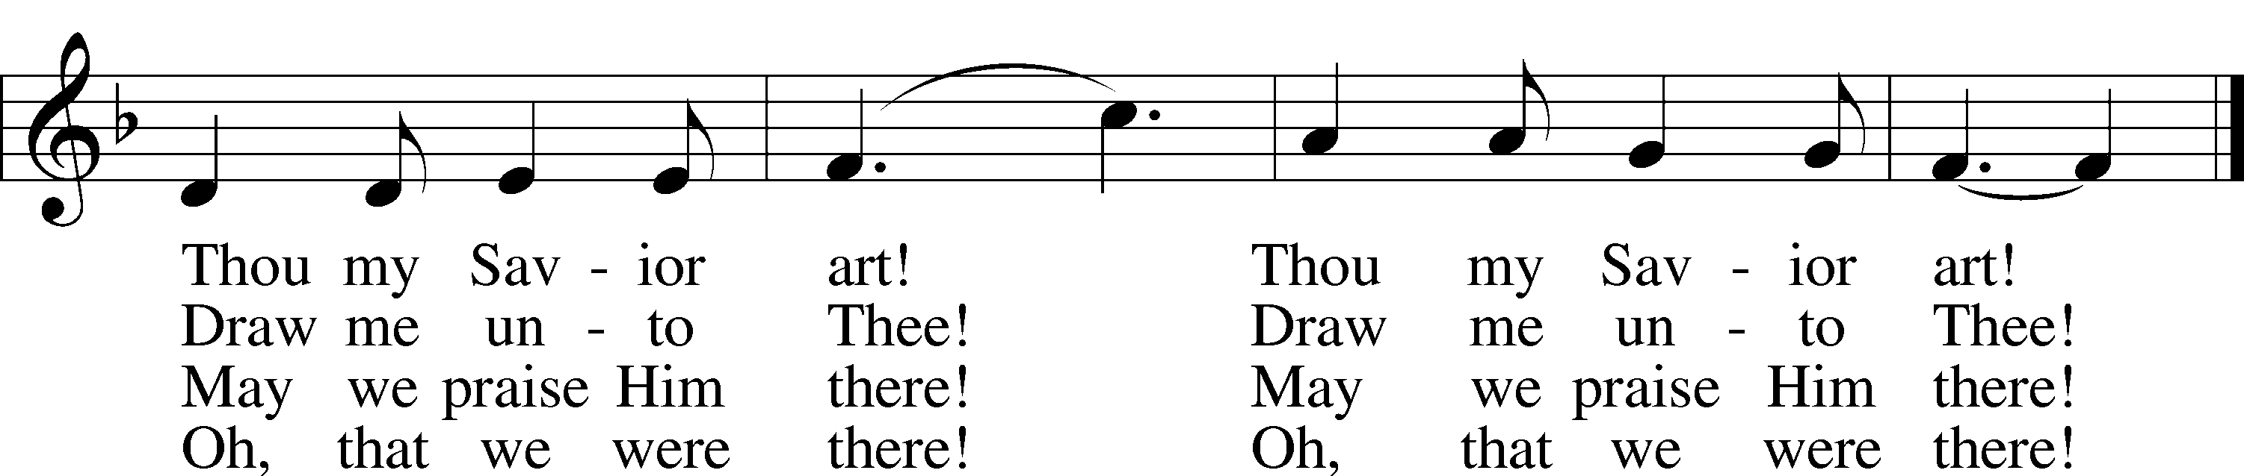
Text and tune: Public domain

In dismissing the communicants, the following is said:

The Dismissal LSB 199
P The body and blood of our Lord Jesus Christ strengthen and preserve you in body and soul to life everlasting. Depart T in peace.
C Amen.

Stand

Nunc Dimittis LSB 199
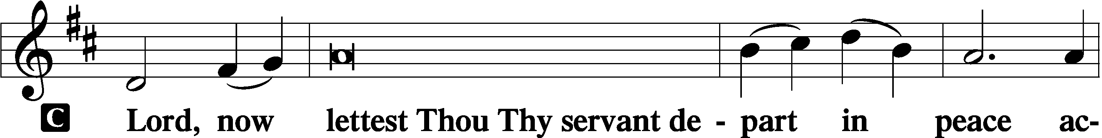

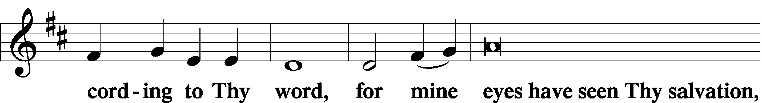

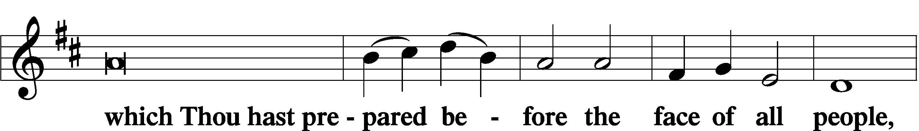

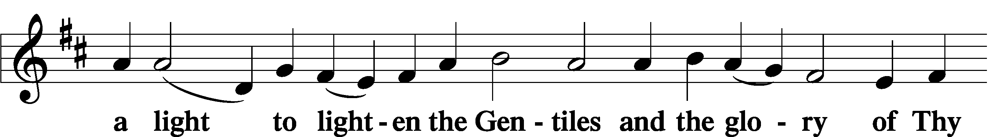

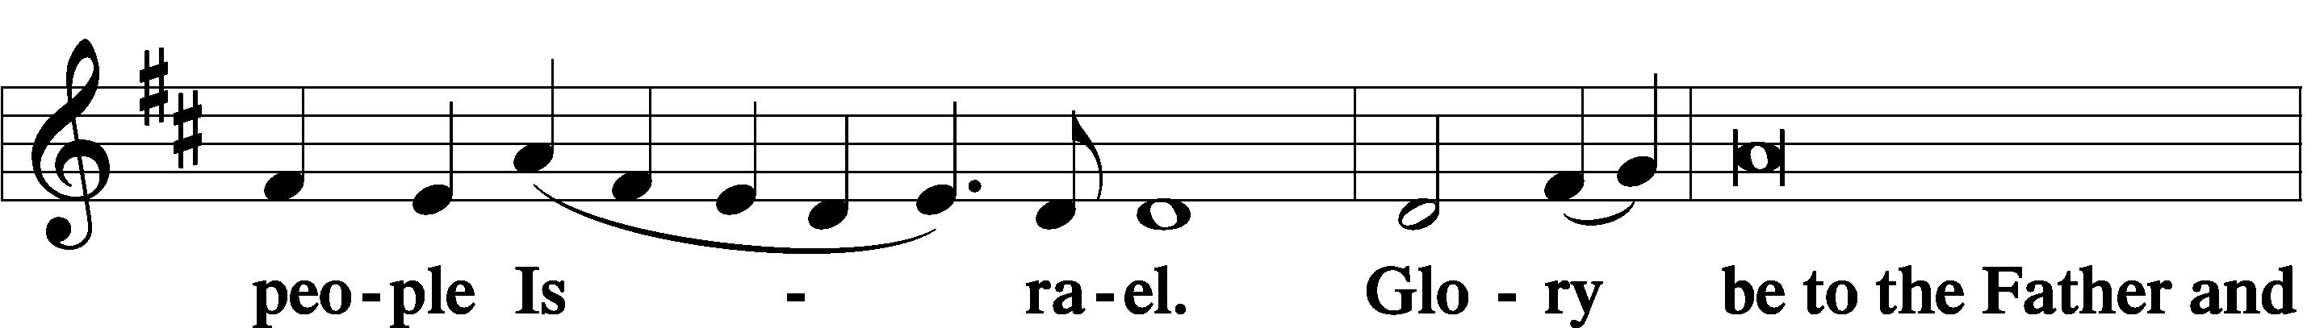

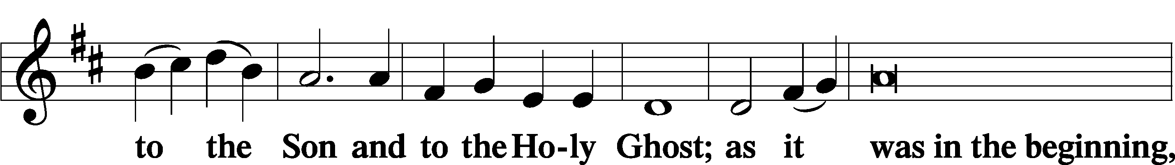

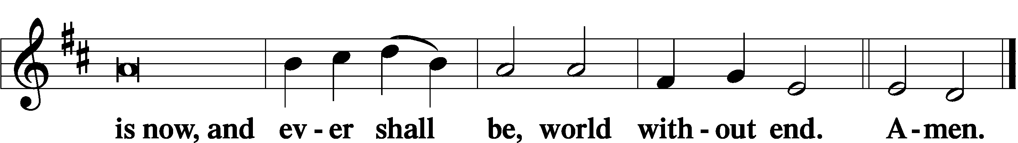

Thanksgiving LSB 200
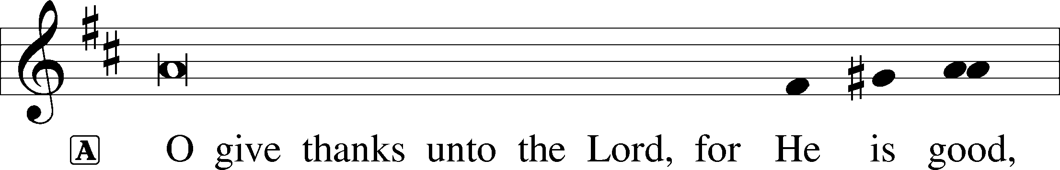

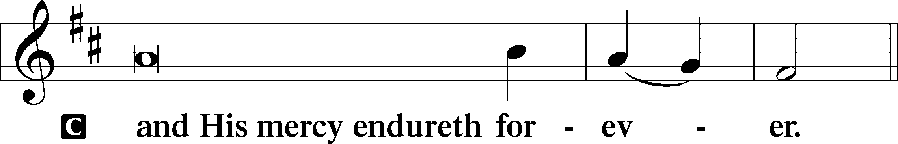
Post-Communion Collect
A Let us pray.
We give thanks to You, almighty God, that You have refreshed us through this salutary gift, and we implore You that of Your mercy You would strengthen us through the same in faith toward You and in fervent love toward one another; through Jesus Christ, Your Son, our Lord, who lives and reigns with You and the Holy Spirit, one God, now and forever.
C Amen.

Salutation LSB 201
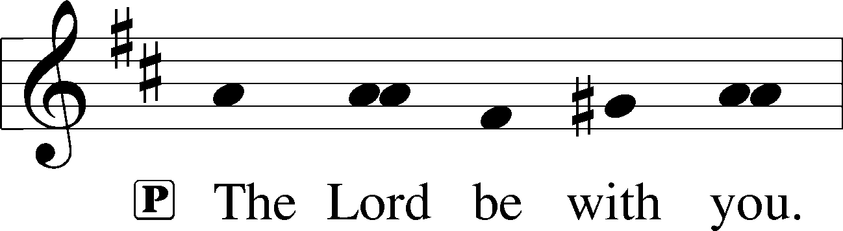

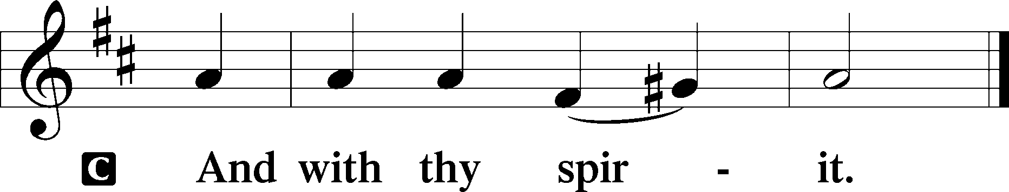

Benedicamus LSB 202
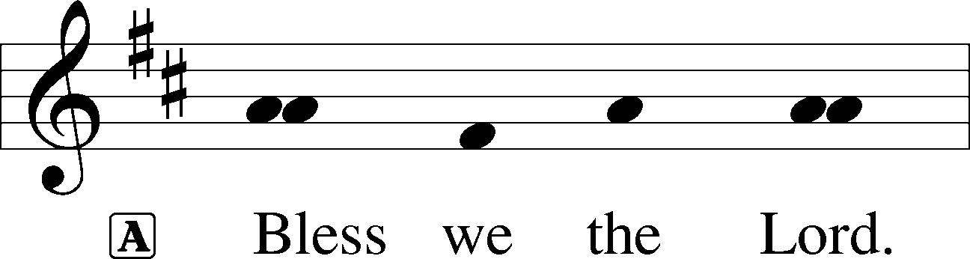

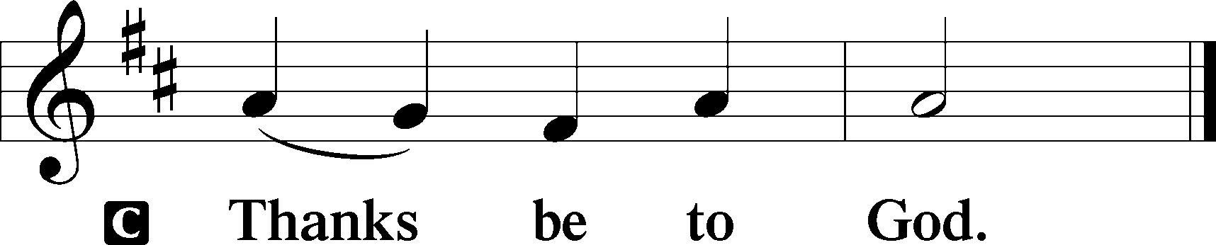

Benediction LSB 202
P The Lord bless you and keep you.
The Lord make His face shine upon you and be gracious unto you.
The Lord lift up His countenance upon you and T give you peace.
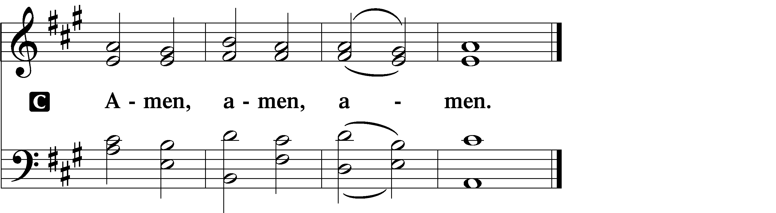

387 Joy to the World
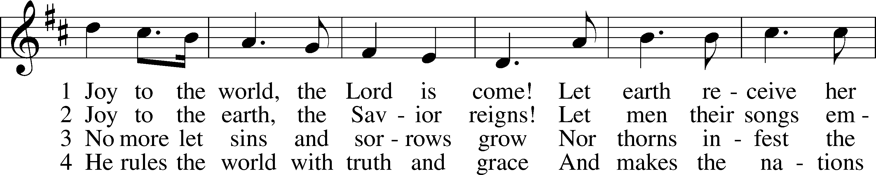
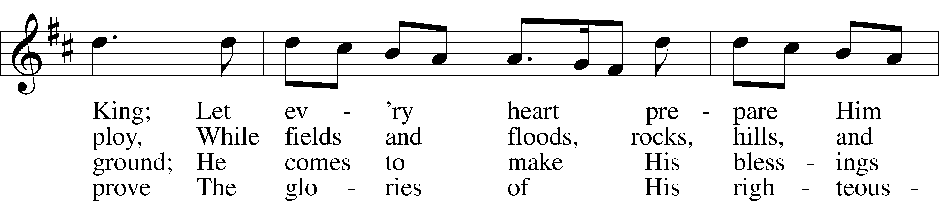
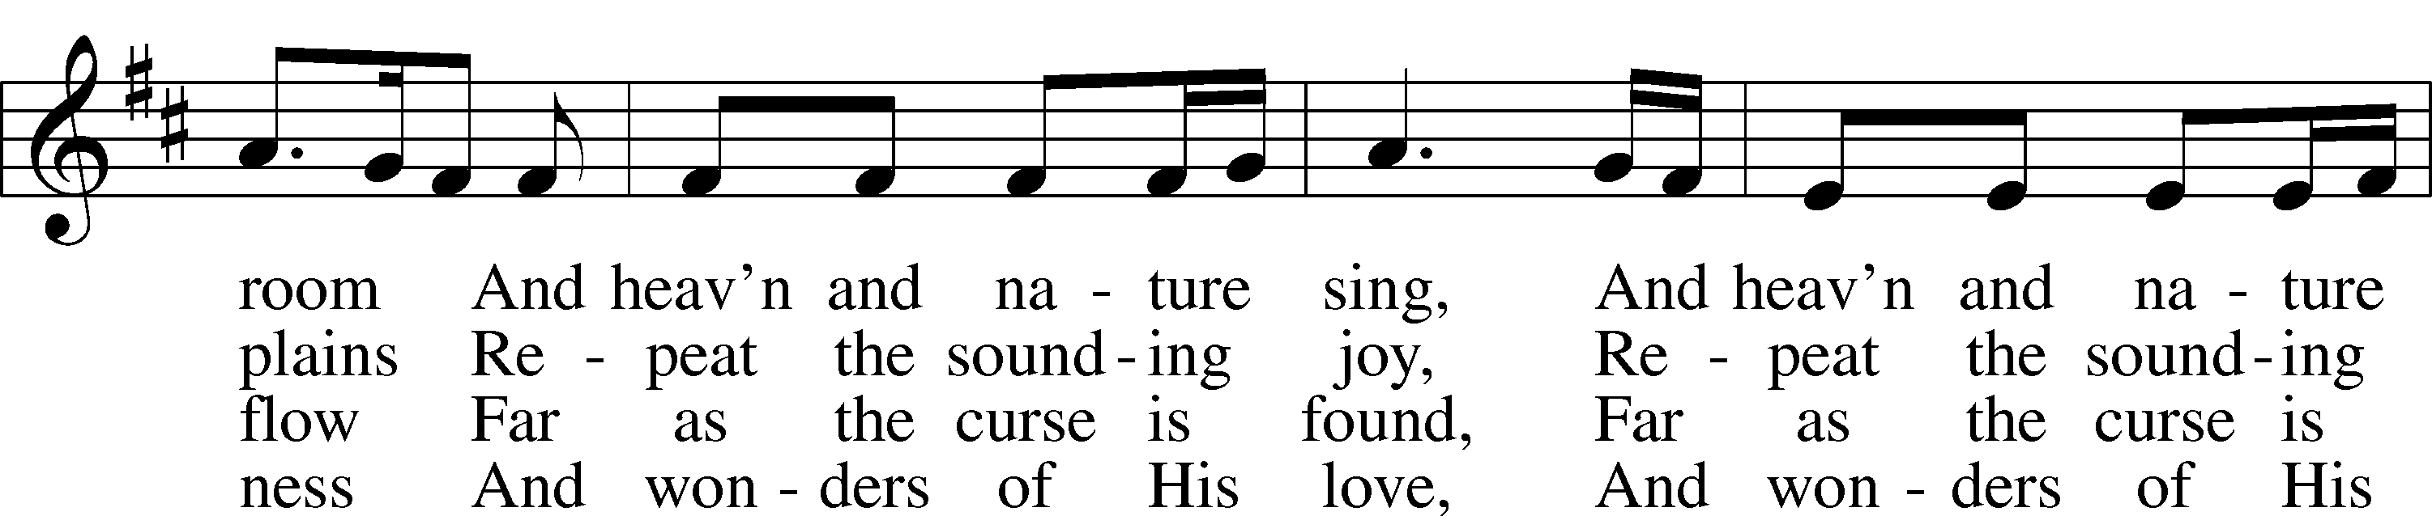
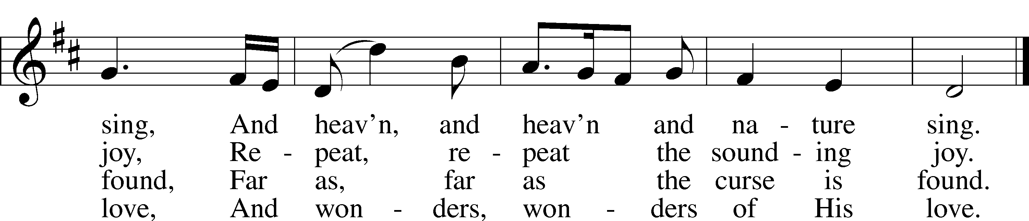
Text and tune: Public domain

Acknowledgments
Unless otherwise indicated, Scripture quotations are from the ESV® Bible (The Holy Bible, English Standard Version®), copyright © 2001 by Crossway, a publishing ministry of Good News Publishers. Used by permission. All rights reserved.
Created by Lutheran Service Builder © 2020 Concordia Publishing House.

Prayers for Our Members
Bailey Hockemeier, Leah Vogel | Expectant Mothers
Birth of a son to Aaron and Bailey Hockemeier, Miles Hockemeier | Thanksgiving
Norman Abels (Brookestone Meadows – Elkhorn) | Healing
Judy Ahrens | Healing
Vaughn Albrecht (Northridge) | Healing
Tom & DyAnn Altwine | Healing
David Banner | Healing
Lyle Colsden (Mother Hull) | Healing
Pat Flodine (Cambridge Court) | Healing
Vi Fox (Prairie View) | Healing
Verleen Gentry | Healing
Ruby Hatfield | Healing
Michelle Millsap | Healing
Roger Riekenberg | Healing
Don Richmond | Healing
Marion Richmond | Healing
Fran Junge | Cancer
Bev Nuttelman | Cancer
Kim Vos | Cancer

Prayers for Our Members’ Family & Friends
Dawn Gaunt (Pr. & Carol Gaunt’s daughter-in-law) | Expectant Mother
Brandon & Shannon Howell (Quentin & Janel Lange’s friends) | Expecting
Will Brennemann (Jami Helmbrecht’s father) | Healing
Reg Duke (Westman’s brother-in-law) | Healing
James Gentry (Verleen Gentry’s son) | Healing
Roger Hoffman (Marc’s father) | Healing
Sharon Kreutzer (former member) | Healing
Lyra Mais (Zion student) | Healing
Randy Solomon (Beth Rosenthal’s father) | Healing
Mary Ann Mertz (Pam’s Uhlir’s friend) | Healing
Roy Reynolds (Verleen Gentry’s son-in-law) | Healing
Janet Stalder (Carol Florang’s sister) | Healing
D.D. Dugger (Sue Kaiser’s brother) | Cancer
Ron Halvorsen (Jeff’s dad) | Cancer
Carol Haubold (Don Helmbrecht’s sister) | Cancer
Tyler Holland (Quentin & Janel Lange’s brother-in-law) | Cancer
Randy Jochum (Ken Hockemeier’s brother-in-law) | Cancer
Fred Koch (Pam Uhlir’s cousin) | Cancer
Lynda Kreutzer (Rich & Carol’s sister-in-law) | Cancer
John Moore (family of Susan Tonniges) | Cancer
Sharon Mulhair (Pam Uhlir’s cousin) | Cancer
Becky Rathkie (former Zion teacher) | Cancer
Jeannie Schmidt (Lisa Splittgerber’s sister-in-law) | Cancer
Tyrone Uhlir (Pam’s nephew) | Cancer

Today’s Radio Broadcast is given to the Glory of the Lord by Dan & Shirley Oertwig in loving memory of fathers
Fred Oertwig & Virgil Wuehler

Serving in Worship

Sunday, December 27~ 9:00am

Elder: Rich Kreutzer
Usher: Mike Wilkens
Engineer: Shawn Starkey
Announcer: Carol Kreutzer
Altar Guild: Beth Rosenthal
Sunday, January 3~ 9:00am

Elder: Eric Rosenthal
Usher: Fred Flessner & Lennis Hodgson
Engineer: Jamie Nikodym
Announcer: Brooke Fisher
Altar Guild: Sheryl Fox & Shirley Oertwig

Our Response to the Gospel

Date: 12/20/2020

Offering: $8,508.00
Weekly Need: $7,542.37

ZION LUTHERAN CHURCH AND SCHOOL

Pr. James DeLoach, Pastor + (308) 627-5260
james.deloach@zionkearney.org
Pr. Doug Gaunt, Pastor + (308) 455-0552
doug.gaunt@zionkearney.org
Tony Splittgerber, Principal + (308) 293-0168
anthony.splittgerber@zionkearney.org

Church Office
Administrative Assistant: Jessica Shiers
Email: school@zionkearney.org
Phone: (308)-234-3410 Fax: (308) 236-8100
Office Hours: Monday-Friday 8:00am-4:00pm
Radio Broadcast: Sunday @ 10:30 a.m. on 1460 AM
Website: www.zionkearney.com

This Week at Zion

Sun  12/27 | 9:00a  10:30a | Divine Service  Radio Broadcast 1460am
Mon  12/28 | Birthdays  Anniversaries | Zachariah DeLoach  Don Engel  Jacqulyn Zehendner  ---
Tues  12/29 | Birthdays  Anniversaries | Chelsea Herrers  ---
Wed  12/30 | Birthdays  Anniversaries | Betty Mustard  ---
Thurs  12/31 | Birthdays  Anniversaries | ---  ---
Fri  01/01 | Birthdays  Anniversaries | Jeffrey Halvorsen  Jeanne Wollberg  ---
Sat  01/02 | 5:00p  Birthdays  Anniversaries | Divine Service  Jamie Nikodym  ---
Sun  01/03 | 9:00a  10:30a  Birthdays  Anniversaries | Divine Service  Radio Broadcast 1460am  ---  ---
ANNOUNCEMENTS
Where our Triune God strengthens us through His mercy in faith toward Him and in fervent love toward one another.

Masks – According to Kearney City Ordinance No. 8457 masks are required “at a location that is open to the general public and where they cannot maintain six foot of distance.”

Thank You – for all of the musicians who provided special music this Christmas week – Grace Burger, Miriam Gaunt, Abigail DeLoach, Zach DeLoach, Don Richmond, and Jamie Wilkens. Thank you so much for sharing your talents with us!

Year-End Reports - The Chairman of each board and organization is asked to turn in a Year End Report to the Church office. The most convenient way to receive these is by email. school@zionkearney.org

Office Closed – The church office will be closed Monday, December 21-Tuesday, January 5th. For Pastoral emergencies please call Pastor DeLoach (308-627-5260) or Pastor Gaunt (308-455-0552).

POINSETTIAS - Thank you to the following families who provided poinsettias for use in our sanctuary this Christmas season: Patrick & Patrice Brost, Paul & Rachael Burger, Waunita DeLaet, Wes & Mary Fiddelke, Bob & Wanda Glanzer, Lonna Gronewoller, Don & Shirley Helmbrecht, Matt & Amy Hodgson, Chris & Sarah Hoehner, Todd & Ellen Koopman, Doreen Lemburg, Dan & Shirley Oertwig, Don & Marion Richmond, Jane Schmid, Becky Thornton, Cinda Ward.

2020 Contributions - Just a reminder that the 2020 contributions must be dated December 31, 2020 and put in the plate by December 31 to be counted as 2020 contributions.

A Bible Study – is prerecorded and available each Sunday, along with a study guide you can use to follow along. We are studying the three lessons for the day—the Old Testament, the Epistle, and the Gospel. Go to Zion’s website www.zionkearney.com to access the video and study guide.

Offering Envelopes – 2021 offering envelopes are in your church mailbox.

Offering during this time. If you are not able to attend live Church Services, you may: drop your offering in the mail slot by the south doors, mail it to the church, or use online giving option at zionkearney.com. If you have any questions or need assistance please contact the office at 308-234-3410 or school@zionkearney.org. Thank you for supporting of your church!
Radio Broadcast & Altar Flowers - Please help Zion spread the Gospel! There are several open dates. This is a great need during this time, many people are listening to our broadcast during this time. There are also many openings for altar flowers. Please help beautify the sanctuary.

Mission Offerings - The fourth quarter missions, October through December, will support those preparing for fulltime church work (Peter Kreutzer and Taylor Zehendner, both at CUNE). If you would like to donate to this mission please use the mission envelopes located in the narthex. Thank you for your support.

Registration Open- Registration is now open for the 2021-2022 school year for current school families and Zion church members. Registration will open to the public on Wednesday, January 6th. New this year is and all-day prekindergarten! If you have any questions please feel free to contact the office. Please tell your family and friends about Zion. Enroll early to make sure you have a spot. We invited everyone to reenroll. Zion is a wonderful school family, we would love to see everyone back!

New Teacher Search - Mr. Vogel and family will be moving at the conclusion of this school year so the search for another high quality Lutheran teacher has begun. Full time teachers in our school must be members of the LCMS (or willing to become so). The grade level will most probably be for the 3rd/4th grade. If you or someone you know might be interested in this position please contact Mr. Splittgerber

Important Calendar Change - The Board of Education, on its December 8th meeting, voted to add two days to the school Christmas break. Zion will now return from break on Wednesday, January 6.

This change was made in part to recognize the Herculean efforts that Zion’s teachers have made to keep the school running during a pandemic. This change will also align Zion’s calendar with that of other Kearney schools.

