Matins
Lutheran Service Book, p. 219ff.

647 Lord Jesus Christ, the Church’s Head
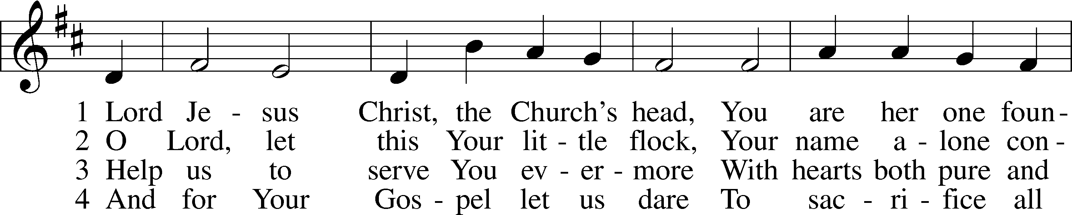
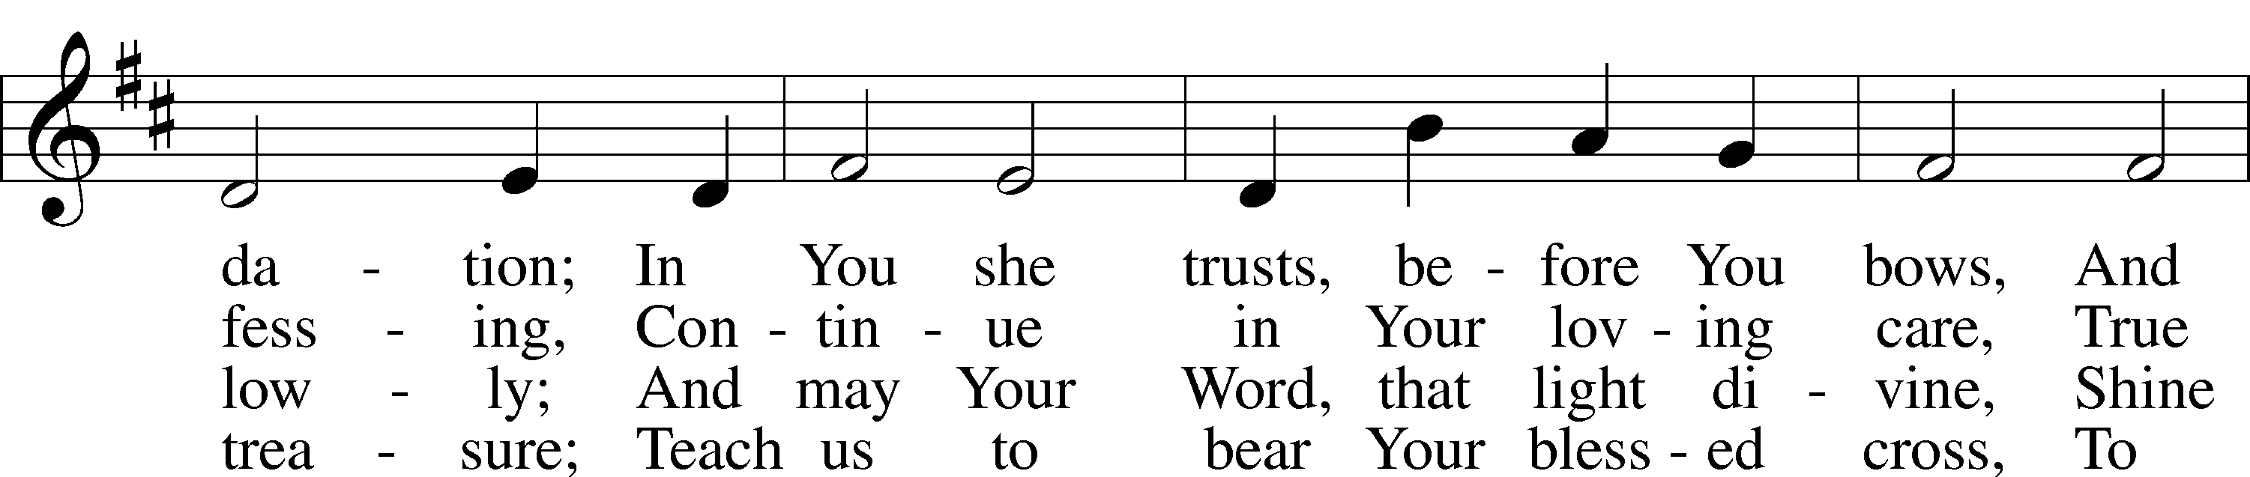
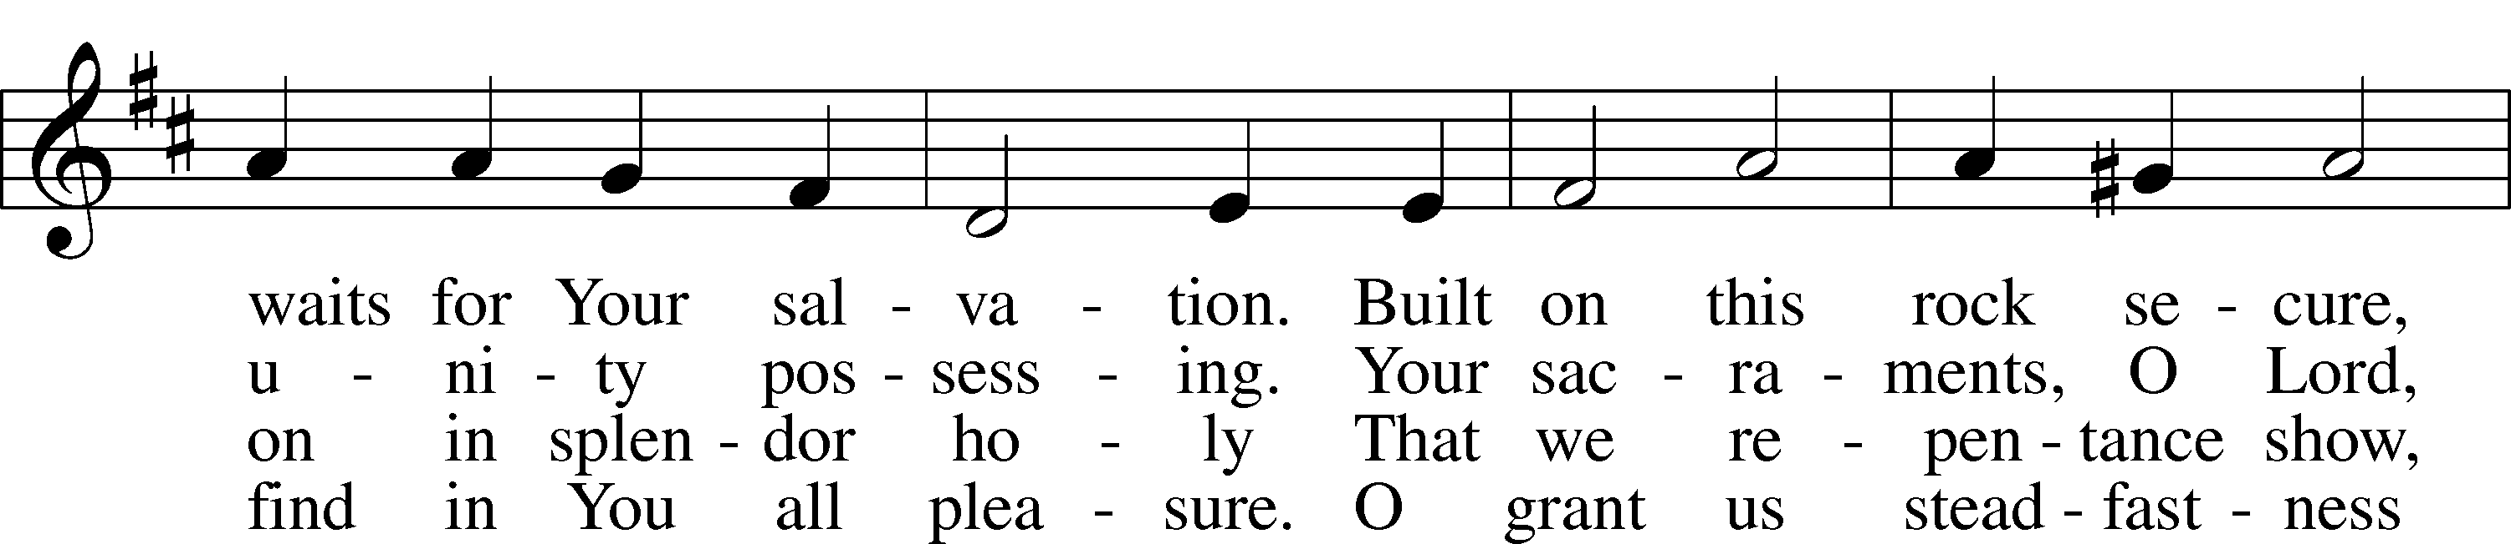
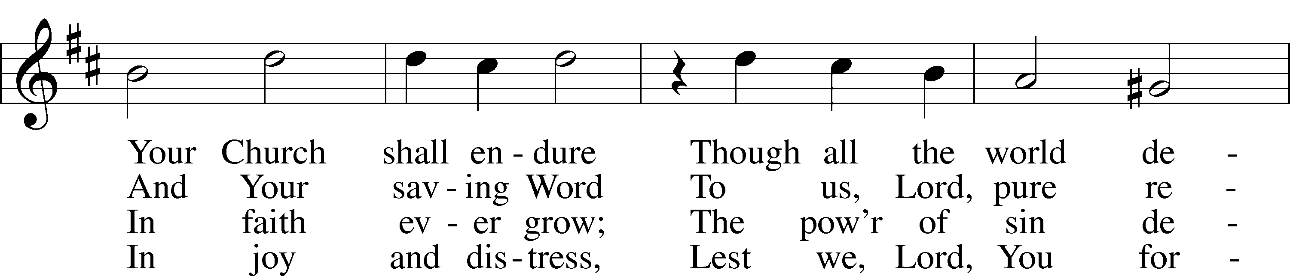
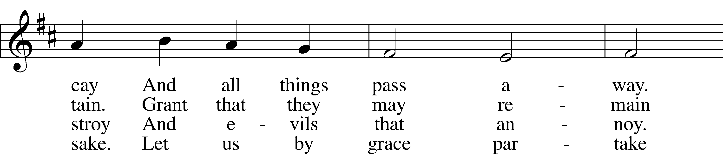
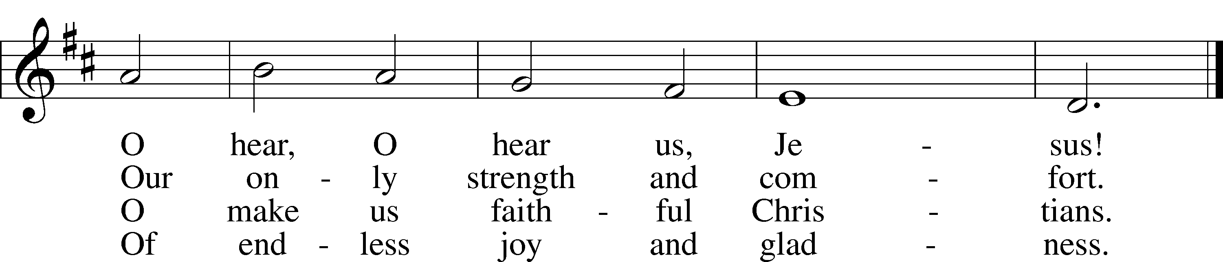
Text: © 1941 Concordia Publishing House. Used by permission: CPH Limited Promotional License no. 119000000
Tune: Public domain

Stand

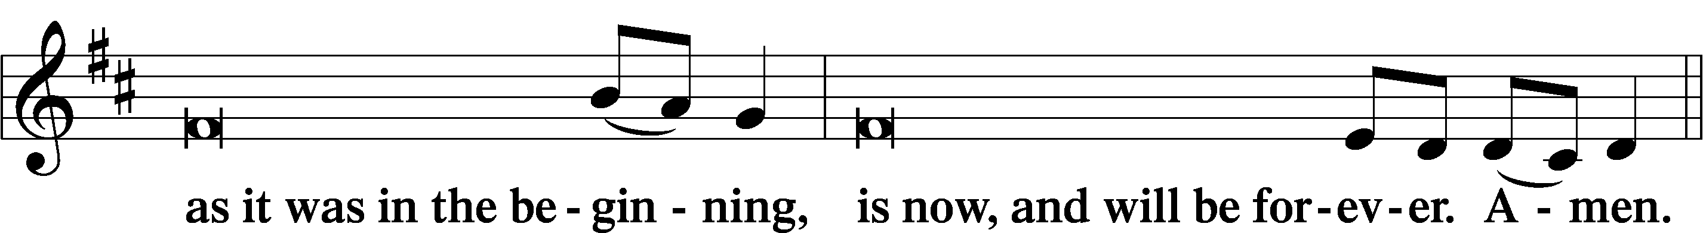
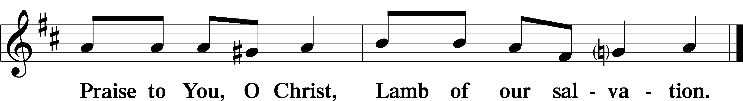

Psalmody

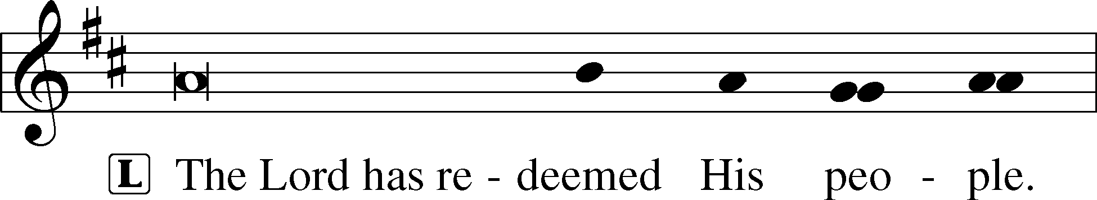
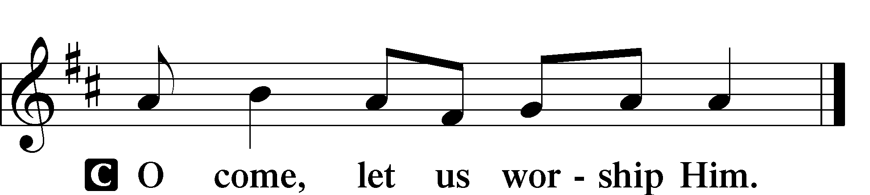

Venite LSB 220
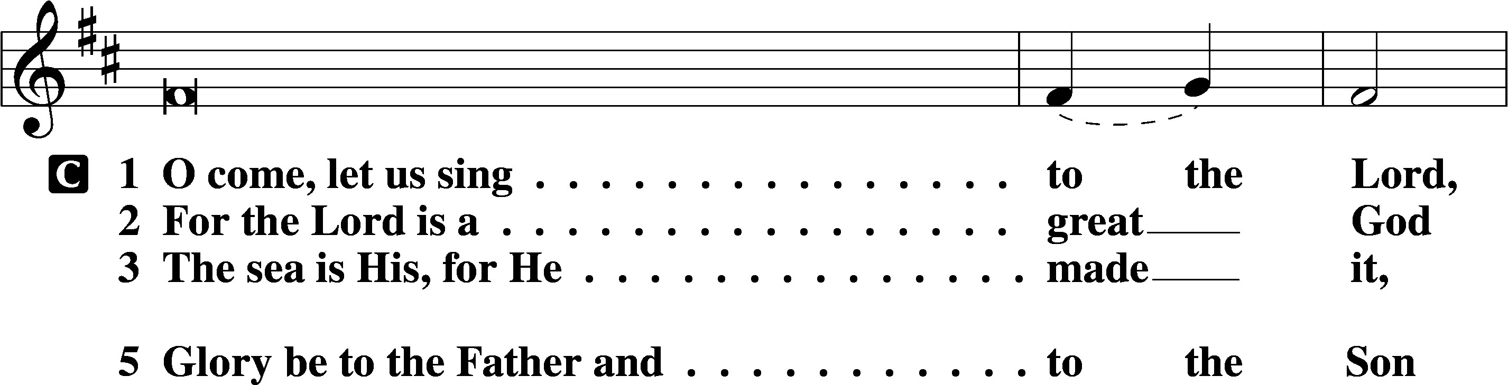
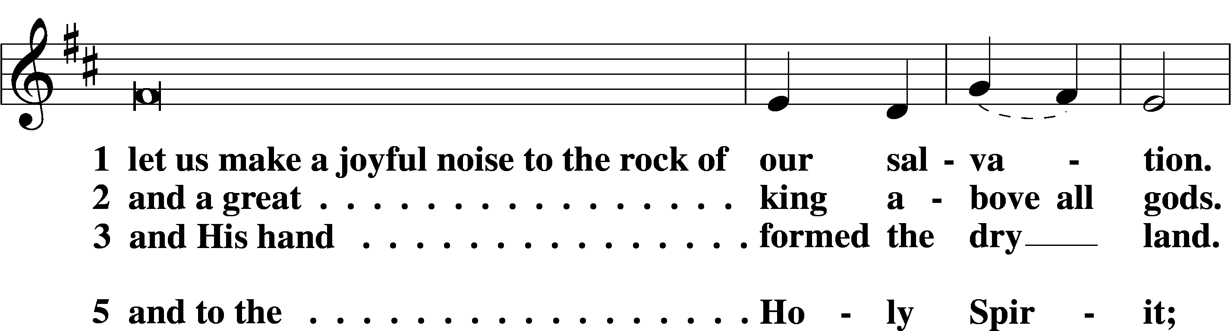
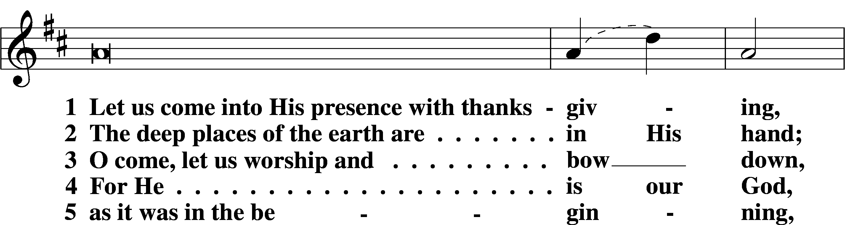
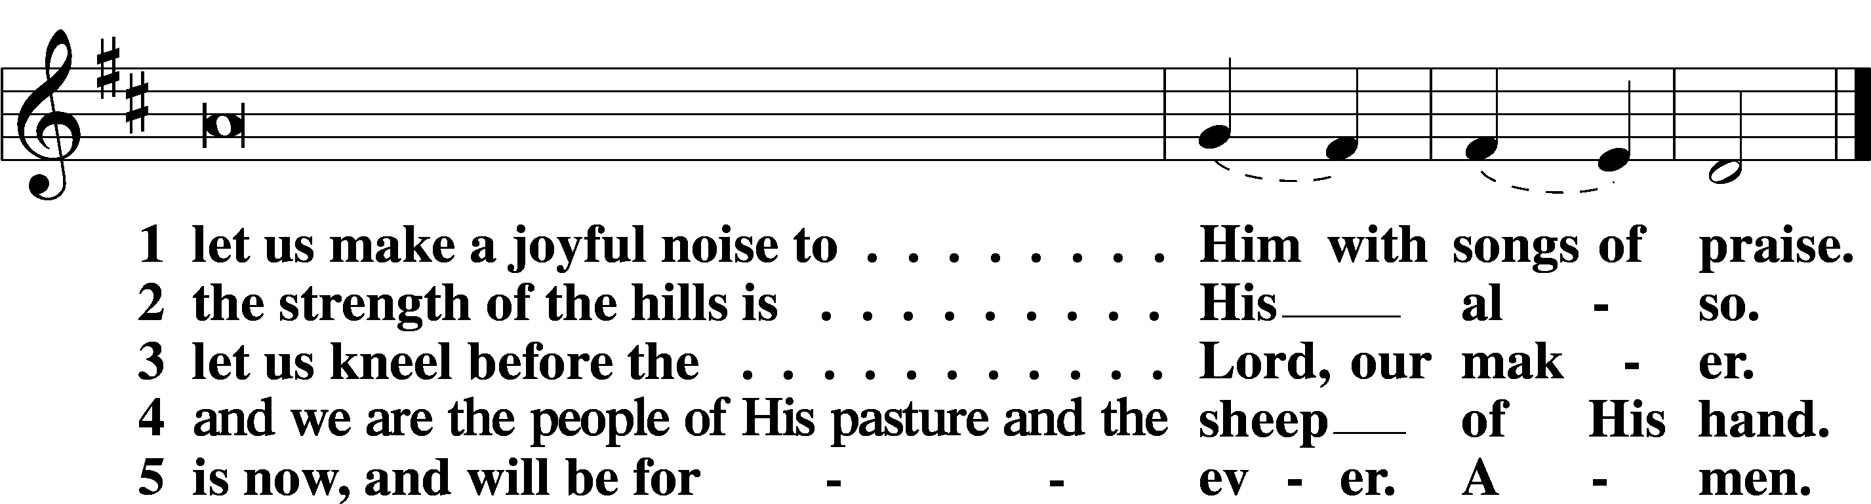

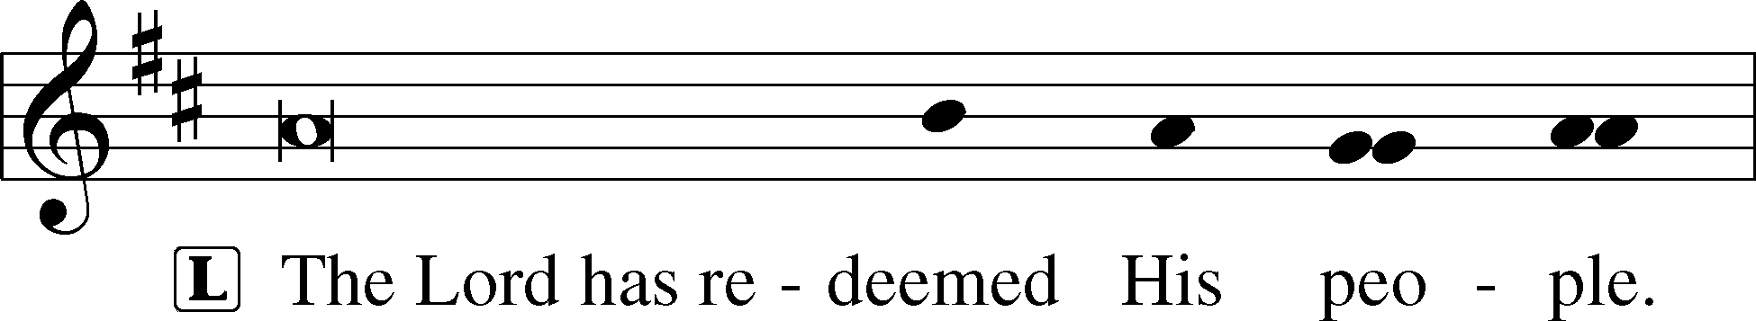
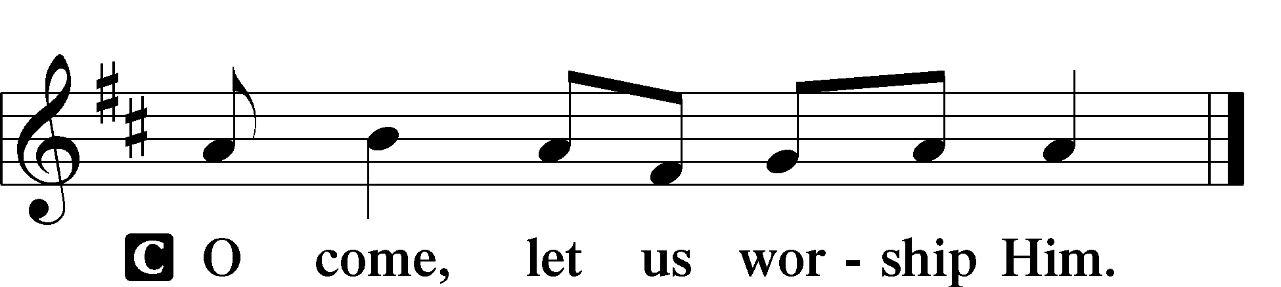

Additional Psalms Psalm 130; antiphon: v. 7
1Out | of the depths*
I cry to you, | O Lord!
2O Lord, | hear my voice!*
Let your ears be attentive
to the voice of my pleas for | mercy!
3If you, O Lord, should mark in- | iquities,*
O Lord, | who could stand?
4But with you there is for- | giveness,*
that you | may be feared.
5I wait for the Lord, my | soul waits,*
and in his | word I hope;
6my soul waits for the Lord
more than watchmen for the | morning,*
more than watchmen for the | morning.
7O Israel, hope in the Lord!
For with the Lord there is | steadfast love,*
and with him is plentiful re- | demption.
8And he will redeem | Israel*
from all his in- | iquities.

Sit

430 My Song Is Love Unknown
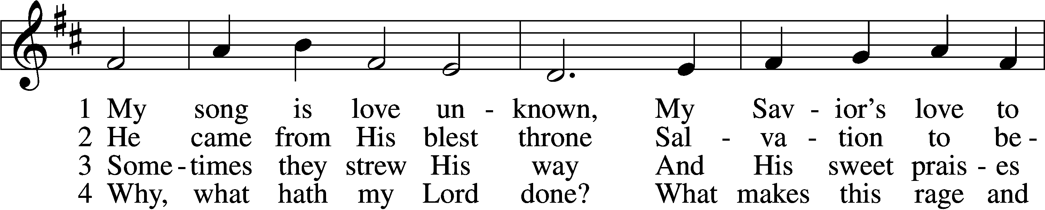
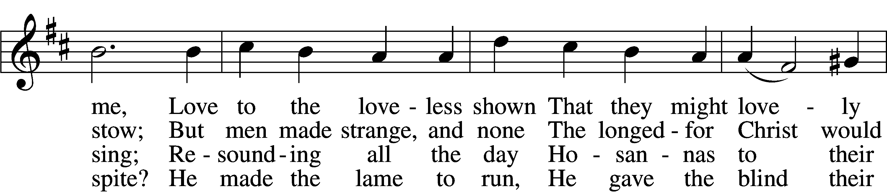
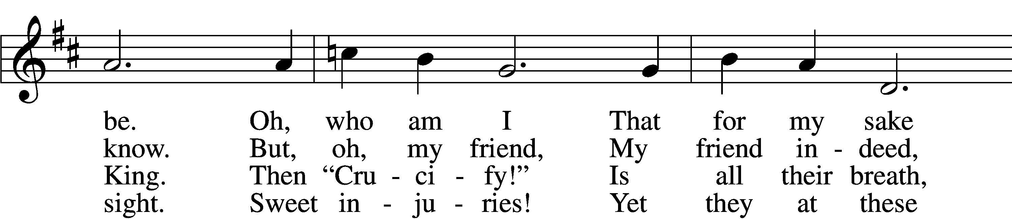
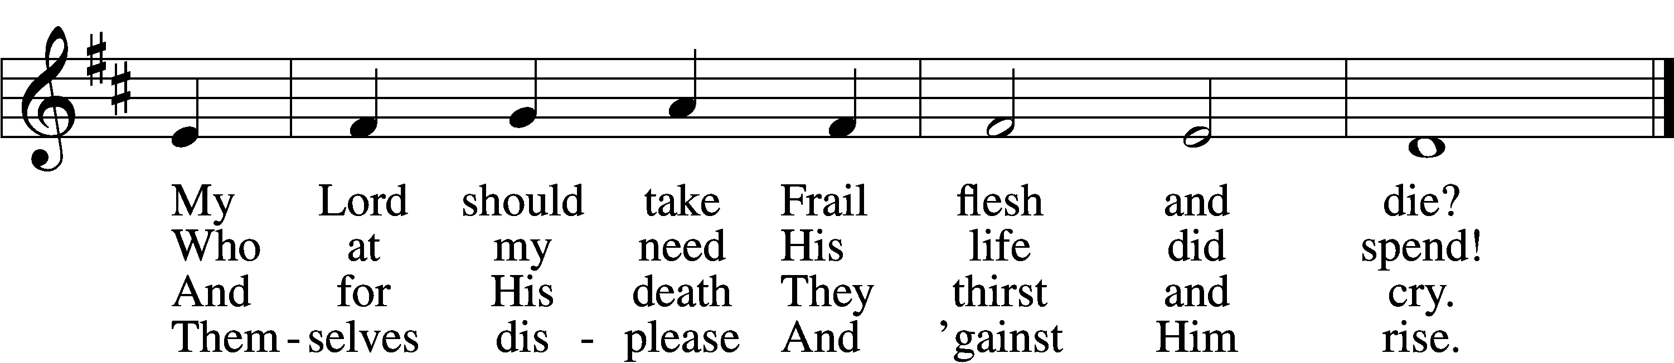

5 They rise and needs will have
My dear Lord made away;
A murderer they save,
The Prince of Life they slay.
Yet cheerful He
To suff’ring goes
That He His foes
From thence might free.

6 In life no house, no home
My Lord on earth might have;
In death no friendly tomb
But what a stranger gave.
What may I say?
Heav’n was His home
But mine the tomb
Wherein He lay.

7 Here might I stay and sing,
No story so divine!
Never was love, dear King,
Never was grief like Thine.
This is my friend,
In whose sweet praise
I all my days
Could gladly spend!
Tune: © John Ireland Trust. Used by permission: CPH Limited Promotional License no. 119000000
Text: Public domain

Readings

Reading Ezekiel 37:1–14
1The hand of the Lord was upon me, and he brought me out in the Spirit of the Lord and set me down in the middle of the valley; it was full of bones. 2And he led me around among them, and behold, there were very many on the surface of the valley, and behold, they were very dry. 3And he said to me, “Son of man, can these bones live?” And I answered, “O Lord God, you know.” 4Then he said to me, “Prophesy over these bones, and say to them, O dry bones, hear the word of the Lord. 5Thus says the Lord God to these bones: Behold, I will cause breath to enter you, and you shall live. 6And I will lay sinews upon you, and will cause flesh to come upon you, and cover you with skin, and put breath in you, and you shall live, and you shall know that I am the Lord.”
7So I prophesied as I was commanded. And as I prophesied, there was a sound, and behold, a rattling, and the bones came together, bone to its bone. 8And I looked, and behold, there were sinews on them, and flesh had come upon them, and skin had covered them. But there was no breath in them. 9Then he said to me, “Prophesy to the breath; prophesy, son of man, and say to the breath, Thus says the Lord God: Come from the four winds, O breath, and breathe on these slain, that they may live.” 10So I prophesied as he commanded me, and the breath came into them, and they lived and stood on their feet, an exceedingly great army.
11Then he said to me, “Son of man, these bones are the whole house of Israel. Behold, they say, ‘Our bones are dried up, and our hope is lost; we are clean cut off.’ 12Therefore prophesy, and say to them, Thus says the Lord God: Behold, I will open your graves and raise you from your graves, O my people. And I will bring you into the land of Israel. 13And you shall know that I am the Lord, when I open your graves, and raise you from your graves, O my people. 14And I will put my Spirit within you, and you shall live, and I will place you in your own land. Then you shall know that I am the Lord; I have spoken, and I will do it, declares the Lord.”

P: This is the Word of the Lord.

C: Thanks be to God.

Reading Romans 8:1–11
1There is therefore now no condemnation for those who are in Christ Jesus. 2For the law of the Spirit of life has set you free in Christ Jesus from the law of sin and death. 3For God has done what the law, weakened by the flesh, could not do. By sending his own Son in the likeness of sinful flesh and for sin, he condemned sin in the flesh, 4in order that the righteous requirement of the law might be fulfilled in us, who walk not according to the flesh but according to the Spirit. 5For those who live according to the flesh set their minds on the things of the flesh, but those who live according to the Spirit set their minds on the things of the Spirit. 6To set the mind on the flesh is death, but to set the mind on the Spirit is life and peace. 7For the mind that is set on the flesh is hostile to God, for it does not submit to God’s law; indeed, it cannot. 8Those who are in the flesh cannot please God.
9You, however, are not in the flesh but in the Spirit, if in fact the Spirit of God dwells in you. Anyone who does not have the Spirit of Christ does not belong to him. 10But if Christ is in you, although the body is dead because of sin, the Spirit is life because of righteousness. 11If the Spirit of him who raised Jesus from the dead dwells in you, he who raised Christ Jesus from the dead will also give life to your mortal bodies through his Spirit who dwells in you.

P: This is the Word of the Lord.

C: Thanks be to God.

Reading John 11:1–45
1Now a certain man was ill, Lazarus of Bethany, the village of Mary and her sister Martha. 2It was Mary who anointed the Lord with ointment and wiped his feet with her hair, whose brother Lazarus was ill. 3So the sisters sent to him, saying, “Lord, he whom you love is ill.” 4But when Jesus heard it he said, “This illness does not lead to death. It is for the glory of God, so that the Son of God may be glorified through it.”
5Now Jesus loved Martha and her sister and Lazarus. 6So, when he heard that Lazarus was ill, he stayed two days longer in the place where he was. 7Then after this he said to the disciples, “Let us go to Judea again.” 8The disciples said to him, “Rabbi, the Jews were just now seeking to stone you, and are you going there again?” 9Jesus answered, “Are there not twelve hours in the day? If anyone walks in the day, he does not stumble, because he sees the light of this world. 10But if anyone walks in the night, he stumbles, because the light is not in him.” 11After saying these things, he said to them, “Our friend Lazarus has fallen asleep, but I go to awaken him.” 12The disciples said to him, “Lord, if he has fallen asleep, he will recover.” 13Now Jesus had spoken of his death, but they thought that he meant taking rest in sleep. 14Then Jesus told them plainly, “Lazarus has died, 15and for your sake I am glad that I was not there, so that you may believe. But let us go to him.” 16So Thomas, called the Twin, said to his fellow disciples, “Let us also go, that we may die with him.”
17Now when Jesus came, he found that Lazarus had already been in the tomb four days. 18Bethany was near Jerusalem, about two miles off, 19and many of the Jews had come to Martha and Mary to console them concerning their brother. 20So when Martha heard that Jesus was coming, she went and met him, but Mary remained seated in the house. 21Martha said to Jesus, “Lord, if you had been here, my brother would not have died. 22But even now I know that whatever you ask from God, God will give you.” 23Jesus said to her, “Your brother will rise again.” 24Martha said to him, “I know that he will rise again in the resurrection on the last day.” 25Jesus said to her, “I am the resurrection and the life. Whoever believes in me, though he die, yet shall he live, 26and everyone who lives and believes in me shall never die. Do you believe this?” 27She said to him, “Yes, Lord; I believe that you are the Christ, the Son of God, who is coming into the world.”
28When she had said this, she went and called her sister Mary, saying in private, “The Teacher is here and is calling for you.” 29And when she heard it, she rose quickly and went to him. 30Now Jesus had not yet come into the village, but was still in the place where Martha had met him. 31When the Jews who were with her in the house, consoling her, saw Mary rise quickly and go out, they followed her, supposing that she was going to the tomb to weep there. 32Now when Mary came to where Jesus was and saw him, she fell at his feet, saying to him, “Lord, if you had been here, my brother would not have died.” 33When Jesus saw her weeping, and the Jews who had come with her also weeping, he was deeply moved in his spirit and greatly troubled. 34And he said, “Where have you laid him?” They said to him, “Lord, come and see.” 35Jesus wept. 36So the Jews said, “See how he loved him!” 37But some of them said, “Could not he who opened the eyes of the blind man also have kept this man from dying?”
38Then Jesus, deeply moved again, came to the tomb. It was a cave, and a stone lay against it. 39Jesus said, “Take away the stone.” Martha, the sister of the dead man, said to him, “Lord, by this time there will be an odor, for he has been dead four days.” 40Jesus said to her, “Did I not tell you that if you believed you would see the glory of God?” 41So they took away the stone. And Jesus lifted up his eyes and said, “Father, I thank you that you have heard me. 42I knew that you always hear me, but I said this on account of the people standing around, that they may believe that you sent me.” 43When he had said these things, he cried out with a loud voice, “Lazarus, come out.” 44The man who had died came out, his hands and feet bound with linen strips, and his face wrapped with a cloth. Jesus said to them, “Unbind him, and let him go.”
45Many of the Jews therefore, who had come with Mary and had seen what he did, believed in him.

P: This is the Word of the Lord.

C: Thanks be to God.

Responsory (Lent) LSB 222
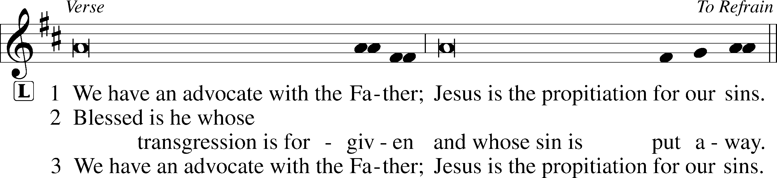
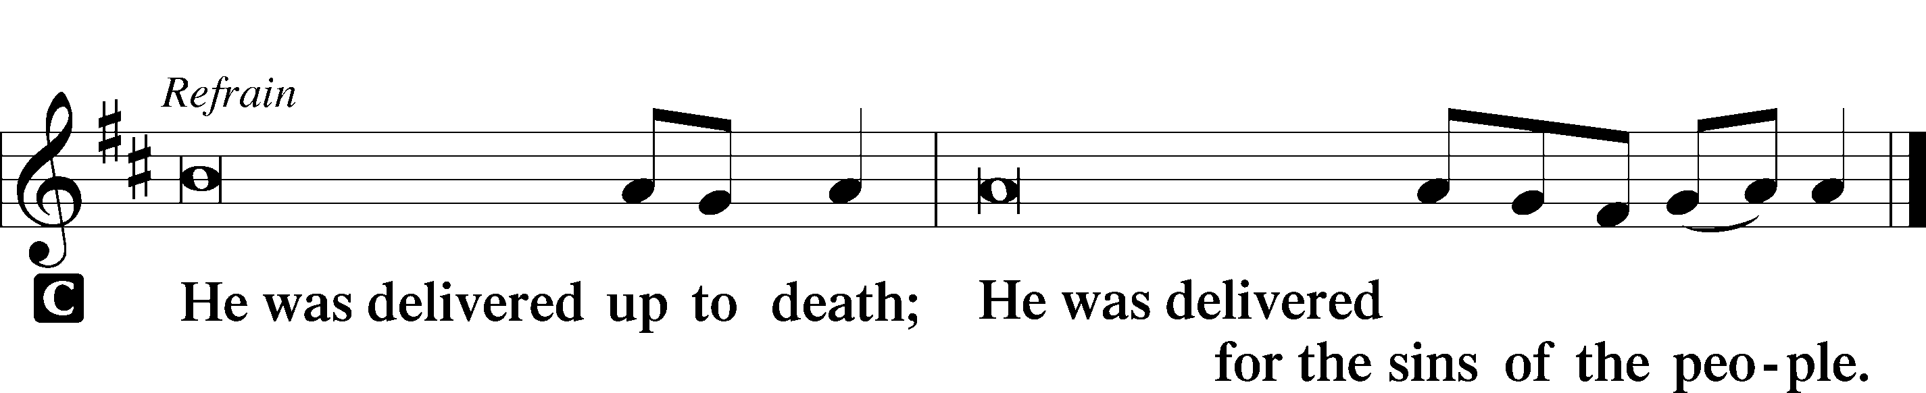

Sermon

Canticle

Stand

Te Deum LSB 223
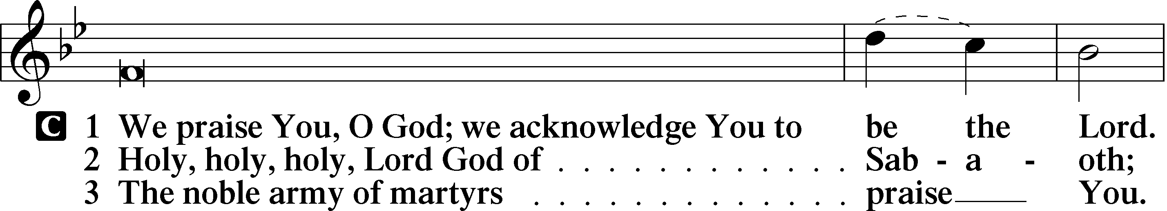
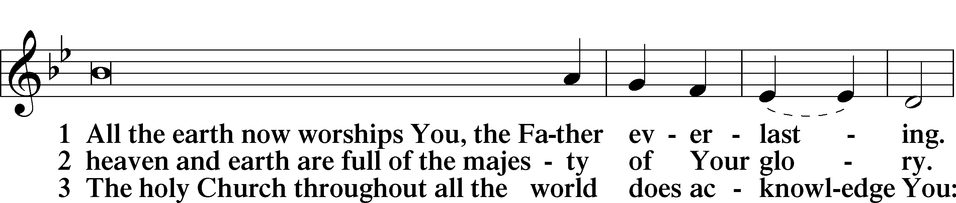
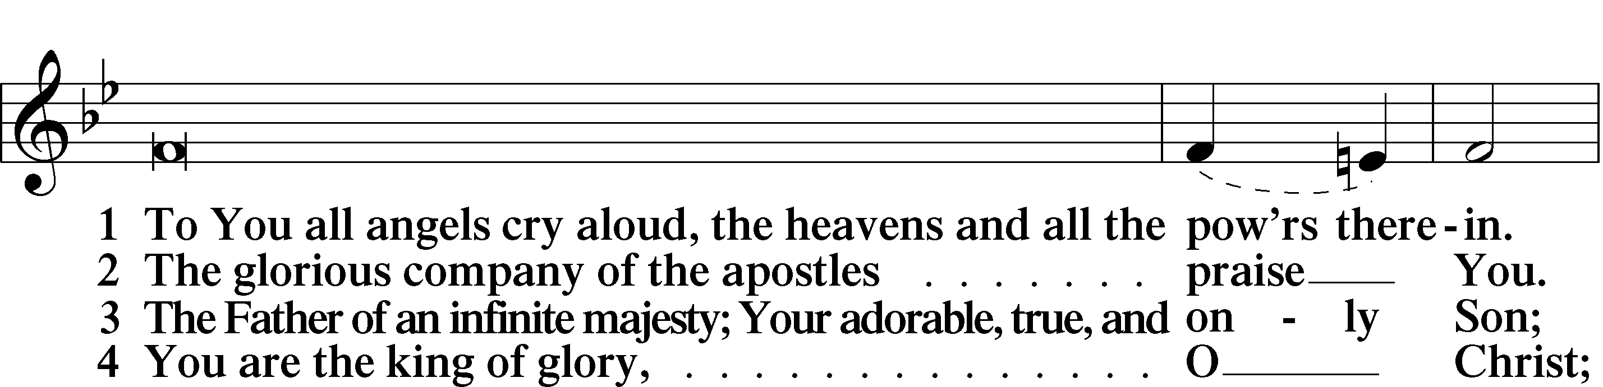
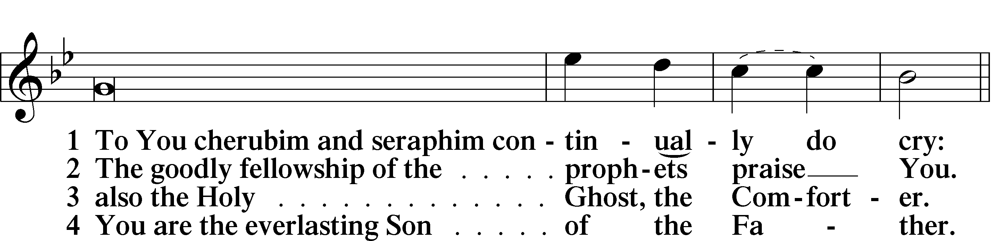
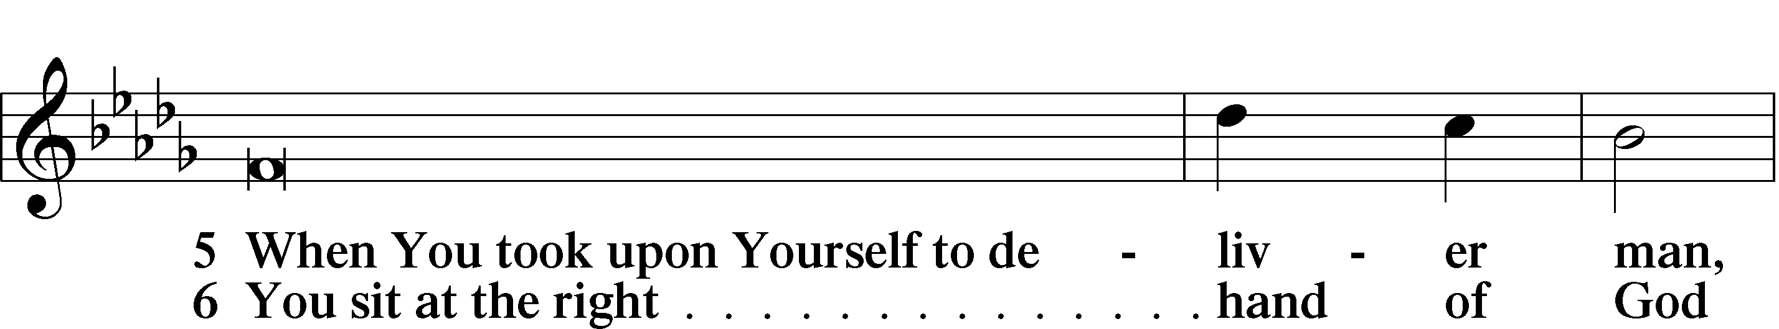
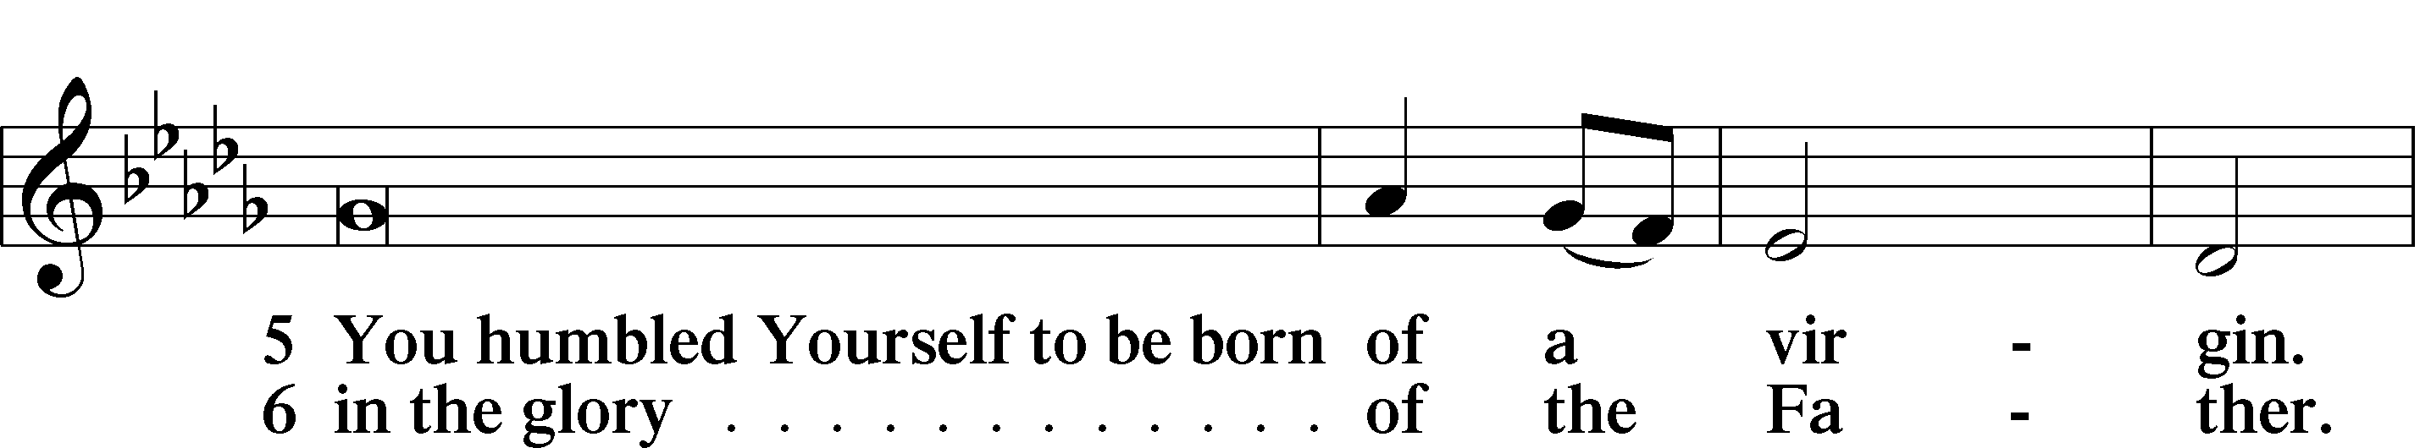
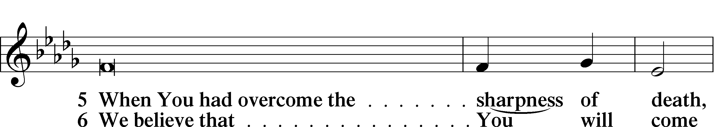
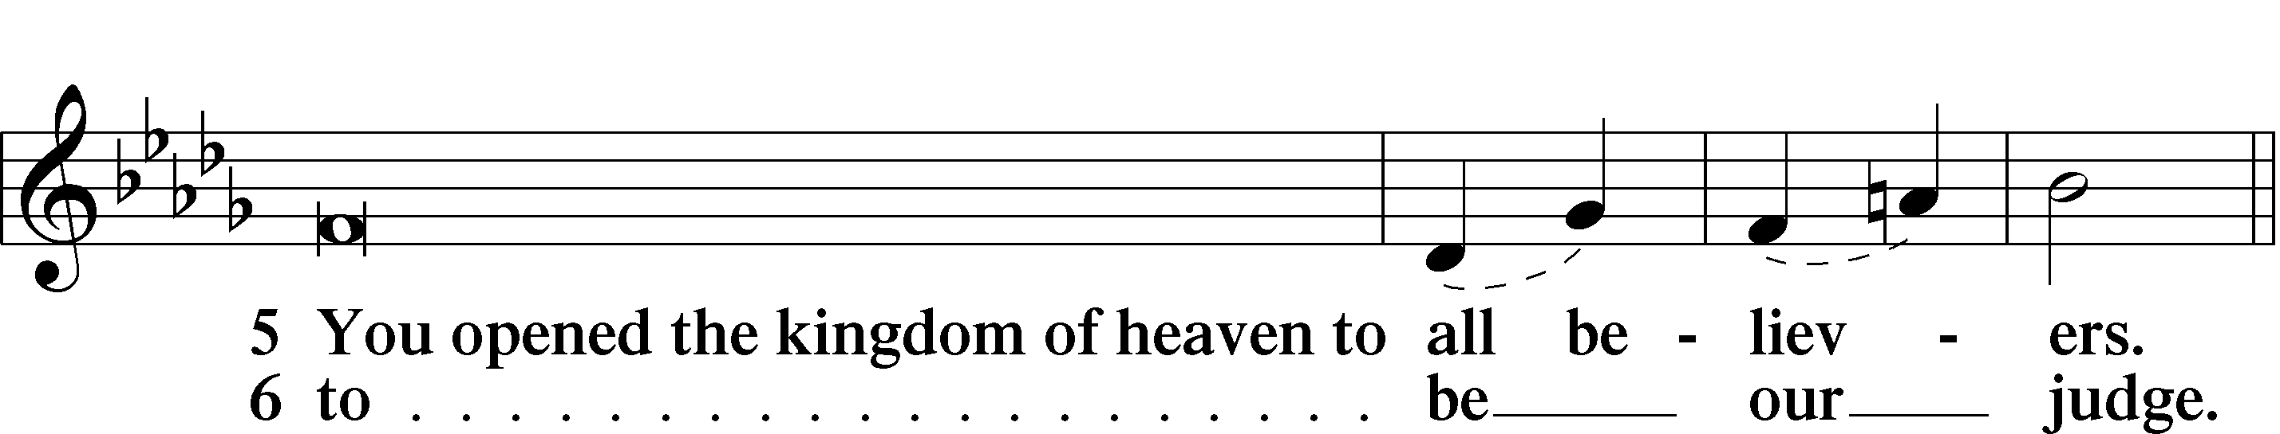

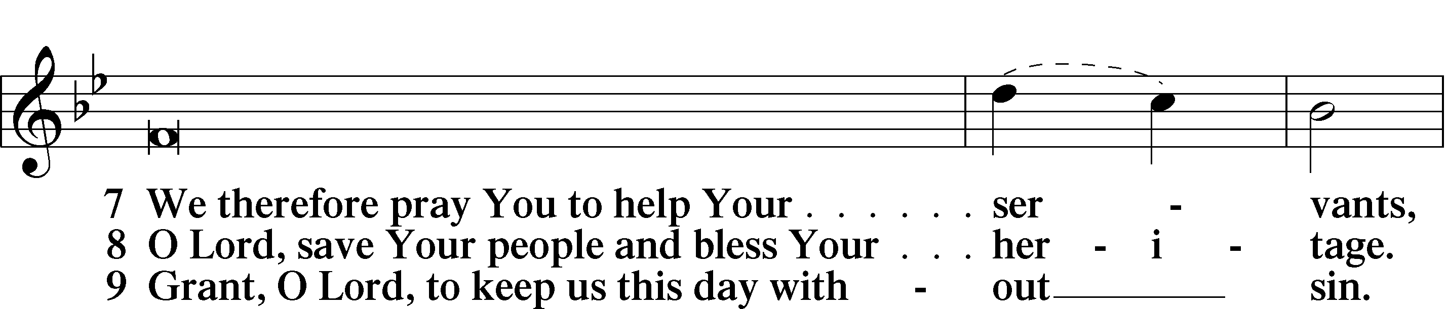
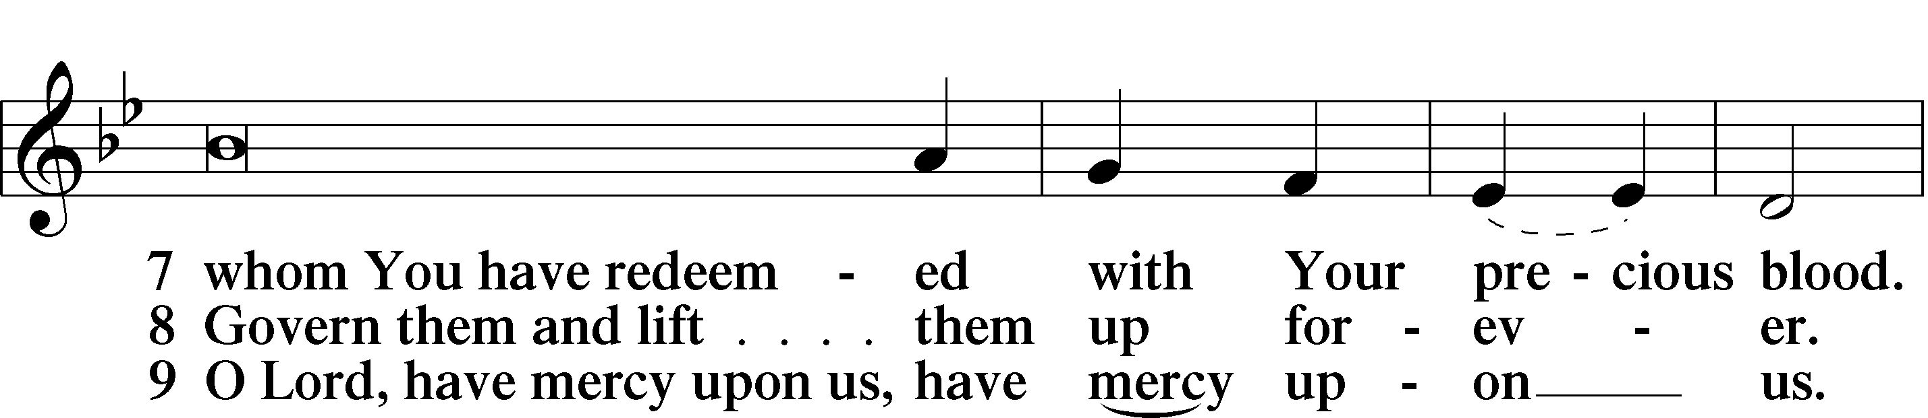
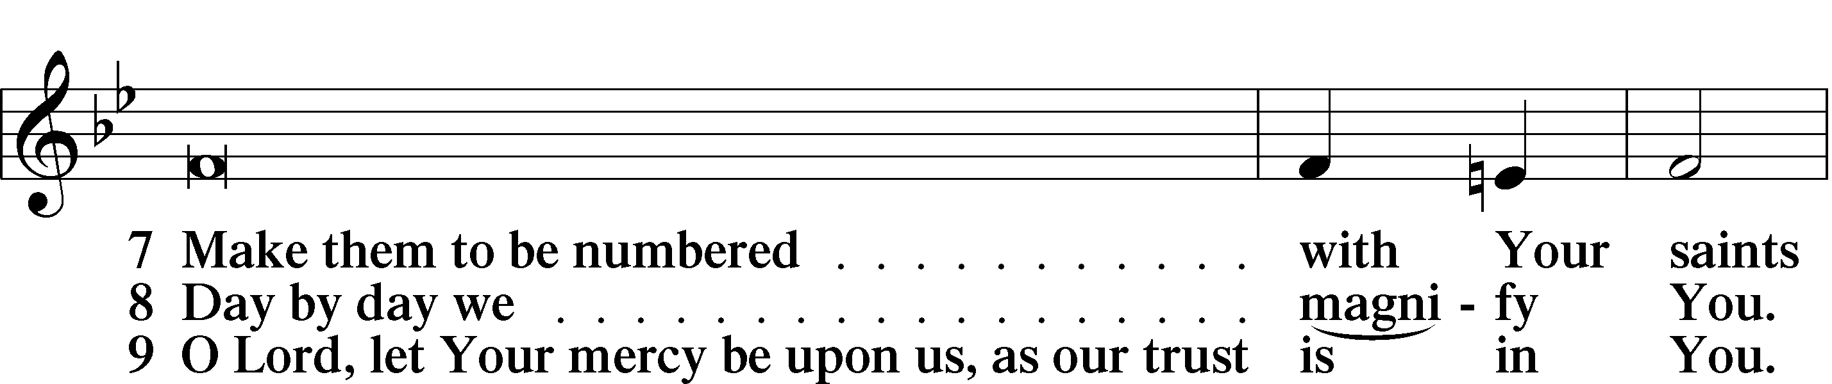
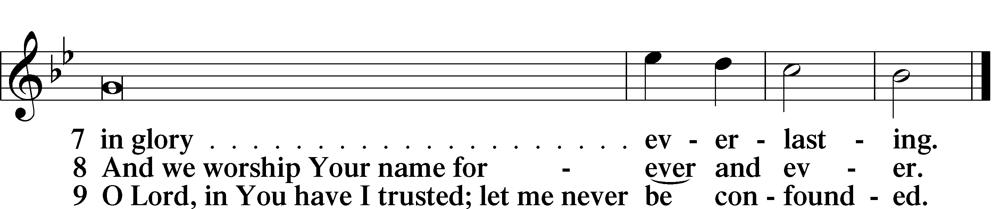

Sit

Offering Options:

1) Go to www.zionkearney.org and click on the Push Pay icon;

2) Mail or drop off your envelope at 2421 Avenue C, Kearney, NE 68847
Prayer

Kneel/Stand

Kyrie LSB 227
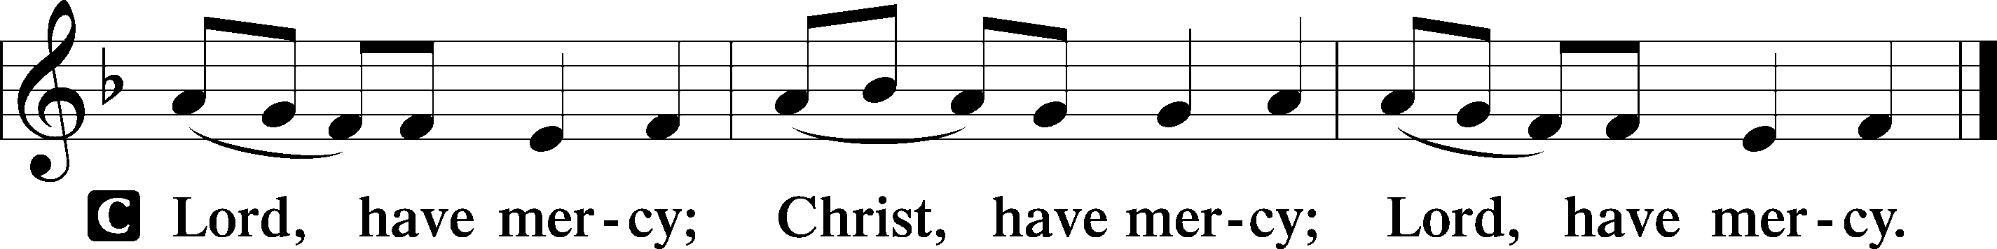

Lord’s Prayer
C Our Father who art in heaven,
hallowed be Thy name,
Thy kingdom come,
Thy will be done on earth
as it is in heaven;
give us this day our daily bread;
and forgive us our trespasses
as we forgive those
who trespass against us;
and lead us not into temptation,
but deliver us from evil.
For Thine is the kingdom
and the power and the glory
forever and ever. Amen.

Collects

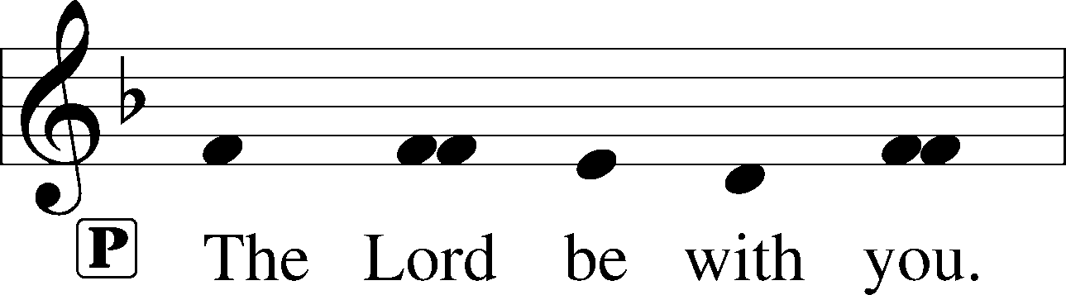
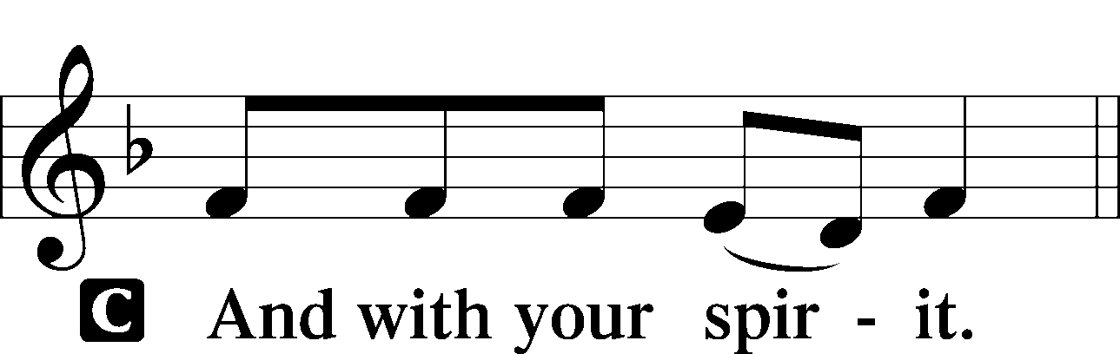

Collect of the Day
L Almighty God, by Your great goodness mercifully look upon Your people that we may be governed and preserved
evermore in body and soul; through Jesus Christ, Your Son, our Lord, who lives and reigns with You and the Holy Spirit, one God, now and forever.
C Amen.

Prayers of the Church

Collect for Grace
L O Lord, our heavenly Father, almighty and everlasting God, You have safely brought us to the beginning of this day. Defend us in the same with Your mighty power and grant that this day we fall into no sin, neither run into any kind of danger, but that all our doings, being ordered by Your governance, may be righteous in Your sight; through Jesus Christ, Your Son, our Lord, who lives and reigns with You and the Holy Spirit, one God, now and forever.
C Amen.

Stand

Benedicamus LSB 228
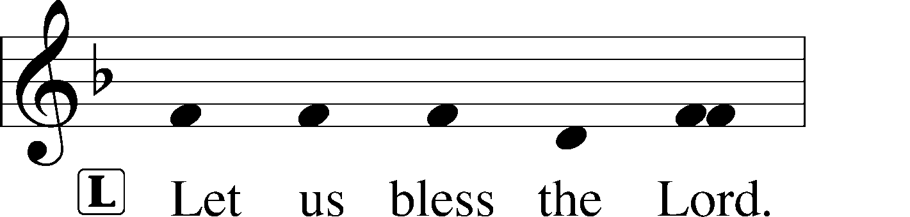
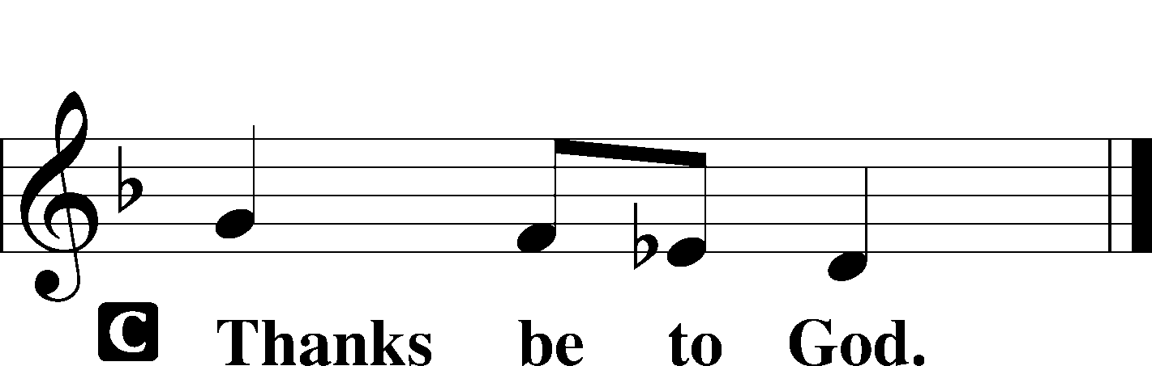

Benediction LSB 228
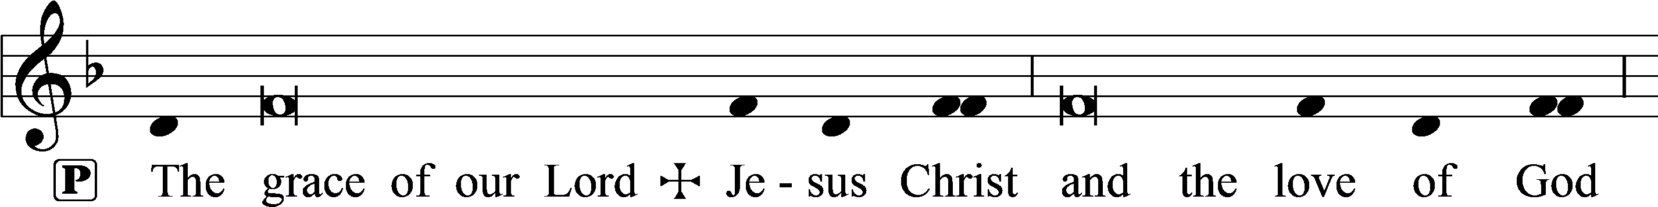
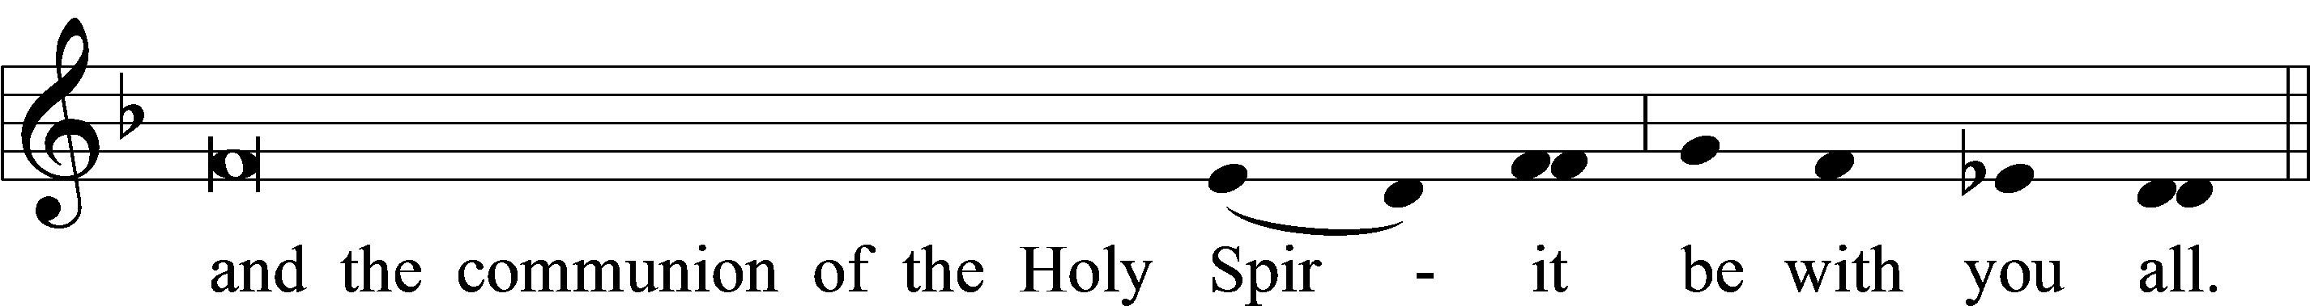

543 What Wondrous Love Is This
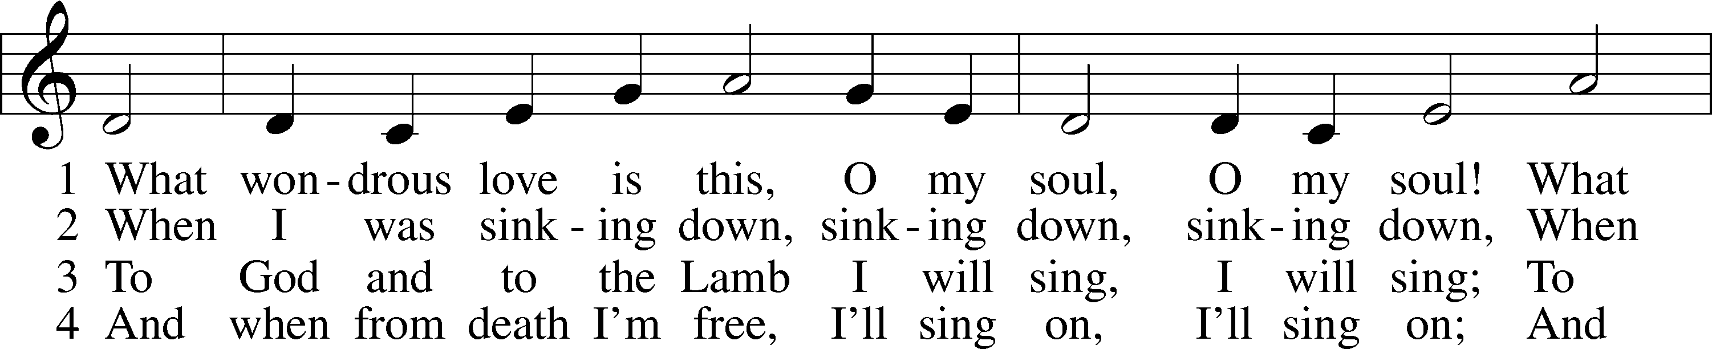
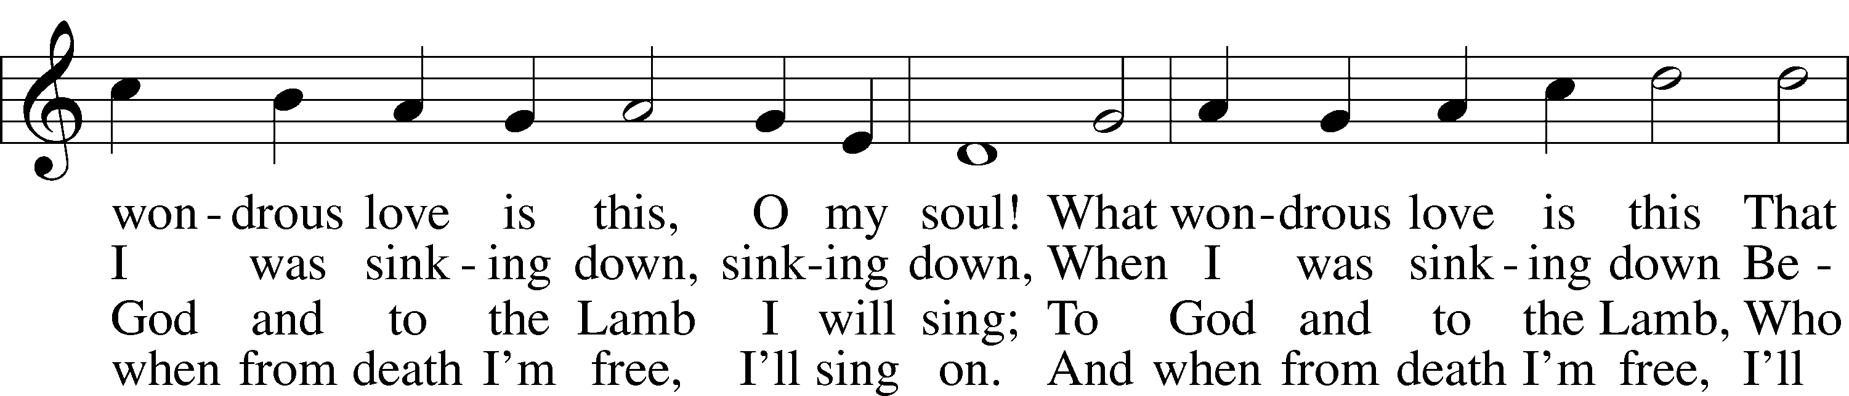
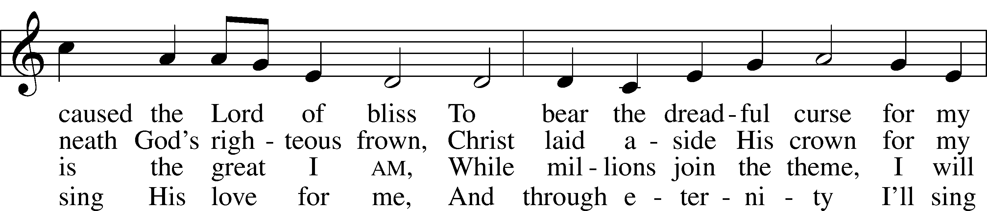
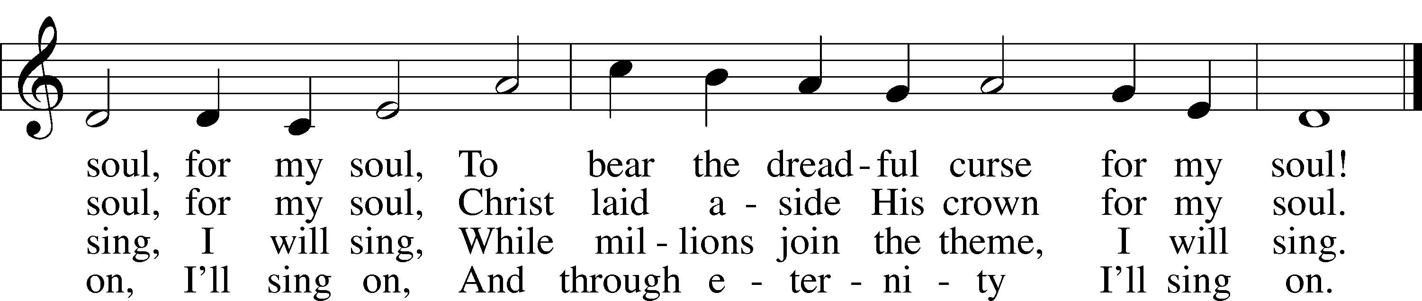
Tune and text: Public domain

Acknowledgments
Matins from Lutheran Service Book
Unless otherwise indicated, Scripture quotations are from the ESV® Bible (The Holy Bible, English Standard Version®), copyright © 2001 by Crossway, a publishing ministry of Good News Publishers. Used by permission. All rights reserved.
Created by Lutheran Service Builder © 2018 Concordia Publishing House.

The Radio Broadcast today is given to the Glory of the Lord by Todd & Ellen Koopman

Our Response to the Gospel

Date: 03/22/2020

Attendance: cancelled

Offering: $3,855.00
Weekly Need: $7,542.37

Prayers for Our Members
Chelsea Junge, Christina Long, Tenaya Nuttelman | Expectant Mothers
Norman Abels (Brookestone Meadows – Elkhorn) | Healing
Judy Ahrens | Healing
Vaughn Albrecht (Northridge) | Healing
Tom & DyAnn Altwine | Healing
Lyle Colsden (Mother Hull) | Healing
Brenda Fletcher | Healing
Pat Flodine (Cambridge Court) | Healing
Vi Fox (Prairie View) | Healing
Verleen Gentry | Healing
Robert Glanzer | Healing
Tiffany Hartman | Healing
Ruby Hatfield | Healing
Carol Herron | Healing
Carol Kreutzer | Healing
Marion Richmond | Healing
Geraldine Roeder | Healing
Dorothy Sikes | Healing
Carolyn Westman | Healing
Bev Nuttelman | Cancer
Kim Vos | Cancer
Prayers for Our Members’ Family & Friends
Brittany Helmbrecht (Don & Shirley’s daughter-in-law) | Expectant Mother
Becci Koopman (Todd & Ellen Koopman daughter-in-law) | Expectant Mother
Shaylee Kreutzer (Rich & Carol Kreutzer’s daughter-in-law) | Expectant Mother
Lana Latsabidze (Bruce & Ann Fattig daughter-in-law) | Expectant Mother
Amy Nuttelman (Keith & Bev Nuttelman’s daughter-in-law) | Expectant Mother
Family and Friends Wyatt Smidt (Zion student) | Grief
Ava Jean Winnie (Nic Kitzing’s cousin) | Healing
Will Brennemann (Jami Helmbrecht’s father) | Healing
Don Berg (Evelyn Heiden’s brother) | Healing
Reg Duke (Westman’s brother-in-law) | Healing
James Gentry (Verleen Gentry’s son) | Healing
Mark Glover (Shirley Helmbrecht’s brother) | Healing
Brooke Guthrie (Bailey Hockemeier’s sister) | Healing
Lois Hanson (Pastor Hanson’s wife) | Healing
Norman Hockemeier (Ken’s father) | Healing
Roger Hoffman (Marc’s father) | Healing
Miles Margritz (Wanda Glanzer’s nephew) | Healing
Randy Solomon (Beth Rosenthal’s father) | Healing
Mary Ann Mertz (Pam’s Uhlir’s friend) | Healing
Roy Reynolds (Verleen Gentry’s son-in-law) | Healing
Larry Willers (Todd Willers’ father) | Healing
Tyler Christensen (Bruce & Joni Brooks nephew) | Cancer
Patty Ellis (Fran Junge’s sister) | Cancer
Ron Halvorsen (Jeff’s dad) | Cancer
Carol Haubold (Don Helmbrecht’s sister) | Cancer
Tyler Holland (Quentin & Janel Lange brother-in-law) | Cancer
Fred Koch (Pam Uhlir’s cousin) | Cancer
Lynda Kreutzer (Rich & Carol’s sister-in-law) | Cancer
Sharon Mulhair (Pam Uhlir’s cousin) | Cancer
Tyrone Uhlir (Pam’s nephew) | Cancer
Members of Zion Lutheran North Shelton | Loss & Restoration
Pr.James, Pr. Clausing, Our sister congregations in Haiti | Missionaries
John Christensen, John Harbols | Military

Note: The bold items are new or changes

Sun  03/29 | 9:00a | Divine Service
Mon  03/30 | Birthdays  Anniversaries | ---  ---
Tues  03/31 | Birthdays  Anniversaries | Carol Florang  ---
Wed  04/01 | 5:45p  Birthdays  Anniversaries | Midweek - ONLINE  ---  James & Patricia Catterson
Thurs  04/02 | 7:00p  Birthdays  Anniversaries | Adult Instruction  ---  Alton & Sylvia Schmitt
Fri  04/03 | Birthdays  Anniversaries | Quentin Lange  ---
Sat  04/04 | Birthdays  Anniversaries | ---  ---
Sun  04/05 | 9:00a  Birthdays  Anniversaries | Divine Service  Addison Helmbrecht  Donald Richmond  ---

Serving in Worship

Sunday, March 29 9:00am
Acolyte: Jacob Halvorsen
Elder: Dan Oertwig
Usher: Marc Hoffman & Steve Junge
Engineer: Peter Kreutzer
Announcer: Brooke Fisher
Altar Guild: Mary Fiddelke & Lyn Hoffman

Sunday, April 5 9:00am
Acolyte: Allison Wilkens
Elder: Ken Hockemeier
Usher: Fred Flessner & Lennis Hodgson
Engineer: Peter Kreutzer
Announcer: Jesse Florang
Altar Guild: Ellen Hockemeier &
Rachael Burger

ZION LUTHERAN CHURCH AND SCHOOL

Pr. James DeLoach, Pastor + (308) 627-5260
james.deloach@zionkearney.org

Pr. Doug Gaunt, Pastor + (308) 455-0552
doug.gaunt@zionkearney.org

Tony Splittgerber, Principal + (308) 293-0168
anthony.splittgerber@zionkearney.org

Church Office
Administrative Assistant: Jessica Shiers
Email: school@zionkearney.org
Phone: (308)-234-3410 Fax: (308) 236-8100
Office Hours: Monday-Friday 8:00am-4:00pm
Radio Broadcast: Sunday @ 10:30 a.m. on 1460 AM
Website: www.zionkearney.com

