Confession and Absolution

709 The King of Love My Shepherd Is
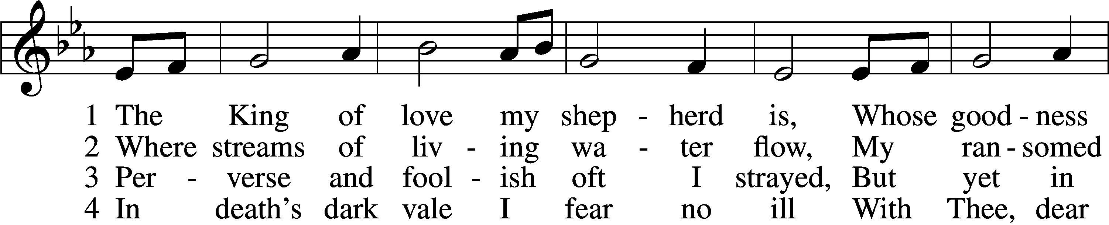
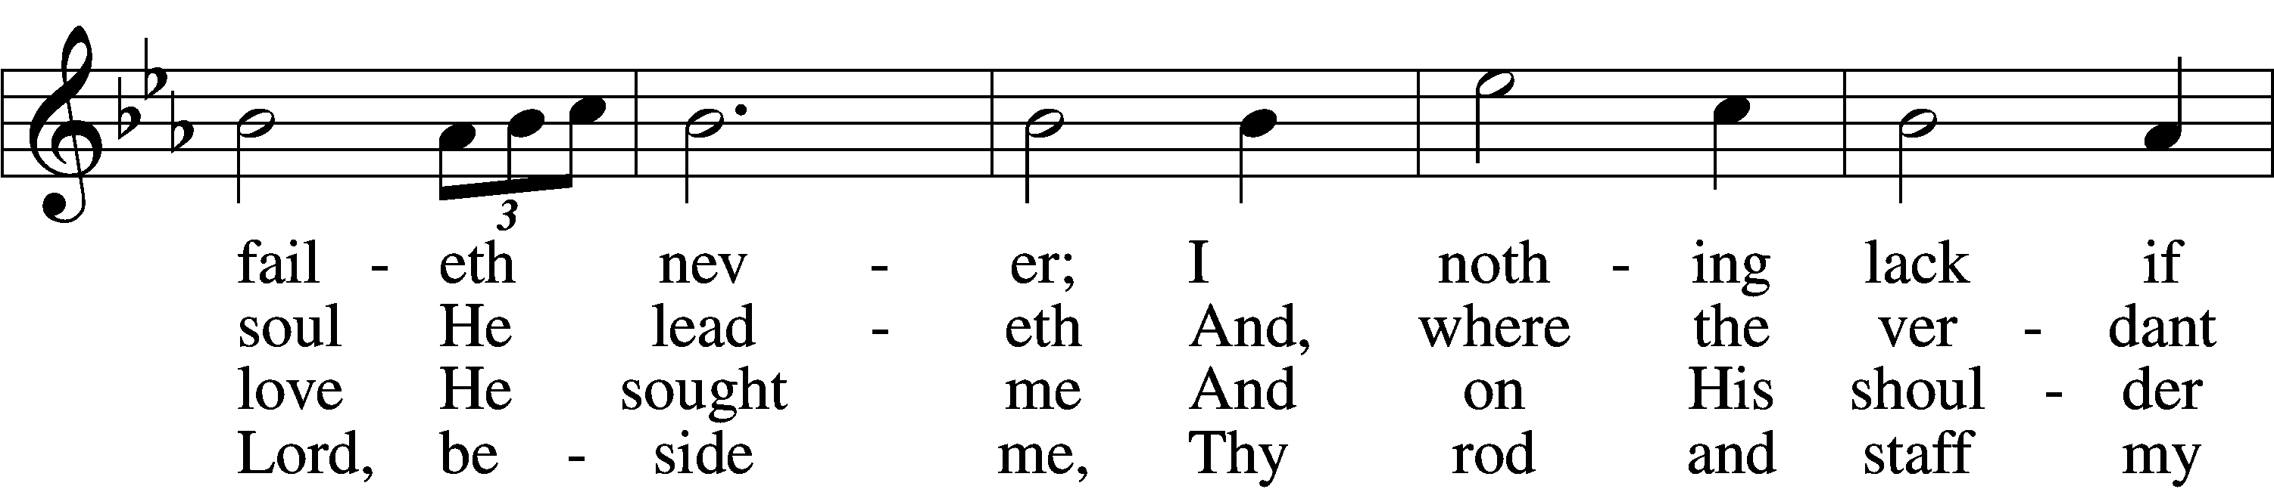
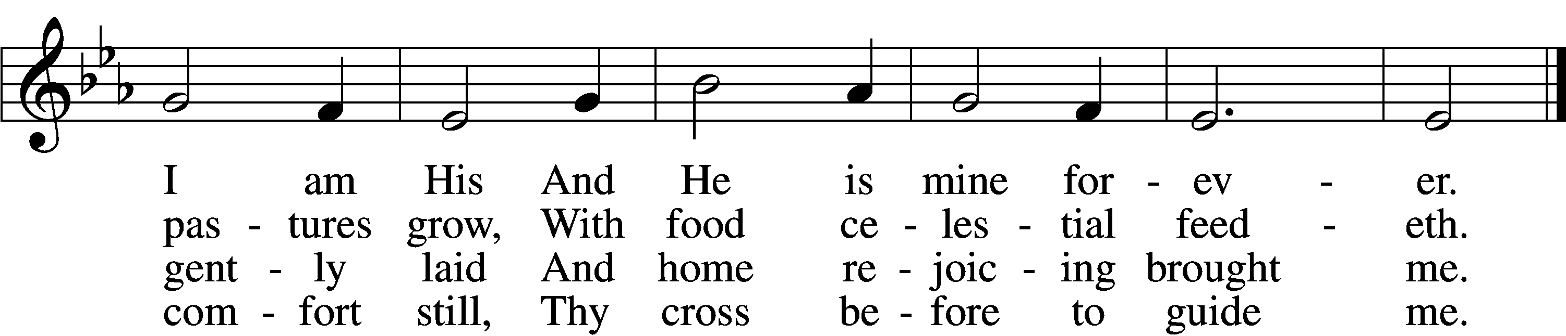

5 Thou spreadst a table in my sight;
Thine unction grace bestoweth;
And, oh, what transport of delight
From Thy pure chalice floweth!

6 And so through all the length of days
Thy goodness faileth never;
Good Shepherd, may I sing Thy praise
Within Thy house forever!
Text and tune: Public domain

The sign of the cross may be made by all in remembrance of their Baptism.

P In the name of the Father and of the T Son and of the Holy Spirit.
C Amen.

P If we say we have no sin, we deceive ourselves, and the truth is not in us.
C But if we confess our sins, God, who is faithful and just, will forgive our sins and cleanse us from all unrighteousness.

Silence for reflection on God’s Word and for self-examination.

P Let us then confess our sins to God our Father.
C Most merciful God, we confess that we are by nature sinful and unclean. We have sinned against You in thought, word, and deed, by what we have done and by what we have left undone. We have not loved You with our whole heart; we have not loved our neighbors as ourselves. We justly deserve Your present and eternal punishment. For the sake of Your Son, Jesus Christ, have mercy on us. Forgive us, renew us, and lead us, so that we may delight in Your will and walk in Your ways to the glory of Your holy name. Amen.

P Almighty God in His mercy has given His Son to die for you and for His sake forgives you all your sins. As a called and ordained servant of Christ, and by His authority, I therefore forgive you all your sins in the name of the Father and of the T Son and of the Holy Spirit.
C Amen.

Service of the Word

Introit Psalm 95:1–3, 6–7a; antiphon: John 10:14, 15b
I am the good | shepherd.*
I know my own and my own know me, and I lay down my life | for the sheep.
Oh come, let us sing | to the Lord;*
let us make a joyful noise to the rock of our sal- | vation!
Let us come into his presence with thanks- | giving;*
let us make a joyful noise to him with | songs of praise!
For the Lord is a | great God,*
and a great King a- | bove all gods.
Oh come, let us worship and | bow down;*
let us kneel before the Lord, our | Maker!
For he | is our God,*
and we are the people of his pasture, and the sheep | of his hand.
Glory be to the Father and | to the Son*
and to the Holy | Spirit;
as it was in the be- | ginning,*
is now, and will be forever. | Amen.
I am the good | shepherd.*
I know my own and my own know me, and I lay down my life | for the sheep.

Kyrie LSB 152
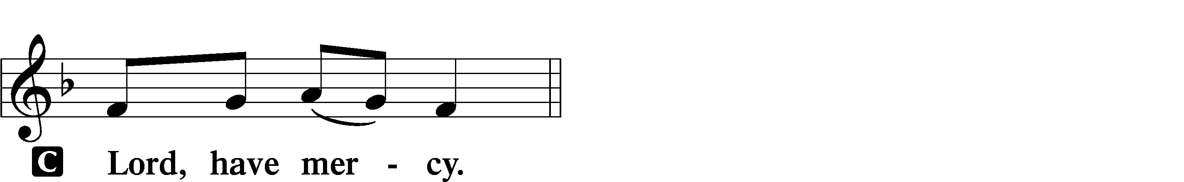

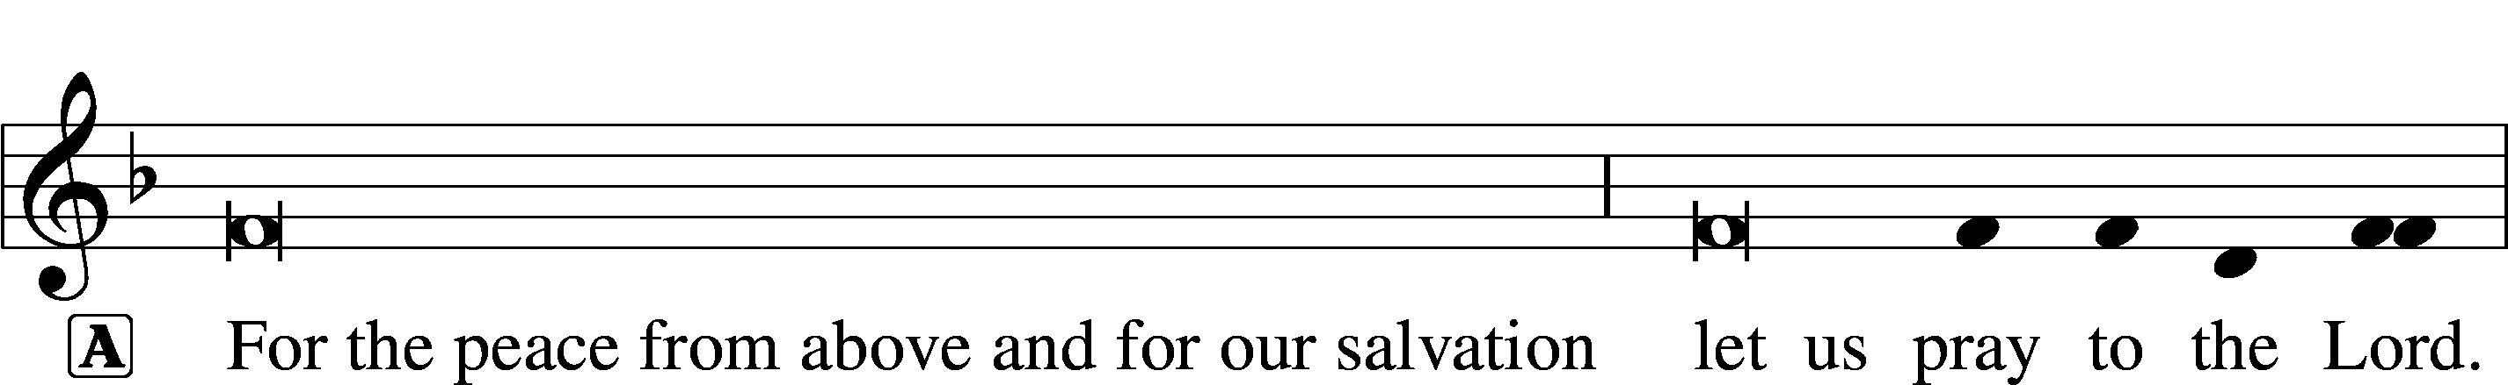
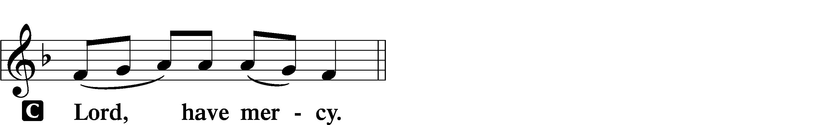

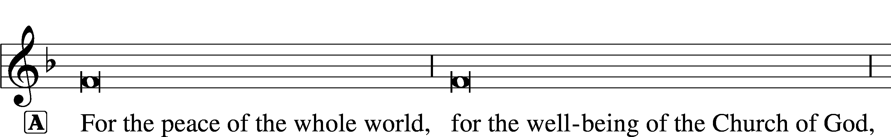

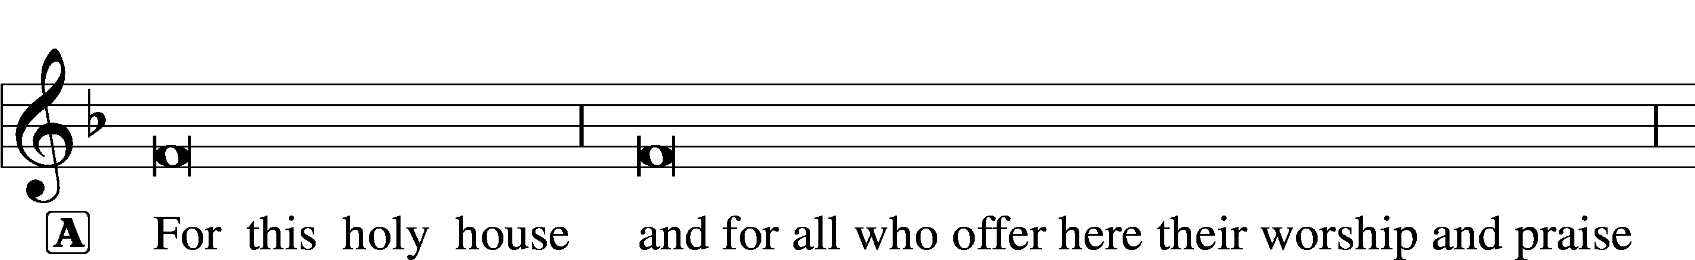
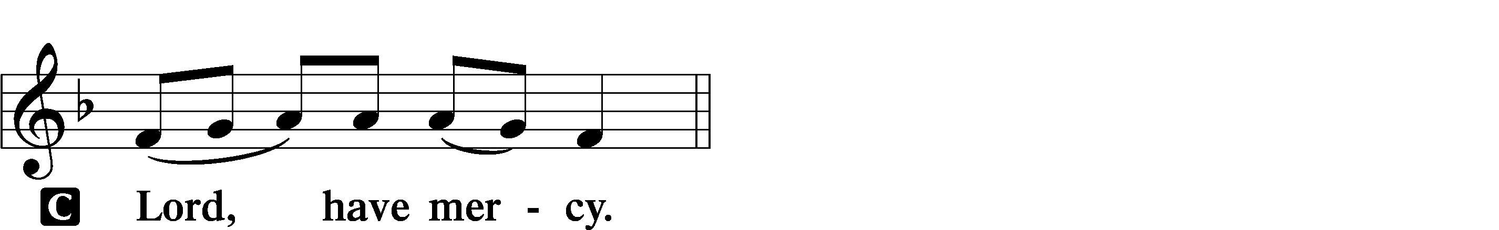

This Is the Feast LSB 155
C This is the feast of victory for our God.
Alleluia, alleluia, alleluia.

Worthy is Christ, the Lamb who was slain, whose blood set us free to be people of God.

This is the feast of victory for our God.
Alleluia, alleluia, alleluia.

Power, riches, wisdom, and strength, and honor, blessing, and glory are His.

This is the feast of victory for our God.
Alleluia, alleluia, alleluia.

Sing with all the people of God, and join in the hymn of all creation:
Blessing, honor, glory, and might be to God and the Lamb forever. Amen.

This is the feast of victory for our God.
Alleluia, alleluia, alleluia.

For the Lamb who was slain has begun His reign. Alleluia.

This is the feast of victory for our God.
Alleluia, alleluia, alleluia.

Salutation and Collect of the Day
P The Lord be with you.
C And also with you.

P Let us pray.
Almighty God, merciful Father, since You have wakened from death the Shepherd of Your sheep, grant us Your Holy Spirit that when we hear the voice of our Shepherd we may know Him who calls us each by name and follow where He leads; through the same Jesus Christ, Your Son, our Lord, who lives and reigns with You and the Holy Spirit, one God, now and forever.

C Amen.

Sit

First Reading Acts 2:42–47
42They devoted themselves to the apostles’ teaching and fellowship, to the breaking of bread and the prayers. 43And awe came upon every soul, and many wonders and signs were being done through the apostles. 44And all who believed were together and had all things in common. 45And they were selling their possessions and belongings and distributing the proceeds to all, as any had need. 46And day by day, attending the temple together and breaking bread in their homes, they received their food with glad and generous hearts, 47praising God and having favor with all the people. And the Lord added to their number day by day those who were being saved.

A This is the Word of the Lord.
C Thanks be to God.

Psalm (prayed in unison) Psalm 23; antiphon: v. 1
1The Lord is my | shepherd;*
I | shall not want.
2He makes me lie down in green | pastures.*
He leads me beside still | waters.
3He re- | stores my soul.*
He leads me in paths of righteousness for his | name’s sake.
4Even though I walk through the valley of the shadow of death,
I will fear no evil, for you are | with me;*
your rod and your staff, they | comfort me.
5You prepare a table before me
in the presence of my | enemies;*
you anoint my head with oil;
my cup | overflows.
6Surely goodness and mercy shall follow me
all the days | of my life,*
and I shall dwell in the house of the Lord for- | ever.

Epistle 1 Peter 2:19–25
19This is a gracious thing, when, mindful of God, one endures sorrows while suffering unjustly. 20For what credit is it if, when you sin and are beaten for it, you endure? But if when you do good and suffer for it you endure, this is a gracious thing in the sight of God. 21For to this you have been called, because Christ also suffered for you, leaving you an example, so that you might follow in his steps. 22He committed no sin, neither was deceit found in his mouth. 23When he was reviled, he did not revile in return; when he suffered, he did not threaten, but continued entrusting himself to him who judges justly. 24He himself bore our sins in his body on the tree, that we might die to sin and live to righteousness. By his wounds you have been healed. 25For you were straying like sheep, but have now returned to the Shepherd and Overseer of your souls.

A This is the Word of the Lord.
C Thanks be to God.

Alleluia and Verse LSB 156
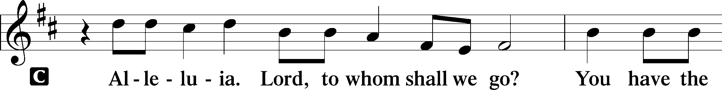
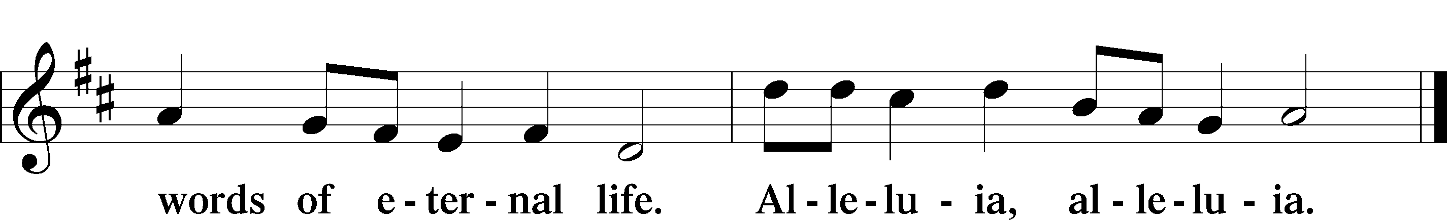

Holy Gospel John 10:1–10
P The Holy Gospel according to St. John, the tenth chapter.
C Glory to You, O Lord.

1[Jesus said:] “Truly, truly, I say to you, he who does not enter the sheepfold by the door but climbs in by another way, that man is a thief and a robber. 2But he who enters by the door is the shepherd of the sheep. 3To him the gatekeeper opens. The sheep hear his voice, and he calls his own sheep by name and leads them out. 4When he has brought out all his own, he goes before them, and the sheep follow him, for they know his voice. 5A stranger they will not follow, but they will flee from him, for they do not know the voice of strangers.” 6This figure of speech Jesus used with them, but they did not understand what he was saying to them.
7So Jesus again said to them, “Truly, truly, I say to you, I am the door of the sheep. 8All who came before me are thieves and robbers, but the sheep did not listen to them. 9I am the door. If anyone enters by me, he will be saved and will go in and out and find pasture. 10The thief comes only to steal and kill and destroy. I came that they may have life and have it abundantly.”

P This is the Gospel of the Lord.
C Praise to You, O Christ.

735 Have No Fear, Little Flock
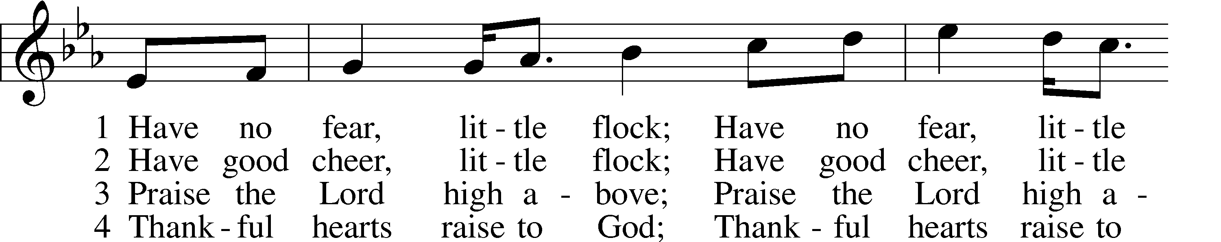
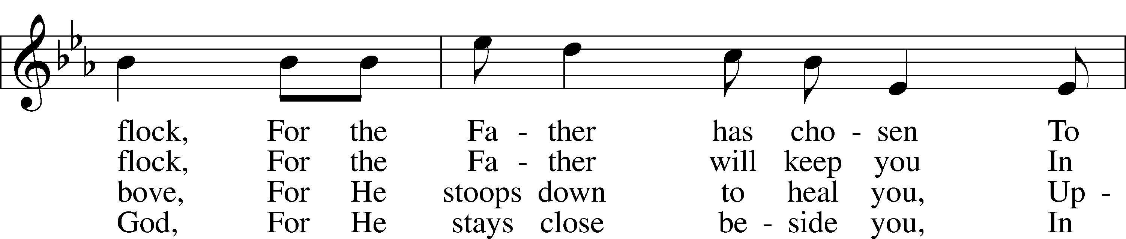
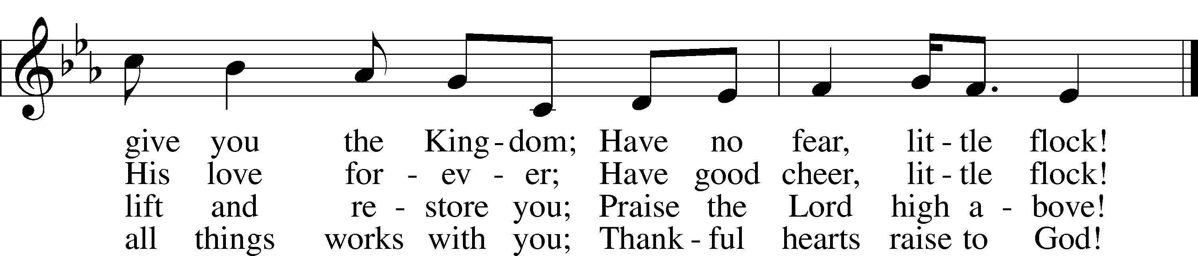
Tune and text: © 1973 Concordia Publishing House. Used by permission: CPH Limited Promotional License no. 119000000

Sermon – What Flocks Do

Prayer of the Church

Offering

Offertory LSB 159
C What shall I render to the Lord for all His benefits to me?
I will offer the sacrifice of thanksgiving and will call on the name of the Lord.
I will take the cup of salvation and will call on the name of the Lord.
I will pay my vows to the Lord now in the presence of all His people,
in the courts of the Lord’s house, in the midst of you, O Jerusalem.

Service of the Sacrament

Preface LSB 160
P The Lord be with you.
C And also with you.

P Lift up your hearts.
C We lift them to the Lord.

P Let us give thanks to the Lord our God.
C It is right to give Him thanks and praise.

P It is truly good, right, and salutary that we should at all times and in all places give thanks to You, holy Lord, almighty Father, everlasting God. And most especially are we bound to praise You on this day for the glorious resurrection of Your Son, Jesus Christ, the very Paschal Lamb, who was sacrificed for us and bore the sins of the world. By His dying He has destroyed death, and by His rising again He has restored to us everlasting life. Therefore with Mary Magdalene, Peter and John, and with all the witnesses of the resurrection, with angels and archangels, and with all the company of heaven we laud and magnify Your glorious name, evermore praising You and saying:

Sanctus LSB 161
C Holy, holy, holy Lord God of pow’r and might:
Heaven and earth are full of Your glory.
Hosanna. Hosanna.
Hosanna in the highest.
Blessed is He who comes in the name of the Lord.
Hosanna in the highest.

Lord’s Prayer LSB 162
P Lord, remember us in Your kingdom and teach us to pray:
C Our Father who art in heaven,
hallowed be Thy name,
Thy kingdom come,
Thy will be done on earth
as it is in heaven;
give us this day our daily bread;
and forgive us our trespasses
as we forgive those
who trespass against us;
and lead us not into temptation,
but deliver us from evil.
For Thine is the kingdom
and the power and the glory
forever and ever. Amen.

The Words of Our Lord
P Our Lord Jesus Christ, on the night when He was betrayed, took bread, and when He had given thanks, He broke it and gave it to the disciples and said: “Take, eat; this is My T body, which is given for you. This do in remembrance of Me.”

In the same way also He took the cup after supper, and when He had given thanks, He gave it to them, saying: “Drink of it, all of you; this cup is the new testament in My T blood, which is shed for you for the forgiveness of sins. This do, as often as you drink it, in remembrance of Me.”

Pax Domini LSB 163
P The peace of the Lord be with you always.
C Amen.

Agnus Dei LSB 163
C Lamb of God, You take away the sin of the world; have mercy on us.
Lamb of God, You take away the sin of the world; have mercy on us.
Lamb of God, You take away the sin of the world; grant us peace.

Distribution

Thank the Lord LSB 164
C Thank the Lord and sing His praise; tell ev’ryone what He has done.
Let all who seek the Lord rejoice and proudly bear His name.
He recalls His promises and leads His people forth in joy
with shouts of thanksgiving. Alleluia, alleluia.

Post-Communion Collect
A Let us pray.
We give thanks to You, almighty God, that You have refreshed us through this salutary gift, and we implore You that of Your mercy You would strengthen us through the same in faith toward You and in fervent love toward one another; through Jesus Christ, Your Son, our Lord, who lives and reigns with You and the Holy Spirit, one God, now and forever.
C Amen.

Benediction LSB 166
P The Lord bless you and keep you.
The Lord make His face shine on you and be gracious to you.
The Lord look upon you with favor and T give you peace.
C Amen.

740 I Am Jesus’ Little Lamb
1 I am Jesus’ little lamb,
Ever glad at heart I am;
For my Shepherd gently guides me,
Knows my need and well provides me,
Loves me ev’ry day the same,
Even calls me by my name.

2 Day by day, at home, away,
Jesus is my staff and stay.
When I hunger, Jesus feeds me,
Into pleasant pastures leads me;
When I thirst, He bids me go
Where the quiet waters flow.

3 Who so happy as I am,
Even now the Shepherd’s lamb?
And when my short life is ended,
By His angel host attended,
He shall fold me to His breast,
There within His arms to rest.
Text: Public domain

Acknowledgments
Divine Service, Setting One from Lutheran Service Book
Unless otherwise indicated, Scripture quotations are from the ESV® Bible (The Holy Bible, English Standard Version®), copyright © 2001 by Crossway, a publishing ministry of Good News Publishers. Used by permission. All rights reserved.
Created by Lutheran Service Builder © 2018 Concordia Publishing House.

The Radio Broadcast today is given to the Glory of the Lord by
Dan & Shirley Oertwig for their anniversary

Prayers for Our Members
Chelsea Junge, Christina Long, Tenaya Nuttelman | Expectant Mothers
Family & Friends of Vivian Axmann | Grief
Norman Abels (Brookestone Meadows – Elkhorn) | Healing
Judy Ahrens | Healing
Vaughn Albrecht (Northridge) | Healing
Tom & DyAnn Altwine | Healing
Lyle Colsden (Mother Hull) | Healing
Brenda Fletcher | Healing
Pat Flodine (Cambridge Court) | Healing
Vi Fox (Prairie View) | Healing
Verleen Gentry | Healing
Tiffany Hartman | Healing
Ruby Hatfield | Healing
Carol Herron | Healing
Carol Kreutzer | Healing
Teresa Leising | Healing
Marion Richmond | Healing
Geraldine Roeder | Healing
Dorothy Sikes | Healing
Bev Nuttelman | Cancer
Kim Vos | Cancer
Ramona Gaunt | Palliative Care
Linda Nuttelman | Recovery
Prayers for Our Members’ Family & Friends
Becci Koopman (Todd & Ellen Koopman daughter-in-law) | Expectant Mother
Shaylee Kreutzer (Rich & Carol Kreutzer’s daughter-in-law) | Expectant Mother
Lana Latsabidze (Bruce & Ann Fattig daughter-in-law) | Expectant Mother
Amy Nuttelman (Keith & Bev Nuttelman’s daughter-in-law) | Expectant Mother
Ava Jean Winnie (Nic Kitzing’s cousin) | Healing
Will Brennemann (Jami Helmbrecht’s father) | Healing
Don Berg (Evelyn Heiden’s brother) | Healing
Reg Duke (Westman’s brother-in-law) | Healing
James Gentry (Verleen Gentry’s son) | Healing
Lee Gilbert | Healing
Mark Glover (Shirley Helmbrecht’s brother) | Healing
Brooke Guthrie (Bailey Hockemeier’s sister) | Healing
Lois Hanson (Pastor Hanson’s wife) | Healing
Norman Hockemeier (Ken’s father) | Healing
Roger Hoffman (Marc’s father) | Healing
Vernon Knight Jr. (Brenda Fletcher’s brother) | Healing
Miles Margritz (Wanda Glanzer’s nephew) | Healing
Randy Solomon (Beth Rosenthal’s father) | Healing
Mary Ann Mertz (Pam’s Uhlir’s friend) | Healing
Roy Reynolds (Verleen Gentry’s son-in-law) | Healing
Janet Stalder (Carol Florang’s sister) | Healing
Patty Ellis (Fran Junge’s sister) | Cancer
Ron Halvorsen (Jeff’s dad) | Cancer
Carol Haubold (Don Helmbrecht’s sister) | Cancer
Tyler Holland (Quentin & Janel Lange brother-in-law) | Cancer
Fred Koch (Pam Uhlir’s cousin) | Cancer
Lynda Kreutzer (Rich & Carol’s sister-in-law) | Cancer
Sharon Mulhair (Pam Uhlir’s cousin) | Cancer
Tyrone Uhlir (Pam’s nephew) | Cancer
Members of Zion Lutheran North Shelton | Loss & Restoration
Pr.James, Pr. Clausing, Our sister congregations in Haiti | Missionaries
John Christensen, John Harbols | Military

Sun  05/03 | 9:00a | Divine Service
Mon  05/04 | Birthdays  Anniversaries | Kenzie Ahrens  Lincoln Florang  Janelle Schmid  Hazel Stickney  Robert Vos  Bruce & Joni Brooks
Tues  05/05 | Birthdays  Anniversaries | Ann Fattig  Clayton McKillip  ---
Wed  05/06 | Birthdays  Anniversaries | Sharon Hockemeier  ---
Thurs  05/07 | Birthdays  Anniversaries | ---  ---
Fri  05/08 | Birthdays  Anniversaries | James Catterson  Donald Helmbrecht  John Musfelt  Dan & Shirley Oertwig
Sat  05/09 | Birthdays  Anniversaries | ---  ---
Sun  05/10 | 9:00a  Birthdays  Anniversaries | Divine Service  ---  ---

Our Response to the Gospel

Date: 04/26/2020

Attendance: cancelled

Offering: $11,139.23
Weekly Need: $7,542.37

ANNOUNCEMENTS

Offering during this time. There are several options to get your weekly offering into church. Please continue to give weekly offering because we are committed to continue to pay employees, utilities, and the monthly expenses. Ways to continue your offering are: drop the offering in the mail slot by the south doors, mail it to the church, or utilize online giving at zionkearney.com. If you have any questions or need assistance please contact the office at 308-234-3410 or school@zionkearney.org. Thank you for your support of our church!

Radio Broadcast - Please help Zion spread the Gospel! This is a great need during this time, many people are utilizing this resource during this time.

Men’s Bible Study – The Men’s Bible Study will tentatively meet on Thursday, May 21st. Watch for confirmation and details.

Best of Kearney – Congratulations to Zion’s preschool for being voted Best of Kearney by the readers of the Kearney Hub for a seventh year!

Thank You – Thank you for those that contributed to the P.E.A.C.E auction. It was a different year and a completely different way to have the auction. We appreciate your support of our wonderful Lutheran School.

