Divine Service
Second Sunday After Christmas
January 3, 2021
Zion Lutheran Church
Kearney, Nebraska

Welcome to Zion!
All worshippers please fill out an attendance card in the pew rack and let us know how we might be of service to you.

Holy Communion at Zion

The Lord’s Supper is celebrated at this congregation as Jesus has given it. As he says, our Lord gives into our mouths not only bread and wine but his very body and blood to eat and to drink for the forgiveness of sins and to strengthen our union with him and with one another. Our Lord invites to his table those who trust his words, repent of all sin, and set aside any refusal to forgive and love as he forgives and loves us, that they may show forth his death until he comes. All communicants need to register in the narthex prior to the service.

Because those who eat and drink our Lord’s body and blood unworthily do great harm and because Holy Communion is a confession of the faith which is confessed at this altar, any who are not yet instructed, in doubt, or who hold a confession differing from that of this congregation and The Lutheran Church—Missouri Synod, are asked not to commune until they are able to speak with our pastor first. He is happy to visit with you about the Christian faith and how to receive the Lord’s Supper for your good and for the good of others. Those not communing are invited to come to the altar, cross your arms in front of you, and bow your head to receive a pastoral blessing.

The Time Has Fully Come for Redemption and Purification through Jesus Christ, Our Lord

“When the fullness of time had come, God sent forth his Son,” born of the woman, “to redeem those who were under the law” (Gal. 4:4–5). Therefore, “according to the Law of Moses,” Mary and Joseph “brought him up to Jerusalem to present him to the Lord” (Luke 2:22). There He was received and taken up into the arms of Simeon, who was righteous and devout, “waiting for the consolation of Israel” (Luke 2:25). Simeon praised God and blessed the parents by confessing the cross for which this child was appointed. “At that very hour,” old and faithful Anna, who had watched, prayed and worshiped in the temple for so long, came up and “began to give thanks to God and to speak of him to all who were waiting for the redemption of Jerusalem” (Luke 2:38). The Lord causes “righteousness and praise to sprout up before all the nations” (Is. 61:11). We also “greatly rejoice in the Lord,” because this child has clothed us “with the garments of salvation,” covered us “with the robe of righteousness” and called us “by a new name” (Is. 61:10; 62:2).
Tune and text: Public domain

384 Of the Father’s Love Begotten
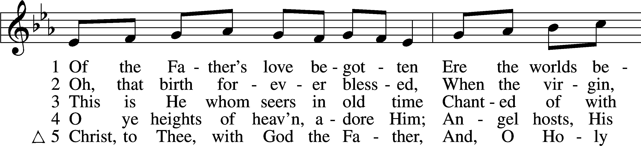
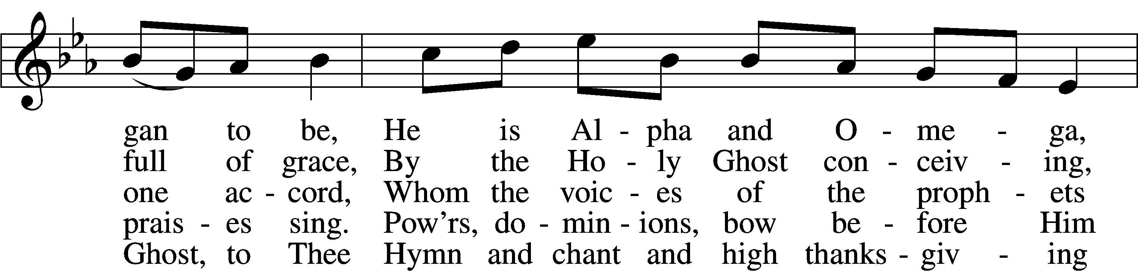
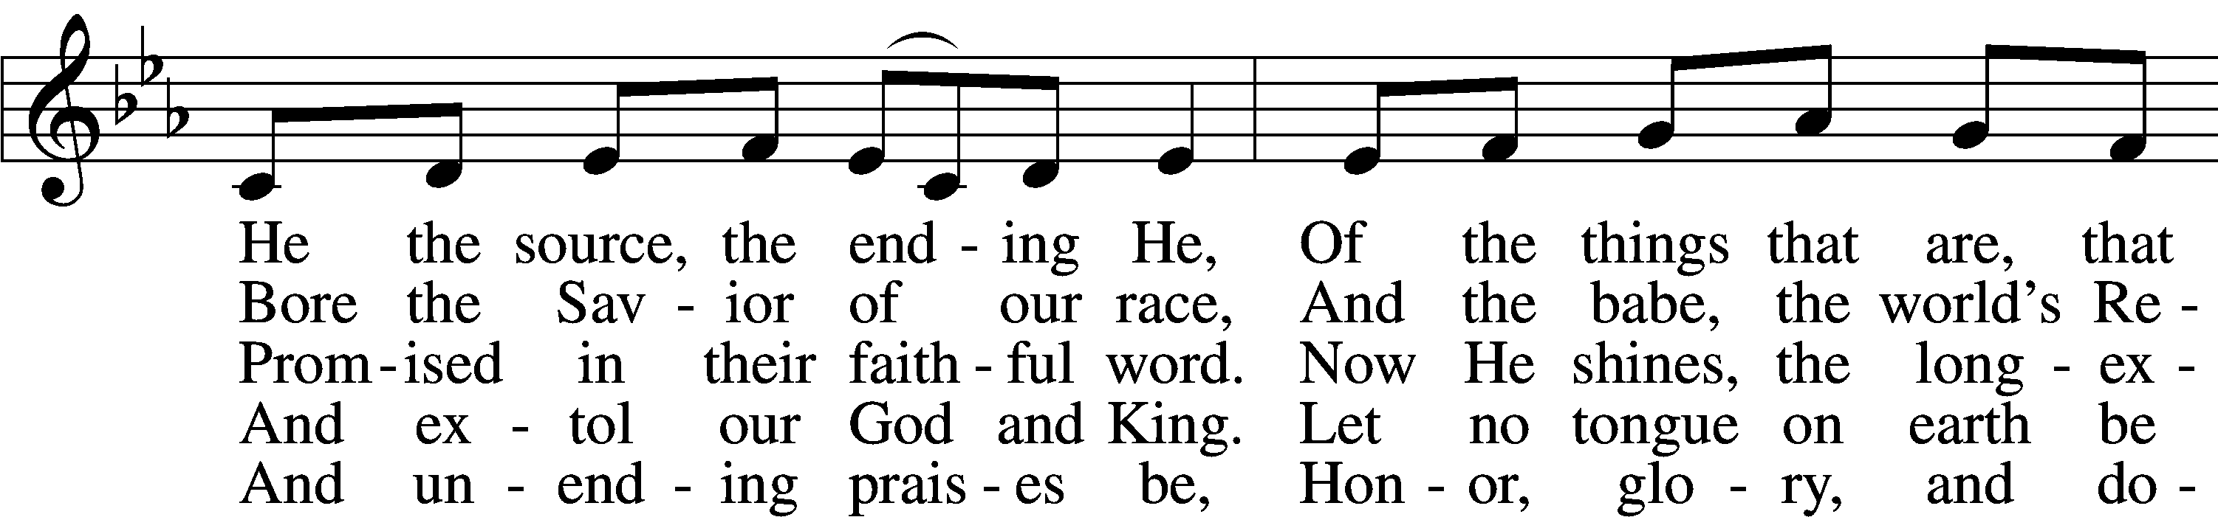
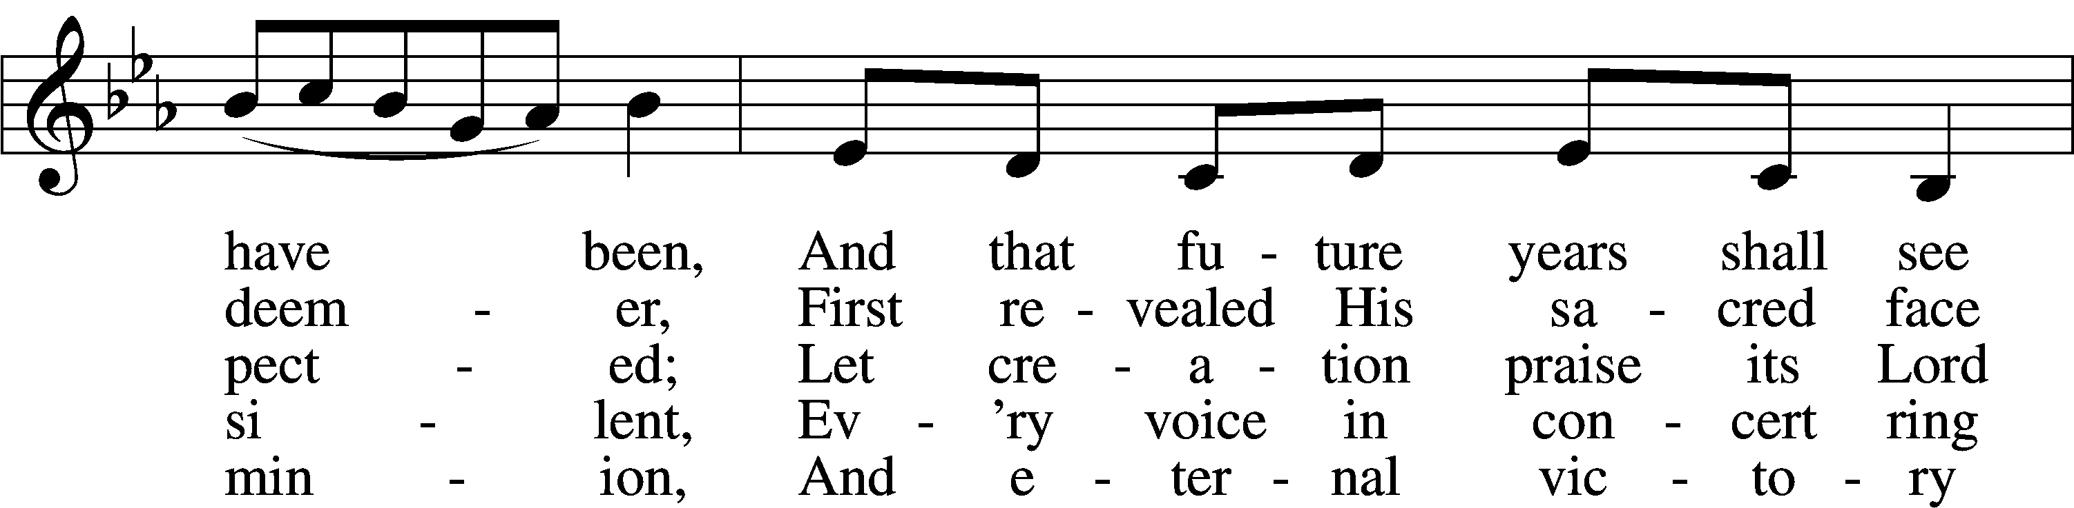
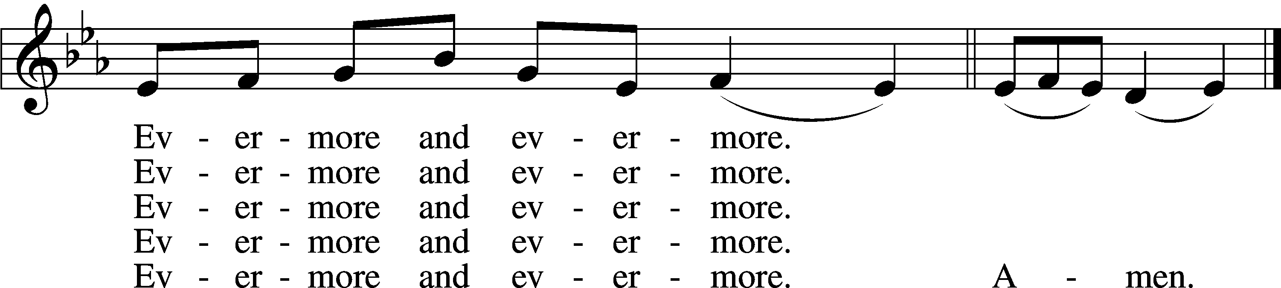
Text and tune: Public domain

The Rite of Holy Baptism (5 p.m. service) LSB 268

Confession and Absolution

Stand

The sign of the cross may be made by all in remembrance of their Baptism.

Invocation
P In the name of the Father and of the T Son and of the Holy Spirit.
C Amen.

Exhortation LSB 184
P Beloved in the Lord! Let us draw near with a true heart and confess our sins unto God our Father, beseeching Him in the name of our Lord Jesus Christ to grant us forgiveness.

P Our help is in the name of the Lord,
C who made heaven and earth.
P I said, I will confess my transgressions unto the Lord,
C and You forgave the iniquity of my sin.

Kneel/Stand

Silence for reflection on God’s Word and for self-examination.

Confession of Sins LSB 184
P O almighty God, merciful Father,
C I, a poor, miserable sinner, confess unto You all my sins and iniquities with which I have ever offended You and justly deserved Your temporal and eternal punishment. But I am heartily sorry for them and sincerely repent of them, and I pray You of Your boundless mercy and for the sake of the holy, innocent, bitter sufferings and death of Your beloved Son, Jesus Christ, to be gracious and merciful to me, a poor, sinful being.

Absolution LSB 185
P Upon this your confession, I, by virtue of my office, as a called and ordained servant of the Word, announce the grace of God unto all of you, and in the stead and by the command of my Lord Jesus Christ I forgive you all your sins in the name of the Father and of the T Son and of the Holy Spirit.
C Amen.

Stand

Service of the Word

Introit
The Word became flesh and dwelt among us, and we have seen his | glory,*
glory as of the only Son from the Father, full of | grace and truth.
Praise the Lord! For it is good to sing praises | to our God;*
for it is pleasant, and a song of praise is | fitting.
Great is our Lord, and abun- | dant in power;*
his understanding is beyond | measure.
But the Lord takes pleasure in those who | fear him,*
in those who hope in his | steadfast love.
Praise the Lord, O Je- | rusalem!*
Praise your God, O | Zion!

Gloria Patri LSB 186
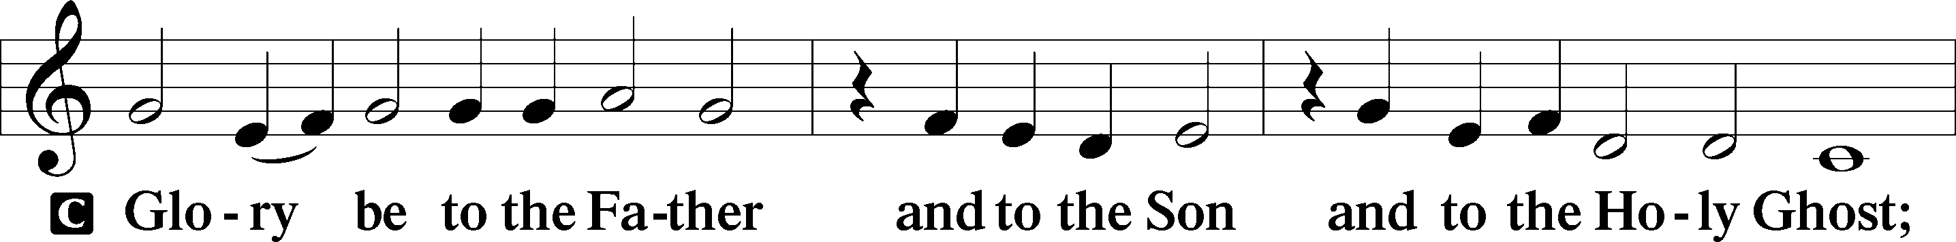
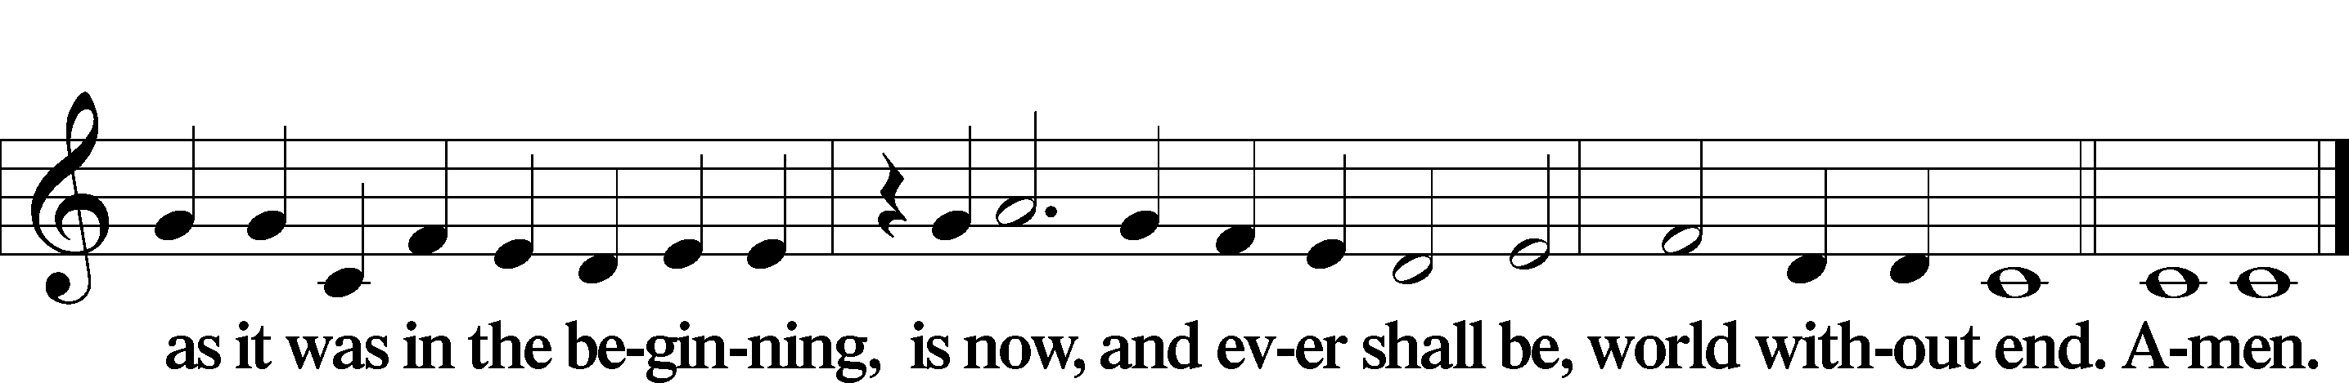

Kyrie LSB 186
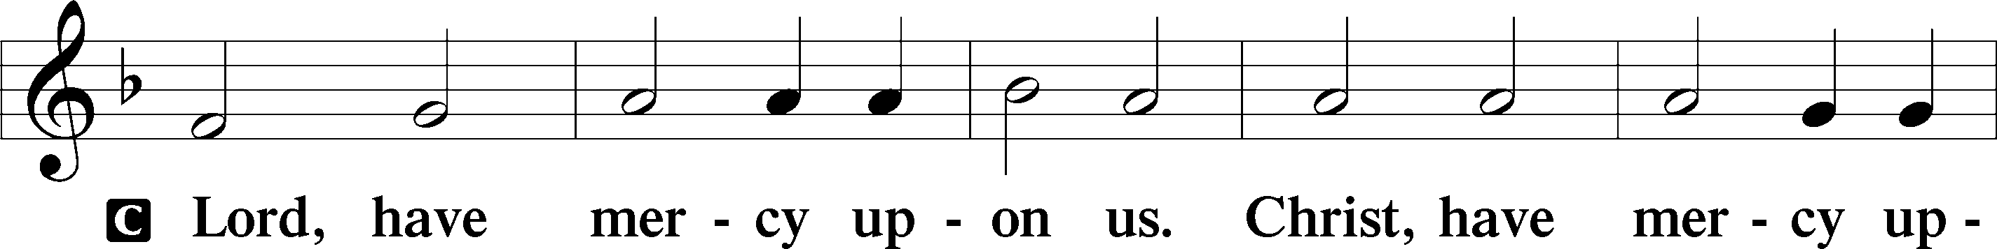
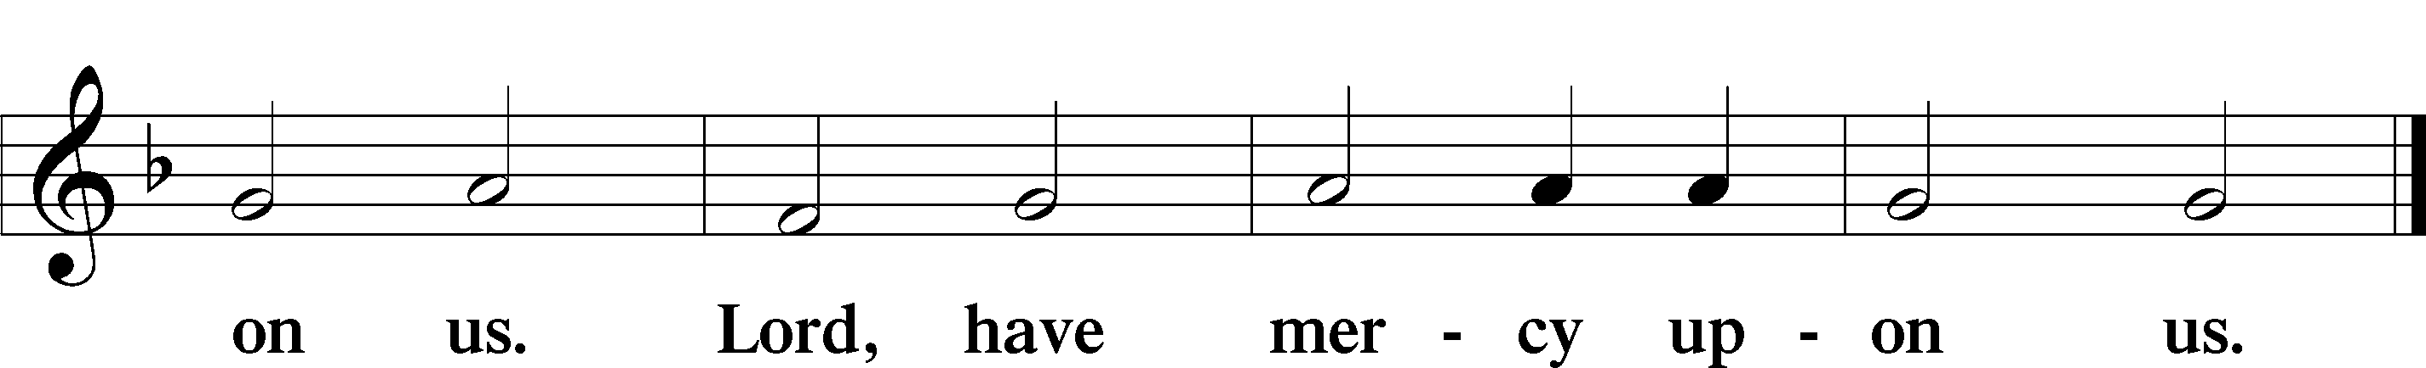

Gloria in Excelsis LSB 187
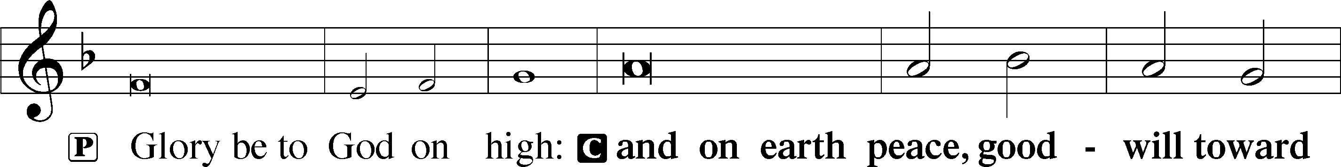
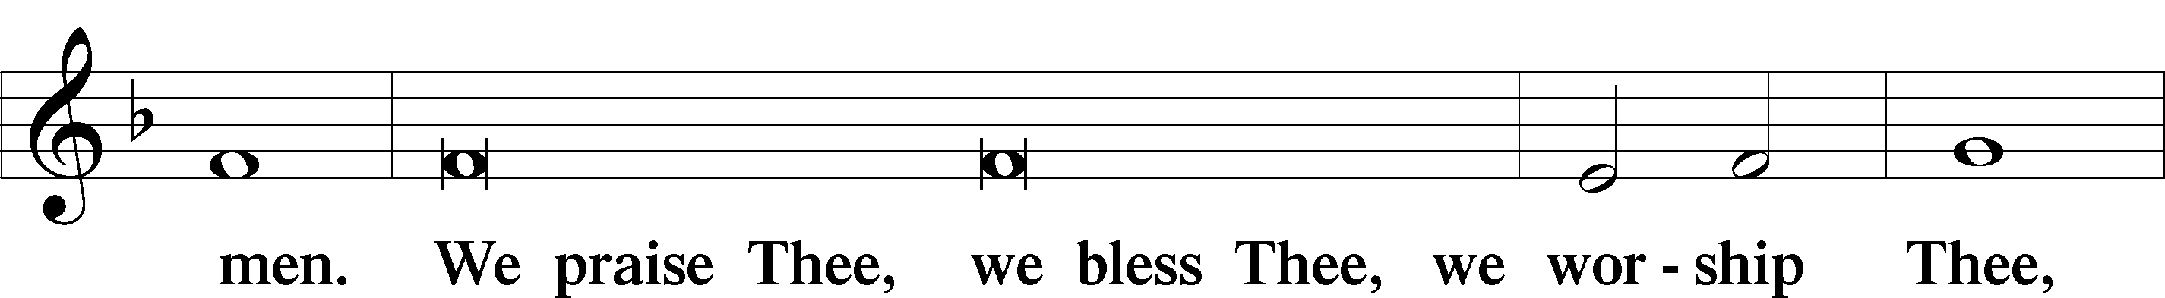
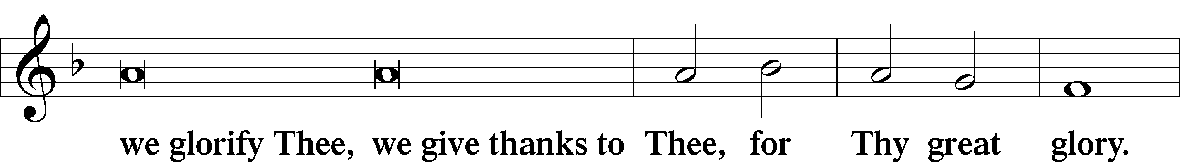
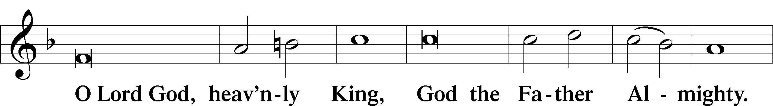
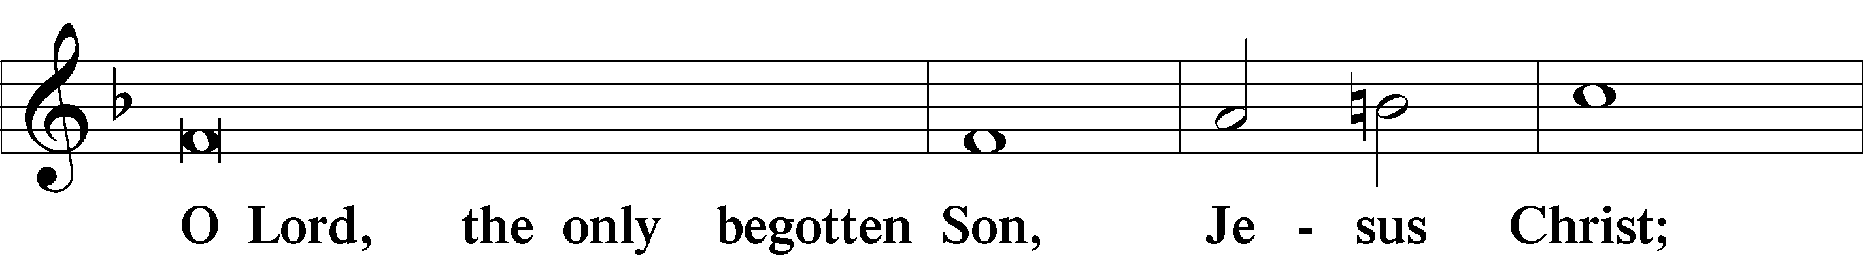
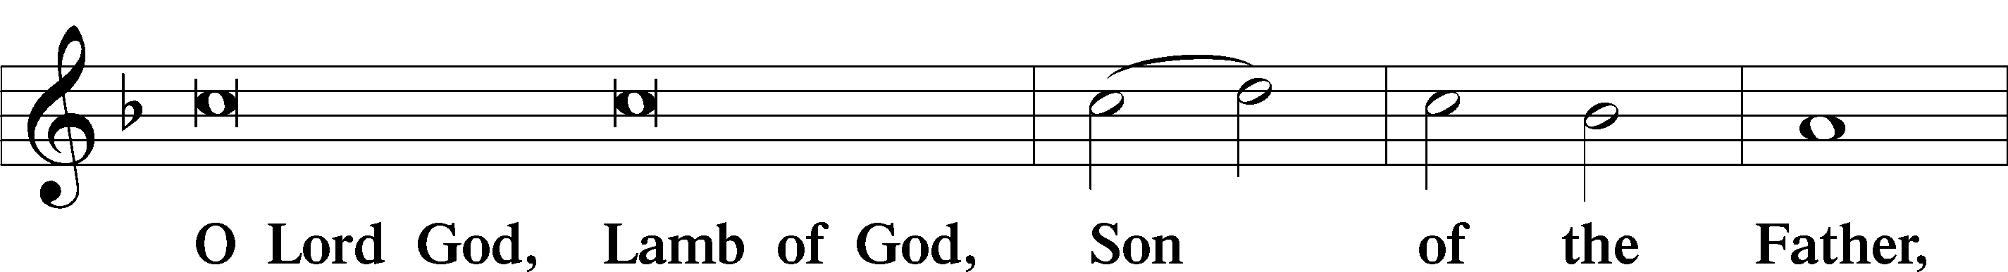
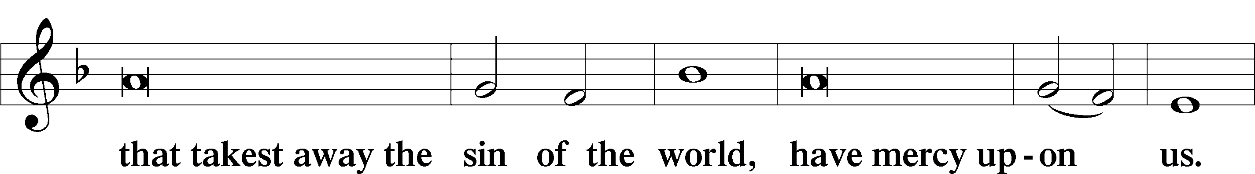
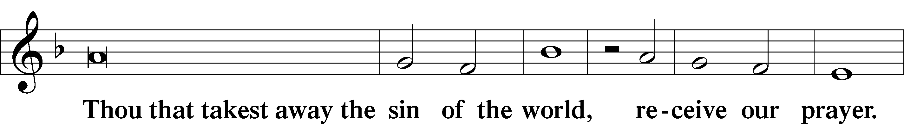
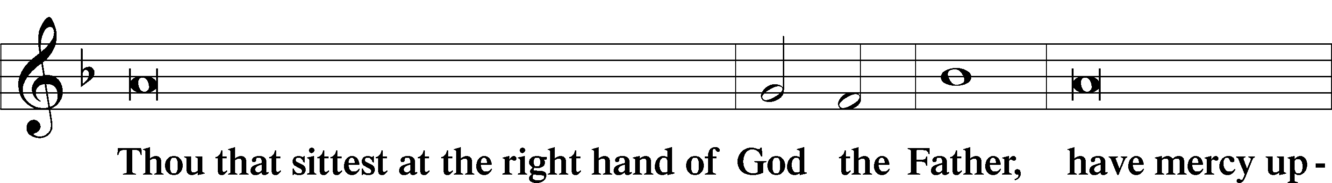
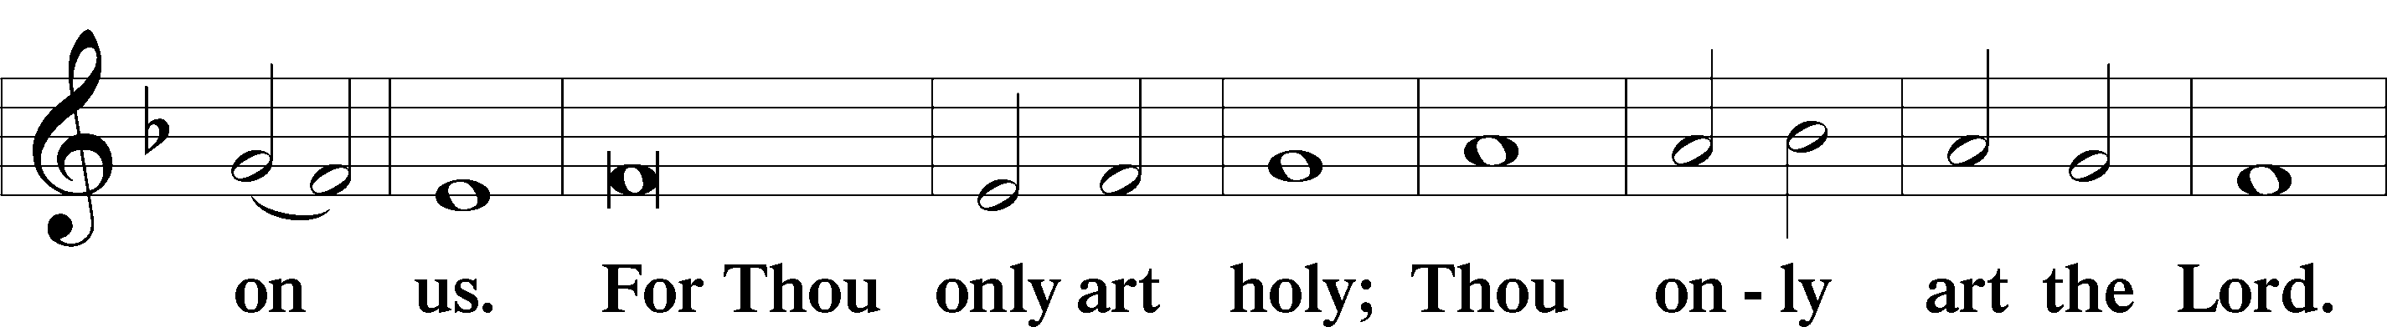
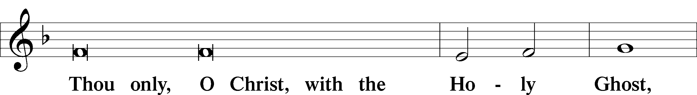
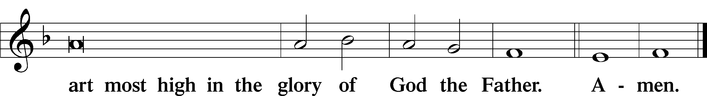

Salutation and Collect of the Day
P The Lord be with you.
C And with thy spirit.

P Let us pray.
Almighty God, You have poured into our hearts the true Light of Your incarnate Word. Grant that this Light may shine forth in our lives; through the same Jesus Christ, Your Son, our Lord, who lives and reigns with You and the Holy Spirit, one God, now and forever.

C Amen.

Sit

Old Testament Reading 1 Kings 3:4–15
⁴ The king went to Gibeon to sacrifice there, for that was the great high place. Solomon used to offer a thousand burnt offerings on that altar. ⁵At Gibeon the Lord appeared to Solomon in a dream by night, and God said, “Ask what I shall give you.” ⁶And Solomon said, “You have shown great and steadfast love to your servant David my father, because he walked before you in faithfulness, in righteousness, and in uprightness of heart toward you. And you have kept for him this great and steadfast love and have given him a son to sit on his throne this day. ⁷And now, O Lord my God, you have made your servant king in place of David my father, although I am but a little child. I do not know how to go out or come in. ⁸And your servant is in the midst of your people whom you have chosen, a great people, too many to be numbered or counted for multitude. ⁹Give your servant therefore an understanding mind to govern your people, that I may discern between good and evil, for who is able to govern this your great people?”
¹⁰It pleased the Lord that Solomon had asked this. ¹¹And God said to him, “Because you have asked this, and have not asked for yourself long life or riches or the life of your enemies, but have asked for yourself understanding to discern what is right, ¹²behold, I now do according to your word. Behold, I give you a wise and discerning mind, so that none like you has been before you and none like you shall arise after you. ¹³I give you also what you have not asked, both riches and honor, so that no other king shall compare with you, all your days. ¹⁴And if you will walk in my ways, keeping my statutes and my commandments, as your father David walked, then I will lengthen your days.”
¹⁵And Solomon awoke, and behold, it was a dream. Then he came to Jerusalem and stood before the ark of the covenant of the Lord, and offered up burnt offerings and peace offerings, and made a feast for all his servants.

A This is the Word of the Lord.
C Thanks be to God.

Gradual Isaiah 9:6; Psalm 98:1a
To us a child is born, to us a son is | given;*
and the government shall be upon his | shoulder.
And his name shall be called Wonderful Counselor, | Mighty God,*
Everlasting Father, | Prince of Peace.
Sing to the Lord a | new song,*
for he has done | marvelous things!

Epistle Ephesians 1:3–14
Spiritual Blessings in Christ
³Blessed be the God and Father of our Lord Jesus Christ, who has blessed us in Christ with every spiritual blessing in the heavenly places, ⁴even as he chose us in him before the foundation of the world, that we should be holy and blameless before him. In love ⁵he predestined us for adoption as sons through Jesus Christ, according to the purpose of his will, ⁶to the praise of his glorious grace, with which he has blessed us in the Beloved. ⁷In him we have redemption through his blood, the forgiveness of our trespasses, according to the riches of his grace, ⁸which he lavished upon us, in all wisdom and insight ⁹making known to us the mystery of his will, according to his purpose, which he set forth in Christ ¹⁰as a plan for the fullness of time, to unite all things in him, things in heaven and things on earth.
¹¹In him we have obtained an inheritance, having been predestined according to the purpose of him who works all things according to the counsel of his will, ¹²so that we who were the first to hope in Christ might be to the praise of his glory. ¹³In him you also, when you heard the word of truth, the gospel of your salvation, and believed in him, were sealed with the promised Holy Spirit, ¹⁴who is the guarantee of our inheritance until we acquire possession of it, to the praise of his glory.

A This is the Word of the Lord.
C Thanks be to God.

Stand

Alleluia LSB 190
C Alleluia. Alleluia. Alleluia.

Holy Gospel Luke 2:40–52
P The Holy Gospel according to St. Luke, the second chapter.
C Glory be to Thee, O Lord.

⁴⁰The child [Jesus] grew and became strong, filled with wisdom. And the favor of God was upon him.
The Boy Jesus in the Temple
⁴¹Now his parents went to Jerusalem every year at the Feast of the Passover. ⁴²And when he was twelve years old, they went up according to custom. ⁴³And when the feast was ended, as they were returning, the boy Jesus stayed behind in Jerusalem. His parents did not know it, ⁴⁴but supposing him to be in the group they went a day’s journey, but then they began to search for him among their relatives and acquaintances, ⁴⁵and when they did not find him, they returned to Jerusalem, searching for him. ⁴⁶After three days they found him in the temple, sitting among the teachers, listening to them and asking them questions. ⁴⁷And all who heard him were amazed at his understanding and his answers. ⁴⁸And when his parents saw him, they were astonished. And his mother said to him, “Son, why have you treated us so? Behold, your father and I have been searching for you in great distress.” ⁴⁹And he said to them, “Why were you looking for me? Did you not know that I must be in my Father’s house?” ⁵⁰And they did not understand the saying that he spoke to them. ⁵¹And he went down with them and came to Nazareth and was submissive to them. And his mother treasured up all these things in her heart.
⁵²And Jesus increased in wisdom and in stature and in favor with God and man.

P This is the Gospel of the Lord.
C Praise be to Thee, O Christ.

Nicene Creed
C I believe in one God,
the Father Almighty,
maker of heaven and earth
and of all things visible and invisible.

And in one Lord Jesus Christ,
the only-begotten Son of God,
begotten of His Father before all worlds,
God of God, Light of Light,
very God of very God,
begotten, not made,
being of one substance with the Father,
by whom all things were made;
who for us men and for our salvation came down from heaven
and was incarnate by the Holy Spirit of the virgin Mary
and was made man;
and was crucified also for us under Pontius Pilate.
He suffered and was buried.
And the third day He rose again according to the Scriptures
and ascended into heaven
and sits at the right hand of the Father.
And He will come again with glory to judge both the living and the dead,
whose kingdom will have no end.

And I believe in the Holy Spirit,
the Lord and giver of life,
who proceeds from the Father and the Son,
who with the Father and the Son together is worshiped and glorified,
who spoke by the prophets.
And I believe in one holy Christian and apostolic Church,
I acknowledge one Baptism for the remission of sins,
and I look for the resurrection of the dead
and the life T of the world to come. Amen.

Sit

410 Within the Father’s House
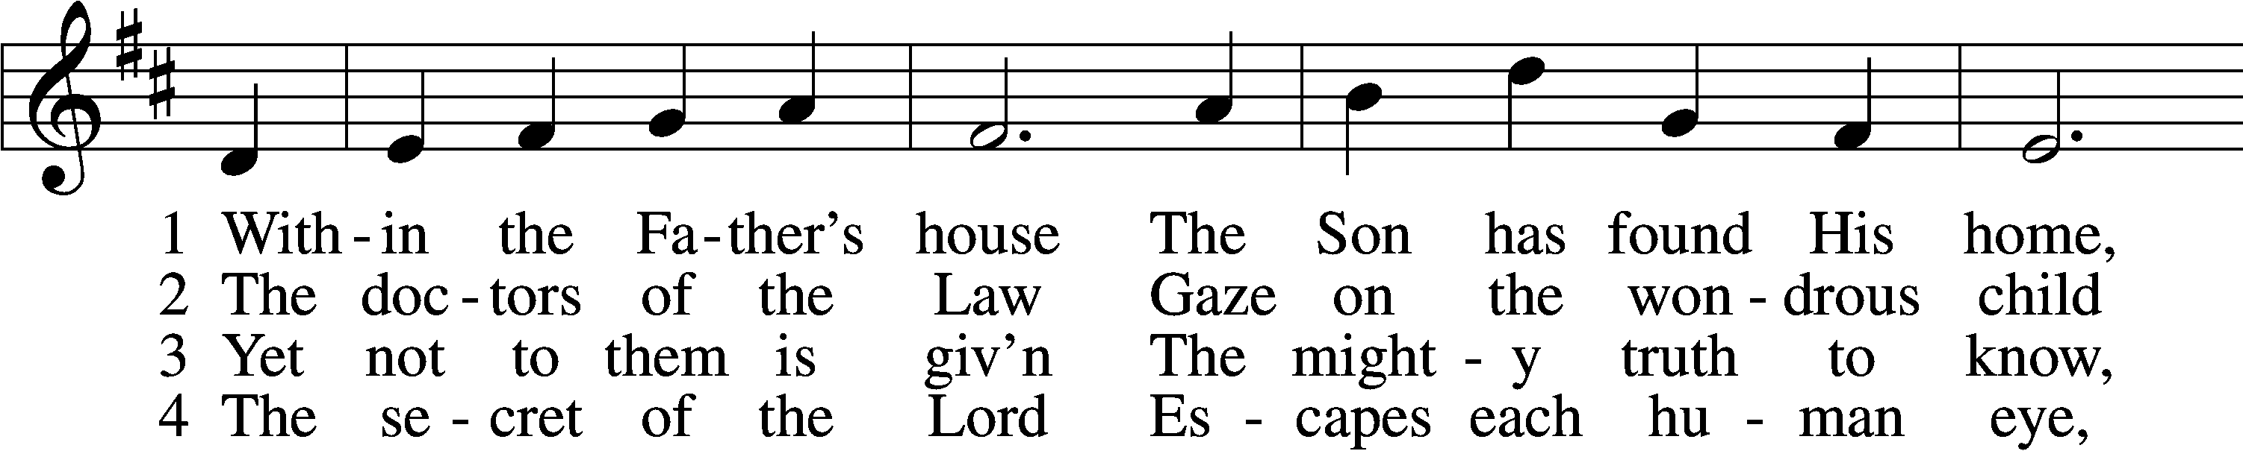
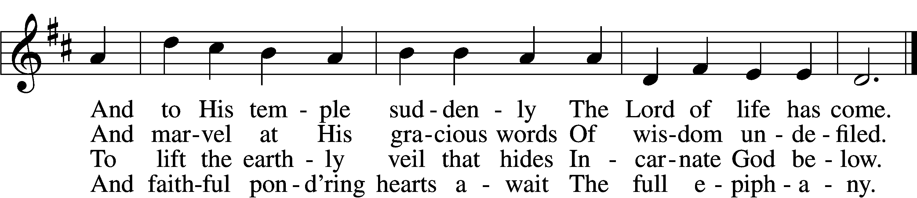

5 Lord, visit Thou our souls
And teach us by Thy grace
Each dim revealing of Thyself
With loving awe to trace

D 6 Till we behold Thy face
And know as we are known
Thee, Father, Son, and Holy Ghost,
Coequal Three in One.
Text and tune: Public domain

Sermon

Stand

Offertory LSB 192
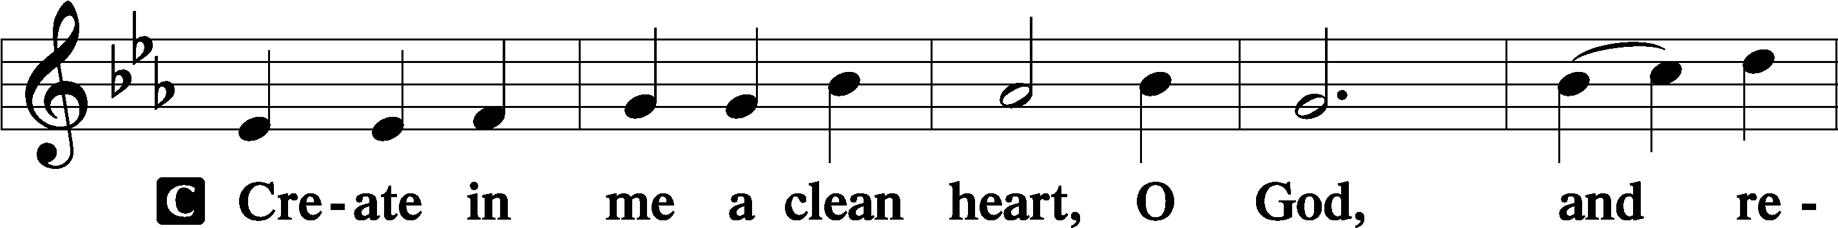
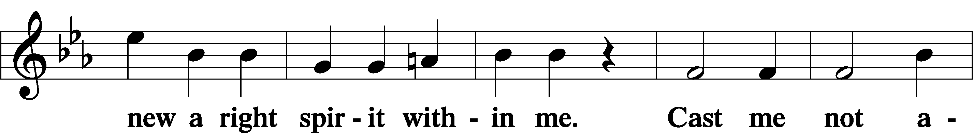
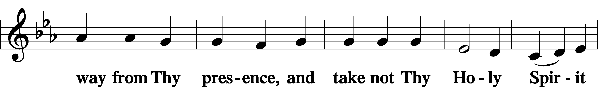
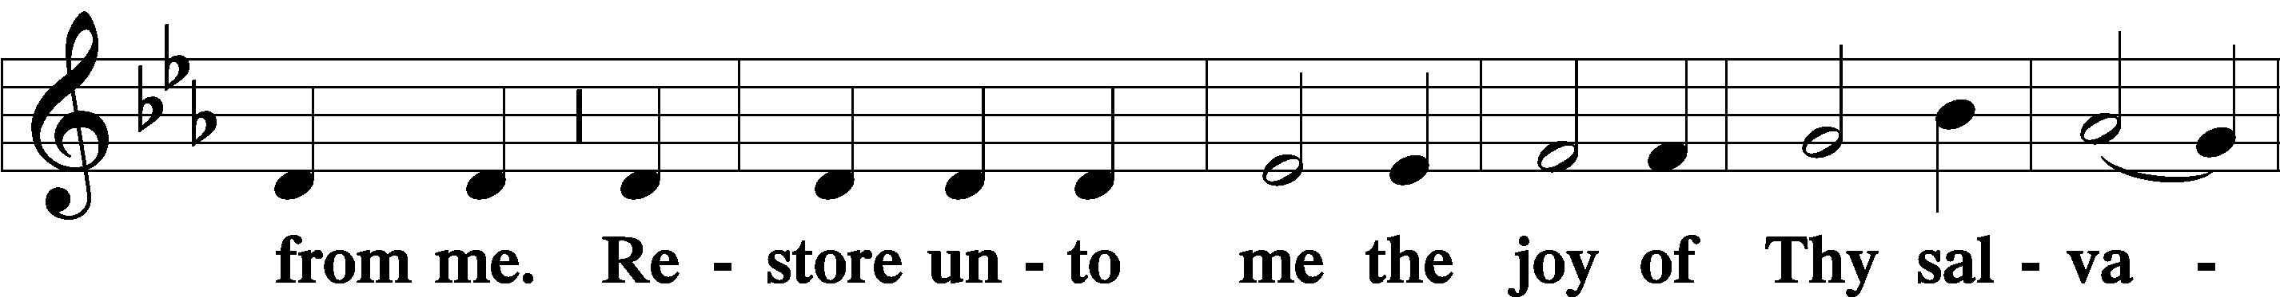
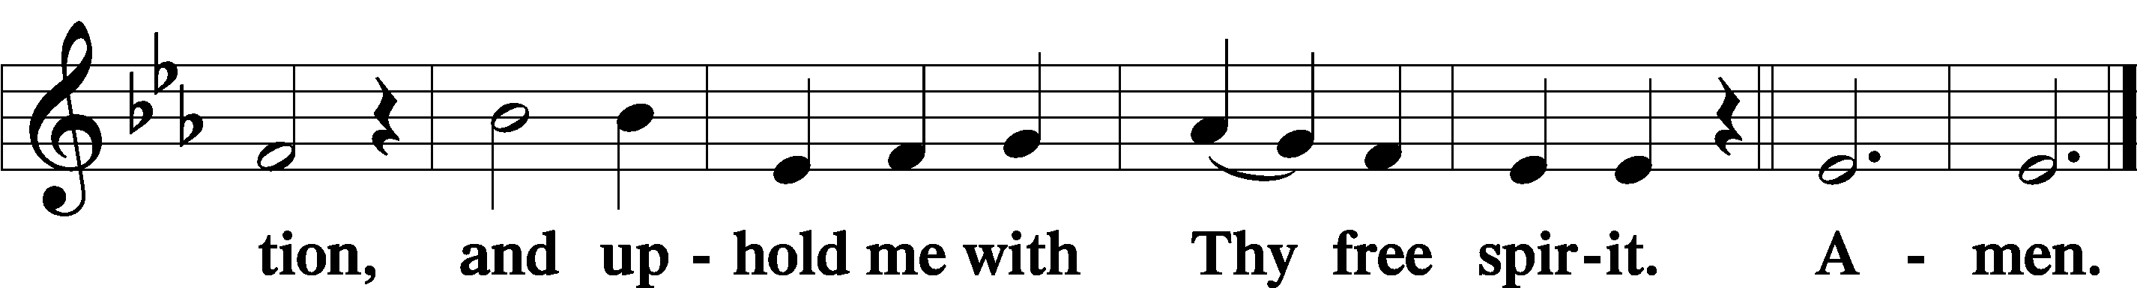

Prayer of the Church

Service of the Sacrament

Preface LSB 194

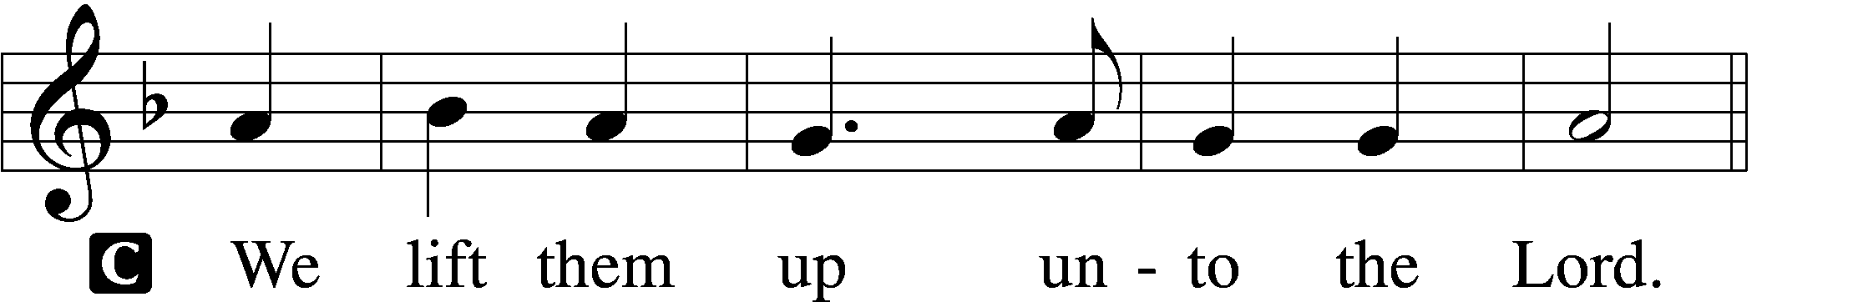

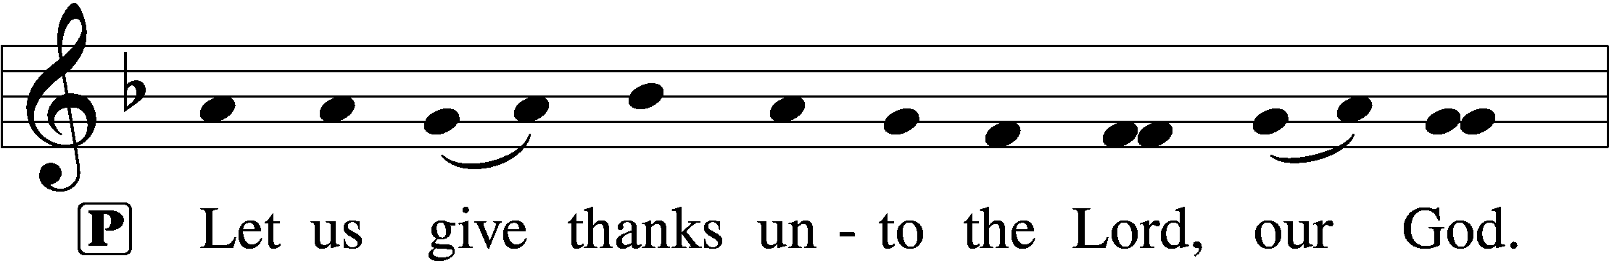
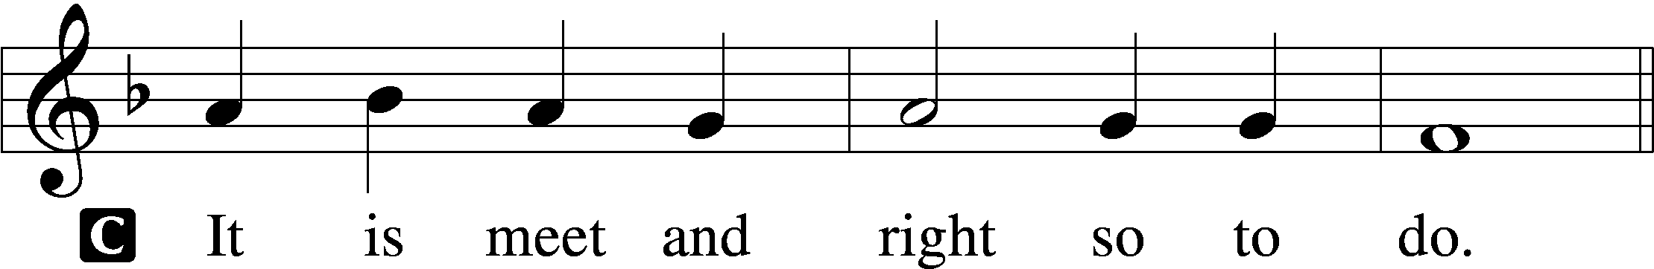

Proper Preface (Full)
P It is truly meet, right, and salutary that we should at all times and in all places give thanks to You, holy Lord, almighty Father, everlasting God, through Jesus Christ, our Lord; for in the mystery of the Word made flesh You have given us a new revelation of Your glory that, seeing You in the person of Your Son, we may know and love those things which are not seen. Therefore with angels and archangels and with all the company of heaven we laud and magnify Your glorious name, evermore praising You and saying:

Sanctus LSB 195
C Holy, holy, holy Lord God of Sabaoth;
heav’n and earth are full of Thy glory.
Hosanna, hosanna, hosanna in the highest.
Blessed is He, blessed is He, blessed is He that cometh in the name of the Lord.
Hosanna, hosanna, hosanna in the highest.

Lord’s Prayer LSB 196
P Our Father who art in heaven,
hallowed be Thy name,
Thy kingdom come,
Thy will be done on earth as it is in heaven;
give us this day our daily bread;
and forgive us our trespasses as we forgive those who trespass against us;
and lead us not into temptation,
but deliver us from evil.
C For Thine is the kingdom and the power and the glory forever and ever. Amen.

The Words of Our Lord LSB 197
P Our Lord Jesus Christ, on the night when He was betrayed, took bread, and when He had given thanks, He broke it and gave it to the disciples and said: “Take, eat; this is My T body, which is given for you. This do in remembrance of Me.”

In the same way also He took the cup after supper, and when He had given thanks, He gave it to them, saying: “Drink of it, all of you; this cup is the new testament in My T blood, which is shed for you for the forgiveness of sins. This do, as often as you drink it, in remembrance of Me.”

Pax Domini LSB 197
P The peace of the Lord be with you always.
C Amen.

Agnus Dei LSB 198
C O Christ, Thou Lamb of God, that takest away the sin of the world, have mercy upon us.
O Christ, Thou Lamb of God, that takest away the sin of the world, have mercy upon us.
O Christ, Thou Lamb of God, that takest away the sin of the world, grant us Thy peace. Amen.

Sit

401 From God the Father, Virgin-Born
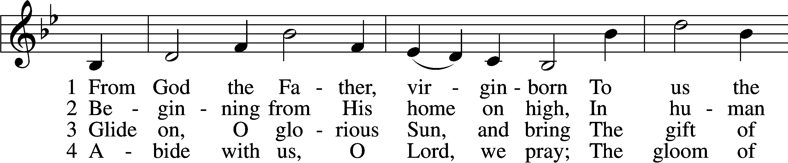
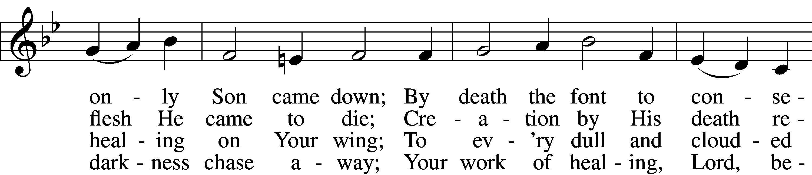
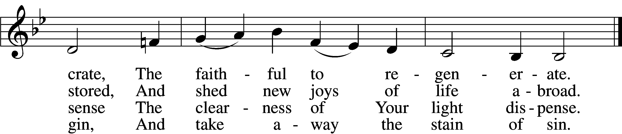

5 Lord, once You came to earth’s domain
And, we believe, shall come again;
Be with us on the battlefield,
From ev’ry harm Your people shield.

D 6 To You, O Lord, all glory be
For this Your blest epiphany;
To God, whom all His hosts adore,
And Holy Spirit evermore.
Text and tune: Public domain

635 O Gracious Lord, I Firmly Am Believing sts. 1–5
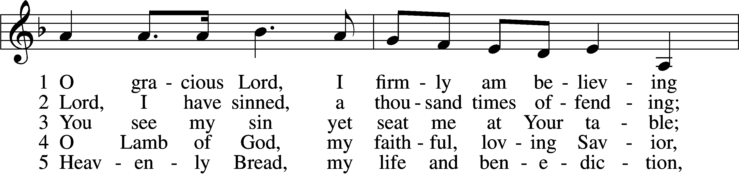
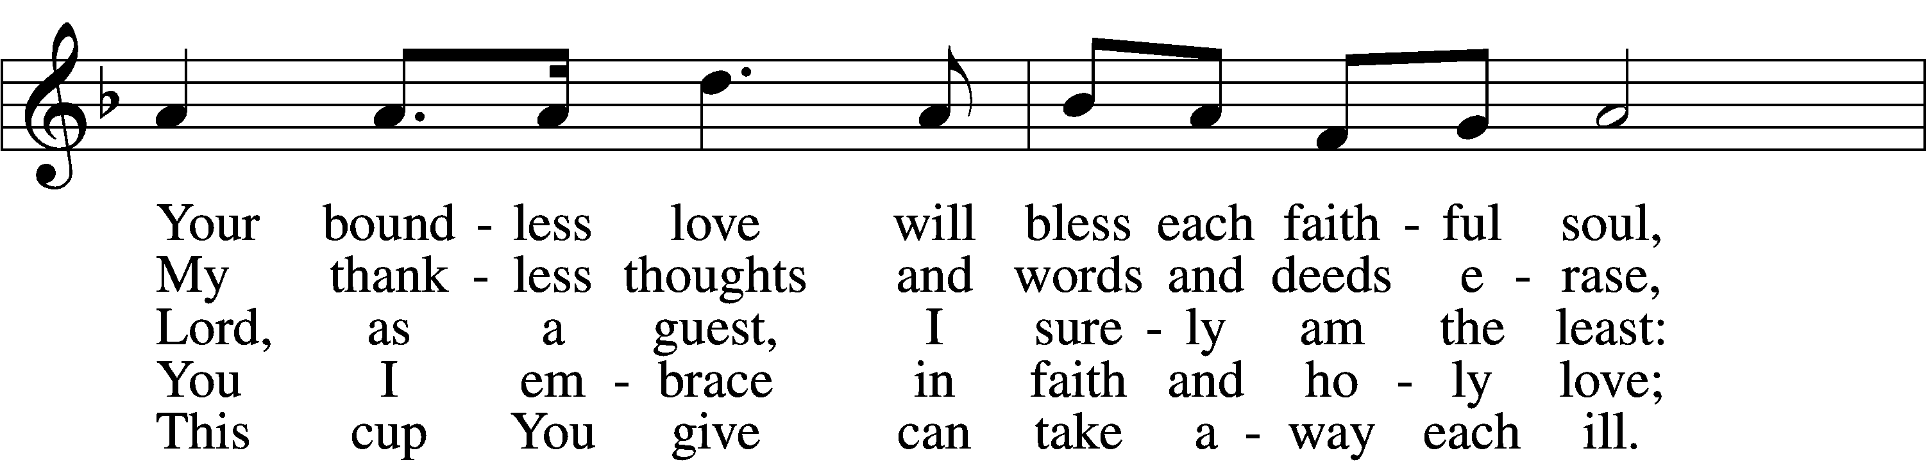
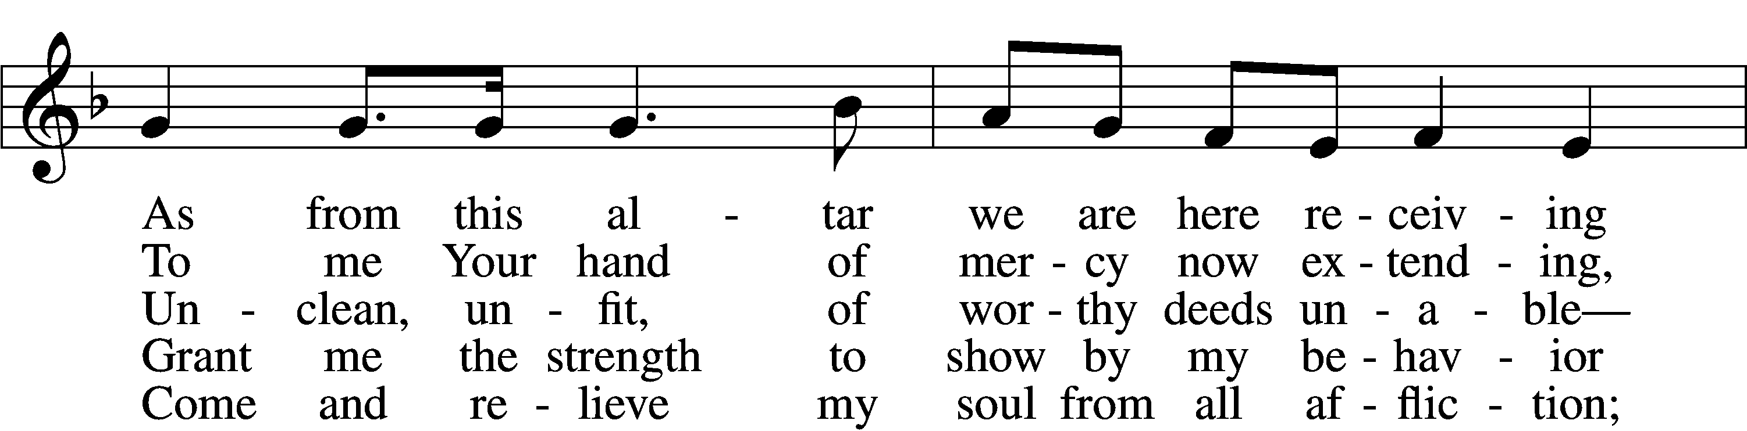
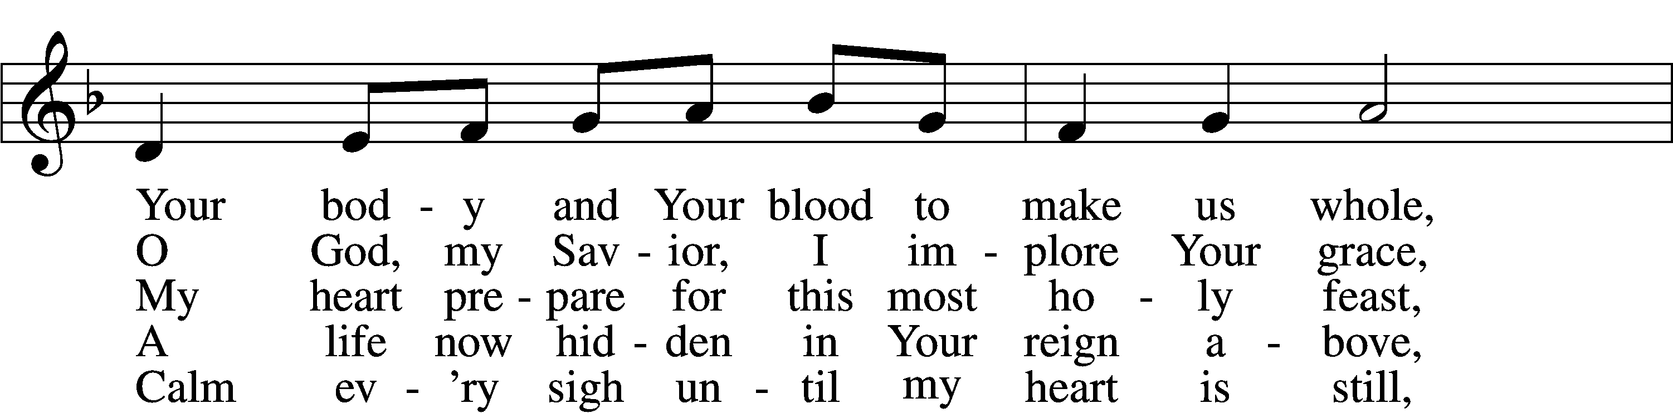
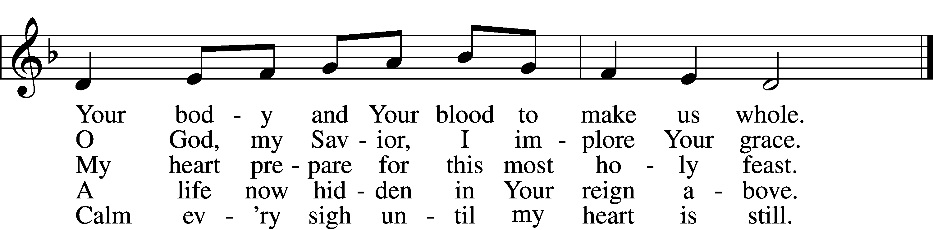
Tune: Public domain
Text: © 2004 Stephen P. Starke, admin. Concordia Publishing House. Used by permission: LSB Hymn License no. 110003744
Distribution Hymn
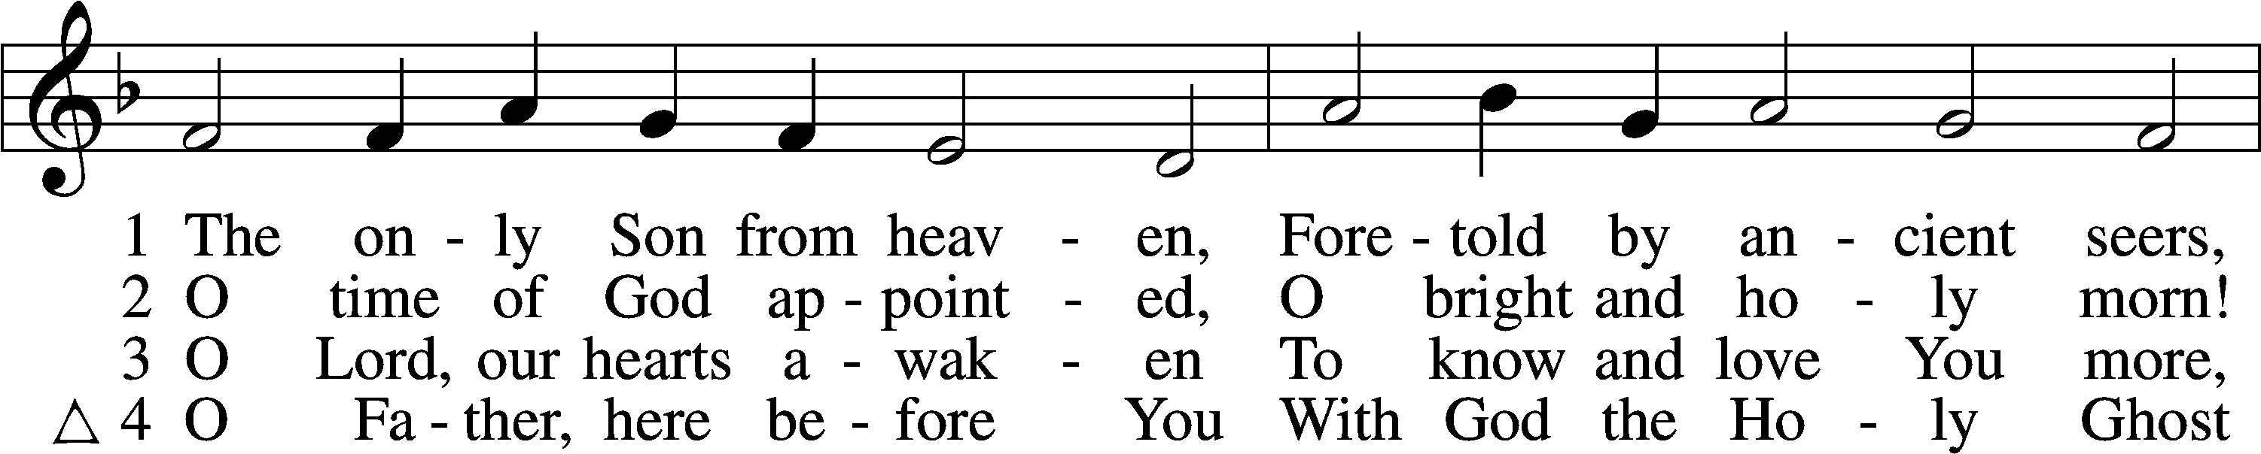
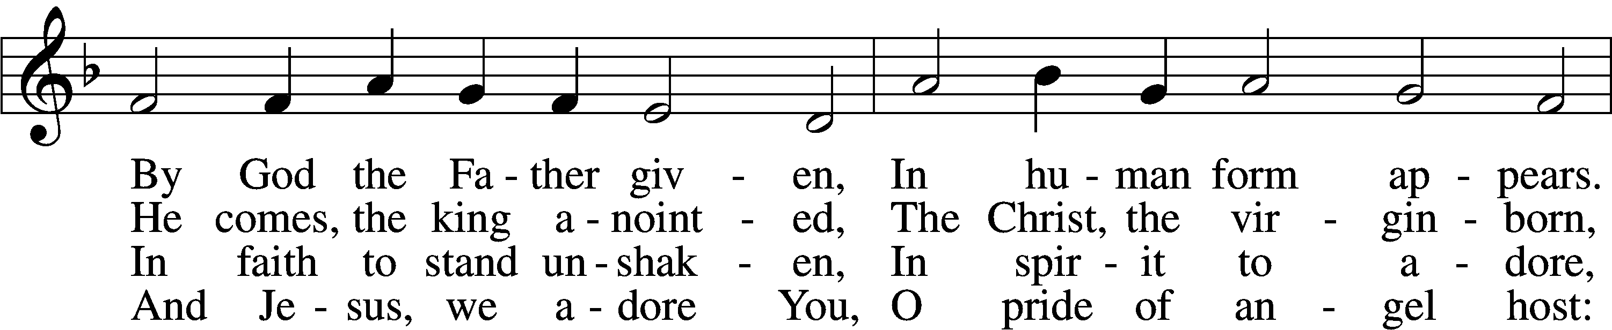
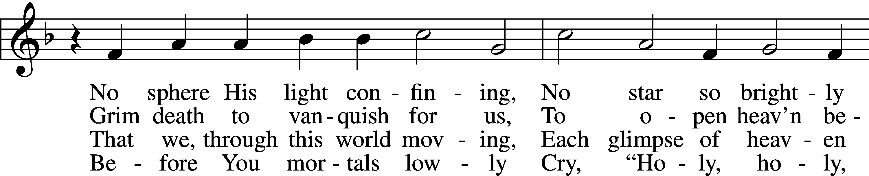
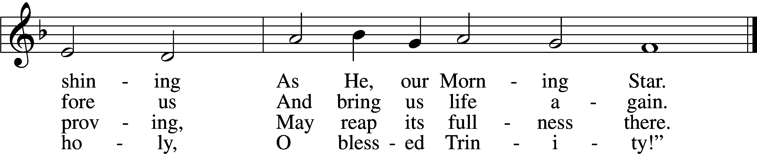
Tune and text: Public domain

In dismissing the communicants, the following is said:

The Dismissal LSB 199
P The body and blood of our Lord Jesus Christ strengthen and preserve you in body and soul to life everlasting. Depart T in peace.
C Amen.

Stand

Nunc Dimittis LSB 199
C Lord, now lettest Thou Thy servant depart in peace according to Thy word,
for mine eyes have seen Thy salvation, which Thou hast prepared before the face of all people,
a light to lighten the Gentiles and the glory of Thy people Israel.
Glory be to the Father and to the Son and to the Holy Ghost;
as it was in the beginning, is now, and ever shall be, world without end. Amen.

Thanksgiving LSB 200
A O give thanks unto the Lord, for He is good,
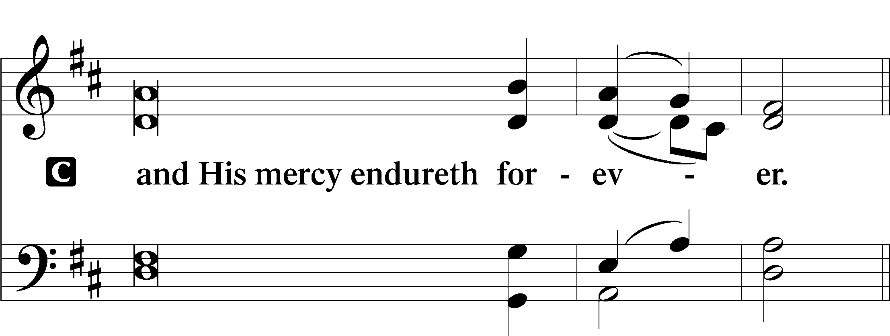

Post-Communion Collect
A Let us pray.
O God the Father, the fountain and source of all goodness, who in loving-kindness sent Your only-begotten Son into the flesh, we thank You that for His sake You have given us pardon and peace in this Sacrament, and we ask You not to forsake Your children but always to rule our hearts and minds by Your Holy Spirit that we may be enabled constantly to serve You; through Jesus Christ, Your Son, our Lord, who lives and reigns with You and the Holy Spirit, one God, now and forever.
C Amen.

Salutation LSB 201
P The Lord be with you.
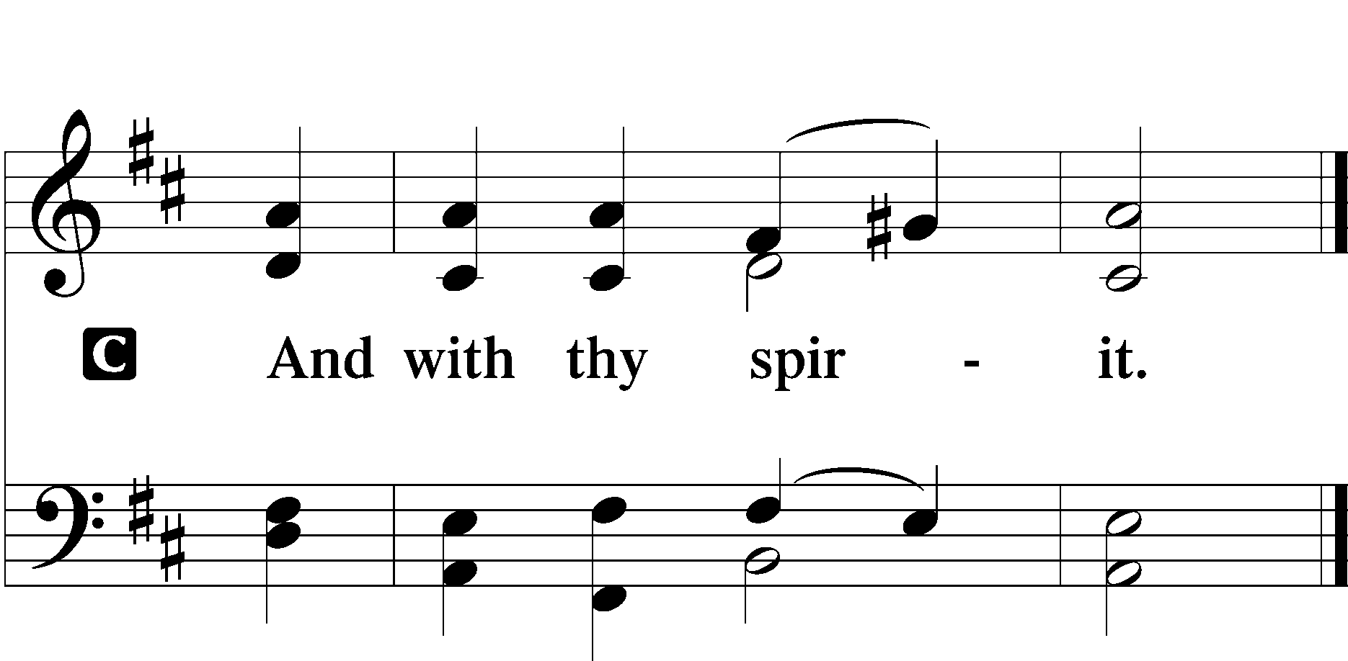

Benedicamus LSB 202
A Bless we the Lord.
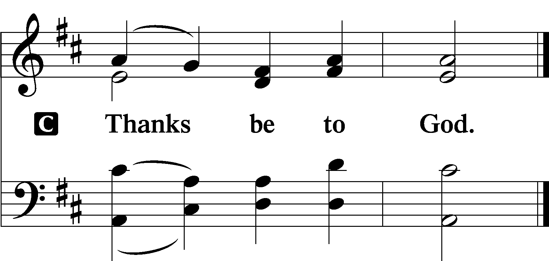

Benediction LSB 202
P The Lord bless you and keep you.
The Lord make His face shine upon you and be gracious unto you.
The Lord lift up His countenance upon you and T give you peace.
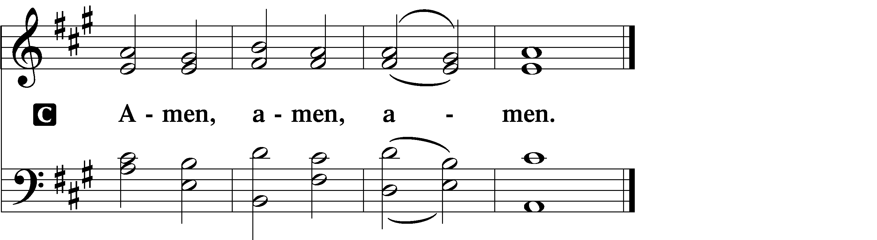

385 From East to West
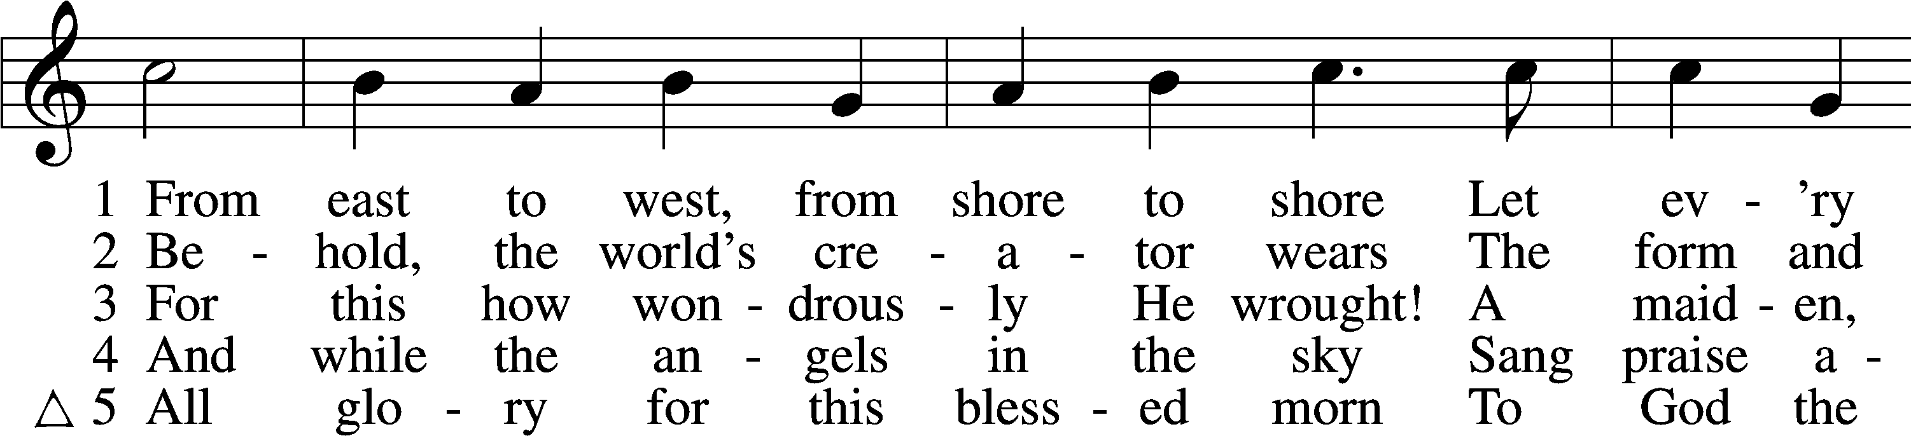
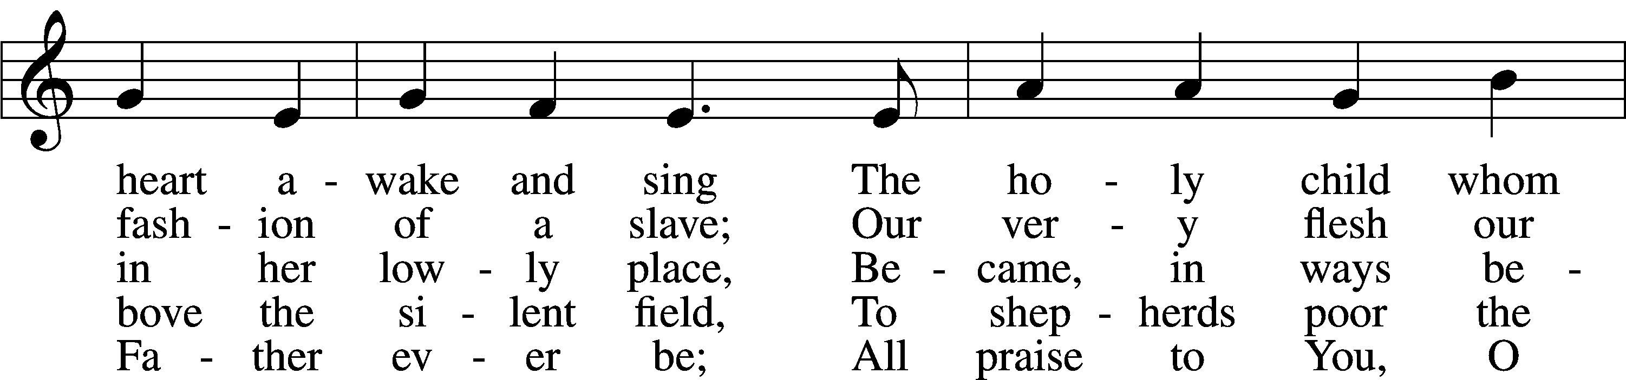
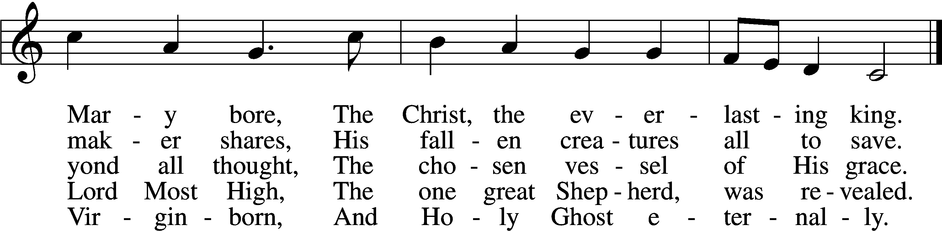
Tune and text: Public domain

Acknowledgments
Unless otherwise indicated, Scripture quotations are from the ESV® Bible (The Holy Bible, English Standard Version®), copyright © 2001 by Crossway, a publishing ministry of Good News Publishers. Used by permission. All rights reserved.
Created by Lutheran Service Builder © 2020 Concordia Publishing House.

Prayers for Our Members
Leah Vogel | Expectant Mothers
Catherine Johanna Baker | Baptism
Norman Abels (Brookestone Meadows – Elkhorn) | Healing
Judy Ahrens | Healing
Vaughn Albrecht (Northridge) | Healing
Tom & DyAnn Altwine | Healing
David Banner | Healing
Lyle Colsden (Mother Hull) | Healing
Pat Flodine (Cambridge Court) | Healing
Vi Fox (Prairie View) | Healing
Verleen Gentry | Healing
Ruby Hatfield | Healing
Michelle Millsap | Healing
Roger Riekenberg | Healing
Don Richmond | Healing
Marion Richmond | Healing
Fran Junge | Cancer
Bev Nuttelman | Cancer
Kim Vos | Cancer

Prayers for Our Members’ Family & Friends
Dawn Gaunt (Pr. & Carol Gaunt’s daughter-in-law) | Expectant Mother
Brandon & Shannon Howell (Quentin & Janel Lange’s friends) | Expecting
Will Brennemann (Jami Helmbrecht’s father) | Healing
Reg Duke (Westman’s brother-in-law) | Healing
James Gentry (Verleen Gentry’s son) | Healing
Roger Hoffman (Marc’s father) | Healing
Sharon Kreutzer (former member) | Healing
Lyra Mais (Zion student) | Healing
Randy Solomon (Beth Rosenthal’s father) | Healing
Mary Ann Mertz (Pam’s Uhlir’s friend) | Healing
Roy Reynolds (Verleen Gentry’s son-in-law) | Healing
Janet Stalder (Carol Florang’s sister) | Healing
D.D. Dugger (Sue Kaiser’s brother) | Cancer
Ron Halvorsen (Jeff’s dad) | Cancer
Carol Haubold (Don Helmbrecht’s sister) | Cancer
Tyler Holland (Quentin & Janel Lange’s brother-in-law) | Cancer
Randy Jochum (Ken Hockemeier’s brother-in-law) | Cancer
Fred Koch (Pam Uhlir’s cousin) | Cancer
Lynda Kreutzer (Rich & Carol’s sister-in-law) | Cancer
John Moore (family of Susan Tonniges) | Cancer
Sharon Mulhair (Pam Uhlir’s cousin) | Cancer
Becky Rathkie (former Zion teacher) | Cancer
Jeannie Schmidt (Lisa Splittgerber’s sister-in-law) | Cancer
Tyrone Uhlir (Pam’s nephew) | Cancer

Today’s Radio Broadcast is given to the Glory of the Lord by
Vi Fox in memory of Don’s birthday and their anniversary

Serving in Worship

Sunday, January 3~ 9:00am

Elder: Eric Rosenthal
Usher: Fred Flessner & Lennis Hodgson
Engineer: Jamie Nikodym
Announcer: Brooke Fisher
Altar Guild: Sheryl Fox & Shirley Oertwig
Sunday, January 10~ 9:00am

Elder: Dan Oertwig
Usher: Marc Hoffman & Steve Junge
Engineer: Zach DeLoach
Announcer: Jesse Florang
Altar Guild: Sheryl Fox & Shirley Oertwig

Our Response to the Gospel

Date: 12/27/2020

Offering: $8,339.60
Weekly Need: $7,542.37

ZION LUTHERAN CHURCH AND SCHOOL

Pr. James DeLoach, Pastor + (308) 627-5260
james.deloach@zionkearney.org
Pr. Doug Gaunt, Pastor + (308) 455-0552
doug.gaunt@zionkearney.org
Tony Splittgerber, Principal + (308) 293-0168
anthony.splittgerber@zionkearney.org

Church Office
Administrative Assistant: Jessica Shiers
Email: school@zionkearney.org
Phone: (308)-234-3410 Fax: (308) 236-8100
Office Hours: Monday-Friday 8:00am-4:00pm
Radio Broadcast: Sunday @ 10:30 a.m. on 1460 AM
Website: www.zionkearney.com

This Week at Zion

Sun  01/03 | 9:00a  10:30a | Divine Service  Radio Broadcast 1460am
Mon  01/04 | Birthdays  Anniversaries | Todd Koopman  ---
Tues  01/05 | Birthdays  Anniversaries | Aaron Hockemeier  ---
Wed  01/06 | Birthdays  Anniversaries | School Resumes  ---  ---
Thurs  01/07 | Birthdays  Anniversaries | Titus Gaunt  Matthew Podany  Emma Rosenthal  ---
Fri  01/08 | Birthdays  Anniversaries | Bailey Hockemeier  Donald Trampe  ---
Sat  01/09 | 5:00p  Birthdays  Anniversaries | Divine Service  ---  ---
Sun  01/10 | 9:00a  10:30a  Birthdays  Anniversaries | Divine Service  Radio Broadcast 1460am  ---  ---
ANNOUNCEMENTS
Where our Triune God strengthens us through His mercy in faith toward Him and in fervent love toward one another.

Masks – According to Kearney City Ordinance No. 8457 masks are required “at a location that is open to the general public and where they cannot maintain six foot of distance.”

Baptism – We welcome Catherine Johanna Baker to Zion. She is the daughter of Flynn and Robin Baker.

POINSETTIAS - Thank you to all that provided poinsettias to beautify the sanctuary during the Christmas season. You are welcome to take your plant home with you immediately following the service. Please leave the water tray, so we may use them again next year.

Un-decorate – Please help un-decorate the church on Saturday, January 10th at 9:00 a.m. Any help would be appreciated.

Year-End Reports - The Chairman of each board and organization is asked to turn in a Year End Report to the Church office. The most convenient way to receive these is by email. school@zionkearney.org

Office Closed – The church office will be closed Monday, December 21-Tuesday, January 5th. For Pastoral emergencies please call Pastor DeLoach (308-627-5260) or Pastor Gaunt (308-455-0552).

A Bible Study – is prerecorded and available each Sunday, along with a study guide you can use to follow along. We are studying the three lessons for the day—the Old Testament, the Epistle, and the Gospel. Go to Zion’s website www.zionkearney.com to access the video and study guide.

Offering Envelopes – 2021 offering envelopes are in your church mailbox.

Offering during this time. If you are not able to attend live Church Services, you may: drop your offering in the mail slot by the south doors, mail it to the church, or use online giving option at zionkearney.com. If you have any questions or need assistance please contact the office at 308-234-3410 or school@zionkearney.org. Thank you for supporting of your church!

Bible Reading Cards - A new set of Bible reading cards for the new year can be picked up in the Chruch entryway. Each card is a tool to keep track of your Bible reading progress as you mark each chapter you have read in 2020. God works through His word.

Radio Broadcast & Altar Flowers - Please help Zion spread the Gospel! There are several open dates. This is a great need during this time, many people are listening to our broadcast during this time. There are also many openings for altar flowers. Please help beautify the sanctuary.

Mission Offerings - The fourth quarter missions, October through December, will support those preparing for fulltime church work (Peter Kreutzer and Taylor Zehendner, both at CUNE). If you would like to donate to this mission please use the mission envelopes located in the narthex. Thank you for your support.

Registration Open- Registration is now open for the 2021-2022 New this year is and all-day prekindergarten! If you have any questions please feel free to contact the office. Please tell your family and friends about Zion. Enroll early to make sure you have a spot. We invited everyone to reenroll. Zion is a wonderful school family, we would love to see everyone back!

New Teacher Search - Mr. Vogel and family will be moving at the conclusion of this school year so the search for another high quality Lutheran teacher has begun. Full time teachers in our school must be members of the LCMS (or willing to become so). The grade level will most probably be for the 3rd/4th grade. If you or someone you know might be interested in this position please contact Mr. Splittgerber

