Divine Service
Baptism of our Lord
January 10, 2021
Zion Lutheran Church
Kearney, Nebraska

Welcome to Zion!
All worshippers please fill out an attendance card in the pew rack and let us know how we might be of service to you.

Holy Communion at Zion

The Lord’s Supper is celebrated at this congregation as Jesus has given it. As he says, our Lord gives into our mouths not only bread and wine but his very body and blood to eat and to drink for the forgiveness of sins and to strengthen our union with him and with one another. Our Lord invites to his table those who trust his words, repent of all sin, and set aside any refusal to forgive and love as he forgives and loves us, that they may show forth his death until he comes. All communicants need to register in the narthex prior to the service.

Because those who eat and drink our Lord’s body and blood unworthily do great harm and because Holy Communion is a confession of the faith which is confessed at this altar, any who are not yet instructed, in doubt, or who hold a confession differing from that of this congregation and The Lutheran Church—Missouri Synod, are asked not to commune until they are able to speak with our pastor first. He is happy to visit with you about the Christian faith and how to receive the Lord’s Supper for your good and for the good of others. Those not communing are invited to come to the altar, cross your arms in front of you, and bow your head to receive a pastoral blessing.

In Holy Baptism, the Triune God Reveals Himself and Recreates Us in His Image

“In the beginning, God created the heavens and the earth” (Gen. 1:1). Then, as “the Spirit of God was hovering over the face of the waters” (Gen. 1:2), God spoke His Word: “‘Let there be light,’ and there was light” (Gen. 1:3). In the same way, “the beginning of the gospel of Jesus Christ” (Mark 1:1) brings about the new creation through the waters of Baptism by the same Word and Spirit of God. When John the Baptist came, “proclaiming a baptism of repentance for the forgiveness of sins,” Jesus also came “and was baptized by John in the Jordan” (Mark 1:4, 9). Although He had no sins of His own, He took His stand with sinners in His Baptism and took the sins and mortality of the world upon Himself. He was baptized into His own death, by which the heavens are opened and the Spirit is given to us. God the Father is well pleased with His beloved Son and raises Him from the dead. As we share His Baptism and are “united with him in a death like his” (Rom. 6:5), we also share His resurrection unto “newness of life” (Rom. 6:4).

Confession and Absolution

404 Jesus, Once with Sinners Numbered
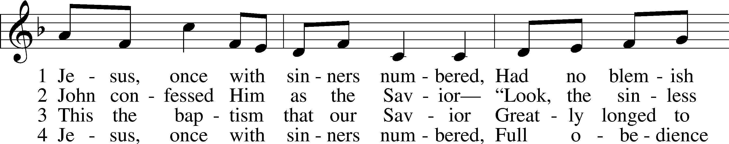
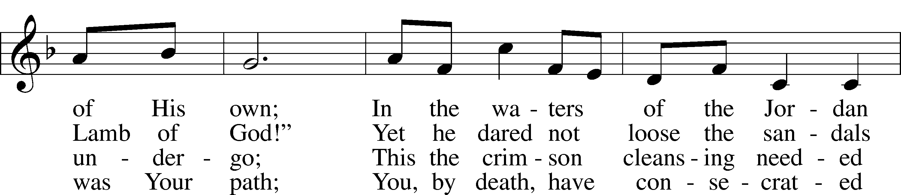
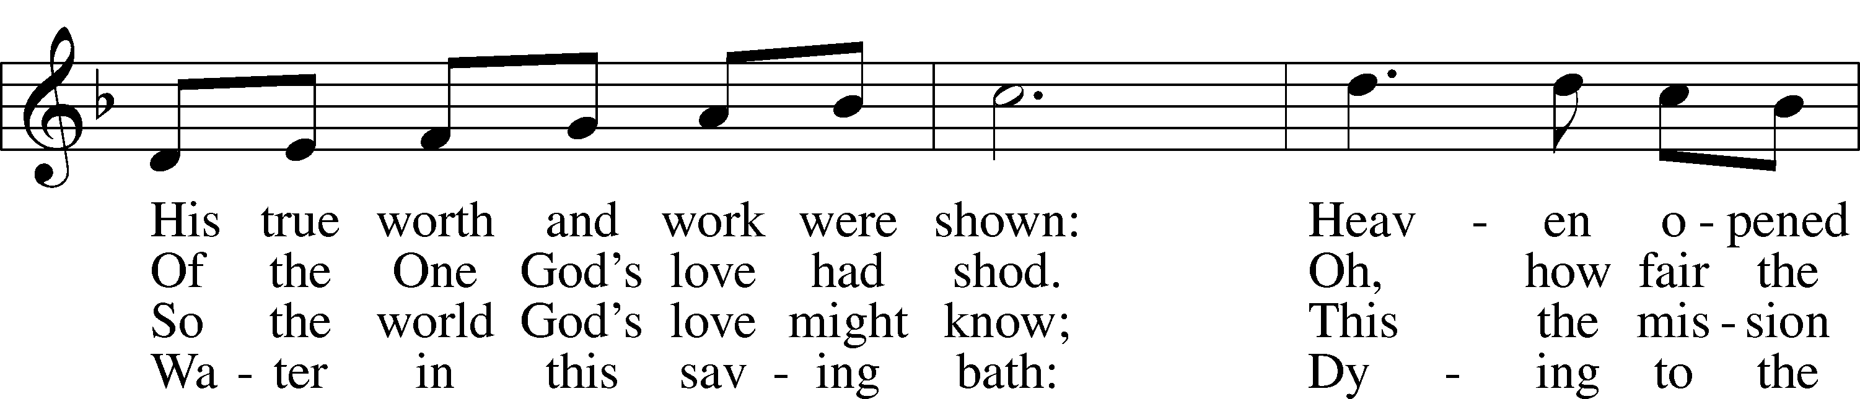
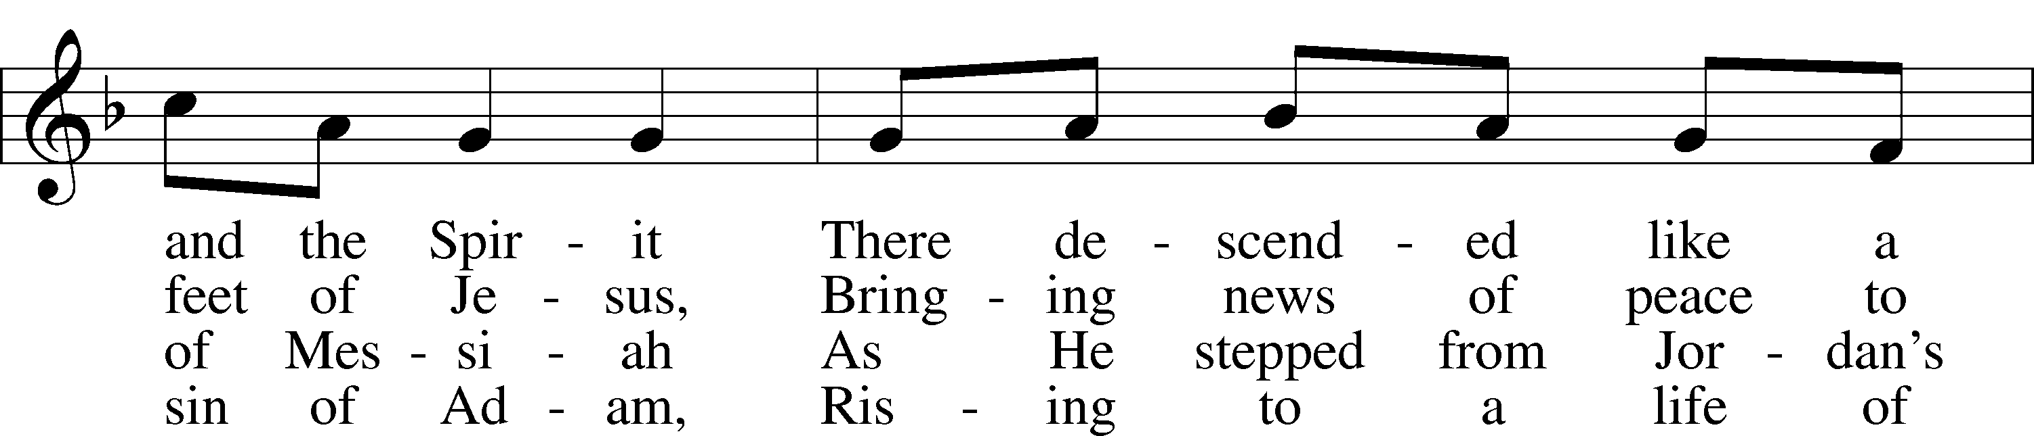
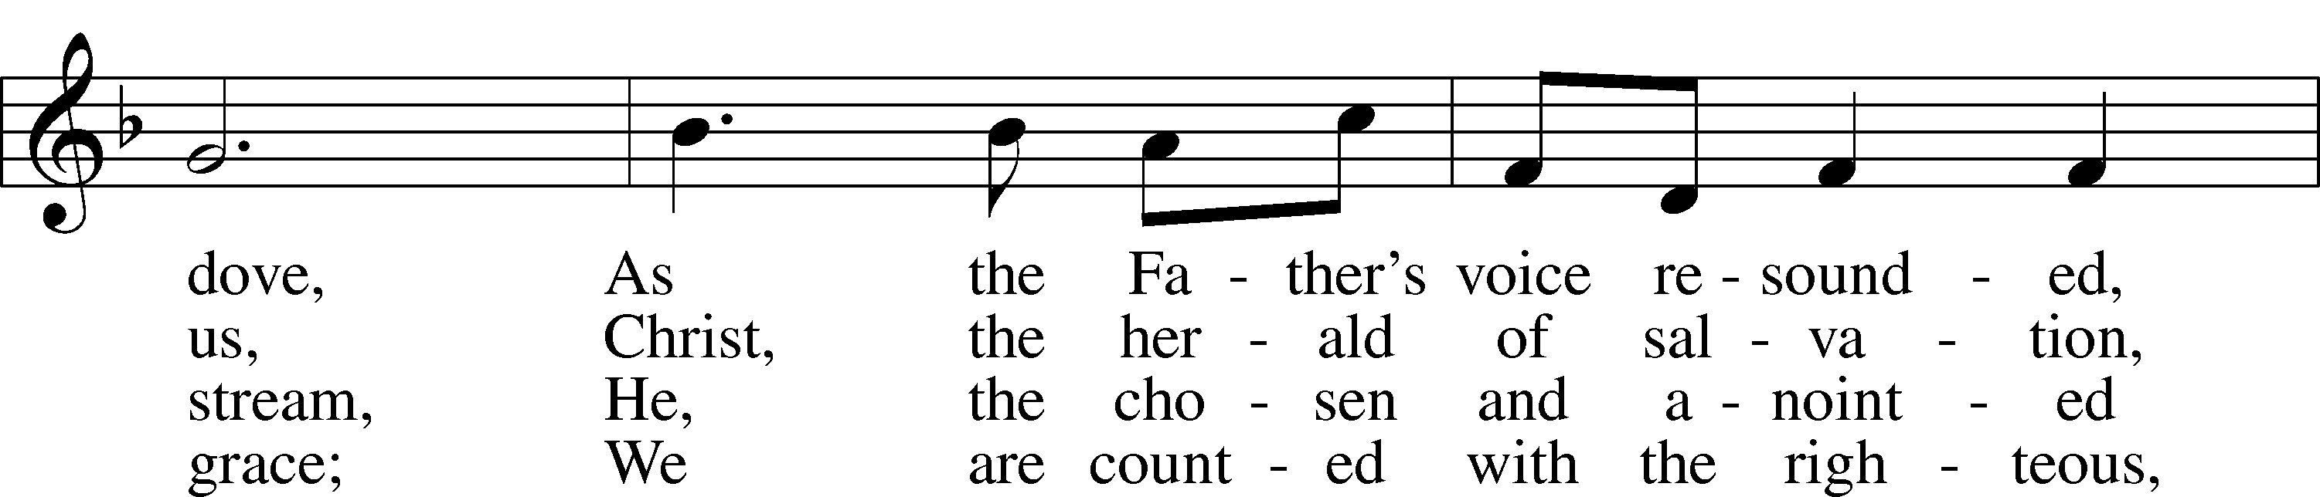
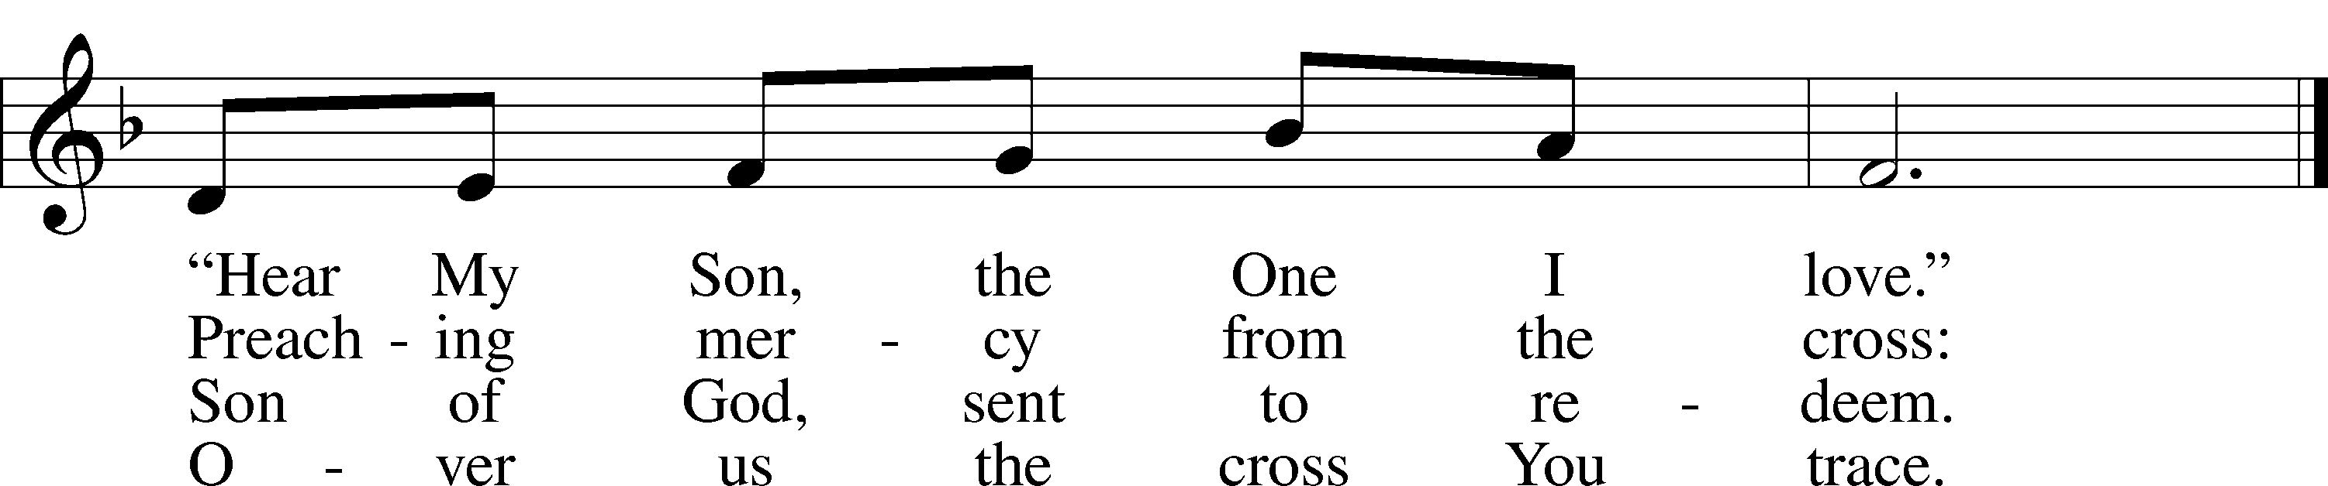
Text: © 1999 Stephen P. Starke, admin. Concordia Publishing House. Used by permission: LSB Hymn License no. 110003744
Tune: © 1995 Augsburg Fortress. Used by permission: LSB Hymn License no. 110003744

Stand
The sign of the cross may be made by all in remembrance of their Baptism.

P In the name of the Father and of the T Son and of the Holy Spirit.
C Amen.

P If we say we have no sin, we deceive ourselves, and the truth is not in us.
C But if we confess our sins, God, who is faithful and just, will forgive our sins and cleanse us from all unrighteousness.

Kneel/Stand

Silence for reflection on God’s Word and for self-examination.

P Let us then confess our sins to God our Father.
C Most merciful God, we confess that we are by nature sinful and unclean. We have sinned against You in thought, word, and deed, by what we have done and by what we have left undone. We have not loved You with our whole heart; we have not loved our neighbors as ourselves. We justly deserve Your present and eternal punishment. For the sake of Your Son, Jesus Christ, have mercy on us. Forgive us, renew us, and lead us, so that we may delight in Your will and walk in Your ways to the glory of Your holy name. Amen.

P Almighty God in His mercy has given His Son to die for you and for His sake forgives you all your sins. As a called and ordained servant of Christ, and by His authority, I therefore forgive you all your sins in the name of the Father and of the T Son and of the Holy Spirit.
C Amen.

Stand

Service of the Word

Introit Psalm 2:7–11, 12c; antiphon: Isaiah 42:1a
Behold my servant, whom | I uphold,*
my chosen, in whom my | soul delights.
I will tell of | the decree:*
The Lord said to me, “You are my Son; today I have be- | gotten you.
Ask of me, and I will make the nations your | heritage,*
and the ends of the earth your pos- | session.
You shall break them with a | rod of iron*
and dash them in pieces like a potter’s | vessel.”
Now therefore, O | kings, be wise;*
be warned, O rulers | of the earth.
Serve the |Lord with fear,*
and rejoice with | trembling,
for his wrath is quickly | kindled.*
Blessèd are all who take ref- | uge in him.
Glory be to the Father and | to the Son*
and to the Holy | Spirit;
as it was in the be- | ginning,*
is now, and will be forever. | Amen.
Behold my servant, whom | I uphold,*
my chosen, in whom my | soul delights.

Kyrie LSB 152
A In peace let us pray to the Lord.
C Lord, have mercy.
A For the peace from above and for our salvation let us pray to the Lord.
C Lord, have mercy.
A For the peace of the whole world, for the well-being of the Church of God, and for the unity of all let us pray to the Lord.
C Lord, have mercy.
A For this holy house and for all who offer here their worship and praise let us pray to the Lord.
C Lord, have mercy.
A Help, save, comfort, and defend us, gracious Lord.
C Amen.

Gloria in Excelsis LSB 154
A Glory to God in the highest, and peace to His people on earth.
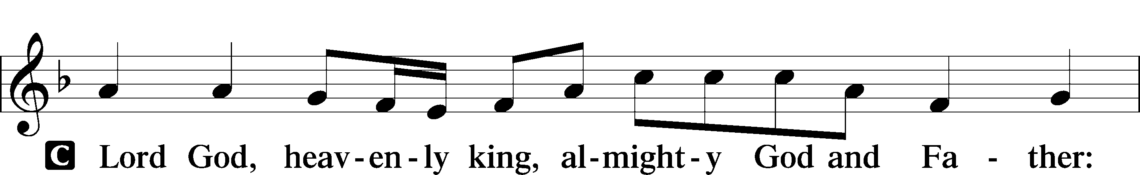
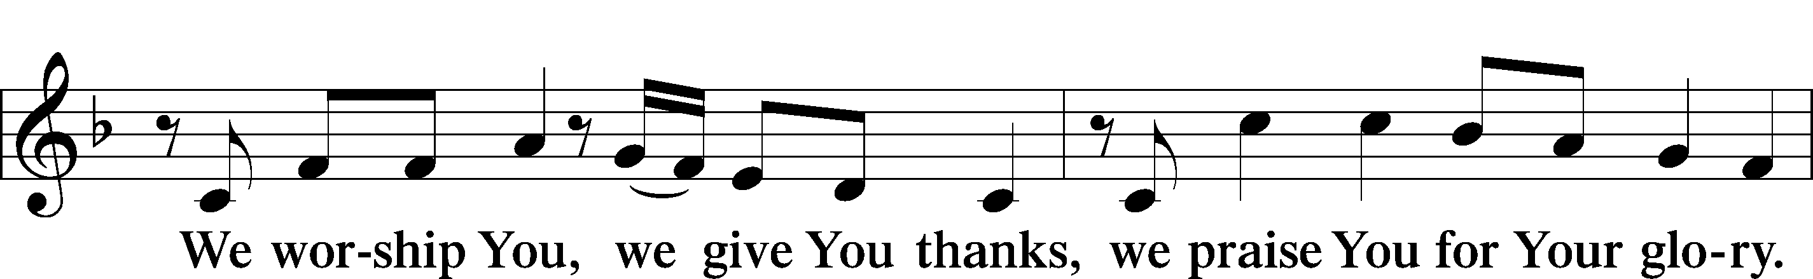
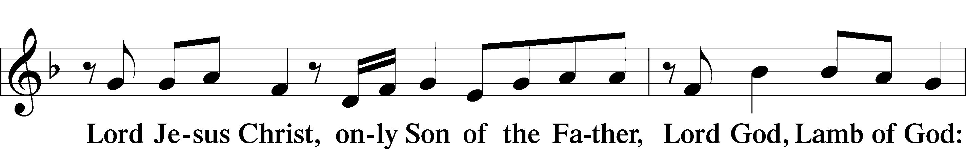
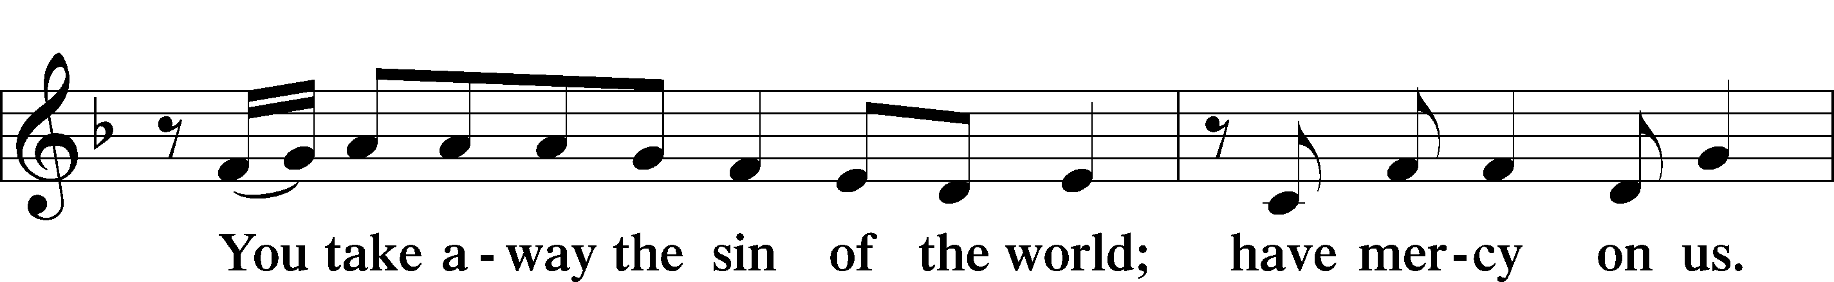
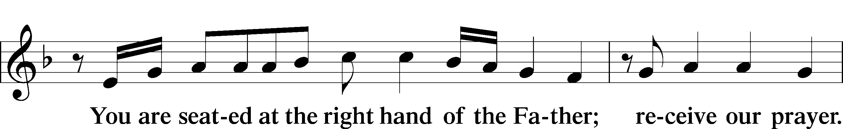
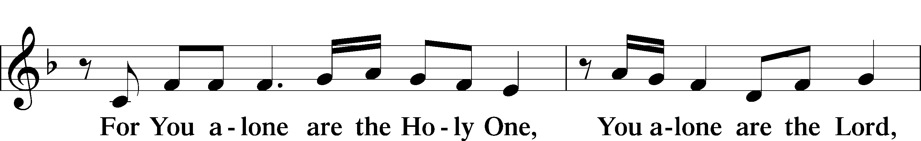
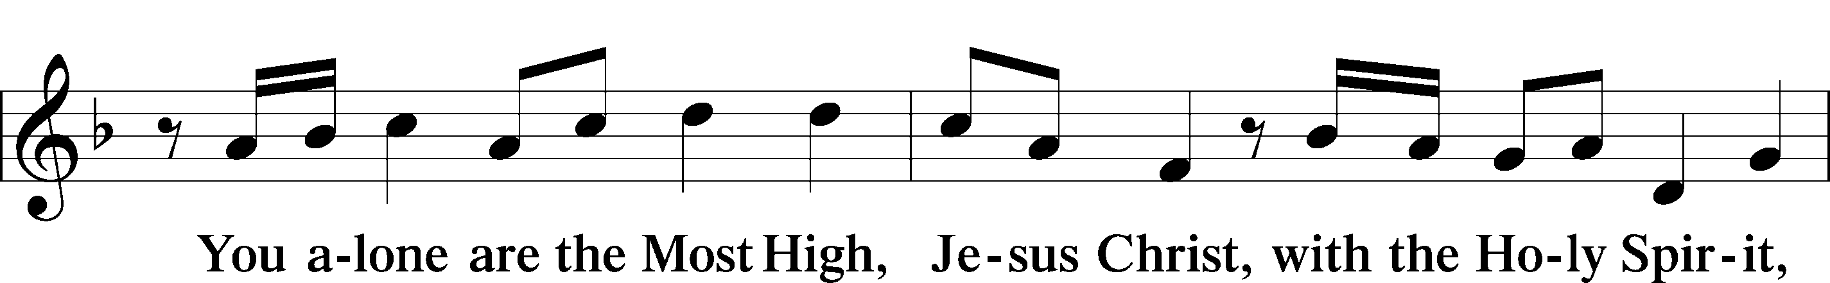
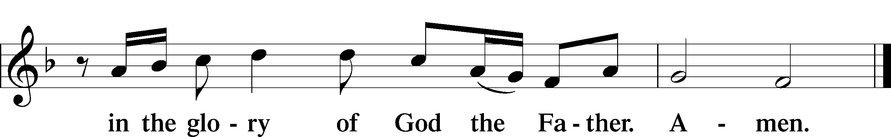

Salutation and Collect of the Day
P The Lord be with you.
C And also with you.

P Let us pray.
Father in heaven, at the Baptism of Jesus in the Jordan River You proclaimed Him Your beloved Son and anointed Him with the Holy Spirit. Make all who are baptized in His name faithful in their calling as Your children and inheritors with Him of everlasting life; through the same Jesus Christ, our Lord, who lives and reigns with You and the Holy Spirit, one God, now and forever.

C Amen.

Sit

Old Testament Reading Genesis 1:1–5
The Beginning of Creation
¹In the beginning, God created the heavens and the earth. ²The earth was without form and void, and darkness was over the face of the deep. And the Spirit of God was hovering over the face of the waters.

The Six Days of Creation
³And God said, “Let there be light,” and there was light. ⁴And God saw that the light was good. And God separated the light from the darkness. ⁵God called the light Day, and the darkness he called Night. And there was evening and there was morning, the first day.

A This is the Word of the Lord.
C Thanks be to God.

Gradual Psalm 117:1–2a; 96:8
Praise the Lord, all | nations!*
Extol him, all | peoples!
For great is his steadfast | love toward us,*
and the faithfulness of the Lord endures for- | ever.
Ascribe to the Lord the glory | due his name;*
bring an offering, and come in- | to his courts!

Epistle Romans 6:1–11
Dead to Sin, Alive to God
¹What shall we say then? Are we to continue in sin that grace may abound? ²By no means! How can we who died to sin still live in it? ³Do you not know that all of us who have been baptized into Christ Jesus were baptized into his death? ⁴We were buried therefore with him by baptism into death, in order that, just as Christ was raised from the dead by the glory of the Father, we too might walk in newness of life.
⁵For if we have been united with him in a death like his, we shall certainly be united with him in a resurrection like his. ⁶We know that our old self was crucified with him in order that the body of sin might be brought to nothing, so that we would no longer be enslaved to sin. ⁷For one who has died has been set free from sin. ⁸Now if we have died with Christ, we believe that we will also live with him. ⁹We know that Christ being raised from the dead will never die again; death no longer has dominion over him. ¹⁰For the death he died he died to sin, once for all, but the life he lives he lives to God. ¹¹So you also must consider yourselves dead to sin and alive to God in Christ Jesus.

A This is the Word of the Lord.
C Thanks be to God.

Stand

Alleluia and Verse LSB 156
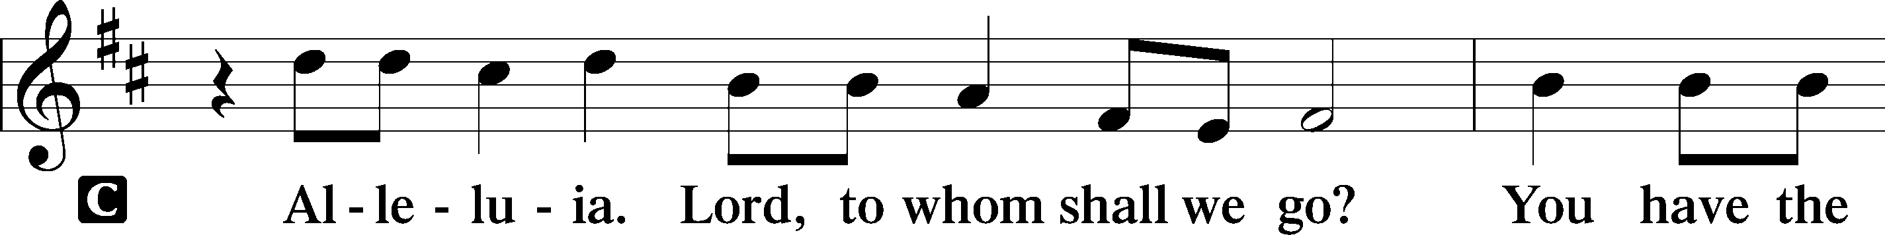
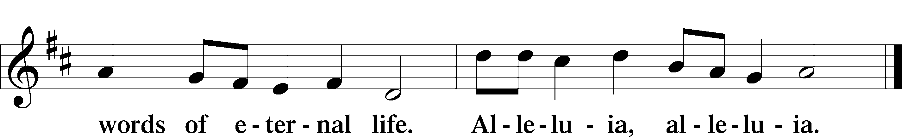

Holy Gospel Mark 1:4–11
P The Holy Gospel according to St. Mark, the first chapter.
C Glory to You, O Lord.

⁴John appeared, baptizing in the wilderness and proclaiming a baptism of repentance for the forgiveness of sins. ⁵And all the country of Judea and all Jerusalem were going out to him and were being baptized by him in the river Jordan, confessing their sins. ⁶Now John was clothed with camel’s hair and wore a leather belt around his waist and ate locusts and wild honey. ⁷And he preached, saying, “After me comes he who is mightier than I, the strap of whose sandals I am not worthy to stoop down and untie. ⁸I have baptized you with water, but he will baptize you with the Holy Spirit.”
The Baptism of Jesus
⁹In those days Jesus came from Nazareth of Galilee and was baptized by John in the Jordan. ¹⁰And when he came up out of the water, immediately he saw the heavens opening and the Spirit descending on him like a dove. ¹¹And a voice came from heaven, “You are my beloved Son; with you I am well pleased.”

P This is the Gospel of the Lord.
C Praise to You, O Christ.

Sit

406 To Jordan Came the Christ, Our Lord
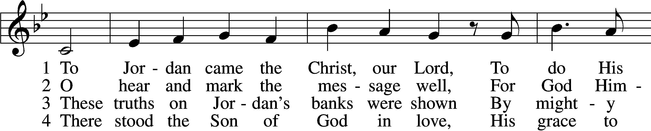
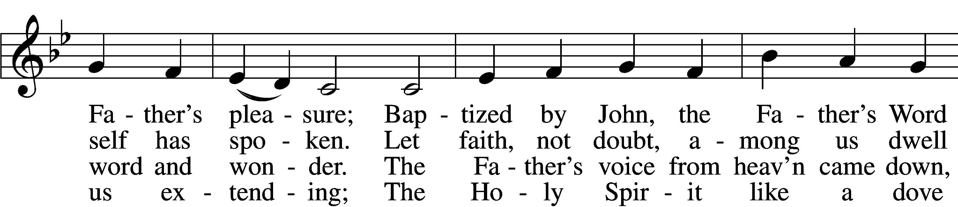
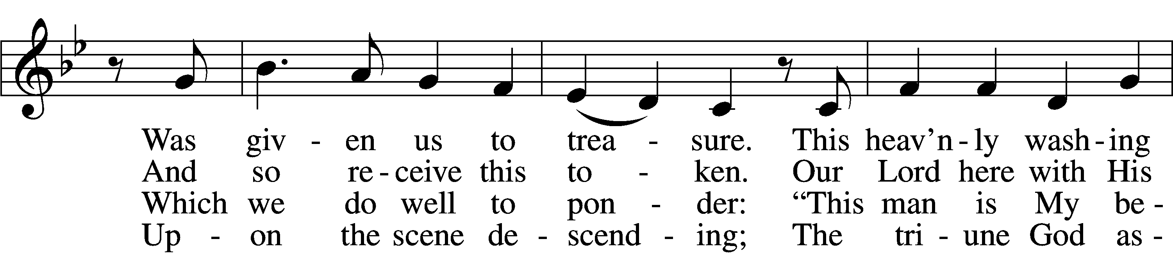
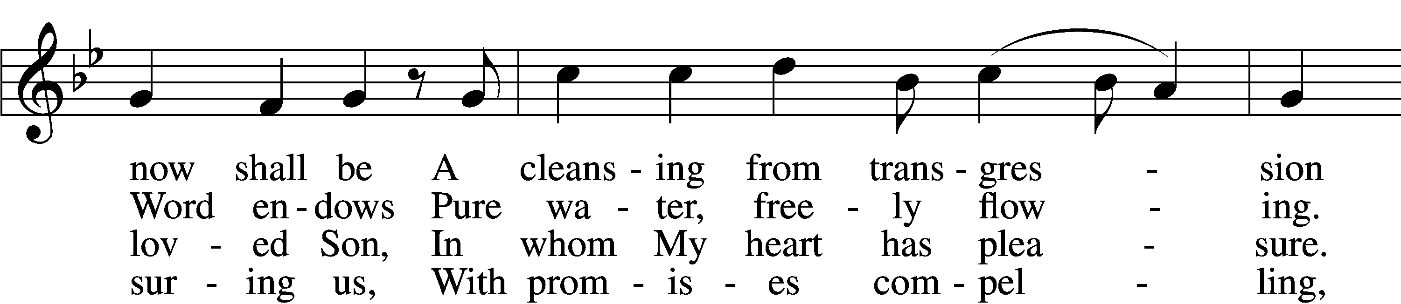
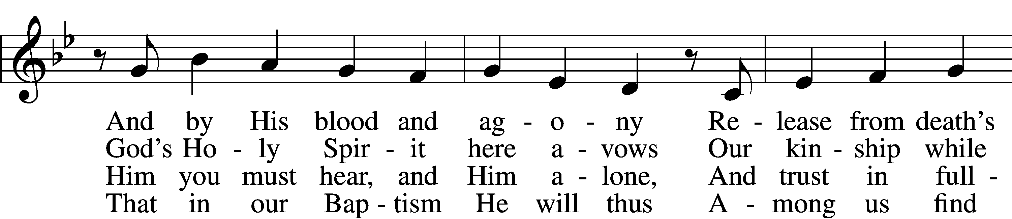
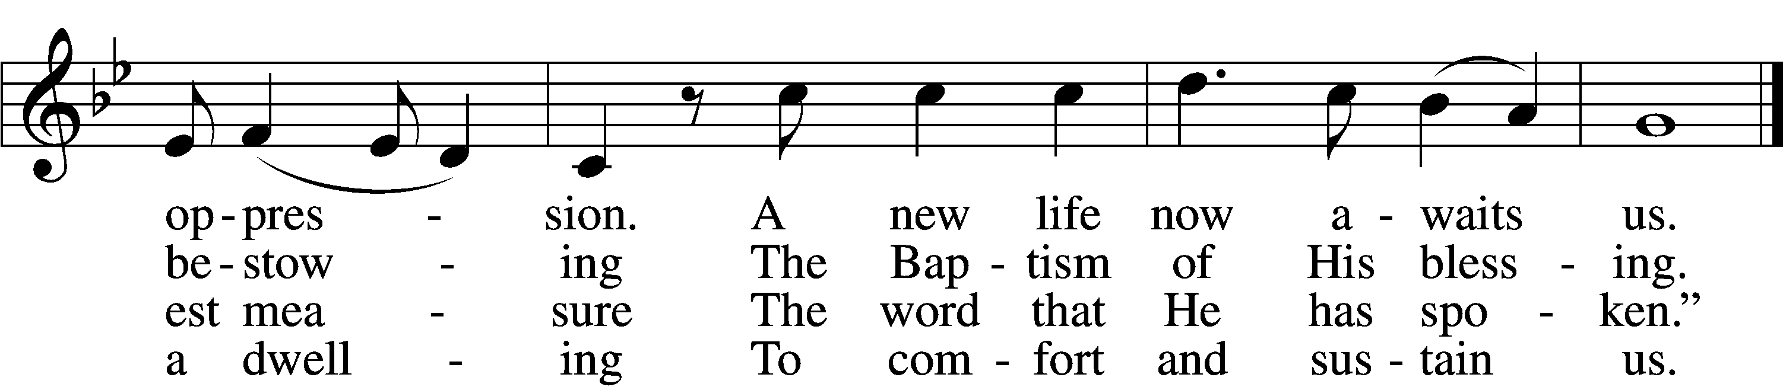

5 To His disciples spoke the Lord,
“Go out to ev’ry nation,
And bring to them the living Word
And this My invitation:
Let ev’ryone abandon sin
And come in true contrition
To be baptized and thereby win
Full pardon and remission
And heav’nly bliss inherit.”

6 But woe to those who cast aside
This grace so freely given;
They shall in sin and shame abide
And to despair be driven.
For born in sin, their works must fail,
Their striving saves them never;
Their pious acts do not avail,
And they are lost forever,
Eternal death their portion.

7 All that the mortal eye beholds
Is water as we pour it.
Before the eye of faith unfolds
The pow’r of Jesus’ merit.
For here it sees the crimson flood
To all our ills bring healing;
The wonders of His precious blood
The love of God revealing,
Assuring His own pardon.
Text: © 1976 Elizabeth Quitmeyer. Used by permission: LSB Hymn License no. 110003744
Tune: Public domain

Sermon

Stand

Nicene Creed
C I believe in one God,
the Father Almighty,
maker of heaven and earth
and of all things visible and invisible.

And in one Lord Jesus Christ,
the only-begotten Son of God,
begotten of His Father before all worlds,
God of God, Light of Light,
very God of very God,
begotten, not made,
being of one substance with the Father,
by whom all things were made;
who for us men and for our salvation came down from heaven
and was incarnate by the Holy Spirit of the virgin Mary
and was made man;
and was crucified also for us under Pontius Pilate.
He suffered and was buried.
And the third day He rose again according to the Scriptures
and ascended into heaven
and sits at the right hand of the Father.
And He will come again with glory to judge both the living and the dead,
whose kingdom will have no end.

And I believe in the Holy Spirit,
the Lord and giver of life,
who proceeds from the Father and the Son,
who with the Father and the Son together is worshiped and glorified,
who spoke by the prophets.
And I believe in one holy Christian and apostolic Church,
I acknowledge one Baptism for the remission of sins,
and I look for the resurrection of the dead
and the life T of the world to come. Amen.

Prayer of the Church

Offertory LSB 159
C What shall I render to the Lord for all His benefits to me?
I will offer the sacrifice of thanksgiving and will call on the name of the Lord.
I will take the cup of salvation and will call on the name of the Lord.
I will pay my vows to the Lord now in the presence of all His people,
in the courts of the Lord’s house, in the midst of you, O Jerusalem.

Service of the Sacrament

Preface LSB 160
P The Lord be with you.

P Lift up your hearts.

P Let us give thanks to the Lord our God.
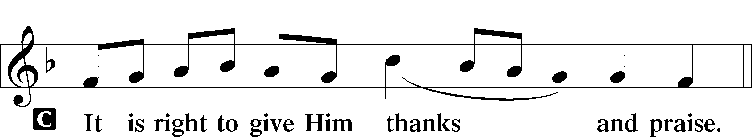

P It is truly good, right, and salutary that we should at all times and in all places give thanks to You, holy Lord, almighty Father, everlasting God, through Jesus Christ, our Lord; for what had been hidden from before the foundation of the world You have made known to the nations in Your Son. In Him, being found in the substance of our mortal nature, You have manifested the fullness of Your glory. Therefore with angels and archangels and with all the company of heaven we laud and magnify Your glorious name, evermore praising You and saying:

Sanctus LSB 161
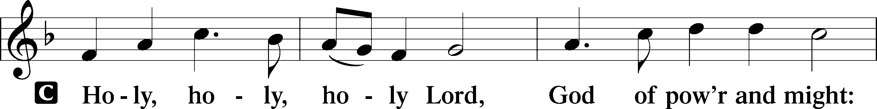
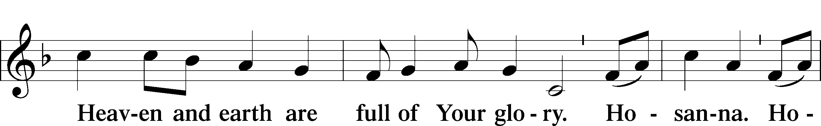
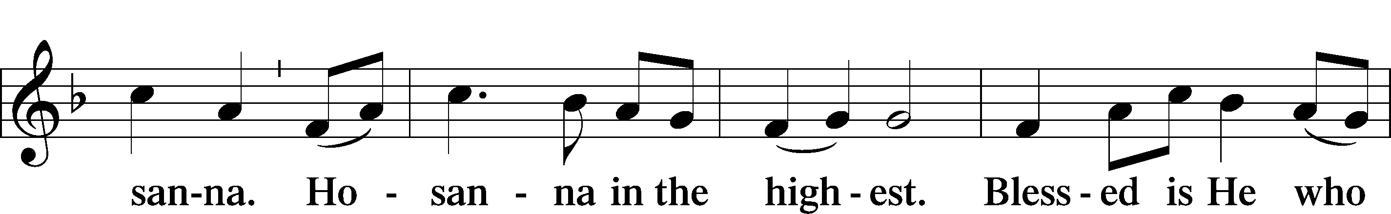
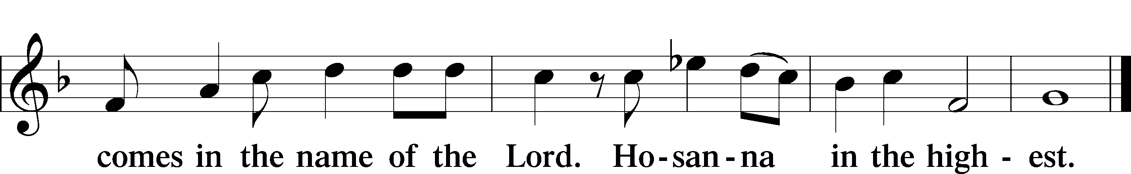

Prayer of Thanksgiving LSB 161
P Blessed are You, Lord of heaven and earth, for You have had mercy on those whom You created and sent Your only-begotten Son into our flesh to bear our sin and be our Savior. With repentant joy we receive the salvation accomplished for us by the all-availing sacrifice of His body and His blood on the cross.

Gathered in the name and the remembrance of Jesus, we beg You, O Lord, to forgive, renew, and strengthen us with Your Word and Spirit. Grant us faithfully to eat His body and drink His blood as He bids us do in His own testament. Gather us together, we pray, from the ends of the earth to celebrate with all the faithful the marriage feast of the Lamb in His kingdom, which has no end. Graciously receive our prayers; deliver and preserve us. To You alone, O Father, be all glory, honor, and worship, with the Son and the Holy Spirit, one God, now and forever.
C Amen.

The Words of Our Lord
P Our Lord Jesus Christ, on the night when He was betrayed, took bread, and when He had given thanks, He broke it and gave it to the disciples and said: “Take, eat; this is My T body, which is given for you. This do in remembrance of Me.”

In the same way also He took the cup after supper, and when He had given thanks, He gave it to them, saying: “Drink of it, all of you; this cup is the new testament in My T blood, which is shed for you for the forgiveness of sins. This do, as often as you drink it, in remembrance of Me.”

P As often as we eat this bread and drink this cup, we proclaim the Lord’s death until He comes.
C Amen. Come, Lord Jesus.

P O Lord Jesus Christ, only Son of the Father, in giving us Your body and blood to eat and to drink, You lead us to remember and confess Your holy cross and passion, Your blessed death, Your rest in the tomb, Your resurrection from the dead, Your ascension into heaven, and Your coming for the final judgment. So remember us in Your kingdom and teach us to pray:

Lord’s Prayer
C Our Father who art in heaven,
hallowed be Thy name,
Thy kingdom come,
Thy will be done on earth
as it is in heaven;
give us this day our daily bread;
and forgive us our trespasses
as we forgive those
who trespass against us;
and lead us not into temptation,
but deliver us from evil.
For Thine is the kingdom
and the power and the glory
forever and ever. Amen.

Pax Domini LSB 163
P The peace of the Lord be with you always.
C Amen.

Agnus Dei LSB 163
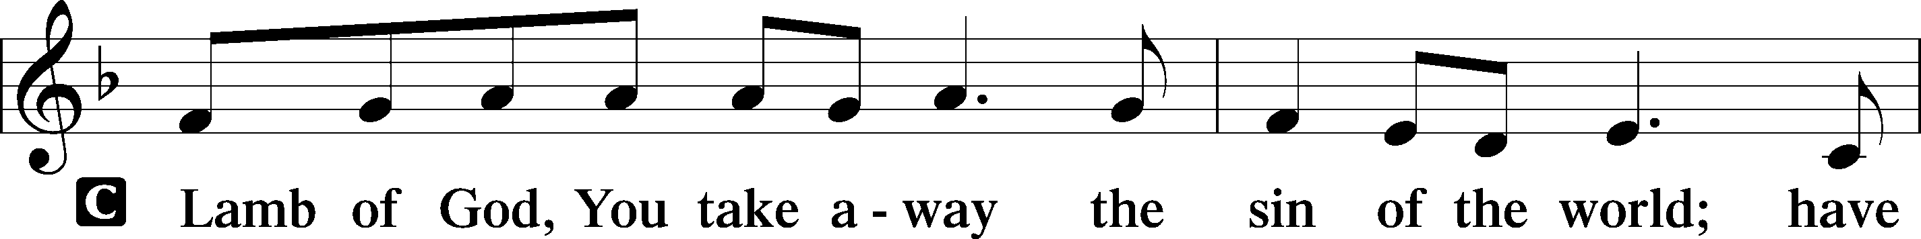
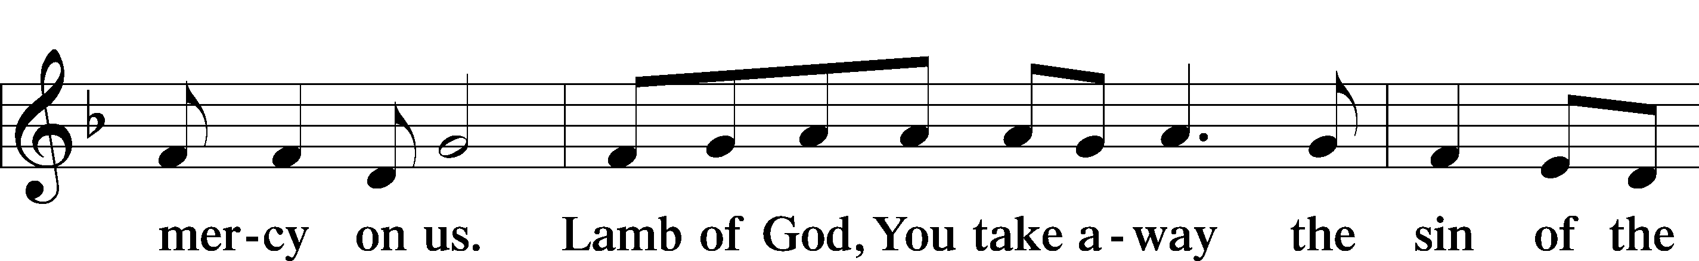
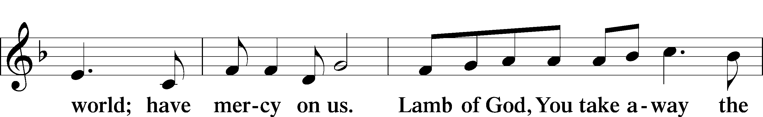
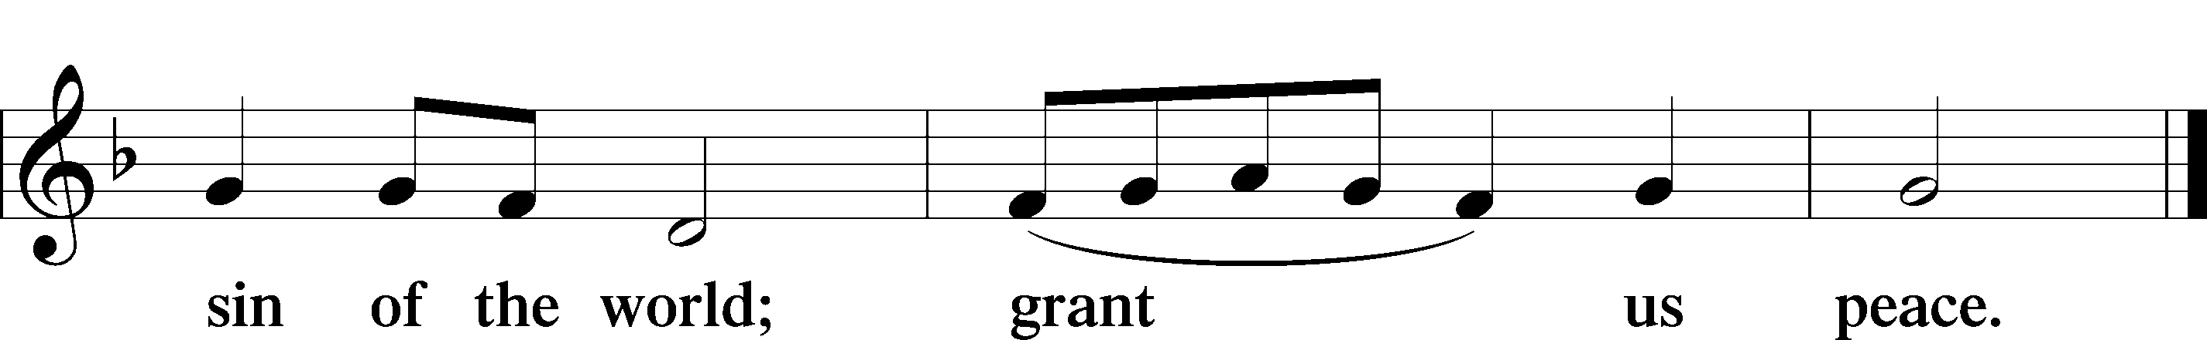

Sit

Distribution

594 God’s Own Child, I Gladly Say It
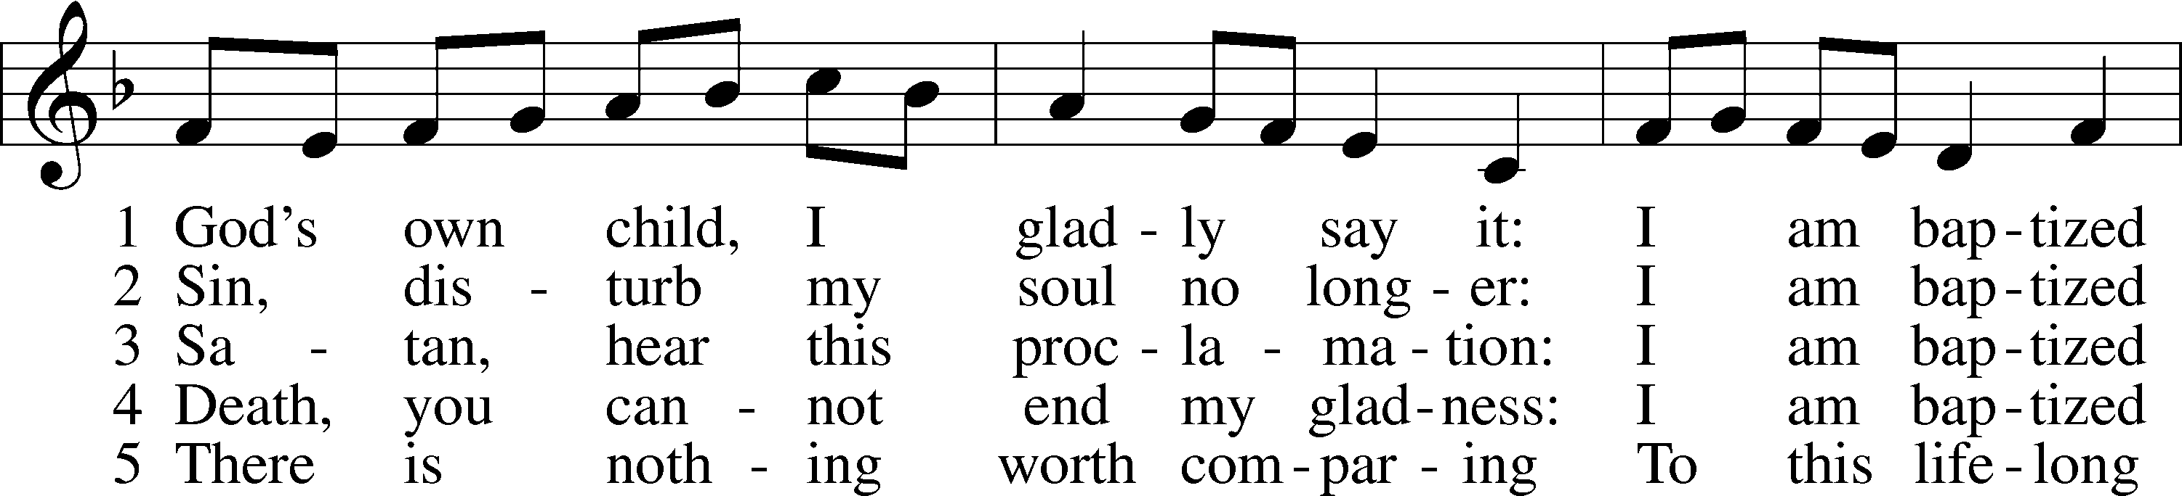
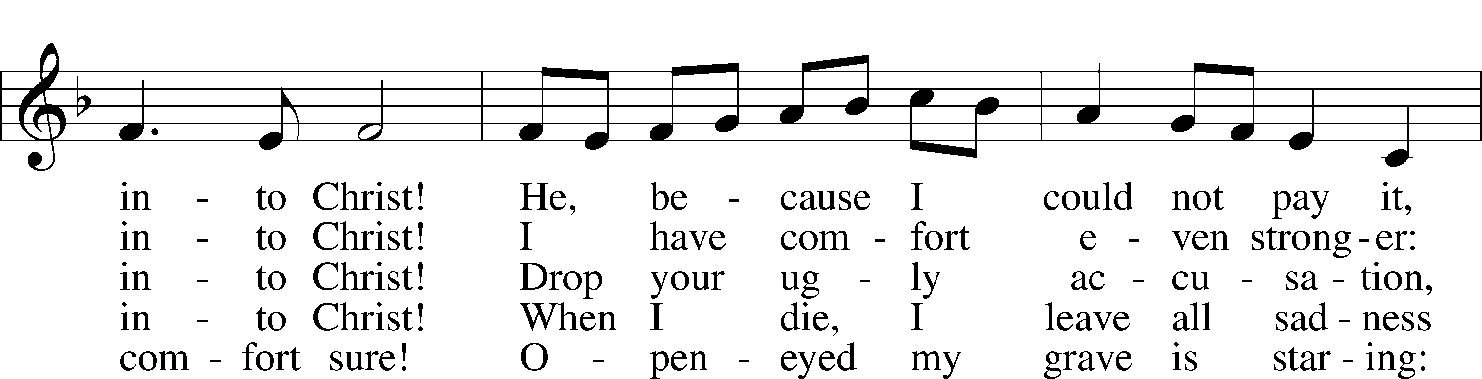
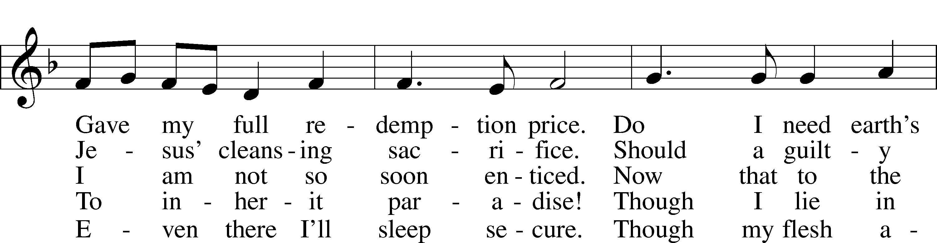
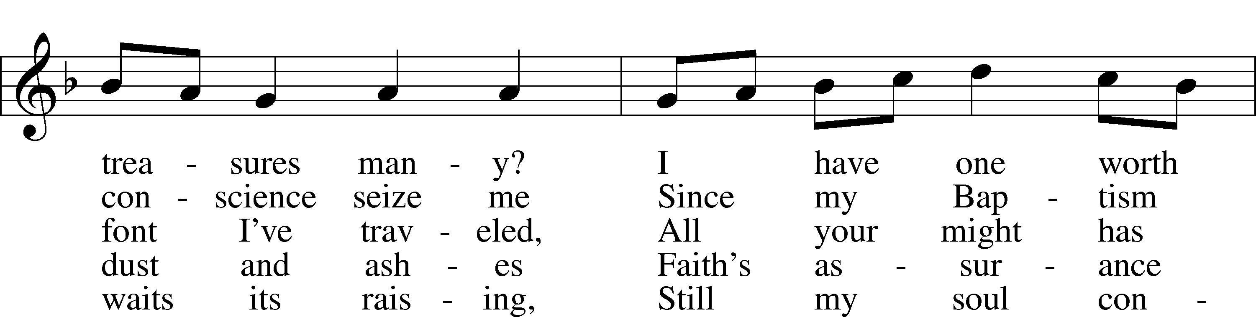
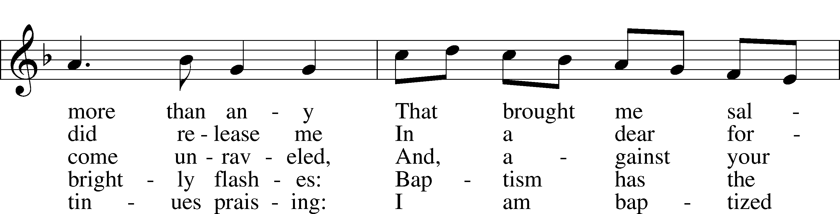
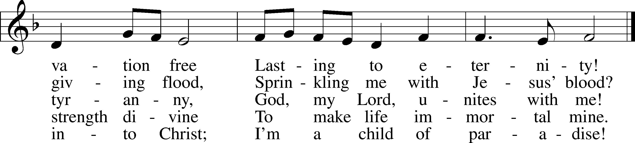
Text: © 1991 Robert E. Voelker. Used by permission: LSB Hymn License no. 110003744
Tune: Public domain
619 Thy Body, Given for Me, O Savior
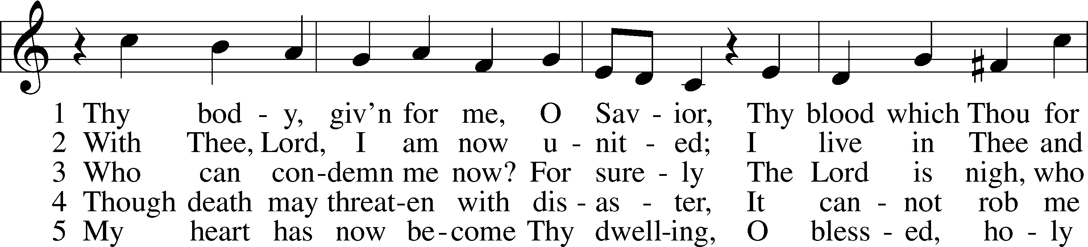
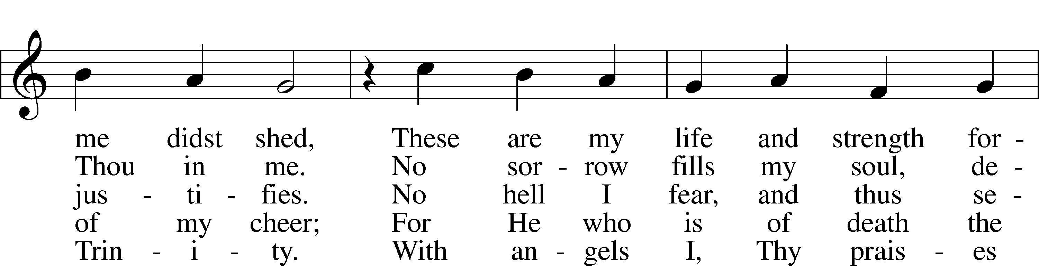
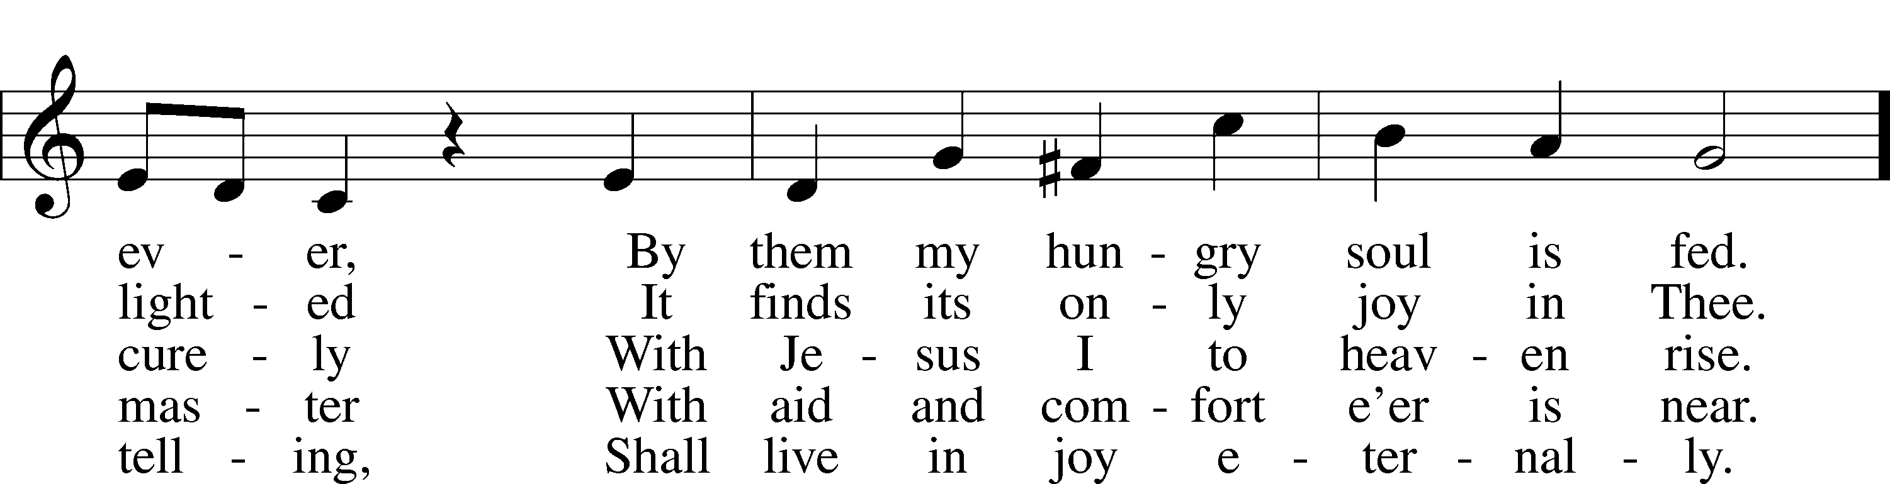
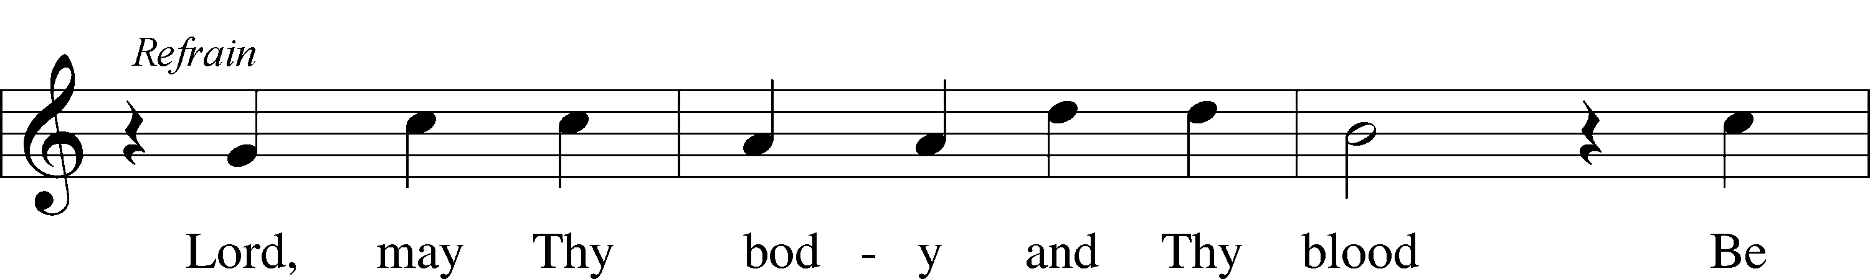
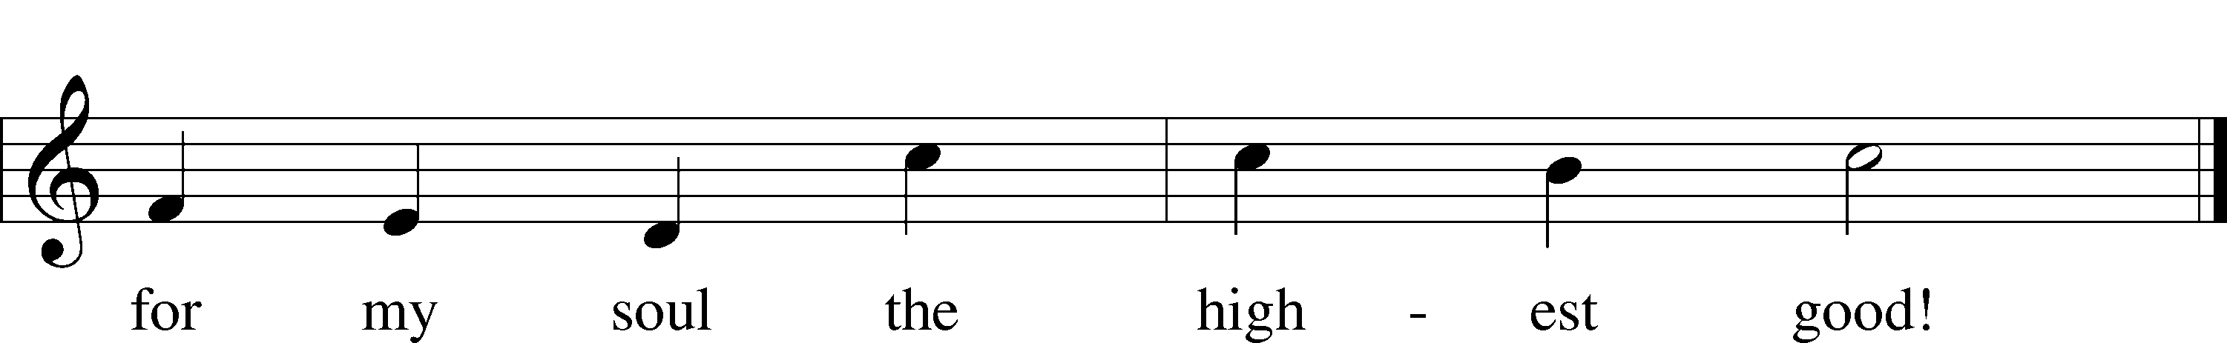
Tune: Public domain
Text: © 1941 Concordia Publishing House. Used by permission: LSB Hymn License no. 110003744

601 All Who Believe and Are Baptized
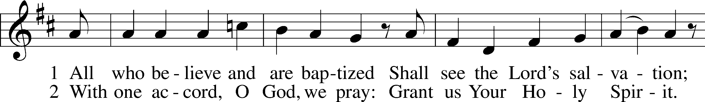
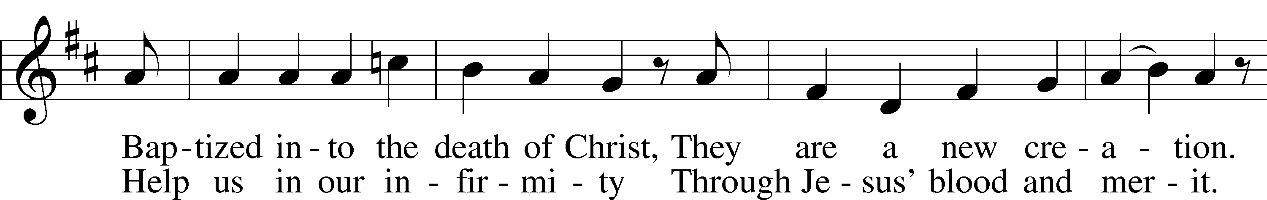
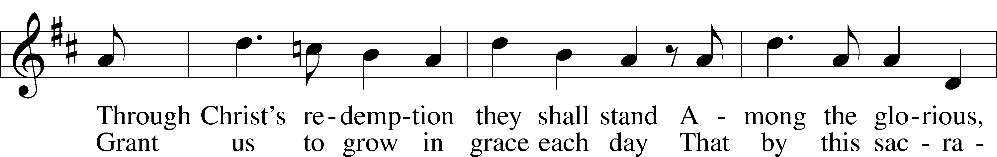
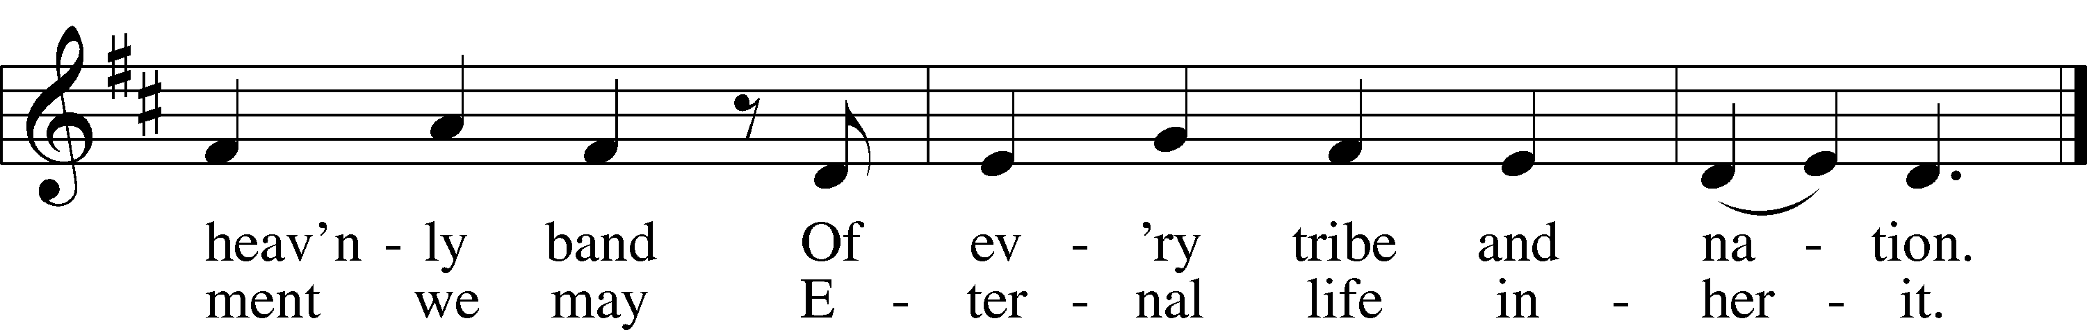
Text and tune: Public domain

Stand

P The body and blood of our Lord Jesus Christ strengthen and preserve you in body and soul to life everlasting. Depart T in peace.
C Amen.

Thank the Lord LSB 164
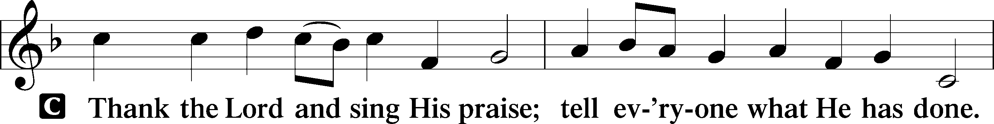
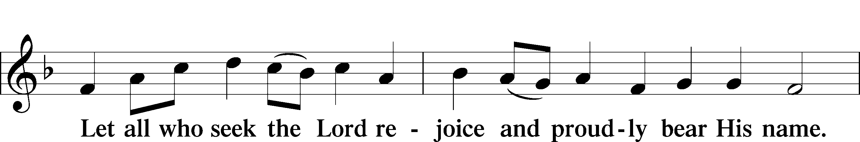
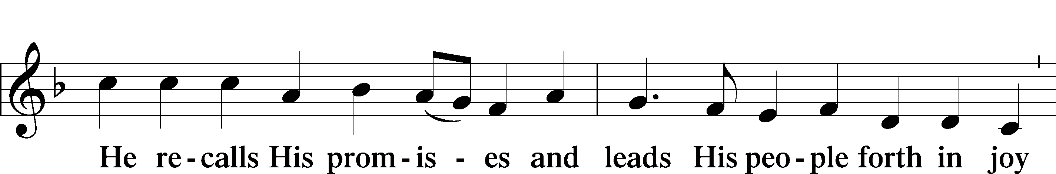
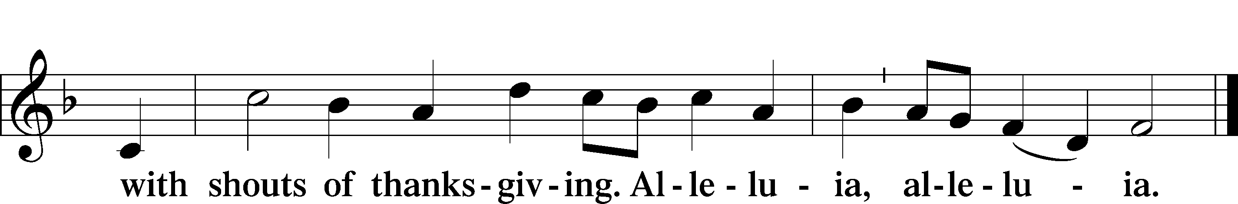
Post-Communion Collect
A Let us pray.
We give thanks to You, almighty God, that You have refreshed us through this salutary gift, and we implore You that of Your mercy You would strengthen us through the same in faith toward You and in fervent love toward one another; through Jesus Christ, Your Son, our Lord, who lives and reigns with You and the Holy Spirit, one God, now and forever.
C Amen.

Benediction LSB 166
P The Lord bless you and keep you.
The Lord make His face shine on you and be gracious to you.
The Lord look upon you with favor and T give you peace.
C Amen.

405 To Jordan’s River Came Our Lord
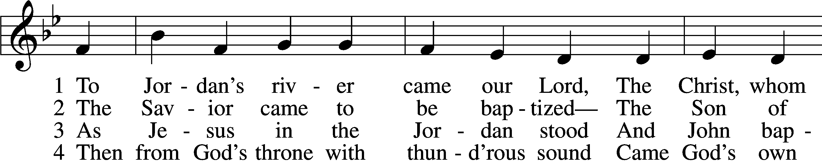
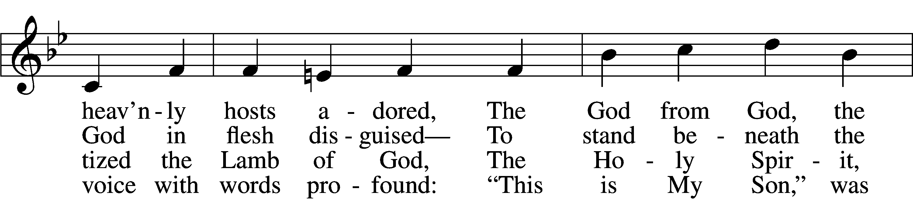
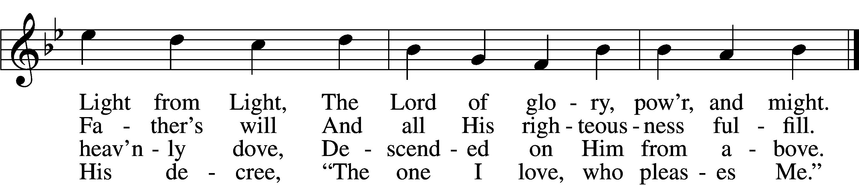

5 The Father’s word, the Spirit’s flight
Anointed Christ in glorious sight
As God’s own choice, from Adam’s fall
To save the world and free us all.

6 Now rise, faint hearts, be resolute;
This man is Christ, our substitute!
He was baptized in Jordan’s stream,
Proclaimed Redeemer, Lord supreme.

Tune: Public domain Acknowledgments
Divine Service, Setting One from Lutheran Service Book
Unless otherwise indicated, Scripture quotations are from the ESV® Bible (The Holy Bible, English Standard Version®), copyright © 2001 by Crossway, a publishing ministry of Good News Publishers. Used by permission. All rights reserved.
Created by Lutheran Service Builder © 2021 Concordia Publishing Text: © 1993 James P. Tiefel. Used by

Prayers for Our Members
Leah Vogel | Expectant Mother
Norman Abels (Brookestone Meadows – Elkhorn) | Healing
Judy Ahrens | Healing
Vaughn Albrecht (Northridge) | Healing
Tom & DyAnn Altwine | Healing
David Banner | Healing
Lyle Colsden (Mother Hull) | Healing
Pat Flodine (Cambridge Court) | Healing
Vi Fox (Prairie View) | Healing
Verleen Gentry | Healing
Ruby Hatfield | Healing
Boyd Millsap | Healing
Michelle Millsap | Healing
Roger Riekenberg | Healing
Don Richmond | Healing
Marion Richmond | Healing
Laverne Stuehm (Emerald Care Center, Grand Island) | Healing
Fran Junge | Cancer
Bev Nuttelman | Cancer
Kim Vos | Cancer

Prayers for Our Members’ Family & Friends
Dawn Gaunt (Pr. & Carol Gaunt’s daughter-in-law) | Expectant Mother
Brandon & Shannon Howell (Quentin & Janel Lange’s friends) | Expecting
Will Brennemann (Jami Helmbrecht’s father) | Healing
Reg Duke (Westman’s brother-in-law) | Healing
James Gentry (Verleen Gentry’s son) | Healing
Roger Hoffman (Marc’s father) | Healing
Sharon Kreutzer (former member) | Healing
Lyra Mais (Zion student) | Healing
Randy Solomon (Beth Rosenthal’s father) | Healing
Mary Ann Mertz (Pam’s Uhlir’s friend) | Healing
Roy Reynolds (Verleen Gentry’s son-in-law) | Healing
Janet Stalder (Carol Florang’s sister) | Healing
D.D. Dugger (Sue Kaiser’s brother) | Cancer
Ron Halvorsen (Jeff’s dad) | Cancer
Carol Haubold (Don Helmbrecht’s sister) | Cancer
Tyler Holland (Quentin & Janel Lange’s brother-in-law) | Cancer
Randy Jochum (Ken Hockemeier’s brother-in-law) | Cancer
Fred Koch (Pam Uhlir’s cousin) | Cancer
Lynda Kreutzer (Rich & Carol’s sister-in-law) | Cancer
John Moore (family of Susan Tonniges) | Cancer
Sharon Mulhair (Pam Uhlir’s cousin) | Cancer
Becky Rathkie (former Zion teacher) | Cancer
Jeannie Schmidt (Lisa Splittgerber’s sister-in-law) | Cancer
Tyrone Uhlir (Pam’s nephew) | Cancer

Today’s Radio Broadcast is given to the Glory of the Lord by
Wes & Mary Fiddelke in memory of fathers:
Harvey Fiddelke and John Fletcher

Serving in Worship

Sunday, January 10~ 9:00am

Elder: Dan Oertwig
Usher: Marc Hoffman & Steve Junge
Engineer: Zach DeLoach
Announcer: Jesse Florang
Altar Guild: Sheryl Fox & Shirley Oertwig
Sunday, January 17~ 9:00am

Elder: Ken Hockemeier
Usher: Roger Riekenberg & Robert Glanzer
Engineer: Jared Nuttelman
Announcer: Lonna Gronewoller
Altar Guild: Sheryl Fox & Shirley Oertwig

Our Response to the Gospel

Date: 01/03/2021

Offering: $4,405.00
Weekly Need: $7,542.37

ZION LUTHERAN CHURCH AND SCHOOL

Pr. James DeLoach, Pastor + (308) 627-5260
james.deloach@zionkearney.org
Pr. Doug Gaunt, Pastor + (308) 455-0552
doug.gaunt@zionkearney.org
Tony Splittgerber, Principal + (308) 293-0168
anthony.splittgerber@zionkearney.org

Church Office
Administrative Assistant: Jessica Shiers
Email: school@zionkearney.org
Phone: (308)-234-3410 Fax: (308) 236-8100
Office Hours: Monday-Friday 8:00am-4:00pm
Radio Broadcast: Sunday @ 10:30 a.m. on 1460 AM
Website: www.zionkearney.com

This Week at Zion

Sun  01/10 | 9:00a  10:30a | Divine Service  Radio Broadcast 1460am
Mon  01/11 | 7:00p  Birthdays  Anniversaries | Mary Martha - FH  William Hodgson  ---
Tues  01/12 | 1:30p  7:00p  7:00p  Birthdays  Anniversaries | Sleeping Mats  Bd of Elders  Bd of Trustees  ---  ---
Wed  01/13 | 8:30a  5:45p  Birthdays  Anniversaries | Chapel  Midweek  Jane Schmid  ---
Thurs  01/14 | Birthdays  Anniversaries | ---  ---
Fri  01/15 | Birthdays  Anniversaries | ---  ---
Sat  01/16 | 5:00p  Birthdays  Anniversaries | Divine Service  Helana Baker  Kara Dauel  ---
Sun  01/17 | 9:00a  10:30a  10:30-1:30  Birthdays  Anniversaries | Divine Service  Radio Broadcast 1460am  S. Schmidt Gym  ---  ---
ANNOUNCEMENTS
Where our Triune God strengthens us through His mercy in faith toward Him and in fervent love toward one another.

Bible Reading Cards - A new set of Bible reading cards for the new year can be picked up in the church entryway. Each card is a tool to keep track of your Bible reading progress as you mark each chapter you have read in 2021. God works through His Word.

Masks – According to Kearney City Ordinance No. 8457 masks are required “at a location that is open to the general public and where they cannot maintain six foot of distance.”

Year-End Reports - The Chairman of each board and organization is asked to turn in a Year End Report to the Church office. The most convenient way to receive these is by email. school@zionkearney.org

A Bible Study – is prerecorded and available each Sunday, along with a study guide you can use to follow along. We are studying the three lessons for the day—the Old Testament, the Epistle, and the Gospel. Go to Zion’s website www.zionkearney.com to access the video and study guide.

Offering Envelopes – 2021 offering envelopes are in your church mailbox.

Offering during this time. If you are not able to attend live Church Services, you may: drop your offering in the mail slot by the south doors, mail it to the church, or use online giving option at zionkearney.com. If you have any questions or need assistance please contact the office at 308-234-3410 or school@zionkearney.org. Thank you for supporting of your church!

Radio Broadcast & Altar Flowers - Please help Zion spread the Gospel! There are several open dates. This is a great need during this time, many people are listening to our broadcast during this time. There are also many openings for altar flowers. Please help beautify the sanctuary.

Mission Offerings - The first quarter missions will support Lutherans for Life, January through March. If you would like to donate to this mission please use the mission envelopes located in the narthex. Thank you for your support.

Handbells & Choir - Our Handbell and Adult choir will take a short break before resuming rehearsals on in February.
Thank You – to those that helped un-decorate the church. We appreciate your work that you do to help out!

Registration Open - Registration is now open for the 2021-2022. New this year is an all-day prekindergarten option! If you have any questions please feel free to contact the office. Please tell your family and friends about Zion. Enroll early to make sure you have a spot.

New Teacher Search - Mr. Vogel and family will be moving at the conclusion of this school year so the search for another high quality Lutheran teacher has begun. Full time teachers in our school must be members of the LCMS (or willing to become so). The grade level will most probably be for the 3rd/4th grade. If you or someone you know might be interested in this position please contact Mr. Splittgerber

Zion Basketball - Basketball practices for the girls and boys has begun. Since this is a club team, all Zion members in grades 5th-8th who attend public school are welcome to be on the team. Please contact Mr. Splittgerber for more information.

Basketball Schedule for 2021
January 14 | GB 4:30 / BB 5:30 @ Trinity GI
January 19 | GB 4:30 / BB 5:30 HOME vs Juniata
February 9 | GB 5:00 / BB 6:00 @ York
February ? | Staplehurst Tournament at Bee
February 26-28 | C-Club Tournament @ Concordia Seward time TBD

Scrip Cards - Scrip cards are still available during this time. Visit the office during normal hours to purchase your gift cards.

Part-time Cook Needed - Zion is looking for a part-time cook! Tasks include meal prep, serving, and cleaning. Candidate strengths should include time-management and a positive disposition. The position is for 3 days week, 8-1 pm. Please share and contact the office with questions!

