Divine Service

Transfiguration
of Our Lord

February 14, 2021

Zion Lutheran Church
Kearney, Nebraska

Welcome to Zion!
All worshippers please fill out an attendance card in the pew rack and let us know how we might be of service to you.

Holy Communion at Zion

The Lord’s Supper is celebrated at this congregation as Jesus has given it. As he says, our Lord gives into our mouths not only bread and wine but his very body and blood to eat and to drink for the forgiveness of sins and to strengthen our union with him and with one another. Our Lord invites to his table those who trust his words, repent of all sin, and set aside any refusal to forgive and love as he forgives and loves us, that they may show forth his death until he comes. All communicants need to register in the narthex prior to the service.

Because those who eat and drink our Lord’s body and blood unworthily do great harm and because Holy Communion is a confession of the faith which is confessed at this altar, any who are not yet instructed, in doubt, or who hold a confession differing from that of this congregation and The Lutheran Church—Missouri Synod, are asked not to commune until they are able to speak with our pastor first. He is happy to visit with you about the Christian faith and how to receive the Lord’s Supper for your good and for the good of others. Those not communing are invited to come to the altar, cross your arms in front of you, and bow your head to receive a pastoral blessing.

The Face of Jesus Christ Manifests the Light of the Knowledge of the Glory of God

It was “a hard thing” that Elisha asked, but by his persistence he was able to see the prophet Elijah being taken “by a whirlwind into heaven.” Although “chariots of fire and horses of fire separated the two of them,” Elisha received Elijah’s cloak and a “double portion” of his spirit for preaching the Lord’s Word (2 Kings 2:9–11). It was a hard thing, too, for Israel to see Moses and come near to him, when “the skin of his face shone because he had been talking with God” (Ex. 34:29–30). Therefore, after “he commanded them all that the Lord had spoken with him in Mount Sinai,” Moses “put a veil over his face” (Ex. 34:32–33). Only the Word of the Gospel lifts the veil, and “only through Christ is it taken away” (2 Cor. 3:14). Thus are we able to behold “the light of the knowledge of the glory of God in the face of Jesus Christ,” who is “the image of God” (2 Cor. 4:4–6). For the Law and the prophets are all fulfilled in Him. Therefore, “listen to him,” and fix your sights on “Jesus only” (Mark 9:7–8).
Confession and Absolution

414 ’Tis Good, Lord, to Be Here
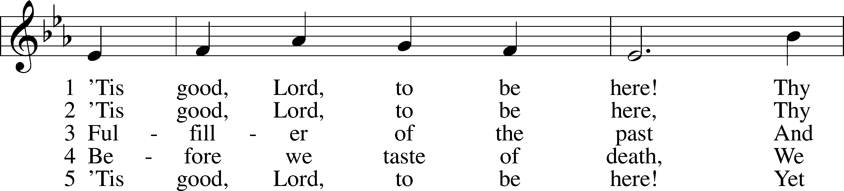
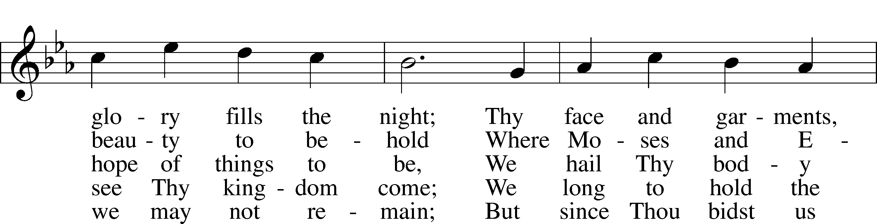
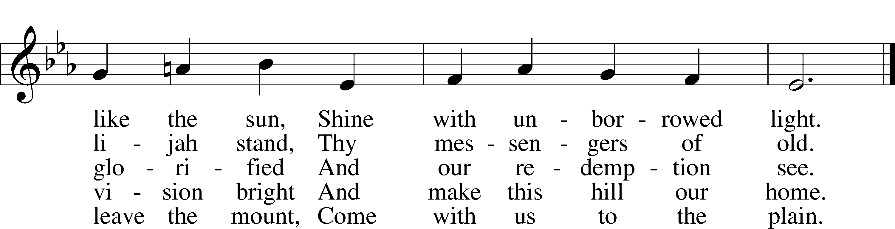
Tune and text: Public domain

Stand

The sign of the cross may be made by all in remembrance of their Baptism.

Invocation
P In the name of the Father and of the T Son and of the Holy Spirit.
C Amen.

Exhortation LSB 151
P If we say we have no sin, we deceive ourselves, and the truth is not in us.
C But if we confess our sins, God, who is faithful and just, will forgive our sins and cleanse us from all unrighteousness.

Silence for reflection on God’s Word and for self-examination.

Confession of Sins LSB 151
P Let us then confess our sins to God our Father.
C Most merciful God, we confess that we are by nature sinful and unclean. We have sinned against You in thought, word, and deed, by what we have done and by what we have left undone. We have not loved You with our whole heart; we have not loved our neighbors as ourselves. We justly deserve Your present and eternal punishment. For the sake of Your Son, Jesus Christ, have mercy on us. Forgive us, renew us, and lead us, so that we may delight in Your will and walk in Your ways to the glory of Your holy name. Amen.

Absolution LSB 151
P Almighty God in His mercy has given His Son to die for you and for His sake forgives you all your sins. As a called and ordained servant of Christ, and by His authority, I therefore forgive you all your sins in the name of the Father and of the T Son and of the Holy Spirit.
C Amen.

Service of the Word

Introit Psalm 99:1–5; antiphon: v. 9
Exalt the Lord our God, and worship at his holy | mountain;*
for the Lord our God is | holy!
The Lord reigns; let the peoples | tremble!*
He sits enthroned upon the cherubim; let the | earth quake!
The Lord is great in | Zion;*
he is exalted over all the | peoples.
Let them praise your great and | awesome name!*
Ho- | ly is he!
The King in his might loves | justice.*
You have established equity; you have executed justice and righteousness in | Jacob.
Exalt the Lord our God; worship at his | footstool!*
Ho- | ly is he!
Glory be to the Father and | to the Son*
and to the Holy | Spirit;
as it was in the be- | ginning,*
is now, and will be forever. | Amen.
Exalt the Lord our God, and worship at his holy | mountain;*
for the Lord our God is | holy!

Kyrie LSB 152
A In peace let us pray to the Lord.
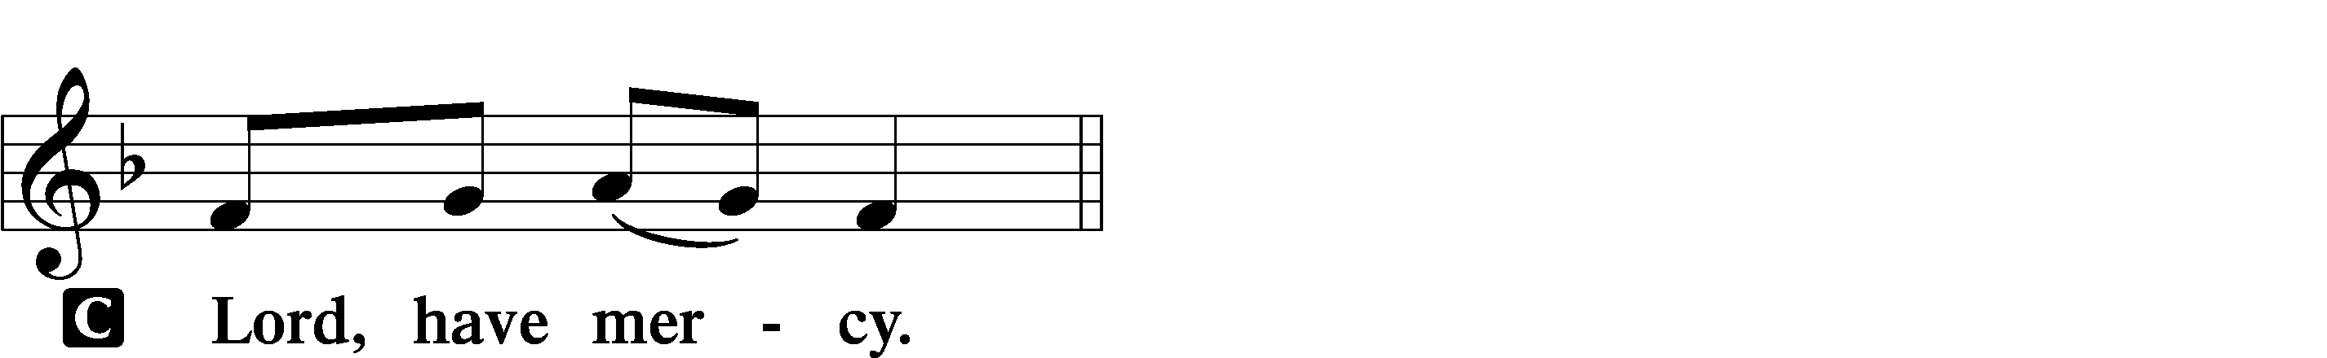

A For the peace from above and for our salvation let us pray to the Lord.
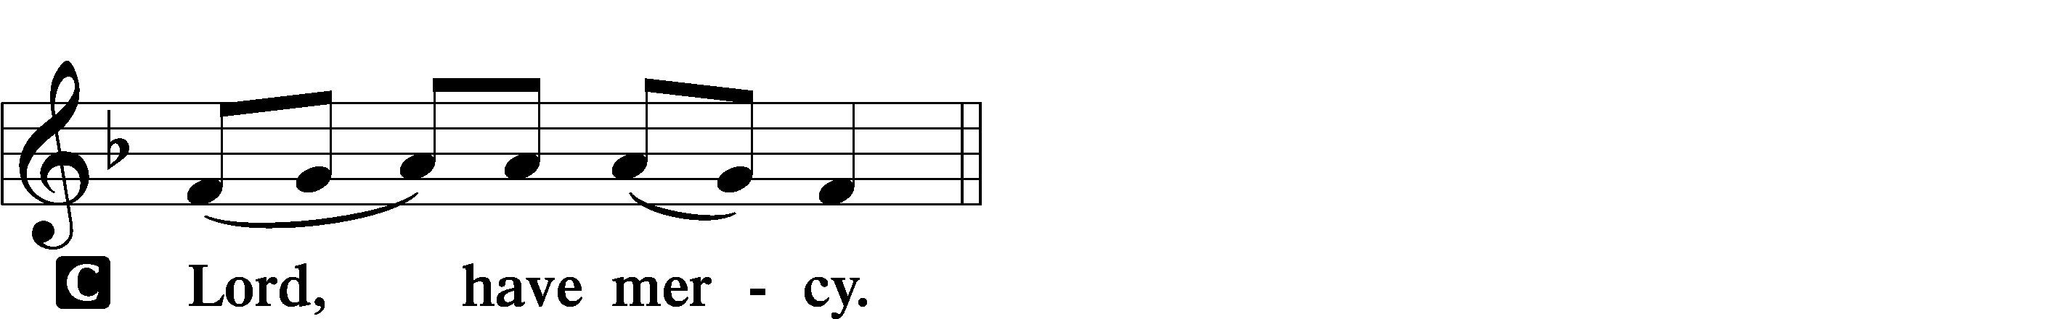

A For the peace of the whole world, for the well-being of the Church of God, and for the unity of all let us pray to the Lord.
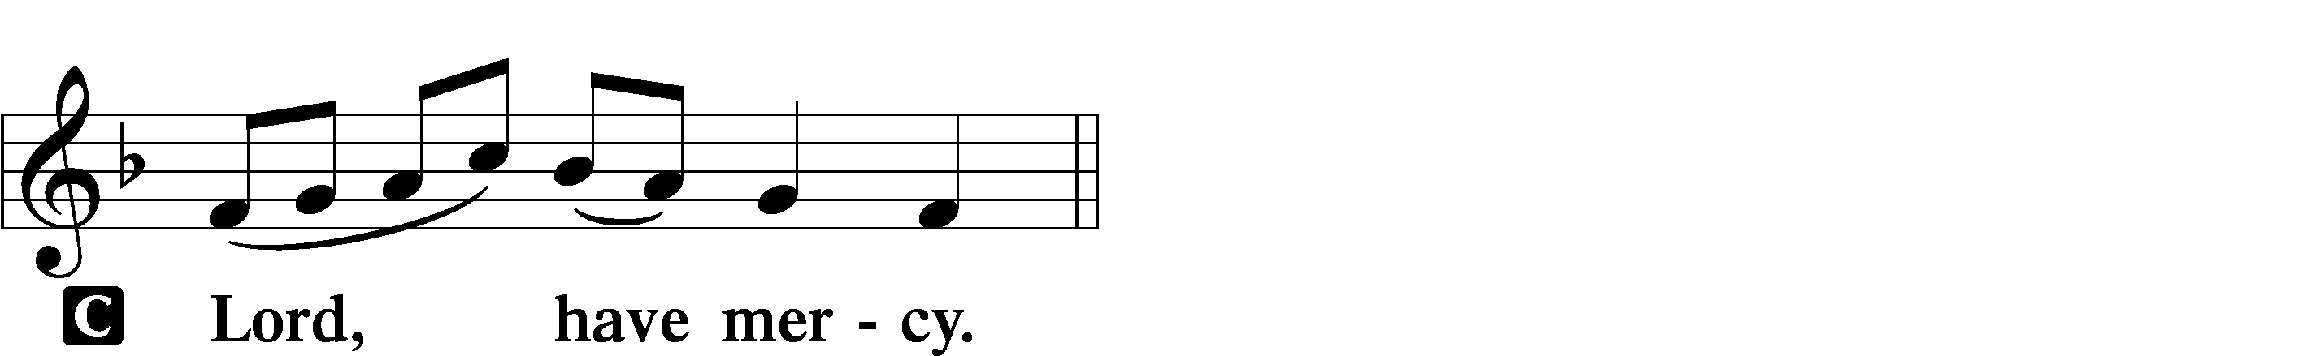

A For this holy house and for all who offer here their worship and praise let us pray to the Lord.
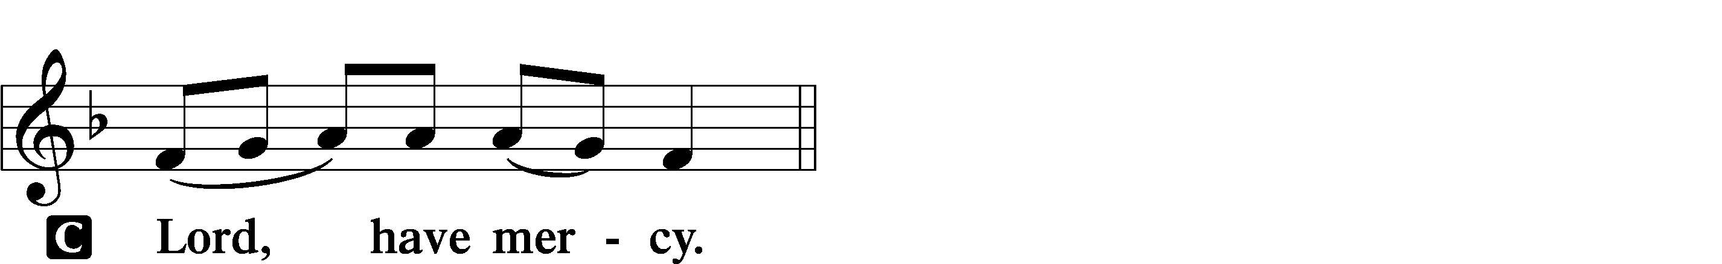

A Help, save, comfort, and defend us, gracious Lord.

Gloria in Excelsis LSB 154
A Glory to God in the highest, and peace to His people on earth.
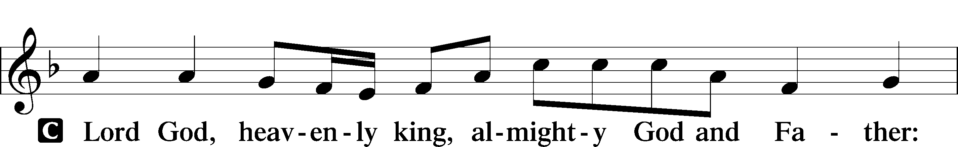
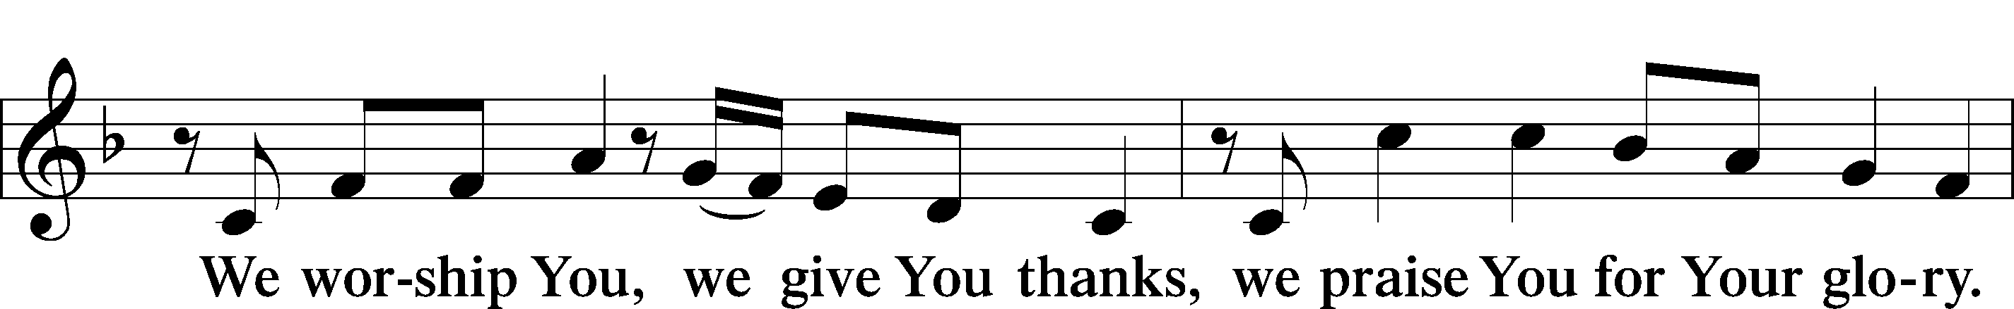
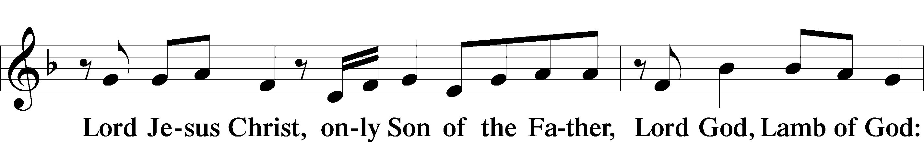
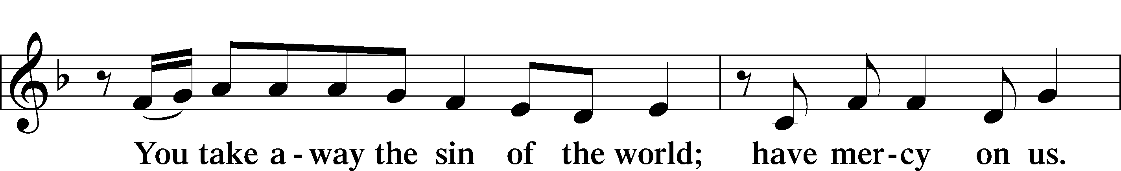
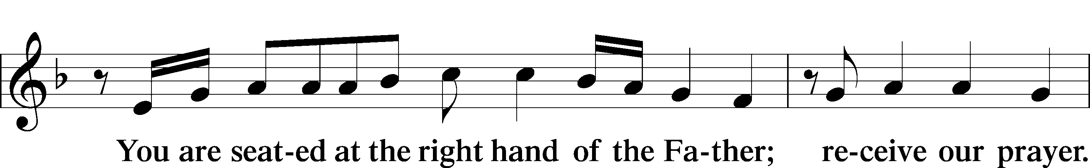
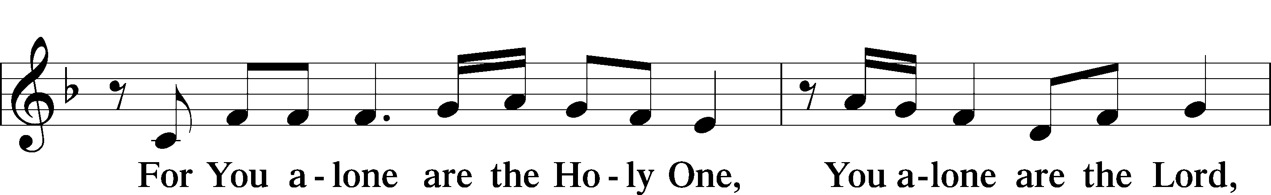
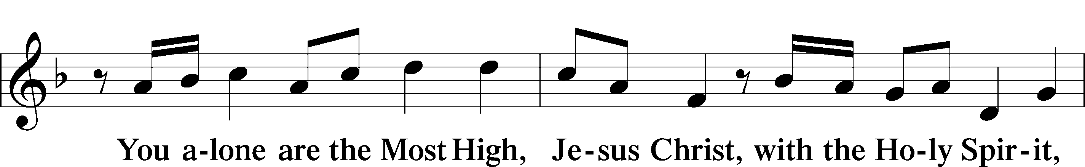
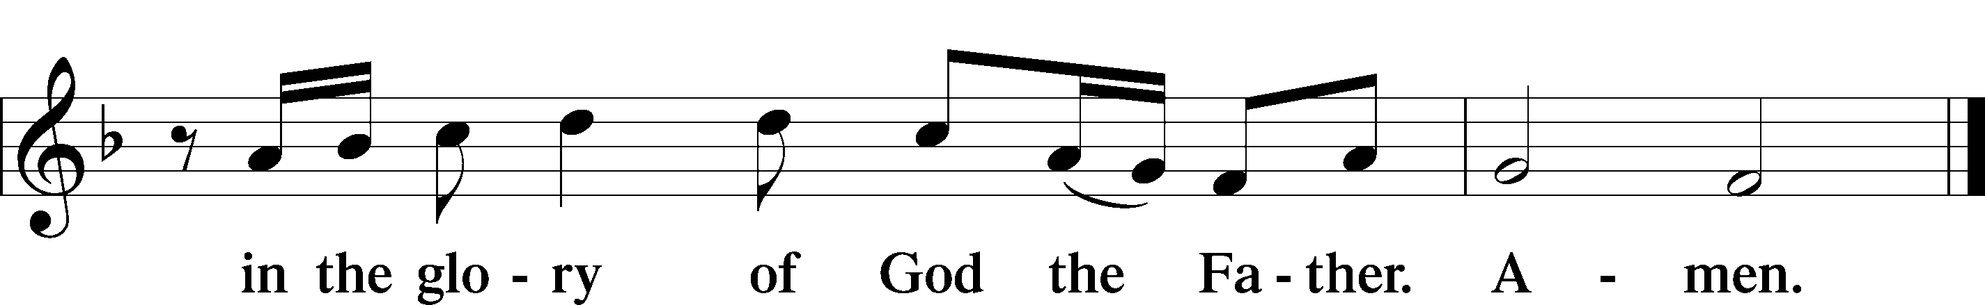

Salutation and Collect of the Day
P The Lord be with you.
C And also with you.

P Let us pray.
O God, in the glorious transfiguration of Your beloved Son You confirmed the mysteries of the faith by the testimony of Moses and Elijah. In the voice that came from the bright cloud You wonderfully foreshowed our adoption by grace. Mercifully make us co-heirs with the King in His glory and bring us to the fullness of our inheritance in heaven; through the same Jesus Christ, our Lord, who lives and reigns with You and the Holy Spirit, one God, now and forever.

C Amen.

Sit

Old Testament Reading 2 Kings 2:1–12
Elijah Taken to Heaven
1When the Lord was about to take Elijah up to heaven by a whirlwind, Elijah and Elisha were on their way from Gilgal. 2And Elijah said to Elisha, “Please stay here, for the Lord has sent me as far as Bethel.” But Elisha said, “As the Lord lives, and as you yourself live, I will not leave you.” So they went down to Bethel. 3And the sons of the prophets who were in Bethel came out to Elisha and said to him, “Do you know that today the Lord will take away your master from over you?” And he said, “Yes, I know it; keep quiet.”
4Elijah said to him, “Elisha, please stay here, for the Lord has sent me to Jericho.” But he said, “As the Lord lives, and as you yourself live, I will not leave you.” So they came to Jericho. 5The sons of the prophets who were at Jericho drew near to Elisha and said to him, “Do you know that today the Lord will take away your master from over you?” And he answered, “Yes, I know it; keep quiet.”
6Then Elijah said to him, “Please stay here, for the Lord has sent me to the Jordan.” But he said, “As the Lord lives, and as you yourself live, I will not leave you.” So the two of them went on. 7Fifty men of the sons of the prophets also went and stood at some distance from them, as they both were standing by the Jordan. 8Then Elijah took his cloak and rolled it up and struck the water, and the water was parted to the one side and to the other, till the two of them could go over on dry ground.
9When they had crossed, Elijah said to Elisha, “Ask what I shall do for you, before I am taken from you.” And Elisha said, “Please let there be a double portion of your spirit on me.” 10And he said, “You have asked a hard thing; yet, if you see me as I am being taken from you, it shall be so for you, but if you do not see me, it shall not be so.” 11And as they still went on and talked, behold, chariots of fire and horses of fire separated the two of them. And Elijah went up by a whirlwind into heaven. 12And Elisha saw it and he cried, “My father, my father! The chariots of Israel and its horsemen!” And he saw him no more.
A This is the Word of the Lord.
C Thanks be to God.

Gradual Psalm 117:1–2a; 96:8
Praise the Lord, all | nations!*
Extol him, all | peoples!
For great is his steadfast | love toward us,*
and the faithfulness of the Lord endures for- | ever.
Ascribe to the Lord the glory | due his name;*
bring an offering, and come in- | to his courts!
Epistle 2 Corinthians 3:12–18; 4:1–6
12Since we have such a hope, we are very bold, 13not like Moses, who would put a veil over his face so that the Israelites might not gaze at the outcome of what was being brought to an end. 14But their minds were hardened. For to this day, when they read the old covenant, that same veil remains unlifted, because only through Christ is it taken away. 15Yes, to this day whenever Moses is read a veil lies over their hearts. 16But when one turns to the Lord, the veil is removed. 17Now the Lord is the Spirit, and where the Spirit of the Lord is, there is freedom. 18And we all, with unveiled face, beholding the glory of the Lord, are being transformed into the same image from one degree of glory to another. For this comes from the Lord who is the Spirit.
The Light of the Gospel
1Therefore, having this ministry by the mercy of God, we do not lose heart. 2But we have renounced disgraceful, underhanded ways. We refuse to practice cunning or to tamper with God’s word, but by the open statement of the truth we would commend ourselves to everyone’s conscience in the sight of God. 3And even if our gospel is veiled, it is veiled only to those who are perishing. 4In their case the god of this world has blinded the minds of the unbelievers, to keep them from seeing the light of the gospel of the glory of Christ, who is the image of God. 5For what we proclaim is not ourselves, but Jesus Christ as Lord, with ourselves as your servants for Jesus’ sake. 6For God, who said, “Let light shine out of darkness,” has shone in our hearts to give the light of the knowledge of the glory of God in the face of Jesus Christ.

A This is the Word of the Lord.
C Thanks be to God.

Stand

Alleluia and Verse 156
C Alleluia. Lord, to whom shall we go?
You have the words of eternal life. Alleluia, alleluia.

Holy Gospel Mark 9:2–9
P The Holy Gospel according to St. Mark, the ninth chapter.
C Glory to You, O Lord.

The Transfiguration
2After six days Jesus took with him Peter and James and John, and led them up a high mountain by themselves. And he was transfigured before them, 3and his clothes became radiant, intensely white, as no one on earth could bleach them. 4And there appeared to them Elijah with Moses, and they were talking with Jesus. 5And Peter said to Jesus, “Rabbi, it is good that we are here. Let us make three tents, one for you and one for Moses and one for Elijah.” 6For he did not know what to say, for they were terrified. 7And a cloud overshadowed them, and a voice came out of the cloud, “This is my beloved Son; listen to him.” 8And suddenly, looking around, they no longer saw anyone with them but Jesus only.
9And as they were coming down the mountain, he charged them to tell no one what they had seen, until the Son of Man had risen from the dead.

P This is the Gospel of the Lord.
C Praise to You, O Christ.

Sit

413 O Wondrous Type! O Vision Fair
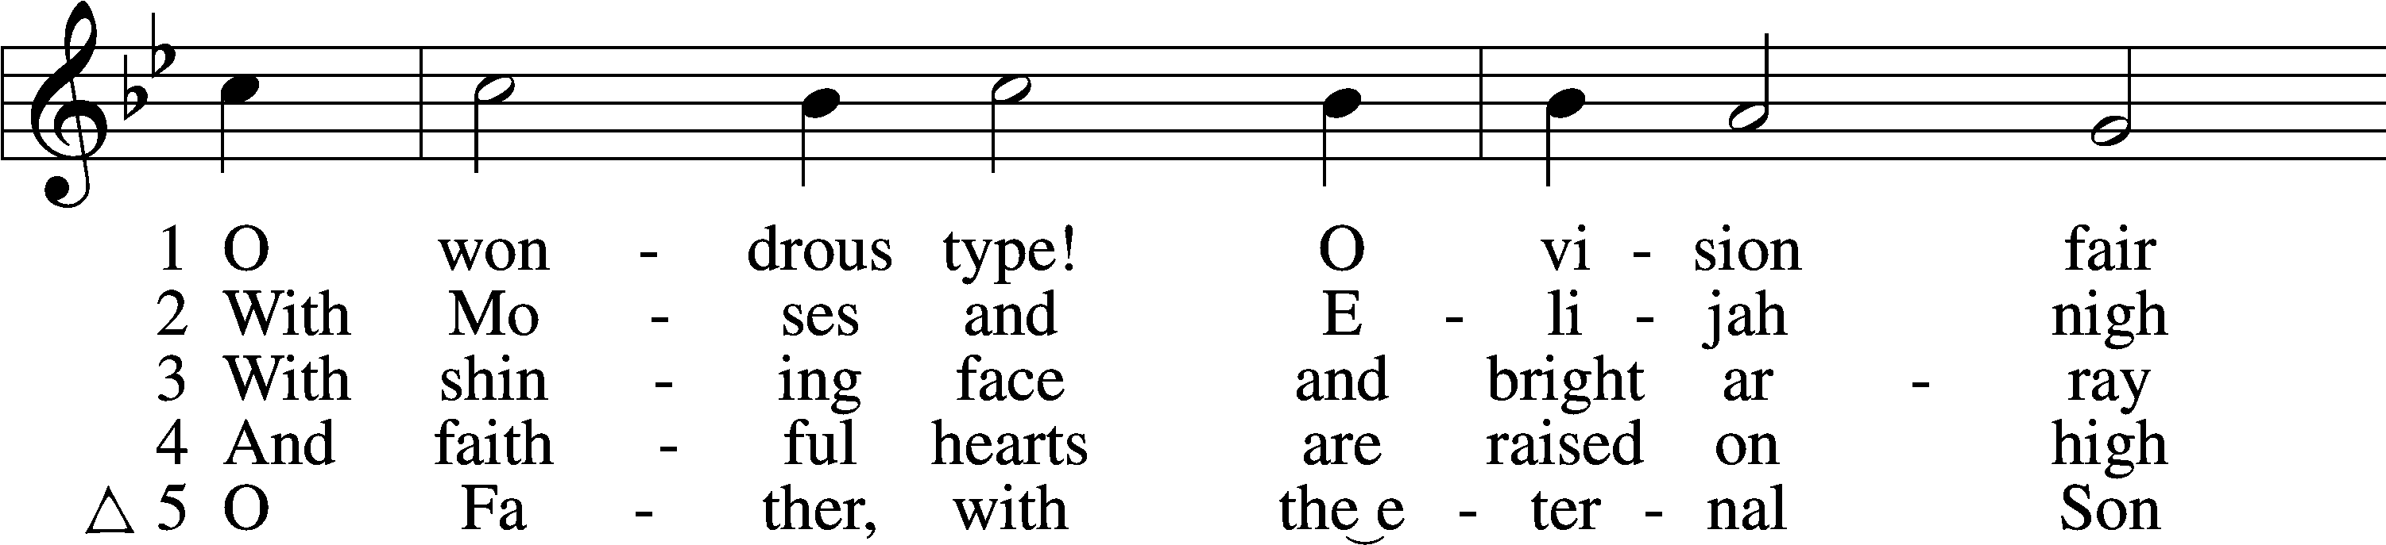
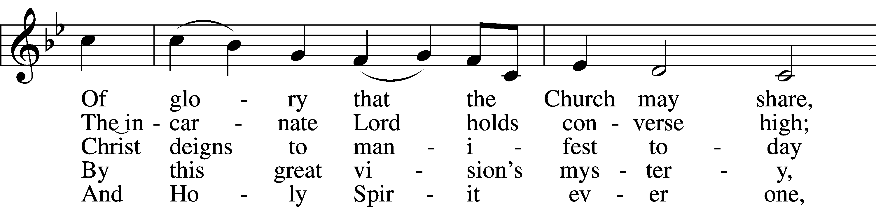
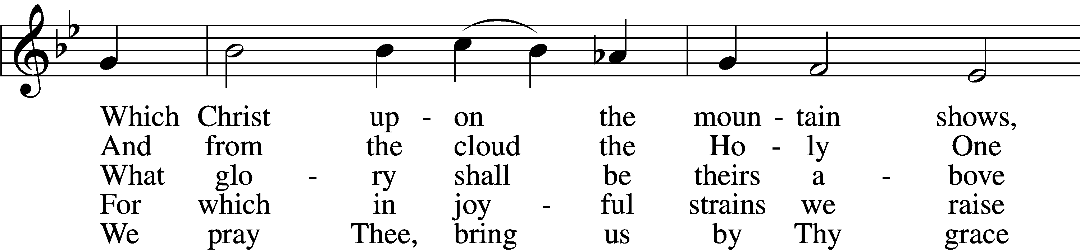
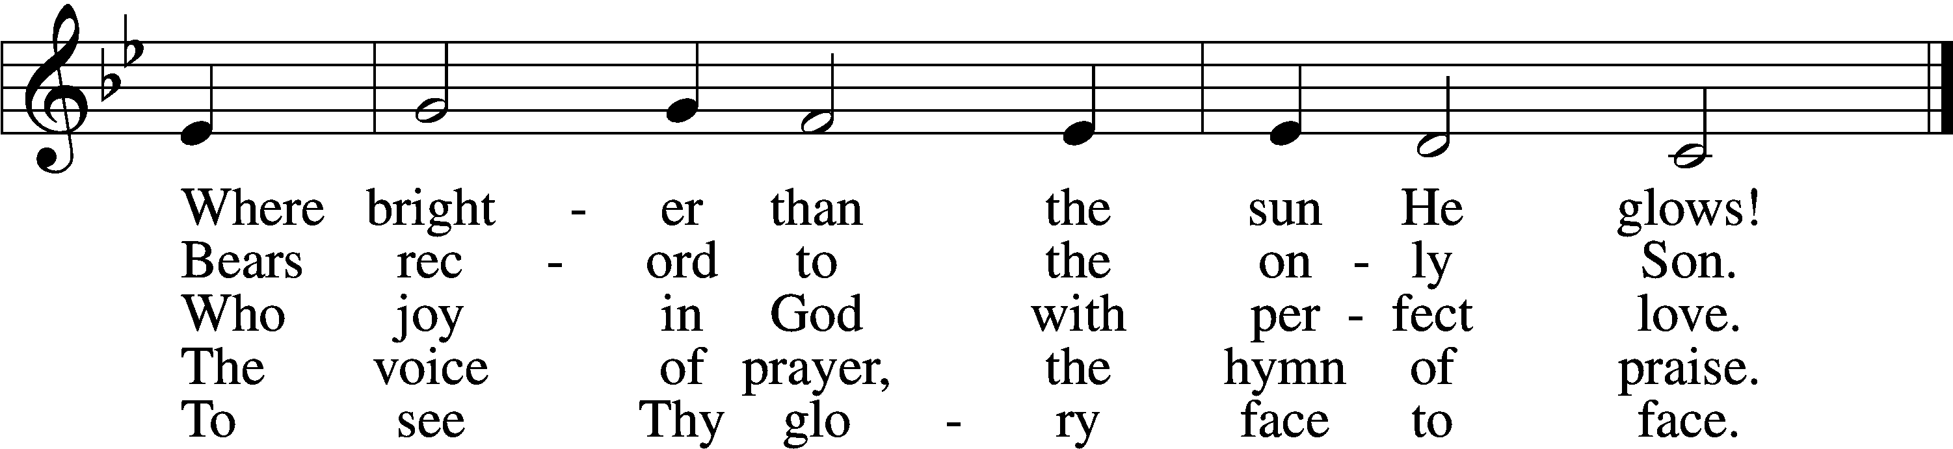
Tune and text: Public domain

Sermon

Stand

Apostles’ Creed
C I believe in God, the Father Almighty,
maker of heaven and earth.

And in Jesus Christ, His only Son, our Lord,
who was conceived by the Holy Spirit,
born of the virgin Mary,
suffered under Pontius Pilate,
was crucified, died and was buried.
He descended into hell.
The third day He rose again from the dead.
He ascended into heaven
and sits at the right hand of God the Father Almighty.
From thence He will come to judge the living and the dead.

I believe in the Holy Spirit,
the holy Christian Church,
the communion of saints,
the forgiveness of sins,
the resurrection of the body,
and the life T everlasting. Amen.

Prayer of the Church

Offertory LSB 159
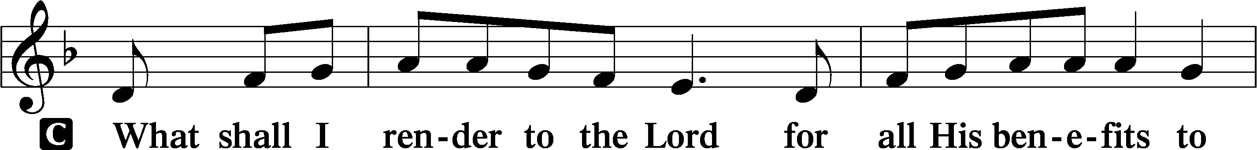
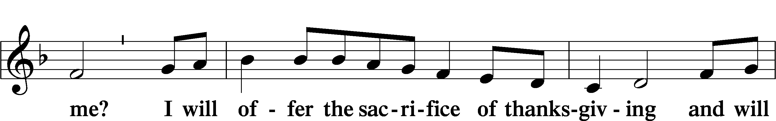
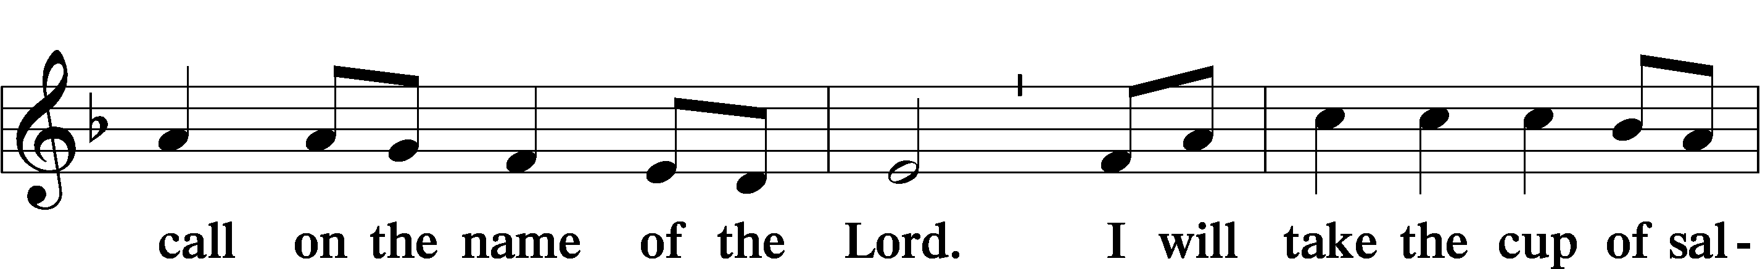
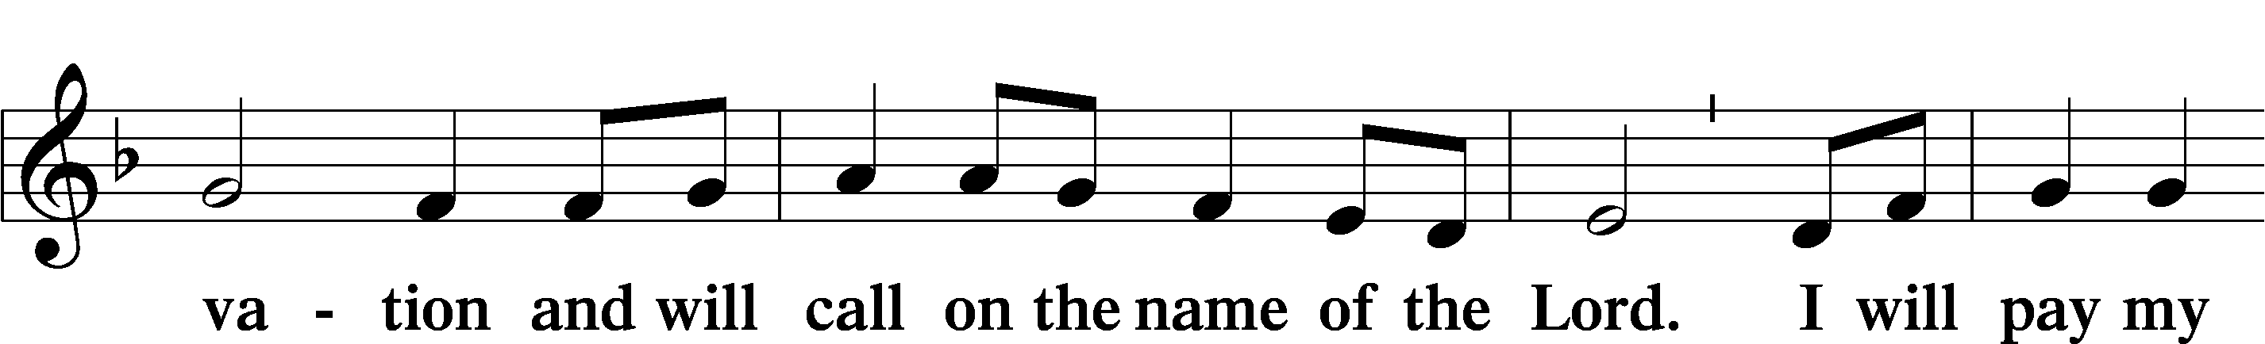
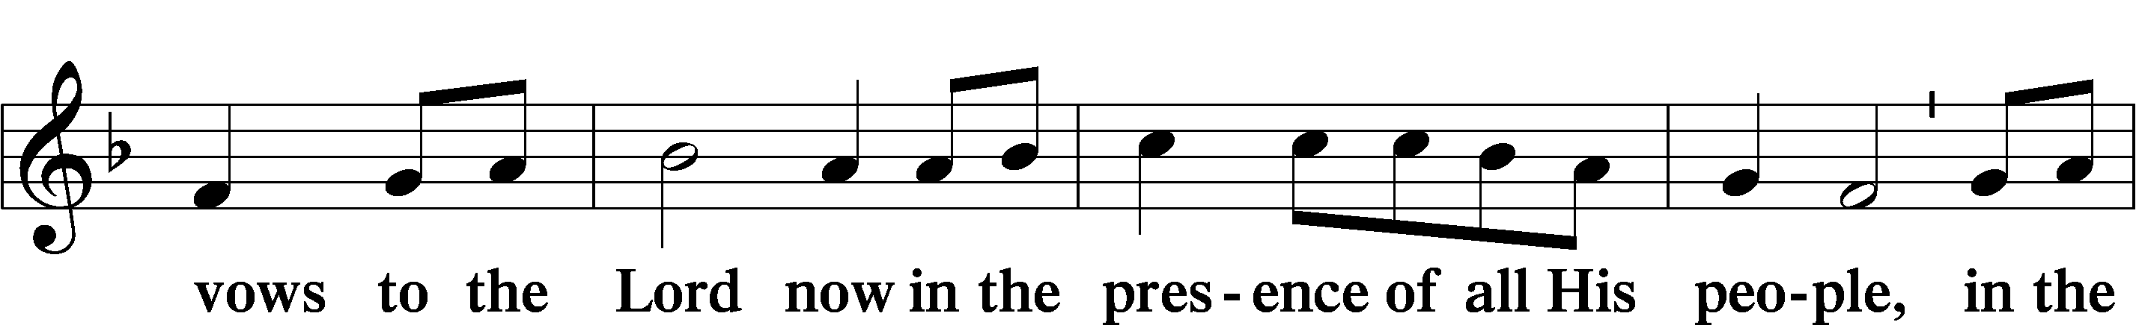
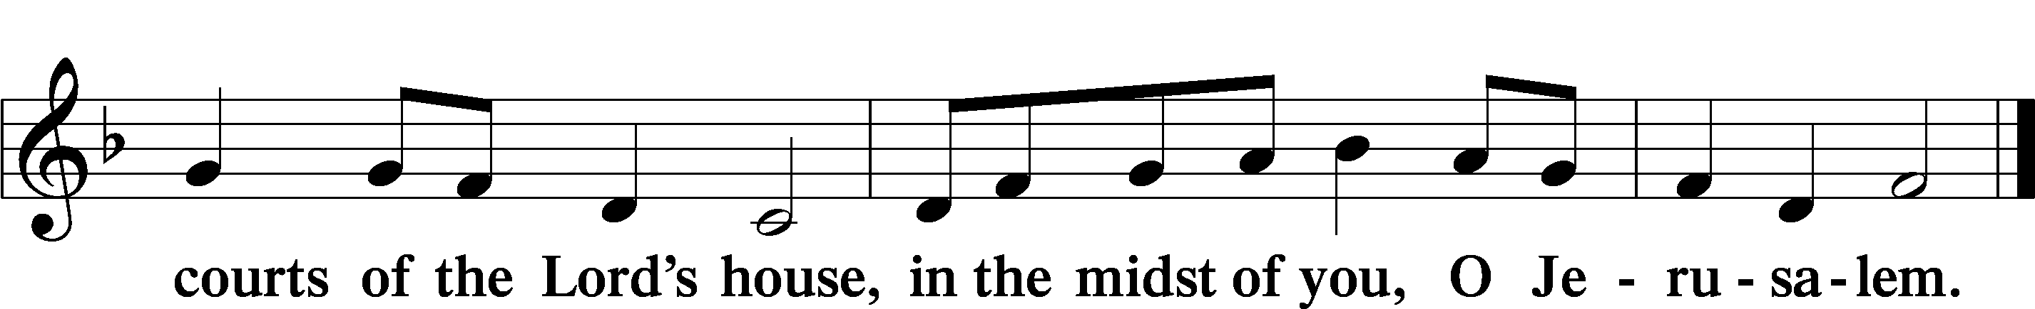

Service of the Sacrament

Preface LSB 160
P The Lord be with you.

P Lift up your hearts.

P Let us give thanks to the Lord our God.
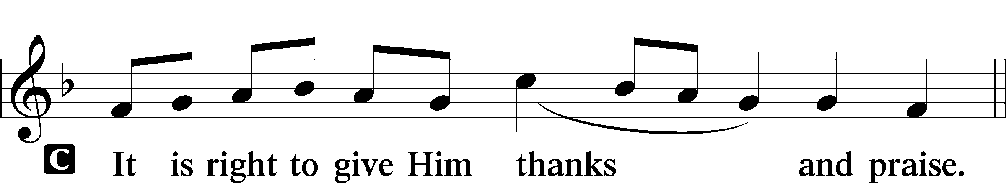

Proper Preface (Full)
P It is truly good, right, and salutary that we should at all times and in all places give thanks to You, holy Lord, almighty Father, everlasting God, through Jesus Christ, our Lord, who at His transfiguration revealed His glory to His disciples that they might be strengthened to proclaim His cross and resurrection and with all the faithful look forward to the glory of life everlasting. Therefore with angels and archangels and with all the company of heaven we laud and magnify Your glorious name, evermore praising You and saying:

Sanctus LSB 161
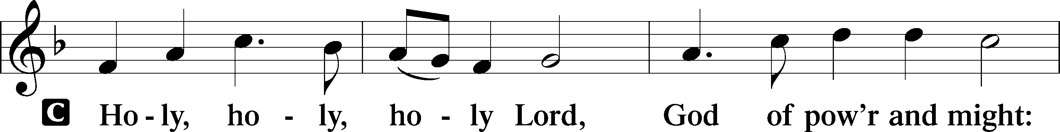
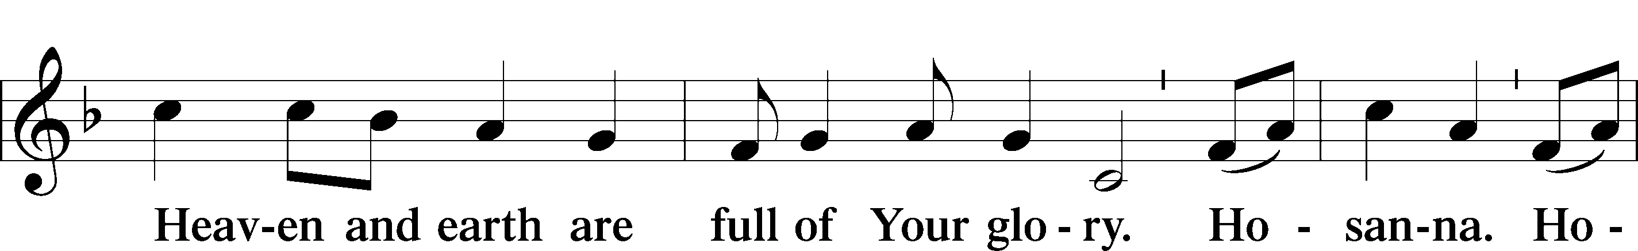
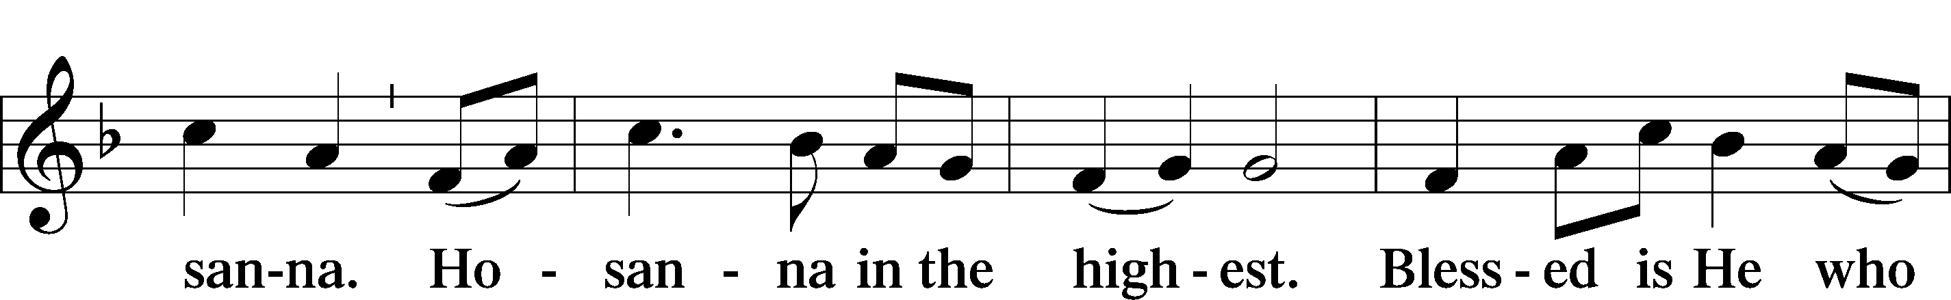
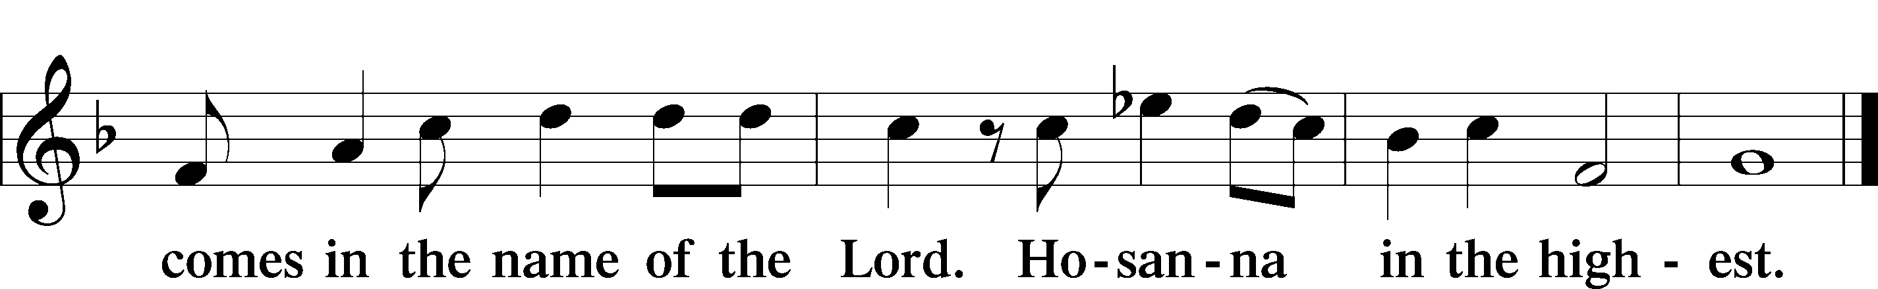

Lord’s Prayer
C Our Father who art in heaven,
hallowed be Thy name,
Thy kingdom come,
Thy will be done on earth
as it is in heaven;
give us this day our daily bread;
and forgive us our trespasses
as we forgive those
who trespass against us;
and lead us not into temptation,
but deliver us from evil.
For Thine is the kingdom
and the power and the glory
forever and ever. Amen.

The Words of Our Lord
P Our Lord Jesus Christ, on the night when He was betrayed, took bread, and when He had given thanks, He broke it and gave it to the disciples and said: “Take, eat; this is My T body, which is given for you. This do in remembrance of Me.”

In the same way also He took the cup after supper, and when He had given thanks, He gave it to them, saying: “Drink of it, all of you; this cup is the new testament in My T blood, which is shed for you for the forgiveness of sins. This do, as often as you drink it, in remembrance of Me.”
Pax Domini LSB 163
P The peace of the Lord be with you always.
C Amen.

Agnus Dei LSB 163
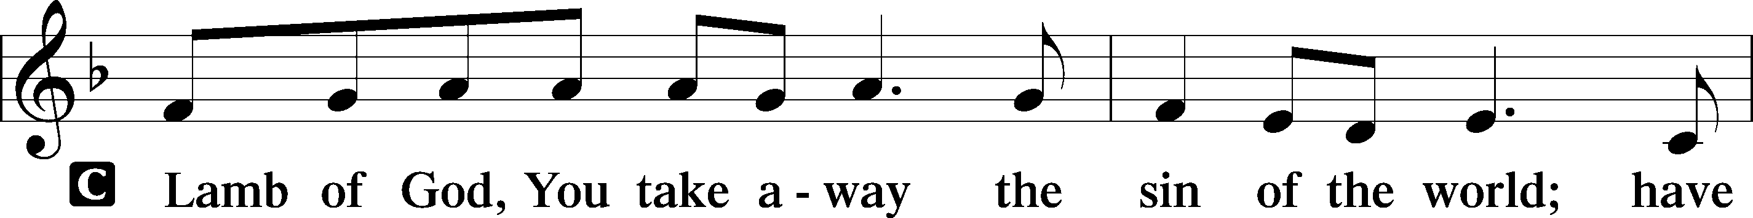
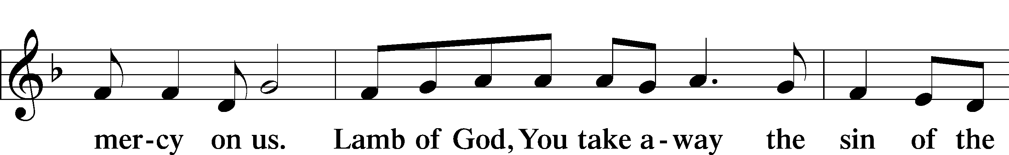
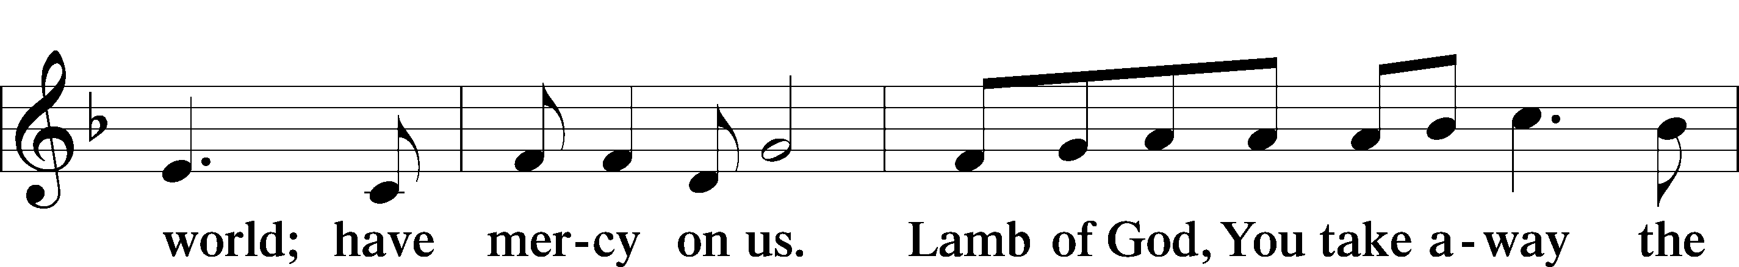
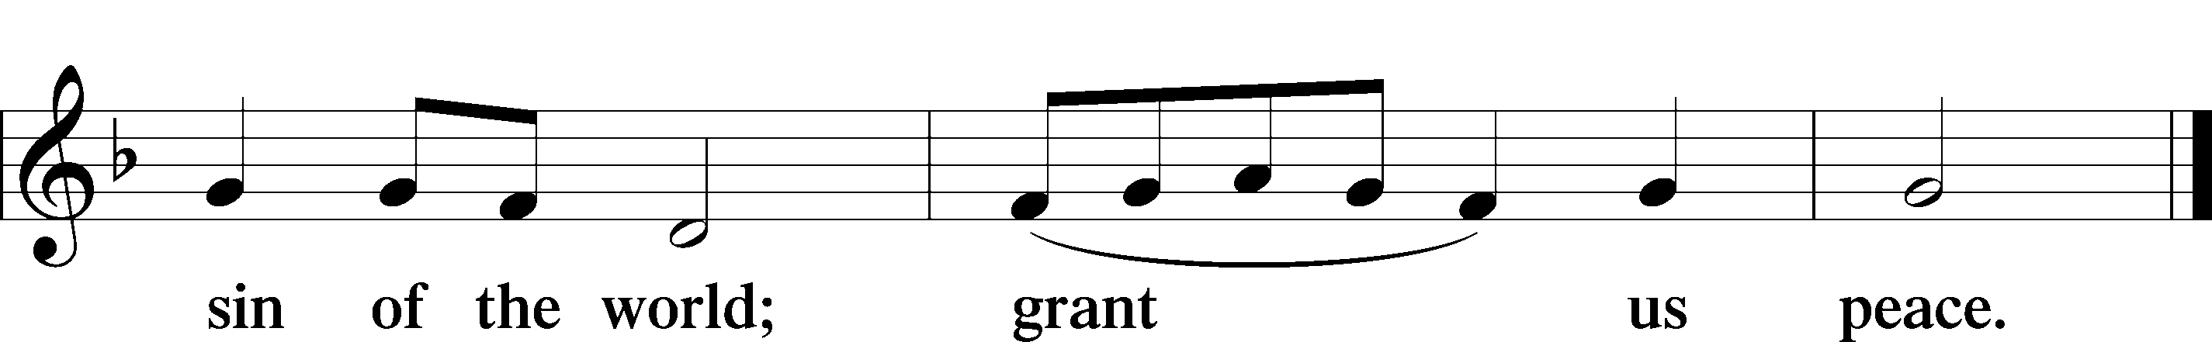

Sit

Distribution

873 Christ, Whose Glory Fills the Skies
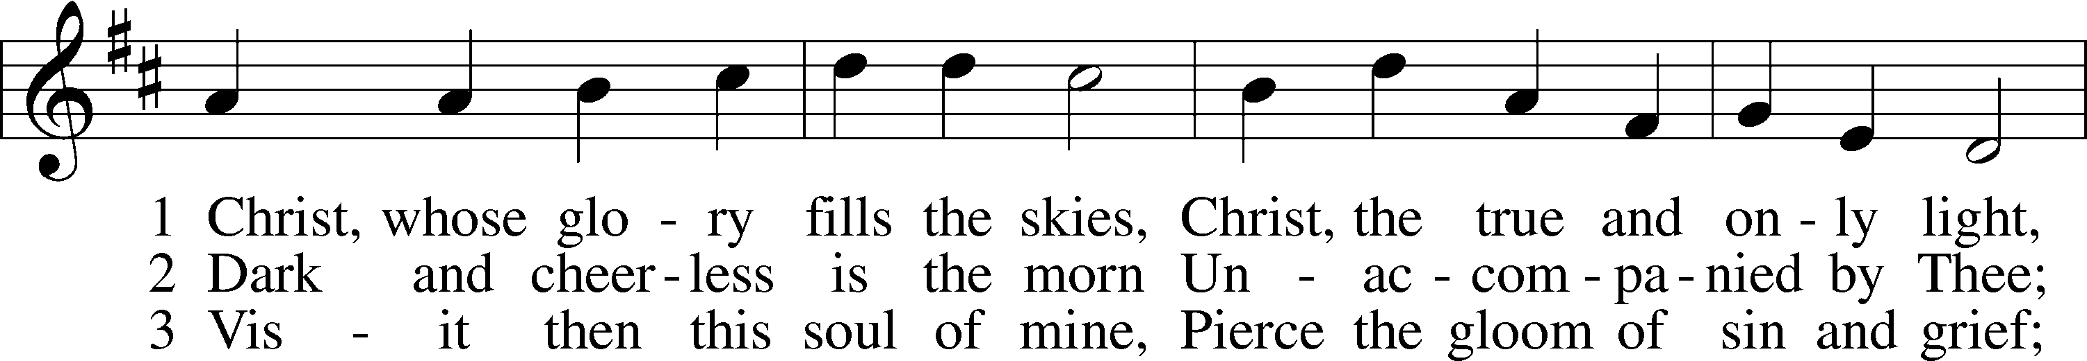
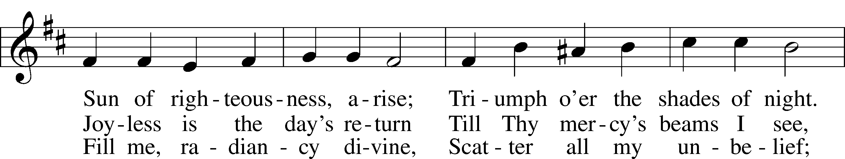
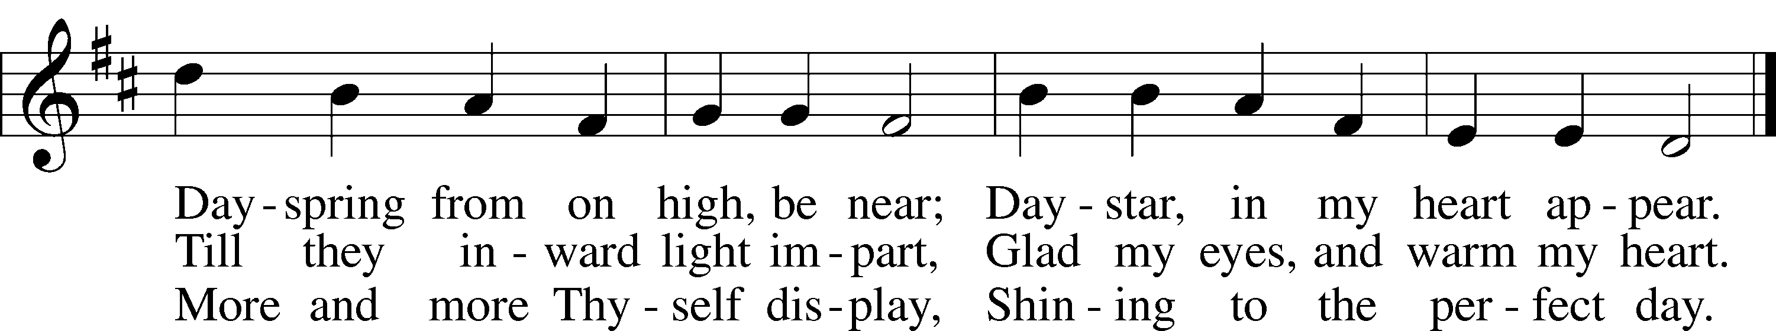
Text and tune: Public domain

631 Here, O My Lord, I See Thee Face to Face
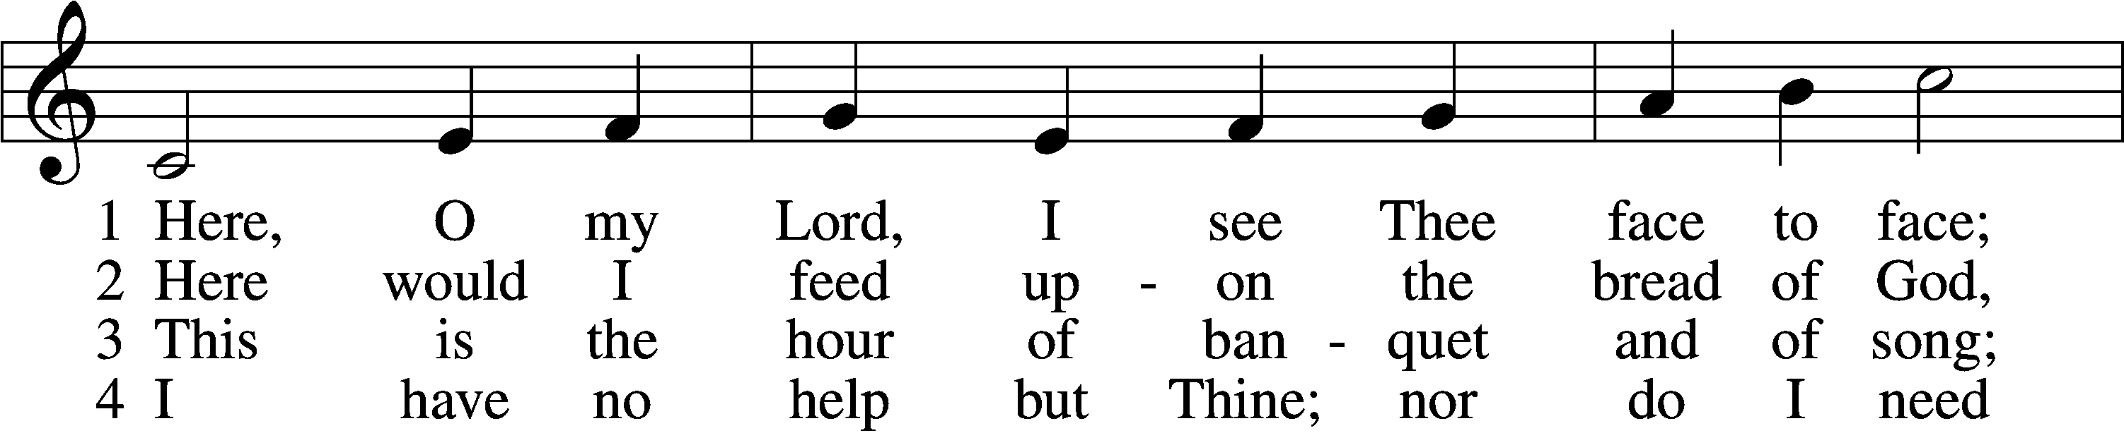
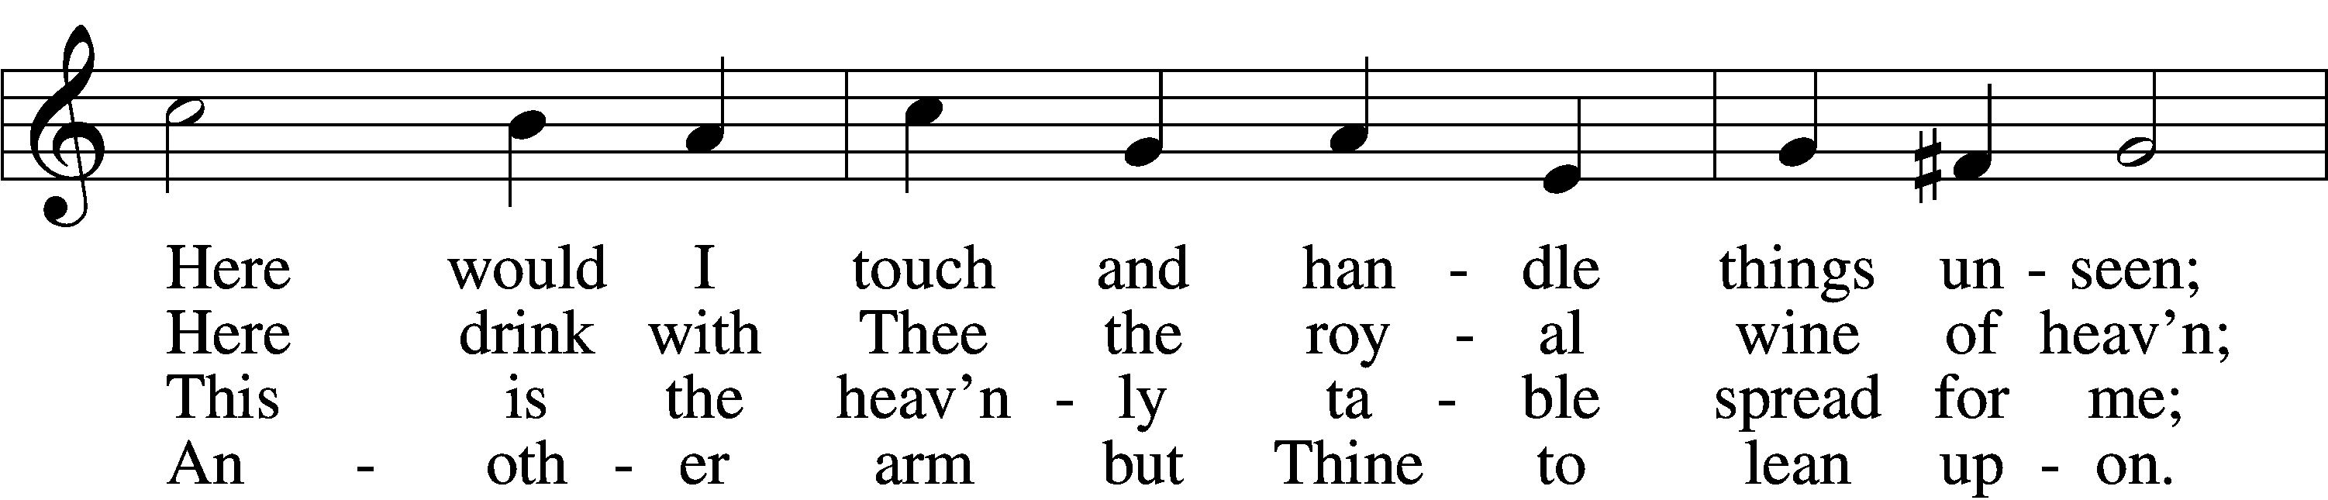
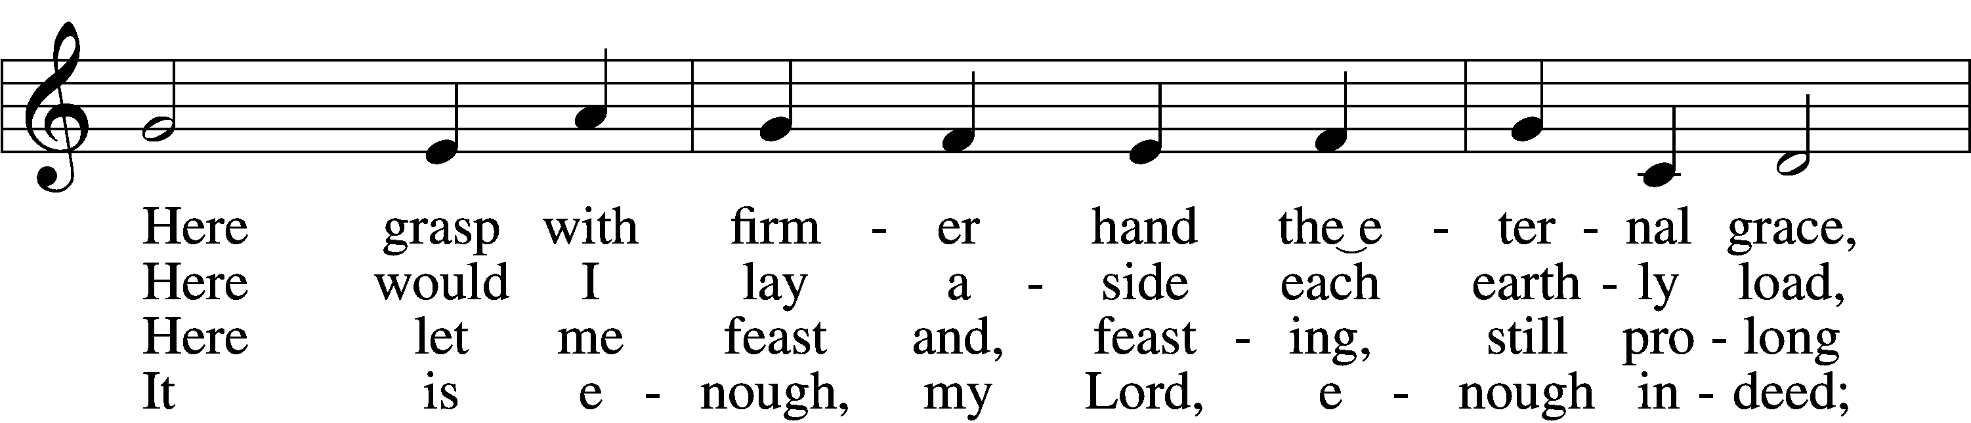
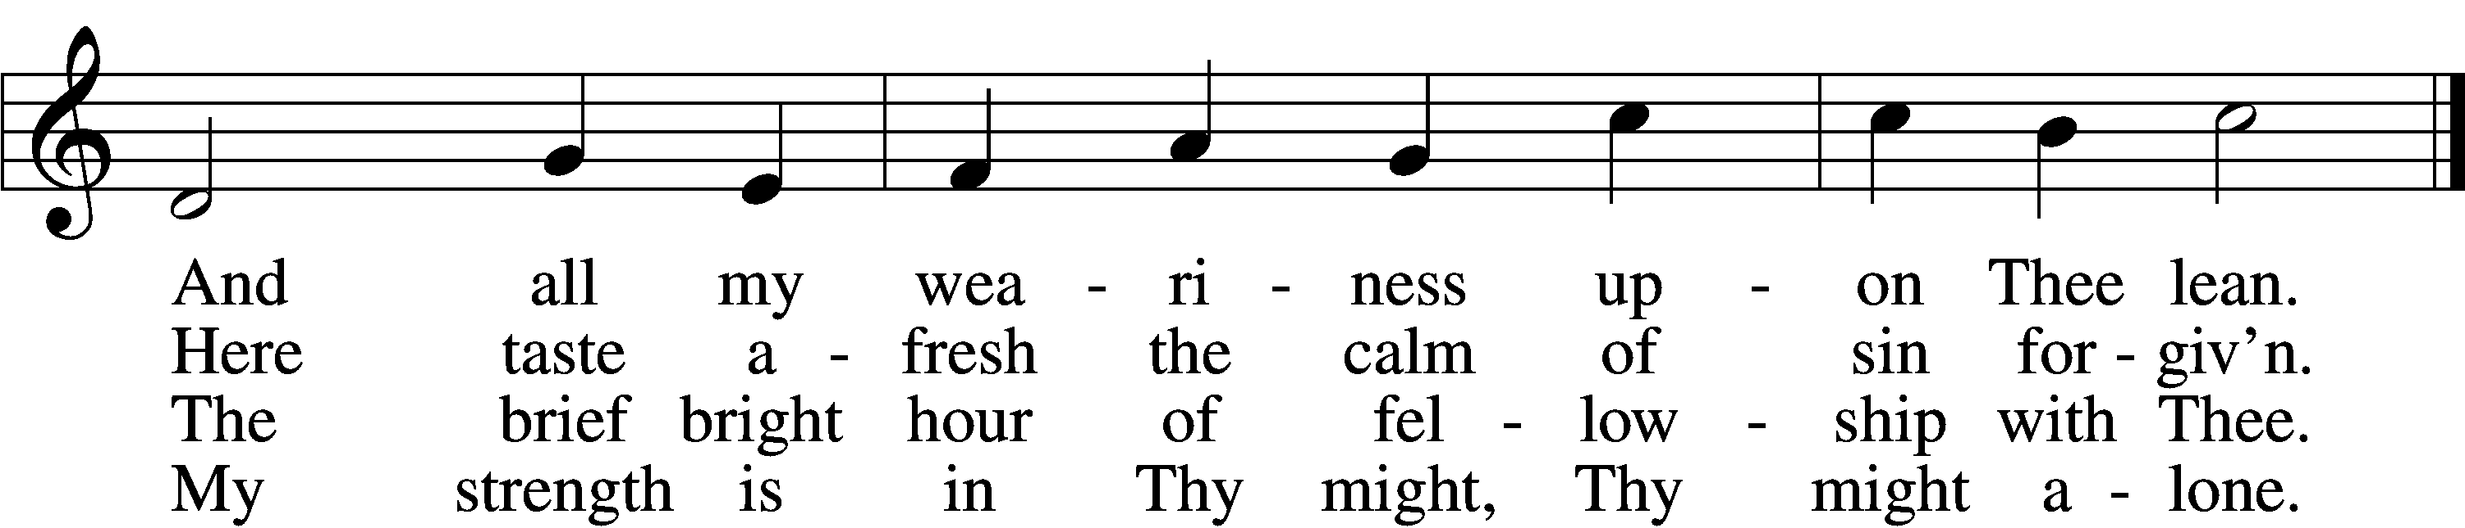

5 Mine is the sin, but Thine the righteousness;
Mine is the guilt, but Thine the cleansing blood;
Here is my robe, my refuge, and my peace:
Thy blood, Thy righteousness, O Lord my God.

6 Too soon we rise; the vessels disappear;
The feast, though not the love, is past and gone;
The bread and wine remove, but Thou art here;
Nearer than ever; still my shield and sun.

7 Feast after feast thus comes and passes by,
Yet, passing, points to that glad feast above,
Giving sweet foretaste of the festal joy,
The Lamb’s great marriage feast of bliss and love.
Text and tune: Public domain

417 Alleluia, Song of Gladness
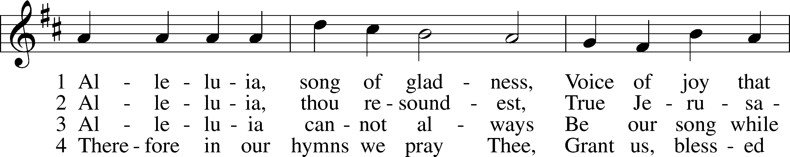
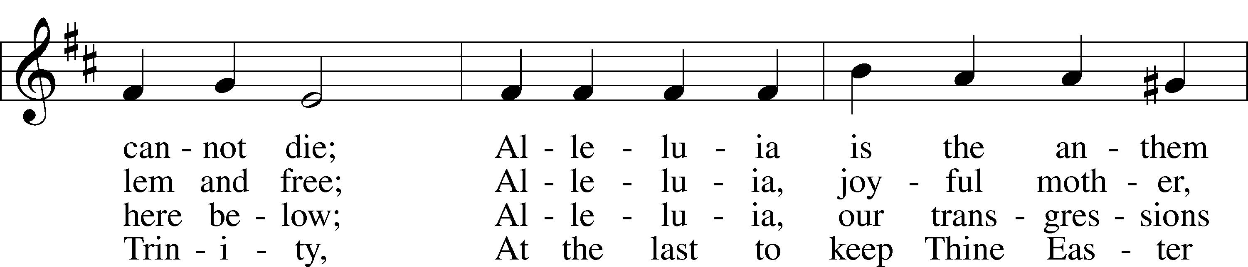
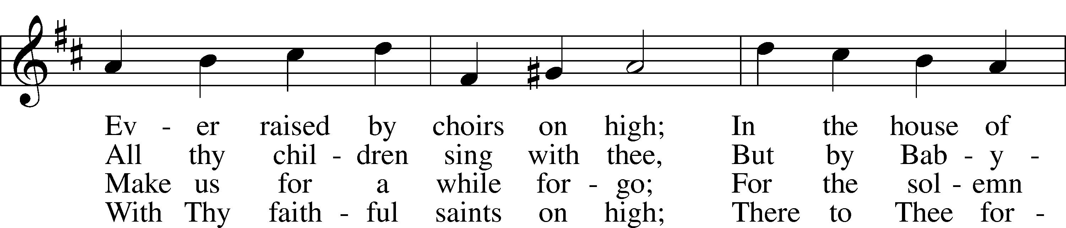
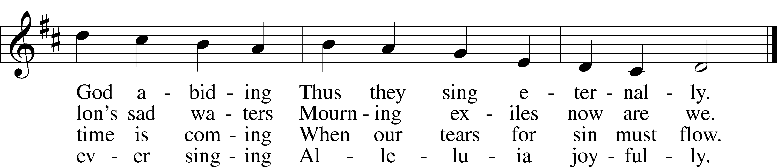
Text and tune: Public domain

Stand

The Dismissal
P The body and blood of our Lord Jesus Christ strengthen and preserve you in body and soul to life everlasting. Depart T in peace.
C Amen.

Thank the Lord LSB 164
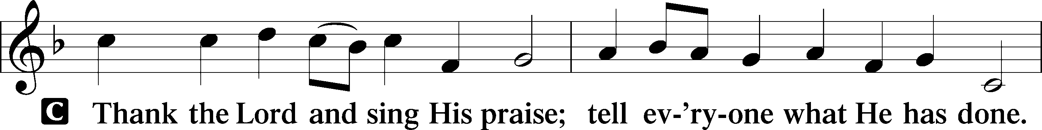
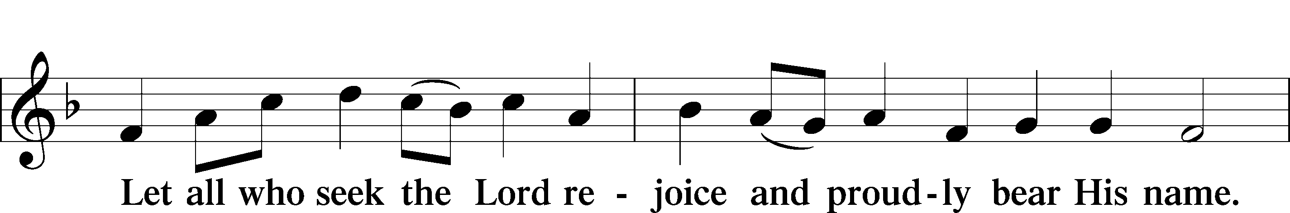
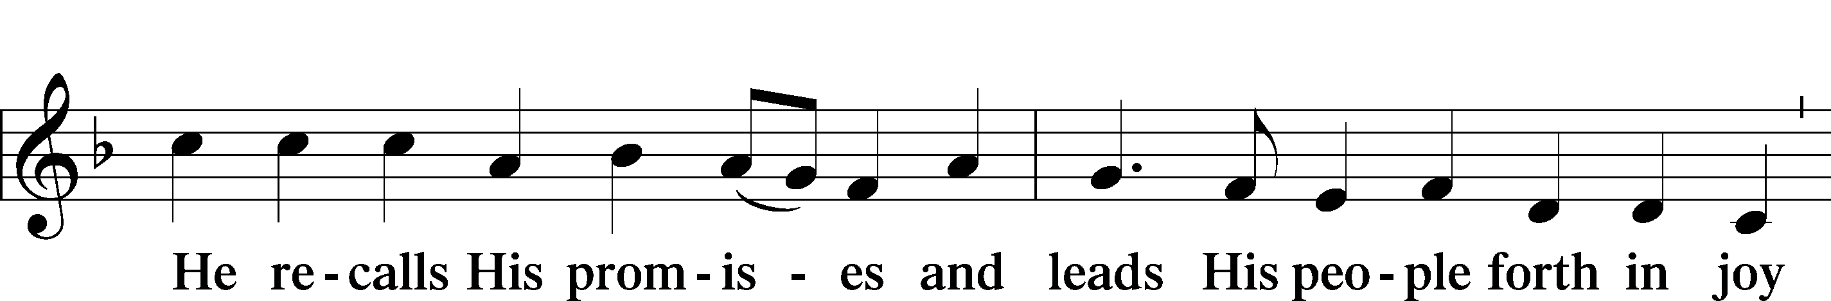
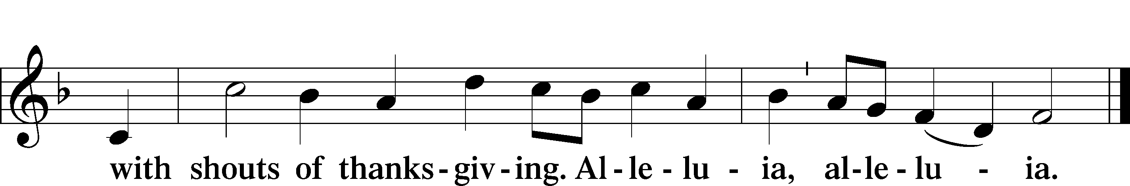

Post-Communion Collect
A Let us pray.
Gracious God, our heavenly Father, You have given us a foretaste of the feast to come in the Holy Supper of Your Son’s body and blood. Keep us firm in the true faith throughout our days of pilgrimage that, on the day of His coming, we may, together with all Your saints, celebrate the marriage feast of the Lamb in His kingdom which has no end; through Jesus Christ, Your Son, our Lord, who lives and reigns with You and the Holy Spirit, one God, now and forever.
C Amen.

Benediction LSB 166
P The Lord bless you and keep you.
The Lord make His face shine on you and be gracious to you.
The Lord look upon you with favor and T give you peace.
C Amen.

415 Jesus on the Mountain Peak
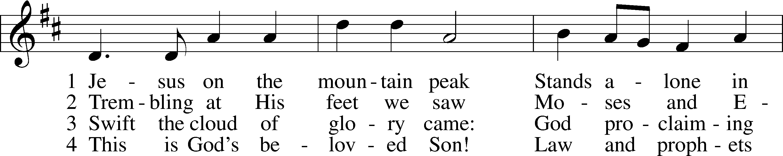
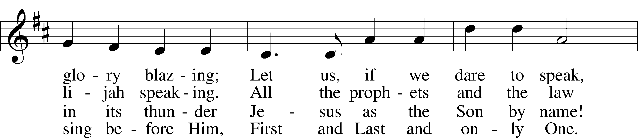
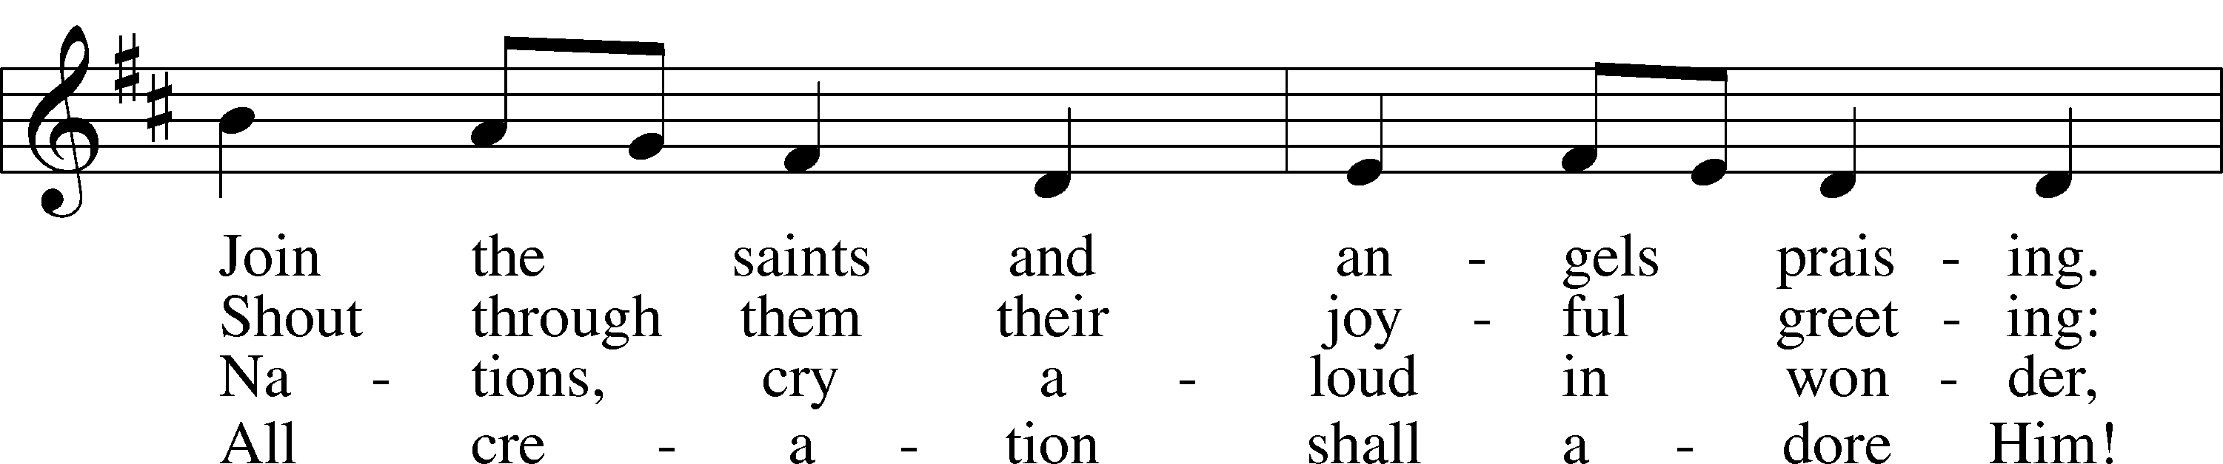
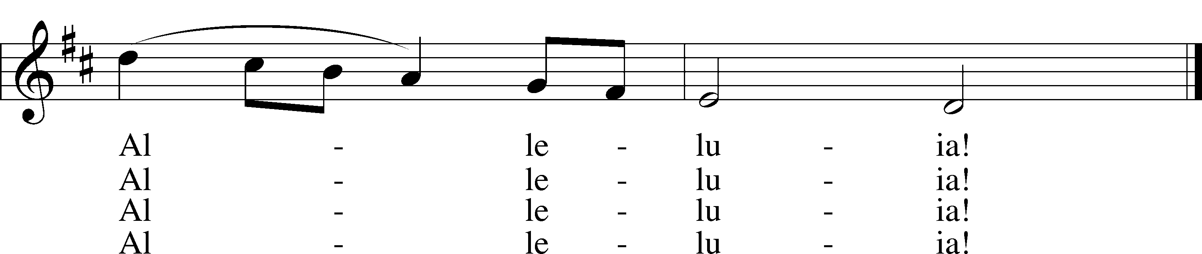
Text: © 1977 Hope Publishing Co. Used by permission: LSB Hymn License no. 110003744
Tune: © 1998 Theodore A. Beck. Used by permission: LSB Hymn License no. 110003744

Acknowledgments
Unless otherwise indicated, Scripture quotations are from the ESV® Bible (The Holy Bible, English Standard Version®), copyright © 2001 by Crossway, a publishing ministry of Good News Publishers. Used by permission. All rights reserved.
Created by Lutheran Service Builder © 2021 Concordia Publishing House.

ZION LUTHERAN CHURCH AND SCHOOL

Pr. James DeLoach, Pastor + (308) 627-5260
james.deloach@zionkearney.org
Pr. Doug Gaunt, Pastor + (308) 455-0552
doug.gaunt@zionkearney.org
Tony Splittgerber, Principal + (308) 293-0168
anthony.splittgerber@zionkearney.org

Church Office
Administrative Assistant: Jessica Shiers
Email: school@zionkearney.org
Phone: (308)-234-3410 Fax: (308) 236-8100
Office Hours: Monday-Friday 8:00am-4:00pm
Radio Broadcast: Sunday @ 10:30 a.m. on 1460 AM
Website: www.zionkearney.com

Prayers for Our Members
Jade Florang, Nicole Teten | Expectant Mother
Norman Abels (Brookestone Meadows – Elkhorn) | Healing
Judy Ahrens | Healing
Vaughn Albrecht (Northridge) | Healing
Tom & DyAnn Altwine | Healing
David Banner | Healing
Jim Catterson | Healing
Lyle Colsden (Mother Hull) | Healing
Pat Flodine (Cambridge Court) | Healing
Vi Fox (Prairie View) | Healing
Verleen Gentry | Healing
Ruby Hatfield | Healing
Boyd Millsap | Healing
Michelle Millsap | Healing
Roger Riekenberg | Healing
Don Richmond | Healing
Marion Richmond | Healing
Fran Junge | Cancer
Bev Nuttelman | Cancer
Kim Vos | Cancer

Prayers for Our Members’ Family & Friends
Dawn Gaunt (Pr. & Carol Gaunt’s daughter-in-law) | Expectant Mother
Brandon & Shannon Howell (Quentin & Janel Lange’s friends) | Expecting
Will Brennemann (Jami Helmbrecht’s father) | Healing
Reg Duke (Westman’s brother-in-law) | Healing
James Gentry (Verleen Gentry’s son) | Healing
Roger Hoffman (Marc’s father) | Healing
Sharon Kreutzer (former member) | Healing
Lyra Mais (Zion student) | Healing
Bailey Markowski (Steve & Fran Junge’s great niece) | Healing
Mary Ann Mertz (Pam’s Uhlir’s friend) | Healing
Tim Powers (Kim Wilken’s brother) | Healing
Roy Reynolds (Verleen Gentry’s son-in-law) | Healing
Lynne Saathoff (Verleen Gentry’s sister-in-law) | Healing
Randy Solomon (Beth Rosenthal’s father) | Healing
Janet Stalder (Carol Florang’s sister) | Healing
D.D. Dugger (Sue Kaiser’s brother) | Cancer
Ron Halvorsen (Jeff’s dad) | Cancer
Carol Haubold (Don Helmbrecht’s sister) | Cancer
Tyler Holland (Quentin & Janel Lange’s brother-in-law) | Cancer
Randy Jochum (Ken Hockemeier’s brother-in-law) | Cancer
Fred Koch (Pam Uhlir’s cousin) | Cancer
Lynda Kreutzer (Rich & Carol’s sister-in-law) | Cancer
John Moore (family of Susan Tonniges) | Cancer
Sharon Mulhair (Pam Uhlir’s cousin) | Cancer
Jeannie Schmidt (Lisa Splittgerber’s sister-in-law) | Cancer
Tyrone Uhlir (Pam’s nephew) | Cancer

Today’s Radio Broadcast is given to the Glory of the Lord
By: Quentin and Janel Lange

Today’s flowers is given to the Glory of the Lord by
Flynn & Robin Baker

Serving in Worship

Sunday, February 14 ~ 9:00am

Elder: Dan Oertwig
Usher: Marc Hoffman & Steve Junge
Engineer: Zach DeLoach
Announcer: Lonna Gronewoller
Altar Guild: Shirley Helmbrecht

Ash Wednesday, February 17 ~ 7:00pm

Elder: Dan Oertwig
Usher: Marc Hoffman & Steve Junge
Engineer: Zach DeLoach
Altar Guild: Shirley Helmbrecht

Sunday, February 21 ~ 9:00am

Elder: Ken Hockemeier
Usher: Roger Riekenberg & Robert Glanzer
Engineer: Jared Nuttelman
Announcer: Carol Kreutzer
Altar Guild: Shirley Helmbrecht

Our Response to the Gospel

Date: 02/07/2021

Offering: $5,919.00
Weekly Need: $7,542.37

This Week at Zion

Sun  02/14 | 9:00a  10:30a | Divine Service  Radio Broadcast 1460am
Mon  02/15 | Birthdays  Anniversaries | ---  ---
Tues  02/16 | 1:30p  7:00p  Birthdays  Anniversaries | Sleeping Mats  Church Council  Katherine Nuttelman  ---
Wed  02/17 | 8:30a  5:45p  7:00p  8:00p  Birthdays  Anniversaries | Chapel  Midweek  Ash Wednesday Service  Adult Choir  David Banner  ---
Thurs  02/18 | 7:00p  Birthdays  Anniversaries | Men’s Bible Study  Devon Altwine  Trevor Altwine  ---
Fri  02/19 | Birthdays  Anniversaries | Joyce Hartman  ---
Sat  02/20 | 5:00p  Birthdays  Anniversaries | Divine Service  Denae Kuhl  ---
Sun  02/21 | 9:00a  10:30a  Birthdays  Anniversaries | Divine Service  Radio Broadcast 1460am  Jarren Blattner  Madison Vetter  ---
ANNOUNCEMENTS
Where our Triune God strengthens us through His mercy in faith toward Him and in fervent love toward one another.

A Bible Study – is prerecorded and available each Sunday, along with a study guide you can use to follow along. We are studying the three lessons for the day—the Old Testament, the Epistle, and the Gospel. Go to Zion’s website www.zionkearney.com to access the video and study guide.

Ash Wednesday – Please join us on Wednesday, February 17 at 7:00 pm as we begin this year’s “Return to the Lord” Lenten series. This Divine Service will include the Rite of the Imposition of Ashes. “A Call to Return”. Joel's prophecy is dark and terrifying, and the imagery is vivid. It sets the stage for God's invitation and promise: "You have turned away from me in your hearts and minds, and I have now shown you where that path will take you. But it is not too late. Turn back! Return to the Lord! I am gracious and merciful, and I will bless you." Each week we will consider how the call to return plays out in practical ways as we examine specific events in the saga of our Lord’s passion story.

Lenten Series – In the Book of Joel, the prophet paints a vivid picture of the coming judgment of God, the Day of the Lord. The imagery is bold and terrifying: hordes of locusts swarming over the land and decimating everything. Joel’s prophecy has teeth even today as wars rage, natural disasters threaten and destroy, and our culture seems to be unraveling. But right in the middle of this frightening portent, we find a tender invitation from the Lord: “Return to the Lord your God, for He is gracious and merciful, slow to anger, and abounding in steadfast love; and He relents over disaster” (Joel 2:13). God’s invitation and promise finds its fullness in Jesus Christ, who personifies and accomplishes all that God declares. During this season of Lent, we will consider the theme “Return to the Lord” and examine how the call to return played out in practical ways for the people who walked alongside Christ as He demonstrated and carried out God’s grace and mercy on our behalf, taking God’s wrath upon Himself, setting the stage for God to “turn and relent, and leave a blessing behind Him” (Joel 2:14). Each sermon in this series focuses on a particular event in the Passion, with a special focus on the people involved in the event. This will help to connect the hearers with Series Introduction their own sinful nature, to emphasize how we have turned away from the Lord, and to reinforce and rejoice in God’s call for us to return to Him with all our heart.

Bible Reading Cards - A new set of Bible reading cards for the new year can be picked up in the church entryway. Each card is a tool to keep track of your Bible reading progress as you mark each chapter you have read in 2021. God works through His Word.

Church Management Software – Zion is excited to announce that we will be moving to a new church management software. It will have a lot of great features and flexibility. Scan the QR code to take a look at the directory, get set up for online giving, just to explore the new software.

Offering during this time. If you are not able to attend live Church Services, you may: drop your offering in the mail slot by the south doors, mail it to the church, or use online giving option at zionkearney.com. If you have any questions or need assistance, please contact the office at 308-234-3410 or school@zionkearney.org. Thank you for supporting of your church!

Mission Offerings - The first quarter missions will support Lutherans for Life, January through March. If you would like to donate to this mission, please use the mission envelopes located in the narthex. Thank you for your support.

Radio Broadcast - Please help Zion spread the Gospel! There are several open dates. This is a great need since, many people are listening to our broadcast during this time.

Masks – According to Kearney City Ordinance No. 8457 masks are required “at a location that is open to the general public and where they cannot maintain six foot of distance.”

SCHOOL NEWS

Registration Open - Registration is now open for the 2021-2022. New this year is an all-day prekindergarten option! If you have any questions, please feel free to contact the office. Please tell your family and friends about Zion. Enroll early to make sure you have a spot.

Best of Kearney - - Best of Kearney 2021 has arrived, but with changes. From February 1-14 they are taking nominations. Then from March 1-16 is the voting. Please nominate Zion preschool under the daily living section and preschool. Thank you so much for your support!

http://kearneyhub.secondstreetapp.com/Best-of-Kearney-2021/gallery?group=368765

New Teacher Search - The search for another high quality Lutheran teacher has begun. Full time teachers in our school must be members of the LCMS (or willing to become so). The grade level will most probably be for the 3rd/4th grade. If you or someone you know might be interested in this position, please contact Mr. Splittgerber
Scrip Cards - Scrip cards are still available during this time. Visit the office during normal hours to purchase your gift cards.

Part-time Cook Needed - Zion is looking for a part-time cook! Tasks include meal prep, serving, and cleaning. Candidate strengths should include time-management and a positive disposition. The position is for 3 days week, 8-1 pm. Please share and contact the office with questions!

Apple Market Receipts – Apple Market receipts are due February 28, 2021 Please turn them into the office by then, so the school can get free class supplies. Thank you for supporting our school!

Heartland Lutheran High School: 8th Grade Students and Families: Heartland Lutheran High School in Grand Island is offering the Fall semester TUITION FREE for you to come join our Red Hornet family! We would love to have you as a student! Enrollment forms are available now with a registration discount if received by March 15. For more information, please contact cliess@heartlandlutheran.org.

