Divine Service
Sixteenth Sunday
after Pentecost
September 12, 2021

Zion Lutheran Church
Kearney, Nebraska

Welcome to Zion!
All worshippers please fill out an attendance card in the pew rack and let us know how we might be of service to you.

Holy Communion at Zion

The Lord’s Supper is celebrated at this congregation as Jesus has given it. As he says, our Lord gives into our mouths not only bread and wine but his very body and blood to eat and to drink for the forgiveness of sins and to strengthen our union with him and with one another. Our Lord invites to his table those who trust his words, repent of all sin, and set aside any refusal to forgive and love as he forgives and loves us, that they may show forth his death until he comes. All communicants need to register in the narthex prior to the service.

Because those who eat and drink our Lord’s body and blood unworthily do great harm and because Holy Communion is a confession of the faith which is confessed at this altar, any who are not yet instructed, in doubt, or who hold a confession differing from that of this congregation and The Lutheran Church—Missouri Synod, are asked not to commune until they are able to speak with our pastor first. He is happy to visit with you about the Christian faith and how to receive the Lord’s Supper for your good and for the good of others. Those not communing are invited to come to the altar, cross your arms in front of you, and bow your head to receive a pastoral blessing.

Christ Jesus Delivers Us from Sin, Death and the Devil

Those who teach the Word of God “will be judged with greater strictness” (James 3:1) because it is by the Word that saving faith is obtained, whereas false doctrine always threatens to destroy Christian faith and life. The tongue “boasts of great things,” whether for good or evil (James 3:5). In fallen man, “it is a restless evil, full of deadly poison” (James 3:8). But anyone who bridles his tongue with the Word of God, who “does not stumble in what he says, he is a perfect man” (James 3:2). It is Christ who opens His ear to the voice of His Father, so that, with “the tongue of those who are taught,” He is able to sustain the weary “with a word” (Is. 50:4–5). Entrusting Himself to His Father, even to death, He is not put to shame but is vindicated in His resurrection (Is. 50:6–9). By His faith and faithfulness, He casts out the “mute and deaf spirit” from us (Mark 9:25). He has compassion on us and helps us, so that we are not destroyed but cleansed from every evil and raised up from death to life (Mark 9:22–27).

Confession and Absolution

611 Chief of Sinners Though I Be
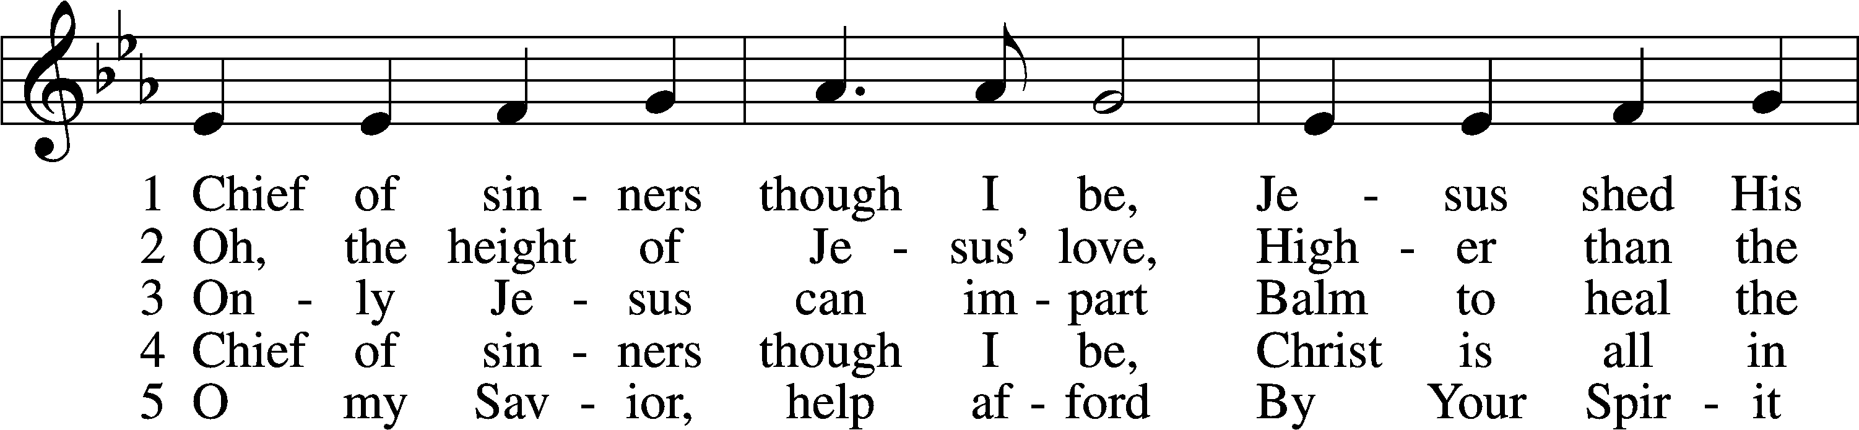
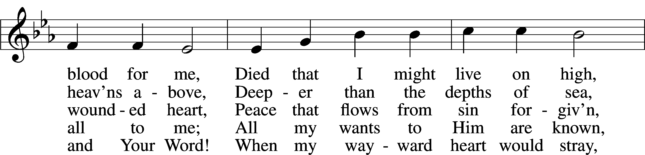
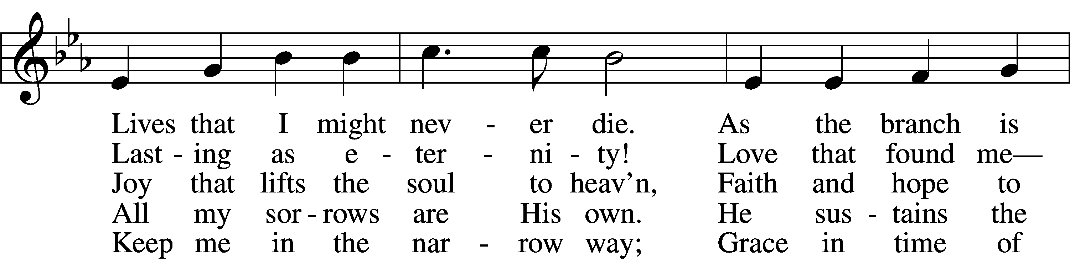
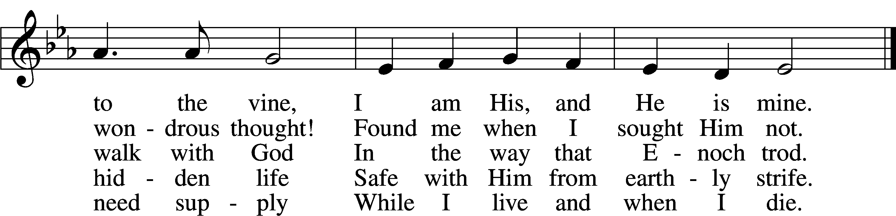
Tune and text: Public domain

Stand

The sign of the cross may be made by all in remembrance of their Baptism.

Invocation
P In the name of the Father and of the T Son and of the Holy Spirit.
C Amen.

Exhortation LSB 151
P If we say we have no sin, we deceive ourselves, and the truth is not in us.
C But if we confess our sins, God, who is faithful and just, will forgive our sins and cleanse us from all unrighteousness.
Silence for reflection on God’s Word and for self-examination.

Confession of Sins LSB 151
P Let us then confess our sins to God our Father.
C Most merciful God, we confess that we are by nature sinful and unclean. We have sinned against You in thought, word, and deed, by what we have done and by what we have left undone. We have not loved You with our whole heart; we have not loved our neighbors as ourselves. We justly deserve Your present and eternal punishment. For the sake of Your Son, Jesus Christ, have mercy on us. Forgive us, renew us, and lead us, so that we may delight in Your will and walk in Your ways to the glory of Your holy name. Amen.

Absolution LSB 151
P Almighty God in His mercy has given His Son to die for you and for His sake forgives you all your sins. As a called and ordained servant of Christ, and by His authority, I therefore forgive you all your sins in the name of the Father and of the T Son and of the Holy Spirit.
C Amen.

Service of the Word

Introit Psalm 31:14–16; antiphon: v. 24
Be strong, and let your heart take | courage,*
all you who wait | for the Lord!
But I trust in you, | O Lord;*
I say, “You | are my God.”
My times are | in your hand;*
rescue me from the hand of my enemies and from my perse- | cutors!
Make your face shine on your | servant;*
save me in your | steadfast love!
Glory be to the Father and | to the Son*
and to the Holy | Spirit;
as it was in the be- | ginning,*
is now, and will be forever. | Amen.
Be strong, and let your heart take | courage,*
all you who wait | for the Lord!
Kyrie LSB 152
A In peace let us pray to the Lord.
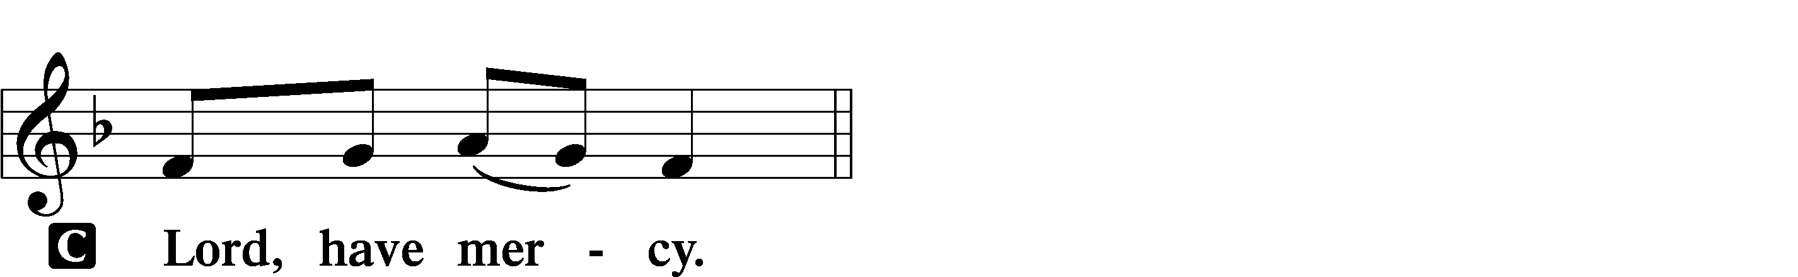

A For the peace from above and for our salvation let us pray to the Lord.
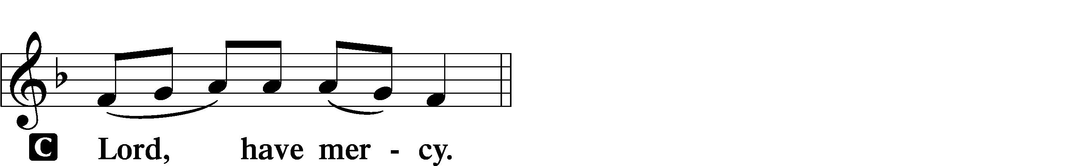

A For the peace of the whole world, for the well-being of the Church of God, and for the unity of all let us pray to the Lord.
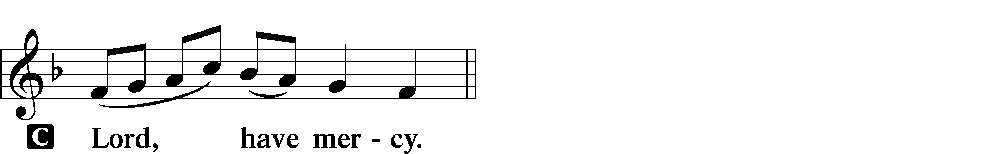

A For this holy house and for all who offer here their worship and praise let us pray to the Lord.
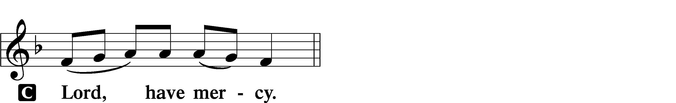

A Help, save, comfort, and defend us, gracious Lord.

Gloria in Excelsis LSB 154
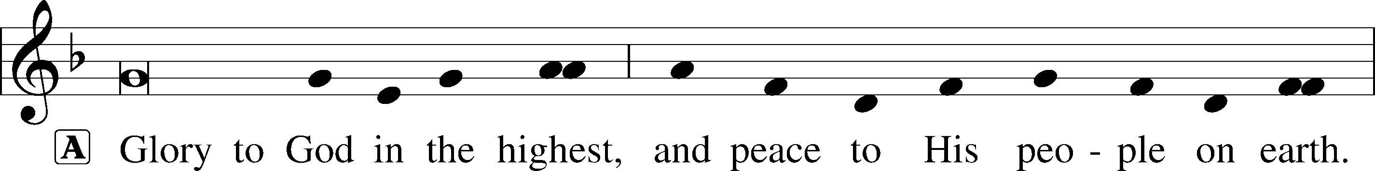
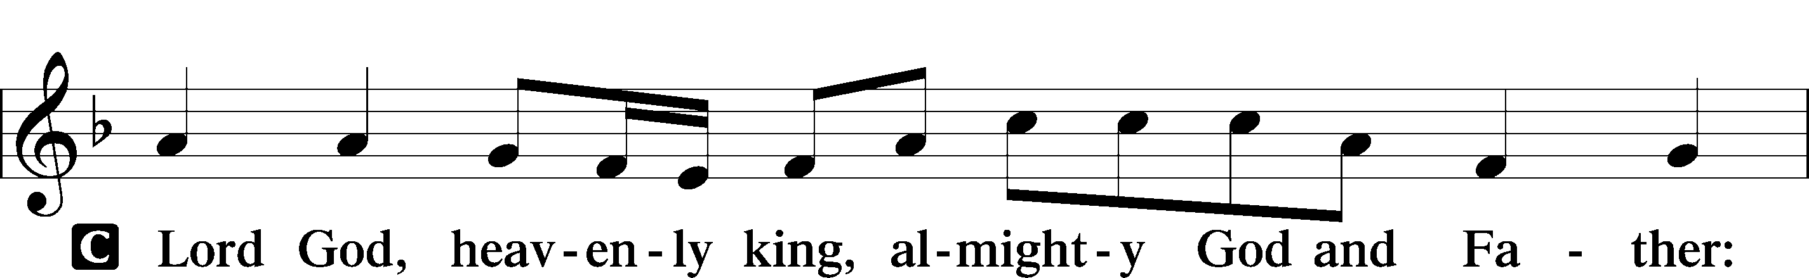
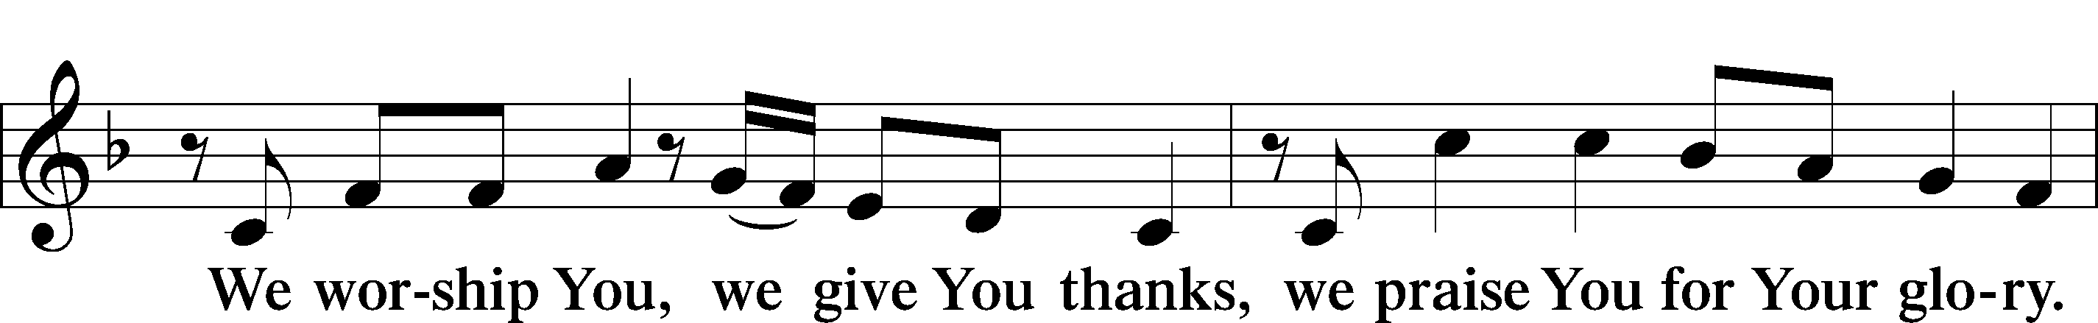
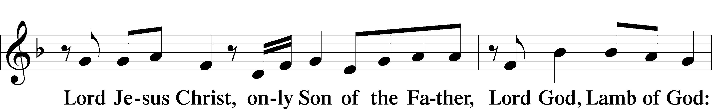
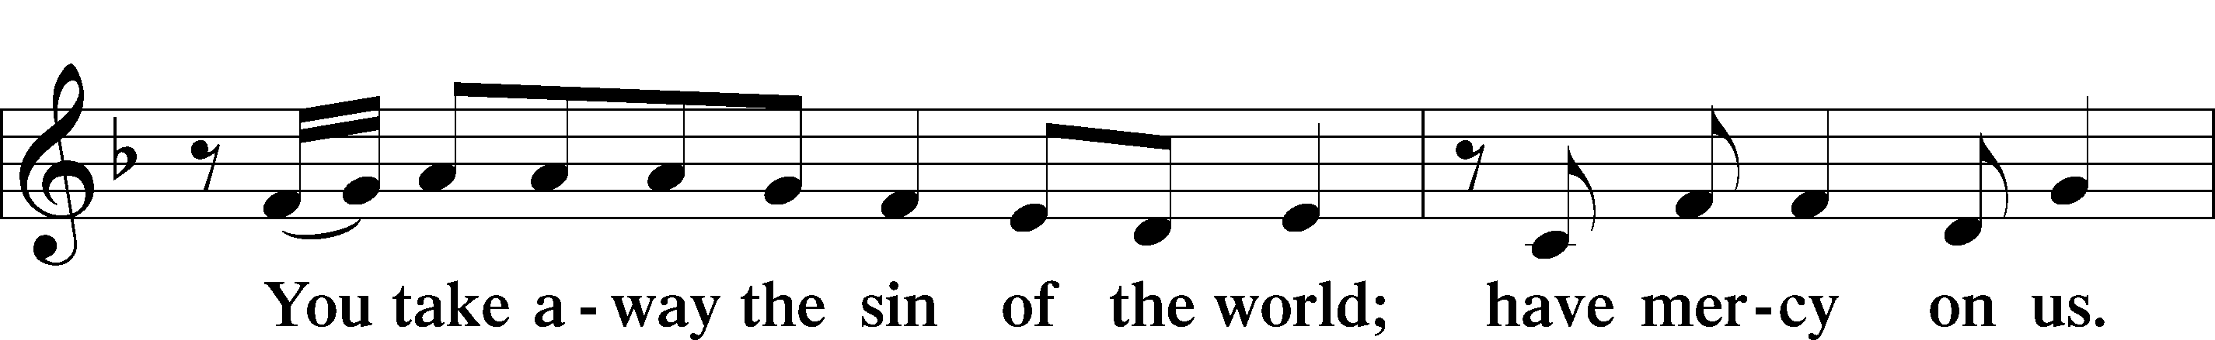
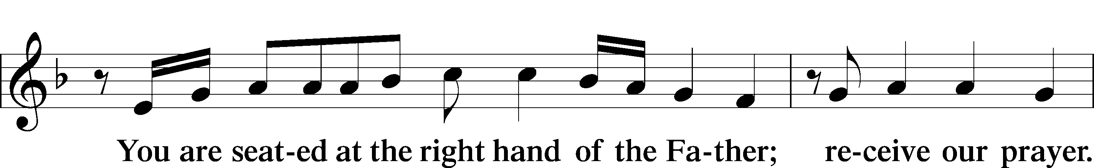
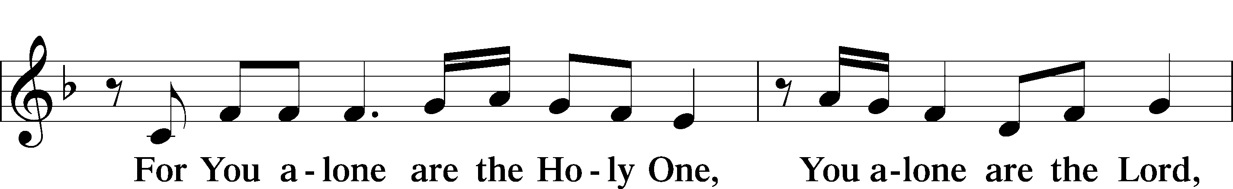
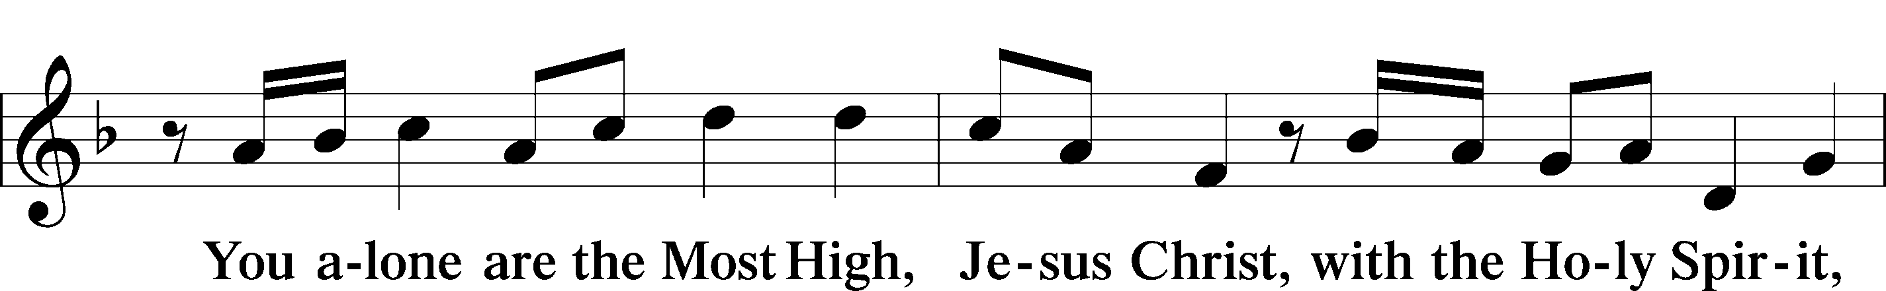
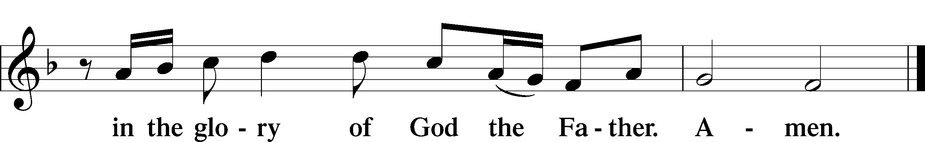

Salutation and Collect of the Day
P The Lord be with you.
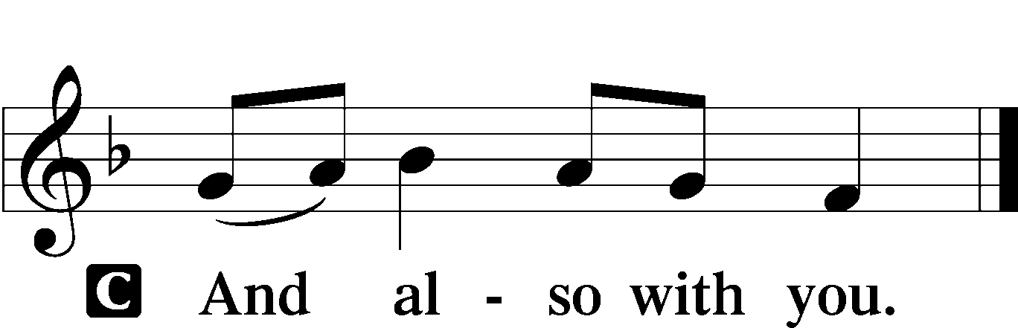

P Let us pray.
Lord Jesus Christ, our support and defense in every need, continue to preserve Your Church in safety, govern her by Your goodness, and bless her with Your peace; for You live and reign with the Father and the Holy Spirit, one God, now and forever.

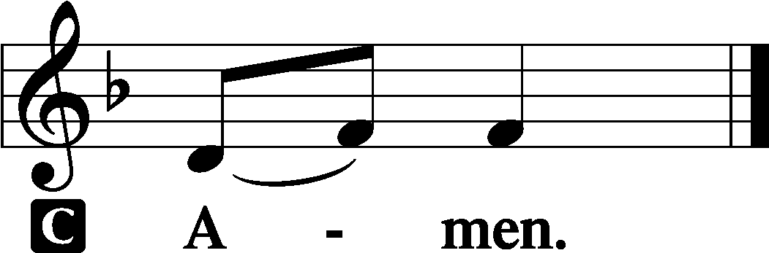

Sit

Old Testament Reading Isaiah 50:4–10
4The Lord God has given me
the tongue of those who are taught,
that I may know how to sustain with a word
him who is weary.
Morning by morning he awakens;
he awakens my ear
to hear as those who are taught.
5The Lord God has opened my ear,
and I was not rebellious;
I turned not backward.
6I gave my back to those who strike,
and my cheeks to those who pull out the beard;
I hid not my face
from disgrace and spitting.
7But the Lord God helps me;
therefore I have not been disgraced;
therefore I have set my face like a flint,
and I know that I shall not be put to shame.
8He who vindicates me is near.
Who will contend with me?
Let us stand up together.
Who is my adversary?
Let him come near to me.
9Behold, the Lord God helps me;
who will declare me guilty?
Behold, all of them will wear out like a garment;
the moth will eat them up.
10Who among you fears the Lord
and obeys the voice of his servant?
Let him who walks in darkness
and has no light
trust in the name of the Lord
and rely on his God.

A This is the Word of the Lord.
C Thanks be to God.

Gradual Psalm 34:9, 19, alt.
Fear the Lord, | you his saints,*
for those who fear him lack | nothing!
Many are the afflictions of the | righteous,*
but the Lord delivers him out | of them all.
Epistle James 3:1–12
Taming the Tongue
1Not many of you should become teachers, my brothers, for you know that we who teach will be judged with greater strictness. 2For we all stumble in many ways, and if anyone does not stumble in what he says, he is a perfect man, able also to bridle his whole body. 3If we put bits into the mouths of horses so that they obey us, we guide their whole bodies as well. 4Look at the ships also: though they are so large and are driven by strong winds, they are guided by a very small rudder wherever the will of the pilot directs. 5So also the tongue is a small member, yet it boasts of great things.
How great a forest is set ablaze by such a small fire! 6And the tongue is a fire, a world of unrighteousness. The tongue is set among our members, staining the whole body, setting on fire the entire course of life, and set on fire by hell. 7For every kind of beast and bird, of reptile and sea creature, can be tamed and has been tamed by mankind, 8but no human being can tame the tongue. It is a restless evil, full of deadly poison. 9With it we bless our Lord and Father, and with it we curse people who are made in the likeness of God. 10From the same mouth come blessing and cursing. My brothers, these things ought not to be so. 11Does a spring pour forth from the same opening both fresh and salt water? 12Can a fig tree, my brothers, bear olives, or a grapevine produce figs? Neither can a salt pond yield fresh water.

A This is the Word of the Lord.
C Thanks be to God.

Stand

Alleluia and Verse LSB 156
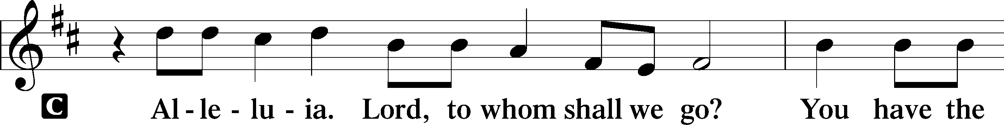
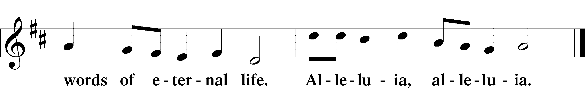

Holy Gospel Mark 9:14–29
P The Holy Gospel according to St. Mark, the ninth chapter.

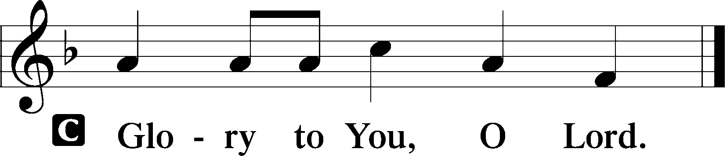

Healing of a Boy with an Unclean Spirit
14When they came to the disciples, they saw a great crowd around them, and scribes arguing with them. 15And immediately all the crowd, when they saw him, were greatly amazed and ran up to [Jesus] and greeted him. 16And he asked them, “What are you arguing about with them?” 17And someone from the crowd answered him, “Teacher, I brought my son to you, for he has a spirit that makes him mute. 18And whenever it seizes him, it throws him down, and he foams and grinds his teeth and becomes rigid. So I asked your disciples to cast it out, and they were not able.” 19And he answered them, “O faithless generation, how long am I to be with you? How long am I to bear with you? Bring him to me.” 20And they brought the boy to him. And when the spirit saw him, immediately it convulsed the boy, and he fell on the ground and rolled about, foaming at the mouth. 21And Jesus asked his father, “How long has this been happening to him?” And he said, “From childhood. 22And it has often cast him into fire and into water, to destroy him. But if you can do anything, have compassion on us and help us.” 23And Jesus said to him, “If you can! All things are possible for one who believes.” 24Immediately the father of the child cried out and said, “I believe; help my unbelief!” 25And when Jesus saw that a crowd came running together, he rebuked the unclean spirit, saying to it, “You mute and deaf spirit, I command you, come out of him and never enter him again.” 26And after crying out and convulsing him terribly, it came out, and the boy was like a corpse, so that most of them said, “He is dead.” 27But Jesus took him by the hand and lifted him up, and he arose. 28And when he had entered the house, his disciples asked him privately, “Why could we not cast it out?” 29And he said to them, “This kind cannot be driven out by anything but prayer.”

P This is the Gospel of the Lord.

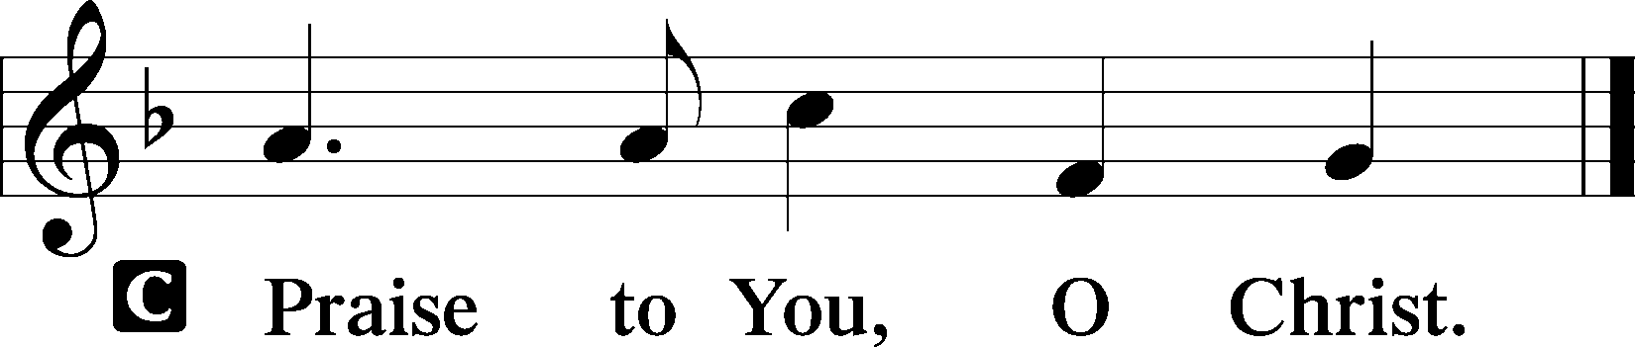

Sit

849 Praise the One Who Breaks the Darkness
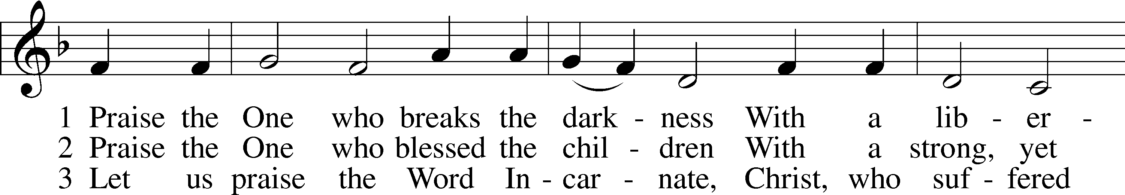
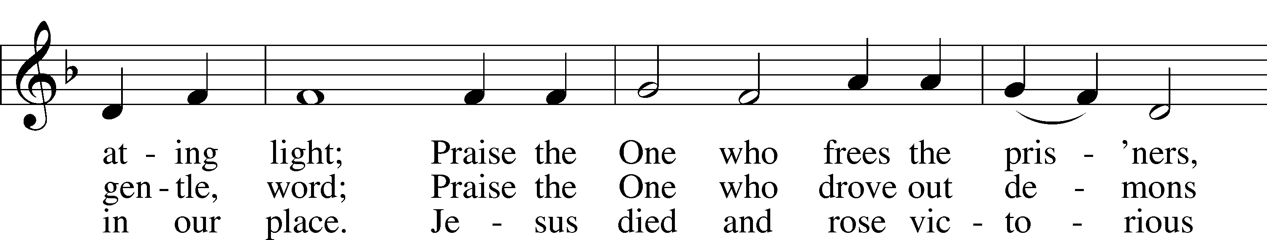
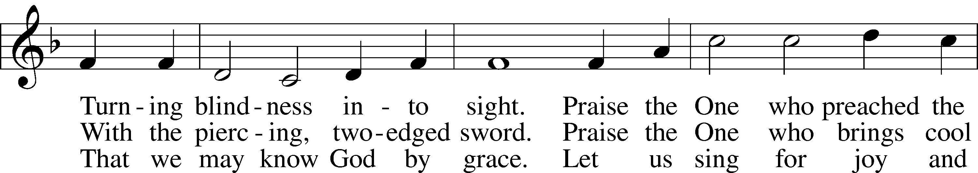
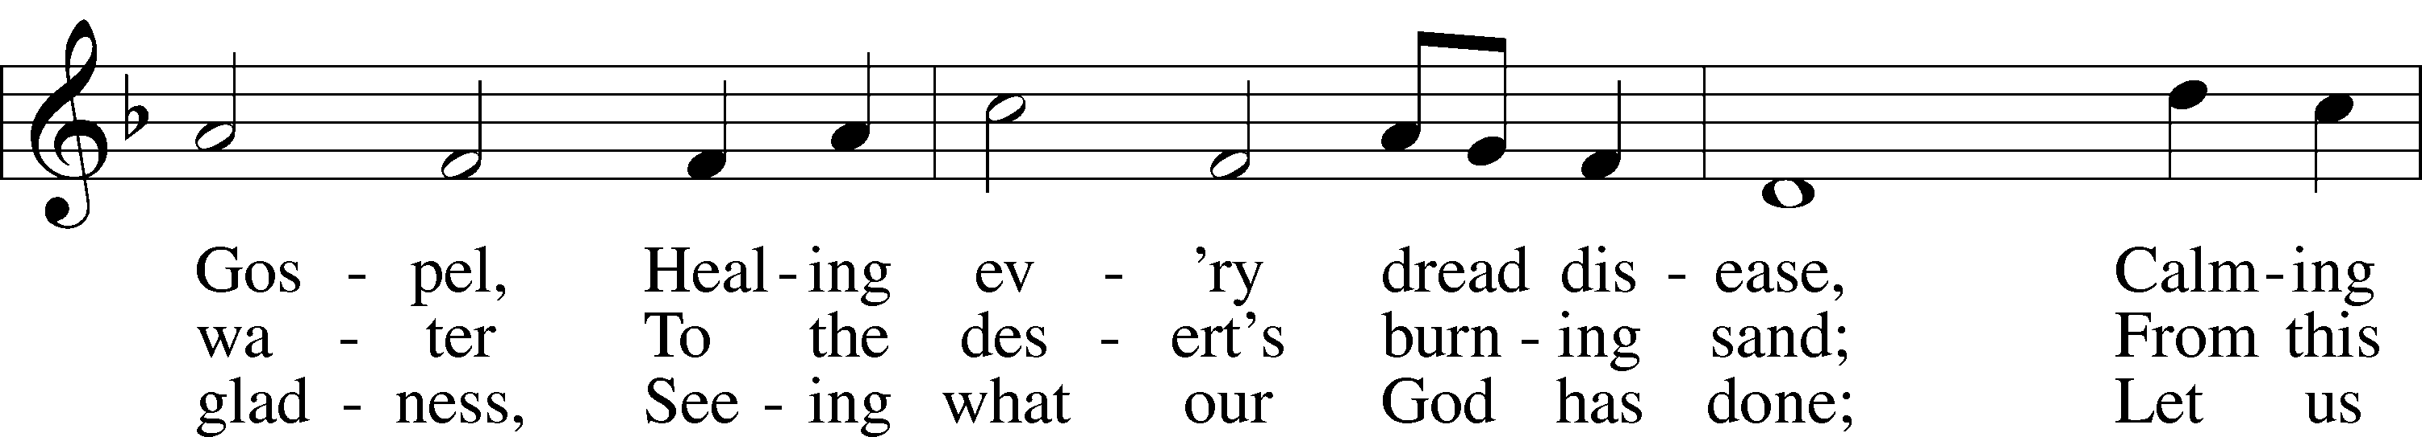
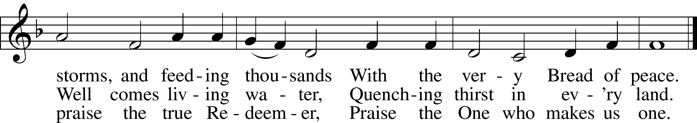
Tune: Public domain
Text: © 1987 Hope Publishing Co. Used by permission: LSB Hymn License no. 110003744

Sermon

Stand

Apostles’ Creed
C I believe in God, the Father Almighty,
maker of heaven and earth.

And in Jesus Christ, His only Son, our Lord,
who was conceived by the Holy Spirit,
born of the virgin Mary,
suffered under Pontius Pilate,
was crucified, died and was buried.
He descended into hell.
The third day He rose again from the dead.
He ascended into heaven
and sits at the right hand of God the Father Almighty.
From thence He will come to judge the living and the dead.

I believe in the Holy Spirit,
the holy Christian Church,
the communion of saints,
the forgiveness of sins,
the resurrection of the body,
and the life T everlasting. Amen.

Prayer of the Church

Offering and Offertory LSB 159
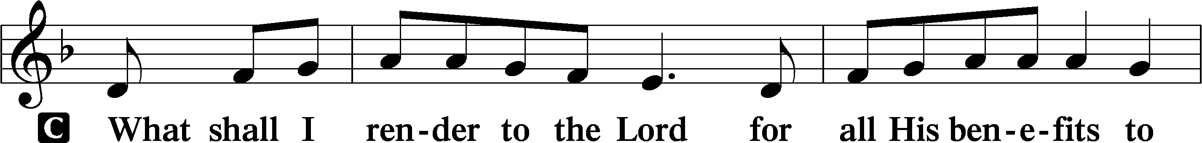
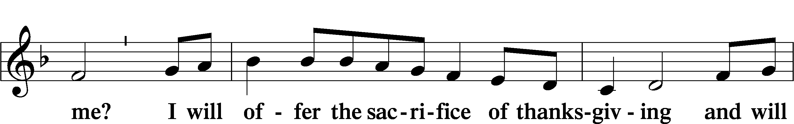
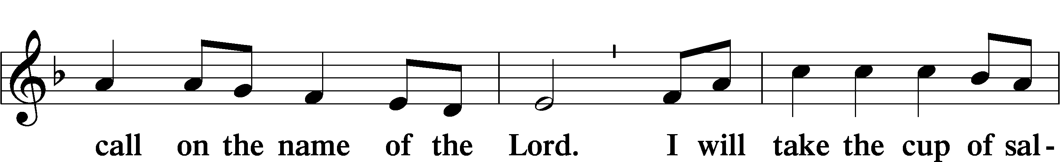
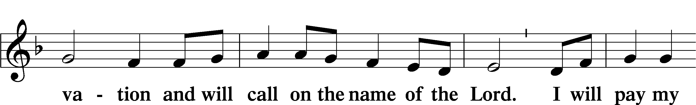
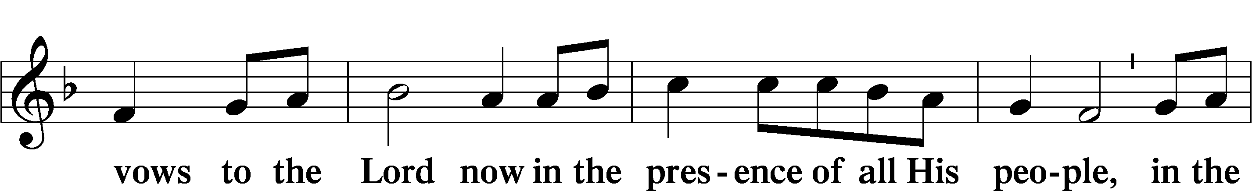
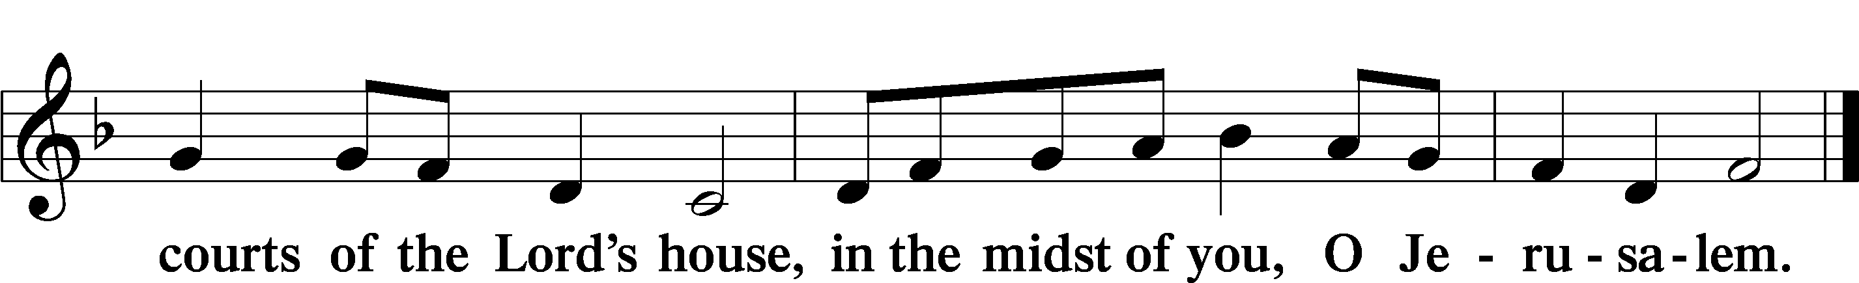

Service of the Sacrament

Preface LSB 160
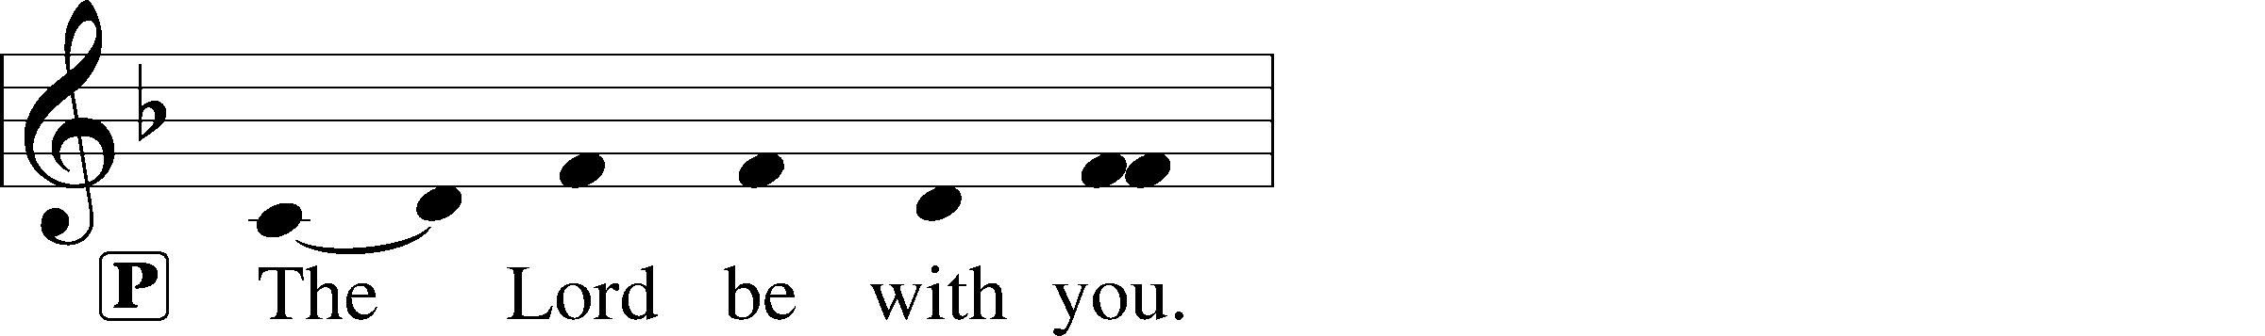
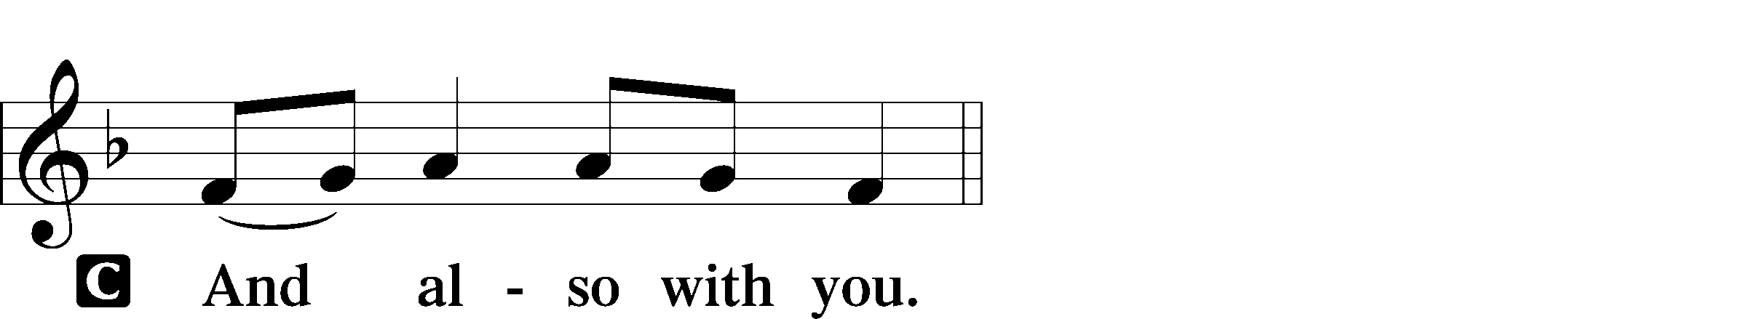
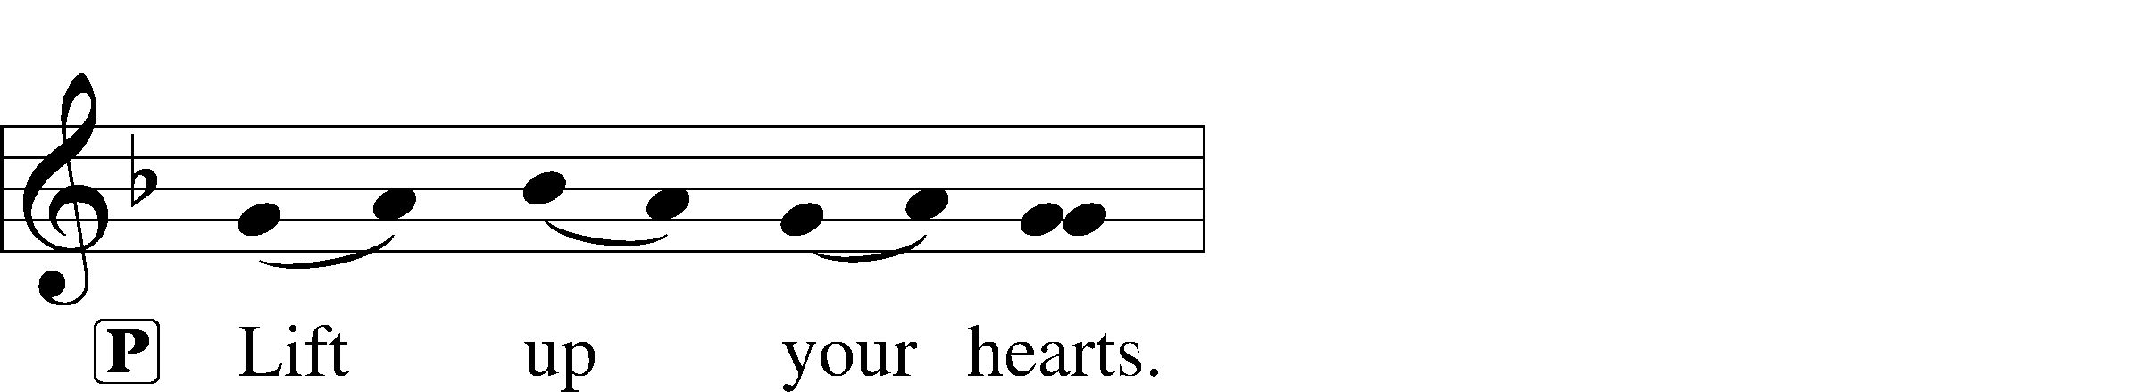
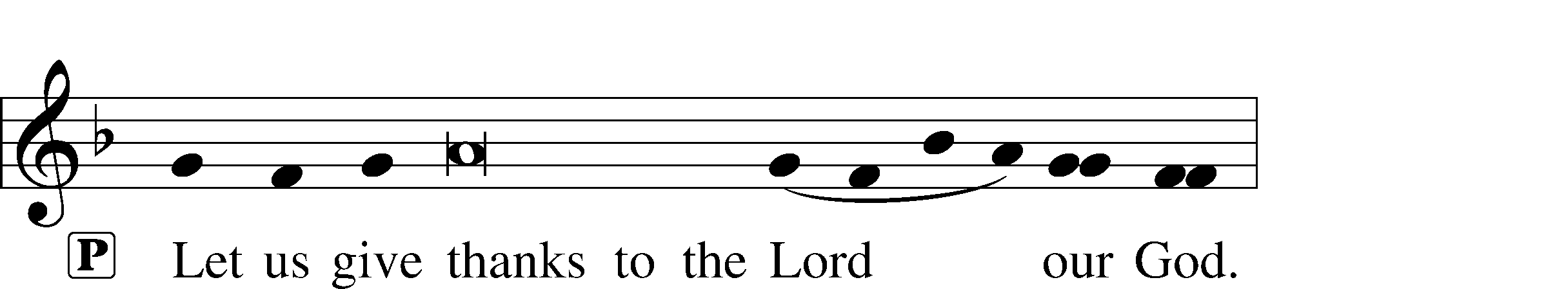
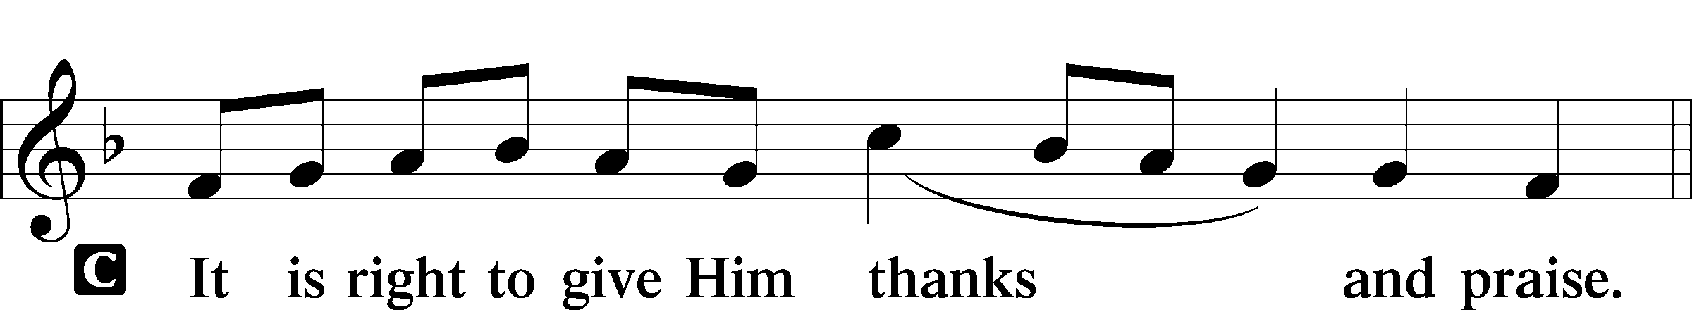

Proper Preface
P It is truly good, right, and salutary that we should at all times and in all places give thanks to You, holy Lord, almighty Father, everlasting God, through Jesus Christ, our Lord, who on this day overcame death and the grave and by His glorious resurrection opened to us the way of everlasting life. Therefore with angels and archangels and with all the company of heaven we laud and magnify Your glorious name, evermore praising You and saying:

Sanctus LSB 161
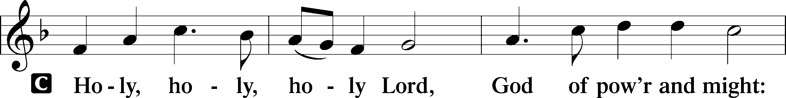
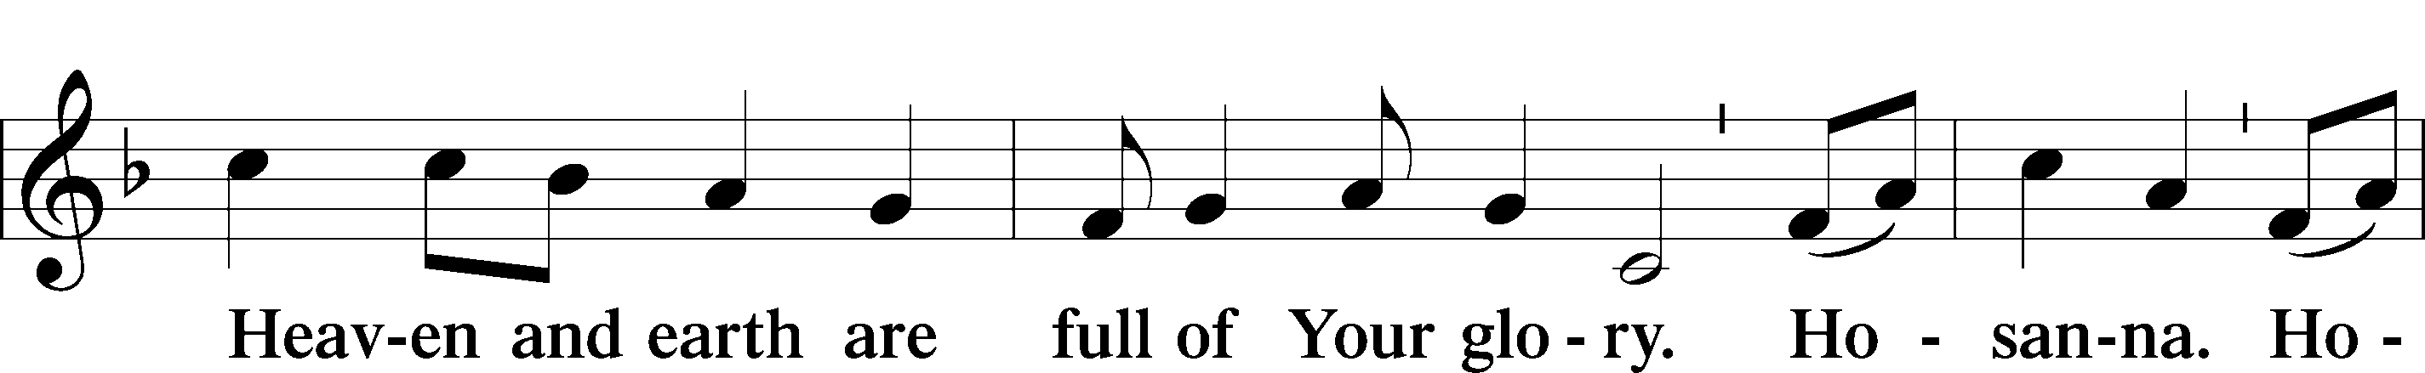
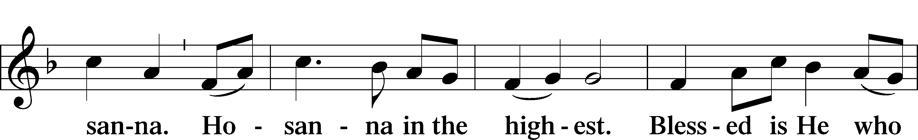
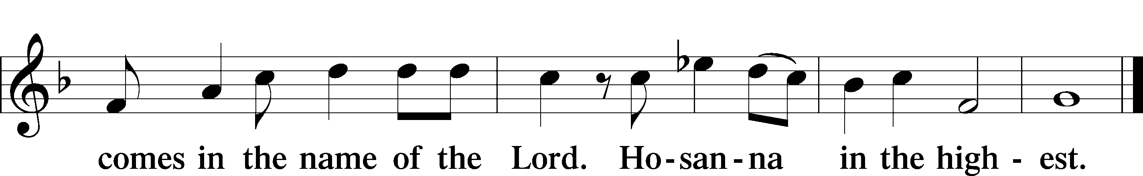

Lord’s Prayer
C Our Father who art in heaven,
hallowed be Thy name,
Thy kingdom come,
Thy will be done on earth
as it is in heaven;
give us this day our daily bread;
and forgive us our trespasses
as we forgive those
who trespass against us;
and lead us not into temptation,
but deliver us from evil.
For Thine is the kingdom
and the power and the glory
forever and ever. Amen.

The Words of Our Lord
P Our Lord Jesus Christ, on the night when He was betrayed, took bread, and when He had given thanks, He broke it and gave it to the disciples and said: “Take, eat; this is My T body, which is given for you. This do in remembrance of Me.”

In the same way also He took the cup after supper, and when He had given thanks, He gave it to them, saying: “Drink of it, all of you; this cup is the new testament in My T blood, which is shed for you for the forgiveness of sins. This do, as often as you drink it, in remembrance of Me.”

Pax Domini LSB 163
P The peace of the Lord be with you always.
C Amen.

Agnus Dei LSB 163
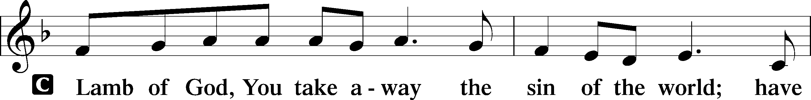
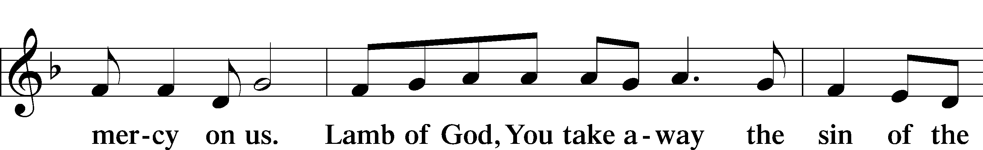
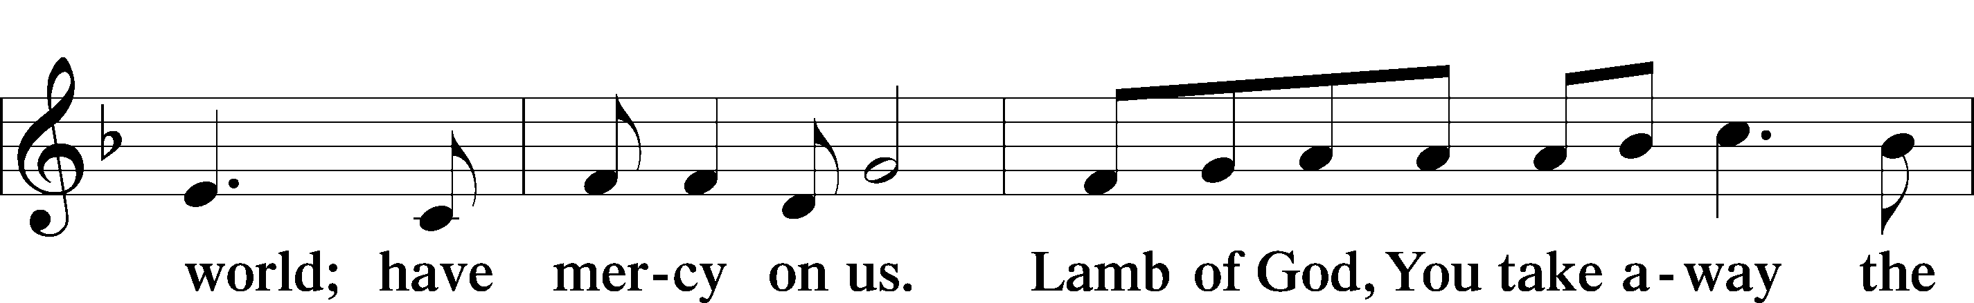
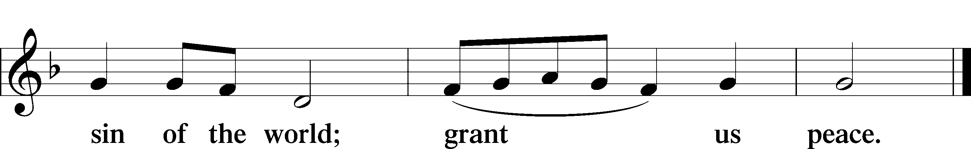

Sit

Distribution

724 If God Himself Be for Me sts. 1–5, 8
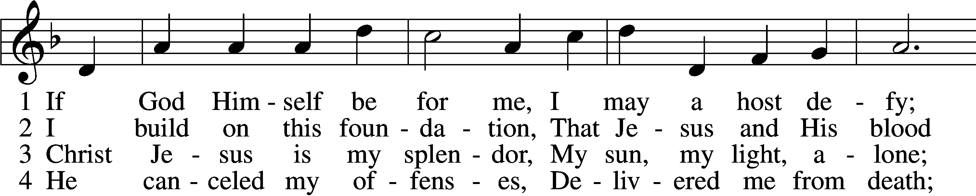
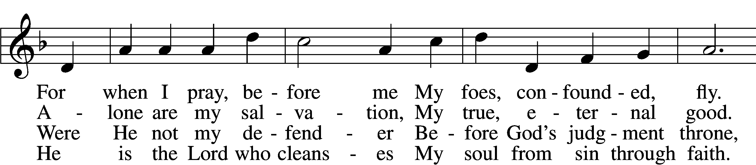
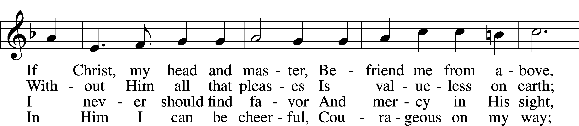
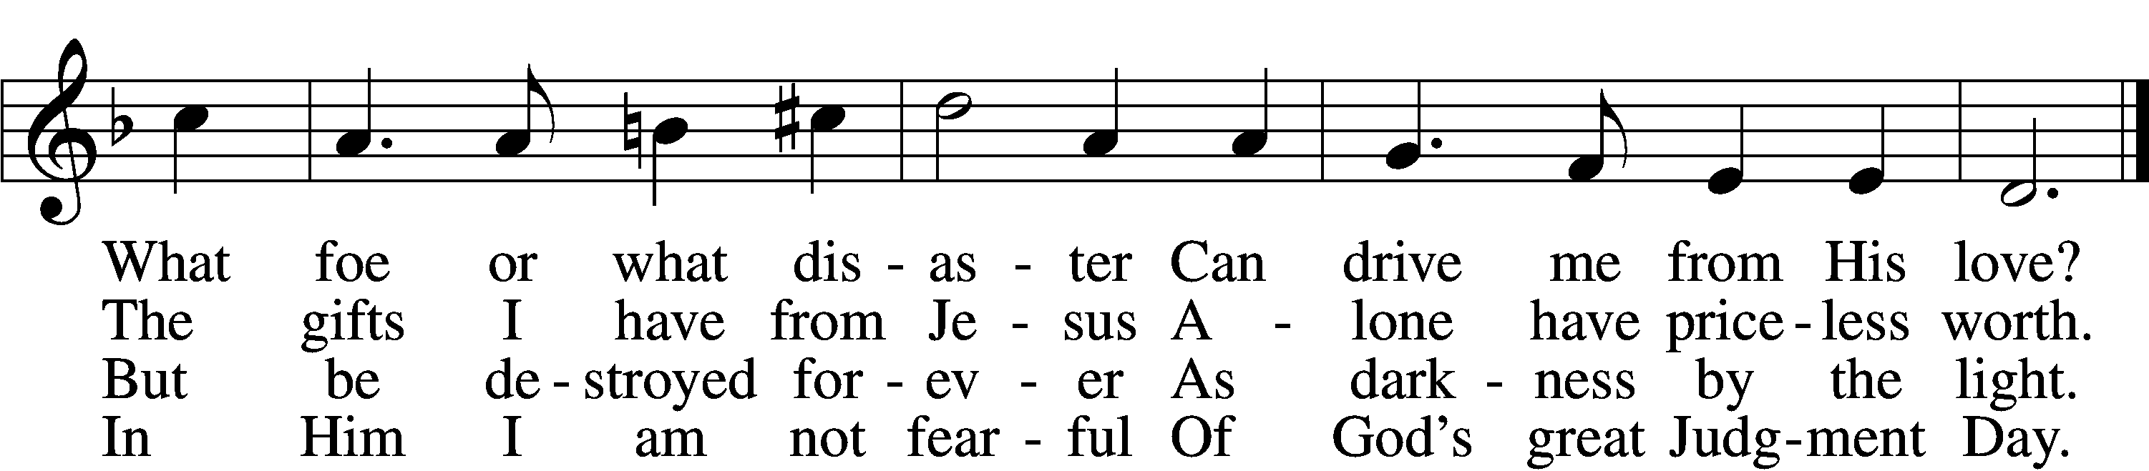

5 For no one can condemn me
Or set my hope aside;
Now hell no more can claim me:
Its fury I deride.
No sentence now reproves me,
No guilt destroys my peace;
For Christ, my Savior, loves me
And shields me with His grace.

8 No danger, thirst, or hunger,
No pain or poverty,
No earthly tyrant’s anger
Shall ever vanquish me.
Though earth should break asunder,
My fortress You shall be;
No fire or sword or thunder
Shall sever You from me.
Text and tune: Public domain

635 O Gracious Lord, I Firmly Am Believing sts. 1–5
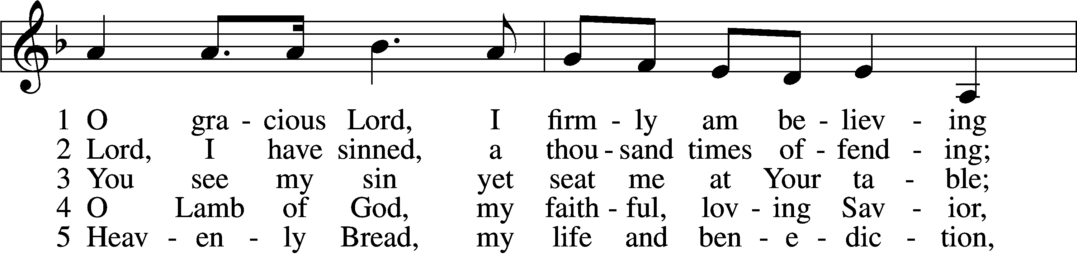
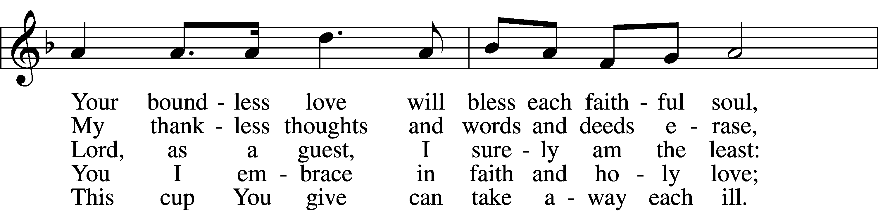
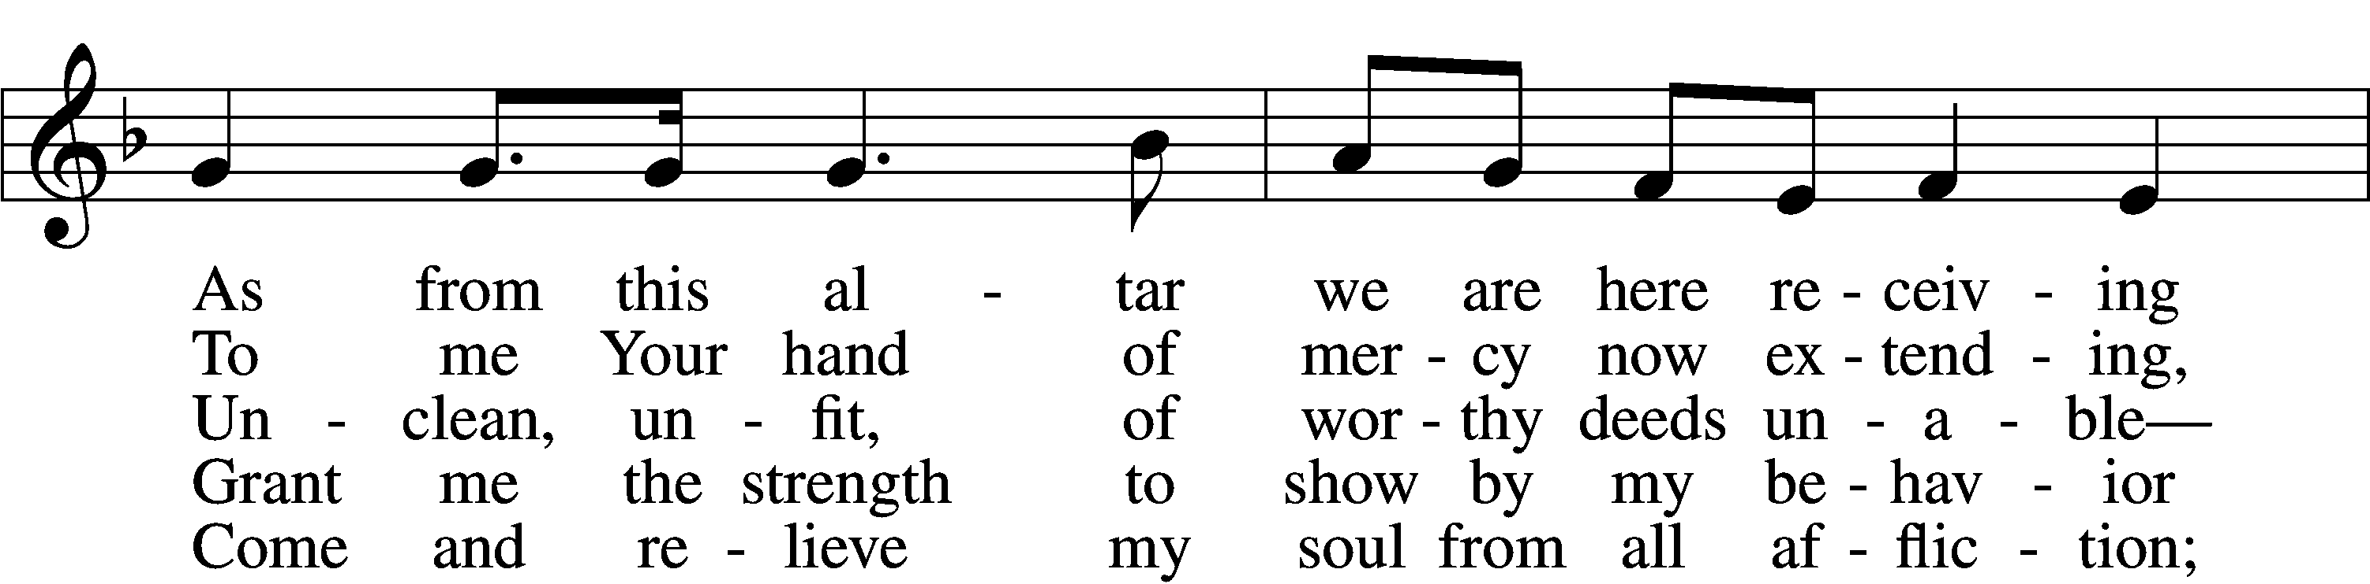
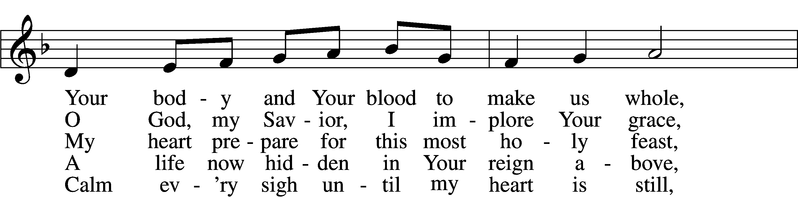
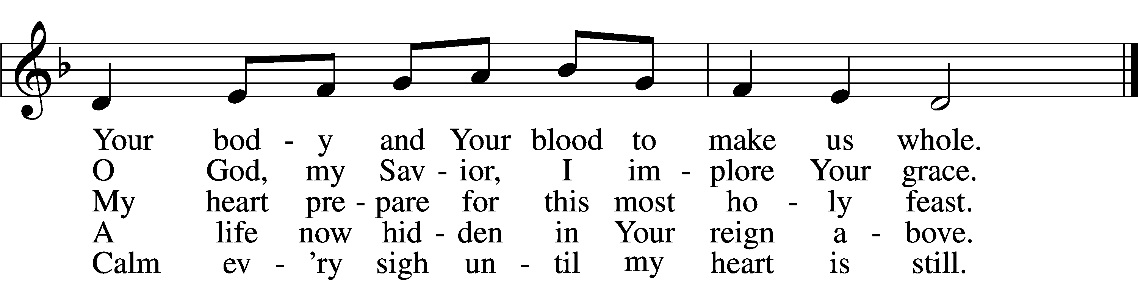
Tune: Public domain
Text: © 2004 Stephen P. Starke, admin. Concordia Publishing House. Used by permission: LSB Hymn License no. 110003744

713 From God Can Nothing Move Me
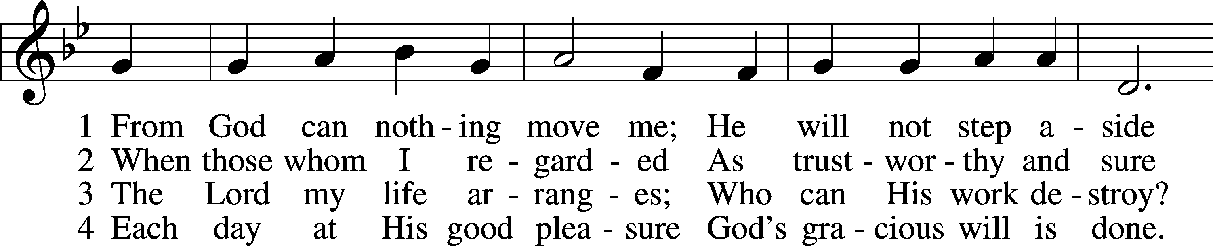
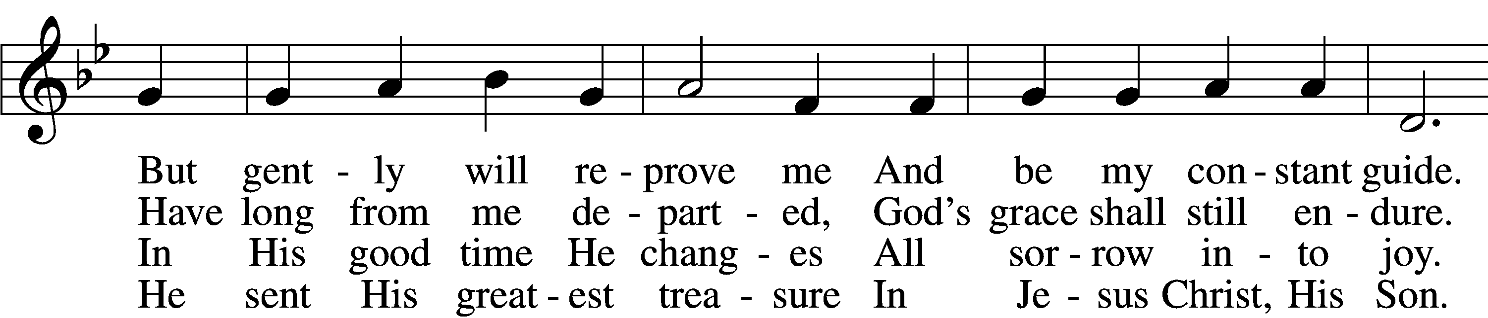
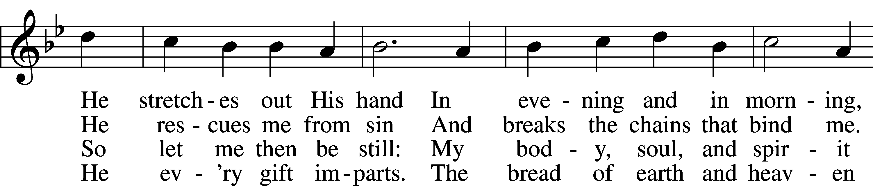
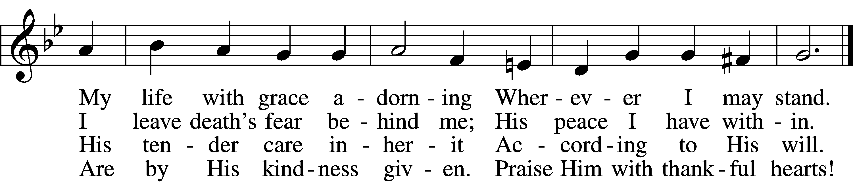

5 Praise God with acclamation
And in His gifts rejoice.
Each day finds its vocation
Responding to His voice.
Soon years on earth are past;
But time we spend expressing
The love of God brings blessing
That will forever last!

6 Yet even though I suffer
The world’s unpleasantness,
And though the days grow rougher
And bring me great distress,
That day of bliss divine,
Which knows no end or measure,
And Christ, who is my pleasure,
Forever shall be mine.

D 7 For thus the Father willed it,
Who fashioned us from clay;
And His own Son fulfilled it
And brought eternal day.
The Spirit now has come,
To us true faith has given;
He leads us home to heaven.
O praise the Three in One!
Tune: Public domain
Text (sts. 1–2, 6): © 1978 Lutheran Book of Worship; (sts. 3–5, 7): © 2006 Concordia Publishing House. Used by permission: LSB Hymn License no. 110003744

Stand

The Dismissal
P The body and blood of our Lord Jesus Christ strengthen and preserve you in body and soul to life everlasting. Depart T in peace.
C Amen.

Thank the Lord LSB 164
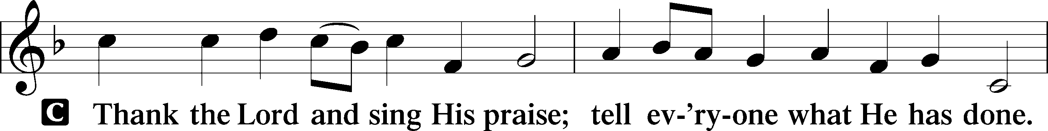
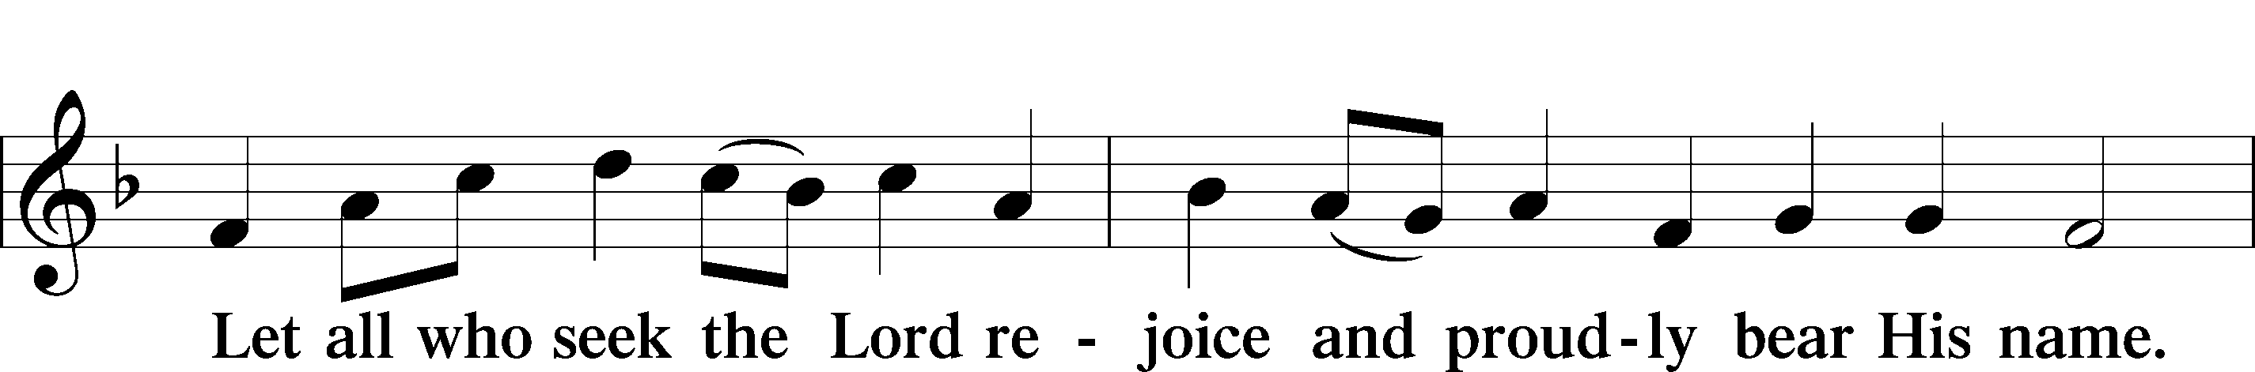
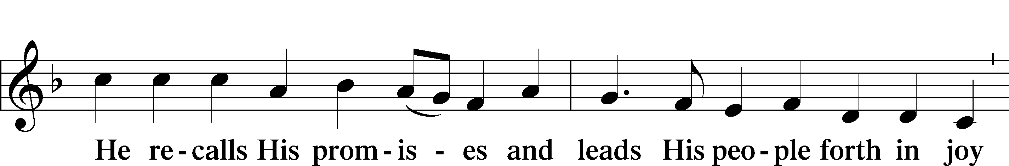
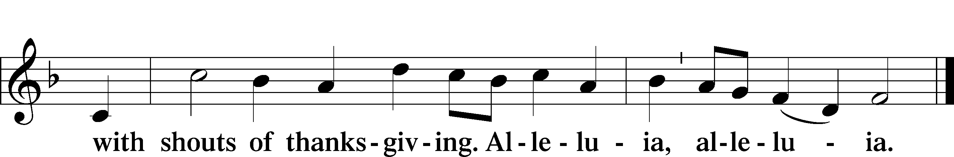
Post-Communion Collect
A Let us pray.
Gracious God, our heavenly Father, You have given us a foretaste of the feast to come in the Holy Supper of Your Son’s body and blood. Keep us firm in the true faith throughout our days of pilgrimage that, on the day of His coming, we may, together with all Your saints, celebrate the marriage feast of the Lamb in His kingdom which has no end; through Jesus Christ, Your Son, our Lord, who lives and reigns with You and the Holy Spirit, one God, now and forever.

Benediction LSB 166
P The Lord bless you and keep you.
The Lord make His face shine on you and be gracious to you.
The Lord look upon you with favor and T give you peace.
C Amen.

783 Take My Life and Let It Be
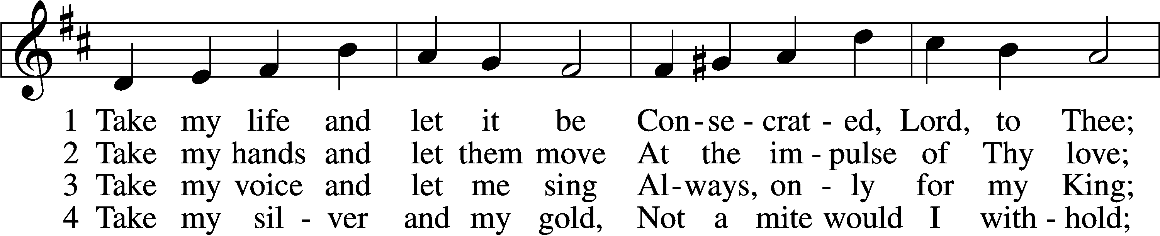
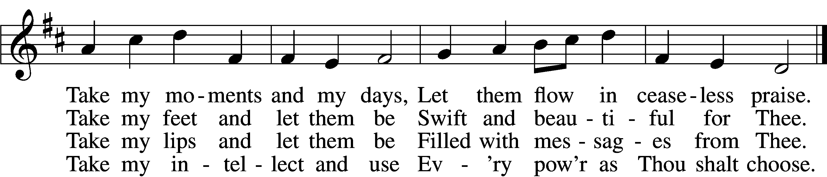

5 Take my will and make it Thine,
It shall be no longer mine;
Take my heart, it is Thine own,
It shall be Thy royal throne.

6 Take my love, my Lord, I pour
At Thy feet its treasure store;
Take myself, and I will be
Ever, only, all for Thee.
Tune and text: Public domain

Acknowledgments
Unless otherwise indicated, Scripture quotations are from the ESV® Bible (The Holy Bible, English Standard Version®), copyright © 2001 by Crossway, a publishing ministry of Good News Publishers. Used by permission. All rights reserved.
Created by Lutheran Service Builder © 2021 Concordia Publishing House.

Prayers for Our Members
Sharon Hockemeier | Expectant Mother
Norman Abels (Brookestone Meadows – Elkhorn) | Healing
Judy Ahrens | Healing
Vaughn Albrecht (Mount Carmel) | Healing
Tom & DyAnn Altwine | Healing
Lyle Colsden (Mother Hull) | Healing
Pat Flodine (Cambridge Court) | Healing
Vi Fox (Prairie View) | Healing
Verleen Gentry | Healing
Ruby Hatfield | Healing
Lennis Hodgson | Healing
Boyd Millsap | Healing
Michelle Millsap | Healing
Roger Riekenberg | Healing
Don Richmond | Healing
Marion Richmond | Healing
Bob Glanzer | Upcoming Surgery
Ivan Bombeck | Cancer
Fran Junge | Cancer
Bertha Marienau | Cancer
Kim Vos | Cancer

ZION LUTHERAN CHURCH AND SCHOOL

Pr. James DeLoach, Pastor + (308) 627-5260
james.deloach@zionkearney.org
Pr. Doug Gaunt, Pastor + (308) 455-0552
doug.gaunt@zionkearney.org
Tony Splittgerber, Principal + (308) 293-0168
anthony.splittgerber@zionkearney.org

Church Office
Secretary: Shirley Oertwig
Email: school@zionkearney.org
Phone: (308)-234-3410 Fax: (308) 236-8100
Office Hours: Monday-Friday 8:00am-4:00pm
Radio Broadcast: Sunday @ 10:30 a.m. on 1460 AM
Website: www.zionkearney.com

Prayers for Our Members’ Family & Friends
Naomi Wollberg (Andy & Jeanne Wollberg’s daughter-in-law) | Expecting
Reg Duke (Westman’s brother-in-law) | Healing
James Gentry (Verleen Gentry’s son) | Healing
Roger Hoffman (Marc’s father) | Healing
David Kreutzer | Healing
Sharon Kreutzer (Richard’s mother) | Healing
Pastor Rob Kuefner | Healing
Lyra Mais (Zion student) | Healing
Dillon Malchow (Joy Barefoot’s nephew) | Healing
Mary Ann Mertz (Pam’s Uhlir’s friend) | Healing
Tommy Parks (Katie Nuttelman’s friend) | Healing
Tim Powers (Kim Wilken’s brother) | Healing
Roy Reynolds (Verleen Gentry’s son-in-law) | Healing
Lynne Saathoff (Verleen Gentry’s sister-in-law) | Healing
Randy Solomon (Beth Rosenthal’s father) | Healing
Angela Well (Charles Marineau’s granddaughter) | Healing
Larry Bombeck (Ivan’s brother) | Healing
Katie Cunningham (Quentin & Janel Lange’s friend) | Burn
Jonah (Jase & Jarren Blattner’s friend) | Cancer
D.D. Dugger (Sue Kaiser’s brother) | Cancer
Stuart Gronewoller (Lonna’s brother-in-law) | Cancer
Ron Halvorsen (Jeff’s dad) | Cancer
Randy Jochum (Ken Hockemeier’s brother-in-law) | Cancer
Fred Koch (Pam Uhlir’s cousin) | Cancer
John Moore (family of Susan Tonniges) | Cancer
Sharon Mulhair (Pam Uhlir’s cousin) | Cancer
Kolby Shiers (Jessica’s cousin) | Cancer
Tyrone Uhlir (Pam’s nephew) | Cancer

Today’s Radio Broadcast and Altar Flowers are given to the Glory of the Lord by
Don and Shirley Helmbrecht in celebration of their 45th wedding anniversary.

Worship Assistants

Sunday, September 12 ~ 9:00am

Elder: Dan Oertwig
Usher: Marc Hoffman, Steve Junge
Acolyte: Abigail Lange
Engineer: Zach DeLoach
Announcer: Brooke Fisher
Altar Guild: Carol Gaunt & Liz Gaunt

Sunday, September 19 ~ 9:00am

Elder: Ken Hockemeier
Usher: Andy Wollberg
Acolyte: Addison Helmbrecht
Engineer: Jared Nuttelman
Announcer: Jesse Florang
Altar Guild: Carol Gaunt & Liz Gaunt

Our Response to the Gospel

Date: 09/05/2021

Offering: $5,735.00
Weekly Need: $7,457.69

This Week at Zion

Sun  09/12 | 9:00a  10:30a  10:15a  1:00p  Birthdays | Divine Service  Radio Broadcast 1460am & 92.1fm  Bible Study  Zion Golf Tournament  Colton Zehendner
Mon  09/013 | 7:00p  Birthdays | Mary Martha  Jeff Strong
Tues  09/14 | 1:30p  7:00p  Birthdays  Anniversaries | Sleeping Mats  Bd. Of Education, Elders, Trustees  Amy Tonniges  ---
Wed  09/015 | 8:30a  5:45p  6:00p  7:00p  Birthdays  Anniversaries | Chapel  Midweek  Bell Choir  Adult Choir  Grace Burger  ---
Thurs  09/16 | 7:00p  Birthdays  Anniversaries | Men’s Bible Study  Jordan Hockemeier  Herb & Linda Johnson
Fri  09/17 | Birthdays  Anniversaries | Masie Dulitz  ---
Sat  09/18 | 5:00p  Birthdays  Anniversaries | Divine Service  ---  Lee & Phyllis Wells
Sun  09/19 | 9:00a  10:30a  Birthdays  Anniversaries | Divine Service  Radio Broadcast 1460am & 92.1fm  Trevor Hoehner, Bertha Marienau  ---

Where our Triune God strengthens us through His mercy in faith toward Him and in fervent love toward one another.

ANNOUNCEMENTS

Zion Golf Tournament Today
The Zion golf tournament is today at 1:00 at Elks Country Golf. If you have not registered yet please speak with Steve Junge to see if there are openings.

Mary Martha LWML circles will meet Monday, September 13 in the Fellowship Hall. Ellen Koopman's Love Circle will be hosting and leading the bible study. All women are invited to join us.

Adult Bell Choir - will resume this week, Wednesday, September 15, at 6:00 p.m. If you have NOT played bells before but are interested in trying it please contact me at carol.deloach@gmail.com. Also, if you have had previous experience playing handbells and wish to join our small group please let me know. Space is restricted in the balcony so our adult handbell choir is limited in size. Whether you sing in Zion’s choir, play handbells, or sing as part of the congregation we rejoice in the gift of music. “I will sing unto the Lord as long as I live: I will sing praise to my God while I have my being.” Psalm 104:33 KJV

Men’s Bible Study Group will meet Thursday, September 16 at 7:00 pm. All men, college age and older are encouraged to attend.

Thank You - I want to thank you all for all the care and generosity you have shown to our family and me at the loss of my wife Beverly. Your prayers, cards, and memorial gifts have been a comfort and a reminder of the eternal life we have in our Lord and Savior Jesus Christ.
Keith and family

Sunday School Teachers The Board of Education is getting ready to restart Sunday School. However, we do not have enough teachers! We are looking to establish a teacher rotation so volunteers have schedule flexibility and won’t feel obligated to teach forever! If you would be willing to be part of a weekly or monthly teaching rotation, please tell the office, Pastor DeLoach, or Matt Hodgson. Our priority is for grades K-6, but we would love to do preschool/pre-k if we can get the volunteers.

Employment Opportunity
Secretary for the Church and the School:
If you enjoy working with people, have clerical/office experience, and like a fast-paced, ever-changing workday – this may be the position for you! Please contact Pastor DeLoach or Mr. Splittgerber if you are interested.

Adult Bible Study -The adult bible study class is meeting once again on Sunday mornings. We have just begun a study entitled “Just Words.” It is a study of the doctrine of justification by grace through faith and the various biblical metaphors that convey the Gospel. Come grab a donut and cup of coffee as we learn together.

Offering Options:
1) Place your offering in the basket as you leave
2) Go to zionkearney.churchtrac.com/give
3) Go to zionkearney.com and click on the ChurchTrac icon
4) Mail your gift to Zion Lutheran Church, 2421 C Ave, Kearney, NE 68847 or place it in the mail slot on the south side of the building.
Radio Broadcast - Please help Zion spread the Gospel, signup to sponsor a radio broadcast! There are several open dates.

Church Management System – Zion has switched to a web-based church management system called ChurchTrac. Please pick-up a yellow sheet in the narthex to get setup today to view all of the benefits and features.

It is very important that you setup your account. This is the only way for the office to know of birthdays, anniversaries, etc. The old software program is no longer working, so old information is all what is being used, so more than likely we are missing a lot of babies, etc.

Mission Offerings - If you would like to donate to the missions Zion supports, please use the mission envelopes located in the narthex. The third quarter missions will be going to support Jonathan Clausing. Thank you for your support.

https://www.lcms.org/clausing

https://missioncentral.us/category/africa/jonathan-and-anita-clausing/
SCHOOL NEWS

The Theme for our school year is “Together by Christ’s Love” based on
1 John 4:7-8.

- Our Zion boys and girls cross country teams are working hard and have run very well at recent meets.
- The girls’ volleyball game scheduled last Thursday had to be postponed, so the team is looking forward to competing in the triangular on Sept. 21 at Juniata.
Early Childhood Openings!

We do still have openings in our 3 yr. old preschool classes. If you or someone you know is still looking for a high quality early childhood experience, please refer us to them!

Ways to Help our School

Zion Scrip
Participate in the Zion scrip program. It is easy to use and to earn money toward tuition and for Zion. Just stop by the office and purchase gift cards for your everyday items or for gifts. It is that simple. 50% goes toward your tuition and 50% goes to Zion building fund. To learn more about the program contact the office.
Big G Boxtops
Download the Big G Boxtop app on your smartphone, select Zion as your choice school, scan your receipt. That is all, quick and simple for Zion to earn money on qualifying items.

Family Fresh Register Receipts
After Zion receives $150,000 worth of receipts, Zion will receive $1,000.

Apple Mart Register Receipts
Save receipts dated September 1. 2021 through March 1, 2022
With the register receipts Zion earns points for dollars spent at Apple Market. The points are redeemed for school items.
It is easy to earn money for your school! Turn your receipts into the office. If you have any questions please stop by the office.

Best Choice and Our Family UPC Codes

