Divine Service
Seventeenth Sunday
after Pentecost
September 19, 2021

Zion Lutheran Church
Kearney, Nebraska

Welcome to Zion!
All worshippers please fill out an attendance card in the pew rack and let us know how we might be of service to you.

Holy Communion at Zion

The Lord’s Supper is celebrated at this congregation as Jesus has given it. As he says, our Lord gives into our mouths not only bread and wine but his very body and blood to eat and to drink for the forgiveness of sins and to strengthen our union with him and with one another. Our Lord invites to his table those who trust his words, repent of all sin, and set aside any refusal to forgive and love as he forgives and loves us, that they may show forth his death until he comes. All communicants need to register in the narthex prior to the service.

Because those who eat and drink our Lord’s body and blood unworthily do great harm and because Holy Communion is a confession of the faith which is confessed at this altar, any who are not yet instructed, in doubt, or who hold a confession differing from that of this congregation and The Lutheran Church—Missouri Synod, are asked not to commune until they are able to speak with our pastor first. He is happy to visit with you about the Christian faith and how to receive the Lord’s Supper for your good and for the good of others. Those not communing are invited to come to the altar, cross your arms in front of you, and bow your head to receive a pastoral blessing.

Our Father Cares for His Children with the Gospel of His Son

The sinful heart is filled with “bitter jealousy and selfish ambition” (James 3:14), which causes hostility, quarrels and conflicts, even among those who are fellow members of the Body of Christ. This should not be so! Rather, God “opposes the proud” with His Law, in order to humble them unto repentance; He “gives grace to the humble,” in order to exalt them by His Gospel of forgiveness (James 4:6–10). This true “wisdom from above” is found in the gentleness, mercy and peace of our Lord, Jesus Christ, who humbled Himself and sacrificed Himself for the salvation of sinners (James 3:17). He was “like a gentle lamb led to the slaughter,” committing Himself to God, His Father, “who judges righteously, who tests the heart and the mind” (Jer. 11:19–20). Therefore, “after three days,” His Father exalted Him by raising Him from the dead (Mark 9:31). In Holy Baptism, He takes disciples of all ages into His arms like little children. In receiving Him through repentance and faith in His forgiveness of sins, they receive from His Father a share in the glory of His cross and resurrection (Mark 9:36–37).

Confession and Absolution

473 Our Paschal Lamb, That Sets Us Free
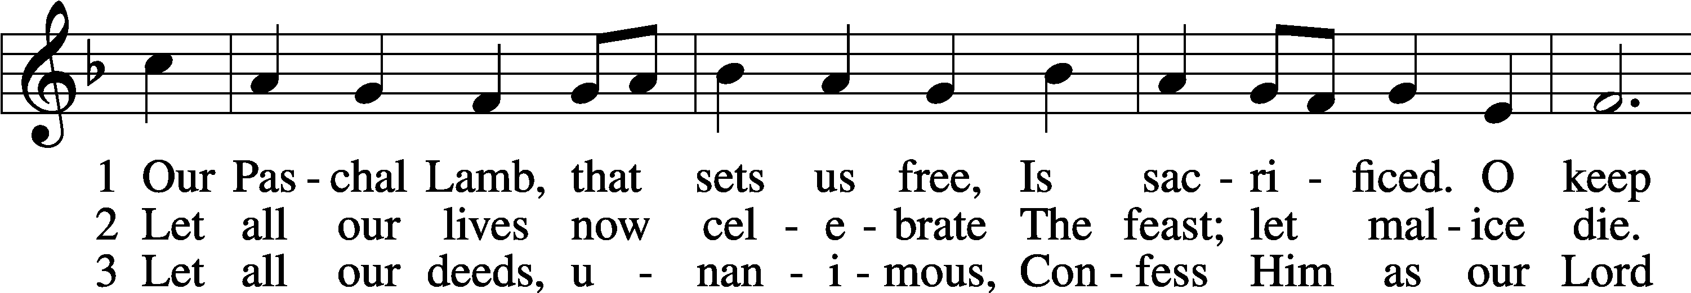
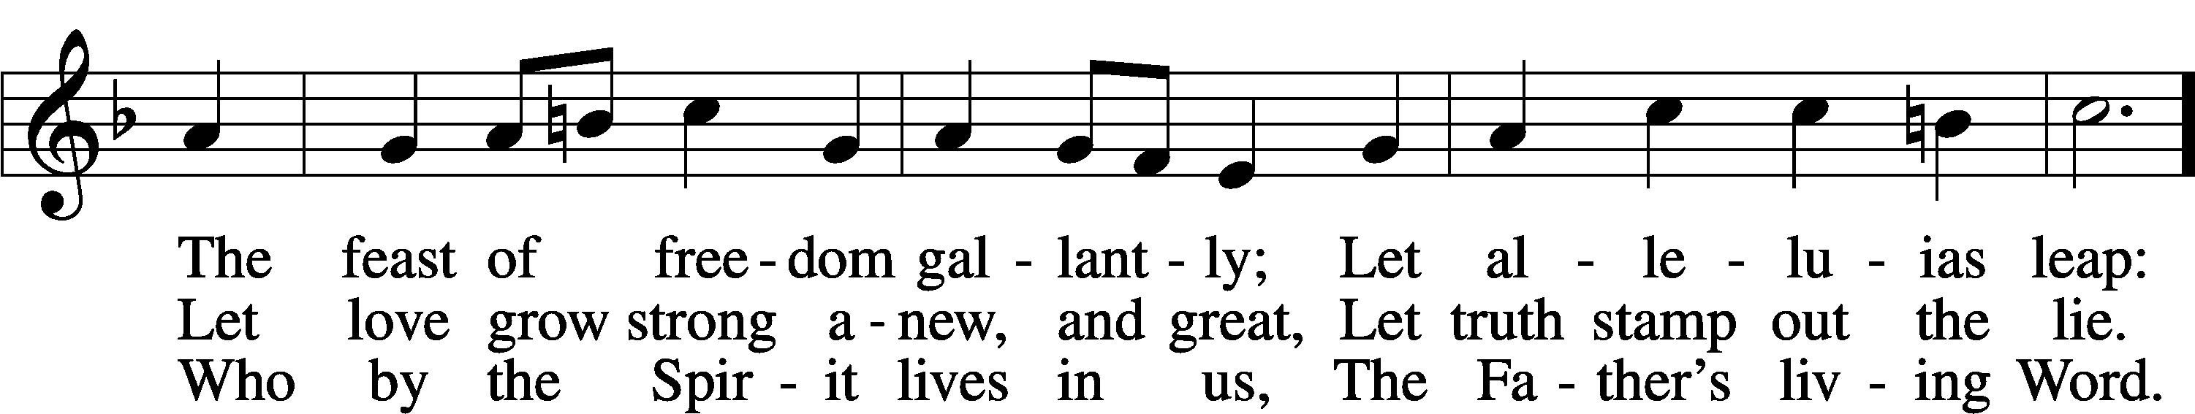
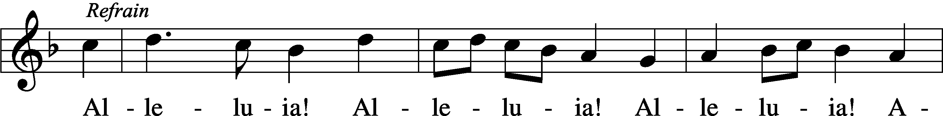
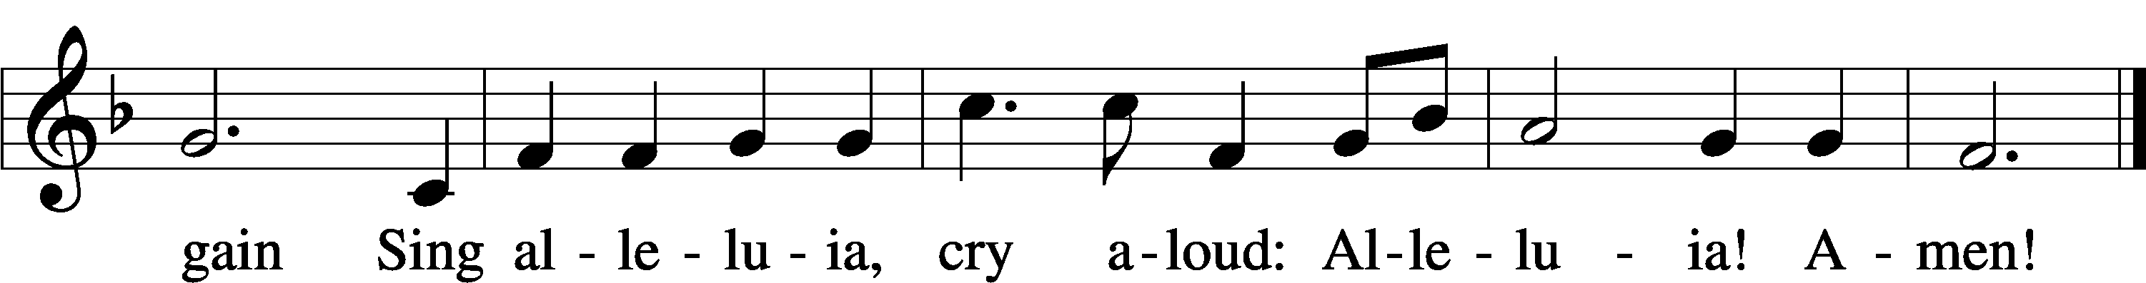
Tune and text: © 1974 Augsburg Publishing House. Used by permission: LSB Hymn License no. 110003744

Stand

The sign of the cross may be made by all in remembrance of their Baptism.

Invocation
P In the name of the Father and of the T Son and of the Holy Spirit.
C Amen.

Exhortation LSB 151
P If we say we have no sin, we deceive ourselves, and the truth is not in us.
C But if we confess our sins, God, who is faithful and just, will forgive our sins and cleanse us from all unrighteousness.

Silence for reflection on God’s Word and for self-examination.

Confession of Sins LSB 151
P Let us then confess our sins to God our Father.
C Most merciful God, we confess that we are by nature sinful and unclean. We have sinned against You in thought, word, and deed, by what we have done and by what we have left undone. We have not loved You with our whole heart; we have not loved our neighbors as ourselves. We justly deserve Your present and eternal punishment. For the sake of Your Son, Jesus Christ, have mercy on us. Forgive us, renew us, and lead us, so that we may delight in Your will and walk in Your ways to the glory of Your holy name. Amen.

Absolution LSB 151
P Almighty God in His mercy has given His Son to die for you and for His sake forgives you all your sins. As a called and ordained servant of Christ, and by His authority, I therefore forgive you all your sins in the name of the Father and of the T Son and of the Holy Spirit.
C Amen.

Service of the Word

Introit Psalm 37:5–7; antiphon: v. 4
Delight yourself | in the Lord,*
and he will give you the desires | of your heart.
Commit your way | to the Lord;*
trust in him, and | he will act.
He will bring forth your righteousness | as the light,*
and your justice as the | noonday.
Be still before the Lord and wait patiently | for him;*
fret not yourself over the one who prospers in his way, over the man who carries out evil de- | vices!
Glory be to the Father and | to the Son*
and to the Holy | Spirit;
as it was in the be- | ginning,*
is now, and will be forever. | Amen.
Delight yourself | in the Lord,*
and he will give you the desires | of your heart.

Kyrie LSB 152
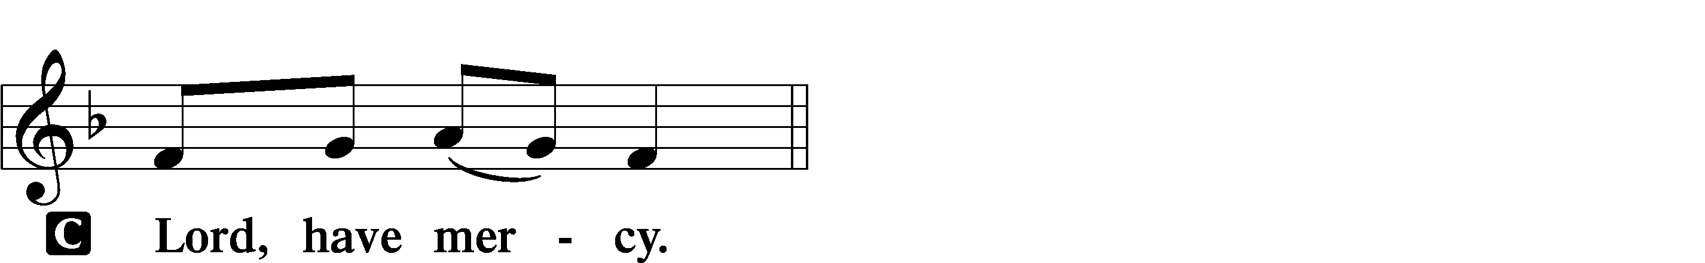

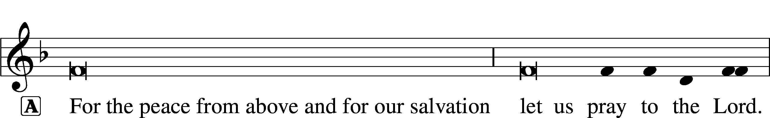
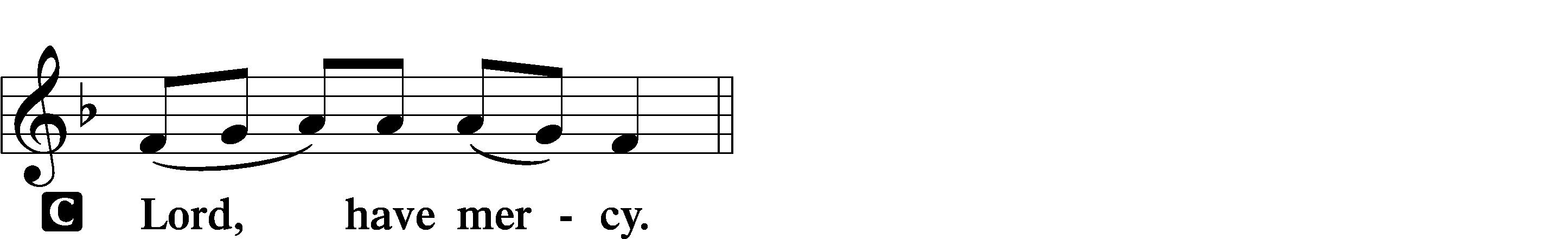

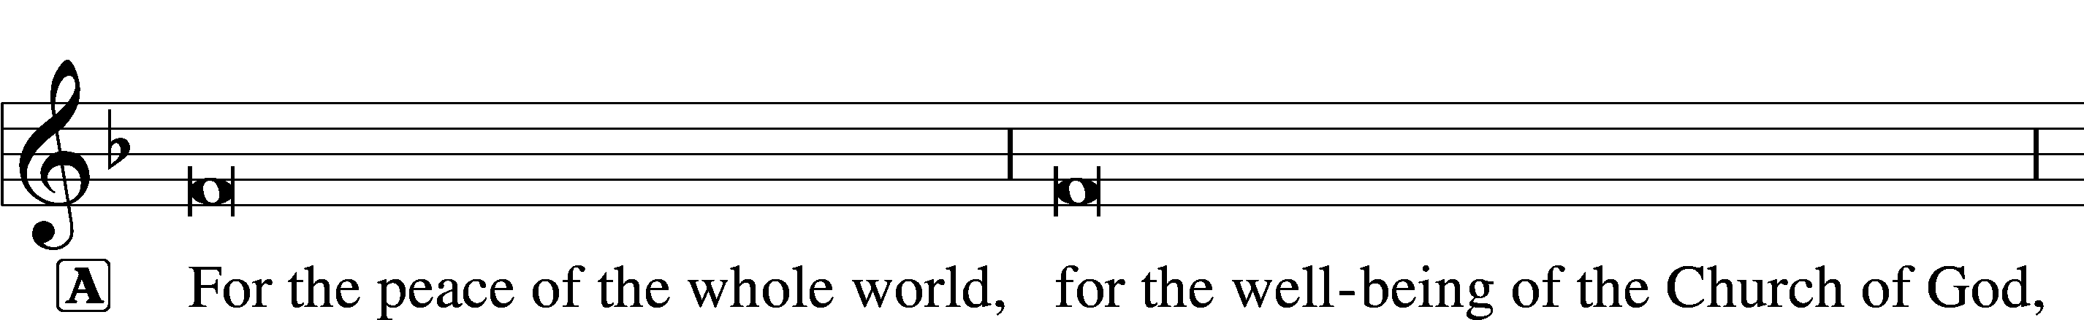
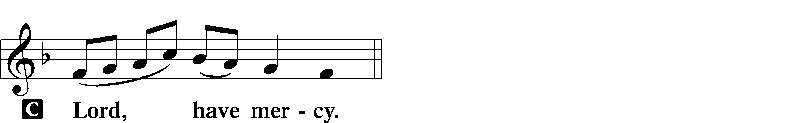

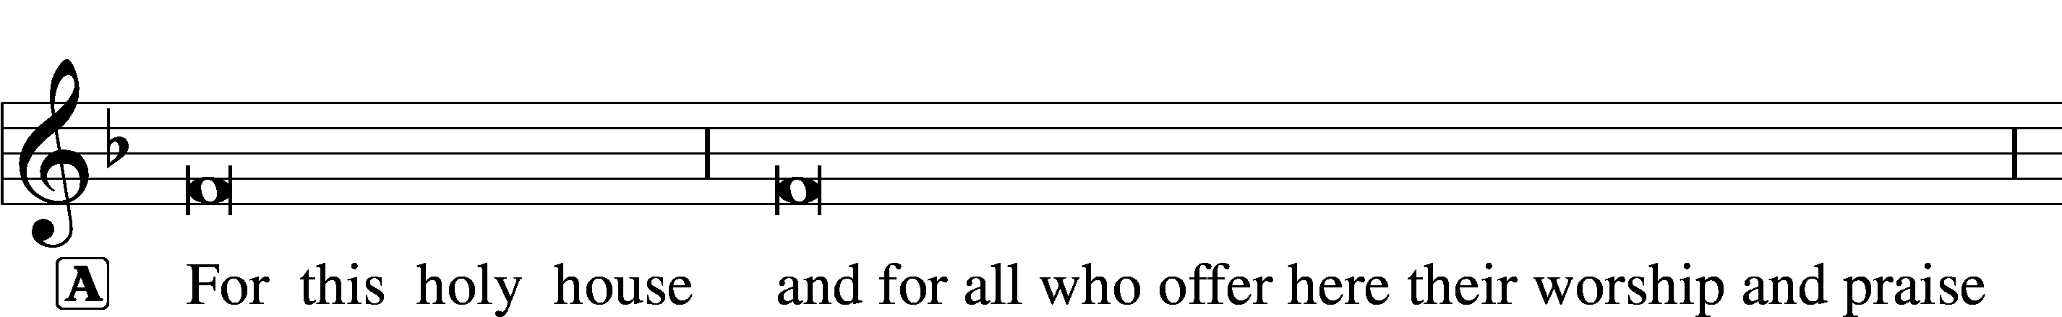
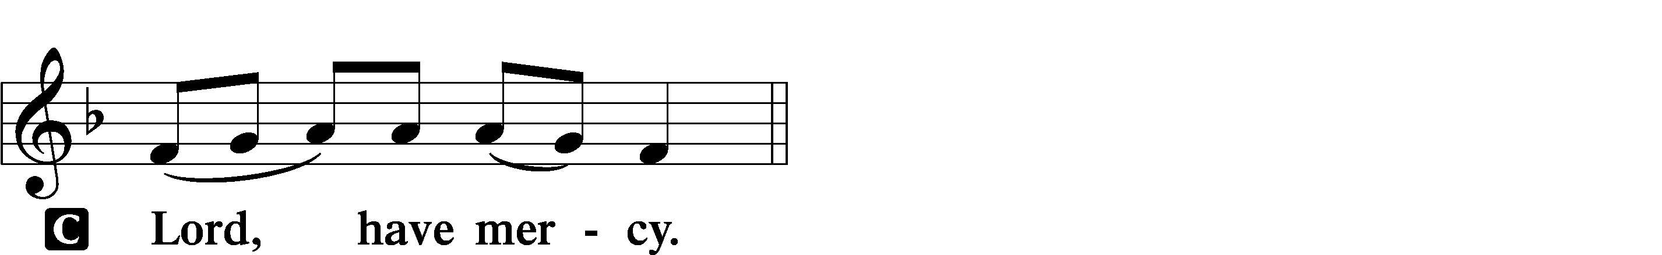

Gloria in Excelsis LSB 154
A Glory to God in the highest, and peace to His people on earth.
C Lord God, heavenly king, almighty God and Father:
We worship You, we give You thanks, we praise You for Your glory.
Lord Jesus Christ, only Son of the Father, Lord God, Lamb of God:
You take away the sin of the world; have mercy on us.
You are seated at the right hand of the Father; receive our prayer.
For You alone are the Holy One, You alone are the Lord,
You alone are the Most High, Jesus Christ, with the Holy Spirit,
in the glory of God the Father. Amen.

Salutation and Collect of the Day
P The Lord be with you.
C And also with you.

P Let us pray.
O God, whose strength is made perfect in weakness, grant us humility and childlike faith that we may please You in both will and deed; through Jesus Christ, Your Son, our Lord, who lives and reigns with You and the Holy Spirit, one God, now and forever.

C Amen.

Sit

Old Testament Reading Jeremiah 11:18–20
18The Lord made it known to me and I knew;
then you showed me their deeds.
19But I was like a gentle lamb
led to the slaughter.
I did not know it was against me
they devised schemes, saying,
“Let us destroy the tree with its fruit,
let us cut him off from the land of the living,
that his name be remembered no more.”
20But, O Lord of hosts, who judges righteously,
who tests the heart and the mind,
let me see your vengeance upon them,
for to you have I committed my cause.

A This is the Word of the Lord.
C Thanks be to God.

Gradual Psalm 34:9, 19, alt.
Fear the Lord, | you his saints,*
for those who fear him lack | nothing!
Many are the afflictions of the | righteous,*
but the Lord delivers him out | of them all.

Epistle James 3:13—4:10
Wisdom from Above
13Who is wise and understanding among you? By his good conduct let him show his works in the meekness of wisdom. 14But if you have bitter jealousy and selfish ambition in your hearts, do not boast and be false to the truth. 15This is not the wisdom that comes down from above, but is earthly, unspiritual, demonic. 16For where jealousy and selfish ambition exist, there will be disorder and every vile practice. 17But the wisdom from above is first pure, then peaceable, gentle, open to reason, full of mercy and good fruits, impartial and sincere. 18And a harvest of righteousness is sown in peace by those who make peace.
Warning Against Worldliness
1What causes quarrels and what causes fights among you? Is it not this, that your passions are at war within you? 2You desire and do not have, so you murder. You covet and cannot obtain, so you fight and quarrel. You do not have, because you do not ask. 3You ask and do not receive, because you ask wrongly, to spend it on your passions. 4You adulterous people! Do you not know that friendship with the world is enmity with God? Therefore whoever wishes to be a friend of the world makes himself an enemy of God. 5Or do you suppose it is to no purpose that the Scripture says, “He yearns jealously over the spirit that he has made to dwell in us”? 6But he gives more grace. Therefore it says, “God opposes the proud, but gives grace to the humble.” 7Submit yourselves therefore to God. Resist the devil, and he will flee from you. 8Draw near to God, and he will draw near to you. Cleanse your hands, you sinners, and purify your hearts, you double-minded. 9Be wretched and mourn and weep. Let your laughter be turned to mourning and your joy to gloom. 10Humble yourselves before the Lord, and he will exalt you.

A This is the Word of the Lord.
C Thanks be to God.

Stand

Alleluia and Verse LSB 156
C Alleluia.
Lord, to whom shall we go?
You have the words of eternal life.
Alleluia, alleluia.
Holy Gospel Mark 9:30–37
P The Holy Gospel according to St. Mark, the ninth chapter.

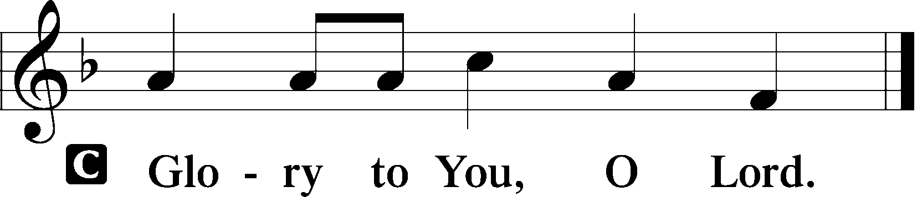

Jesus Again Foretells Death, Resurrection
30[The disciples] went on from there and passed through Galilee. And [Jesus] did not want anyone to know, 31for he was teaching his disciples, saying to them, “The Son of Man is going to be delivered into the hands of men, and they will kill him. And when he is killed, after three days he will rise.” 32But they did not understand the saying, and were afraid to ask him.
Who Is the Greatest?
33And they came to Capernaum. And when he was in the house he asked them, “What were you discussing on the way?” 34But they kept silent, for on the way they had argued with one another about who was the greatest. 35And he sat down and called the twelve. And he said to them, “If anyone would be first, he must be last of all and servant of all.” 36And he took a child and put him in the midst of them, and taking him in his arms, he said to them, 37“Whoever receives one such child in my name receives me, and whoever receives me, receives not me but him who sent me.”

P This is the Gospel of the Lord.

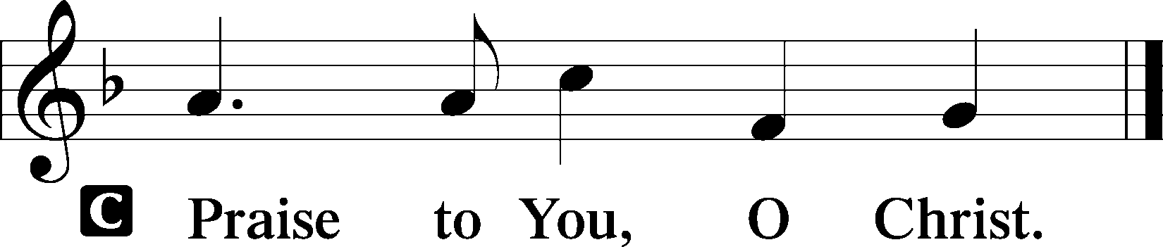

Sit

851 Lord of Glory, You Have Bought Us
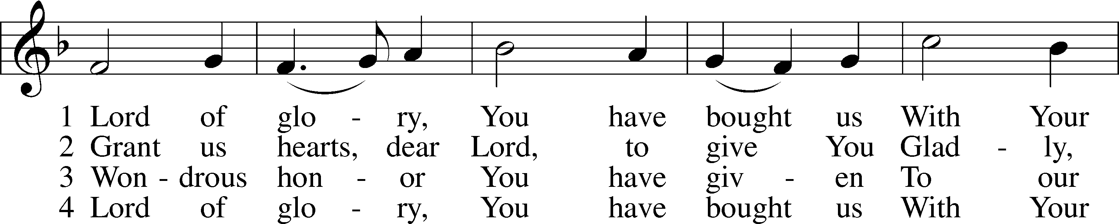
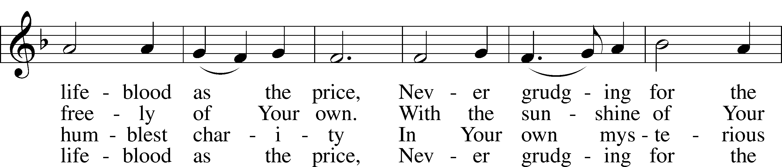
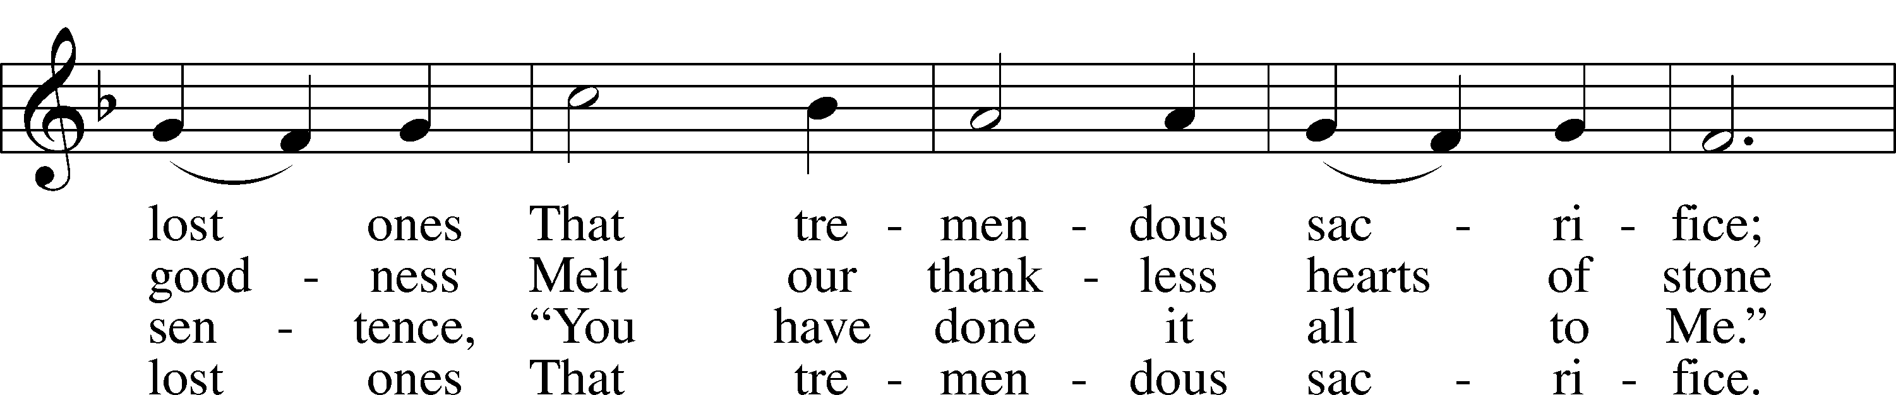
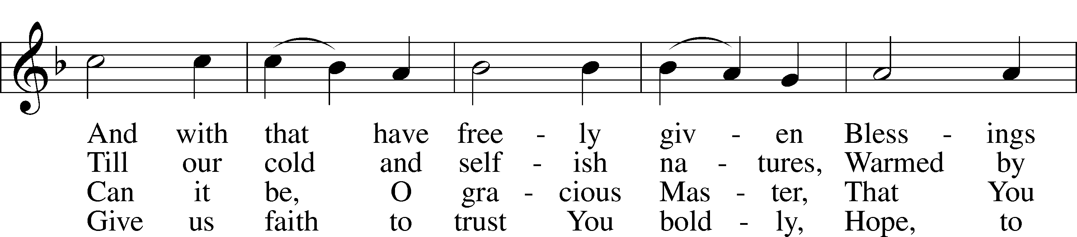
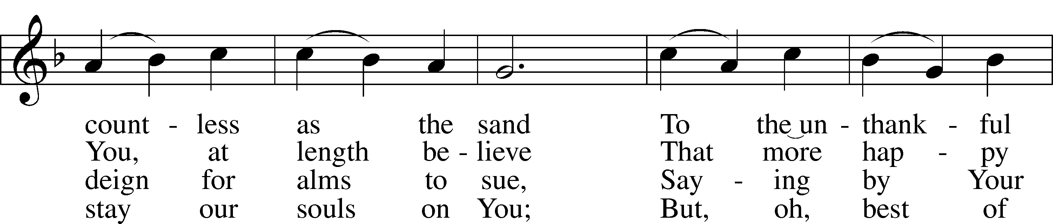
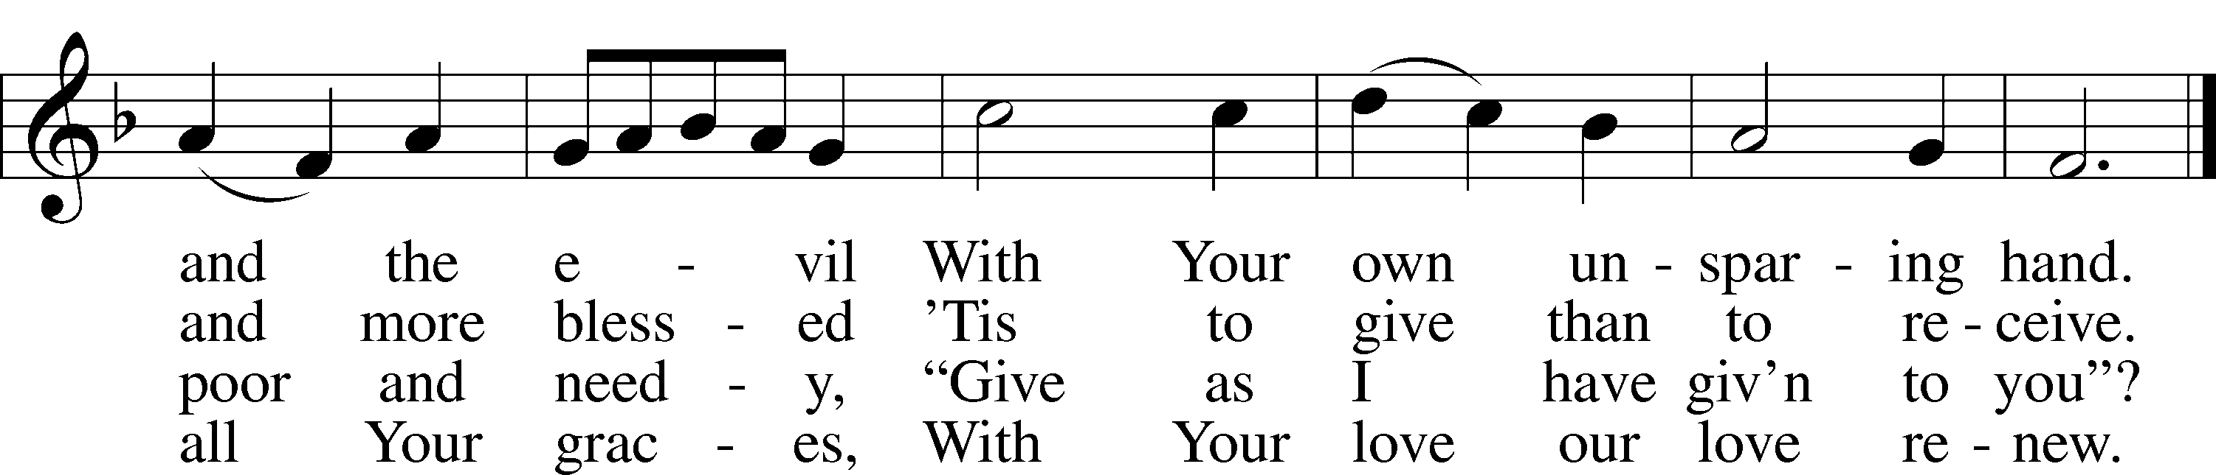
Text and tune: Public domain

Sermon

Stand

Nicene Creed
C I believe in one God,
the Father Almighty,
maker of heaven and earth
and of all things visible and invisible.

And in one Lord Jesus Christ,
the only-begotten Son of God,
begotten of His Father before all worlds,
God of God, Light of Light,
very God of very God,
begotten, not made,
being of one substance with the Father,
by whom all things were made;
who for us men and for our salvation came down from heaven
and was incarnate by the Holy Spirit of the virgin Mary
and was made man;
and was crucified also for us under Pontius Pilate.
He suffered and was buried.
And the third day He rose again according to the Scriptures
and ascended into heaven
and sits at the right hand of the Father.
And He will come again with glory to judge both the living and the dead,
whose kingdom will have no end.

And I believe in the Holy Spirit,
the Lord and giver of life,
who proceeds from the Father and the Son,
who with the Father and the Son together is worshiped and glorified,
who spoke by the prophets.
And I believe in one holy Christian and apostolic Church,
I acknowledge one Baptism for the remission of sins,
and I look for the resurrection of the dead
and the life T of the world to come. Amen.

Prayer of the Church

Offering and Offertory LSB 159
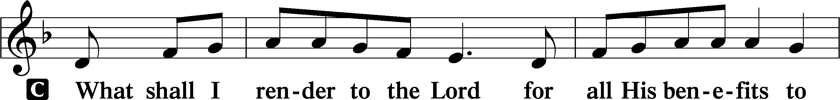
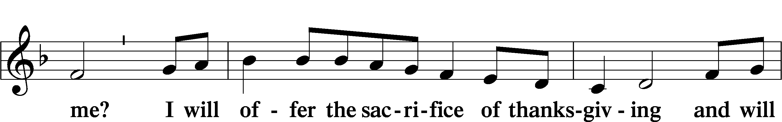
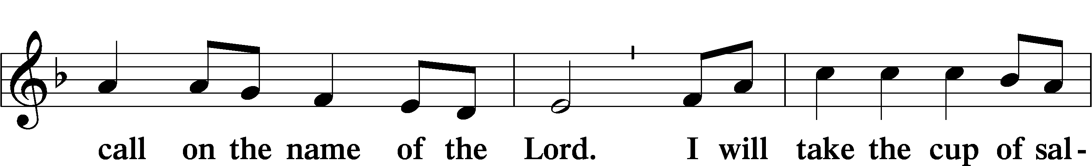
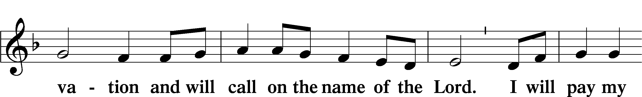
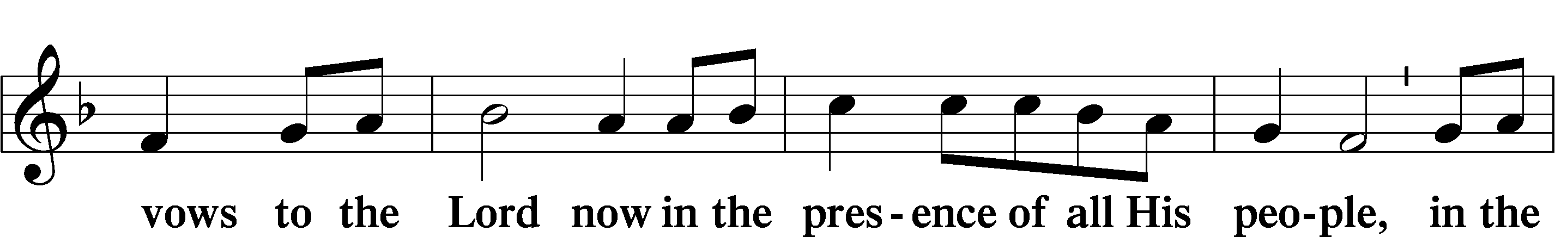
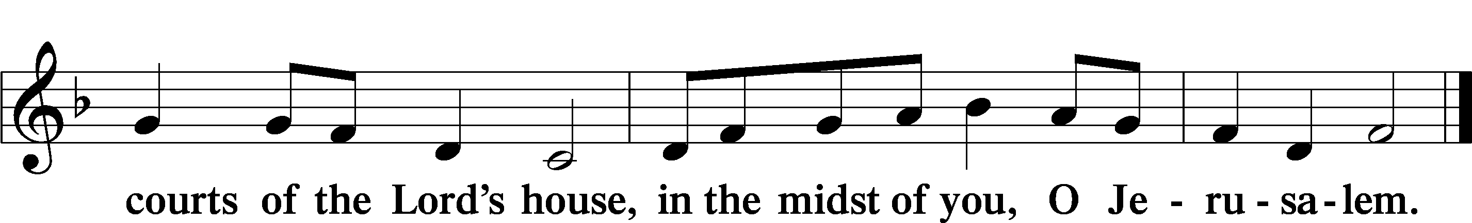

Service of the Sacrament

Preface LSB 160
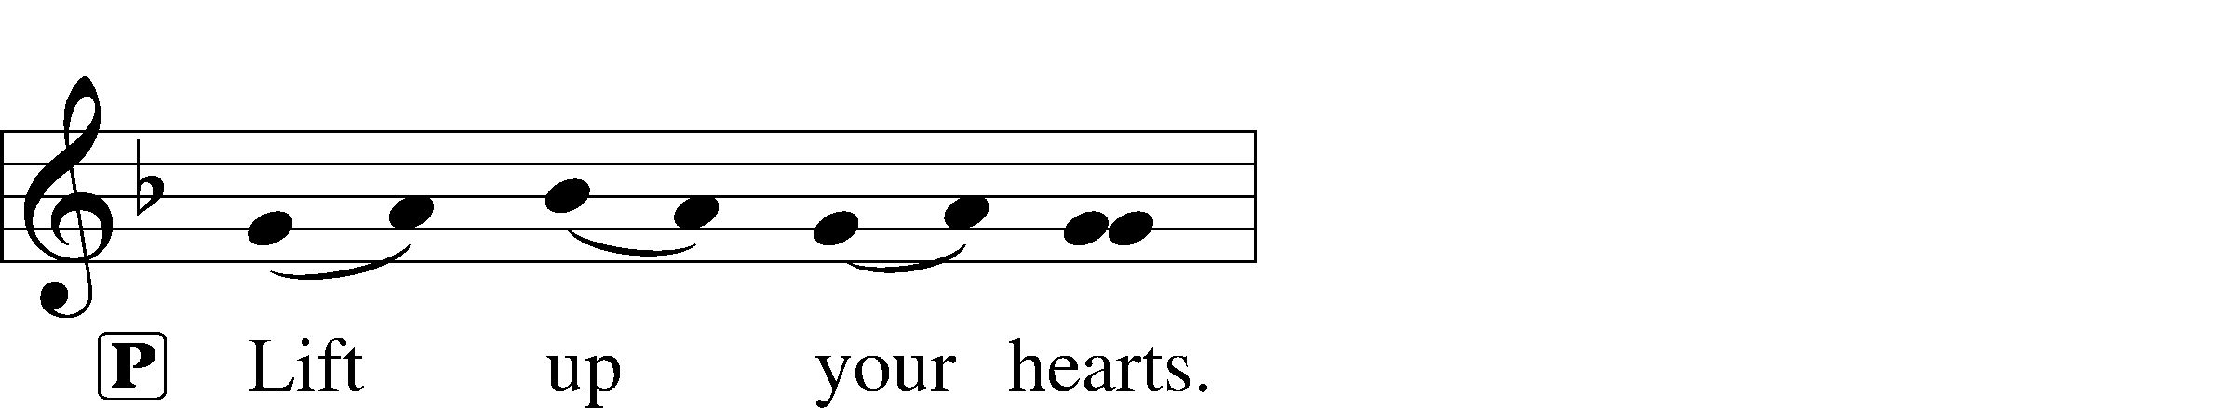
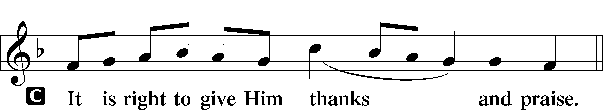

Proper Preface
P It is truly good, right, and salutary that we should at all times and in all places give thanks to You, holy Lord, almighty Father, everlasting God, through Jesus Christ, our Lord, who, out of love for His fallen creation, humbled Himself by taking on the form of a servant, becoming obedient unto death, even death upon a cross. Risen from the dead, He has freed us from eternal death and given us life everlasting. Therefore with angels and archangels and with all the company of heaven we laud and magnify Your glorious name, evermore praising You and saying:

Sanctus LSB 161
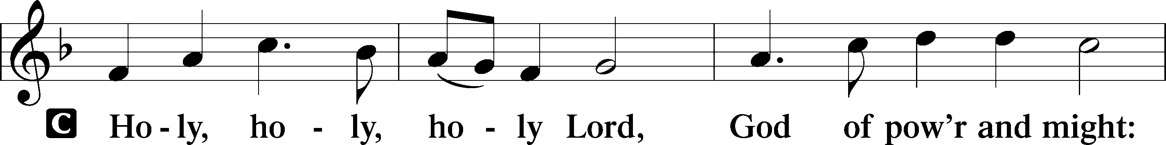
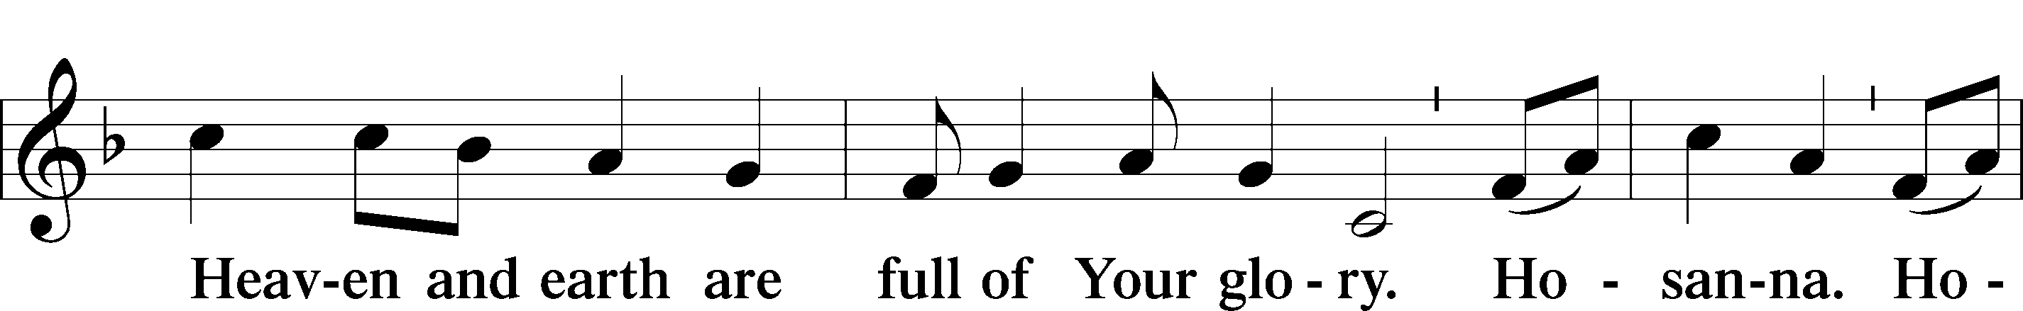
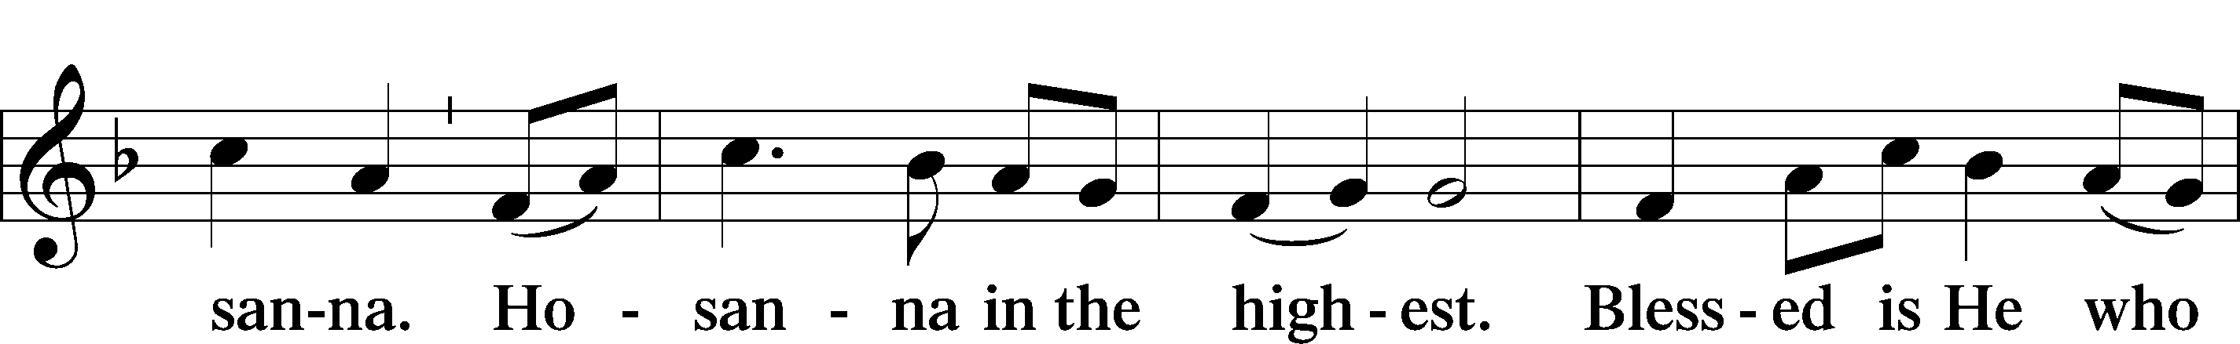
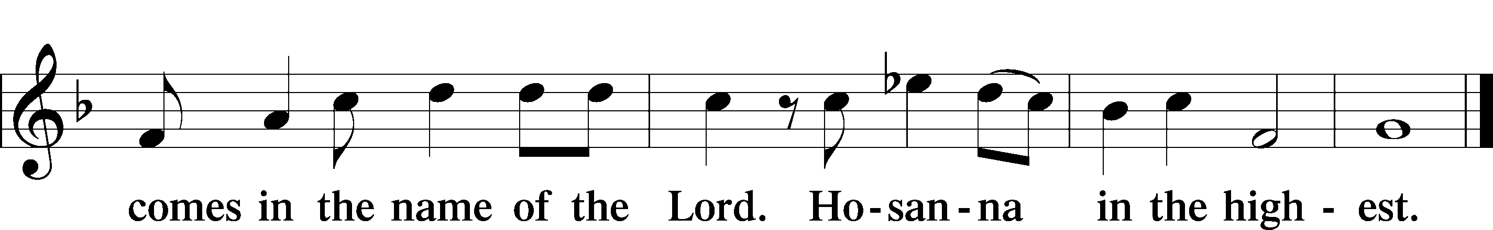

Lord’s Prayer
C Our Father who art in heaven,
hallowed be Thy name,
Thy kingdom come,
Thy will be done on earth
as it is in heaven;
give us this day our daily bread;
and forgive us our trespasses
as we forgive those
who trespass against us;
and lead us not into temptation,
but deliver us from evil.
For Thine is the kingdom
and the power and the glory
forever and ever. Amen.

The Words of Our Lord
P Our Lord Jesus Christ, on the night when He was betrayed, took bread, and when He had given thanks, He broke it and gave it to the disciples and said: “Take, eat; this is My T body, which is given for you. This do in remembrance of Me.”

In the same way also He took the cup after supper, and when He had given thanks, He gave it to them, saying: “Drink of it, all of you; this cup is the new testament in My T blood, which is shed for you for the forgiveness of sins. This do, as often as you drink it, in remembrance of Me.”

Pax Domini LSB 163
P The peace of the Lord be with you always.
C Amen.

Agnus Dei LSB 163
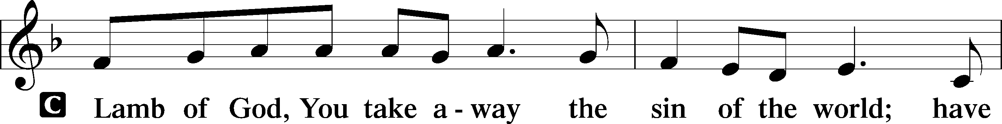
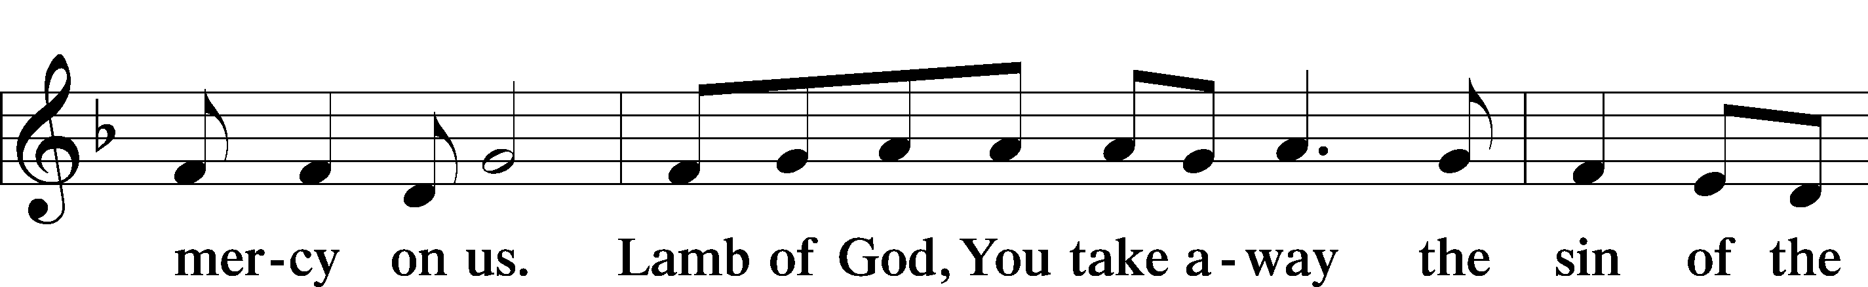
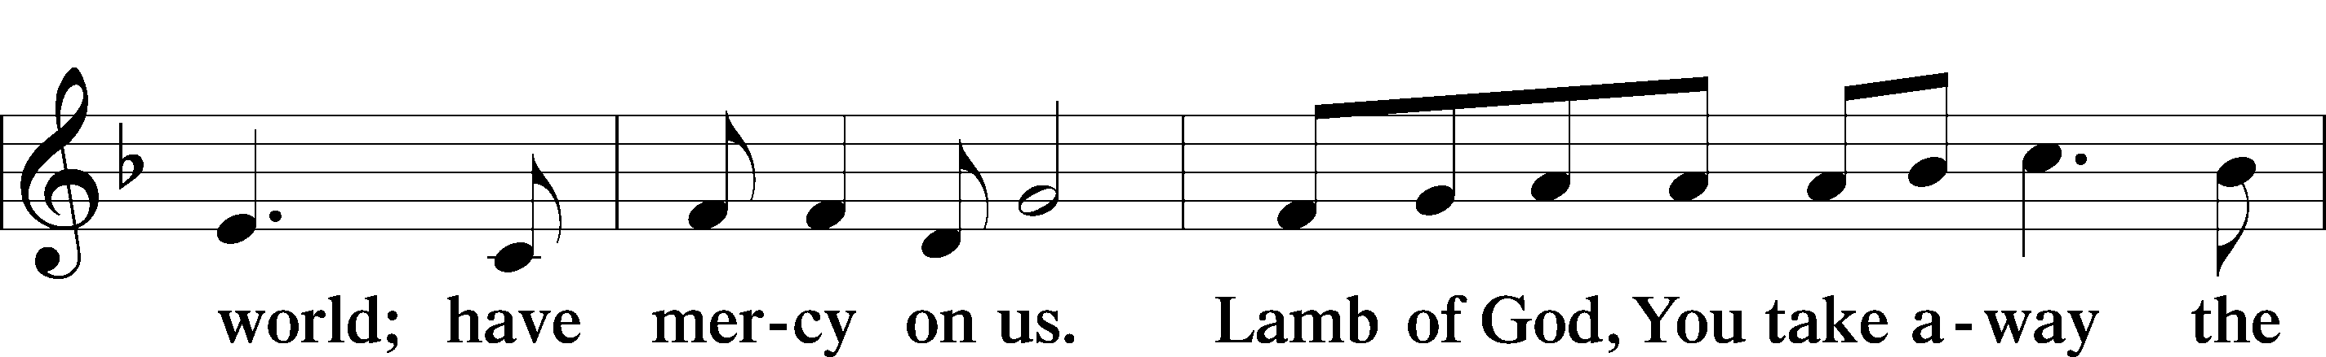
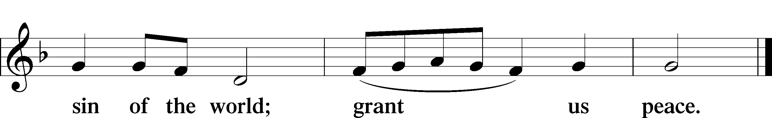

Sit

Distribution

633 At the Lamb’s High Feast We Sing sts. 1–4, 6, 8
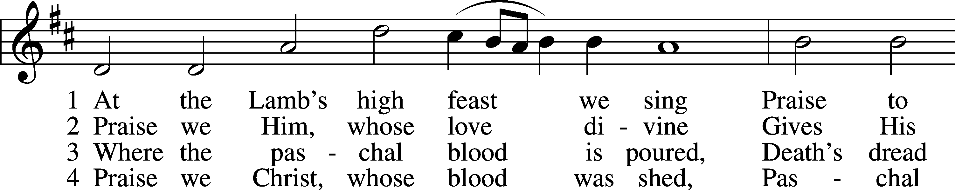
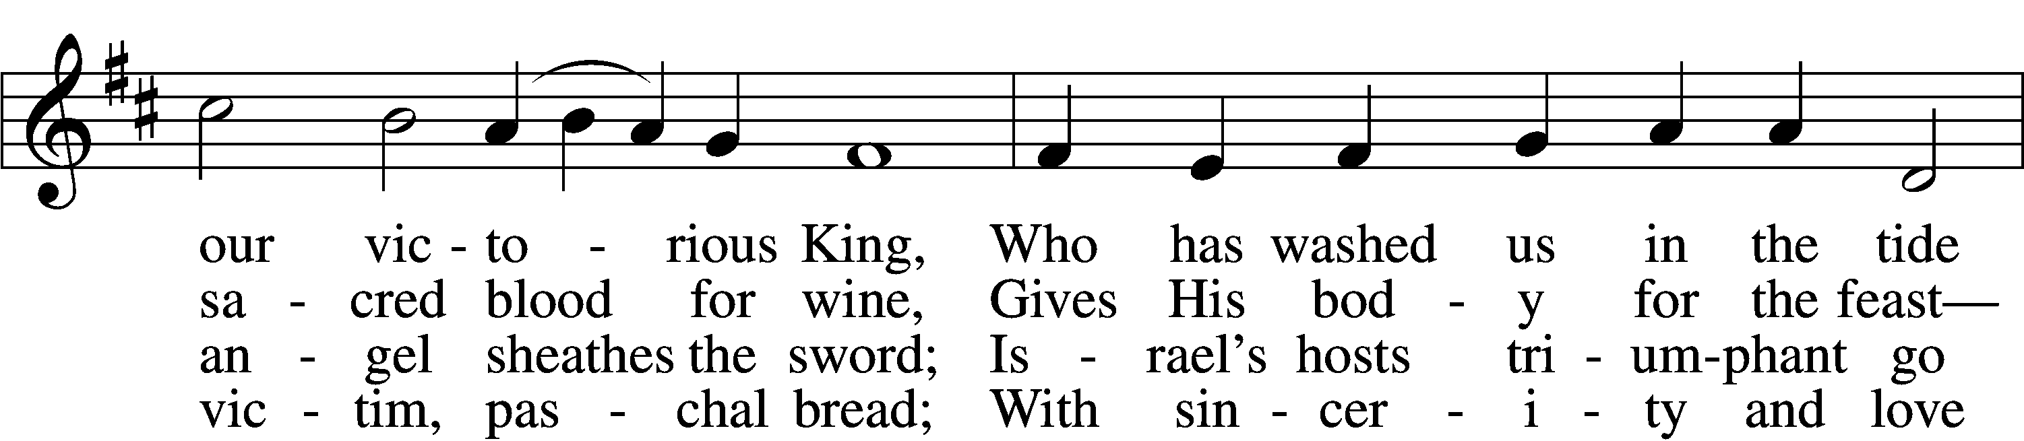
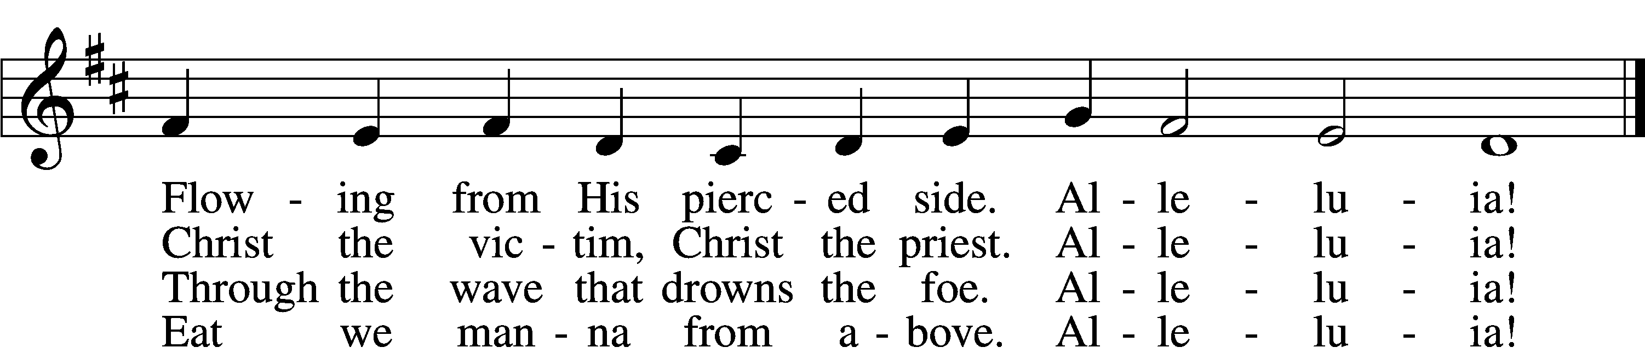

6 Now no more can death appall,
Now no more the grave enthrall;
You have opened paradise,
And Your saints in You shall rise.
Alleluia!

D 8 Father, who the crown shall give,
Savior, by whose death we live,
Spirit, guide through all our days:
Three in One, Your name we praise.
Alleluia!
Tune and text: Public domain

606 I Lay My Sins on Jesus
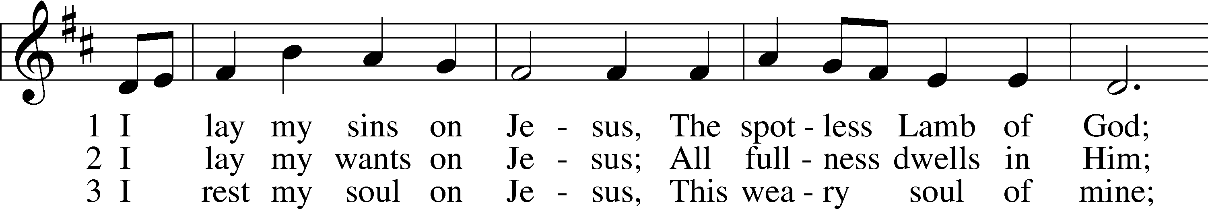
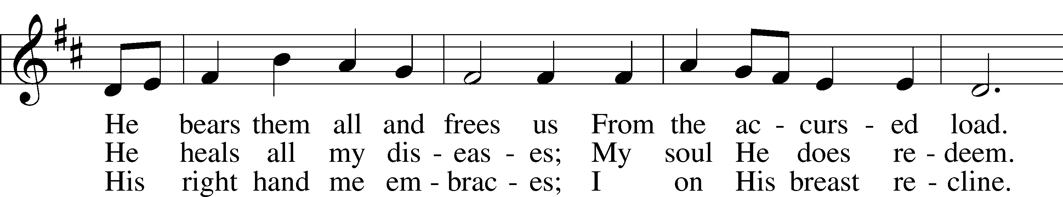
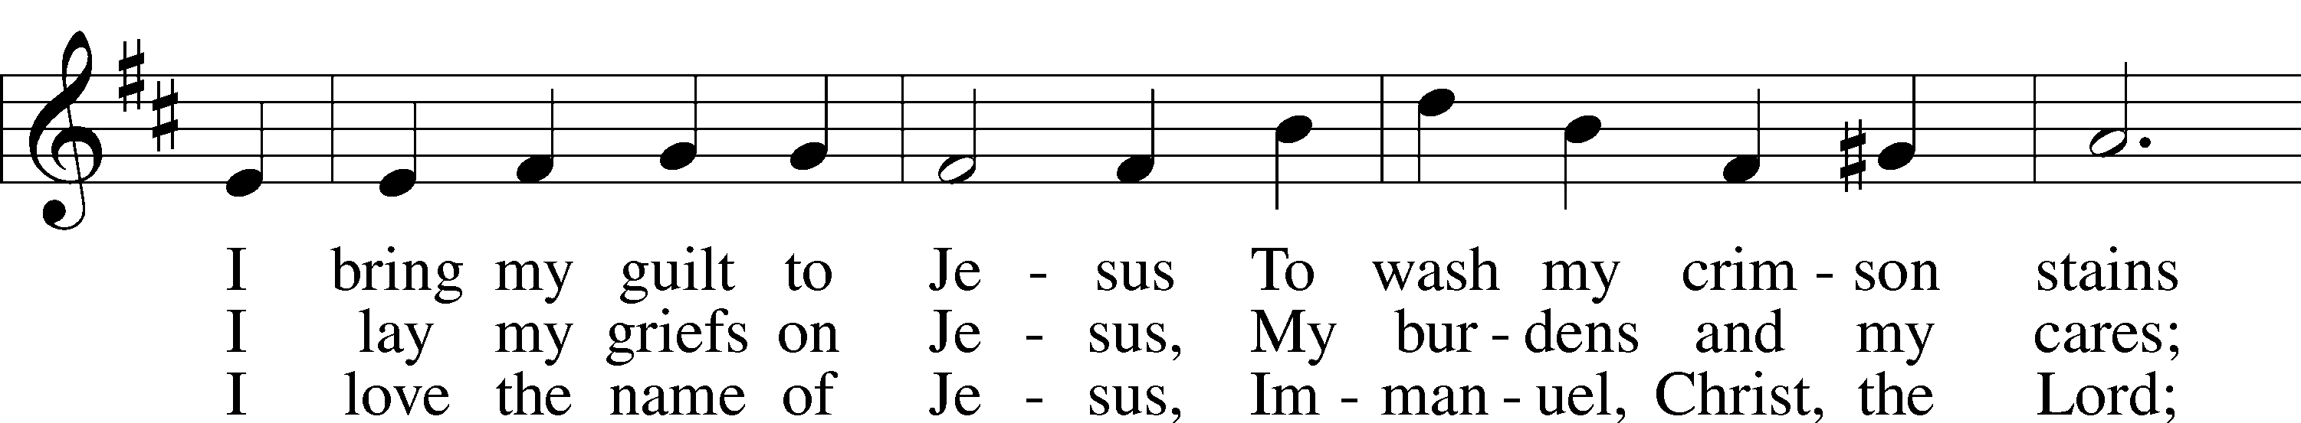
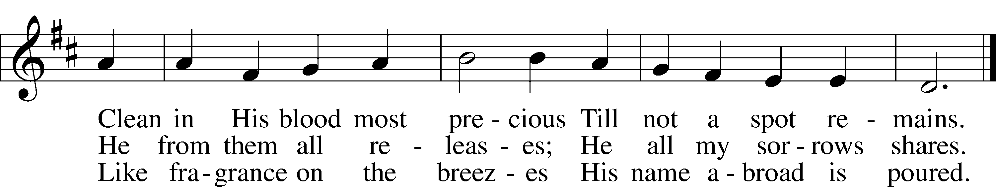
Text and tune: Public domain

634 The Death of Jesus Christ, Our Lord sts. 1–4, 8
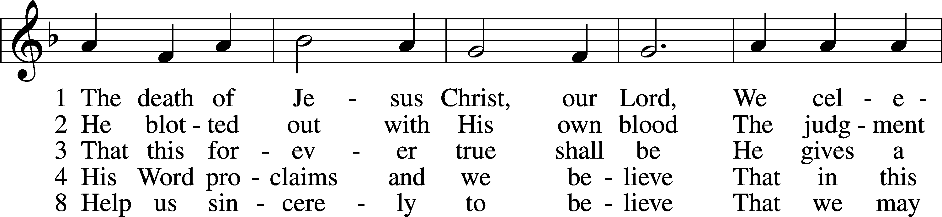
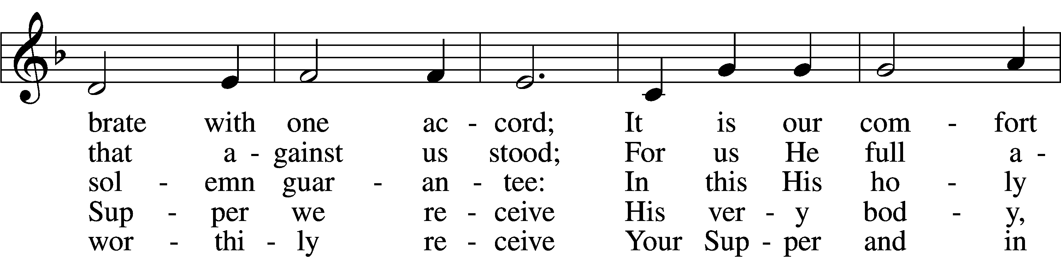
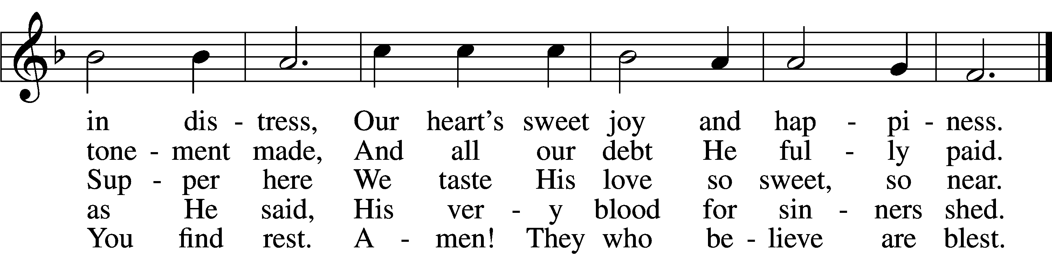
Tune and text: Public domain

Stand

The Dismissal
P The body and blood of our Lord Jesus Christ strengthen and preserve you in body and soul to life everlasting. Depart T in peace.
C Amen.

Thank the Lord LSB 164
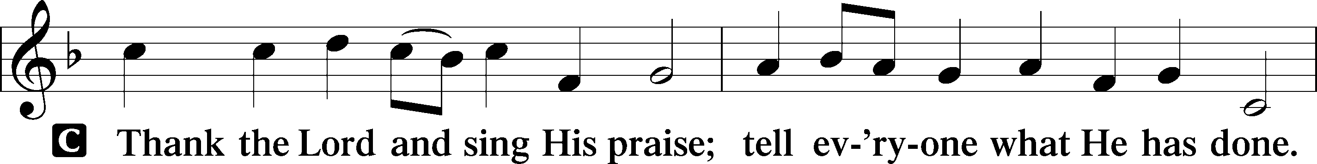
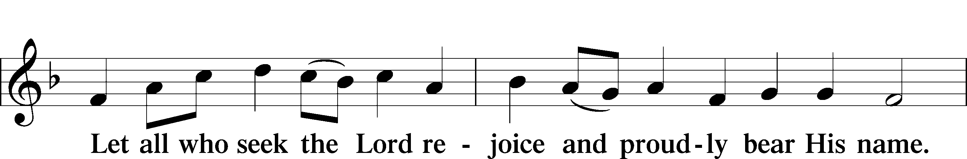
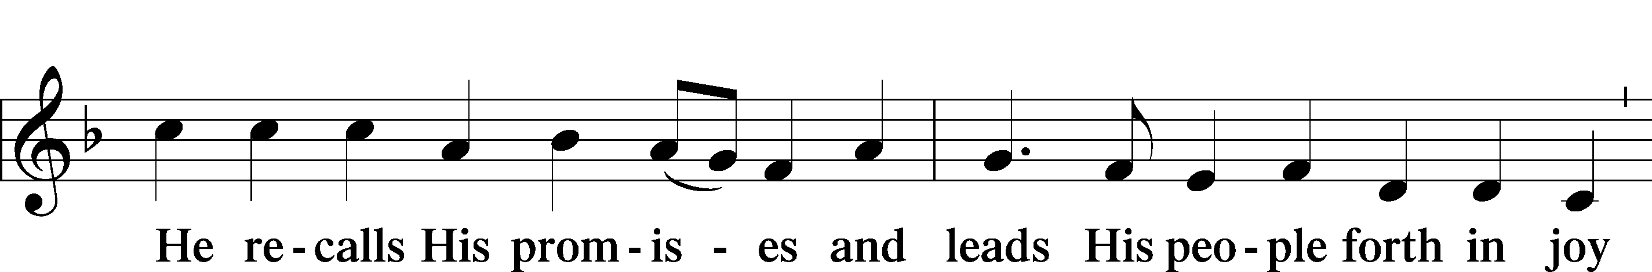
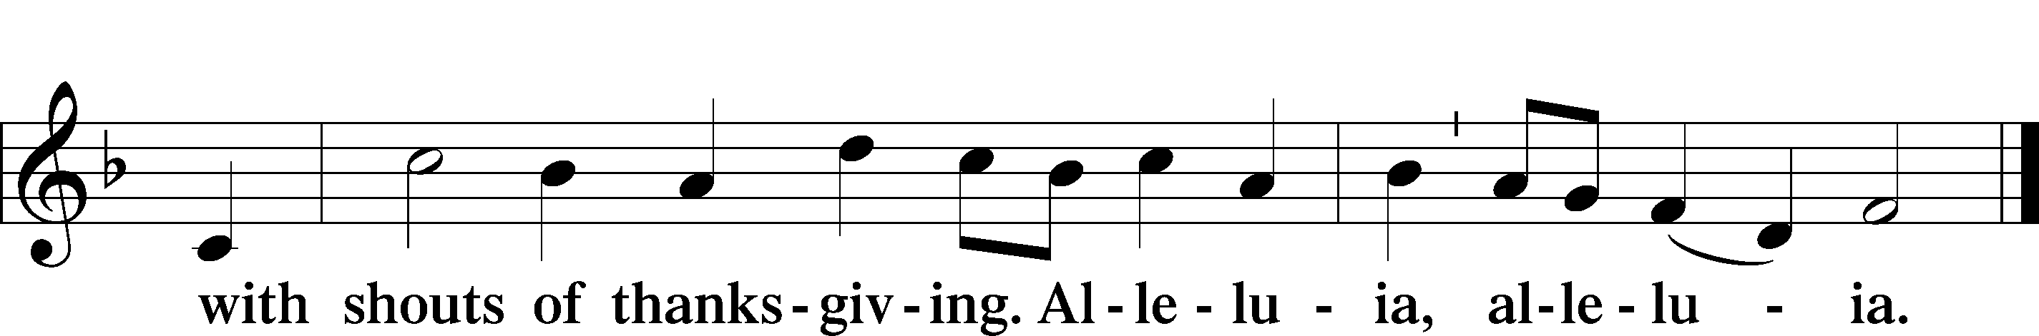

Post-Communion Collect
A Let us pray.
We give thanks to You, almighty God, that You have refreshed us through this salutary gift, and we implore You that of Your mercy You would strengthen us through the same in faith toward You and in fervent love toward one another; through Jesus Christ, Your Son, our Lord, who lives and reigns with You and the Holy Spirit, one God, now and forever.
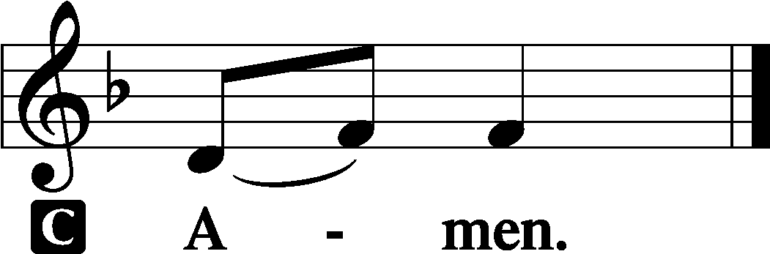

Benediction LSB 166
P The Lord bless you and keep you.
The Lord make His face shine on you and be gracious to you.
The Lord look upon you with favor and T give you peace.

740 I Am Jesus’ Little Lamb
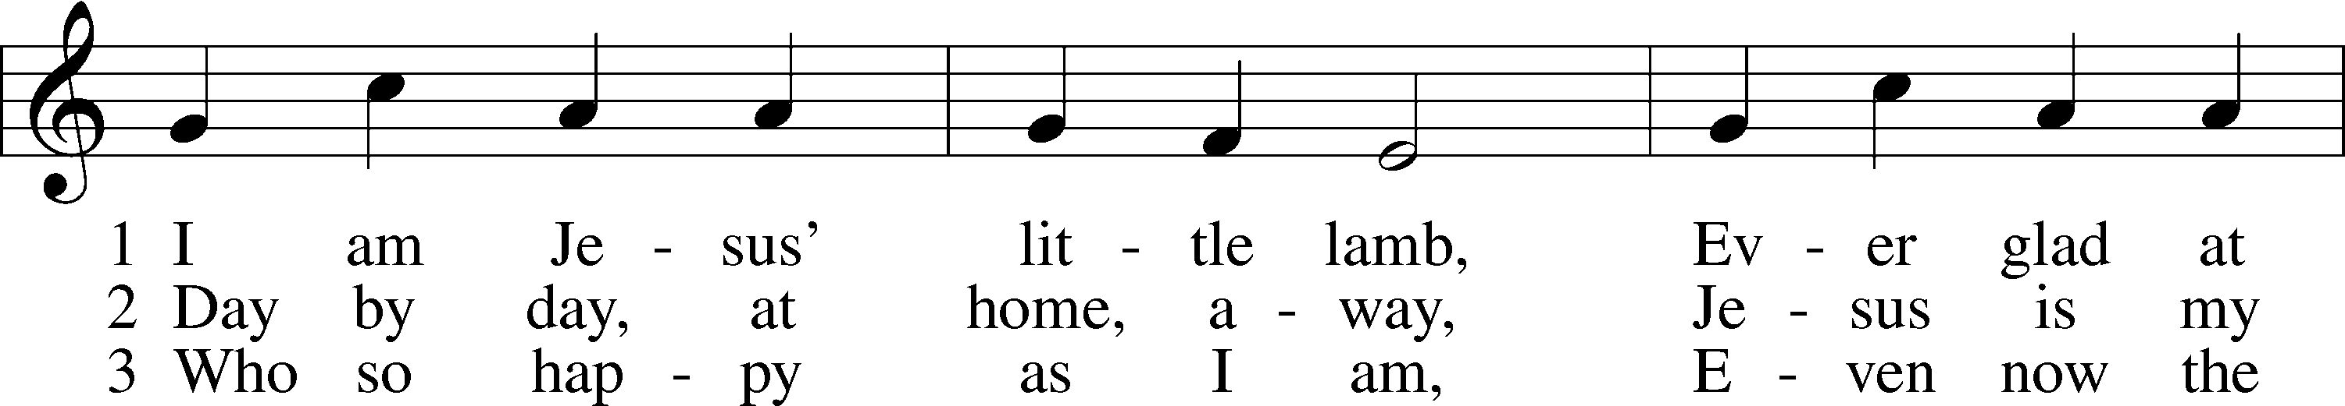
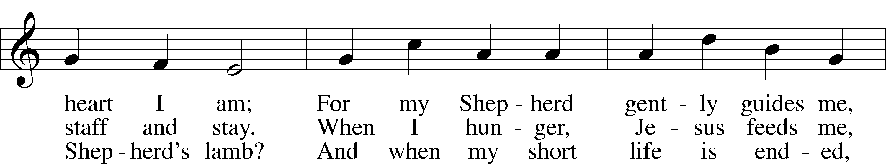
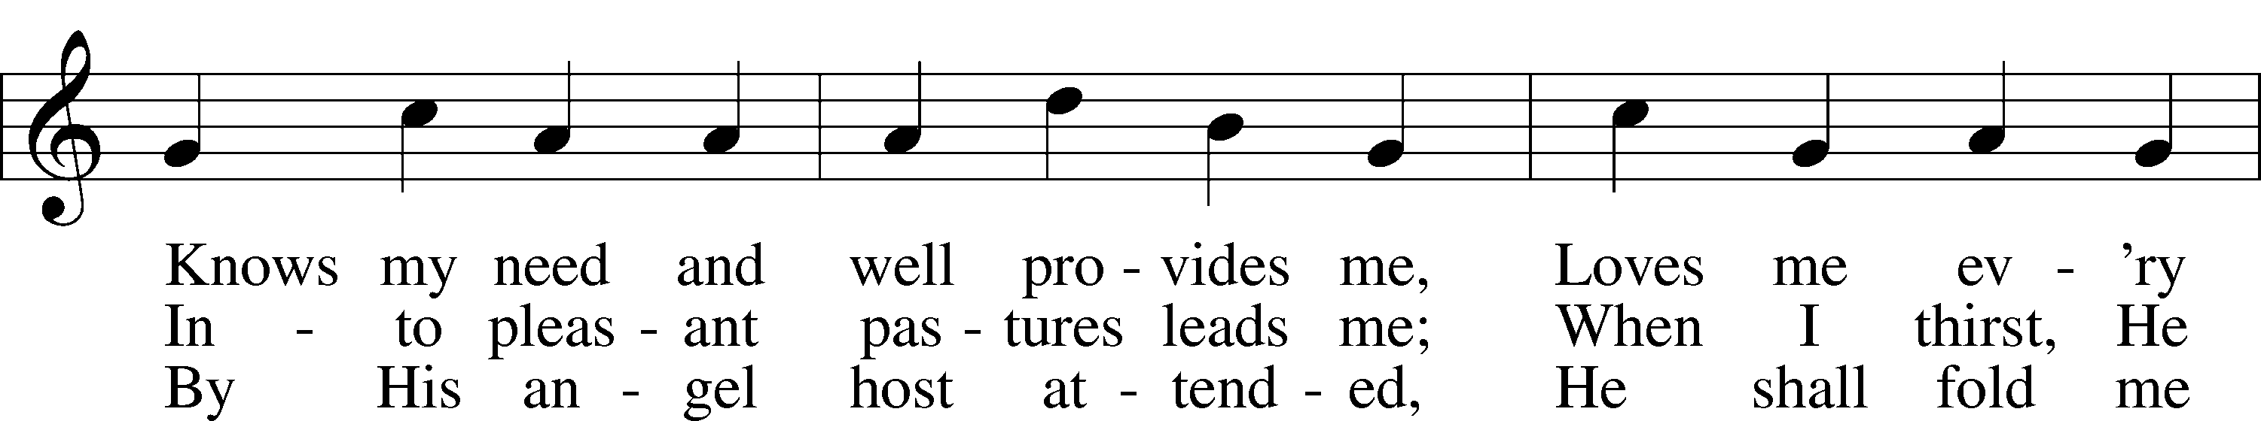
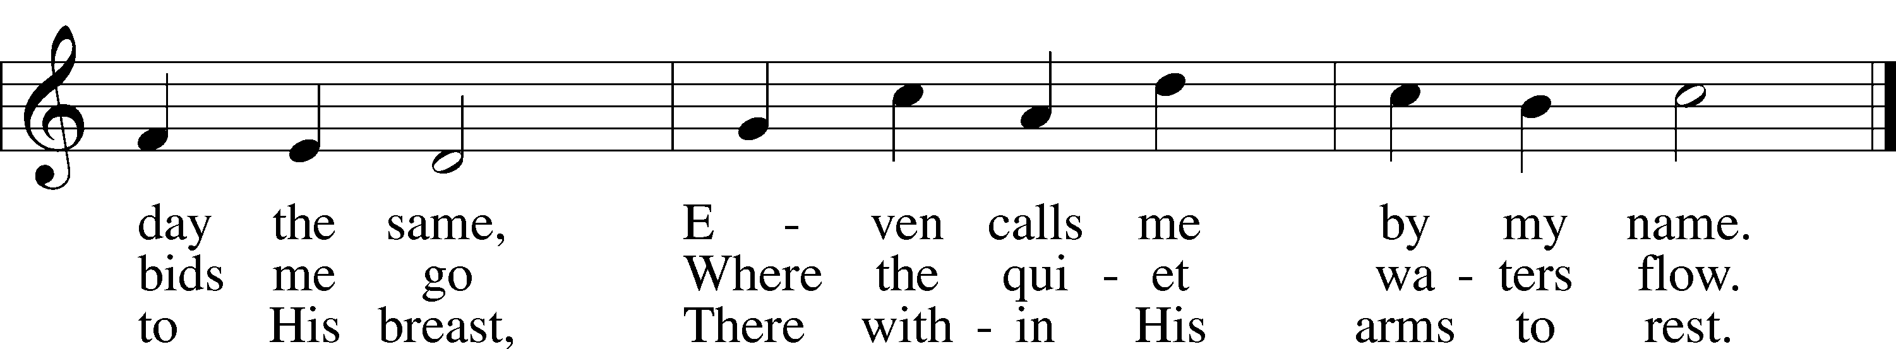
Text and tune: Public domain

Acknowledgments
Unless otherwise indicated, Scripture quotations are from the ESV® Bible (The Holy Bible, English Standard Version®), copyright © 2001 by Crossway, a publishing ministry of Good News Publishers. Used by permission. All rights reserved.
Created by Lutheran Service Builder © 2021 Concordia Publishing House.

Prayers for Our Members
Sharon Hockemeier | Expectant Mother
Norman Abels (Brookestone Meadows – Elkhorn) | Healing
Judy Ahrens | Healing
Vaughn Albrecht (Mount Carmel) | Healing
Tom & DyAnn Altwine | Healing
Lyle Colsden (Mother Hull) | Healing
Pat Flodine (Cambridge Court) | Healing
Vi Fox (Prairie View) | Healing
Verleen Gentry | Healing
Ruby Hatfield | Healing
Lennis Hodgson | Healing
Boyd Millsap | Healing
Michelle Millsap | Healing
Roger Riekenberg | Healing
Don Richmond | Healing
Marion Richmond | Healing
Bob Glanzer | Healing
Ivan Bombeck | Cancer
Fran Junge | Cancer
Bertha Marienau | Cancer
Kim Vos | Cancer

ZION LUTHERAN CHURCH AND SCHOOL

Pr. James DeLoach, Pastor + (308) 627-5260
james.deloach@zionkearney.org
Pr. Doug Gaunt, Pastor + (308) 455-0552
doug.gaunt@zionkearney.org
Tony Splittgerber, Principal + (308) 293-0168
anthony.splittgerber@zionkearney.org

Church Office
Secretary: Shirley Oertwig
Email: school@zionkearney.org
Phone: (308)-234-3410 Fax: (308) 236-8100
Office Hours: Monday-Friday 8:00am-4:00pm
Radio Broadcast: Sunday @ 10:30 a.m. on 1460 AM
Website: www.zionkearney.com

Prayers for Our Members’ Family & Friends
Naomi Wollberg (Andy & Jeanne Wollberg’s daughter-in-law) | Expecting
Reg Duke (Westman’s brother-in-law) | Healing
James Gentry (Verleen Gentry’s son) | Healing
Roger Hoffman (Marc’s father) | Healing
David Kreutzer | Healing
Sharon Kreutzer (Richard’s mother) | Healing
Pastor Rob Kuefner | Healing
Lyra Mais (Zion student) | Healing
Dillon Malchow (Joy Barefoot’s nephew) | Healing
Mary Ann Mertz (Pam’s Uhlir’s friend) | Healing
Tommy Parks (Katie Nuttelman’s friend) | Healing
Tim Powers (Kim Wilken’s brother) | Healing
Roy Reynolds (Verleen Gentry’s son-in-law) | Healing
Lynne Saathoff (Verleen Gentry’s sister-in-law) | Healing
Randy Solomon (Beth Rosenthal’s father) | Healing
Angela Well (Charles Marineau’s granddaughter) | Healing
Larry Bombeck (Ivan’s brother) | Healing
Katie Cunningham (Quentin & Janel Lange’s friend) | Burn
Jonah (Jase & Jarren Blattner’s friend) | Cancer
D.D. Dugger (Sue Kaiser’s brother) | Cancer
Stuart Gronewoller (Lonna’s brother-in-law) | Cancer
Ron Halvorsen (Jeff’s dad) | Cancer
Randy Jochum (Ken Hockemeier’s brother-in-law) | Cancer
Fred Koch (Pam Uhlir’s cousin) | Cancer
John Moore (family of Susan Tonniges) | Cancer
Sharon Mulhair (Pam Uhlir’s cousin) | Cancer
Kolby Shiers (Jessica’s cousin) | Cancer
Tyrone Uhlir (Pam’s nephew) | Cancer
Tim Smallcomb (Wilkens’ friend) | Deployment

Today’s Radio Broadcast is given to the Glory of the Lord by
Lee & Phyllis Wells.

Worship Assistants

Sunday, September 19 ~ 9:00am

Elder: Ken Hockemeier
Usher: Andy Wollberg
Acolyte: Addison Helmbrecht
Engineer: Jared Nuttelman
Announcer: Jesse Florang
Altar Guild: Carol Gaunt & Liz Gaunt

Sunday, September 26 ~ 9:00am

Elder: Nathan Gaunt
Usher: Mike Wilkens & Jeff Strong
Acolyte: Addison Splittgerber
Engineer: Shawn Starkey
Announcer: Lonna Gronewoller
Altar Guild: Carol Gaunt & Liz Gaunt

Our Response to the Gospel

Date: 09/12/2021

Offering: $7,176.00
Weekly Need: $7,457.69

This Week at Zion

Sun  09/19 | 9:00a  10:30a  10:15a | Divine Service  Radio Broadcast 1460am & 92.1fm  Bible Study
Mon  09/20 | Birthdays  Anniversary | Madisen Eckhoff  John & Juanita Musfelt
Tues  09/21 | 1:30p  7:00p  Birthdays  Anniversaries | Sleeping Mats  Council  ---  ---
Wed  09/22 | 8:30a  5:45p  6:00p  7:00p  Birthdays  Anniversaries | Chapel  Midweek  Bell Choir  Adult Choir  --  ---
Thurs  09/23 | Birthdays  Anniversaries | Parent/Teacher Conferences-No School  ---  ---
Fri  09/24 | Birthdays  Anniversaries | No School  ---  ---
Sat  09/25 | 5:00p  Birthdays  Anniversaries | Divine Service  ---  --
Sun  09/26 | 9:00a  10:30a  Birthdays  Anniversaries | Divine Service  Radio Broadcast 1460am & 92.1fm  John Colsden  ---

Where our Triune God strengthens us through His mercy in faith toward Him and in fervent love toward one another.

ANNOUNCEMENTS
Sunday School is set to resume for our children on Sunday, October 3.
There are teachers for all children and youth in Kindergarten through High school. We would welcome more volunteers to serve as teachers on a rotating or part-time basis.

To help with ordering the correct amount of Sunday School materials, would parents please list on one of the attendance cards in your pew, your children’s names and current grade, to indicate that your children will be attending. Please hand the card to Pastor DeLoach as you leave today.

Thank You to all who participated in the Zion Golf Tournament last Sunday. Congratulations to the winners Chad and Stephen Anderson in the Adult/Youth division and Quinten and Will Hogeland in the Adult division.
A big thank you to all of our hole sponsors: Auto Central, O & O Farms, Hinrichs family and the Gaunt & DeLoach families.

The Ainsworth Symposium begins this afternoon and goes through Tuesday. Pastor DeLoach and Mr. Splittgerber will attend. For Pastoral emergencies please call Pastor Gaunt (308-455-0052) or the Church office.

The Zion Office will be closed on Thursday and Friday of this week as there is no school. Thursday there will be Parent /Teacher Conferences.

Adult Bible Study -The adult bible study class is meeting once again on Sunday mornings. We have begun a study entitled “Just Words.” It is a study of the doctrine of justification by grace through faith and the various biblical metaphors that convey the Gospel. Come grab a donut and cup of coffee as we learn together.

New Custodian Mr. Dennis Bartels will begin serving this week as our Zion custodian. Mr. Bartels and his wife Sue moved to Kearney recently from Colorado. Be sure to introduce yourself and welcome them.

Thank You - I want to thank you all for all the care and generosity you have shown to our family and me at the loss of my wife Beverly. Your prayers, cards, and memorial gifts have been a comfort and a reminder of the eternal life we have in our Lord and Savior Jesus Christ.
Keith and family
Employment Opportunity
Secretary for the Church and the School:
If you enjoy working with people, have clerical/office experience, and like a fast-paced, ever-changing workday – this may be the position for you! Please contact Pastor DeLoach or Mr. Splittgerber if you are interested.

Offering Options:
1) Place your offering in the basket as you leave
2) Go to zionkearney.churchtrac.com/give
3) Go to zionkearney.com and click on the ChurchTrac icon
4) Mail your gift to Zion Lutheran Church, 2421 C Ave, Kearney, NE 68847 or place it in the mail slot on the south side of the building.
Radio Broadcast - Please help Zion spread the Gospel, signup to sponsor a radio broadcast! There are several open dates.

Church Management System – Zion has switched to a web-based church management system called ChurchTrac. Please pick-up a yellow sheet in the narthex to get setup today to view all of the benefits and features.

It is very important that you setup your account. This is the only way for the office to know of birthdays, anniversaries, etc. The old software program is no longer working, so old information is all what is being used, so more than likely we are missing a lot of babies, etc.

Mission Offerings - If you would like to donate to the missions Zion supports, please use the mission envelopes located in the narthex. The third quarter missions will be going to support Jonathan Clausing. Thank you for your support.

https://www.lcms.org/clausing

https://missioncentral.us/category/africa/jonathan-and-anita-clausing/
SCHOOL NEWS

The Theme for our school year is “Together by Christ’s Love” based on
1 John 4:7-8.

- This Thursday, Zion Lutheran School will be hold Parent/Teacher conferences. There is no school Thursday or Friday.
- Our Zion boys and girls cross country teams are working hard and have run very well at recent meets.
- The girls’ volleyball team had their first competition of the year with Kearney Catholic this week and played well, winning both sets.

Early Childhood Openings!

We do still have openings in our 3 yr. old preschool classes. If you or someone you know is still looking for a high quality early childhood experience, please refer us to them!

Ways to Help our School

Zion Scrip
Participate in the Zion scrip program. It is easy to use and to earn money toward tuition and for Zion. Just stop by the office and purchase gift cards for your everyday items or for gifts. It is that simple. 50% goes toward your tuition and 50% goes to Zion building fund. To learn more about the program contact the office.
Big G Boxtops
Download the Big G Boxtop app on your smartphone, select Zion as your choice school, scan your receipt. That is all, quick and simple for Zion to earn money on qualifying items.

Family Fresh Register Receipts
After Zion receives $150,000 worth of receipts, Zion will receive $1,000.

Apple Mart Register Receipts
Save receipts dated September 1. 2021 through March 1, 2022
With the register receipts Zion earns points for dollars spent at Apple Market. The points are redeemed for school items.
It is easy to earn money for your school! Turn your receipts into the office. If you have any questions please stop by the office.

Best Choice and Our Family UPC Codes

