Divine Service
Eighteenth Sunday
after Pentecost
September 26, 2021

Zion Lutheran Church
Kearney, Nebraska

Welcome to Zion!
All worshippers please fill out an attendance card in the pew rack and let us know how we might be of service to you.

Holy Communion at Zion

The Lord’s Supper is celebrated at this congregation as Jesus has given it. As he says, our Lord gives into our mouths not only bread and wine but his very body and blood to eat and to drink for the forgiveness of sins and to strengthen our union with him and with one another. Our Lord invites to his table those who trust his words, repent of all sin, and set aside any refusal to forgive and love as he forgives and loves us, that they may show forth his death until he comes. All communicants need to register in the narthex prior to the service.

Because those who eat and drink our Lord’s body and blood unworthily do great harm and because Holy Communion is a confession of the faith which is confessed at this altar, any who are not yet instructed, in doubt, or who hold a confession differing from that of this congregation and The Lutheran Church—Missouri Synod, are asked not to commune until they are able to speak with our pastor first. He is happy to visit with you about the Christian faith and how to receive the Lord’s Supper for your good and for the good of others. Those not communing are invited to come to the altar, cross your arms in front of you, and bow your head to receive a pastoral blessing.

Christ Jesus, the Son of God, Cares for Us and Serves Us with the Forgiveness of Sins

When the people of Israel wept, complaining that they had no meat to eat (Num. 11:4), Moses cried out to the Lord that “the burden of all this people” was too heavy for him and that he was “not able to carry all this people alone” (Num. 11:11–14). So the Lord had Moses gather “seventy men of the elders of Israel” (Num. 11:16), and the Lord “took some of the Spirit that was on him and put it on the seventy elders” (Num. 11:25), so that Moses would not carry the burden alone. All who thus labor are honored, and all the people are cared for, in the name of the Lord (Mark 9:39–41). Everything is done with reference to Christ Jesus. So we cling to Him, and we flee from all sins that would separate us from Him (Mark 9:42–48). The life of the Church is one of repentant faith in Christ. Christians confess their sins to one another, and they “pray for one another,” that each would be raised up and healed by the Lord Jesus, who covers “a multitude of sins” and saves our souls from death (James 5:15–20).

Confession and Absolution

901 Open Now Thy Gates of Beauty
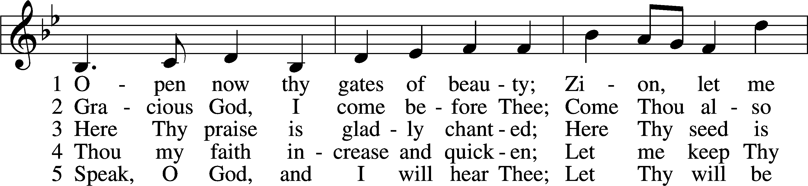
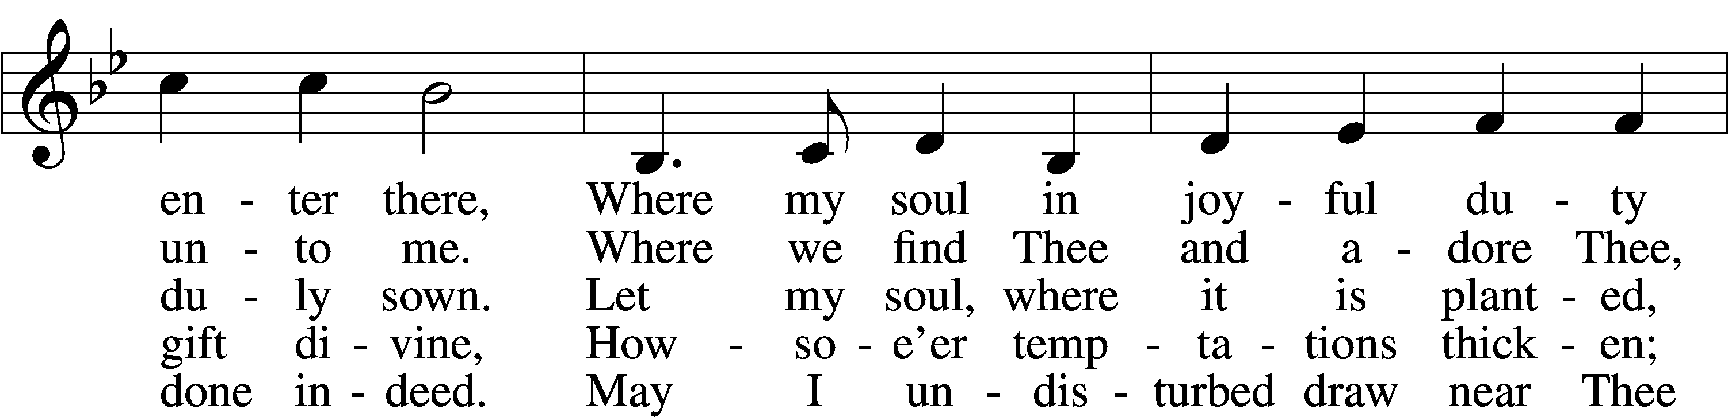
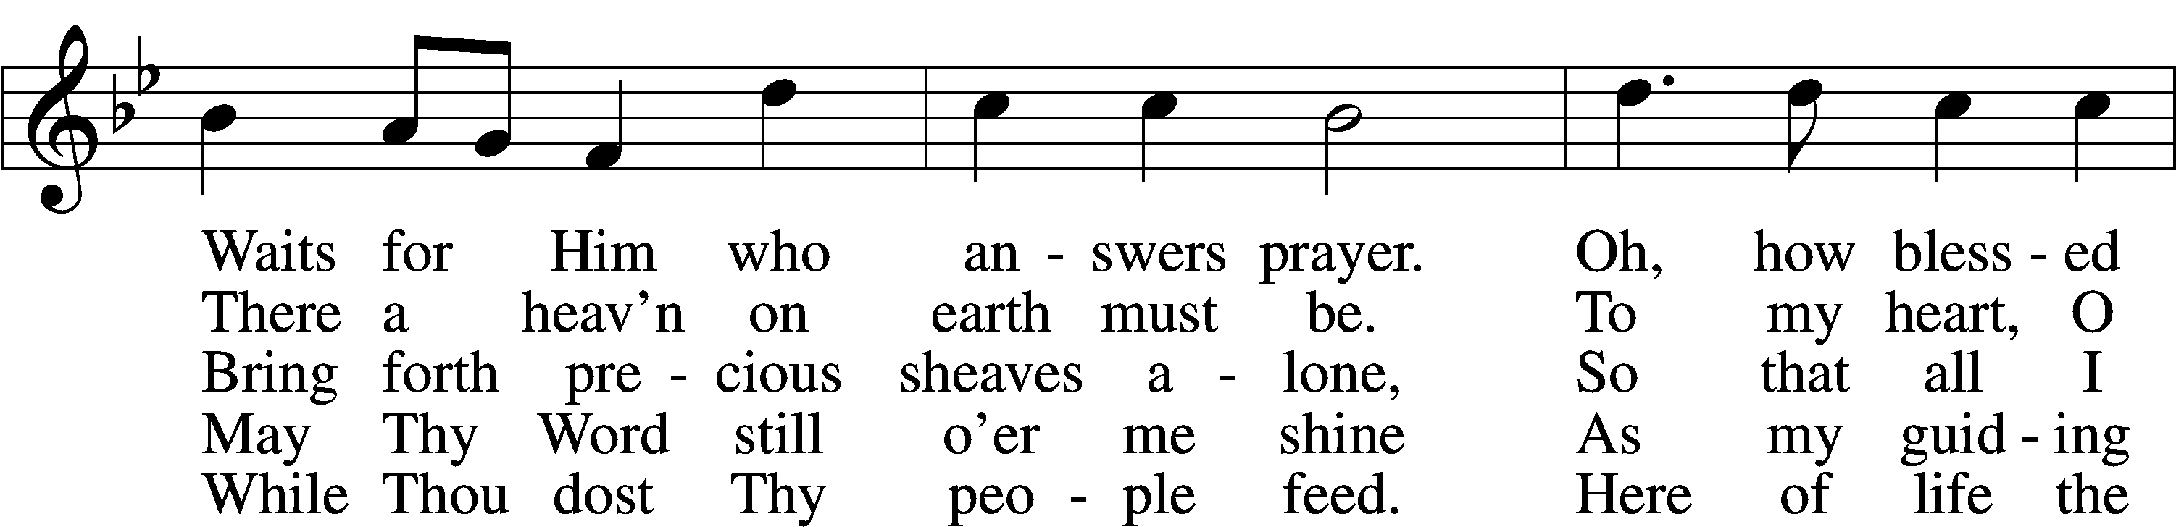
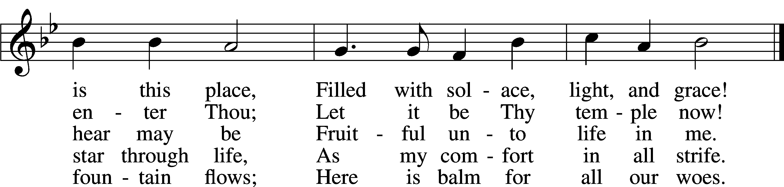
Text and tune: Public domain

Please stand. The sign of the cross may be made by all in remembrance of their Baptism.

Invocation
P In the name of the Father and of the T Son and of the Holy Spirit.
C Amen.

Exhortation LSB 151
P If we say we have no sin, we deceive ourselves, and the truth is not in us.
C But if we confess our sins, God, who is faithful and just, will forgive our sins and cleanse us from all unrighteousness.

Silence for reflection on God’s Word and for self-examination.

Confession of Sins LSB 151
P Let us then confess our sins to God our Father.
C Most merciful God, we confess that we are by nature sinful and unclean. We have sinned against You in thought, word, and deed, by what we have done and by what we have left undone. We have not loved You with our whole heart; we have not loved our neighbors as ourselves. We justly deserve Your present and eternal punishment. For the sake of Your Son, Jesus Christ, have mercy on us. Forgive us, renew us, and lead us, so that we may delight in Your will and walk in Your ways to the glory of Your holy name. Amen.

Absolution LSB 151
P Almighty God in His mercy has given His Son to die for you and for His sake forgives you all your sins. As a called and ordained servant of Christ, and by His authority, I therefore forgive you all your sins in the name of the Father and of the T Son and of the Holy Spirit.
C Amen.

Service of the Word

Introit Psalm 135:1–3, 13–14; antiphon: v. 13
Your name, O Lord, endures for- | ever,*
your renown, O Lord, throughout all | ages.
Praise the Lord! Praise the name | of the Lord,*
give praise, O servants | of the Lord,
who stand in the house | of the Lord,*
in the courts of the house | of our God!
Praise the Lord, for the | Lord is good;*
sing to his name, for it is | pleasant!
Your name, O Lord, endures for- | ever,*
your renown, O Lord, throughout all | ages.
For the Lord will vindicate his | people*
and have compassion on his | servants.
Glory be to the Father and | to the Son*
and to the Holy | Spirit;
as it was in the be- | ginning,*
is now, and will be forever. | Amen.
Your name, O Lord, endures for- | ever,*
your renown, O Lord, throughout all | ages.

Kyrie LSB 152
A In peace let us pray to the Lord.

A For the peace from above and for our salvation let us pray to the Lord.

A For the peace of the whole world, for the well-being of the Church of God, and for the unity of all let us pray to the Lord.

A For this holy house and for all who offer here their worship and praise let us pray to the Lord.

A Help, save, comfort, and defend us, gracious Lord.

Gloria in Excelsis LSB 154
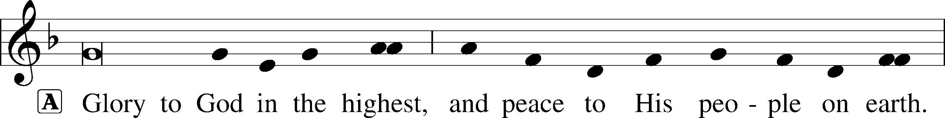
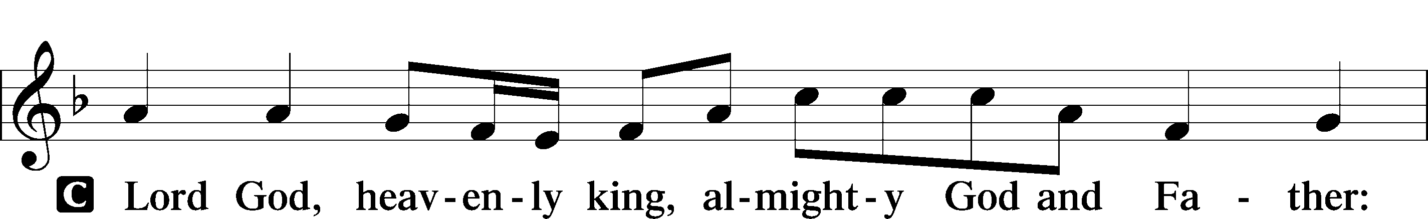
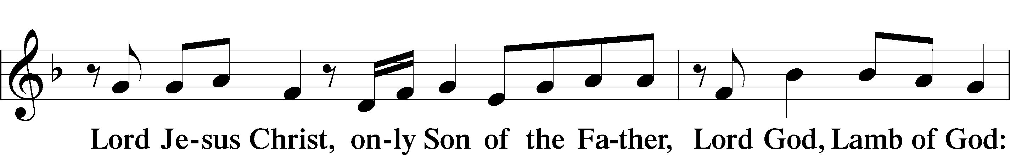
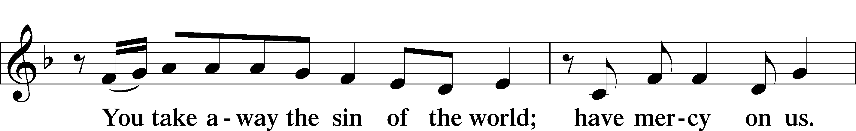
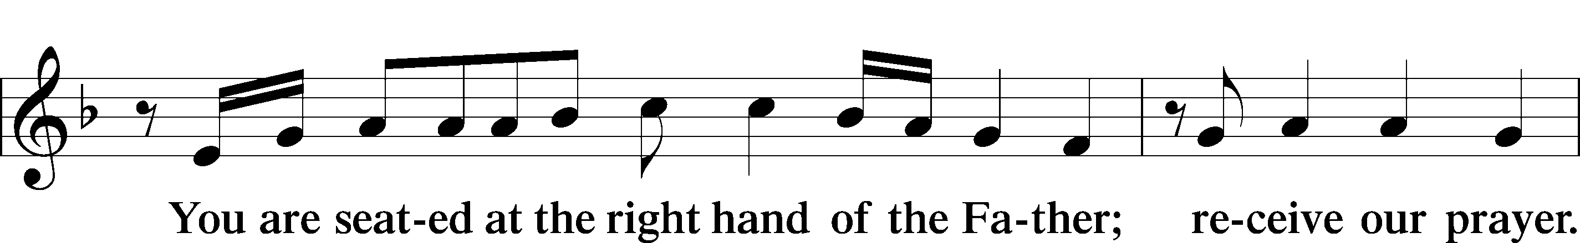
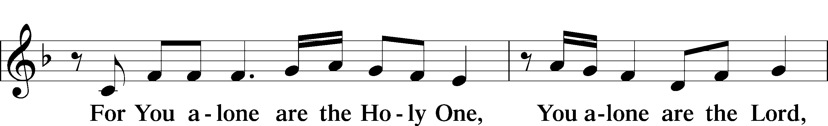
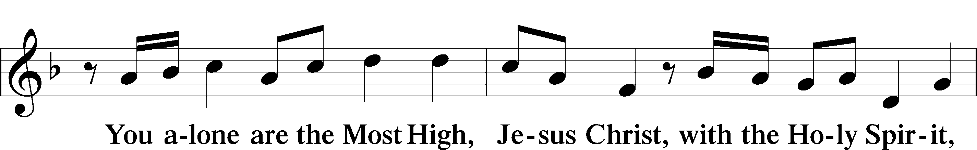
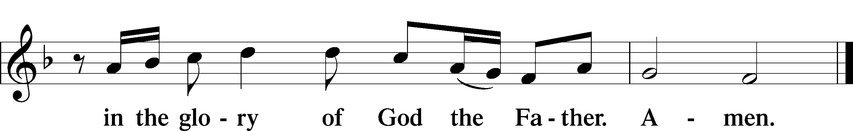

Salutation and Collect of the Day
P The Lord be with you.
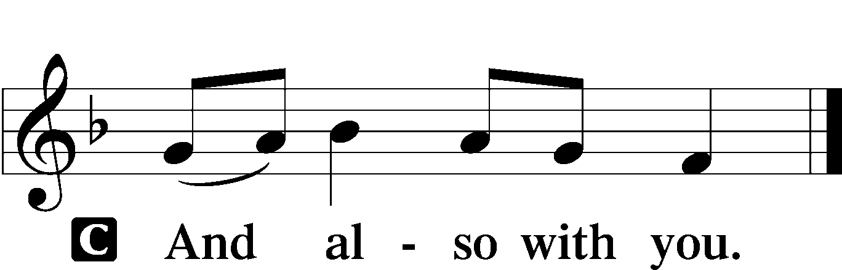

P Let us pray.
Everlasting Father, source of every blessing, mercifully direct and govern us by Your Holy Spirit that we may complete the works You have prepared for us to do; through Jesus Christ, Your Son, our Lord, who lives and reigns with You and the Holy Spirit, one God, now and forever.

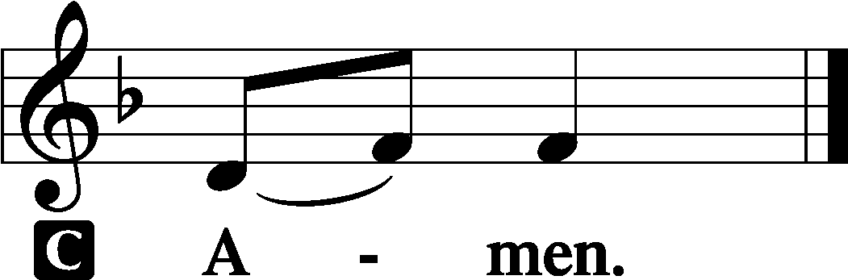

Sit
Old Testament Reading Numbers 11:4–6, 10–16, 24–29
4Now the rabble that was among [the children of Israel] had a strong craving. And the people of Israel also wept again and said, “Oh that we had meat to eat! 5We remember the fish we ate in Egypt that cost nothing, the cucumbers, the melons, the leeks, the onions, and the garlic. 6But now our strength is dried up, and there is nothing at all but this manna to look at. . . .”
10Moses heard the people weeping throughout their clans, everyone at the door of his tent. And the anger of the Lord blazed hotly, and Moses was displeased. 11Moses said to the Lord, “Why have you dealt ill with your servant? And why have I not found favor in your sight, that you lay the burden of all this people on me? 12Did I conceive all this people? Did I give them birth, that you should say to me, ‘Carry them in your bosom, as a nurse carries a nursing child,’ to the land that you swore to give their fathers? 13Where am I to get meat to give to all this people? For they weep before me and say, ‘Give us meat, that we may eat.’ 14I am not able to carry all this people alone; the burden is too heavy for me. 15If you will treat me like this, kill me at once, if I find favor in your sight, that I may not see my wretchedness.”
Elders Appointed to Aid Moses
16Then the Lord said to Moses, “Gather for me seventy men of the elders of Israel, whom you know to be the elders of the people and officers over them, and bring them to the tent of meeting, and let them take their stand there with you. . . .”
24So Moses went out and told the people the words of the Lord. And he gathered seventy men of the elders of the people and placed them around the tent. 25Then the Lord came down in the cloud and spoke to him, and took some of the Spirit that was on him and put it on the seventy elders. And as soon as the Spirit rested on them, they prophesied. But they did not continue doing it.
26Now two men remained in the camp, one named Eldad, and the other named Medad, and the Spirit rested on them. They were among those registered, but they had not gone out to the tent, and so they prophesied in the camp. 27And a young man ran and told Moses, “Eldad and Medad are prophesying in the camp.” 28And Joshua the son of Nun, the assistant of Moses from his youth, said, “My lord Moses, stop them.” 29But Moses said to him, “Are you jealous for my sake? Would that all the Lord’s people were prophets, that the Lord would put his Spirit on them!”

A This is the Word of the Lord.
C Thanks be to God.
Gradual Psalm 91:11; 103:1
He will command his angels con- | cerning you*
to guard you in | all your ways.
Bless the Lord, | O my soul,*
and all that is within me, bless his | holy name!
Epistle James 5:1–20
Warning to the Rich
1Come now, you rich, weep and howl for the miseries that are coming upon you. 2Your riches have rotted and your garments are moth-eaten. 3Your gold and silver have corroded, and their corrosion will be evidence against you and will eat your flesh like fire. You have laid up treasure in the last days. 4Behold, the wages of the laborers who mowed your fields, which you kept back by fraud, are crying out against you, and the cries of the harvesters have reached the ears of the Lord of hosts. 5You have lived on the earth in luxury and in self-indulgence. You have fattened your hearts in a day of slaughter. 6You have condemned; you have murdered the righteous person. He does not resist you.
Patience in Suffering
7Be patient, therefore, brothers, until the coming of the Lord. See how the farmer waits for the precious fruit of the earth, being patient about it, until it receives the early and the late rains. 8You also, be patient. Establish your hearts, for the coming of the Lord is at hand. 9Do not grumble against one another, brothers, so that you may not be judged; behold, the Judge is standing at the door. 10As an example of suffering and patience, brothers, take the prophets who spoke in the name of the Lord. 11Behold, we consider those blessed who remained steadfast. You have heard of the steadfastness of Job, and you have seen the purpose of the Lord, how the Lord is compassionate and merciful.
12But above all, my brothers, do not swear, either by heaven or by earth or by any other oath, but let your “yes” be yes and your “no” be no, so that you may not fall under condemnation.
The Prayer of Faith
13Is anyone among you suffering? Let him pray. Is anyone cheerful? Let him sing praise. 14Is anyone among you sick? Let him call for the elders of the church, and let them pray over him, anointing him with oil in the name of the Lord. 15And the prayer of faith will save the one who is sick, and the Lord will raise him up. And if he has committed sins, he will be forgiven. 16Therefore, confess your sins to one another and pray for one another, that you may be healed. The prayer of a righteous person has great power as it is working. 17Elijah was a man with a nature like ours, and he prayed fervently that it might not rain, and for three years and six months it did not rain on the earth. 18Then he prayed again, and heaven gave rain, and the earth bore its fruit.
19My brothers, if anyone among you wanders from the truth and someone brings him back, 20let him know that whoever brings back a sinner from his wandering will save his soul from death and will cover a multitude of sins.

A This is the Word of the Lord.
C Thanks be to God.

Stand
Alleluia and Verse LSB 156
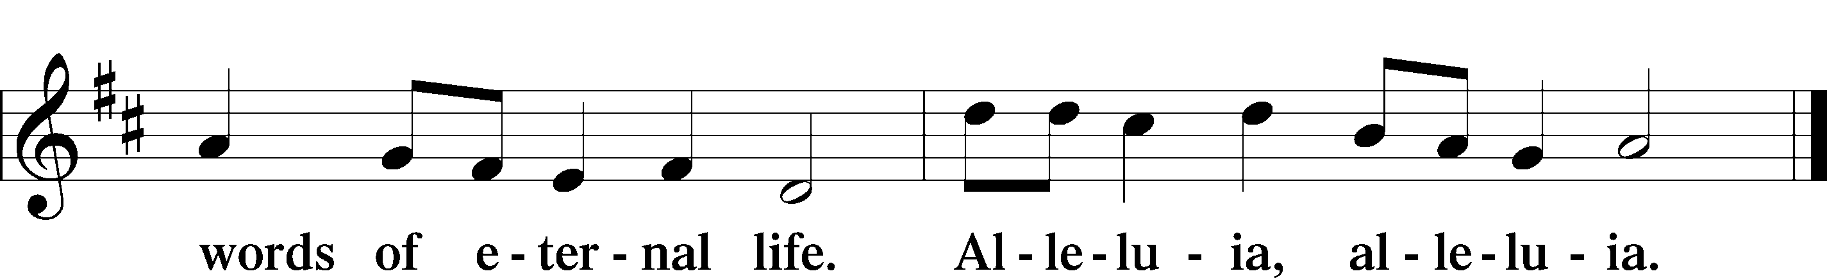

Holy Gospel Mark 9:38–50
P The Holy Gospel according to St. Mark, the ninth chapter.

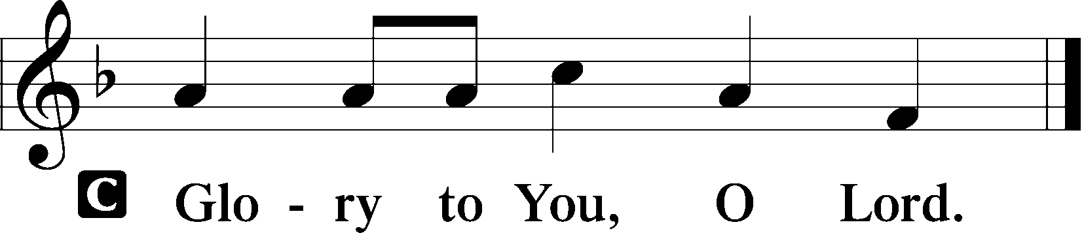
Anyone Not Against Us Is for Us
38John said to [Jesus], “Teacher, we saw someone casting out demons in your name, and we tried to stop him, because he was not following us.” 39But Jesus said, “Do not stop him, for no one who does a mighty work in my name will be able soon afterward to speak evil of me. 40For the one who is not against us is for us. 41For truly, I say to you, whoever gives you a cup of water to drink because you belong to Christ will by no means lose his reward.
Temptations to Sin
42“Whoever causes one of these little ones who believe in me to sin, it would be better for him if a great millstone were hung around his neck and he were thrown into the sea. 43And if your hand causes you to sin, cut it off. It is better for you to enter life crippled than with two hands to go to hell, to the unquenchable fire. 45And if your foot causes you to sin, cut it off. It is better for you to enter life lame than with two feet to be thrown into hell. 47And if your eye causes you to sin, tear it out. It is better for you to enter the kingdom of God with one eye than with two eyes to be thrown into hell, 48‘where their worm does not die and the fire is not quenched.’ 49For everyone will be salted with fire. 50Salt is good, but if the salt has lost its saltiness, how will you make it salty again? Have salt in yourselves, and be at peace with one another.”

P This is the Gospel of the Lord.

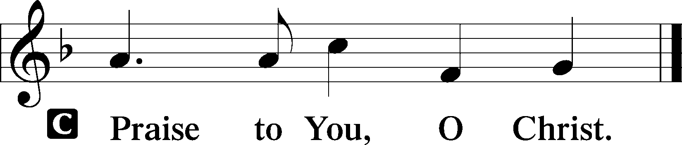

Sit

506 Glory Be to God the Father
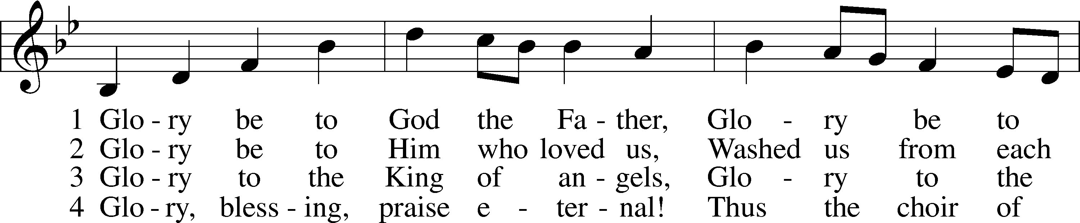
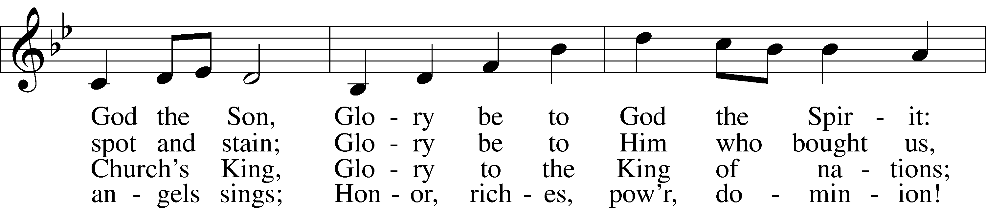
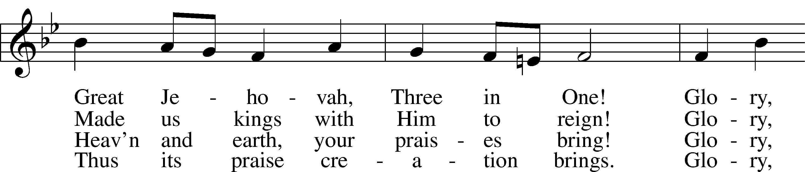
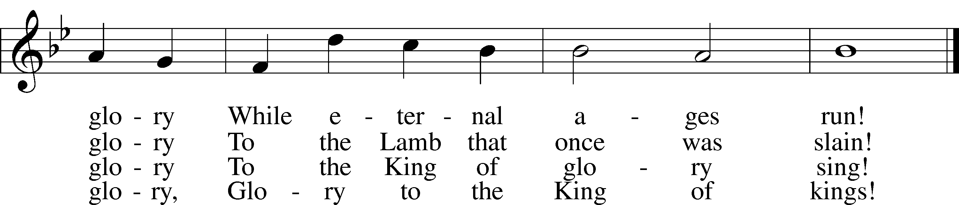
Tune and text: Public domain

Sermon

Stand

Apostles’ Creed
C I believe in God, the Father Almighty,
maker of heaven and earth.

And in Jesus Christ, His only Son, our Lord,
who was conceived by the Holy Spirit,
born of the virgin Mary,
suffered under Pontius Pilate,
was crucified, died and was buried.
He descended into hell.
The third day He rose again from the dead.
He ascended into heaven
and sits at the right hand of God the Father Almighty.
From thence He will come to judge the living and the dead.

I believe in the Holy Spirit,
the holy Christian Church,
the communion of saints,
the forgiveness of sins,
the resurrection of the body,
and the life T everlasting. Amen.

Prayer of the Church

Offering and Offertory LSB 159
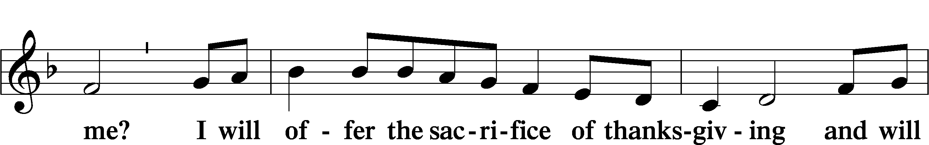
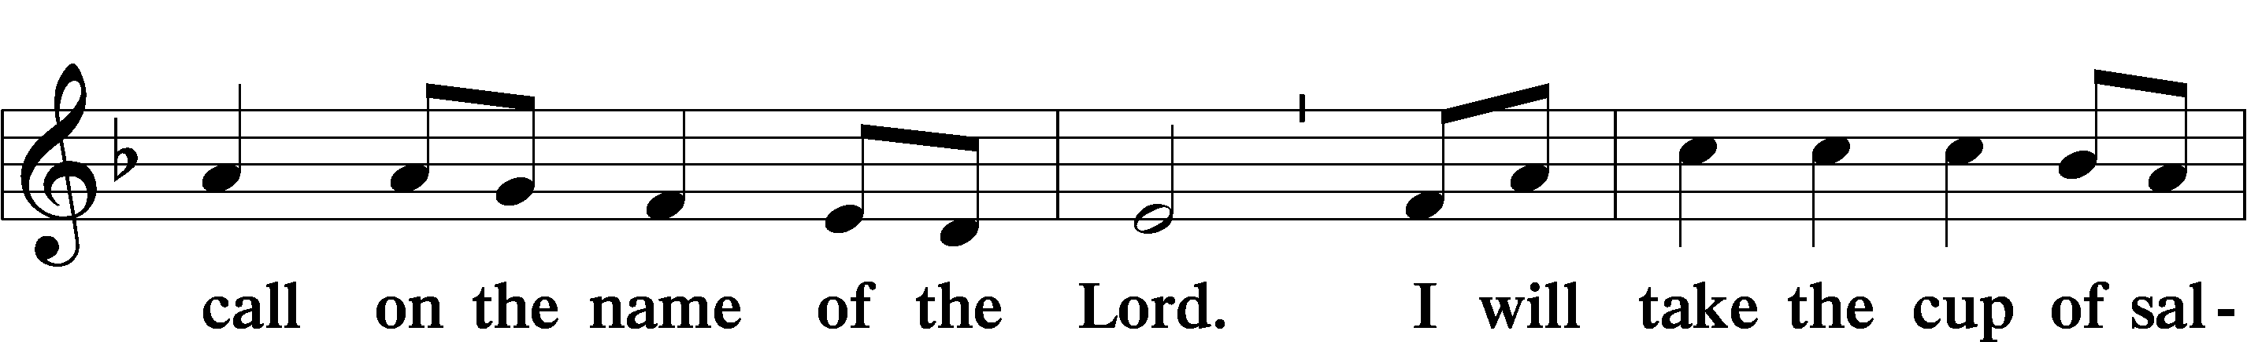
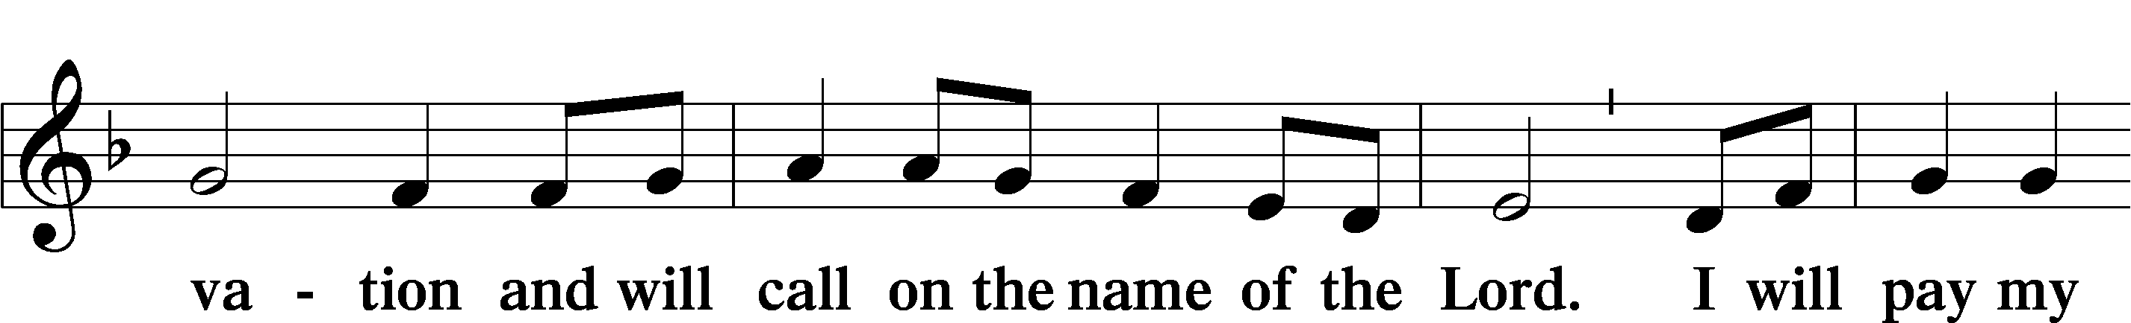
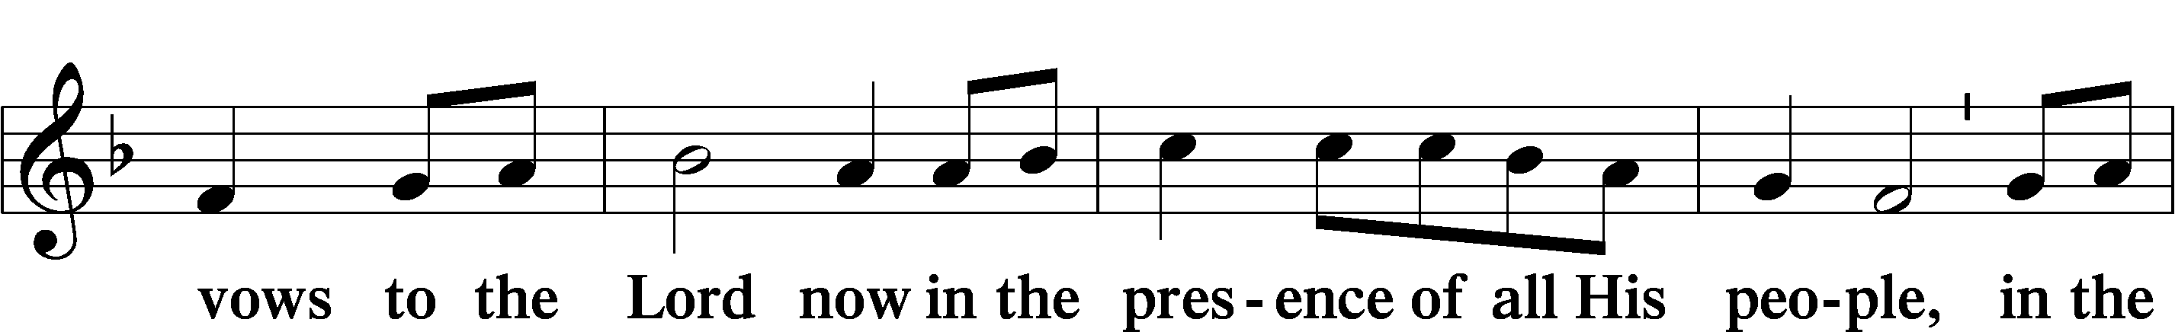
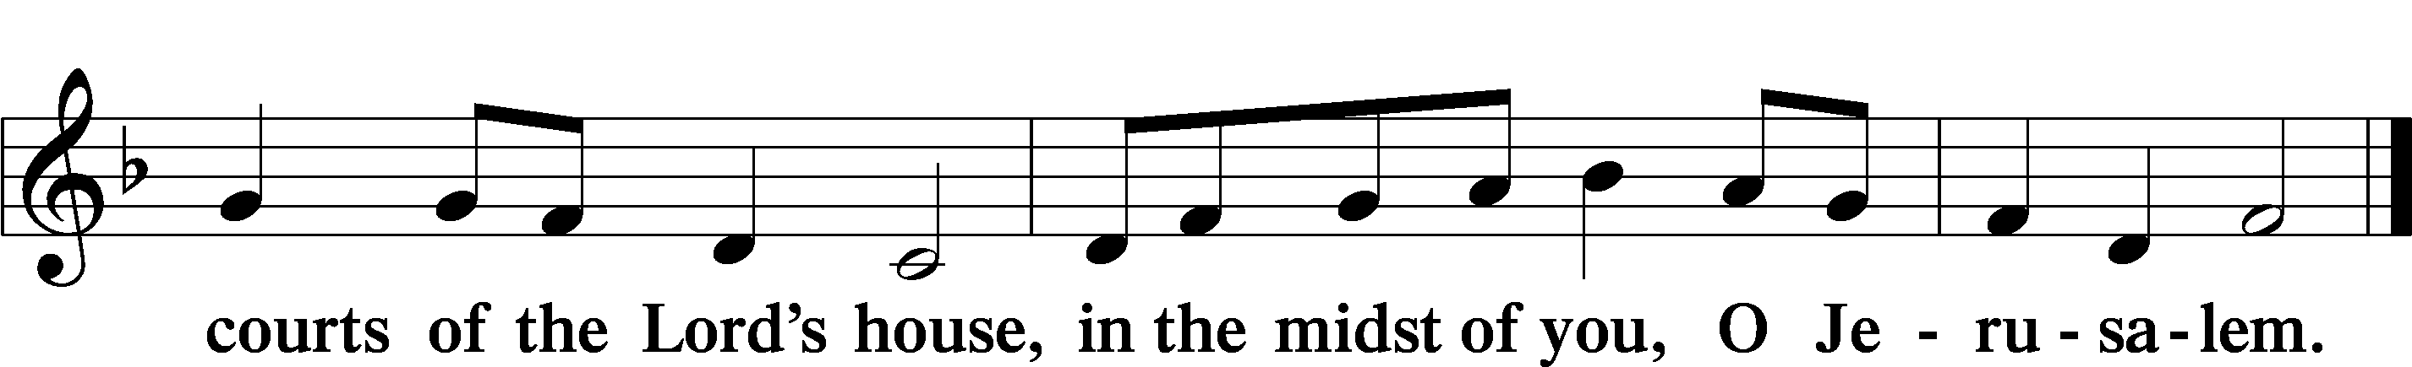

Service of the Sacrament

Preface LSB 160
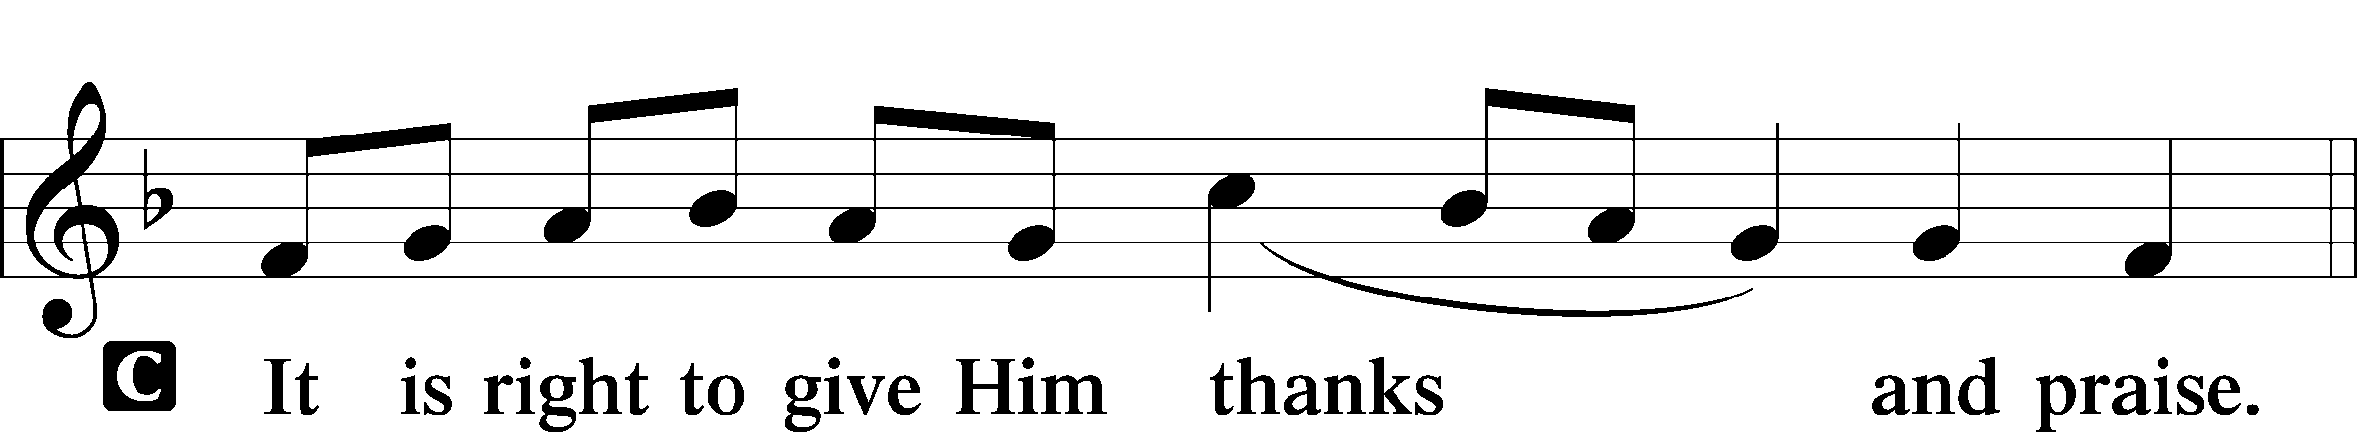

Proper Preface
P It is truly good, right, and salutary that we should at all times and in all places give thanks to You, holy Lord, almighty Father, everlasting God, through Jesus Christ, our Lord, who, out of love for His fallen creation, humbled Himself by taking on the form of a servant, becoming obedient unto death, even death upon a cross. Risen from the dead, He has freed us from eternal death and given us life everlasting. Therefore with angels and archangels and with all the company of heaven we laud and magnify Your glorious name, evermore praising You and saying:

Sanctus LSB 161
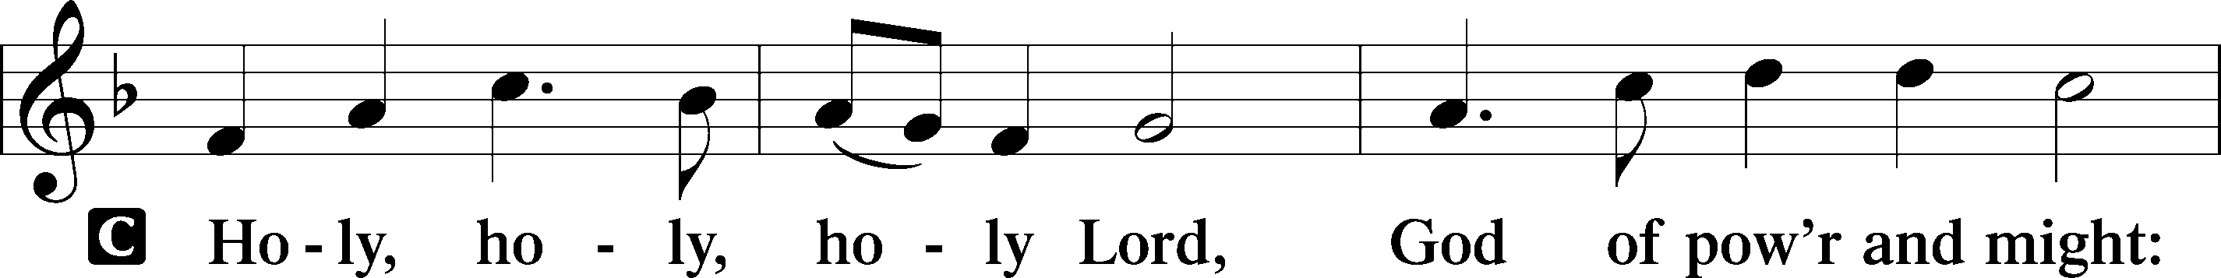
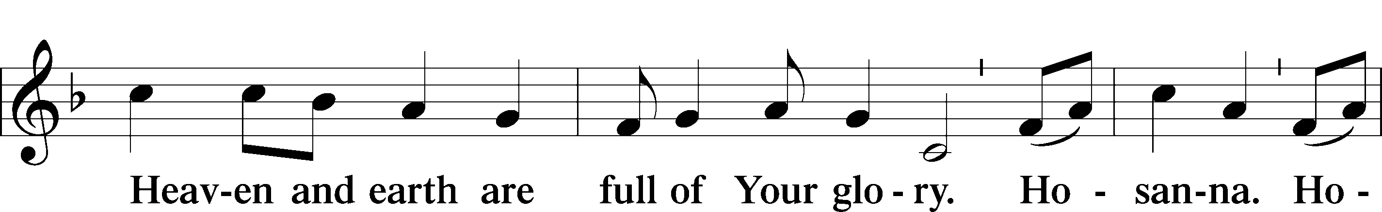
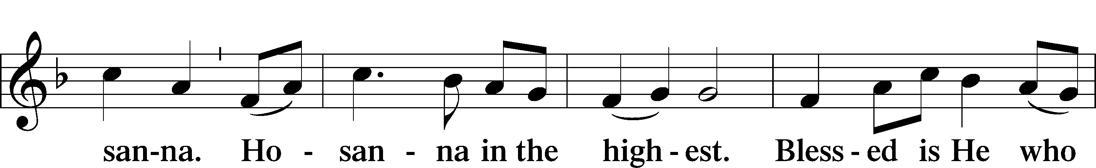
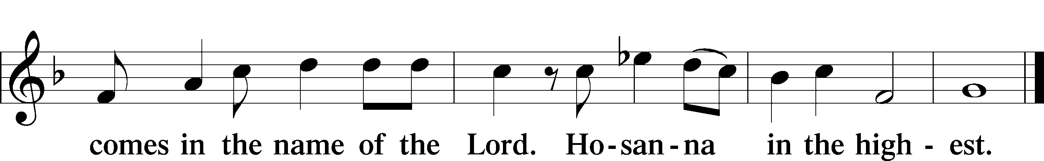

Lord’s Prayer
C Our Father who art in heaven,
hallowed be Thy name,
Thy kingdom come,
Thy will be done on earth
as it is in heaven;
give us this day our daily bread;
and forgive us our trespasses
as we forgive those
who trespass against us;
and lead us not into temptation,
but deliver us from evil.
For Thine is the kingdom
and the power and the glory
forever and ever. Amen.

The Words of Our Lord
P Our Lord Jesus Christ, on the night when He was betrayed, took bread, and when He had given thanks, He broke it and gave it to the disciples and said: “Take, eat; this is My T body, which is given for you. This do in remembrance of Me.”

In the same way also He took the cup after supper, and when He had given thanks, He gave it to them, saying: “Drink of it, all of you; this cup is the new testament in My T blood, which is shed for you for the forgiveness of sins. This do, as often as you drink it, in remembrance of Me.”

Pax Domini LSB 163
P The peace of the Lord be with you always.
C Amen.

Agnus Dei LSB 163
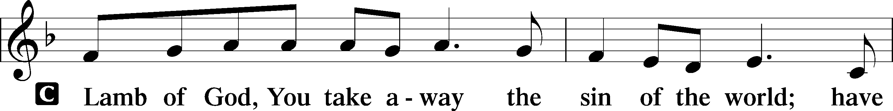
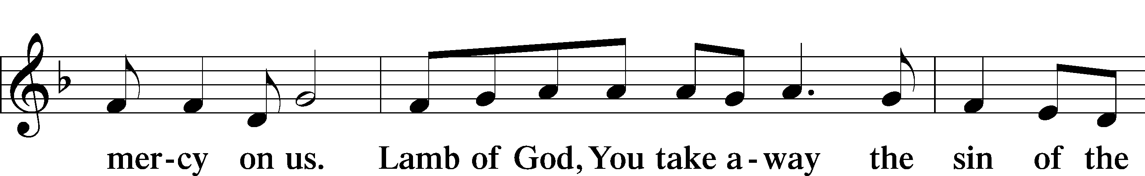
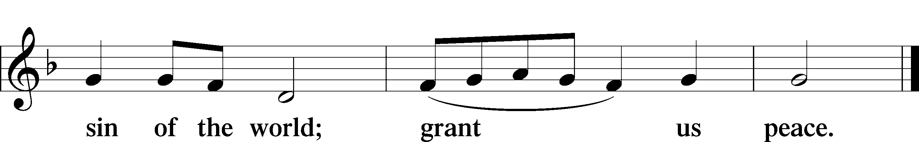

Sit

Distribution

636 Soul, Adorn Yourself with Gladness sts. 1–5, 7
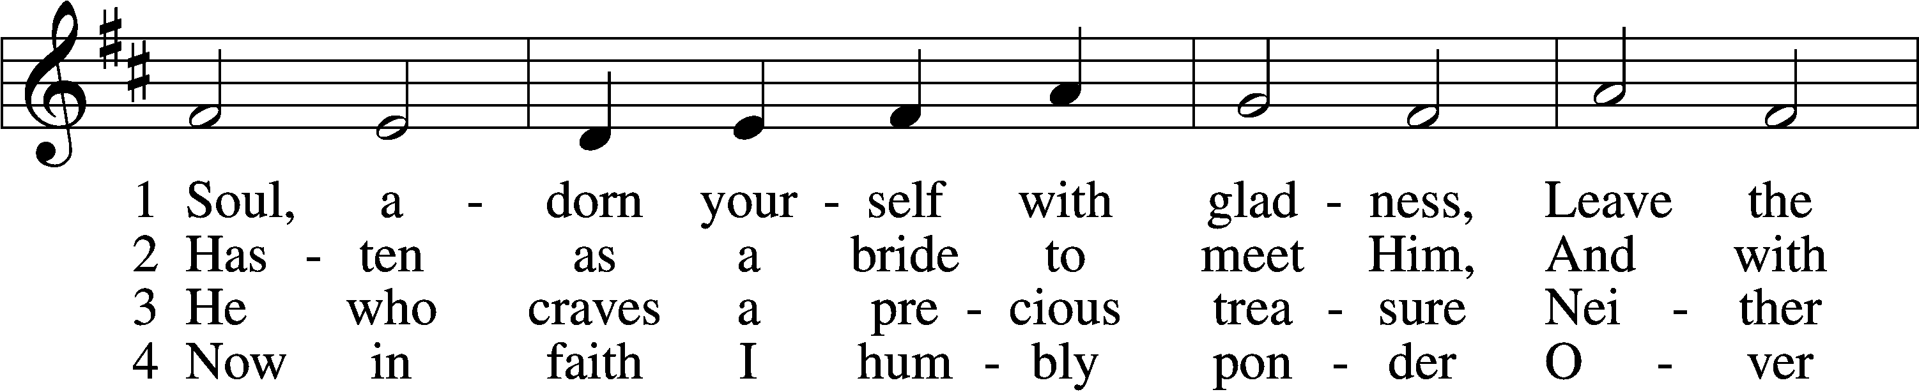
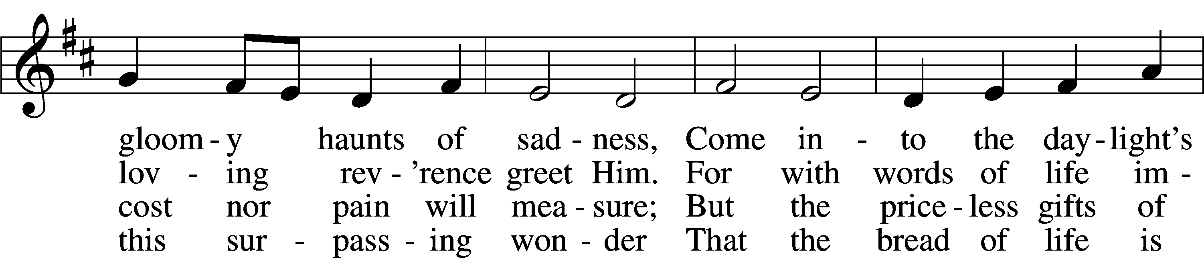
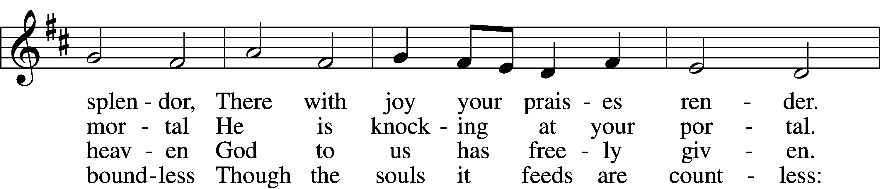
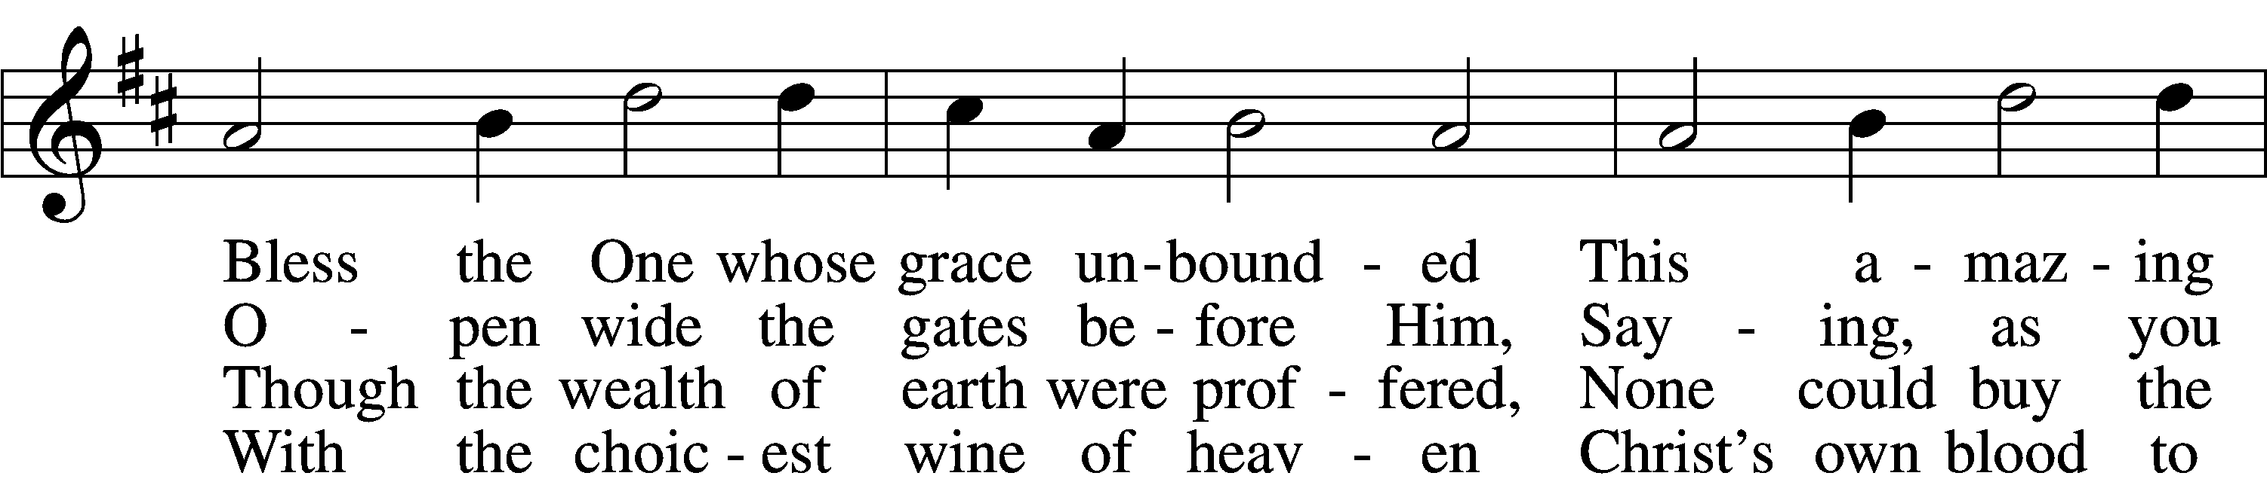
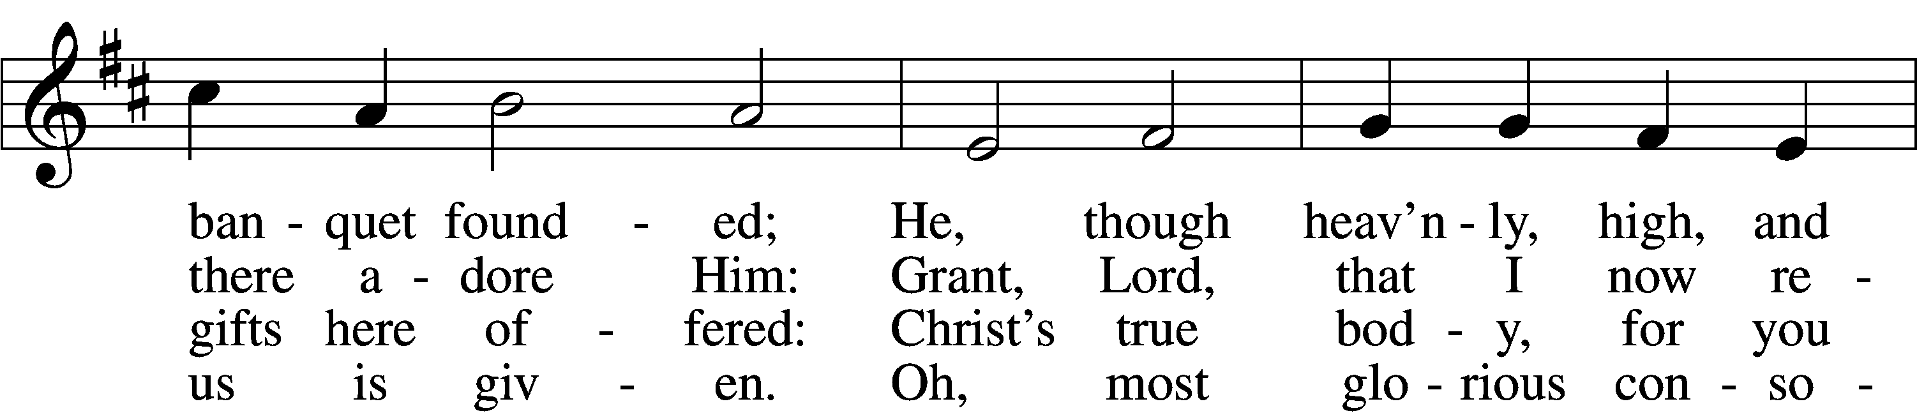
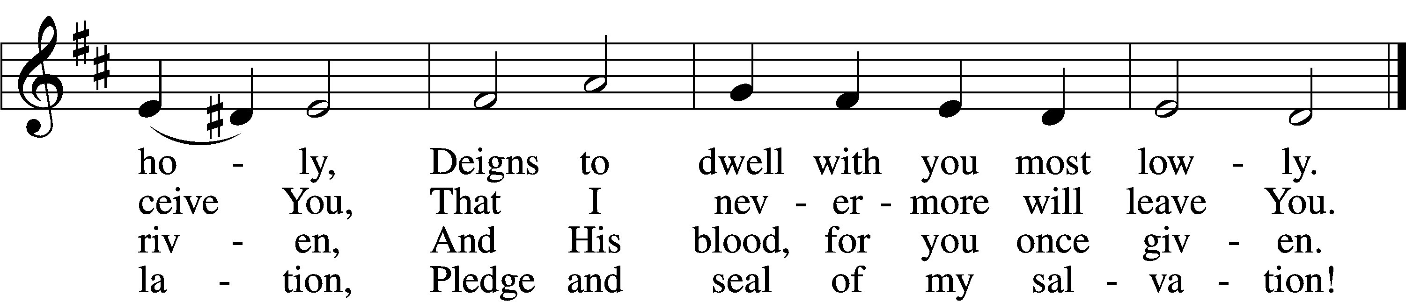

5 Jesus, source of lasting pleasure,
Truest friend, and dearest treasure,
Peace beyond all understanding,
Joy into all life expanding:
Humbly now, I bow before You;
Love incarnate, I adore You;
Worthily let me receive You
And, so favored, never leave You.

7 Lord, by love and mercy driven,
You once left Your throne in heaven
On the cross for me to languish
And to die in bitter anguish,
To forego all joy and gladness
And to shed Your blood in sadness.
By this blood redeemed and living,
Lord, I praise You with thanksgiving.
Tune and text: Public domain
Text (sts. 1, 4–5): © 1978 Lutheran Book of Worship. Used by permission: LSB Hymn License no. 110003744

768 To God the Holy Spirit Let Us Pray
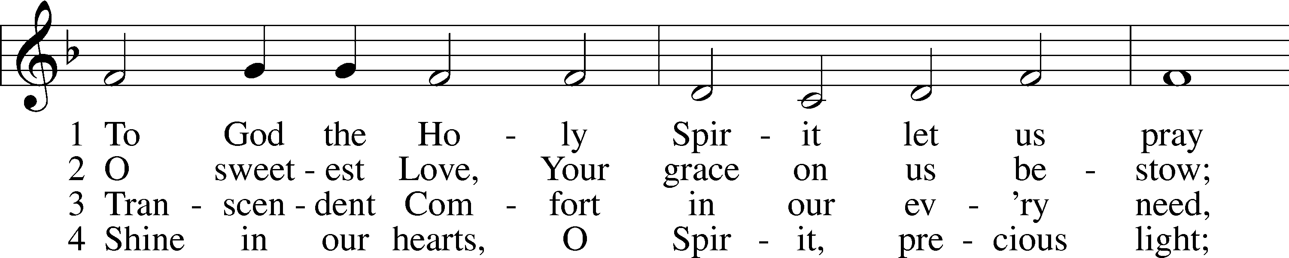
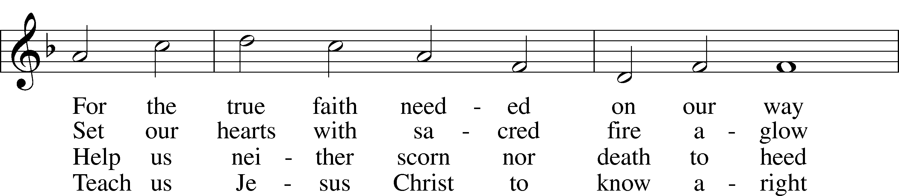
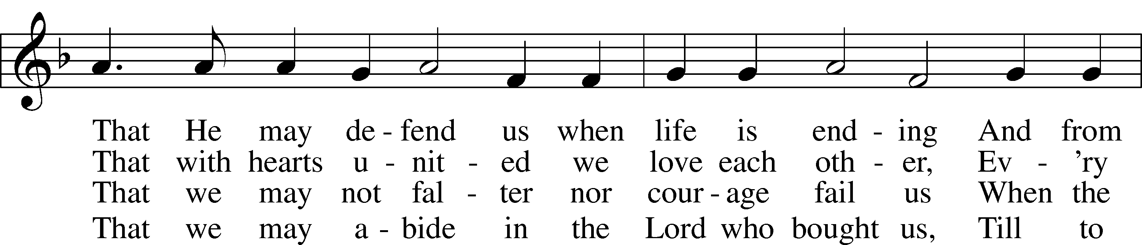
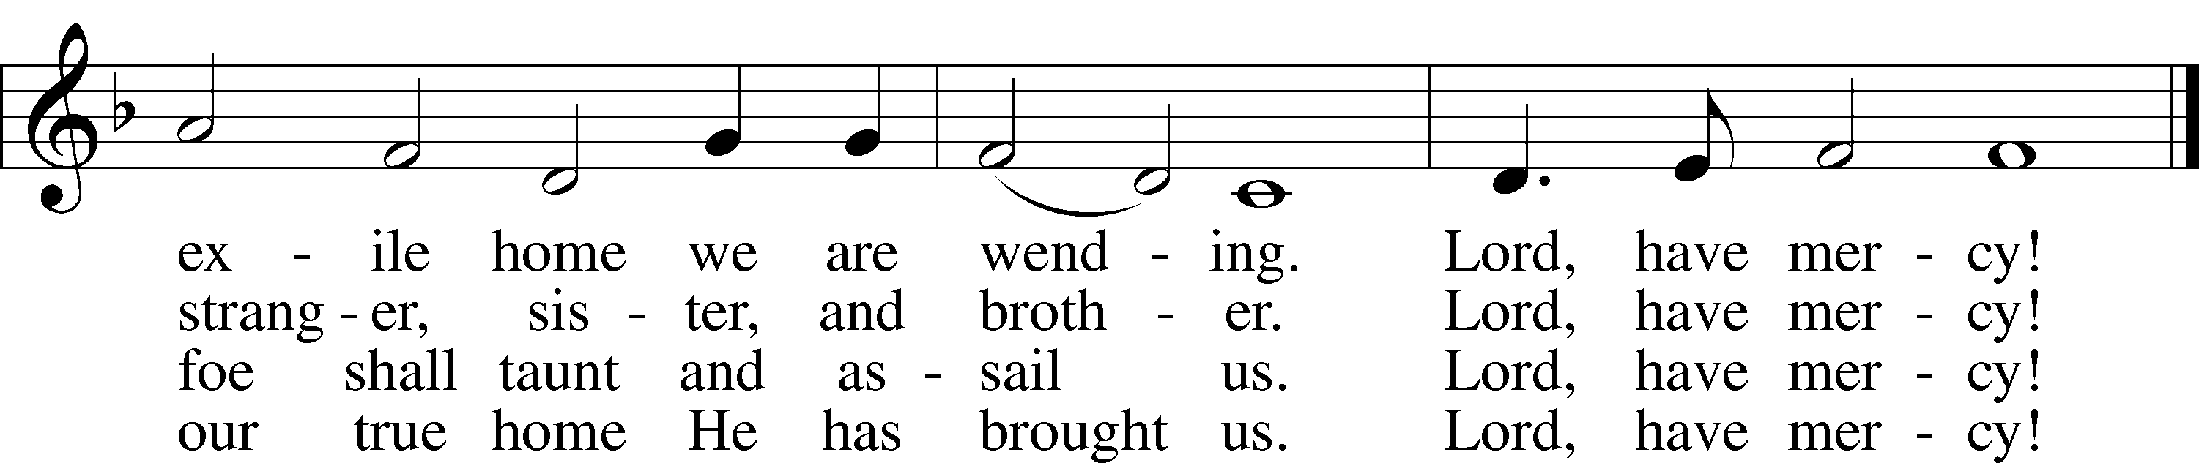
Tune: Public domain
Text: © 1969 Concordia Publishing House. Used by permission: LSB Hymn License no. 110003744

602 The Gifts Christ Freely Gives
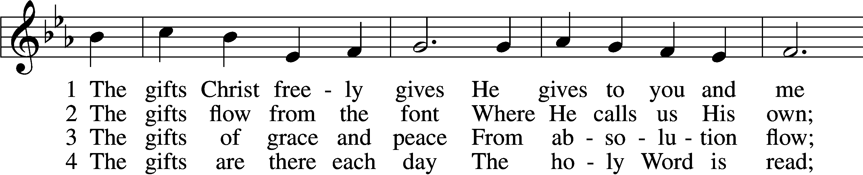
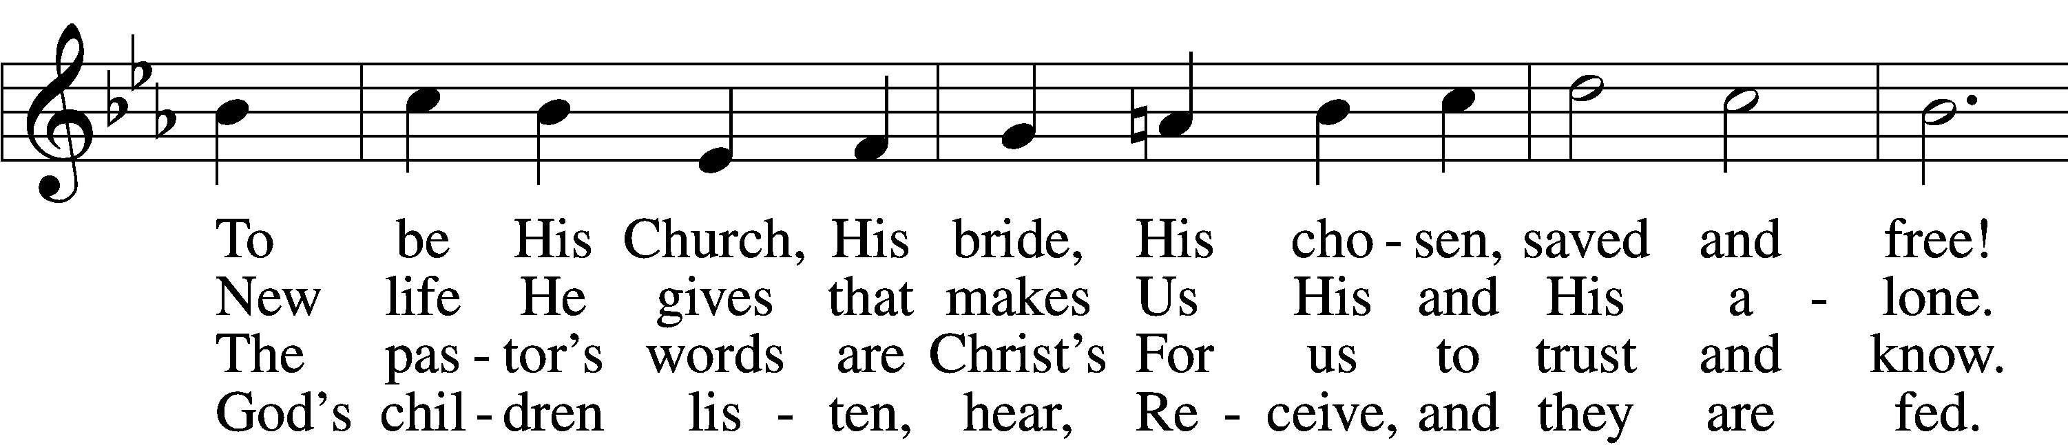
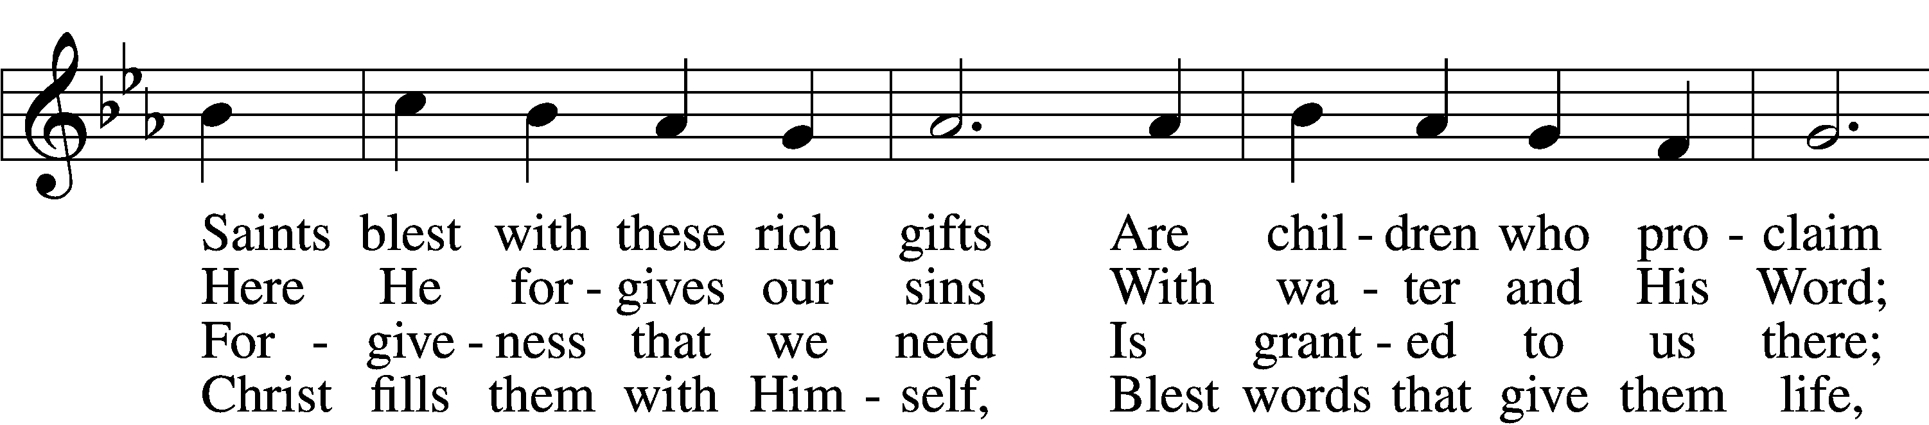
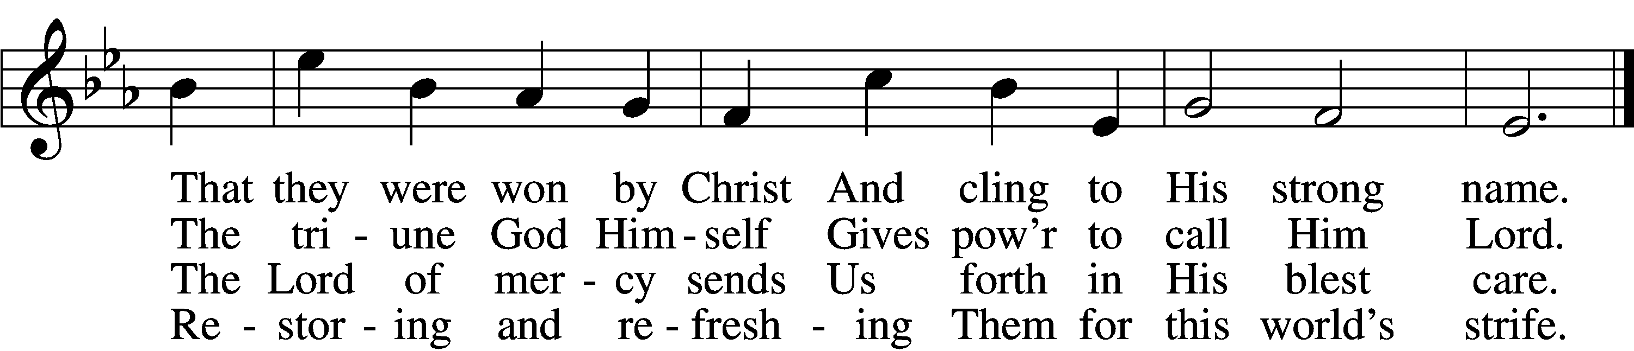

5 The gifts are in the feast,
Gifts far more than we see;
Beneath the bread and wine
Is food from Calvary.
The body and the blood
Remove our ev’ry sin;
We leave His presence in
His peace, renewed again.

6 All glory to the One
Who lavishes such love;
The triune God in love
Assures our life above.
His means of grace for us
Are gifts He loves to give;
All thanks and praise for His
Great love by which we live!
Tune: Public domain
Text: © 2001 Richard C. Resch. Used by permission: LSB Hymn License no. 110003744
Stand

The Dismissal
P The body and blood of our Lord Jesus Christ strengthen and preserve you in body and soul to life everlasting. Depart T in peace.
C Amen.

Thank the Lord LSB 164
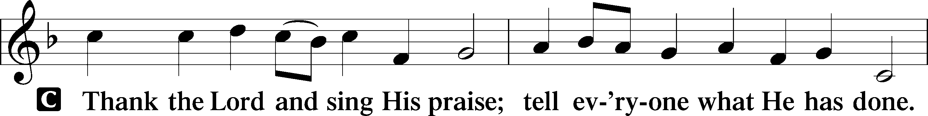
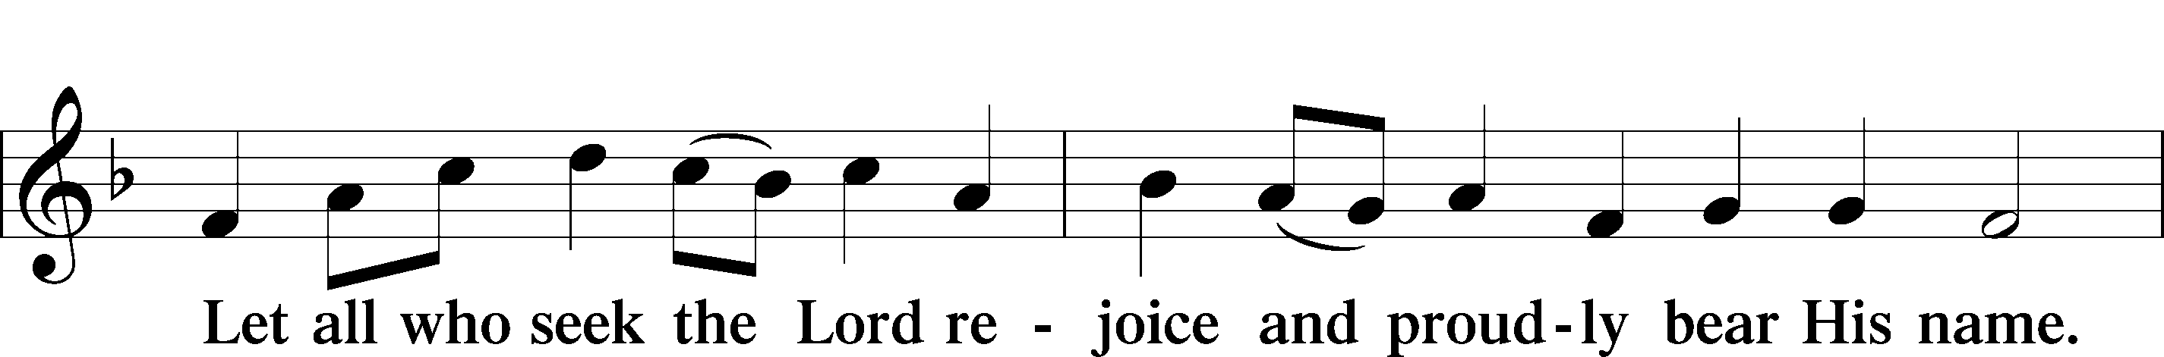
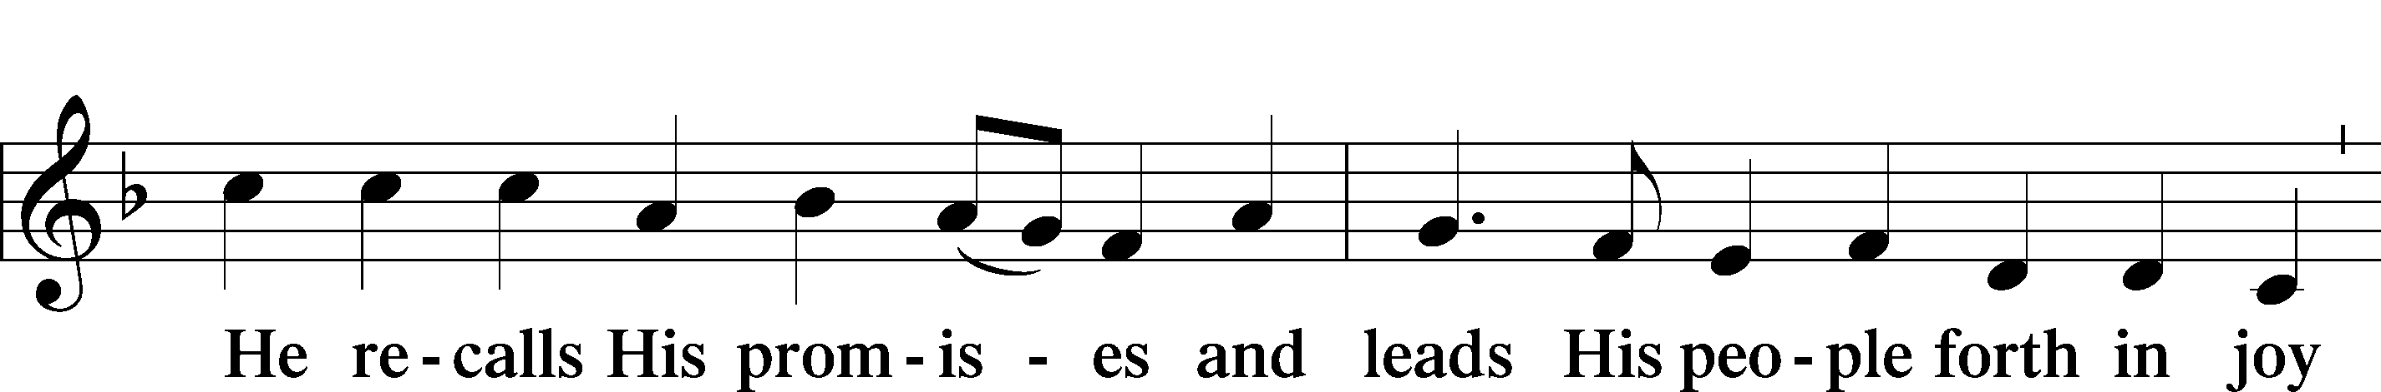
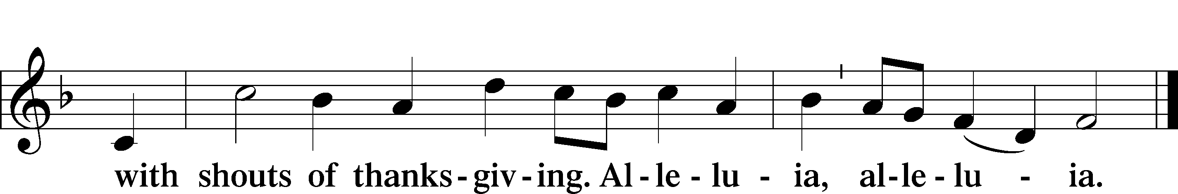

Post-Communion Collect
A Let us pray.
We give thanks to You, almighty God, that You have refreshed us through this salutary gift, and we implore You that of Your mercy You would strengthen us through the same in faith toward You and in fervent love toward one another; through Jesus Christ, Your Son, our Lord, who lives and reigns with You and the Holy Spirit, one God, now and forever.
C Amen.

Benediction LSB 166
P The Lord bless you and keep you.
The Lord make His face shine on you and be gracious to you.
The Lord look upon you with favor and T give you peace.
C Amen.

922 Go, My Children, with My Blessing sts. 1–4
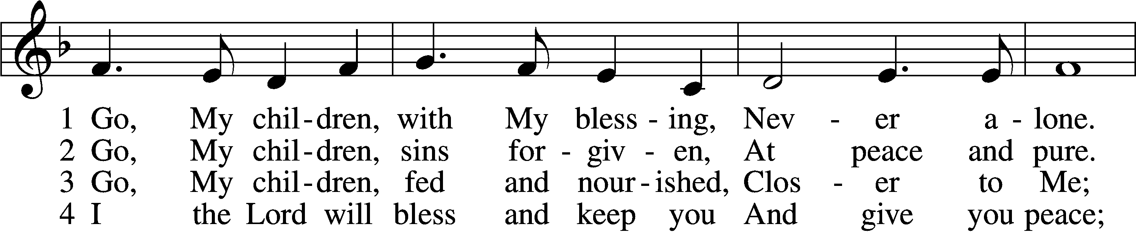
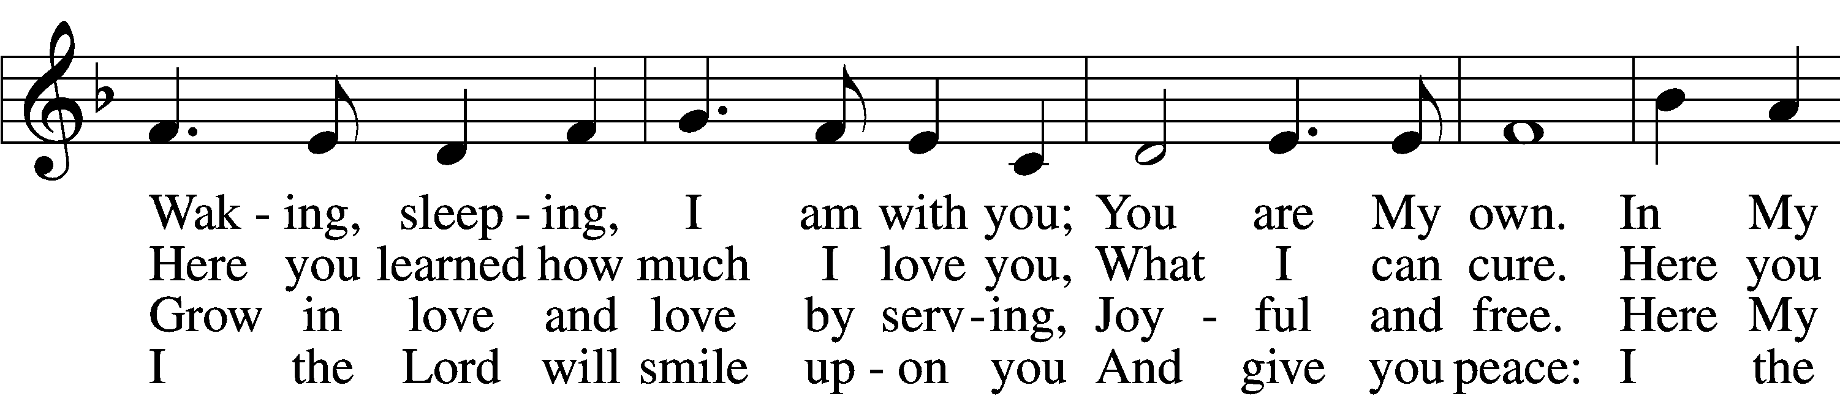
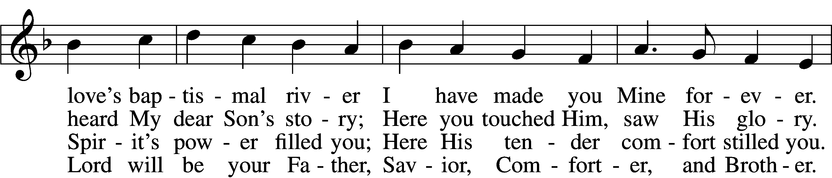
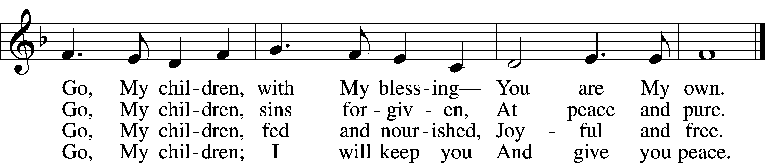
Text: © 1983 Concordia Publishing House. Used by permission: LSB Hymn License no. 110003744
Tune: Public domain

Acknowledgments
Unless otherwise indicated, Scripture quotations are from the ESV® Bible (The Holy Bible, English Standard Version®), copyright © 2001 by Crossway, a publishing ministry of Good News Publishers. Used by permission. All rights reserved.
Created by Lutheran Service Builder © 2021 Concordia Publishing House.

Prayers for Our Members
Sharon Hockemeier, Tenaya Nuttelman | Expectant Mothers
Norman Abels (Brookestone Meadows – Elkhorn) | Healing
Judy Ahrens | Healing
Vaughn Albrecht (Mount Carmel) | Healing
Tom & DyAnn Altwine | Healing
Lyle Colsden (Mother Hull) | Healing
Pat Flodine (Cambridge Court) | Healing
Vi Fox (Prairie View) | Healing
Verleen Gentry | Healing
Wanda Glanzer | Healing
Ruby Hatfield | Healing
Evelyn Heiden | Hospitalized
Lennis Hodgson | Surgery
Boyd Millsap | Healing
Michelle Millsap | Healing
Roger Riekenberg | Healing
Don Richmond | Healing
Marion Richmond | Healing
Ivan Bombeck | Cancer
Fran Junge | Cancer
Bertha Marienau | Cancer
Kim Vos | Cancer

ZION LUTHERAN CHURCH AND SCHOOL

Pr. James DeLoach, Pastor + (308) 627-5260
james.deloach@zionkearney.org
Pr. Doug Gaunt, Pastor + (308) 455-0552
doug.gaunt@zionkearney.org
Tony Splittgerber, Principal + (308) 293-0168
anthony.splittgerber@zionkearney.org

Church Office
Secretary: Shirley Oertwig
Email: school@zionkearney.org
Phone: (308)-234-3410 Fax: (308) 236-8100
Office Hours: Monday-Friday 8:00am-4:00pm
Radio Broadcast: Sunday @ 10:30 a.m. on 1460 AM
Website: www.zionkearney.com

Prayers for Our Members’ Family & Friends
Naomi Wollberg (Andy & Jeanne Wollberg’s daughter-in-law) | Expecting
Gary Catterson family (Jim’s brother) | Grief
Reg Duke (Westman’s brother-in-law) | Healing
James Gentry (Verleen Gentry’s son) | Healing
Roger Hoffman (Marc’s father) | Healing
David Kreutzer | Healing
Sharon Kreutzer (Richard’s mother) | Healing
Pastor Rob Kuefner | Healing
Lyra Mais (Zion student) | Healing
Dillon Malchow (Joy Barefoot’s nephew) | Healing
Mary Ann Mertz (Pam’s Uhlir’s friend) | Healing
Tommy Parks (Katie Nuttelman’s friend) | Healing
Tim Powers (Kim Wilken’s brother) | Healing
Roy Reynolds (Verleen Gentry’s son-in-law) | Healing
Lynne Saathoff (Verleen Gentry’s sister-in-law) | Healing
Randy Solomon (Beth Rosenthal’s father) | Healing
Tim Trampe (Don & Gretchen’s son) | Healing
Angela Well (Charles Marineau’s granddaughter) | Healing
Larry Bombeck (Ivan’s brother) | Healing
Katie Cunningham (Quentin & Janel Lange’s friend) | Burn
Jonah (Jase & Jarren Blattner’s friend) | Cancer
D.D. Dugger (Sue Kaiser’s brother) | Cancer
Stuart Gronewoller (Lonna’s brother-in-law) | Cancer
Ron Halvorsen (Jeff’s dad) | Cancer
Randy Jochum (Ken Hockemeier’s brother-in-law) | Cancer
Fred Koch (Pam Uhlir’s cousin) | Cancer
John Moore (family of Susan Tonniges) | Cancer
Sharon Mulhair (Pam Uhlir’s cousin) | Cancer
Kolby Shiers (Jessica’s cousin) | Cancer
Tyrone Uhlir (Pam’s nephew) | Cancer
Tim Smallcomb (Wilkens’ friend) | Deployment

Today’s Radio Broadcast is given to the Glory of the Lord by
Dave & Kay Banner

Worship Assistants

Sunday, September 26 ~ 9:00am

Elder: Nathan Gaunt
Usher: Mike Wilkens
Acolyte: Addison Splittgerber
Engineer: Shawn Starkey
Announcer: Lonna Gronewoller
Altar Guild: Carol Gaunt & Liz Gaunt

Sunday, October 3 ~ 9:00am

Elder: Bruce Brooks
Usher: Fred Flessner
Acolyte: Amy Tonniges
Engineer: Jamie Nikodym
Announcer: Carol Kreutzer
Altar Guild: Jamie & Shirley Helmbrecht

Our Response to the Gospel

Date: 09/19/2021

Offering:
Weekly Need: $7,457.69

This Week at Zion

Sun  09/26 | 9:00a  10:30a  10:15a | Divine Service  Radio Broadcast 1460am & 92.1fm  Bible Study
Mon  09/27 | Birthdays  Anniversary | ---  ---
Tues  09/28 | 1:30p  7:00p  Birthdays  Anniversaries | Sleeping Mats  Council  Jill Bates  ---
Wed  09/29 | 8:30a  5:45p  7:00p  Birthdays  Anniversaries | Chapel  Midweek  Adult Choir  --  ---
Thurs  09/30 | Birthdays  Anniversaries | ---  Todd & Chelsea Junge
Fri  10/01 | Birthdays  Anniversaries | No School- Teacher In-Service  Seth Altwine, Alexis Wommer  ---
Sat  10/02 | 11:00am-3:00  5:00p  Birthdays  Anniversaries | Baby Shower in F.H.  Divine Service  ---  --
Sun  10/03 | 9:00a  10:30a  Birthdays  Anniversaries | Divine Service  Radio Broadcast 1460am & 92.1fm  Elaine Stuehm  Jerry & Marge Hansen

Where our Triune God strengthens us through His mercy in faith toward Him and in fervent love toward one another.

ANNOUNCEMENTS

Sunday School is set to resume for our children Next Sunday,
October 3. There are classes planned for all children and youth in Kindergarten – 12th grade. Class time will be 10:15-11:15.
We would welcome more volunteers to serve as teachers on a rotating or part-time basis.

Thank you to Joy and Luke Barefoot and Jamie Wilkens for providing the violin music this morning.
Next Sunday October 3, is LWML Sunday. All who have been saving mites to help with the LWML mission projects throughout the world are invited to bring them. There will be a large Mite box in the Narthex where they may be placed.
The following is an example of one of the mission grants that Mites will be used for in the 2021-2023 Biennium which has a Mission Goal of $2,150,000.
Lutheran Women’s Missionary League Grant #1
Deaconess Ministry Dakota Boys and Girls Ranch— $81,680

Hundreds of young people from across the nation will come to Dakota Boys and Girls Ranch during the next biennium. Hope and healing await them all. A former male resident stated, “The people at the Ranch honestly cared for me and loved me at a time in my life when I thought the whole world was against me. With their help, and the introduction of God as our truly loving Father, I realized I could do it and that I could change.” The staff continued to reach out and reflect Christ’s love to this young man. Today, he has hope and, thanks in part to the Ranch’s scholarship program, he is in college.

American Red Cross Blood Drive
Hello! Gibbon Public Schools is hosting a Blood Drive on October 26th at Gibbon Public Schools from 8 a.m. to 3 p.m. Please let Lindsay Wilkens know if you would like to donate at (308)-627-0885. Thank you!

The Zion Office will be closed on Friday of this week as there is no school. Our teachers will attend an in-service at Hampton.

Thank You to all who participated in the Zion Golf Tournament Congratulations to the winners Chad and Stephen Anderson in the Adult/Youth division, and Quinten and Will Hogeland in the Adult division.
A big thank you to all of our hole sponsors: Auto Central, O & O Farms, Hinrichs family and the Gaunt & DeLoach families.

Adult Bible Study -The adult bible study class is meeting once again on Sunday mornings. We have begun a study entitled “Just Words.” It is a study of the doctrine of justification by grace through faith and the various biblical metaphors that convey the Gospel. Come grab a donut and cup of coffee as we learn together.

New Custodian Mr. Dennis Bartels began serving this week as our Zion custodian. Mr. Bartels and his wife Sue moved to Kearney recently from Colorado. Be sure to introduce yourself and welcome them.

Offering Options:
1) Place your offering in the basket as you leave
2) Go to zionkearney.churchtrac.com/give
3) Go to zionkearney.com and click on the ChurchTrac icon
4) Mail your gift to Zion Lutheran Church, 2421 C Ave, Kearney, NE 68847 or place it in the mail slot on the south side of the building.
Radio Broadcast - Please help Zion spread the Gospel, signup to sponsor a radio broadcast! There are several open dates.

Church Management System – Zion has switched to a web-based church management system called ChurchTrac. Please pick-up a yellow sheet in the narthex to get setup today to view all of the benefits and features.

It is very important that you setup your account. This is the only way for the office to know of birthdays, anniversaries, etc. The old software program is no longer working, so old information is all what is being used, so more than likely we are missing a lot of babies, etc.

Mission Offerings - If you would like to donate to the missions Zion supports, please use the mission envelopes located in the narthex. The third quarter missions will be going to support Jonathan Clausing. Thank you for your support.

https://www.lcms.org/clausing

https://missioncentral.us/category/africa/jonathan-and-anita-clausing/
SCHOOL NEWS

The Theme for our school year is “Together by Christ’s Love” based on
1 John 4:7-8.

There is no school this Friday, October 1. Our teachers will attend an in-service.

The Zion School Board and staff are holding a scavenger hunt for our school families Thursday, September 30th. Students will receive a map at the end of their school day. Then, starting at 5:30, they will follow the map to meet staff and school board members and get prizes. After completing the map, families will return to Zion to turn in their map for prize drawings and enjoy a special treat.
Early Childhood Openings!

We do still have openings in our 3 yr. old preschool classes. If you or someone you know is still looking for a high quality early childhood experience, please refer us to them!

Ways to Help our School

Zion Scrip
Participate in the Zion scrip program. It is easy to use and to earn money toward tuition and for Zion. Just stop by the office and purchase gift cards for your everyday items or for gifts. It is that simple. 50% goes toward your tuition and 50% goes to Zion building fund. To learn more about the program contact the office.
Big G Boxtops
Download the Big G Boxtop app on your smartphone, select Zion as your choice school, scan your receipt. That is all, quick and simple for Zion to earn money on qualifying items.

Family Fresh Register Receipts
After Zion receives $150,000 worth of receipts, Zion will receive $1,000.

Apple Mart Register Receipts
Save receipts dated September 1. 2021 through March 1, 2022
With the register receipts Zion earns points for dollars spent at Apple Market. The points are redeemed for school items.
It is easy to earn money for your school! Turn your receipts into the office. If you have any questions please stop by the office.

Best Choice and Our Family UPC Codes

Sunday
Oct. 3, 2021
2:30-3:30 p.m.

Join the NATIONAL LIFE CHAIN!

Stand with thousands of pro-lifers throughout the USA!
Pick up signs at Medicap Pharmacy
2706 2nd Ave starting at 2:15
Bring your whole family! Rain or shine!
Water, lawn chairs, umbrellas and strollers are welcome!
As you pick up a sign please refrain from congregating and spread out along 2nd Ave, as we are still practicing social distancing.

The life chain will be attended at more than 1740 locations in 1470 cities and towns across the United States and Canada.

LIFE CHAIN is a peaceful and prayerful public witness of Pro-life individuals standing for one hour praying for our nation and for an end to abortion. It is a visual statement of solidarity by the Christian community that supports and respects the sanctity of human life from conception through natural death.

