Divine Service
Twentieth Sunday
after Pentecost
October 10, 2021

Zion Lutheran Church
Kearney, Nebraska

Welcome to Zion!
All worshippers please fill out an attendance card in the pew rack and let us know how we might be of service to you.

Holy Communion at Zion

The Lord’s Supper is celebrated at this congregation as Jesus has given it. As he says, our Lord gives into our mouths not only bread and wine but his very body and blood to eat and to drink for the forgiveness of sins and to strengthen our union with him and with one another. Our Lord invites to his table those who trust his words, repent of all sin, and set aside any refusal to forgive and love as he forgives and loves us, that they may show forth his death until he comes. All communicants need to register in the narthex prior to the service.

Because those who eat and drink our Lord’s body and blood unworthily do great harm and because Holy Communion is a confession of the faith which is confessed at this altar, any who are not yet instructed, in doubt, or who hold a confession differing from that of this congregation and The Lutheran Church—Missouri Synod, are asked not to commune until they are able to speak with our pastor first. He is happy to visit with you about the Christian faith and how to receive the Lord’s Supper for your good and for the good of others. Those not communing are invited to come to the altar, cross your arms in front of you, and bow your head to receive a pastoral blessing.

Christ Jesus Is the One and Only Good
by Whom You Inherit Eternal Life

The Lord is the Author and Giver of life, as well as a consuming fire of judgment against all “who afflict the righteous, who take a bribe, and turn aside the needy in the gate” (Amos 5:12). “Seek the Lord and live,” therefore, by hating what is evil, loving what is good and doing what is just and right, according to His Word. “And so the Lord, the God of hosts, will be with you” (Amos 5:6, 14–15). Understand that “no one is good except God alone” (Mark 10:18). The life that you are called to live is found neither in your “great possessions,” nor in your good works, but only in Christ Jesus. Let go of “all that you have” and follow Him, even unto death, and “you will have treasure in heaven” (Mark 10:21–22). Do not harden your heart against His voice, nor turn away from Him, lest you “fall away from the living God.” Rather, hear and heed His call, cling to His Word, and “exhort one another every day,” that you may remain steadfast in Christ and “firm to the end” (Heb. 3:12–15).
Confession and Absolution

718 Jesus, Lead Thou On
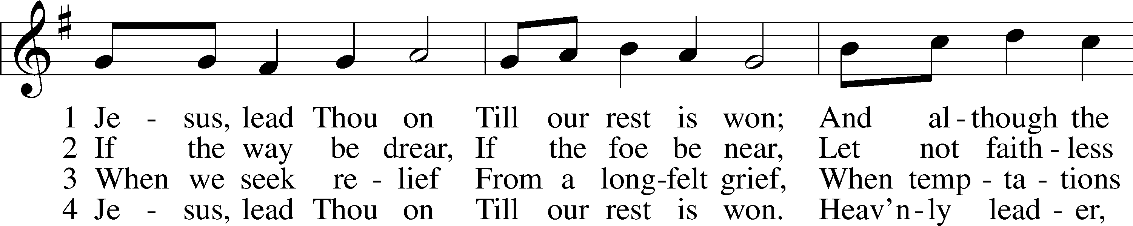
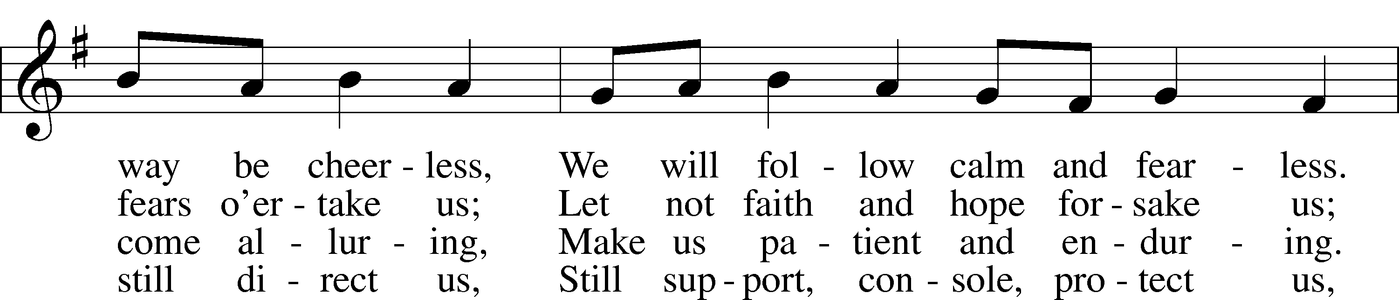
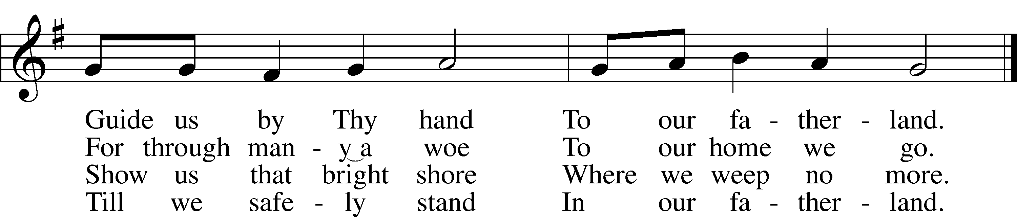
Text and tune: Public domain

Stand. The sign of the cross may be made by all in remembrance of their Baptism.

Invocation
P In the name of the Father and of the T Son and of the Holy Spirit.
C Amen.

Exhortation LSB 151
P If we say we have no sin, we deceive ourselves, and the truth is not in us.
C But if we confess our sins, God, who is faithful and just, will forgive our sins and cleanse us from all unrighteousness.

Silence for reflection on God’s Word and for self-examination.

Confession of Sins LSB 151
P Let us then confess our sins to God our Father.
C Most merciful God, we confess that we are by nature sinful and unclean. We have sinned against You in thought, word, and deed, by what we have done and by what we have left undone. We have not loved You with our whole heart; we have not loved our neighbors as ourselves. We justly deserve Your present and eternal punishment. For the sake of Your Son, Jesus Christ, have mercy on us. Forgive us, renew us, and lead us, so that we may delight in Your will and walk in Your ways to the glory of Your holy name. Amen.

Absolution LSB 151
P Almighty God in His mercy has given His Son to die for you and for His sake forgives you all your sins. As a called and ordained servant of Christ, and by His authority, I therefore forgive you all your sins in the name of the Father and of the T Son and of the Holy Spirit.
C Amen.

Service of the Word

Introit Psalm 112:3–6; antiphon: v. 1
Praise the Lord! Blessèd is the man who | fears the Lord,*
who greatly delights in his com- | mandments!
Wealth and riches are | in his house,*
and his righteousness endures for- | ever.
Light dawns in the darkness for the | upright;*
he is gracious, merciful, and | righteous.
It is well with the man who deals generous- | ly and lends;*
who conducts his affairs with | justice.
For the righteous will nev- | er be moved;*
he will be remembered for- | ever.
Glory be to the Father and | to the Son*
and to the Holy | Spirit;
as it was in the be- | ginning,*
is now, and will be forever. | Amen.
Praise the Lord! Blessèd is the man who | fears the Lord,*
who greatly delights in his com- | mandments!

Kyrie LSB 152
A In peace let us pray to the Lord.
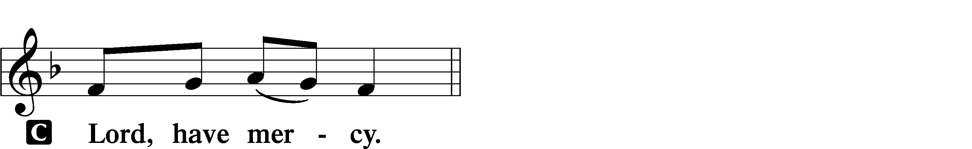

A For the peace from above and for our salvation let us pray to the Lord.

A For the peace of the whole world, for the well-being of the Church of God, and for the unity of all let us pray to the Lord.

A For this holy house and for all who offer here their worship and praise let us pray to the Lord.
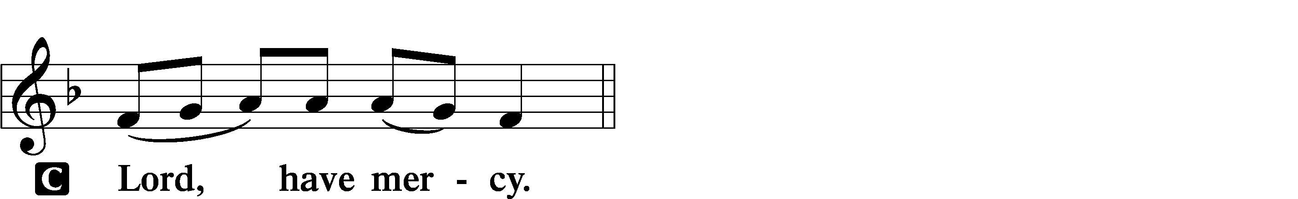

A Help, save, comfort, and defend us, gracious Lord.

Gloria in Excelsis LSB 154
A Glory to God in the highest, and peace to His people on earth.
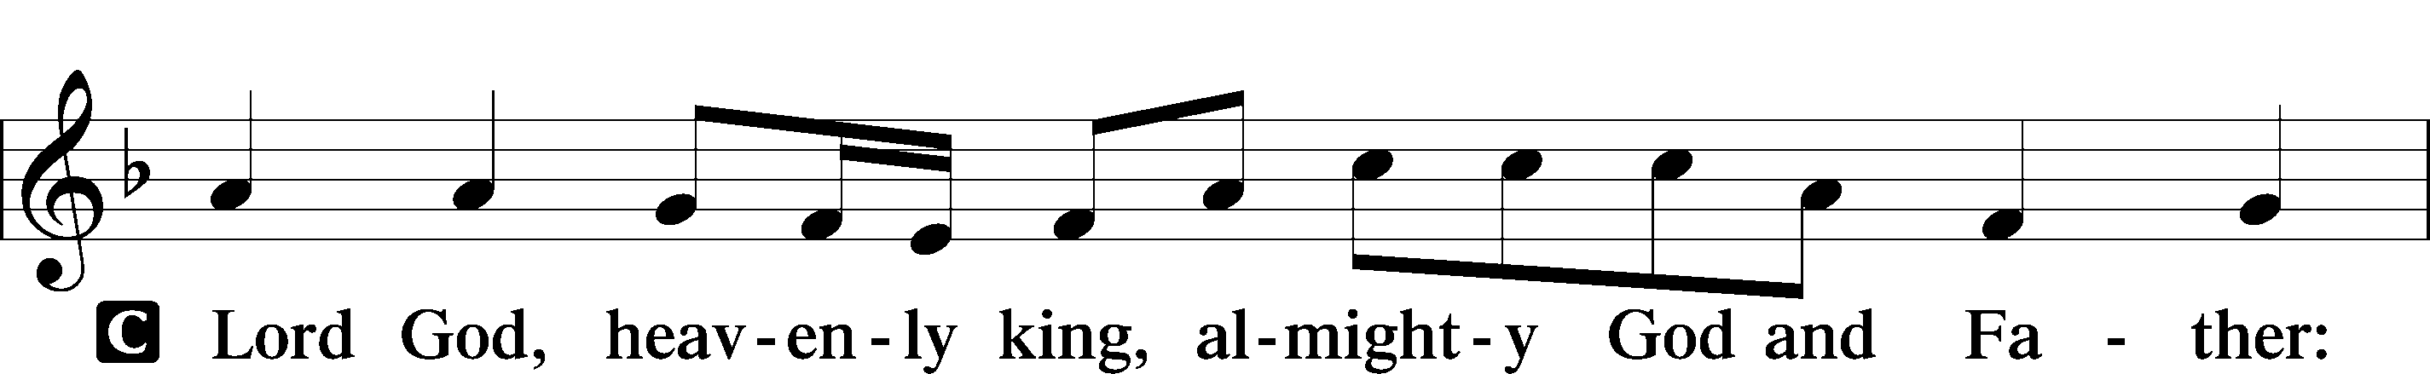
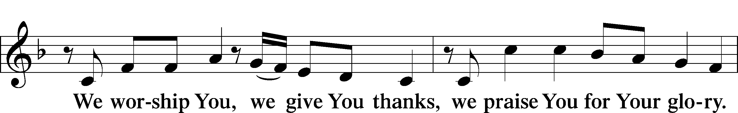
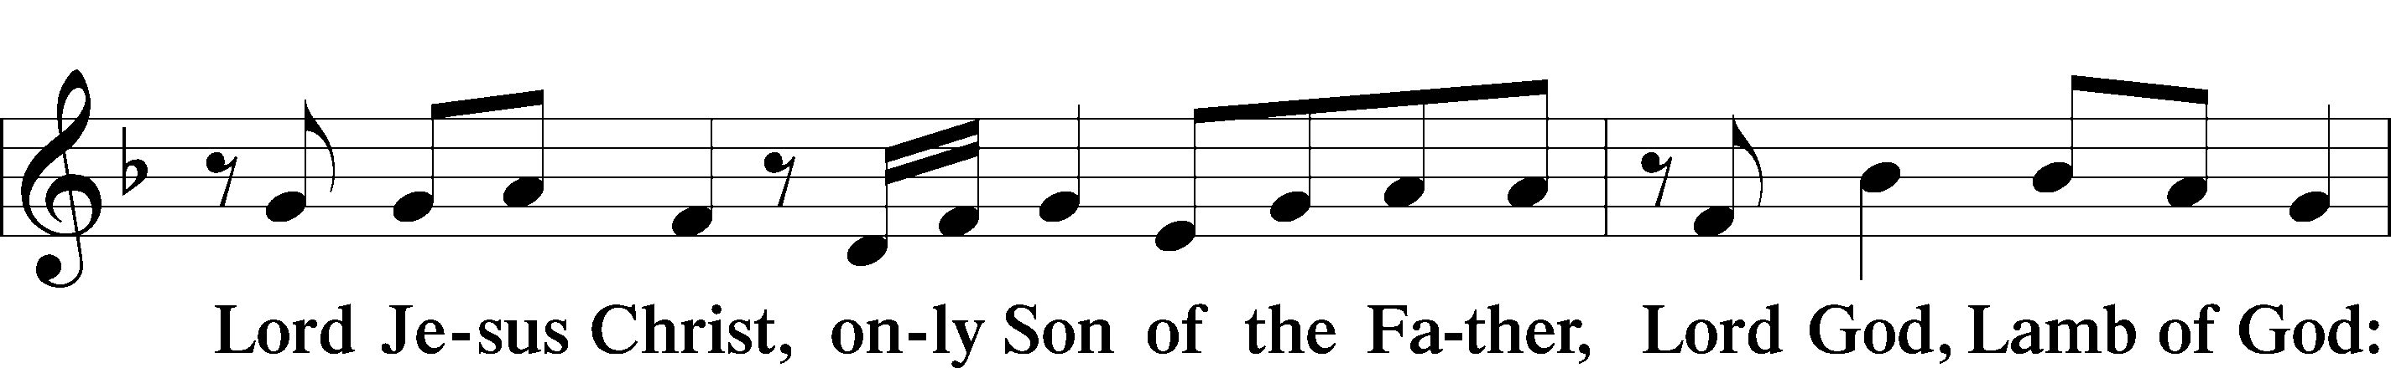
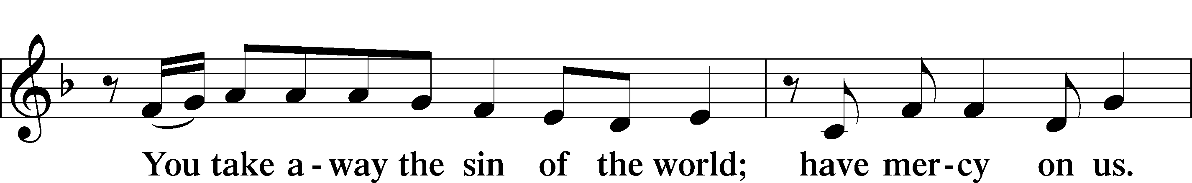
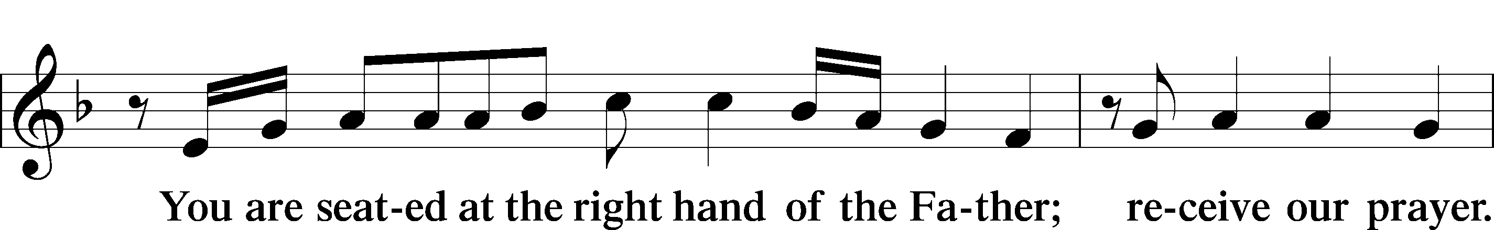
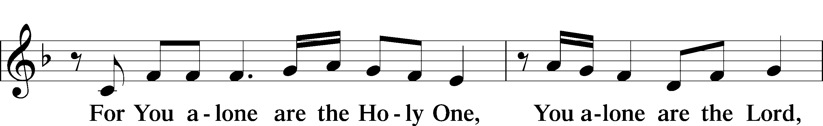
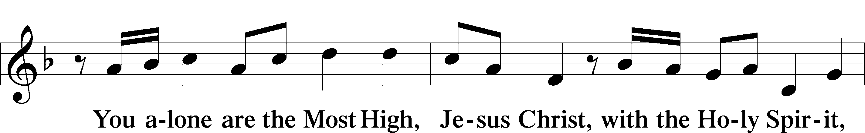
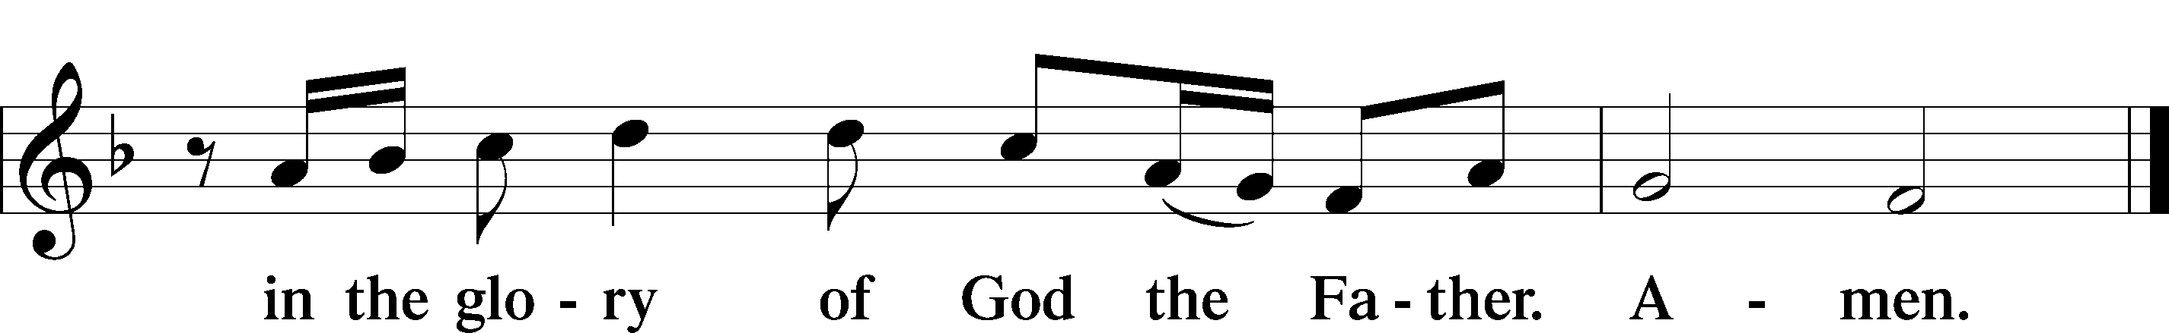

Salutation and Collect of the Day
P The Lord be with you.
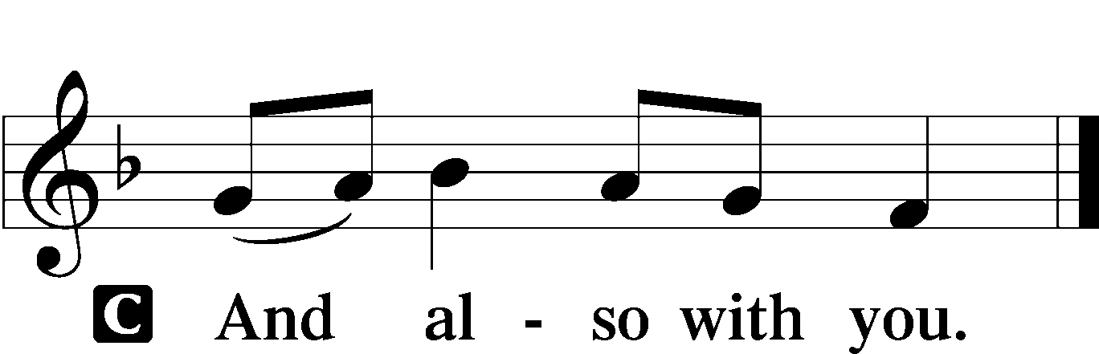

P Let us pray.
Lord Jesus Christ, whose grace always precedes and follows us, help us to forsake all trust in earthly gain and to find in You our heavenly treasure; for You live and reign with the Father and the Holy Spirit, one God, now and forever.

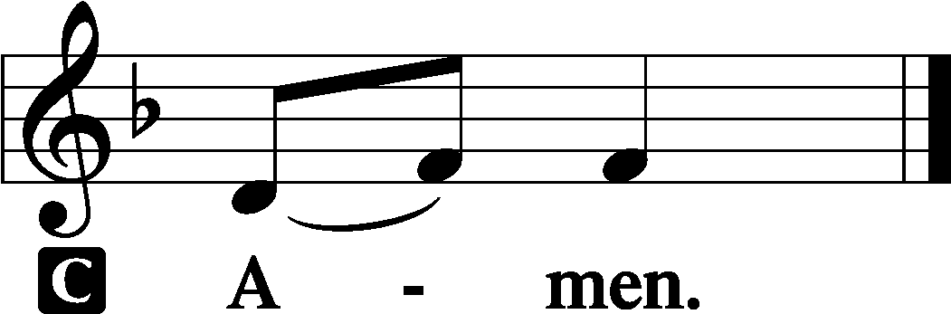

Sit
Old Testament Reading Amos 5:6–7, 10–15
⁶Seek the Lord and live,
lest he break out like fire in the house of Joseph,
and it devour, with none to quench it for Bethel,
⁷O you who turn justice to wormwood
and cast down righteousness to the earth! . . .
¹⁰They hate him who reproves in the gate,
and they abhor him who speaks the truth.
¹¹Therefore because you trample on the poor
and you exact taxes of grain from him,
you have built houses of hewn stone,
but you shall not dwell in them;
you have planted pleasant vineyards,
but you shall not drink their wine.
¹²For I know how many are your transgressions
and how great are your sins—
you who afflict the righteous, who take a bribe,
and turn aside the needy in the gate.
¹³Therefore he who is prudent will keep silent in such a time,
for it is an evil time.
¹⁴Seek good, and not evil,
that you may live;
and so the Lord, the God of hosts, will be with you,
as you have said.
¹⁵Hate evil, and love good,
and establish justice in the gate;
it may be that the Lord, the God of hosts,
will be gracious to the remnant of Joseph.
A This is the Word of the Lord.
C Thanks be to God.

Gradual Psalm 91:11; 103:1
He will command his angels con- | cerning you*
to guard you in | all your ways.
Bless the Lord, | O my soul,*
and all that is within me, bless his | holy name!

Epistle Hebrews 3:12–19

¹²Take care, brothers, lest there be in any of you an evil, unbelieving heart, leading you to fall away from the living God. ¹³But exhort one another every day, as long as it is called “today,” that none of you may be hardened by the deceitfulness of sin. ¹⁴For we share in Christ, if indeed we hold our original confidence firm to the end. ¹⁵As it is said,
“Today, if you hear his voice,
do not harden your hearts as in the rebellion.”
¹⁶For who were those who heard and yet rebelled? Was it not all those who left Egypt led by Moses? ¹⁷And with whom was he provoked for forty years? Was it not with those who sinned, whose bodies fell in the wilderness? ¹⁸And to whom did he swear that they would not enter his rest, but to those who were disobedient? ¹⁹So we see that they were unable to enter because of unbelief.

A This is the Word of the Lord.
C Thanks be to God.

Stand

Alleluia and Verse LSB 156
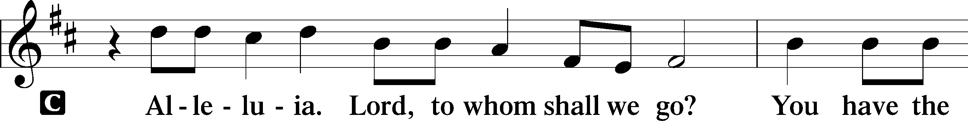
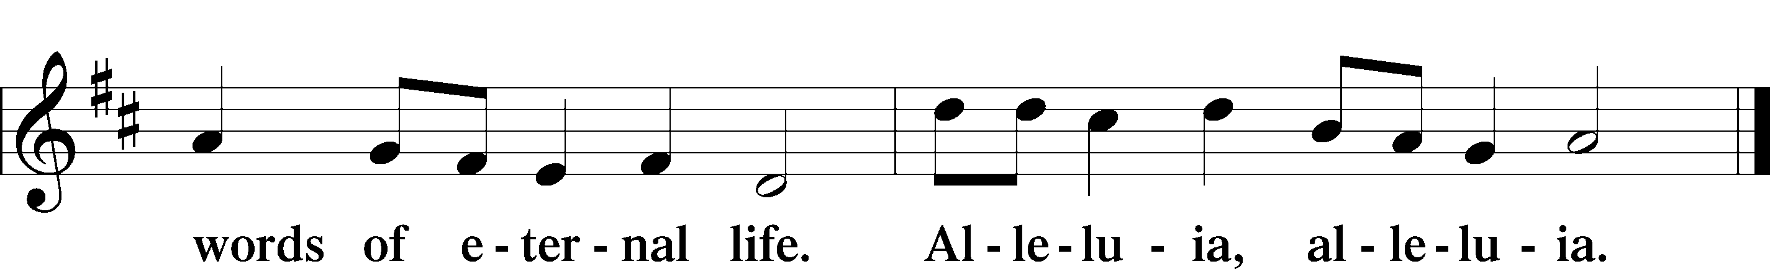

Holy Gospel Mark 10:2–16

P The Holy Gospel according to St. Mark, the tenth chapter.

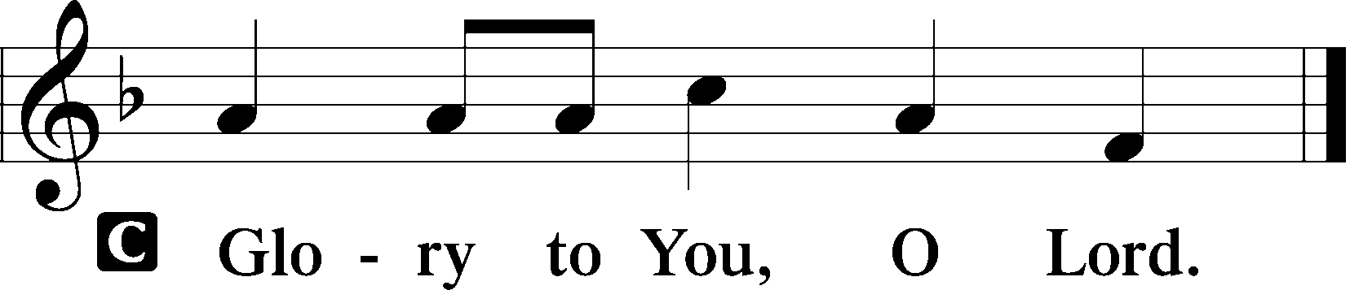

The Rich Young Man
¹⁷As [Jesus] was setting out on his journey, a man ran up and knelt before him and asked him, “Good Teacher, what must I do to inherit eternal life?” ¹⁸And Jesus said to him, “Why do you call me good? No one is good except God alone. ¹⁹You know the commandments: ‘Do not murder, Do not commit adultery, Do not steal, Do not bear false witness, Do not defraud, Honor your father and mother.’” ²⁰And he said to him, “Teacher, all these I have kept from my youth.” ²¹And Jesus, looking at him, loved him, and said to him, “You lack one thing: go, sell all that you have and give to the poor, and you will have treasure in heaven; and come, follow me.” ²²Disheartened by the saying, he went away sorrowful, for he had great possessions.

P This is the Gospel of the Lord.

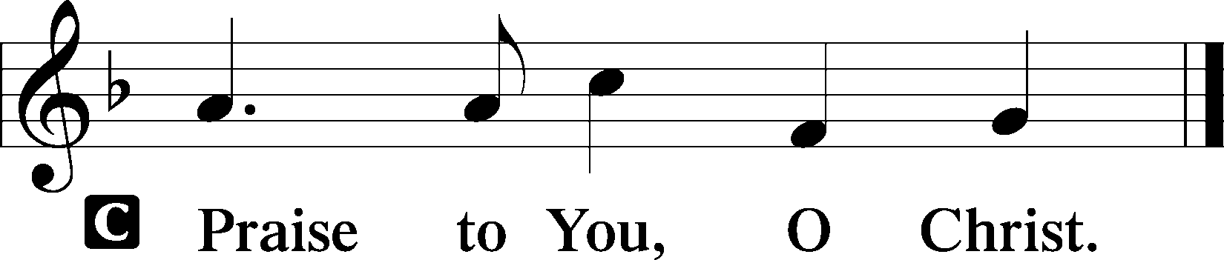

Sit

694 Thee Will I Love, My Strength, My Tower
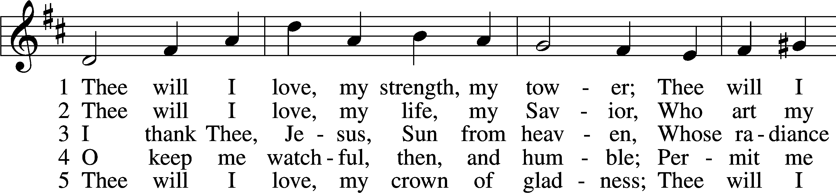
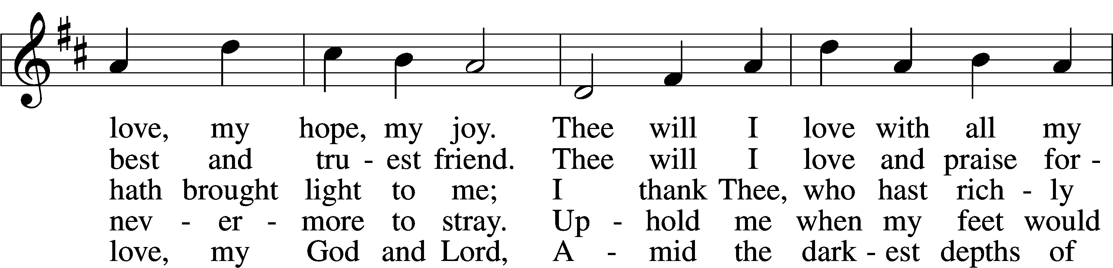
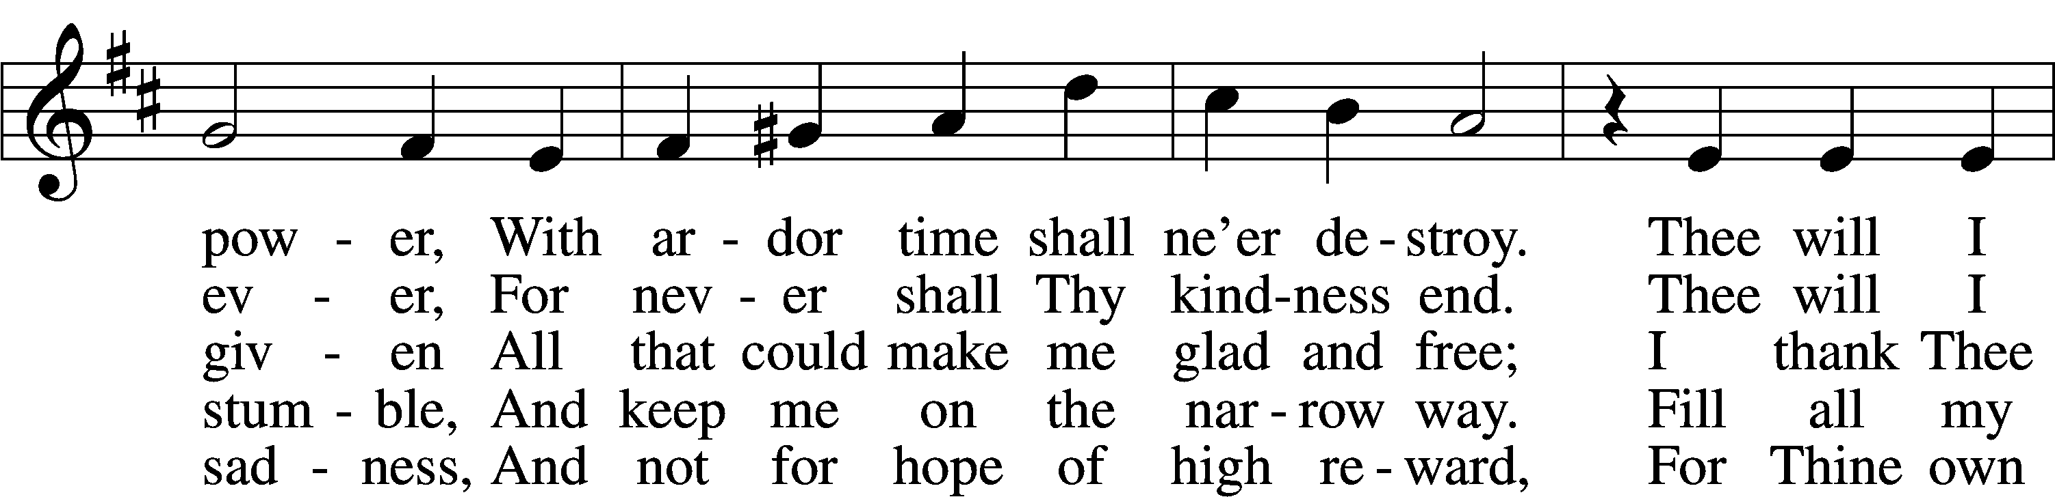
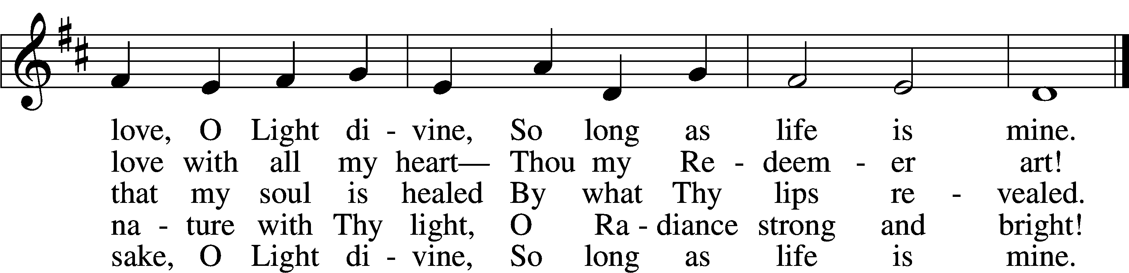
Text and tune: Public domain

Sermon

Please stand

Nicene Creed

I believe in one God,
the Father Almighty,
maker of heaven and earth and of all things visible and invisible.

And in one Lord Jesus Christ,
the only-begotten Son of God,
begotten of His Father before all worlds,
God of God, Light of Light,
very God of very God,
begotten, not made,
being of one substance with the Father,
by whom all things were made;
who for us men and for our salvation came down from heaven
and was incarnate by the Holy Spirit of the virgin Mary
and was made man;
and was crucified also for us under Pontius Pilate.
He suffered and was buried.
And the third day He rose again according to the Scriptures
and ascended into heaven
and sits at the right hand of the Father.
And He will come again with glory to judge both the living and the dead,
whose kingdom will have no end.

And I believe in the Holy Spirit,
the Lord and giver of life,
who proceeds from the Father and the Son,
who with the Father and the Son together is worshiped and glorified,
who spoke by the prophets.
And I believe in one holy Christian and apostolic Church,
I acknowledge one Baptism for the remission of sins,
and I look for the resurrection of the dead
and the life T of the world to come. Amen.

Prayer of the Church

Offerings and Offertory LSB 159
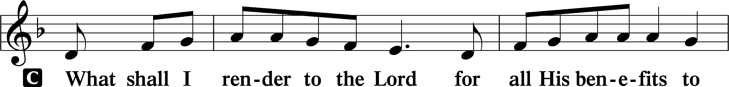
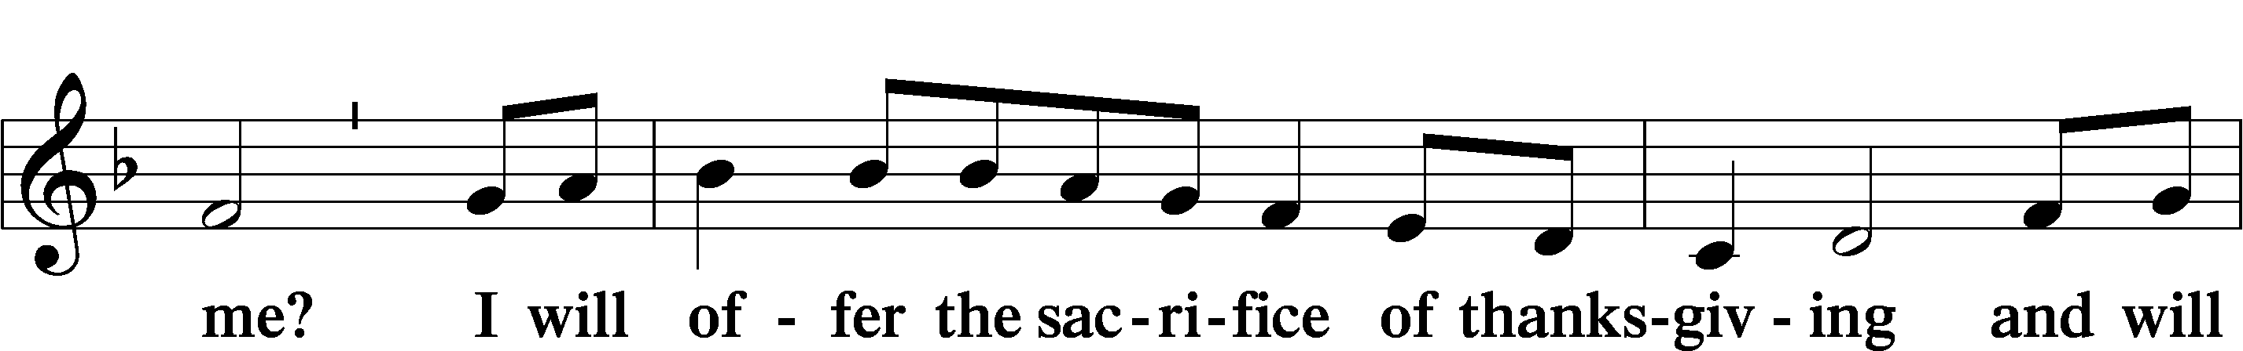
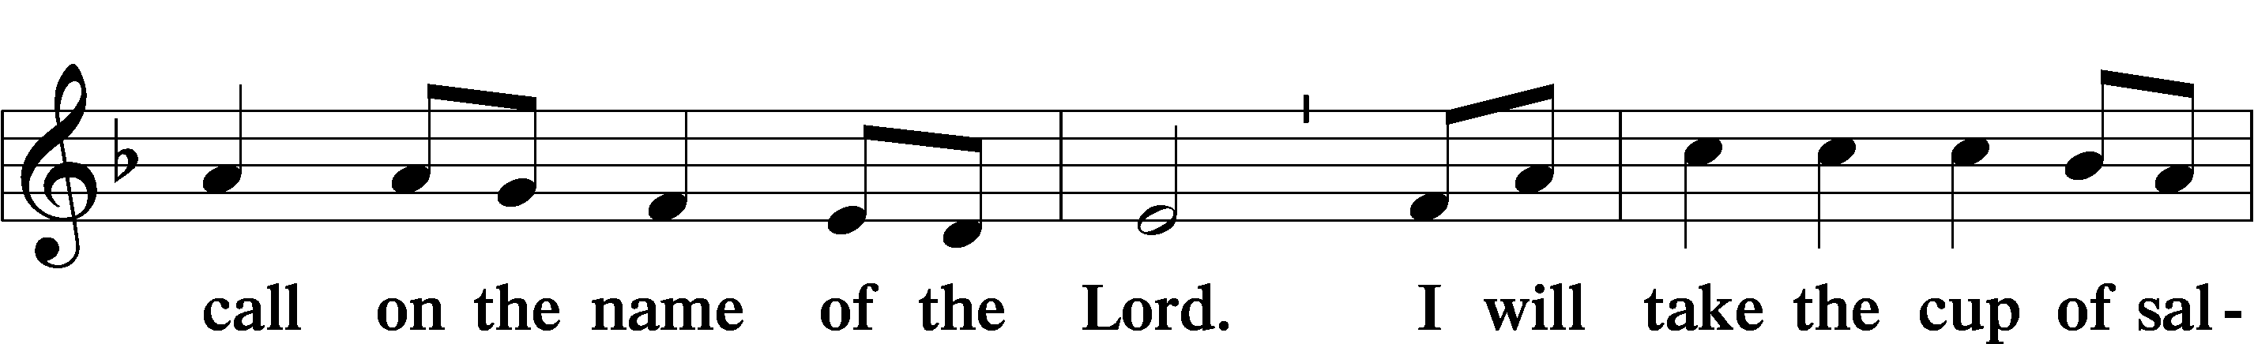
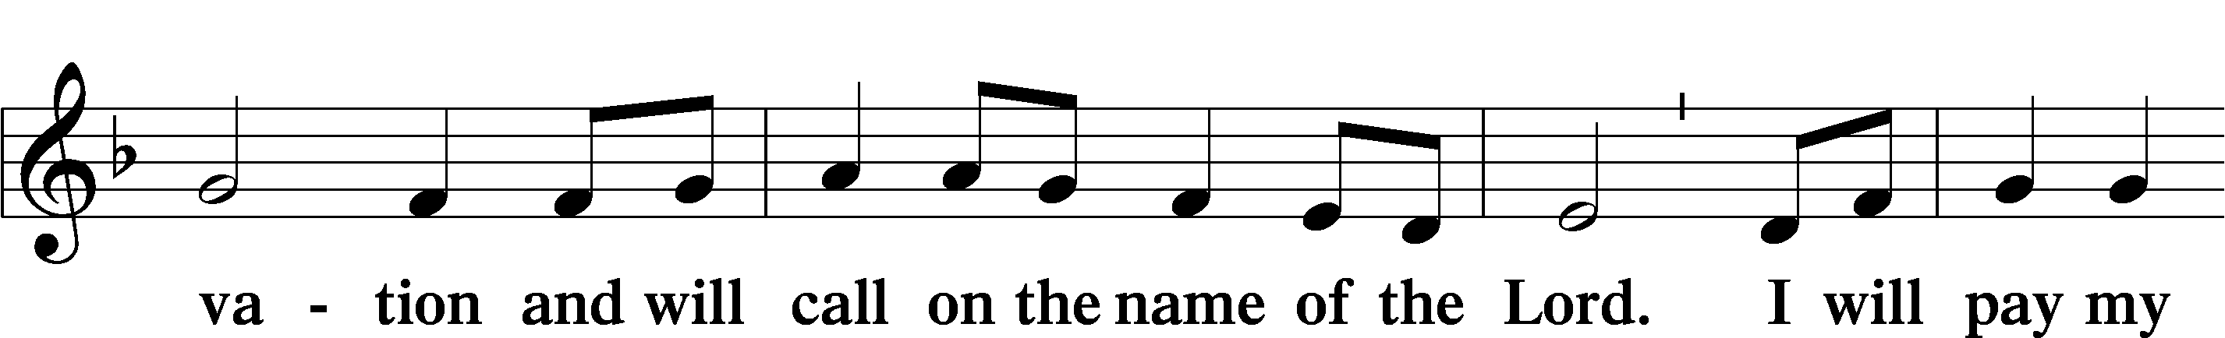
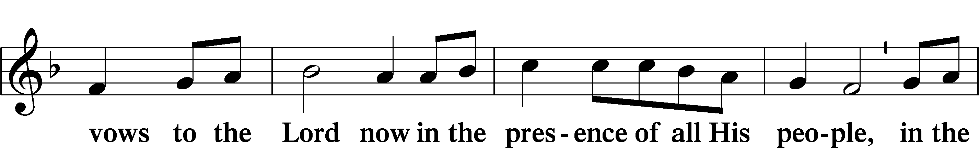
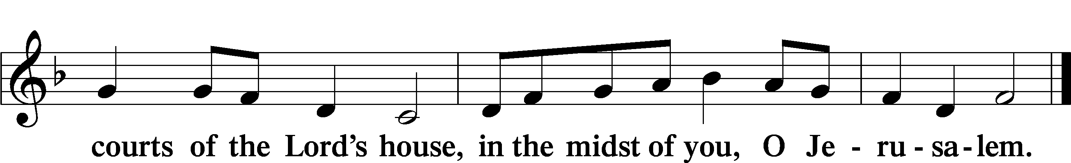

Service of the Sacrament

Preface LSB 160
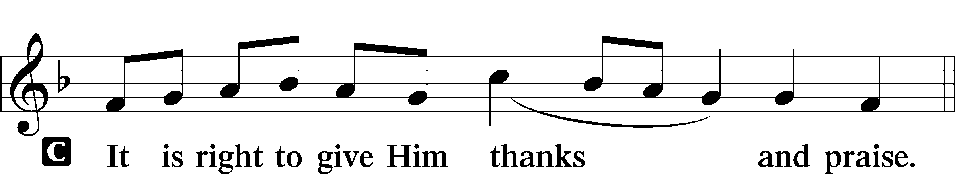

P It is truly good, right, and salutary that we should at all times and in all places give thanks to You, holy Lord, almighty Father, everlasting God, through Jesus Christ, our Lord, who, out of love for His fallen creation, humbled Himself by taking on the form of a servant, becoming obedient unto death, even death upon a cross. Risen from the dead, He has freed us from eternal death and given us life everlasting. Therefore with angels and archangels and with all the company of heaven we laud and magnify Your glorious name, evermore praising You and saying:

Sanctus LSB 161
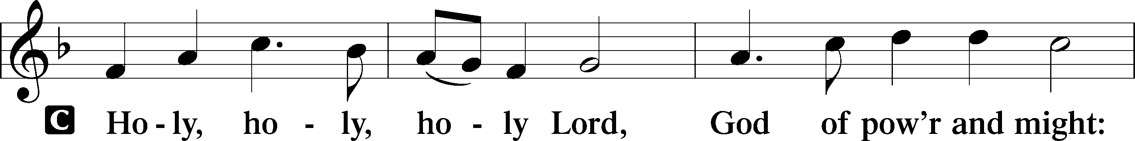
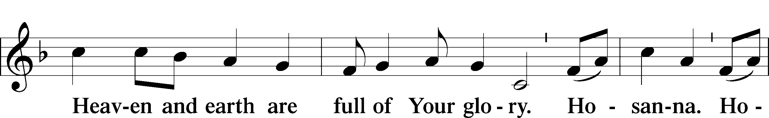
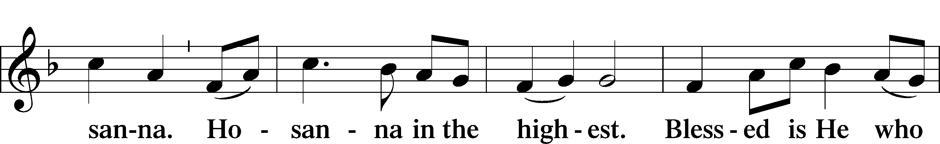
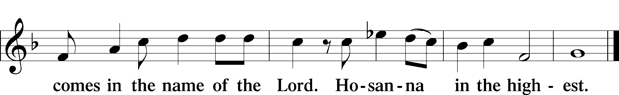

Lord’s Prayer
C Our Father who art in heaven,
hallowed be Thy name,
Thy kingdom come,
Thy will be done on earth
as it is in heaven;
give us this day our daily bread;
and forgive us our trespasses
as we forgive those
who trespass against us;
and lead us not into temptation,
but deliver us from evil.
For Thine is the kingdom
and the power and the glory
forever and ever. Amen.

The Words of Our Lord
P Our Lord Jesus Christ, on the night when He was betrayed, took bread, and when He had given thanks, He broke it and gave it to the disciples and said: “Take, eat; this is My T body, which is given for you. This do in remembrance of Me.”

In the same way also He took the cup after supper, and when He had given thanks, He gave it to them, saying: “Drink of it, all of you; this cup is the new testament in My T blood, which is shed for you for the forgiveness of sins. This do, as often as you drink it, in remembrance of Me.”

Pax Domini LSB 163
P The peace of the Lord be with you always.
C Amen.

Agnus Dei LSB 163
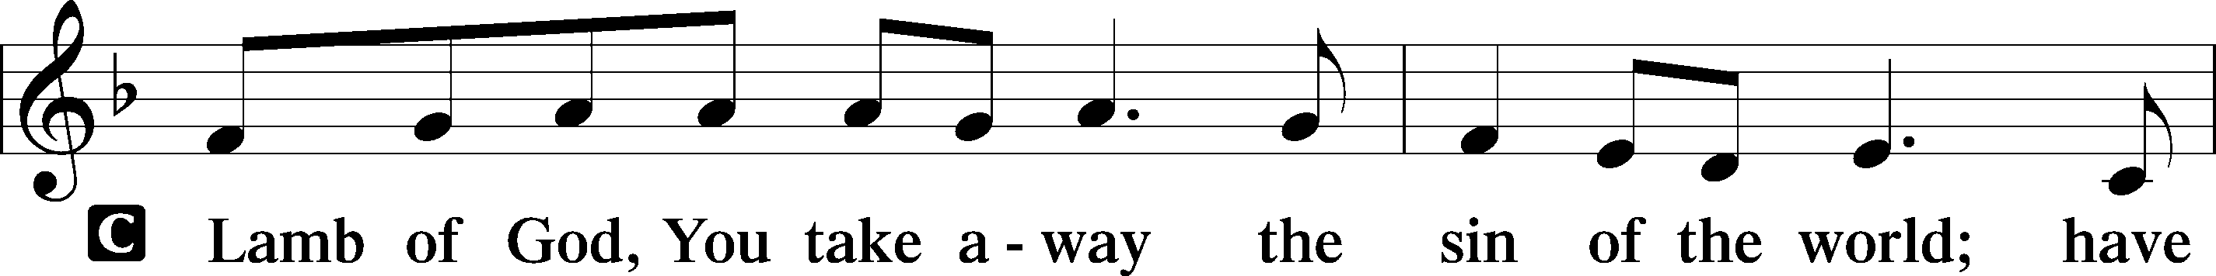
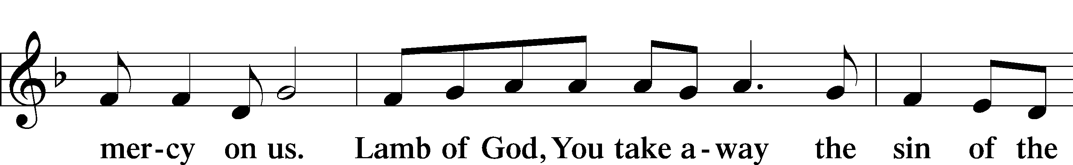
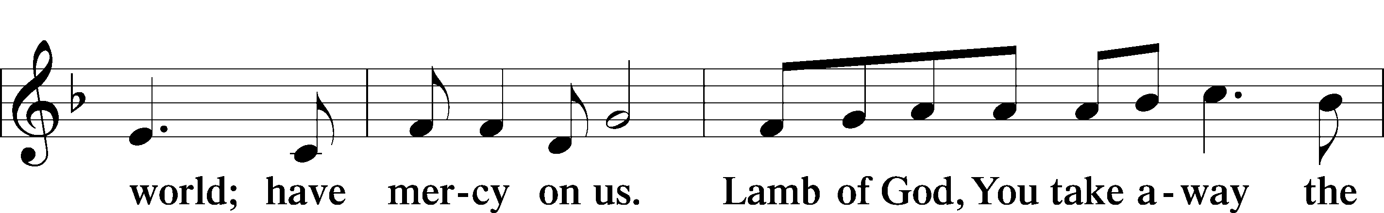
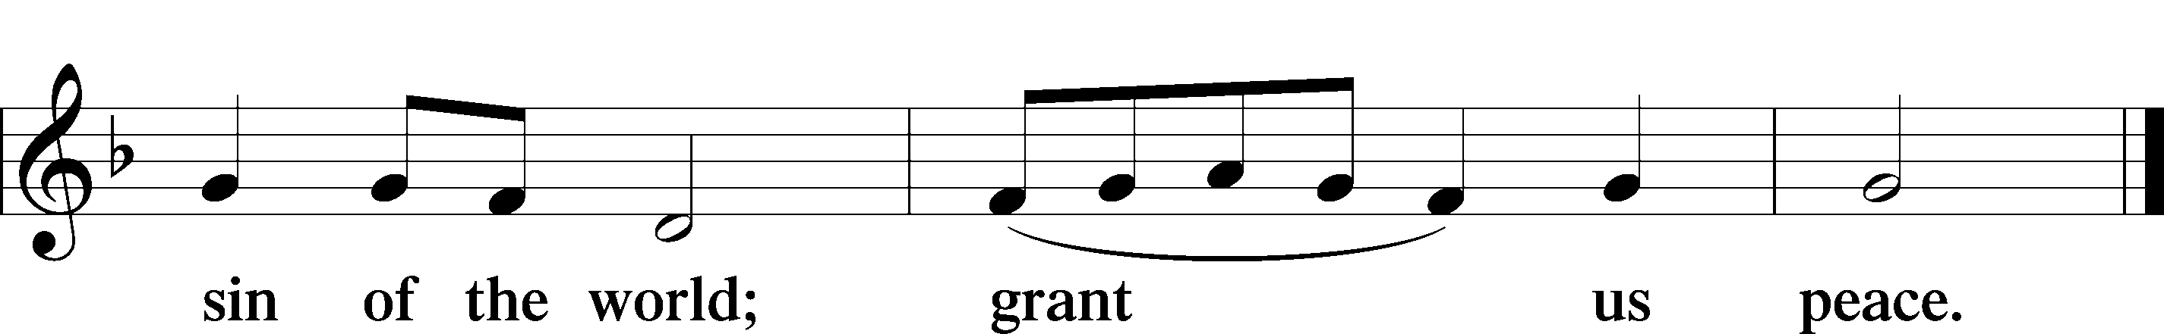
Sit

Distribution

642 O Living Bread from Heaven
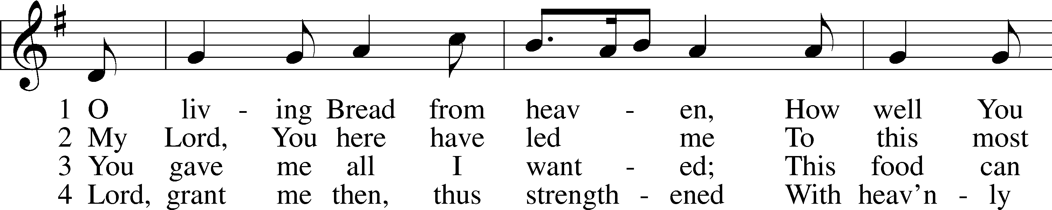
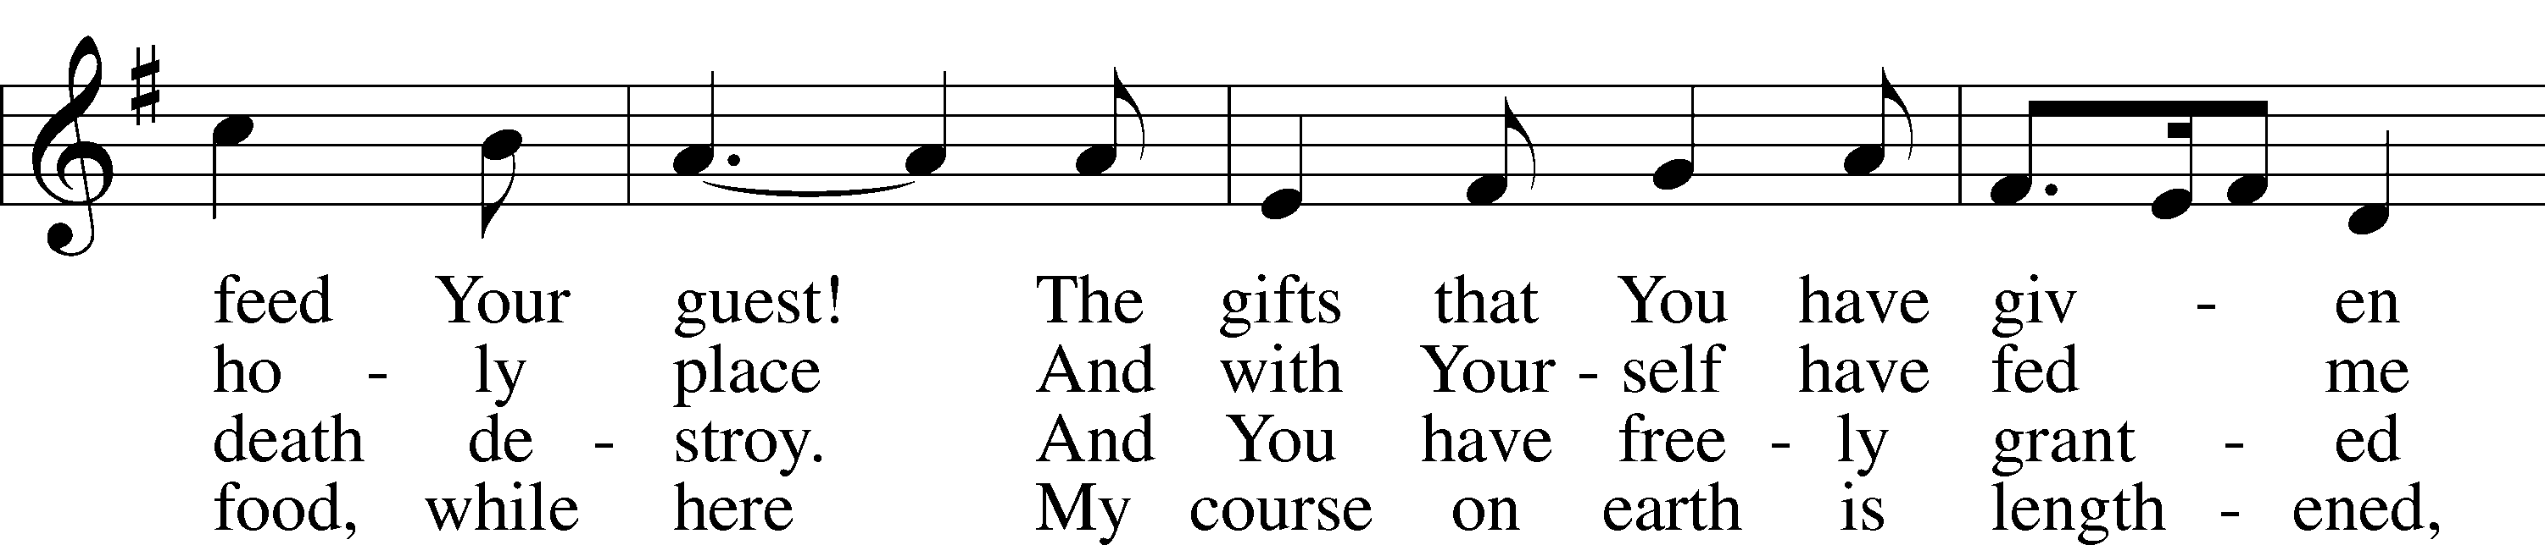
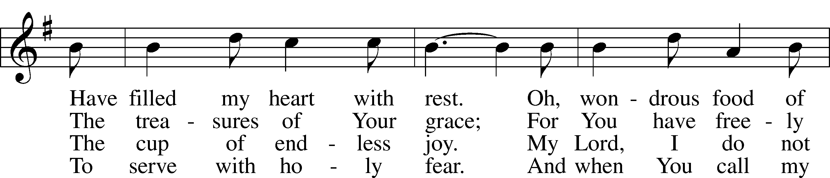
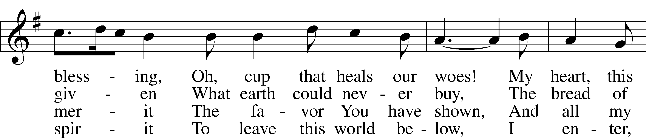
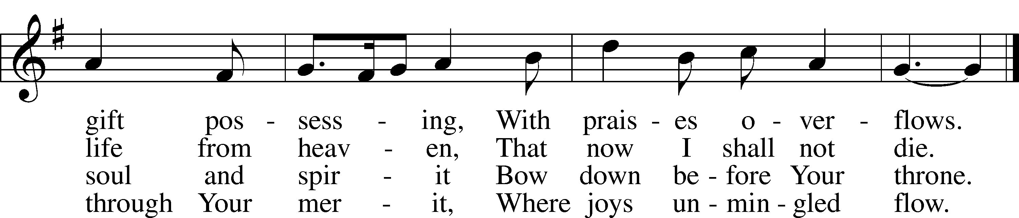
Tune and text: Public domain
783 Take My Life and Let It Be
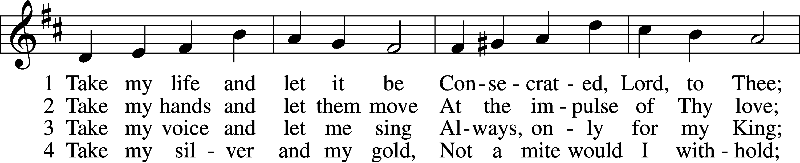
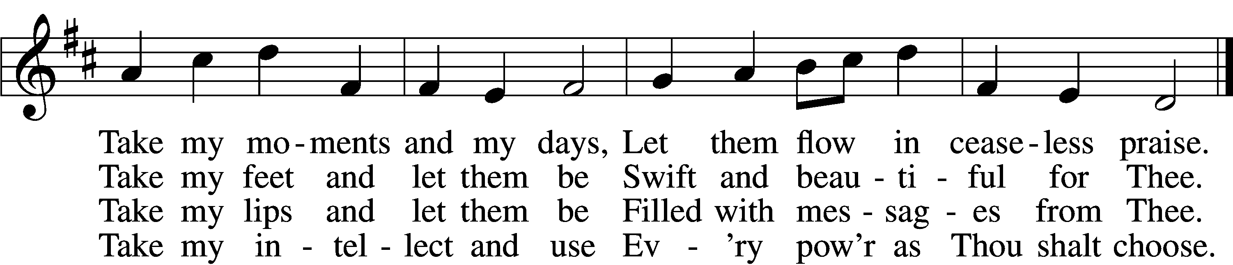

5 Take my will and make it Thine,
It shall be no longer mine;
Take my heart, it is Thine own,
It shall be Thy royal throne.

6 Take my love, my Lord, I pour
At Thy feet its treasure store;
Take myself, and I will be
Ever, only, all for Thee.
Tune and text: Public domain

743 Jesus, Priceless Treasure
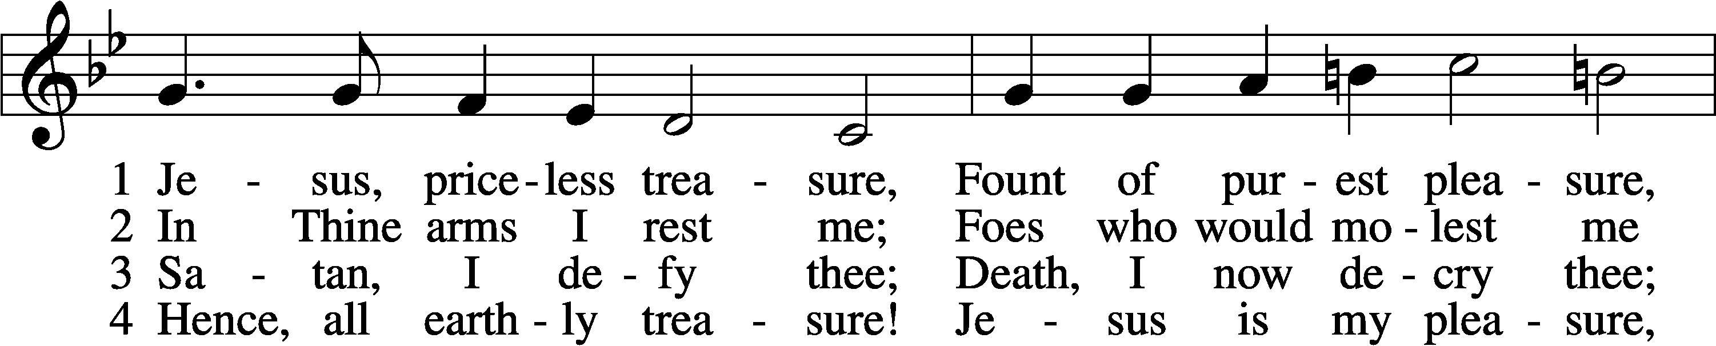
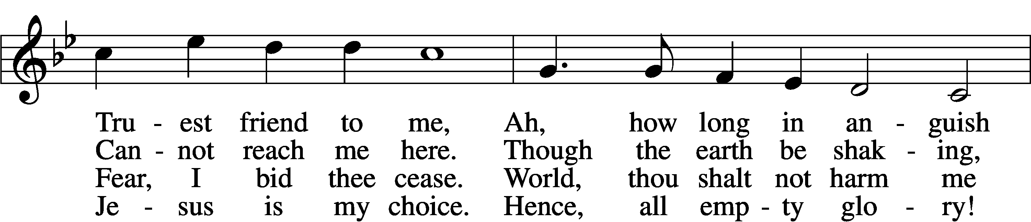
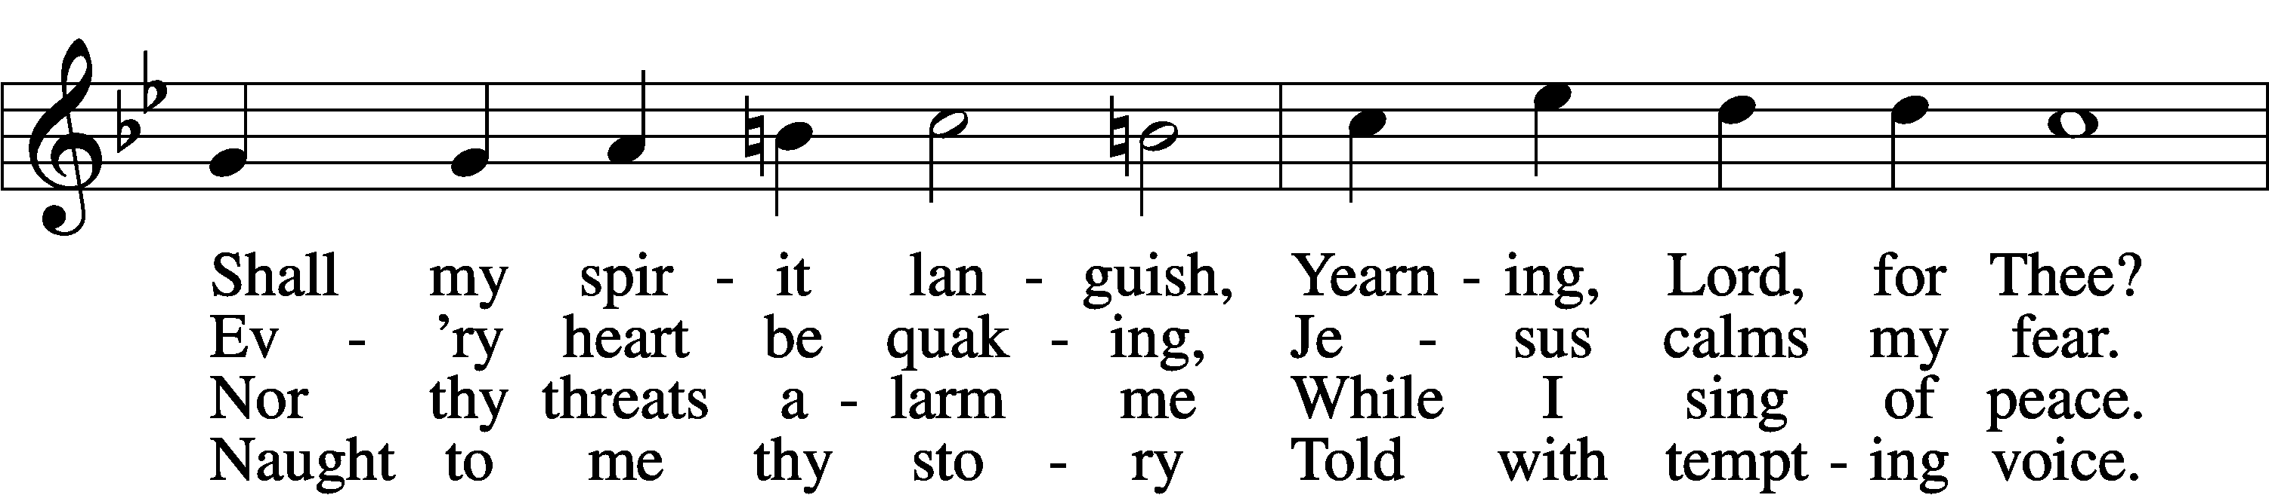
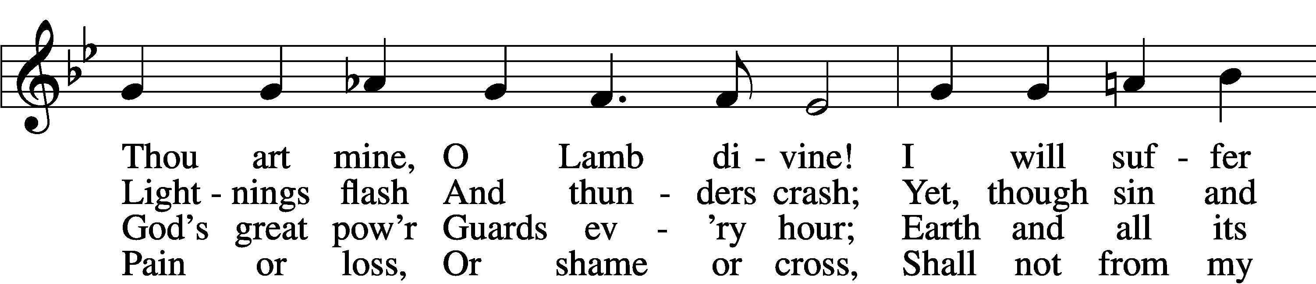
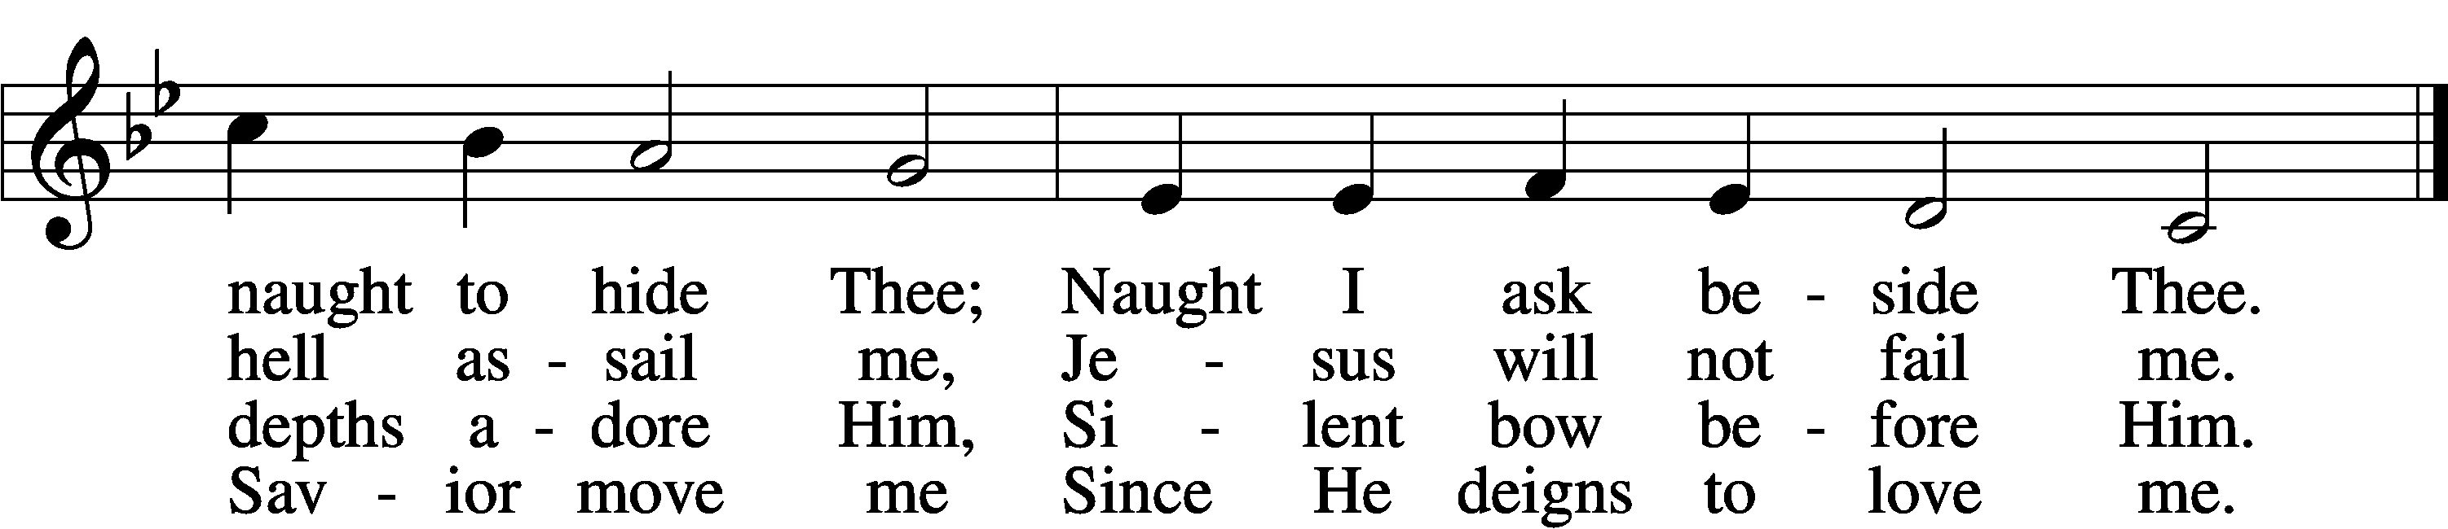

6 Hence, all fear and sadness!
For the Lord of gladness,
Jesus, enters in.
Those who love the Father,
Though the storms may gather,
Still have peace within.
Yea, whate’er
I here must bear,
Thou art still my purest pleasure,
Jesus, priceless treasure!
Text and tune: Public domain

Stand

The Dismissal
P The body and blood of our Lord Jesus Christ strengthen and preserve you in body and soul to life everlasting. Depart T in peace.
C Amen.

Thank the Lord LSB 164
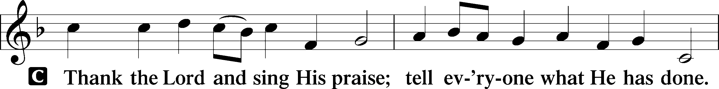
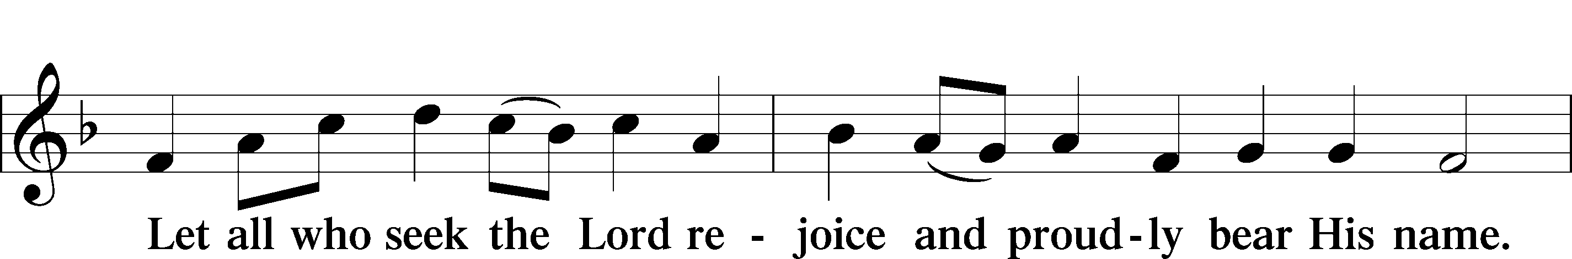
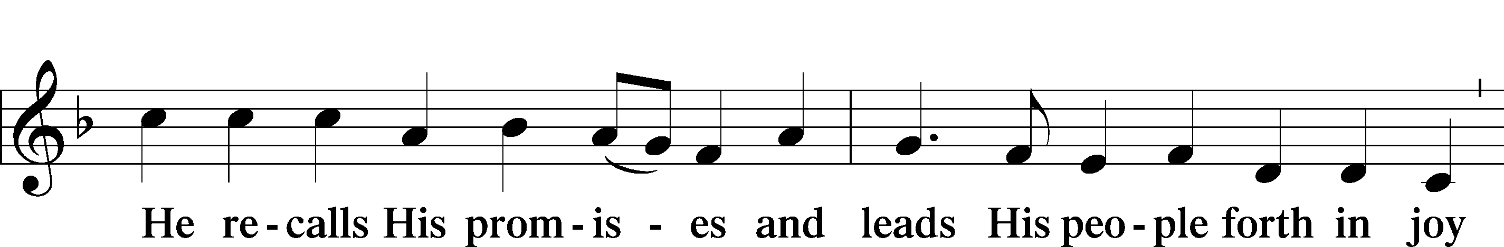
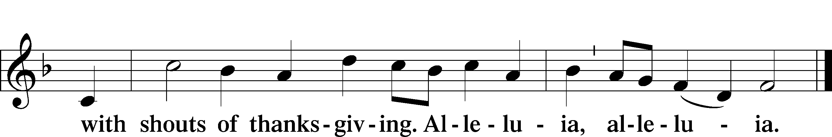

Post-Communion Collect
A Let us pray.
We give thanks to You, almighty God, that You have refreshed us through this salutary gift, and we implore You that of Your mercy You would strengthen us through the same in faith toward You and in fervent love toward one another; through Jesus Christ, Your Son, our Lord, who lives and reigns with You and the Holy Spirit, one God, now and forever.
C Amen.

Benediction LSB 166
P The Lord bless you and keep you.
The Lord make His face shine on you and be gracious to you.
The Lord look upon you with favor and T give you peace.
C Amen.

643 Sent Forth by God’s Blessing
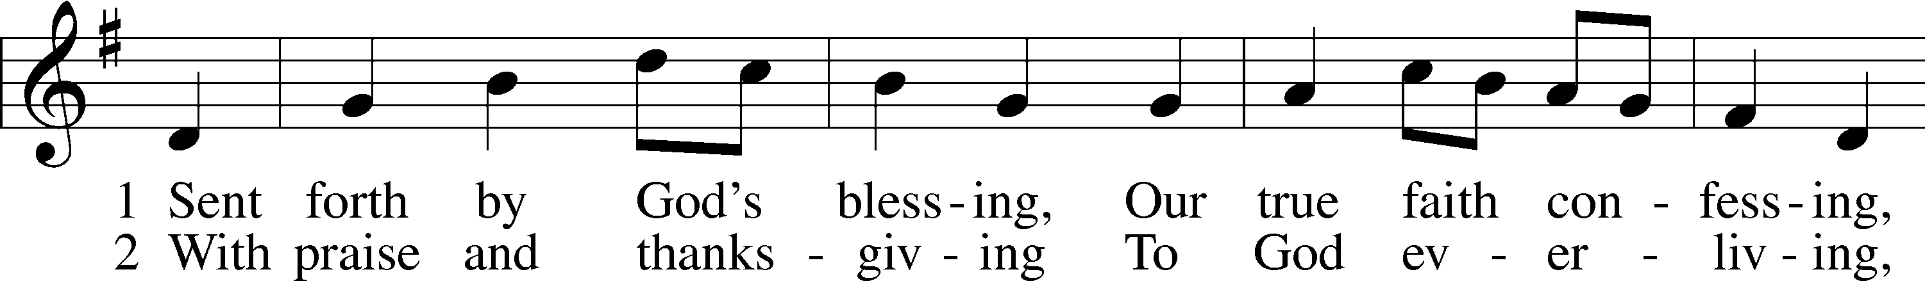
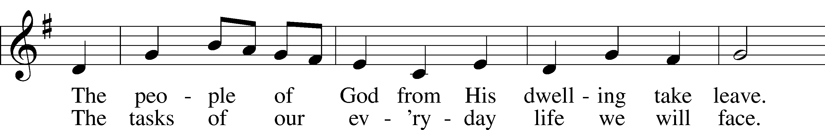
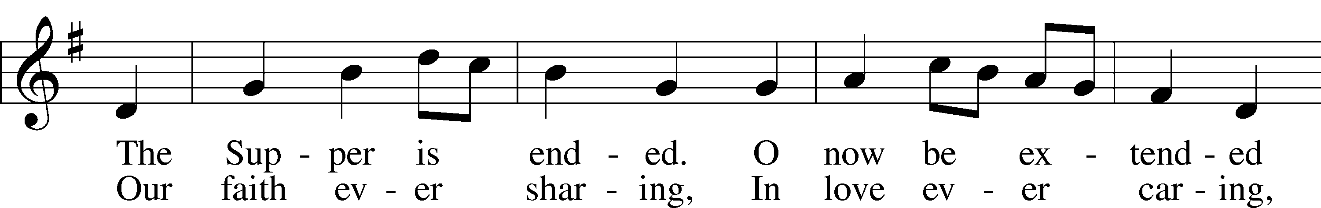
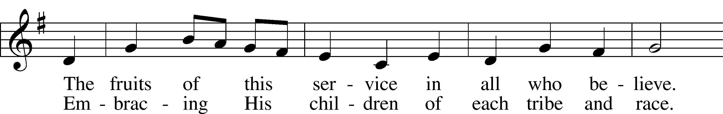
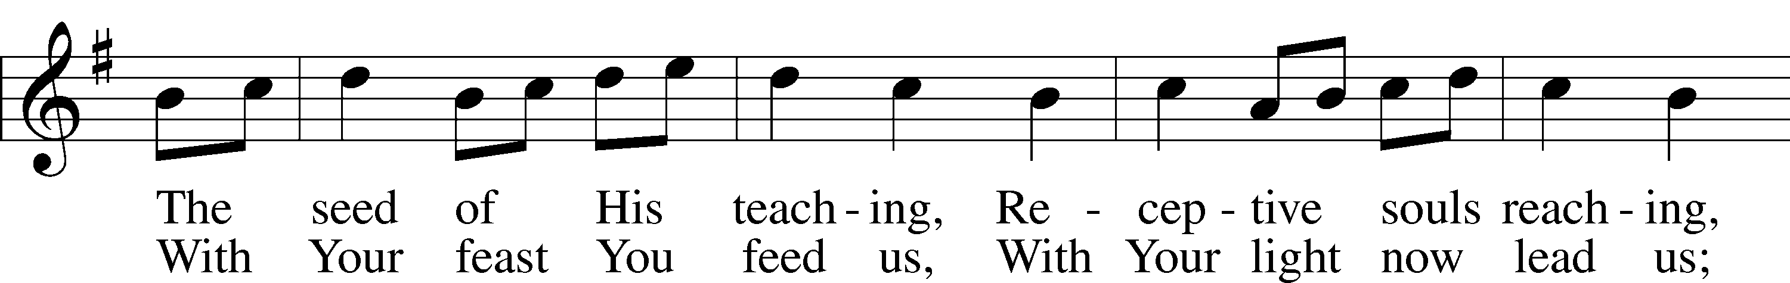
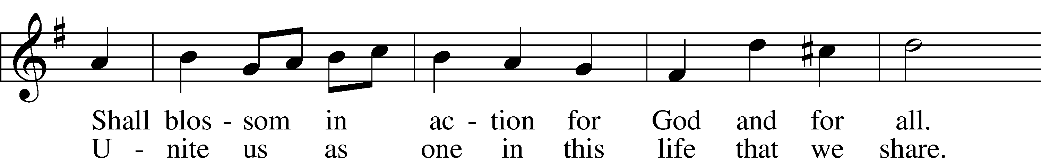
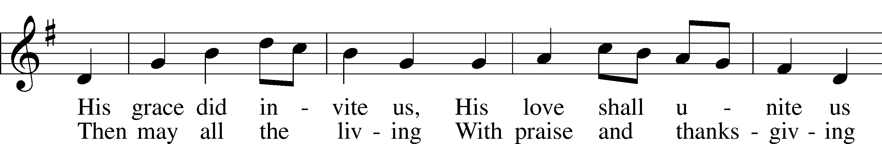
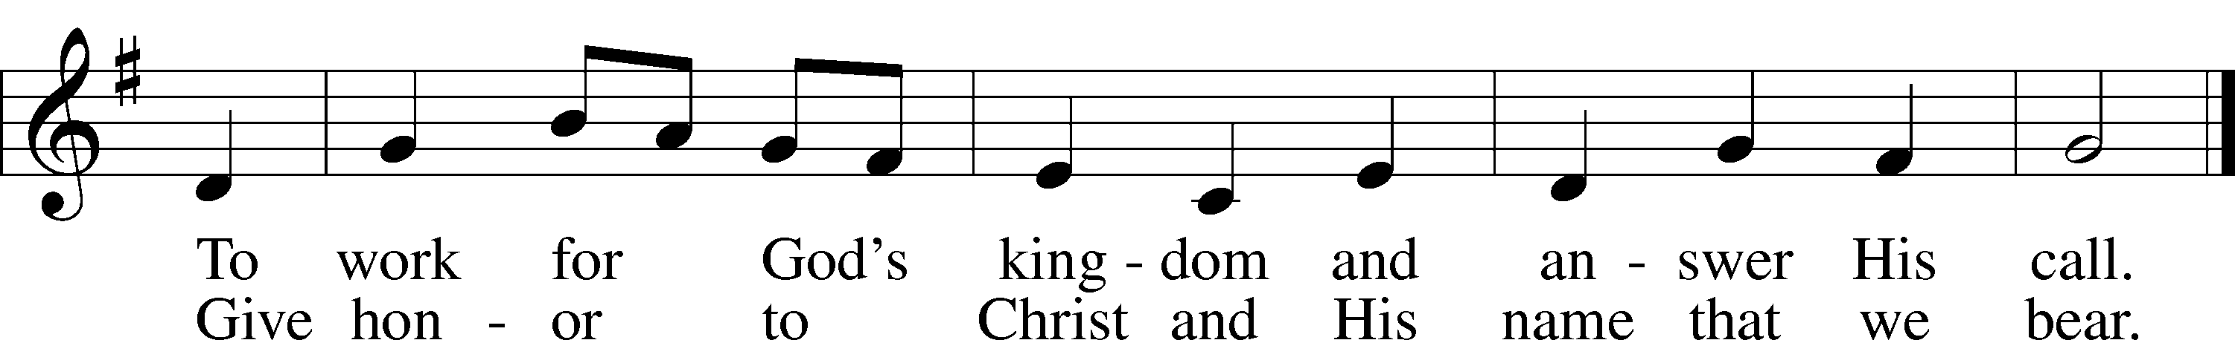
Tune: Public domain
Text: © 1964 World Library Publications. Used by permission: LSB Hymn License no. 110003744

Acknowledgments
Unless otherwise indicated, Scripture quotations are from the ESV® Bible (The Holy Bible, English Standard Version®), copyright © 2001 by Crossway, a publishing ministry of Good News Publishers. Used by permission. All rights reserved.
Created by Lutheran Service Builder © 2021 Concordia Publishing House.

Prayers for Our Members
Sharon Hockemeier, Tenaya Nuttelman | Expectant Mothers
Nicholas & Holly (Fletcher) Kitzing | 10/16 Marriage
Norman Abels (Brookestone Meadows – Elkhorn) | Healing
Judy Ahrens | Healing
Vaughn Albrecht (Mount Carmel) | Healing
Tom & DyAnn Altwine | Healing
Lyle Colsden (Mother Hull) | Healing
Pat Flodine (Cambridge Court) | Healing
Vi Fox (Prairie View) | Healing
Verleen Gentry | Healing
Wanda Glanzer | Healing
Ruby Hatfield | Healing
Evelyn Heiden (Mother Hull) | Healing
Lennis Hodgson | Healing
Don Richmond | Healing
Ivan Bombeck | Cancer
Fran Junge | Cancer
Bertha Marienau | Cancer
Kim Vos | Cancer

ZION LUTHERAN CHURCH AND SCHOOL

Pr. James DeLoach, Pastor + (308) 627-5260
james.deloach@zionkearney.org
Pr. Doug Gaunt, Pastor + (308) 455-0552
doug.gaunt@zionkearney.org
Tony Splittgerber, Principal + (308) 293-0168
anthony.splittgerber@zionkearney.org

Church Office
Secretary: Holly Reid
Email: school@zionkearney.org
Phone: (308)-234-3410 Fax: (308) 236-8100
Office Hours: Monday-Friday 8:00am-4:00pm
Radio Broadcast: Sunday @ 10:30 a.m. on 1460 AM and 92.1 FM
Website: www.zionkearney.com
Prayers for Our Members’ Family & Friends
Naomi Wollberg (Matthias’ wife) | Expecting
Reg Duke (Westman’s brother-in-law) | Healing
James Gentry (Verleen’s son) | Healing
Roger Hoffman (Marc’s father) | Healing
David Kreutzer (Richard’s brother) | Healing
Pastor Rob Kuefner | Healing
Dillon Malchow (Joy Barefoot’s nephew) | Healing
Urijah Mitchell (Sue & Dennis Bartels’ Grandson) | Healing
Tim Powers (Kim Wilken’s brother) | Healing
Roy Reynolds (Verleen Gentry’s son-in-law) | Healing
Lynne Saathoff (Verleen Gentry’s sister-in-law) | Healing
Randy Solomon (Beth Rosenthal’s father) | Healing
Tim Trampe (Don & Gretchen’s son) | Healing
Larry Bombeck (Ivan’s brother) | Healing
Katie Cunningham (Quentin & Janel Lange’s friend) | Burn
Jonah (Jase & Jarren Blattner’s friend) | Cancer
D.D. Dugger (Sue Kaiser’s brother) | Cancer
Stuart Gronewoller (Lonna’s brother-in-law) | Cancer
Ron Halvorsen (Jeff’s dad) | Cancer
Bill Jedlicka (Pam Uhlir’s cousin) | Cancer
Randy Jochum (Ken Hockemeier’s brother-in-law) | Cancer
John Moore (family of Susan Tonniges) | Thanksgiving
Sharon Mulhair (Pam Uhlir’s cousin) | Cancer
Kolby Shiers (Jessica’s cousin) | Cancer
Tyrone Uhlir (Pam’s nephew) | Cancer
John Weber (Zehendner’s friend) | Covid & Cancer
Tim Smallcomb (Wilkens’ friend) | Deployment

Today’s Radio Broadcast is given to the Glory of the Lord by the Laverne Stuehm Memorial.

Worship Assistants

Sunday, October 10 ~ 9:00am

Elder: Eric Rosenthal
Usher: Steve Junge
Acolyte: Jarren Blattner
Engineer: Zach DeLoach
Announcer: Brooke Fisher
Altar Guild: Jamie & Shirley Helmbrecht

Sunday, October 17~ 9:00am

Elder: Dan Oertwig
Usher: Andy Wollberg
Acolyte: Lindsay Wilkens
Engineer: Jared Nuttelman
Announcer: Jesse Florang
Altar Guild: Jamie & Shirley Helmbrecht

Our Response to the Gospel

Date: 10/03/2021
Offering: $10,386
Weekly Need: $7,457.69

This Week at Zion

Sun  10/10 | 9:00a  10:20a  10:30a  5:00p | Divine Service  Bible Study  Radio Broadcast 1460am & 92.1fm  Divine Service
Mon  10/11 | 7:00p  Birthdays  Anniversaries | Mary Martha  Anthony Splittgerber  Kelie & Jill Bates
Tues  10/12 | 1:30p  7:00p  Birthdays  Anniversaries | Sleeping Mats  Bd. of Ed., Elders, Trustees  Eli Randolph  Adam & Jami Helmbrecht
Wed  10/13 | 8:30a  5:45p  7:00p  Birthdays | Chapel  Midweek  Adult Choir  Ryan Fisher  Ashli Florang  Nancy McKillip
Thurs  10/14 | Birthdays | Gerald Dulitz  Leviticus Gaunt
Fri  10/15 | 6:00 p  Birthdays | Kitzing/Fletcher Wedding Rehearsal  Cody Willers
Sat  10/16 | 3:00p  Birthdays | Kitzing/Fletcher Wedding  Lacey Ahrens  Robert Glanzer  Elizabeth Lange
Sun  10/17 | 9:00a  10:30a  5:00p | Divine Service  Radio Broadcast 1460am & 92.1fm  Divine Service

Where our Triune God strengthens us through His mercy in faith toward Him and in fervent love toward one another.

ANNOUNCEMENTS

Mary Martha meets this Monday at 7pm for a charcuterie board demonstration and election of officers for the coming year. All ladies are welcome to join!

Holly Reid begins serving Zion Lutheran Church and School tomorrow as our secretary. Please greet her and introduce yourself to her.

Sunday School is being offered for grades K-High School at 10:20am.

Adult Bible Study is studying the rich variety of words God uses to communicate the Gospel—that we are justified by grace through faith. Come grab a donut and cup of coffee as we fellowship and learn together.

Why has Zion’s 5pm service moved from Saturday to Sunday?

- Families who are out of town on Saturday at the lake, camping, or for travel sports will be back in time for a Sunday evening worship.
- Some of our older members attend Saturday evenings because of lighter street and parking lot traffic. Sunday evenings will allow them a similar opportunity.
- Due to leading the Saturday evening services our pastors often cannot attend their kids’ or grandkids’ Saturday games or events.
- A move to Sunday evening allows Pr. DeLoach and Carol to spend Saturday together, with family, or with friends without the responsibility of preaching or playing for a service that evening.
- If our pastors preside at a Saturday wedding, they are unable to attend the reception until much later, especially where travel is involved.
- Sunday evening is often a better option for our college and high school students.
- There are fewer social or sporting events on Sunday evenings.

Zion’s 4th Quarter (Oct – Dec) Mission Offerings will support Zion’s current students, who are studying for full-time church work. All our students are at Concordia (CUNE):
Peter Kreutzer - Lutheran Teacher’s Diploma (LTD)
Jessica Zehendner – LTD
Taylor Zehendner – LTD
Please use the mission envelopes located in the narthex for this offering. Or give via Church Trac by selecting “Missions.” Thank you for your support.

Offering Options:
1) Place your offering in the basket as you leave
2) Go to zionkearney.churchtrac.com/give
3) Go to zionkearney.com and click on the ChurchTrac icon
4) Mail your gift to Zion Lutheran Church, 2421 C Ave, Kearney, NE 68847. Or place it in the mail slot on the south side of the building.
Radio Broadcast – Please help Zion spread the Gospel, signup to sponsor a radio broadcast! There are several open dates including October 17th and 31st.

SCHOOL NEWS

The Theme for our school year is “Together by Christ’s Love” based on 1 John 4:7-8.

- Congratulations to our Girls’ Volleyball A Team and B Team, who both defeated York this past Tuesday. Their final tournament will be the Lutheran State Volleyball Tournament in Lincoln, NE, on October 16
- Our Boys’ and Girls’ Cross Country teams finished their season by running at the Nebraska State Junior High Cross Country Meet hosted by Papillion-LaVista South on Oct. 9. Congratulations to all our students who ran throughout this season. Special thanks to Mr. Torres, Pr. Anderson, and Miss Nikodym for coaching our inaugural team.
- 5th-8th grade sang the National Anthem at Storm Hockey game on October 9th

Early Childhood Openings!
We do still have openings in our 3 yr. old preschool classes. If you or someone you know is still looking for a high-quality early childhood experience, please refer us to them!

