Divine Service
Twenty First Sunday
after Pentecost
October 17, 2021

Zion Lutheran Church
Kearney, Nebraska

Welcome to Zion!
All worshippers please fill out an attendance card in the pew rack and let us know how we might be of service to you.

Holy Communion at Zion

The Lord’s Supper is celebrated at this congregation as Jesus has given it. As he says, our Lord gives into our mouths not only bread and wine but his very body and blood to eat and to drink for the forgiveness of sins and to strengthen our union with him and with one another. Our Lord invites to his table those who trust his words, repent of all sin, and set aside any refusal to forgive and love as he forgives and loves us, that they may show forth his death until he comes. All communicants need to register in the narthex prior to the service.

Because those who eat and drink our Lord’s body and blood unworthily do great harm and because Holy Communion is a confession of the faith which is confessed at this altar, any who are not yet instructed, in doubt, or who hold a confession differing from that of this congregation and The Lutheran Church—Missouri Synod, are asked not to commune until they are able to speak with our pastor first. He is happy to visit with you about the Christian faith and how to receive the Lord’s Supper for your good and for the good of others. Those not communing are invited to come to the altar, cross your arms in front of you, and bow your head to receive a pastoral blessing.

By the Voluntary Poverty of Christ,
We Enter the Kingdom of God

To love and trust in earthly wealth is vanity. For nothing of this earth will last forever, nor can any of it grant eternal life (Eccl. 5:10). But the one who trusts in God is “occupied with joy in his heart” and is able to sleep in peace, “whether he eats little or much,” because he knows that the “days of his life” are “the gift of God” (Eccl. 5:12, 18–20). The person who trusts in riches cannot sleep, because he “shall take nothing for his toil that he may carry away in his hand” (Eccl. 5:15). Therefore, it is difficult “for those who have wealth to enter the kingdom of God” (Mark 20:23). Indeed, it is impossible for man, yet “all things are possible with God” (Mark 20:27). Thus, the Rich Man, Jesus Christ, has made Himself poor and has gone through “the eye of a needle,” through death and the grave, “to enter the kingdom of God” on our behalf (Mark 20:24–25). He is the “great high priest who has passed through the heavens” (Heb. 4:14), so that we may now enter His Sabbath rest by faith in His forgiveness (Heb. 4:3–9).
Confession and Absolution

788 Forgive Us, Lord, for Shallow Thankfulness
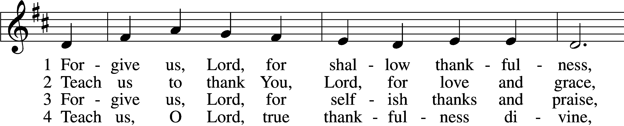
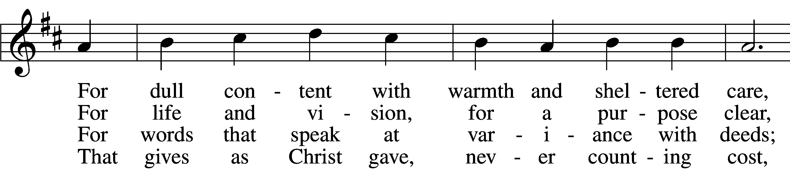
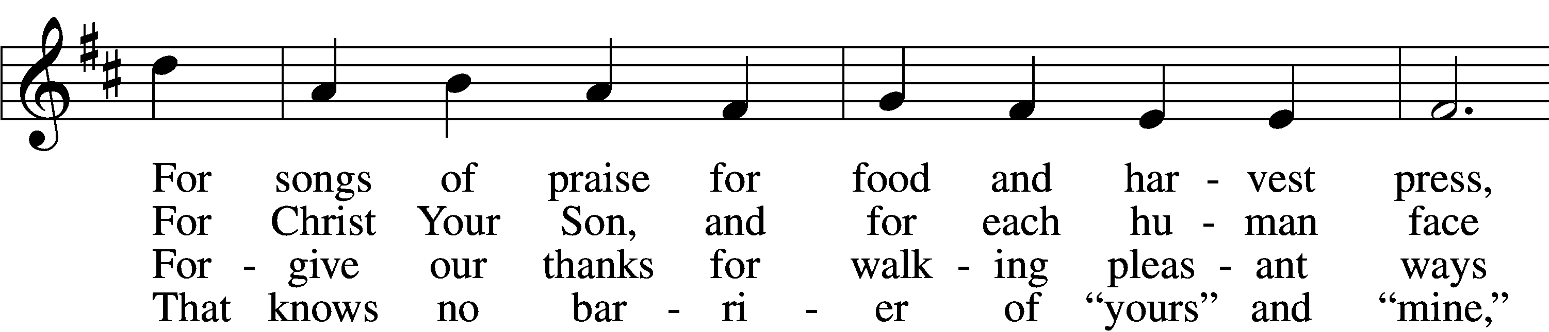
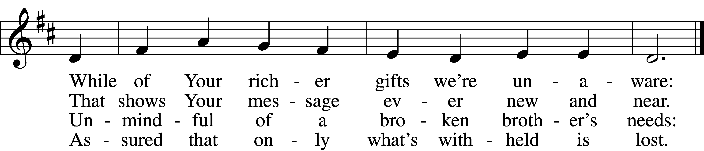

5 Forgive us, Lord, for feast that knows not fast,
For joy in things that meanwhile starve the soul,
For walls and wars that hide Your mercies vast
And blur our vision of the Kingdom goal:

6 Open our eyes to see Your love’s intent,
To know with minds and hearts its depth and height;
May thankfulness be days in service spent,
Reflection of Christ’s life and love and light.

Tune: © 1990 Church of the Ascension, Atlantic City, N.J. Used by permission: LSB Hymn License no. 110003744
Text: © 1965, renewed 1993 The Hymn Society, admin. Hope Publishing Co. Used by permission: LSB Hymn License no. 110003744

Stand. The sign of the cross may be made by all in remembrance of their Baptism.

Invocation
P In the name of the Father and of the T Son and of the Holy Spirit.
C Amen.

Exhortation LSB 151
P If we say we have no sin, we deceive ourselves, and the truth is not in us.
C But if we confess our sins, God, who is faithful and just, will forgive our sins and cleanse us from all unrighteousness.

Silence for reflection on God’s Word and for self-examination.

Confession of Sins LSB 151
P Let us then confess our sins to God our Father.
C Most merciful God, we confess that we are by nature sinful and unclean. We have sinned against You in thought, word, and deed, by what we have done and by what we have left undone. We have not loved You with our whole heart; we have not loved our neighbors as ourselves. We justly deserve Your present and eternal punishment. For the sake of Your Son, Jesus Christ, have mercy on us. Forgive us, renew us, and lead us, so that we may delight in Your will and walk in Your ways to the glory of Your holy name. Amen.

Absolution LSB 151
P Almighty God in His mercy has given His Son to die for you and for His sake forgives you all your sins. As a called and ordained servant of Christ, and by His authority, I therefore forgive you all your sins in the name of the Father and of the T Son and of the Holy Spirit.
C Amen.

Service of the Word

Introit Psalm 34:1–4, 17; antiphon: v. 18
The Lord is near to the broken- | hearted*
and saves the crushed in | spirit.
I will bless the Lord at | all times;*
his praise shall continually be | in my mouth.
My soul makes its boast | in the Lord;*
let the humble hear | and be glad.
Oh, magnify the | Lord with me,*
and let us exalt his name to- | gether!
I sought the Lord, and he | answered me*
and delivered me from | all my fears.
When the righteous cry for help, the | Lord hears*
and delivers them out of all their | troubles.
Glory be to the Father and | to the Son*
and to the Holy | Spirit;
as it was in the be- | ginning,*
is now, and will be forever. | Amen.
The Lord is near to the broken- | hearted*
and saves the crushed in | spirit.

Kyrie LSB 152
A In peace let us pray to the Lord.
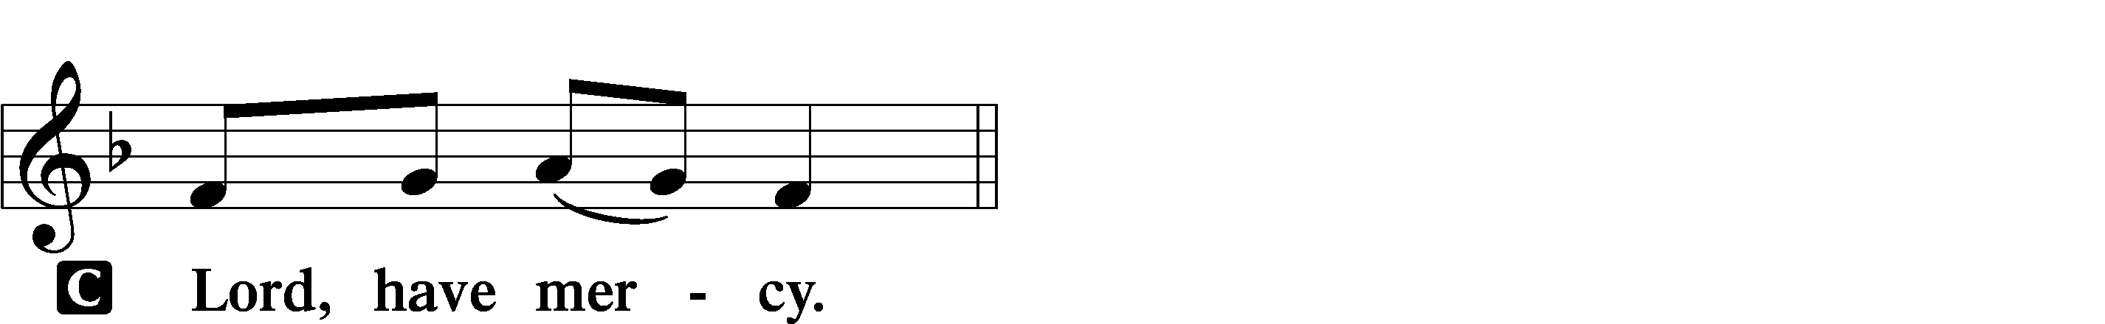

A For the peace from above and for our salvation let us pray to the Lord.
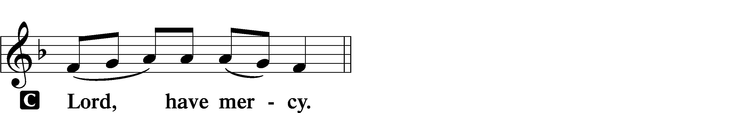

A For the peace of the whole world, for the well-being of the Church of God, and for the unity of all let us pray to the Lord.
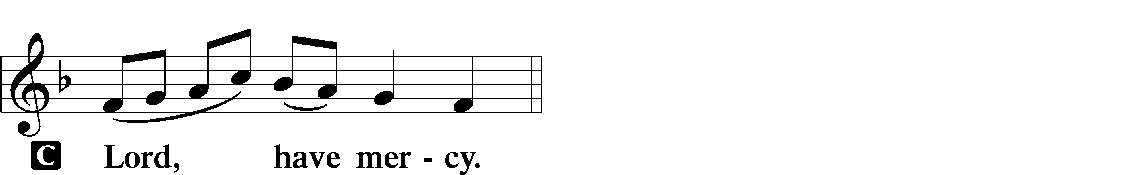

A For this holy house and for all who offer here their worship and praise let us pray to the Lord.
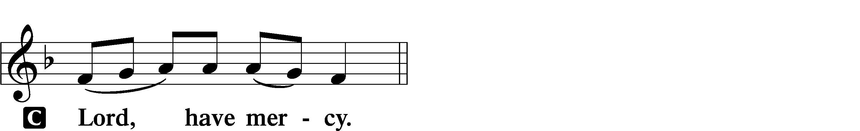

A Help, save, comfort, and defend us, gracious Lord.

Gloria in Excelsis LSB 154
A Glory to God in the highest, and peace to His people on earth.
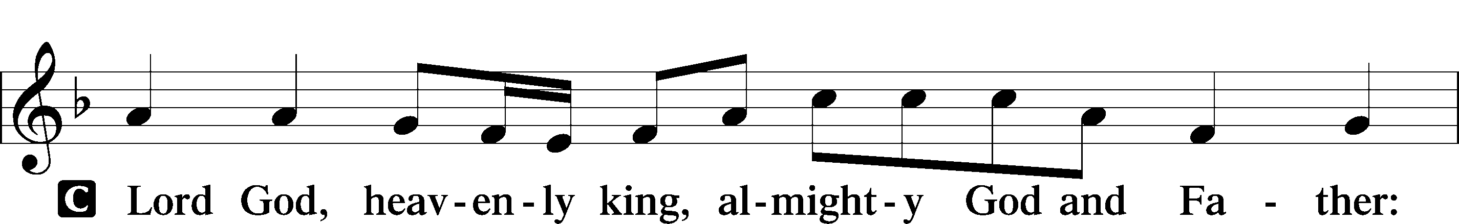
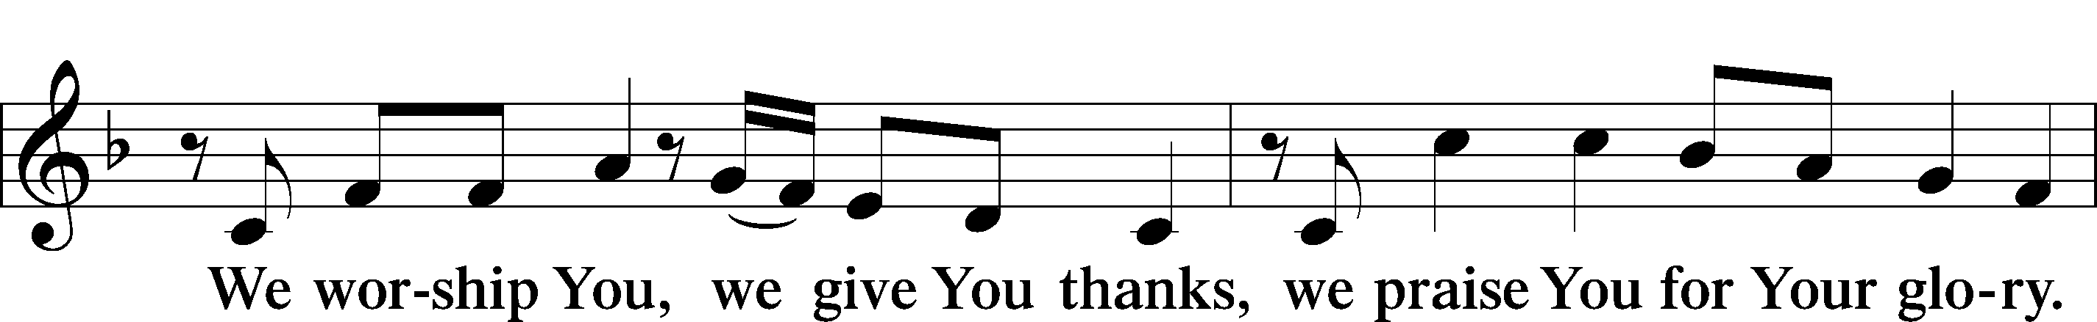
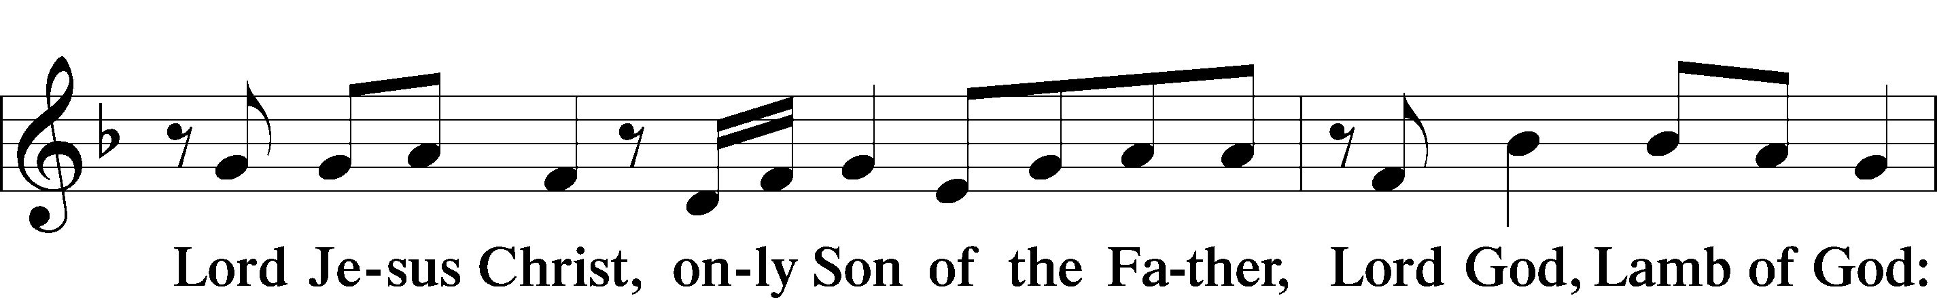
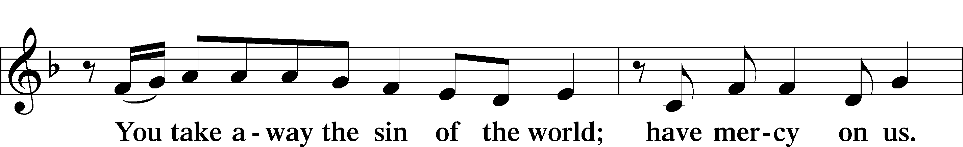
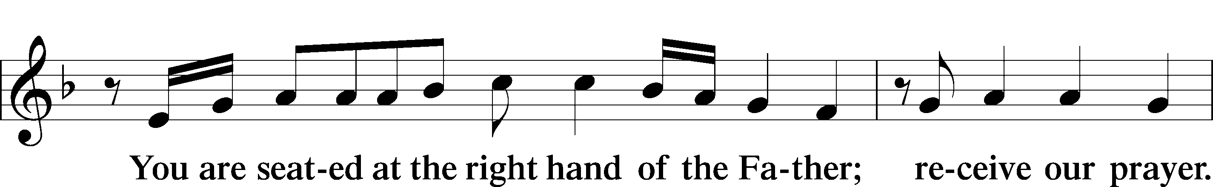
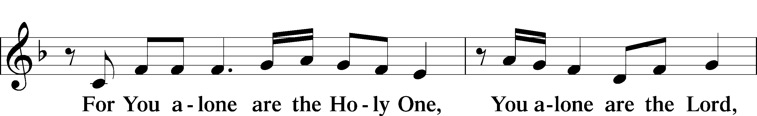
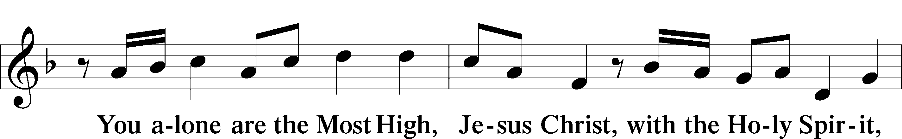
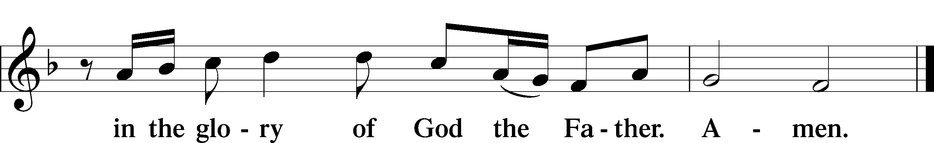

Salutation and Collect of the Day
P The Lord be with you.
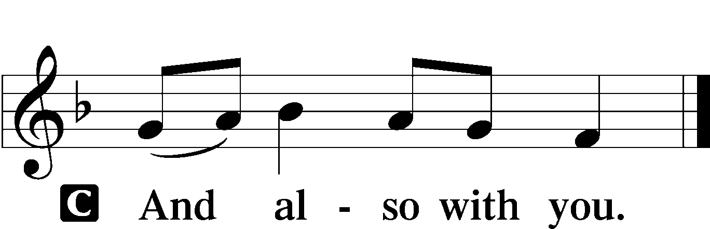

P Let us pray.
O God, Your divine wisdom sets in order all things in heaven and on earth. Put away from us all things hurtful and give us those things that are beneficial for us; through Jesus Christ, Your Son, our Lord, who lives and reigns with You and the Holy Spirit, one God, now and forever.

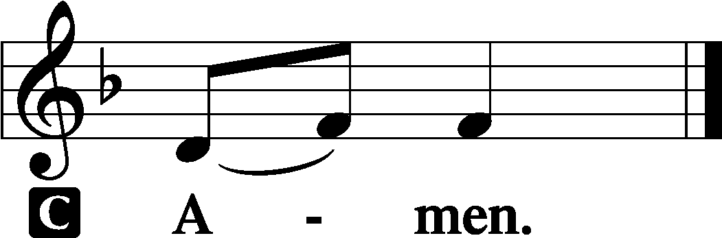

Sit
Old Testament Reading Ecclesiastes 5:10–20
10He who loves money will not be satisfied with money, nor he who loves wealth with his income; this also is vanity. 11When goods increase, they increase who eat them, and what advantage has their owner but to see them with his eyes? 12Sweet is the sleep of a laborer, whether he eats little or much, but the full stomach of the rich will not let him sleep.
13There is a grievous evil that I have seen under the sun: riches were kept by their owner to his hurt, 14and those riches were lost in a bad venture. And he is father of a son, but he has nothing in his hand. 15As he came from his mother’s womb he shall go again, naked as he came, and shall take nothing for his toil that he may carry away in his hand. 16This also is a grievous evil: just as he came, so shall he go, and what gain is there to him who toils for the wind? 17Moreover, all his days he eats in darkness in much vexation and sickness and anger.
18Behold, what I have seen to be good and fitting is to eat and drink and find enjoyment in all the toil with which one toils under the sun the few days of his life that God has given him, for this is his lot. 19Everyone also to whom God has given wealth and possessions and power to enjoy them, and to accept his lot and rejoice in his toil—this is the gift of God. 20For he will not much remember the days of his life because God keeps him occupied with joy in his heart.

A This is the Word of the Lord.
C Thanks be to God.

Gradual Psalm 91:11; 103:1
He will command his angels con- | cerning you*
to guard you in | all your ways.
Bless the Lord, | O my soul,*
and all that is within me, bless his | holy name!

Epistle Hebrews 4:1–13

1Therefore, while the promise of entering his rest still stands, let us fear lest any of you should seem to have failed to reach it. 2For good news came to us just as to them, but the message they heard did not benefit them, because they were not united by faith with those who listened. 3For we who have believed enter that rest, as he has said,
“As I swore in my wrath,
‘They shall not enter my rest,’”
although his works were finished from the foundation of the world. 4For he has somewhere spoken of the seventh day in this way: “And God rested on the seventh day from all his works.” 5And again in this passage he said,
“They shall not enter my rest.”
6Since therefore it remains for some to enter it, and those who formerly received the good news failed to enter because of disobedience, 7again he appoints a certain day, “Today,” saying through David so long afterward, in the words already quoted,
“Today, if you hear his voice,
do not harden your hearts.”
8For if Joshua had given them rest, God would not have spoken of another day later on. 9So then, there remains a Sabbath rest for the people of God, 10for whoever has entered God’s rest has also rested from his works as God did from his.
11Let us therefore strive to enter that rest, so that no one may fall by the same sort of disobedience. 12For the word of God is living and active, sharper than any two-edged sword, piercing to the division of soul and of spirit, of joints and of marrow, and discerning the thoughts and intentions of the heart. 13And no creature is hidden from his sight, but all are naked and exposed to the eyes of him to whom we must give account.

A This is the Word of the Lord.
C Thanks be to God.

Stand

Alleluia and Verse LSB 156
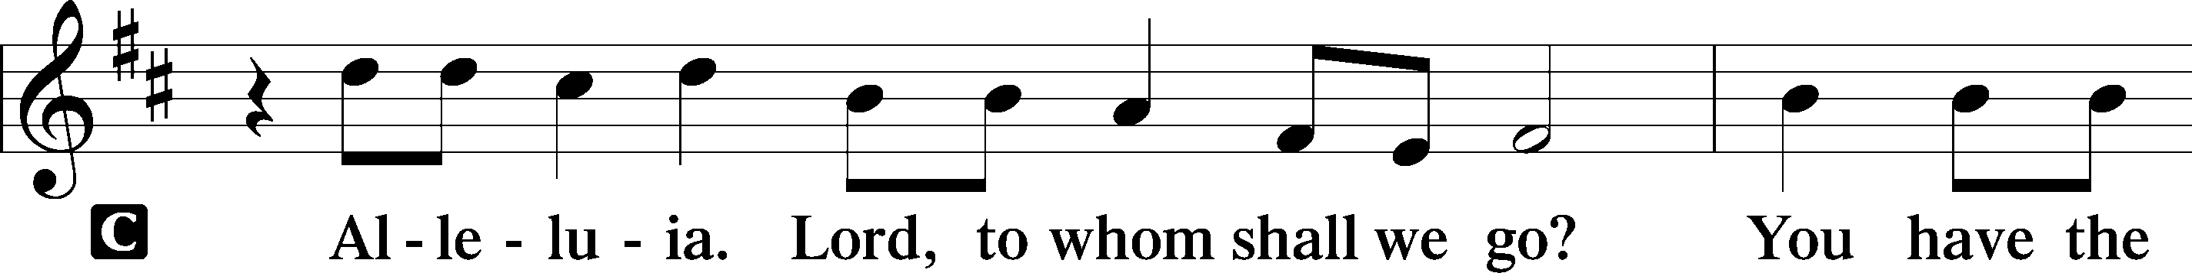
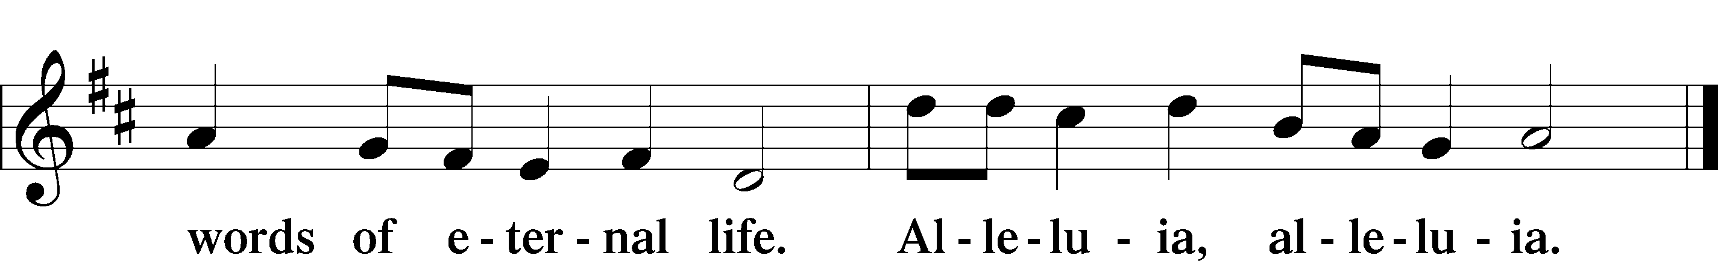

Holy Gospel Mark 10:23-31

P The Holy Gospel according to St. Mark, the tenth chapter.

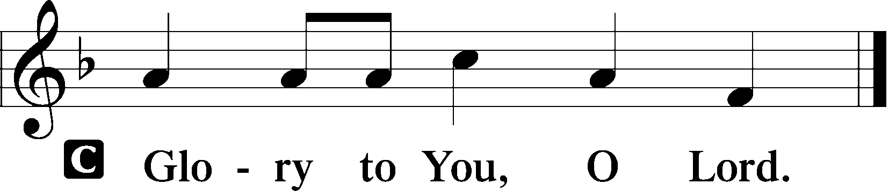

23Jesus looked around and said to his disciples, “How difficult it will be for those who have wealth to enter the kingdom of God!” 24And the disciples were amazed at his words. But Jesus said to them again, “Children, how difficult it is to enter the kingdom of God! 25It is easier for a camel to go through the eye of a needle than for a rich person to enter the kingdom of God.” 26And they were exceedingly astonished, and said to him, “Then who can be saved?” 27Jesus looked at them and said, “With man it is impossible, but not with God. For all things are possible with God.” 28Peter began to say to him, “See, we have left everything and followed you.” 29Jesus said, “Truly, I say to you, there is no one who has left house or brothers or sisters or mother or father or children or lands, for my sake and for the gospel, 30who will not receive a hundredfold now in this time, houses and brothers and sisters and mothers and children and lands, with persecutions, and in the age to come eternal life. 31But many who are first will be last, and the last first.”

P This is the Gospel of the Lord.

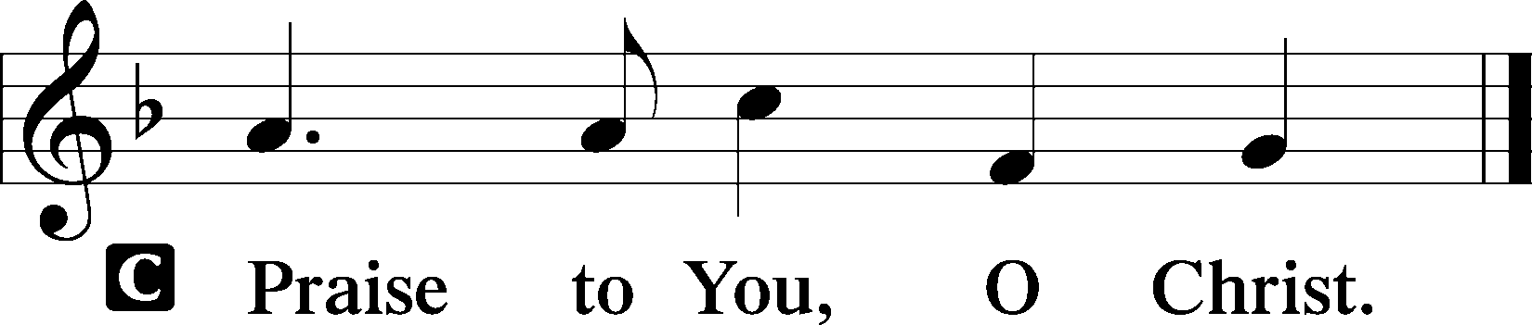

Sit

690 Hope of the World

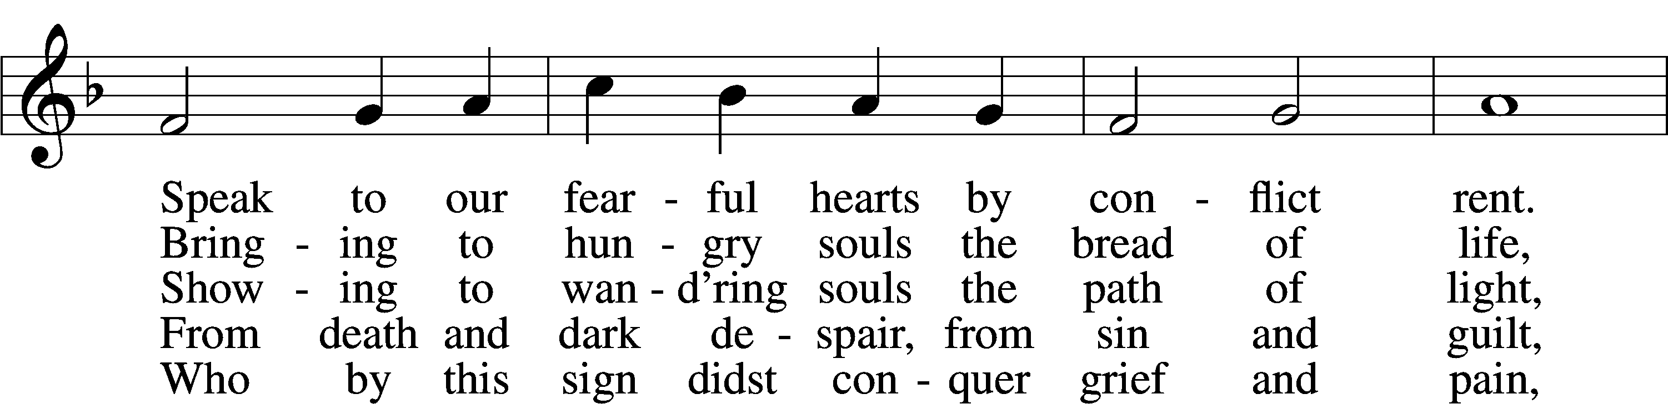
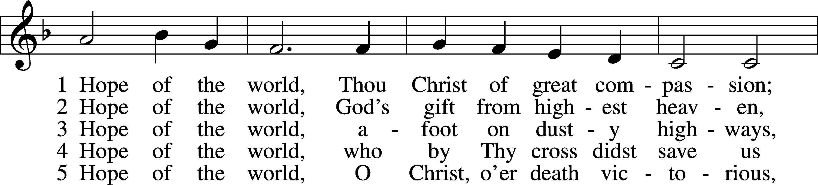
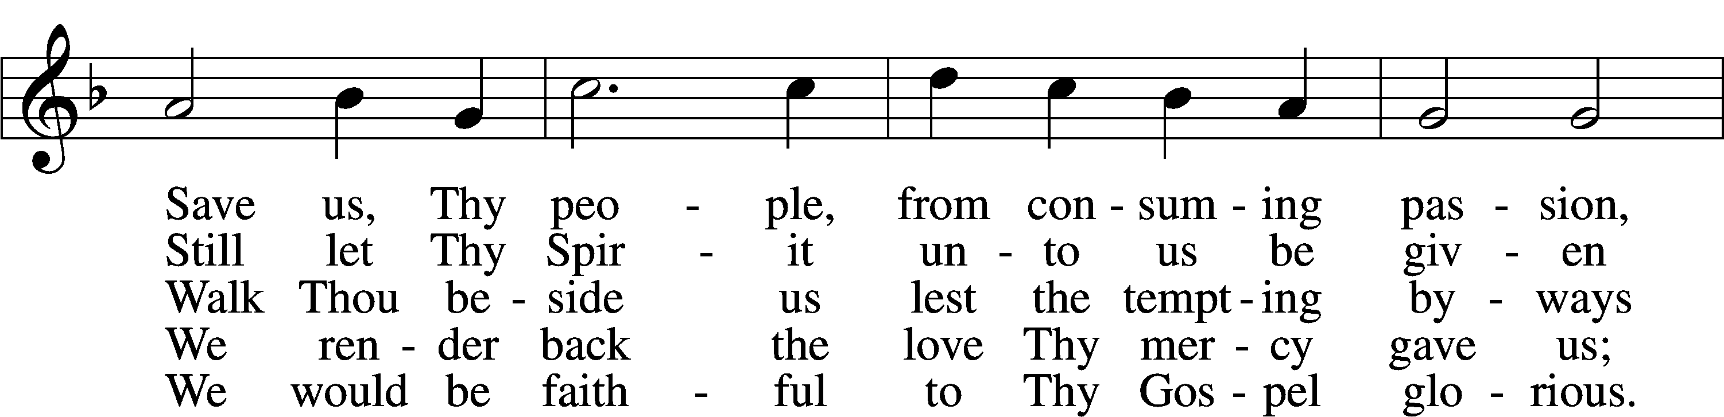
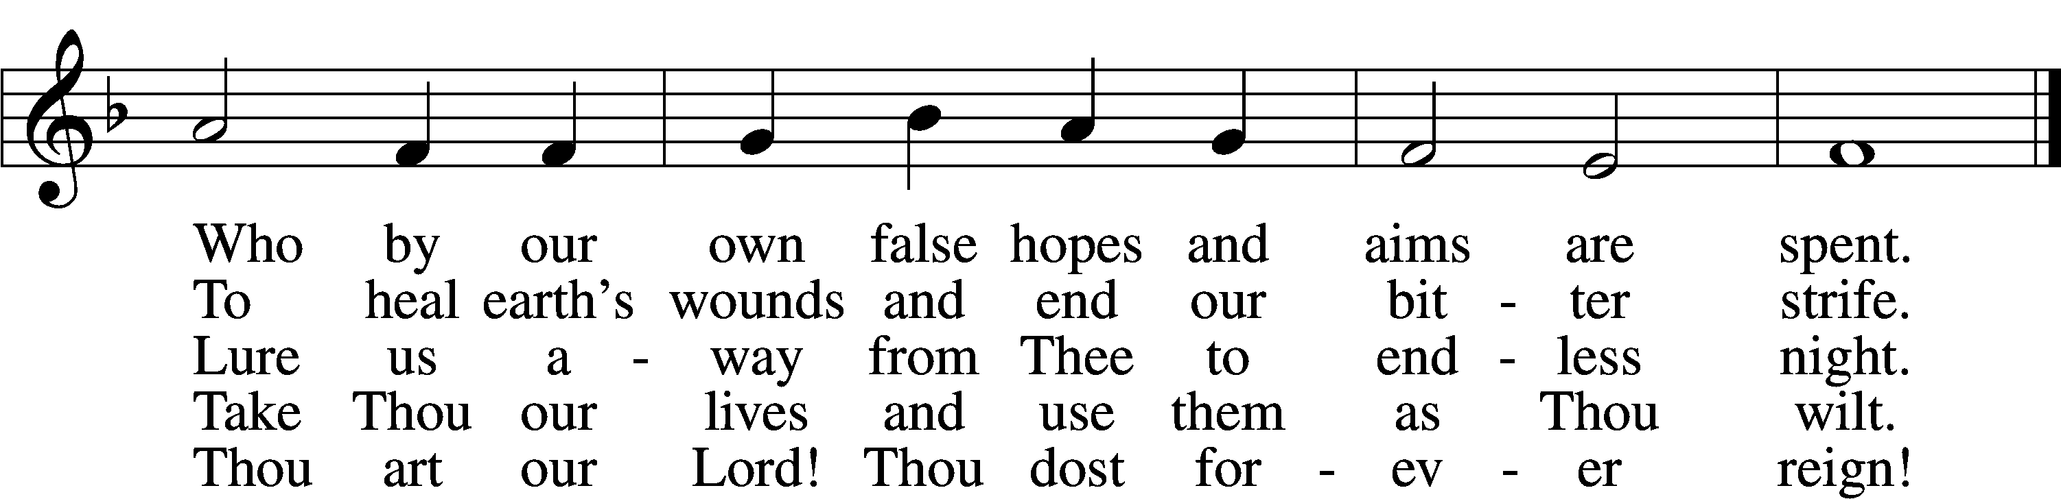

Text: © 1954, renewed 1982 The Hymn Society, admin. Hope Publishing Co. Used by permission: LSB Hymn License no. 110003744
Tune: Public domain

Sermon

Please stand

Apostles’ Creed
C I believe in God, the Father Almighty,
maker of heaven and earth.

And in Jesus Christ, His only Son, our Lord,
who was conceived by the Holy Spirit,
born of the virgin Mary,
suffered under Pontius Pilate,
was crucified, died and was buried.
He descended into hell.
The third day He rose again from the dead.
He ascended into heaven
and sits at the right hand of God the Father Almighty.
From thence He will come to judge the living and the dead.

I believe in the Holy Spirit,
the holy Christian Church,
the communion of saints,
the forgiveness of sins,
the resurrection of the body,
and the life T everlasting. Amen.

Prayer of the Church

Offerings and Offertory LSB 159
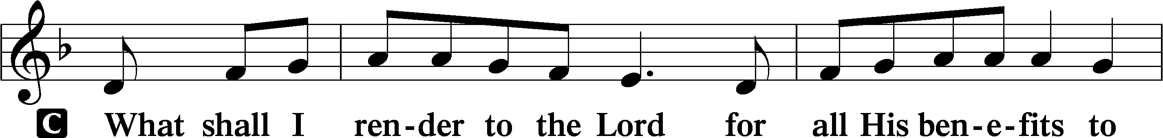
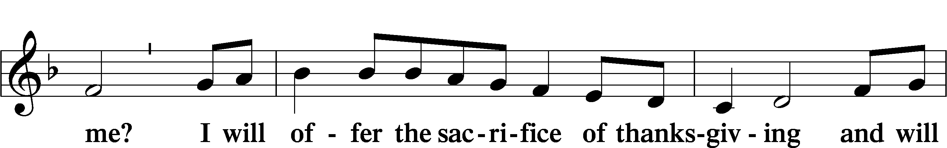
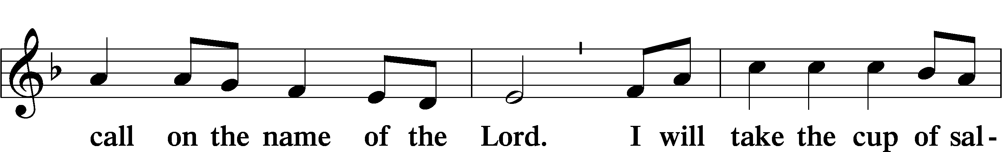
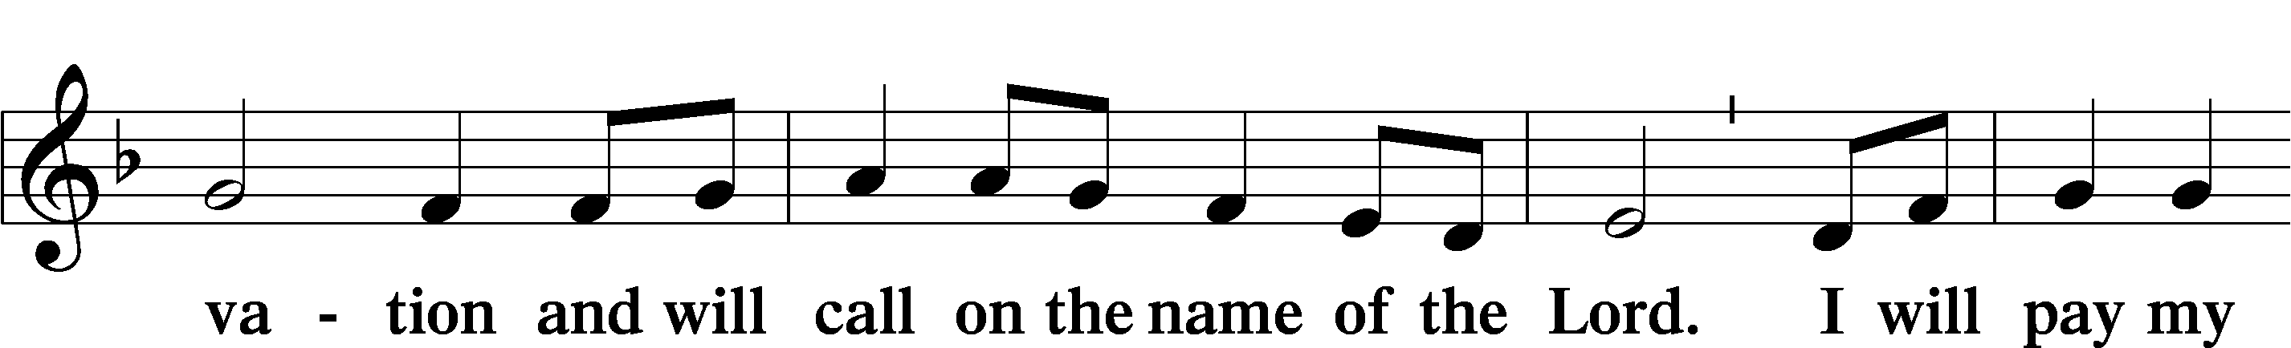
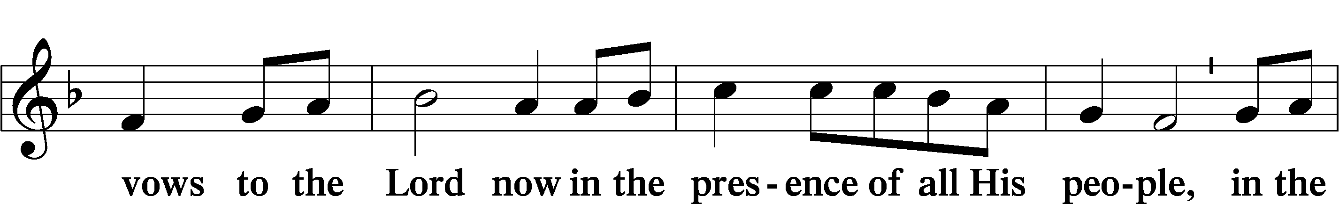
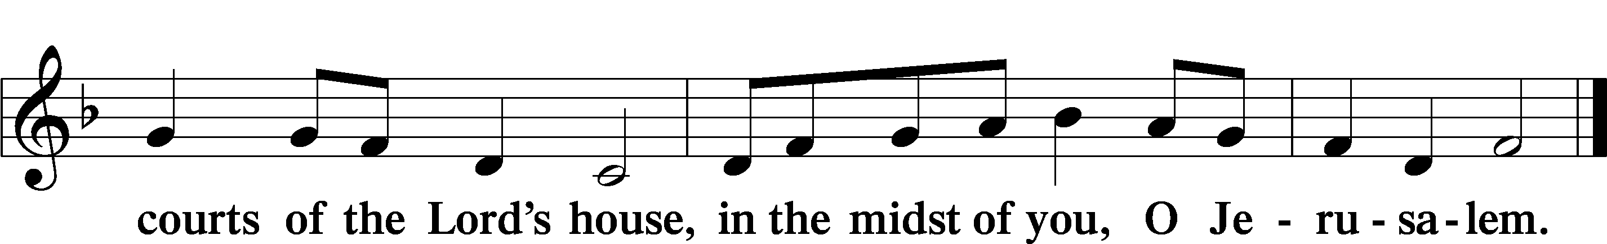

Service of the Sacrament

Preface LSB 160
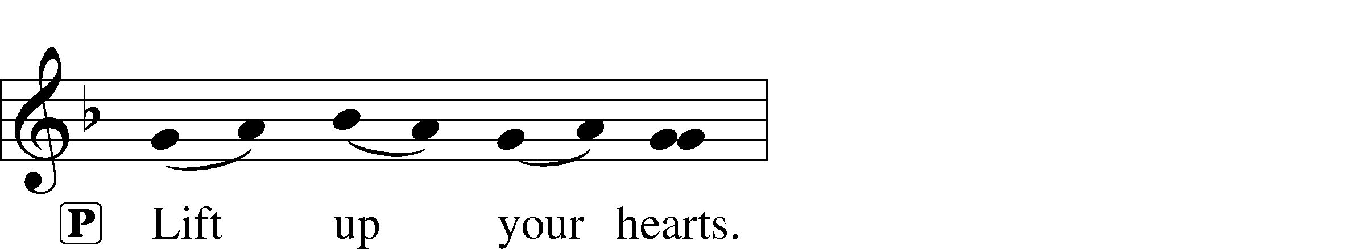
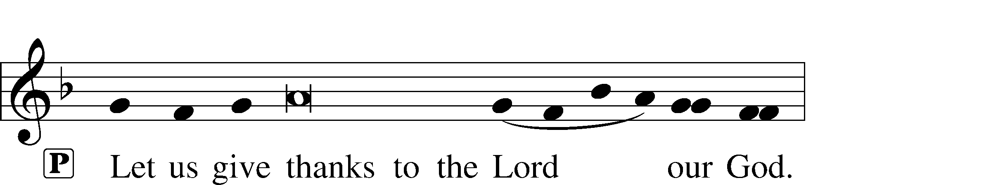
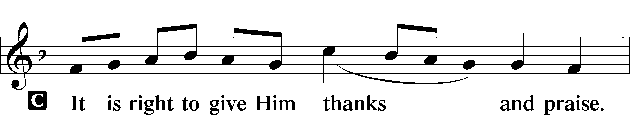

P It is truly good, right, and salutary that we should at all times and in all places give thanks to You, holy Lord, almighty Father, everlasting God, through Jesus Christ, our Lord. Therefore with angels and archangels and with all the company of heaven we laud and magnify Your glorious name, evermore praising You and saying:

Sanctus LSB 161
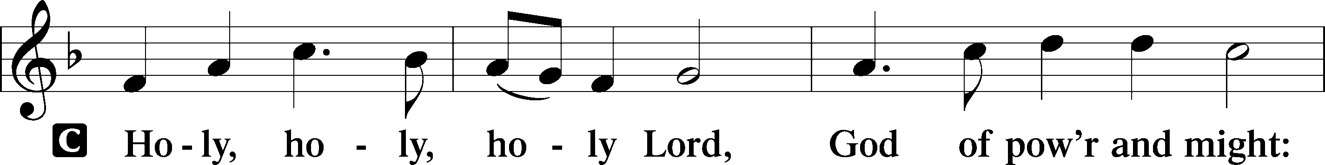
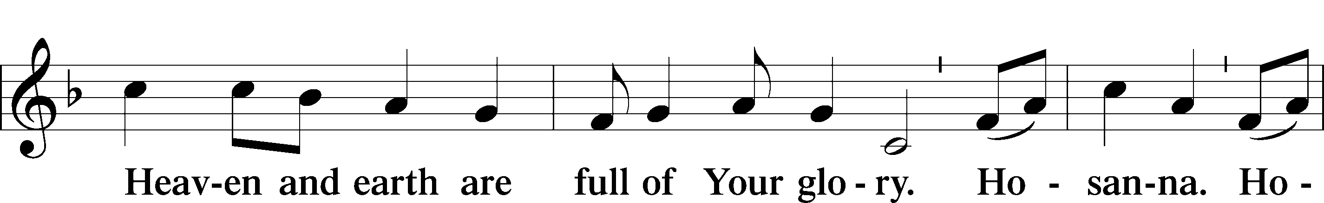
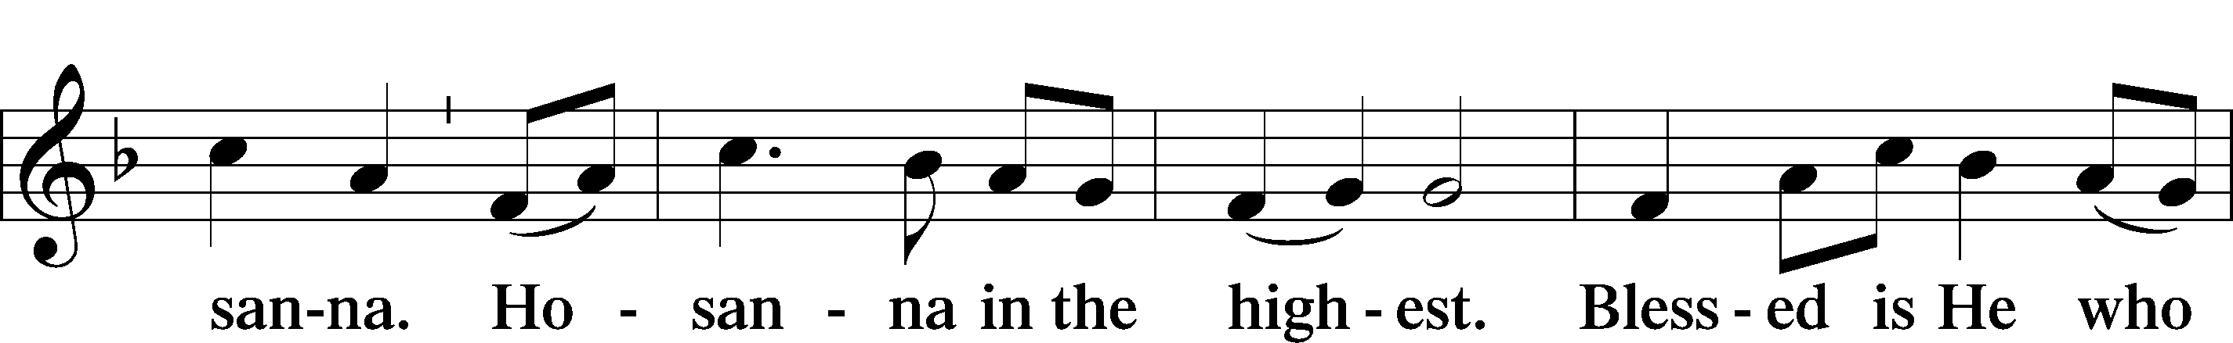
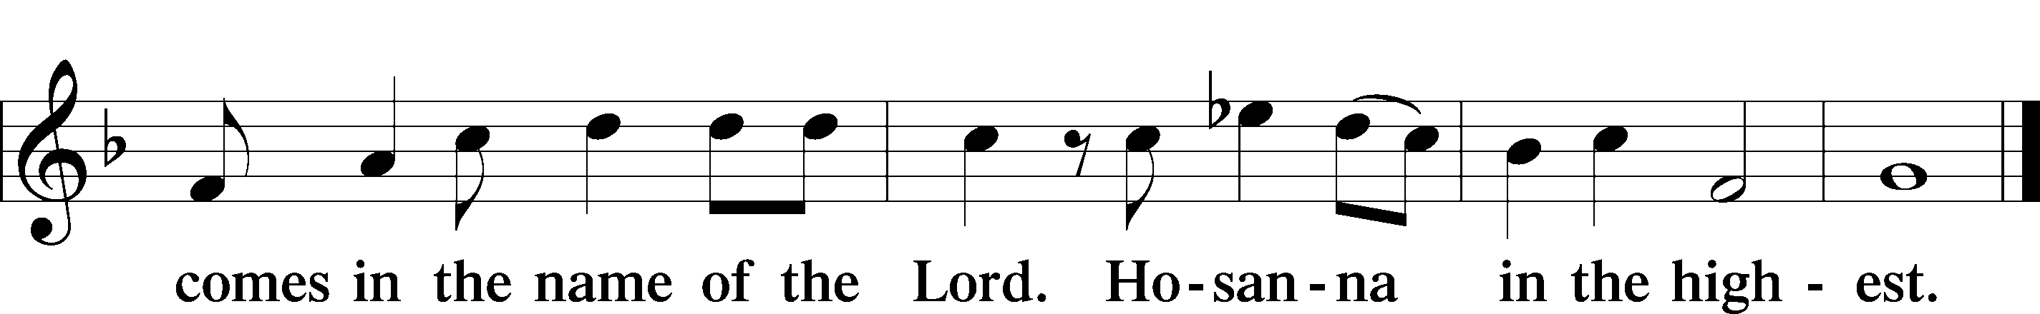

Lord’s Prayer
C Our Father who art in heaven,
hallowed be Thy name,
Thy kingdom come,
Thy will be done on earth
as it is in heaven;
give us this day our daily bread;
and forgive us our trespasses
as we forgive those
who trespass against us;
and lead us not into temptation,
but deliver us from evil.
For Thine is the kingdom
and the power and the glory
forever and ever. Amen.

The Words of Our Lord
P Our Lord Jesus Christ, on the night when He was betrayed, took bread, and when He had given thanks, He broke it and gave it to the disciples and said: “Take, eat; this is My T body, which is given for you. This do in remembrance of Me.”

In the same way also He took the cup after supper, and when He had given thanks, He gave it to them, saying: “Drink of it, all of you; this cup is the new testament in My T blood, which is shed for you for the forgiveness of sins. This do, as often as you drink it, in remembrance of Me.”

Pax Domini LSB 163
P The peace of the Lord be with you always.
C Amen.

Agnus Dei LSB 163
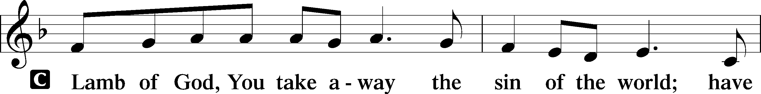
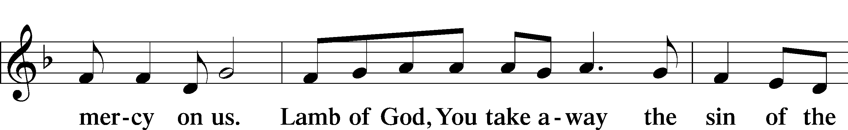
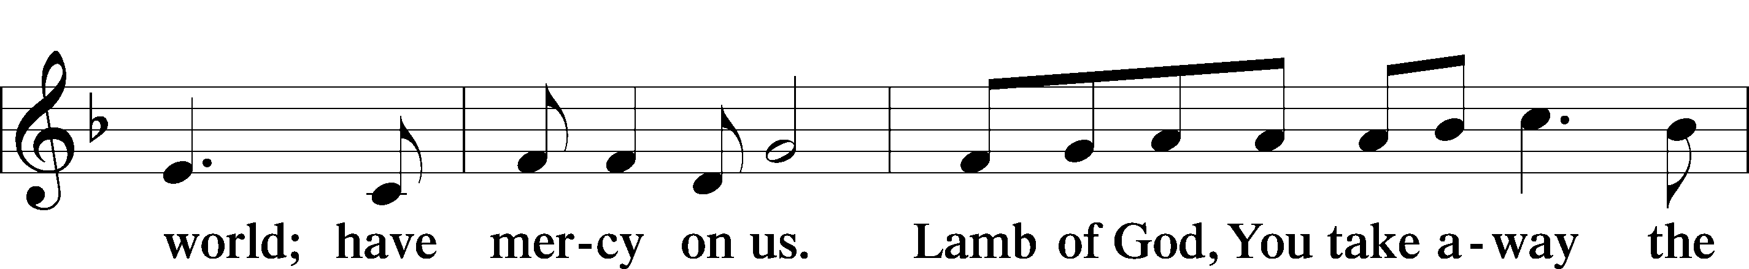
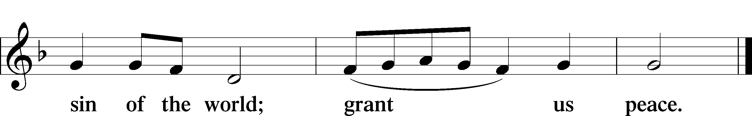
Sit

Distribution

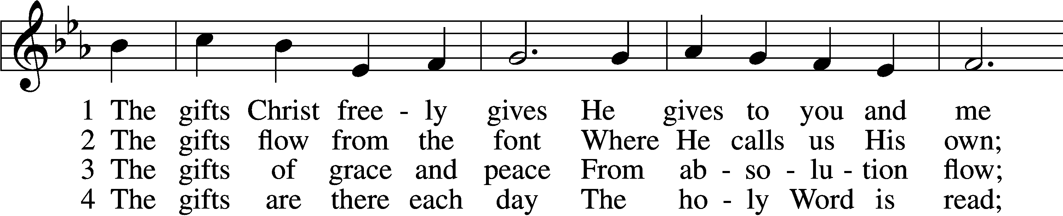
602 The Gifts Christ Freely Gives
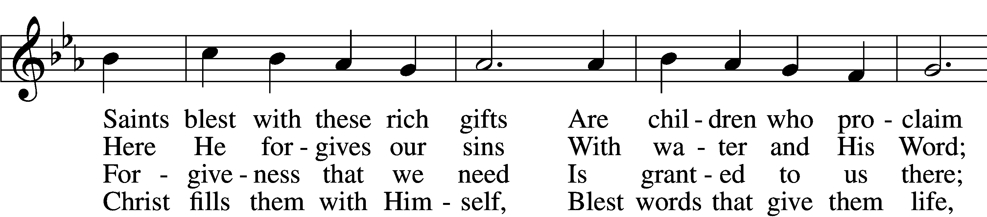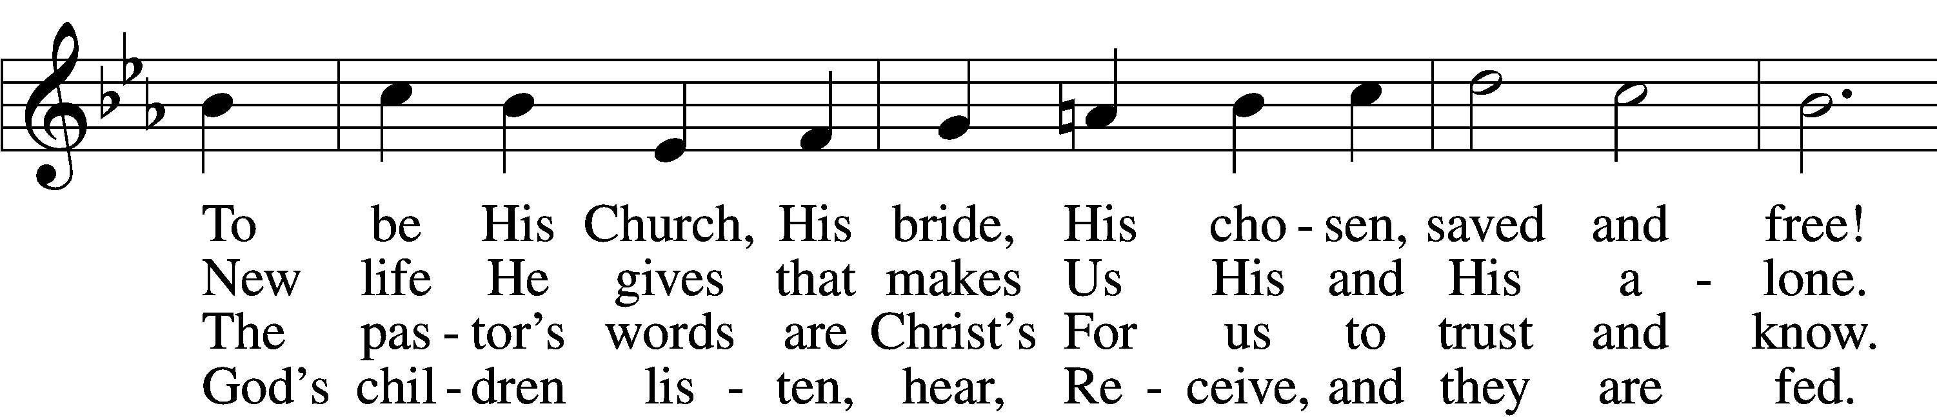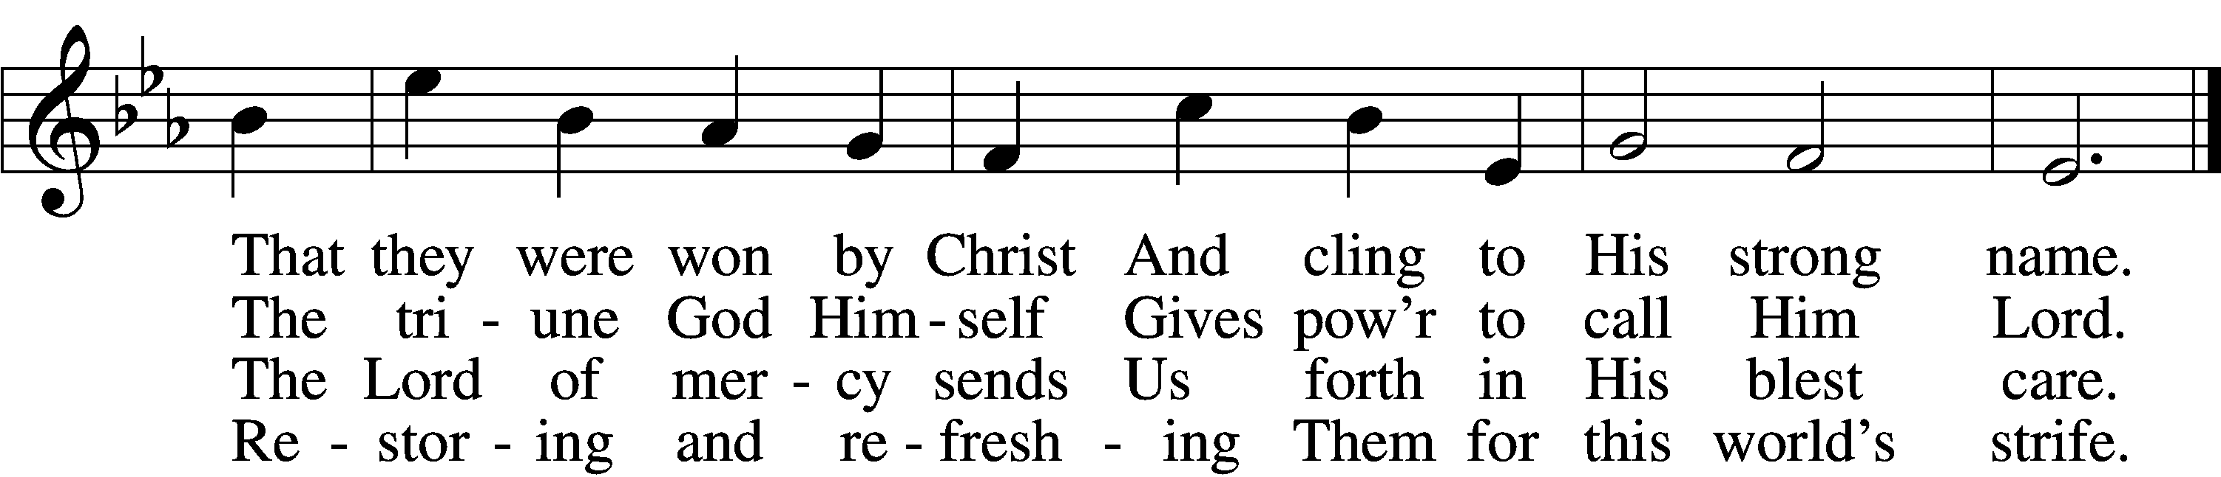

5 The gifts are in the feast,
Gifts far more than we see;
Beneath the bread and wine
Is food from Calvary.
The body and the blood
Remove our ev’ry sin;
We leave His presence in
His peace, renewed again.

6 All glory to the One
Who lavishes such love;
The triune God in love
Assures our life above.
His means of grace for us
Are gifts He loves to give;
All thanks and praise for His
Great love by which we live!
Tune: Public domain
Text: © 2001 Richard C. Resch. Used by permission: LSB Hymn License no. 110003744

782 Gracious God, You Send Great Blessings
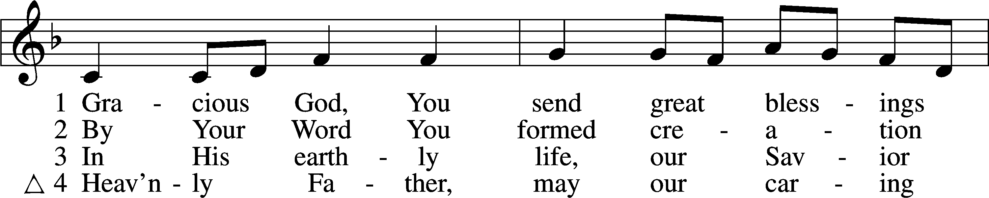

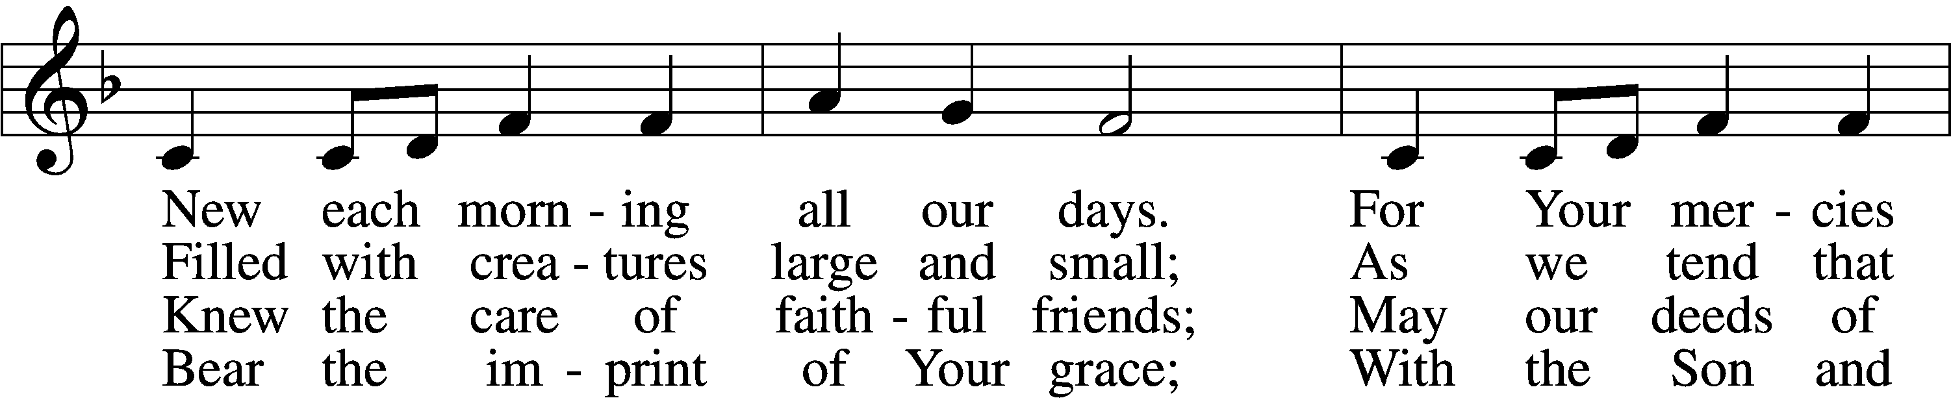

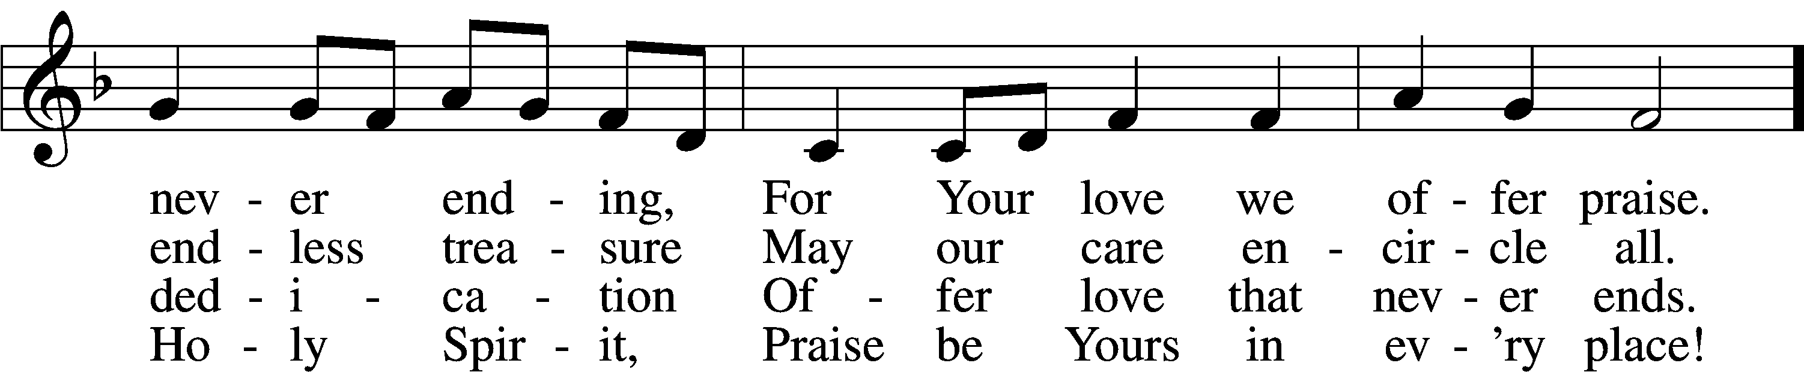

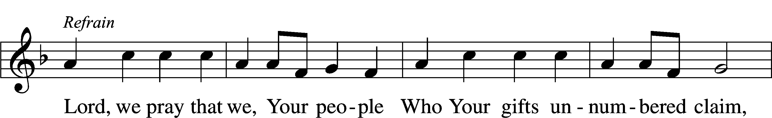

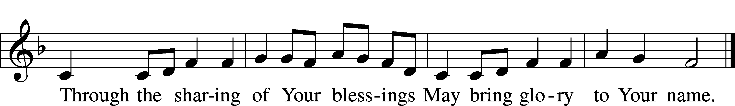

Text: © 2004 Gregory J. Wismar. Used by permission: LSB Hymn License no. 110003744
Tune: Public domain

632 O Jesus, Blessed Lord, to Thee
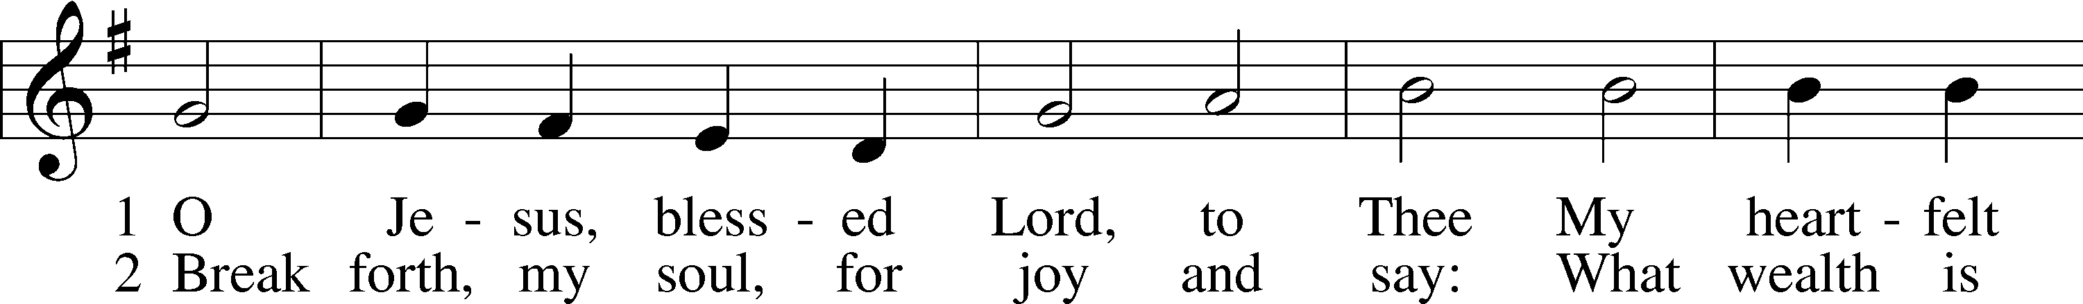
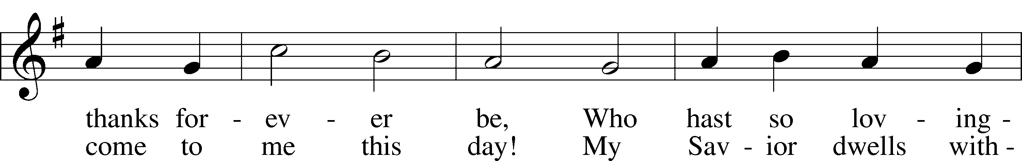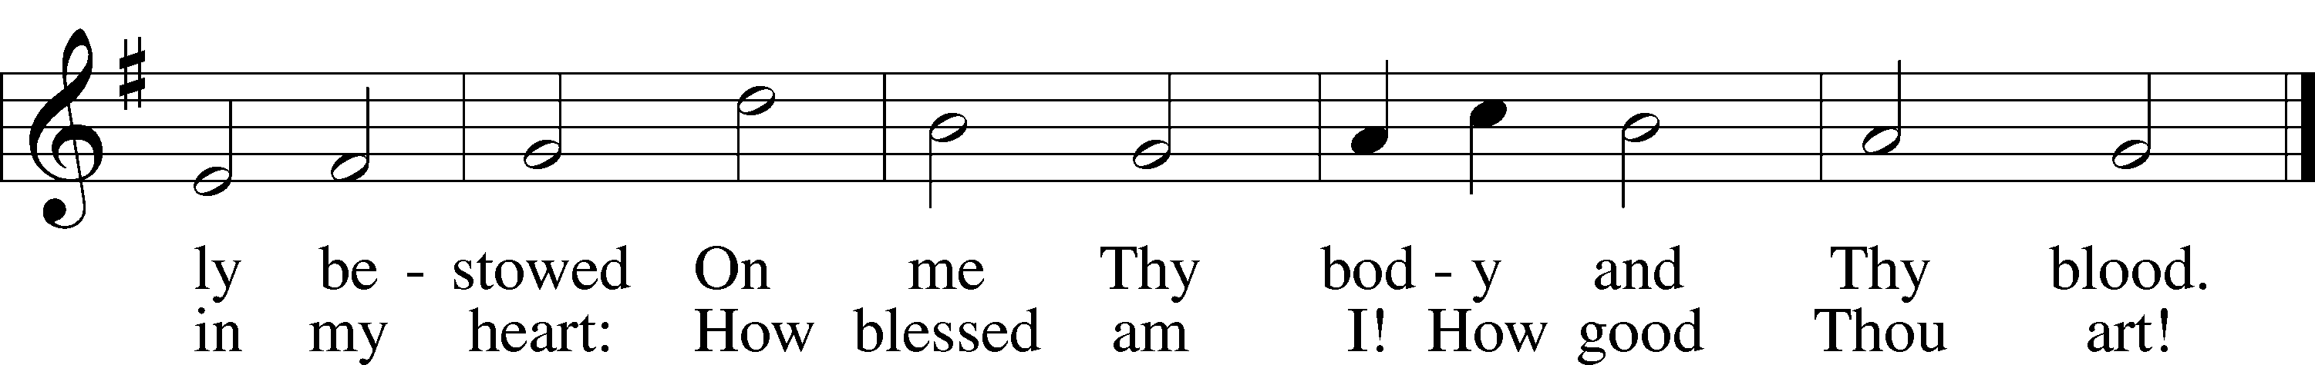
Tune and text: Public domain

Stand

The Dismissal
P The body and blood of our Lord Jesus Christ strengthen and preserve you in body and soul to life everlasting. Depart T in peace.
C Amen.

Thank the Lord LSB 164
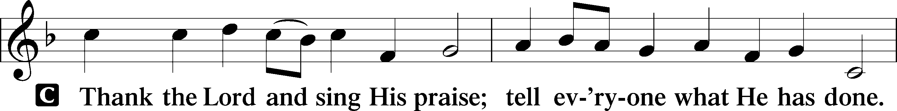
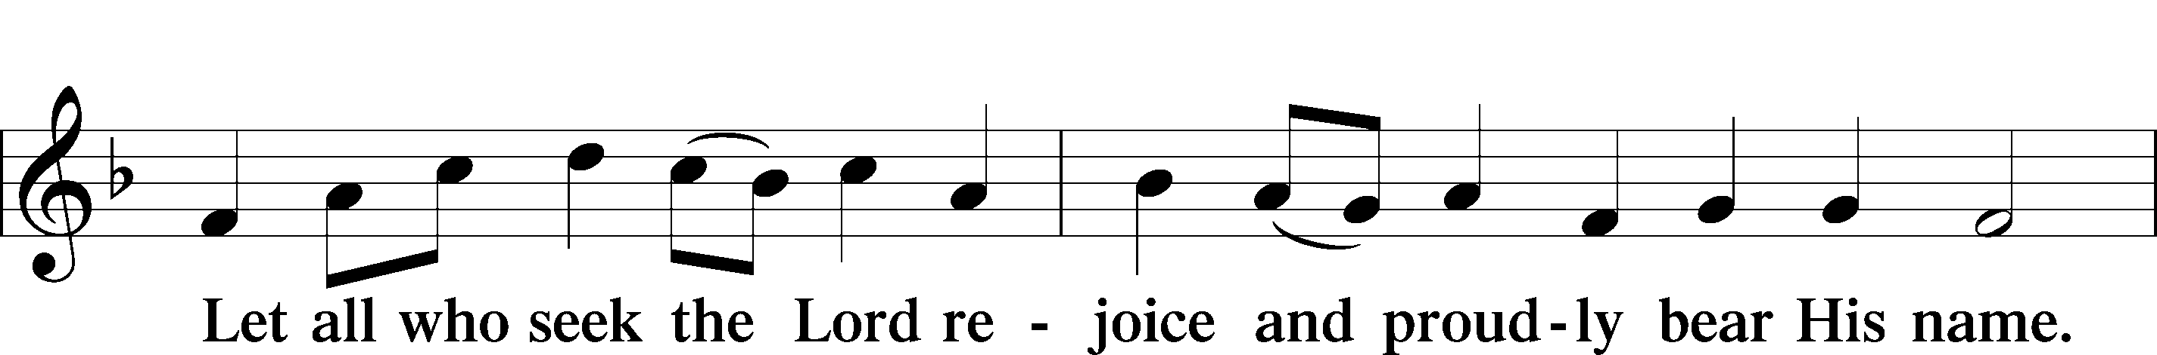
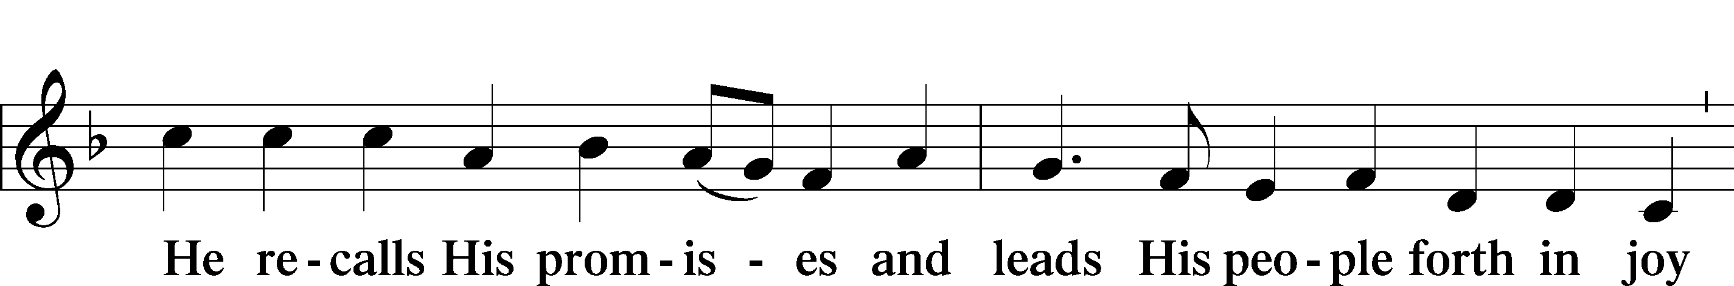
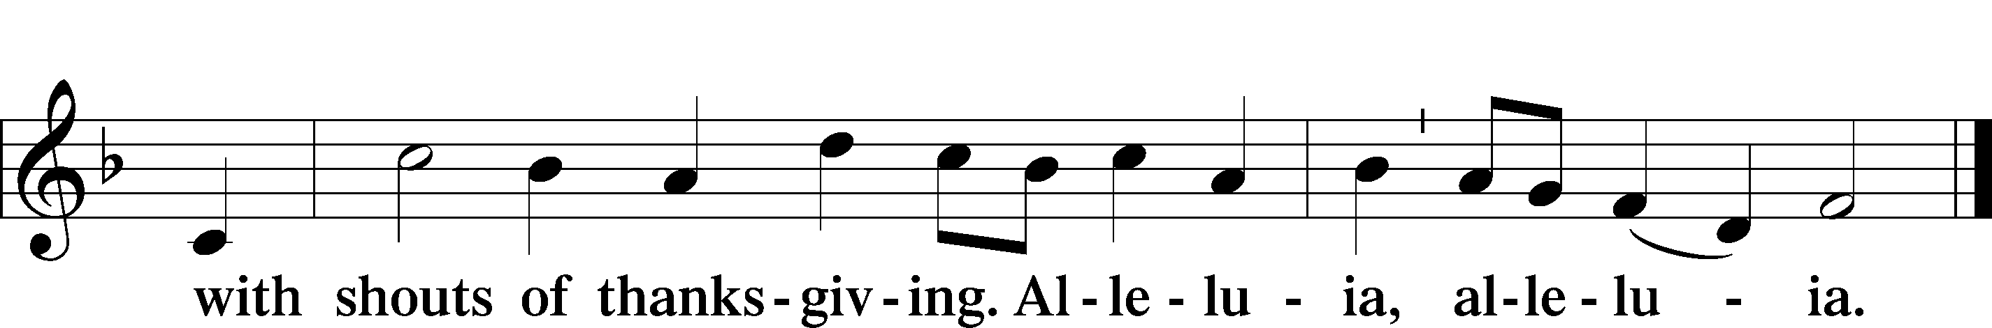

Post-Communion Collect
A Let us pray.
We give thanks to You, almighty God, that You have refreshed us through this salutary gift, and we implore You that of Your mercy You would strengthen us through the same in faith toward You and in fervent love toward one another; through Jesus Christ, Your Son, our Lord, who lives and reigns with You and the Holy Spirit, one God, now and forever.
C Amen.

Benediction LSB 166
P The Lord bless you and keep you.
The Lord make His face shine on you and be gracious to you.
The Lord look upon you with favor and T give you peace.
C Amen.

906 O Day of Rest and Gladness
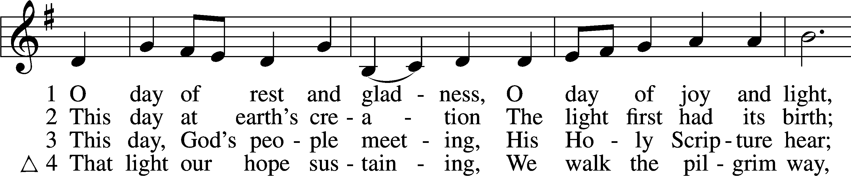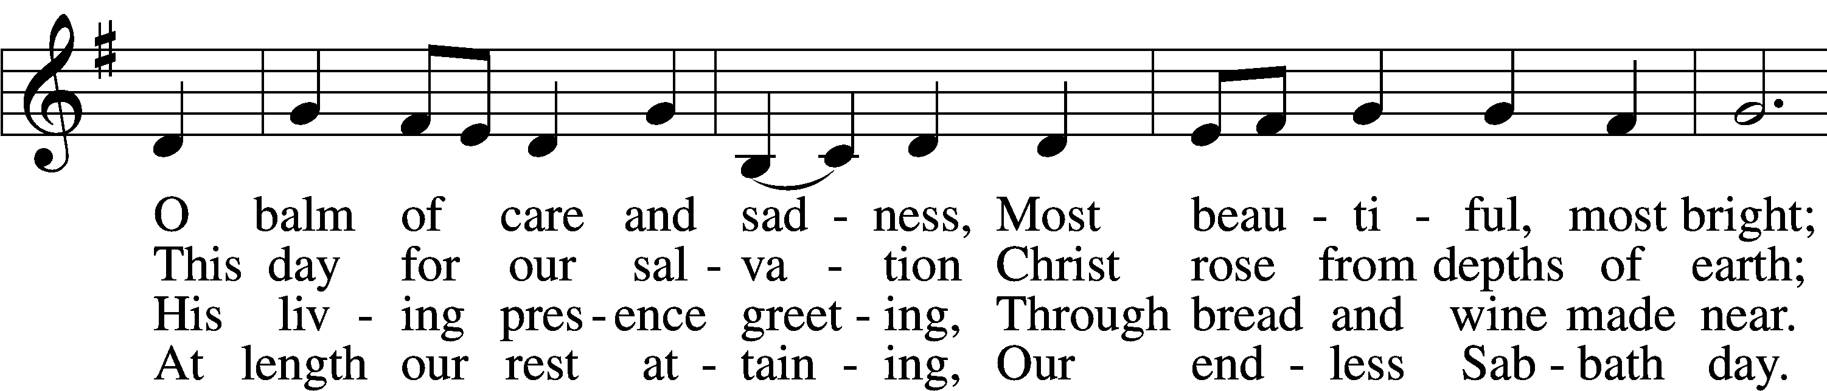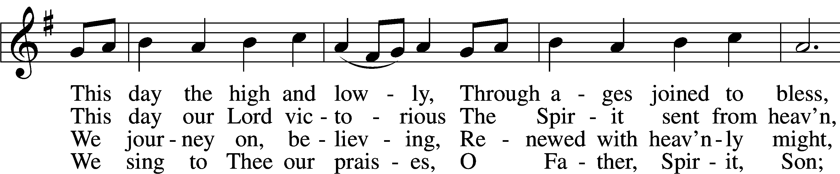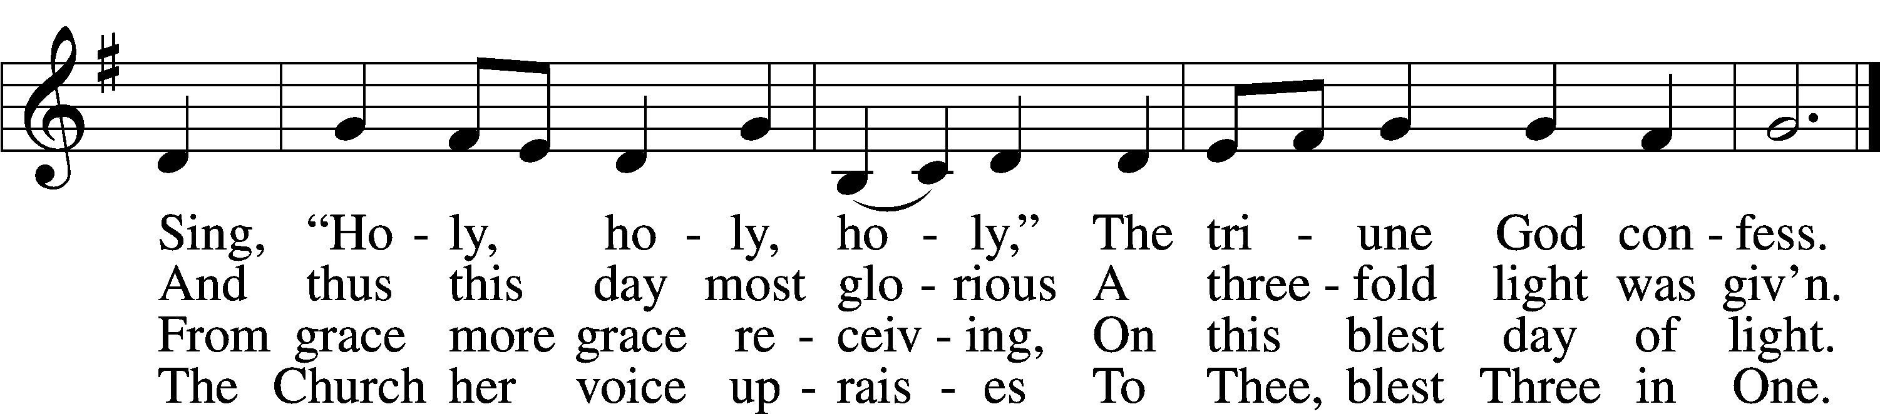
Text (st. 3) and tune: © 1982 Charles P. Price; (st. 4): © 1985 The Church Pension Fund. Used by permission: LSB Hymn License no. 110003744
Text (sts. 1–2) and tune: Public domain
Acknowledgments
Unless otherwise indicated, Scripture quotations are from the ESV® Bible (The Holy Bible, English Standard Version®), copyright © 2001 by Crossway, a publishing ministry of Good News Publishers. Used by permission. All rights reserved.
Created by Lutheran Service Builder © 2021 Concordia Publishing House
Prayers for Our Members
Sharon Hockemeier, Tenaya Nuttelman | Expectant Mothers
Nicholas & Holly (Fletcher) Kitzing | 10/16 Marriage
Norman Abels (Brookestone Meadows – Elkhorn) | Healing
Judy Ahrens | Healing
Vaughn Albrecht (Mount Carmel) | Healing
Tom & DyAnn Altwine | Healing
Lyle Colsden (Mother Hull) | Healing
Pat Flodine (Cambridge Court) | Healing
Vi Fox (Prairie View) | Hospitalized
Verleen Gentry | Healing
Wanda Glanzer | Healing
Ruby Hatfield | Healing
Evelyn Heiden (Mother Hull) | Healing
Lennis Hodgson | Healing
Don Richmond | Healing
Ivan Bombeck | Cancer
Fran Junge | Cancer
Bertha Marienau | Cancer
Kim Vos | Cancer

ZION LUTHERAN CHURCH AND SCHOOL

Pr. James DeLoach, Pastor + (308) 627-5260
james.deloach@zionkearney.org
Pr. Doug Gaunt, Pastor + (308) 455-0552
doug.gaunt@zionkearney.org
Tony Splittgerber, Principal + (308) 293-0168
anthony.splittgerber@zionkearney.org

Church Office
Secretary: Holly Reid
Email: school@zionkearney.org
Phone: (308)-234-3410 Fax: (308) 236-8100
Office Hours: Monday-Friday 8:00am-4:00pm
Radio Broadcast: Sunday @ 10:30 a.m. on 1460 AM and 92.1 FM
Website: www.zionkearney.com
Prayers for Our Members’ Family & Friends
Naomi Wollberg (Matthias’ wife) | Expecting
Elaine Arehardt (Zion’s Music Teacher) | Expecting
Larry Bombeck (Ivan’s brother) | Healing
Katie Cunningham (Quentin & Janel Lange’s friend) | Healing
Reg Duke (Westman’s brother-in-law) | Healing
James Gentry (Verleen’s son) | Healing
Roger Hoffman (Marc’s father) | Healing
David Kreutzer (Richard’s brother) | Healing
Pr. Rob Kuefner (Kearney Circuit Visitor) | Healing
Dillon Malchow (Joy Barefoot’s nephew) | Healing
Urijah Mitchell (Sue & Dennis Bartels’ Grandson) | Healing
Tim Powers (Kim Wilken’s brother) | Healing
Roy Reynolds (Verleen Gentry’s son-in-law) | Healing
Lynne Saathoff (Verleen Gentry’s sister-in-law) | Healing
Randy Solomon (Beth Rosenthal’s father) | Healing
Tim Trampe (Don & Gretchen’s son) | Healing
Jonah (Jase & Jarren Blattner’s friend) | Cancer
D.D. Dugger (Sue Kaiser’s brother) | Cancer
Stuart Gronewoller (Lonna’s brother-in-law) | Cancer
Linda Heapy (Janel Lange’s mother) | Cancer
Ron Halvorsen (Jeff’s dad) | Cancer
Bill Jedlicka (Pam Uhlir’s cousin) | Cancer
Randy Jochum (Ken Hockemeier’s brother-in-law) | Cancer
Sharon Mulhair (Pam Uhlir’s cousin) | Cancer
Kolby Shiers (Jessica’s cousin) | Cancer
Pr. Richard Snow (NE District President) | Cancer
Tyrone Uhlir (Pam’s nephew) | Cancer
John Weber (Zehendner’s friend) | Covid & Cancer
Tim Smallcomb (Wilkens’ friend) | Deployment
Family of Roger Kaiser (Susan Tonniges father) | Grief
Today’s Radio Broadcast is sponsored in thanks to our Heavenly Father for faithful Christian families
– Marian Allwardt

Worship Assistants

Sunday, October 17~ 9:00am

Elder: Dan Oertwig
Usher: Andy Wollberg
Acolyte: Lindsay Wilkens
Engineer: Jared Nuttelman
Announcer: Jesse Florang
Altar Guild: Jamie & Shirley Helmbrecht

Sunday, October 24~ 9:00am

Elder: Ken Hockemeier
Usher: Mike Wilkens
Acolyte: Makenna Starkey
Engineer: Shawn Starkey
Announcer: Lonna Gronewoller
Altar Guild: Jamie & Shirley Helmbrecht

Our Response to the Gospel

Date: 10/10/2021
Offering: $6,136
Weekly Need: $7,457.69

This Week at Zion

Sun  10/17 | 9:00a  10:20a  10:30a  5:00p  12p-5pm | Divine Service  Bible Study/Sunday School  Radio Broadcast 1460am & 92.1fm  Divine Service  Hockemeier – Fellowship Hall
Mon
10/18
Tues  10/19 | 1:30p  7:00p | Sleeping Mats  Church Council
Wed  10/20 | 8:30a  5:45p  7:00p  Anniversaries | Chapel  Midweek  Adult Choir  Jordan & Sharon Hockemeier
Thurs  10/21 | All Day  7:00p | No School – Teacher’s Conference  Men’s Bible Study
Fri  10/22 | All Day  Birthdays | No School – Teacher’s Conference  Kassidy Halvorsen  Rachel Barefoot
Sat  10/23 | Birthdays | Nancy Dissmeyer
Sun  10/24 | 9:00a  10:20a  10:30a  5:00p | Divine Service  Bible Study/Sunday School  Radio Broadcast 1460am & 92.1fm  Divine Service

Where our Triune God strengthens us through His mercy in faith toward Him and in fervent love toward one another.

ANNOUNCEMENTS

The Kearney Circuit Reformation Service will be hosted by Zion on October 31, at 4:30 pm. All LCMS Congregations, in the Kearney Circuit and Nebraska, are invited. Dr. Gerhard Bode, a professor at Concordia Seminary, St. Louis will preach for this service. His areas of interest and expertise include the Reformation and the history of Lutheranism.

Following the service all are invited to stay for a meal of Brats & Hot Dogs, Potato Salad, Beans and Desserts. There will be a freewill offering that will go to the International Lutheran Council in support of other Lutherans throughout the world. All food will be provided by Zion Lutheran members and Thrivent. Dr. Bode will also be leading a study on the Reformation during Bible Class (Sun @ 10:30a).

Holly Reid began serving Zion Lutheran Church and School as our secretary. Please greet her and introduce yourself to her.

Sunday School is being offered for grades K-High School at 10:20am.

Adult Bible Study is studying the rich variety of words God uses to communicate the Gospel—that we are justified by grace through faith. Come grab a donut and cup of coffee as we fellowship and learn together.

Why has Zion’s 5pm service moved from Saturday to Sunday?

- Families who are out of town on Saturday at the lake, camping, or for travel sports will be back in time for a Sunday evening worship.
- Some of our older members attend Saturday evenings because of lighter street and parking lot traffic. Sunday evenings will allow them a similar opportunity.
- Due to leading the Saturday evening services our pastors often cannot attend their kids’ or grandkids’ Saturday games or events.
- A move to Sunday evening allows Pr. DeLoach and Carol to spend Saturday together, with family, or with friends without the responsibility of preaching or playing for a service that evening.
- If our pastors preside at a Saturday wedding, they are unable to attend the reception until much later, especially where travel is involved.
- Sunday evening is often a better option for our college and high school students.
- There are fewer social or sporting events on Sunday evenings.
Zion’s 4th Quarter (Oct – Dec) Mission Offerings will support Zion’s current students, who are studying for full-time church work. All our students are at Concordia (CUNE):
Peter Kreutzer - Lutheran Teacher’s Diploma (LTD)
Jessica Zehendner – LTD
Taylor Zehendner – LTD
Please use the mission envelopes located in the narthex for this offering. Or give via Church Trac by selecting “Missions.” Thank you for your support.

Offering Options:
1) Place your offering in the basket as you leave
2) Go to zionkearney.churchtrac.com/give
3) Go to zionkearney.com and click on the ChurchTrac icon
4) Mail your gift to Zion Lutheran Church, 2421 C Ave, Kearney, NE 68847. Or place it in the mail slot on the south side of the building.
Radio Broadcast – Please help Zion spread the Gospel, signup to sponsor a radio broadcast! There are several open dates including October 31st.

SCHOOL NEWS

The Theme for our school year is “Together by Christ’s Love” based on 1 John 4:7-8.

- Pie Sales are still going. Place an order with any Zion student or with the office by Friday, October 29th. The pie pick-up date is November 17th.
- The School Carnival is Saturday, October 30th from 1pm-4pm. Join us for games, food, and prizes. Tickets are $0.25 each. *Costumes are allowed but please help your children make appropriate choices on what to wear.

