Divine Service
Reformation Sunday
October 31, 2021

Zion Lutheran Church
Kearney, Nebraska

Welcome to Zion!
All worshippers please fill out an attendance card in the pew rack and let us know how we might be of service to you.

Holy Communion at Zion

The Lord’s Supper is celebrated at this congregation as Jesus has instituted it. As he says, so our Lord gives into our mouths not only bread and wine but his very body and blood to eat and to drink for the forgiveness of sins and to strengthen our union with him and with one another. Our Lord invites to his table those who repent of all sin, trust his words “given and shed for you for the forgiveness of sins,” and set aside any refusal to forgive and love as he forgives and loves us, that they may show forth his death until he comes. All communicants need to register in the narthex prior to the service.

The Lord’s Supper can harm those who receive it unworthily. Holy Communion is also a confession of the faith which is confessed at this altar. Therefore, any who are not yet instructed, in doubt, or who hold a confession differing from that of this congregation and The Lutheran Church—Missouri Synod, are asked not to commune until they are able to speak with our pastor first. He is most happy to visit with you about the Christian faith and how to receive the Lord’s Supper for your good and for the good of others. Those not communing are invited to come to the altar, cross your arms in front of you, and bow your head to receive a pastoral blessing.

The Son of God Has Set Us Free from Sin and Death by His Grace

“Wisdom is justified by her deeds” (Matt. 11:19), and the true Wisdom of God, Christ Jesus, the incarnate Son, has justified us by His deeds. He prepares His way by the preaching of repentance, but He has suffered the violence of the Law and voluntarily handed Himself over to violent men, that we might eat and drink with Him in His kingdom and “remain in the house forever” (John 8:35). He is “a friend of tax collectors and sinners” (Matt. 11:18–19), and He has rescued us by His grace from the slavery of sin and death. By the proclamation of His eternal Gospel “to those who dwell on earth, to every nation and tribe and language and people” (Rev. 14:6), “the righteousness of God has been manifested apart from the law” (Rom. 3:21), “that he might be just and the justifier of the one who has faith in Jesus” (Rom. 3:26). And by the hearing of that Gospel of Christ Jesus, “whom God put forward as a propitiation by his blood, to be received by faith” (Rom. 3:25), “you will know the truth, and the truth will set you free” (John 8:31–32).

657 A Mighty Fortress Is Our God sts. 1–4
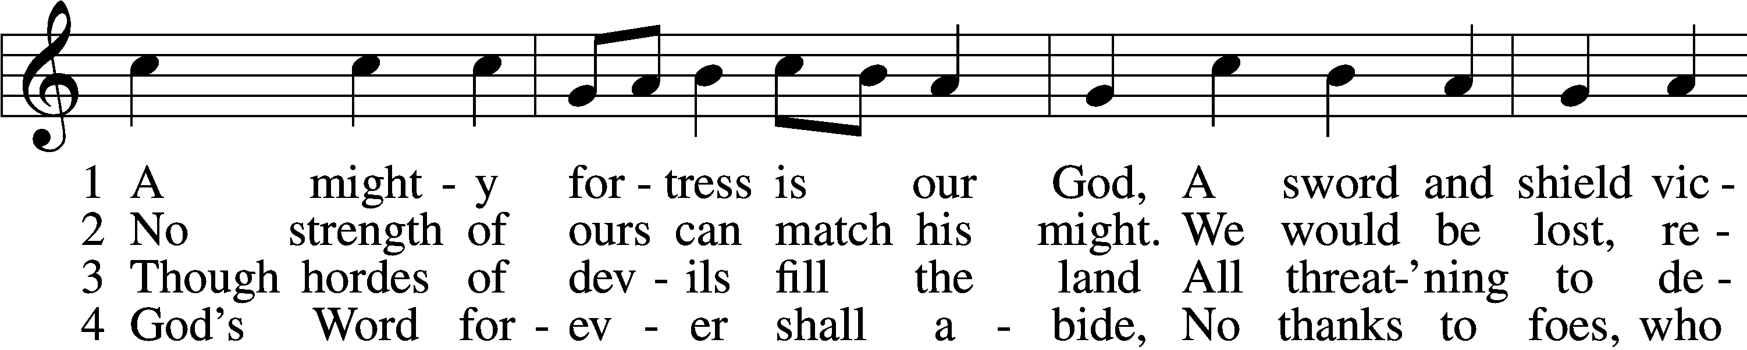
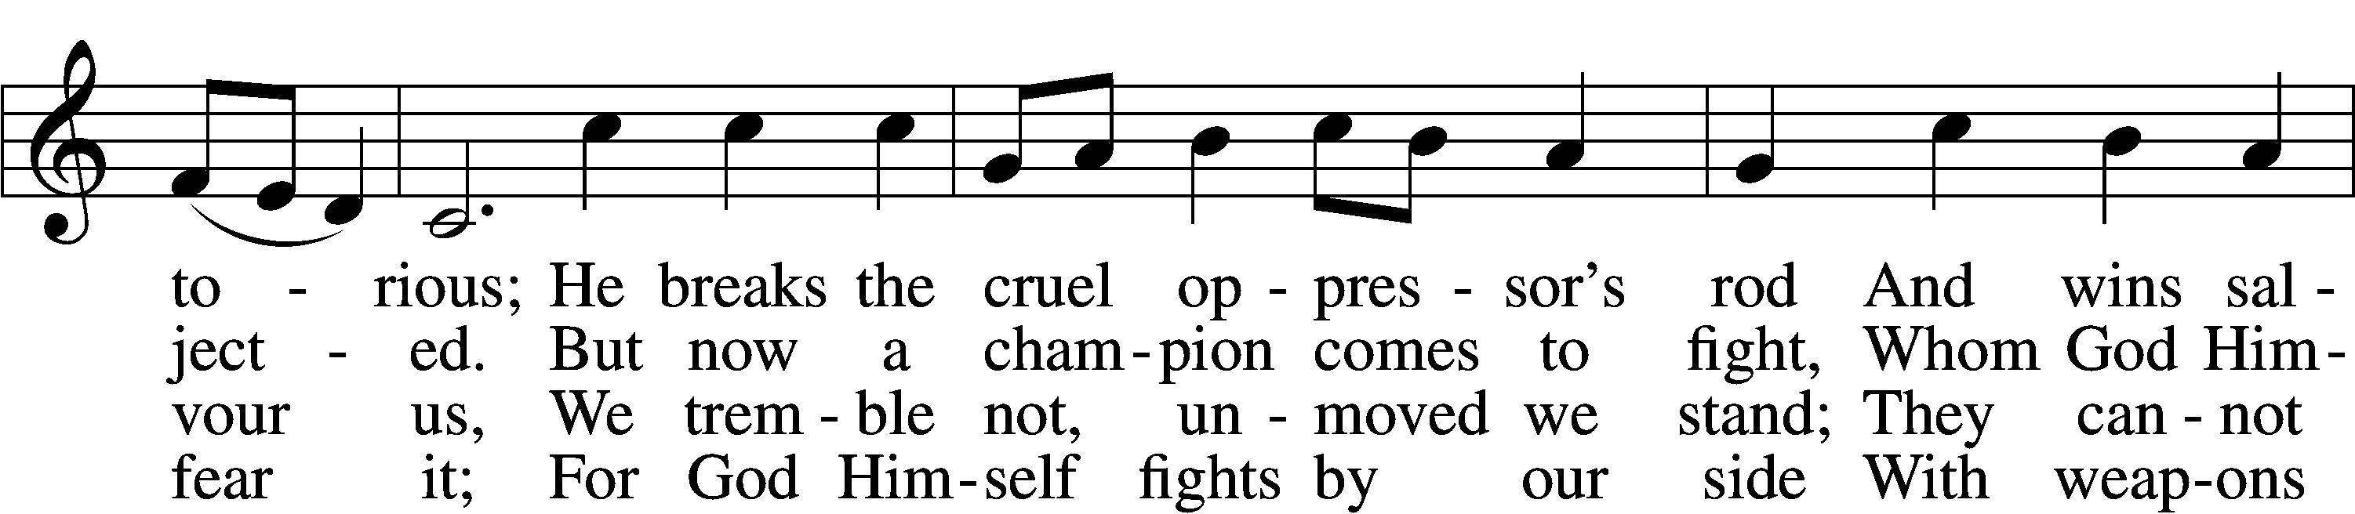
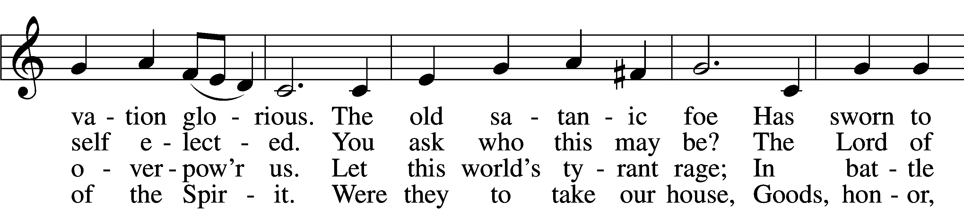
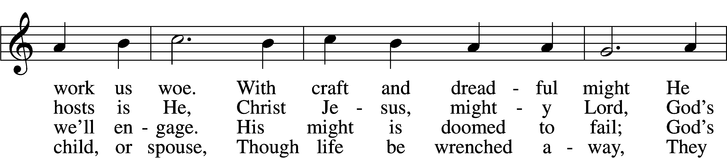
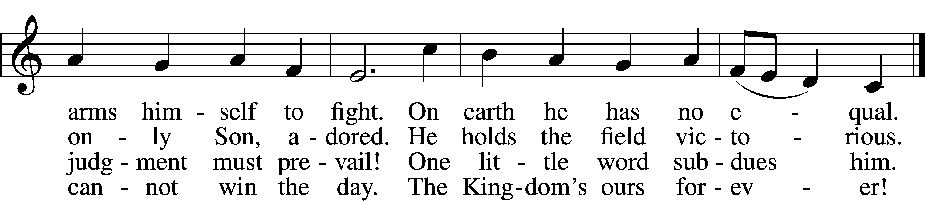
Text: © 1978 Lutheran Book of Worship. Used by permission: LSB Hymn License no. 110003744
Tune: Public domain

Stand
Confession and Absolution

The sign of the cross may be made by all in remembrance of their Baptism.

Invocation
P In the name of the Father and of the T Son and of the Holy Spirit.
C Amen.

Exhortation LSB 151
P If we say we have no sin, we deceive ourselves, and the truth is not in us.
C But if we confess our sins, God, who is faithful and just, will forgive our sins and cleanse us from all unrighteousness.

Silence for reflection on God’s Word and for self-examination.

Confession of Sins LSB 151
P Let us then confess our sins to God our Father.
C Most merciful God, we confess that we are by nature sinful and unclean. We have sinned against You in thought, word, and deed, by what we have done and by what we have left undone. We have not loved You with our whole heart; we have not loved our neighbors as ourselves. We justly deserve Your present and eternal punishment. For the sake of Your Son, Jesus Christ, have mercy on us. Forgive us, renew us, and lead us, so that we may delight in Your will and walk in Your ways to the glory of Your holy name. Amen.

Absolution LSB 151
P Almighty God in His mercy has given His Son to die for you and for His sake forgives you all your sins. As a called and ordained servant of Christ, and by His authority, I therefore forgive you all your sins in the name of the Father and of the T Son and of the Holy Spirit.
C Amen.

Service of the Word

Psalm 46 (Spoken responsively by whole verse)

¹God is our refuge and strength,
a very present help in trouble.
²Therefore we will not fear though the earth gives way,
though the mountains be moved into the heart of the sea,
³though its waters roar and foam,
though the mountains tremble at its swelling.
⁴There is a river whose streams make glad the city of God,
the holy habitation of the Most High.
⁵God is in the midst of her; she shall not be moved;
God will help her when morning dawns.
⁶The nations rage, the kingdoms totter;
he utters his voice, the earth melts.
⁷The Lord of hosts is with us;
the God of Jacob is our fortress.
⁸Come, behold the works of the Lord,
how he has brought desolations on the earth.
⁹He makes wars cease to the end of the earth;
he breaks the bow and shatters the spear;
he burns the chariots with fire.
¹⁰“Be still, and know that I am God.
I will be exalted among the nations,
I will be exalted in the earth!”
¹¹The Lord of hosts is with us;
the God of Jacob is our fortress.
Glory be to the Father and to the Son
and to the Holy Spirit;
as it was in the be- ginning,
is now, and will be forever. Amen.
Kyrie LSB 152
P In peace let us pray to the Lord.
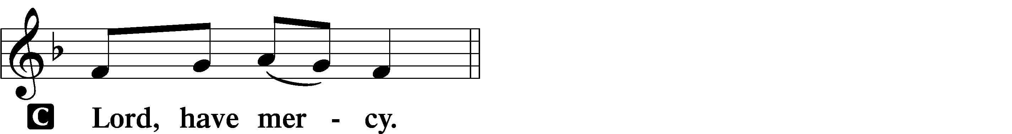
P For the peace from above and for our salvation let us pray to the Lord.
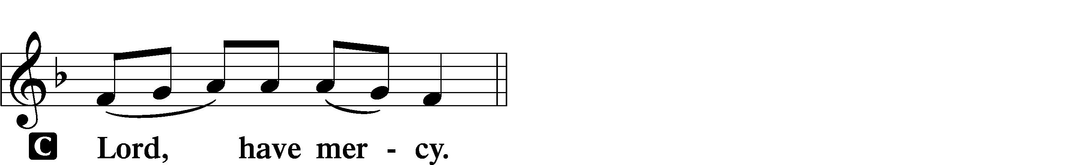
P For the peace of the whole world, for the well-being of the Church of God, and for the unity of all let us pray to the Lord.
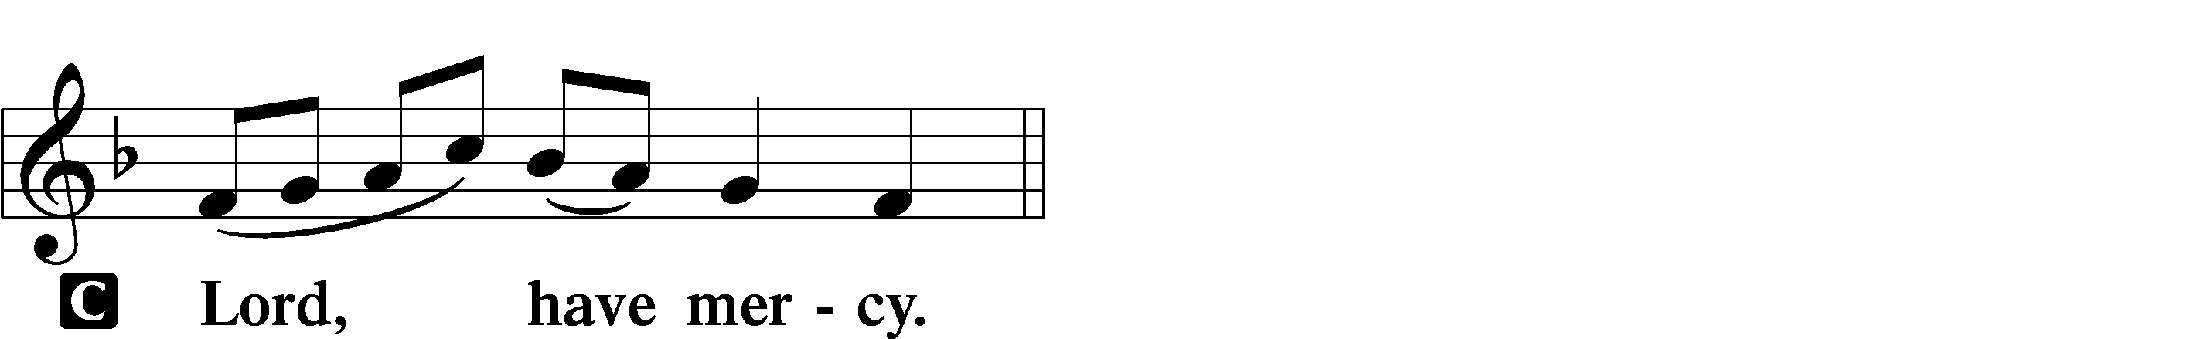
P For this holy house and for all who offer here their worship and praise let us pray to the Lord.
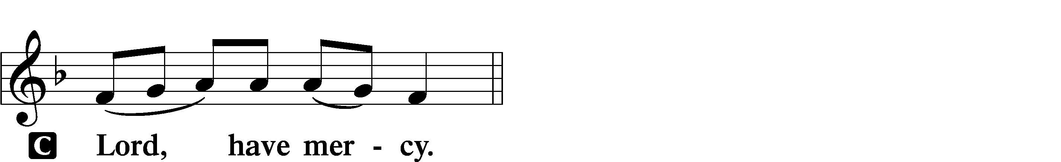
P Help, save, comfort, and defend us, gracious Lord.
This Is the Feast LSB 155
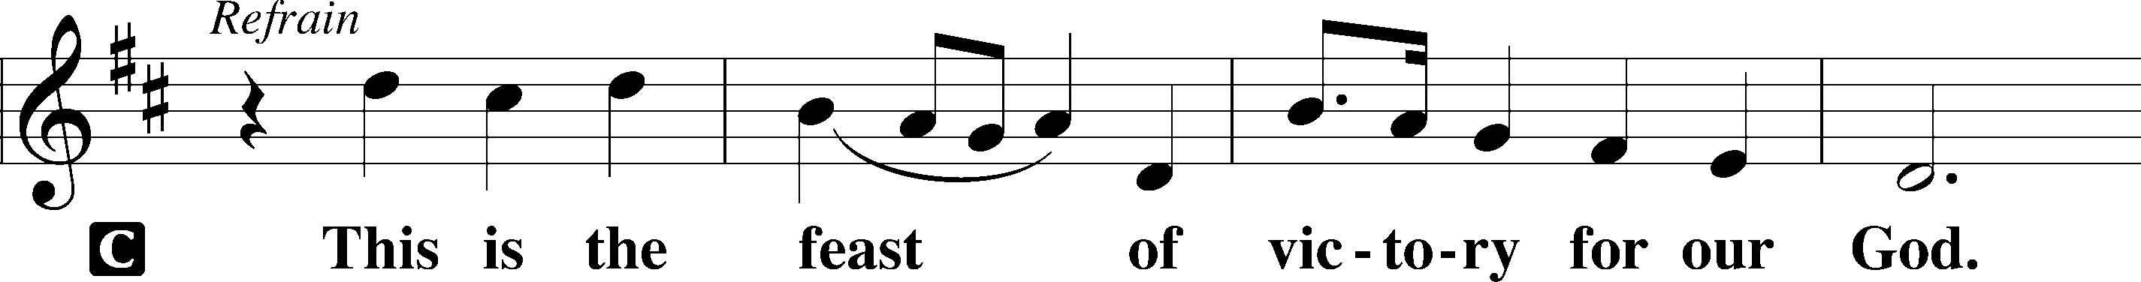
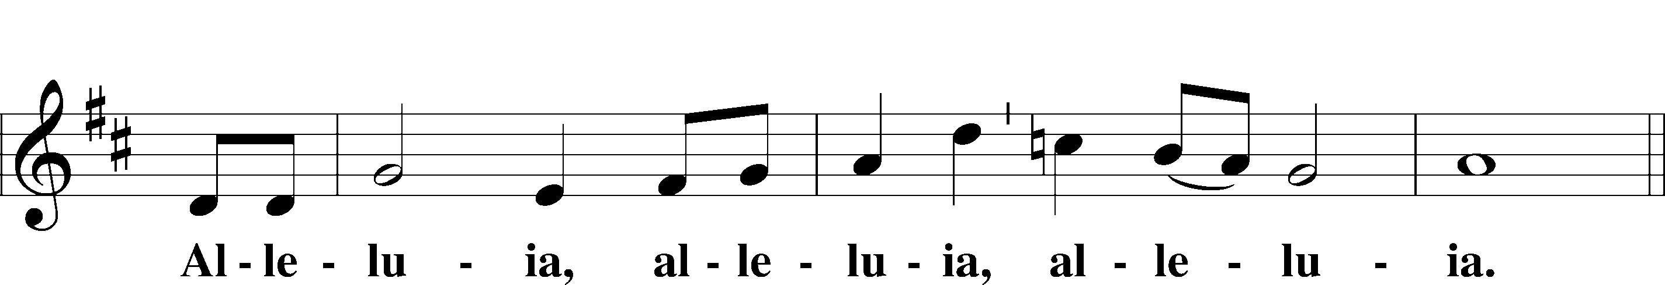
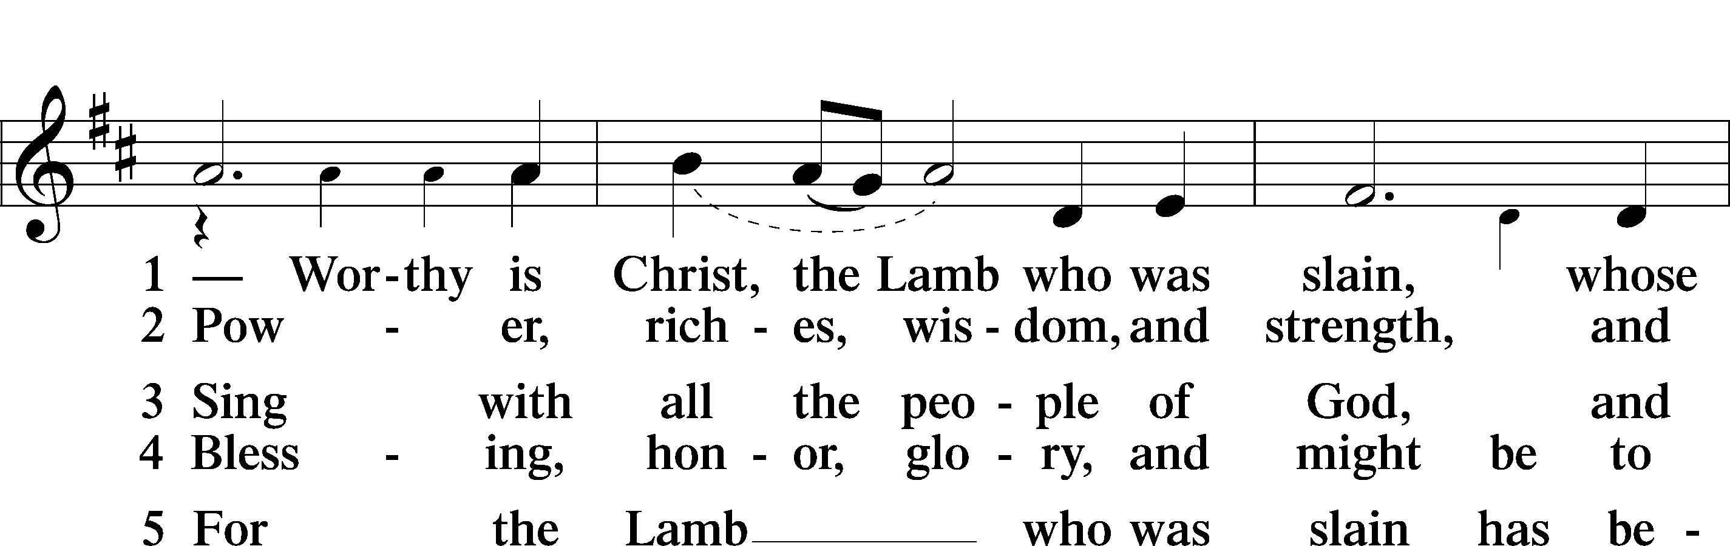
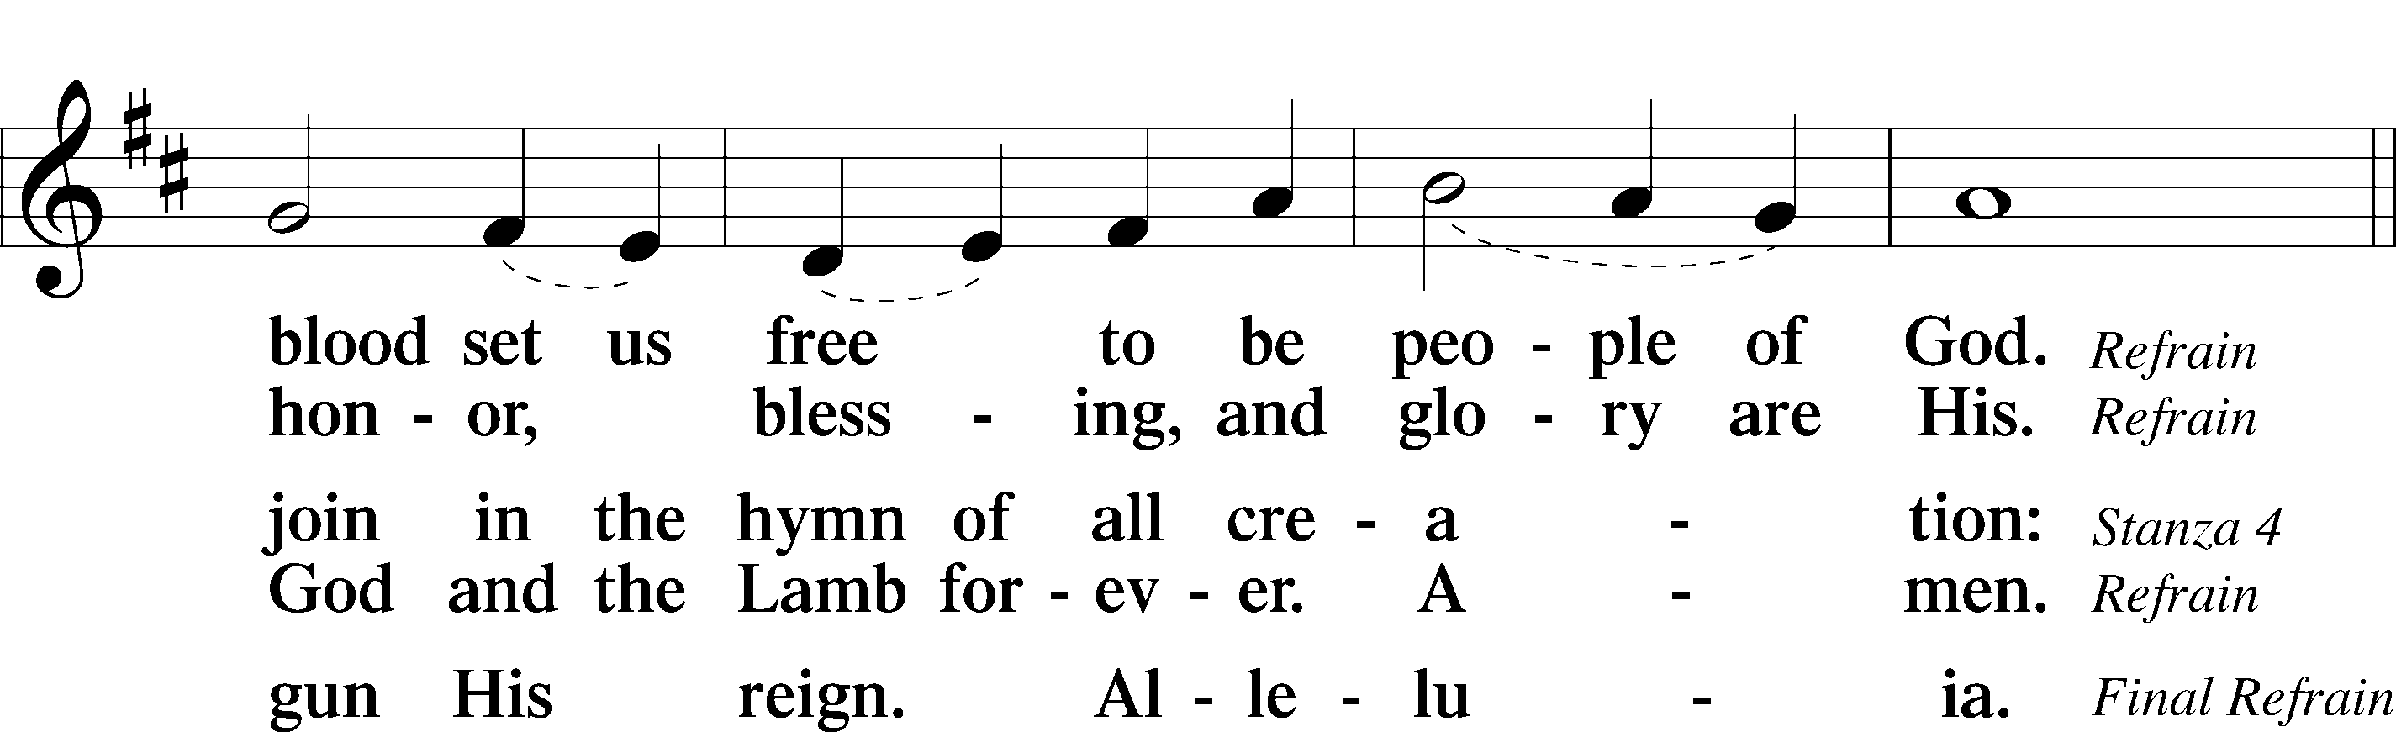
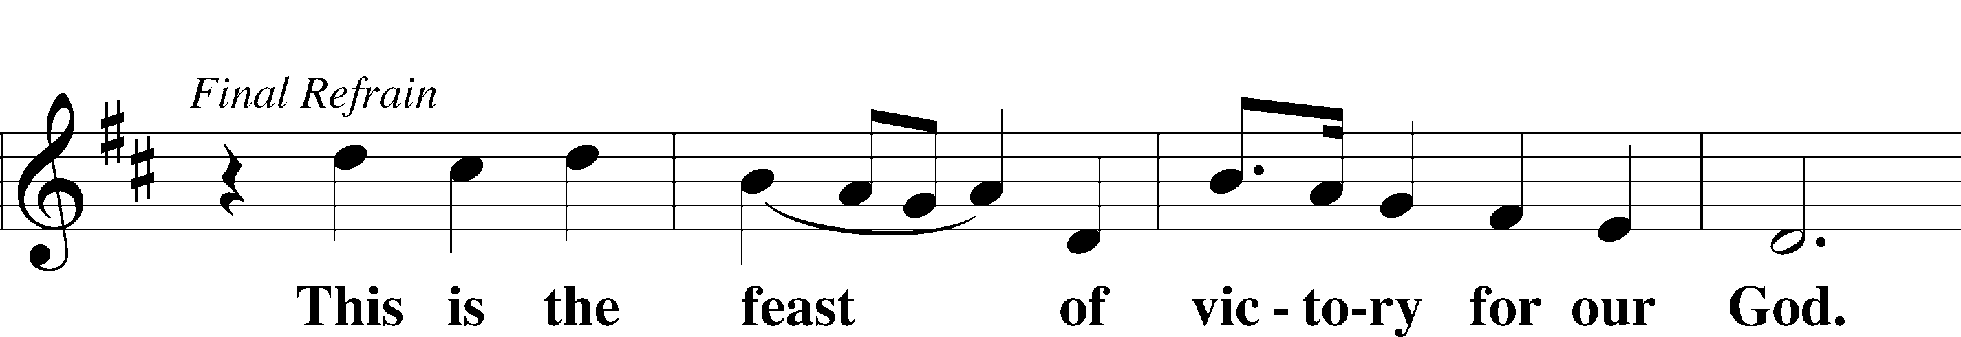
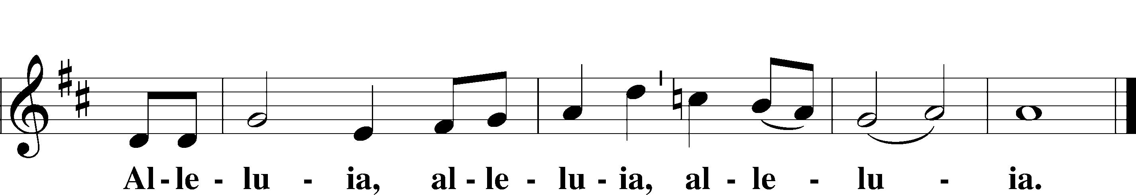

Salutation and Collect of the Day
P The Lord be with you.
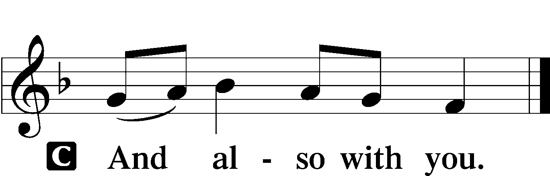

P Let us pray.
Almighty and gracious Lord, pour out Your Holy Spirit on Your faithful people. Keep us steadfast in Your grace and truth, protect and deliver us in times of temptation, defend us against all enemies, and grant to Your Church Your saving peace; through Jesus Christ, Your Son, our Lord, who lives and reigns with You and the Holy Spirit, one God, now and forever.

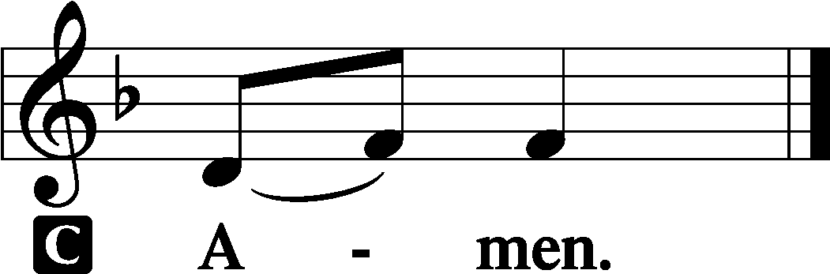

Sit

First Reading Revelation 14:6–7

⁶Then I saw another angel flying directly overhead, with an eternal gospel to proclaim to those who dwell on earth, to every nation and tribe and language and people. ⁷And he said with a loud voice, “Fear God and give him glory, because the hour of his judgment has come, and worship him who made heaven and earth, the sea and the springs of water.”

P This is the Word of the Lord. C Thanks be to God.

Gradual Psalm 48:1a, 12–14a
Great is the Lord and greatly | to be praised*
in the city | of our God!
Walk about Zion, go around her, number her | towers,*
consider well her ramparts, go through her | citadels,
that you may tell the next gener- | ation*
that this is God, our God forever and | ever.
Epistle Romans 3:19–28

¹⁹Now we know that whatever the law says it speaks to those who are under the law, so that every mouth may be stopped, and the whole world may be held accountable to God. ²⁰For by works of the law no human being will be justified in his sight, since through the law comes knowledge of sin.
²¹But now the righteousness of God has been manifested apart from the law, although the Law and the Prophets bear witness to it— ²²the righteousness of God through faith in Jesus Christ for all who believe. For there is no distinction: ²³for all have sinned and fall short of the glory of God, ²⁴and are justified by his grace as a gift, through the redemption that is in Christ Jesus, ²⁵whom God put forward as a propitiation by his blood, to be received by faith. This was to show God’s righteousness, because in his divine forbearance he had passed over former sins. ²⁶It was to show his righteousness at the present time, so that he might be just and the justifier of the one who has faith in Jesus.
²⁷Then what becomes of our boasting? It is excluded. By what kind of law? By a law of works? No, but by the law of faith. ²⁸For we hold that one is justified by faith apart from works of the law.

P This is the Word of the Lord.
C Thanks be to God.

Stand

Alleluia and Verse LSB 156
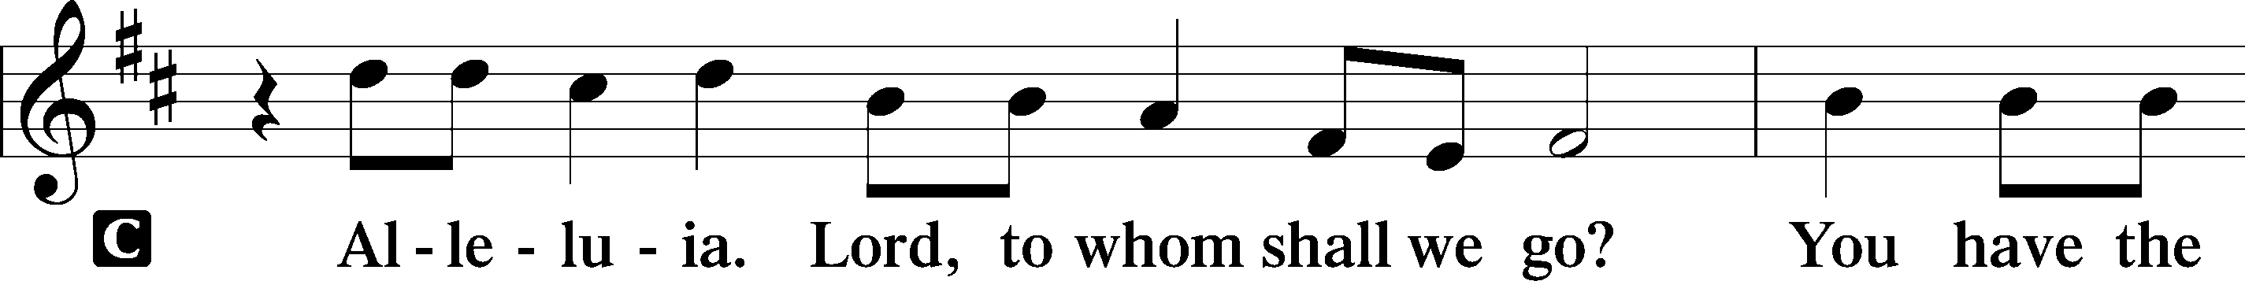
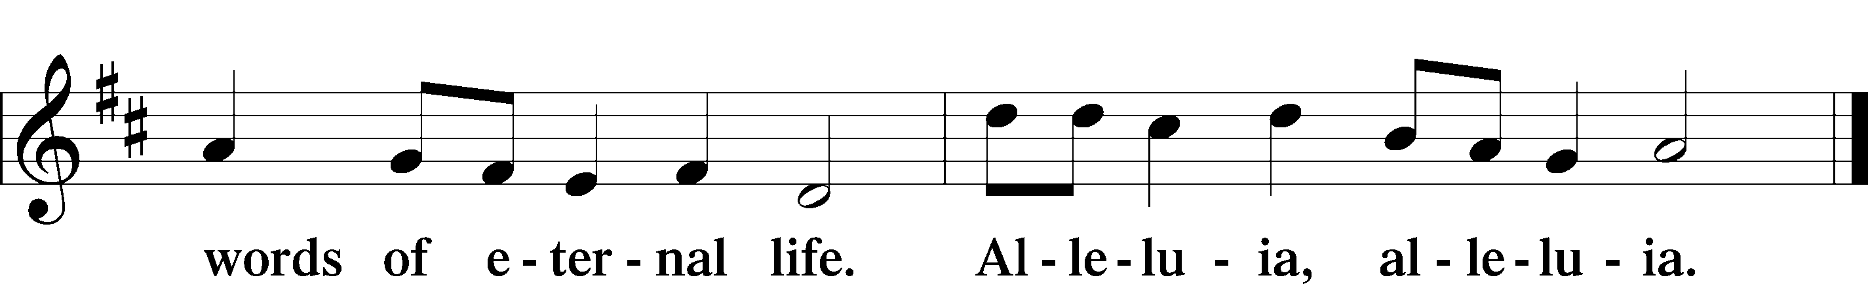

Holy Gospel John 8:31–36
P The Holy Gospel according to St. John, the eighth chapter.

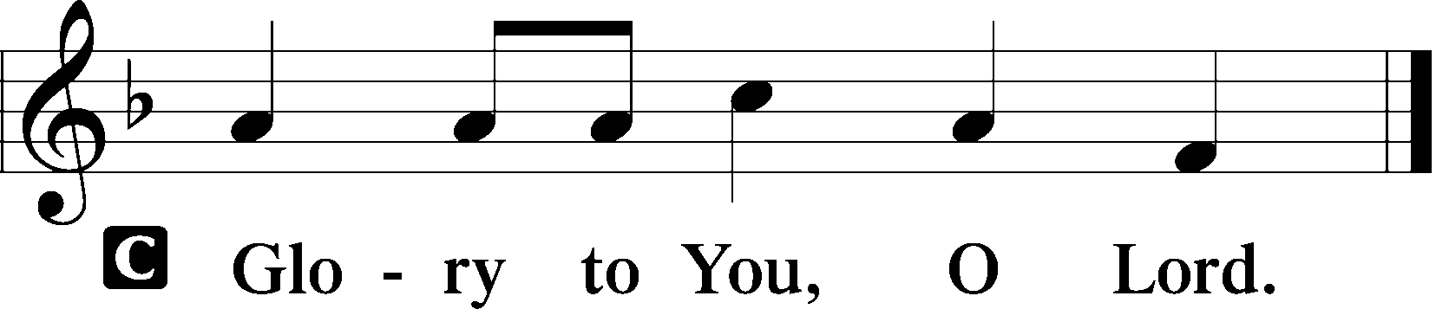

³¹So Jesus said to the Jews who had believed in him, “If you abide in my word, you are truly my disciples, ³²and you will know the truth, and the truth will set you free.” ³³They answered him, “We are offspring of Abraham and have never been enslaved to anyone. How is it that you say, ‘You will become free’?”
³⁴Jesus answered them, “Truly, truly, I say to you, everyone who commits sin is a slave to sin. ³⁵The slave does not remain in the house forever; the son remains forever. ³⁶So if the Son sets you free, you will be free indeed.”

P This is the Gospel of the Lord.

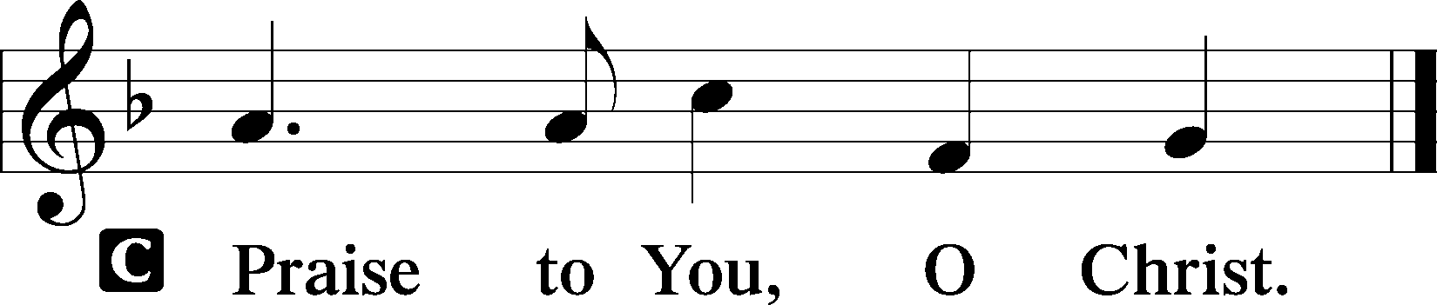

Sit

582 God’s Word Is Our Great Heritage
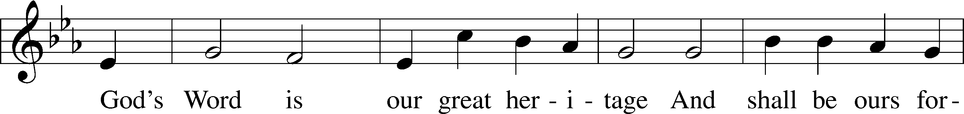
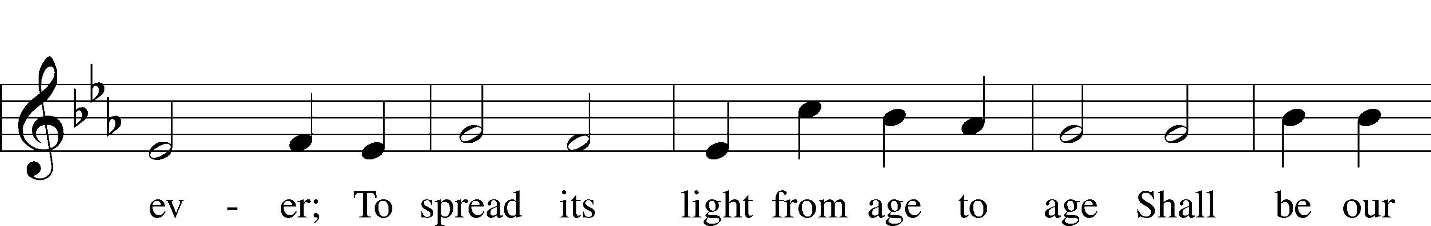
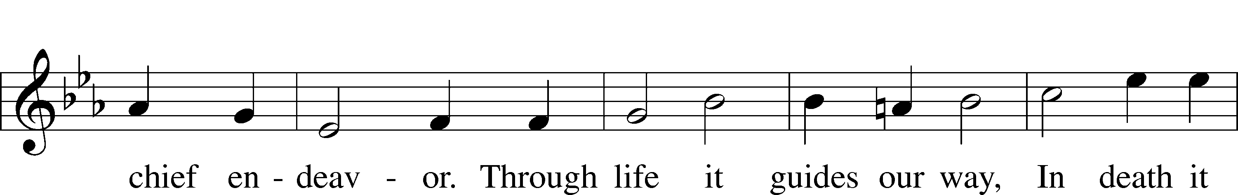
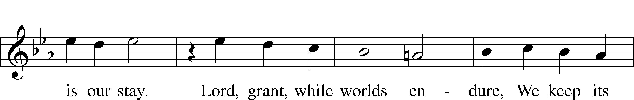
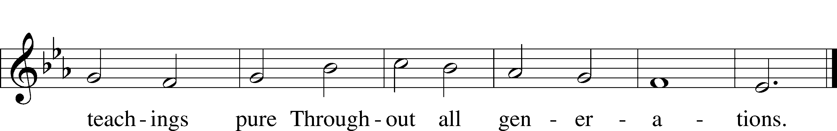
Text and tune: Public domain

Sermon ~ "Reformation Freedom" based on John 8:31

Stand

Nicene Creed

I believe in one God, the Father Almighty,
maker of heaven and earth and of all things visible and invisible.

And in one Lord Jesus Christ,
the only-begotten Son of God,
begotten of His Father before all worlds,
God of God, Light of Light,
very God of very God,
begotten, not made,
being of one substance with the Father,
by whom all things were made;
who for us men and for our salvation came down from heaven
and was incarnate by the Holy Spirit of the virgin Mary
and was made man;
and was crucified also for us under Pontius Pilate.
He suffered and was buried.
And the third day He rose again according to the Scriptures
and ascended into heaven
and sits at the right hand of the Father.
And He will come again with glory to judge both the living and the dead,
whose kingdom will have no end.

And I believe in the Holy Spirit,
the Lord and giver of life,
who proceeds from the Father and the Son,
who with the Father and the Son together is worshiped and glorified,
who spoke by the prophets.
And I believe in one holy Christian and apostolic Church,
I acknowledge one Baptism for the remission of sins,
and I look for the resurrection of the dead
and the life T of the world to come. Amen.

Prayer of the Church

Zion Adult Choir

“This Is the Threefold Truth, Hymnal Supplement”

This is the threefold truth on which our faith depends;
And with this joyful cry, worship begins and ends:
Christ has died! Christ is risen! Christ will come again!

On this we fix our minds as, kneeling side by side,
We take the bread and wine - take Him the Crucified:
Christ has died! Christ is risen! Christ will come again!

This is the threefold truth which if we hold it fast,
Changes the world and us and brighs us home at last;
Christ has died! Christ is risen! Christ will come again!

Offerings and Offertory LSB 159
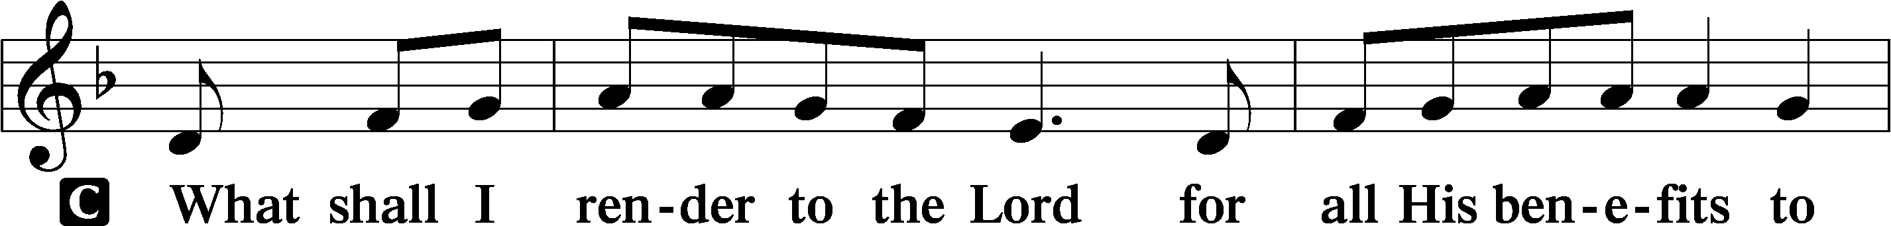
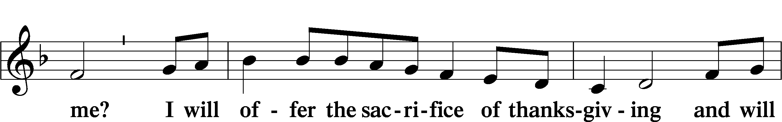
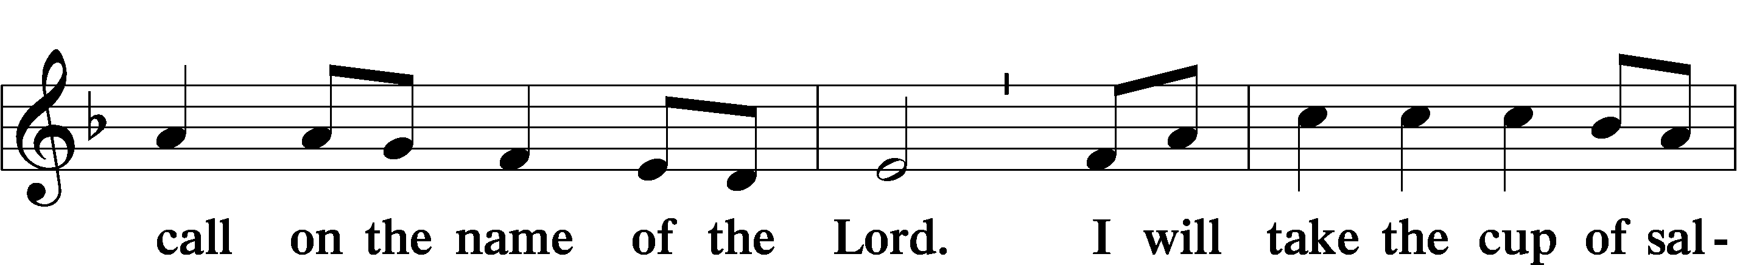
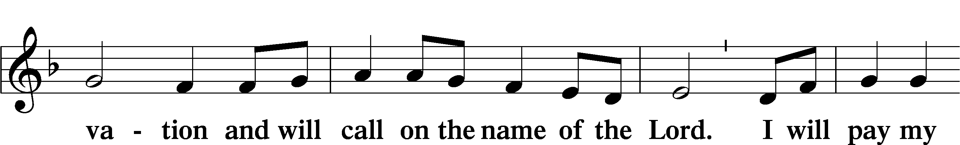
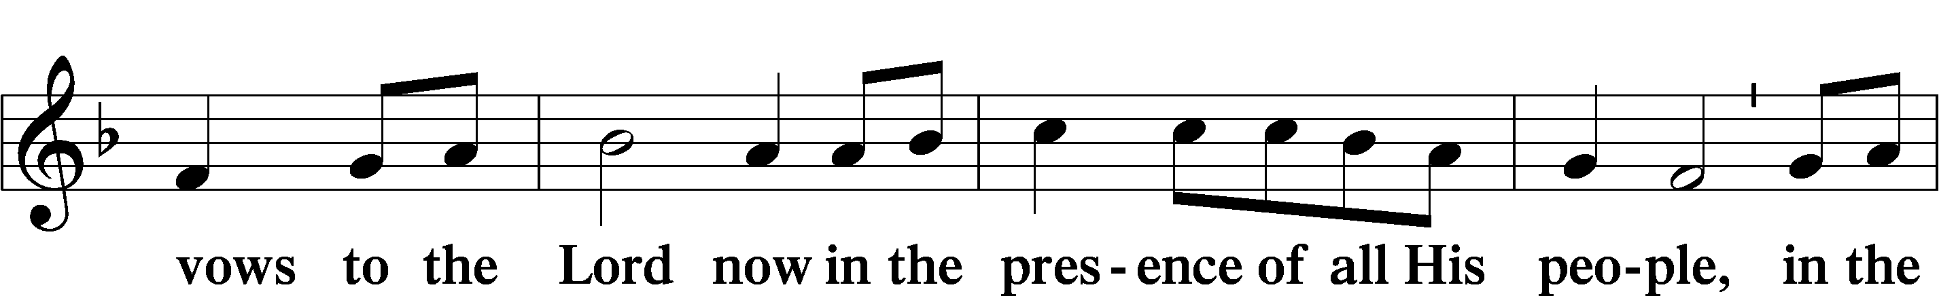
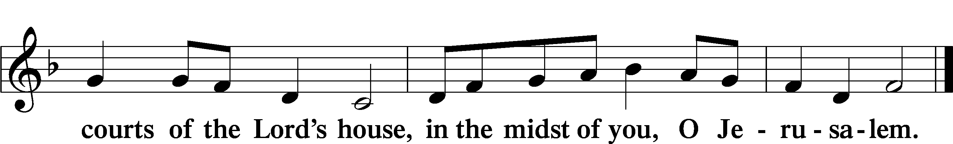

Service of the Sacrament
Preface LSB 160
P The Lord be with you.
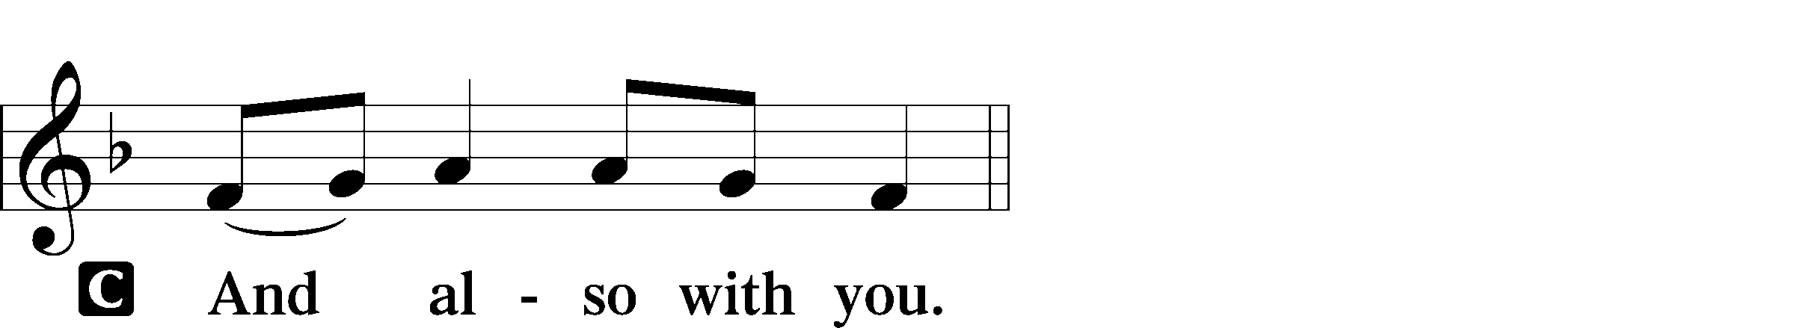

P Lift up your hearts.

P Let us give thanks to the Lord our God.
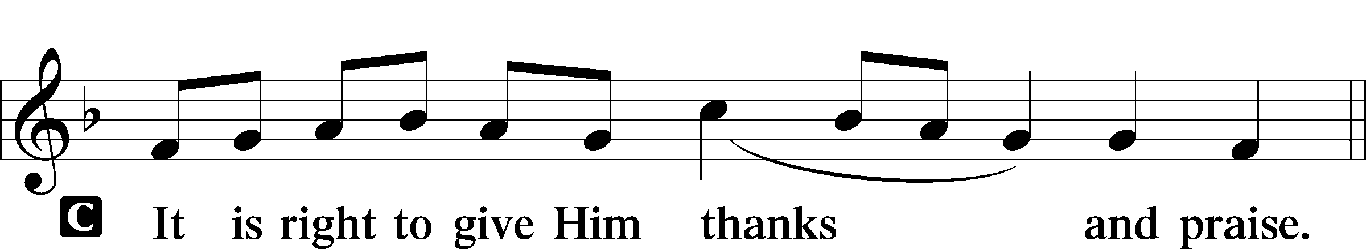

P It is truly good, right, and salutary that we should at all times and in all places give thanks to You, holy Lord, almighty Father, everlasting God, through Jesus Christ, our Lord, who on this day overcame death and the grave and by His glorious resurrection opened to us the way of everlasting life. Therefore with angels and archangels and with all the company of heaven we laud and magnify Your glorious name, evermore praising You and saying:

Sanctus LSB 161
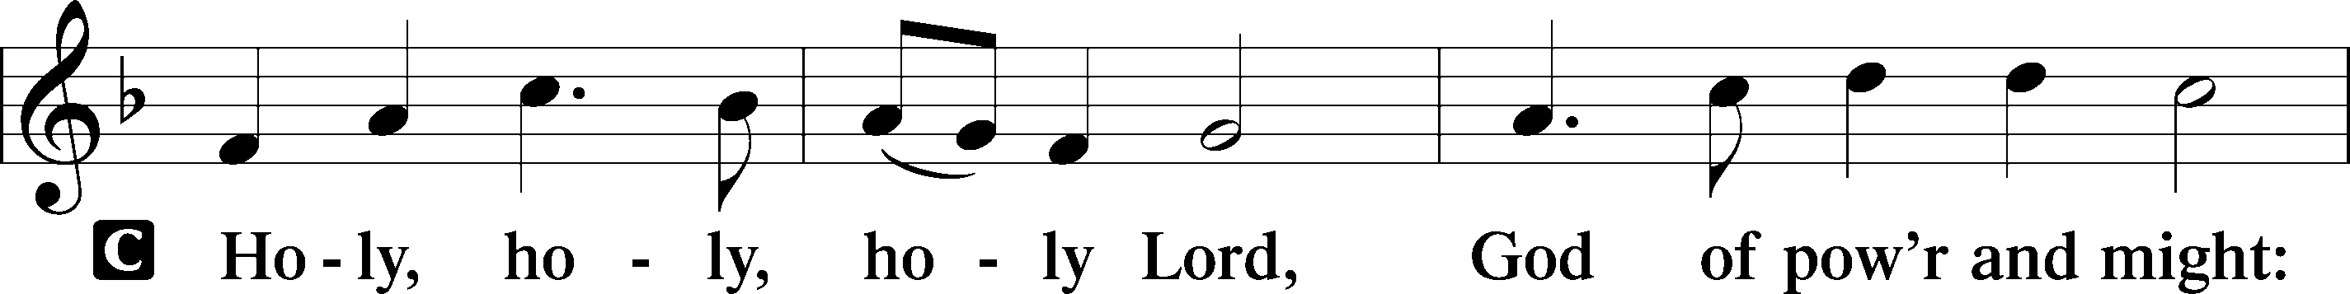
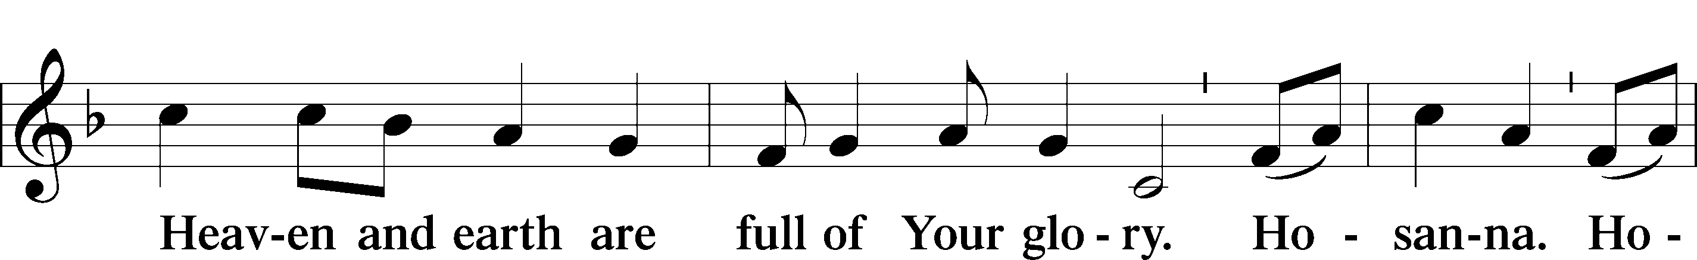
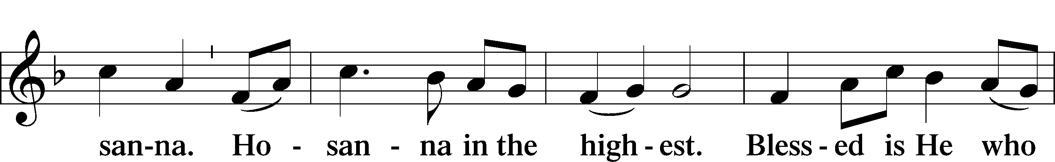
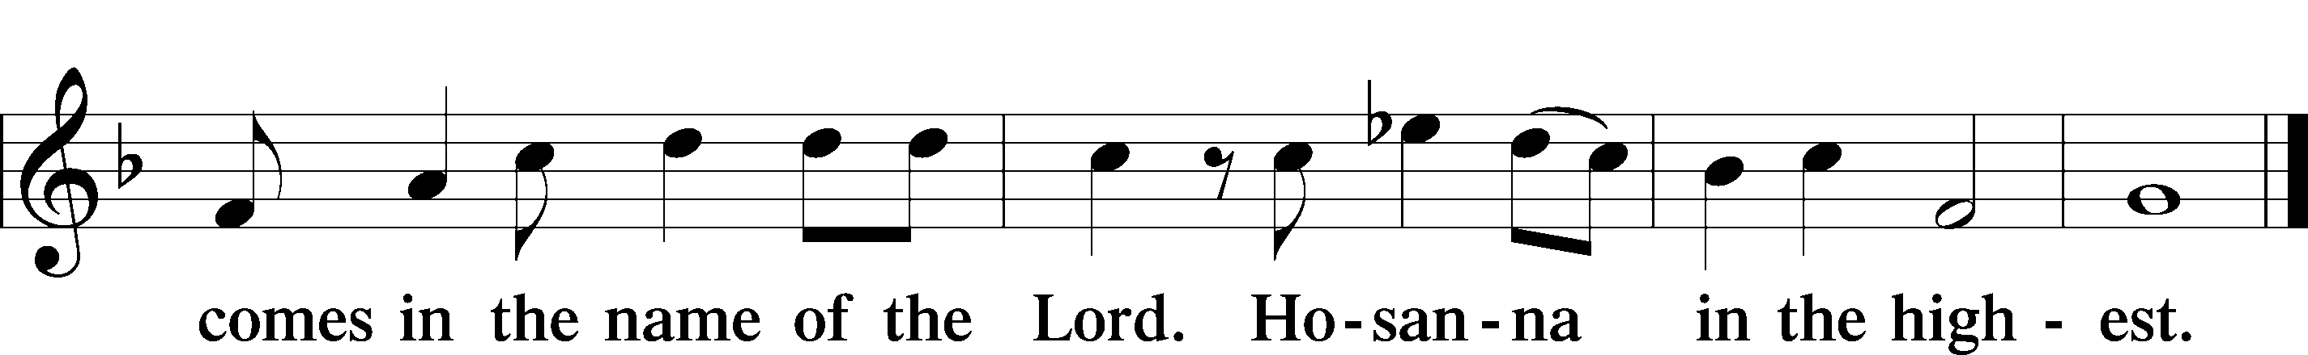
Lord’s Prayer

The Words of Our Lord
P Our Lord Jesus Christ, on the night when He was betrayed, took bread, and when He had given thanks, He broke it and gave it to the disciples and said: “Take, eat; this is My T body, which is given for you. This do in remembrance of Me.”

In the same way also He took the cup after supper, and when He had given thanks, He gave it to them, saying: “Drink of it, all of you; this cup is the new testament in My T blood, which is shed for you for the forgiveness of sins. This do, as often as you drink it, in remembrance of Me.”

Pax Domini LSB 163
P The peace of the Lord be with you always.
C Amen.
Agnus Dei LSB 163
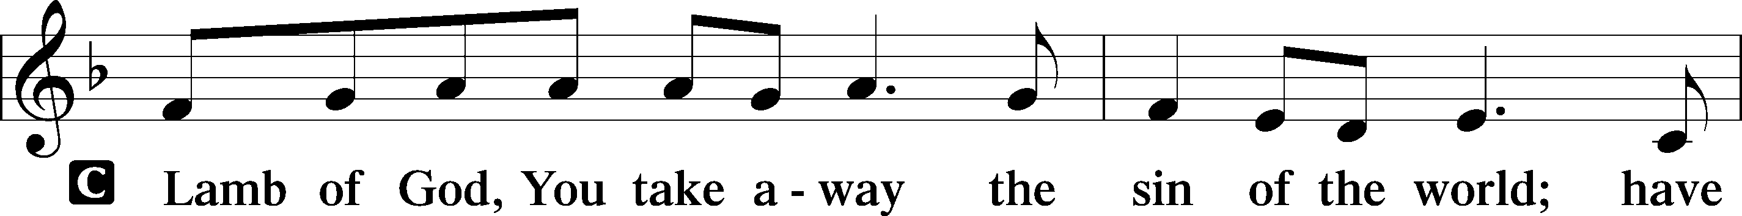
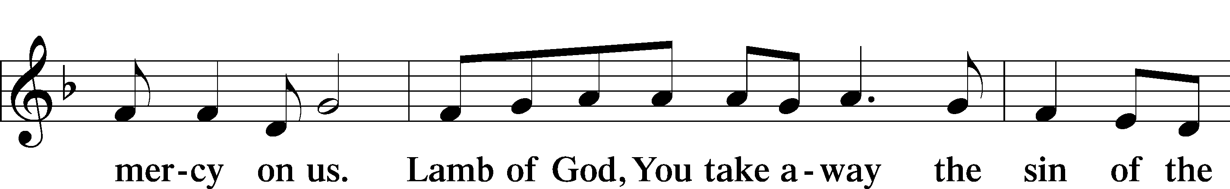
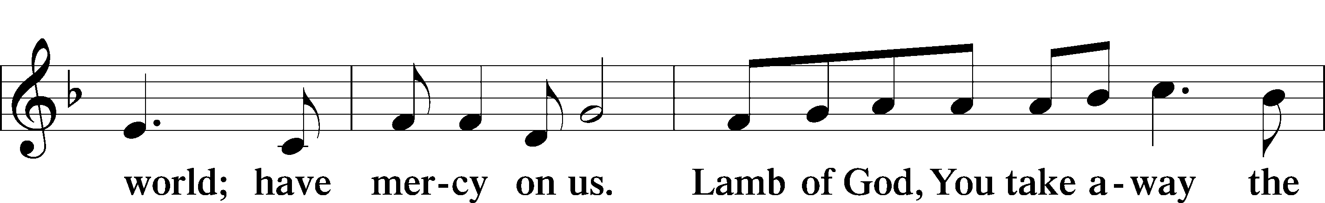
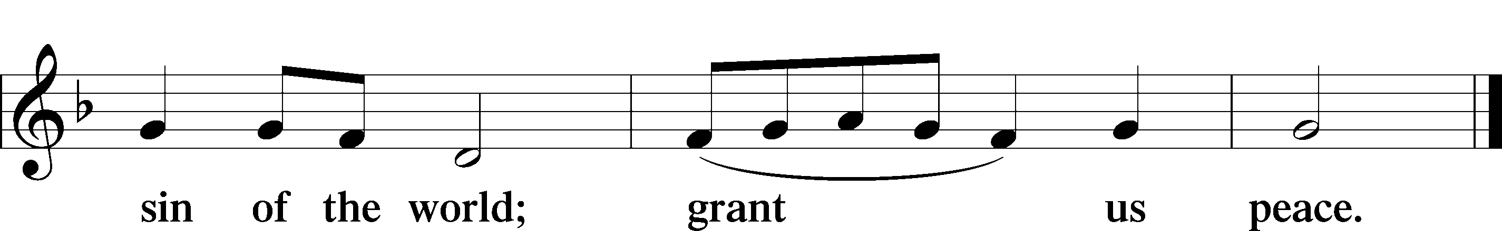
Sit

Distribution

623 Lord Jesus Christ, We Humbly Pray
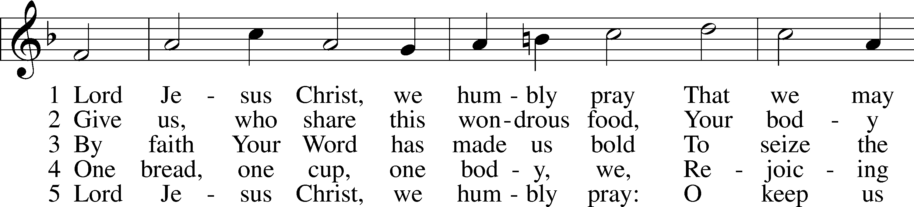
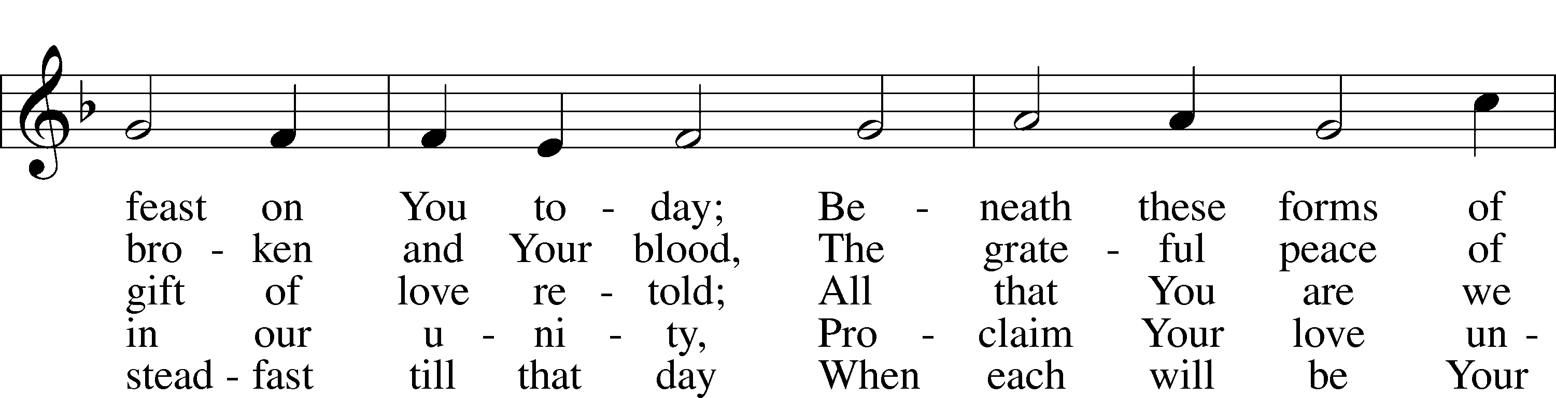
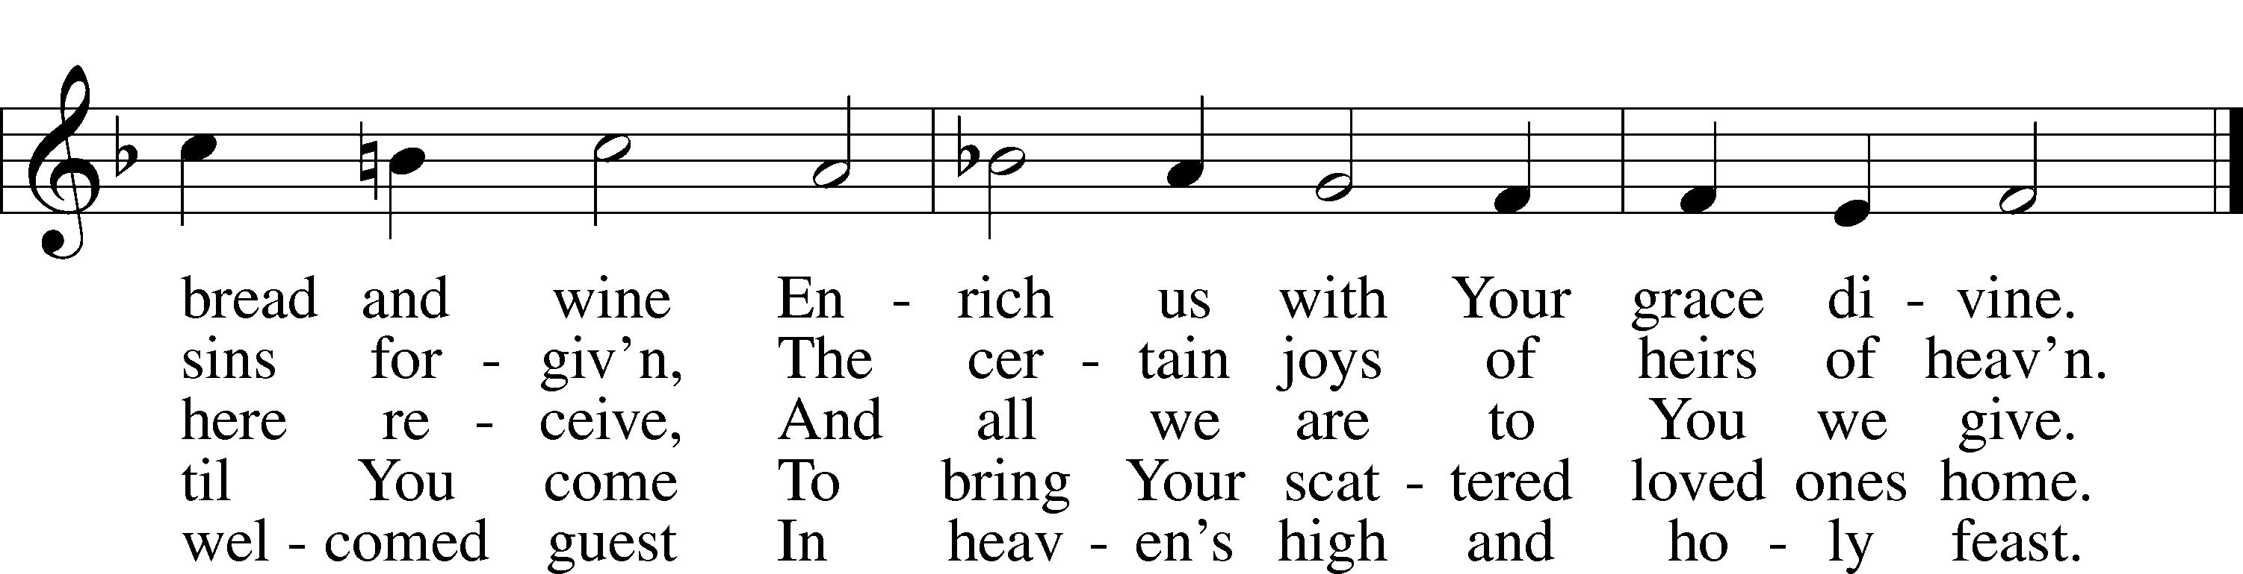
Text and tune: Public domain
828 We Are Called to Stand Together
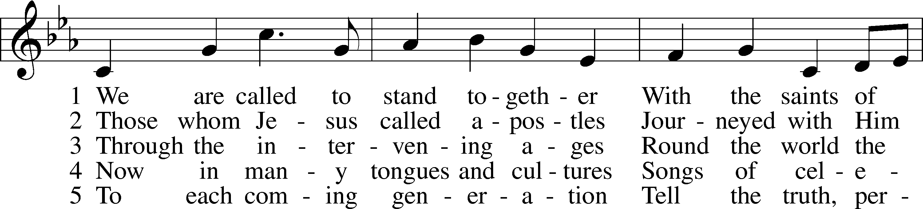
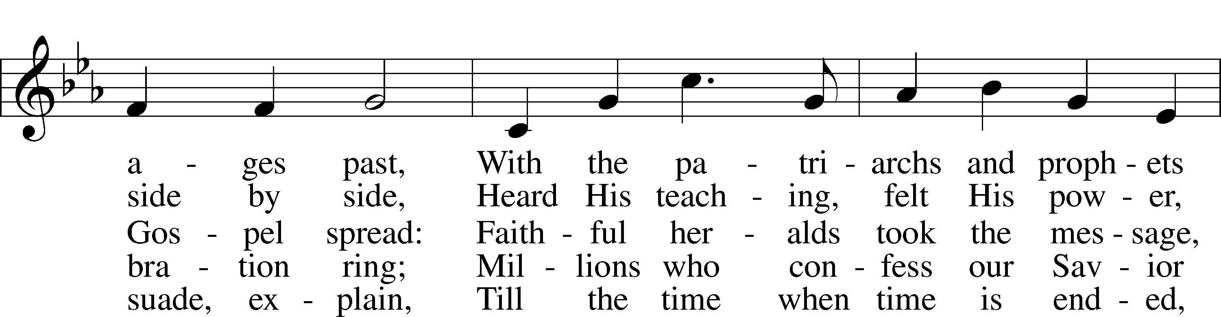
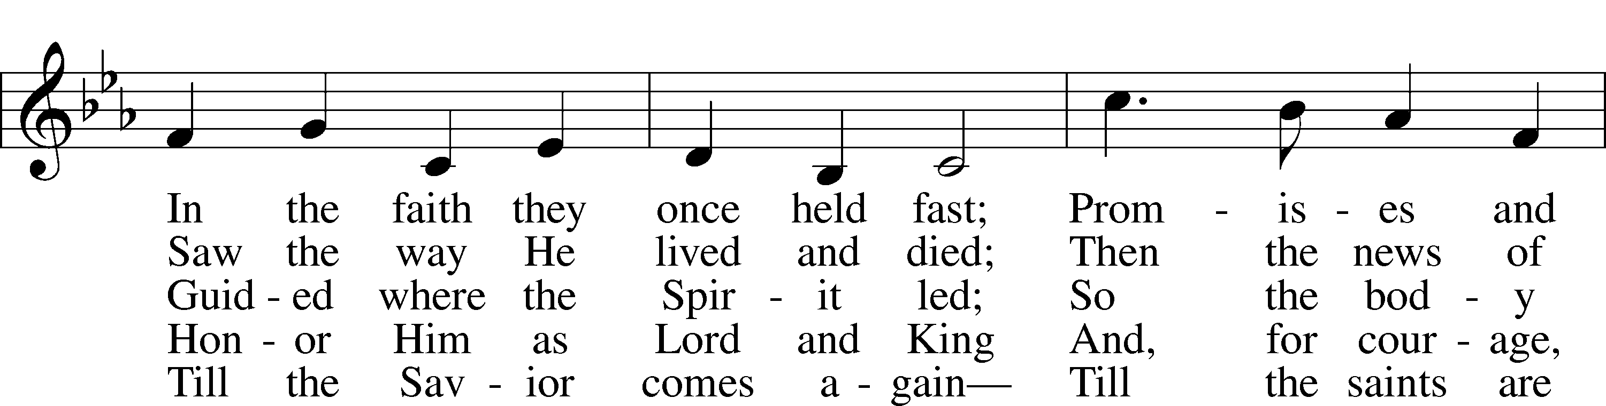
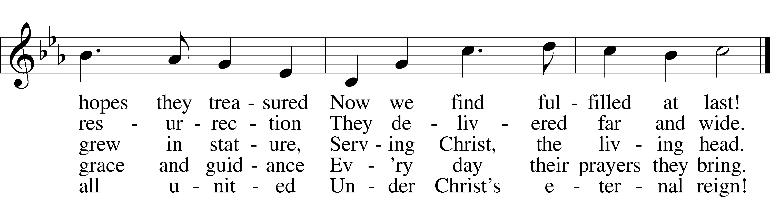
Tune: © 1973 Henry V. Gerike. Used by permission: LSB Hymn License no. 110003744
Text: © 2000 Kevin Mayhew Ltd. Used by permission: LSB Hymn License no. 110003744

556 Dear Christians, One and All, Rejoice sts. 1–4, 6, 8, 10
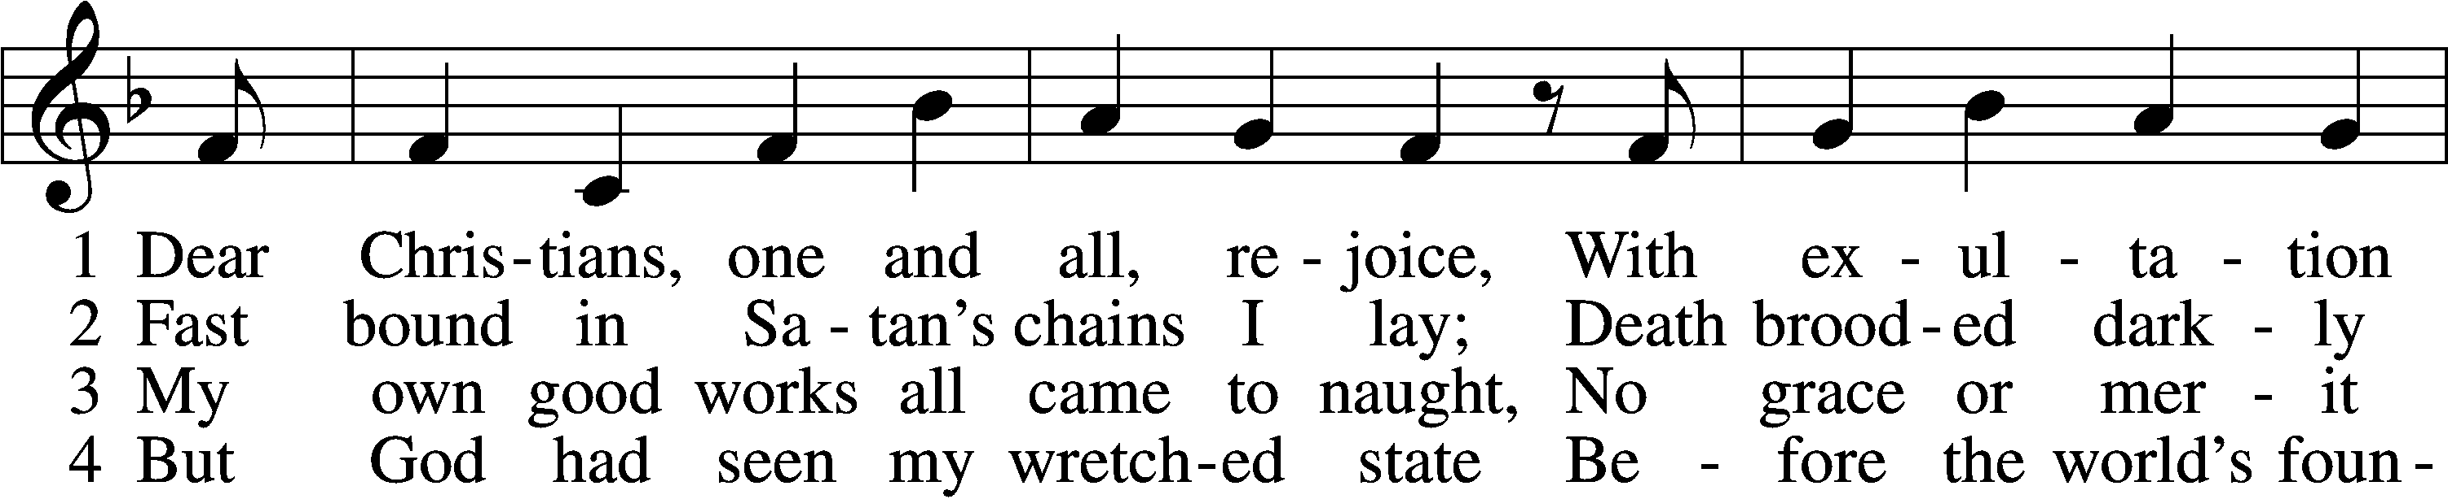
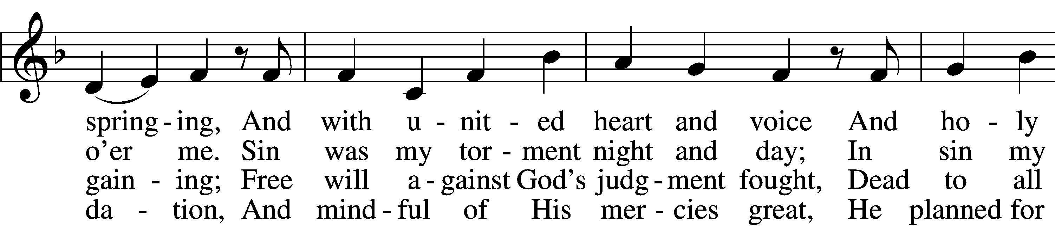
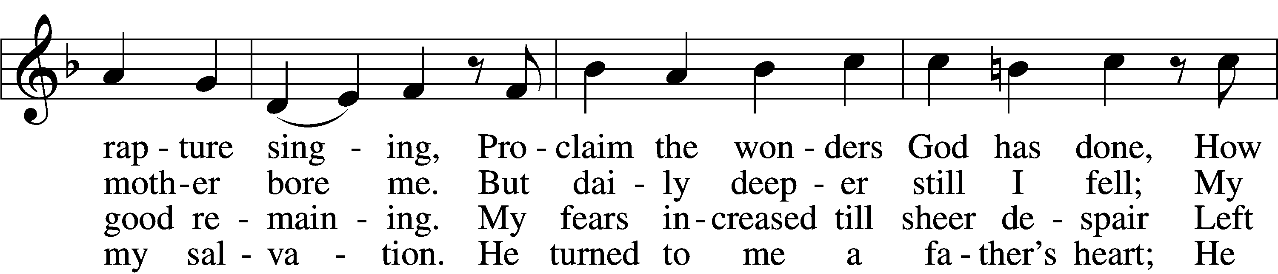
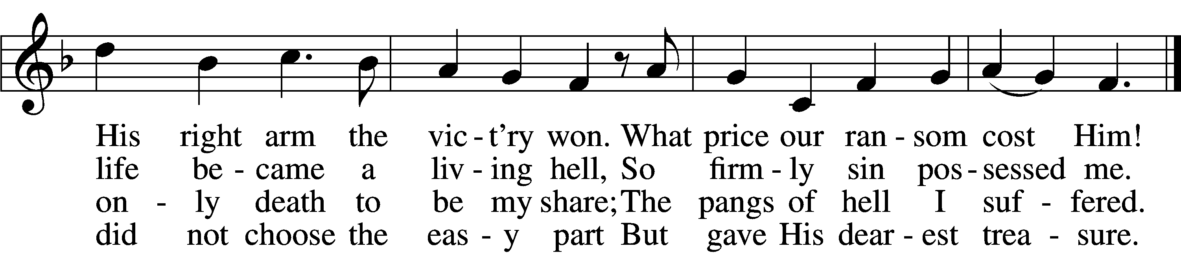

6 The Son obeyed His Father’s will,
Was born of virgin mother;
And God’s good pleasure to fulfill,
He came to be my brother.
His royal pow’r disguised He bore;
A servant’s form, like mine, He wore
To lead the devil captive.

8 “Though he will shed My precious blood,
Me of My life bereaving,
All this I suffer for your good;
Be steadfast and believing.
Life will from death the vict’ry win;
My innocence shall bear your sin,
And you are blest forever.

10 “What I on earth have done and taught
Guide all your life and teaching;
So shall the kingdom’s work be wrought
And honored in your preaching.
But watch lest foes with base alloy
The heav’nly treasure should destroy;
This final word I leave you.”
Text and tune: Public domain

Stand

The Dismissal
P The body and blood of our Lord Jesus Christ strengthen and preserve you in body and soul to life everlasting. Depart T in peace.
C Amen.
Thank the Lord LSB 164
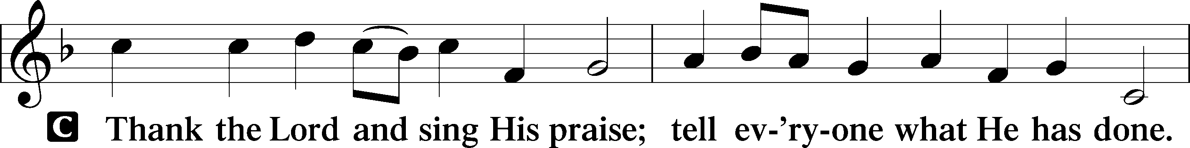
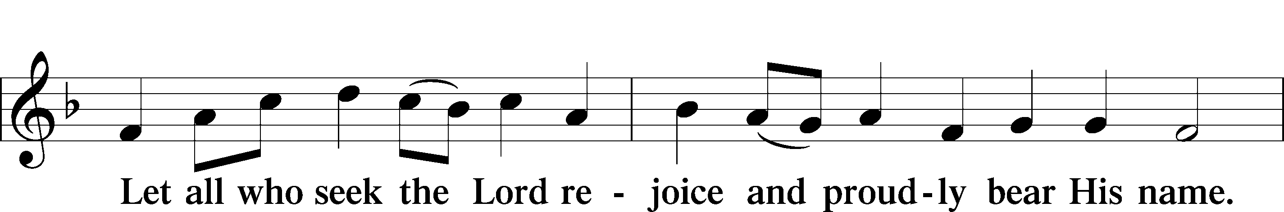
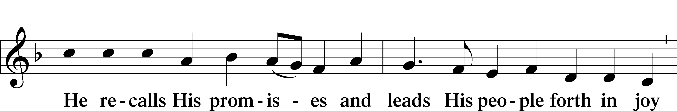
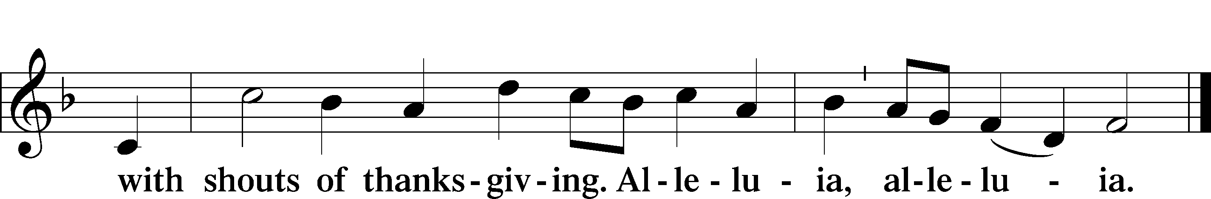

Post-Communion Collect
P Let us pray.
O God the Father, the fountain and source of all goodness, who in loving-kindness sent Your only-begotten Son into the flesh, we thank You that for His sake You have given us pardon and peace in this Sacrament, and we ask You not to forsake Your children but always to rule our hearts and minds by Your Holy Spirit that we may be enabled constantly to serve You; through Jesus Christ, Your Son, our Lord, who lives and reigns with You and the Holy Spirit, one God, now and forever.
C Amen.

Benediction LSB 166
P The Lord bless you and keep you.
The Lord make His face shine on you and be gracious to you.
The Lord look upon you with favor and T give you peace.
C Amen.

655 Lord, Keep Us Steadfast in Your Word
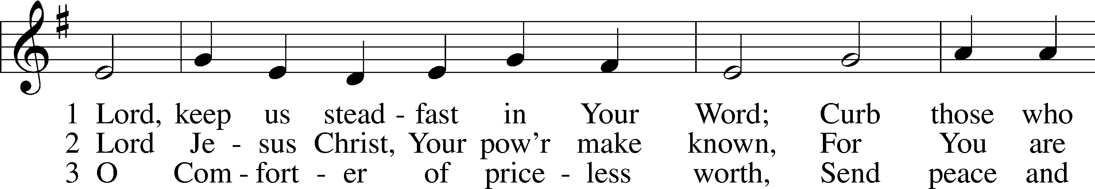
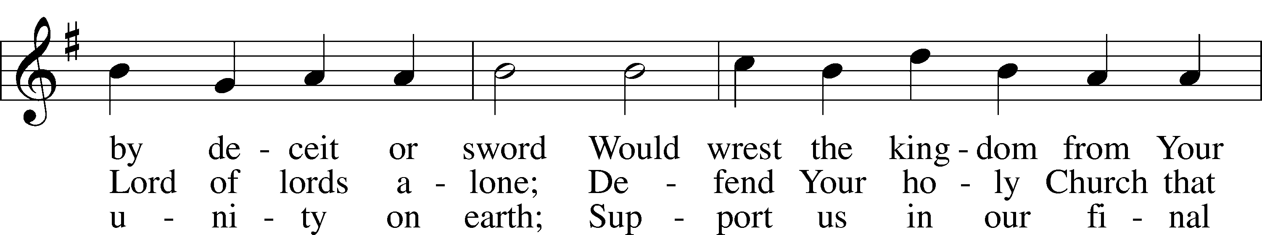
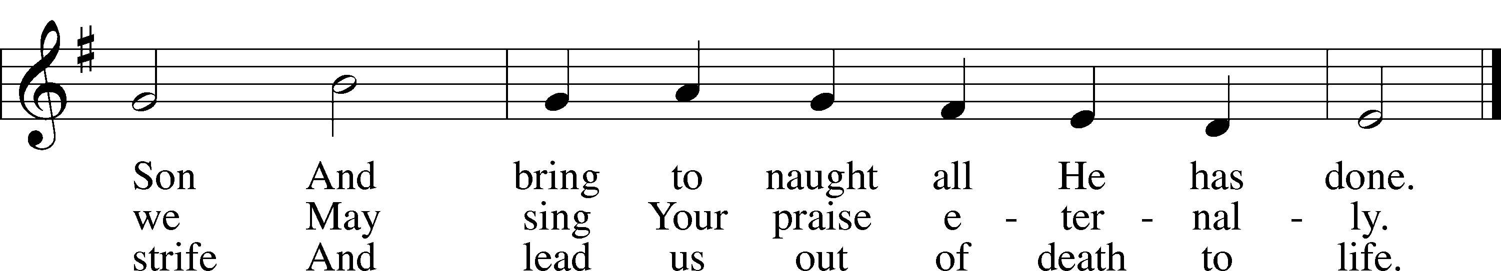
Text and tune: Public domain

Acknowledgments
Divine Service, Setting One from Lutheran Service Book
Unless otherwise indicated, Scripture quotations are from the ESV® Bible (The Holy Bible, English Standard Version®), copyright © 2001 by Crossway, a publishing ministry of Good News Publishers. Used by permission. All rights reserved.
Created by Lutheran Service Builder © 2021 Concordia Publishing House.

Prayers for Our Members
Sharon Hockemeier, Tenaya Nuttelman | Expectant Mothers
Norman Abels (Brookestone Meadows – Elkhorn) | Healing
Judy Ahrens | Healing
Vaughn Albrecht (Mount Carmel) | Healing
Tom & DyAnn Altwine | Healing
Lyle Colsden (Mother Hull) | Healing
Pat Flodine (Cambridge Court) | Healing
Vi Fox (Prairie View) | Hospitalized
Verleen Gentry | Healing
Wanda Glanzer | Healing
Ruby Hatfield | Healing
Evelyn Heiden (Mother Hull) | Healing
Lennis Hodgson | Healing
Don Richmond | Healing
Ivan Bombeck | Cancer
Fran Junge | Cancer
Bertha Marienau | Cancer
Kim Vos | Cancer

Prayers for Our Members’ Family & Friends
Naomi Wollberg (Matthias’ wife) | Expecting
Elaine Arehardt (Zion’s Music Teacher) | Expecting
Larry Bombeck (Ivan’s brother) | Healing
Katie Cunningham (Quentin & Janel Lange’s friend) | Healing
Reg Duke (Westman’s brother-in-law) | Healing
James Gentry (Verleen’s son) | Healing
Roger Hoffman (Marc’s father) | Healing
David Kreutzer (Richard’s brother) | Healing
Pr. Rob Kuefner (Kearney Circuit Visitor) | Healing
Dillon Malchow (Joy Barefoot’s nephew) | Healing
Urijah Mitchell (Sue & Dennis Bartels’ Grandson) | Healing
Tim Powers (Kim Wilken’s brother) | Healing
Roy Reynolds (Verleen Gentry’s son-in-law) | Healing
Lynne Saathoff (Verleen Gentry’s sister-in-law) | Healing
Randy Solomon (Beth Rosenthal’s father) | Healing
Tim Trampe (Don & Gretchen’s son) | Healing
Jonah (Jase & Jarren Blattner’s friend) | Cancer
D.D. Dugger (Sue Kaiser’s brother) | Cancer
Stuart Gronewoller (Lonna’s brother-in-law) | Cancer
Linda Heapy (Janel Lange’s mother) | Cancer
Ron Halvorsen (Jeff’s dad) | Cancer
Bill Jedlicka (Pam Uhlir’s cousin) | Cancer
Randy Jochum (Ken Hockemeier’s brother-in-law) | Cancer
Robin Keilig (Zehendner’s friend) | Cancer
Sharon Mulhair (Pam Uhlir’s cousin) | Cancer
Kolby Shiers (Jessica’s cousin) | Cancer
Pr. Richard Snow (NE District President) | Cancer
Tyrone Uhlir (Pam’s nephew) | Cancer
John Weber (Zehendner’s friend) | Covid & Cancer
Tim Smallcomb (Wilkens’ friend) | Deployment

Our Response to the Gospel

Date: 10/24/2021
Offering: $5,119
Weekly Need: $7,457.69

Sunday, October 31~ 9:00am
Today’s Radio Broadcast is sponsored by Cindy Ward – in honor of birth of her grandchild and 3 grandchildren.

Worship Assistants

Elder: Nathan Gaunt
Usher: Mike Wilkens
Acolyte: Noah Randolph
Engineer: Shawn Starkey
Announcer: Carol Kreutzer
Altar Guild: Jamie & Shirley Helmbrecht
Thank you to Jamie Nikodym and the Zion Adult Choir for providing their musical gifts today!
Sunday, November 7~ 9:00am

Elder: Bruce Brooks
Usher: Fred Flessner
Acolyte: Landen Eckhoff
Engineer: Jamie Nikodym
Announcer: Brooke Fisher
Altar Guild: Brooke Fisher & Tracy Schake

ZION LUTHERAN CHURCH AND SCHOOL

Pr. James DeLoach, Pastor + (308) 627-5260
james.deloach@zionkearney.org
Pr. Doug Gaunt, Pastor + (308) 455-0552
doug.gaunt@zionkearney.org
Tony Splittgerber, Principal + (308) 293-0168
anthony.splittgerber@zionkearney.org

Church Office
Secretary: Holly Reid
Email: school@zionkearney.org
Phone: (308)-234-3410 Fax: (308) 236-8100
Office Hours: Monday-Friday 8:00am-4:00pm
Radio Broadcast: Sunday @ 10:30 a.m. on 1460 AM and 92.1 FM
Website: www.zionkearney.com

Where our Triune God strengthens us through His mercy in faith toward Him and in fervent love toward one another.

This Week at Zion

Sun  10/31 | 9:00a  10:20a  10:30a  4:30p | Divine Service  Bible Study/Sunday School  Radio Broadcast 1460am & 92.1fm  Kearney Circuit Reformation Service & Potluck
Mon
11/1
Tues  11/2 | 1:30p  Birthdays | Sleeping Mats  Lynette Johnson
Wed  11/3 | 8:30a  5:45p  7:00p  7:00p | Chapel  Midweek  Adult Choir  Bell Choir
Thurs  11/4 | Birthdays | Abigail Burger
Fri  11/5 | Anniversaries | Quentin & Janel Lange
Sat  11/6 | 1:00p-4:00p  Birthdays  Anniversaries | School Carnival  Kelly Eckhoff  Elizabeth Gaunt  Shane & Kelly Eckhoff
Sun  11/7 | 9:00a  10:20a  10:30a  5:00p | Divine Service  Bible Study/Sunday School  Radio Broadcast 1460am & 92.1fm  Divine Service
ANNOUNCEMENTS

The Kearney Circuit Reformation Service will be hosted by Zion this afternoon at 4:30 pm. All LCMS Congregations, in the Kearney Circuit and Nebraska, are invited. Dr. Gerhard Bode, a professor at Concordia Seminary, St. Louis will preach for this service. His areas of interest and expertise include the Reformation and the history of Lutheranism. He will be leading a study on the Reformation during Bible Class after the service. The offering from the service will go to the International Lutheran Council in support of other Lutherans throughout the world.

The Zion Youth Group would like to give back this season by helping in our community. If you have any small jobs that you would like help with in the month of November, please contact Miss Nikodym (402) 746-0561 or Miss Dauel (308) 627-2113. Examples of jobs include raking leaves, cleaning up a garden, putting out or taking down decorations, etc.

Adult Bible Study is studying the rich variety of words God uses to communicate the Gospel—that we are justified by grace through faith. Come grab a donut and cup of coffee as we fellowship and learn together.

Zion’s 4th Quarter (Oct – Dec) Mission Offerings will support Zion’s current students, who are studying for full-time church work. All our students are at Concordia (CUNE):
Peter Kreutzer - Lutheran Teacher’s Diploma (LTD)
Jessica Zehendner – LTD
Taylor Zehendner – LTD
Please use the mission envelopes located in the narthex for this offering. Or give via Church Trac by selecting “Missions.” Thank you for your support.

Offering Options:
1) Place your offering in the basket as you leave
2) Go to zionkearney.churchtrac.com/give
3) Go to zionkearney.com and click on the ChurchTrac icon
4) Mail your gift to Zion Lutheran Church, 2421 C Ave, Kearney, NE 68847. Or place it in the mail slot on the south side of the building.

Poinsettias – Zion will be taking poinsettia orders to adorn the Church Sanctuary during Christmas time. They will be $15.00 per plant. To order there is an envelope in the Fellowship Hall on Sunday’s and the Church Office during the week. Place your money in the envelope with your name, place the envelope in the offering plate or the mail slot on the south side of the building or drop it off during office hours. Please make checks out to Mary Martha.

Radio Broadcast – The sign-up sheets for the 2022 radio broadcast and altar flowers are up by the mailboxes! The remaining 2021 sheets are still up on the right side. The 14th, 21st, and 28th of November are still available for radio sponsors! Please help Zion spread the Gospel!

SCHOOL NEWS

The Theme for our school year is “Together by Christ’s Love” based on 1 John 4:7-8.

- Pie Sales are still going. Place an order with any Zion student or with the office by Friday, October 29th. The pie pick-up date is November 17th.
- The School Carnival is Saturday, October 30th from 1pm-4pm. Join us for games, food, and prizes. Tickets are $0.25 each. *Costumes are allowed but please help your children make appropriate choices on what to wear.
- Give Where You Live - Zion will be participating in the Give Where You Live Campaign again! It will be December 2nd (giving day), but donations will be accepted beginning November 4th. To contribute online go to: https://www.givewhereyoulive.net//zionlutheranschool. If you would rather give in person feel free to stop by the office. Please share this with family and friends.

