Divine Service
Twenty Fifth Sunday after Pentecost
November 14, 2021
Zion Lutheran Church
Kearney, Nebraska
Welcome to Zion!
All worshippers please fill out an attendance card in the pew rack and let us know how we might be of service to you.

Holy Communion at Zion

The Lord’s Supper is celebrated at this congregation as Jesus instituted it. As he says, so our Lord gives into our mouths not only bread and wine but his very body and blood to eat and to drink for the forgiveness of sins and to strengthen our union with him and with one another. Our Lord invites to his table those who repent of all sin, trust his words “given and shed for you for the forgiveness of sins,” and set aside any refusal to forgive and love as he forgives and loves us, that they may show forth his death until he comes. All communicants need to register in the narthex prior to the service.

The Lord’s Supper can harm those who receive it unworthily. Holy Communion is also a confession of the faith which is confessed at this altar. Therefore, any who are not yet instructed, in doubt, or who hold a confession differing from that of this congregation and The Lutheran Church—Missouri Synod, are asked not to commune until they are able to speak with our pastor first. He is most happy to visit with you about the Christian faith and how to receive the Lord’s Supper for your good and for the good of others. Those not communing are invited to come to the altar, cross your arms in front of you, and bow your head to receive a pastoral blessing.

The Crucified and Risen Body of Christ Jesus
Is the True Temple of God
Despite its “wonderful stones” and “great buildings,” the Jerusalem temple would be torn down, with not one stone left upon another, just as this present world and its kingdoms will come to an end (Mark 13:1–8). But that temple pointed beyond itself to Christ, to His sacrifice upon the cross and to the resurrection of His body as the true Temple of God. In the midst of sin and death, by the proclamation of the Gospel, He now gathers disciples into His body, wherein “the one who endures to the end will be saved” (Mark 13:10–13). For He is “a great priest over the house of God,” who “will remember their sins and their lawless deeds no more.” By the pure water of His Baptism, they “draw near with a true heart in full assurance of faith,” and by His flesh and blood, they enter the Holy of Holies (Heb. 10:17–22). Thus are His people delivered, “everyone whose name shall be found written in the book.” For by the wisdom of His Gospel, He turns “many to righteousness,” so that “many of those who sleep in the dust of the earth shall awake” to everlasting life (Dan. 12:1–3).
793 Praise, My Soul, the King of Heaven
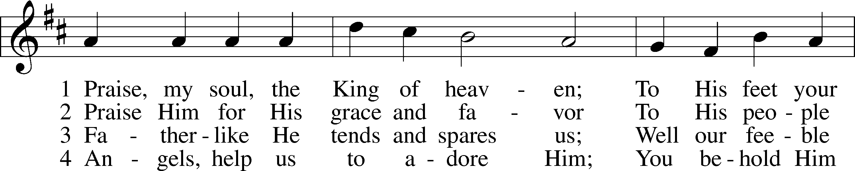
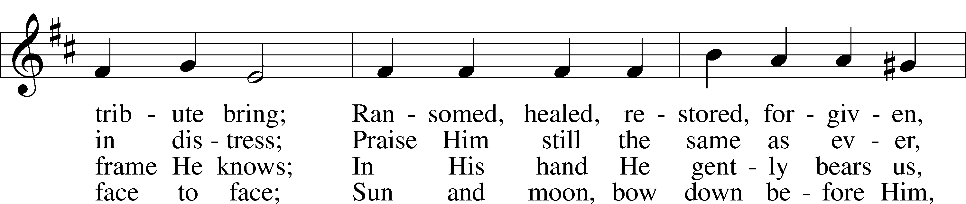
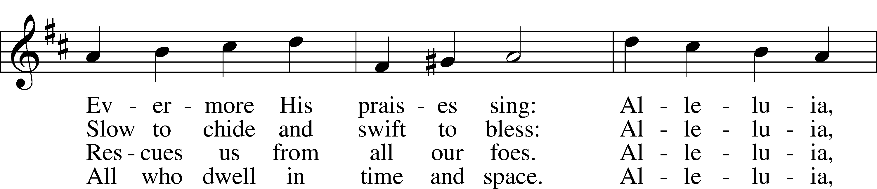
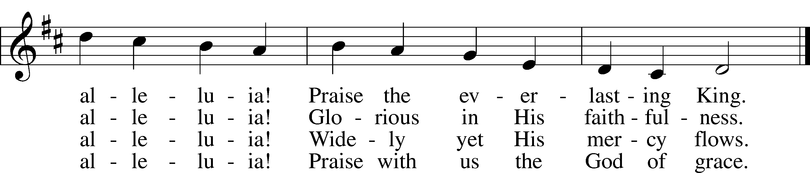
Tune and text: Public domain

Confession and Absolution
Stand. The sign of the cross may be made by all in remembrance of their Baptism.

Invocation
P In the name of the Father and of the T Son and of the Holy Spirit.
C Amen.
Invocation
P Beloved in the Lord! Let us draw near with a true heart and confess our sins unto God our Father, beseeching Him in the name of our Lord Jesus Christ to grant us forgiveness.

P Our help is in the name of the Lord,
C who made heaven and earth.
P I said, I will confess my transgressions unto the Lord,
C and You forgave the iniquity of my sin.

Silence for reflection on God’s Word and for self-examination.
Confession of Sins
P O almighty God, merciful Father,
C I, a poor, miserable sinner, confess unto You all my sins and iniquities with which I have ever offended You and justly deserved Your temporal and eternal punishment. But I am heartily sorry for them and sincerely repent of them, and I pray You of Your boundless mercy and for the sake of the holy, innocent, bitter sufferings and death of Your beloved Son, Jesus Christ, to be gracious and merciful to me, a poor, sinful being.

Absolution
P Upon this your confession, I, by virtue of my office, as a called and ordained servant of the Word, announce the grace of God unto all of you, and in the stead and by the command of my Lord Jesus Christ I forgive you all your sins in the name of the Father and of the T Son and of the Holy Spirit.
C Amen.

Service of the Word
Introit Psalm 31:1, 3, 5; antiphon: Revelation 7:14b

These are the ones coming out of the great tribu-| lation.*
They have washed their robes and made them white in the blood | of the Lamb.
In you, O Lord, do I take refuge; let me never be | put to shame;*
in your righteousness de-| liver me.
For you are my rock and my | fortress;*
and for your name’s sake you lead me and | guide me.
Into your hand I commit my | spirit;*
you have redeemed me, O Lord, | faithful God.

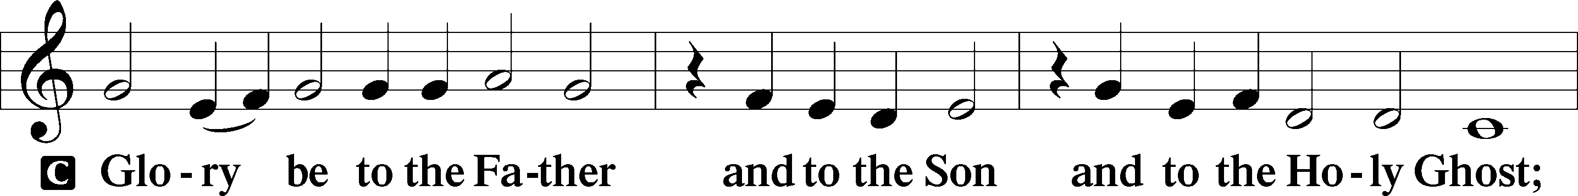
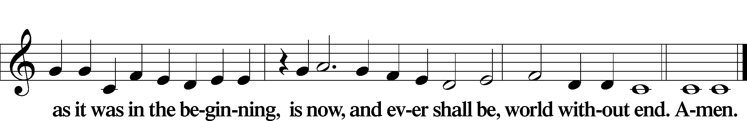

Kyrie LSB 186

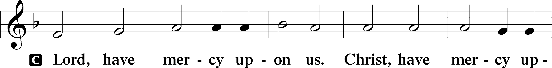
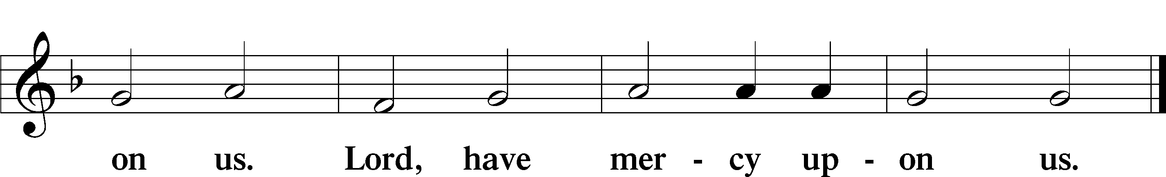

Gloria in Excelsis LSB 187
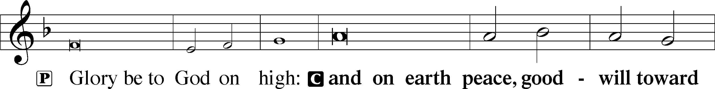
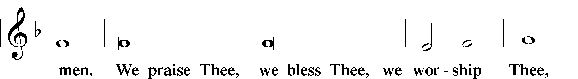
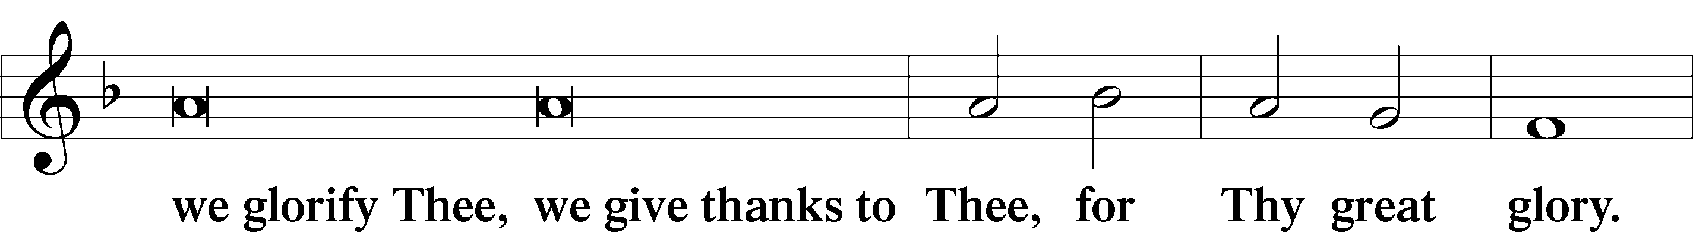
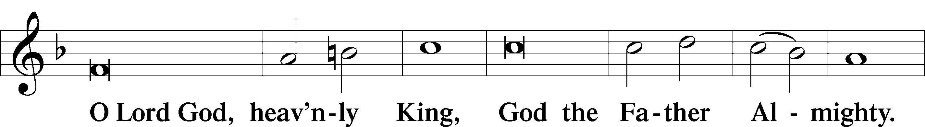
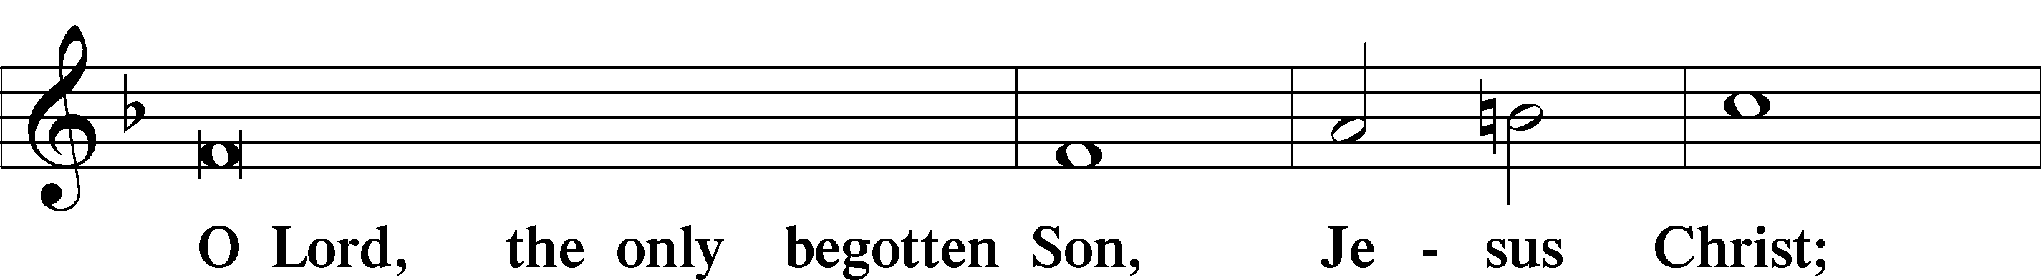
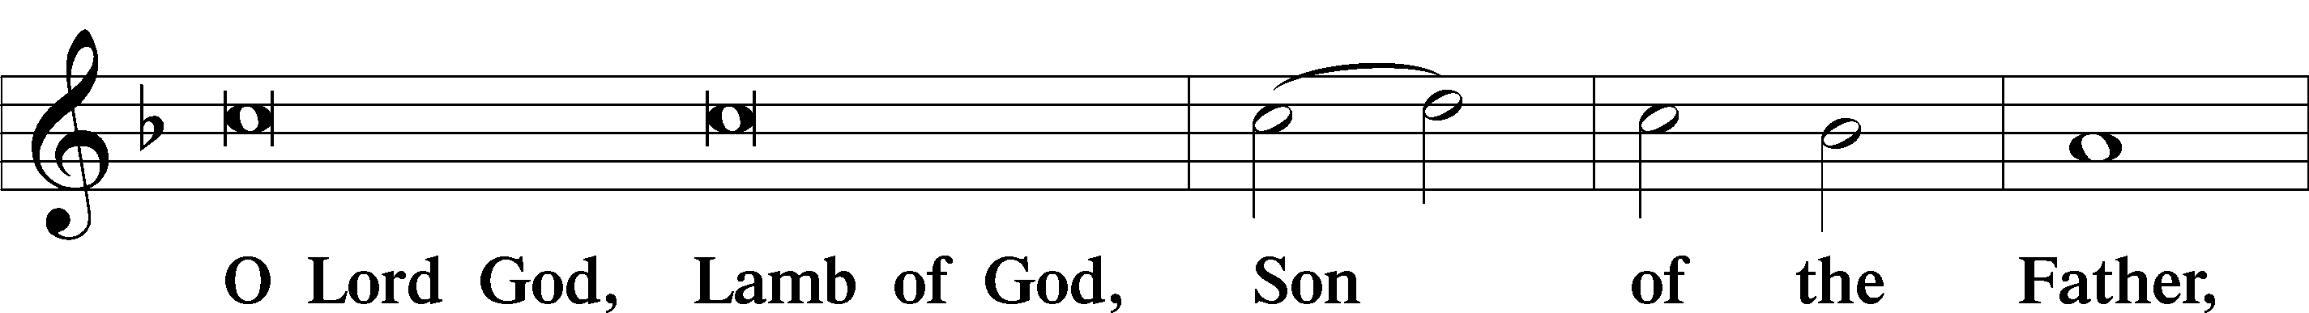
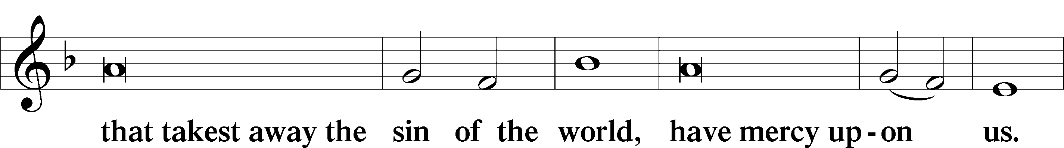
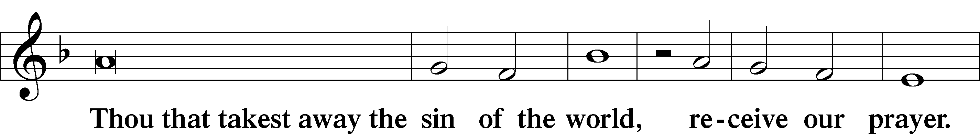
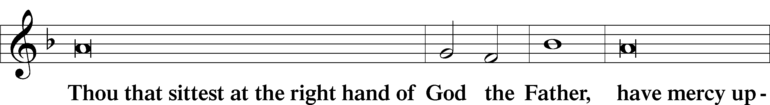
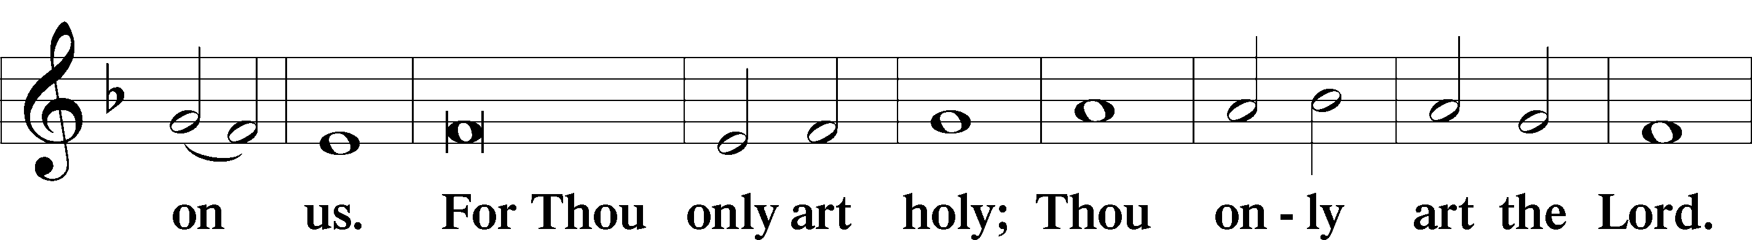
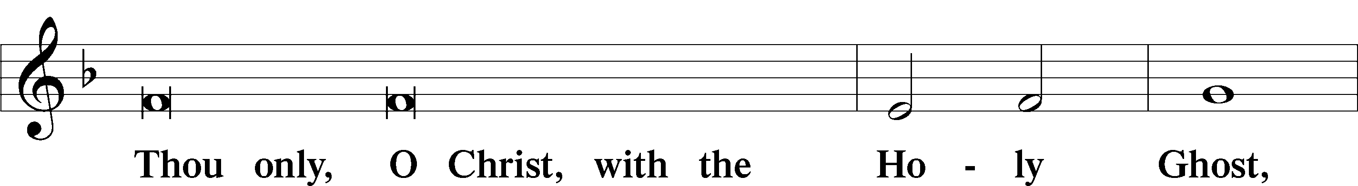
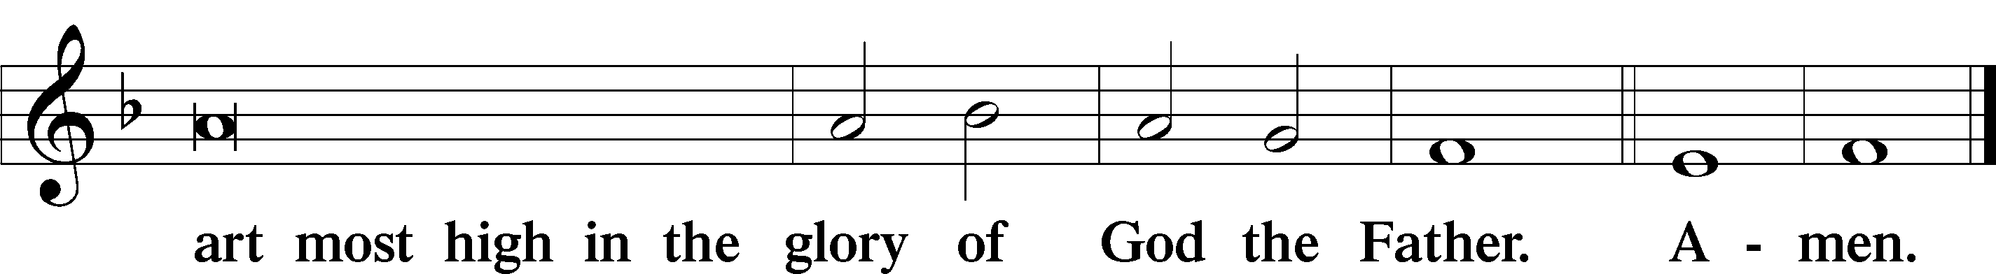

Salutation and Collect of the Day

P The Lord be with you.
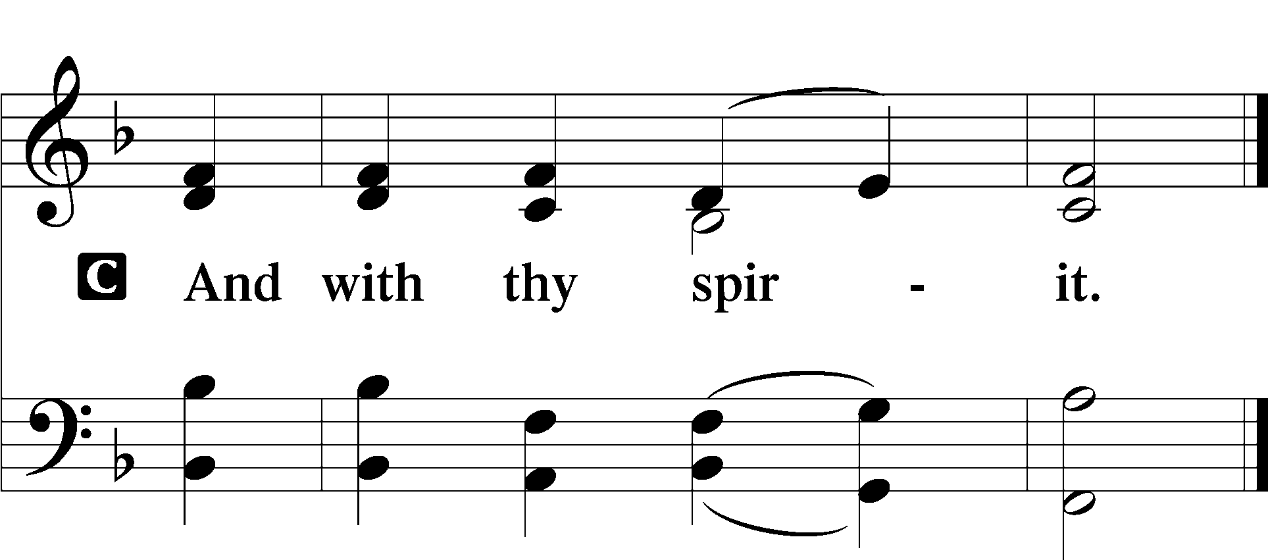

P Let us pray.
O Lord, by Your bountiful goodness release us from the bonds of our sins, which by reason of our weakness we have brought upon ourselves, that we may stand firm until the day of our Lord Jesus Christ, who lives and reigns with You and the Holy Spirit, one God, now and forever.

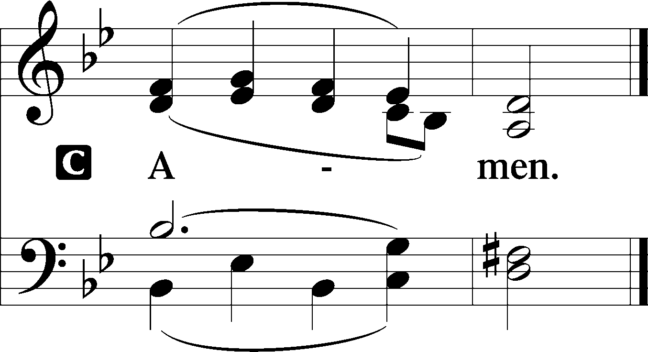

Sit

Old Testament Daniel 12:1-3
1“At that time shall arise Michael, the great prince who has charge of your people. And there shall be a time of trouble, such as never has been since there was a nation till that time. But at that time your people shall be delivered, everyone whose name shall be found written in the book. 2And many of those who sleep in the dust of the earth shall awake, some to everlasting life, and some to shame and everlasting contempt. 3And those who are wise shall shine like the brightness of the sky above; and those who turn many to righteousness, like the stars forever and ever.”

A This is the Word of the Lord.
C Thanks be to God.

Gradual Revelation 7:14b; Psalm 84:5
These are the ones coming out of the great tribu- | lation.*
They have washed their robes and made them white in the blood | of the Lamb.
Blessèd are those whose strength is | in you,*
in whose heart are the highways to | Zion.

Epistle Hebrews 10:11-25
11Every priest stands daily at his service, offering repeatedly the same sacrifices, which can never take away sins. 12But when Christ had offered for all time a single sacrifice for sins, he sat down at the right hand of God, 13waiting from that time until his enemies should be made a footstool for his feet. 14For by a single offering he has perfected for all time those who are being sanctified.
15And the Holy Spirit also bears witness to us; for after saying,
16“This is the covenant that I will make with them
after those days, declares the Lord:
I will put my laws on their hearts,
and write them on their minds,”
17then he adds,
“I will remember their sins and their lawless deeds no more.”
18Where there is forgiveness of these, there is no longer any offering for sin.

19Therefore, brothers, since we have confidence to enter the holy places by the blood of Jesus, 20by the new and living way that he opened for us through the curtain, that is, through his flesh, 21and since we have a great priest over the house of God, 22let us draw near with a true heart in full assurance of faith, with our hearts sprinkled clean from an evil conscience and our bodies washed with pure water. 23Let us hold fast the confession of our hope without wavering, for he who promised is faithful. 24And let us consider how to stir up one another to love and good works, 25not neglecting to meet together, as is the habit of some, but encouraging one another, and all the more as you see the Day drawing near.
A This is the Word of the Lord.
C Thanks be to God.

Stand
Alleluia LSB 190
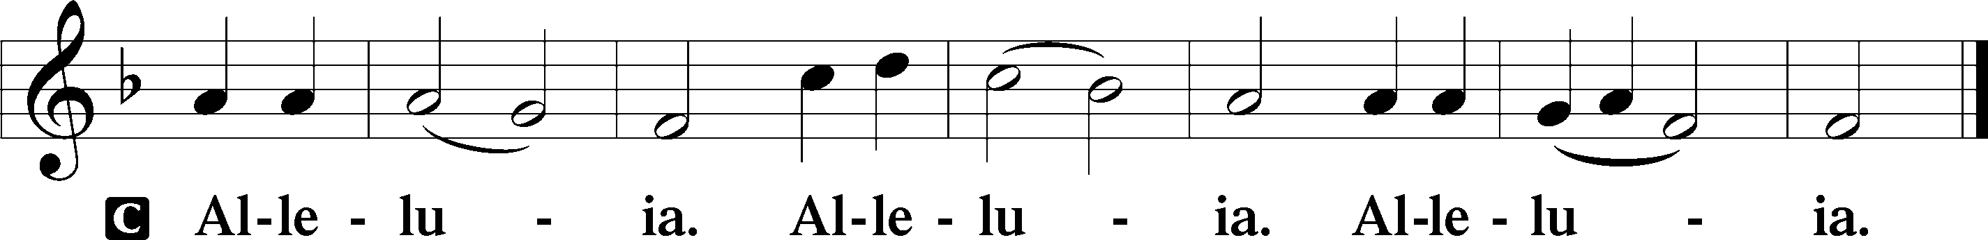

Holy Gospel Matthew 13:1–13
P The Holy Gospel according to St. Mark, the thirteenth chapter.
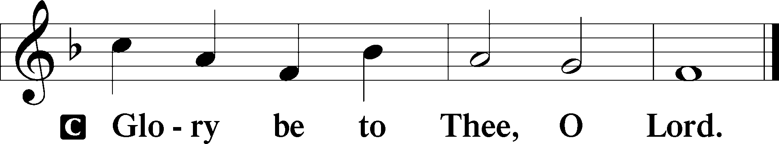

1As [Jesus] came out of the temple, one of his disciples said to him, “Look, Teacher, what wonderful stones and what wonderful buildings!” 2And Jesus said to him, “Do you see these great buildings? There will not be left here one stone upon another that will not be thrown down.”

3And as he sat on the Mount of Olives opposite the temple, Peter and James and John and Andrew asked him privately, 4“Tell us, when will these things be, and what will be the sign when all these things are about to be accomplished?” 5And Jesus began to say to them, “See that no one leads you astray. 6Many will come in my name, saying, ‘I am he!’ and they will lead many astray. 7And when you hear of wars and rumors of wars, do not be alarmed. This must take place, but the end is not yet. 8For nation will rise against nation, and kingdom against kingdom. There will be earthquakes in various places; there will be famines. These are but the beginning of the birth pains.
9“But be on your guard. For they will deliver you over to councils, and you will be beaten in synagogues, and you will stand before governors and kings for my sake, to bear witness before them. 10And the gospel must first be proclaimed to all nations. 11And when they bring you to trial and deliver you over, do not be anxious beforehand what you are to say, but say whatever is given you in that hour, for it is not you who speak, but the Holy Spirit. 12And brother will deliver brother over to death, and the father his child, and children will rise against parents and have them put to death. 13And you will be hated by all for my name’s sake. But the one who endures to the end will be saved.”

P This is the Gospel of the Lord.

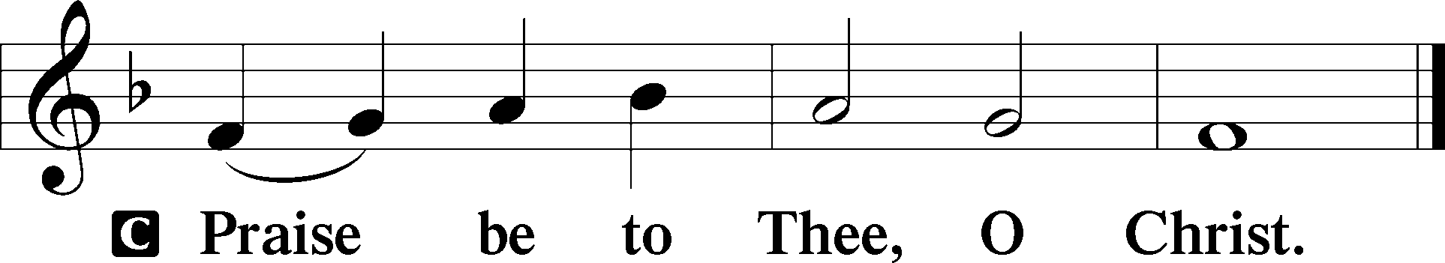

Nicene Creed

C I believe in one God,
the Father Almighty,
maker of heaven and earth
and of all things visible and invisible.

And in one Lord Jesus Christ,
the only-begotten Son of God,
begotten of His Father before all worlds,
God of God, Light of Light,
very God of very God,
begotten, not made,
being of one substance with the Father,
by whom all things were made;
who for us men and for our salvation came down from heaven
and was incarnate by the Holy Spirit of the virgin Mary
and was made man;
and was crucified also for us under Pontius Pilate.
He suffered and was buried.
And the third day He rose again according to the Scriptures
and ascended into heaven
and sits at the right hand of the Father.
And He will come again with glory to judge both the living and the dead,
whose kingdom will have no end.

And I believe in the Holy Spirit,
the Lord and giver of life,
who proceeds from the Father and the Son,
who with the Father and the Son together is worshiped and glorified,
who spoke by the prophets.
And I believe in one holy Christian and apostolic Church,
I acknowledge one Baptism for the remission of sins,
and I look for the resurrection of the dead
and the life T of the world to come. Amen.

508 The Day Is Surely Drawing Near
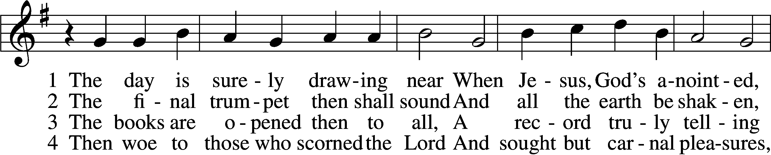
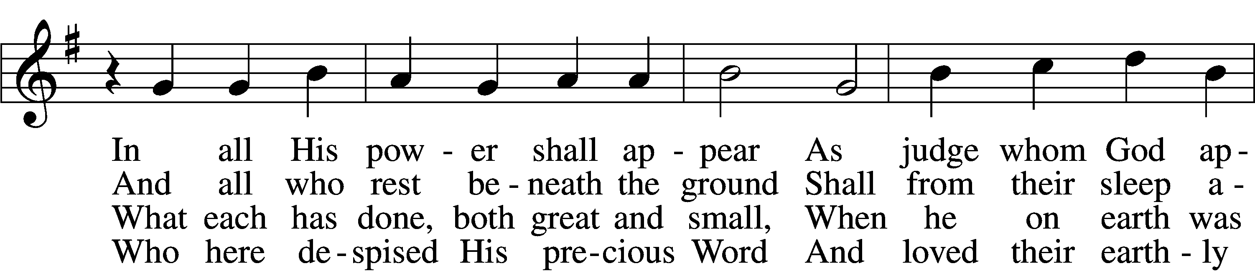
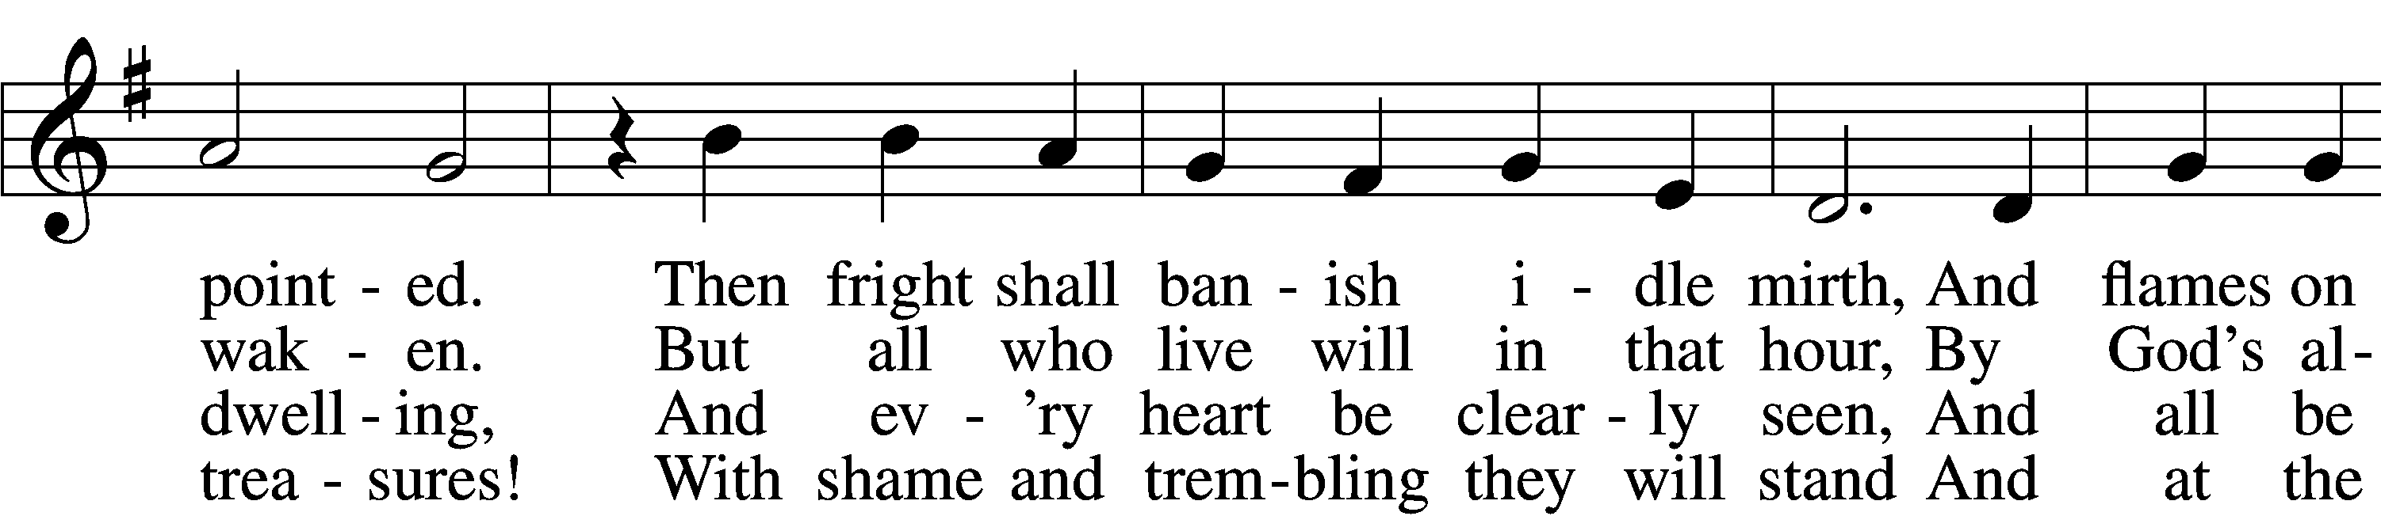
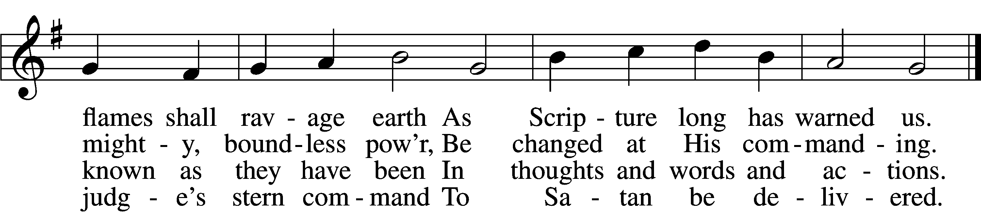

77 7 O Jesus Christ, do not delay,
But hasten our salvation;
We often tremble on our way
In fear and tribulation.
O hear and grant our fervent plea:
Come, mighty judge, and set us free
From death and ev’ry evil.
Tune and text: Public domain

5 My Savior paid the debt I owe
And for my sin was smitten;
Within the Book of Life I know
My name has now been written.
I will not doubt, for I am free,
And Satan cannot threaten me;
There is no condemnation!

6 May Christ our intercessor be
And through His blood and merit
Read from His book that we are free
With all who life inherit.
Then we shall see Him face to face,
With all His saints in that blest place
Which He has purchased for us.

Sermon

Stand

Offertory LSB 192
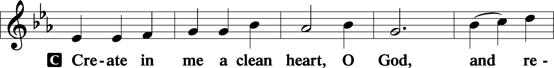
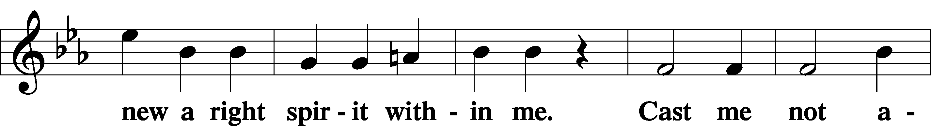
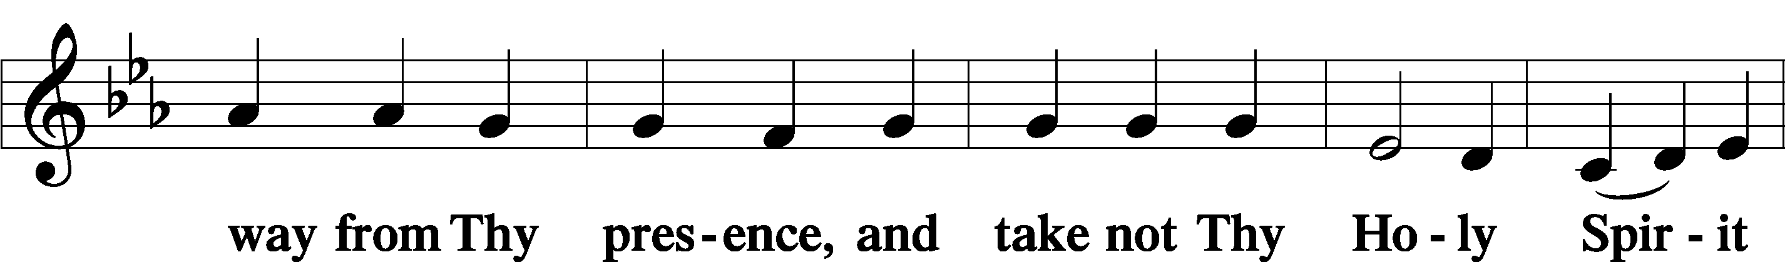
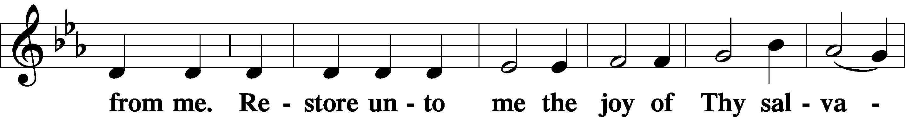
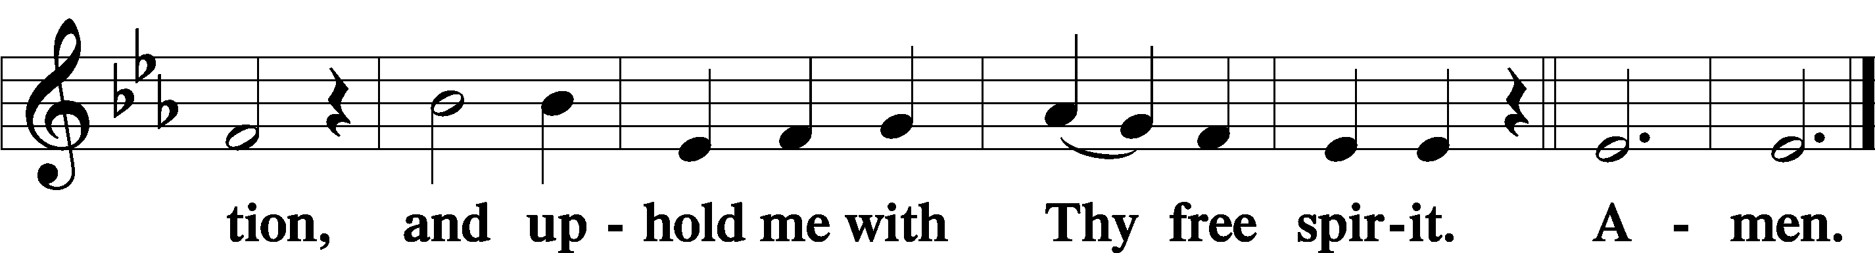

Service of the Sacrament
Preface LSB 194

P The Lord be with you.

P Lift up your hearts.
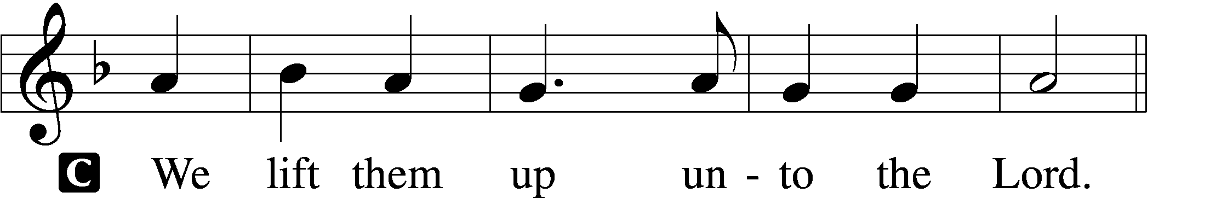

P Let us give thanks unto the Lord, our God.
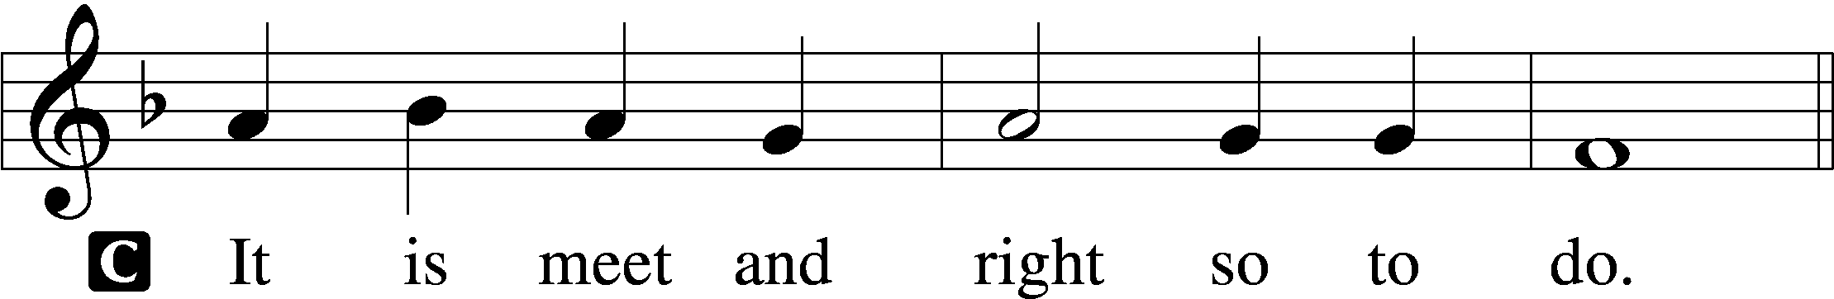

P It is truly good, right, and salutary that we should at all times and in all places give thanks to You, holy Lord, almighty Father, everlasting God. In the communion of all Your saints gathered into the one body of Your Son, You have surrounded us with so great a cloud of witnesses that we, encouraged by their faith and strengthened by their fellowship, may run with perseverance the race that is set before us and, together with them, receive the crown of glory that does not fade away. Therefore with angels and archangels and with all the company of heaven we laud and magnify Your glorious name, evermore praising You and saying:

Sanctus LSB 195
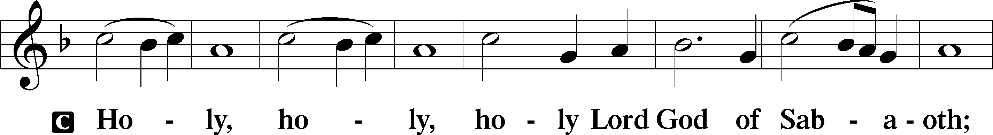
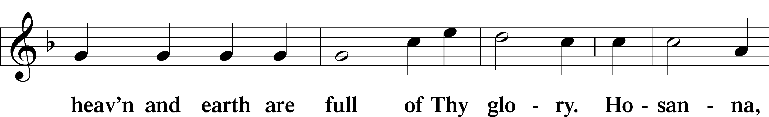
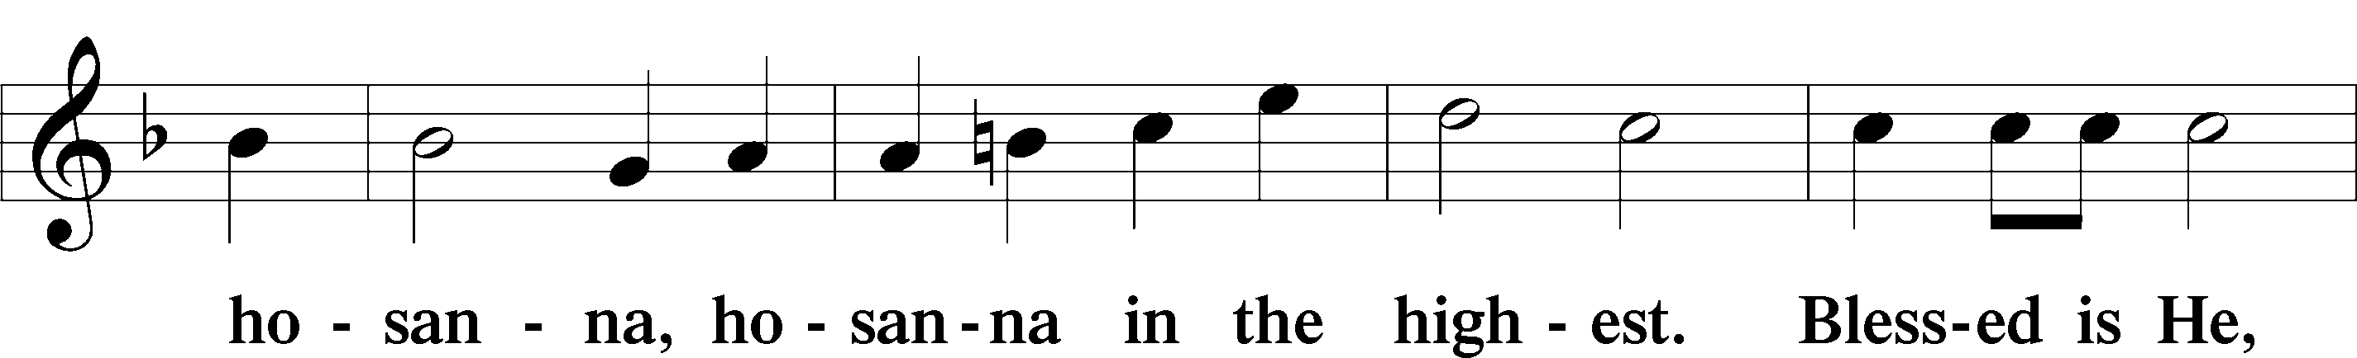
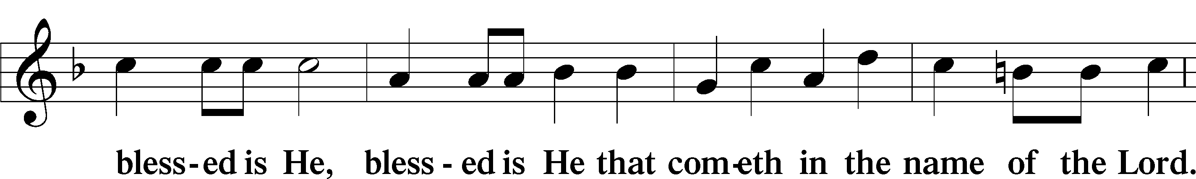
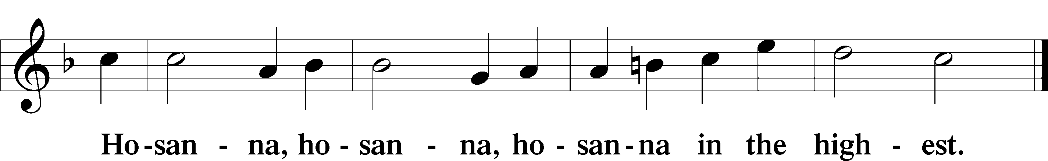

The Lord’s Prayer 196
P Our Father who art in heaven,
hallowed be Thy name,
Thy kingdom come,
Thy will be done on earth as it is in heaven;
give us this day our daily bread;
and forgive us our trespasses as we forgive those who trespass against us;
and lead us not into temptation,
but deliver us from evil.
For Thine is the kingdom and the power and the glory forever and ever. Amen.

The Words of Our Lord LSB 197
P Our Lord Jesus Christ, on the night when He was betrayed, took bread, and when He had given thanks, He broke it and gave it to the disciples and said: “Take, eat; this is My T body, which is given for you. This do in remembrance of Me.”

In the same way also He took the cup after supper, and when He had given thanks, He gave it to them, saying: “Drink of it, all of you; this cup is the new testament in My T blood, which is shed for you for the forgiveness of sins. This do, as often as you drink it, in remembrance of Me.”

Pax Domini LSB 197
P The peace of the Lord be with you always.
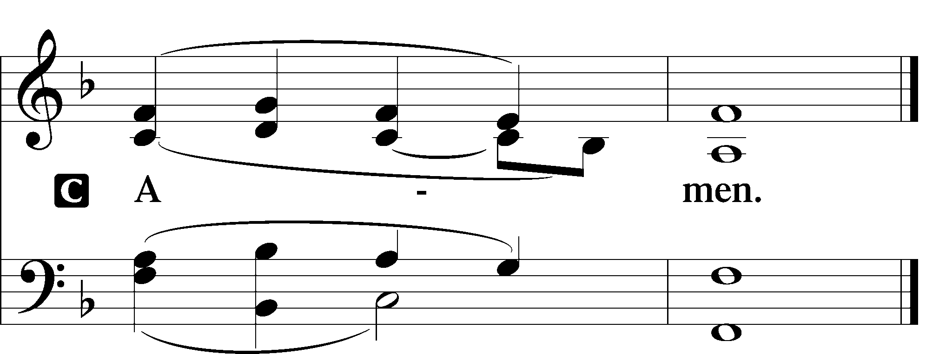

Agnus Dei LSB 198
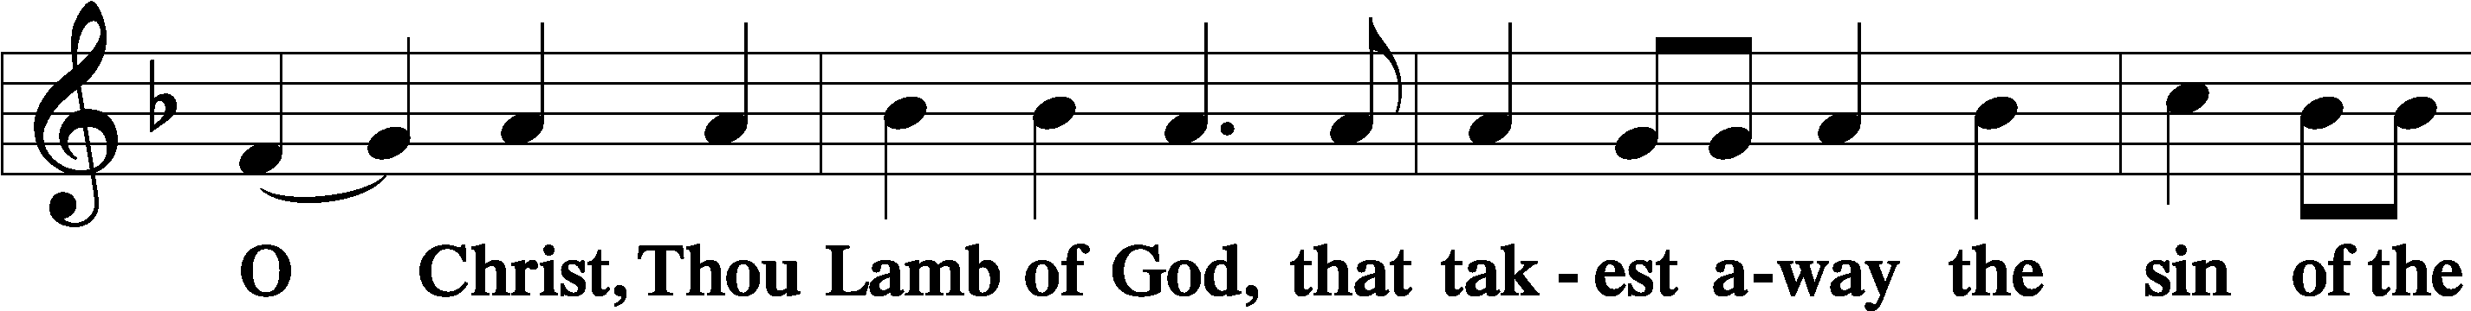
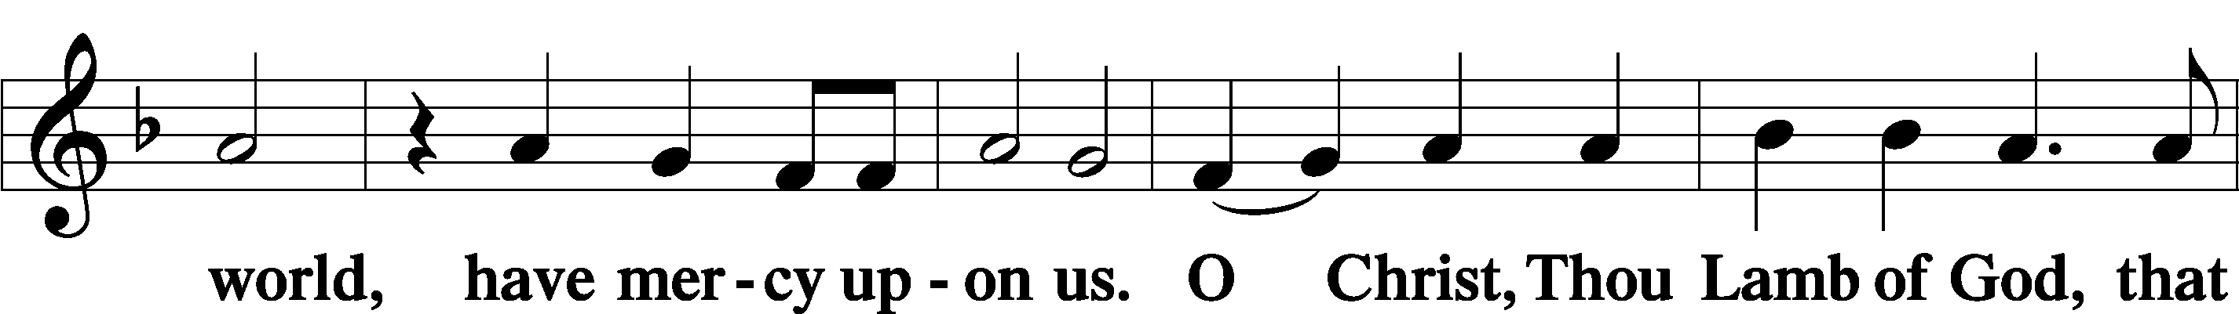
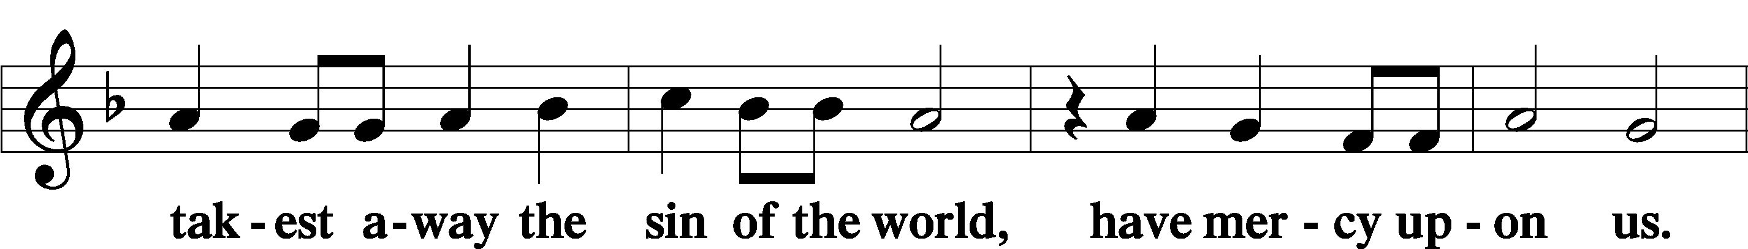
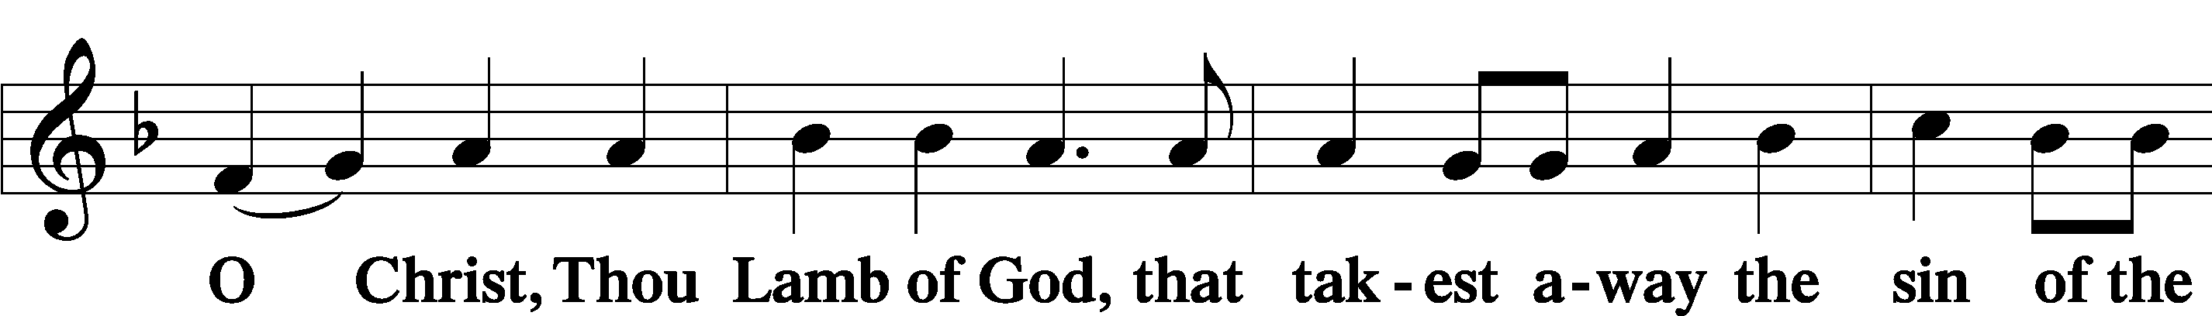
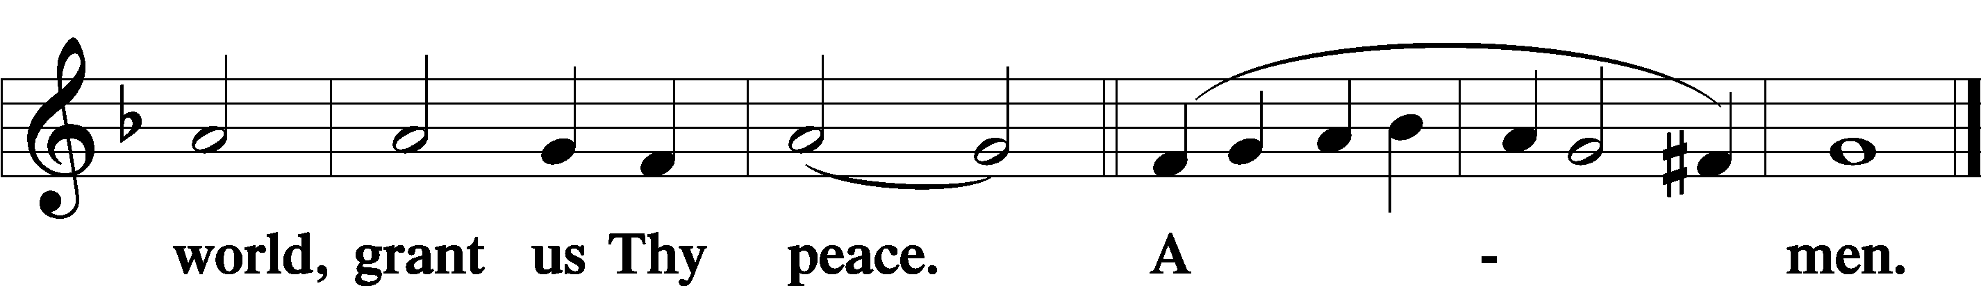

Sit

Distribution

623 Lord Jesus Christ, We Humbly Pray
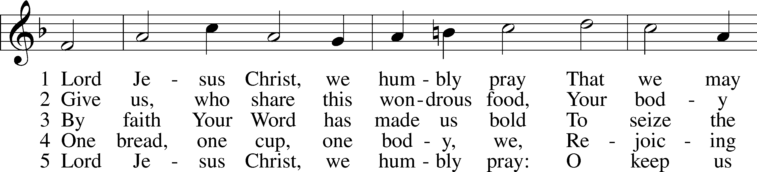
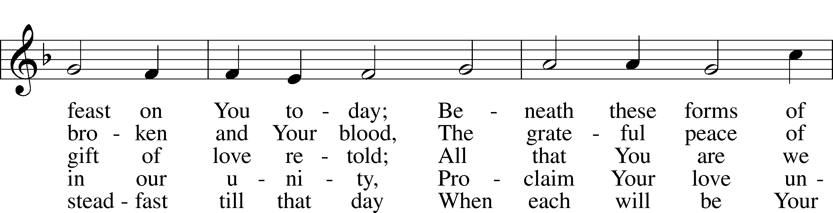
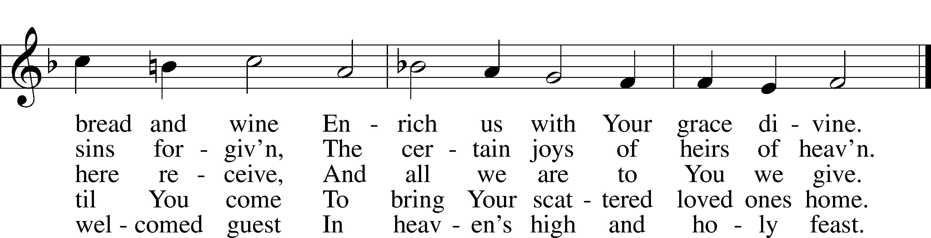
Text and tune: Public domain

563 Jesus, Thy Blood and Righteousness
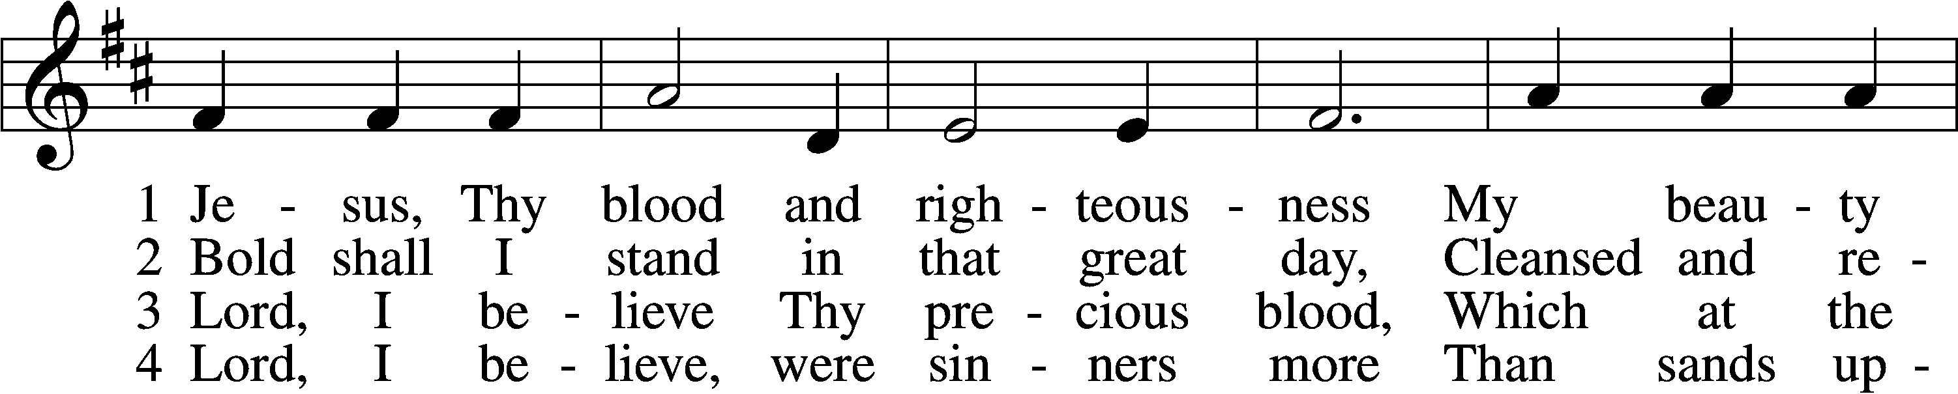
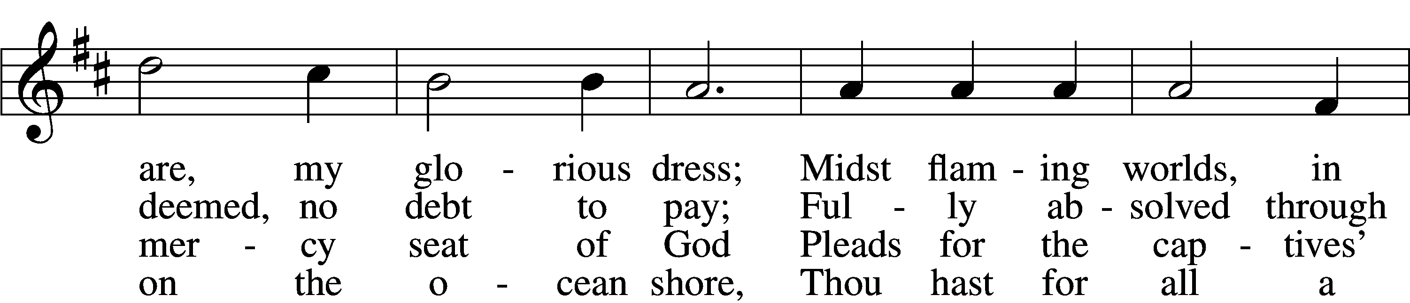
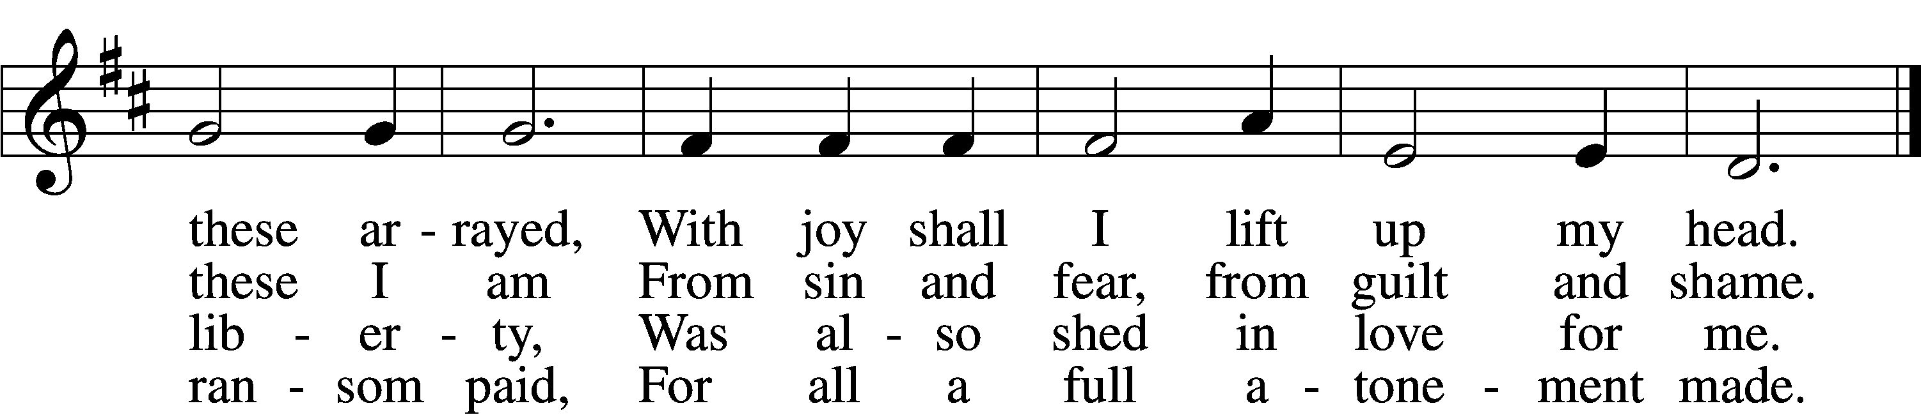

5 When from the dust of death I rise
To claim my mansion in the skies,
This then shall be my only plea:
Jesus hath lived and died for me.

6 Jesus, be endless praise to Thee,
Whose boundless mercy hath for me,
For me, and all Thy hands have made,
An everlasting ransom paid.
Text and tune: Public domain

624 The Infant Priest Was Holy Born
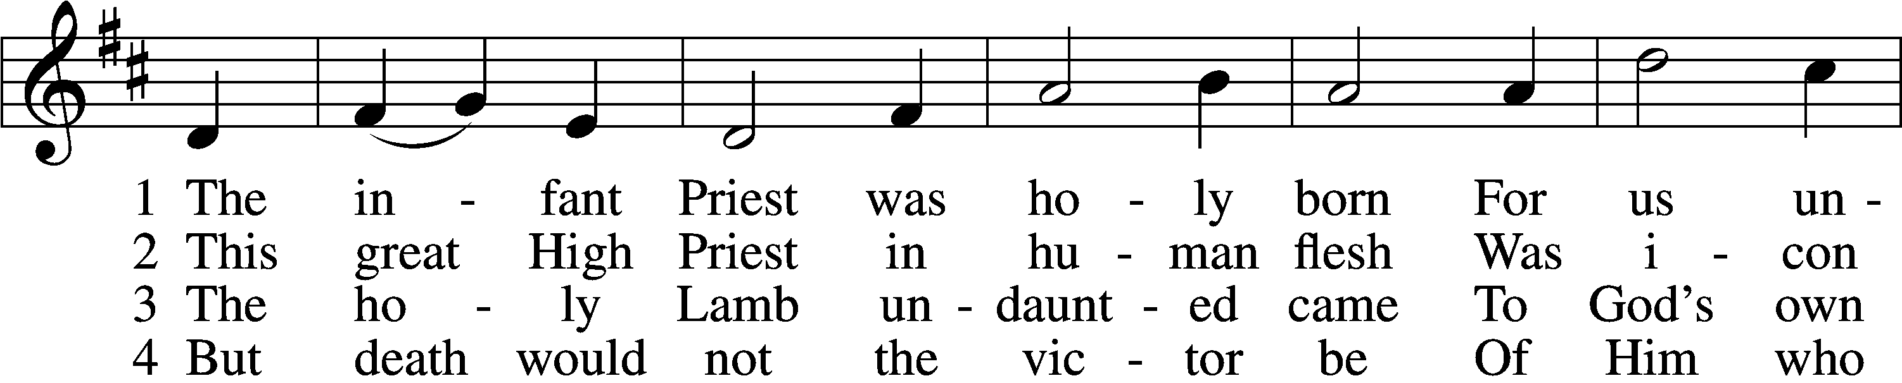
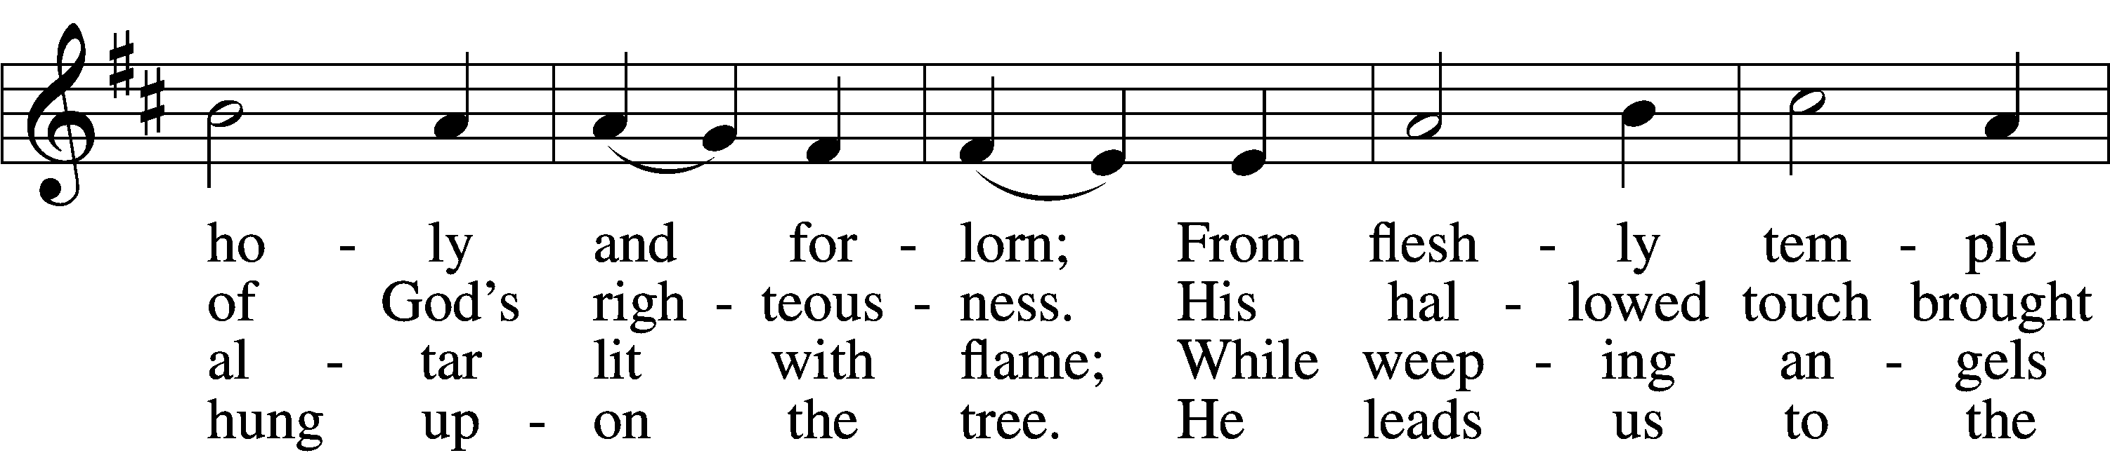
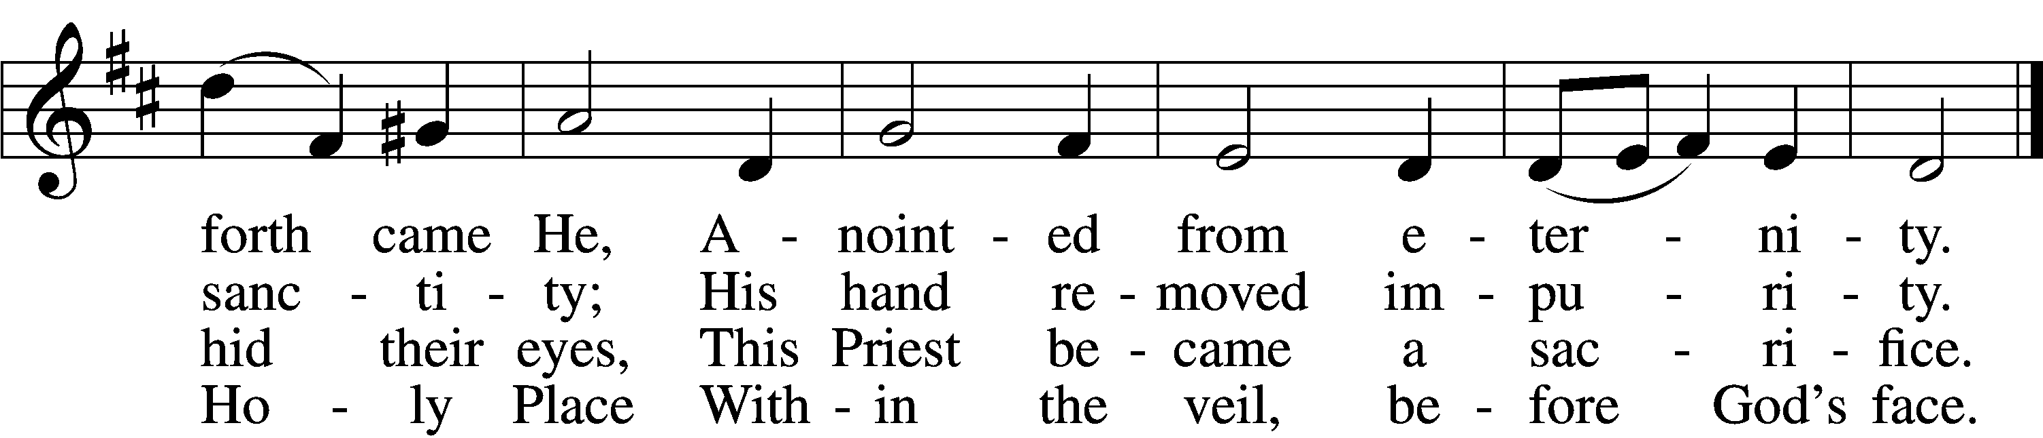

5 The veil is torn, our Priest we see,
As at the rail on bended knee
Our hungry mouths from Him receive
The bread of immortality.

6 The body of God’s Lamb we eat,
A priestly food and priestly meat;
On sin-parched lips the chalice pours
His quenching blood that life restores.

7 With cherubim and seraphim
Our voices join the endless hymn,
And “Holy, holy, holy” sing
To Christ, God’s Lamb, our Priest and King.
Text: © 1997, 2003 Chad L. Bird. Used by permission: LSB Hymn License no. 110003744
Tune: Public domain

In dismissing the communicants, the following is said:

The Dismissal LSB 199
P The body and blood of our Lord Jesus Christ strengthen and preserve you in body and soul to life everlasting. Depart T in peace.
C Amen.

Nunc Dimittis LSB 199
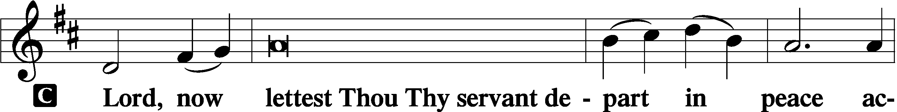
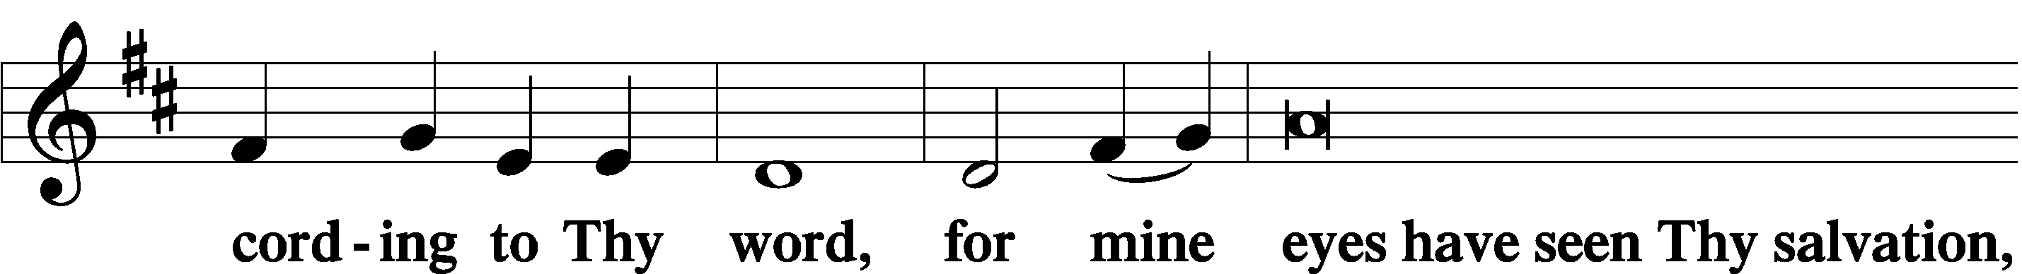
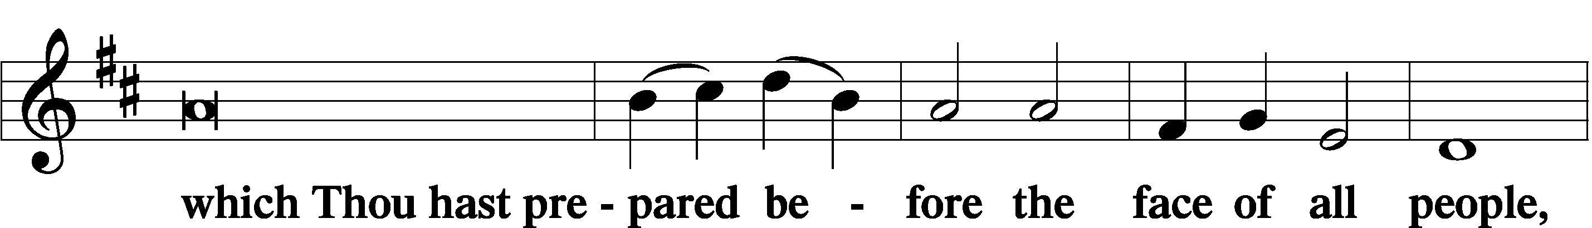
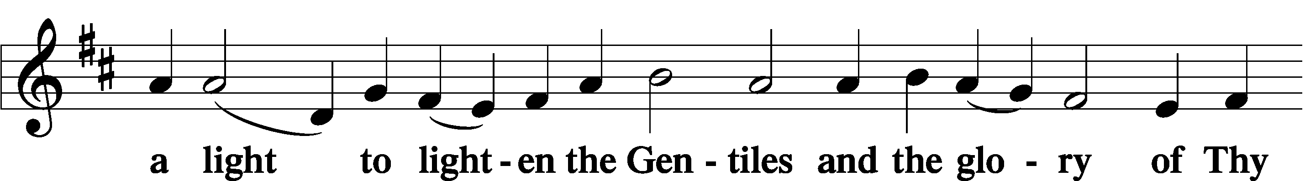
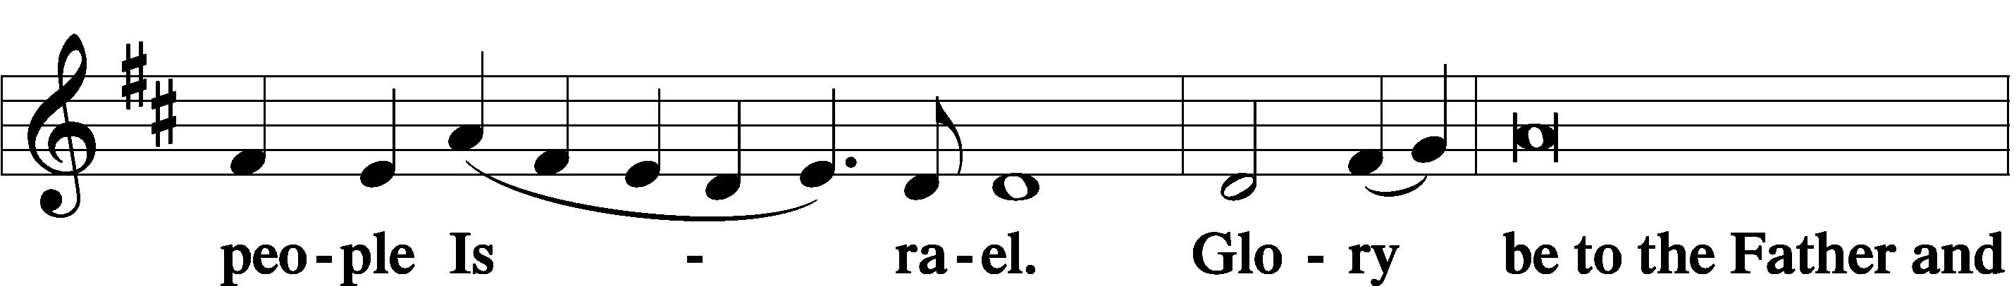
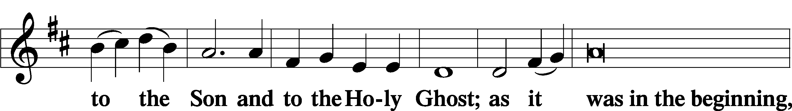
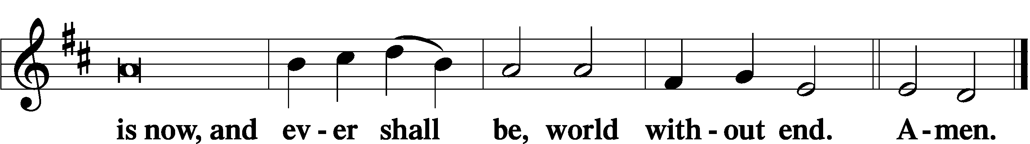

Thanksgiving LSB 200
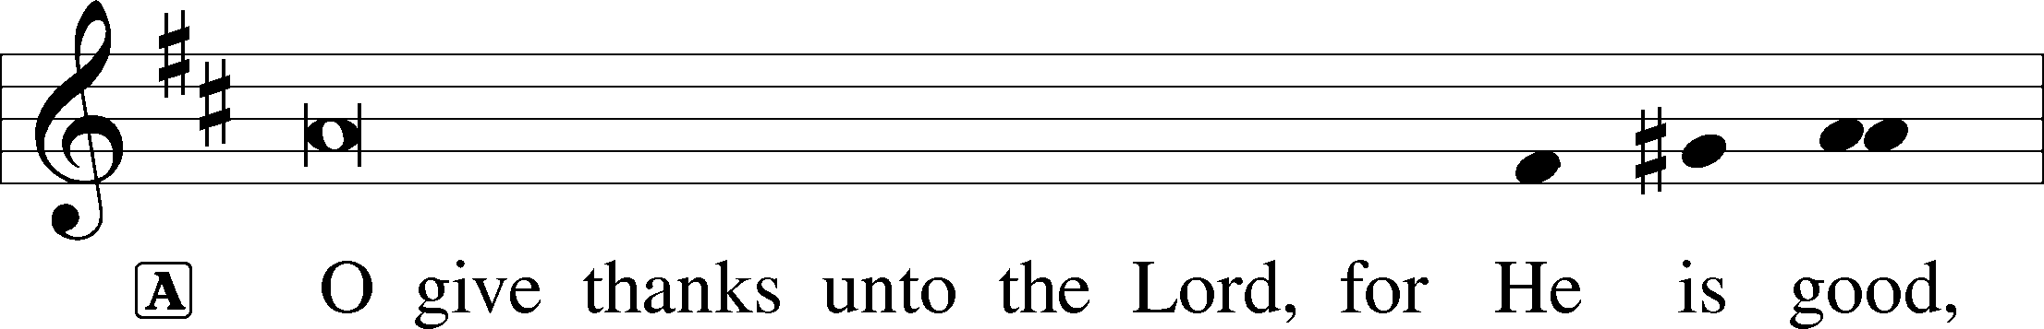
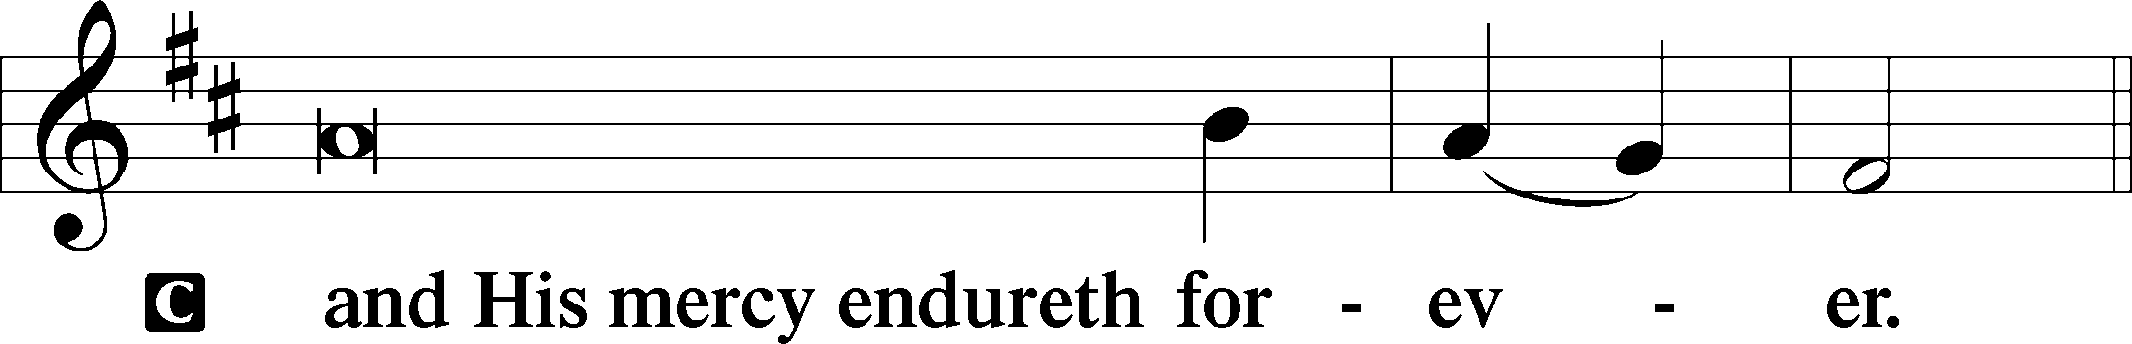

Post-Communion Collect
P Let us pray…
Gracious God, our heavenly Father, You have given us a foretaste of the feast to come in the Holy Supper of Your Son’s body and blood. Keep us firm in the true faith throughout our days of pilgrimage that, on the day of His coming, we may, together with all Your saints, celebrate the marriage feast of the Lamb in His kingdom which has no end; through Jesus Christ, Your Son, our Lord, who lives and reigns with You and the Holy Spirit, one God, now and forever.

Salutation LSB 201
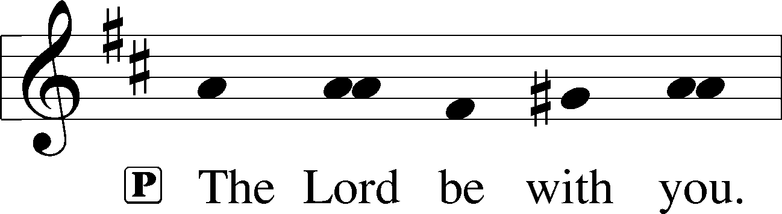

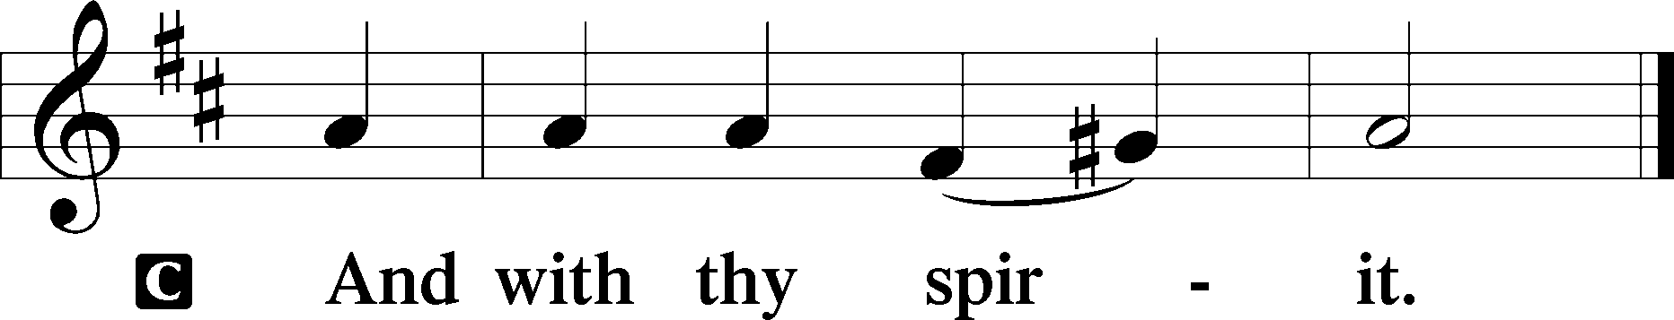

Benedicamus LSB 202
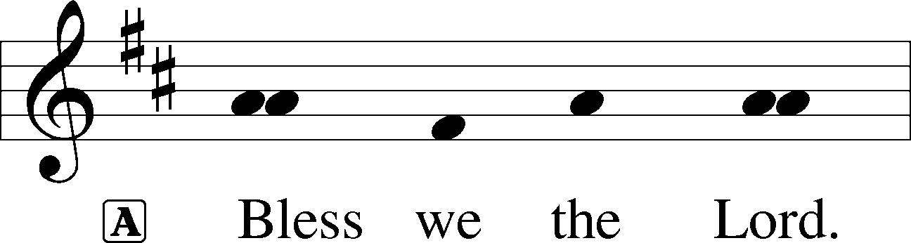

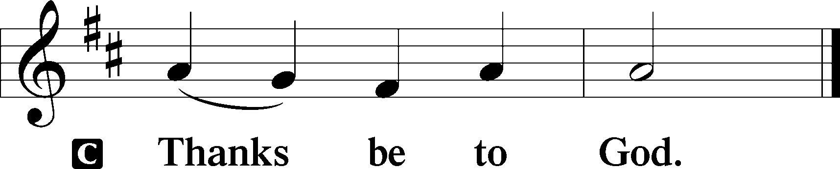

Benediction LSB 202
P The Lord bless you and keep you.
The Lord make His face shine upon you and be gracious unto you.
The Lord lift up His countenance upon you and T give you peace.
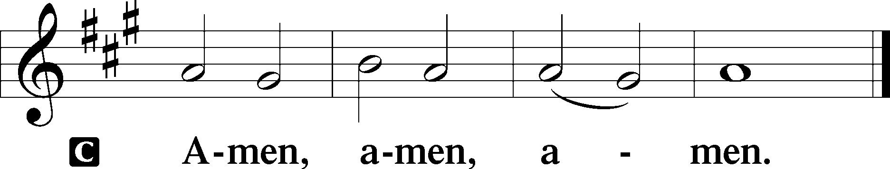

673 Jerusalem, My Happy Home
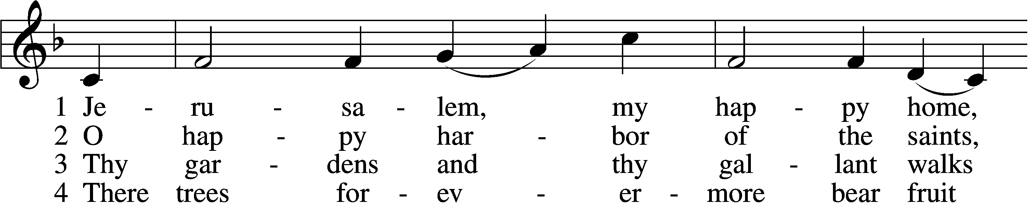
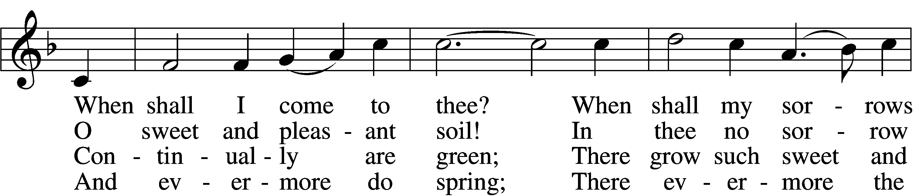
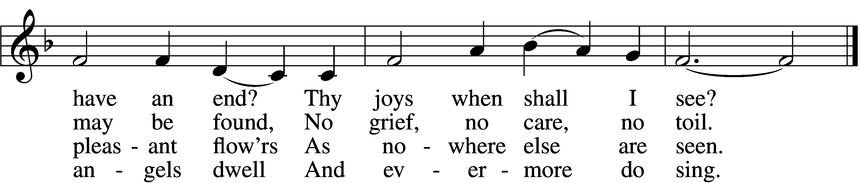

5 Apostles, martyrs, prophets, there
Around my Savior stand;
And soon my friends in Christ below
Will join the glorious band.

6 O Christ, do Thou my soul prepare
For that bright home of love
That I may see Thee and adore
With all Thy saints above.
Tune and text: Public domain

Acknowledgments
Unless otherwise indicated, Scripture quotations are from the ESV® Bible (The Holy Bible, English Standard Version®), copyright © 2001 by Crossway, a publishing ministry of Good News Publishers. Used by permission. All rights reserved.
Created by Lutheran Service Builder © 2021 Concordia Publishing House.

Prayers for Our Members
Sharon Hockemeier, Tenaya Nuttelman | Expectant Mothers
Norman Abels (Brookestone Meadows – Elkhorn) | Healing
Judy Ahrens | Healing
Vaughn Albrecht (Mount Carmel) | Healing
Tom & DyAnn Altwine | Healing
Lyle Colsden (Mother Hull) | Healing
Mary Fiddelke | Back Surgery
Pat Flodine (Cambridge Court) | Healing
Vi Fox (Prairie View) | Hospitalized
Verleen Gentry | Healing
Wanda Glanzer | Healing
Ruby Hatfield | Healing
Evelyn Heiden (Mother Hull) | Healing
Lennis Hodgson | Healing
Don Richmond | Healing
Ivan Bombeck | Cancer
Fran Junge | Thanksgiving
Bertha Marienau | Cancer
Kim Vos | Cancer

ZION LUTHERAN CHURCH AND SCHOOL

Pr. James DeLoach, Pastor + (308) 627-5260
james.deloach@zionkearney.org
Pr. Doug Gaunt, Pastor + (308) 455-0552
doug.gaunt@zionkearney.org
Tony Splittgerber, Principal + (308) 293-0168
anthony.splittgerber@zionkearney.org

Church Office
Secretary: Holly Reid
Email: school@zionkearney.org
Phone: (308)-234-3410 Fax: (308) 236-8100
Office Hours: Monday-Friday 8:00am-4:00pm
Radio Broadcast: Sunday @ 10:30 a.m. on 1460 AM and 92.1 FM
Website: www.zionkearney.com
Prayers for Our Members’ Family & Friends
Naomi Wollberg (Matthias’ wife) | Expecting
Elaine Arehart (Zion’s Music Teacher) | Expecting
Jean Brooks (Bruce Brooks & Becky Thornton’s sister-in-law) | Healing
Mike McDaniel (Dennis & Sue Bartel’s brother-in-law | Healing
Larry Bombeck (Ivan’s brother) | Healing
Katie Cunningham (Quentin & Janel Lange’s friend) | Healing
Reg Duke (Westman’s brother-in-law) | Healing
James Gentry (Verleen’s son) | Healing
Roger Hoffman (Marc’s father) | Healing
David Kreutzer (Richard’s brother) | Healing
Pr. Rob Kuefner (Kearney Circuit Visitor) | Healing
Dillon Malchow (Joy Barefoot’s nephew) | Healing
Urijah Mitchell (Sue & Dennis Bartels’ Grandson) | Healing
Tim Powers (Kim Wilken’s brother) | Healing
Roy Reynolds (Verleen Gentry’s son-in-law) | Healing
Lynne Saathoff (Verleen Gentry’s sister-in-law) | Healing
Randy Solomon (Beth Rosenthal’s father) | Healing
Tim Trampe (Don & Gretchen’s son) | Healing
Jonah (Jase & Jarren Blattner’s friend) | Cancer
D.D. Dugger (Sue Kaiser’s brother) | Cancer
Stuart Gronewoller (Lonna’s brother-in-law) | Cancer
Linda Heapy (Janel Lange’s mother) | Cancer
Ron Halvorsen (Jeff’s dad) | Cancer
Bill Jedlicka (Pam Uhlir’s cousin) | Cancer
Randy Jochum (Ken Hockemeier’s brother-in-law) | Cancer
Sharon Mulhair (Pam Uhlir’s cousin) | Cancer
Kolby Shiers (Jessica’s cousin) | Cancer
Pr. Richard Snow (NE District President) | Cancer
Tyrone Uhlir (Pam’s nephew) | Cancer
Birth of Ella Harper Unick (Great niece of Dennis & Sue Bartels) | Thanksgiving
Scott Catterson (Jim & Pat’s Son) | Deployment
Tim Smallcomb (Wilkens’ friend) | Deployment
Today’s Altar Flowers are provided by Cheryl Scarborough, in honor of her birthday today.

Worship Assistants

Sunday, November 14th~ 9:00am

Elder: Eric Rosenthal
Usher: Steve Junge
Acolyte: Jase Blattner
Engineer: Zach DeLoach
Announcer: Jesse Florang
Altar Guild: Brooke Fisher & Tracy Schake

Sunday, November 21st~ 9:00am

Elder: Dan Oertwig
Usher: Andy Wollberg
Acolyte: Colton Zehendner
Engineer: Jared Nuttelman
Announcer: Lonna Gronewoller
Altar Guild: Brooke Fisher & Tracy Schake

Our Response to the Gospel

Date: 11/7/2021
Offering: $8,631
Weekly Need: $7,457.69

This Week at Zion

Sun  11/14 | 9:00a  10:20a  10:30a  5:00p  Birthdays | Divine Service  Bible Study/Sunday School  Radio Broadcast 1460am & 92.1fm  Divine Service  Cheryl Scarborough
Mon
11/15
Tues  11/16 | 1:30p  7:00p  Birthdays | Sleeping Mats  Church Council  Edward DeLaet
Wed  11/17 | 8:30a  5:45p  6:00p  7:00p  Birthdays | Chapel  Midweek  Bell Choir  Adult Choir  Wanda Glanzer
Thurs  11/18 | 7:00p  Birthdays | Men’s Bible Study  Sandra Heiden
Fri
11/19
Sat  11/20 | Birthdays | Rachael Burger
Sun  11/21 | 9:00a  10:15a  10:30a  5:00p | Divine Service  Bible Study/Sunday School  Radio Broadcast 1460am & 92.1fm  Divine Service
Where our Triune God strengthens us through His mercy in faith toward Him and in fervent love toward one another.

ANNOUNCEMENTS

Pastor Gaunt’s 35th Anniversary of Ordination: All wanting to show their appreciation for Pr. Gaunt’s years of service can donate toward his gift or give him a card to thank him. Please put your donation in an envelope and give it to Pr. DeLoach, who will be purchasing his gift.

The Zion Youth Group would like to give back this season by helping in our community. If you have any small jobs that you would like help with in the month of November, please contact Miss Nikodym (402) 746-0561 or Miss Dauel (308) 627-2113. Examples of jobs include raking leaves, cleaning up a garden, putting out or taking down decorations, etc.

Adult Bible Study is studying the rich variety of words God uses to communicate the Gospel—that we are justified by grace through faith. Come grab a donut and cup of coffee as we fellowship and learn together.

Zion’s 4th Quarter (Oct – Dec) Mission Offerings will support Zion’s current students, who are studying for full-time church work. All our students are at Concordia (CUNE):
Peter Kreutzer - Lutheran Teacher’s Diploma (LTD)
Jessica Zehendner – LTD
Taylor Zehendner – LTD
Please use the mission envelopes located in the narthex for this offering. Or give via Church Trac by selecting “Missions.” Thank you for your support.

Offering Options:
1) Place your offering in the basket as you leave
2) Go to zionkearney.churchtrac.com/give
3) Go to zionkearney.com and click on the ChurchTrac icon
4) Mail your gift to Zion Lutheran Church, 2421 C Ave, Kearney, NE 68847. Or place it in the mail slot on the south side of the building.
Poinsettias – Zion will be taking poinsettia orders to adorn the Church Sanctuary during Christmas time. They will be $15.00 per plant. To order, there is an envelope in the Fellowship Hall on Sunday’s and in the Church Office during the week. Place your money in the envelope with your name, place the envelope in the offering plate or the mail slot on the south side of the building or drop it off during office hours. Please make checks out to Mary Martha.

Radio Broadcast – The sign-up sheets for the 2022 radio broadcast and altar flowers are up by the mailboxes! The remaining 2021 sheets are still up on the right side. The 28th of November is still available for radio sponsors! Please help Zion spread the Gospel!

SCHOOL NEWS

The Theme for our school year is “Together by Christ’s Love” based on 1 John 4:7-8.

- ZION JOB OPPORTUNITY: There is an opening for an Early Childhood Aide in one of our MWF Pre-K classes starting in January! This would be a part time morning position. If you enjoy working with children 3yrs and up, this will be a fun position for you. Contact Mr. Splittgerber if you have any questions.

- Thanksgiving Break: NO SCHOOL November 24th-26th. Have a great Thanksgiving!

- Give Where You Live - Zion will be participating in the Give Where You Live Campaign again! It will be December 2nd (giving day), but donations will be accepted beginning November 4th. To contribute online go to: https://www.givewhereyoulive.net//zionlutheranschool. If you would rather give in person feel free to stop by the office. Please share this with family and friends.

