Divine Service

First Sunday of Advent
November 28, 2021
Zion Lutheran Church
Kearney, Nebraska
Welcome to Zion!
All worshippers please fill out an attendance card in the pew rack and let us know how we might be of service to you.

Holy Communion at Zion

The Lord’s Supper is celebrated at this congregation as Jesus instituted it. As he says, so our Lord gives into our mouths not only bread and wine but his very body and blood to eat and to drink for the forgiveness of sins and to strengthen our union with him and with one another. Our Lord invites to his table those who repent of all sin, trust his words “given and shed for you for the forgiveness of sins,” and set aside any refusal to forgive and love as he forgives and loves us, that they may show forth his death until he comes. All communicants need to register in the narthex prior to the service.

The Lord’s Supper can harm those who receive it unworthily. Holy Communion is also a confession of the faith which is confessed at this altar. Therefore, any who are not yet instructed, in doubt, or who hold a confession differing from that of this congregation and The Lutheran Church—Missouri Synod, are asked not to commune until they are able to speak with our pastor first. He is most happy to visit with you about the Christian faith and how to receive the Lord’s Supper for your good and for the good of others. Those not communing are invited to come to the altar, cross your arms in front of you, and bow your head to receive a pastoral blessing.

The Lord Jesus Comes in Humility to Redeem Us

The season of Advent focuses on the coming of our Lord Jesus Christ, and this first Sunday establishes this theme for the rest of the season. The Son of God came long ago to be our Savior, “a righteous Branch” descended from David (Jer. 33:15). As He then came into Jerusalem, riding on a lowly donkey to sacrifice Himself for the sins of the world (Luke 19:28–40), so does He come to His Church today in the humility of Word and Sacrament to deliver the fruits of His Passion: the forgiveness of sins and eternal life. He absolves us and establishes our hearts “blameless in holiness before our God and Father” (1 Thess. 3:13). The same Lord Jesus, who came to Jerusalem then and who comes to us now in peace, will come again with power and great glory on the Last Day. Then there will be “distress of nations in perplexity,” with “people fainting with fear.” Yet, as we anticipate that great and terrible day, He bids us to rest securely in Him: “Raise your heads, because your redemption is drawing near” (Luke 21:25, 26, 28).

Confession and Absolution

341 Lift Up Your Heads, Ye Mighty Gates
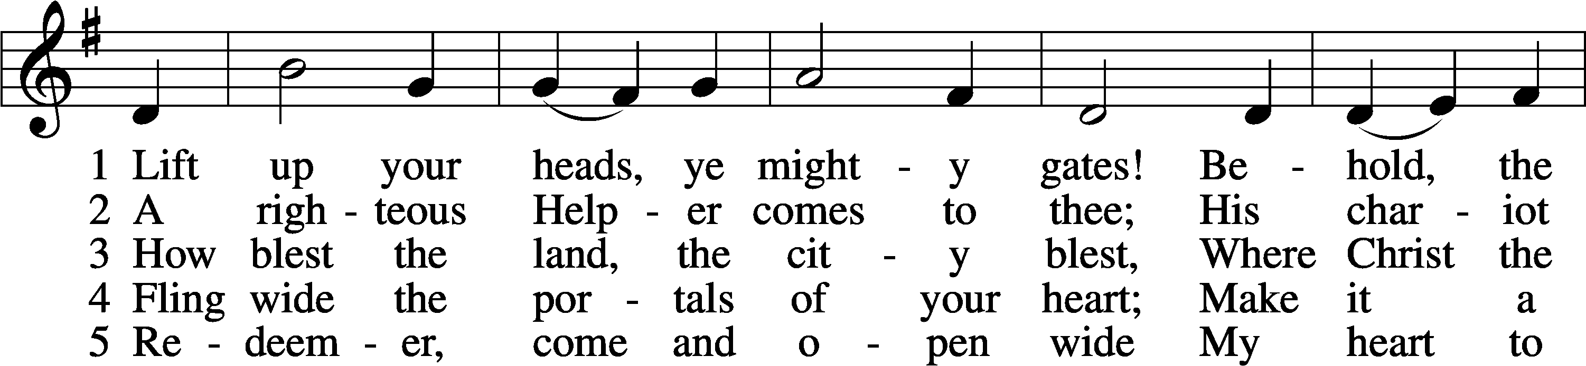
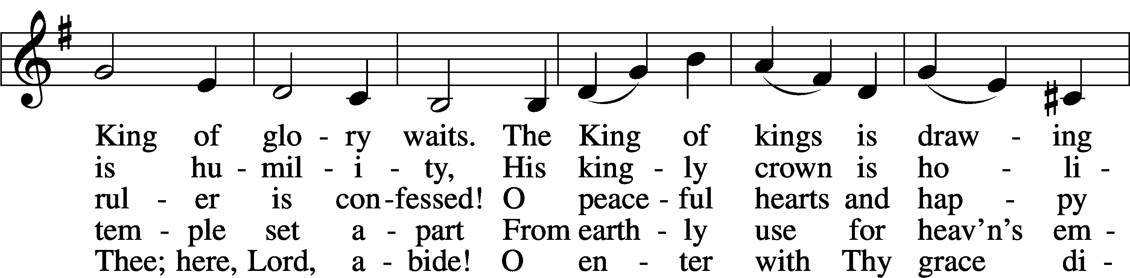
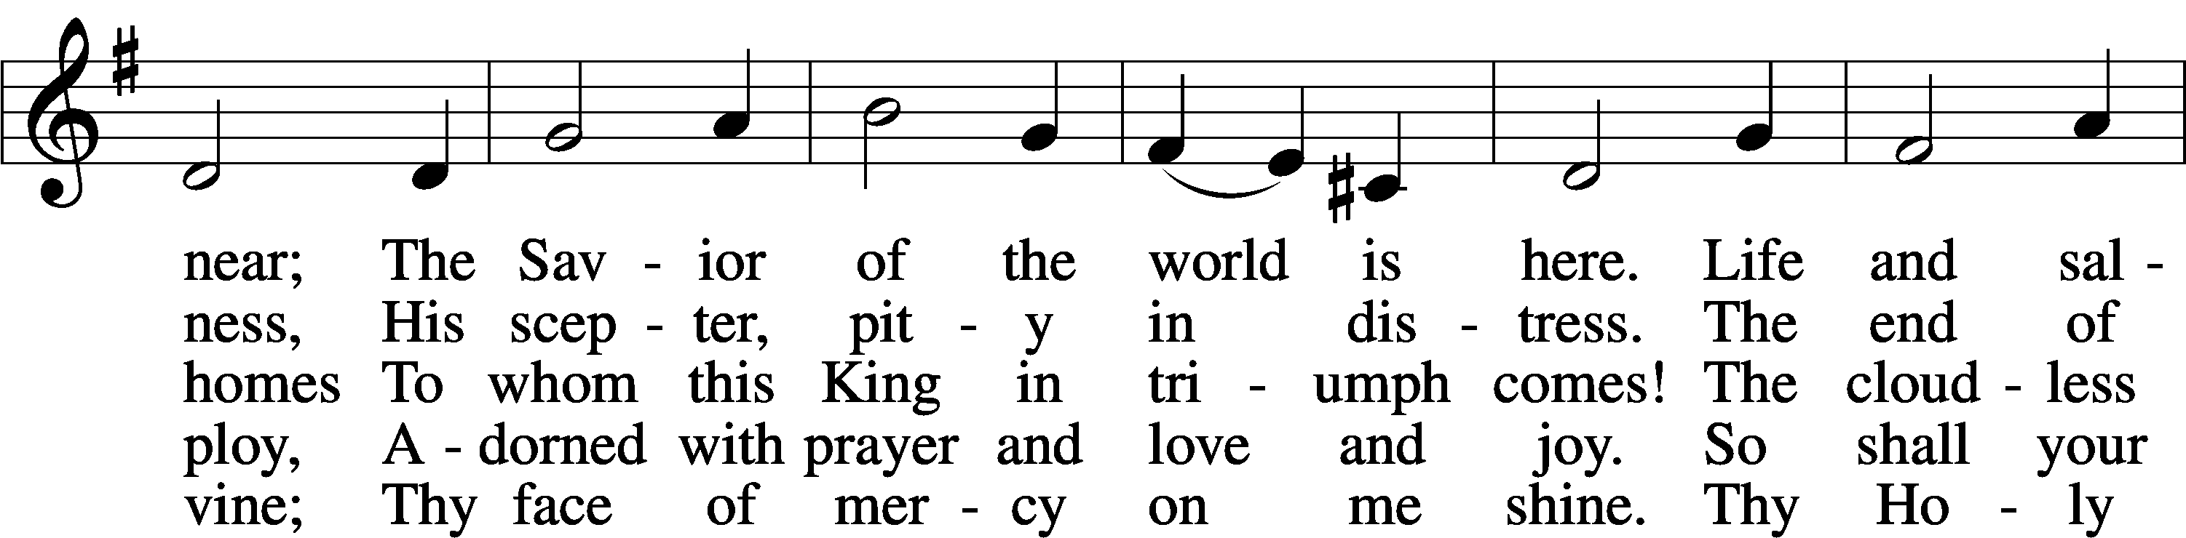
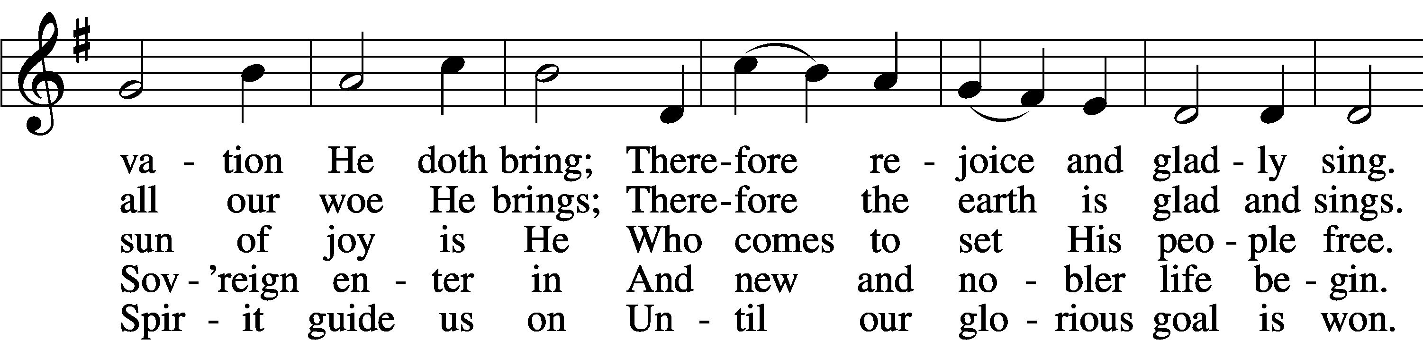
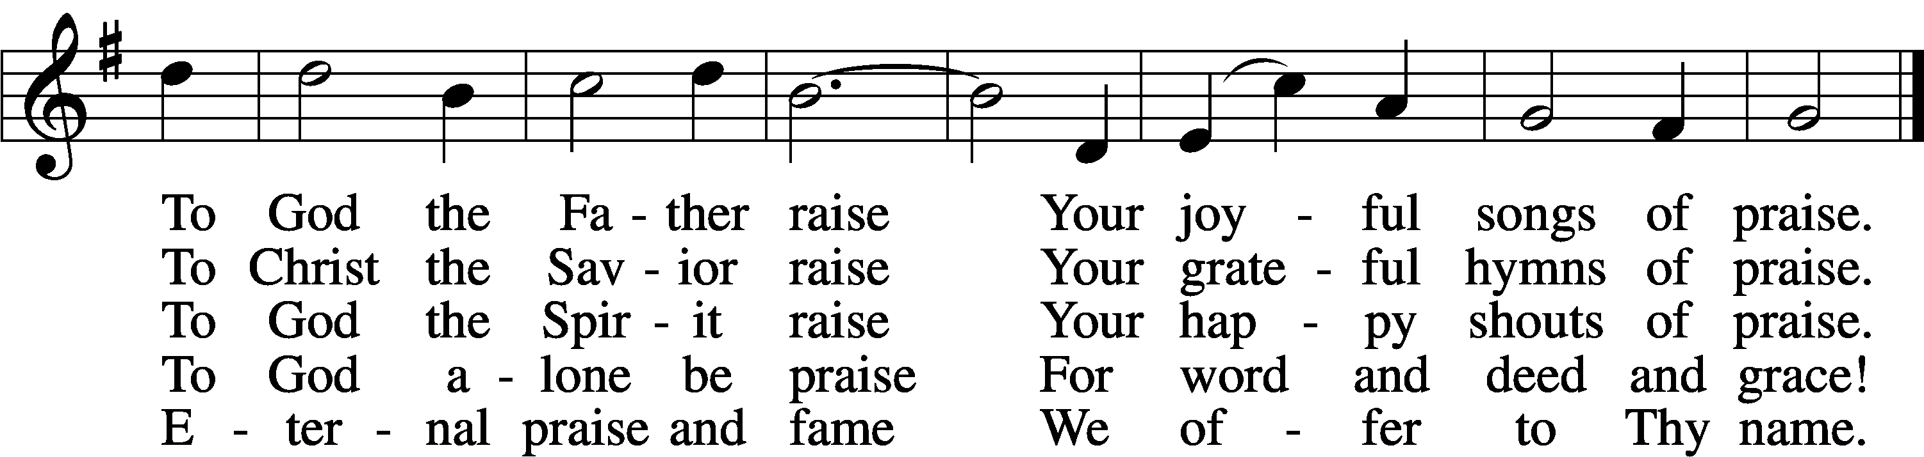
Tune and text: Public domain

Stand. The sign of the cross may be made by all in remembrance of their Baptism.

Invocation
P In the name of the Father and of the T Son and of the Holy Spirit.
C Amen.

Exhortation LSB 184
P Beloved in the Lord! Let us draw near with a true heart and confess our sins unto God our Father, beseeching Him in the name of our Lord Jesus Christ to grant us forgiveness.

P Our help is in the name of the Lord,
C who made heaven and earth.
P I said, I will confess my transgressions unto the Lord,
C and You forgave the iniquity of my sin.

Kneel/Stand

Silence for reflection on God’s Word and for self-examination.

Confession of Sins LSB 184
P O almighty God, merciful Father,
C I, a poor, miserable sinner, confess unto You all my sins and iniquities with which I have ever offended You and justly deserved Your temporal and eternal punishment. But I am heartily sorry for them and sincerely repent of them, and I pray You of Your boundless mercy and for the sake of the holy, innocent, bitter sufferings and death of Your beloved Son, Jesus Christ, to be gracious and merciful to me, a poor, sinful being.

Absolution
P Upon this your confession, I, by virtue of my office, as a called and ordained servant of the Word, announce the grace of God unto all of you, and in the stead and by the command of my Lord Jesus Christ I forgive you all your sins in the name of the Father and of the T Son and of the Holy Spirit.
C Amen.

Service of the Word
Introit
Behold, your king is com- | ing to you;*
righteous and having sal- | vation.
Who in the skies can be compared | to the Lord?*
Who among the heavenly beings is | like the Lord?
Righteousness and justice are the foundation | of your throne;*
steadfast love and faithfulness go be- | fore you.
Blessèd are the people who know the | festal shout,*
who walk, O Lord, in the light | of your face,
who exult in your name | all the day*
and in your righteousness are ex- | alted.
For our shield belongs | to the Lord,*
our king to the Holy One of | Israel.

Gloria Patri LSB 186
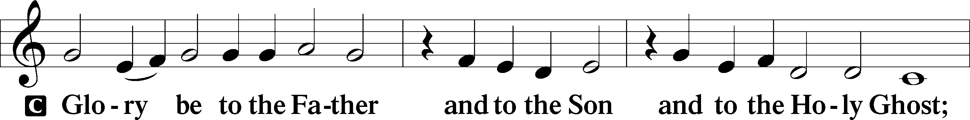
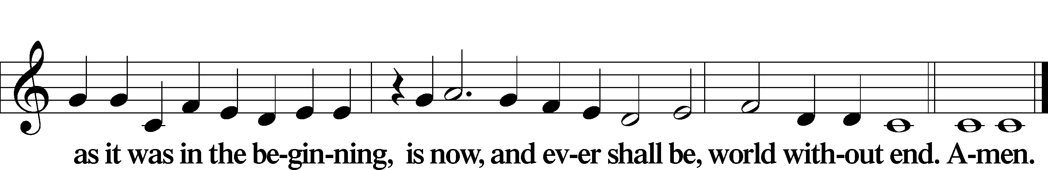

Kyrie LSB 186

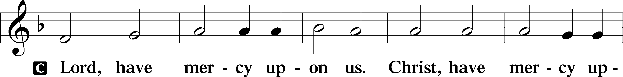
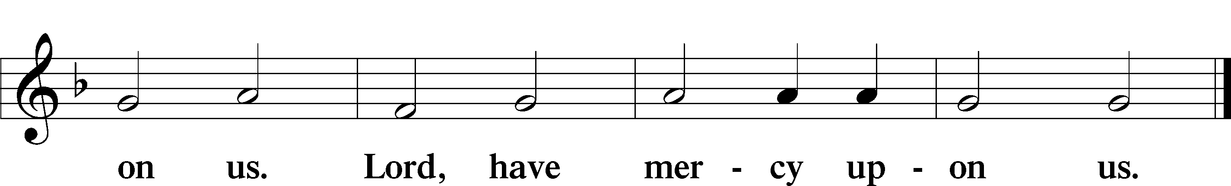

357 O Come, O Come, Emmanuel sts. 1, ref
1 O come, O come, Emmanuel,
And ransom captive Israel,
That mourns in lonely exile here
Until the Son of God appear. Refrain

Ref Rejoice! Rejoice! Emmanuel
shall come to thee, O Israel!
Text: Public domain

Salutation and Collect of the Day
P The Lord be with you.
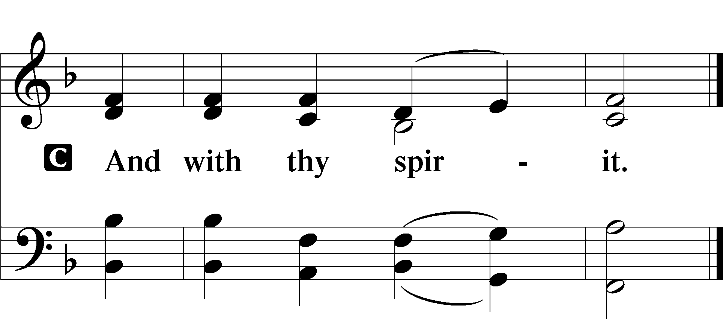
P Let us pray.
Stir up Your power, O Lord, and come, that by your protection we may be rescued from the threatening perils of our sins and saved by Your mighty deliverance; for You live and reign with the Father and the Holy Spirit, one God, now and forever.

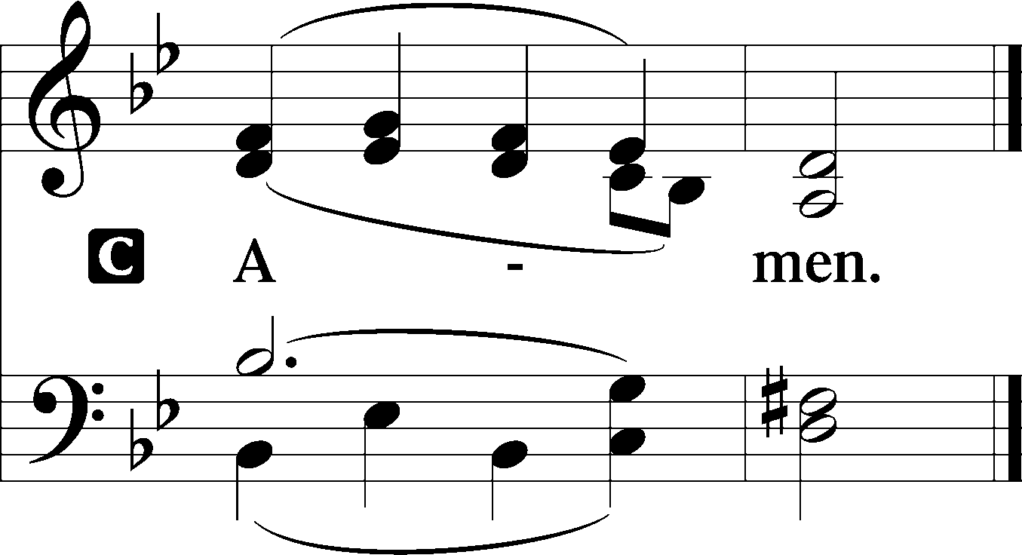

Sit

Old Testament Reading Jeremiah 33:14–16
¹⁴“Behold, the days are coming, declares the Lord, when I will fulfill the promise I made to the house of Israel and the house of Judah. ¹⁵In those days and at that time I will cause a righteous Branch to spring up for David, and he shall execute justice and righteousness in the land. ¹⁶In those days Judah will be saved and Jerusalem will dwell securely. And this is the name by which it will be called: ‘The Lord is our righteousness.’”

P This is the Word of the Lord.
C Thanks be to God.

Gradual Zechariah 9:9; Psalm 118:26, alt.
Rejoice greatly, O daughter of | Zion.*
Shout aloud, O daughter of Je- | rusalem.
Behold, your king is com- | ing to you;*
righteous and having sal- | vation.
Blessèd is he who comes in the name | of the Lord.*
From the house of the Lord we | bless you.
Epistle 1 Thessalonians 3:9–13
⁹What thanksgiving can we return to God for you, for all the joy that we feel for your sake before our God, ¹⁰as we pray most earnestly night and day that we may see you face to face and supply what is lacking in your faith?
¹¹Now may our God and Father himself, and our Lord Jesus, direct our way to you, ¹²and may the Lord make you increase and abound in love for one another and for all, as we do for you, ¹³so that he may establish your hearts blameless in holiness before our God and Father, at the coming of our Lord Jesus with all his saints.

P This is the Word of the Lord.
C Thanks be to God.

Stand

Alleluia LSB 190

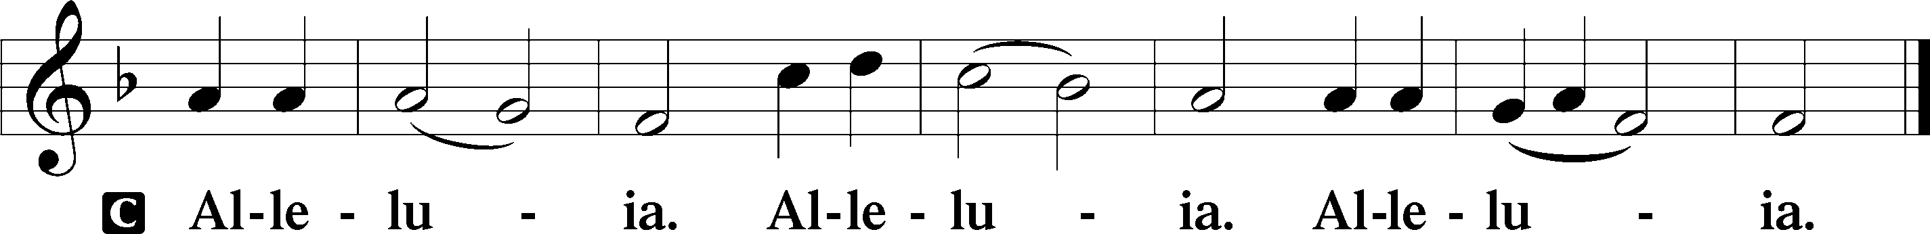

Holy Gospel Luke 19:28–40
P The Holy Gospel according to St. Luke, the nineteenth chapter.
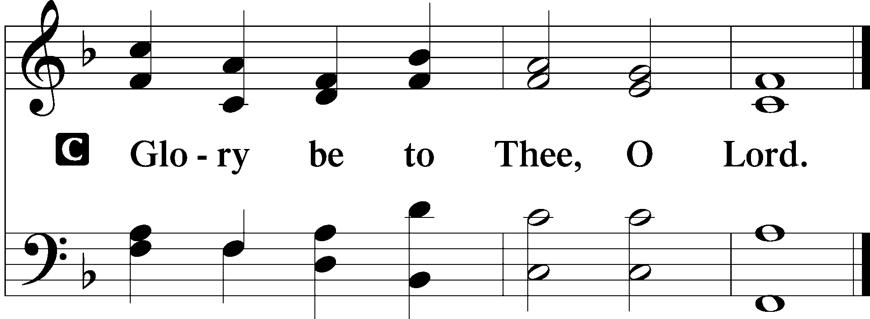

²⁸When [Jesus] had said these things, he went on ahead, going up to Jerusalem. ²⁹When he drew near to Bethphage and Bethany, at the mount that is called Olivet, he sent two of the disciples, ³⁰saying, “Go into the village in front of you, where on entering you will find a colt tied, on which no one has ever yet sat. Untie it and bring it here. ³¹If anyone asks you, ‘Why are you untying it?’ you shall say this: ‘The Lord has need of it.’” ³²So those who were sent went away and found it just as he had told them. ³³And as they were untying the colt, its owners said to them, “Why are you untying the colt?” ³⁴And they said, “The Lord has need of it.” ³⁵And they brought it to Jesus, and throwing their cloaks on the colt, they set Jesus on it. ³⁶And as he rode along, they spread their cloaks on the road. ³⁷As he was drawing near—already on the way down the Mount of Olives—the whole multitude of his disciples began to rejoice and praise God with a loud voice for all the mighty works that they had seen, ³⁸saying, “Blessed is the King who comes in the name of the Lord! Peace in heaven and glory in the highest!” ³⁹And some of the Pharisees in the crowd said to him, “Teacher, rebuke your disciples.” ⁴⁰He answered, “I tell you, if these were silent, the very stones would cry out.”

P This is the Gospel of the Lord.
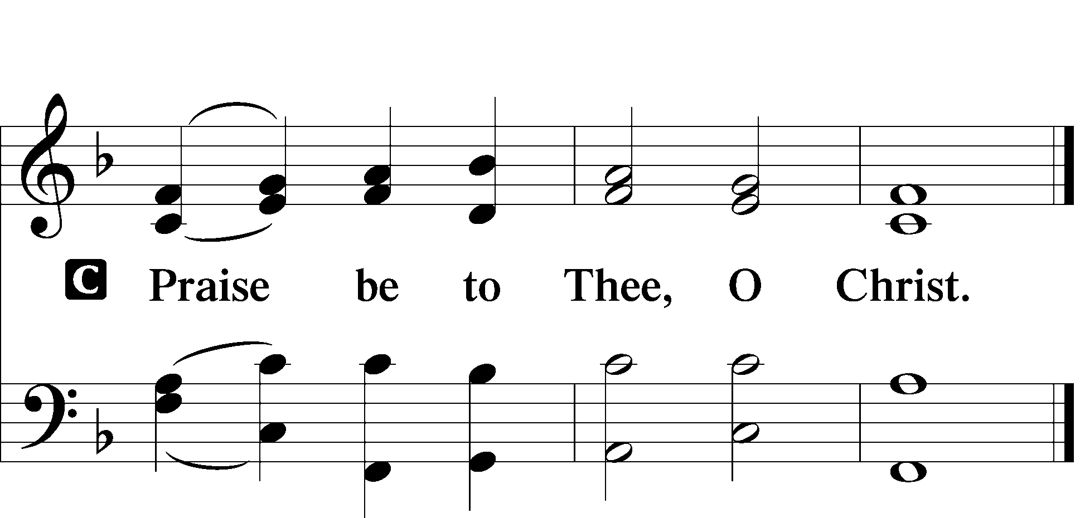

Nicene Creed

C I believe in one God,
the Father Almighty,
maker of heaven and earth
and of all things visible and invisible.

And in one Lord Jesus Christ,
the only-begotten Son of God,
begotten of His Father before all worlds,
God of God, Light of Light,
very God of very God,
begotten, not made,
being of one substance with the Father,
by whom all things were made;
who for us men and for our salvation came down from heaven
and was incarnate by the Holy Spirit of the virgin Mary
and was made man;
and was crucified also for us under Pontius Pilate.
He suffered and was buried.
And the third day He rose again according to the Scriptures
and ascended into heaven
and sits at the right hand of the Father.
And He will come again with glory to judge both the living and the dead,
whose kingdom will have no end.

And I believe in the Holy Spirit,
the Lord and giver of life,
who proceeds from the Father and the Son,
who with the Father and the Son together is worshiped and glorified,
who spoke by the prophets.
And I believe in one holy Christian and apostolic Church,
I acknowledge one Baptism for the remission of sins,
and I look for the resurrection of the dead
and the life T of the world to come. Amen.
Sit

332 Savior of the Nations, Come
(1-2=All, 3=W, 4=W, 5=M, 6=W, 7-8=All)
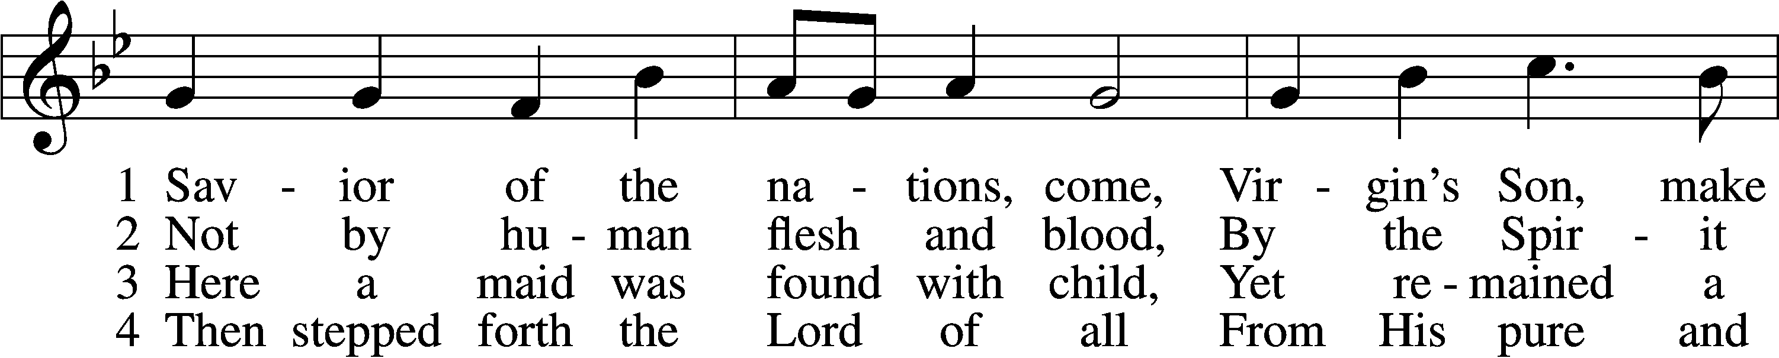
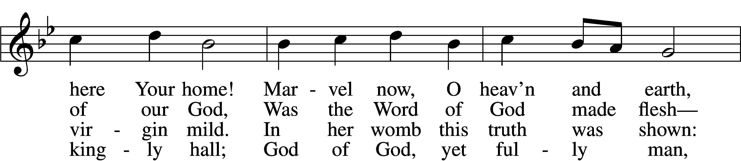
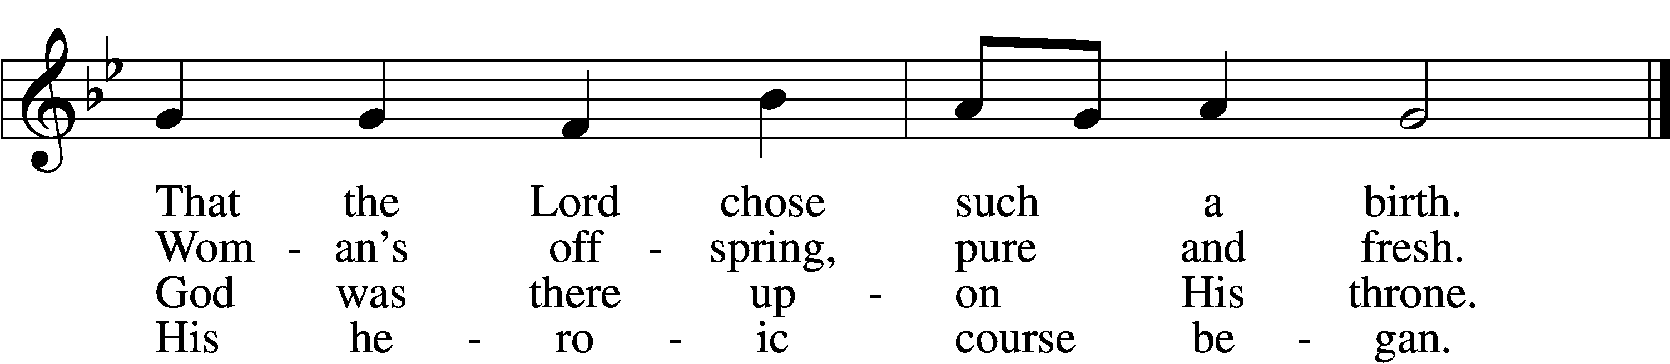

5 God the Father was His source,
Back to God He ran His course.
Into hell His road went down,
Back then to His throne and crown.

6 For You are the Father’s Son
Who in flesh the vict’ry won.
By Your mighty pow’r make whole
All our ills of flesh and soul.
7 From the manger newborn light
Shines in glory through the night.
Darkness there no more resides;
In this light faith now abides.

D 8 Glory to the Father sing,
Glory to the Son, our king,
Glory to the Spirit be
Now and through eternity.

Text (sts. 3, 6–7): © 2006 Concordia Publishing House; (sts. 4–5, 8): © 1978 Concordia Publishing House. Used by permission: LSB Hymn License no. 110003744
Text (sts. 1–2) and tune: Public domain

Sermon Luke 19:28–40

Stand

Offertory LSB 192
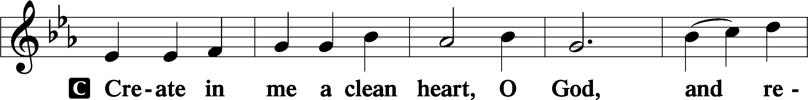
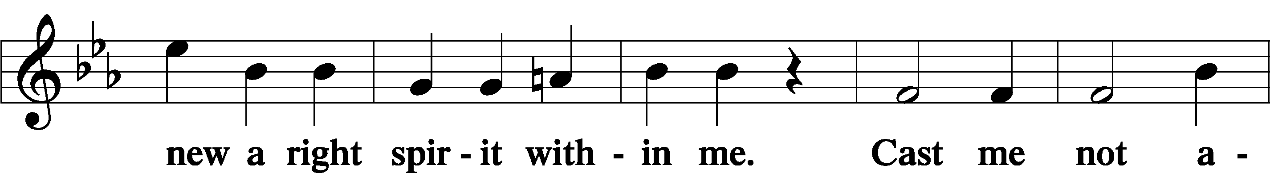
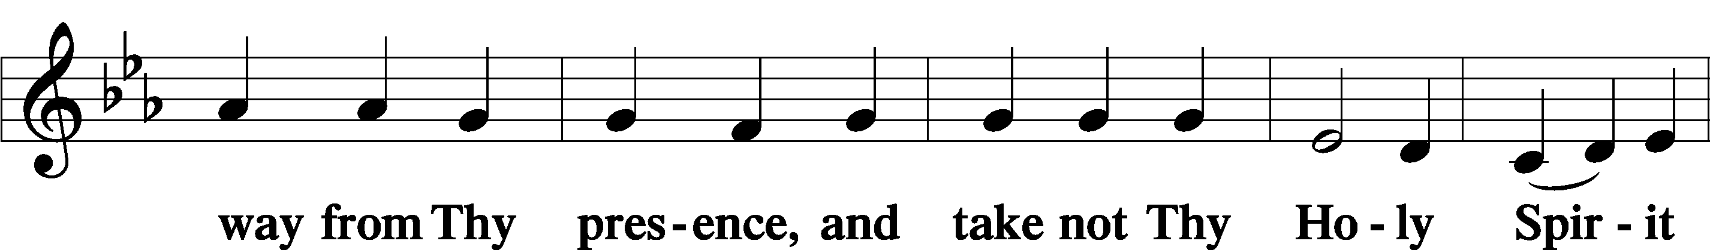
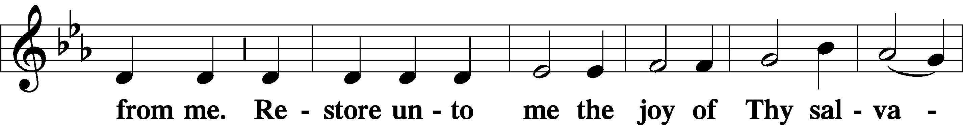
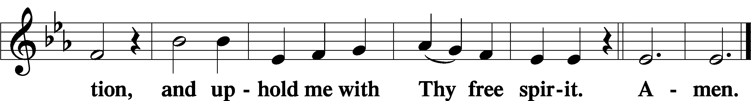

Prayer of the Church

Sit

Offering & Preparation

After the prayers please be seated while the altar is set for the Lord’s Supper and the offering is brought forward. To prepare you may use the prayers in the front of the hymnal or meditate on a communion hymn.

Stand

Service of the Sacrament
Preface LSB 194

P The Lord be with you.

P Lift up your hearts.

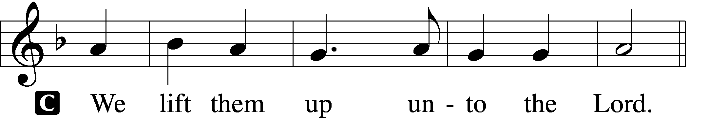

P Let us give thanks unto the Lord, our God.

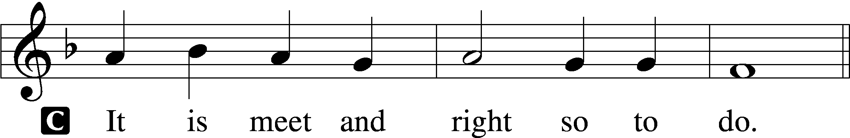

Proper Preface
P It is truly meet, right, and salutary that we should at all times and in all places give thanks to You, holy Lord, almighty Father, everlasting God, through Jesus Christ, our Lord, whose way John the Baptist prepared, proclaiming Him the promised Messiah, the very Lamb of God who takes away the sin of the world, and calling sinners to repentance that they might escape from the wrath to be revealed when He comes again in glory. Therefore with angels and archangels and with all the company of heaven we laud and magnify Your glorious name, evermore praising You and saying:

Sanctus LSB 195
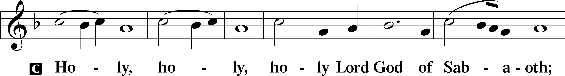
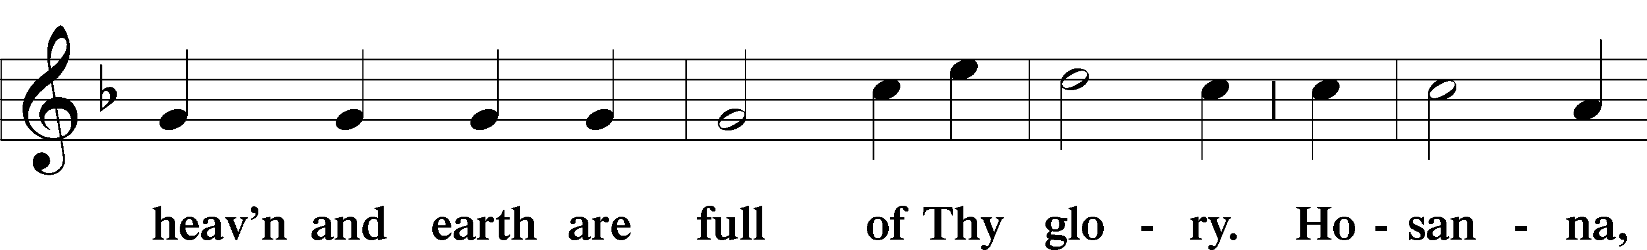
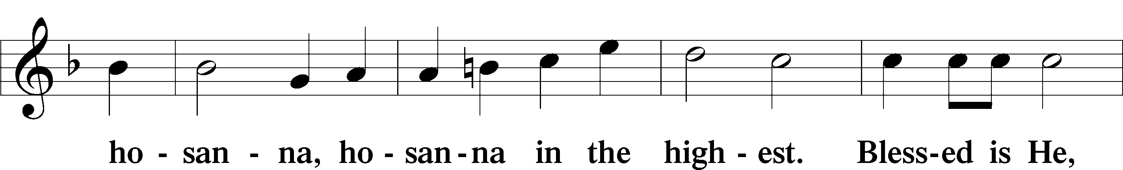
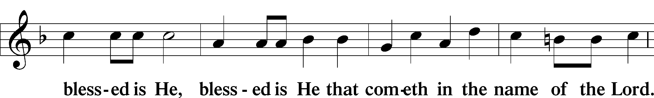
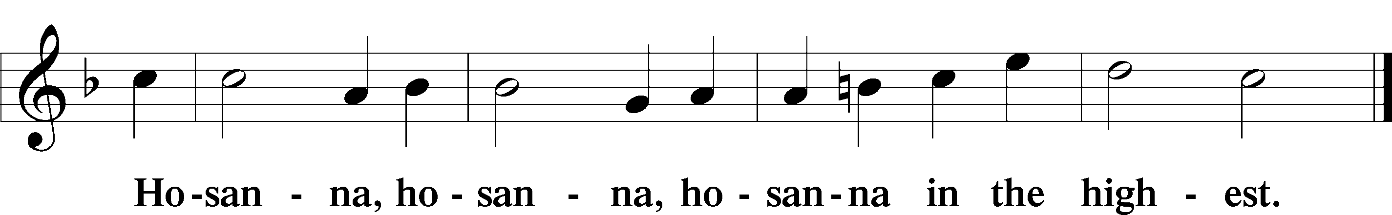

The Lord’s Prayer 196
Our Father who art in heaven,
hallowed be Thy name,
Thy kingdom come,
Thy will be done on earth as it is in heaven;
give us this day our daily bread;
and forgive us our trespasses as we forgive those who trespass against us;
and lead us not into temptation,
but deliver us from evil.
For Thine is the kingdom and the power and the glory forever and ever. Amen.

The Words of Our Lord LSB 197
P Our Lord Jesus Christ, on the night when He was betrayed, took bread, and when He had given thanks, He broke it and gave it to the disciples and said: “Take, eat; this is My T body, which is given for you. This do in remembrance of Me.”

In the same way also He took the cup after supper, and when He had given thanks, He gave it to them, saying: “Drink of it, all of you; this cup is the new testament in My T blood, which is shed for you for the forgiveness of sins. This do, as often as you drink it, in remembrance of Me.”

Pax Domini LSB 197
P The peace of the Lord be with you always.
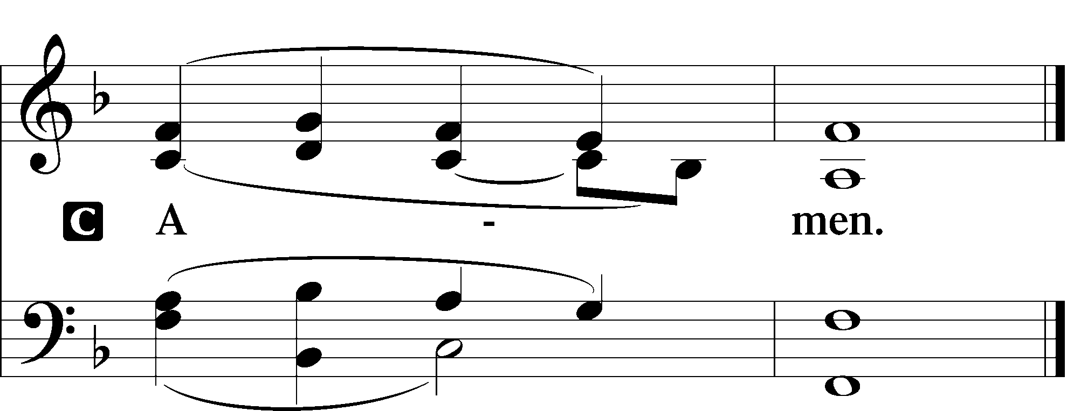
Agnus Dei LSB 198
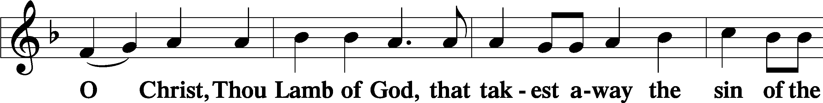
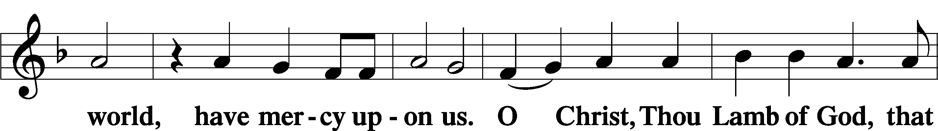
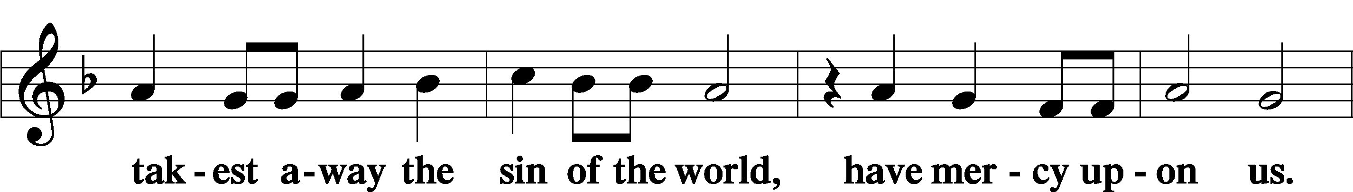
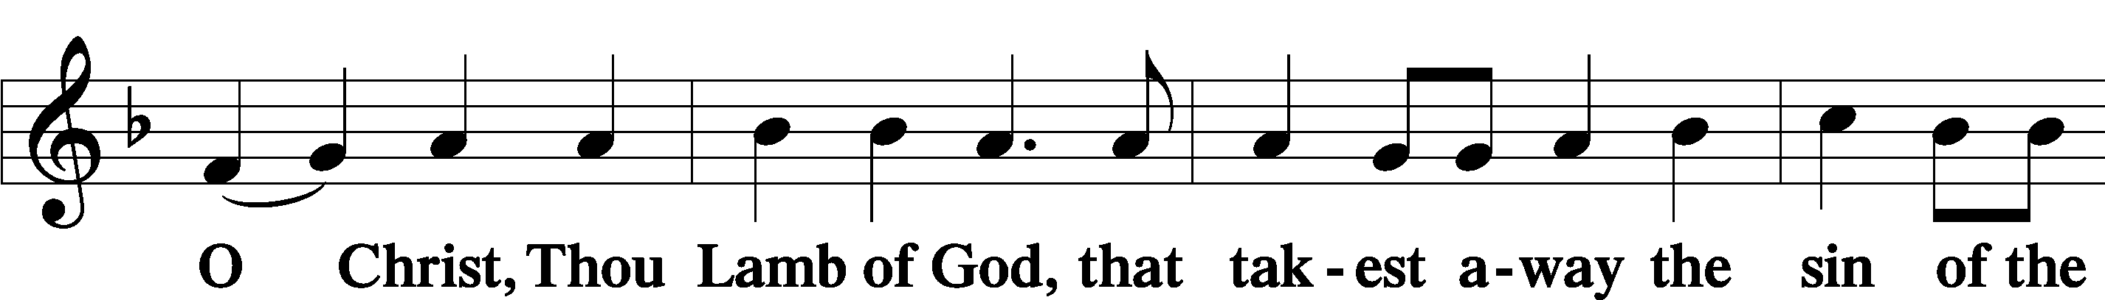

Sit

Distribution

628 Your Table I Approach
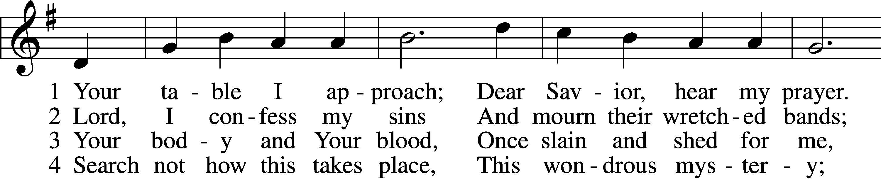
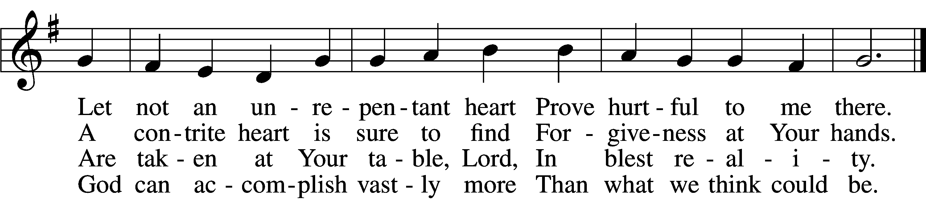

5 O grant, most blessèd Lord,
That earth and hell combined
May not about this sacrament
Raise doubt within my mind.

6 Oh, may I never fail
To thank You day and night
For Your true body and true blood,
O God, my peace and light.
Text and tune: Public domain
334 O Lord, How Shall I Meet You
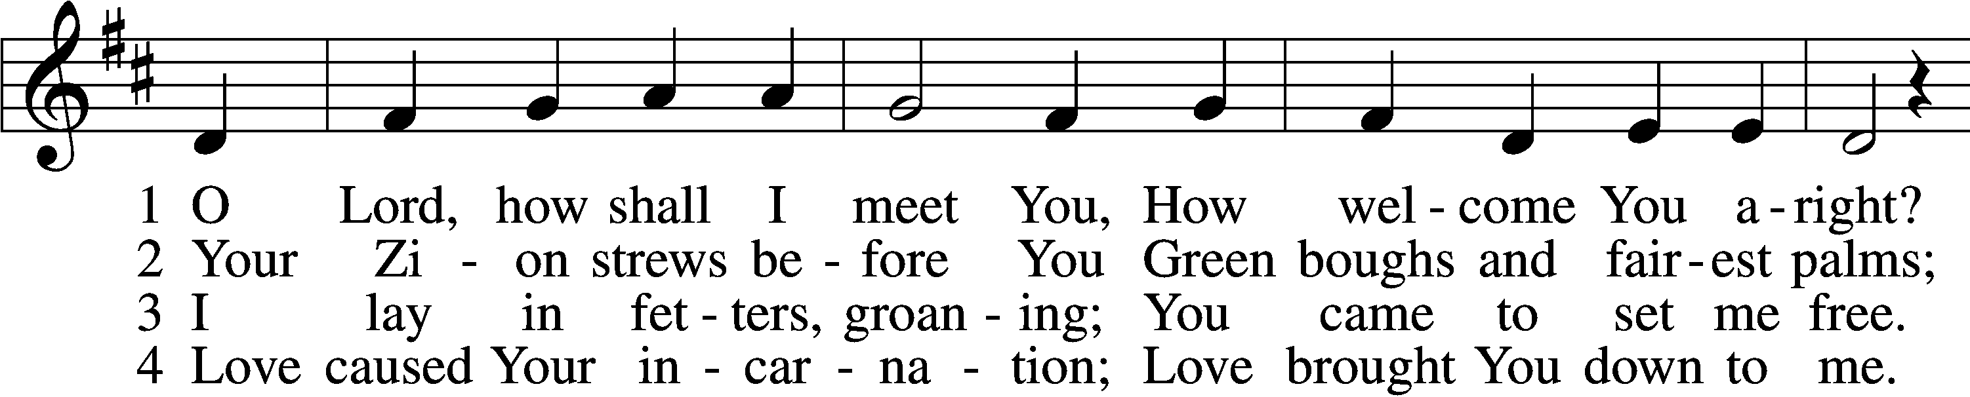
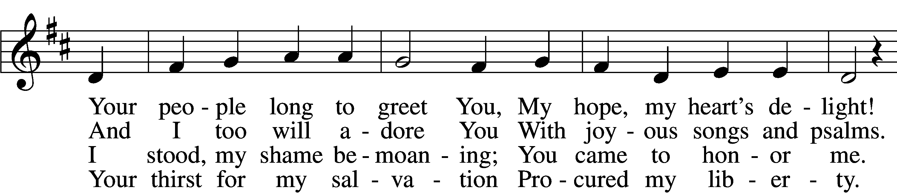
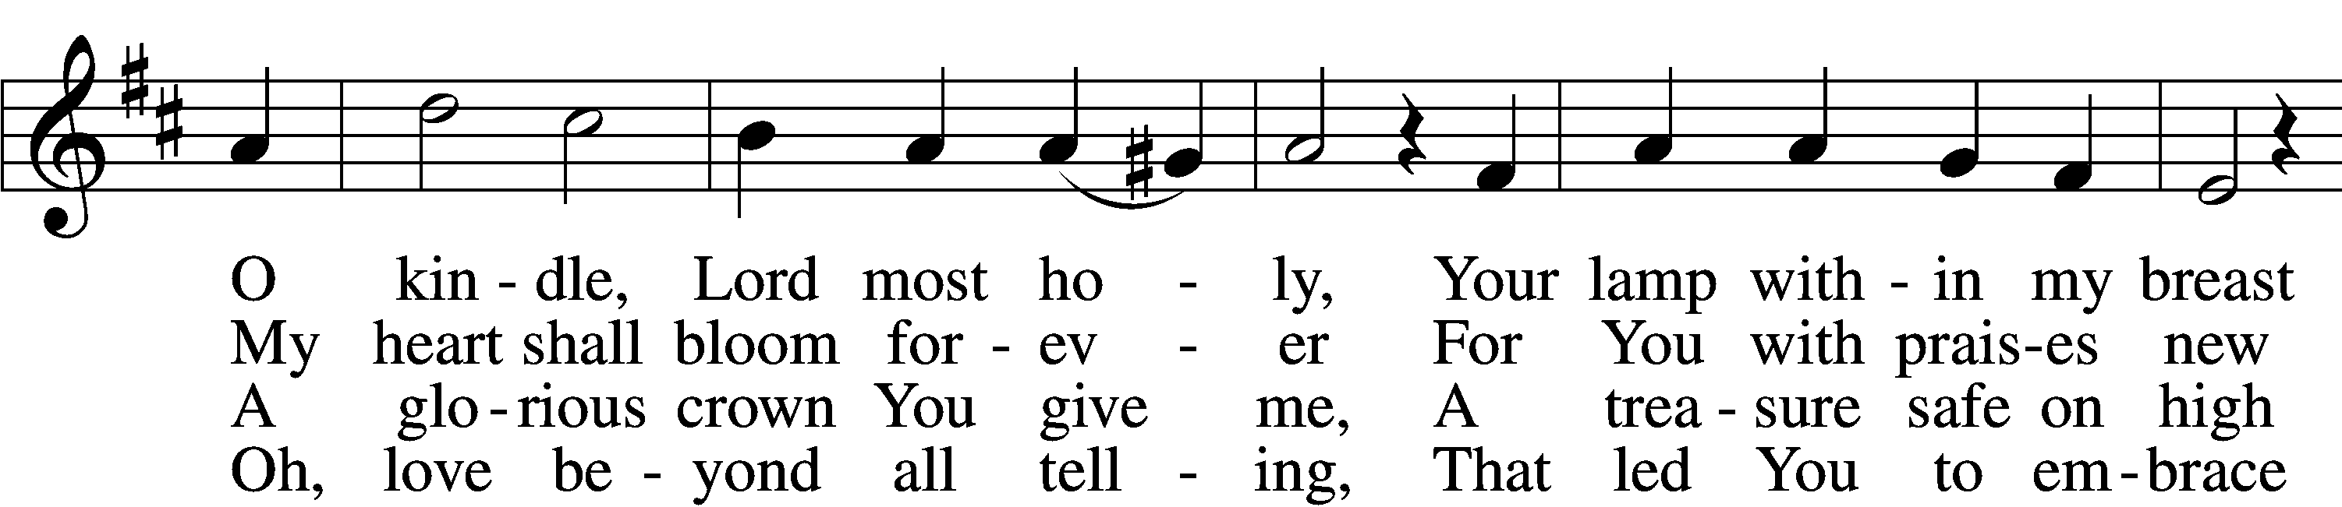
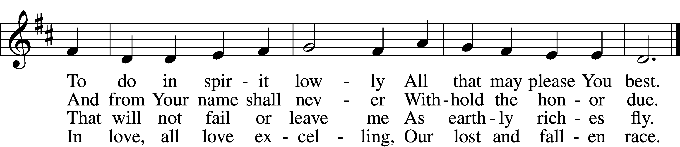

5 Sin’s debt, that fearful burden,
Cannot His love erase;
Your guilt the Lord will pardon
And cover by His grace.
He comes, for you procuring
The peace of sin forgiv’n,
His children thus securing
Eternal life in heav’n.

6 He comes to judge the nations,
A terror to His foes,
A light of consolations
And blessèd hope to those
Who love the Lord’s appearing.
O glorious Sun, now come,
Send forth Your beams so cheering,
And guide us safely home.
Tune and text: Public domain

629 What Is This Bread
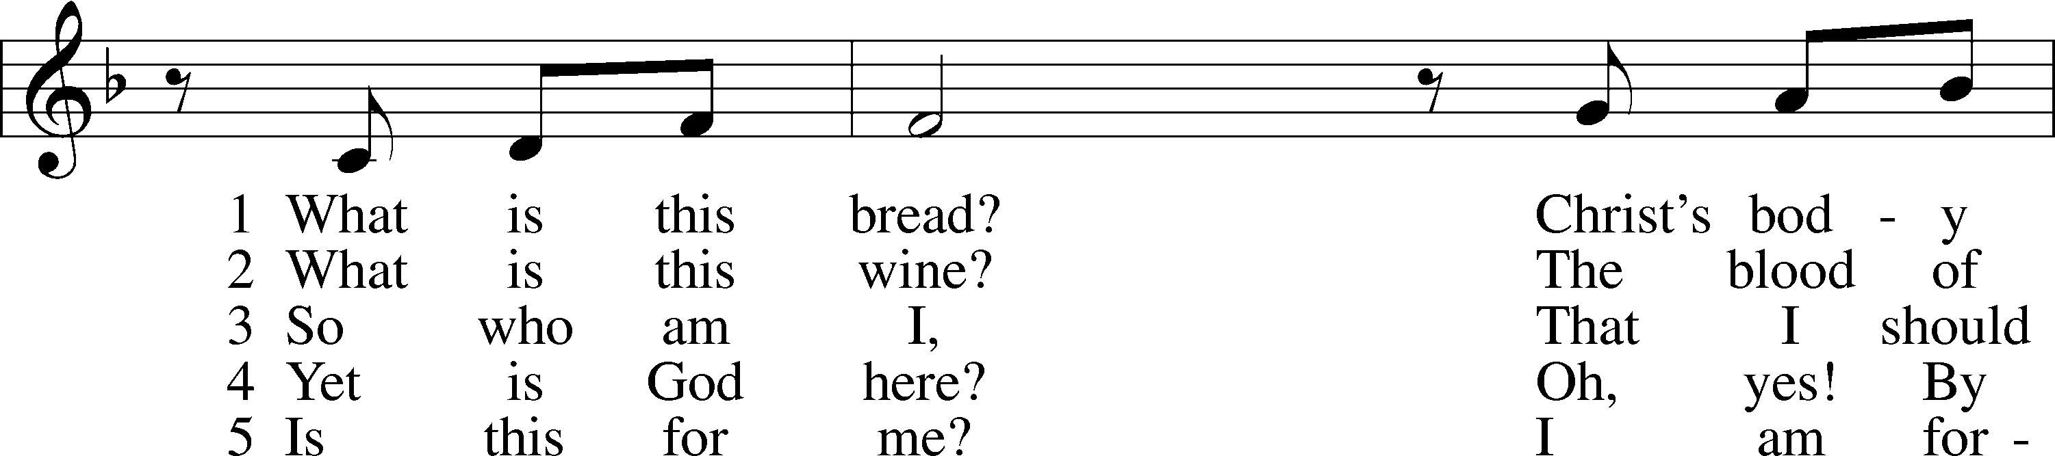
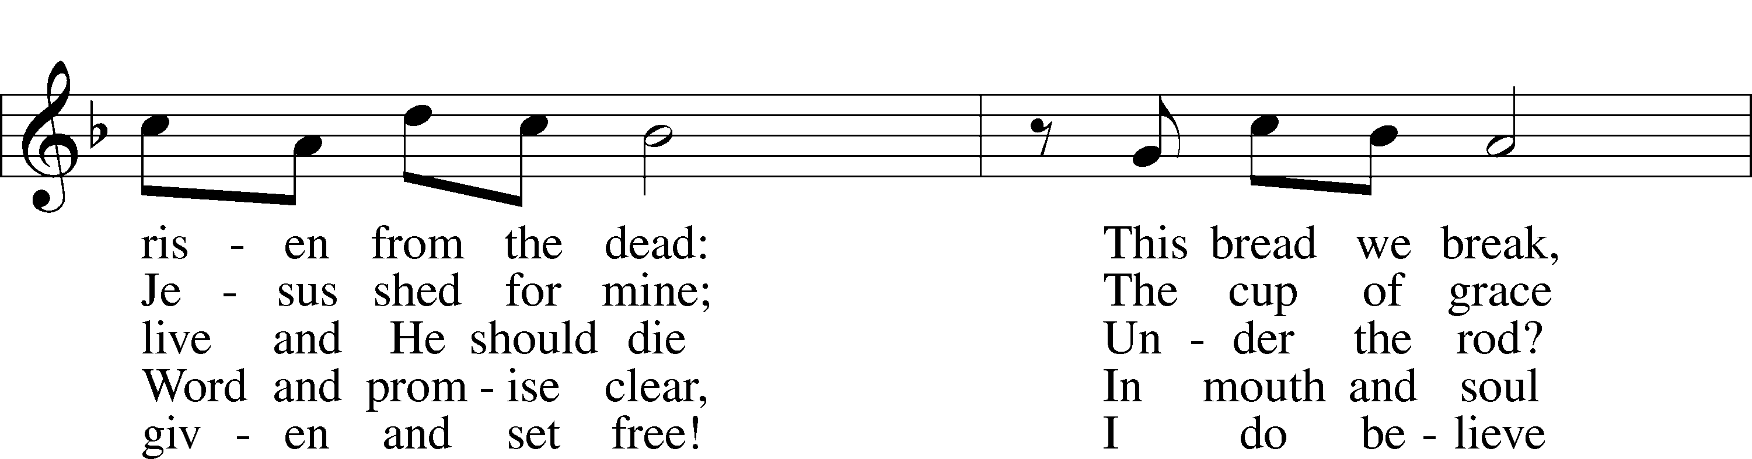
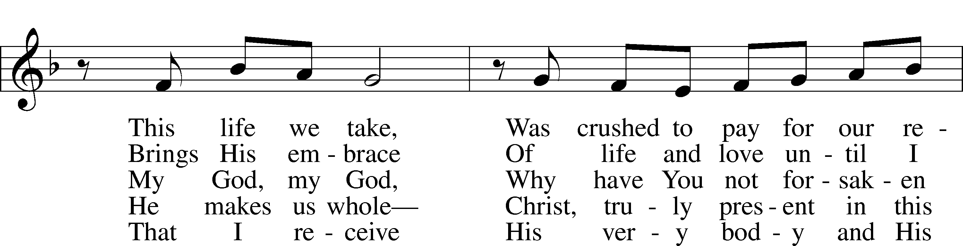
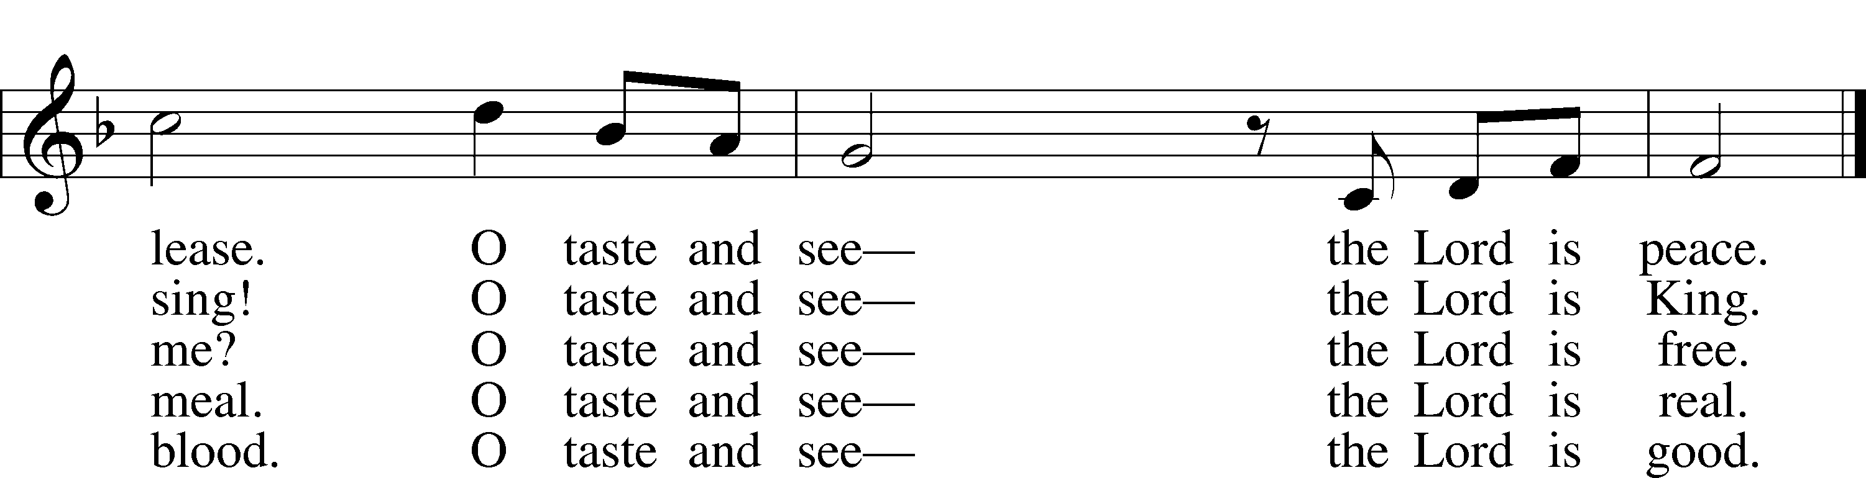
Tune and text: © 1991 Fred and Jean Baue. Used by permission: LSB Hymn License no. 110003744

The Dismissal
P The body and blood of our Lord Jesus Christ strengthen and preserve you in body and soul to life everlasting. Depart T in peace.
C Amen.

Nunc Dimittis LSB 199
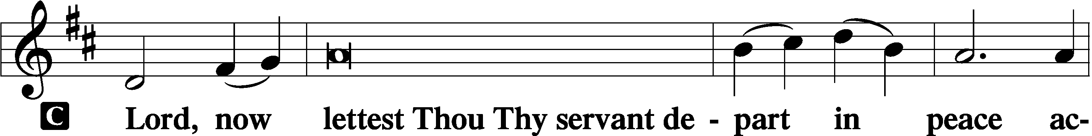
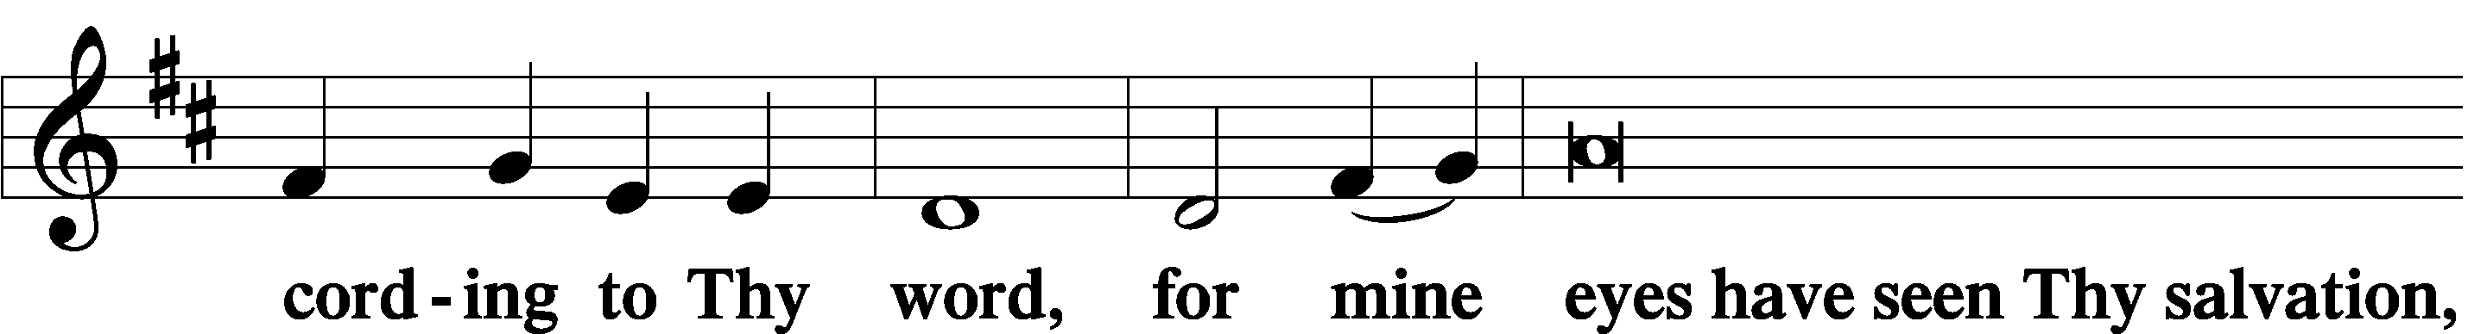
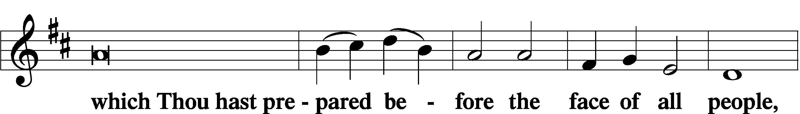
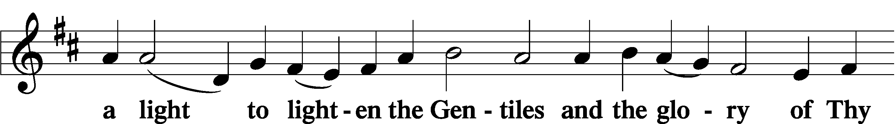
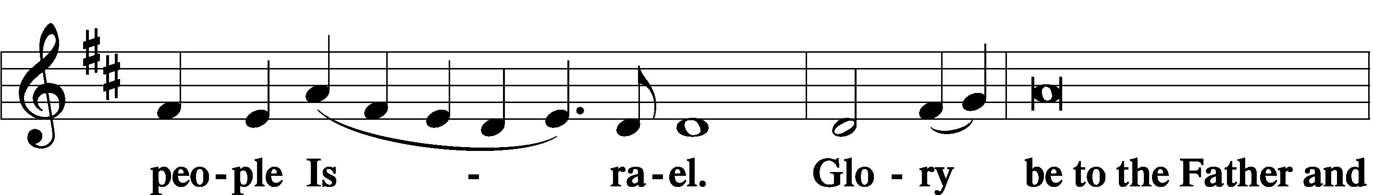
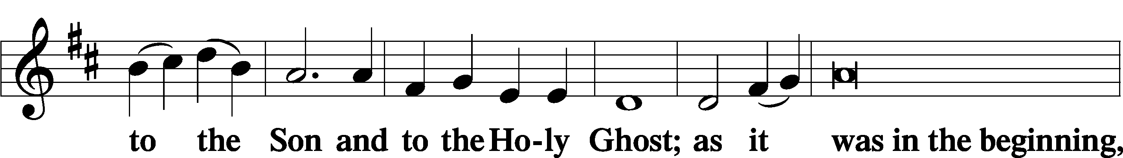
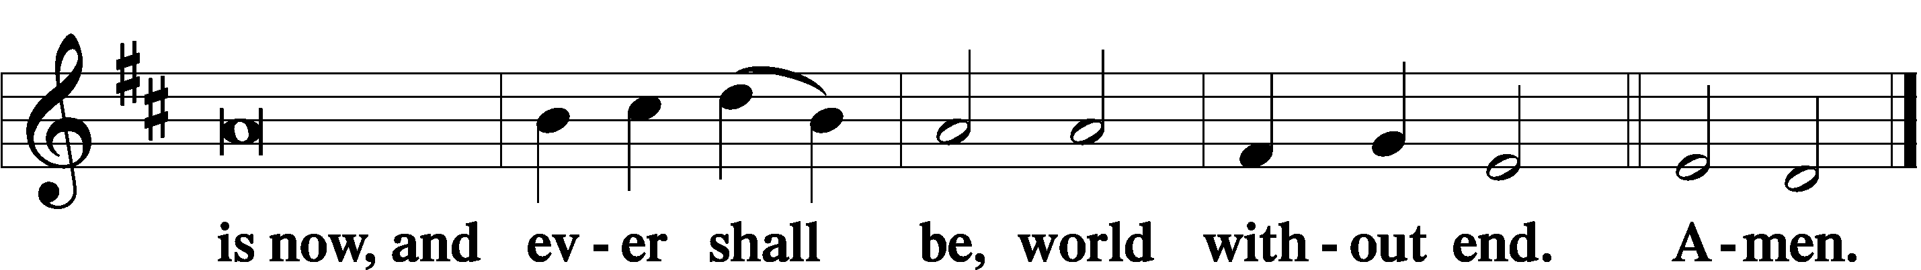

Thanksgiving LSB 200
A O give thanks unto the Lord, for He is good,

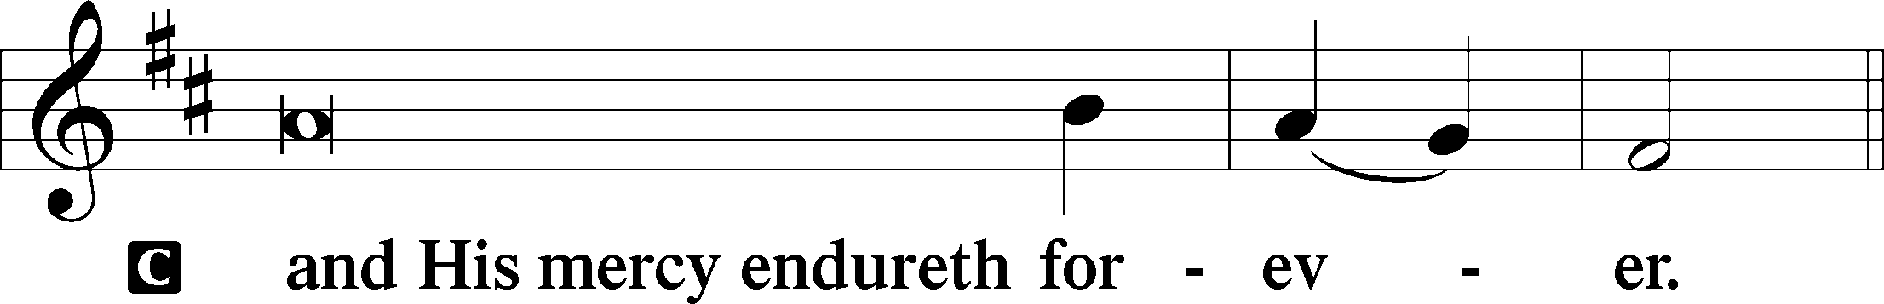

A Let us pray.
We give thanks to You, almighty God, that You have refreshed us through this salutary gift, and we implore You that of Your mercy You would strengthen us through the same in faith toward You and in fervent love toward one another; through Jesus Christ, Your Son, our Lord, who lives and reigns with You and the Holy Spirit, one God, now and forever.

Salutation LSB 201
P The Lord be with you.

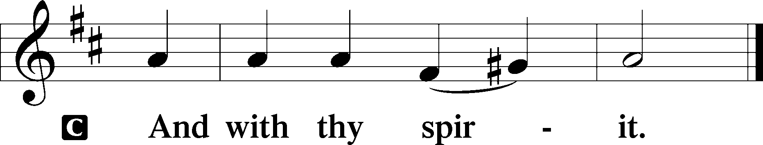

Benedicamus LSB 202
A Bless we the Lord.

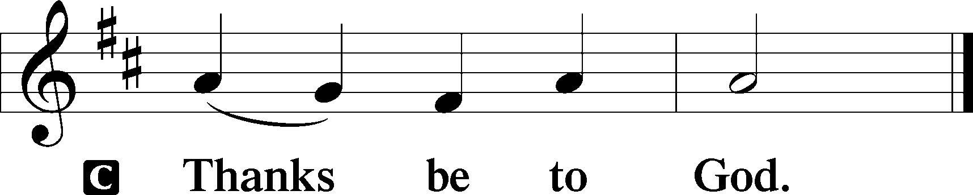

Benediction LSB 202
P The Lord bless you and keep you.
The Lord make His face shine upon you and be gracious unto you.
The Lord lift up His countenance upon you and T give you peace.
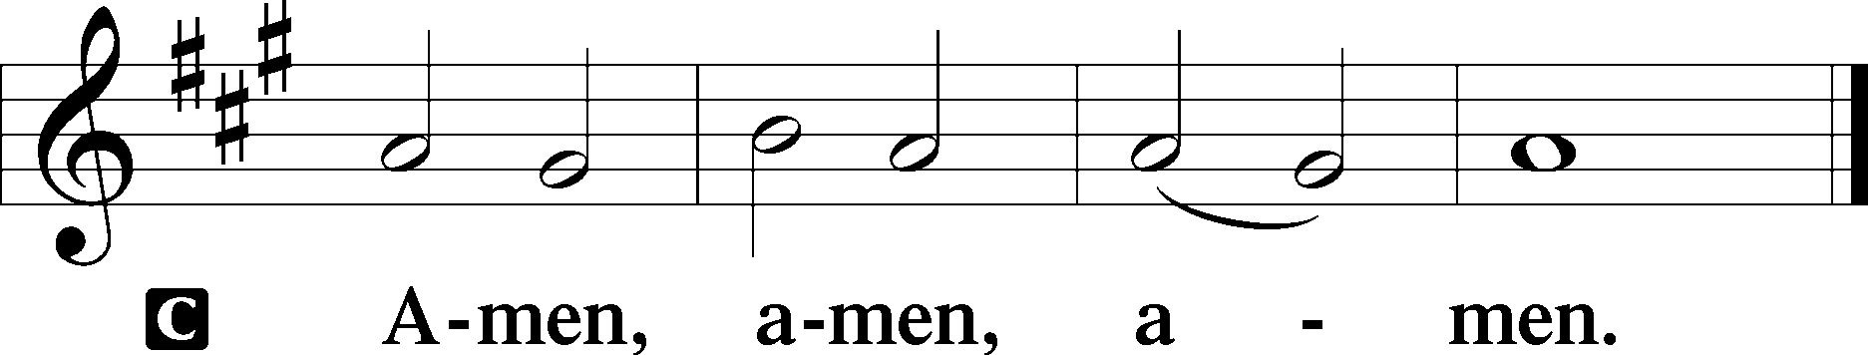

331 The Advent of Our King
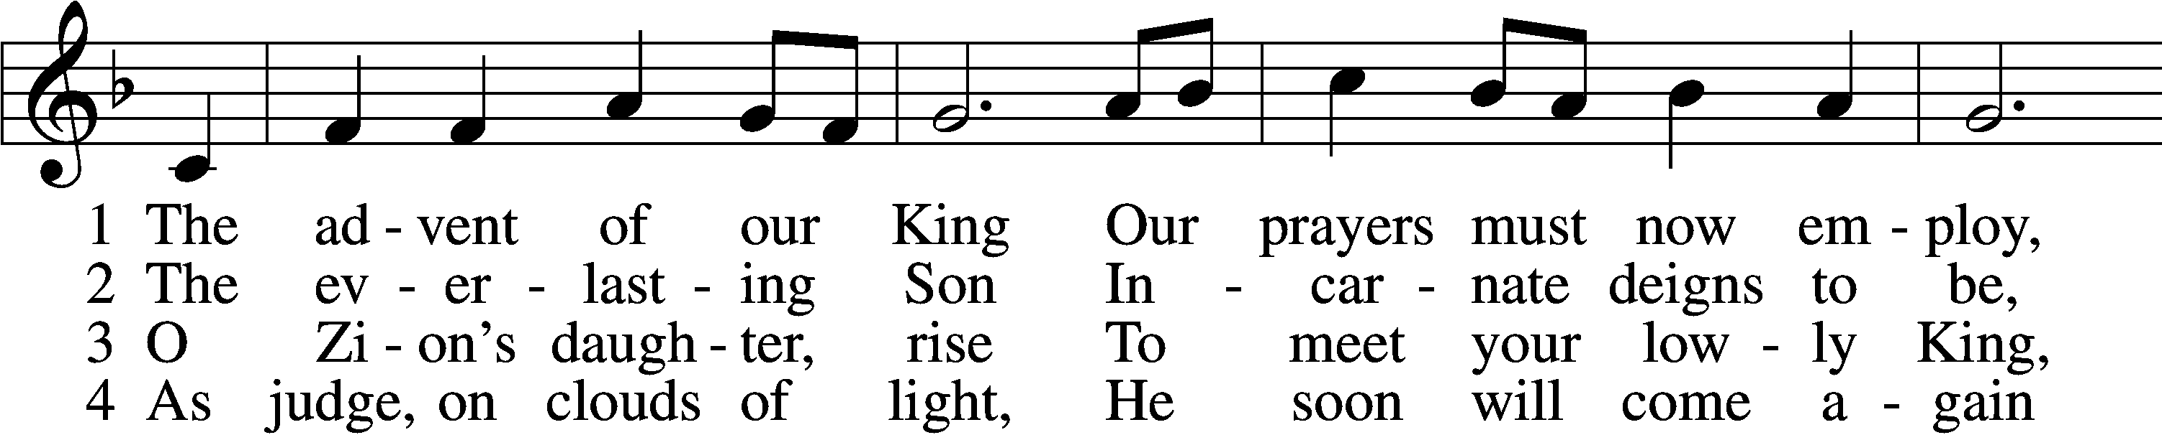
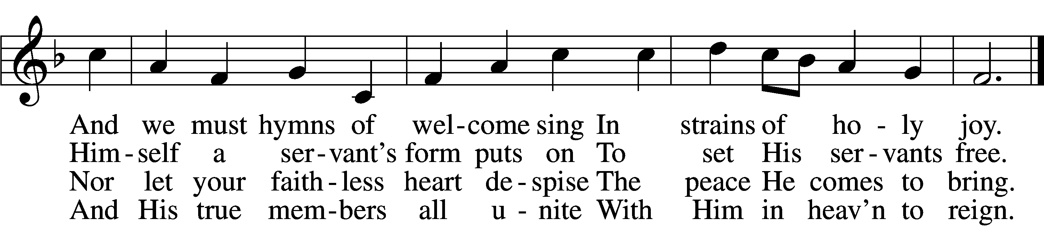

5 Before the dawning day
Let sin’s dark deeds be gone,
The sinful self be put away,
The new self now put on.

D 6 All glory to the Son,
Who comes to set us free,
With Father, Spirit, ever one
Through all eternity.
Tune and text: Public domain

Acknowledgments
Unless otherwise indicated, Scripture quotations are from the ESV® Bible (The Holy Bible, English Standard Version®), copyright © 2001 by Crossway, a publishing ministry of Good News Publishers. Used by permission. All rights reserved.
Created by Lutheran Service Builder © 2021 Concordia Publishing House.

Prayers for Our Members
Sharon Hockemeier, Tenaya Nuttelman | Expectant Mothers
Birth of Luke Hansen (Son of Leif & Keri Hanson) | Thanksgiving
Norman Abels (Brookestone Meadows – Elkhorn) | Healing
Judy Ahrens | Healing
Vaughn Albrecht (Mount Carmel) | Healing
Tom & DyAnn Altwine | Healing
Lyle Colsden (Mother Hull) | Healing
Mary Fiddelke | Healing
Pat Flodine (Cambridge Court) | Healing
Vi Fox (Prairie View) | Healing
Verleen Gentry | Healing
Wanda Glanzer | Healing
Ruby Hatfield | Healing
Evelyn Heiden (Mother Hull) | Healing
Lennis Hodgson | Healing
Don Richmond | Healing
Ivan Bombeck | Cancer
Bertha Marienau | Cancer
Kim Vos | Cancer

ZION LUTHERAN CHURCH AND SCHOOL

Pr. James DeLoach, Pastor + (308) 627-5260
james.deloach@zionkearney.org
Pr. Doug Gaunt, Pastor + (308) 455-0552
doug.gaunt@zionkearney.org
Tony Splittgerber, Principal + (308) 293-0168
anthony.splittgerber@zionkearney.org

Church Office
Secretary: Holly Reid
Email: school@zionkearney.org
Phone: (308)-234-3410 Fax: (308) 236-8100
Office Hours: Monday-Friday 8:00am-4:00pm
Radio Broadcast: Sunday @ 10:30 a.m. on 1460 AM and 92.1 FM
Website: www.zionkearney.com
Prayers for Our Members’ Family & Friends
Albrecht Andrew Kuddes Wollberg (Son of Matthias & Naomi Wollberg) | Thanksgiving
Family of D.D. Dugger (Sue Kaiser’s brother) | Grief
Family of Bill Jedlicka (Pam Uhlir’s cousin) | Grief
Elaine Arehart (Zion’s Music Teacher) | Expecting
Family of James Sexton (Helmbrecht’s friend) | Dying
Jean Brooks (Bruce Brooks & Becky Thornton’s sister-in-law) | Healing
Larry Bombeck (Ivan’s brother) | Healing
Katie Cunningham (Quentin & Janel Lange’s friend) | Healing
Reg Duke (Westman’s brother-in-law) | Healing
James Gentry (Verleen’s son) | Healing
Roger Hoffman (Marc’s father) | Healing
David Kreutzer (Richard’s brother) | Healing
Dillon Malchow (Joy Barefoot’s nephew) | Healing
Urijah Mitchell (Sue & Dennis Bartels’ Grandson) | Healing
Tim Powers (Kim Wilken’s brother) | Healing
Roy Reynolds (Verleen Gentry’s son-in-law) | Healing
Lynne Saathoff (Verleen Gentry’s sister-in-law) | Healing
Randy Solomon (Beth Rosenthal’s father) | Healing
Tim Trampe (Don & Gretchen’s son) | Healing
Jonah (Jase & Jarren Blattner’s friend) | Cancer
Stuart Gronewoller (Lonna’s brother-in-law) | Cancer
Linda Heapy (Janel Lange’s mother) | Cancer
Ron Halvorsen (Jeff’s dad) | Cancer
Randy Jochum (Ken Hockemeier’s brother-in-law) | Cancer
Sharon Mulhair (Pam Uhlir’s cousin) | Cancer
Kolby Shiers (Jessica’s cousin) | Cancer
Pr. Richard Snow (NE District President) | Cancer
Tyrone Uhlir (Pam’s nephew) | Cancer
Scott Catterson (Jim & Pat’s Son) | Deployment
Tim Smallcomb (Wilkens’ friend) | Deployment
Today’s Altar Flowers are provided by Paul & Rachael Burger, in honor of their anniversary.

Today’s Radio Broadcast is sponsored by Vi Fox,
all glory be to God.

Worship Assistants
Sunday, November 28th~ 9:00am

Elder: Ken Hockemeier
Usher: Steve Junge
Acolyte: Eli Randolph
Engineer: Shawn Starkey
Announcer: Carol Kreutzer
Altar Guild: Brooke Fisher & Tracy Schake

Sunday, December 5th~ 9:00am

Elder: Nathan Gaunt
Usher: Fred Flessner
Acolyte: Lexie Eckhoff
Engineer: Jamie Nikodym
Announcer: Brooke Fisher
Altar Guild: Beth Rosenthal

Our Response to the Gospel

Date: 11/21/2021
Offering: $6,155
Weekly Need: $7,457.69

This Week at Zion

Sun  11/28 | 9:00a  10:20a  10:20a  10:30a  5:00p  Anniversaries | Divine Service  Voter’s Meeting  Sunday School  Radio Broadcast 1460AM & 92.1FM  Divine Service  Paul & Rachael Burger
Mon  11/29 | Birthdays | Hendrix Herrera  Christopher Hoehner
Tues  11/30 | 1:30p | Sleeping Mats
Wed  12/1 | 8:30a  5:30p  7:00p  8:00p  Birthdays | Chapel  Advent Meal  Advent Service  Adult Choir  Michael Dulitz  Makenna Starkey
Thurs  12/2 | Anniversaries 5:15p | Charles & Bertha Marienau  Adult Bell Choir
Fri
12/3
Sat  12/4 | 9:00a  10:30a | Christmas Eve Rehearsal  Christmas Decorating
Sun  12/5 | 9:00a  10:15a  10:30a  5:00p  Birthdays | Divine Service  Bible Study/Sunday School  Radio Broadcast 1460AM & 92.1FM  Divine Service  Bailey Bates  Adam Herrera
Where our Triune God strengthens us through His mercy in faith toward Him and in fervent love toward one another.

ANNOUNCEMENTS

Advent Services and Meals: Advent services and meals start this week! At 5:30pm on the 1st, 8th, and 15th, there will be an Advent meal served before service at 7pm. This week, the ladies of LWML will be serving chili dogs. Come enjoy a nice meal and prepare your hearts for the celebration of Christ’s birth!

December Sower: The December Sower is getting prepared! If you have anything you would like announced in the sower, please email Holly by November 29th with the details. Thank you!

Our Annual Food Collection is underway and will continue through Christmas. Please place your non-perishable food items in one of the grocery carts. If you can help deliver these items to various relief agencies, please let Holly know (234-3410).

Sunday School Christmas Eve Service: The Sunday school classes plan to lead the Christmas Eve service once again. Depending on the number of children participating, we are going to have practice on the following dates:
Dec. 4th – 9-10:30am
Dec. 11th – 9-10:30am
Dec. 18th – 9-10:30am
Unfortunately, we will not be able to go caroling at the care homes because of Covid, but we will have a fun event for everyone to join in. Please let us know if your child will join us and if you are willing to help.
Thank You,
Matt Hodgson – (308)627-7732 – matthodgson1@hotmail.com

Christmas Decorating: We will be decorating the church Saturday, Dec. 4th at 10:30am (note the change of time from 9am to 10:30am). All members are welcome and encouraged to join in on the decorating! *Men are encouraged to help with the heavier decorations.

Pastor Gaunt’s 35th Anniversary of Ordination: All wanting to show their appreciation for Pr. Gaunt’s years of service can donate toward his gift or give him a card to thank him. Please put your donation in an envelope and give it to Pr. DeLoach, who will be purchasing his gift.

Poinsettias – Friday, December 3rd is the last day to place your poinsettia order! Look for the folder in the Fellowship hall today or come by the office during the week! Help beautify the sanctuary by buying a poinsettia!

Zion Pie Sales: We still have some remaining pies left to purchase. If you are interested, stop by the office. Thanks!
Zion’s 4th Quarter (Oct – Dec) Mission Offerings will support Zion’s current students, who are studying for full-time church work. All our students are at Concordia (CUNE):
Peter Kreutzer - Lutheran Teacher’s Diploma (LTD)
Jessica Zehendner – LTD
Taylor Zehendner – LTD
Please use the mission envelopes located in the narthex for this offering. Or give via Church Trac by selecting “Missions.” Thank you for your support.

Radio Broadcast – The sign-up sheets for the 2022 radio broadcast and altar flowers are up by the mailboxes! The remaining 2021 sheets are still up on the right side. The 28th of November is still available for radio sponsors! Please help Zion spread the Gospel!

Offering Options:
1) Place your offering in the basket as you leave
2) Go to zionkearney.churchtrac.com/give
3) Go to zionkearney.com and click on the ChurchTrac icon
4) Mail your gift to Zion Lutheran Church, 2421 C Ave, Kearney, NE 68847. Or place it in the mail slot on the south side of the building.

SCHOOL NEWS

The theme for our school year is “Together by Christ’s Love” based on 1 John 4:7-8.

- ZION JOB OPPORTUNITY: Music substitute teacher needed. Our K-8 music teacher, Mrs. Arehart, is expecting! She will be due sometime in March and we will need a substitute to teach music 2-3 days a week for the fourth quarter of the year. Current teacher certification needed. If you or someone you know may be eligible to help us, please contact Mr. Splittgerber.
(anthony.splittgerber@zionkearney.org).

- Give Where You Live - Zion will be participating in the Give Where You Live Campaign again! It will be this Thursday, December 2nd (giving day), but they are accepting donations before then as well! To contribute, go to: https://www.givewhereyoulive.net//zionlutheranschool. If you would rather give in person feel free to stop by the office. Please share this with family and friends.
- Zion Basketball - Basketball practices for the girls and boys began this week. Since this is a club team, all Zion members in grades 5th-8th who attend public school are welcome to be on the team.
  - Boys Practices will be Mondays and Wednesdays at 3:30-5:15 starting November 29th.
  - Girls Practices will be Tuesdays and Thursdays and every other Friday at 3:45-5:00, starting November 30th.
Please contact Mr. Splittgerber for more information.

