Divine Service

First Sunday in Advent

November 27th, 2022
Zion Lutheran Church
Kearney, Nebraska

Welcome to Zion!
Guests please record your attendance on a card in the pew rack and let us know how we can be of service to you.

Holy Communion at Zion

The Lord’s Supper is celebrated at this congregation as Jesus has given it. As he says, our Lord gives into our mouths not only bread and wine but his very body and blood to eat and to drink for the forgiveness of sins and to strengthen our union with him and with one another. Our Lord invites to his table those who trust his words, repent of all sin, and set aside any refusal to forgive and love as he forgives and loves us, that they may show forth his death until he comes. All communicants need to register in the narthex prior to the service.

Because those who eat and drink our Lord’s body and blood unworthily do so to their great harm and because Holy Communion is a confession of the faith which is confessed at this altar, any who are not yet instructed, in doubt, or who hold a confession differing from that of this congregation and The Lutheran Church—Missouri Synod, are asked not to commune until they are able to speak with our pastor first. He is happy to visit with you about the Christian faith and how to receive the Lord’s Supper for your good and for the good of others. Those not communing are invited to come to the altar, cross your arms in front of you, and bow your head to receive a pastoral blessing.

The Lord Comes in Meekness and Humility to Save Us Now

The Lord Jesus enters Jerusalem “humble, and mounted on a donkey,” riding on “a beast of burden” (Matt. 21:5), as He Himself bears the sins of the world in His body. Now He comes by the ministry of the Gospel to save us from sin, death, the devil and hell. Therefore, we sing, “Blessed is he who comes in the name of the Lord!” (Matt. 21:9). For we are called “to the mountain of the Lord, to the house of the God of Jacob,” His Holy Church, “that he may teach us his ways and that we may walk in his paths” (Is. 2:3). By His Word, we “walk in the light of the Lord” (Is. 2:5). That is to live in love, which “does no wrong to a neighbor” (Rom. 13:10). We “cast off the works of darkness and put on the armor of light,” for “salvation is nearer to us now than when we first believed” (Rom. 13:11, 12). Hence, the entire Christian life is a time to wake and watch, “for you do not know on what day your Lord is coming” (Matt. 24:42).

331 The Advent of Our King
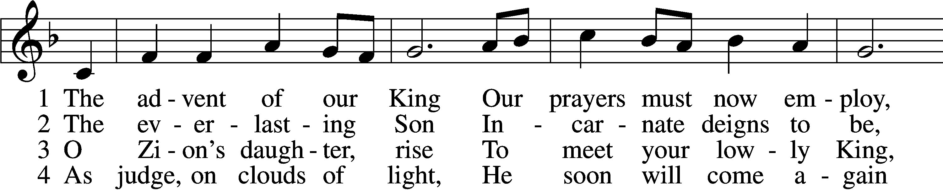
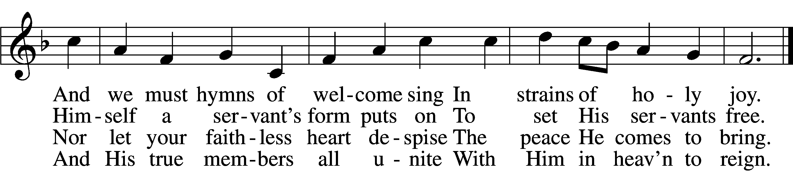

5 Before the dawning day
Let sin’s dark deeds be gone,
The sinful self be put away,
The new self now put on.
D 6 All glory to the Son,
Who comes to set us free,
With Father, Spirit, ever one
Through all eternity.

Text: Charles Coffin, 1676–1749; tr. John Chandler, 1806–76, alt. Tune: Aaron Williams, 1731–76 Text and tune: Public domain

Stand

Invocation LSB 184
P In the name of the Father and of the T Son and of the Holy Spirit.
C Amen.

P Our help is in the name of the Lord,
C who made heaven and earth.
P I said, I will confess my transgressions unto the Lord,
C and You forgave the iniquity of my sin.

Silence for reflection on God’s Word and for self-examination.

P O almighty God, merciful Father,
C I, a poor, miserable sinner, confess unto You all my sins and iniquities with which I have ever offended You and justly deserved Your temporal and eternal punishment. But I am heartily sorry for them and sincerely repent of them, and I pray You of Your boundless mercy and for the sake of the holy, innocent, bitter sufferings and death of Your beloved Son, Jesus Christ, to be gracious and merciful to me, a poor, sinful being.

Absolution LSB 185
P Upon this your confession, I, by virtue of my office, as a called and ordained servant of the Word, announce the grace of God unto all of you, and in the stead and by the command of my Lord Jesus Christ I forgive you all your sins in the name of the Father and of the T Son and of the Holy Spirit.
C Amen.

Introit Psalm 118:25–28; antiphon: Zechariah 9:9b, alt.
Behold, your king is com- | ing to you;*
righteous and having sal- | vation.
Save us, we pray, | O Lord!*
O Lord, we pray, give | us success!
Blessèd is he who comes in the name | of the Lord!*
We bless you from the house | of the Lord.
The Lord is God, and he has made his light to shine up- | on us.*
Bind the festal sacrifice with cords, up to the horns of the | altar!
You are my God, and I will give | thanks to you;*
you are my God; I will ex- | tol you.
Behold, your king is com- | ing to you;*
righteous and having sal- | vation.

Gloria Patri LSB 186
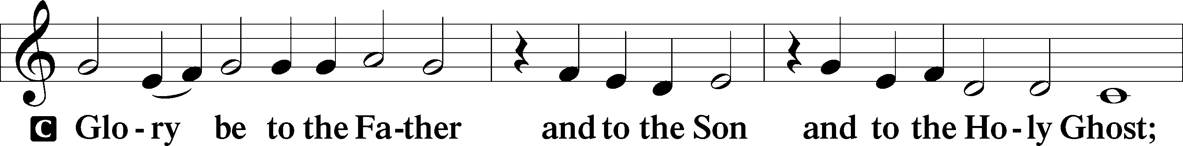

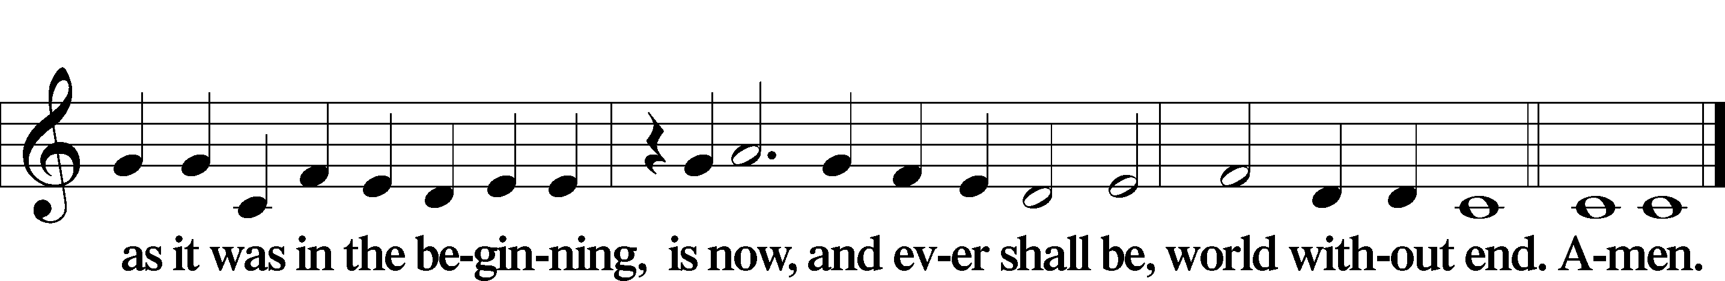

Kyrie LSB 186
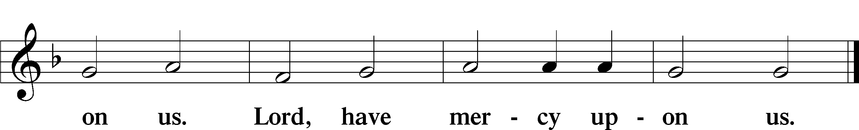
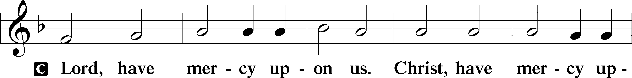

357 O Come, O Come, Emmanuel sts. 1, ref
1 O come, O come, Emmanuel,
And ransom captive Israel,
That mourns in lonely exile here
Until the Son of God appear. Refrain

ref Rejoice! Rejoice! Emmanuel
Shall come to thee, O Israel!
Text: Latin, c. 12th cent.; Psalteriolum Cantionum Catholicarum, 1710, Köln; tr. John Mason Neale, 1818–66, alt. Text: Public domain

Salutation and Collect of the Day
P The Lord be with you.
C And with thy spirit.
P Let us pray.
Stir up Your power, O Lord, and come, that by Your protection we may be rescued from the threatening perils of our sins and saved by Your mighty deliverance; for You live and reign with the Father and the Holy Spirit, one God, now and forever.
C Amen.

Sit

Old Testament Reading Isaiah 2:1–5
¹The word that Isaiah the son of Amoz saw concerning Judah and Jerusalem.
²It shall come to pass in the latter days
that the mountain of the house of the Lord
shall be established as the highest of the mountains,
and shall be lifted up above the hills;
and all the nations shall flow to it,
³and many peoples shall come, and say:
“Come, let us go up to the mountain of the Lord,
to the house of the God of Jacob,
that he may teach us his ways
and that we may walk in his paths.”
For out of Zion shall go the law,
and the word of the Lord from Jerusalem.
⁴He shall judge between the nations,
and shall decide disputes for many peoples;
and they shall beat their swords into plowshares,
and their spears into pruning hooks;
nation shall not lift up sword against nation,
neither shall they learn war anymore.
⁵O house of Jacob,
come, let us walk
in the light of the Lord.
P This is the Word of the Lord.
C Thanks be to God.

Gradual Zechariah 9:9; Psalm 118:26, alt.
Rejoice greatly, O daughter of | Zion.*
Shout aloud, O daughter of Je- | rusalem.
Behold, your king is com- | ing to you;*
righteous and having sal- | vation.
Blessèd is he who comes in the name | of the Lord.*
From the house of the Lord we | bless you.

Epistle Romans 13:8–14
⁸Owe no one anything, except to love each other, for the one who loves another has fulfilled the law. ⁹The commandments, “You shall not commit adultery, You shall not murder, You shall not steal, You shall not covet,” and any other commandment, are summed up in this word: “You shall love your neighbor as yourself.” ¹⁰Love does no wrong to a neighbor; therefore love is the fulfilling of the law.
¹¹Besides this you know the time, that the hour has come for you to wake from sleep. For salvation is nearer to us now than when we first believed. ¹²The night is far gone; the day is at hand. So then let us cast off the works of darkness and put on the armor of light. ¹³Let us walk properly as in the daytime, not in orgies and drunkenness, not in sexual immorality and sensuality, not in quarreling and jealousy. ¹⁴But put on the Lord Jesus Christ, and make no provision for the flesh, to gratify its desires.
P This is the Word of the Lord.
C Thanks be to God.

Stand

Alleluia LSB 190
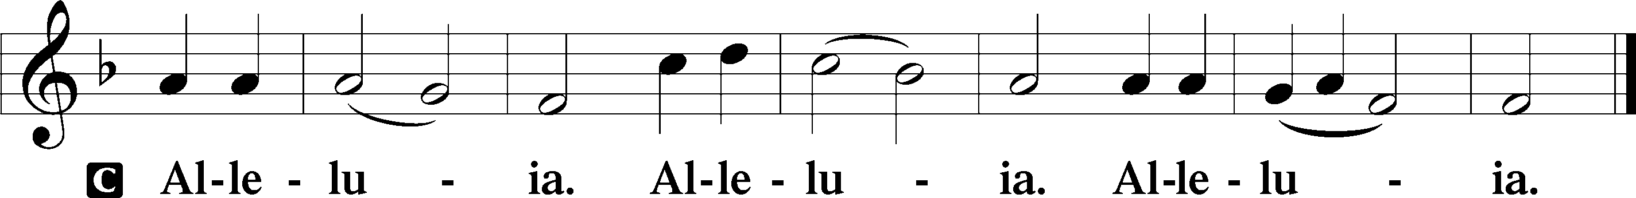

Holy Gospel Matthew 21:1–11
P The Holy Gospel according to St. Matthew, the twenty-first chapter.
C Glory be to Thee, O Lord.
¹Now when they drew near to Jerusalem and came to Bethphage, to the Mount of Olives, then Jesus sent two disciples, ²saying to them, “Go into the village in front of you, and immediately you will find a donkey tied, and a colt with her. Untie them and bring them to me. ³If anyone says anything to you, you shall say, ‘The Lord needs them,’ and he will send them at once.” ⁴This took place to fulfill what was spoken by the prophet, saying,
⁵“Say to the daughter of Zion,
‘Behold, your king is coming to you,
humble, and mounted on a donkey,
and on a colt, the foal of a beast of burden.’”
⁶The disciples went and did as Jesus had directed them. ⁷They brought the donkey and the colt and put on them their cloaks, and he sat on them. ⁸Most of the crowd spread their cloaks on the road, and others cut branches from the trees and spread them on the road. ⁹And the crowds that went before him and that followed him were shouting, “Hosanna to the Son of David! Blessed is he who comes in the name of the Lord! Hosanna in the highest!” ¹⁰And when he entered Jerusalem, the whole city was stirred up, saying, “Who is this?” ¹¹And the crowds said, “This is the prophet Jesus, from Nazareth of Galilee.”

P This is the Gospel of the Lord. C Praise be to Thee, O Christ.
Nicene Creed
C I believe in one God,
the Father Almighty,
maker of heaven and earth
and of all things visible and invisible.
And in one Lord Jesus Christ,
the only-begotten Son of God,
begotten of His Father before all worlds,
God of God, Light of Light,
very God of very God,
begotten, not made,
being of one substance with the Father,
by whom all things were made;
who for us men and for our salvation came down from heaven
and was incarnate by the Holy Spirit of the virgin Mary
and was made man;
and was crucified also for us under Pontius Pilate.
He suffered and was buried.
And the third day He rose again according to the Scriptures
and ascended into heaven
and sits at the right hand of the Father.
And He will come again with glory to judge both the living and the dead,
whose kingdom will have no end.
And I believe in the Holy Spirit,
the Lord and giver of life,
who proceeds from the Father and the Son,
who with the Father and the Son together is worshiped and glorified,
who spoke by the prophets.
And I believe in one holy Christian and apostolic Church,
I acknowledge one Baptism for the remission of sins,
and I look for the resurrection of the dead
and the life T of the world to come. Amen.

Sit

332 Savior of the Nations, Come
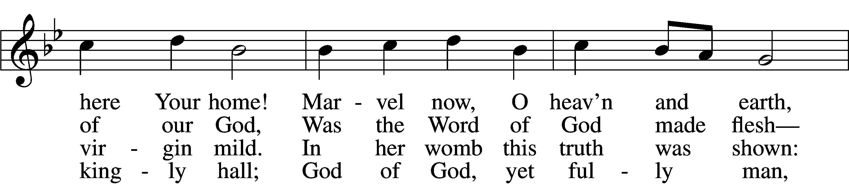
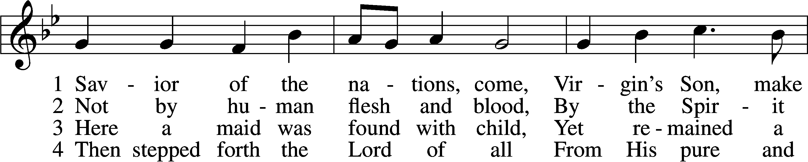

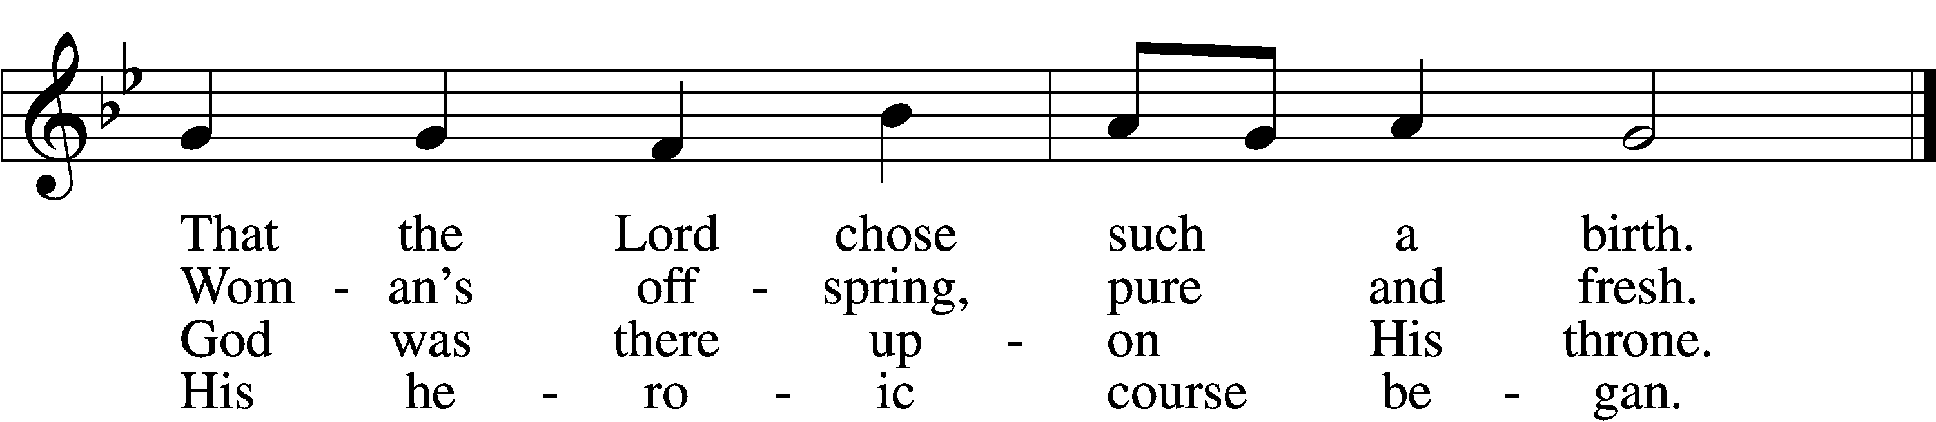

5 God the Father was His source,
Back to God He ran His course.
Into hell His road went down,
Back then to His throne and crown.

6 For You are the Father’s Son
Who in flesh the vict’ry won.
By Your mighty pow’r make whole
All our ills of flesh and soul.
7 From the manger newborn light
Shines in glory through the night.
Darkness there no more resides;
In this light faith now abides.

D 8 Glory to the Father sing,
Glory to the Son, our king,
Glory to the Spirit be
Now and through eternity.

Text: attr. Ambrose of Milan, 340–397; German version, Martin Luther, 1483–1546; (sts. 1–2): tr. William M. Reynolds, 1812–76; (sts. 3, 6): tr. Lutheran Service Book, 2006; (sts. 4–5, 8): tr. F. Samuel Janzow, 1913–2001; (st. 7): tr. Gifford A. Grobien, 1973
Tune: Geystliche gesangk Buchleyn, 1524, Wittenberg, ed. Johann Walter Text (sts. 3, 6–7): © 2006 Concordia Publishing House; (sts. 4–5, 8): © 1978 Concordia Publishing House. Used by permission: LSB Hymn License no. 110003744
Text (sts. 1–2) and tune: Public domain

Sermon

Stand

Offertory LSB 192
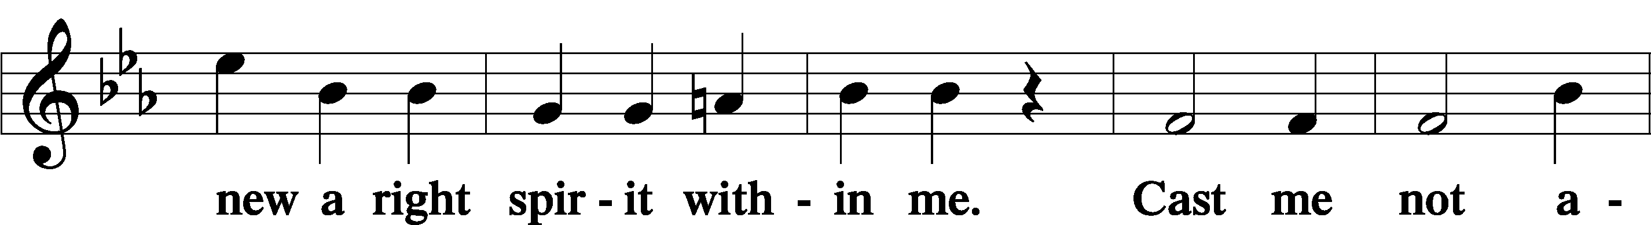
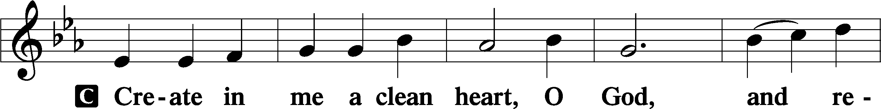

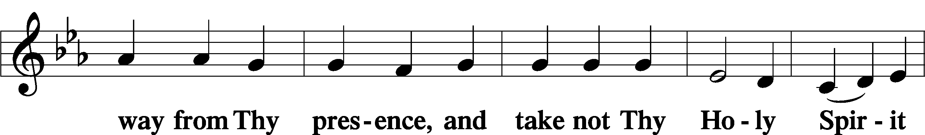

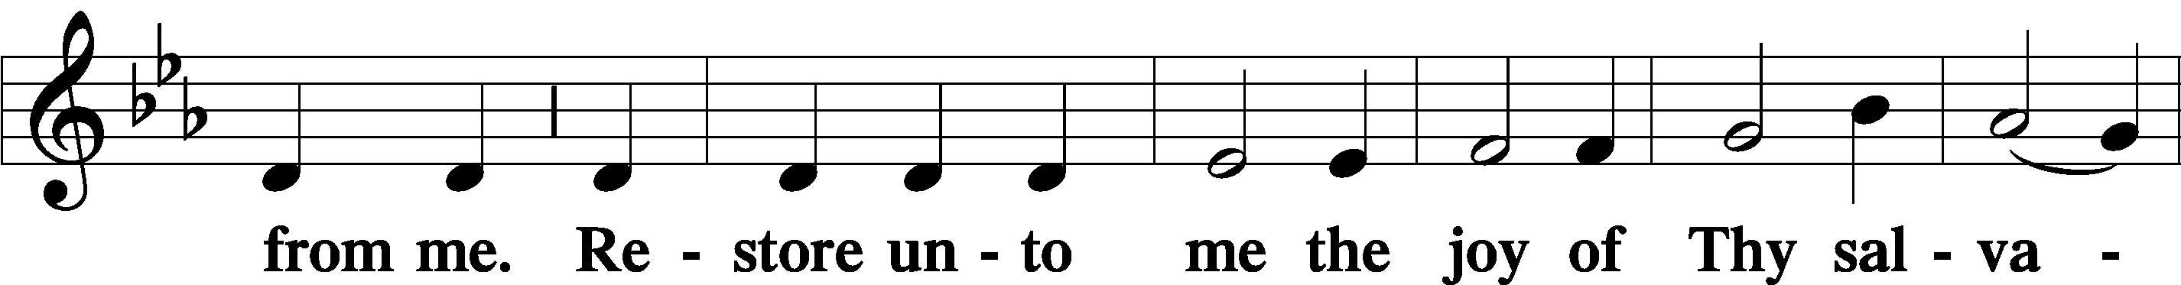

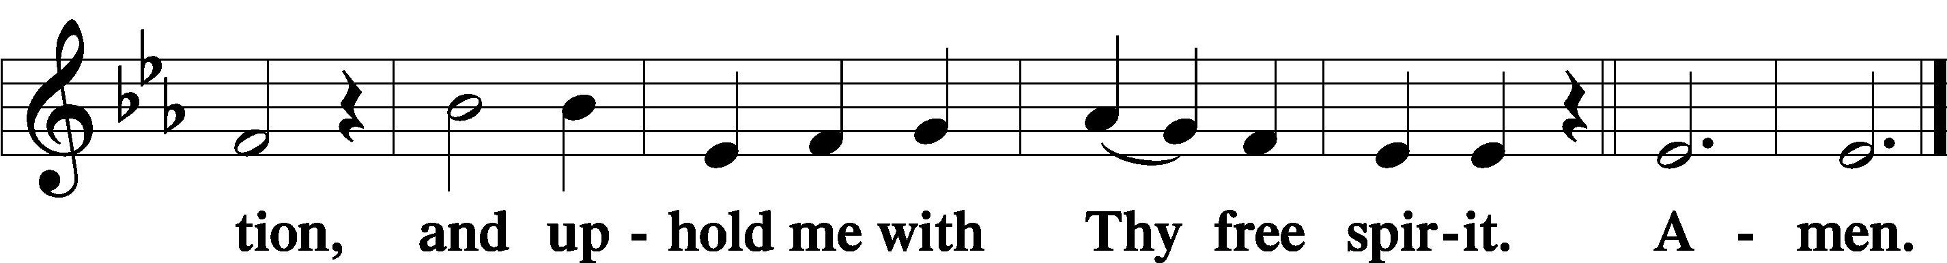

Prayer of the Church

Sit

Consecration of the Offering
After the prayers please be seated. The altar is set for the Lord’s Supper and the offering is consecrated. As you prepare to receive the sacrament you may use the prayers in the front of the hymnal or meditate on a communion hymn.

Stand
Service of the Sacrament
Preface LSB 194
P The Lord be with you.
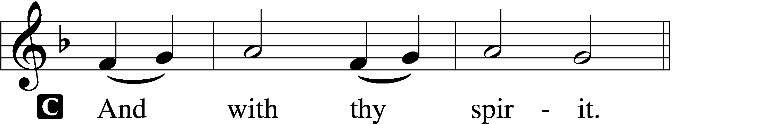
P Lift up your hearts.
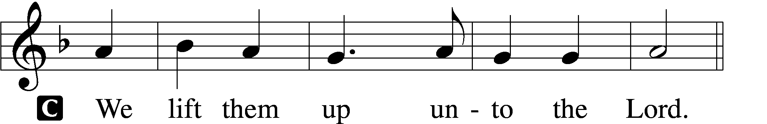

P Let us give thanks unto the Lord, our God.
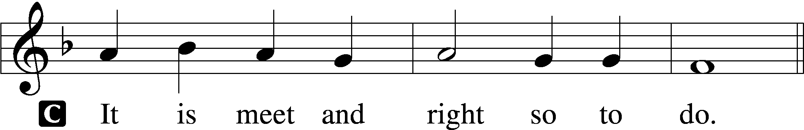

P It is truly meet, right, and salutary that we should at all times and in all places give thanks to You, holy Lord, almighty Father, everlasting God, through Jesus Christ, our Lord. Therefore with angels and archangels and with all the company of heaven we laud and magnify Your glorious name, evermore praising You and saying:

Sanctus LSB 195
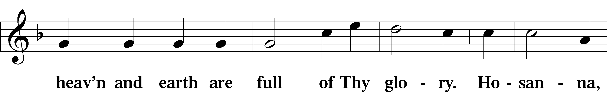
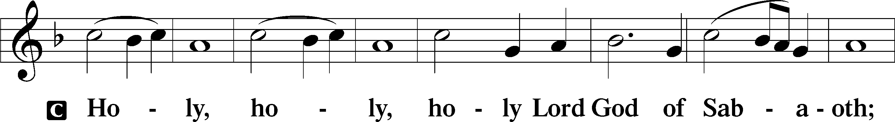

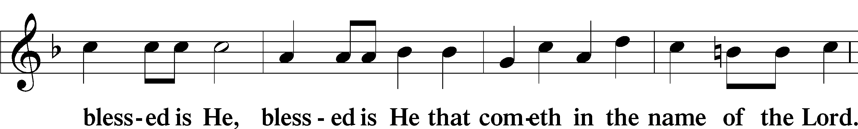
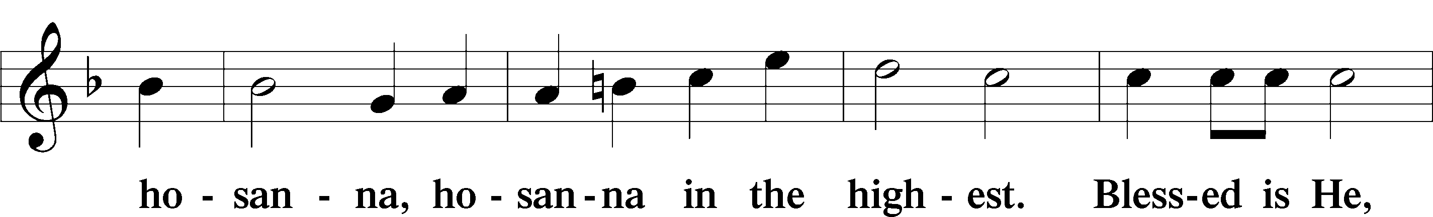

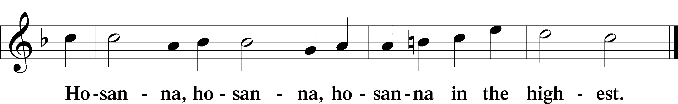

Lord’s Prayer
C Our Father who art in heaven,
hallowed be Thy name,
Thy kingdom come,
Thy will be done on earth
as it is in heaven;
give us this day our daily bread;
and forgive us our trespasses
as we forgive those
who trespass against us;
and lead us not into temptation,
but deliver us from evil.
For Thine is the kingdom
and the power and the glory
forever and ever. Amen.

The Words of Our Lord
P Our Lord Jesus Christ, on the night when He was betrayed, took bread, and when He had given thanks, He broke it and gave it to the disciples and said: “Take, eat; this is My T body, which is given for you. This do in remembrance of Me.”
In the same way also He took the cup after supper, and when He had given thanks, He gave it to them, saying: “Drink of it, all of you; this cup is the new testament in My T blood, which is shed for you for the forgiveness of sins. This do, as often as you drink it, in remembrance of Me.”

Pax Domini LSB 197
P The peace of the Lord be with you always.
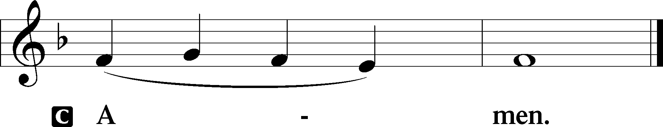

Agnus Dei LSB 198
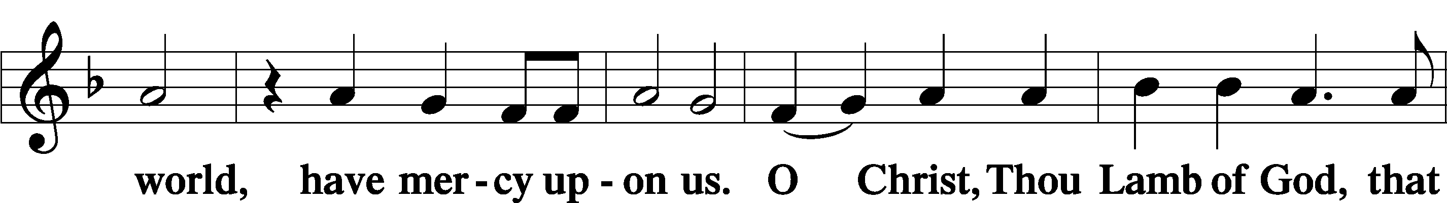
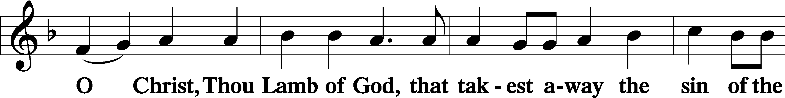

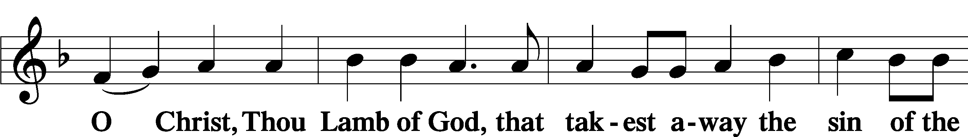
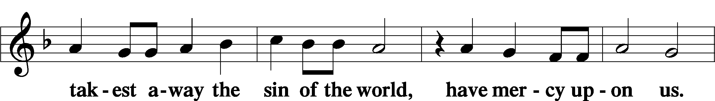

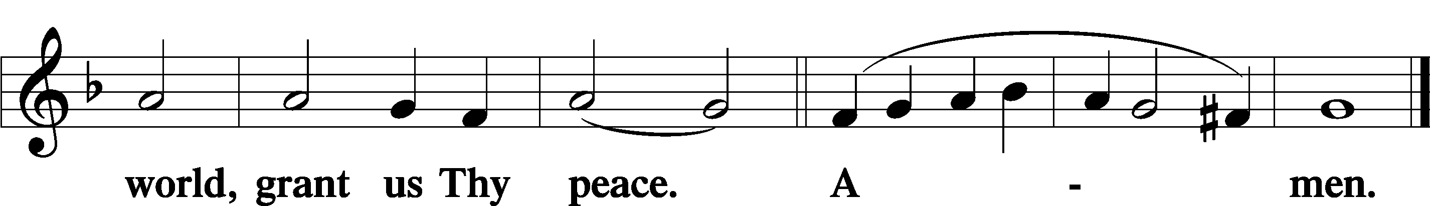

Sit

Distribution

341 Lift Up Your Heads, Ye Mighty Gates
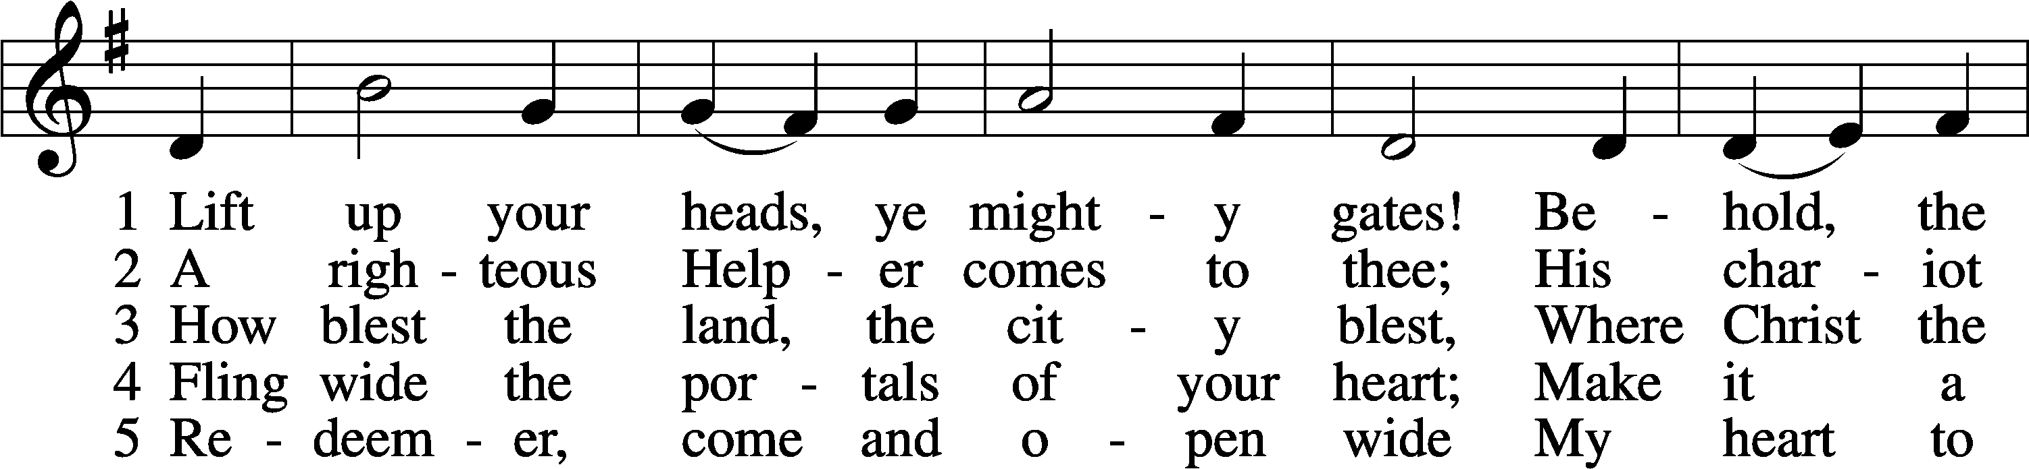
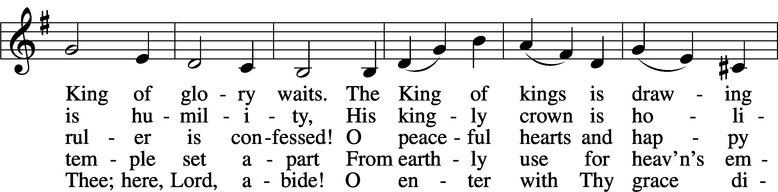
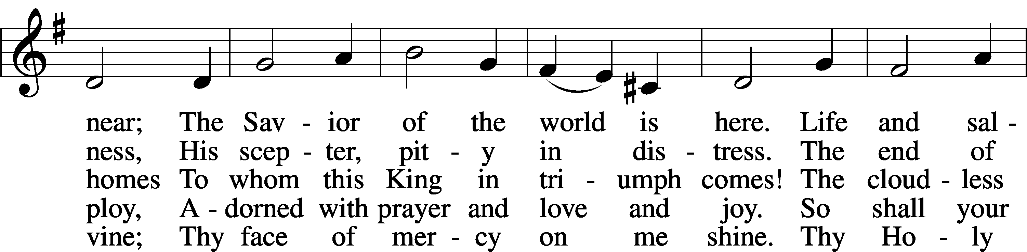
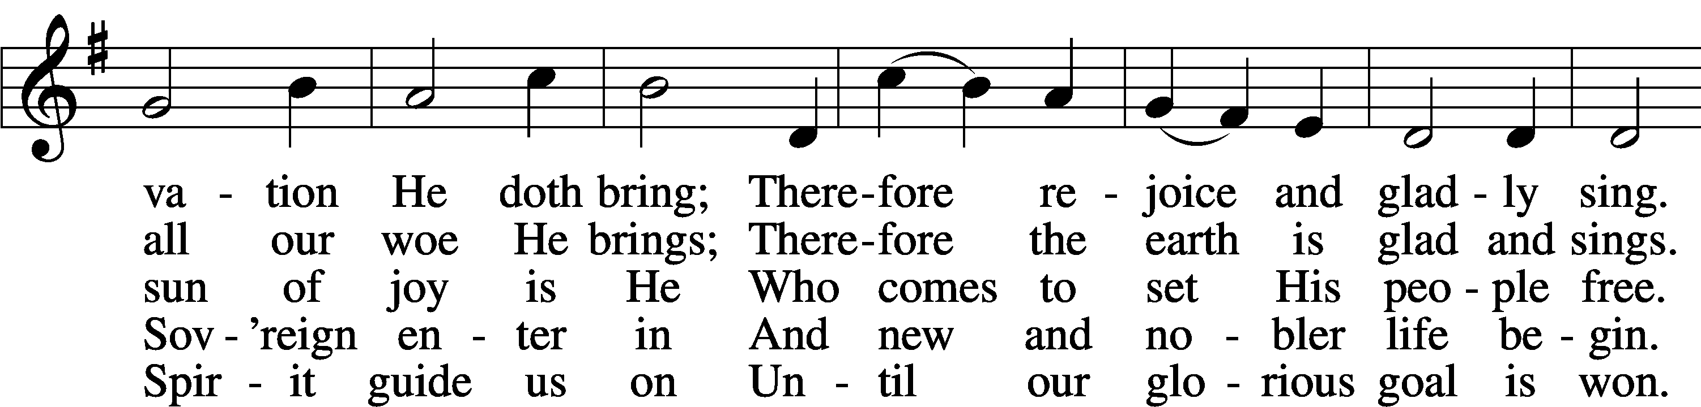
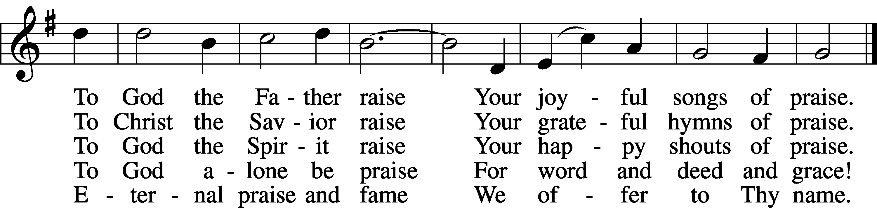
Text: Georg Weissel, 1590–1635; tr. Catherine Winkworth, 1827–78, alt. Tune: August Lemke, 1820–1913 Text and tune: Public domain

641 You Satisfy the Hungry Heart
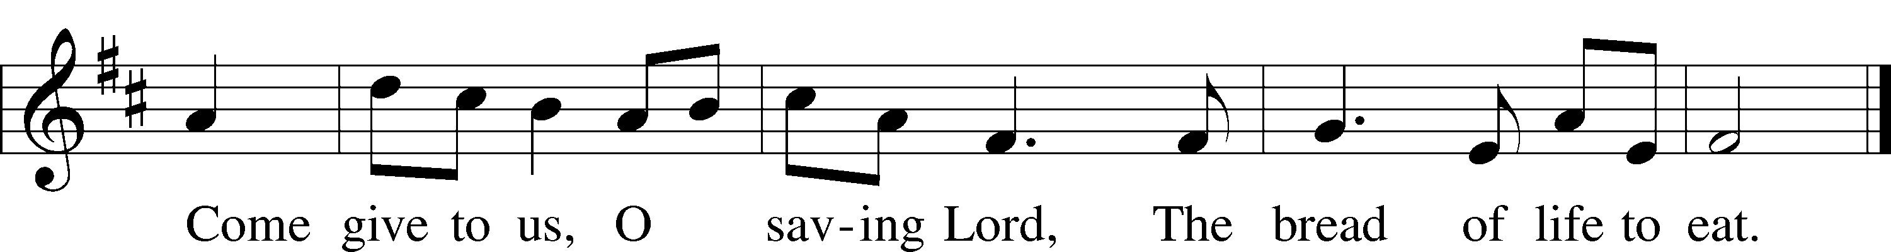
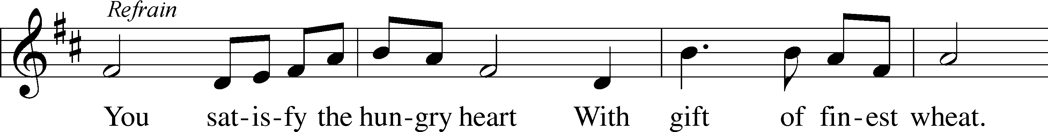

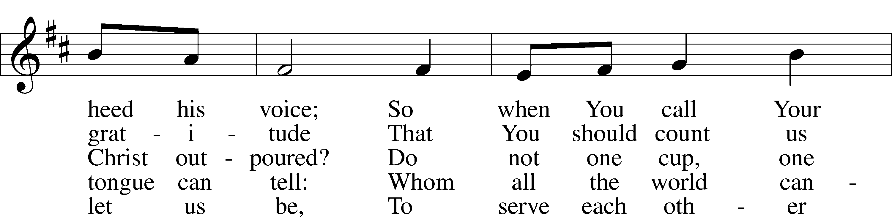
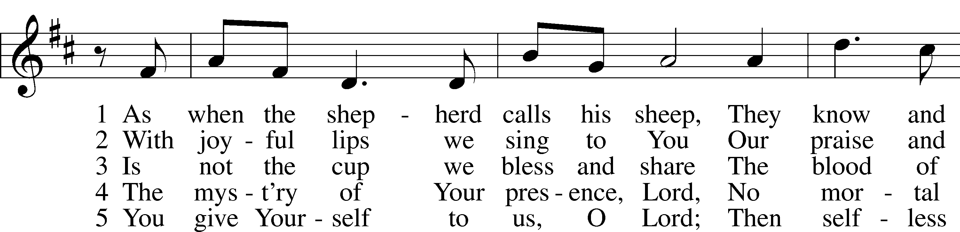

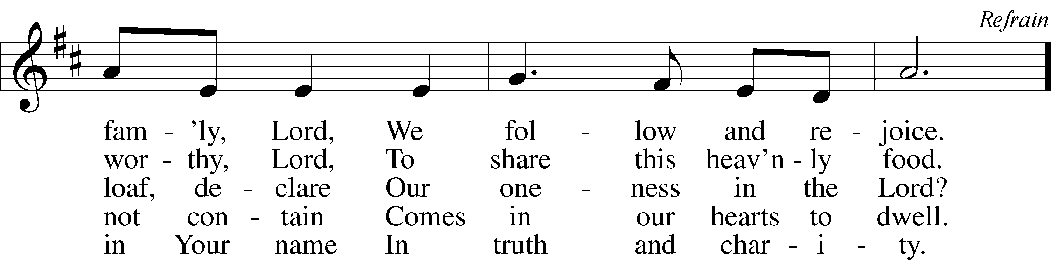

Text: Omer E. Westendorf, 1916–97 Tune: Robert E. Kreutz, 1922–96 Text and tune: © 1977 Archdiocese of Philadelphia, admin. International Liturgy Publications. Used by permission: LSB Hymn License no. 110003744

349 Hark the Glad Sound
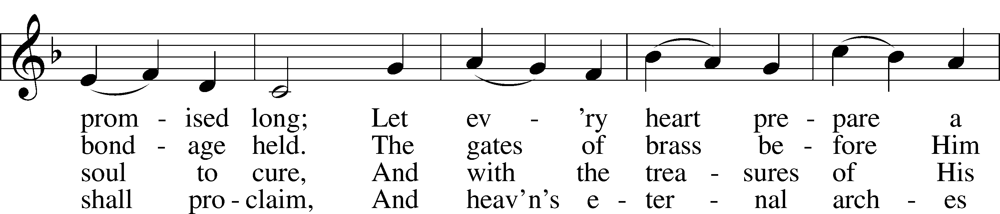
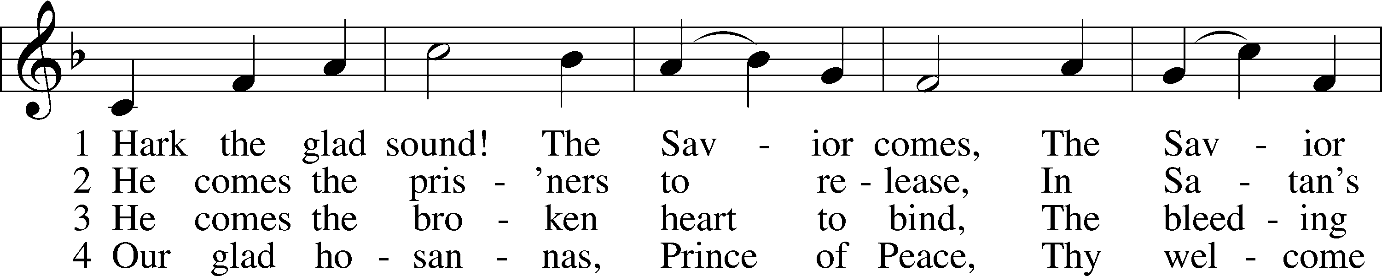

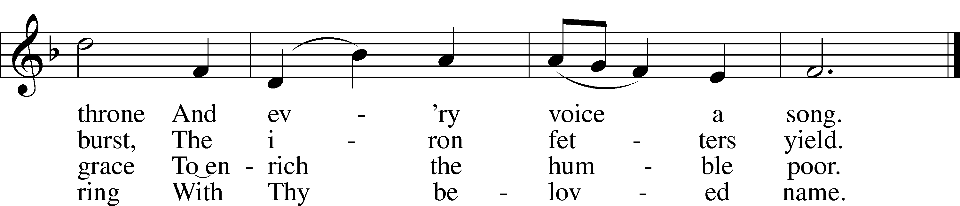

Text: Philip Doddridge, 1702–51 Tune: Thomas Haweis, 1734–1820 Text and tune: Public domain
516 Wake, Awake, for Night Is Flying
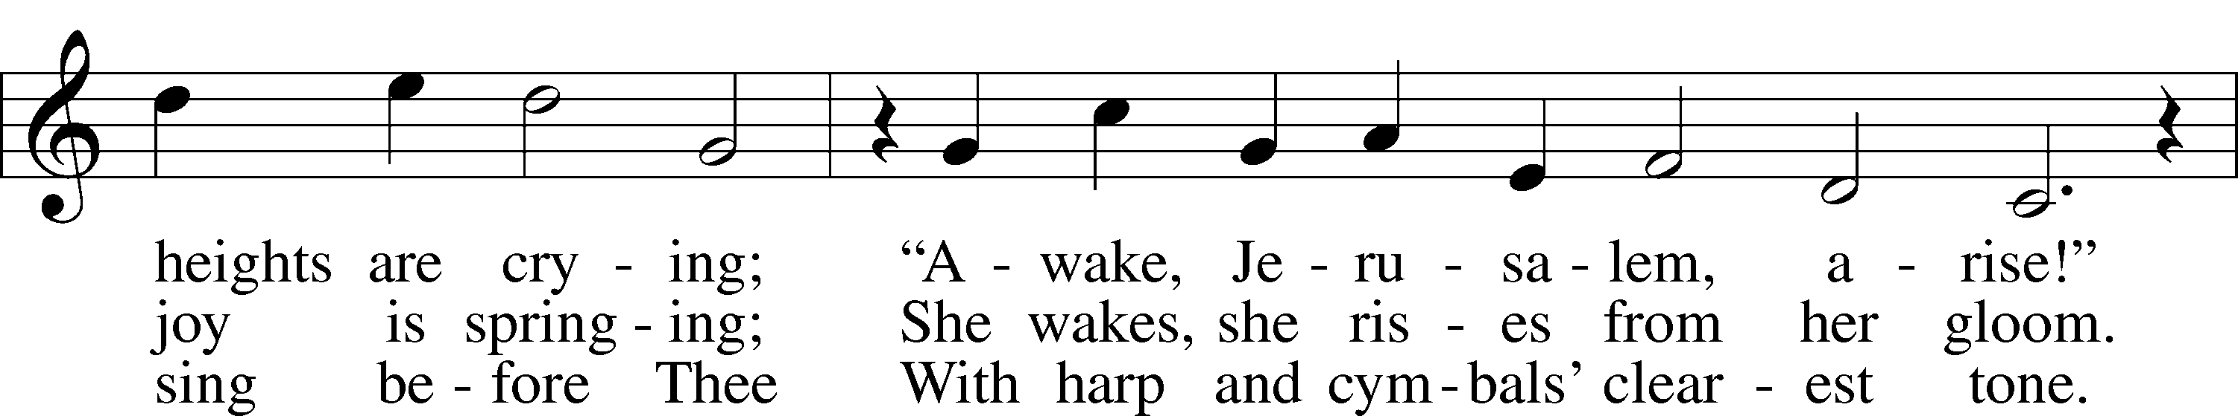
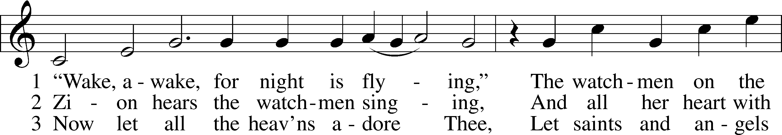

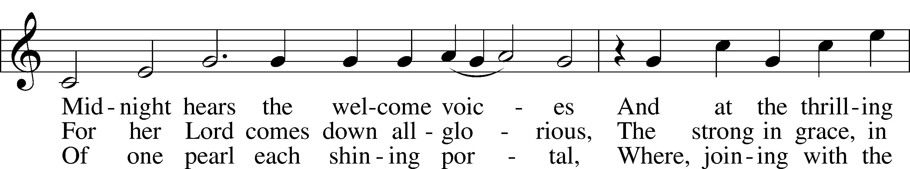

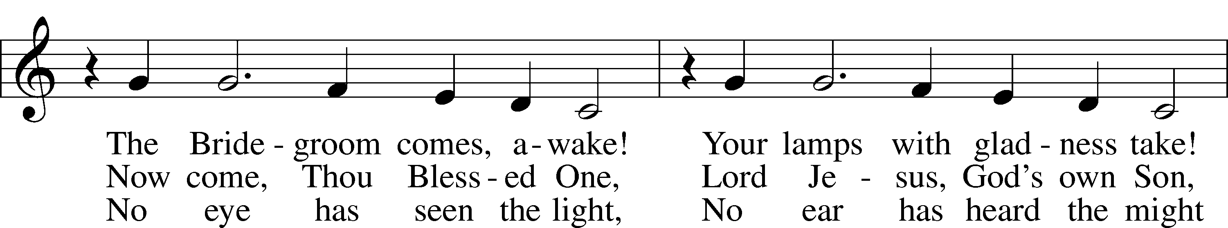
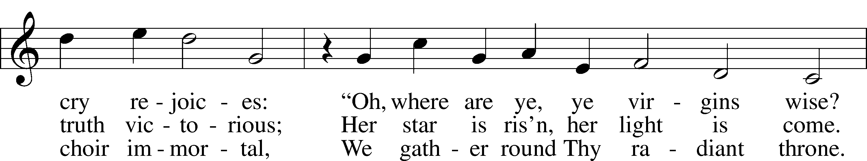

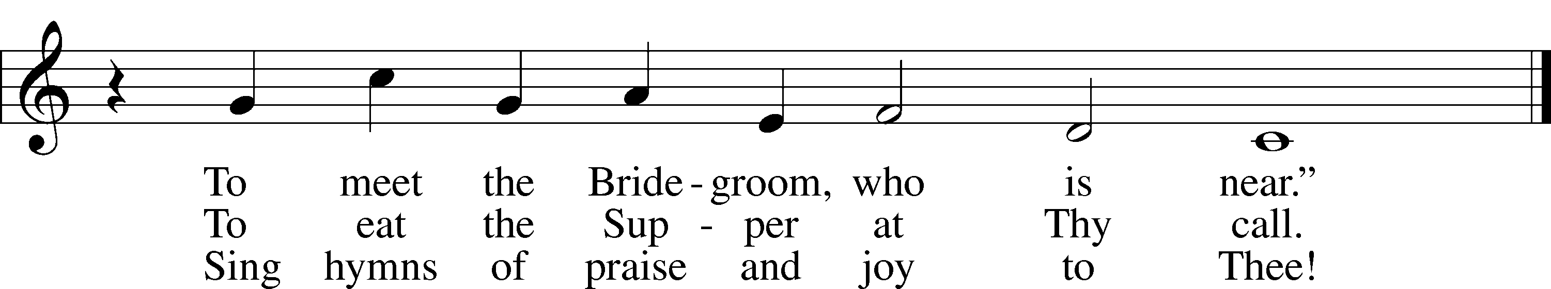
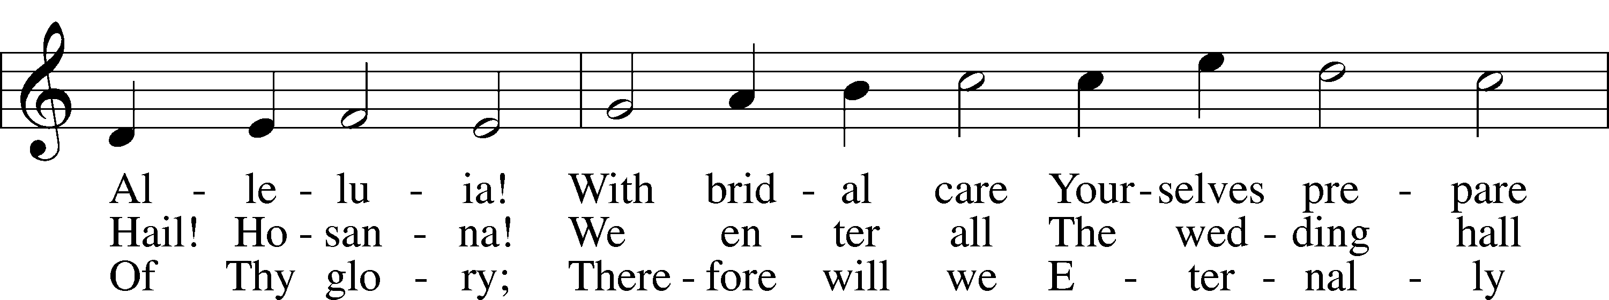

Text: tr. Catherine Winkworth, 1827–78, alt. Text and tune: Philipp Nicolai, 1556–1608 Text and tune: Public domain

The Dismissal
P The body and blood of our Lord Jesus Christ strengthen and preserve you in body and soul to life everlasting. Depart T in peace.
C Amen.

Stand

Nunc Dimittis LSB 199
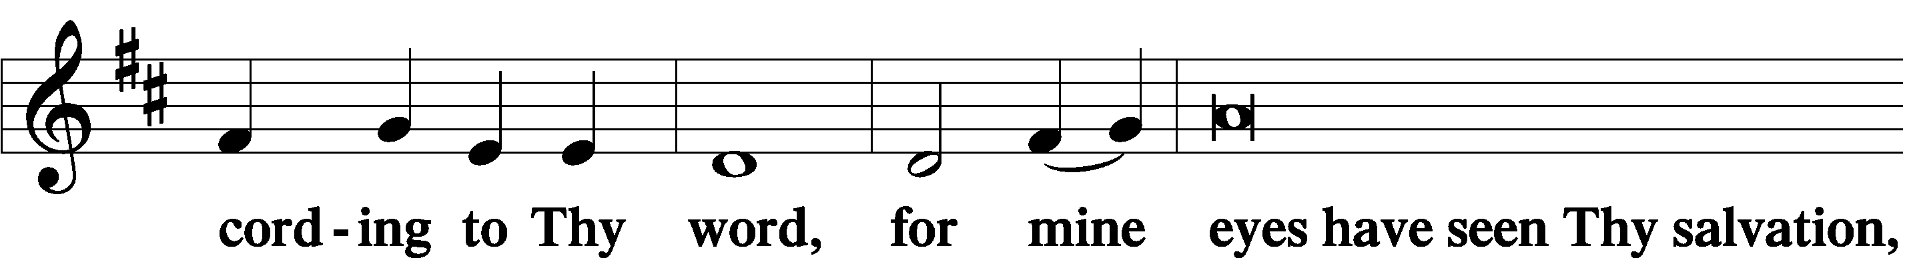
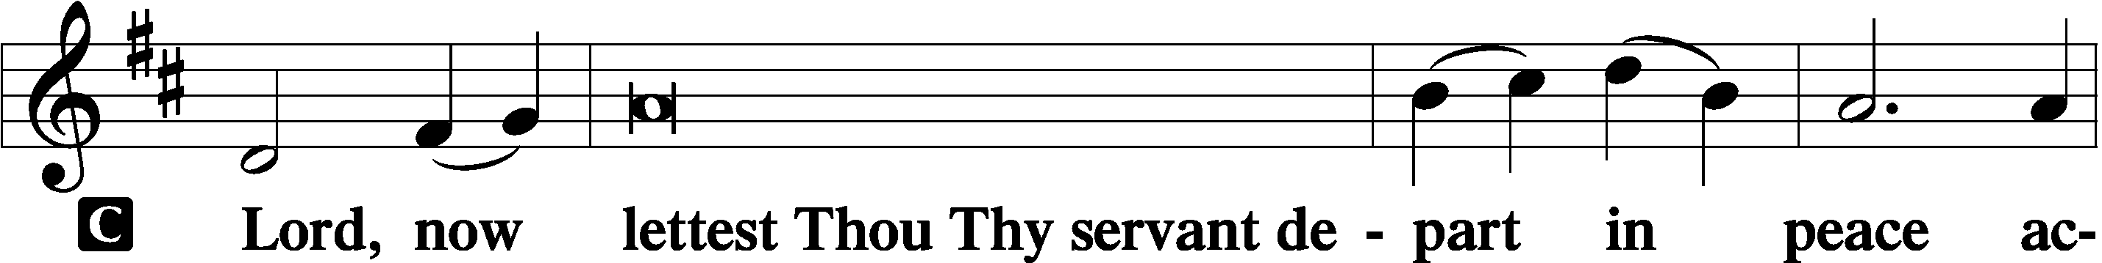

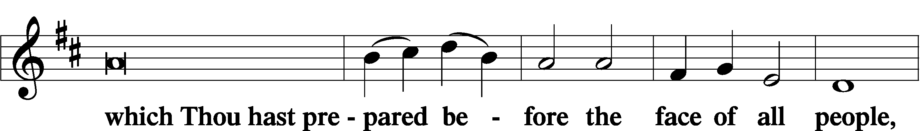

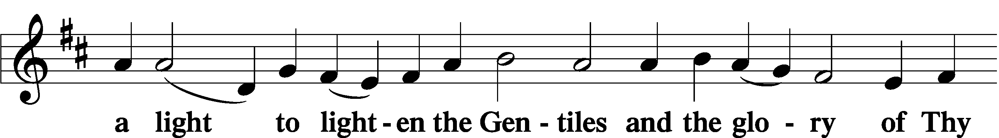

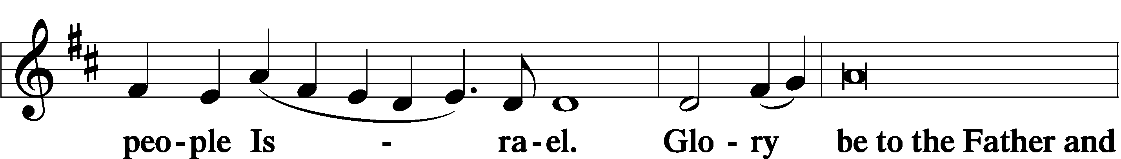

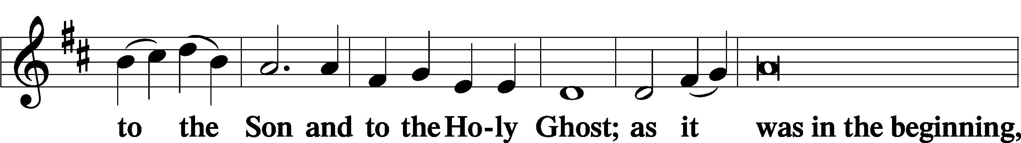

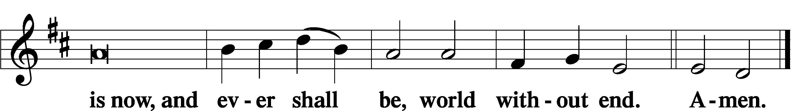

Thanksgiving LSB 200
P O give thanks unto the Lord, for He is good,
C and His mercy endureth forever.
P Let us pray.
We give thanks to You, almighty God, that You have refreshed us through this salutary gift, and we implore You that of Your mercy You would strengthen us through the same in faith toward You and in fervent love toward one another; through Jesus Christ, Your Son, our Lord, who lives and reigns with You and the Holy Spirit, one God, now and forever.
C Amen.

P The Lord be with you.
C And with thy spirit.

Benedicamus LSB 202
P Bless we the Lord.
C Thanks be to God.

Benediction LSB 202
P The Lord bless you and keep you.
The Lord make His face shine upon you and be gracious unto you.
The Lord lift up His countenance upon you and T give you peace.
C Amen, amen, amen.

348 The King Shall Come When Morning Dawns
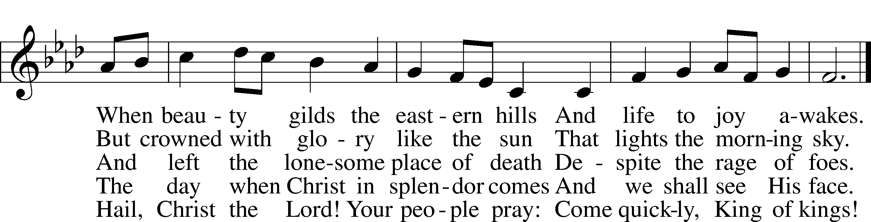
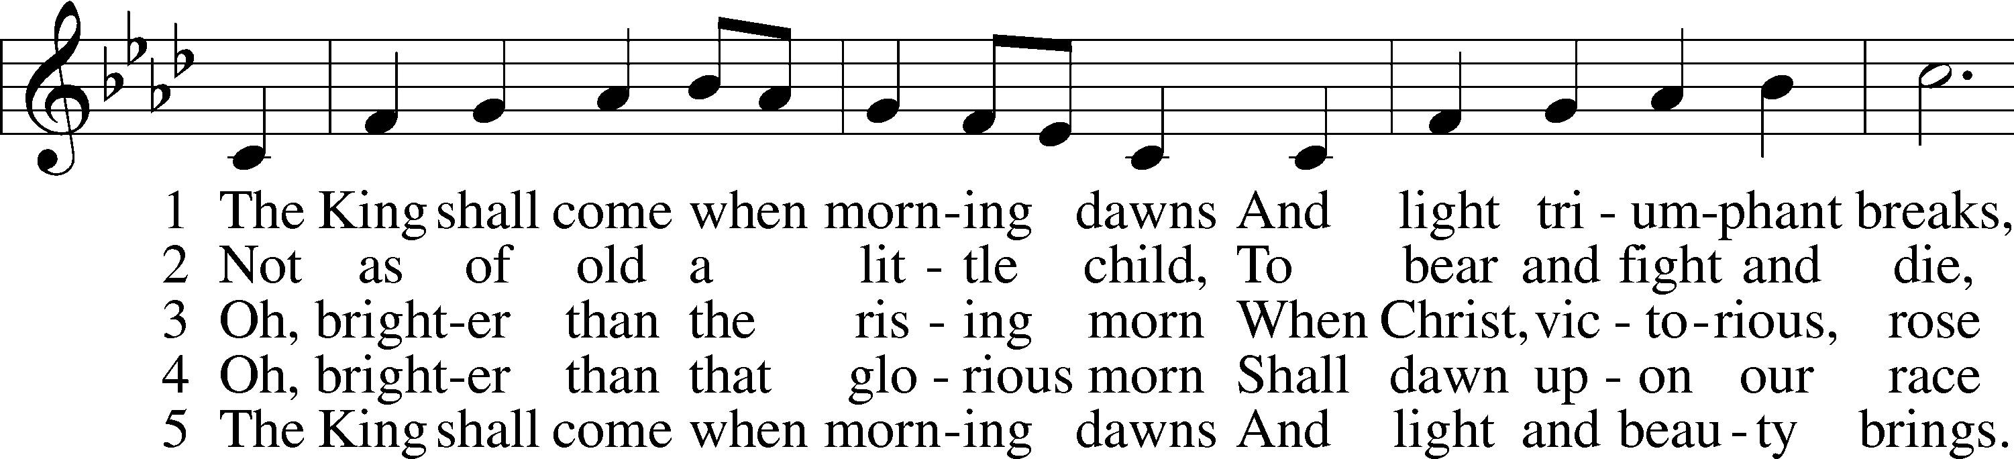

Text: John Brownlie, 1859–1925, alt. Tune: Repository of Sacred Music, Part Second, 1813, Harrisburg, ed. John Wyeth Text and tune: Public domain
Acknowledgments
Unless otherwise indicated, Scripture quotations are from the ESV® Bible (The Holy Bible, English Standard Version®), copyright © 2001 by Crossway, a publishing ministry of Good News Publishers. Used by permission. All rights reserved.
Created by Lutheran Service Builder © 2021 Concordia Publishing House.

Prayers for Our Members
Norman Abels (Brookestone Meadows–Elkhorn) | Healing
Judy Ahrens | Healing
Vaughn Albrecht (Mount Carmel) | Healing
Tom & DyAnn Altwine | Healing
Lyle Colsden (Mother Hull) | Healing
Pat Flodine (Cambridge Court) | Healing
Vi Fox (Prairie View) | Healing
Wanda Glanzer | Healing
Jan Hatfield | Healing
Ruby Hatfield | Healing
Evelyn Heiden (Mother Hull) | Healing
Linda Luhn | Healing
Jackie Ohlmann | Healing
Diane Plummer | Healing
Debra Schinkel | Healing
Don Trampe | Healing
Robin Baker | Cancer
Ivan Bombeck | Cancer
Bertha Marienau | Cancer

Prayers for Our Members’ Family & Friends
Lana Fattig (Eric’s wife) | Expecting
Roger Young (Tiffany Davis’ father) | Parkinson’s
Deb Engles (Lorelie’s sister) | Healing
Paul Hanneman (Lorelie’s brother) | Healing
Roger Hoffman (Marc’s father) | Healing
Luetta Lammers (Ruby Hatfield’s sister) | Healing
LeRoyce Margaritz (brother of Wanda Glanzer) | Healing
Tim Powers (Kim Wilken’s brother) | Healing
Howard Quandt (Don & Shirley Helmbrecht’s family) | Healing
David & Carol Shiers (Jessica’s parents) | Healing
Randy Solomon (Beth Rosenthal’s father) | Healing
Jonah (Jase & Jarren Blattner’s friend) | Cancer
Glenda Fichtner (Ruby Hatfield’s niece) | Cancer
Ron Halvorsen (Jeff’s dad) | Cancer
Sharon Mulhair (Pam Uhlir’s cousin) | Cancer
Milton Naprstek (Marilyn Fuqua’s brother) | Cancer
Cindy Pietsch (Ellen Koopman’s sister-in-law) | Cancer
Rick Schnacker (Marilyn Fuqua’s nephew) | Cancer
Tyrone Uhlir (Pam’s nephew) | Cancer
Ray Vang (Don & Shirley Helmbrecht’s brother-in-law) | Cancer

Our Response to the Gospel
Date: 11/20/2022
Offering: $6,123
Weekly Need: $7,500
Offering Options:
To worship the Lord with your offering:
1) Place your offering in the offering plate as you enter or leave.
2) Go to zionkearney.churchtrac.com/give
3) Go to zionkearney.com and click on the ChurchTrac icon
4) Mail your gift to Zion Lutheran Church, 2421 C Ave, Kearney, NE 68847 or place it in the mail slot on the south side of the building.
Today’s Radio Broadcast is sponsored by Vi Fox, with many thanks for the Radio Broadcast.
Today’s Altar Flowers are giving by Paul & Rachael Burger, in honor of their anniversary on the 28th.

Worship Assistants

Sunday, November 27th – 9:00am
Elder: Bruce Brooks  Acolyte: Noah Randolph  Announcer: Carol Kreutzer | Usher: Mike Wilkens  Engineer: Jared Nuttelman  Altar Guild: Brooke Fisher & Tracy Schake
Sunday, December 4th – 9:00am
Elder: Elder Rosenthal  Acolyte: Brynne Fisher  Announcer: Brooke Fisher | Usher: Fred Flessner  Engineer: Reilly Fisher  Altar Guild: Beth Rosenthal & Shirley Helmbrecht

ZION LUTHERAN CHURCH AND SCHOOL

Pr. James DeLoach, Pastor + (308) 627-5260
james.deloach@zionkearney.org
Pr. Doug Gaunt, Pastor + (308) 455-0552
doug.gaunt@zionkearney.org
Tony Splittgerber, Principal + (308) 293-0168
anthony.splittgerber@zionkearney.org

Church Office
Administrative Assistant: Holly Reid
Email: school@zionkearney.org
Phone: (308)-234-3410 Fax: (308) 236-8100
Office Hours: Monday-Friday 8:00am-4:00pm
Radio Broadcast: Sunday @ 10:30 a.m. on 1460 AM
Website: www.zionkearney.com
This Week at Zion
Sun 11/27  First Sunday in Advent | 9:00a  10:30a  10:30a  5:00p | Divine Service  Adult Bible Study & Sunday School  Radio Broadcast  1460AM & 92.1FM  Divine Service
Mon 11/28 | Anniversaries | Paul & Rachael Burger  Mike & Melinda Dulitz
Tues 11/29 | 1:30p  Birthdays | Sleeping Mats  Hendrix Herrera  Christopher Hoehner
Wed 11/30 | 8:30a  5:30p  7:00p  8:00p | Chapel  Advent Meal  Advent Service  Adult Choir
Thurs 12/1 | Birthdays | Mike Dulitz  Makenna Starkey
Fri 12/2
Sat 12/3 | 1:00p | Christmas Decorating
Sun 12/4 | 9:00a  10:30a  10:30a  5:00p | Divine Service  Adult Bible Study & Sunday School  Radio Broadcast  1460AM & 92.1FM  Divine Service

Announcements for November 27th, 2022

Advent Meal and Worship: We will be starting midweek Advent meals and worship this week. The meal will start at 5:30p and will be served by the Zion Middle School. Worship will begin at 7:00p. Come join us as we prepare for the celebration of Christ’s birth.

Radio Broadcast & Altar Flowers: The sign-up sheets for the 2023 radio broadcasts and flowers are on the bulletin board by the mailboxes. If you want a certain date, sign up ASAP.

Youth Poinsettias: For those that ordered poinsettias from the youth group, they will be available for pick up on Sunday, December 4th. There are extras available if you would like to purchase more.

Poinsettias to Beautify God’s House: during the two weeks prior to our Savior’s birth can now be purchased. The cost is $13.00, and checks can be made out to Mary Martha. You are welcome to take your poinsettia home following the Divine Service on Christmas Day. The poinsettia order sign-up envelope will be with Holly in the office during the week, and in narthex on Sundays. Questions? Please contact Carol DeLoach at 308/627-2279.

Christmas Decorating: Help!!! Your church needs you! Please join us in decorating the sanctuary to celebrate our Savior’s birth this Saturday, December 3, at 1:00 pm. Men are needed especially right at 1:00 pm to put up the tree. Thank you!

Annual Food Collection: We have had a great start to our food collection! We will also accept toiletries, cleaning products, paper items, as well as items that cannot be purchased with food stamps. If you are able to gather the items and take them to the Jubilee center, contact the office.

Sunday School: The Board of education is looking for volunteers to teach or help with teaching Sunday school. We are looking for 3 -pre-K, K – 2nd and 3rd–5th class teachers, subs or helpers. If you would be willing to teach or be a helper, please contact the office or Matt Hodgson (308)627-7732 -matthodgson1@hotmail.com

Radio Broadcast & Altar Flowers: The sign-up sheets for the radio broadcast and altar flowers are up by the mailboxes. Please help Zion spread the Gospel and decorate the sanctuary.

SCHOOL NEWS

Extra Pies: There are plenty of extra pies left over from our sale. Contact the office for availability and pricing.

Christmas Program: The K-8 Christmas Program will be Sunday, December 11th at 4pm. People are allowed to attend the dress rehearsal on Friday, December 9th at 12:30pm. Come listen to the students celebrate the birth of Christ! Refreshments to follow. Parents are asked to bring 2 dozen cookies and/or treats to share with those in attendance.

Receipts: Remember to save your grocery receipts, UPC codes and Coke rewards codes. Family Fresh register receipts (all year) and Apple Market receipts (dated September 1 through March 31 of each year) Best Choice UPC (Apple Market & Boogaarts private label) and Our Family UPC (Family Fresh private label) Coke Rewards codes from 20 oz, .5 L, 1.25 L, 2 L, Fridge packs and 24 packs. Just drop them in the small container by the south parking lot door.

