Divine Service

Third Sunday in Advent

December 11th, 2022
Zion Lutheran Church
Kearney, Nebraska
Welcome to Zion!
Guests please record your attendance on a card in the pew rack and let us know how we can be of service to you.

Holy Communion at Zion

The Lord’s Supper is celebrated at this congregation as Jesus has given it. As he says, our Lord gives into our mouths not only bread and wine but his very body and blood to eat and to drink for the forgiveness of sins and to strengthen our union with him and with one another. Our Lord invites to his table those who trust his words, repent of all sin, and set aside any refusal to forgive and love as he forgives and loves us, that they may show forth his death until he comes. All communicants need to register in the narthex prior to the service.

Because those who eat and drink our Lord’s body and blood unworthily do so to their great harm and because Holy Communion is a confession of the faith which is confessed at this altar, any who are not yet instructed, in doubt, or who hold a confession differing from that of this congregation and The Lutheran Church—Missouri Synod, are asked not to commune until they are able to speak with our pastor first. He is happy to visit with you about the Christian faith and how to receive the Lord’s Supper for your good and for the good of others. Those not communing are invited to come to the altar, cross your arms in front of you, and bow your head to receive a pastoral blessing.

The Coming of the Lord Jesus Christ Brings True Rejoicing, Even Under the Cross

Sometimes life requires the astonishing patience of Job. Like him, we are to rejoice in the midst of affliction, be grounded in repentance under the cross of Christ, and hope relentlessly in His resurrection, that we might see “the purpose of the Lord, how the Lord is compassionate and merciful” (James 5:11). In the promise of the Gospel, therefore, “be patient” and “establish your hearts, for the coming of the Lord is at hand” (James 5:7, 8). Like St. John the Baptist, whatever your own kind of prison or suffering may be, call upon Jesus and receive the strength of His Word from those He sends to you. For as “the blind receive their sight and the lame walk, lepers are cleansed and the deaf hear, and the dead are raised up,” so is the Good News of Jesus preached to you also (Matt. 11:5). He comes and restores the fortunes of Zion, His Holy Church, so that “sorrow and sighing shall flee away” (Is. 35:10).
349 Hark the Glad Sound
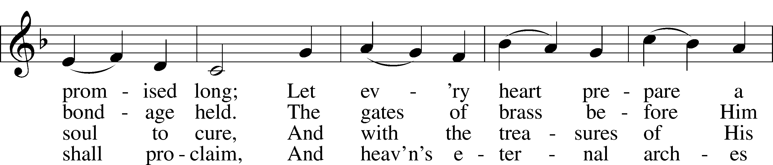
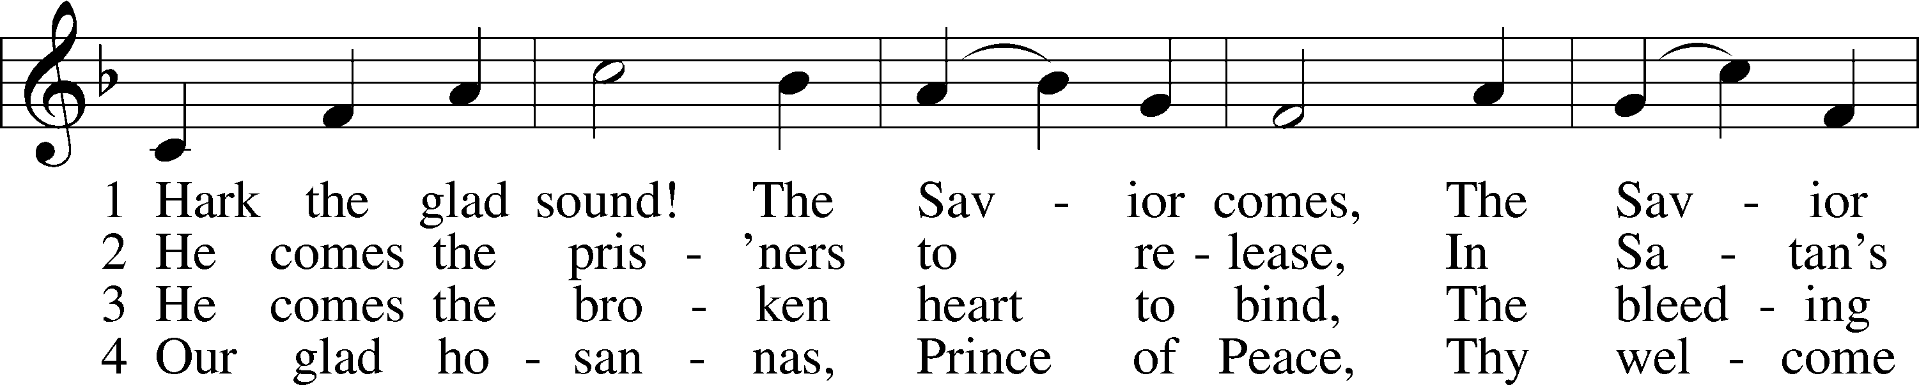

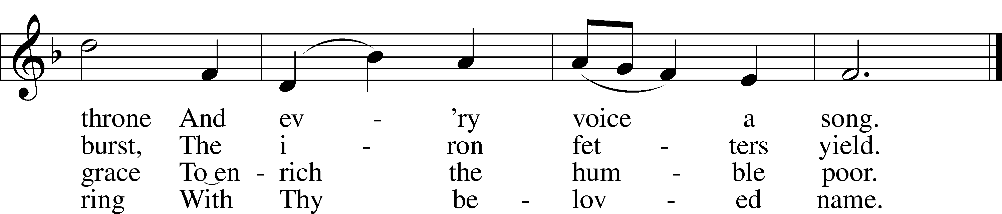

Text: Philip Doddridge, 1702–51 Tune: Thomas Haweis, 1734–1820 Text and tune: Public domain

Stand

Invocation LSB 184
P In the name of the Father and of the T Son and of the Holy Spirit.
C Amen.

P Our help is in the name of the Lord,
C who made heaven and earth.
P I said, I will confess my transgressions unto the Lord,
C and You forgave the iniquity of my sin.

Silence for reflection on God’s Word and for self-examination.

P O almighty God, merciful Father,
C I, a poor, miserable sinner, confess unto You all my sins and iniquities with which I have ever offended You and justly deserved Your temporal and eternal punishment. But I am heartily sorry for them and sincerely repent of them, and I pray You of Your boundless mercy and for the sake of the holy, innocent, bitter sufferings and death of Your beloved Son, Jesus Christ, to be gracious and merciful to me, a poor, sinful being.

Absolution LSB 185
P Upon this your confession, I, by virtue of my office, as a called and ordained servant of the Word, announce the grace of God unto all of you, and in the stead and by the command of my Lord Jesus Christ I forgive you all your sins in the name of the Father and of the T Son and of the Holy Spirit.
C Amen.

Introit Psalm 71:14–18; antiphon: Philippians 4:4
Rejoice in the Lord | always;*
again I will say, | Rejoice.
I will hope con- | tinually*
and will praise you yet | more and more.
My mouth will tell of your righteous acts, of your deeds of salvation | all the day,*
for their number is past my | knowledge.
With the mighty deeds of the Lord God | I will come;*
I will remind them of your righteousness, | yours alone.
O God, from my youth you have | taught me,*
and I still proclaim your | wondrous deeds.
So even to old age and gray hairs, O God, do not for- | sake me,*
until I proclaim your might to another generation, your power to all | those to come.
Rejoice in the Lord | always;*
again I will say, | Rejoice.

Gloria Patri LSB 186
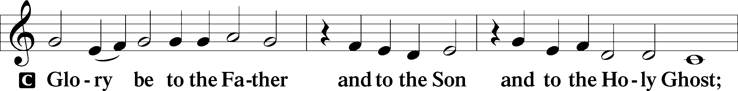

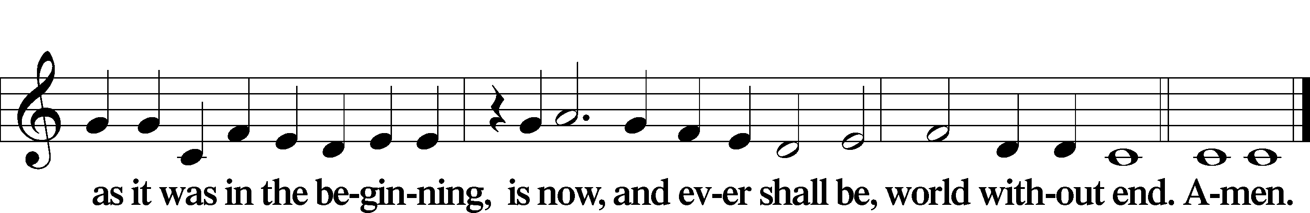

Kyrie LSB 186
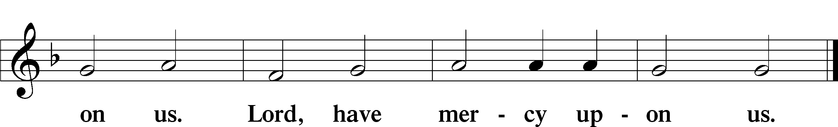
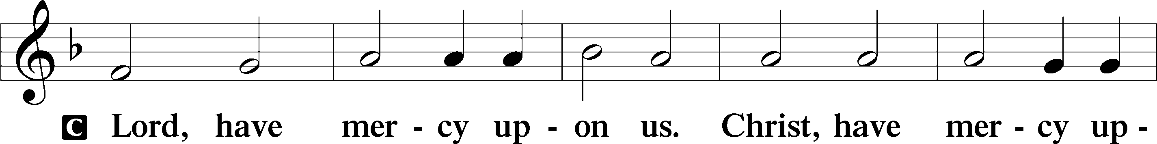

357 O Come, O Come, Emmanuel sts. ref, 4
4 O come, Thou Branch of Jesse’s tree,
Free them from Satan’s tyranny
That trust Thy mighty pow’r to save,
And give them vict’ry o’er the grave. Refrain
ref Rejoice! Rejoice! Emmanuel
Shall come to thee, O Israel!
Text: Latin, c. 12th cent.; Psalteriolum Cantionum Catholicarum, 1710, Köln; tr. John Mason Neale, 1818–66, alt. Text: Public domain

Salutation and Collect of the Day
P The Lord be with you.
C And with thy spirit.
P Let us pray.
Lord Jesus Christ, we implore You to hear our prayers and to lighten the darkness of our hearts by Your gracious visitation; for You live and reign with the Father and the Holy Spirit, one God, now and forever. C Amen.
Sit

Old Testament Reading Isaiah 35:1–10
¹The wilderness and the dry land shall be glad;
the desert shall rejoice and blossom like the crocus;
²it shall blossom abundantly
and rejoice with joy and singing.
The glory of Lebanon shall be given to it,
the majesty of Carmel and Sharon.
They shall see the glory of the Lord,
the majesty of our God.
³Strengthen the weak hands,
and make firm the feeble knees.
⁴Say to those who have an anxious heart,
“Be strong; fear not!
Behold, your God
will come with vengeance,
with the recompense of God.
He will come and save you.”
⁵Then the eyes of the blind shall be opened,
and the ears of the deaf unstopped;
⁶then shall the lame man leap like a deer,
and the tongue of the mute sing for joy.
For waters break forth in the wilderness,
and streams in the desert;
⁷the burning sand shall become a pool,
and the thirsty ground springs of water;
in the haunt of jackals, where they lie down,
the grass shall become reeds and rushes.
⁸And a highway shall be there,
and it shall be called the Way of Holiness;
the unclean shall not pass over it.
It shall belong to those who walk on the way;
even if they are fools, they shall not go astray.
⁹No lion shall be there,
nor shall any ravenous beast come up on it;
they shall not be found there,
but the redeemed shall walk there.
¹⁰And the ransomed of the Lord shall return
and come to Zion with singing;
everlasting joy shall be upon their heads;
they shall obtain gladness and joy,
and sorrow and sighing shall flee away.
P This is the Word of the Lord.
C Thanks be to God.

Gradual Zechariah 9:9; Psalm 118:26, alt.
Rejoice greatly, O daughter of | Zion.*
Shout aloud, O daughter of Je- | rusalem.
Behold, your king is com- | ing to you;*
righteous and having sal- | vation.
Blessèd is he who comes in the name | of the Lord.*
From the house of the Lord we | bless you.

Epistle James 5:7–11
⁷Be patient, therefore, brothers, until the coming of the Lord. See how the farmer waits for the precious fruit of the earth, being patient about it, until it receives the early and the late rains. ⁸You also, be patient. Establish your hearts, for the coming of the Lord is at hand. ⁹Do not grumble against one another, brothers, so that you may not be judged; behold, the Judge is standing at the door. ¹⁰As an example of suffering and patience, brothers, take the prophets who spoke in the name of the Lord. ¹¹Behold, we consider those blessed who remained steadfast. You have heard of the steadfastness of Job, and you have seen the purpose of the Lord, how the Lord is compassionate and merciful.
P This is the Word of the Lord.
C Thanks be to God.

Stand

Alleluia LSB 190
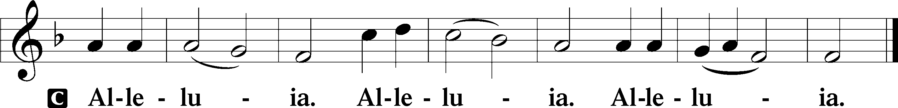

Holy Gospel Matthew 11:2–15
P The Holy Gospel according to St. Matthew, the eleventh chapter.
C Glory be to Thee, O Lord.
²When John heard in prison about the deeds of the Christ, he sent word by his disciples ³and said to him, “Are you the one who is to come, or shall we look for another?” ⁴And Jesus answered them, “Go and tell John what you hear and see: ⁵the blind receive their sight and the lame walk, lepers are cleansed and the deaf hear, and the dead are raised up, and the poor have good news preached to them. ⁶And blessed is the one who is not offended by me.”
⁷As they went away, Jesus began to speak to the crowds concerning John: “What did you go out into the wilderness to see? A reed shaken by the wind? ⁸What then did you go out to see? A man dressed in soft clothing? Behold, those who wear soft clothing are in kings’ houses. ⁹What then did you go out to see? A prophet? Yes, I tell you, and more than a prophet. ¹⁰This is he of whom it is written,
“‘Behold, I send my messenger before your face,
who will prepare your way before you.’
¹¹Truly, I say to you, among those born of women there has arisen no one greater than John the Baptist. Yet the one who is least in the kingdom of heaven is greater than he. ¹²From the days of John the Baptist until now the kingdom of heaven has suffered violence, and the violent take it by force. ¹³For all the Prophets and the Law prophesied until John, ¹⁴and if you are willing to accept it, he is Elijah who is to come. ¹⁵He who has ears to hear, let him hear.”
P This is the Gospel of the Lord.
C Praise be to Thee, O Christ.

Nicene Creed
C I believe in one God,
the Father Almighty,
maker of heaven and earth
and of all things visible and invisible
And in one Lord Jesus Christ,
the only-begotten Son of God,
begotten of His Father before all worlds,
God of God, Light of Light,
very God of very God,
begotten, not made,
being of one substance with the Father,
by whom all things were made;
who for us men and for our salvation came down from heaven
and was incarnate by the Holy Spirit of the virgin Mary
and was made man;
and was crucified also for us under Pontius Pilate.
He suffered and was buried.
And the third day He rose again according to the Scriptures
and ascended into heaven
and sits at the right hand of the Father.
And He will come again with glory to judge both the living and the dead,
whose kingdom will have no end.
And I believe in the Holy Spirit,
the Lord and giver of life,
who proceeds from the Father and the Son,
who with the Father and the Son together is worshiped and glorified,
who spoke by the prophets.
And I believe in one holy Christian and apostolic Church,
I acknowledge one Baptism for the remission of sins,
and I look for the resurrection of the dead
and the life T of the world to come. Amen.

Sit

346 When All the World Was Cursed
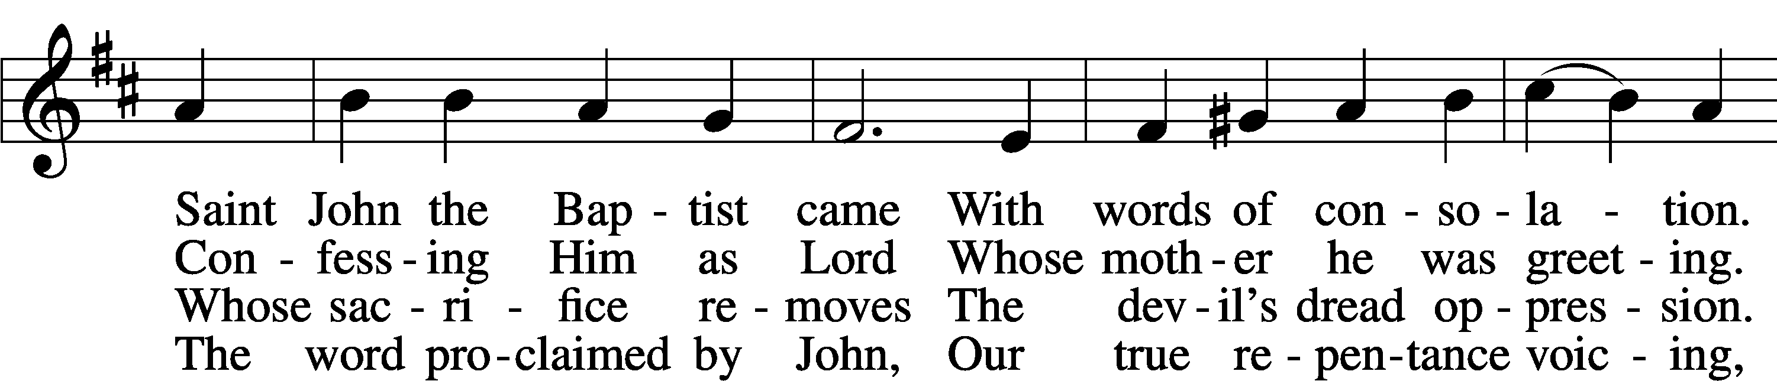
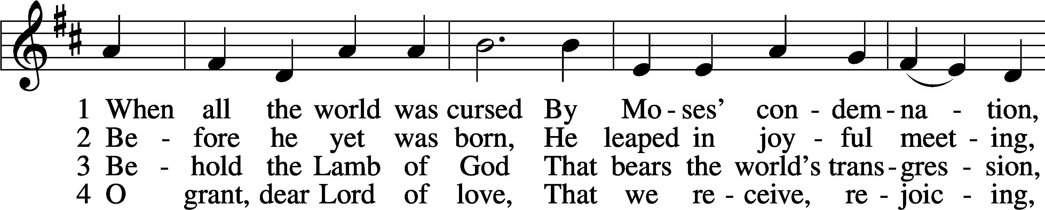

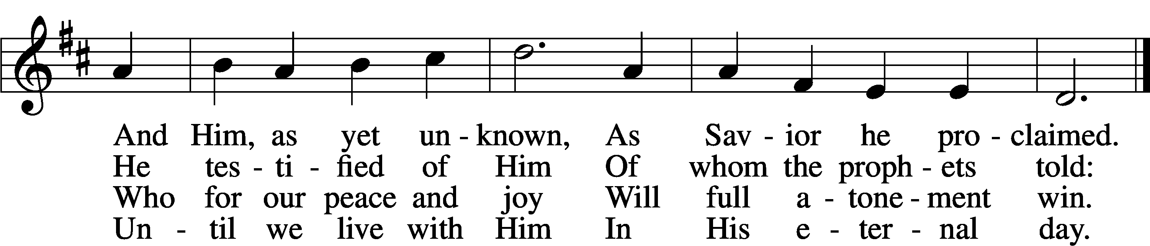
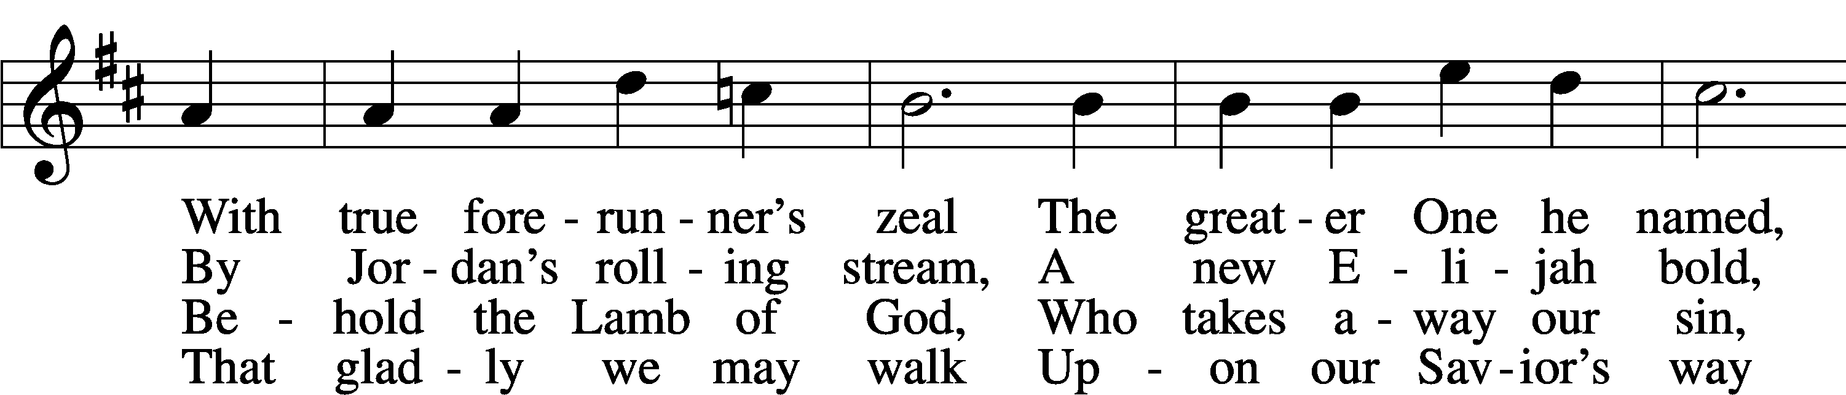

Text: Johann Gottfried Olearius, 1635–1711; tr. Paul E. Kretzmann, 1883–1965, alt. Tune: Ahasverus Fritsch, 1629–1701
Text: © 1941 Concordia Publishing House. Used by permission: LSB Hymn License no. 110003744 Tune: Public domain

Sermon

Stand

Offertory LSB 192
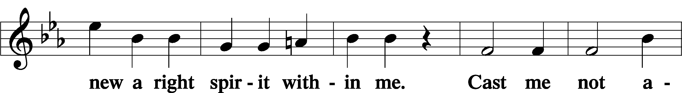
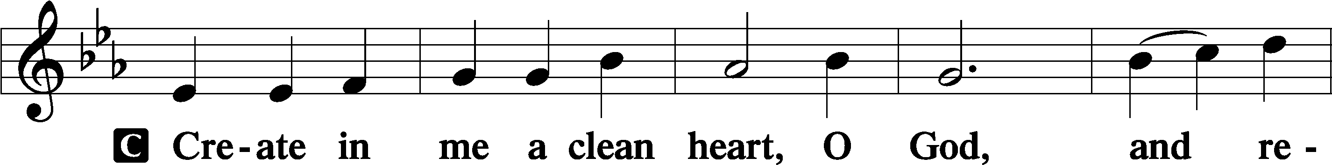

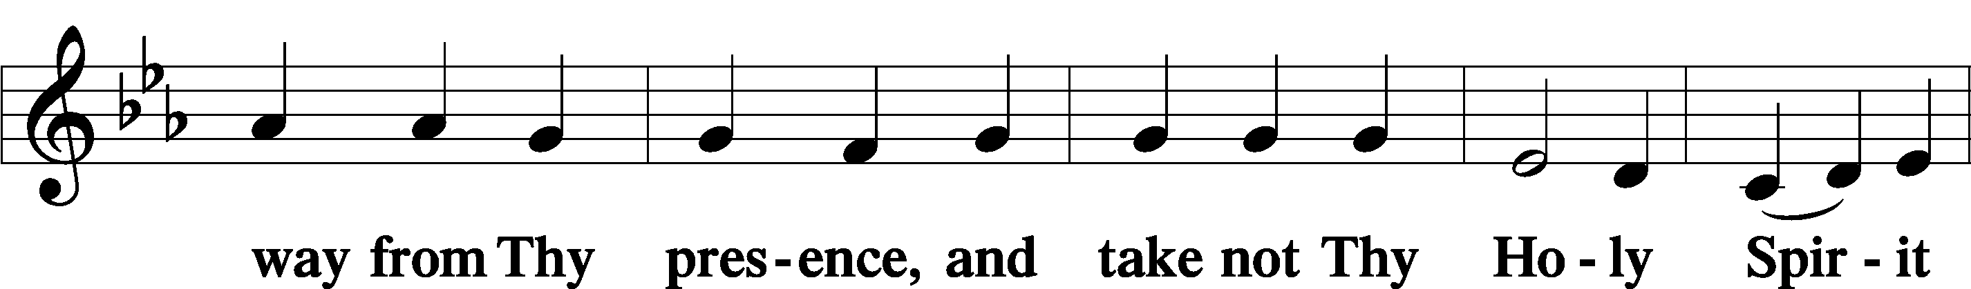

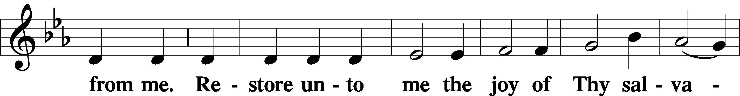

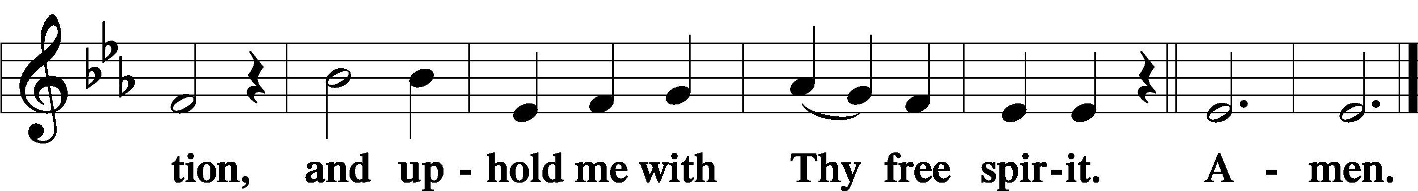

Prayer of the Church

Sit

Consecration of the Offering
After the prayers please be seated. The altar is set for the Lord’s Supper and the offering is consecrated. As you prepare to receive the sacrament you may use the prayers in the front of the hymnal or meditate on a communion hymn.

Stand
Service of the Sacrament
Preface LSB 194
P The Lord be with you.
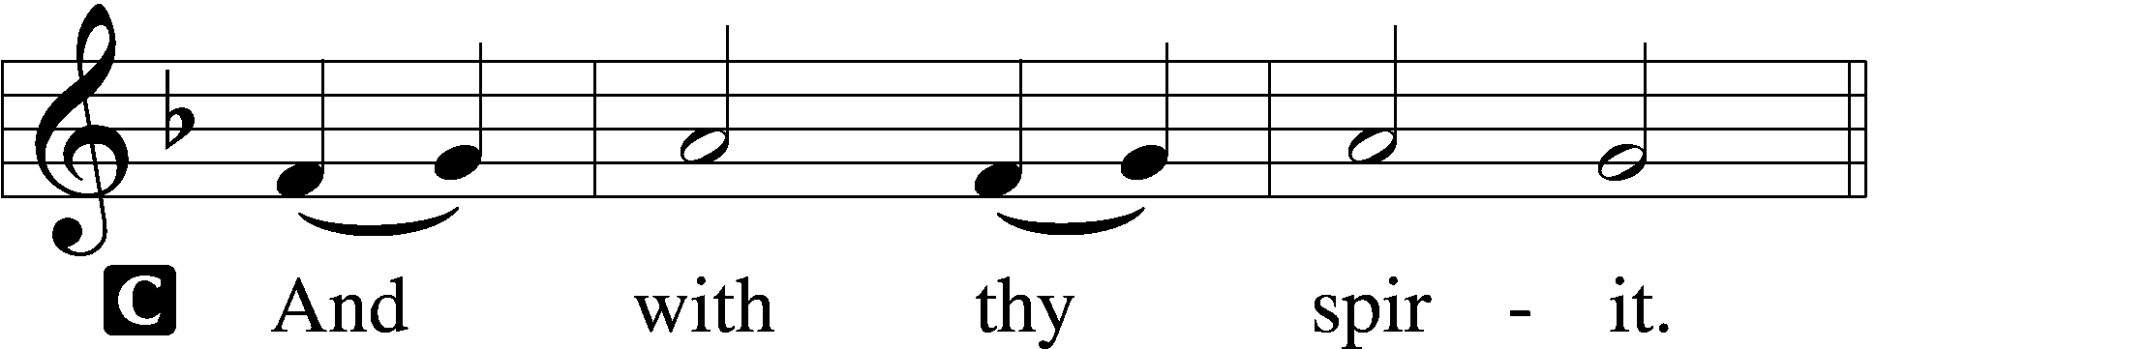
P Lift up your hearts.
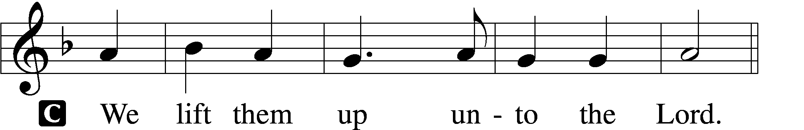

P Let us give thanks unto the Lord, our God.
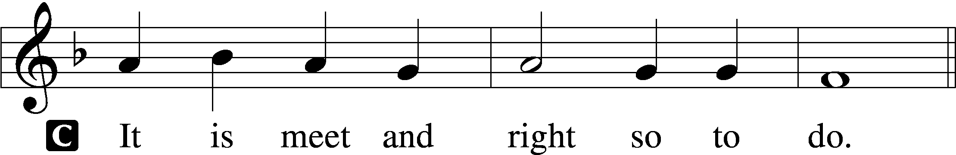

P It is truly meet, right, and salutary that we should at all times and in all places give thanks to You, holy Lord, almighty Father, everlasting God, through Jesus Christ, our Lord, whose way John the Baptist prepared, proclaiming Him the promised Messiah, the very Lamb of God who takes away the sin of the world, and calling sinners to repentance that they might escape from the wrath to be revealed when He comes again in glory. Therefore with angels and archangels and with all the company of heaven we laud and magnify Your glorious name, evermore praising You and saying:

Sanctus LSB 195
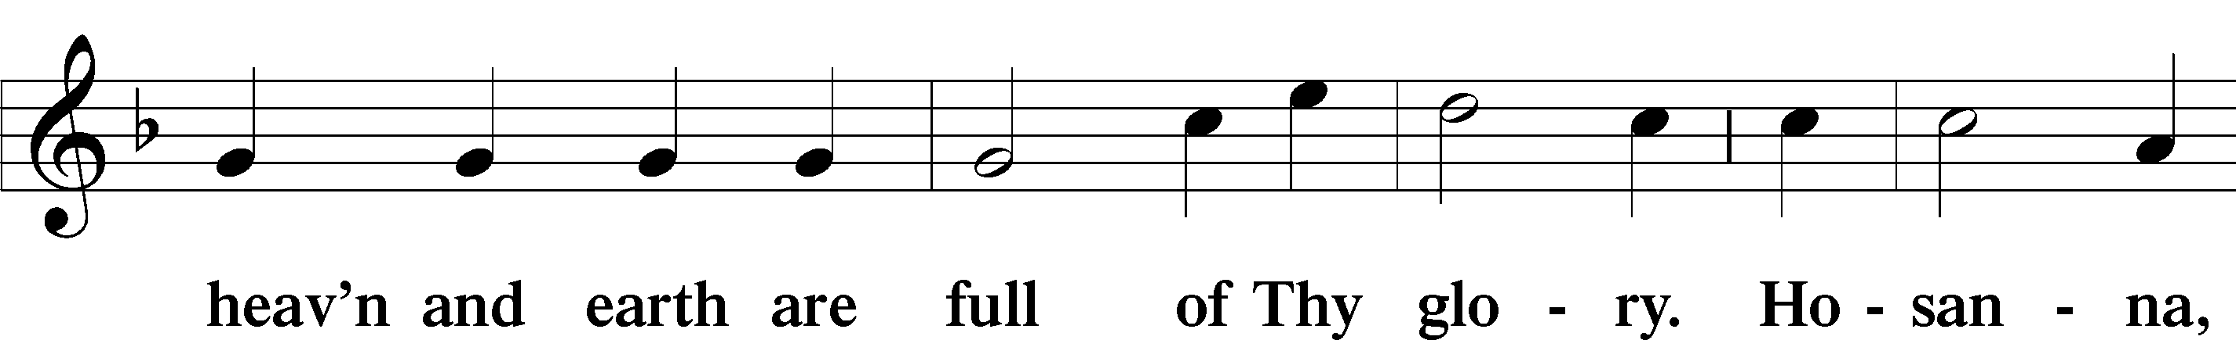
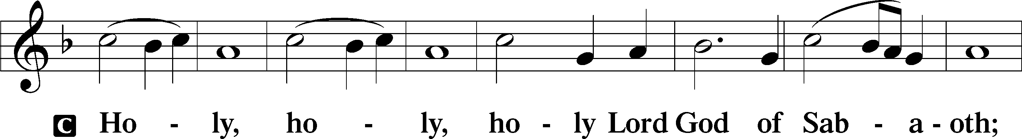

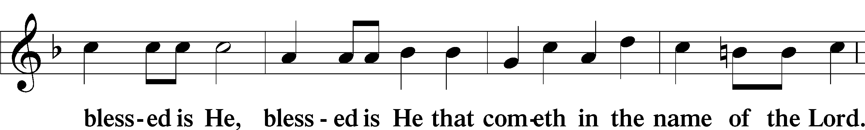
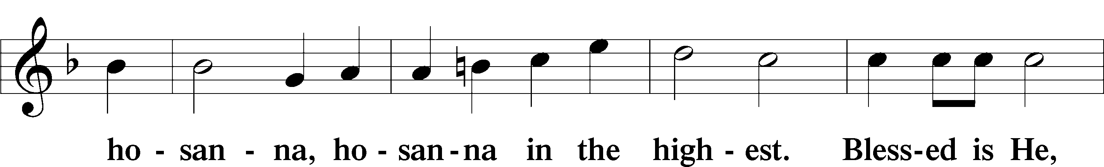

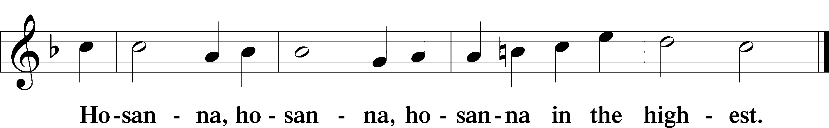

Lord’s Prayer
C Our Father who art in heaven,
hallowed be Thy name,
Thy kingdom come,
Thy will be done on earth
as it is in heaven;
give us this day our daily bread;
and forgive us our trespasses
as we forgive those
who trespass against us;
and lead us not into temptation,
but deliver us from evil.
For Thine is the kingdom
and the power and the glory
forever and ever. Amen.

The Words of Our Lord
P Our Lord Jesus Christ, on the night when He was betrayed, took bread, and when He had given thanks, He broke it and gave it to the disciples and said: “Take, eat; this is My T body, which is given for you. This do in remembrance of Me.”
In the same way also He took the cup after supper, and when He had given thanks, He gave it to them, saying: “Drink of it, all of you; this cup is the new testament in My T blood, which is shed for you for the forgiveness of sins. This do, as often as you drink it, in remembrance of Me.”

Pax Domini LSB 197
P The peace of the Lord be with you always.
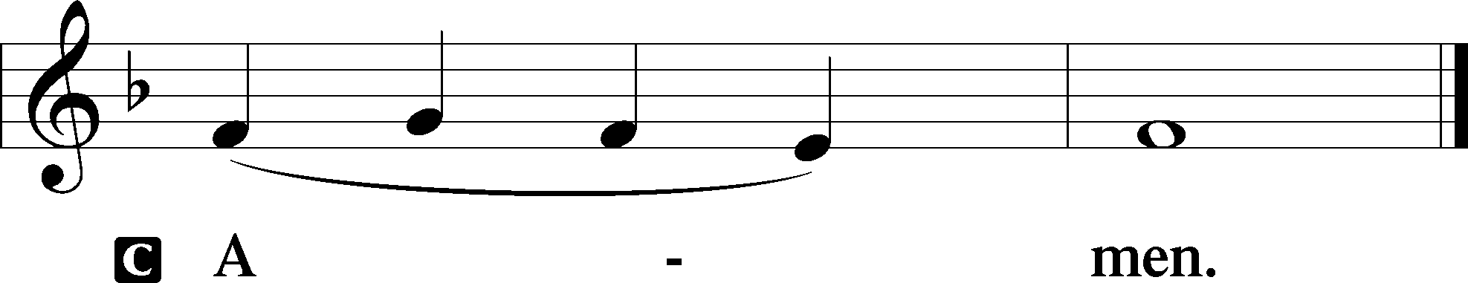

Agnus Dei LSB 198
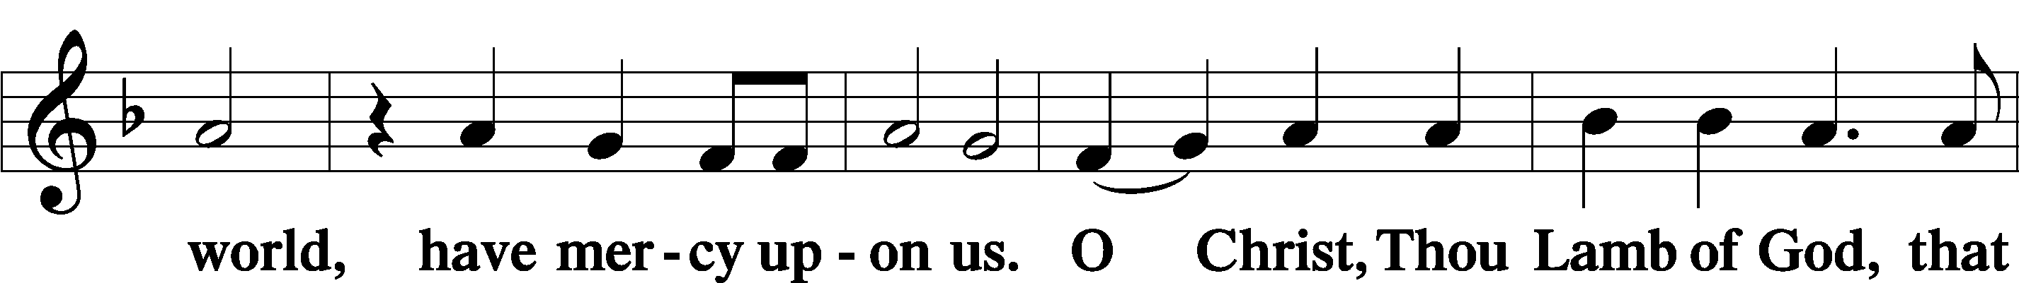
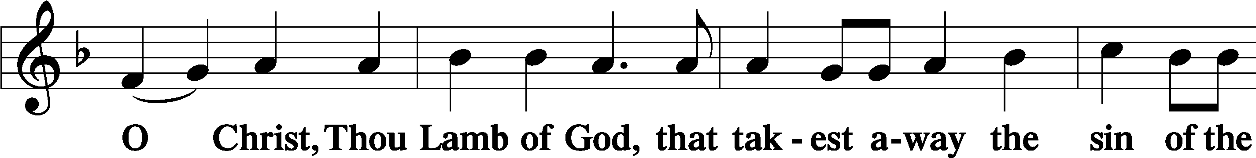

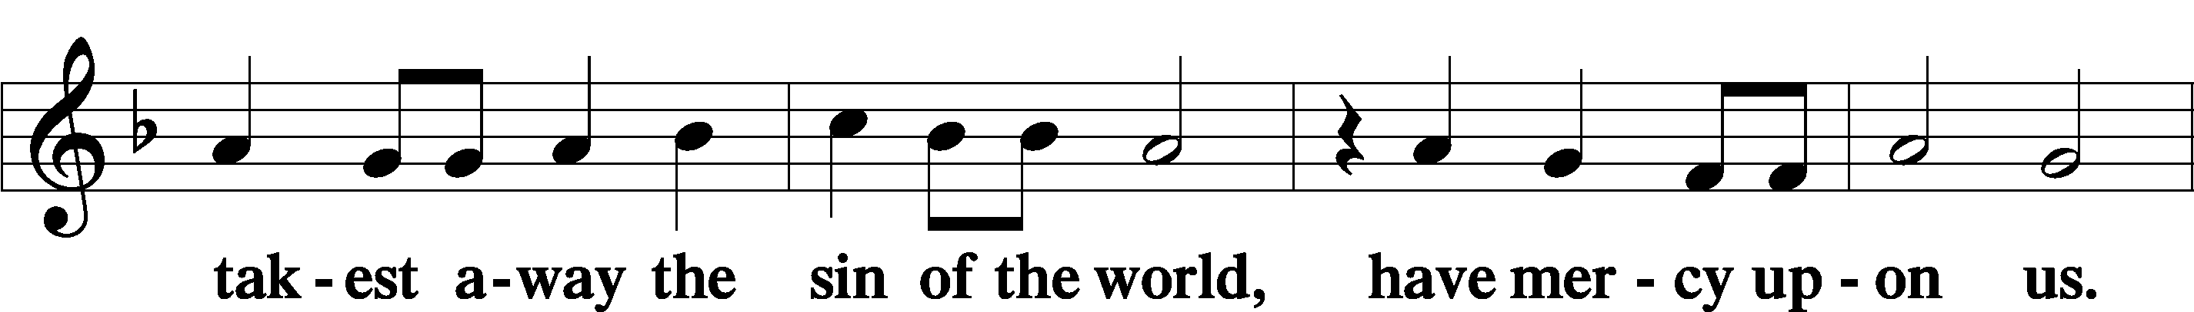

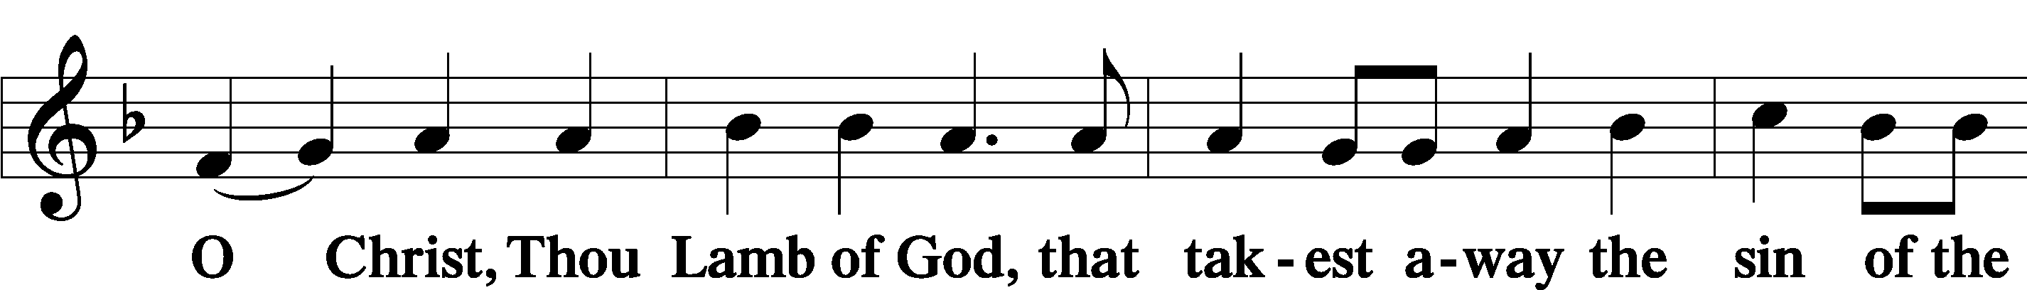

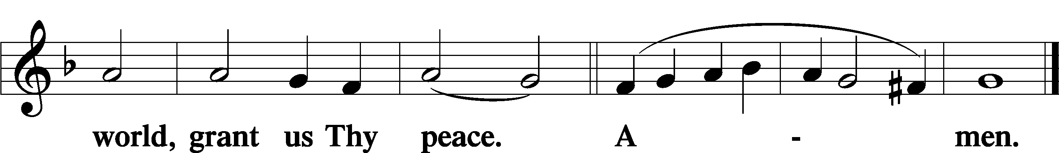

Sit

Distribution

“Joseph’s Song” – written by Michael McLean Solo by Don Richmond

He was working in his garden
With the wood he knew so well
Though at first she couldn’t tell.
A strange sadness welled inside
When she asked, “Aren’t you the
father of the man they crucified?”
Then the carpenter responded,
As he had so many times
He said, “I was not his father,
He was mine”.

Then he humbly went on working
With his worn and callused hands
And though she did not understand,
So he asked if she could help him,
He saw her answer in a glance
And she did the things he asked her,
And was happy for the chance
And they talked for hours of Jesus,
And how he knew He was divine
He said I was not his father,
He was mine.

How could one so foolish and so flawed
Ever hope to raise the Son of God
And he spoke of his misgivings
That he’d had a thousand times,
How Jesus found the tender moments
To let him know he’d done just fine
And the carpenter recounted
The greatest truths he’d ever learned
And testified they came from Jesus,
And her heart within her burned
They embraced as she departed
Joseph told her one more time
Tell them I was not His father,
Tell them He was mine…
No, I was not His father, He was mine.

333 Once He Came in Blessing
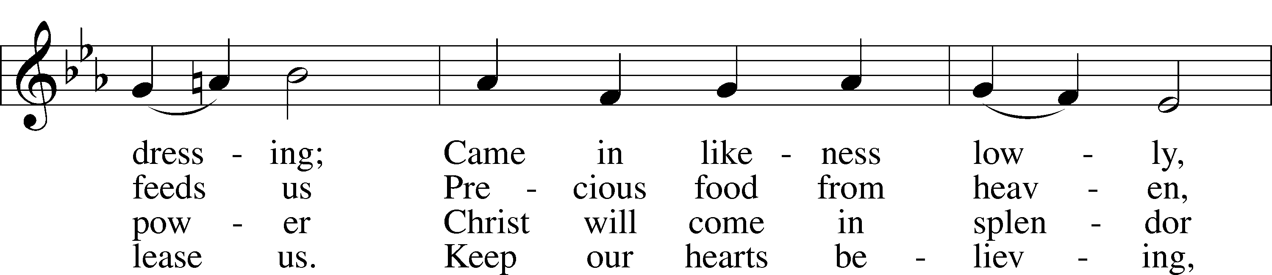
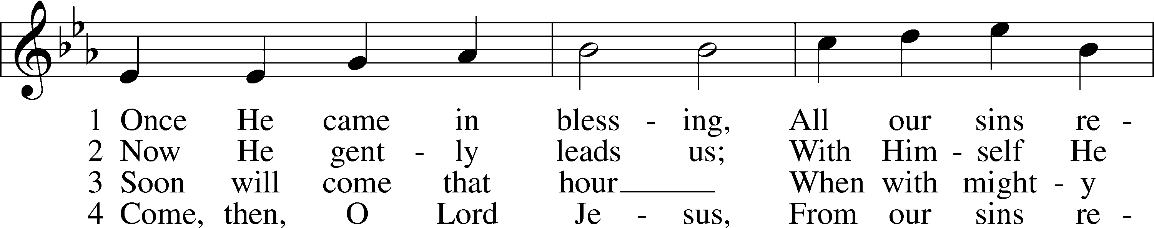

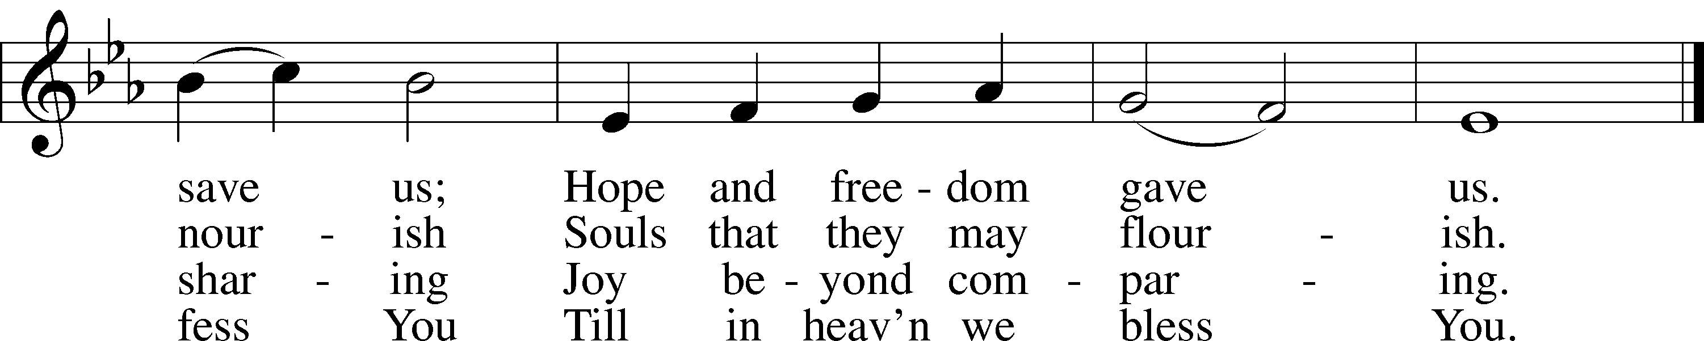
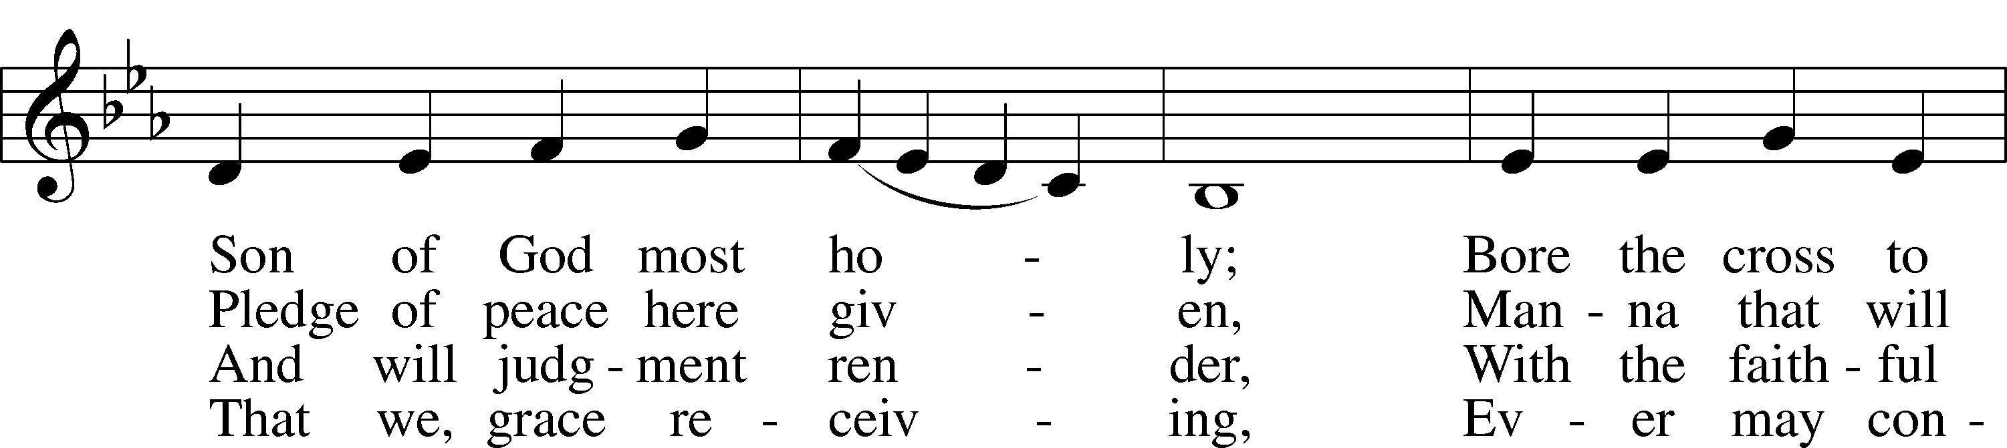

Text: Johann Horn, c. 1490–1547; (sts. 1, 4): tr. Catherine Winkworth, 1827–78, alt.; (sts. 2–3): tr. Lutheran Service Book, 2006 Tune: Michael Weisse, c. 1480–1534 Text (sts. 2–3): © 2006 Concordia Publishing House. Used by permission: LSB Hymn License no. 110003744 Text (sts. 1, 4) and tune: Public domain

624 The Infant Priest Was Holy Born
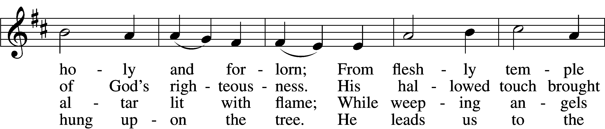
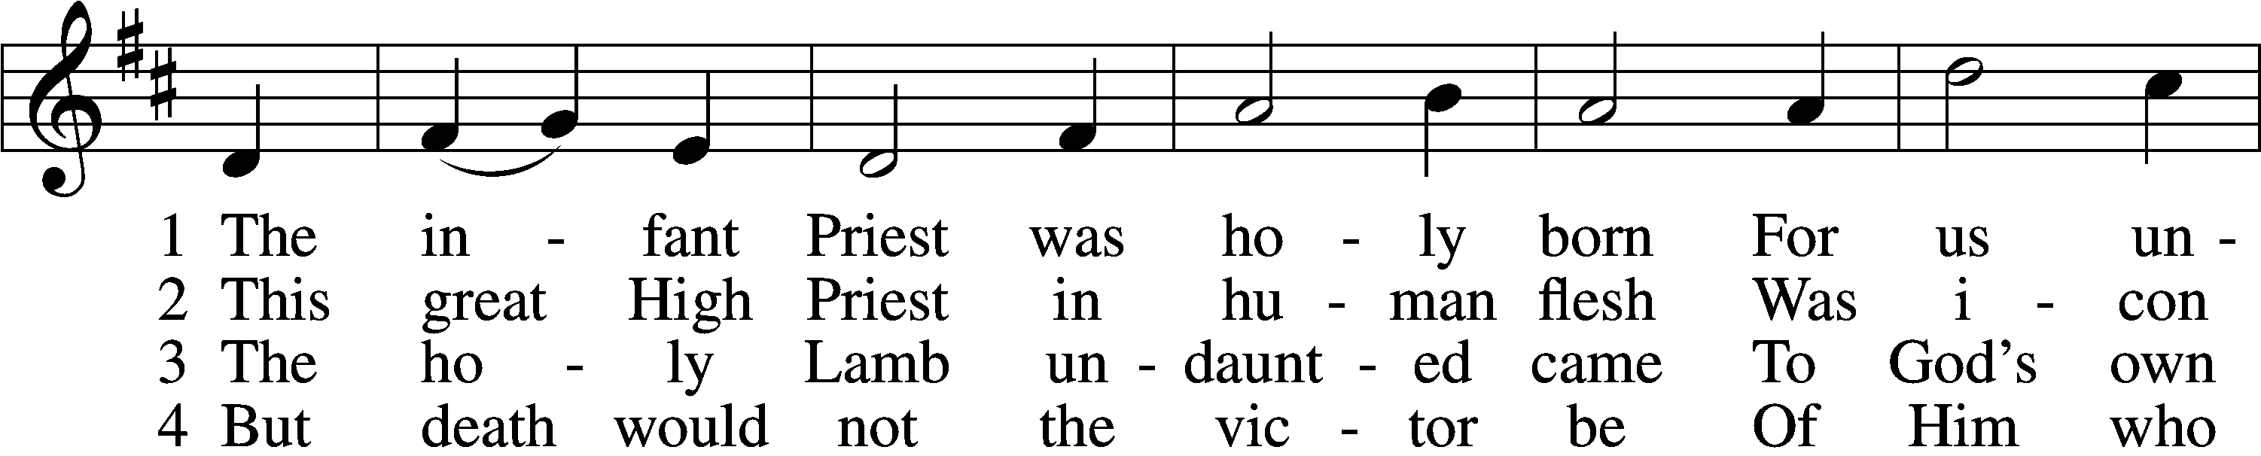

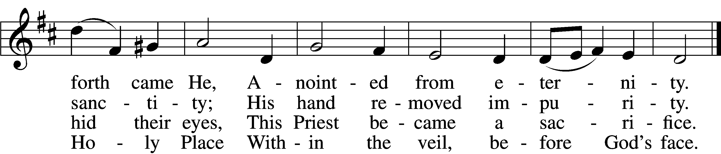

5 The veil is torn, our Priest we see,
As at the rail on bended knee
Our hungry mouths from Him receive
The bread of immortality.

6 The body of God’s Lamb we eat,
A priestly food and priestly meat;
On sin-parched lips the chalice pours
His quenching blood that life restores.

7 With cherubim and seraphim
Our voices join the endless hymn,
And “Holy, holy, holy” sing
To Christ, God’s Lamb, our Priest and King.
Text: Chad L. Bird, 1970 Tune: Second Supplement to Psalmody in Miniature, 1778, London; adapt. Edward Miller, 1731–1807 Text: © 1997, 2003 Chad L. Bird. Used by permission: LSB Hymn License no. 110003744 Tune: Public domain
334 O Lord, How Shall I Meet You
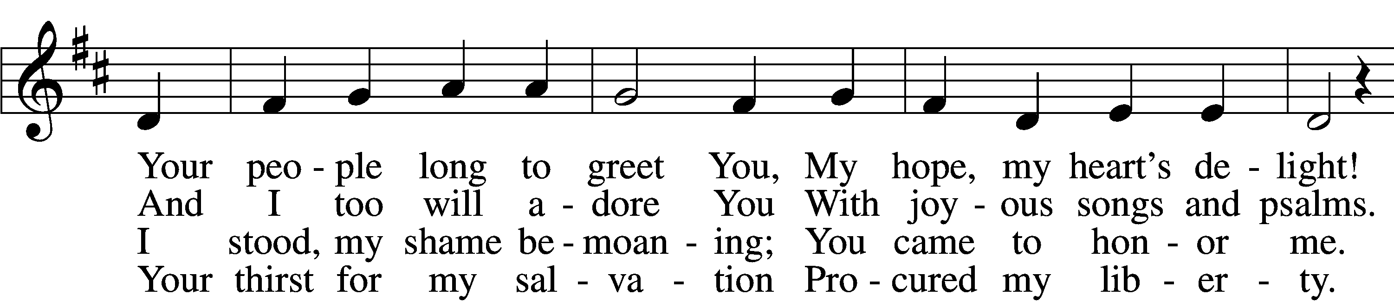
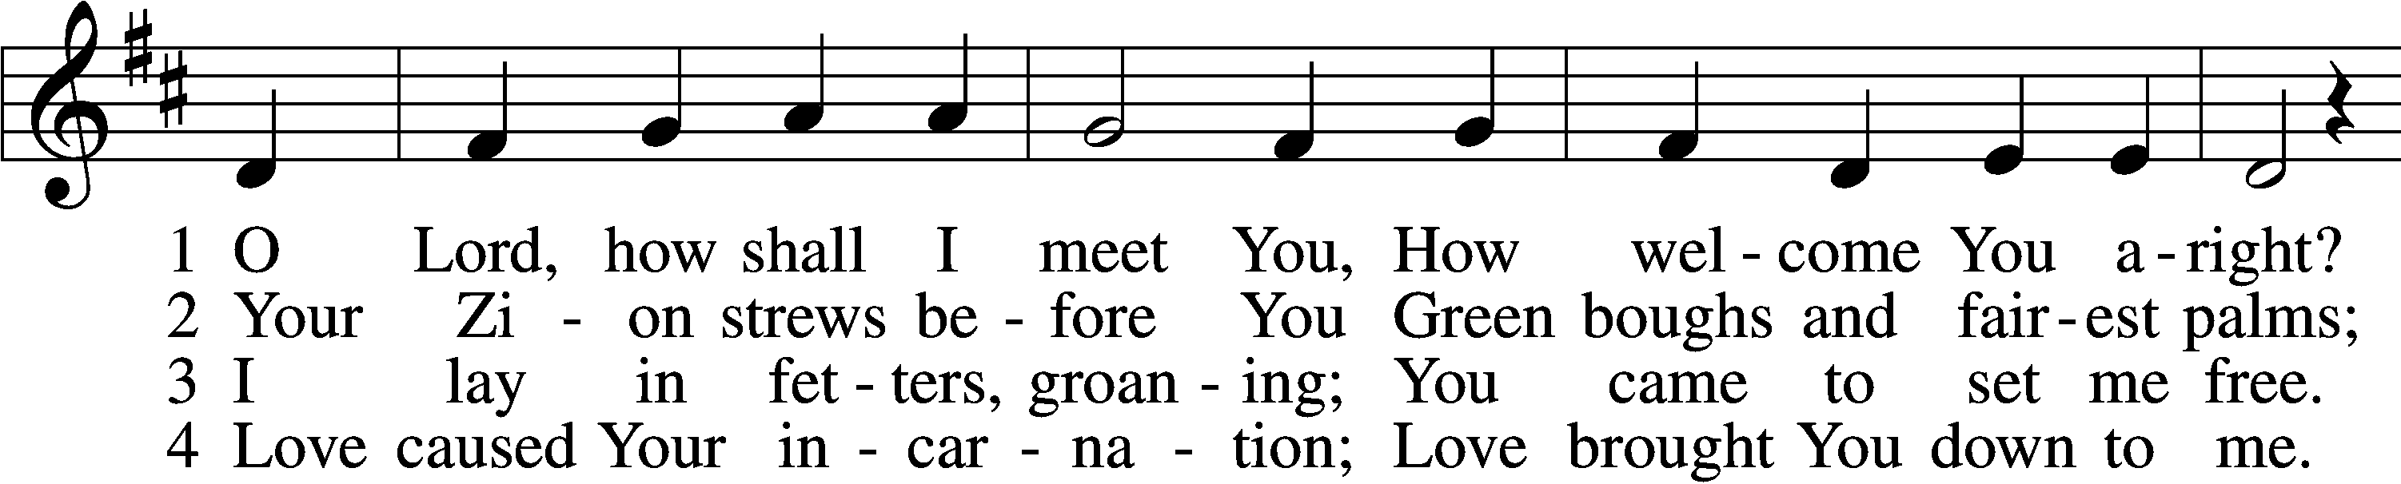

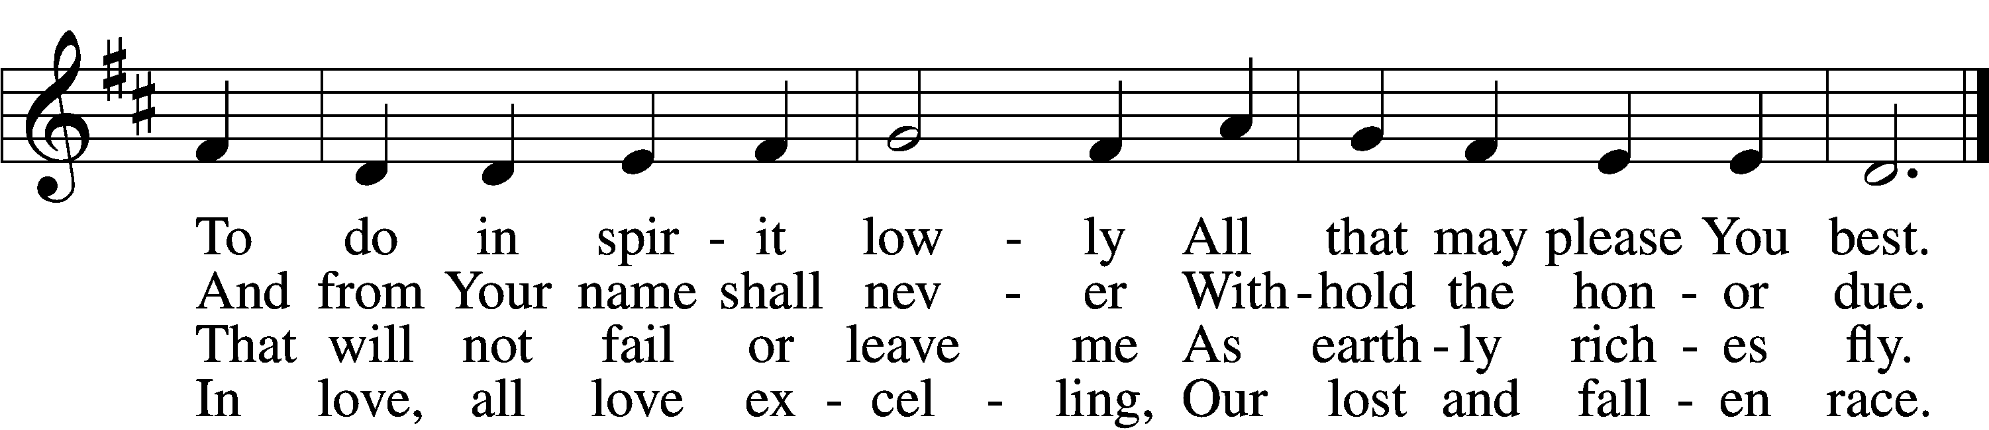
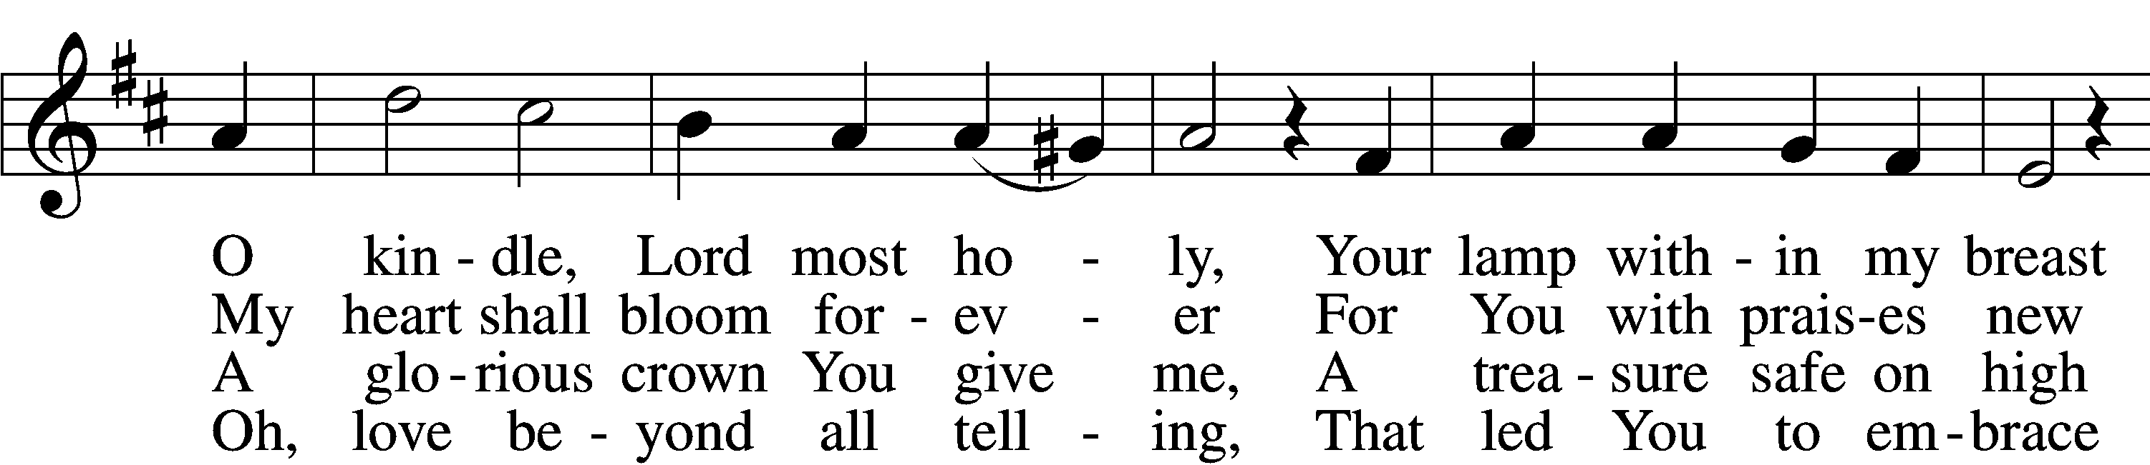

5 Sin’s debt, that fearful burden,
Cannot His love erase;
Your guilt the Lord will pardon
And cover by His grace.
He comes, for you procuring
The peace of sin forgiv’n,
His children thus securing
Eternal life in heav’n.
6 He comes to judge the nations,
A terror to His foes,
A light of consolations
And blessèd hope to those
Who love the Lord’s appearing.
O glorious Sun, now come,
Send forth Your beams so cheering,
And guide us safely home.

Text: Paul Gerhardt, 1607–76; tr. The Lutheran Hymnal, 1941, alt. Tune: Johann Crüger, 1598–1662 Text and tune: Public domain
632 O Jesus, Blessed Lord, to Thee
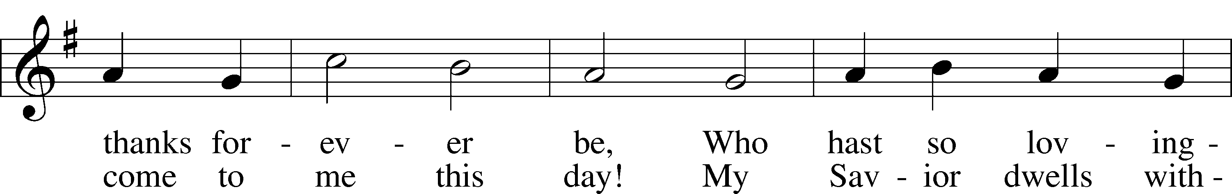
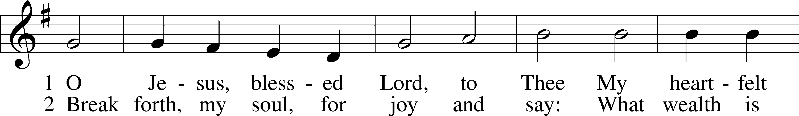

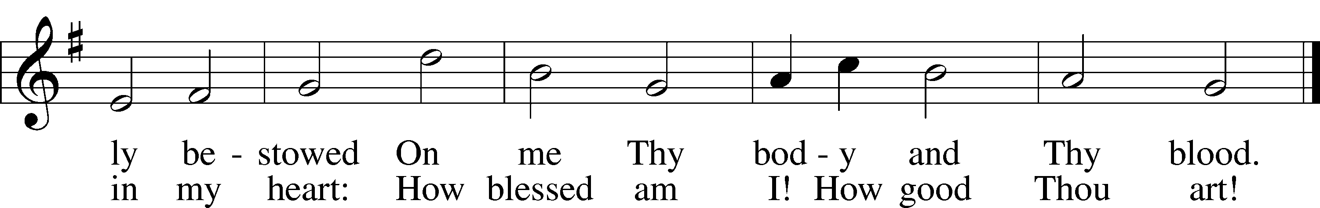

Text: Thomas Hansen Kingo, 1634–1703; tr. Arthur J. Mason, 1851–1928 Tune: Trente quatre Pseaumes de David, 1551, Geneva, ed. Louis Bourgeois Text and tune: Public domain
The Dismissal
P The body and blood of our Lord Jesus Christ strengthen and preserve you in body and soul to life everlasting. Depart T in peace.
C Amen.

Stand

Nunc Dimittis LSB 199
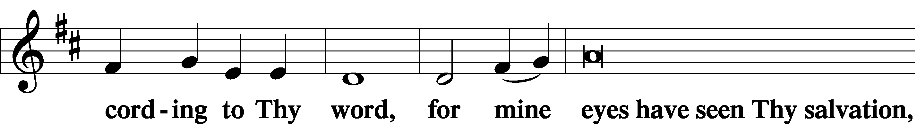
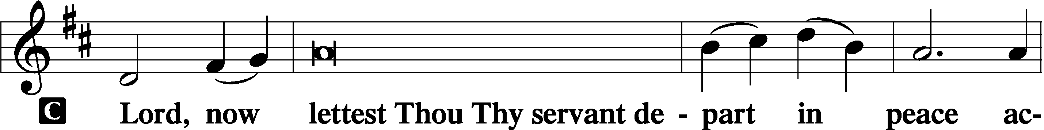

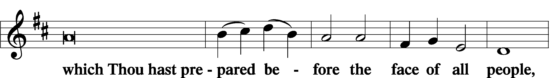

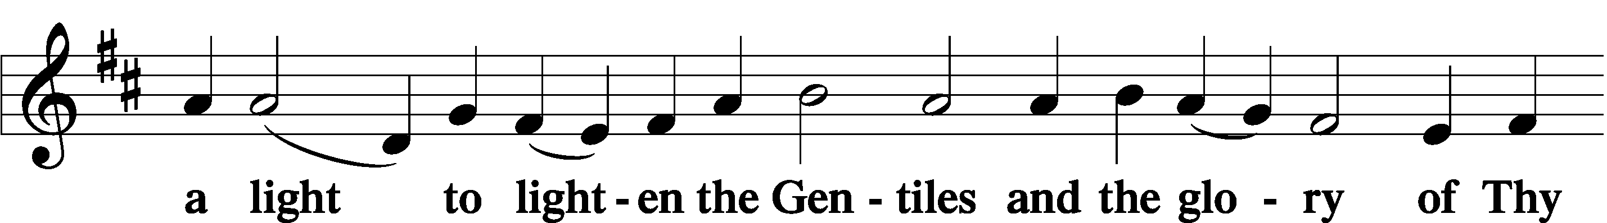

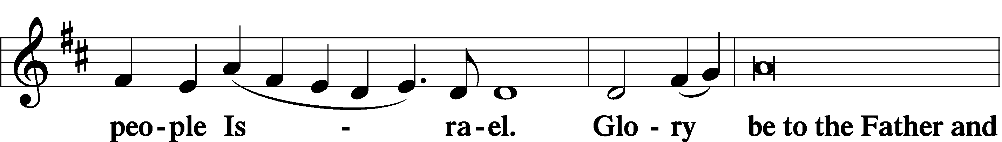

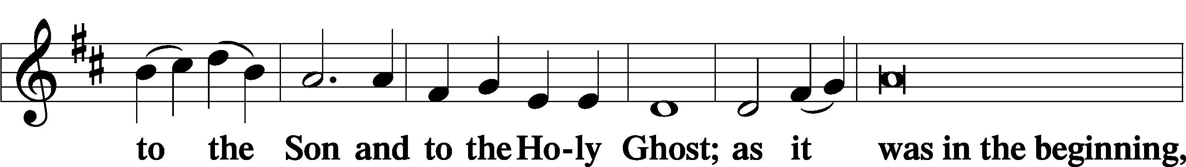

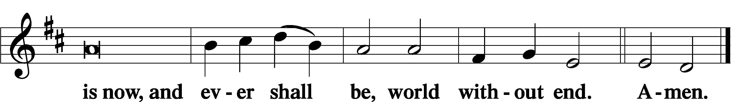

Thanksgiving LSB 200
P O give thanks unto the Lord, for He is good,
C and His mercy endureth forever.
P Let us pray.
O God the Father, the fountain and source of all goodness, who in loving-kindness sent Your only-begotten Son into the flesh, we thank You that for His sake You have given us pardon and peace in this Sacrament, and we ask You not to forsake Your children but always to rule our hearts and minds by Your Holy Spirit that we may be enabled constantly to serve You; through Jesus Christ, Your Son, our Lord, who lives and reigns with You and the Holy Spirit, one God, now and forever.
C Amen.

P The Lord be with you.
C And with thy spirit.
Benedicamus LSB 202
P Bless we the Lord.
C Thanks be to God.

Benediction LSB 202
P The Lord bless you and keep you.
The Lord make His face shine upon you and be gracious unto you.
The Lord lift up His countenance upon you and T give you peace.
C Amen, amen, amen.

338 Come, Thou Long-Expected Jesus
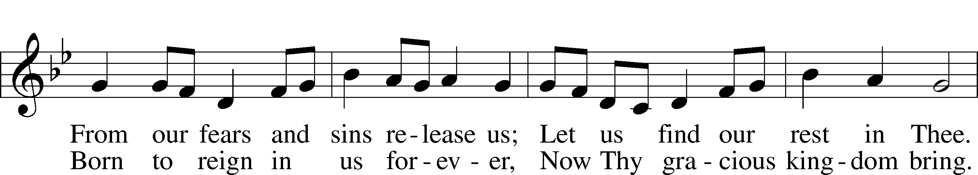
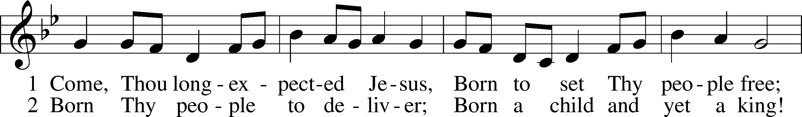

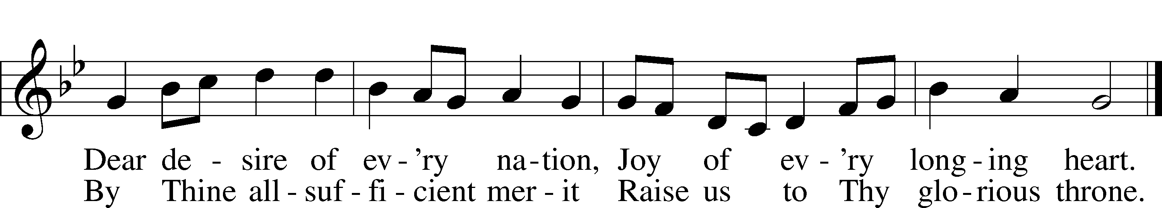
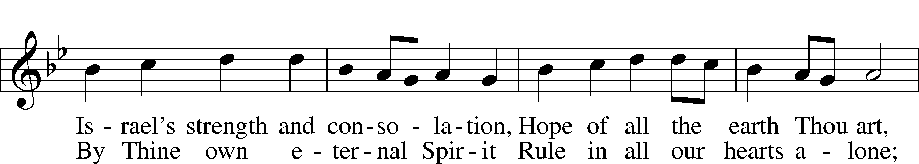

Text: Charles Wesley, 1707–88, alt. Tune: Southern Harmony, 1835, New Haven Text and tune: Public domain
Acknowledgments
Unless otherwise indicated, Scripture quotations are from the ESV® Bible (The Holy Bible, English Standard Version®), copyright © 2001 by Crossway, a publishing ministry of Good News Publishers. Used by permission. All rights reserved.
Created by Lutheran Service Builder © 2021 Concordia Publishing House.

Prayers for Our Members
Norman Abels (Brookestone Meadows–Elkhorn) | Healing
Judy Ahrens | Healing
Vaughn Albrecht (Mount Carmel) | Healing
Tom & DyAnn Altwine | Healing
Lyle Colsden (Mother Hull) | Healing
Pat Flodine (Cambridge Court) | Healing
Vi Fox (Prairie View) | Healing
Wanda Glanzer | Healing
Jan Hatfield | Healing
Ruby Hatfield | Healing
Evelyn Heiden (Mother Hull) | Healing
Linda Luhn | Healing
Diane Plummer | Healing
Debra Schinkel | Healing
Don Trampe | Healing
Robin Baker | Cancer
Ivan Bombeck | Cancer
Bertha Marienau | Cancer
Prayers for Our Members’ Family & Friends
Lana Fattig (Eric’s wife) | Expecting
Roger Young (Tiffany Davis’ father) | Parkinson’s
Greg Blum (Junge Family Friend) | Healing
Elaine de la Motte (Carol Herron’s sister-in-law) | Healing
Deb Engles (Lorelie’s sister) | Healing
Paul Hanneman (Lorelie’s brother) | Healing
Roger Hoffman (Marc’s father) | Healing
Joshua Junge (Steve’s nephew) | Healing
Luetta Lammers (Ruby Hatfield’s sister) | Healing
LeRoyce Margaritz (brother of Wanda Glanzer) | Healing
Tim Powers (Kim Wilken’s brother) | Healing
Howard Quandt (Don & Shirley Helmbrecht’s family) | Healing
Aaron Russell (Becky Thornton’s son-in-law) | Healing
David & Carol Shiers (Jessica’s parents) | Healing
Rev. Richard Snow (Nebraska District President) | Healing
Pat Snyder (Carol Herron’s friend) | Healing
Randy Solomon (Beth Rosenthal’s father) | Healing
Jonah (Jase & Jarren Blattner’s friend) | Cancer
Glenda Fichtner (Ruby Hatfield’s niece) | Cancer
Ron Halvorsen (Jeff’s dad) | Cancer
Sharon Mulhair (Pam Uhlir’s cousin) | Cancer
Milton Naprstek (Marilyn Fuqua’s brother) | Cancer
Cindy Pietsch (Ellen Koopman’s sister-in-law) | Cancer
Rick Schnacker (Marilyn Fuqua’s nephew) | Cancer
Tyrone Uhlir (Pam’s nephew) | Cancer
Ray Vang (Don & Shirley Helmbrecht’s brother-in-law) | Cancer

Response to the Gospel
Date: 12/4/2022
Offering: $12,158.30
Weekly Need: $7,500
Offering Options:
To worship the Lord with your offering:
1) Place your offering in the offering plate as you enter or leave.
2) Go to zionkearney.churchtrac.com/give
3) Go to zionkearney.com and click on the ChurchTrac icon
4) Mail your gift to Zion Lutheran Church, 2421 C Ave, Kearney, NE 68847 or place it in the mail slot on the south side of the building.
Today’s Radio Broadcast is sponsored by Elaine Stuehm,
in memory of Lavern.

Worship Assistants

Sunday, December 11th – 9:00am
Elder: Dan Oertwig  Acolyte: Jase Blattner  Announcer: Lonna Gronewoller | Usher: Mike Wilkens  Engineer: Jared Nuttelman  Altar Guild: Beth Rosenthal  & Shirley Helmbrecht
Wednesday, December 14th – 7:00pm
Elder: Dan Oertwig  Acolyte: Eli Randolph | Usher: Steve Junge  Engineer: Eric Rosenthal  Altar Guild: Beth Rosenthal  & Shirley Helmbrecht
Sunday, December 18th – 9:00am
Elder: Ken Hockemeier  Acolyte: Colton Zehendner  Announcer: Carol Kreutzer | Usher: Andy Wollberg  Engineer: Jamie Nikodym  Altar Guild: Beth Rosenthal  & Shirley Helmbrecht

ZION LUTHERAN CHURCH AND SCHOOL

Pr. James DeLoach, Pastor + (308) 627-5260
james.deloach@zionkearney.org
Pr. Doug Gaunt, Pastor + (308) 455-0552
doug.gaunt@zionkearney.org
Tony Splittgerber, Principal + (308) 293-0168
anthony.splittgerber@zionkearney.org

Church Office
Administrative Assistant: Holly Reid
Email: school@zionkearney.org
Phone: (308)-234-3410 Fax: (308) 236-8100
Office Hours: Monday-Friday 8:00am-4:00pm
Radio Broadcast: Sunday @ 10:30 a.m. on 1460 AM
Website: www.zionkearney.com
This Week at Zion
Sun 12/11 | 9:00a  10:30a  10:30a  4:00p  6:00p | Divine Service  Adult Bible Study & Sunday School  Radio Broadcast  1460AM & 92.1FM  K-8 Christmas Program  Divine Service
Mon 12/12 | 12:00p  7:00p | Sr. Citizens Potluck  Mary Martha
Tues 12/13 | 1:30p  7:00p | Sleeping Mats  Bd of Ed  Bd of Elders  Bd of Trustees
Wed 12/14 | 8:30a  5:30p  5:30p  7:00p  8:00p  Birthdays | Chapel  Advent Meal  Midweek Class  Advent Service  Adult Choir  Vaughn Albrecht
Thurs 12/15 | 6:00p | Men’s Bible Class & Meal
Fri 12/16
Sat 12/17 | 9a-10:30a  1p-5p  Birthdays | Christmas Eve Service Practice  Hockemeier Gym/FH  Marion Richmond  Judy Tadlock
Sun 12/18 | 9:00a  10:30a  10:30a  5:00p  Anniversaries | Divine Service  Adult Bible Study & Sunday School  Radio Broadcast  1460AM & 92.1FM  Divine Service  Eric & Beth Rosenthal

Announcements for December 11th, 2022

Advent Meal and Worship: The meal will start at 5:30p and will be served by the Board of Ed. Worship will begin at 7:00p. We will be doing an Advent series on the Apostle’s Creed. Advent is about God graciously coming to humanity and the Apostle’s Creed as Luther has taught us perfectly articulates this.

Men’s Bible Class & Meal: The Men’s Bible Class will be having a holiday dinner this Thursday at 6:00p in the Fellowship Hall. The dinner will consist of smoked brisket, salads, hors d’oeuvres and dessert. There are sign-up sheets in the narthex and at the office. This will give us an idea of how much food we will need.

Christmas Eve, 7pm: "Jesus Christ -- The Bread of Life"
We hear the answer to the question: "Why was the baby Jesus laid in a manger on the night he was born?" A manger is a feed trough and he's the Bread of Life. We will hear how the Old Testament uses bread to foretell of Jesus' coming.

The Festival of Christmas Day, 10am (Special Time!):
"O Jesus Christ, Thy Manger Is"
Join us on the morning when we celebrate the Incarnation of Jesus Christ and ponder that the Bread of Life was born in Bethlehem--"The House of Bread." Jesus is God's Bread from heaven, who comes to us today in His Holy Word and in the Blessed Feast of His Body and Blood given under bread and wine.

Ark Encounter Trip: Pastor DeLoach would like to make arrangements for a group of Zion’s members to visit the Ark Encounter and the Creation Museum sometime in late May or early June. The Ark Encounter features a full-size Noah’s Ark, built according to the dimensions given in the Bible. Please give Pastor your name and number if you are interested in this trip. You can text or email him or you can put your information on an attendance card and give it to him after the service. Thank you!

Missions Information Director: Zion needs someone to help publicize the name, nature and needs of the many mission projects and workers that we support at various times of the church year. If you are willing and able to help, this please contact Pastor DeLoach.
Bible Reading Cards: A new set of Bible reading cards for the new year can be picked up in the church entryway. Each card is a tool to keep track of your Bible reading progress as you mark each chapter you have read in 2022. God works through His word.

Radio Broadcast & Altar Flowers: The sign-up sheets for the 2023 radio broadcasts and flowers are on the bulletin board by the mailboxes. If you want a certain date, sign up ASAP.

Annual Food Collection: We have had a great start to our food collection! We will also accept toiletries, cleaning products, paper items, as well as items that cannot be purchased with food stamps. If you are able to gather the items and take them to the Jubilee center, contact the office.
SCHOOL NEWS

Extra Pies: There are plenty of extra pies left over from our sale. Contact the office for availability and pricing.

Christmas Program: Zion Lutheran School will host its annual Christmas service on Sunday, Dec. 11. We expect a very full house at our Sunday service, so we are also opening up our Friday, Dec. 9 (12:30) dress rehearsal for congregation members and other friends that would like to attend. Please join us if you can!

