Divine Service

Fourth Sunday in Advent

December 18th, 2022
Zion Lutheran Church
Kearney, Nebraska
Welcome to Zion!
Guests please record your attendance on a card in the pew rack and let us know how we can be of service to you.

Holy Communion at Zion

The Lord’s Supper is celebrated at this congregation as Jesus has given it. As he says, our Lord gives into our mouths not only bread and wine but his very body and blood to eat and to drink for the forgiveness of sins and to strengthen our union with him and with one another. Our Lord invites to his table those who trust his words, repent of all sin, and set aside any refusal to forgive and love as he forgives and loves us, that they may show forth his death until he comes. All communicants need to register in the narthex prior to the service.

Because those who eat and drink our Lord’s body and blood unworthily do so to their great harm and because Holy Communion is a confession of the faith which is confessed at this altar, any who are not yet instructed, in doubt, or who hold a confession differing from that of this congregation and The Lutheran Church—Missouri Synod, are asked not to commune until they are able to speak with our pastor first. He is happy to visit with you about the Christian faith and how to receive the Lord’s Supper for your good and for the good of others. Those not communing are invited to come to the altar, cross your arms in front of you, and bow your head to receive a pastoral blessing.

God’s Word Is Fulfilled for Us in the Flesh
and Blood of Christ Jesus, the Son of Mary

The Fourth Sunday in Advent turns our attention toward the Nativity of Our Lord. With the blessed Virgin Mary, we await the coming of the Christ, her Son, conceived in her womb by the Word and Spirit of God. This fulfillment of the sign once given to the house of David, that “the virgin shall conceive and bear a son” (Is. 7:14), is now given to us in the Gospel. It declares that salvation is by His grace alone, entirely His work and a free gift. It also is the way and means by which the Lord our God is Immanuel, “God with us.” The almighty and eternal Son of God is conceived and born of Mary, and is thus “descended from David according to the flesh” (Rom. 1:3–4). He comes in this way to save us with His own flesh and blood; wherefore, He is called “Jesus, for he will save his people from their sins” (Matt. 1:21). As Joseph received this sign in faith and immediately “did as the angel of the Lord commanded him” (Matt. 1:24), we also live by faith in this Holy Gospel.
357 O Come, O Come, Emmanuel
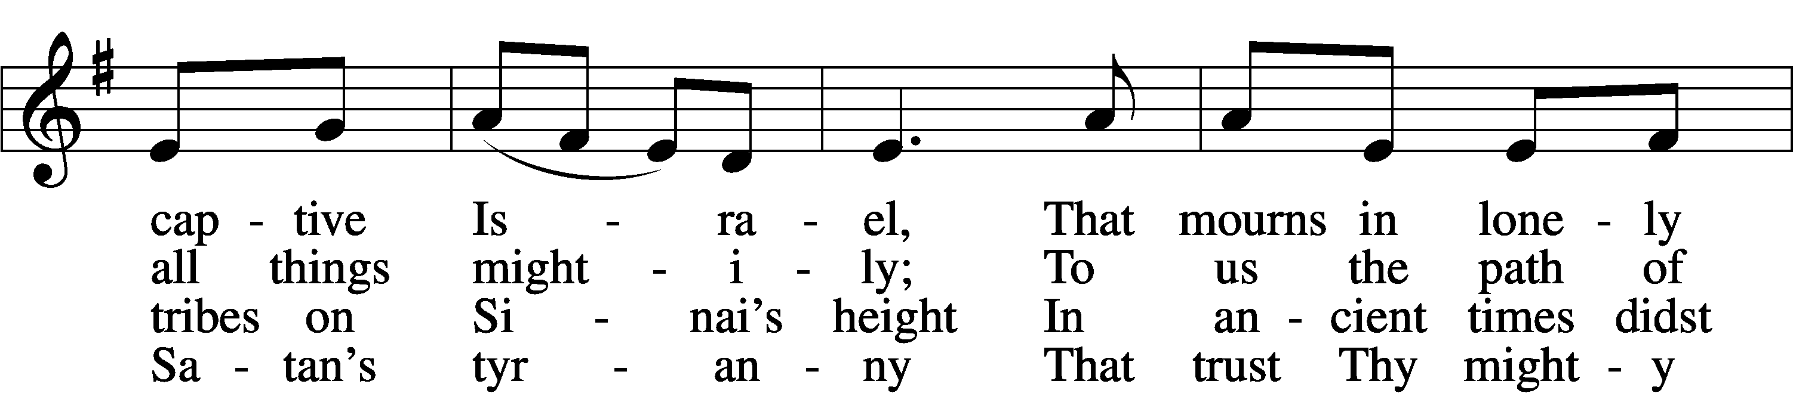
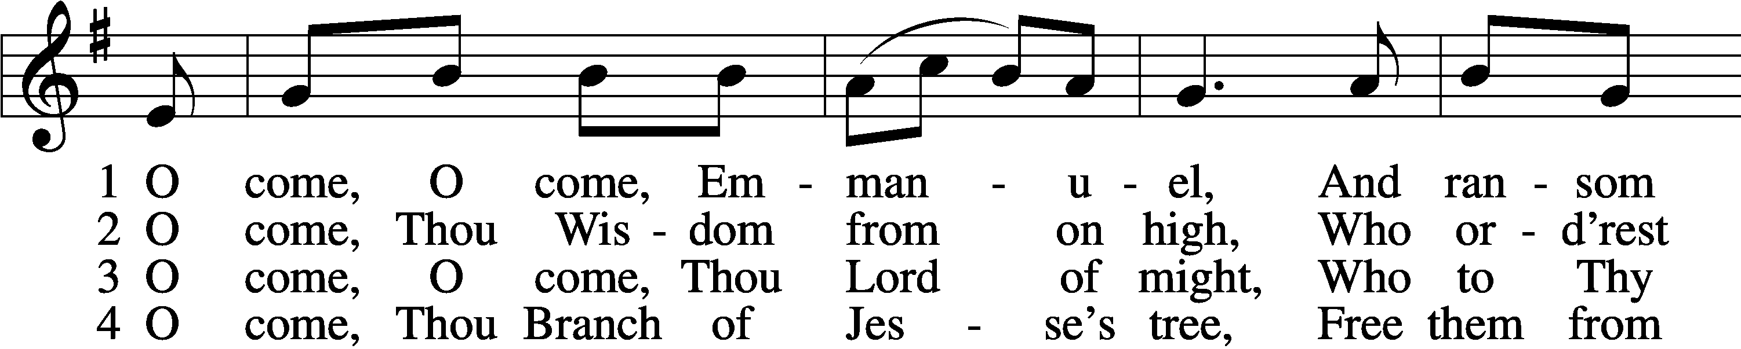

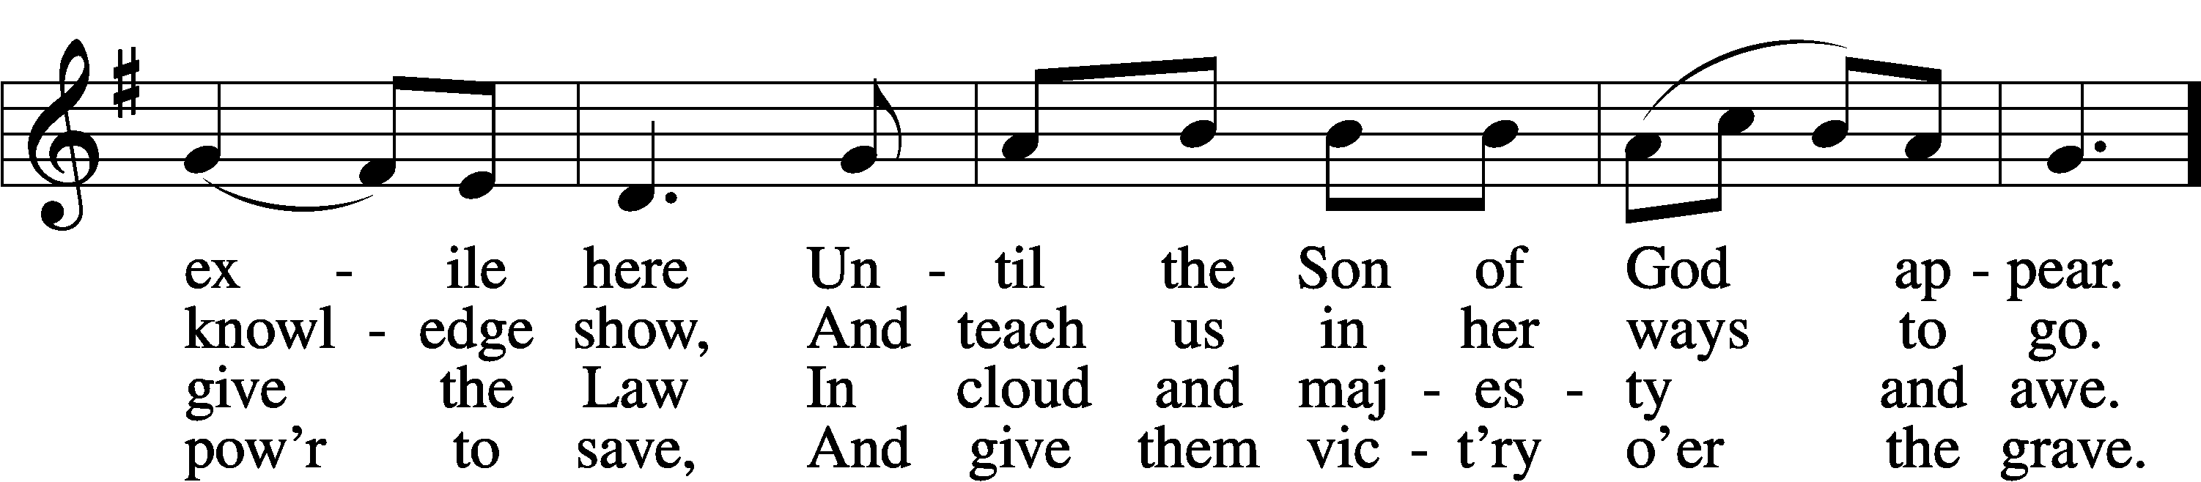

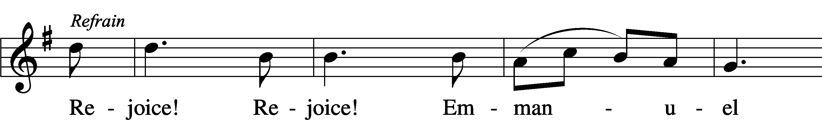

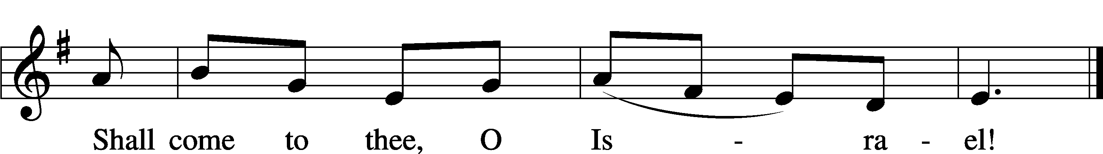

5 O come, Thou Key of David, come,
And open wide our heav’nly home;
Make safe the way that leads on high,
And close the path to misery. Refrain

6 O come, Thou Dayspring from on high,
And cheer us by Thy drawing nigh;
Disperse the gloomy clouds of night,
And death’s dark shadows put to flight. Refrain

7 O come, Desire of nations, bind
In one the hearts of all mankind;
Bid Thou our sad divisions cease,
And be Thyself our King of Peace. Refrain
Text: Latin, c. 12th cent.; Psalteriolum Cantionum Catholicarum, 1710, Köln; tr. John Mason Neale, 1818–66, alt.Tune: French, 15th cent.
Text and tune: Public domain

Stand

Invocation LSB 184
P In the name of the Father and of the T Son and of the Holy Spirit.
C Amen.

P Our help is in the name of the Lord,
C who made heaven and earth.
P I said, I will confess my transgressions unto the Lord,
C and You forgave the iniquity of my sin.

Silence for reflection on God’s Word and for self-examination.

P O almighty God, merciful Father,
C I, a poor, miserable sinner, confess unto You all my sins and iniquities with which I have ever offended You and justly deserved Your temporal and eternal punishment. But I am heartily sorry for them and sincerely repent of them, and I pray You of Your boundless mercy and for the sake of the holy, innocent, bitter sufferings and death of Your beloved Son, Jesus Christ, to be gracious and merciful to me, a poor, sinful being.

Absolution LSB 185
P Upon this your confession, I, by virtue of my office, as a called and ordained servant of the Word, announce the grace of God unto all of you, and in the stead and by the command of my Lord Jesus Christ I forgive you all your sins in the name of the Father and of the T Son and of the Holy Spirit.
C Amen.

Introit Psalm 130:5–8; antiphon: Isaiah 64:1
Oh that you would rend the heavens | and come down,*
that the mountains might quake at your | presence.
I wait for the Lord, my | soul waits,*
and in his | word I hope;
my soul waits for the Lord more than watchmen for the | morning,*
more than watchmen for the | morning.
O Israel, hope in the Lord! For with the Lord there is | steadfast love,*
and with him is plentiful re- | demption.
And he will redeem | Israel*
from all his in- | iquities.
Oh that you would rend the heavens | and come down,*
that the mountains might quake at your | presence.

Gloria Patri LSB 186
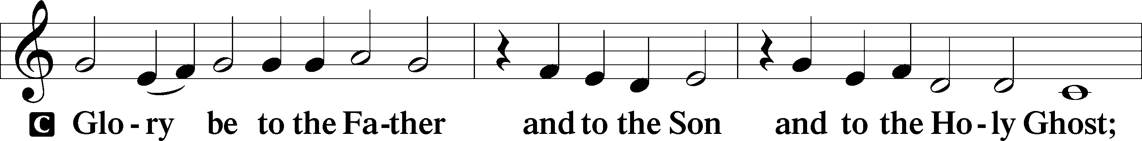

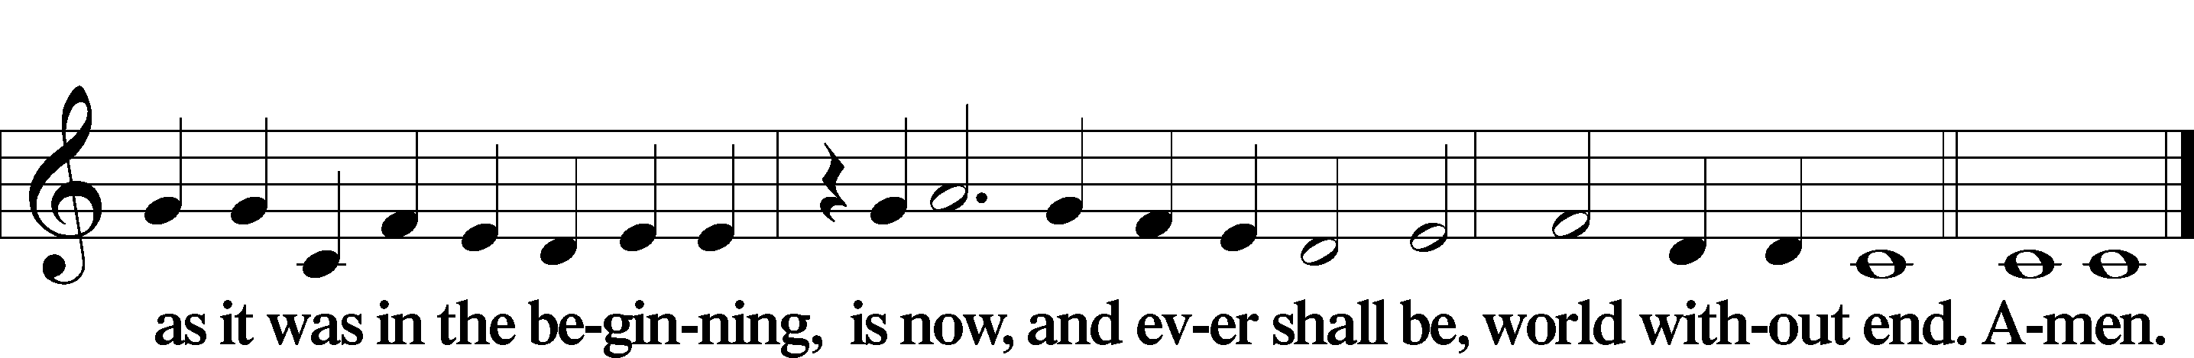

Kyrie LSB 186
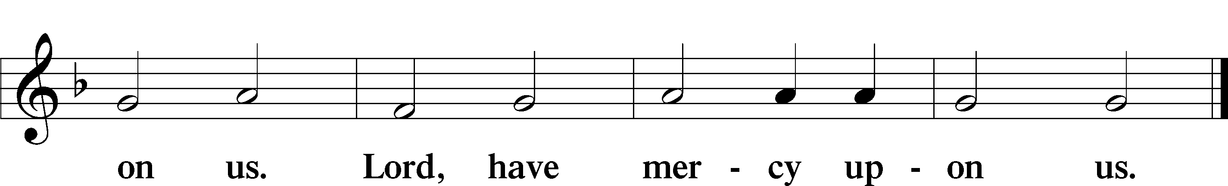
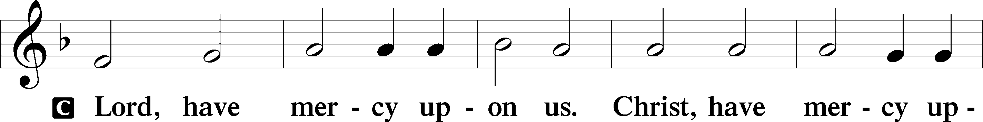

O Come, O Come, Emmanuel sts. 1, ref
1 O come, O come, Emmanuel,
And ransom captive Israel,
That mourns in lonely exile here
Until the Son of God appear. Refrain
ref Rejoice! Rejoice! Emmanuel
Shall come to thee, O Israel!
Text: Latin, c. 12th cent.; Psalteriolum Cantionum Catholicarum, 1710, Köln; tr. John Mason Neale, 1818–66, alt.Text: Public domain

Salutation and Collect of the Day
P The Lord be with you.
C And with thy spirit.
P Let us pray.
Stir up Your power, O Lord, and come and help us by Your might, that the sins which weigh us down may be quickly lifted by Your grace and mercy; for You live and reign with the Father and the Holy Spirit, one God, now and forever.
C Amen.

Sit

Old Testament Reading Isaiah 7:10–17
¹⁰Again the Lord spoke to Ahaz, ¹¹“Ask a sign of the Lord your God; let it be deep as Sheol or high as heaven.” ¹²But Ahaz said, “I will not ask, and I will not put the Lord to the test.” ¹³And he said, “Hear then, O house of David! Is it too little for you to weary men, that you weary my God also? ¹⁴Therefore the Lord himself will give you a sign. Behold, the virgin shall conceive and bear a son, and shall call his name Immanuel. ¹⁵He shall eat curds and honey when he knows how to refuse the evil and choose the good. ¹⁶For before the boy knows how to refuse the evil and choose the good, the land whose two kings you dread will be deserted. ¹⁷The Lord will bring upon you and upon your people and upon your father’s house such days as have not come since the day that Ephraim departed from Judah—the king of Assyria.”
P This is the Word of the Lord.
C Thanks be to God.

Gradual Zechariah 9:9; Psalm 118:26, alt.
Rejoice greatly, O daughter of | Zion.*
Shout aloud, O daughter of Je- | rusalem.
Behold, your king is com- | ing to you;*
righteous and having sal- | vation.
Blessèd is he who comes in the name | of the Lord.*
From the house of the Lord we | bless you.

Epistle Romans 1:1–7
¹Paul, a servant of Christ Jesus, called to be an apostle, set apart for the gospel of God, ²which he promised beforehand through his prophets in the holy Scriptures, ³concerning his Son, who was descended from David according to the flesh ⁴and was declared to be the Son of God in power according to the Spirit of holiness by his resurrection from the dead, Jesus Christ our Lord, ⁵through whom we have received grace and apostleship to bring about the obedience of faith for the sake of his name among all the nations, ⁶including you who are called to belong to Jesus Christ,
⁷To all those in Rome who are loved by God and called to be saints:
Grace to you and peace from God our Father and the Lord Jesus Christ.
P This is the Word of the Lord.
C Thanks be to God.

Stand

Alleluia LSB 190
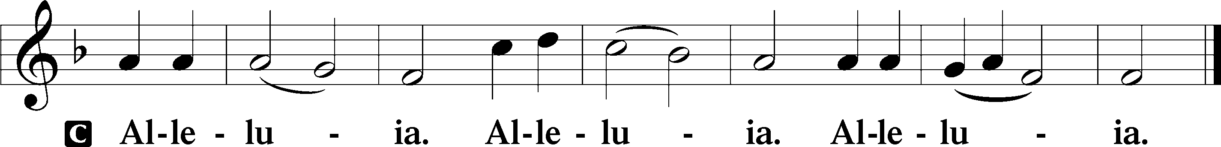

Holy Gospel Matthew 1:18–25
P The Holy Gospel according to St. Matthew, the first chapter.
C Glory be to Thee, O Lord.
¹⁸Now the birth of Jesus Christ took place in this way. When his mother Mary had been betrothed to Joseph, before they came together she was found to be with child from the Holy Spirit. ¹⁹And her husband Joseph, being a just man and unwilling to put her to shame, resolved to divorce her quietly. ²⁰But as he considered these things, behold, an angel of the Lord appeared to him in a dream, saying, “Joseph, son of David, do not fear to take Mary as your wife, for that which is conceived in her is from the Holy Spirit. ²¹She will bear a son, and you shall call his name Jesus, for he will save his people from their sins.” ²²All this took place to fulfill what the Lord had spoken by the prophet:
²³“Behold, the virgin shall conceive and bear a son,
and they shall call his name Immanuel”
(which means, God with us). ²⁴When Joseph woke from sleep, he did as the angel of the Lord commanded him: he took his wife, ²⁵but knew her not until she had given birth to a son. And he called his name Jesus.
P This is the Gospel of the Lord.
C Praise be to Thee, O Christ.
Apostles’ Creed
C I believe in God, the Father Almighty,
maker of heaven and earth.
And in Jesus Christ, His only Son, our Lord,
who was conceived by the Holy Spirit,
born of the virgin Mary,
suffered under Pontius Pilate,
was crucified, died and was buried.
He descended into hell.
The third day He rose again from the dead.
He ascended into heaven
and sits at the right hand of God the Father Almighty.
From thence He will come to judge the living and the dead.
I believe in the Holy Spirit,
the holy Christian Church,
the communion of saints,
the forgiveness of sins,
the resurrection of the body,
and the life T everlasting. Amen.

Sit

684 Come unto Me, Ye Weary
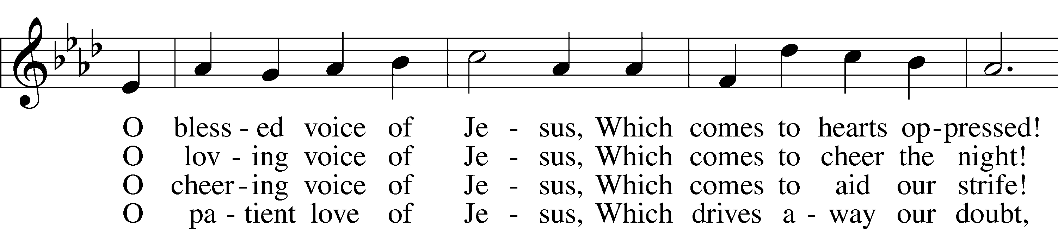
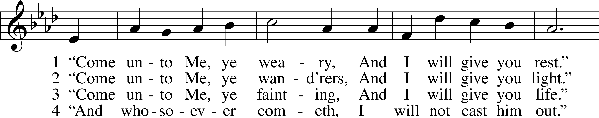

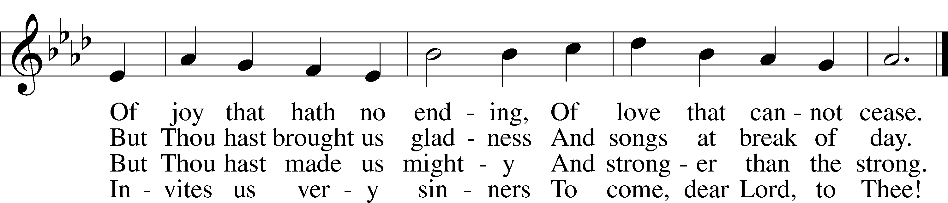
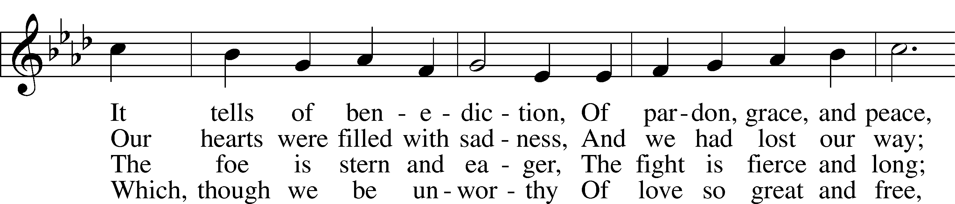

Text: William C. Dix, 1837–98, alt. Tune: Friedrich K. Anthes, 1812–after 1857 Text and tune: Public domain

Sermon – “We Wish You a Weary Christmas?!!” Isaiah 7:13

Stand

Offertory LSB 192
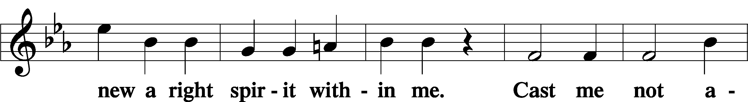
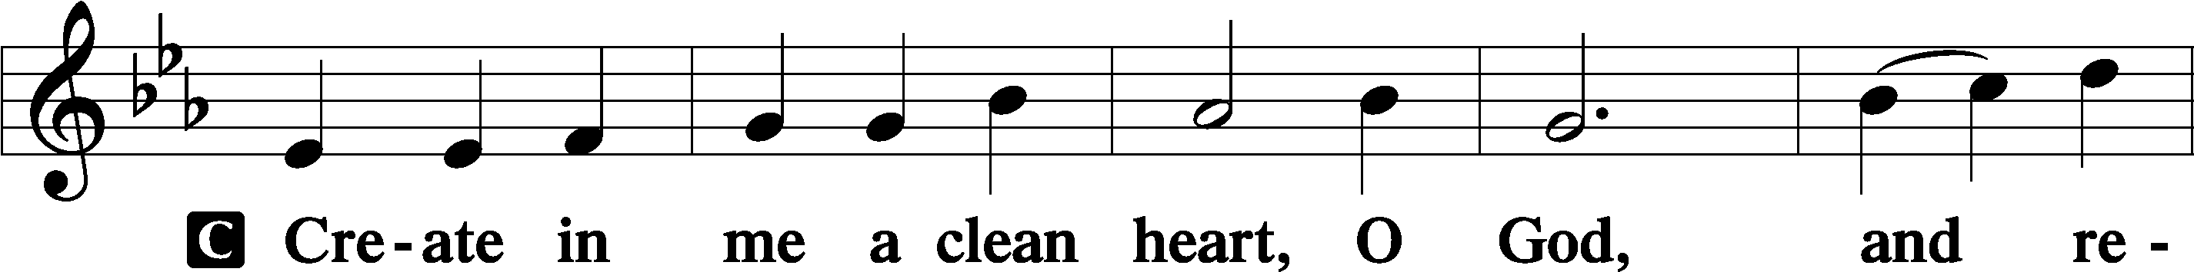

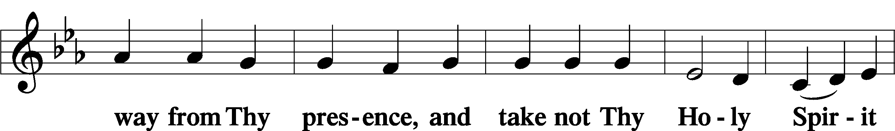

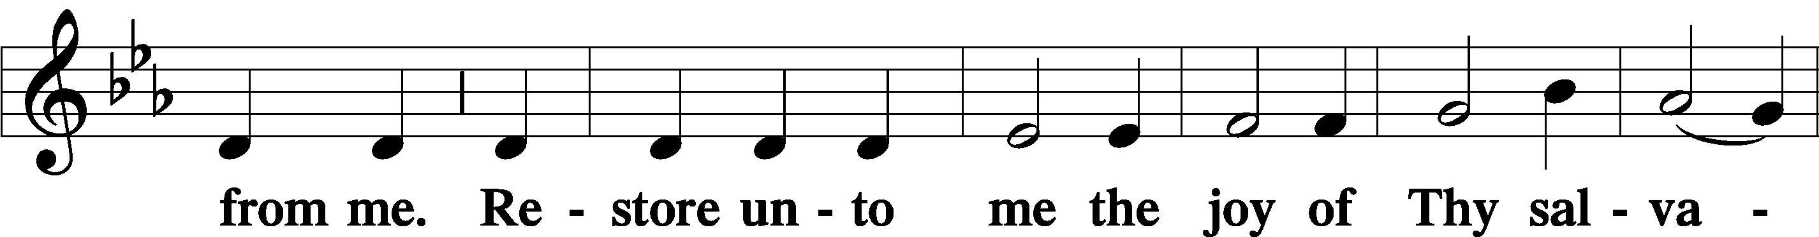

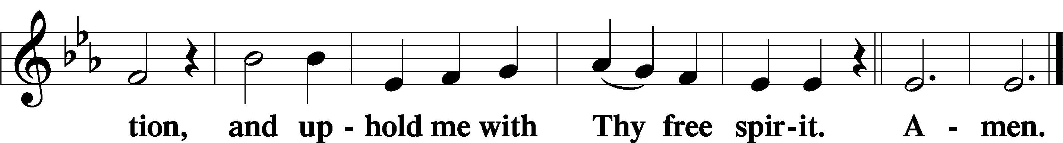

Prayer of the Church

Sit

Consecration of the Offering
After the prayers please be seated. The altar is set for the Lord’s Supper and the offering is consecrated. As you prepare to receive the sacrament you may use the prayers in the front of the hymnal or meditate on a communion hymn.

Stand
Service of the Sacrament
Preface LSB 194
P The Lord be with you.
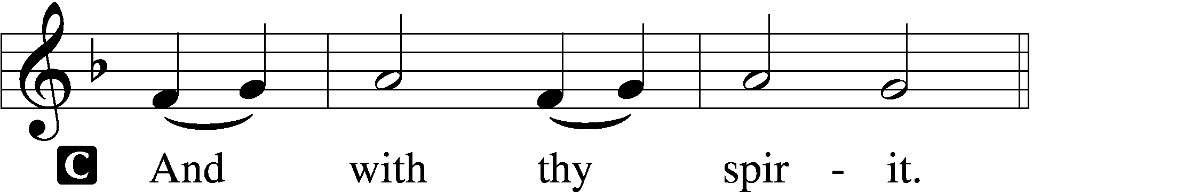
P Lift up your hearts.
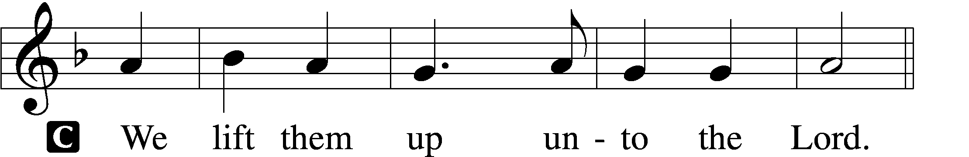

P Let us give thanks unto the Lord, our God.
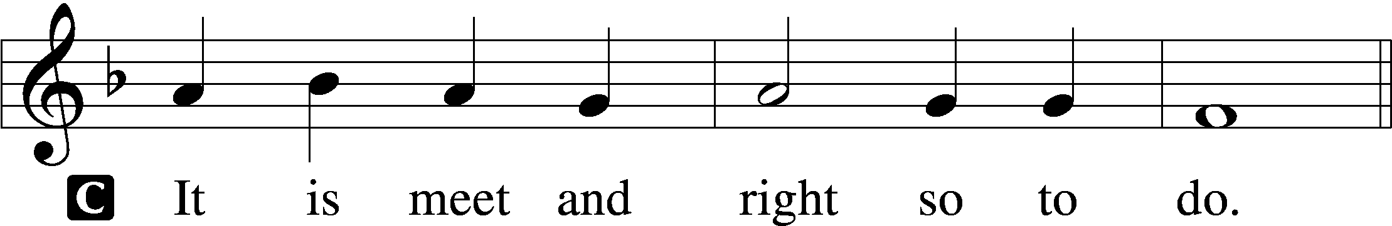

P It is truly meet, right, and salutary that we should at all times and in all places give thanks to You, holy Lord, almighty Father, everlasting God, through Jesus Christ, our Lord, whose way John the Baptist prepared, proclaiming Him the promised Messiah, the very Lamb of God who takes away the sin of the world, and calling sinners to repentance that they might escape from the wrath to be revealed when He comes again in glory. Therefore with angels and archangels and with all the company of heaven we laud and magnify Your glorious name, evermore praising You and saying:

Sanctus LSB 195
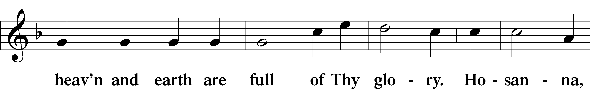
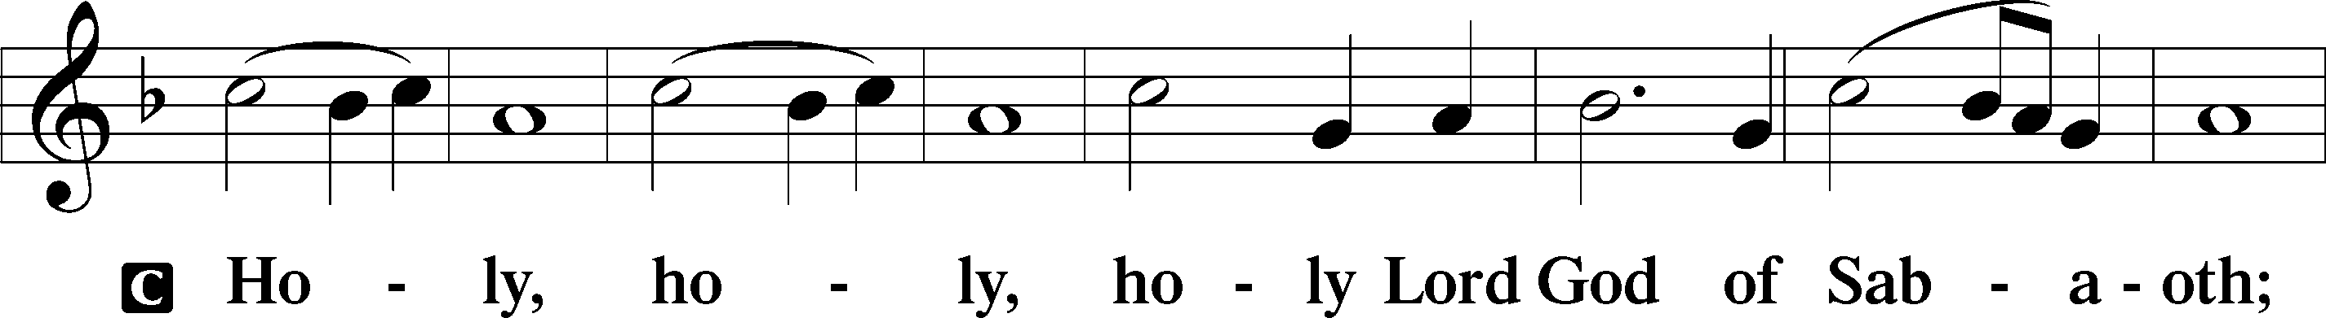

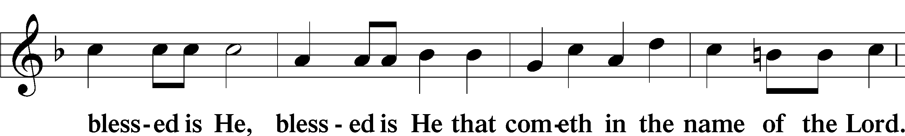
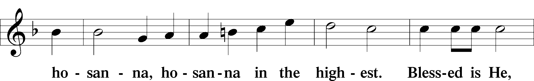

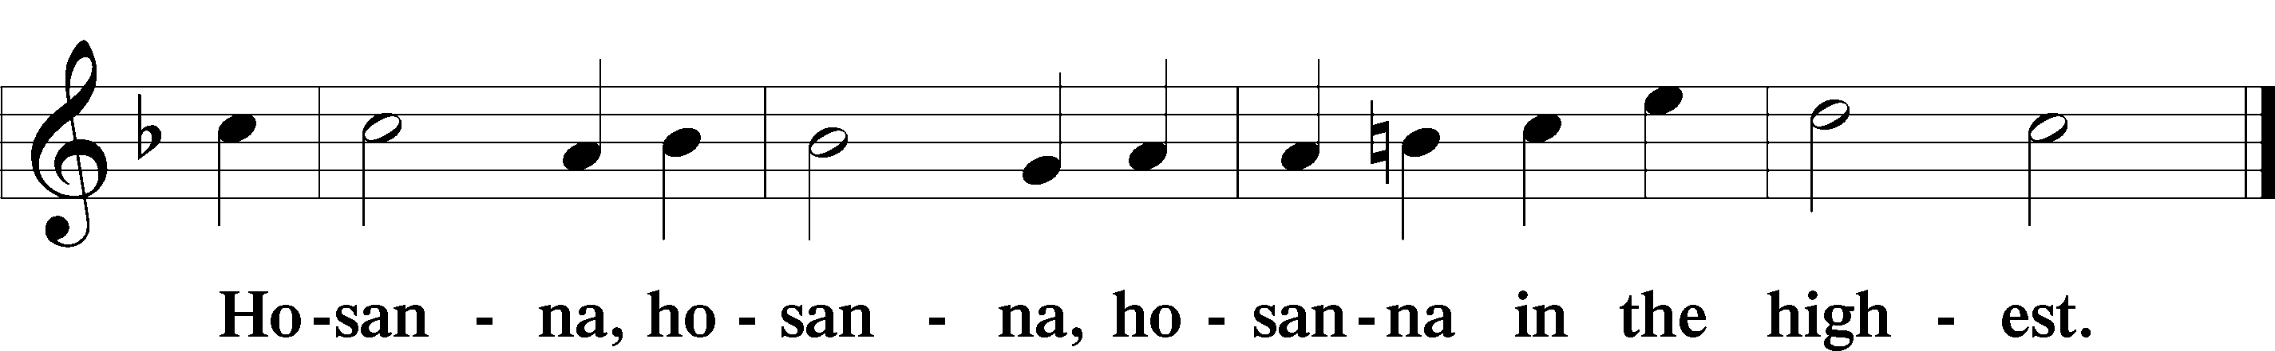

Lord’s Prayer
C Our Father who art in heaven,
hallowed be Thy name,
Thy kingdom come,
Thy will be done on earth
as it is in heaven;
give us this day our daily bread;
and forgive us our trespasses
as we forgive those
who trespass against us;
and lead us not into temptation,
but deliver us from evil.
For Thine is the kingdom
and the power and the glory
forever and ever. Amen.

The Words of Our Lord
P Our Lord Jesus Christ, on the night when He was betrayed, took bread, and when He had given thanks, He broke it and gave it to the disciples and said: “Take, eat; this is My T body, which is given for you. This do in remembrance of Me.”
In the same way also He took the cup after supper, and when He had given thanks, He gave it to them, saying: “Drink of it, all of you; this cup is the new testament in My T blood, which is shed for you for the forgiveness of sins. This do, as often as you drink it, in remembrance of Me.”

Pax Domini LSB 197
P The peace of the Lord be with you always.
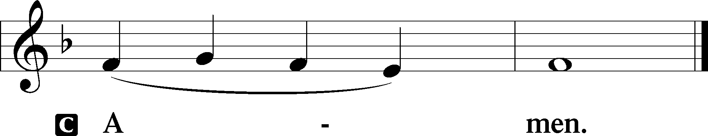

Agnus Dei LSB 198
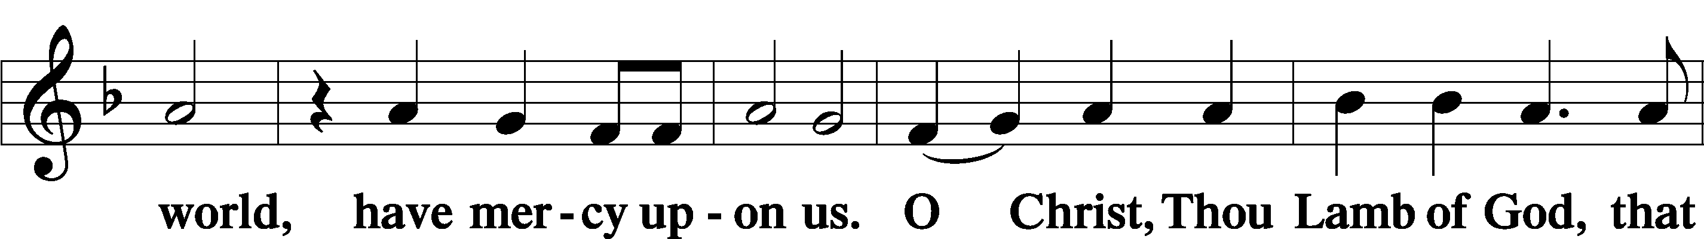
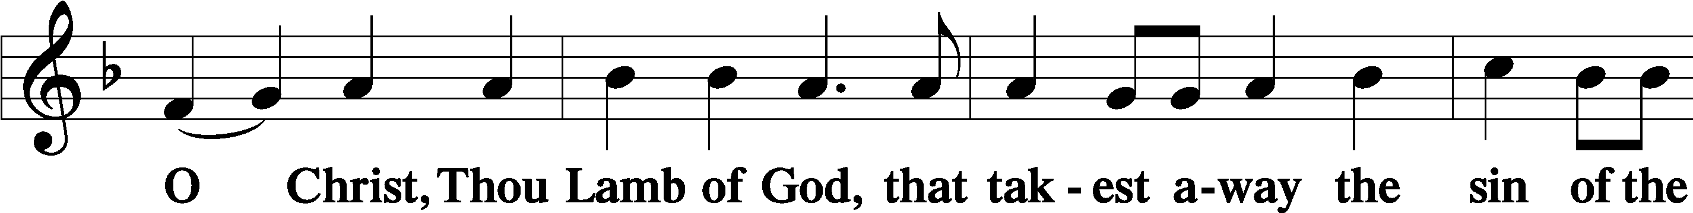

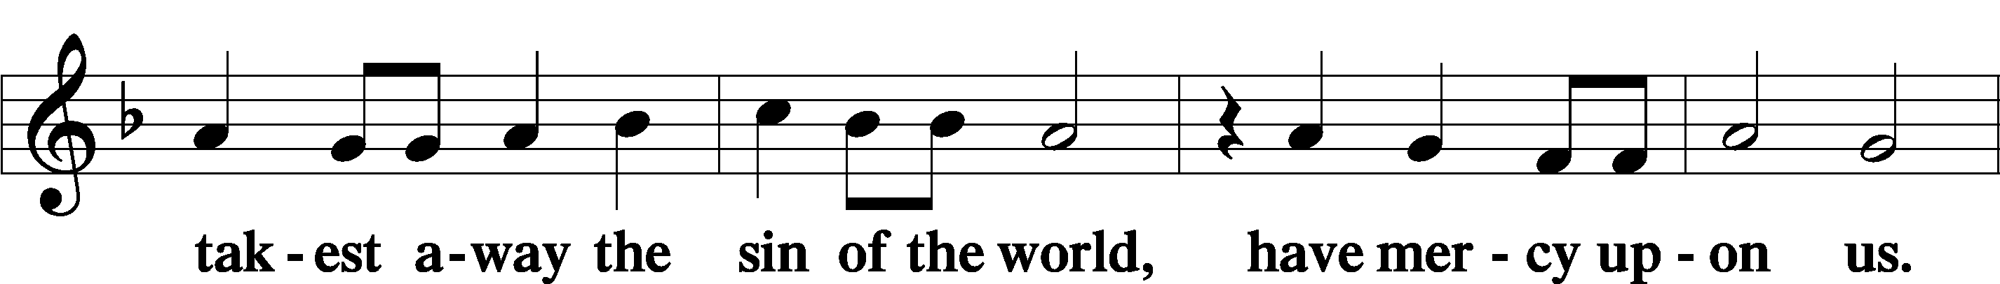

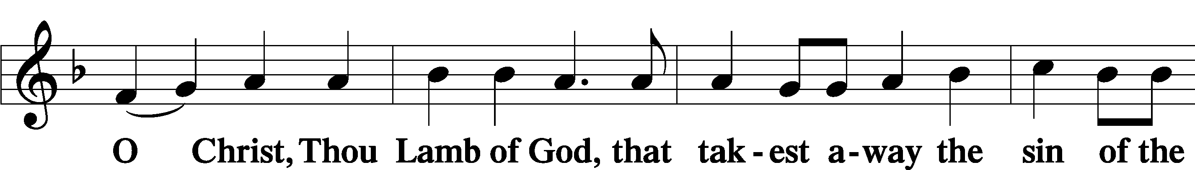

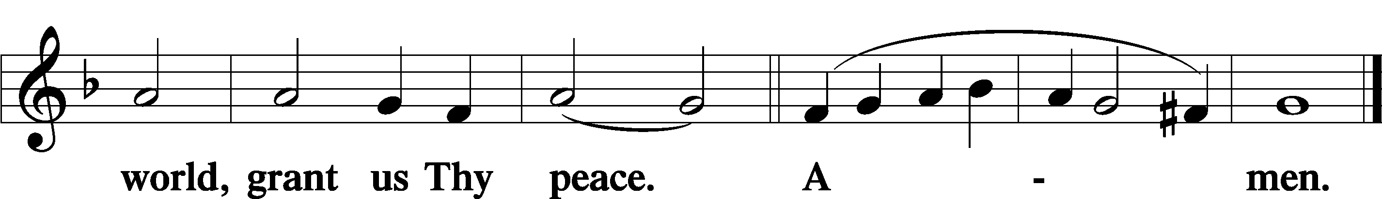

Sit

Distribution

621 Let All Mortal Flesh Keep Silence
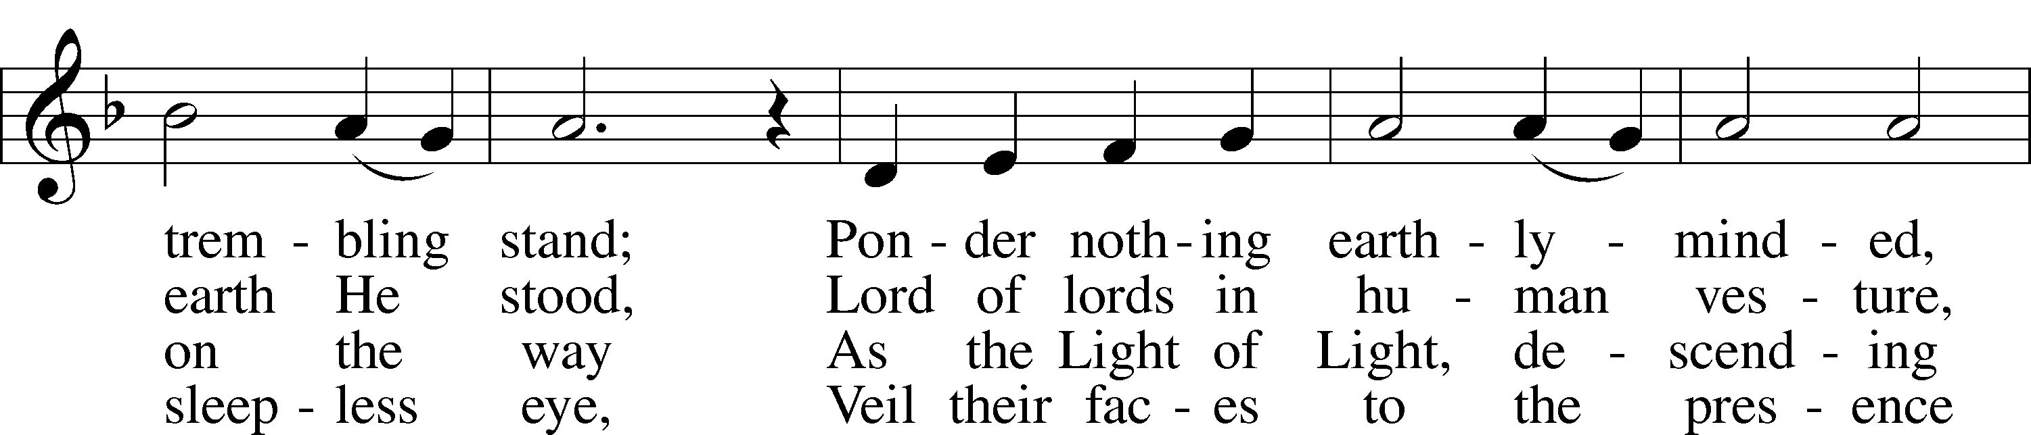
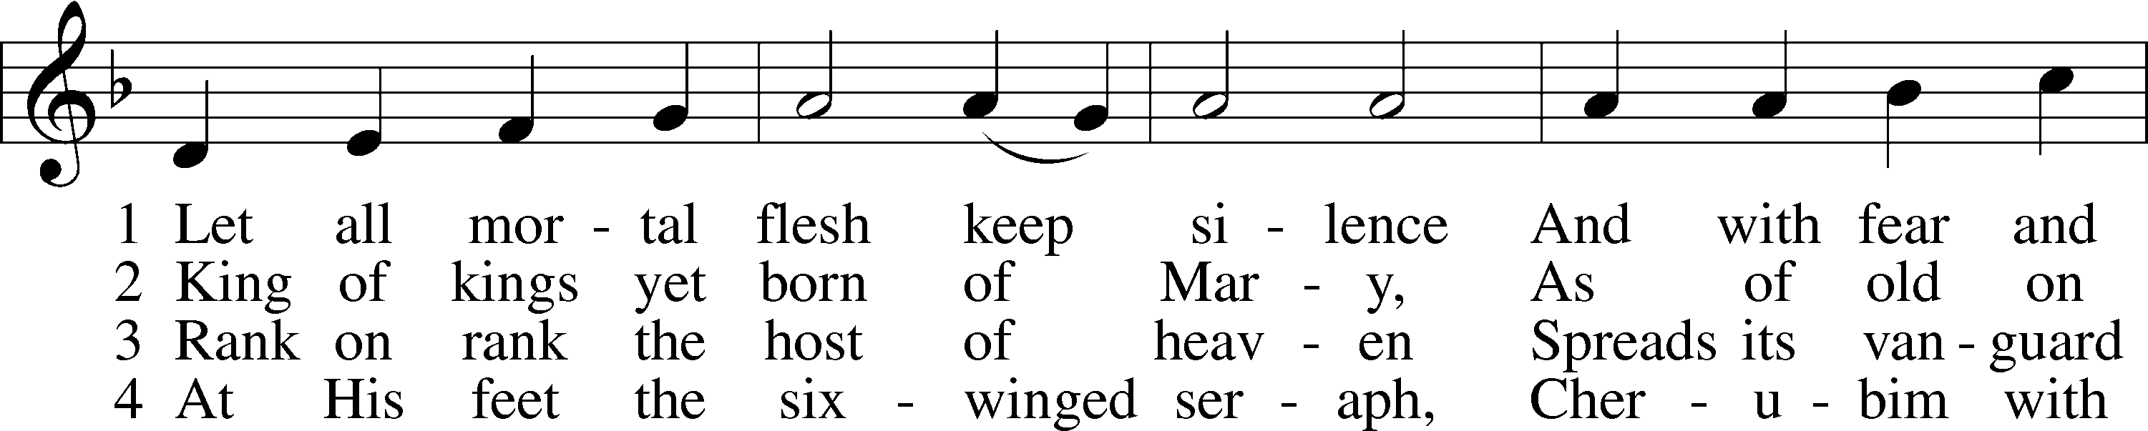

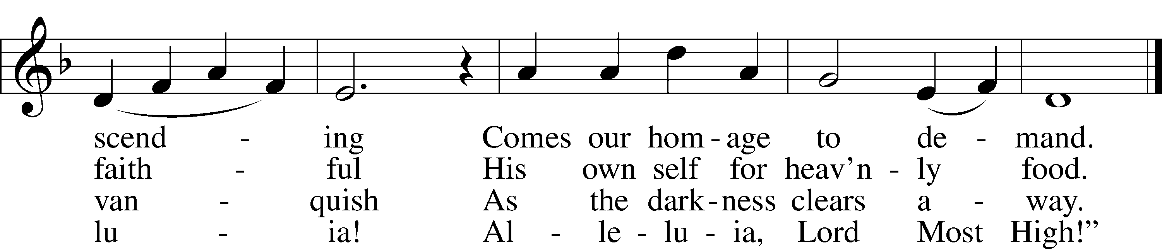
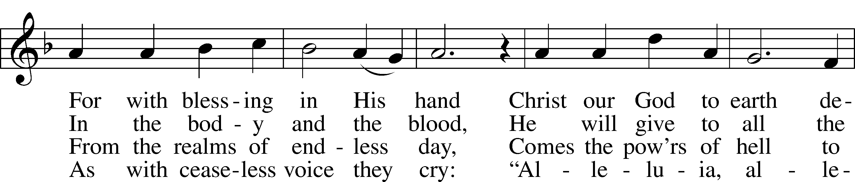

Text: Liturgy of St. James, 5th cent.; tr. Gerard Moultrie, 1829–85, alt. Tune: French, 17th cent. Text and tune: Public domain

626 Come, Let Us Eat
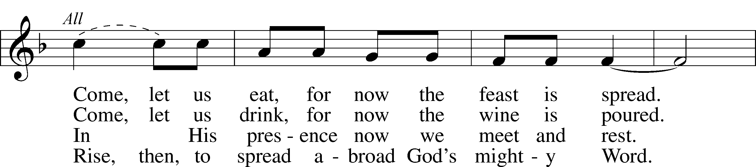
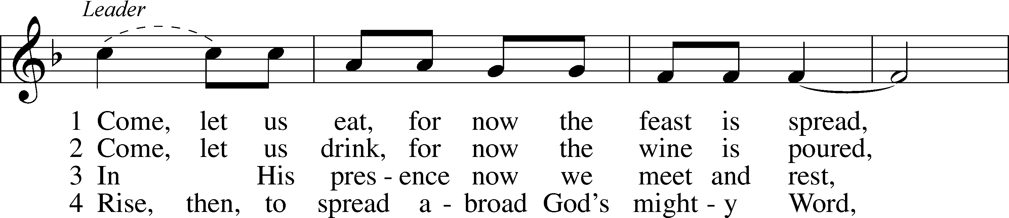

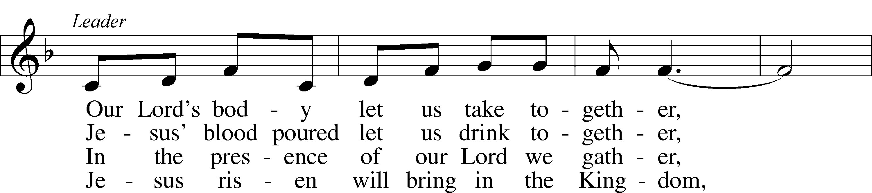

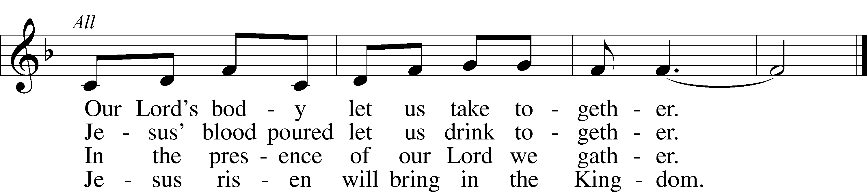

Text (sts. 1–3): tr. Margaret D. Miller, 1927, alt.; (st. 4): Gilbert E. Doan, 1930, alt. Text (sts. 1–3) and tune: Billema Kwillia, 1925
Text (st. 4): © 1972 Augsburg Fortress. Used by permission: LSB Hymn License no. 110003744
Text (sts. 1–3) and tune: © Lutheran World Federation. Used by permission: LSB Hymn License no. 110003744

622 Lord Jesus Christ, You Have Prepared
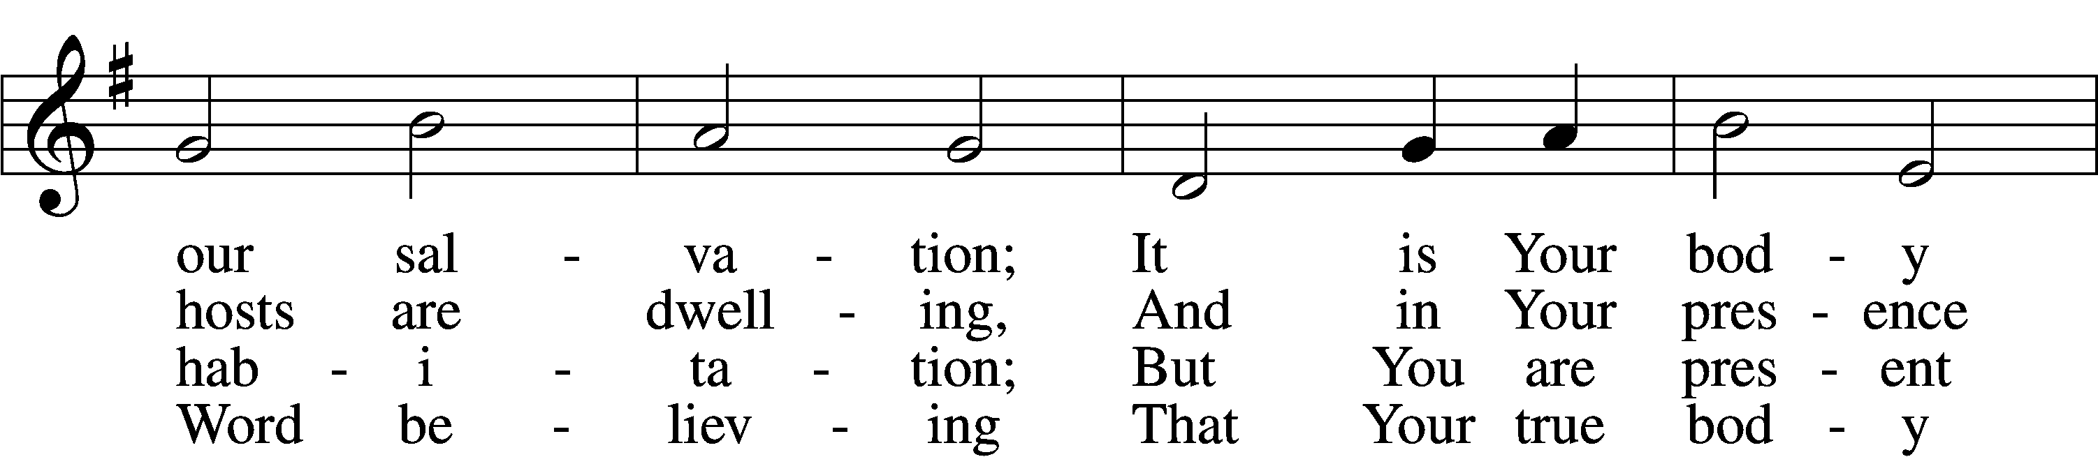
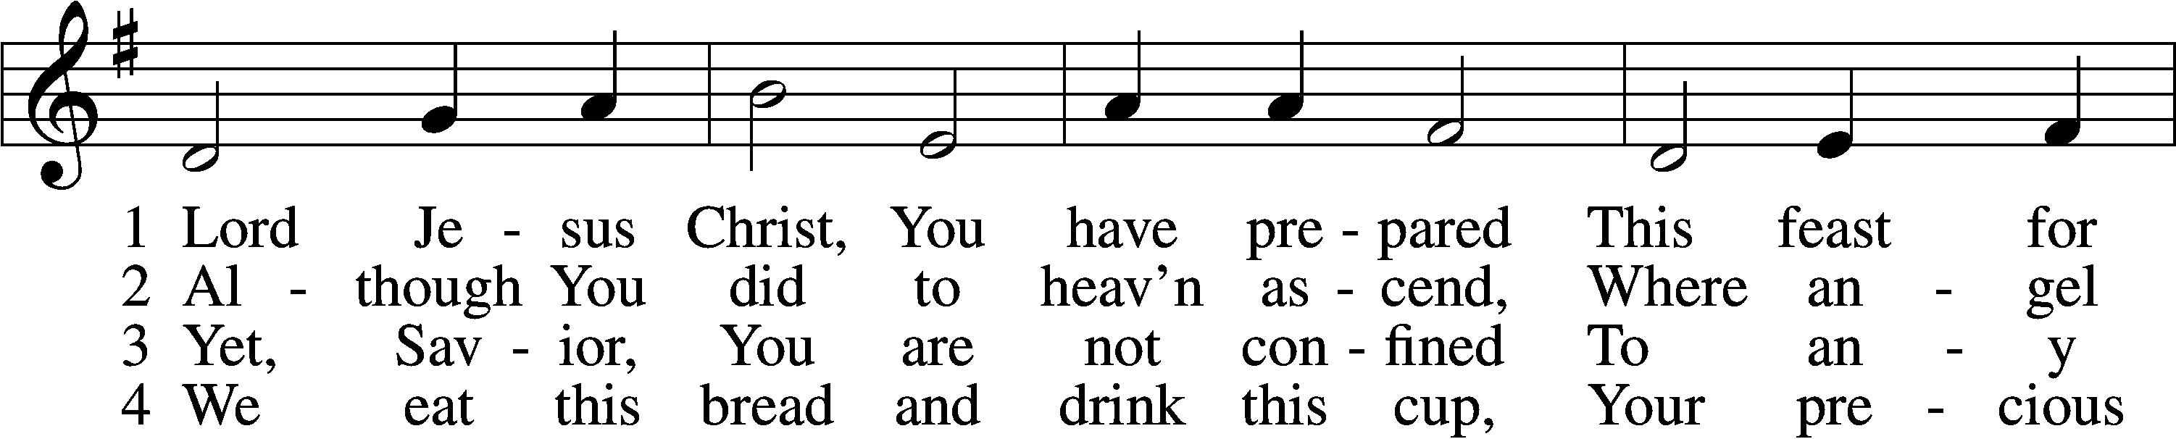

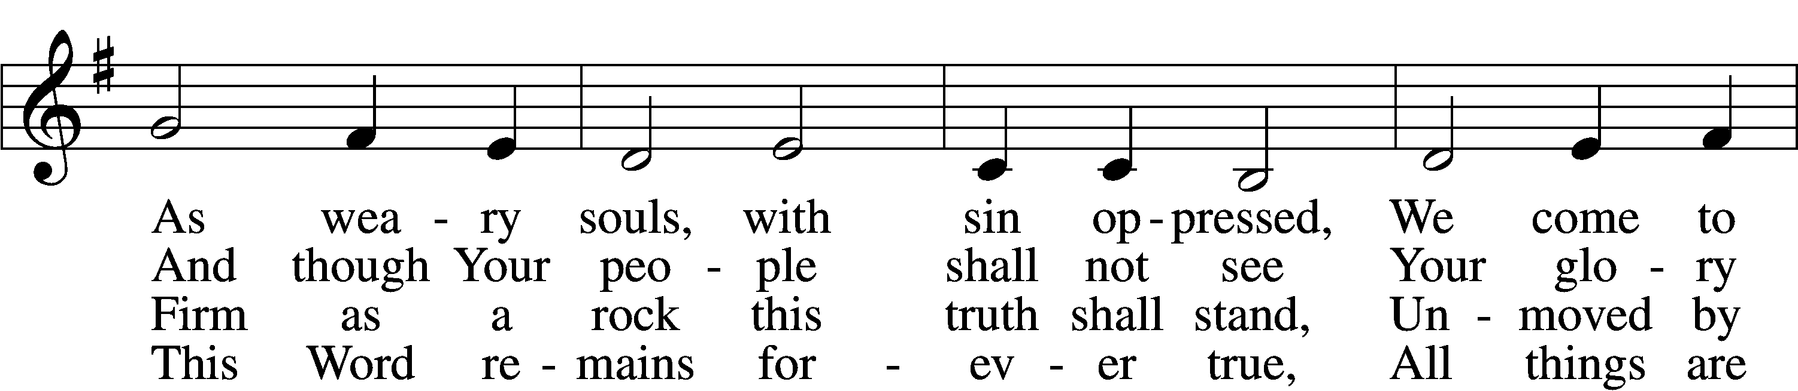
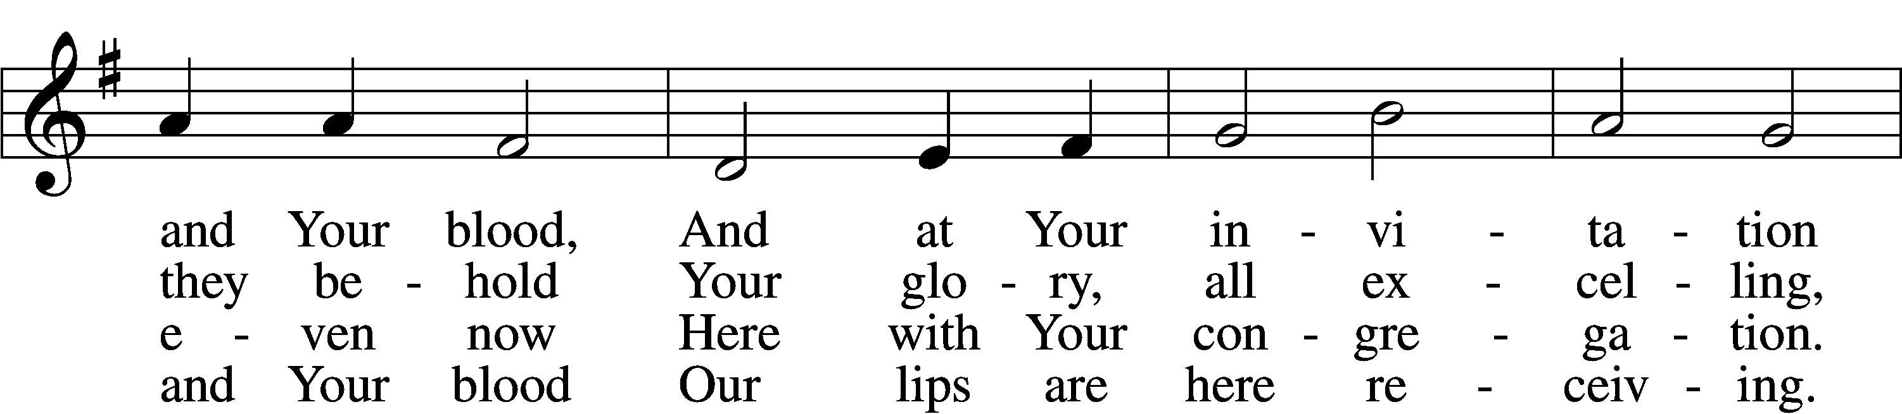

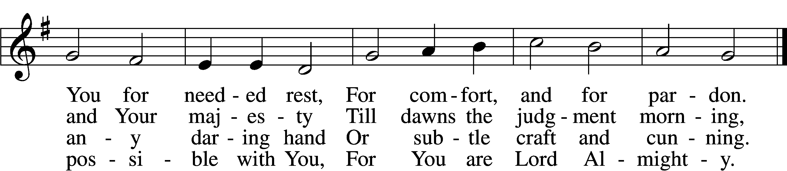

5 Though reason cannot understand,
Yet faith this truth embraces:
Your body, Lord, is even now
At once in many places.
I leave to You how this can be;
Your Word alone suffices me;
I trust its truth unfailing.

6 Lord, I believe what You have said;
Help me when doubts assail me.
Remember that I am but dust,
And let my faith not fail me.
Your supper in this vale of tears
Refreshes me and stills my fears
And is my priceless treasure.
7 Grant that we worthily receive
Your supper, Lord, our Savior,
And, truly grieving for our sins,
May prove by our behavior
That we are thankful for Your grace
And day by day may run our race,
In holiness increasing.

8 For Your consoling supper, Lord,
Be praised throughout all ages!
Preserve it, for in ev’ry place
The world against it rages.
Grant that this sacrament may be
A blessèd comfort unto me
When living and when dying.

Text: Samuel Kinner, 1603–68; tr. Emanuel Cronenwett, 1841–1931, alt. Tune: Peter Sohren, c. 1630–c. 1692, alt. Text and tune: Public domain

350 Come, Thou Precious Ransom, Come
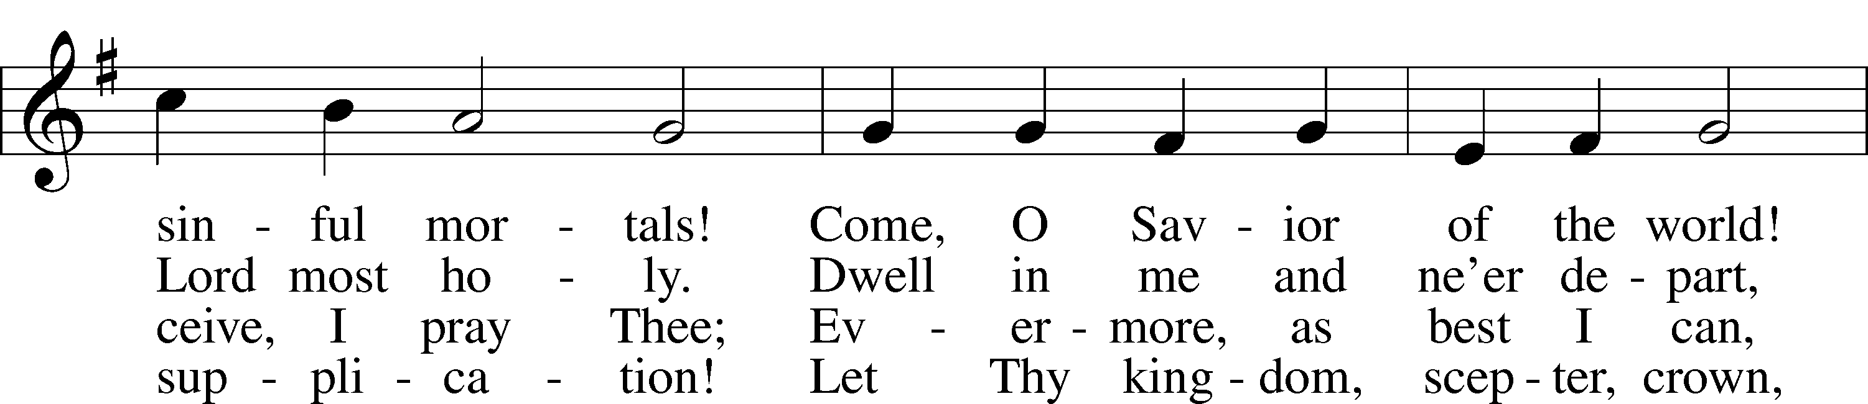
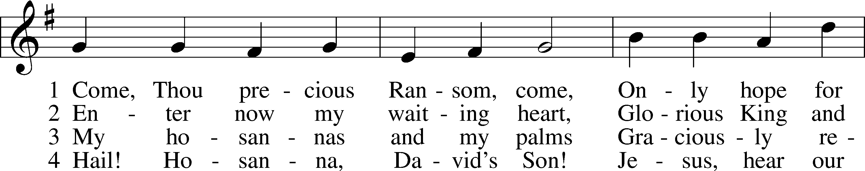

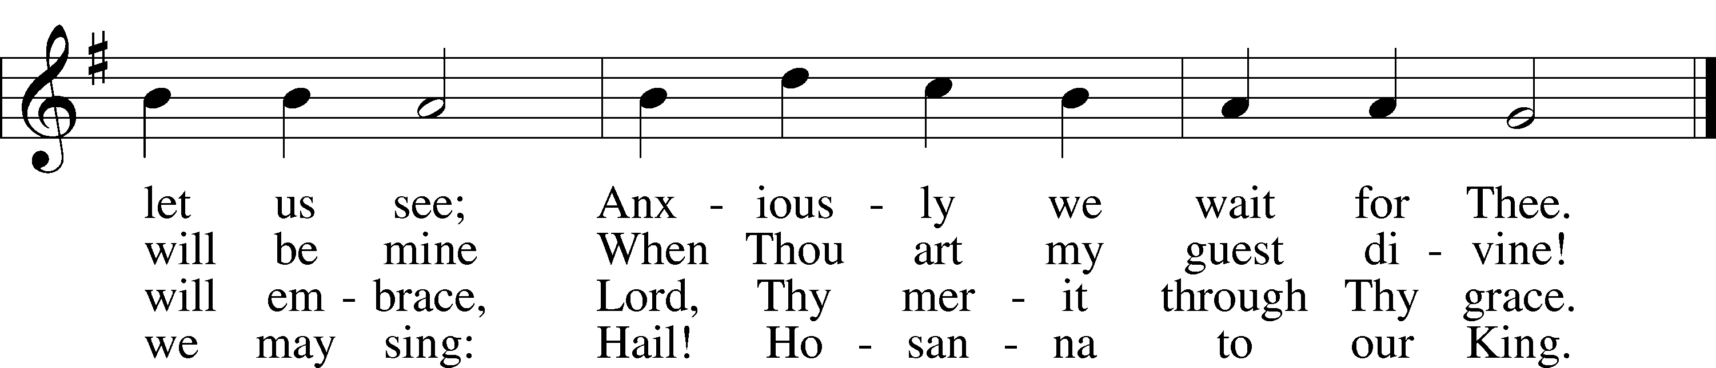
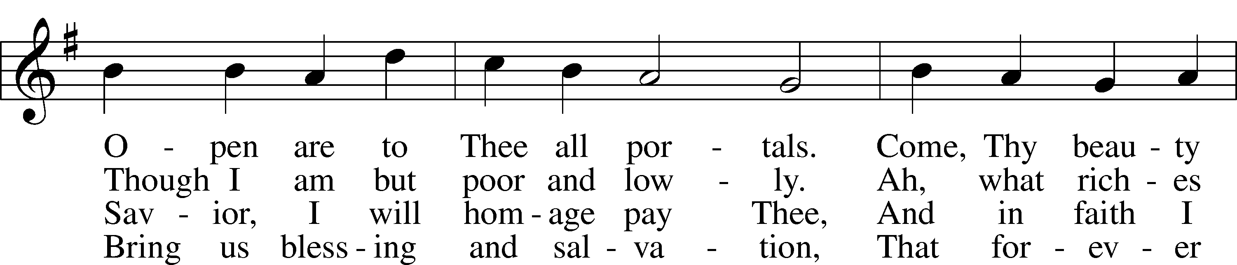

Text: Johann Gottfried Olearius, 1635–1711; tr. August Crull, 1845–1923, alt. Tune: Neu-verfertigtes Darmstädtisches Gesang-Buch, 1699, Darmstadt Text and tune: Public domain

The Dismissal
P The body and blood of our Lord Jesus Christ strengthen and preserve you in body and soul to life everlasting. Depart T in peace.
C Amen.

Stand

Nunc Dimittis LSB 199
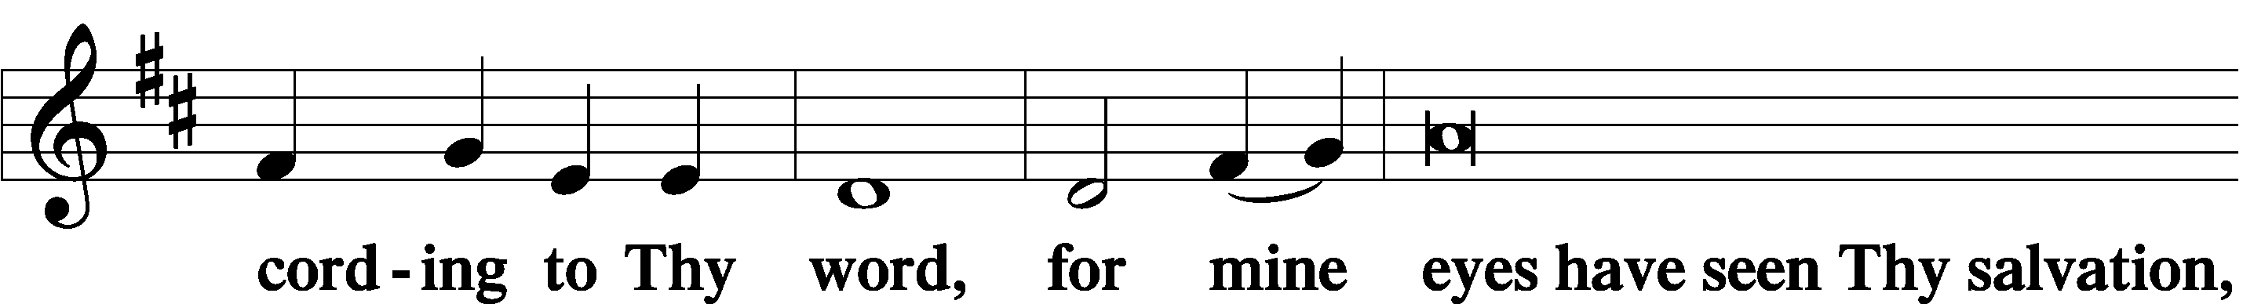
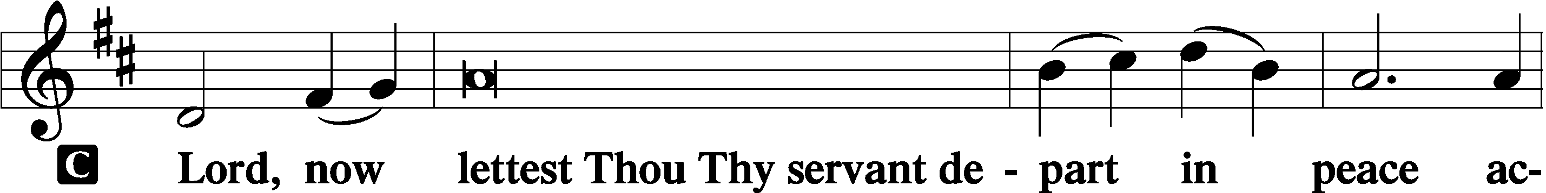

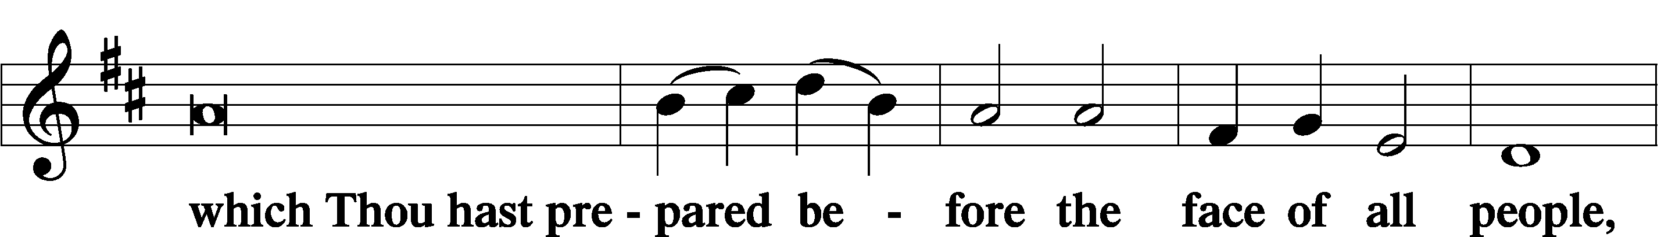

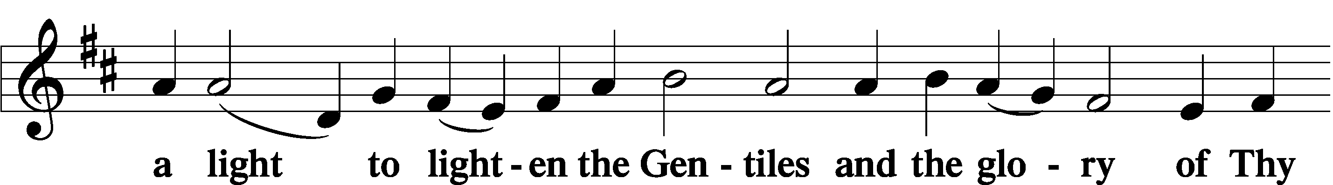

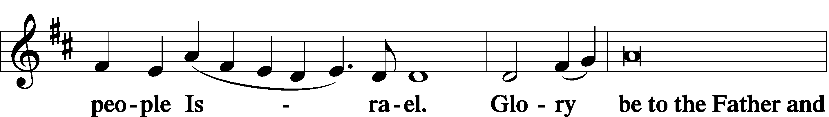

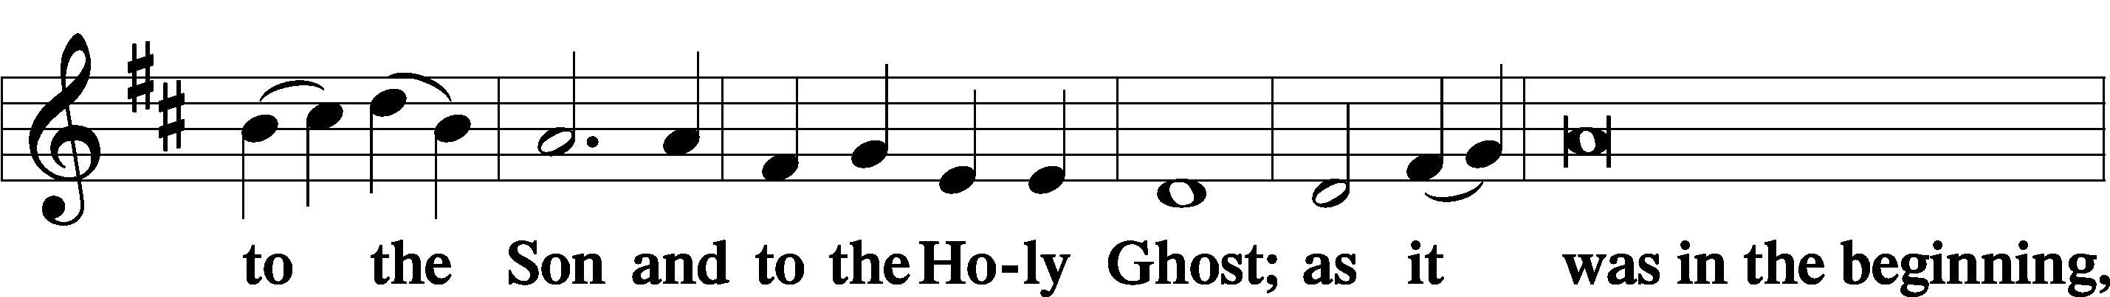

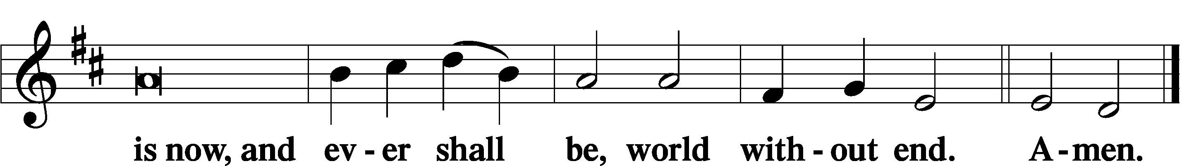

Thanksgiving LSB 200
P O give thanks unto the Lord, for He is good,
C and His mercy endureth forever.
P Let us pray.
O God the Father, the fountain and source of all goodness, who in loving-kindness sent Your only-begotten Son into the flesh, we thank You that for His sake You have given us pardon and peace in this Sacrament, and we ask You not to forsake Your children but always to rule our hearts and minds by Your Holy Spirit that we may be enabled constantly to serve You; through Jesus Christ, Your Son, our Lord, who lives and reigns with You and the Holy Spirit, one God, now and forever.
C Amen.

P The Lord be with you.
C And with thy spirit.
Benedicamus LSB 202
P Bless we the Lord.
C Thanks be to God.

Benediction LSB 202
P The Lord bless you and keep you.
The Lord make His face shine upon you and be gracious unto you.
The Lord lift up His countenance upon you and T give you peace.
C Amen, amen, amen.

338 Come, Thou Long-Expected Jesus
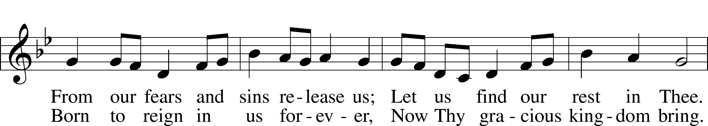
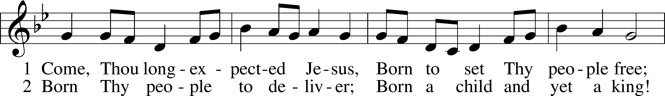

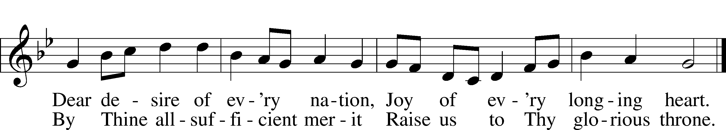
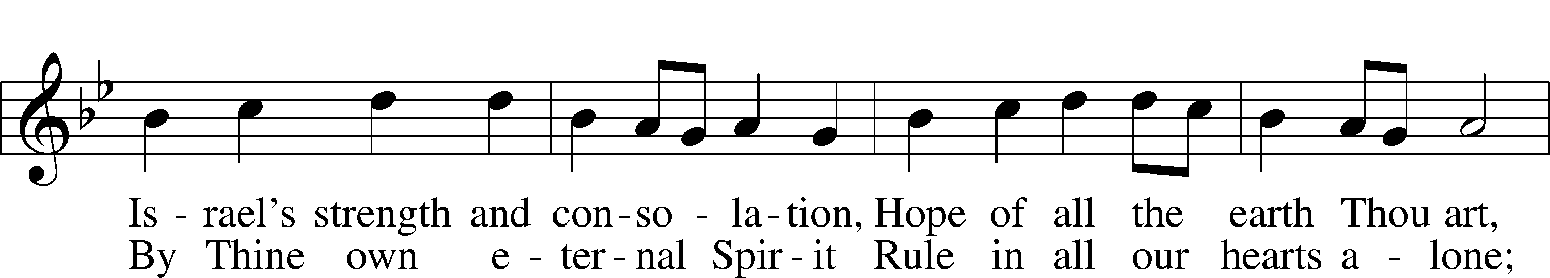

Text: Charles Wesley, 1707–88, alt. Tune: Southern Harmony, 1835, New Haven Text and tune: Public domain
Acknowledgments
Unless otherwise indicated, Scripture quotations are from the ESV® Bible (The Holy Bible, English Standard Version®), copyright © 2001 by Crossway, a publishing ministry of Good News Publishers. Used by permission. All rights reserved.
Prayers for Our Members’ Family & Friends
Lana Fattig (Eric’s wife) | Expecting
Brooke Flodine (Pat’s daughter) | Healing & Grief
Roger Young (Tiffany Davis’ father) | Parkinson’s
Greg Blum (Junge Family Friend) | Healing
Elaine de la Motte (Carol Herron’s sister-in-law) | Healing
Deb Engles (Lorelie’s sister) | Healing
Paul Hanneman (Lorelie’s brother) | Healing
Roger Hoffman (Marc’s father) | Healing
Joshua Junge (Steve’s nephew) | Healing
Luetta Lammers (Ruby Hatfield’s sister) | Healing
LeRoyce Margaritz (brother of Wanda Glanzer) | Healing
Tim Powers (Kim Wilken’s brother) | Healing
Howard Quandt (Don & Shirley Helmbrecht’s family) | Healing
Aaron Russell (Becky Thornton’s son-in-law) | Healing
David & Carol Shiers (Jessica’s parents) | Healing
Rev. Richard Snow (Nebraska District President) | Healing
Pat Snyder (Carol Herron’s friend) | Healing
Randy Solomon (Beth Rosenthal’s father) | Healing
Jonah (Jase & Jarren Blattner’s friend) | Cancer
Glenda Fichtner (Ruby Hatfield’s niece) | Cancer
Ron Halvorsen (Jeff’s dad) | Cancer
Sharon Mulhair (Pam Uhlir’s cousin) | Cancer
Milton Naprstek (Marilyn Fuqua’s brother) | Cancer
Cindy Pietsch (Ellen Koopman’s sister-in-law) | Cancer
Rick Schnacker (Marilyn Fuqua’s nephew) | Cancer
Tyrone Uhlir (Pam’s nephew) | Cancer
Ray Vang (Don & Shirley Helmbrecht’s brother-in-law) | Cancer
Created by Lutheran Service Builder © 2021 Concordia Publishing House.

Prayers for Our Members
Norman Abels (Brookestone Meadows–Elkhorn) | Healing
Judy Ahrens | Healing
Vaughn Albrecht (Mount Carmel) | Healing
Tom & DyAnn Altwine | Healing
Lyle Colsden (Mother Hull) | Healing
Pat Flodine (Cambridge Court) | Healing
Vi Fox (Prairie View) | Healing
Wanda Glanzer | Healing
Jan Hatfield | Healing
Ruby Hatfield | Healing
Evelyn Heiden (Mother Hull) | Healing
Linda Luhn | Healing
Diane Plummer | Healing
Debra Schinkel | Healing
Don Trampe | Healing
Robin Baker | Cancer
Ivan Bombeck | Cancer
Bertha Marienau | Cancer
Response to the Gospel
Date: 12/11/2022
Offering: $6,907
Weekly Need: $7,500
Offering Options:
To worship the Lord with your offering:
1) Place your offering in the offering plate as you enter or leave.
2) Go to zionkearney.churchtrac.com/give
3) Go to zionkearney.com and click on the ChurchTrac icon
4) Mail your gift to Zion Lutheran Church, 2421 C Ave, Kearney, NE 68847 or place it in the mail slot on the south side of the building.
Today’s Radio Broadcast is sponsored by Dave and Kay Banner, in memory of Edsel Johnson, Kay’s father, on his birthday.
Today’s Altar Flowers are sponsored by everyone
who purchased poinsettias.

Worship Assistants

Sunday, December 18th – 9:00am
Elder: Dan Oertwig  Acolyte: Colton Zehendner  Announcer: Carol Kreutzer | Usher: Andy Wollberg  Engineer: Jamie Nikodym  Altar Guild: Beth Rosenthal  & Shirley Helmbrecht
Saturday, December 24th – 7:00pm
Elder: Nathan Gaunt  Acolyte: Abigail Burger | Usher: All Captains  Engineer: Jared Nuttelman  Altar Guild: Beth Rosenthal  & Shirley Helmbrecht
Sunday, December 25th – 10:00am
Elder: Eric Rosenthal  Acolyte: Jamie Wilkens  Crucifer: Reilly Fisher Announcer: Brooke Fisher | Usher: Mike Wilkens  Engineer: Jared Nuttelman  Altar Guild: Beth Rosenthal &  Shirley Helmbrecht

ZION LUTHERAN CHURCH AND SCHOOL

Pr. James DeLoach, Pastor + (308) 627-5260
james.deloach@zionkearney.org
Pr. Doug Gaunt, Pastor + (308) 455-0552
doug.gaunt@zionkearney.org
Tony Splittgerber, Principal + (308) 293-0168
anthony.splittgerber@zionkearney.org

Church Office
Administrative Assistant: Holly Reid
Email: school@zionkearney.org
Phone: (308)-234-3410 Fax: (308) 236-8100
Office Hours: Monday-Friday 8:00am-4:00pm
Radio Broadcast: Sunday @ 10:30 a.m. on 1460 AM
Website: www.zionkearney.com

This Week at Zion
Sun 12/18 | 9:00a  10:30a  10:30a  5:00p  Anniversaries | Divine Service  Adult Bible Study & Sunday School  Radio Broadcast  1460AM & 92.1FM  Divine Service  Eric & Beth Rosenthal
Mon 12/19 |  | NO SCHOOL – DEC. 19TH-JAN. 3RD
Tues 12/20 | 1:30p  Birthdays | Sleeping Mats  Cameron Junge
Wed 12/21 | Anniversaries | Reese & Jade Florang  Dale & Lynette Johnson
Thurs 12/22 | Birthdays | Miles Hockemeier  Pr. James DeLoach
Fri 12/23 | 1p-5p  Birthdays | Hockemeier – Fellowship Hall  Tiffany Davis
Sat 12/24 | 7:00p | Christmas Eve Candlelight Service
Sun 12/25 | 10:00a  10:30a  Birthdays | Divine Service  Radio Broadcast - 1460AM & 92.1FM  Brandon Fletcher  Kaitlyn Kaufman  Justin Ronning

Announcements for December 18th, 2022

Christmas Eve, 7pm: "Jesus Christ -- The Bread of Life"
We hear the answer to the question: "Why was the baby Jesus laid in a manger on the night he was born?" A manger is a feed trough and he's the Bread of Life. We will hear how the Old Testament uses bread to foretell of Jesus' coming.

The Festival of Christmas Day, 10am (Special Time!):
"O Jesus Christ, Thy Manger Is"
Join us on the morning when we celebrate the Incarnation of Jesus Christ and ponder that the Bread of Life was born in Bethlehem--"The House of Bread." Jesus is God's Bread from heaven, who comes to us today in His Holy Word and in the Blessed Feast of His Body and Blood given under bread and wine.

New Church Directory: The parish staff have determined it is time for our new pictorial church directory. We are scheduled for February 7th-9th from 2pm-8:30pm. We will need volunteers to help make this a smooth process. If you are interested in volunteering, contact Holly and she will direct you to the right person.

Year End Reports: Chairman Elect Don Helmbrecht would like all Boards and committees to submit a brief yearly report to be turned in to the Church office by the end of January. The most convenient way to submit these is by email. school@zionkearney.org

2022 Contributions: Since the year ends on a Saturday, your last contributions for 2022 need to be dated and in the plate on January 1, 2023.

Missions Information Director: Zion needs someone to help publicize the name, nature and needs of the many mission projects and workers that we support at various times of the church year. If you are willing and able to help, this please contact Pastor DeLoach.

Ark Encounter Trip: Pastor DeLoach would like to make arrangements for a group of Zion’s members to visit the Ark Encounter and the Creation Museum sometime in late May or early June. The Ark Encounter features a full-size Noah’s Ark, built according to the dimensions given in the Bible. Please give Pastor your name and number if you are interested in this trip. You can text or email him or you can put your information on an attendance card and give it to him after the service. Thank you!

Bible Reading Cards: A new set of Bible reading cards for the new year can be picked up in the church entryway. Each card is a tool to keep track of your Bible reading progress as you mark each chapter you have read in 2022. God works through His word.

Radio Broadcast & Altar Flowers: The sign-up sheets for the 2023 radio broadcasts and flowers are on the bulletin board by the mailboxes. If you want a certain date, sign up ASAP.

Annual Food Collection: We have had a great start to our food collection! We will also accept toiletries, cleaning products, paper items, as well as items that cannot be purchased with food stamps. If you are able to gather the items and take them to the Jubilee center, contact the office.
SCHOOL NEWS

Christmas Break: There will be no school from Dec. 19th-Jan. 3rd. Have a Merry Christmas and a Happy New Year!

Basketball Schedules: Both boys and girls basketball schedules are finalized and posted on the app. The first game will be here on January 10th, starting with the girls at 4:30pm.

Extra Pies: There are plenty of extra pies left over from our sale. Contact the office for availability and pricing.

