Divine Service

The Baptism of Our Lord

January 8th, 2023
Zion Lutheran Church
Kearney, Nebraska
Welcome to Zion!
Guests please record your attendance on a card in the pew rack and let us know how we can be of service to you.

Holy Communion at Zion

The Lord’s Supper is celebrated at this congregation as Jesus has given it. As he says, our Lord gives into our mouths not only bread and wine but his very body and blood to eat and to drink for the forgiveness of sins and to strengthen our union with him and with one another. Our Lord invites to his table those who trust his words, repent of all sin, and set aside any refusal to forgive and love as he forgives and loves us, that they may show forth his death until he comes. All communicants need to register in the narthex prior to the service.

Because those who eat and drink our Lord’s body and blood unworthily do so to their great harm and because Holy Communion is a confession of the faith which is confessed at this altar, any who are not yet instructed, in doubt, or who hold a confession differing from that of this congregation and The Lutheran Church—Missouri Synod, are asked not to commune until they are able to speak with our pastor first. He is happy to visit with you about the Christian faith and how to receive the Lord’s Supper for your good and for the good of others. Those not communing are invited to come to the altar, cross your arms in front of you, and bow your head to receive a pastoral blessing.

The Triune God Is Manifested and
Reveals Himself to Us in Holy Baptism

The Baptism of our Lord is an “epiphany” of the one true God in the flesh and blood of Jesus. He is the chosen servant of the Lord, anointed with the Spirit for the rescue of God’s people to “bring forth justice to the nations” (Is. 42:1). Thus, He makes all things new, and He is given “as a covenant for the people, a light for the nations” (Is. 42:6). In the waters of the Jordan, He takes His place with sinners and takes all the sins of the world upon Himself. He undergoes the Baptism of repentance in order to “fulfill all righteousness” for us (Matt. 3:15). He submits Himself to the curse of sin and death in order to redeem us. We are baptized with a Baptism like His, thereby dying and rising with Him, so that “we will also live with him” (Rom. 6:8). Indeed, all of us who are baptized into Christ Jesus are anointed with His Spirit and named by His Father as beloved and well-pleasing sons and daughters.

404 Jesus, Once with Sinners Numbered
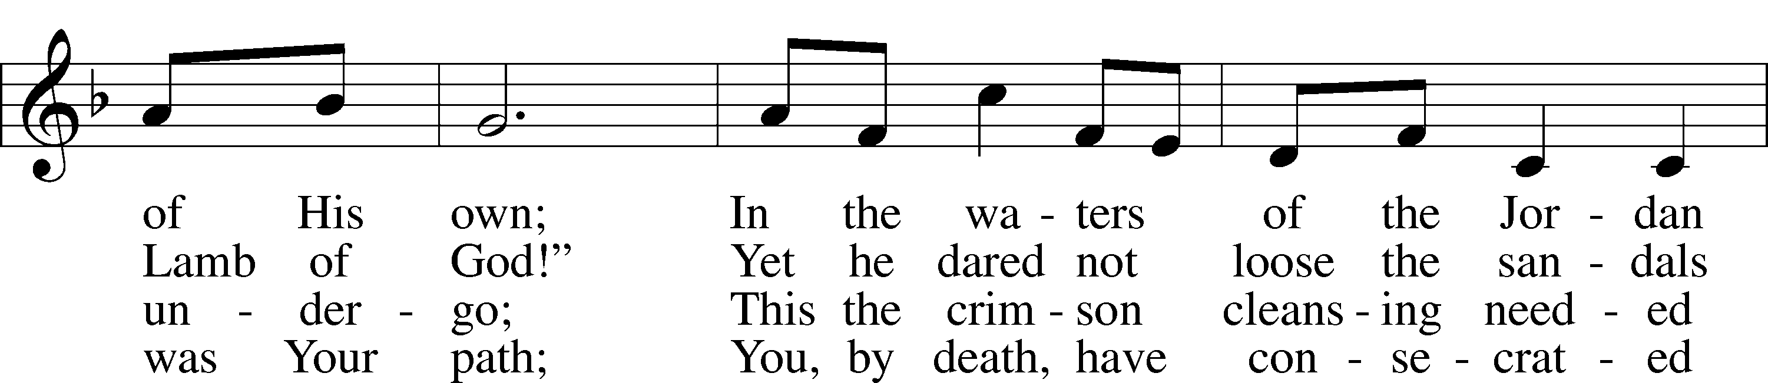
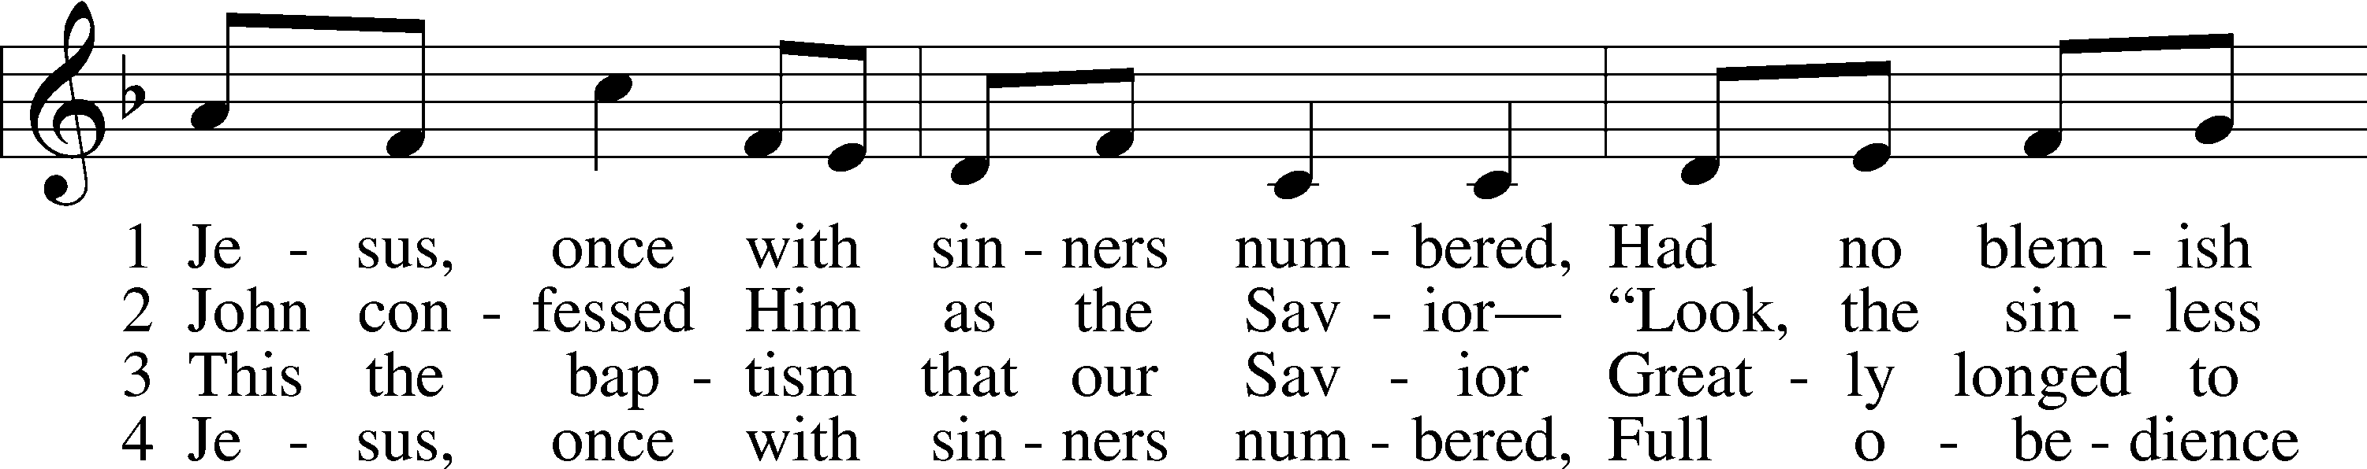

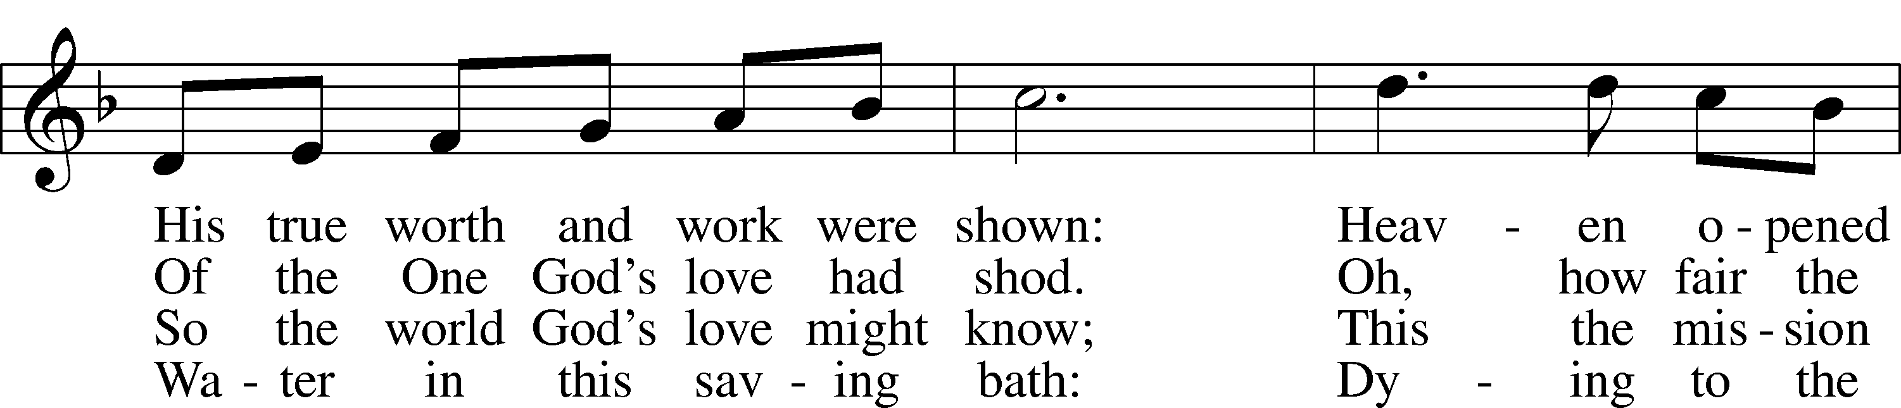

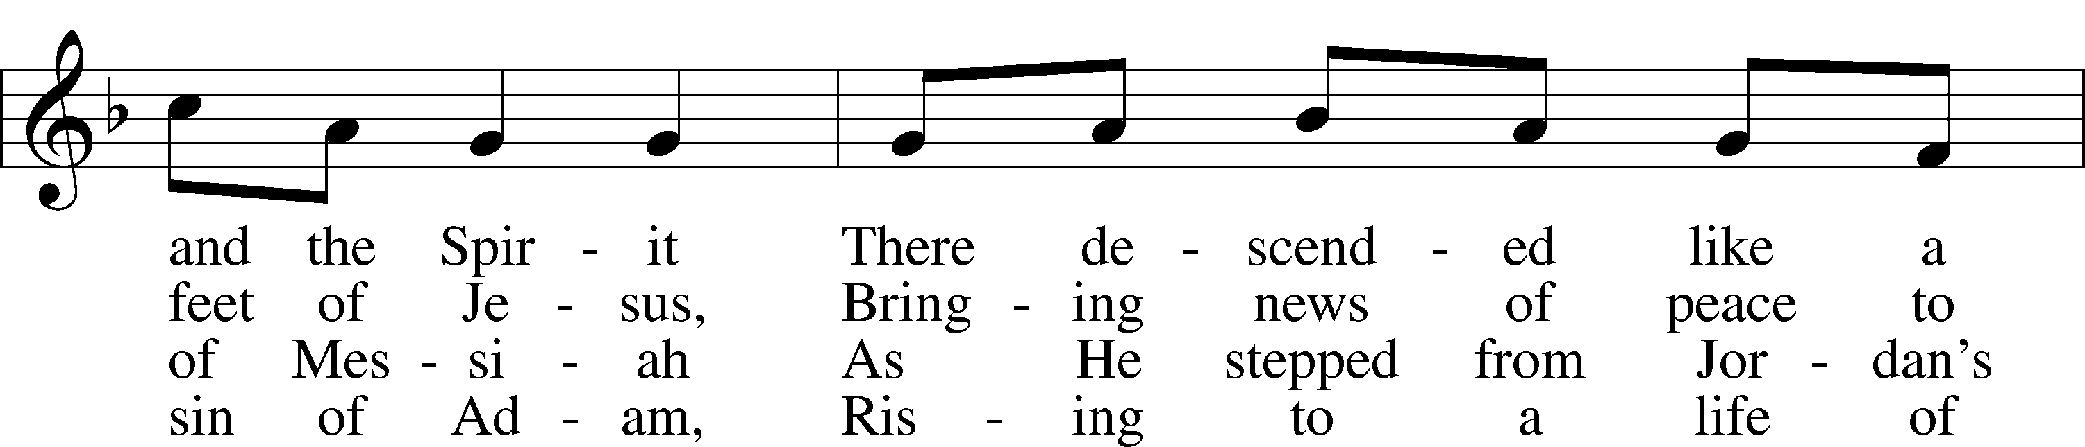

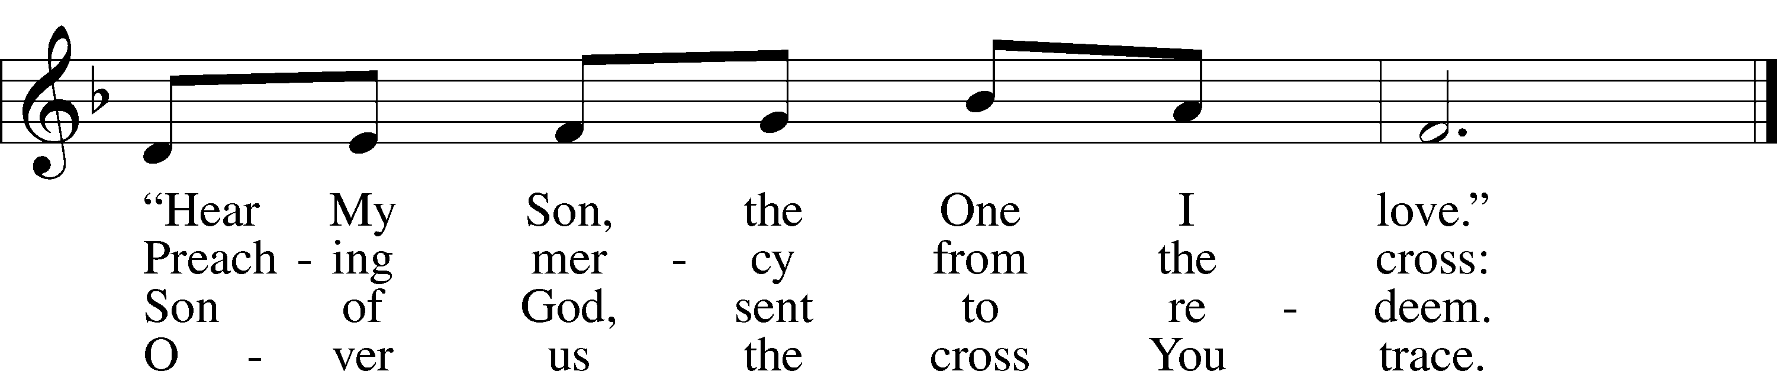
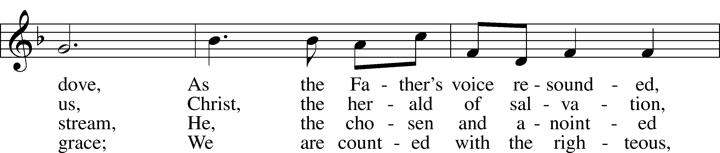

Text: Stephen P. Starke, 1955 Tune: William B. Roberts, 1947 Tune: © 1995 Augsburg Fortress. Used by permission: LSB Hymn License no. 110003744 Text: © 1999 Stephen P. Starke, admin. Concordia Publishing House. Used by permission: LSB Hymn License no. 110003744
Stand

Invocation LSB 151
P In the name of the Father and of the T Son and of the Holy Spirit.
C Amen.
P If we say we have no sin, we deceive ourselves, and the truth is not in us.
C But if we confess our sins, God, who is faithful and just, will forgive our sins and cleanse us from all unrighteousness.

Silence for reflection on God’s Word and for self-examination.

P Let us then confess our sins to God our Father.
C Most merciful God, we confess that we are by nature sinful and unclean. We have sinned against You in thought, word, and deed, by what we have done and by what we have left undone. We have not loved You with our whole heart; we have not loved our neighbors as ourselves. We justly deserve Your present and eternal punishment. For the sake of Your Son, Jesus Christ, have mercy on us. Forgive us, renew us, and lead us, so that we may delight in Your will and walk in Your ways to the glory of Your holy name. Amen.

Absolution
P Almighty God in His mercy has given His Son to die for you and for His sake forgives you all your sins. As a called and ordained servant of Christ, and by His authority, I therefore forgive you all your sins in the name of the Father and of the T Son and of the Holy Spirit.
C Amen.

Introit Psalm 2:7–11, 12c; antiphon: Isaiah 42:1a
Behold my servant, whom | I uphold,*
my chosen, in whom my | soul delights.
I will tell of | the decree:*
The Lord said to me, “You are my Son; today I have be- | gotten you.
Ask of me, and I will make the nations your | heritage,*
and the ends of the earth your pos- | session.
You shall break them with a | rod of iron*
and dash them in pieces like a potter’s | vessel.”
Now therefore, O | kings, be wise;*
be warned, O rulers | of the earth.
Serve the | Lord with fear,*
and rejoice with | trembling,
for his wrath is quickly | kindled.*
Blessèd are all who take ref- | uge in him.
Glory be to the Father and | to the Son*
and to the Holy | Spirit;
as it was in the be- | ginning,*
is now, and will be forever. | Amen.
Behold my servant, whom | I uphold,*
my chosen, in whom my | soul delights.
Kyrie 152
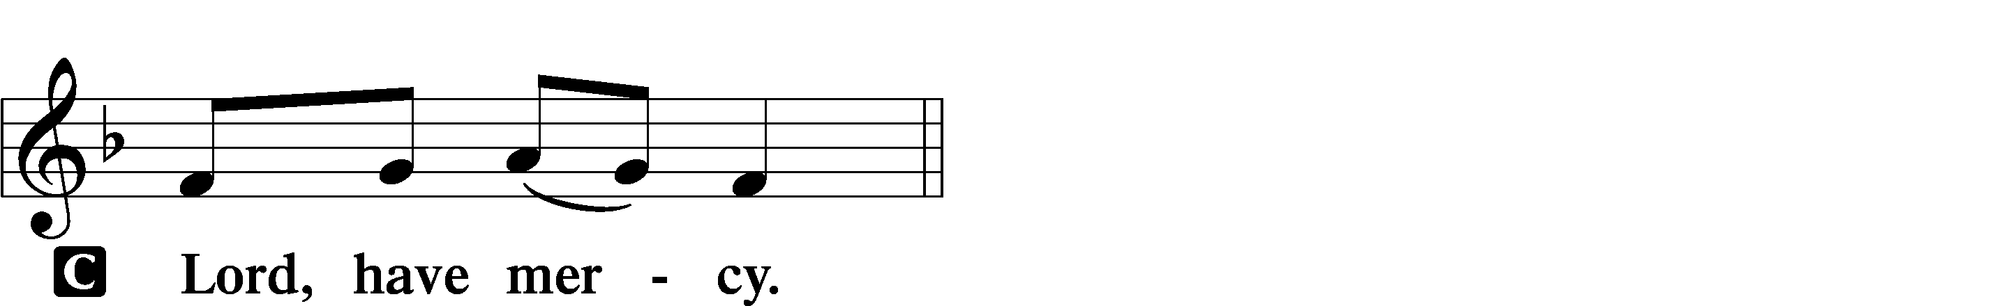
P In peace let us pray to the Lord.

P For the peace from above and for our salvation let us pray to the Lord.

P For the peace of the whole world, for the well-being of the Church of God, and for the unity of all let us pray to the Lord.

P For this holy house and for all who offer here their worship and praise let us pray to the Lord.

P Help, save, comfort, and defend us, gracious Lord.

Gloria in Excelsis LSB 154
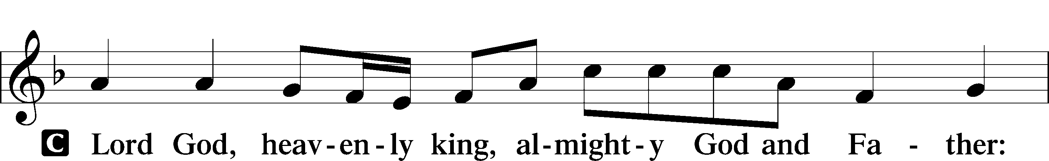
P Glory to God in the highest, and peace to His people on earth.

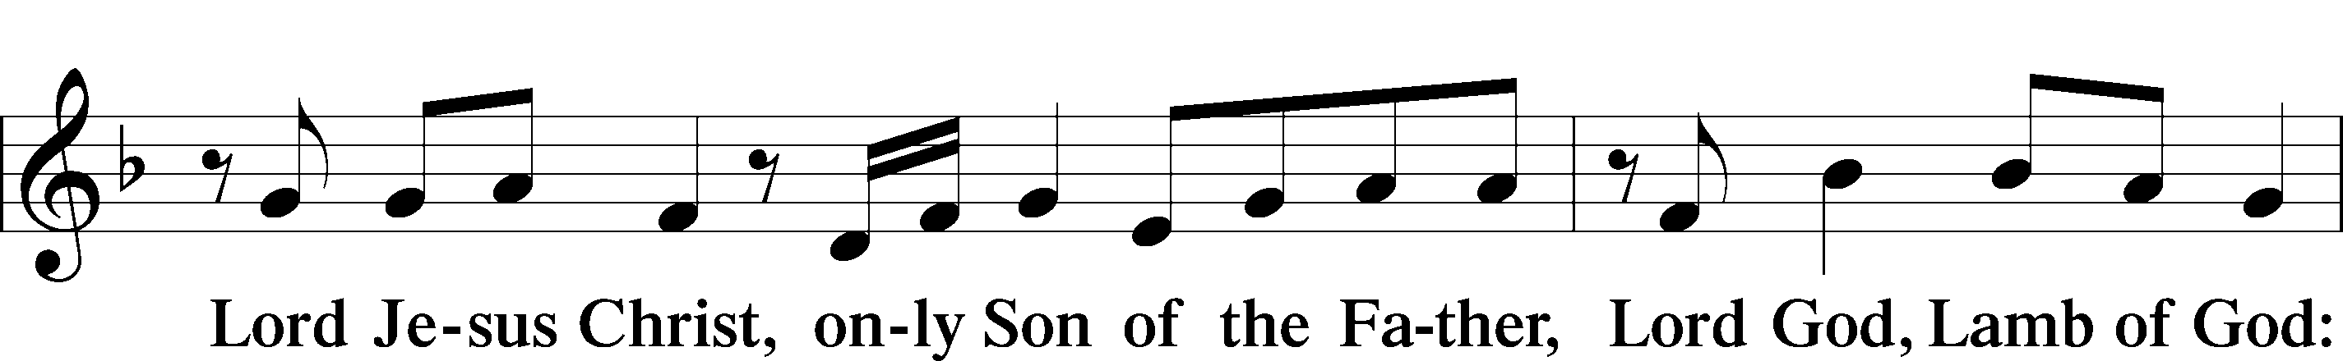
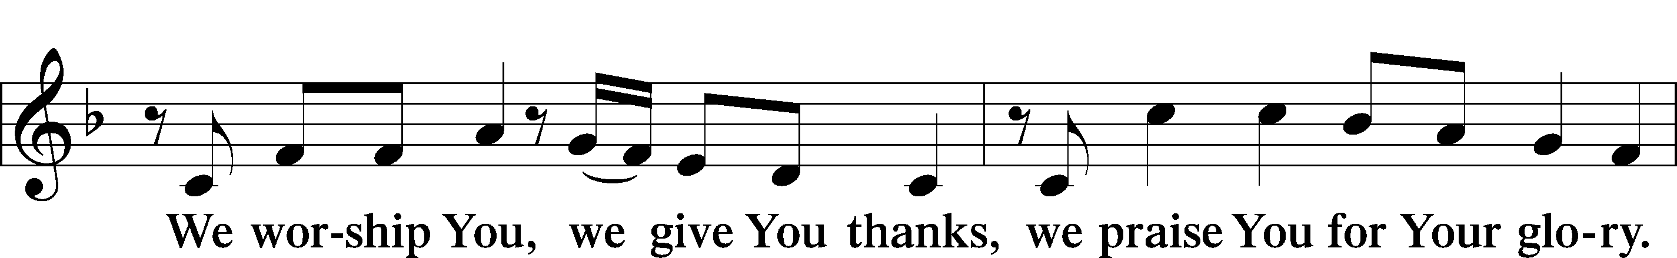

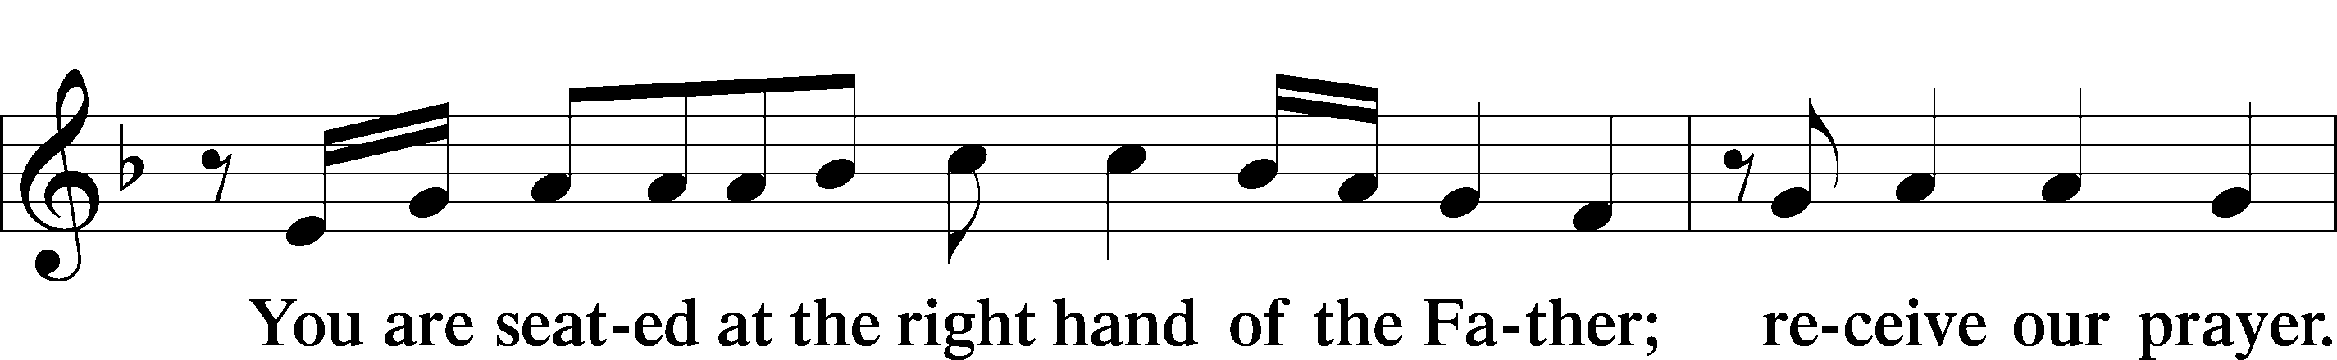
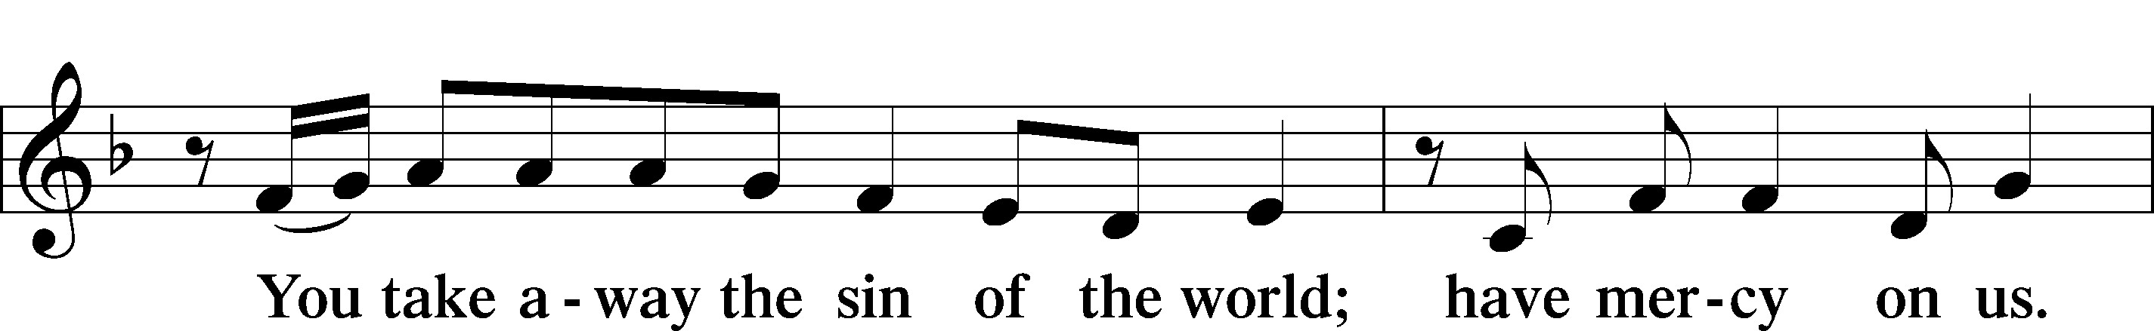

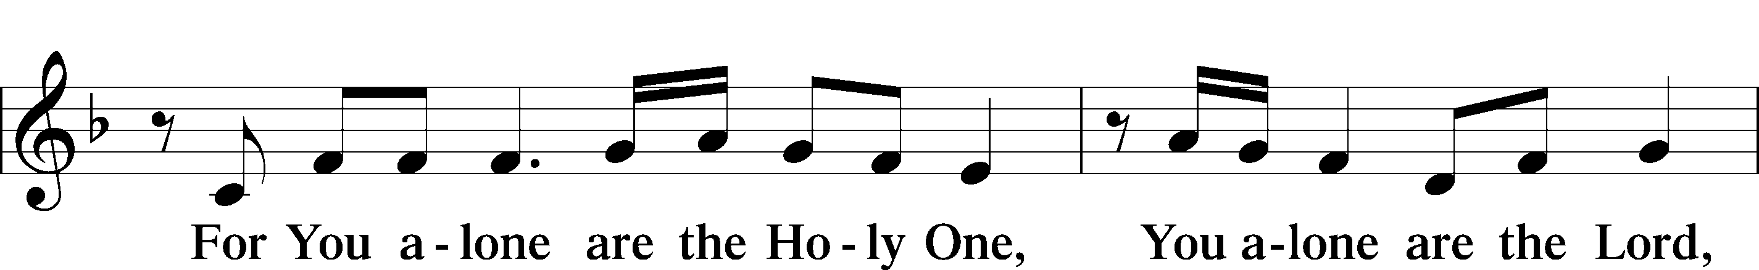

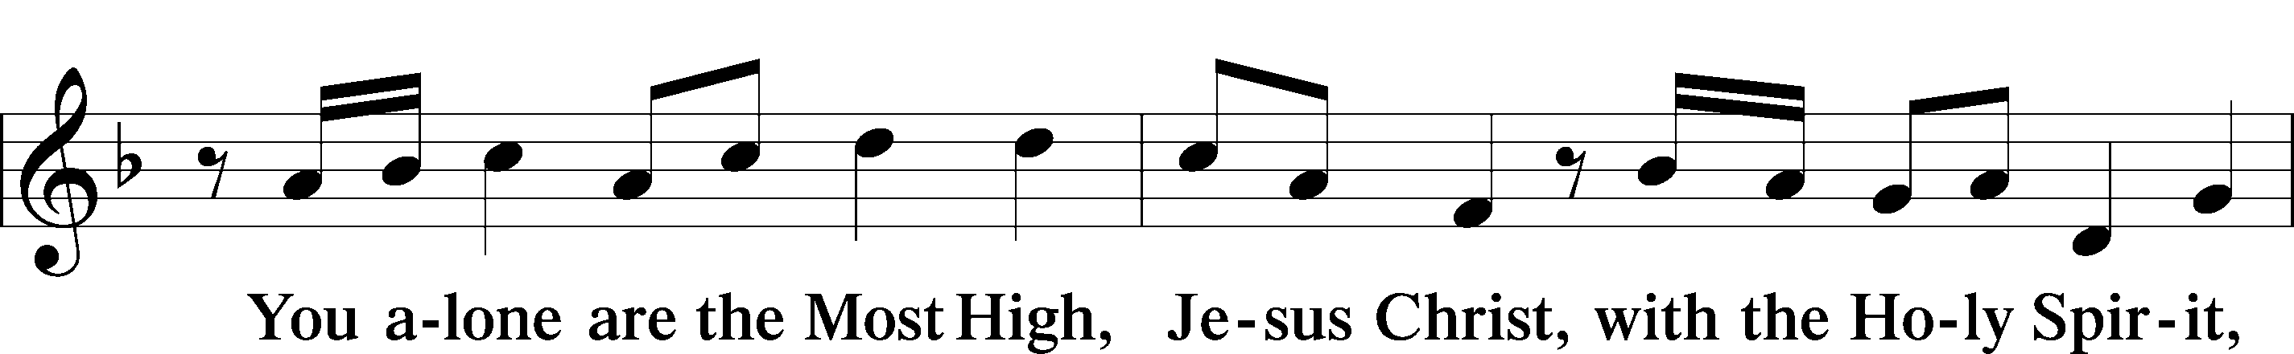

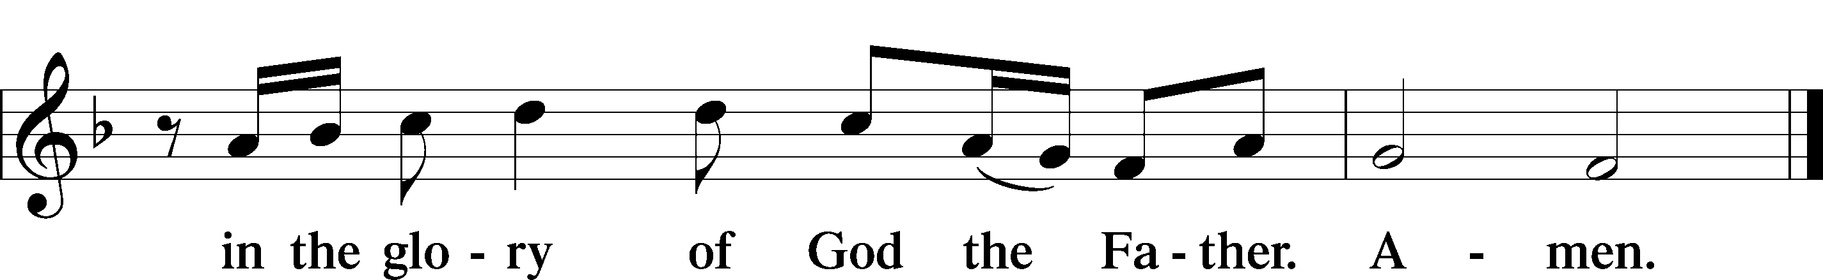

Salutation and Collect of the Day
P The Lord be with you.
C And also with you.
P Let us pray.
Father in heaven, at the Baptism of Jesus in the Jordan River You proclaimed Him Your beloved Son and anointed Him with the Holy Spirit. Make all who are baptized in His name faithful in their calling as Your children and inheritors with Him of everlasting life; through the same Jesus Christ, our Lord, who lives and reigns with You and the Holy Spirit, one God, now and forever.
C Amen.

Sit

Old Testament Reading Isaiah 42:1–9
¹Behold my servant, whom I uphold,
my chosen, in whom my soul delights;
I have put my Spirit upon him;
he will bring forth justice to the nations.
²He will not cry aloud or lift up his voice,
or make it heard in the street;
³a bruised reed he will not break,
and a faintly burning wick he will not quench;
he will faithfully bring forth justice.
⁴He will not grow faint or be discouraged
till he has established justice in the earth;
and the coastlands wait for his law.
⁵Thus says God, the Lord,
who created the heavens and stretched them out,
who spread out the earth and what comes from it,
who gives breath to the people on it
and spirit to those who walk in it:
⁶“I am the Lord; I have called you in righteousness;
I will take you by the hand and keep you;
I will give you as a covenant for the people,
a light for the nations,
⁷to open the eyes that are blind,
to bring out the prisoners from the dungeon,
from the prison those who sit in darkness.
⁸I am the Lord; that is my name;
my glory I give to no other,
nor my praise to carved idols.
⁹Behold, the former things have come to pass,
and new things I now declare;
before they spring forth
I tell you of them.”
P This is the Word of the Lord.
C Thanks be to God.

Gradual Psalm 117:1–2a; 96:8
Praise the Lord, all | nations!*
Extol him, all | peoples!
For great is his steadfast | love toward us,*
and the faithfulness of the Lord endures for- | ever.
Ascribe to the Lord the glory | due his name;*
bring an offering, and come in- | to his courts!

Epistle Romans 6:1–11
¹What shall we say then? Are we to continue in sin that grace may abound? ²By no means! How can we who died to sin still live in it? ³Do you not know that all of us who have been baptized into Christ Jesus were baptized into his death? ⁴We were buried therefore with him by baptism into death, in order that, just as Christ was raised from the dead by the glory of the Father, we too might walk in newness of life.
⁵For if we have been united with him in a death like his, we shall certainly be united with him in a resurrection like his. ⁶We know that our old self was crucified with him in order that the body of sin might be brought to nothing, so that we would no longer be enslaved to sin. ⁷For one who has died has been set free from sin. ⁸Now if we have died with Christ, we believe that we will also live with him. ⁹We know that Christ being raised from the dead will never die again; death no longer has dominion over him. ¹⁰For the death he died he died to sin, once for all, but the life he lives he lives to God. ¹¹So you also must consider yourselves dead to sin and alive to God in Christ Jesus.
P This is the Word of the Lord.
C Thanks be to God.

Stand

Alleluia and Verse LSB 156
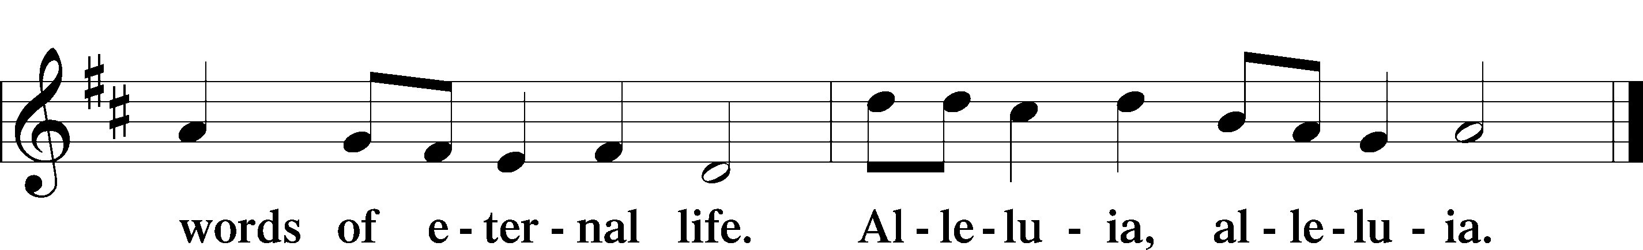
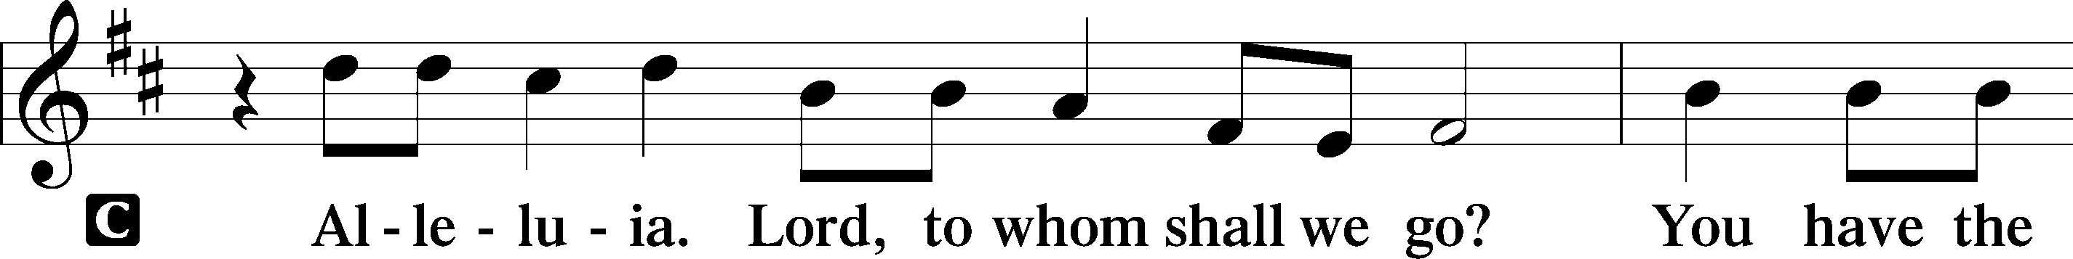

Holy Gospel Matthew 3:13–17
P The Holy Gospel according to St. Matthew, the third chapter.
C Glory to You, O Lord.
¹³Then Jesus came from Galilee to the Jordan to John, to be baptized by him. ¹⁴John would have prevented him, saying, “I need to be baptized by you, and do you come to me?” ¹⁵But Jesus answered him, “Let it be so now, for thus it is fitting for us to fulfill all righteousness.” Then he consented. ¹⁶And when Jesus was baptized, immediately he went up from the water, and behold, the heavens were opened to him, and he saw the Spirit of God descending like a dove and coming to rest on him; ¹⁷and behold, a voice from heaven said, “This is my beloved Son, with whom I am well pleased.”
P This is the Gospel of the Lord.
C Praise to You, O Christ.

Sit

406 To Jordan Came the Christ, Our Lord All:1-2, 7; W:3,5; M:4, 6
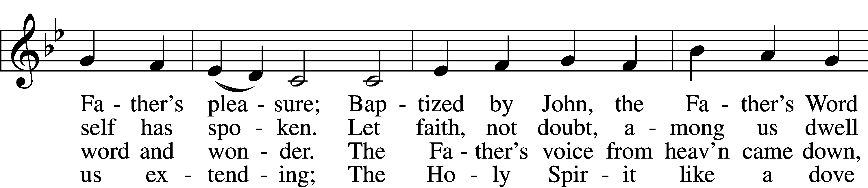
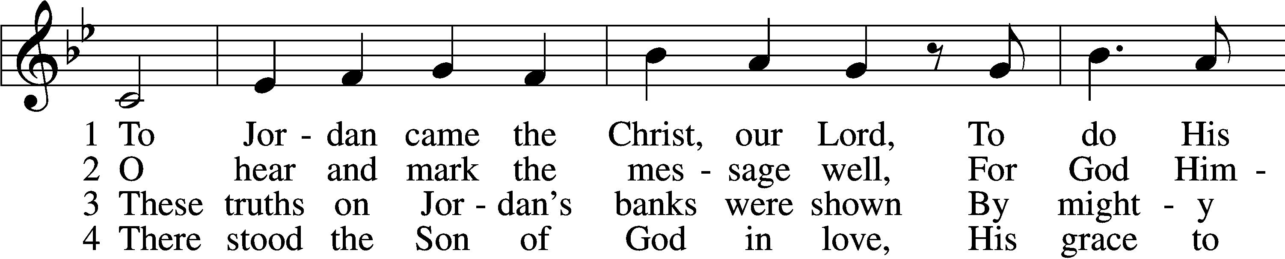

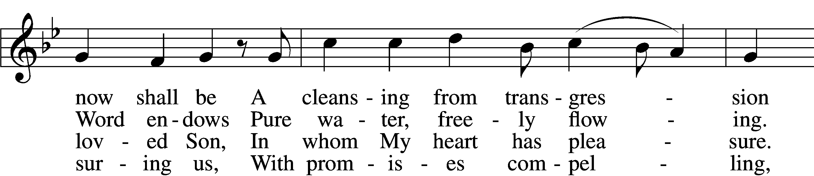
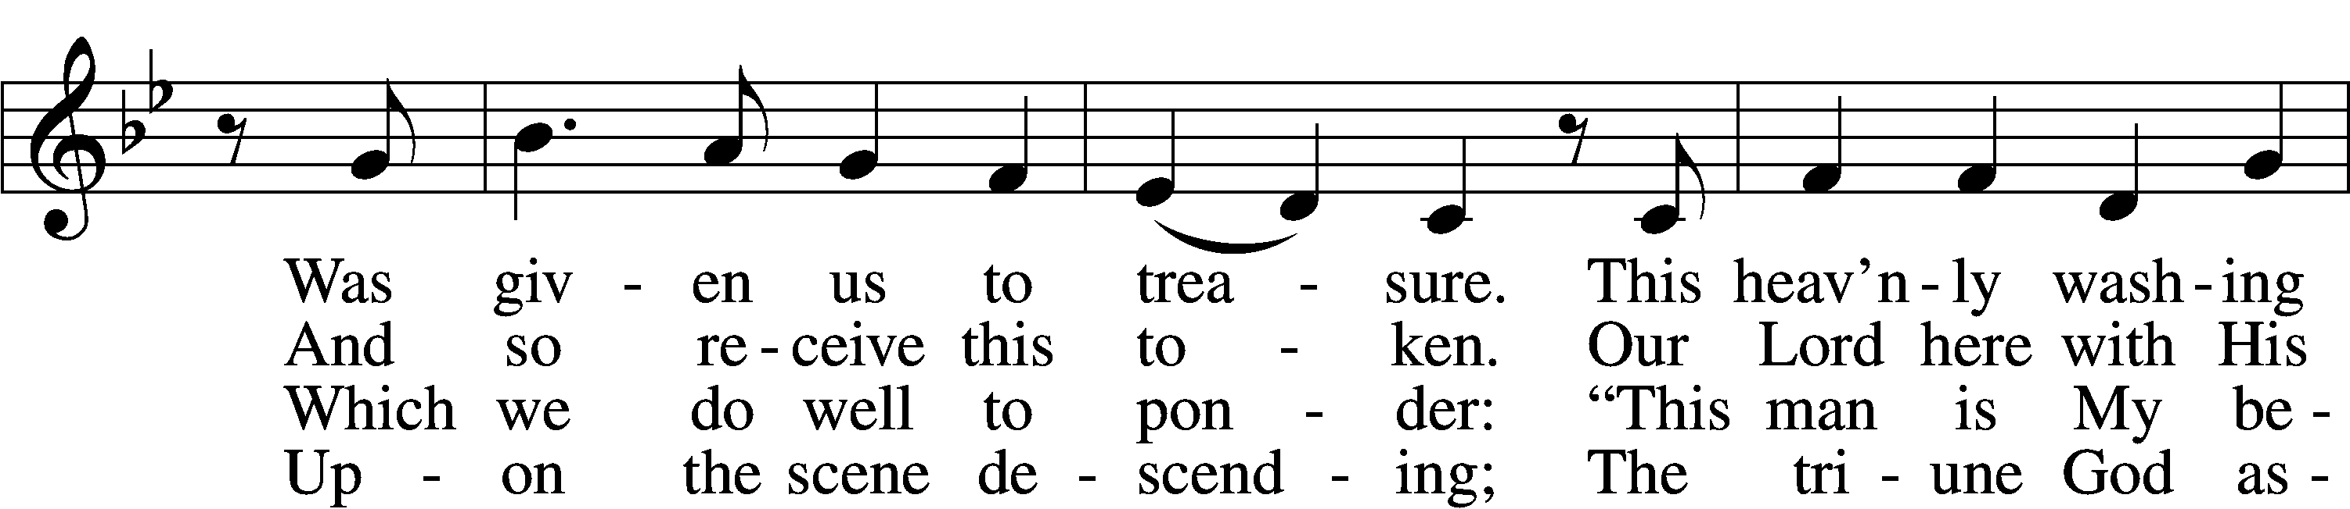

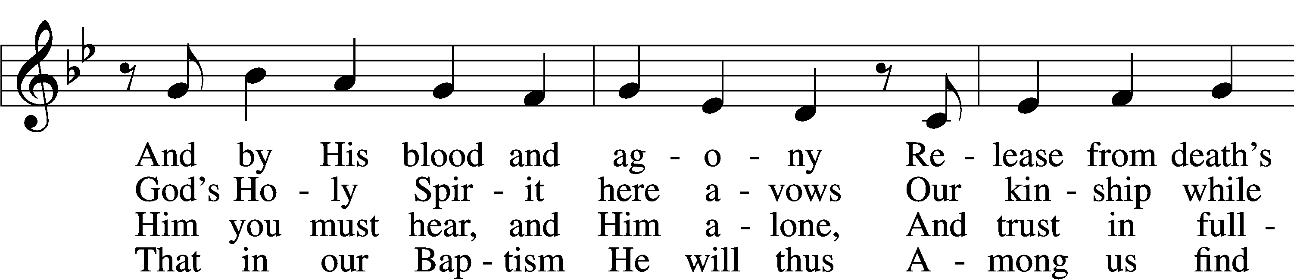

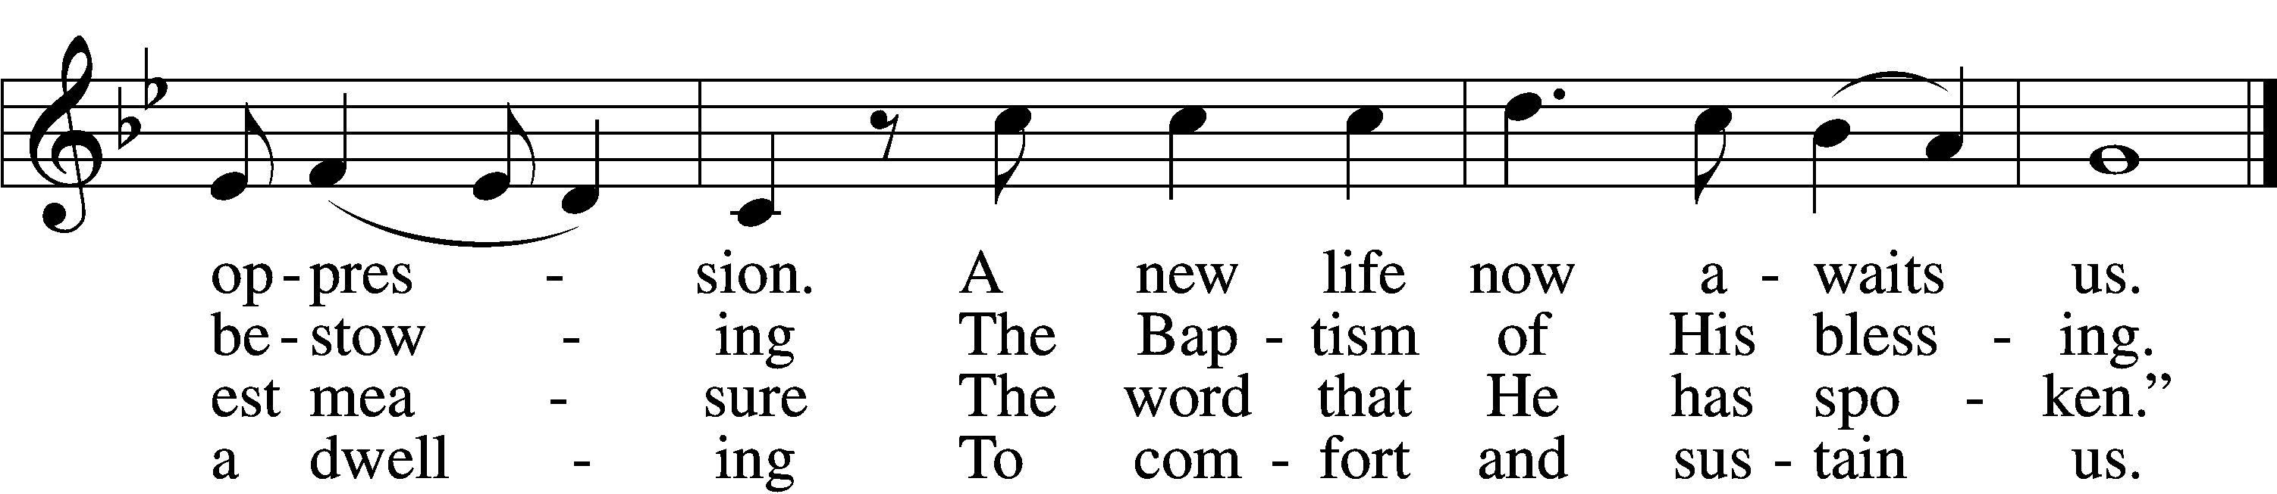

5 To His disciples spoke the Lord,
“Go out to ev’ry nation,
And bring to them the living Word
And this My invitation:
Let ev’ryone abandon sin
And come in true contrition
To be baptized and thereby win
Full pardon and remission
And heav’nly bliss inherit.”

6 But woe to those who cast aside
This grace so freely given;
They shall in sin and shame abide
And to despair be driven.
For born in sin, their works must fail,
Their striving saves them never;
Their pious acts do not avail,
And they are lost forever,
Eternal death their portion.

7 All that the mortal eye beholds
Is water as we pour it.
Before the eye of faith unfolds
The pow’r of Jesus’ merit.
For here it sees the crimson flood
To all our ills bring healing;
The wonders of His precious blood
The love of God revealing,
Assuring His own pardon.
Text: Martin Luther, 1483–1546; tr. Elizabeth Quitmeyer, 1911–88, alt.
Tune: Geystliche gesangk Buchleyn, 1524, Wittenberg, ed. Johann Walter
Text: © 1976 Elizabeth Quitmeyer. Used by permission: LSB Hymn License no. 110003744
Tune: Public domain

Sit

Sermon

Stand

Apostles’ Creed
C I believe in God, the Father Almighty,
maker of heaven and earth.
And in Jesus Christ, His only Son, our Lord,
who was conceived by the Holy Spirit,
born of the virgin Mary,
suffered under Pontius Pilate,
was crucified, died and was buried.
He descended into hell.
The third day He rose again from the dead.
He ascended into heaven
and sits at the right hand of God the Father Almighty.
From thence He will come to judge the living and the dead.
I believe in the Holy Spirit,
the holy Christian Church,
the communion of saints,
the forgiveness of sins,
the resurrection of the body,
and the life T everlasting. Amen.
Prayer of the Church

Sit

Consecration of the Offering
After the prayers please be seated. The altar is set for the Lord’s Supper and the offering is consecrated. As you prepare to receive the sacrament you may use the prayers in the front of the hymnal or meditate on a communion hymn.

Stand

Offertory LSB 159
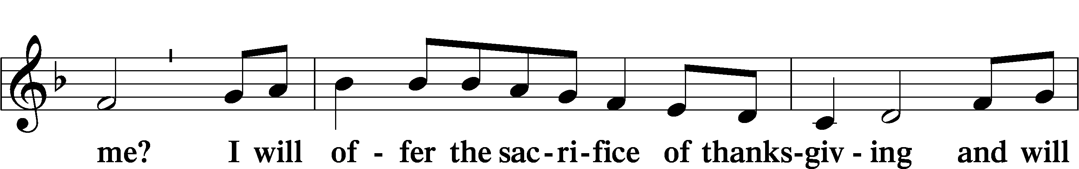
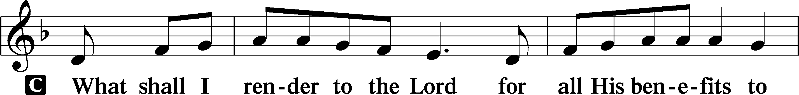

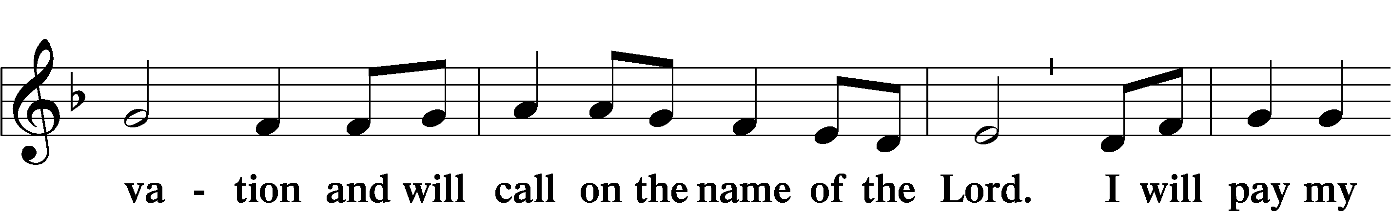
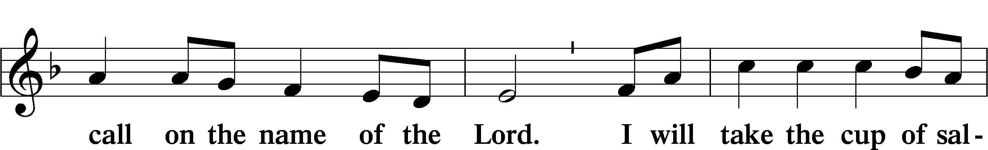

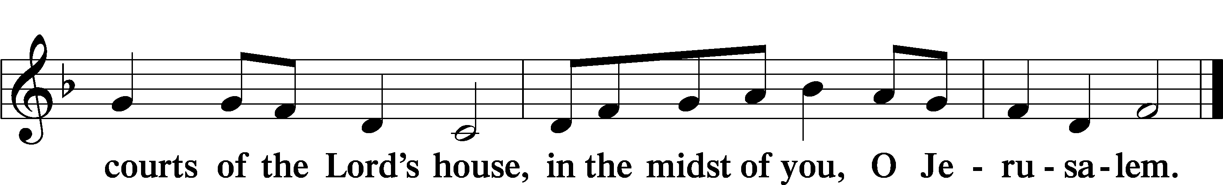
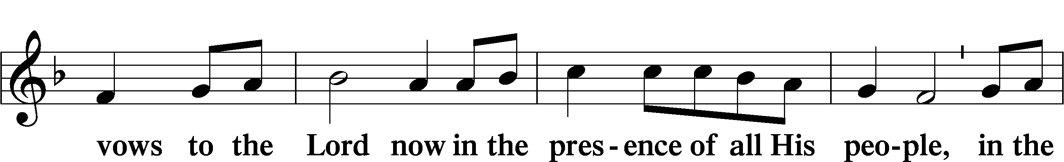

Preface LSB 160

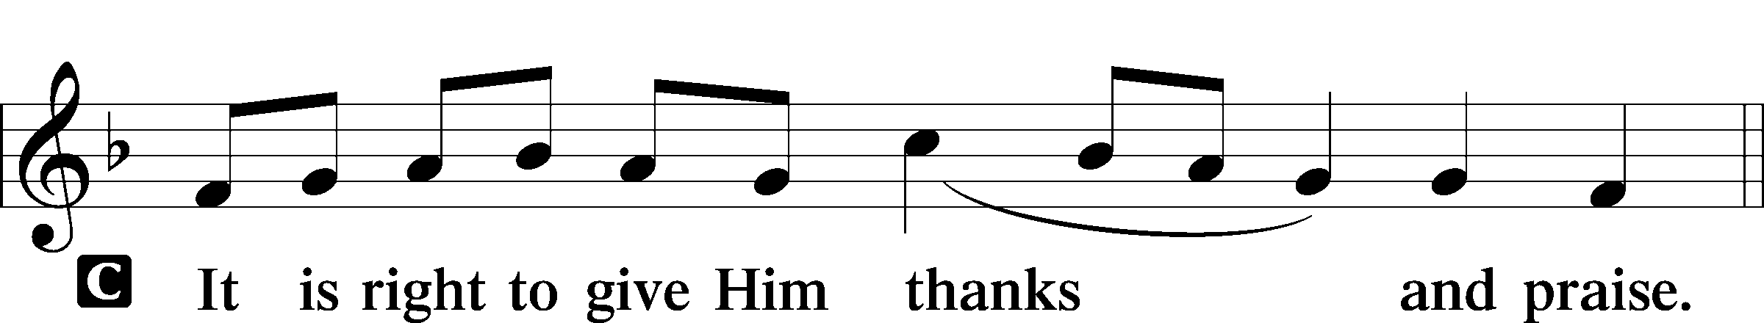

P It is truly good, right, and salutary that we should at all times and in all places give thanks to You, holy Lord, almighty Father, everlasting God, through Jesus Christ, our Lord; for at His Baptism Your voice from heaven revealed Him as Your beloved Son, and the Holy Spirit descended on Him, confirming Him to be the Christ. Therefore with angels and archangels and with all the company of heaven we laud and magnify Your glorious name, evermore praising You and saying:

Sanctus LSB 161
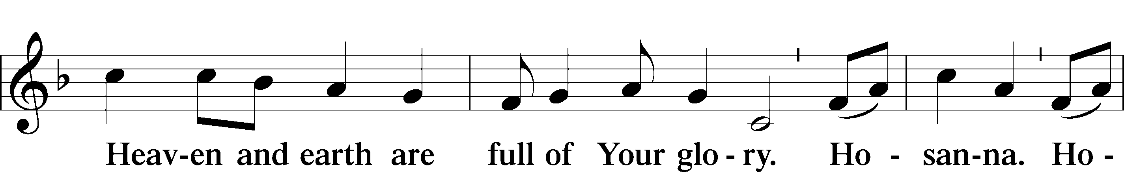
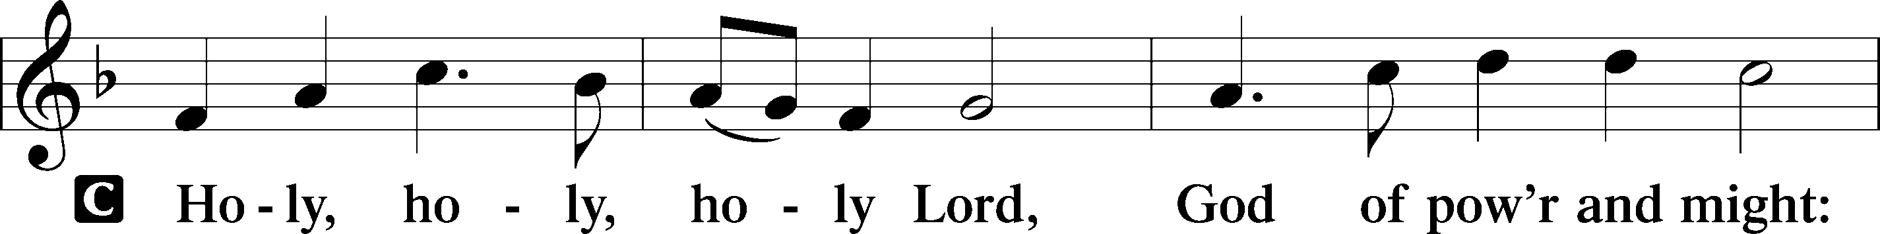

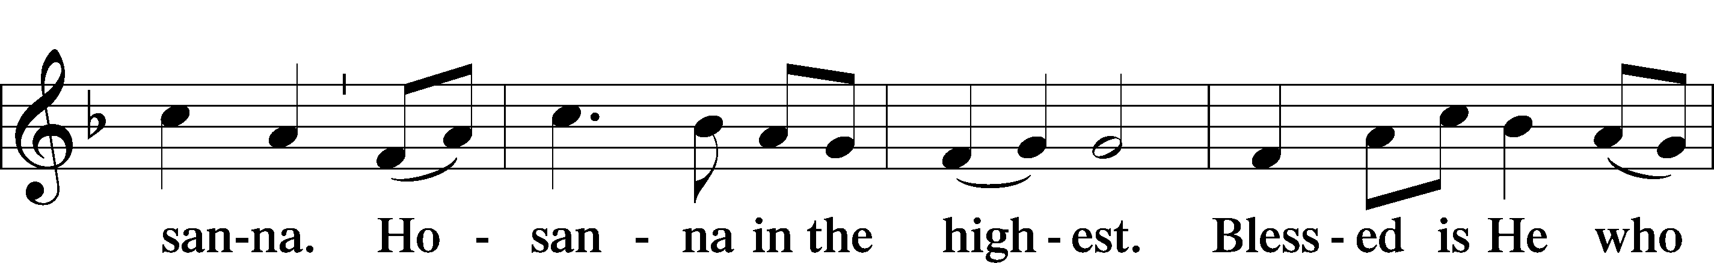

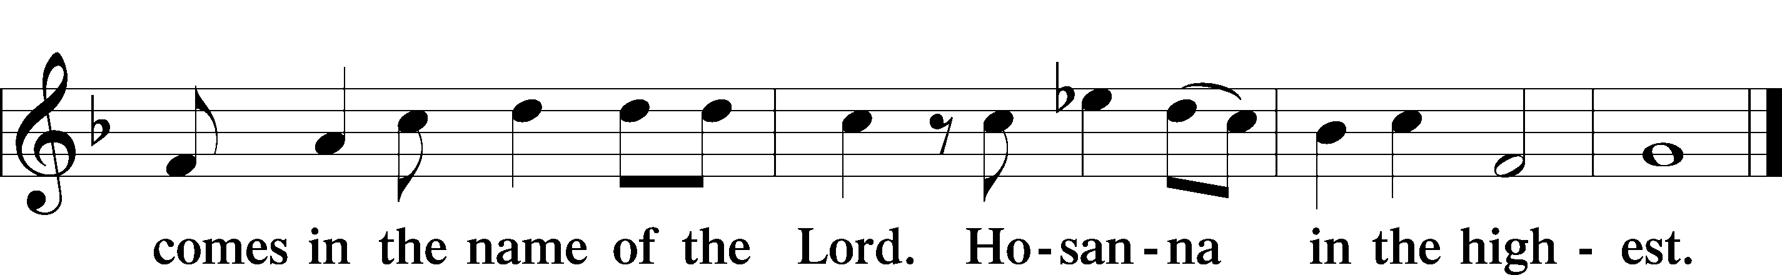

Lord’s Prayer LSB 162
P Lord, remember us in Your kingdom and teach us to pray:
C Our Father who art in heaven,
hallowed be Thy name,
Thy kingdom come,
Thy will be done on earth
as it is in heaven;
give us this day our daily bread;
and forgive us our trespasses
as we forgive those
who trespass against us;
and lead us not into temptation,
but deliver us from evil.
For Thine is the kingdom
and the power and the glory
forever and ever. Amen

The Words of Our Lord
P Our Lord Jesus Christ, on the night when He was betrayed, took bread, and when He had given thanks, He broke it and gave it to the disciples and said: “Take, eat; this is My T body, which is given for you. This do in remembrance of Me.”
In the same way also He took the cup after supper, and when He had given thanks, He gave it to them, saying: “Drink of it, all of you; this cup is the new testament in My T blood, which is shed for you for the forgiveness of sins. This do, as often as you drink it, in remembrance of Me.”
Pax Domini LSB 163
P The peace of the Lord be with you always.

Agnus Dei LSB 163
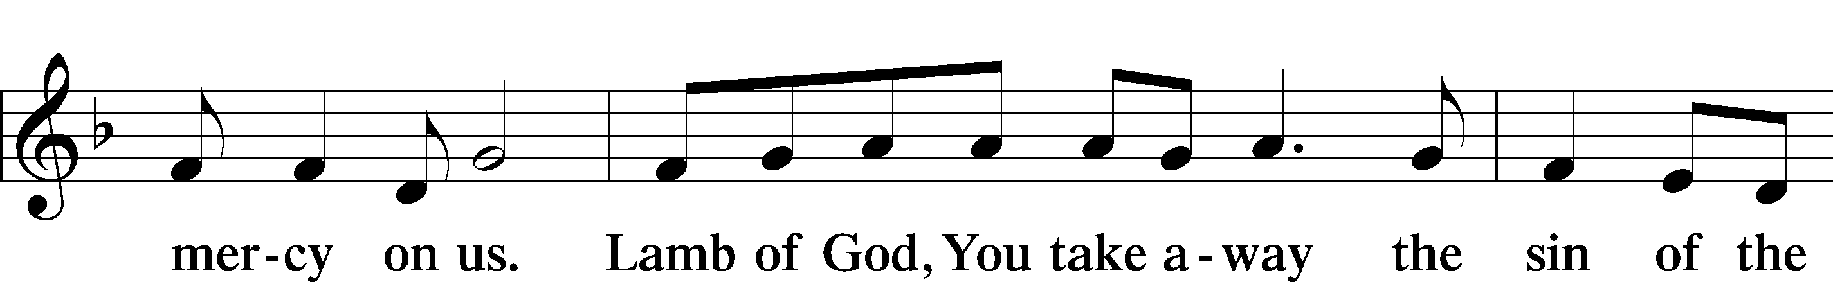
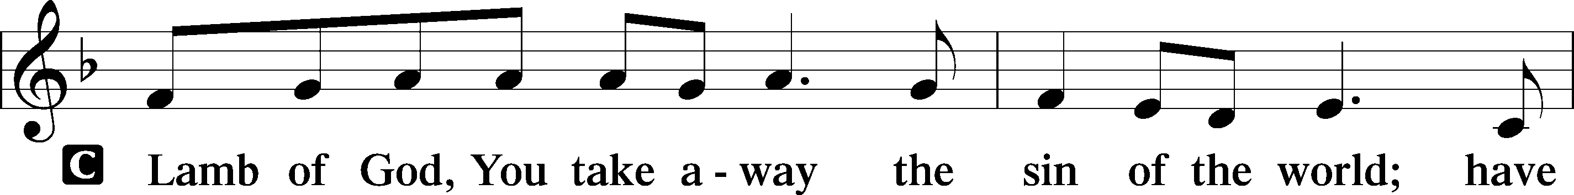

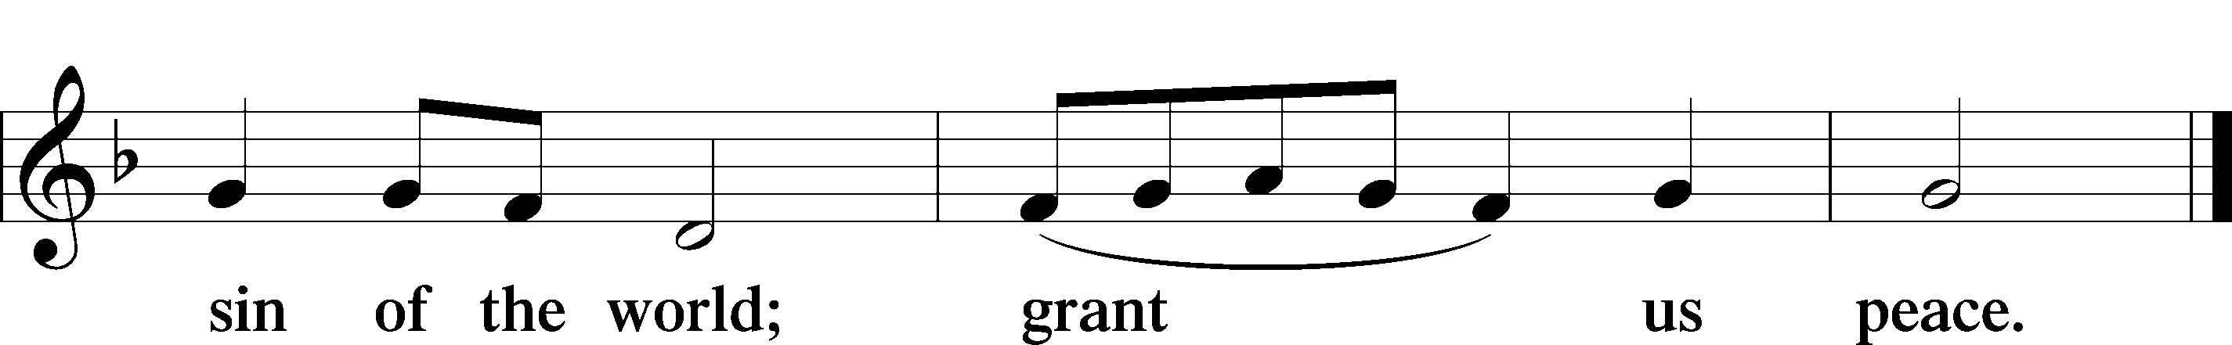
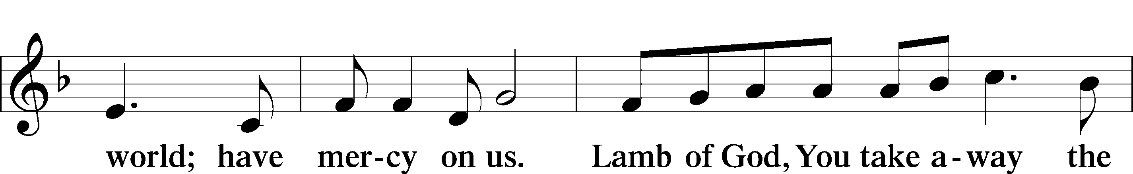

Sit

Distribution

399 The Star Proclaims the King Is Here
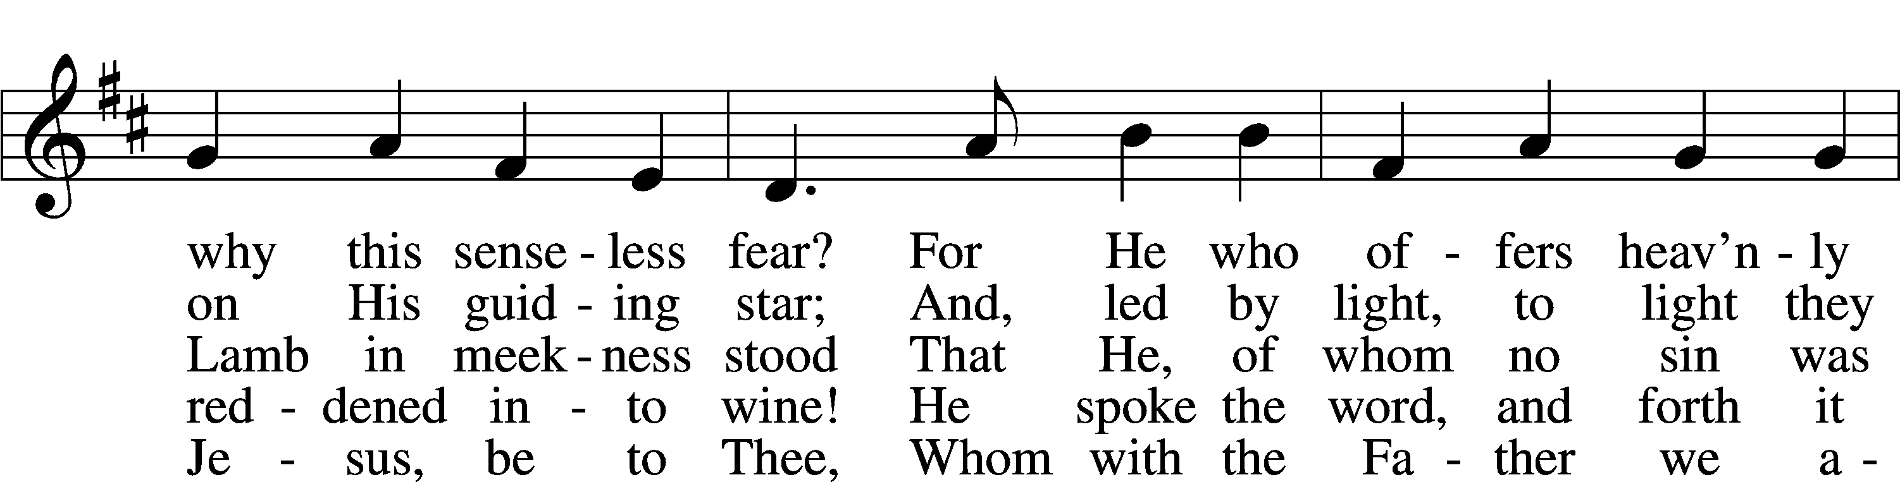
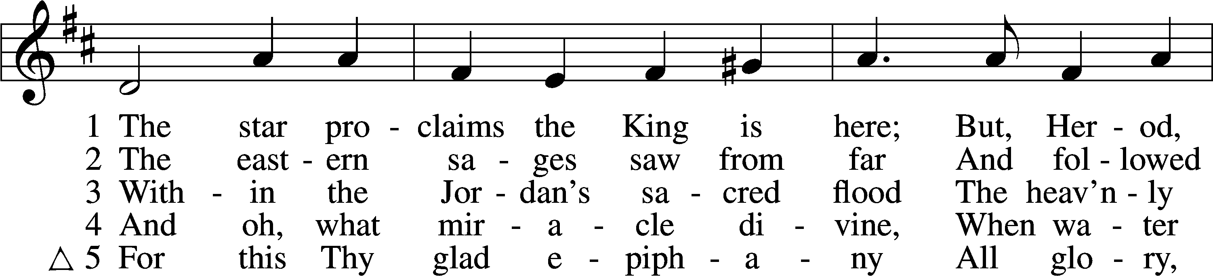

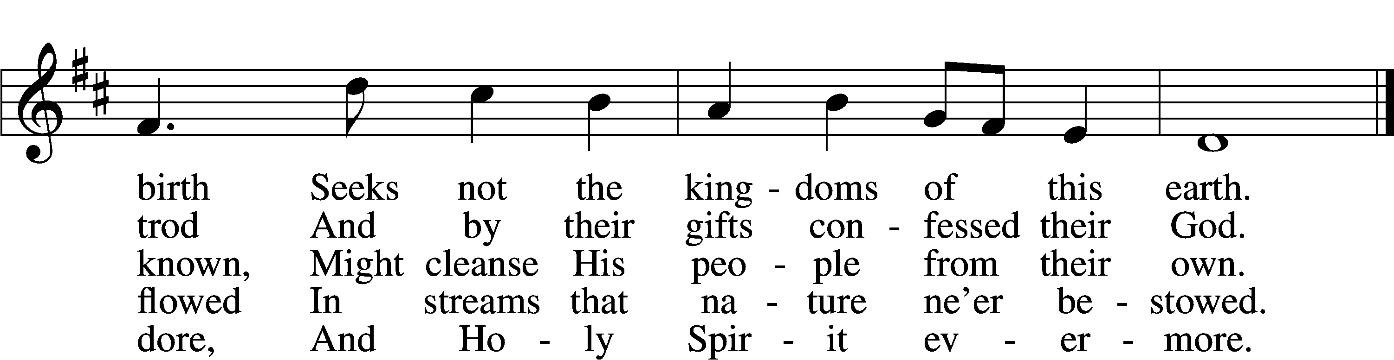
Text: Coelius Sedulius, 5th cent.; tr. John Mason Neale, 1818–66, alt. Tune: Geistliche Lieder auffs new gebessert, 1535, Wittenberg, ed. Joseph Klug Text and tune: Public domain

617 O Lord, We Praise Thee
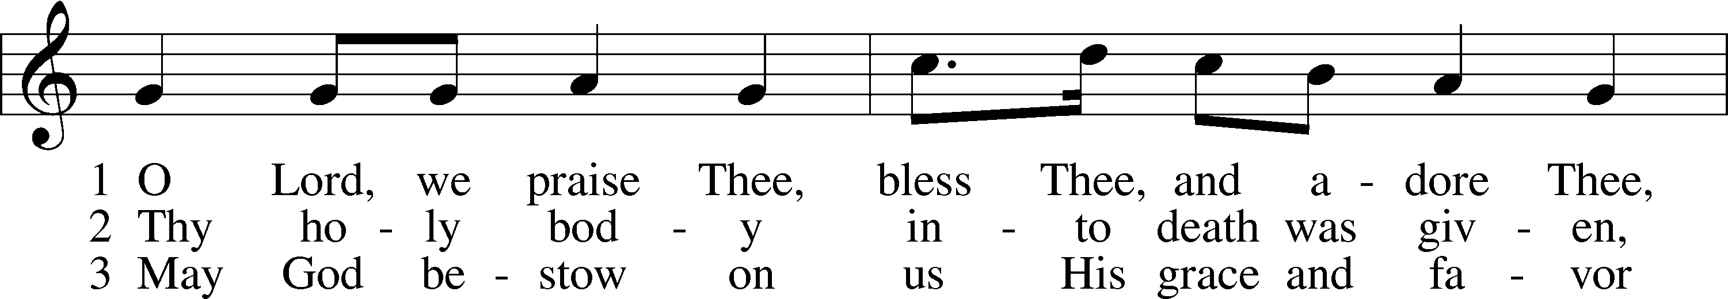
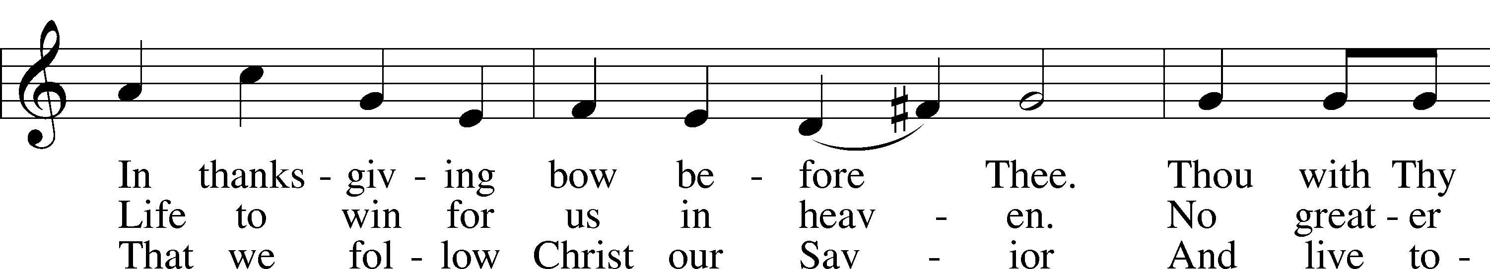
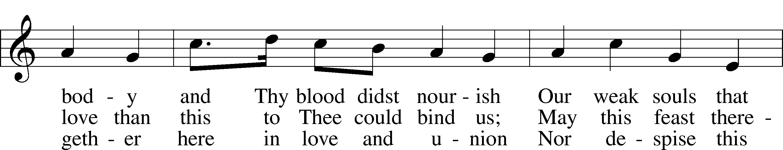
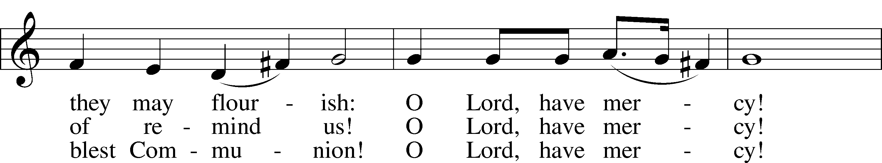
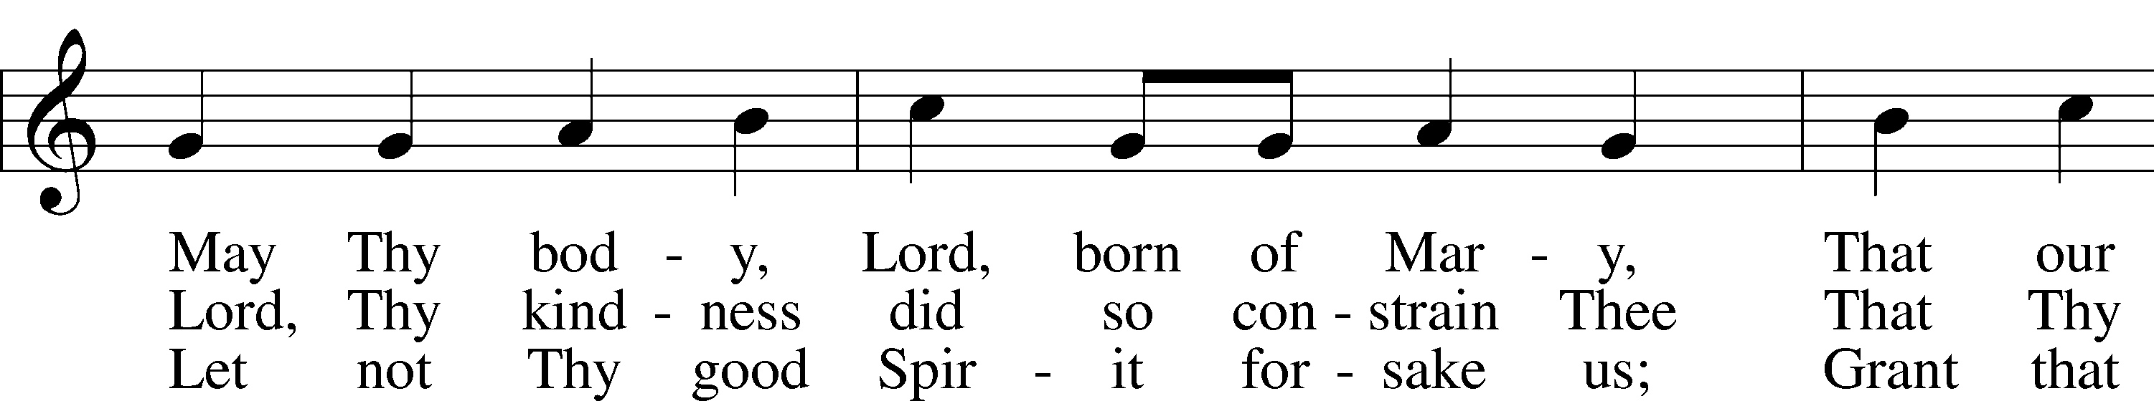
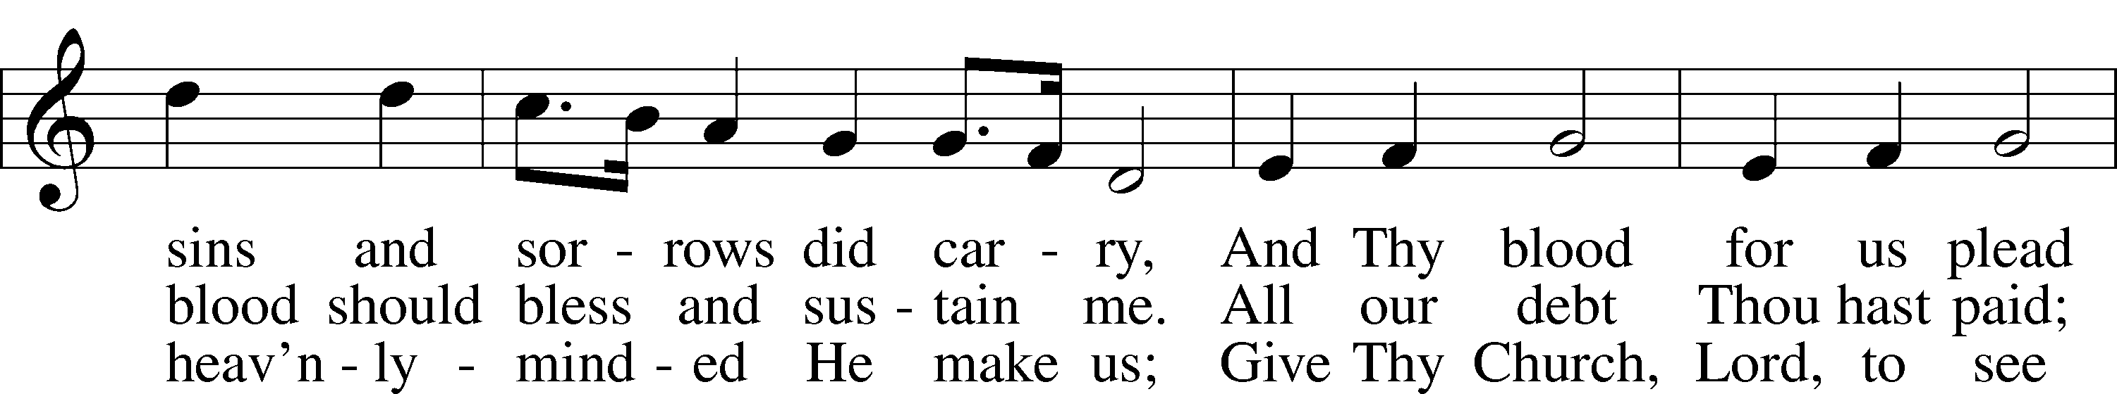
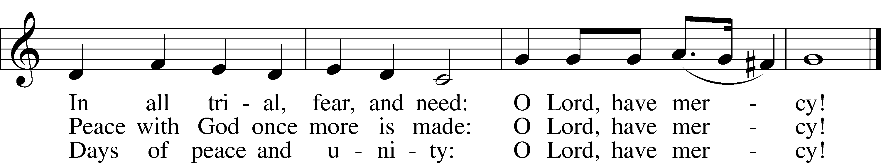
Text: tr. The Lutheran Hymnal, 1941, alt.; (st. 1): German, 14th cent.; (sts. 2–3): Martin Luther, 1483–1546
Tune: Geystliche gesangk Buchleyn, 1524, Wittenberg, ed. Johann Walter
Text: © 1941 Concordia Publishing House. Used by permission: LSB Hymn License no. 110003744
Tune: Public domain

594 God’s Own Child, I Gladly Say It
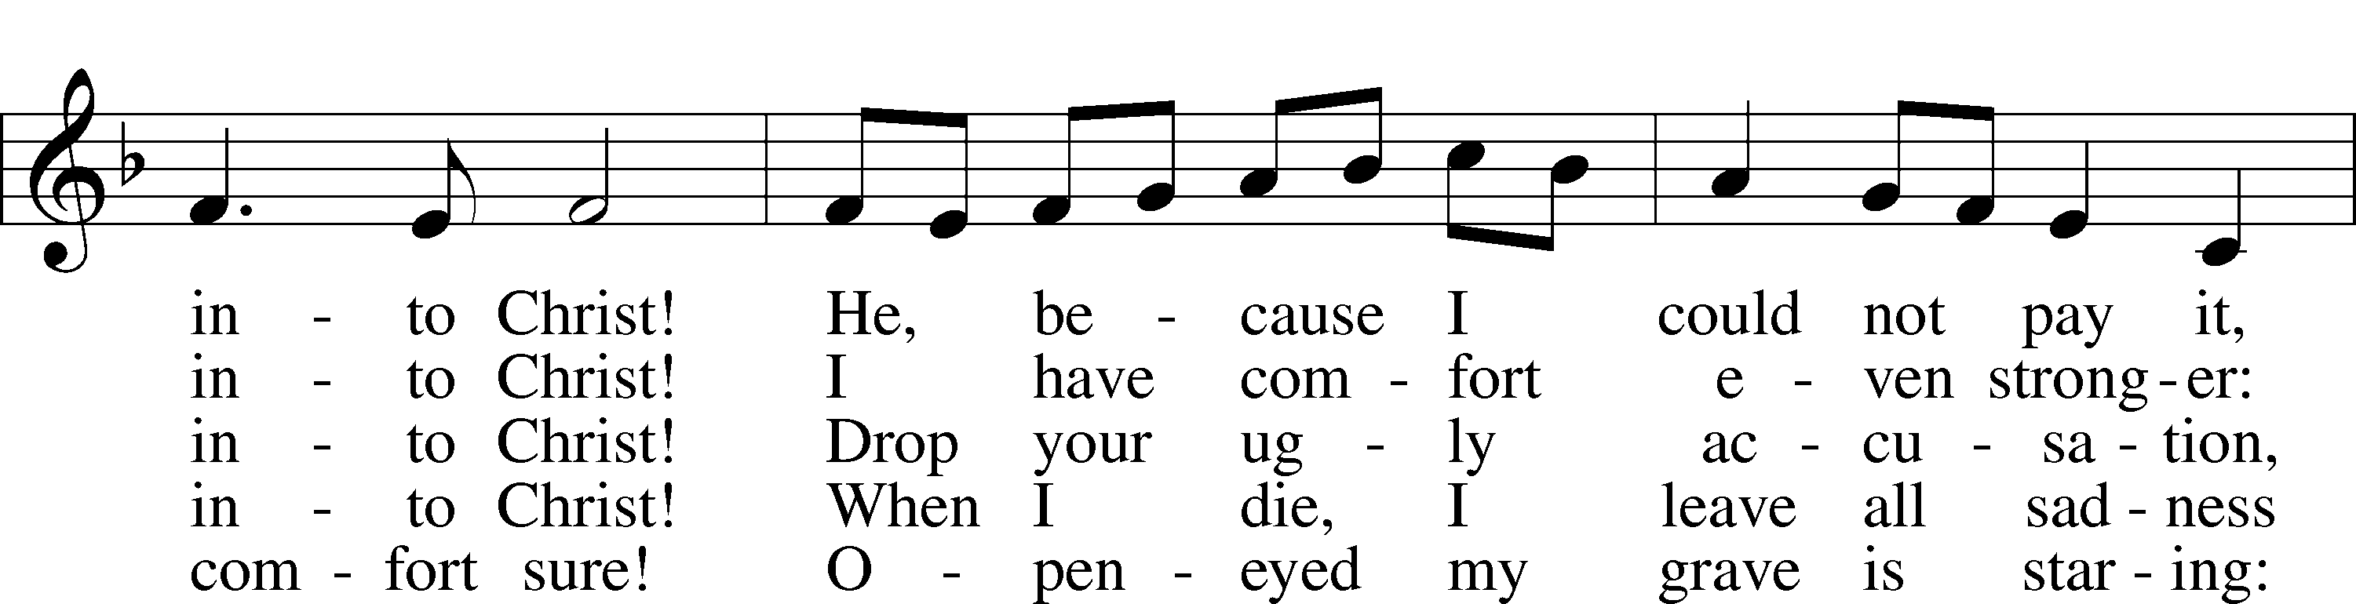
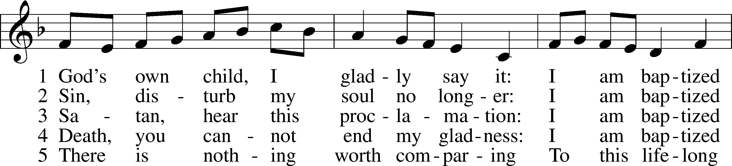

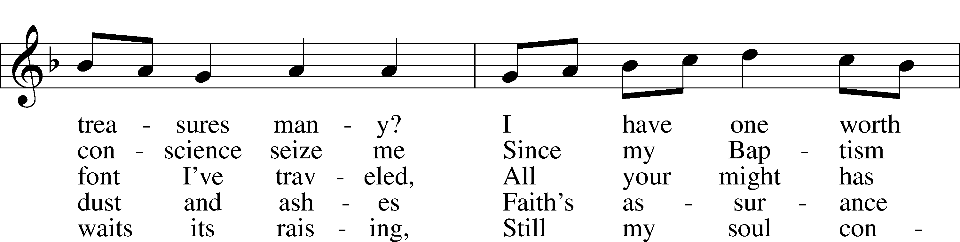
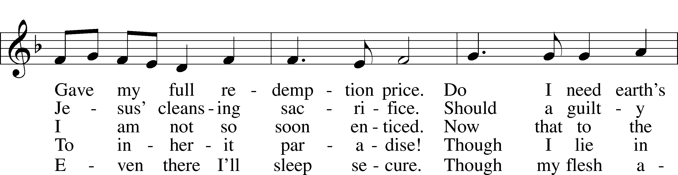

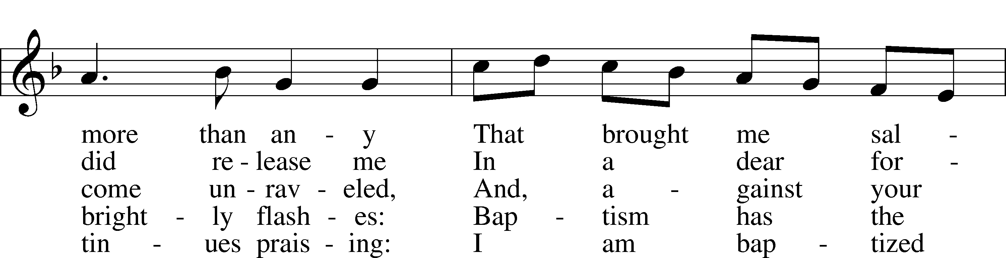

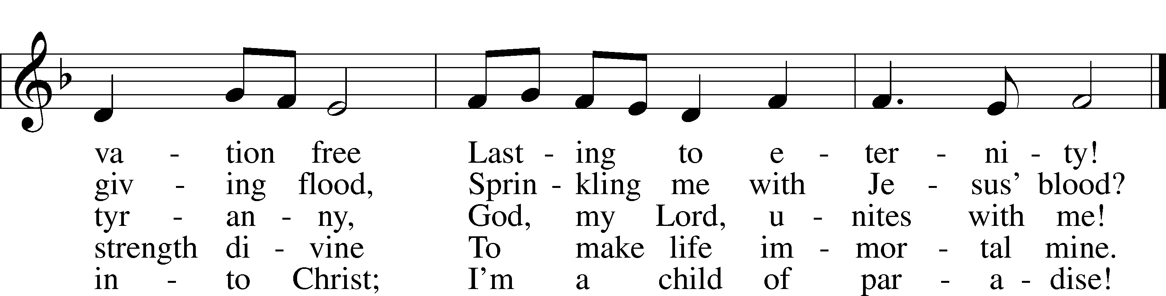

Text: Erdmann Neumeister, 1671–1756; tr. Robert E. Voelker, 1957 Tune: Johann Caspar Bachofen, 1695–1755, alt.
Text: © 1991 Robert E. Voelker. Used by permission: LSB Hymn License no. 110003744 Tune: Public domain

605 Father Welcomes
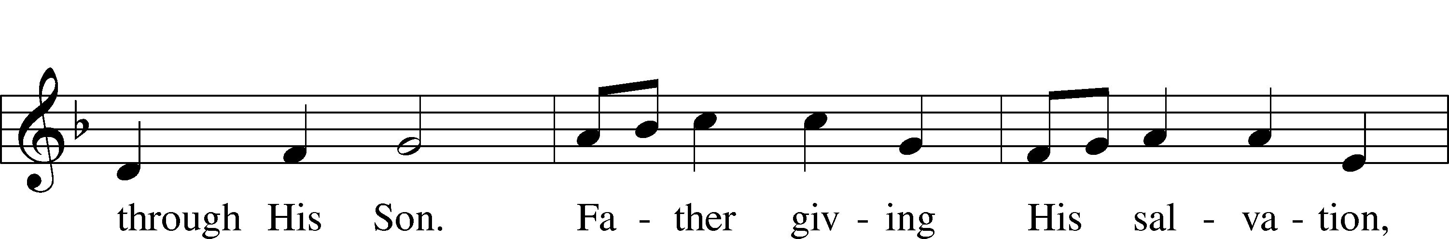
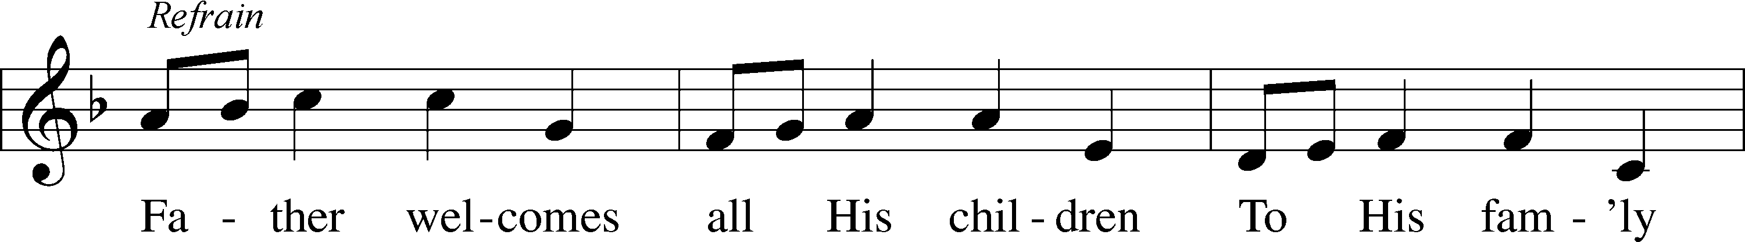

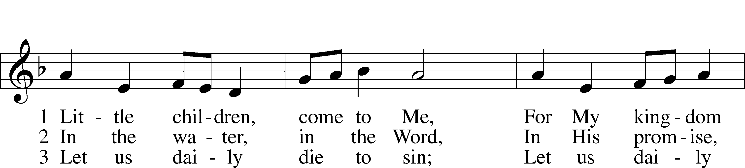

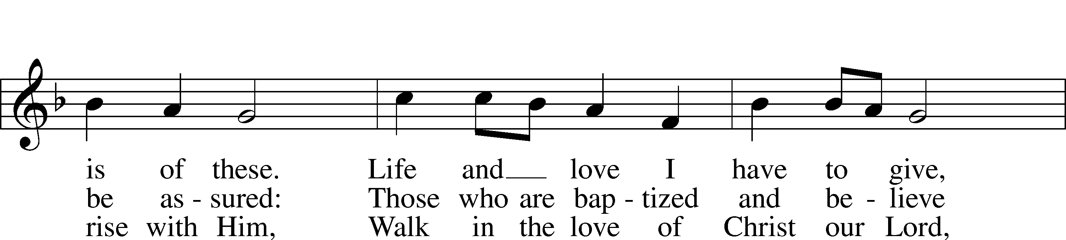

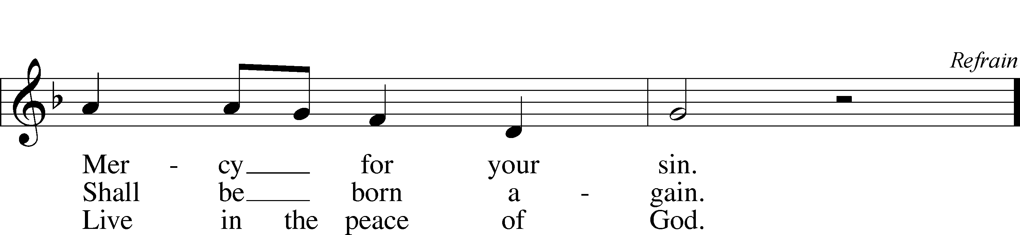

Text and tune: Robin Mann, 1949 Text and tune: © 1986 Kevin Mayhew Ltd. Used by permission: LSB Hymn License no. 110003744

The Dismissal
P The body and blood of our Lord Jesus Christ strengthen and preserve you in body and soul to life everlasting. Depart T in peace.
C Amen.

Stand

Thank the Lord LSB 164
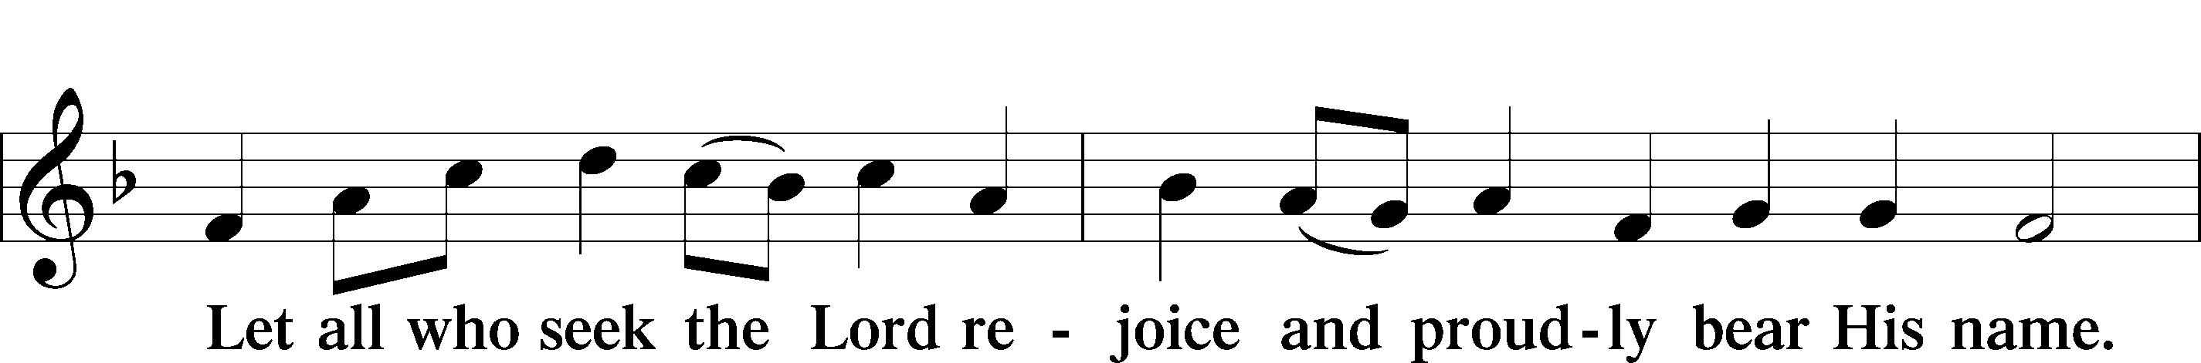
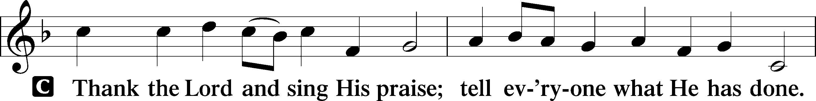

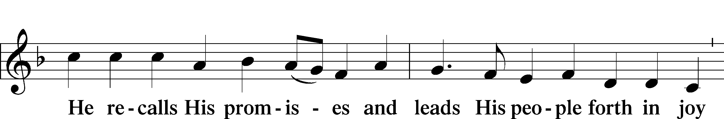

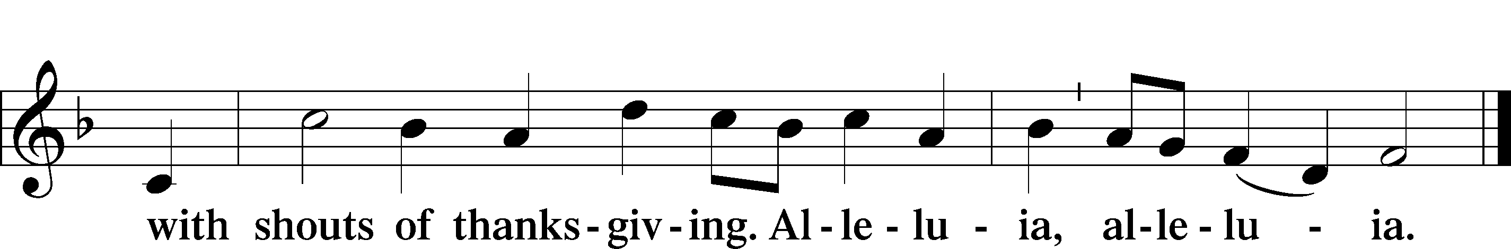

Post-Communion Collect
P Let us pray.
We give thanks to You, almighty God, that You have refreshed us through this salutary gift, and we implore You that of Your mercy You would strengthen us through the same in faith toward You and in fervent love toward one another; through Jesus Christ, Your Son, our Lord, who lives and reigns with You and the Holy Spirit, one God, now and forever.
C Amen.

Benediction LSB 202
P The Lord bless you and keep you.
The Lord make His face shine upon you and be gracious unto you.
The Lord lift up His countenance upon you and T give you peace.
C Amen, amen, amen.
401 From God the Father, Virgin-Born
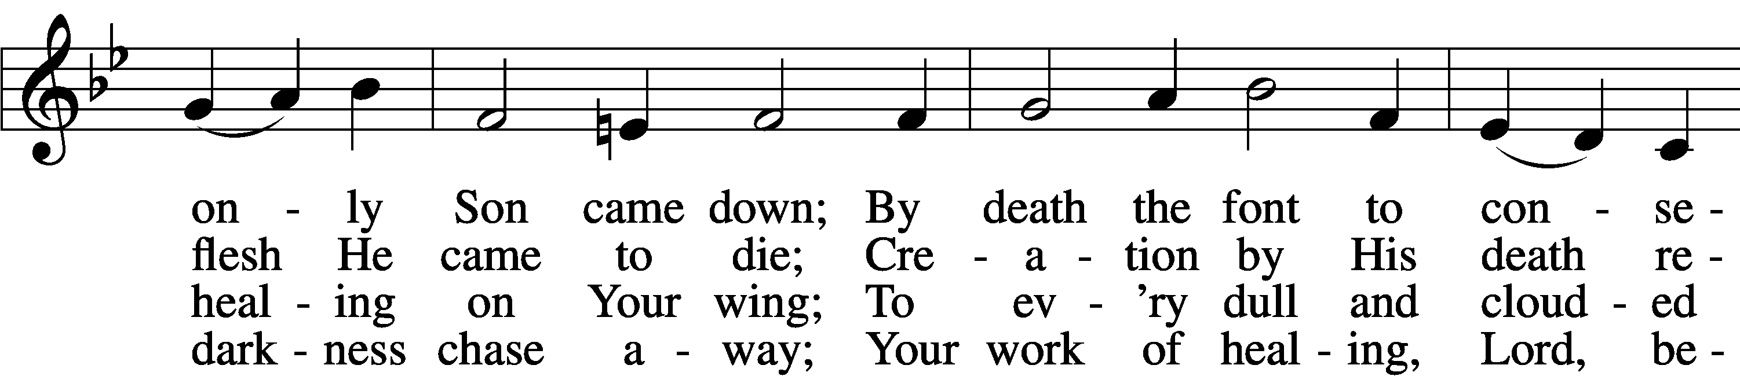
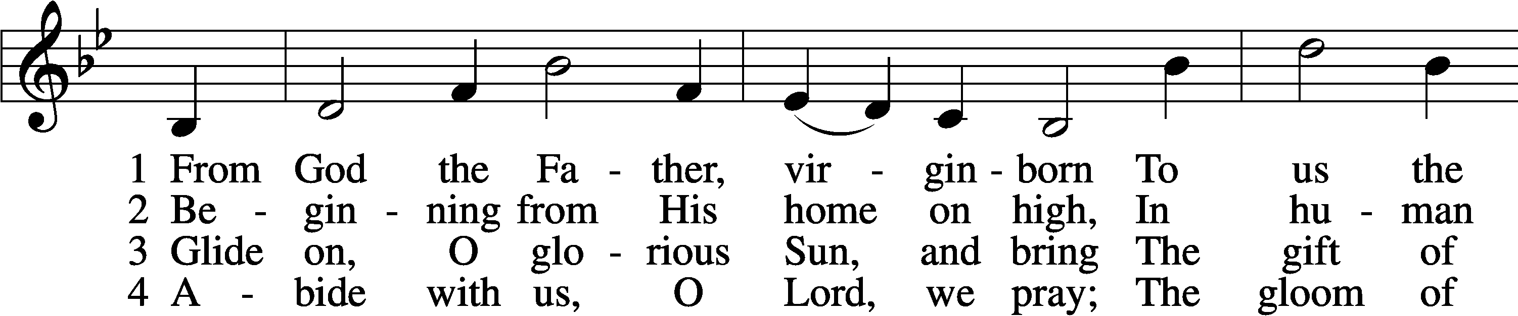

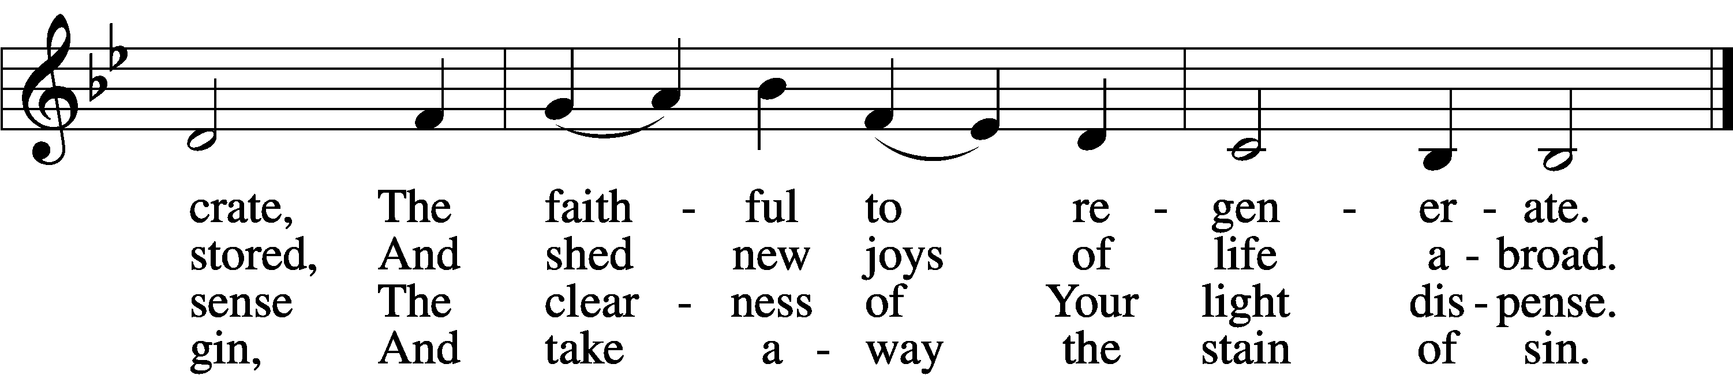

5 Lord, once You came to earth’s domain
And, we believe, shall come again;
Be with us on the battlefield,
From ev’ry harm Your people shield.
D 6 To You, O Lord, all glory be
For this Your blest epiphany;
To God, whom all His hosts adore,
And Holy Spirit evermore.

Text: Latin, c. 5th–10th cent.; tr. John Mason Neale, 1818–66, alt. Tune: Antiphoner, 1753, Grenoble Text and tune: Public domain
Acknowledgments
Unless otherwise indicated, Scripture quotations are from the ESV® Bible (The Holy Bible, English Standard Version®), copyright © 2001 by Crossway, a publishing ministry of Good News Publishers. Used by permission. All rights reserved.
Created by Lutheran Service Builder © 2021 Concordia Publishing House.

Prayers for Our Members
Norman Abels (Brookestone Meadows–Elkhorn) | Healing
Judy Ahrens | Healing
Vaughn Albrecht (Mount Carmel) | Healing
Tom & DyAnn Altwine | Healing
Lyle Colsden (Mother Hull) | Healing
Pat Flodine (Cambridge Court) | Healing
Marilyn Fuqua | Healing
Vi Fox (Prairie View) | Healing
Wanda Glanzer | Healing
Jan Hatfield | Healing
Ruby Hatfield | Healing
Evelyn Heiden (Mother Hull) | Healing
Linda Luhn | Healing
Diane Plummer | Healing
Debra Schinkel | Healing
Don Trampe | Healing
Robin Baker | Cancer
Ivan Bombeck | Cancer
Bertha Marienau | Cancer
Response to the Gospel
Date: 12/25/2022
Offering: $12,398.30
Weekly Need: $7,500
Offering Options:
To worship the Lord with your offering:
1) Place your offering in the offering plate as you enter or leave.
2) Go to zionkearney.churchtrac.com/give
3) Go to zionkearney.com and click on the ChurchTrac icon
Worship Assistants
Sunday, January 8th – 9:00am
Elder: Ken Hockemeier  Acolyte: Miriam Gaunt  Announcer: Carol Kreutzer | Usher: Steve Junge  Engineer: Eric Rosenthal  Altar Guild: Shirley Oertwig & Sheryl Fox
Sunday, January 15th – 9:00p
Elder: Nathan Gaunt  Acolyte: Jacob Halvorsen  Announcer: Brooke Fisher | Usher: Andy Wollberg  Engineer: Jamie Nikodym  Altar Guild: Shirley Oertwig & Sheryl Fox
4) Mail your gift to Zion Lutheran Church, 2421 C Ave, Kearney, NE 68847 or place it in the mail slot on the south side of the building.
Today’s Radio Broadcast is sponsored by the Dorothy Sikes Memorial, in honor of our Lord’s Baptism.
Prayers for Our Members’ Family & Friends
Lana Fattig (Eric’s wife) | Expecting
Roger Young (Tiffany Davis’ father) | Parkinson’s
Greg Blum (Junge Family Friend) | Healing
Elaine de la Motte (Carol Herron’s sister-in-law) | Healing
Roger Hoffman (Marc’s father) | Healing
Joshua Junge (Steve’s nephew) | Healing
Luetta Lammers (Ruby Hatfield’s sister) | Healing
Tim Powers (Kim Wilken’s brother) | Healing
Howard Quandt (Don & Shirley Helmbrecht’s family) | Healing
Aaron Russell (Becky Thornton’s son-in-law) | Healing
David & Carol Shiers (Jessica’s parents) | Healing
Pat Snyder (Carol Herron’s friend) | Healing
Randy Solomon (Beth Rosenthal’s father) | Healing
Jonah (Jase & Jarren Blattner’s friend) | Cancer
Glenda Fichtner (Ruby Hatfield’s niece) | Cancer
Ron Halvorsen (Jeff’s dad) | Cancer
Sharon Mulhair (Pam Uhlir’s cousin) | Cancer
Milton Naprstek (Marilyn Fuqua’s brother) | Cancer
Cindy Pietsch (Ellen Koopman’s sister-in-law) | Cancer
Rick Schnacker (Marilyn Fuqua’s nephew) | Cancer
Tyrone Uhlir (Pam’s nephew) | Cancer
Ray Vang (Don & Shirley Helmbrecht’s brother-in-law) | Cancer

ZION LUTHERAN CHURCH AND SCHOOL

Pr. James DeLoach, Pastor + (308) 627-5260
james.deloach@zionkearney.org
Pr. Doug Gaunt, Pastor + (308) 455-0552
doug.gaunt@zionkearney.org
Tony Splittgerber, Principal + (308) 293-0168
anthony.splittgerber@zionkearney.org

Church Office
Administrative Assistant: Holly Reid
Email: school@zionkearney.org
Phone: (308)-234-3410 Fax: (308) 236-8100
Office Hours: Monday-Friday 8:00am-4:00pm
Radio Broadcast: Sunday @ 10:30 a.m. on 1460 AM
Website: www.zionkearney.com

This Week at Zion
Sun 1/8 | 9:00a  10:30a  10:30a  5:00p  Birthdays | Divine Service  Adult Bible Study & Sunday School  Radio Broadcast  1460AM & 92.1FM  Divine Service  Bailey Hockemeier  Don Trampe
Mon 1/9 | 7:00p | Mary Martha
Tues 1/10 | 1:30p  7:00p | Sleeping Mats  Bd of Ed  Bd of Elders  Bd of Trustees
Wed 1/11 | 8:30a  5:45p  Birthdays | Chapel  Midweek  William Hodgson
Thurs 1/12
Fri 1/13 | Birthdays | Jane Schmid
Sat 1/14
Sun 1/15 | 9:00a  10:30a  10:30a  5:00p | Divine Service  Adult Bible Study & Sunday School  Radio Broadcast  1460AM & 92.1FM  Divine Service

Announcements for January 8th, 2023

Church Directory Update: Our scheduling process has begun. Today, next Sunday and the following Sunday, you can schedule your family for their portrait time. We will have volunteers eager to help you before and after church service. Remember, this is a terrific opportunity for a professional portrait in the comfort of our own church. Schedule your family soon!

Year End Reports: Chairman Elect Don Helmbrecht would like all Boards and committees to submit a brief yearly report to be turned in to the Church office by the end of January. The most convenient way to submit these is by email. school@zionkearney.org

Ark Encounter Trip: Pastor DeLoach would like to arrange for a group of Zion’s members to visit the Ark Encounter and the Creation Museum sometime in late May or early June. The Ark Encounter features a full-size Noah’s Ark, built according to the dimensions given in the Bible. Please give Pastor your name and number if you are interested in this trip. You can text or email him or you can put your information on an attendance card and give it to him after the service. Thank you!

Bible Reading Cards: A new set of Bible reading cards for the new year can be picked up in the church entryway. Each card is a tool to keep track of your Bible reading progress as you mark each chapter you have read in 2022. God works through His word.

Radio Broadcast & Altar Flowers: The sign-up sheets for the 2023 radio broadcasts and flowers are on the bulletin board by the mailboxes. If you want a certain date, sign up ASAP.

SCHOOL NEWS

Basketball Schedules: Both boys and girls basketball schedules are finalized and posted on the app. The first game will be here on January 10th, starting with the girls at 4:30pm.

MAP Testing: 1st-8th students will be testing next week, January 16th-20th.

Extra Pies: There are plenty of extra pies left over from our sale. Contact the office for availability and pricing.

