Jesus, Born For Us
Based on the Christmas poem entitled
“Christmas Night, Fair and Bright”
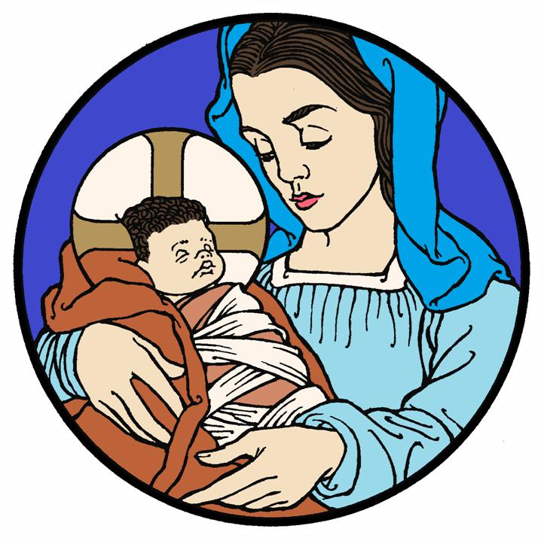
Christmas Eve Service

24 December 2018 + 7:00 p.m.

Zion Lutheran Church & School

Kearney, NE + (308) 234-3410

Rev. James DeLoach, Pastor + (308) 627-5260

Rev. Doug Gaunt, Pastor + (308) 455-0552
Tony Splittgerber, Principal + (308) 293-0168

Pre-Service Music: Adult Bell Choir
“O Come, All Ye Faithful”

PROCESSIONAL HYMN: O Come, All Ye Faithful (LSB 379)
All Stanzas Sung by All

O come, all ye faithful, Joyful and triumphant!
O come ye, O come ye to Bethlehem;
Come and behold Him Born the king of angels: Refrain

Refrain: O come, let us adore Him,
O come, let us adore Him,
O come, let us adore Him,
Christ the Lord!

Highest, most holy, Light of Light eternal,
Born of a virgin, a mortal He comes;
Son of the Father Now in flesh appearing! Refrain

Sing, choirs of angels, Sing in exultation,
Sing, all ye citizens of heaven above!
Glory to God In the highest: Refrain

Yea, Lord, we greet Thee, Born this happy morning;
Jesus, to Thee be glory giv’n!
Word of the Father Now in flesh appearing! Refrain

P In the Name of the Father, and of the Son, + and of the Holy Spirit.
C Amen.

A Pastoral Greeting

FIRST SCRIPTURE READING: Luke 2:1–5

O Little Town of Bethlehem (LSB 361)

(Stanza 1: Sunday School)
O little town of Bethlehem,
How still we see thee lie!
Above thy deep and dreamless sleep
The silent stars go by;
Yet in thy dark streets shineth
The everlasting light.
The hopes and fears of all the years
Are met in thee tonight.

(Stanza 2 Congregation)
For Christ is born of Mary,
And, gathered all above
While mortals sleep, the angels keep
Their watch of wond’ring love.
O morning stars, together
Proclaim the holy birth,
And praises sing to God the king
And peace to all the earth!

(Stanza 3: Congregation)
How silently, how silently
The wondrous gift is giv’n!
So God imparts to human hearts
The blessings of His heav’n.
No ear may hear His coming;
But in this world of sin,
Where meek souls will receive Him, still
The dear Christ enters in.

(Stanza 4: Congregation)
O holy Child of Bethlehem,
Descend to us, we pray;
Cast out our sin, and enter in,
Be born in us today.
We hear the Christmas angels
The great glad tidings tell;
O come to us, abide with us,
Our Lord Immanuel!

RECITATION (Spoken by 3rd and 4th grades):
Christmas moon glows clear and bright,
Shining in a shadowed night,
A slivered moon of perfect light,
For Jesus, born for us.

Frankincense hangs in the air.
Stars are twinkling everywhere.
A Child is born beyond compare—
Jesus, born for us.

SECOND SCRIPTURE READING: Luke 2:6–7

Gentle Mary Laid Her Child (LSB 374)

(Stanza 1: Sunday School)
Gentle Mary laid her child
Lowly in a manger;
There He lay, the Undefiled,
To the world a stranger.
Such a babe in such a place,
Can He be the Savior?
Ask the saved of all the race
Who have found His favor.

(Stanza 2: Congregation)
Angels sang about His birth,
Wise Men sought and found Him;
Heaven’s star shone brightly forth
Glory all around Him.
Shepherds saw the wondrous sight,
Heard the angels singing;
All the plains were lit that night,
All the hills were ringing.

(Stanza 3: Congregation)
Gentle Mary laid her child
Lowly in a manger ;
He is still the Undefiled
But no more a stranger.
Son of God of humble birth,
Beautiful the story;
Praise His name in all the earth;
Hail the King of glory!

RECITATION (Spoken by 5th and 6th grades):
Jesus has no kingly hall.
Jesus has no fortress tall.
Home becomes a cattle stall
for Jesus, born for us.

So sequined stars shine as a crown,
Night, a robe to wrap around,
God’s own Son to earth came down.
He’s Jesus, born for us.

Away in a Manger (LSB 364)

(Stanza 1: PS – 2nd)
Away in a manger, no crib for a bed,
The little Lord Jesus laid down His sweet head.
The stars in the sky looked down where He lay,
The little Lord Jesus asleep on the hay.

(Stanza 2: all Sunday School)
The cattle are lowing, the baby awakes,
But little Lord Jesus no crying He makes.
I love Thee, Lord Jesus! Look down from the sky,
And stay by my cradle till morning is nigh.

(Stanza 3: Sunday School and Congregation)
Be near me, Lord Jesus; I ask Thee to stay
Close by me forever and love me, I pray.
Bless all the dear children in Thy tender care,
And take us to heaven to live with Thee there.

RECITATION (Spoken by grades 1st and 2nd):
Mary, mother, holds her Son:
Promised Savior, holy One.
In Him God’s rescue has begun.
He’s Jesus, born for us.

Hay-filled trough serves as a bed,
Cradling His tiny head.
“Gloria!” the angels said
Of Jesus, born for us.

Infant Holy, Infant Lowly (LSB 393)

(Stanza 1: Sunday School)
Infant holy, Infant lowly,
For His bed a cattle stall;
Oxen lowing, Little knowing
Christ the child is Lord of all.
Swiftly winging, Angels singing,
Bells are ringing, Tidings bringing:
Christ the child is Lord of all!
Christ the child is Lord of all!

(Stanza 2: Sunday School and Congregation)
Flocks were sleeping, Shepherds keeping
Vigil till the morning new
Saw the glory, Heard the story,
Tidings of the Gospel true.
Thus rejoicing, Free from sorrow,
Praises voicing, Greet the morrow:
Christ the child was born for you!
Christ the child was born for you!

THIRD SCRIPTURE READING: Luke 2:8–14

RECITATION (Spoken by Pre-K & Kindergarten):
Sent by angels to this place,
Shepherds see a Child’s face,
Child of mercy, Child of grace:
Jesus, born for us.

Angels We Have Heard on High (LSB 368)

(Stanza 1 - Sunday School)
Angels we have heard on high,
Sweetly singing o’er the plains,
And the mountains in reply,
Echoing their joyous strains.
Glo------------ria in excelsis Deo
Glo------------ria in excelsis Deo

(Stanza 2 - Congregation)
Shepherds, why this jubilee?
Why your joyous strains prolong?
What the gladsome tidings be
Which inspire your heav’nly song?
Glo------------ria in excelsis Deo
Glo------------ria in excelsis Deo

(Stanza 3 - Congregation)
Come to Bethlehem and see
Him whose birth the angels sing;
Come, adore on bended knee
Christ the Lord, the newborn King.
Glo------------ria in excelsis Deo
Glo------------ria in excelsis Deo

FOURTH SCRIPTURE READING: Luke 2:15-20

RECITATION (Spoken by ALL grades):
Born our Savior, born to cry,
born to suffer, born to die.
All our sin on Him will lie,
On Jesus, born for us.

At Christmas gathered in this place,
Though we don’t see our Savior’s face,
We hear God’s precious words of grace
Of Jesus, born for us.

From Heaven Above to Earth I Come (LSB 358)
(Congregational Hymn)

From Heav’n above to earth I come
To bear good news to ev’ry home;
Glad tiding so great joy I bring,
Where of I now will say and sing

This is the Christ, our God Most High,
Who hears your sad and bitter cry;
He will Himself your Savior be
From all your sins so set you free.

Welcome to earth, O noble Guest,
Through whom the sinful world is blest!
You came to share my misery
That You might share Your joy with me.

The Sermon
The Offering

Adult Choir: Break Forth, Oh Beauteous Heav’nly Light (LSB 377)

As the Service of Light begins, the light will proceed from the Christ Candle to each person seated at the ends of each inner aisle. Please tip the unlit candle to the lit candle. These then pass the candle light to those next to them, and so on. For safety’s sake, it is asked that younger children do not handle their own candle, but share with adults or older youth.

The Service of Light

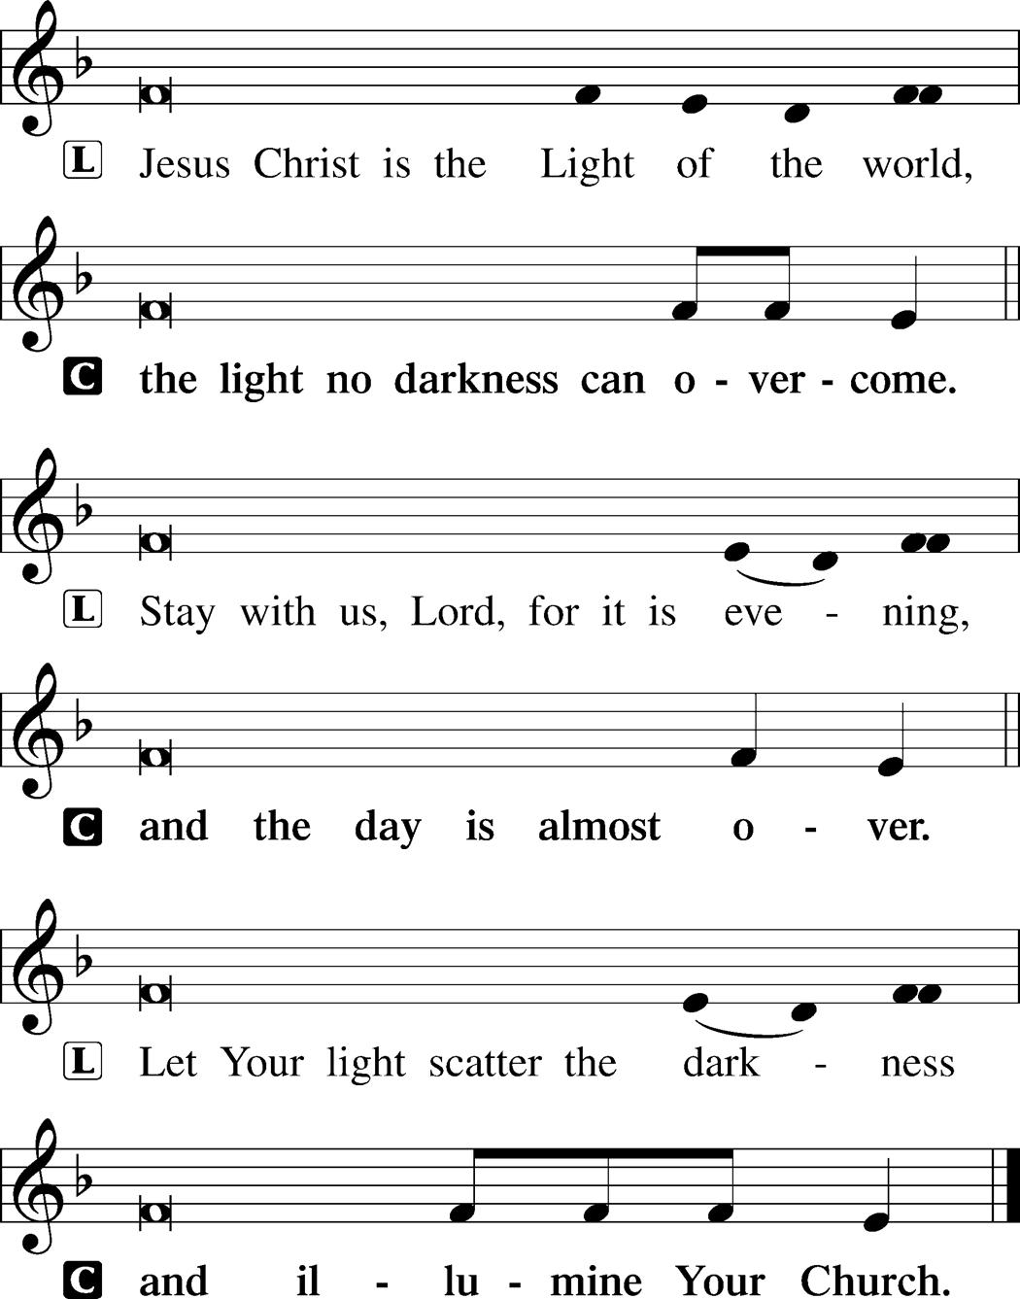

Evening Canticle ~ Hymn of Light

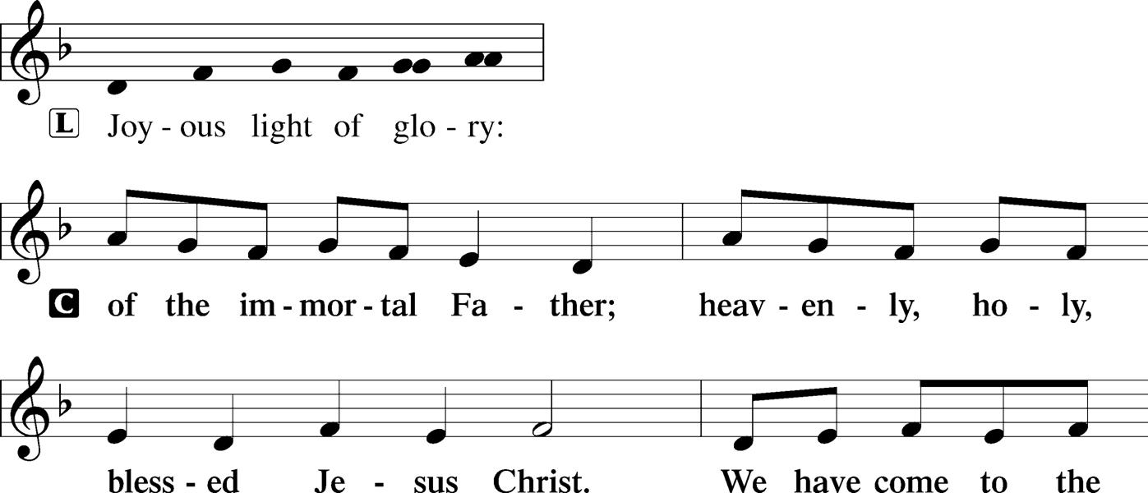
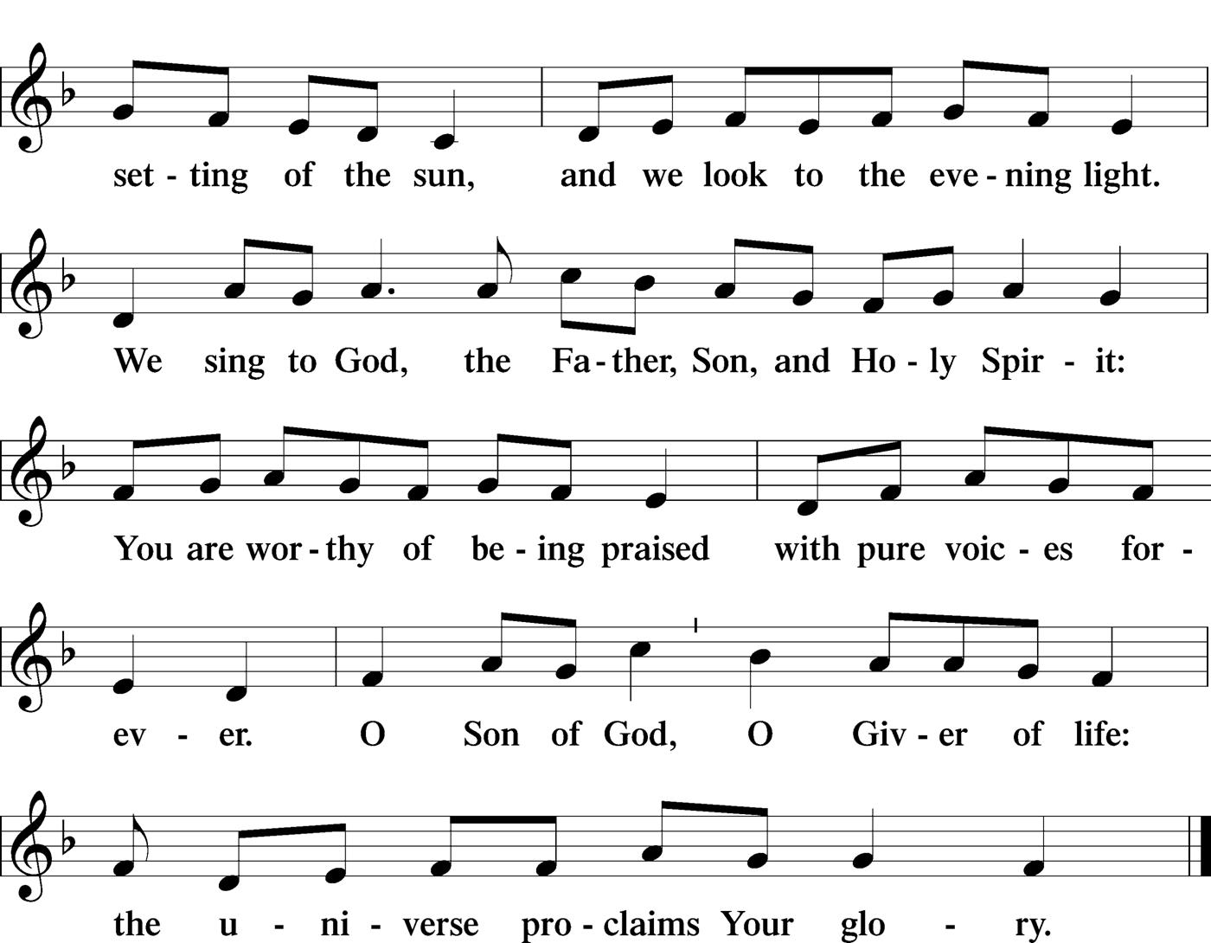

Thanksgiving for Light
P Blessed are You, O Lord our God, King of the universe, who led Your people Israel by a pillar of cloud by day and a pillar of fire by night. Enlighten our darkness by the light of Your Christ; may His Word be a lamp to our feet and a light to our path; for You are merciful, and You love Your whole creation and we, Your creatures, glorify You, Father, Son, and Holy Spirit.
C Amen.

The Collect
P O God, You make us glad with the yearly remembrance of the birth of Your only-begotten Son, Jesus Christ. Grant that, as we joyfully receive Him as our Redeemer, we may with sure confidence behold Him when He comes again in Glory; through the same Jesus Christ, our Lord, who lives and reigns with You and the Holy Spirit, one God, now and forever.
C Amen.

The OUR FATHER
P Taught by our Lord and trusting His promises, we are bold to pray:
C Our Father who art in heaven,
hallowed be Thy name,
Thy kingdom come,
Thy will be done on earth as it is in heaven;
give us this day our daily bread;
and forgive us our trespasses
as we forgive those who trespass against us;
and lead us not into temptation,
but deliver us from evil.
For Thine is the kingdom and the power
and the glory forever and ever. Amen.

Silent Night, Holy Night (LSB 363)
~ All Stanzas Sung by All

Silent night, holy night!
All is calm, all is bright
Round yon virgin mother and child.
Holy Infant, so tender and mild,
Sleep in heavenly peace,
Sleep in heavenly peace.

Silent night, holy night!
Shepherds quake at the sight;
Glories stream from heaven afar,
Heav’nly hosts sing, Alleluia!
Christ, the Savior, is born!
Christ, the Savior, is born!

Silent night, holy night!
Son of God, love’s pure light
Radiant beams from Thy holy face
With the dawn of redeeming grace,
Jesus, Lord, at Thy birth,
Jesus, Lord, at Thy birth.

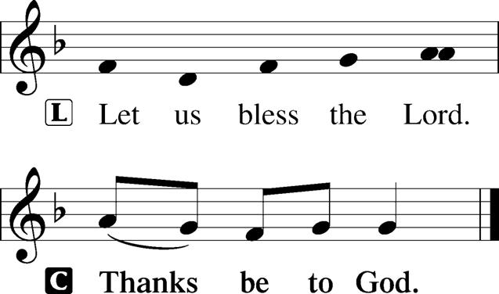

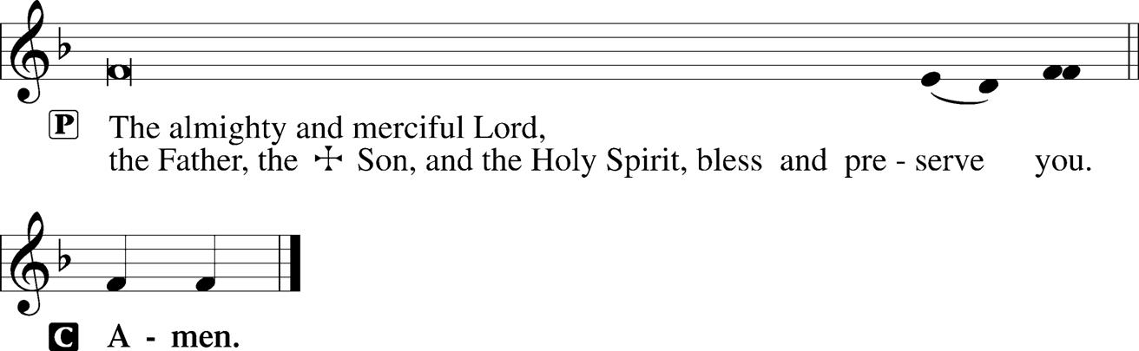

At this time please extinguish your candle and place it in the box as you exit the Sanctuary.

RECESSIONAL HYMN:
Hark! The Herald Angels Sing (LSB 380)
~ All Stanzas Sung by All

Hark! The herald angels sing,
“Glory to the newborn King;
Peace on earth and mercy mild,
God and sinners reconciled!”
Joyful, all ye nations, rise,
Join the triumph of the skies;
With the_angelic host proclaim,
“Christ is born in Bethlehem!” Refrain

Refrain: Hark! The herald angels sing,
“Glory to the newborn King!”

Christ, by highest heav’n adored,
Christ, the everlasting Lord,
Late in time behold Him come,
Offspring of a virgin’s womb.
Veiled in flesh the Godhead see,
Hail the incarnate Deity!
Pleased as Man with man to dwell,
Jesus, our Immanuel! Refrain

Hail, the heav’n-born Prince of Peace!
Hail, the Sun of Righteousness!
Light and life to all He brings,
Ris’n with healing in His wings.
Mild He lays His glory by,
Born that man no more may die,
Born to raise the sons of earth,
Born to give them second birth. Refrain

Organ Postlude

Post-Service Music: Adult Bell Choir
“Joy to the World”
“Angels We Have Heard on High”

