Lenten Vespers V – Eyes on Jesus
(LSB: p229ff.)

Hymn of Invocation 433 Glory Be to Jesus

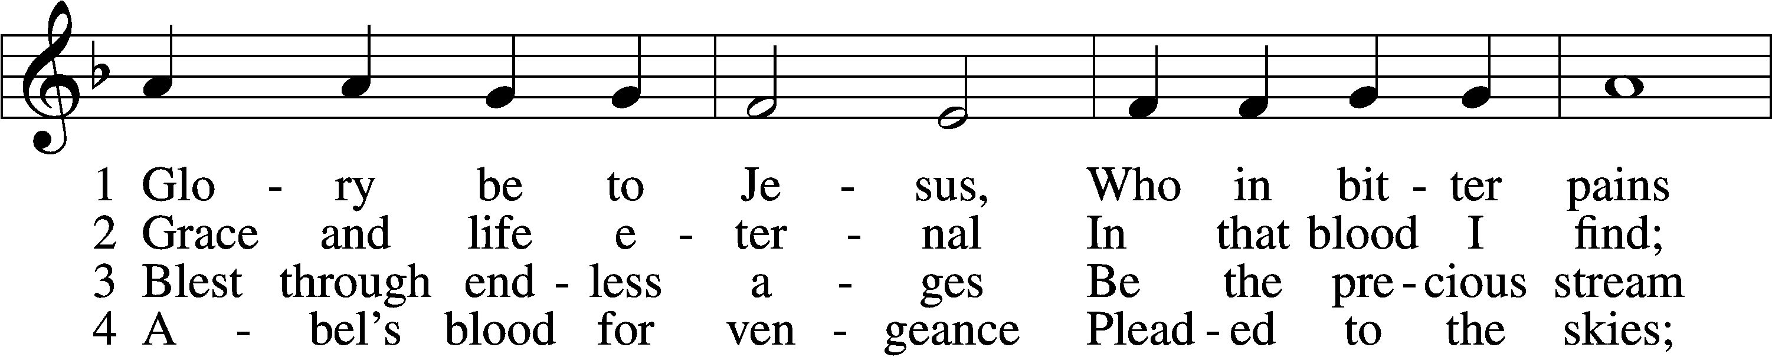
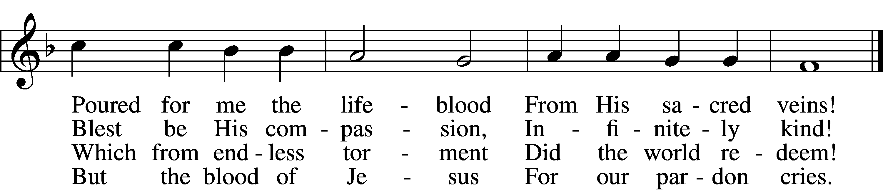

5 Oft as earth exulting
Wafts its praise on high,
Angel hosts rejoicing
Make their glad reply.

6 Lift we, then, our voices,
Swell the mighty flood;
Louder still and louder
Praise the precious blood!
Text and tune: Public domain

L O Lord, open my lips,
C and my mouth will declare Your praise.

L Make haste, O God, to deliver me;
C make haste to help me, O Lord.

C Glory be to the Father and to the Son and to the Holy Spirit;
as it was in the beginning, is now, and will be forever. Amen.
Praise to You, O Christ, Lamb of our salvation.

+ Psalmody +

Psalm Psalm 2
L Why do the nations rage
and the peoples plot in vain?
C The kings of the earth set themselves,
and the rulers take counsel together,
against the Lord and against his anointed, saying,
“Let us burst their bonds apart
and cast away their cords from us.”
L He who sits in the heavens laughs;
the Lord holds them in derision.
C Then he will speak to them in his wrath,
and terrify them in his fury, saying,
“As for me, I have set my King
on Zion, my holy hill.”
L I will tell of the decree:
The Lord said to me, “You are my Son;
today I have begotten you.
C Ask of me, and I will make the nations your heritage,
and the ends of the earth your possession.
L You shall break them with a rod of iron
and dash them in pieces like a potter’s vessel.”
C Now therefore, O kings, be wise;
be warned, O rulers of the earth.
Serve the Lord with fear,
and rejoice with trembling.
L Kiss the Son,
lest he be angry, and you perish in the way,
for his wrath is quickly kindled.
Blessèd are all who take refuge in him.

Sit

Office Hymn 730 What Is the World to Me

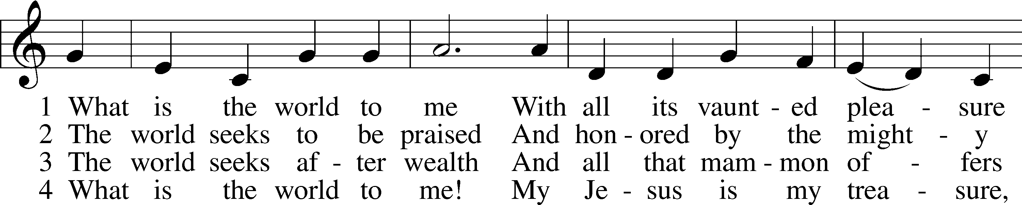
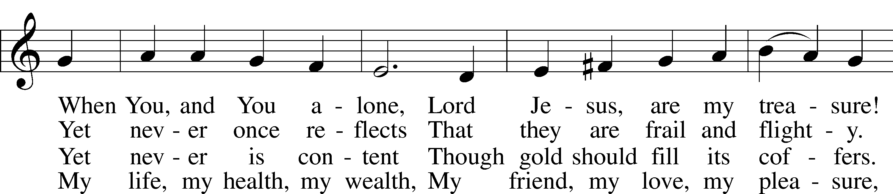
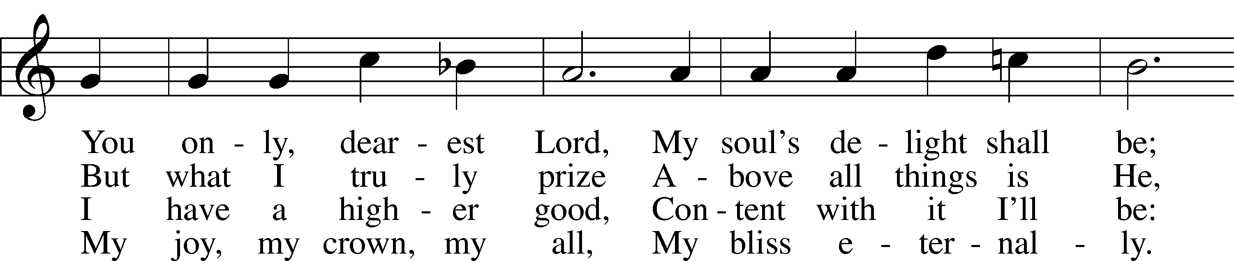
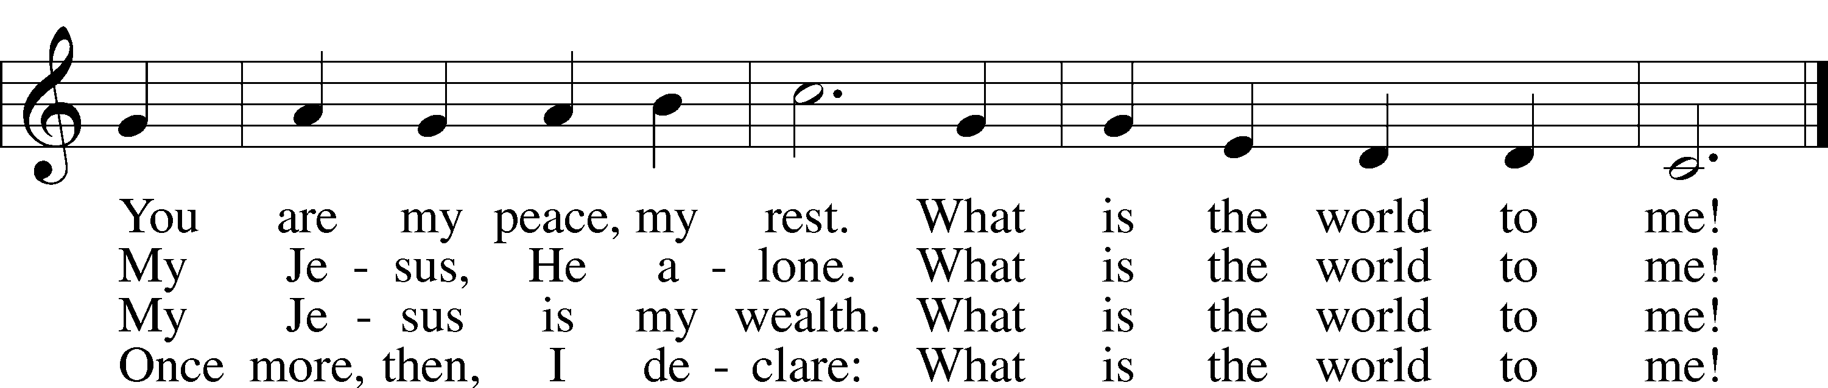
Tune and text: Public domain

+ Readings +

Reading Isaiah 13:9–11
L A reading from Isaiah, chapter 13.

⁹Behold, the day of the Lord comes,
cruel, with wrath and fierce anger,
to make the land a desolation
and to destroy its sinners from it.
¹⁰For the stars of the heavens and their constellations
will not give their light;
the sun will be dark at its rising,
and the moon will not shed its light.
¹¹I will punish the world for its evil,
and the wicked for their iniquity;
I will put an end to the pomp of the arrogant,
and lay low the pompous pride of the ruthless.

L O Lord, have mercy on us.
C Thanks be to God.

Reading 1 John 2:15–17
L A reading from 1 John, chapter 2.

¹⁵Do not love the world or the things in the world. If anyone loves the world, the love of the Father is not in him. ¹⁶For all that is in the world—the desires of the flesh and the desires of the eyes and pride in possessions—is not from the Father but is from the world. ¹⁷And the world is passing away along with its desires, but whoever does the will of God abides forever.

L O Lord, have mercy on us.
C Thanks be to God.

Reading Mark 15:1–20
L A reading from Mark, chapter 15.

¹And as soon as it was morning, the chief priests held a consultation with the elders and scribes and the whole Council. And they bound Jesus and led him away and delivered him over to Pilate. ²And Pilate asked him, “Are you the King of the Jews?” And he answered him, “You have said so.” ³And the chief priests accused him of many things. ⁴And Pilate again asked him, “Have you no answer to make? See how many charges they bring against you.” ⁵But Jesus made no further answer, so that Pilate was amazed.
⁶Now at the feast he used to release for them one prisoner for whom they asked. ⁷And among the rebels in prison, who had committed murder in the insurrection, there was a man called Barabbas. ⁸And the crowd came up and began to ask Pilate to do as he usually did for them. ⁹And he answered them, saying, “Do you want me to release for you the King of the Jews?” ¹⁰For he perceived that it was out of envy that the chief priests had delivered him up. ¹¹But the chief priests stirred up the crowd to have him release for them Barabbas instead. ¹²And Pilate again said to them, “Then what shall I do with the man you call the King of the Jews?” ¹³And they cried out again, “Crucify him.” ¹⁴And Pilate said to them, “Why, what evil has he done?” But they shouted all the more, “Crucify him.” ¹⁵So Pilate, wishing to satisfy the crowd, released for them Barabbas, and having scourged Jesus, he delivered him to be crucified.
¹⁶And the soldiers led him away inside the palace (that is, the governor’s headquarters), and they called together the whole battalion. ¹⁷And they clothed him in a purple cloak, and twisting together a crown of thorns, they put it on him. ¹⁸And they began to salute him, “Hail, King of the Jews!” ¹⁹And they were striking his head with a reed and spitting on him and kneeling down in homage to him. ²⁰And when they had mocked him, they stripped him of the purple cloak and put his own clothes on him. And they led him out to crucify him.

L O Lord, have mercy on us.
C Thanks be to God.

Responsory LSB 231
L Deliver me, O Lord, my God, for You are the God of my salvation.
C Rescue me from my enemies, protect me from those who rise against me.
L In You, O Lord, do I put my trust, leave me not, O Lord, my God.
C Rescue me from my enemies, protect me from those who rise against me.
L Deliver me, O Lord, my God, for You are the God of my salvation.
C Rescue me from my enemies, protect me from those who rise against me.

Sermon “Worldly Eyes” (Mark 15:1–20)

+ Canticle +
Hymn (sung to the tune of “Alas and Did My Savior Bleed”) Our Eyes Behold the Savior’s Face
1 Our eyes behold the Savior’s face
And yet cannot perceive
That His perspective held our grace
Before we could believe.

2 Our focus flits and fails to see
The One whose steadfast gaze
Propelled Him to the darkened tree
Enveloped in death’s haze.

3 Our sights train on the dreadful cross.
Beneath His knowing eyes,
Our sins are bare and set for loss;
He sees us as His prize.

4 Our vision blurs with anxious tears
As Jesus’ eyelids fall
To conquer sin and all our fears
And tear in two our pall.

5 Our view scans for the coming Day
That evermore grows near,
When Jesus wipes our tears away
And all is crystal clear.
Text: Copyright © 2019 Concordia Publishing House. Used by permission.

Offering (Go to zionkearney.com and click on the “Pushpay” icon)

+ Prayer +

Kyrie LSB 233
C Lord, have mercy;
Christ, have mercy;
Lord, have mercy.

Lord’s Prayer
C Our Father who art in heaven,
hallowed be Thy name,
Thy kingdom come,
Thy will be done on earth
as it is in heaven;
give us this day our daily bread;
and forgive us our trespasses
as we forgive those
who trespass against us;
and lead us not into temptation,
but deliver us from evil.
For Thine is the kingdom
and the power and the glory
forever and ever. Amen.

Collects

L O Lord, hear my prayer.
C And let my cry come to You.

Collect of the Day
L Lord Jesus Christ, the devil, the world, and our sinful nature constantly lead us to worldliness. Forgive our worldly sins and grant us the gift of heavenly-mindedness so that we might live in the world while not being of the world; for You live and reign with the Father and the Holy Spirit, one God, now and forever.
C Amen.

Collect
L O God, the protector of all who trust in You, have mercy on us that with You as our ruler and guide we may so pass through things temporal that we lose not the things eternal; through Jesus Christ, Your Son, our Lord, who lives and reigns with You and the Holy Spirit, one God, now and forever.
C Amen.

Collect for Peace
L O God, from whom come all holy desires, all good counsels, and all just works, give to us, Your servants, that peace which the world cannot give, that our hearts may be set to obey Your commandments and also that we, being defended from the fear of our enemies, may live in peace and quietness; through Jesus Christ, Your Son, our Lord, who lives and reigns with You and the Holy Spirit, one God, now and forever.
C Amen.

Stand

Benedicamus LSB 234
L Let us bless the Lord.
C Thanks be to God.

Benediction LSB 234
P The grace of our Lord T Jesus Christ and the love of God and the communion of the Holy Spirit be with you all.
C Amen.

Hymn to Depart 685 Let Us Ever Walk with Jesus

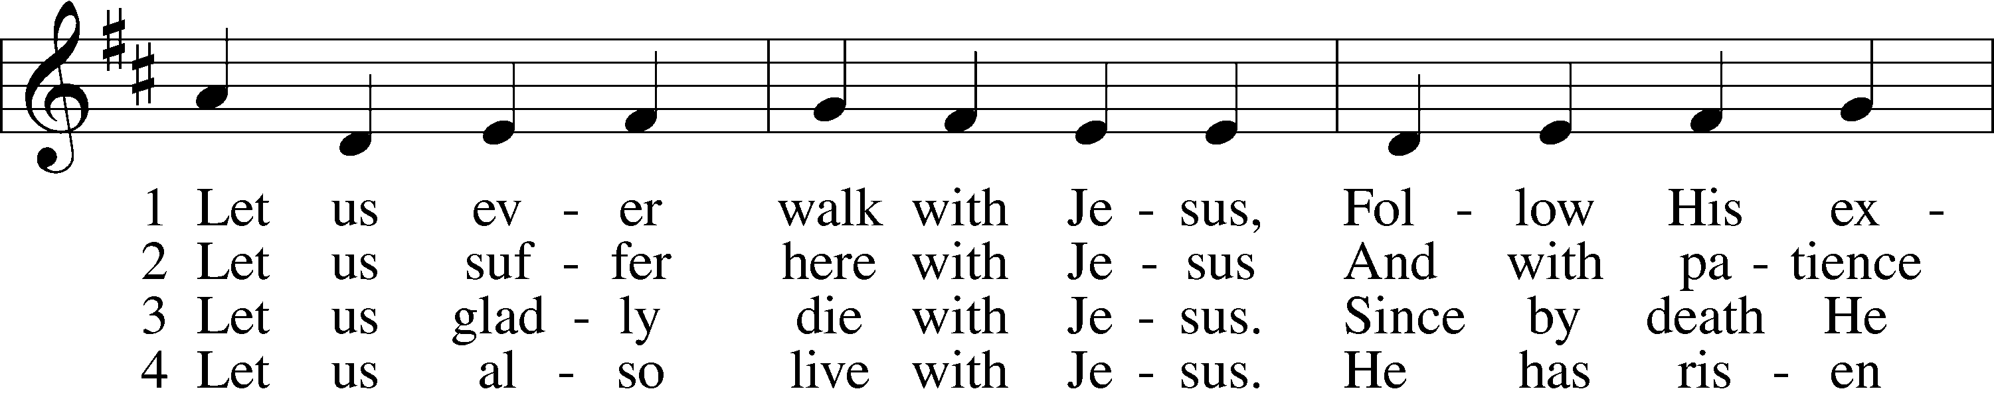
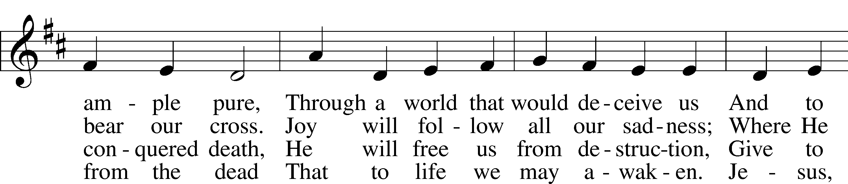
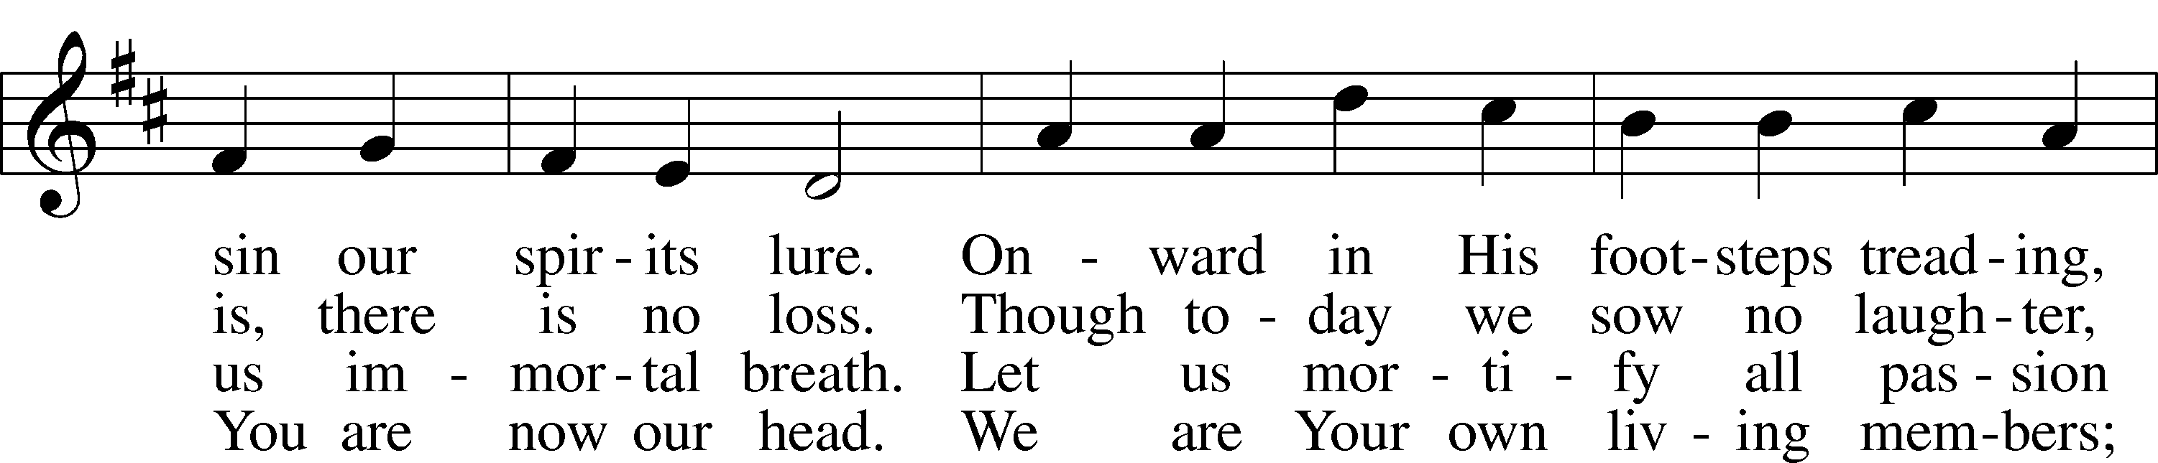
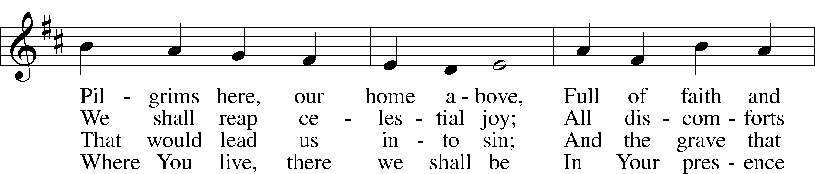
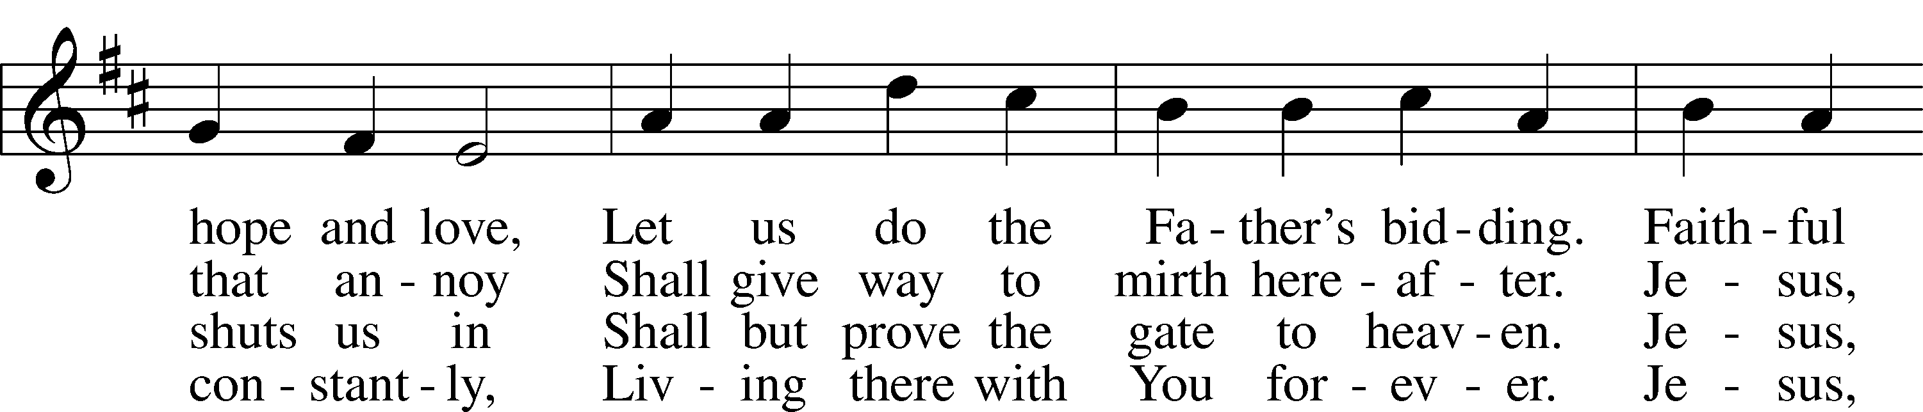
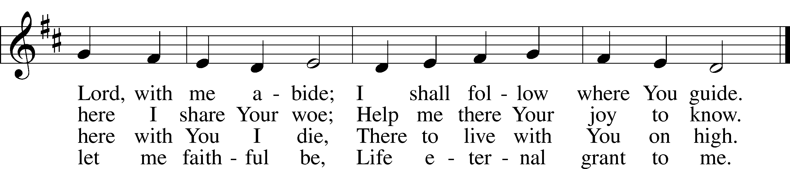
Text: © 1978 Lutheran Book of Worship. Used by permission: CPH Limited Promotional License no. 119000000
Tune: Public domain

Acknowledgments
Unless otherwise indicated, Scripture quotations are from the ESV® Bible (The Holy Bible, English Standard Version®), copyright © 2001 by Crossway, a publishing ministry of Good News Publishers. Used by permission. All rights reserved.
Created by Lutheran Service Builder © 2018 Concordia Publishing House.

