Vera Ehrlich –New Address
The funeral for Max Ehrlich was this past Tuesday at Immanuel Lutheran Church, in Lincoln. Cards can be mailed to Vera at:
Vera Ehrlich, Orchard Garden, 1006 South Mayne St. Apt. 103,
Valley, NE 68064
The special flower arrangement in the sanctuary today is from the Ehrlich family.
Call Extended
At a special voters meeting, a call was extended to Kassidy Rixstine to serve as teacher in our school. Please keep Kassidy in your prayers as she considers this call.

Mailboxes
If there are any Zion members who do not have a Church mailbox and would like one, please let us know at the office.

District Convention Information
Our Nebraska District LCMS will meet in convention June 12-13 in Kearney at the Younes Conference Center. If any members wish to attend the conference, there is a registration form available at the office that would need to be mailed in by May 11. If you wish to only attend the worship service, which is at the Convention Center on June 12 at 1:30, you may do so without registering.

Brandon & Megan Nuttelman Benefit Today
Trinity Lutheran Church in Amherst and the Amherst School parents are sponsoring a benefit for Brandon & Megan Nuttelman to assist them with travel and medical expenses for their son Damon. Today there will be a Sloppy Joe Dinner and Auction. If you are not able to attend, donations can be mailed to Trinity Lutheran Church, Attn. Nuttelman Benefit, P.O. Box 157 Amherst, NE 68812. Thrivent will provide matching funds. (Flyer with more information is on the Bulletin Board).
Stewardship Note

John 10:14 “I am the good shepherd. I know my own and my own know me.” What does it mean to know the Lord? It starts with being known by the Lord: He claims us as His own and calls us by name. Then, once we are His, we learn to know Him…and in knowing Him we learn to imitate Him. And that is how the Christian life of good works and generosity grows from the Lord’s grace.
Announcements – April 26, 2015
Please remember...to silence your cell phone upon entering the sanctuary.

Hearing Loop Zion’s sanctuary is equipped with a hearing loop. Please switch hearing aids to T-coil mode.
We have 2 headsets and receivers that persons without hearing aids can use. Ask an usher for assistance.

Voters Meeting – Today
Our Voters Meeting is scheduled this morning, April 26 at 10:15 in the Fellowship Hall. Business will include presenting the proposed budget for the next fiscal year.

Confirmation Next Sunday
The following youth will be confirmed at Zion on May 3. Kiara Clark, Zachariah DeLoach, Morgan Dulitz, Peter Kreutzer, Elizabeth Lange, Harry Strong, Blake Wilbur, Allison Wilkens.
On Wednesday evening at 6:00 pm the youth board will host a meal for the confirmands and their families.

Saturday Worship
Due to scheduling conflicts, there will also be no Saturday services during the month of May.

Sleeping Mats from Plastic Bags
Zion is starting to collect plastic bags by the south doors. The bags can be from any store like Walmart or Ace. They will be cut and crocheted into 4 foot by 6 foot sleeping mats. It takes 500-700 bags to make one mat. The mats are for the homeless and those in the third world. They are waterproof and do not attract bugs. The Orphan Grain Train will be distributing them for us. If you are interested in crocheting them please contact Margaret Smith.

Custodian
We are now taking applications for a part time custodian for the school. This could include summertime hours as well as afternoon work when the next school year begins. Ed DeLaet plans to continue to work with us, but would like to cut back on hours. Applications are available at the office.

VBS!

ZION LUTHERAN CHURCH

AGES FOUR THROUGH COMPLETED GRADE SIX

JUNE 21-25, 6-8 PM

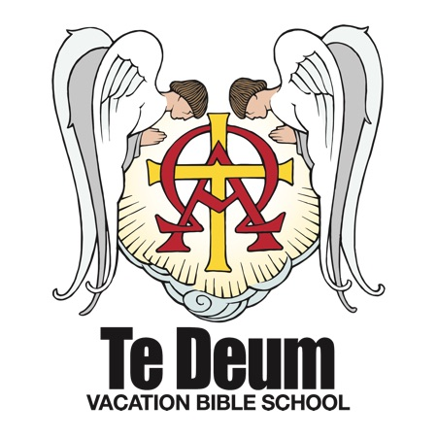
VBS is in the planning stages! Mark your calendars for June 21-25 from 6-8. Please consider donating your time and talents to help the week run smoothly. Volunteers are needed for registration, snacks, teaching and assisting, music and crafts.
The Higher Things "Te Deum" 2015 VBS focuses on the true worship of God in receiving His gifts and in coming to Him in prayer. The "Te Deum" is the ancient hymn of the Christian church, "We praise You, O God!" The Higher Things VBS strengthens our children in the faith of Christ that we confess in the Te Deum and teaches them to call upon that True God for all our needs of body and soul.

If you are willing to help, or if you have any questions, please contact Nathan or Liz Gaunt at 308-293-5689 or ekgaunt@gmail.com.

School News

- There are plants for sale in the hallway today. Lisa Splittgerber will help you with any purchases you wish to make.

- This Friday, our K-8th grade children will participate in the Track & Field Day at Worms, NE.

- On May 8 at 7:00 pm our K-8th grade children will present “King of the Jungle” at our Spring Musical. The congregation is invited.

