Thank You
Thank you to Pastor DeLoach, my family, and Zion members who visited me while I was hospitalized. I appreciate all of the cards and phone calls also. A special thank you to the Zion school children for all of their get well cards. God’s Blessings, Evelyn Heiden

Pastor’s Conference
The District Pastor’s conference is in Lincoln this Monday & Tuesday. Pastor DeLoach will attend as he is able.

Christmas at Concordia
Concordia University, Nebraska invites you to join music lovers from around the country at Christmas at Concordia, December 4-6, 2015. Be filled with joy as more than 250 student musicians share the Good News of Christmas with music from across the ages. Concerts will be held at St. John Lutheran Church in Seward and are scheduled as follows:
7:00 p.m. on Friday, December 4th
3:00 and 7:00 p.m. on Saturday, December 5th
3:00 p.m. on Sunday, December 6th
Admission is free, but tickets are required. Registration is by phone only on November 4th at 4:00 p.m., CST. To register, please call 402-643-7150 or 402-643-7160 at that time. For more information about Christmas at Concordia Weekend, please visit christmasatconcordia.net.

Stewardship
Mark 10:29-30 “Jesus said, "Truly, I say to you, there is no one who has left house or brothers or sisters or mother or father or children or lands, for my sake and for the gospel, ³⁰ who will not receive a hundredfold now in this time, houses and brothers and sisters and mothers and children and lands, with persecutions, and in the age to come eternal life.” This is Jesus’ encouragement for every faithful disciple – let it encourage you today.
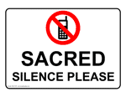
Announcements – October 18, 2015
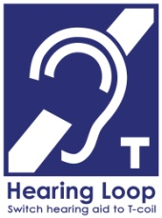
Please remember...to silence your cell phone upon entering the sanctuary.

Zion’s sanctuary is equipped with a HEARING LOOP. Please switch hearing aids to T-coil mode. We have 2 headsets and receivers that persons without hearing aids can use. Ask an usher for assistance.

Our Weekly Memory Work
Apostles’ Creed: 1st Article-Part II

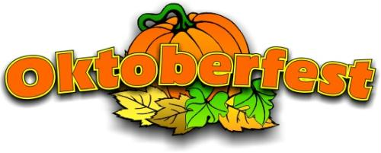
Oktoberfest Today
Please celebrate with us today at our Oktoberfest Meal at 11:30 in the gym.

Before the meal we will welcome all new members received in the past year and to celebrate paying off our debt, we will have a mortgage burning service.

There are special Oktoberfest cut outs, where you may have your picture taken. We also have craft activities for the children.

Come and enjoy the fun and fellowship!

Lucille Fiddelke Funeral
The funeral service for Lucille Fiddelke will be Monday, October 19 at 10:30. The family will be greeting friends this afternoon from 4-6 at Horner Lieske, McBride & Kuhl funeral home.

Senior Citizens
Because of Lucille’s funeral, the Senior Citizens have postponed their pot luck until Monday, October 26 at noon.

No Saturday Service This Week
Please note that there will not be a Saturday evening service this week because of a wedding. Saturday services will resume October 31.

Stewardship Board
The Board of Stewardship will need two new members beginning January of 2016. If you would consider serving please contact Ed DeLaet at 440-3706.

Automatic Giving
If anyone is interested in signing up for automatic giving for the 2016 giving year, please contact the church office to fill out the proper forms. Please complete by December 1st. Thank You

Holy Cross Lutheran Church's 50th Anniversary
On October 25, Holy Cross will hold a 50th Anniversary service at the Younes Conference Center. You are invited to a meal and fellowship that will follow at noon. Please call the office of Holy Cross at 237-2944 to RSVP beginning Oct.5th. A free will offering will be taken during the meal.

Central Nebraska Pro-Life Banquet
UNK Students for Life are hosting a Pro-Life Banquet October 25 at the UNK student union. If you are interested in attending or donating, there are flyers in the narthex with more information and a registration form.

School News

Next Sunday following our worship service, Mr Bob Ziegler who serves the District as Executive for Education and Youth Ministries, will present a certificate which officially recognizes Zion Lutheran School as an NLSA accredited school.

We are now taking orders for delicious holiday pies. Any of our school children would be happy to take your order or you may place your order at the office.

Our teachers will attend the District Teachers Convention in Omaha this Thursday and Friday.

