**Ten Thousand Villages One Day Sale**

Please check the bulletin board for details of the Ten Thousand Villages one day sale to be held November 14 at First Presbyterian Church. The sale of merchandise will directly benefit the artists from underprivileged countries. Proceeds from the sale will be donated to Kearney Area Habitat for Humanity.

**GIVE WHERE YOU LIVE**

This year Zion Lutheran School will be participating in the Give Where You Live Campaign. It is now until December. To participate/contribute online go to: <https://www.razoo.com/story/Zion-Lutheran-School-9> if you would rather donate in person feel free to stop by the office. Please share this with your family and friends. Thank you for your support of this great school!

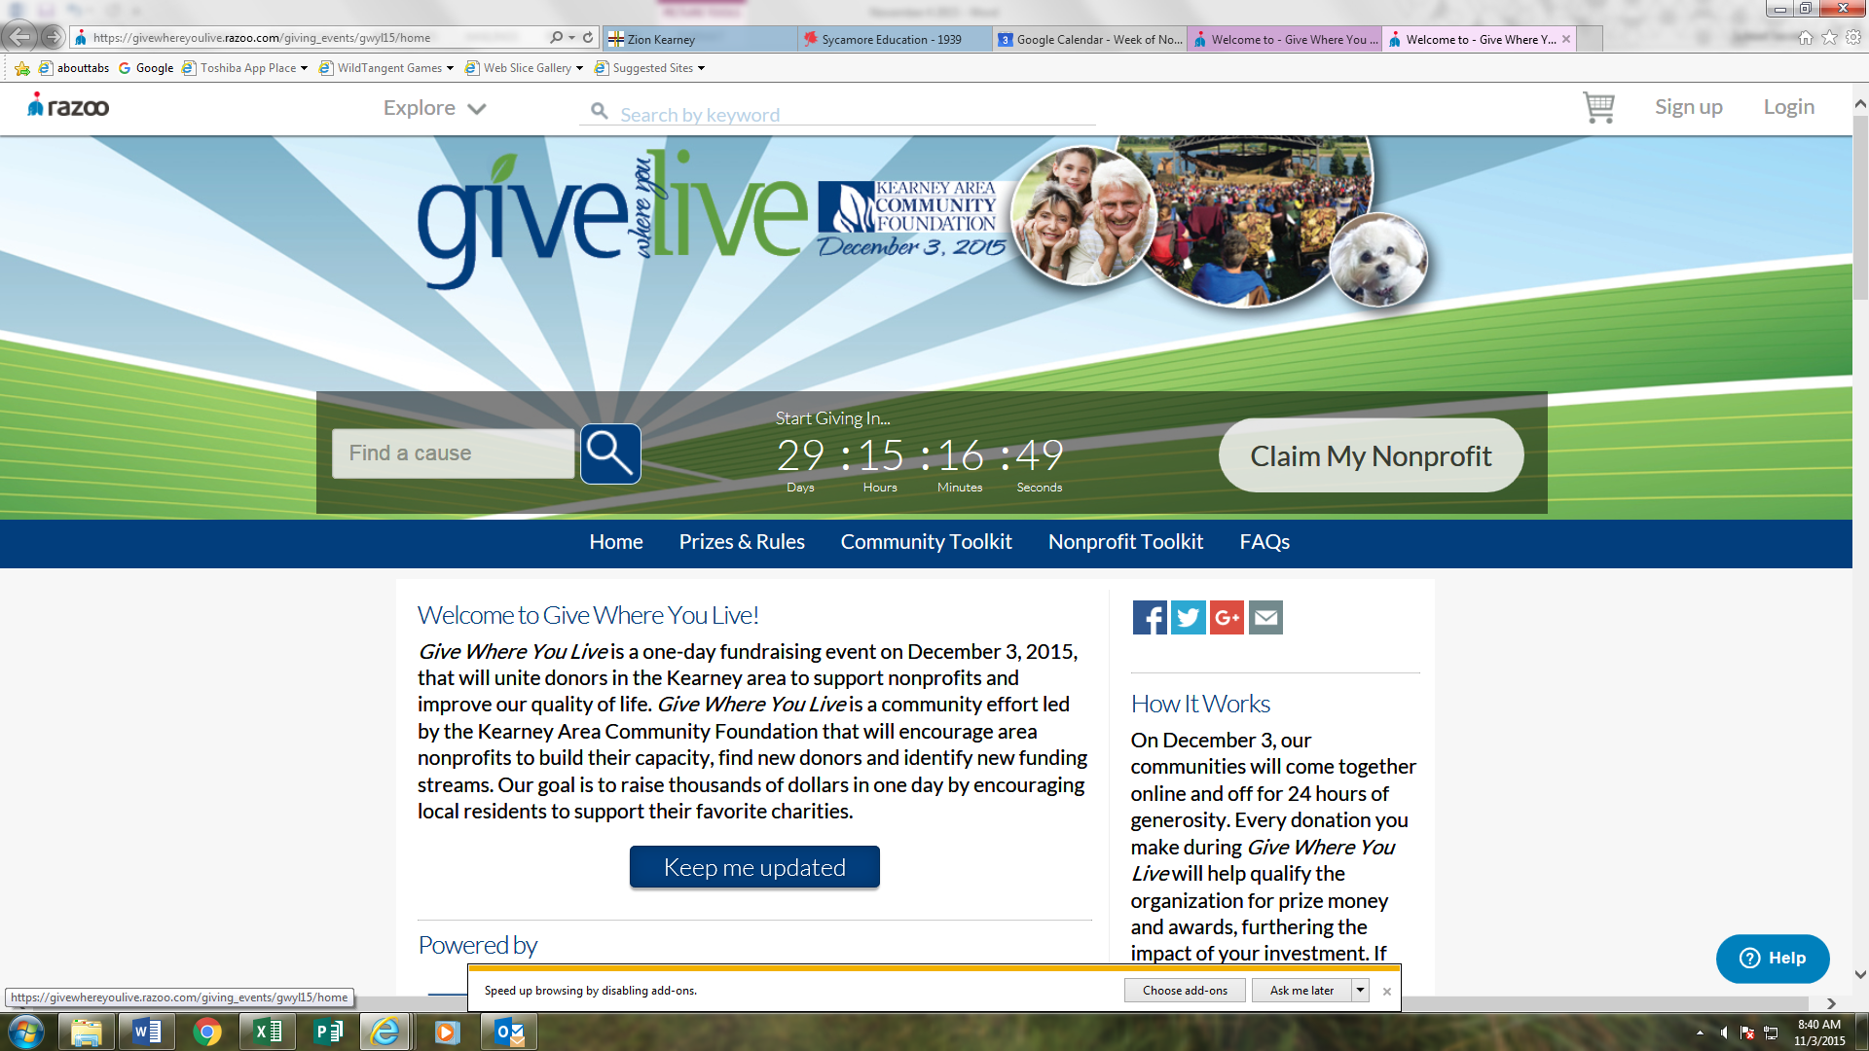

**Stewardship**

Proper 27

Mark 12:44: “For they all contributed out of their abundance, but she out of her poverty has put in everything she had, all she had to live on.” From Old Testament times right through to today the Lord has urged us to give to His work in the Church in *proportion* to how He has blessed us. He has also called us to *sacrificial* giving, that is, giving that actually costs us something. That's the shape of true Christian generosity.

**Announcements – November 8, 2015**

Please remember...to silence your cell phone upon entering the sanctuary.

Zion’s sanctuary is equipped with a **HEARING LOOP**. Please switch hearing aids to T-coil mode.We have 2 headsets and receivers that persons without hearing aids can use. Ask an usher for assistance.

**Our Weekly Memory Work**

Apostles’ Creed: 3rd Article-1st paragraph

**Zion Family Thanksgiving Dinner – Next Sunday**

The Mary Martha Guild invites all members of Zion to join them as we give thanks to God for all that He has done. Make plans to join us for the Family Thanksgiving Dinner to be held Sunday, November 15, at 11:30 a.m. in the gym. The Mary Martha Guild will provide the turkey, dressing, potatoes and gravy, green bean casserole, dinner rolls, drinks and table service. Each family is asked to bring a salad or dessert.

Come and join us as we give thanks for the many blessings the Lord has given to each of us. A free-will offering will be taken with the proceeds going to help support our seminary student Matthias Wollberg. Mary Martha will match all gifts up to a total of $500.

**Mary Martha Circles**

Love Circle (Ellen’s) will meet Monday, November 9 at 7:00 at Ellen Koopmans’s home, 2616 Ave. D.

Peace Circle (Shirley’s) will meet Thursday, November 12 at 7:00 at Shirley Oertwig’s home, 12470 Riverdale Rd.

**Trustees**

Trustees please note that our November meeting time is changed to tomorrow, Nov 9 at 7:00 pm.

**Voters Meeting**

The November Voters Meeting will be help on Sunday, November 22 at 10:15 a.m.

**Food Collection**

Zion will collect food items during the month of November to help supply Kearney agencies who assist the needy. There are grocery carts in the narthex and school area to gather these items. Non-perishable items only please.

**Zion Basketball**

It’s time for basketball!  Zion Lutheran offers extracurricular basketball to the students of Zion Lutheran School and students who are members of the church.  Boys and girls basketball is offered for students in grades 5-8.  If you are a member of Zion Lutheran Church and would like to participate, please see Mr. Splittgerber.

Boys’ basketball will be coached by Mr. Philip Vogel; boys will practice every Tuesday, Thursday, and Friday from 3:45-5:30.  Girls’ Basketball will be coached by Mr. Tyler Kirchner; girls will practice every Monday and Wednesday from 3:45-5:00.

**Automatic Giving**

If anyone is interested in signing up for automatic giving for the 2016 giving year, please contact the church office to fill out the proper forms. Please complete by December 1st. Thank You

**Christmas Decorating**

C:\Users\school\AppData\Local\Microsoft\Windows\Temporary Internet Files\Content.IE5\5XUAILOU\MC900030653[1].wmfWe will be using poinsettias decorate our Church this Christmas season.  If you wish to provide a poinsettia, the cost will be $12.  To avoid confusion, please place your money in an envelope and turn in to the church office.

**School News**

* There are a few t-shirts with this year’s theme “Armored in Christ” available for sale at the office.
* Pies will be available for pickup on Tuesday, November 17.
* Our K-8 choir will sing at Holy Cross November 22.
* Thanksgiving break will be November 25-27
* The school Christmas program is December 13 at 4:00 p.m.