**Automatic Giving**

If anyone is interested in signing up for automatic giving for the 2016 giving year, please contact the church office to fill out the proper forms. Please complete by December 1st. Thank You

**GIVE WHERE YOU LIVE**

This year Zion Lutheran School will be participating in the Give Where You Live Campaign. It is now until December. To participate/contribute online go to: <https://www.razoo.com/story/Zion-Lutheran-School-9> if you would rather donate in person feel free to stop by the office. Please share this with your family and friends. Thank you for your support of this great school!

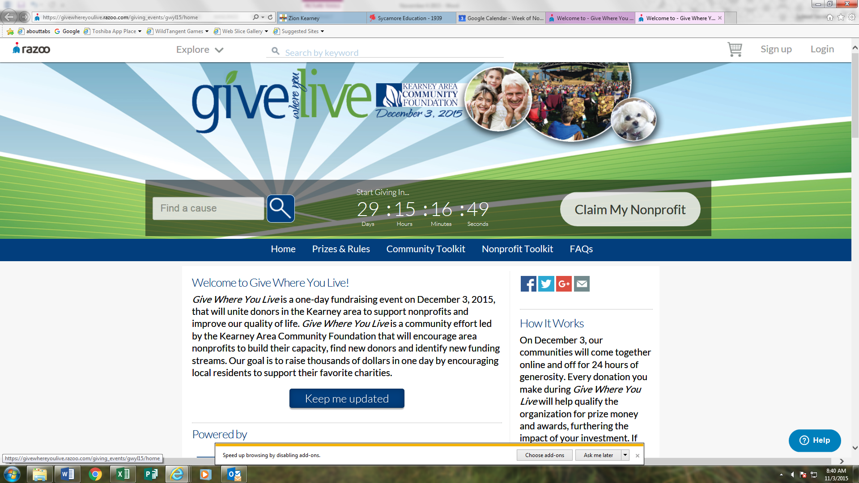

**Stewardship**

Proper 28

Hebrews 10:14: “For by a single offering he has perfected for all time those who are being sanctified.” Our Lord Jesus has provided the one offering for sin. What we offer to the Lord is not a sacrifice for sin; we cannot buy our way into heaven with our money, works, or effort. Rather, what we give to the Lord's work in the Church is a thank offering, a sign of our dependency on God and all He has given us.

**Announcements – November 15, 2015**

Please remember...to silence your cell phone upon entering the sanctuary.

Zion’s sanctuary is equipped with a **HEARING LOOP**. Please switch hearing aids to T-coil mode.We have 2 headsets and receivers that persons without hearing aids can use. Ask an usher for assistance.

**Our Weekly Memory Work**

Apostles’ Creed: 3rd Article and entire meaning

**Zion Family Thanksgiving Dinner – Today**

The Mary Martha Guild invites all members of Zion to join them as we give thanks to God for all that He has done. Please join us for a Thanksgiving meal today at 11:30 in the gymnasium.

Come and join us as we give thanks for the many blessings the Lord has given to each of us. A free-will offering will be taken with the proceeds going to help support our seminary student Matthias Wollberg. Mary Martha will match all gifts up to a total of $500.

**Senior Citizen Potluck**

The senior citizens potluck will be on Monday, November 16 at 12:00 p.m. Come and enjoy the fellowship.

**Voters Meeting next Sunday**

The November Voters Meeting will be held on Sunday, November 22 at 10:15 a.m. Business will include election of officers and board members for 2016.

**Holiday Pies**

The holiday pies will be available for pickup in the gym this Tuesday afternoon from 3:30-6:00 pm.

**Higher Things**

Youth who have been confirmed are encouraged to consider attending the Higher Things conference this summer. The flyer on the opposite page lists the dates and cities the Conferences will be held this year. All youth who are interested are asked to pick up a registration form from the office and return it with your preferred dates circled. We will then decide as a group which one we will attend.

**Food Collection**

Zion will collect food items during the month of November to help supply Kearney agencies who assist the needy. Our school children are making a display with items donated in the hallway. There are grocery carts in the narthex and school area to gather these items. Non-perishable items only please.

**Christmas Decorating**

C:\Users\school\AppData\Local\Microsoft\Windows\Temporary Internet Files\Content.IE5\5XUAILOU\MC900030653[1].wmfWe will be using poinsettias decorate our Church this Christmas season.  If you wish to provide a poinsettia, the cost will be $12.  To avoid confusion, please place your money in an envelope and turn in to the church office.

**Thanksgiving Eve**

We extend a very special invitation to you and your family to come and worship with us on Wednesday, November 25, at 7:00 p.m. For those who have guests visiting, we also invite them to come and worship with us. As Thanksgiving approaches, we ask that you pause and remember the many blessings the Lord has given you. What a gracious God we have!

**School News**

* There are a few t-shirts with this year’s theme “Armored in Christ” available for sale at the office.
* Pies will be available for pickup on Tuesday, November 17.from 3:30-6:00 p.m.
* Our K-8 choir will sing at Holy Cross November 22 at 9:30 a.m.
* Thanksgiving break will be November 25-27
* The school Christmas program is December 13 at 4:00 p.m.