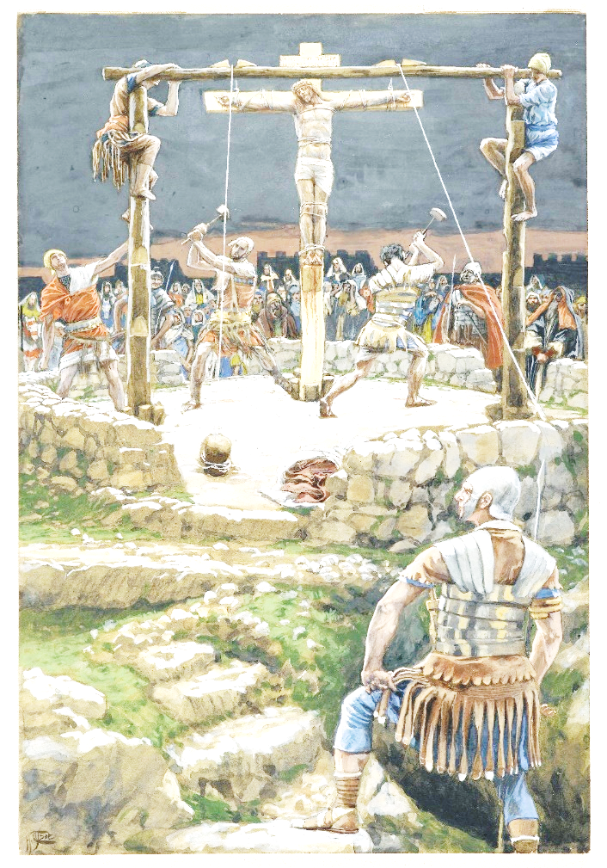
The Five Wedges by James Tissot

Ash Wednesday
10 February 2016 ~ 7:00 p.m.

Zion Lutheran Church & School

Kearney, NE + (308) 234-3410

Rev. James DeLoach, Pastor + (308) 627-5260

Tony Splittgerber, Principal + (308) 293-0168

A WARM WELCOME TO OUR GUESTS

Please sign our guest book in the narthex and let us know how we can be of service to you. If you are a member in good standing of a sister LC-MS congregation, we invite you to commune with us. Members of other church bodies with whom we are not in confessional fellowship are asked to please refrain from communing. Our pastor will be happy to visit with you about our desire for true unity in Christ and how that is connected to our communion practice. All communicants need to register in the narthex prior to the service.

✤ ✤ ✤

Gathering in silence this evening you are asked to prepare for confession by meditating upon Psalm 32, 51, 90, the Ten Commandments (p. 321-322), or Christian Questions with Their Answers (p. 329-330). Due to the somber character of this service, we will speak all the responses in the liturgy while singing the canticles.
Ash Wednesday marks the beginning of Lent, the Christian’s 40-day journey with the Lord to the cross and tomb to await the proclamation of Easter. The 40 days remind us of several biblical events: Jesus’ 40-day fast at the beginning of his ministry; Moses’ stay on Mt. Sinai at the giving of the law; Elijah’s fast on his way to the mountain of God.
Ash Wednesday begins the Christian’s Lenten journey with a reminder of our mortality and a call to repentance. The ancient practice of imposing ashes on the foreheads of the faithful is observed today by Christians of many traditions and gives Ash Wednesday its name. The church father Tertullian (c160-215AD) writes of the practice as a public expression of repentance and of our human frailty that stands in need of Christ. The ashes remind us that the “wages of sin is death.” They are applied in the form of a cross to remind us of Christ’s victory for us over sin and death.
From 6:40 to 6:55pm those who desire to receive the sign of ashes shall come forward up the center aisle and stand in front of the pastor. He will apply ashes to the forehead in the form of a small cross and say, “Remember that you are dust, and to dust you shall return.” The recipient shall then return via the side aisles. Unconfirmed children may come forward at their parents’ discretion.

HYMN #419 ~ Savior, When in Dust to Thee

INVOCATION 184

CONFESSION & ABSOLUTION 184
PSALM 51:1-13 (prayed responsively by ½ verse)
KYRIE 186
SALUTATION and COLLECT OF THE DAY 189

P: | Let us pray.  Almighty and everlasting God, You despise nothing You have made and forgive the sins of all who repent. Create in us new and contrite hearts that confessing our sins and acknowledging our wretchedness we may receive from You full pardon and forgiveness; through Jesus Christ, Your Son, our Lord, who lives and reigns with You and the Holy Spirit, one God, now and forever.

C: | Amen.

OLD TESTAMENT Joel 2:12-19

P: This is the Word of the Lord. C: Thanks be to God.

GRADUAL (based on Hebrews 12:2)

P: [Oh, come,] let us fix our eyes on Jesus,
C: the Author and Perfecter of our faith,

P: Who for the joy set before Him endured the cross, scorning its shame,

C: and sat down at the right hand of the throne of God.

EPISTLE READING 2 Corinthians 5:20b-6:10

P: This is the Word of the Lord. C: Thanks be to God.

LENTEN VERSE (Spoken responsively)

P: Return to the Lord, your God,

C: for He is gracious and merciful,

P: slow to anger, and abounding in steadfast love,

C: and abounding in steadfast love.

HOLY GOSPEL Matthew 6:16-21
(The responses before and after the Gospel are on pages 190-191.)

NICENE CREED 191
HYMN #423 ~ Jesus, Refuge of the Weary
THE SERMON

OFFERTORY & PRAYER OF THE CHURCH 192-193
THE SHARING OF THE PEACE & THE OFFERING
Soloist ~ God Loved the World, So That He Gave
PREFACE & SANCTUS 194-195
LORD’S PRAYER 196

THE WORDS OF OUR LORD 197

PAX DOMINI & AGNUS DEI 197-198
THE DISTRIBUTION
#609 ~ Jesus Sinners Doth Receive
#610 ~ Lord Jesus, Think on Me
#611 ~ Chief of Sinners Though I Be

NUNC DIMITTIS & THANKSGIVING 200-201
SALUTATION & BENEDICAMUS 201-202

BENEDICTION 202

HYMN #718 ~ Jesus, Lead Thou On
Serving Zion This Evening
Preacher: Pr. James DeLoach Organist: Teresa Leising
Elder: Ken Hockemeier Soloist: Kassidy Rixstine
Usher Captain: Fred Flessner Altar Guild: Denae Kuhl
Keith Nuttelman Shirley Helmbrecht
Acolyte: Makayla Kirchner

