Welcome to Zion!
Guests please record your attendance on a pink pad in the pew rack and let us know how we can be of service to you.

Holy Communion at Zion

The Lord’s Supper is celebrated at this congregation as Jesus has given it. As he says, our Lord gives into our mouths not only bread and wine but his very body and blood to eat and to drink for the forgiveness of sins and to strengthen our union with him and with one another. Our Lord invites to his table those who trust his words, repent of all sin, and set aside any refusal to forgive and love as he forgives and loves us, that they may show forth his death until he comes.

Because those who eat and drink our Lord’s body and blood unworthily do so to their great harm and because Holy Communion is a confession of the faith which is confessed at this altar, any who are not yet instructed, in doubt, or who hold a confession differing from that of this congregation and The Lutheran Church—Missouri Synod, and yet desire to receive the sacrament, are asked first to speak with our pastor. He is happy to visit with you about the Christian faith and how to receive the Lord’s Supper for your good and for the good of others. All communicants need to register in the narthex prior to the service.

The Cross and Passion of Our Lord Are the Hour of His Glory

The King of Israel comes into His royal glory by the path of humble obedience “to the point of death, even death on a cross” (Phil. 2:8). He “goes as it has been determined” (Luke 22:22), according to the Scriptures, willingly submitting to His Father’s plan for the salvation of sinners. “Therefore God has highly exalted him and bestowed on him the name that is above every name” (Phil. 2:9). His suffering and death open the way of repentance for the forgiveness of sins because He goes to the cross bearing the sins of the world. In His resurrection, God the Father vindicates His people and has compassion on His servants (Deut. 32:36). He kills to make alive; He wounds in order to heal. In remembrance of Him, we praise God, confessing “that Jesus Christ is Lord, to the glory of God the Father” (Phil. 2:11).

In Our Prayers
Members of Zion:
Marc & Lyn Hoffman | Awaiting Adoption
Chelsea Herrera, Naomi Wollberg | Expectant mothers
Judy Ahrens | Healing
Vaughn Albrecht | Healing
Diane Altwine | Healing
Family & friends of Leonard Ahrens | Grief
Vivian Axmann | Healing
Elaine Buss | Healing
Lyle Colsden | Healing
Ron DeLaet | Healing
Pat Flodine | Healing
Valarie Gant | Healing
Verleen Gentry | Healing
Morris Hilgenkamp | Good Sam Society, Alma
Lillian Johnson | Healing
Charlie Marienau | Healing
Anna Martenson | Hospitalized
Travis McKillip | Healing
Lavonne Peterson | Healing
Gretchen Trampe | Healing
Louie Westman | Healing

Family and Friends of Zion Members:
Kelsey North (Michelle Millsap daughter-in-law) | Expectant mother
Dean & Chris BeeBee(Valarie Gant’s Granddaughter and husband) | Healing
Family & Friends of Eric Benson (Tony & Ryan Splittgerber’s grandfather) | Grief
Bessie Bombeck (Ivan’s mother) | Healing
Patty Ellis (Fran Junge’s sister) | Chemo
Ken Erickson (Friend of Richmond’s and Florang’s) | Cancer
Marcella Esslinger (Marilyn Fuqua’s sister) | Cancer
Jeweldine Gaibler (Joyce Hartman’s mother) | Healing
Dorothy Helmbrecht (Don Helmbrecht’s mother) | Healing
Roger Hoffman (Marc’s father) | Healing
Jan Jurgens (mother of Julie Zobel) | Healing
Kari McIntosh (Friend of Michelle Millsap) | Cancer
Donna Peterson ( Lavonne Peterson’s cousin) | Cancer
Joe Sikes (Wayne and Dorothy’s son) | Cancer
Floyd Stutzman (Friend of Bruce & Joni Brooks) | Healing
Tyrone Uhlir (Pam Uhlir’s nephew) | Healing
Rev. James, Rev. Trump | Missionaries
Kyle Melroy, John Christensen, Cole & Trent MacKley,  Mike Heurtz | Military

Divine Service Three
Welcome & Announcements
Preparation
Opening Hymn |  |  |  |  | #912
Confession and Absolution |  |  |  |  |  |  | p. 184
Service of the Word
Introit |  |  |  |  | Bulletin Insert
Kyrie |  |  |  |  | p. 186
Salutation |  |  |  |  | p. 189
Collect of the Day |  |  |  |  | Bulletin Insert
Response |  |  |  |  | p. 189
First Reading |  | Isaiah 43:16-21
Gradual Hymn |  |  | Bulletin Insert
Epistle | Philippians 3:8-14
Return to the Lord, your God, for He is gracious and merciful, slow to anger and abounding in steadfast love, and abounding in steadfast love.
Holy Gospel  Gospel Response |  |  |  | Luke 20:9-20  p. 191
Apostles’ Creed |  |  |  |  | p. 192
Hymn of the Day |  |  |  |  | #430
Sermon
Offertory |  |  |  |  | p. 192
Prayer of the Church |  |  |  |  | p. 193
Sharing of the Peace
Gathering of the Offering
During the offering the handbells play Stricken, Smitten and Afflicted
Service of the Sacrament
Preface |  |  |  |  |  | p. 194
Sanctus |  |  |  |  |  | p. 195
Lord’s Prayer |  |  |  |  |  | p. 196
Words of Our Lord |  |  |  |  |  | p. 197
Pax Domini |  |  |  |  |  | p. 197
Agnus Dei |  |  |  |  |  | p. 198
Distribution
#435, #560, #624, #644
Nunc Dimittis |  |  |  |  | p. 199
Thanksgiving |  |  |  |  | p. 200
Salutation and Benedicamus |  |  |  |  |  |  | p.201
Benediction |  |  |  |  |  | p.202
Recessional Hymn |  |  |  |  |  | #576

Serving in Worship Today
Organist: Teresa Leising
Acolyte: Abigail DeLoach
Elder: Rich Kreutzer
Usher: Roger Riekenberg & Robert Glanzer
Engineer: Jared Nuttelman
Announcer: Lavonne Peterson
Altar Guild: Mary Fiddelke & Lyn Hoffman
Special Music: Adult Choir & SS Choir, Don Richmond

Serving in Worship March 16, 7:00pm
Organist: Teresa Leising
Acolyte: Bailey Bates
Elder: Craig Nuttelman
Usher: Marc Hoffman & Steve Junge
Engineer: Rich Kreutzer
Altar Guild: Shirley Helmbrecht & Denae Kuhl

Serving in Worship Next Sunday

March 20, 9:00am
Organist: Teresa Leising
Acolyte: Abigail DeLoach
Elder: Rich Kreutzer
Usher: Roger Riekenberg & Robert Glanzer
Engineer: Jared Nuttelman
Announcer: Lavonne Peterson
Altar Guild: Mary Fiddelke & Lyn Hoffman
Special Music: Adult Choir & SS Choir

This Week at Zion

Sun  3/13 | 9:00a  10:15a  10:15a  11:30  Birthdays | Divine Service  Sunday School  Bible Study  Palm Sunday Meal
Mon  3/14 | 12:00  Birthdays | Senior Citizens  --
Tues  3/15 | Birthdays
Wed  3/16 | 5:45p  6:00p  7:00p  8:00p  Birthdays | Handchimes  Handbells  Choir  --
Thurs  3/17 | Birthdays
Fri  3/18 | Birthdays | ---
Sat  3/19 | 5:00p  5:30p  Birthdays
Sun  3/20 | 9:00a  10:15a  10:15a | Divine Service  Sunday School  Bible Study

ZION LUTHERAN CHURCH AND SCHOOL

Rev. James DeLoach, Pastor + (308) 627-5260
Tony Splittgerber, Principal + (308) 293-0168

Church Office
Administrative Assistants: Shirley Oertwig & Jessica Blattner
Email: school@zionkearney.org
Phone: (308)-234-3410 Fax: (308) 236-8100

Hours: Monday – Friday, 8:00am – 4:00pm

Radio Broadcast: Sunday @ 10:30 a.m. on 1460 AM
Website: www.zionkearney.com

The Radio Broadcast today is given to the Glory of the Lord by Esther Abels memorials.

The special flowers today are given to the Glory of the Lord in remembrance of Hulda Smith.

Our Response to the Gospel

Date: 03/06/2016
Attendance: 266
Offering: $5,900
Weekly Need: $7,333

ZION
Palm Sunday/Sunday of the Passion March 20, 2016
LUTHERAN
CHURCH
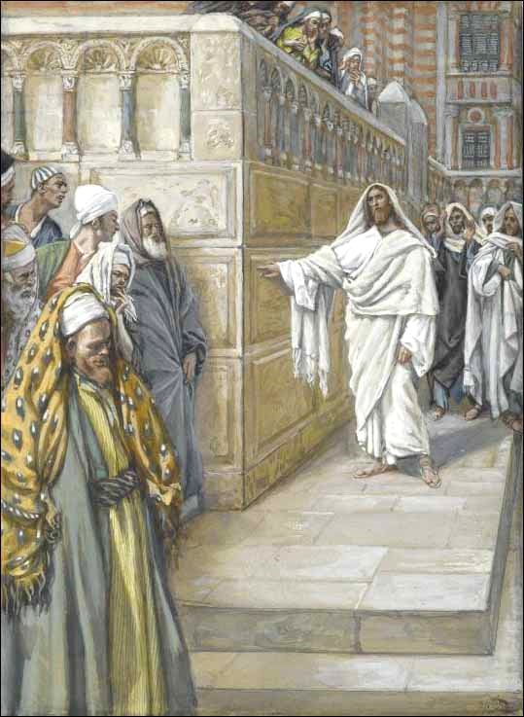
KEARNEY, NEBRASKA

