Thank You
Thank you to everyone who attended my 95th birthday celebration and for the many cards and gifts. It was a most wonderful day.
Norman Abels

Lutheran Witness
It is time to renew our Lutheran Witness Subscription. For those of you who ordered through Zion last year, there is a note in your mailbox asking if you wish to renew. If you would like to be included in in the Zion subscription please notify the office staff. Cost is $15.96 per year.

School News
- The annual Plant sale is now in progress. Any of our school children would be happy to take your order. Last date to order is April 11. Plants will be available for pick-up on April 28 & 29.

- Nearly 30 of our students took part in the Gathering of the Talents at Concordia Seward yesterday.

- Our 3rd-6th grade classes will travel to Lincoln this week for a visit to the state capital building and other places of interest.
- Congratulations to our Zion preschool who was voted “Best of Kearney” by Kearney Hub readers.

- Good News- All of our pre-school and Pre-Kindergarten classes have filled for the coming school year.
Stewardship Note
Hebrews 9:12 “He entered once for all into the holy places, not by means of the blood of goats and calves but by means of his own blood, thus securing an eternal redemption.” The only price that could redeem us was the very Blood of the Christ – this is the only sacrifice of true worth. His sacrificial giving sets the pattern for our life – for how can we who are redeemed by the self-giving of God not also give of ourselves to His Kingdom?
Announcements – April 2, 2017
Please remember...to silence your cell phone upon entering the sanctuary.

Zion’s sanctuary is equipped with a HEARING LOOP. Please switch hearing aids to T-coil mode. We have 2 headsets and receivers that persons without hearing aids can use. Ask an usher for assistance.
Forgot your offering? Don’t have your checkbook or cash? Today or any day you can give in a new way! Visit our website at zionkearney.com and click on the “giving” tab. Or, text “zionkearney” (one word) to 77977. You’ll receive a text back with instructions to start giving.

Lenten Service
Please plan to join us April 5th at 7:00 for our Lenten Service.

Preceding the service, the Zion Church Council will serve a meal in the Fellowship Hall from 5:30-6:30. The freewill offering will be given to the support of missionaries.

Palm Sunday Dinner – Next Sunday
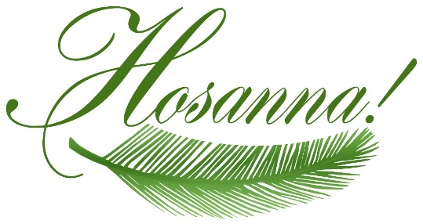
The Mary Martha Guild invites everyone to their Palm Sunday Luncheon Sunday, April 9 beginning at 11:30 a.m. in the gym. All of the food will be provided by the Mary Martha Guild. Please join us for some delicious casseroles, salads, and desserts in the school gym. There will be a freewill offering which will support LWML missions, including Lutheran Family Services, Ysleta Lutheran Mission, Care Net Pregnancy Centers of Albuquerque and the Albuquerque Christian Children’s Home. These gifts will be delivered to the LWML convention which will be held in Albuquerque this summer.

Easter Resurrection Gardens
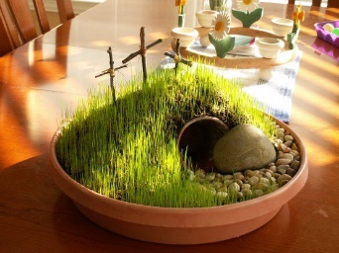
Mary Martha has put together “Resurrection Garden Kits” which will be given out to our families with children in the younger grades. (One per family) Included with the kit are directions for assembling the garden and suggestions for using it to teach your children about the events leading up to Holy Week, as well as Jesus’ suffering, death and resurrection. Thank you to Pastor DeLoach for his assistance with this project.
These will be given out on today.
We ask that parents pick up their children in their classrooms this day so the kits make it home without breaking.

Additional Opportunities to Worship during Lent
DATE | Service Time | LENTEN MEALS AT 5:30 -SERVED BY
April 5 | 7:00pm | Church Council
April 9 | 9:00am | Palm Sunday Meal @ 11:30
April 13- Maundy Thursday | 7:00pm
April 14-Good Friday Service | 2:00pm | Fellowship Hour Following
April 14-Tenebrae Service | 7:00pm
Saturday, April 15 Easter Vigil | 7:00pm
April 16  Easter Divine Service | 7:00am | Easter Breakfast served  8:00-8:45
April 16  Easter Divine Service | 9:00am

Introducing the Vigil of Easter
Saturday, April 15, 2017, at 7:00 p.m. will be the first time in Zion’s recent history that we will celebrate the Vigil of Easter. The sun will set on Holy Saturday as we gather to usher in the celebration of the Resurrection of Our Lord on Easter Sunday. The Vigil of Easter connects the days of Holy Week, especially Holy Thursday and Good Friday, with the culminating celebration of the resurrection of Christ from the dead. We are glad to be able to offer yet another opportunity to anticipate our Lord’s resurrection and our baptism into His death and resurrection.
In some places throughout the early centuries of the Church’s life, the people of God would hold vigil, which means “keep watch,” through the night in expectation of Christ’s return. A vigil in expectation of Christ’s return at Easter became a common feature of the celebration of His crucifixion and resurrection. The vigil consisted of prayer, psalms and hymns, and readings, especially from the Old Testament, culminating in the celebration of the resurrection at dawn with the Lord’s Supper. As the Church gathered in vigil, she waited in hopeful expectation for the appearance of the resurrected Christ in those most recently born in Him, the newly baptized. During the vigil, those who had prepared throughout Lent to be joined to Christ were baptized. At the dawn of the new day at Easter sunrise, the newly baptized joined the entire Church in the chorus of alleluias at Christ’s resurrection from the dead.
While making a vigil through the night may not be common today, Christians nonetheless gather on Holy Saturday to wait in expectation for the news of Christ’s resurrection and for His second coming. I encourage you to try this service. It is very different from what you you have experienced Sunday mornings, or at prayer-services mid-week. It is the kind of service that is better seen than told about, experienced first-hand rather than heard about second-hand, so do consider yourself invited.

