VBS

VBS 2017 is a victory celebration! In Mighty Fortress VBS, your children learn that in Jesus, the victory is won! They’ll look into the Bible, God’s Holy Word, and explore five Bible accounts about God, our Mighty Fortress, and the victory Jesus has won for us.

Registration is open for ages 4yrs-6th grade who will attend VBS from July 16-20, from 6:00-8:00 pm. Come along with us as we sing fun songs, do crazy crafts, eat yummy snacks, play awesome games, and more. Plus, you’ll learn in Jesus, the victory is won! Can’t wait to see you there! Register online at www.vbsmate.com/zionkearney. Or fill out the blue registration form in the narthex and on the table in the school hallway and turn into the office.
Register now for Mighty Fortress Vacation Bible School! Can’t wait to see you there!!
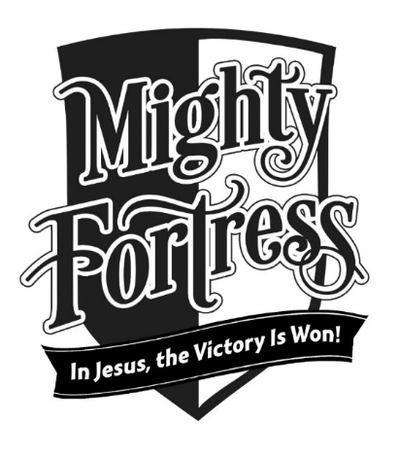

Stewardship Note
Matthew 11:28 “Come to me, all who labor and are heavy laden, and I will give you rest.” Jesus has come to do the work so that we might have rest from burdens and labors we are not capable of bearing. He frees us from sin, death, and the demands of the Law. In that peace and rest of Jesus we find a new purpose – His light yoke which is no burden to bear, but a joy!

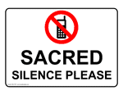
Announcements – July 9, 2017
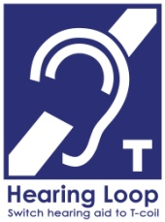
Please remember...to silence your cell phone upon entering the sanctuary.

Zion’s sanctuary is equipped with a HEARING LOOP. Please switch hearing aids to T-coil mode. We have 2 headsets and receivers that persons without hearing aids can use. Ask an usher for assistance.
Forgot your offering? Don’t have your checkbook or cash? Today or any day you can give in a new way! Visit our website at zionkearney.com and click on the “giving” tab. Or, text “zionkearney” (one word) to 77977. You’ll receive a text back with instructions to start giving.

VBS Snacks
Would you be able to help with VBS by donating snacks? There is a display on the bulletin board wall with food items that are needed. Please consider taking one or two of the tags from the display and bringing your donation back to the church. Items can be brought to the Fellowship Hall kitchen next Sunday, July 16.

All VBS Volunteers (Youth and Adult)
There is an important training meeting this Wednesday (7/12) at 7:00 pm. We will go over schedule, assignments, songs, and more. If you cannot attend this meeting, contact Pastor Gaunt ASAP (455-0552) so he can arrange to get this information to you.

Mary Martha
Mary Martha will meet this Monday, July 10 at 7:00 pm in the Fellowship Hall. The meeting will include a report from the LWML convention in Albuquerque. Vicar Matthias Wollberg will lead our bible study. Matthias and his family are moving to Billings, Montana where he will serve as a vicar for one year.

VBS
VBS parents and drivers, you are invited to come in and join your children for our “Mighty Fortress Closing” at 7:40 each night. And then you can enjoy a snack with children and staff after. Both are in the Fellowship Hall.

Voter’s Meeting
The quarterly Voter’s meeting will take place on July 23, at 10:30 in the Fellowship Hall.
VBS

VBS 2017 is a victory celebration! In Mighty Fortress VBS, your children learn that in Jesus, the victory is won! They’ll look into the Bible, God’s Holy Word, and explore five Bible accounts about God, our Mighty Fortress, and the victory Jesus has won for us.

Registration is open for ages 4yrs-6th grade who will attend VBS from July 16-20, from 6:00-8:00 pm. Come along with us as we sing fun songs, do crazy crafts, eat yummy snacks, play awesome games, and more. Plus, you’ll learn in Jesus, the victory is won! Can’t wait to see you there! Register online at www.vbsmate.com/zionkearney. Or fill out the blue registration form in the narthex and on the table in the school hallway and turn into the office.
Register now for Mighty Fortress Vacation Bible School! Can’t wait to see you there!!

Stewardship Note
Matthew 11:28 “Come to me, all who labor and are heavy laden, and I will give you rest.” Jesus has come to do the work so that we might have rest from burdens and labors we are not capable of bearing. He frees us from sin, death, and the demands of the Law. In that peace and rest of Jesus we find a new purpose – His light yoke which is no burden to bear, but a joy!

Announcements – July 9, 2017
Please remember...to silence your cell phone upon entering the sanctuary.

Zion’s sanctuary is equipped with a HEARING LOOP. Please switch hearing aids to T-coil mode. We have 2 headsets and receivers that persons without hearing aids can use. Ask an usher for assistance.
Forgot your offering? Don’t have your checkbook or cash? Today or any day you can give in a new way! Visit our website at zionkearney.com and click on the “giving” tab. Or, text “zionkearney” (one word) to 77977. You’ll receive a text back with instructions to start giving.

VBS Snacks
Would you be able to help with VBS by donating snacks? There is a display on the bulletin board wall with food items that are needed. Please consider taking one or two of the tags from the display and bringing your donation back to the church. Items can be brought to the Fellowship Hall kitchen next Sunday, July 16.

All VBS Volunteers (Youth and Adult)
There is an important training meeting this Wednesday (7/12) at 7:00 pm. We will go over schedule, assignments, songs, and more. If you cannot attend this meeting, contact Pastor Gaunt ASAP (455-0552) so he can arrange to get this information to you.

Mary Martha
Mary Martha will meet this Monday, July 10 at 7:00 pm in the Fellowship Hall. The meeting will include a report from the LWML convention in Albuquerque. Vicar Matthias Wollberg will lead our bible study. Matthias and his family are moving to Billings, Montana where he will serve as a vicar for one year.

VBS
VBS parents and drivers, you are invited to come in and join your children for our “Mighty Fortress Closing” at 7:40 each night. And then you can enjoy a snack with children and staff after. Both are in the Fellowship Hall.

Voter’s Meeting
The quarterly Voter’s meeting will take place on July 23, at 10:30 in the Fellowship Hall.

