YOUTH GROUP EVENTS

9:00 a.m. - Divine Service!
Every Sunday
10:30 a.m. - Jr. High and Sr. High Bible Study!
Invite your friends and come receive true life from Jesus.
Sunday, August 20 at 5 p.m. (grades 7-12) – Swimming at Harmon Park, followed by pizza! Bring your friends. Attendees will help shape future youth events.

August 24-26 (gr 7-12)- All hands on deck! Our turn to sell Colorado Peaches. Our main fund raiser for future events and conferences!
Sunday, September (time/date TBA) -"To Save a Life" movie night and discussion, led by Pastor Gaunt, for Sr. High only and their friends. We will talk about real life challenges and the hard choices students are confronting these days. More information to follow.
October 4 at 6:30 p.m. (gr 7-12) - Martin Luther at The World Theater. Special price of $5 for youth, includes movie and snacks. Limit ten, first paid. Purchase a ticket at the Church Office.
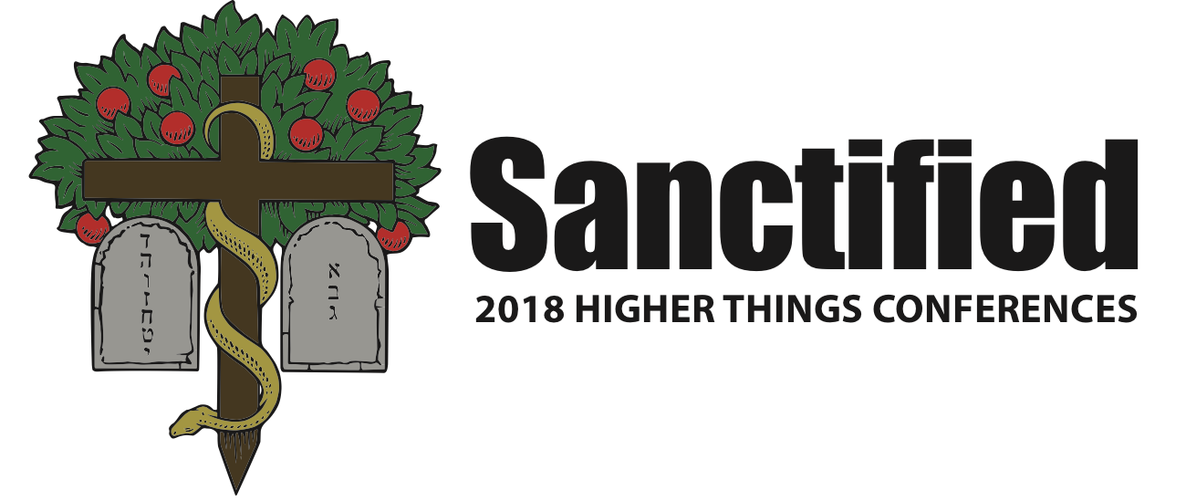
July 24-27, 2018 @ Lawrence, KS

Pastor DeLoach will have registration forms when available.
Forms are due by November 1.

