MC900030653[1]**Poinsettia**

We will be using poinsettias decorate our Church this Christmas season.  If you wish to provide a poinsettia, the cost will be $12.  To avoid confusion, please place your money in an envelope and turn in to the church office. Checks should be made out to Mary Martha.

**Food Collection**

Zion will collect food items during the month of November to help supply Kearney agencies who assist the needy. There are grocery carts in the narthex and school area to gather these items. Non-perishable items only please. **Please note that the Jubilee Center could especially use Peanut Butter, Cereal, and diapers size 3 & 4.**

**School News**

* The date for the school Christmas Program has been set for Sunday, December 10 at 4:30 pm.
* Scrip cards for the new Raising Cane’s restaurant are available in the Booknook.
* We have received word that the Labels for Education (Campbell’s Soup labels) Program is coming to an end. Please turn in any labels that you have collected for us as soon as possible. Our last day to submit these is January 2, 2018.

**Give Where You Live**

This year Zion Lutheran School will be participating in the Give Where You Live Campaign. It will be December 7 (giving day), but donations will be accepted beginning November 1st. To participate/contribute online go to: <https://www.givewhereyoulive.net/ZionLutheranSchool>

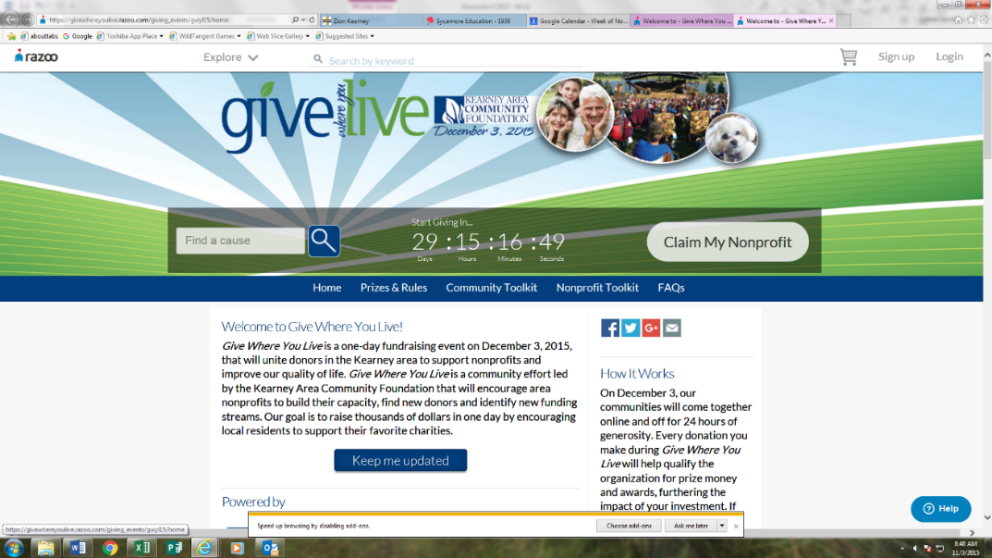if you would rather in person feel free to stop by the office. Please share this with your family and friends.

**Announcements – November 19, 2017**

Please remember...to silence your cell phone upon entering the sanctuary.

Zion’s sanctuary is equipped with a **HEARING LOOP**. Please switch hearing aids to T-coil mode.We have 2 headsets and receivers that persons without hearing aids can use. Ask an usher for assistance.



**Forgot your offering? Don’t have your checkbook or cash? Today or any day you can give in a new way! Visit our website at zionkearney.com and click on the “giving” tab. Or, text “zionkearney” (one word) to 77977. You’ll receive a text back with instructions to start giving.**

**New Organ**

Thanks be to God! Our new organ was installed this past week. Before the service today there will be The Blessing of the Organ.

**Thanksgiving Eve**

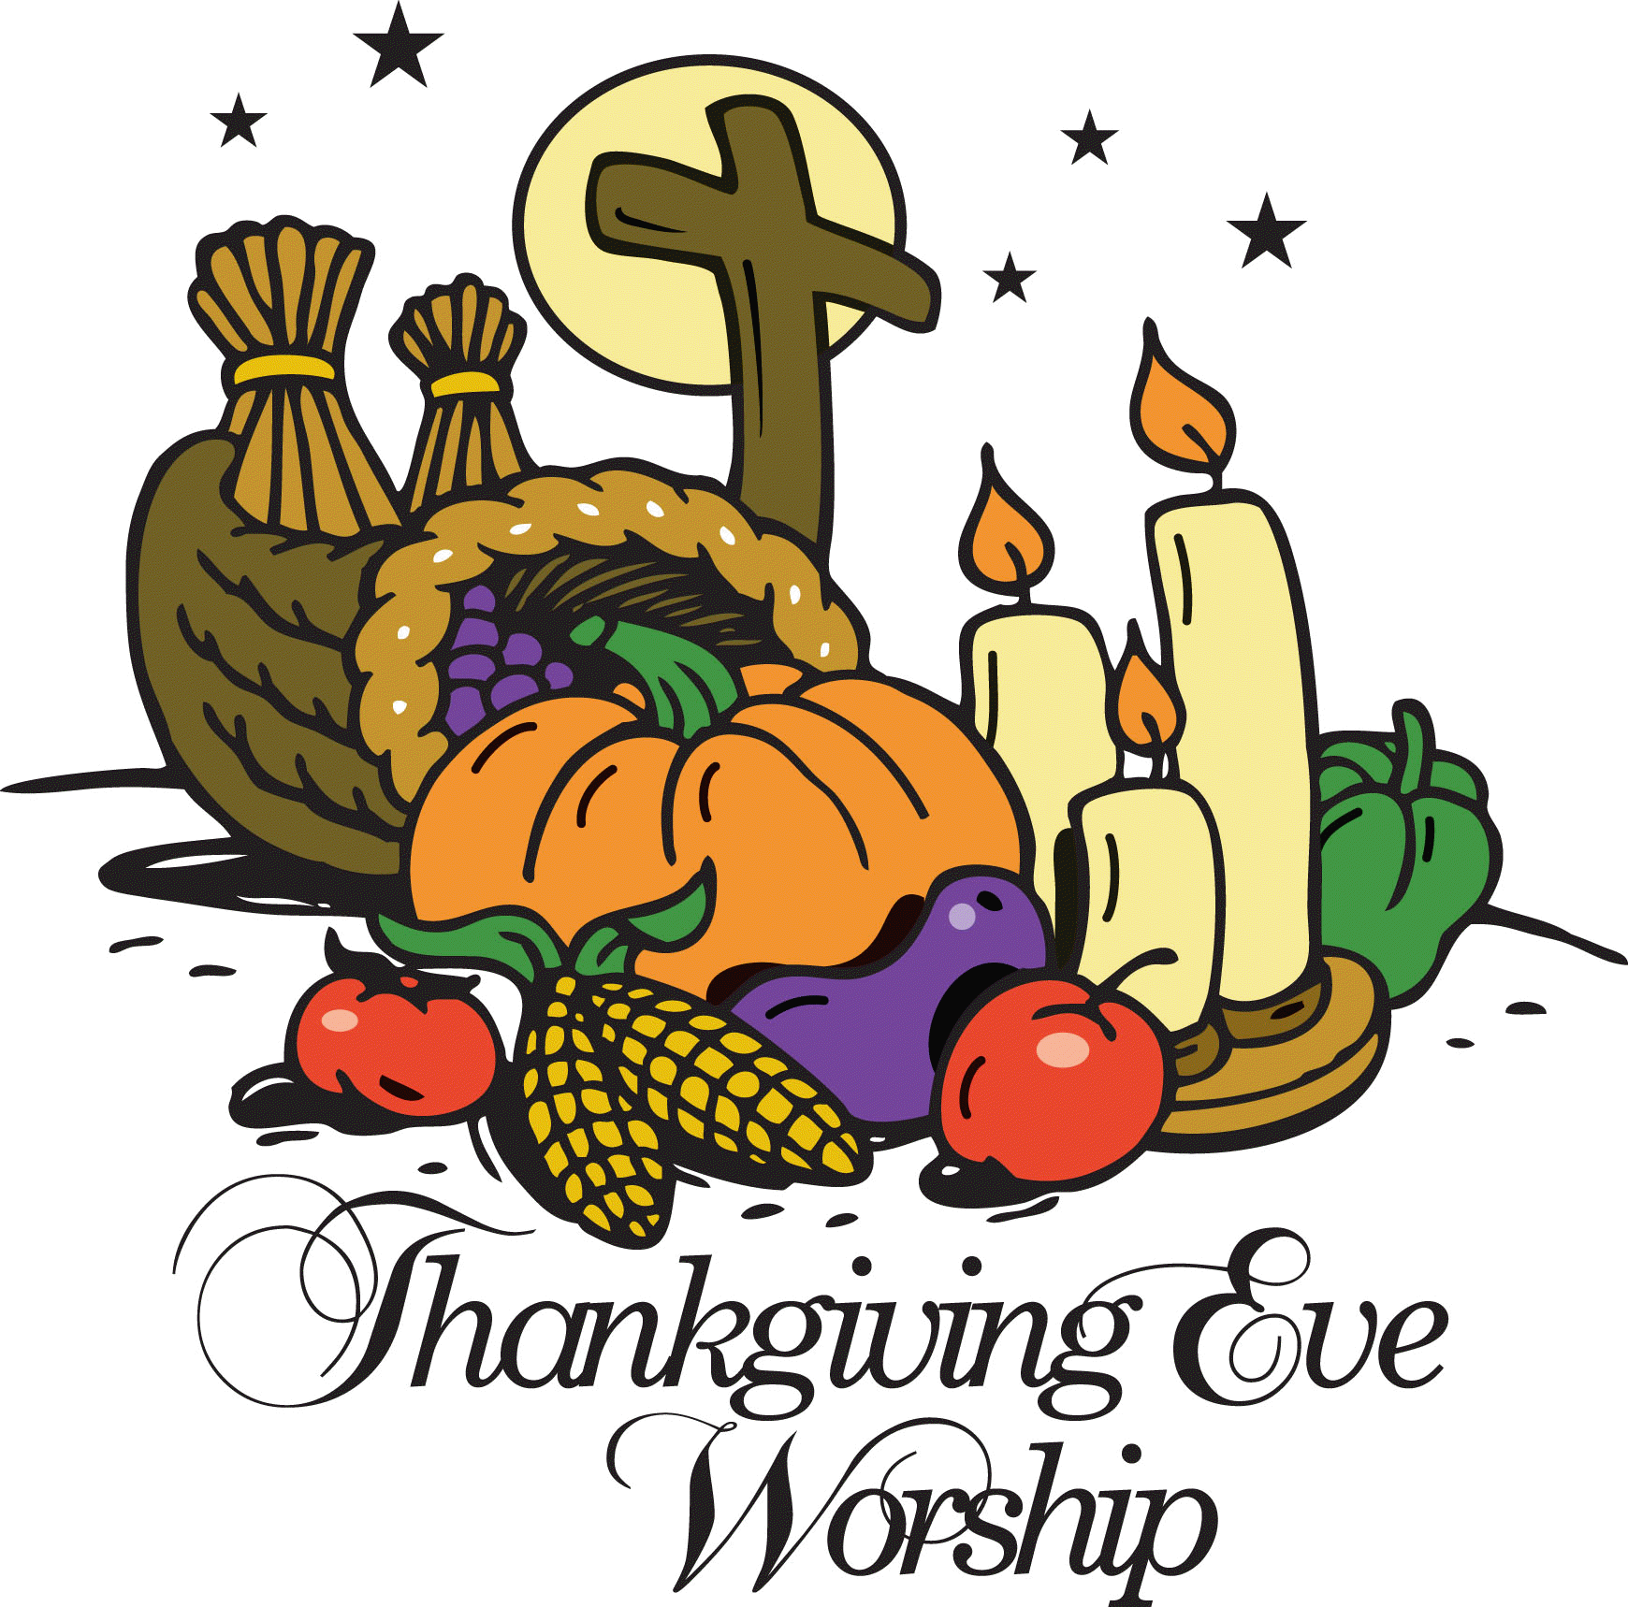We extend a very special invitation to you and your family to come and worship with us on Wednesday, November 22, at 7:00 p.m. For those who have guests visiting, please bring them along.

**Group Picture Directory Photos**

After the service today we will be taking group photos of our boards and organizations. Please meet in the narthex right after all have exited from the sanctuary.



**Senior Citizens**

Our Senior Citizens will meet tomorrow November 20 at 12 noon for their monthly potluck meal. All are welcome to join them.

**Voters Meeting – Next Sunday**

A Voters meeting is scheduled for Sunday, November 26 at 10:30 in the Fellowship Hall. Business will include election of officers and board members for 2018.

**Holiday Pies**

Thank you to all who purchased holiday pies from our school children. Because we have to purchase pies in full cases, we have some of each variety left. If you are interested in purchasing any of these for your holiday celebrations, please speak with Lisa or Shirley after the service today.

**Lifetouch Pictures**

An additional group of 8 x 10 directory photographs were received at the office this week. If you have not received yours yet, please check with Shirley after the service today.

**Mission Sunday**

Last Sunday $495 was collected for Issues Etc. If you still wish to contribute to this, you may do so until the end of November.

**Zion Family Thanksgiving Dinner**

Thank you to Mary Martha for serving the delicious Thanksgiving meal last Sunday. Meals were served to 203 people including 17 meals that were delivered to those who could not attend. Thank you to all who joined us for this meal and for your generous donations. $1,364.70 which was given to our emergency assistance fund.

**Raising Cane’s Fundraiser**

**Zion will be having an in-store fundraiser at Raising Cane’s on Thursday, December 14th from 6:00-9:00 p.m.** Purchase anything from Raising Cane’s mention Zion Lutheran and we will earn 20% of sales. Treat yourself out this night, make cooking easier during the busy time of December and earn money for the school. Don’t forget to mention Zion Lutheran School!

**Stewardship Note – Matthew 25:30** “And cast the worthless servant into the outer darkness.” Why did the worthless servant act the way he did? Because of what he believed about the Master. He didn’t trust or love the Master – and so his actions did not demonstrate love and trust, but rather hate and mistrust. It’s the same with us, but in reverse: since we know our Lord God to be faithful and kind, we desire to serve Him and render faithful service with what He has given us.

**Office Closed**

The Church Office will be closed Wednesday through Friday of this week. If you will need in the church these days please make arrangements to check out a key.

**Devotional Books**

Are you looking for a special gift for yourself or for some other special person? The Book nook has copies of Pastor Allwardt’s 3 devotional books available. They would be great “reading.” Pastor would be happy to sign one for you.

Stop in and check them out!

**Thank You**

Thank you all for the thought and prayers while I’ve been recovering from my broken ankle. I’m healing and will be more mobile soon. Thank goodness.

Marion Richmond

**THANK YOU** for the celebration on Sunday of the 25th anniversary of my ordination. I am humbled and grateful for all your gifts, cards, prayers, and kind words. Carol and I were overwhelmed with the evening and your generosity! It is an honor to be the Lord’s servant at Zion, and to work with you in service to Him. To God be the glory! Pastor and Carol DeLoach

