O give thanks unto the LORD, for He is good:

for His mercy endures forever.

Psalm 107:1

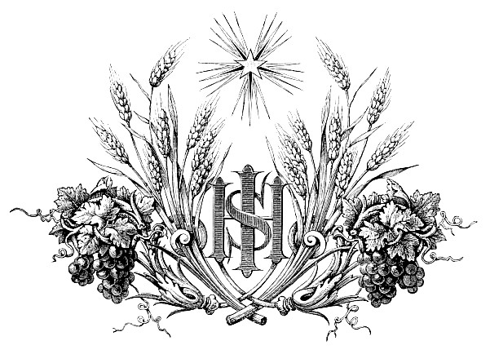

Thanksgiving Eve

November 22, 2017+ 7:00 p.m.

Zion Lutheran Church & School

Kearney, NE + (308) 234-3410

Rev. James DeLoach, Pastor + (308) 627-5260

Rev. Doug Gaunt, Pastor + (308) 455-0552
Tony Splittgerber, Principal + (308) 293-0168
Thanksgiving Eve Vespers
(Lutheran Service Book: 229-234)

Pre-service music and silent prayer before worship

Hymn # 790 |  | “Praise to the Lord, the Almighty”
Opening Versicles |  |  | p. 229
Psalm 67 | (Spoken Responsively by ½ verse)
Readings and Responses |  |  |  |  | p. 230
Deuteronomy 8:1-10
Philippians 4:6-20
Luke 17:11-19
Common Responsory |  |  |  | p. 230
Hymn # 785 |  |  | “We Praise You, O God”
Sermon
Magnificat ~ Song of Mary |  |  |  |  |  | pp. 231-232
Offering

Offertory ~ LSB # 801 “Give Thanks” |  |  |  |  |  |  | Sung by Choir
Prayer |  |  | p. 233
Kyrie
Lord’s Prayer
Salutation

Thanksgiving Litany
P:  C:  P:  C:  P:  C:  P:  C:  P:  C:  P:  C:  P:  C:  P:  C:  P:  C:  P:  C:  P:  C: | Lord God, heavenly Father, from Your hand we receive all good gifts, especially the gift of salvation through our Savior Jesus Christ. Grant us Your Holy Spirit so that we remember to offer you our thanks and praise for your abundant mercy.  For the tender love You show Your whole creation: O, give thanks unto the Lord, for He is good,  and His mercy endures forever.  For the food we eat, the clothes we wear and the homes we live in: O, give thanks unto the Lord, for He is good,  and His mercy endures forever.  For our families, for husbands and wives, and especially children with their joy and their trust, for grandparents and grandchildren, for aunts and uncles: O, give thanks unto the Lord, for He is good,  and His mercy endures forever.  For the fields and their harvest, for farmers and their labors, for the good earth and all its bounty: O, give thanks unto the Lord, for He is good,  and His mercy endures forever.  For our nation and all its people, and for the freedoms we enjoy, especially for the freedom to worship You in peace: O, give thanks unto the Lord, for He is good,  and His mercy endures forever.  For the sufferings that come upon us and for the reminder they bring of the one thing needful: O, give thanks unto the Lord, for He is good,  and His mercy endures forever.  Above all for the incarnation of our Lord, for His suffering and death, for His glorious resurrection and ascension and for the coming of the Holy Spirit, the Comforter: O, give thanks unto the Lord, for He is good,  and His mercy endures forever.  For the holy Church, for the divine waters of Baptism, for the comfort of Holy Absolution, and for the life-giving Sacrament of the Altar: O, give thanks unto the Lord, for He is good,  and His mercy endures forever.  For the Sacred Scriptures, for the holy Law that shows us our sin, and for the holy Gospel that reveals the righteousness of Christ as Your gift to us: O, give thanks unto the Lord, for He is good,  and His mercy endures forever.  For these and all Your mercies, mercies beyond number and measure: O, give thanks unto the Lord, for He is good,  and His mercy endures forever.  You are indeed blessed and holy and worthy of all honor and praise, O Father Almighty, O only-begotten Son, O Spirit of Holiness. To You alone do we give all glory now and forever!  Amen!
Benedicamus and Benediction |  |  | p. 234
Hymn #895 |  | “Now Thank We All Our God”

The illustration is by Alexandre Bida and was part of the book, Christ in Art (1874). The letters IHS make up a monogram which stands for Jesus Christ. He is the One for whom we are most thankful because His great sacrifice for us and our salvation.

This bulletin cover provided by www.scholia.net and is made available without cost.

